19 June2019 Facebook Memories for Books
We hope you enjoy looking back on your memories on Facebook, from the most recent memories to those long ago.

2011 - 2018
Dostan, Naheel and 17 others
4 places
ON THIS DAY
1 year ago



Mervelee Ratty Nembhard
June 19, 2018 at 11:58 PM ·
Bloodklaat Police use #appeal. Employment Tribunal use it. Now rassclaat DWP tink dem gwine do di 🦀 louse same. Mi Nyan dem mooma white fowl?

1Smith Stacey
8 Comments

Share
1 year ago

Mervelee Ratty Nembhard
June 19, 2018 at 11:55 PM ·
Time to get rest, I need it. I will leave the letter fr #DWP til I wake. We will see dis bloodklaat appeal?

Share
1 year ago

Mervelee Ratty Nembhard
June 19, 2018 at 11:52 PM ·
11:50 & thanks to JoJo, I have my freezer stock with #fish. 2 most impt men in my life in UK meet... Yepey

Share
1 year ago

Mervelee Ratty Nembhard
June 19, 2018 at 8:39 PM ·
Now I am going to delete the rubbish off MyJAMAICA so I can have access to my phone. Libbatty takers...?

Share
1 year ago

Mervelee Ratty Nembhard added 30 new photos to the album: Sam King Legacy — feeling inspired at Westminster Abbey.
June 19, 2018 at 8:36 PM · London ·
Privilege to be with the celebrants

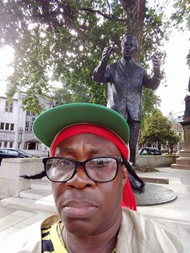

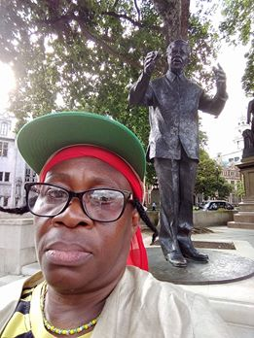

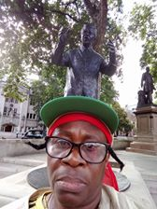

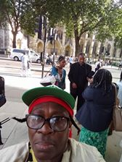

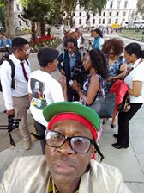
+26

1Mervelee Ratty Nembhard
2 Comments

Share
1 year ago

Mervelee Ratty Nembhard
June 19, 2018 at 8:31 PM ·
Why do I feel so much pride when I see a loving #Father_daughterrelationship? Bring back memories of my father and being an only girl. LEYF Nurseries and cohorts going to pay for messing with my head. Then Parson Daughter Theresa May and her Government can be prepared for what is coming.

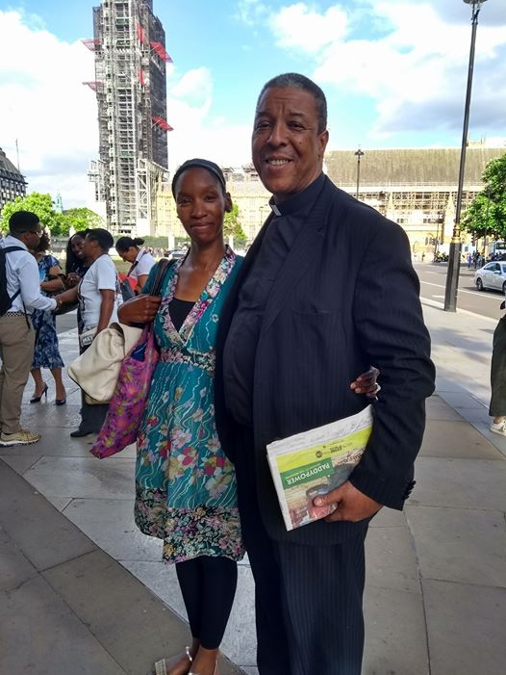

Share
1 year ago

Mervelee Ratty Nembhard
June 19, 2018 at 7:53 PM ·
Why Facebook don't fucking leave me alone? All I am seeing is ads... I don't have a frigging job. I ain't selling my #Cat?

1Mervelee Ratty Nembhard
1 Comment

Share
1 year ago

Mervelee Ratty Nembhard
June 19, 2018 at 7:12 PM ·
Now I go eat. Only eat 1nce since today. Theresa Maygovernment cause my #Stress...

1Mervelee Ratty Nembhard
2 Comments

Share
1 year ago

Mervelee Ratty Nembhard is feeling thankful with Valdin Legister and 3 others at Westminster Abbey.
June 19, 2018 at 7:04 PM · London ·
Just got back from #SamKing celebrating at St Margaret's Church Westminster Abbey. Thanks Lovena Brown for the invite. I am so wrapped up in my own world with my ongoing Fight4justice campaign against LEYF Nurseries and the institutional discrimination. Some days I am out of it. Hearing the speakers today, serve to reinforce that the struggling against OPRRESSION continued.
I was refused an interview for BBC because I am not old enough to be part of the Windrush Generation. My question is, who are the Windrush Generation? In the end I spotted this eyeglasses on the ground that belongs to the #interviewer. Now what would happen if I walked past it?
I however did get in on some of the interviews. Don't know what the quality is like. Big shout out to #MikeyDread the professional photographer. My gratitude....

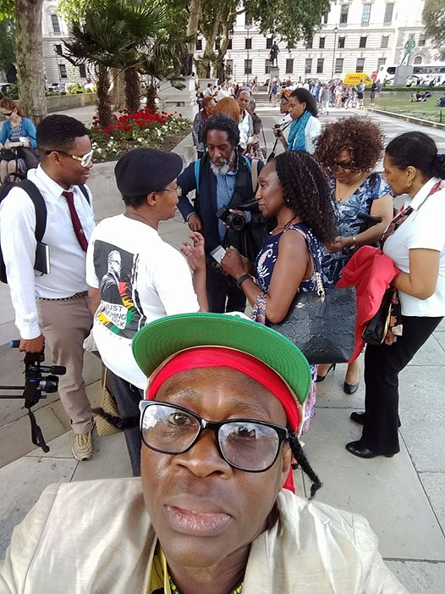

77
4 Comments

Share
1 year ago

Mervelee Ratty Nembhard is with Valdin Legister.
June 19, 2018 at 4:22 PM ·
Remembering #SamKing_MBE at St Margaret's Church, Westminster Abbey. Just listening to #BaronessBenjamin, #DioneMcDonald, #LordOusley, #DrMichelleAsantewa and the Lecture by #ArthurTorringtonmake me want to expose LEYF Nurseries with my Fight4justice campaign.

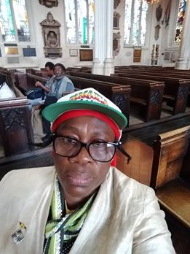

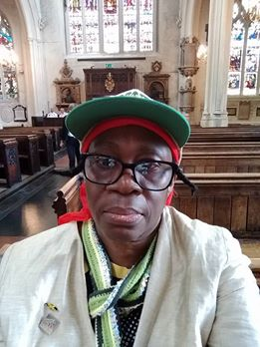

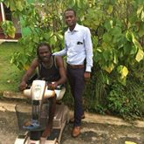

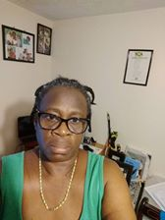

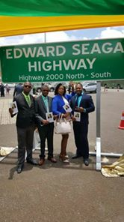
+2

11

Share
1 year ago

Mervelee Ratty Nembhard
June 19, 2018 at 12:04 PM ·
I can feel myself getting #stress and then I start to #cuss. Tom say I must put on bet. Me & LEYF Nurseries & DWP...

Share
1 year ago

Mervelee Ratty Nembhard
June 19, 2018 at 10:36 AM ·
Young Lady call abt Energy. Stupid Gal arguing with me abt my #address? DWP have my name & address right, but I see #Appeal...

1 Comment

Share
1 year ago

Mervelee Ratty Nembhard
June 19, 2018 at 10:33 AM ·
So the scammers start early this morning. Telling me my internet will be disconnected. Go suck..., don't #stress me out...?

1Doreen Desiree Thompson

Share
1 year ago

Mervelee Ratty Nembhard is feeling strong with Valdin Legister and 8 others in London, United Kingdom.
June 19, 2018 at 9:57 AM ·
Taurus: A successful romantic or business partnership allows you to take creative risks. It's easy to venture into unfamiliar territory when you have support of someone special. Take this opportunity to pursue a business launch or start a creative project.
Evaluation: I am giving up on romance. Going with the business partnership. So here is the deal. I am investing in Kevin Murray and Valdin Legister. They are my special support from their Fathers and GOD, my Heavenly Father.

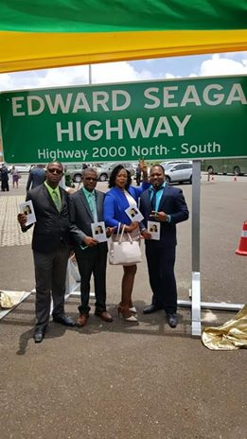

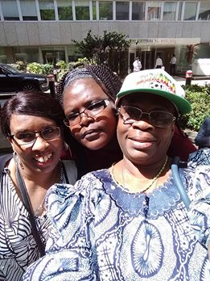



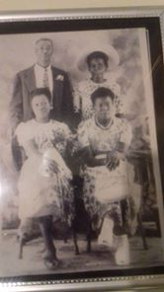

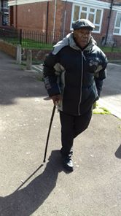
+5

6Arian Murray, Kadian Getfield and 4 others
2 Comments

Share
2 years ago

Mervelee Ratty Nembhard is feeling loved with Valdin Legister and 3 others in London, United Kingdom.
June 19, 2017 at 4:31 PM ·
After my morning ordeals, doing caring duties for my #Husband, I attended the training #Mentoring_Befriending in North London - Kings Cross. Travel on the train to Brixton to get saltfish. Back to #JNBS in Elephant and Castleto send Tom's breda money. So yes I am singing from I'm on the bus. Oh yes they did enjoy my singing "Mango Time..." When the White Bloke was leaving, he compliment me on my singing saying how much he enjoys it....
Hey I'm telling you I am not afraid to make a Poppy Show of myself any time, anywhere, any how, and in whose presence. Wbo cares if I am Tone Deaf, I can still bring #Pleasures to some. Of course it depending on your taste? Look who I found, my #1stLove, Mr ALVERIE Michael Legister. Guess my #2Son Valdin Legister, honouring his #FATHER. Well I can vouch he is the best El Numero Uno Padre in the entire world. Still Love you Boss Man, even when you join the avoidingthe Ratty Brigade.

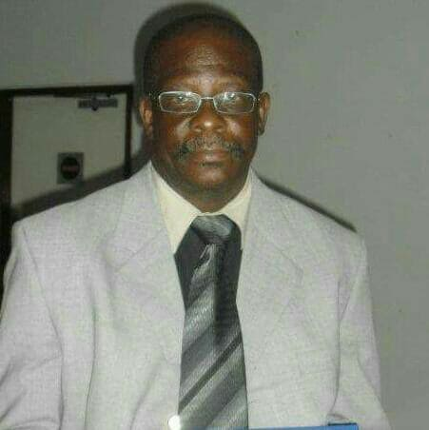

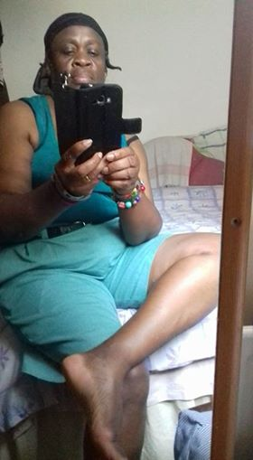

1Mervelee Ratty Nembhard
1 Comment

Share
2 years ago

Mervelee Ratty Nembhard is feeling ready with Olive Regis-Williams at The National Council for Voluntary Organisations.
June 19, 2017 at 10:07 AM · London ·
I was on the #1Bus going towards E&C, and boiling like hell. Wouldn't mind if someone order me to strip down to my underwear.
Ok, put fun and jokes aside, I was fanning and getting acknowledged for sharing... An elderly man got on the bus so I offer my seat. We got talking and he is going to his #Uncle funeral and bemoans the heat.
Ask his uncle's age, told me and indicate with his hand, so I supply Dementia. He said uncle death is a relief...
We chat some more and I tell him "I am an Old Man #Darling_Tom...
So now LEYF Nurseries, the #Establishment and the #Systems know I'm more than the sum of my total

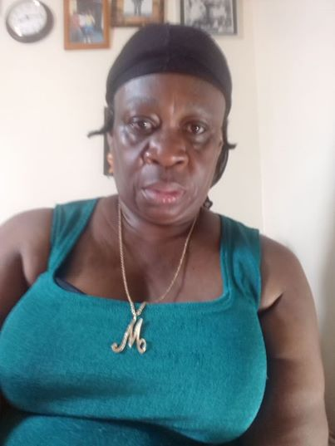

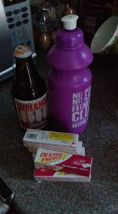

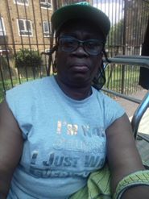

2Arian Murray and Rose Thompson

Share
2 years ago

Mervelee Ratty Nembhard is feeling grateful with Valdin Legister and 2 others at Harris Academy Bermondsey.
June 19, 2017 at 7:39 AM · London ·
Welcome to the life of #MERVELEEMYERS. In case anyone thinking I have it easy, I don't want to work, etc, etc... Nothing could be further from the truth. Since work was my purpose in life before to let me deal with the #POSTTRAUMATICSTRESSDISORDER that blighted my life, I just wanted to know I could provide for myself.
After what LEYF Nurseries done to destroy my life from after I come back from #MamaFuneral, I realised how much I was trying to hold unto the job. Because my previous experience in another workplace told me that you must not #RESIGN no matter what...
But when matters become unbearable, my little breda Ervin Nembhard told me "make your #Husband your priorities... Thanks to him my #DefensivePractice was updated.
This morning bring back to me the way how my life was spiralling out of control at BIB, HOC and then NC... I recall the morning I had to rush out before Tom was fully recovered to get to work. I ask the manager #MarionBreslin to let me call my husband to find out how he was doing... my stories are documented.
That's why I want to write a #BLOG defending the PM Theresa May. She don't deserve what is happening to her, I can tell you because I was label as #UURICA_LE. From thence I was left feeling like a zombie.
Since Tom went to #KingsCollegeHospital, we have not been able to stabilise the sugar. I went out yesterday to get glucose tablets.
He is now like my big old baby. I am lucky the Diabetic Nurse give me tips that I used to stop him going into hypo quicker. I still have a life, but I Owe him a duty of care which is paramount.
That's why these days my life is planned around him.
I am going to training with my tutor and assessor at the #NationalCouncilforVoluntaryOrganisations. So Olive Regis-Williams, sorry I missed you last night, but I have done my best for Tom and going to get ready. I have to be early to lost and find my way. Remember I have Dyslexia combined with the #OCD. That's why my bag of goodies always with me.
Thanks Jillian Williams for being my listing ear last night. The Man is still running....

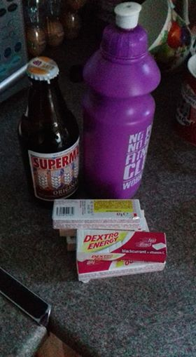



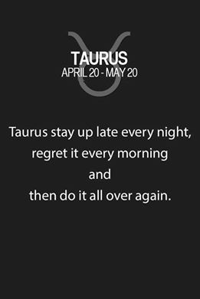

1 Comment1 Share

Share
2 years ago

Mervelee Ratty Nembhard is with Kevin Murray and 2 others.
June 19, 2017 at 12:10 AM ·
Daily Express The things they say... "It's a wise father that knows his own child" William Shakespeare 1564-1616.
This so appropriate on ##FathersDay.
So before the day is closed let me take the time out to salute all my Family and wish them a Happy Father's Day.
On the Chambers side I can only go back as far as Grandpa Claudius and Uncle Terah.
On the Saunders - Grand Uncles Esley & Man. So it's your job to start building the Family Trees.
On the NEMBHARD - Great Grandpa Thomas, Grandpa & Grand Uncle Charles & William, numerous Uncles of whom I knew Uncle Gridley, Sylvester, Aretas.
My 7 bredas Balis, Dostan Nembhard, BYRON, Texchus Nembhard, ASHTER, Amly aka Decosie Nembhard, Ervin Nembhard.
My 2 sons Kevin Murray and Valdin Legister.
Their Fathers #LloydMurray & Michael Legister. The other men who are Fathers and have played important roles in my son's life.

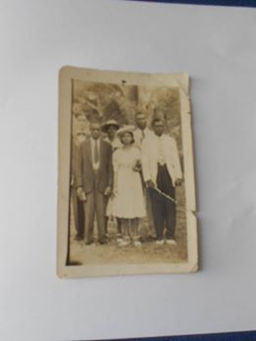

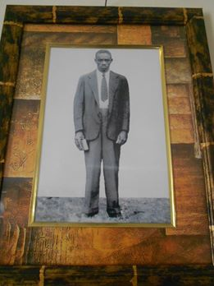

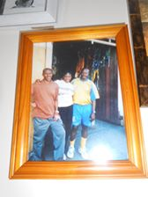

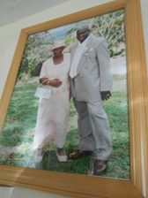

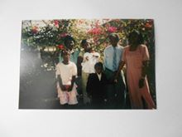
+9

22
1 Share

Share
3 years ago

Mervelee Ratty Nembhard
June 19, 2016 at 11:41 PM ·
As FATHERS DAY 2016 draws to a close, I must say a Big Shout out to all those who played the Roles in whatever Capacity. Be yea Mother/Father/Grands/Brothers/Uncles/Male/Females. For anyone who touched the lives of others, U are truly blessed. Need to Rest as I am still feeling the Effects of Selling the Rum Punch at Dudley's BD Party. Editting still in Progress but I diverted to uncover some of the Double Standards in Society!
God be with You til we meet again...?
Not having a FATHER means I take time to Read the Accolades about the Other Fathers! Mass TOM takes Centre Stage even when I wisn him HFD & him Kiss him Teeth?

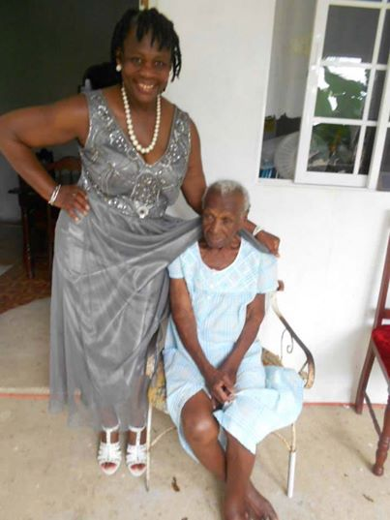

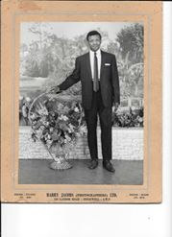

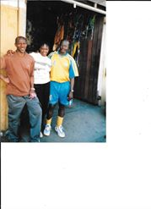

3You, Gregory Legister and Annmarie Grant
1 Comment

Share
3 years ago

Mervelee Ratty Nembhard
June 19, 2016 at 11:28 PM ·
Dudley's BD Party Grove by Annmarie T.
Play
-0:52
Additional Visual Settings
Click to enlarge
Unmute

1Valdin Legister

Share
3 years ago

Mervelee Ratty Nembhard
June 19, 2016 at 5:43 PM ·
Sat in the kitchen cooking chicken & fish. Mass Tom is a Hard Man to Please these Days. Focus on Cooking, catching up with a Few Important things. Haven't read News Paper for Weeks & my Life one big Shambles. I am inspired by this & I know how TRUE it is... Taurus: You work best when allowed to go at your own pace. So take things slow and steady and you'll untangle whatever FINANCIAL knots come your way. A joint venture comes to a close on Monday. Call to hear when you can work more freely.

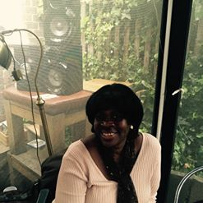

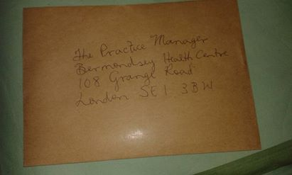

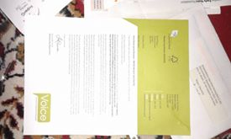

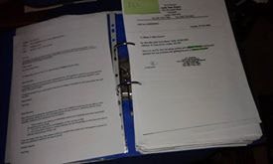

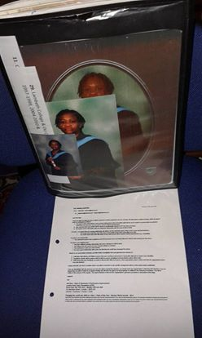

1Mervelee Ratty Nembhard
2 Comments

Share
3 years ago

Mervelee Ratty Nembhard
June 19, 2016 at 5:03 PM ·
Foundation laid by Many!



Naheel Julene Brown Legister
June 19, 2016 at 4:26 PM
Happy Fathers Day to my life partner Sir Valdin Legister. If I could rewrite my life there are a few things that I would change, but you being the father of my child I would do it all again. I love the way you support me with parenting and I love the way you love your children. You being a father extends not just to your biological children but I listen to you planning for the ones at your school, watch you show love to the neighbours and other children you encounter and I know you deserve all the best wishes for this and every other day. Happy Fathers Day to you from us all. Love you.

2Andrea Nembhard and 1 other

3 years ago

Mervelee Ratty Nembhard
June 19, 2016 at 10:58 AM ·
Aint hanging out on SM? WORK to be done in my #FIGHT4JUSTICE! HFD to the World... Out of Many One People!

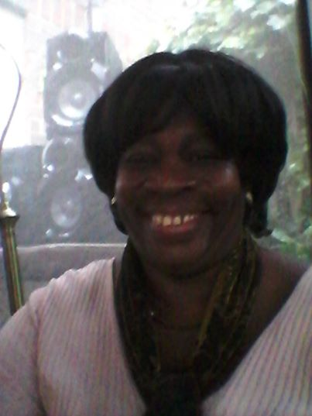



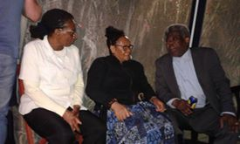

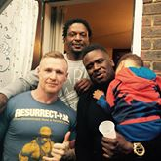

1Narvel Stewart

Share
5 years ago



Naheel Julene Brown Legister added a new photo — with Valdin Legister and 7 others.
June 19, 2014 at 1:05 PM ·

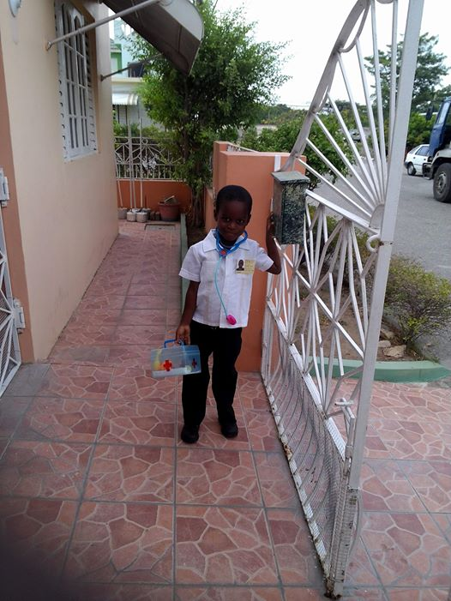

22Judith Gordon, Eileen Besley and 20 others
10 Comments

Share
7 years ago

Mervelee Ratty Nembhard
June 19, 2012 at 10:36 PM · London ·
All set 4 Moi Training 2moro... Had a likkle peep pon dah website since all is a MY-STORY...? So Bed here Moi cum... Nuh Disturbance Plz...!!!

1 Comment

Share
8 years ago

Mervelee Ratty Nembhard is with Valdin Legister and 9 others.
June 19, 2011 at 2:25 PM ·
Happy Father's Day 2 the 2 most important Men in my life Kevin Murray & Valdin Legister. Thanks 2 Lloyd & Alverie (Michael) 4 affording me with the privelege of being Mother to 2 such Lovely Sons who have now become Fathers!!! Love the 4 of U to the Max!!! Respect all the time...

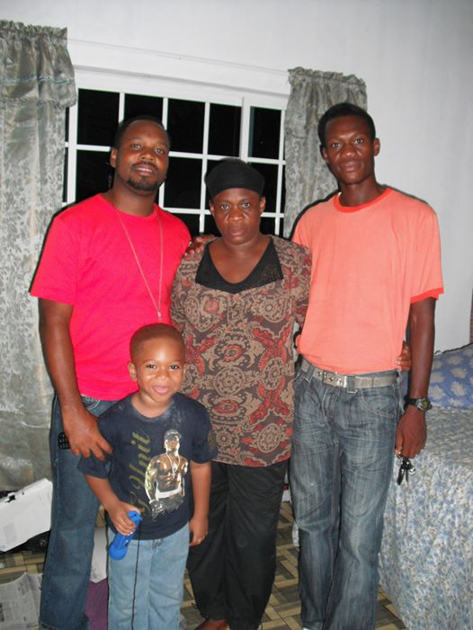

3Hilary Nembhard, Brian Dujon and 1 other
15 Comments22 Shares

Share
8 years ago

Mervelee Ratty Nembhard is with Theresa May and 7 others.
June 19, 2011 at 2:14 PM ·
Wishing my 2 SONS special Father's Day wishes on this momentus day in Ur lives. XXX Mum Ratty, Children Donte, Adrina Legister & Kevin (JR) Murray.

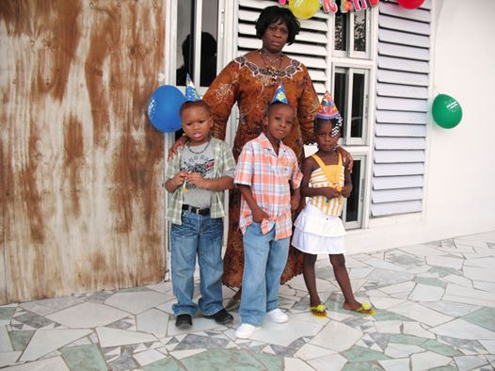

5Karene Salmon, Carmen Lawrence and 3 others
4 Comments8 Shares

Share
Friends Made On This Day



Message
Roy Nembhard1 year ago today
MEMORIES YOU MAY HAVE MISSED



Valdin Legister is with Naheel Julene Brown Legister and Mervelee Ratty Nembhard.
June 16, 2016 at 9:53 PM · Town Head, Jamaica ·
Young General at them........

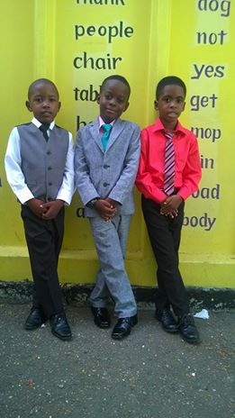

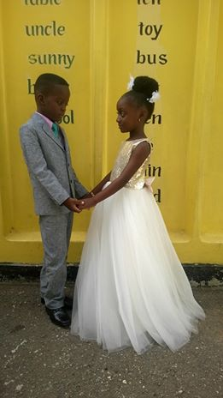






+2

90Kevin Murray, Toya Nembhard and 88 others
13 Comments1 Share

Share

Mervelee Ratty Nembhard is feeling blessed with Mertie Bernard at Bermondsey.
June 13, 2018 at 12:52 PM · London ·
Can LEYF Nurseries read the caption on the t-shirt? Maybe they would like to inform the Employment Tribunal how I come by it? That's why I am not bothered about anyone's preconceived notions about #MerveleeMyers. If you have problems with me, time to sort out your bloodklaat head. I am firmly back to where I was after saying goodbye to my family and friends in Jamaica on Mertie Bernard birthday in July 2014.

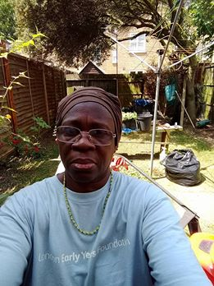

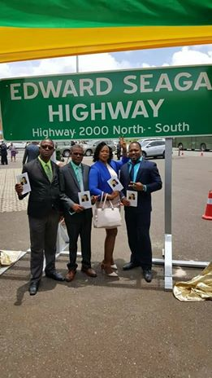

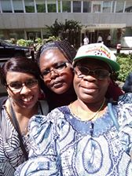



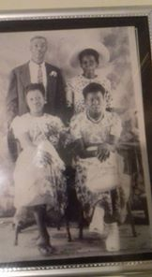
+7

1Kevin Murray

Share
Thanks for coming!

