Engagement Agreement with Winsome Duncan in Facebook Memories 10 May 2019
We hope you enjoy looking back on your memories on Facebook, from the most recent memories to those long ago.

2011 - 2019
Naheel, Myrna and 32 others
2 places
ON THIS DAY
1 year ago



Mervelee Ratty Nembhard is feeling motivated in London, United Kingdom.
May 10, 2018 at 6:32 PM ·
When am in a hurry and the computer deciding to drip, drip along. Satan is at work, with temptations. Mi say, mi nah #cuss2day. So let mi get ready fi choir practice. By the time I walk to Peckham Rye Lane Chapel my head must clear of temptations? Ok, I might walk pass BIB LEYF Nurseries for the fun of it, Satan is putting ideas in my head? Put I am only into paying lip service to the bastards and bitches.

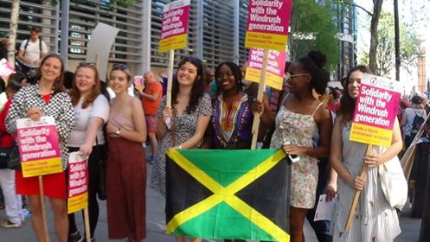

Share
1 year ago

Mervelee Ratty Nembhard
May 10, 2018 at 10:47 AM ·
I am going pre road now. Tomorrow will be the start of a busy weekend.

Share
1 year ago

Mervelee Ratty Nembhard is feeling blessed with Valdin Legister and 5 others in London, United Kingdom.
May 10, 2018 at 10:43 AM ·
Taurus: Group activities bring you lots of contentment and happiness. It's time to reconnect with your favourite people. Lately, you've been concentrating on career concerns. Now the pressures of work are easing and you can take things easy.
Evaluation: I am slowly taking my time sorting my head out. LEYF Nurseriesand cohorts have mess my life up from the time I get back from burying my Mother.
It's time to move on.... I will find it hard to have certain people back in my life and be comfortable opening up to them. I have been disrespected, hurt and disappointed by some of the people who I expect to be there for me. I can no longer take chances.
I am always fear #rejection and that's why I refuse to have expectations. I am grateful for those who have been there through thick and thin. But most of all I am thankful for the people God is bringing into my life to support me in reaching my potential and purpose.
The next couple of weeks will be the most crucial for me on my transition, approaching the big 60s.
I am on a mission with my Fight4justice to change the world for my #granddaughter_AdrinaLegister. I know she has inherited much from her Miserable Cantankerous Granny Ratty Nembhard. But it's part of the DNA.

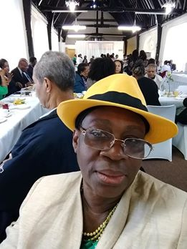

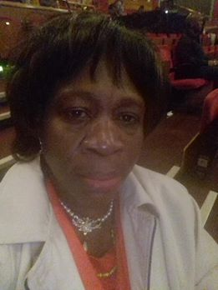

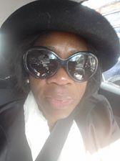

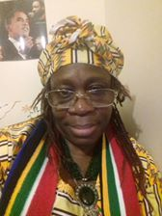

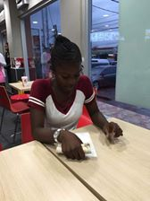
+2

2 Comments

Share
1 year ago

Mervelee Ratty Nembhard is in London, United Kingdom.
May 10, 2018 at 9:38 AM ·
Taurus: Group activities bring you lots of contentment and happiness. It's time to reconnect with your favourite people. Lately, you've been concentrating on career concerns. Now the pressures of work are easing and you can take things easy.
Evaluation: Where my life is in a #nutshell.

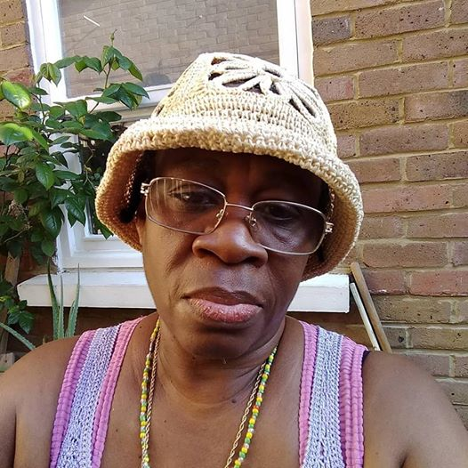

3Jomeo Mcarthur, Karl Ackbersingh and 1 other
1 Comment

Share
2 years ago

Mervelee Ratty Nembhard
May 10, 2017 at 4:23 PM ·
My Public Speaking at GoodAz Gold Events CIC at #brixtonhub. The journey has begun. It's Only Just Beginning the Heartache is Not Over... Gotta Lots of Love to Share...
Play
-0:23
Additional Visual Settings
Click to enlarge
Unmute

4Sarah Allen, Karl Ackbersingh and 2 others
1 Comment39 Views

Share
2 years ago

Mervelee Ratty Nembhard is celebrating victory with Valdin Legister and 4 others in London, United Kingdom.
May 10, 2017 at 3:57 PM ·
I coming in from shopping and meet my neighbour been taken home by the London Ambulance Service NHS Trust. So this young man was so caring... He said to me "You Must Help Your Neighbours..."
So we get in a conversation, was very interesting indeed. Then he asks the question and answer with #NIGERIA.
I laugh saying I know that is exactly what you are going to say. Turn out he's from Somalia, so we have this conversation about Christianity & Muslim Religion.
He leaves me saying now you know about the Muslim Religion and I am positive that Religion based on the Bible & other Books are down to interpretation...?
Now I cook and have the rest of the evening for myself.
I owe a Duty of Care to my #Husband, I'm responsible for helping my #Family_Friends if they are in need... But I owe it to myself to love and cherish myself and be the best that I become. I don't have much time in which to do it, so let me get on with the job. Employers have robbed me of so many opportunities that I no longer want to be merely an Employee, unless I'm accountable to #MERVELEEMYERS.

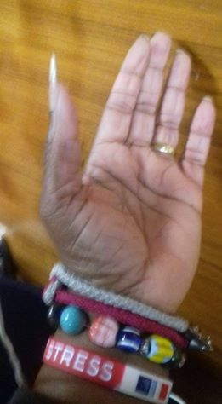

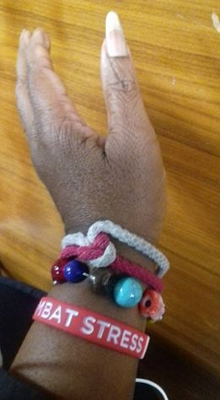

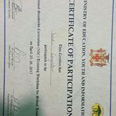



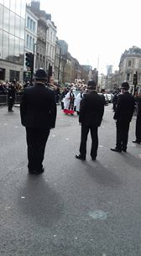
+3

2Barbara Cooper and 1 other
1 Comment

Share
2 years ago



Arian Murray was celebrating Teachers' Day with Kevin Murray and 9 others.
May 10, 2017 at 2:48 PM ·
HAPPY TEACHERS' DAY to all the teachers in Jamaica. #DuhaneyParkPrimary #MerlGroveHighSchool_forgirls
For my kids #GordonPenEarlychildhood #ElthamParkprimary#TownheadPrimary.
And of course ;#ManningsHighSchool #SavannalamarPrimary

11You, Valdin Legister, Delores Russell and 8 others
3 Comments

Share
2 years ago

Mervelee Ratty Nembhard is feeling inspired with Valdin Legister and 8 others at Old Kent Road.
May 10, 2017 at 9:53 AM · London ·
My #AfricanSister just click from the moment we met. I allow GOD to direct me and read the #Horoscope. Check the lady... #UZOAMAKA who is a #PerformancePoet & #WINSOMEDUNCAN - www.peachespublications.com. I am only able small cog in the machine with my Fight4justice campaign. But I intend to be an #Author
20 years after my @LambethCollege tutors advice me to go to university and #WRITE! I done @OpenUniversity, but was too busy being the #Employee to do anything than facing #DISCRIMINATION owing to my #Disabilitities.
Play
-2:46
Additional Visual Settings
Click to enlarge
Unmute

3Arian Murray, Mervelee Ratty Nembhard and 1 other
5 Comments

Share
2 years ago

Mervelee Ratty Nembhard is feeling motivated at Old Kent Road.
May 10, 2017 at 9:11 AM · London ·
I just looked through my Facebook memories and is overcome... Because everything from what I went through from arriving in the UK before leaving JA from my #2Son Valdin Legister wedding is coming back to me.
I told everyone I can't deal with #Rejections, but #ReversePsychology was used to totally rip me apart.
I am happy for the people who have come into my life resulting from the journey of #DISCRIMINATION that LEYF Nurseries put me through because of my #Disabilitities.
That's why I am making my Fight4justice campaign tell my stories in this #MentalHealth_Awareness week.
Play
-2:08
Additional Visual Settings
Click to enlarge
Unmute

2Nicholas Nnamdi Okwulu and 1 other
6 Comments3 Shares

Share
2 years ago

Mervelee Ratty Nembhard is feeling relaxed.
May 10, 2017 at 12:45 AM · London ·
My first #PublicSpeaking forum. Watch out world?
Play
-0:45
Additional Visual Settings
Click to enlarge
Unmute

23Kevin Nembhard, Sarah Allen and 21 others
33 Comments1 Share

Share
3 years ago



‎Myrna Nembhard‎ to Mervelee Ratty Nembhard
May 10, 2016 at 1:10 PM ·
RATTY, GOT A GIFT AT ÇHURCH, BEING THE ELDEST MOTHER PRESENT. IT IS A MOTHERS-DAY-PRESENT.

1Mervelee Ratty Nembhard

Share
3 years ago

Mervelee Ratty Nembhard
May 10, 2016 at 12:06 PM ·
Watch this space, but u can find out so much about my colleague with the 3 Degrees at YouTube

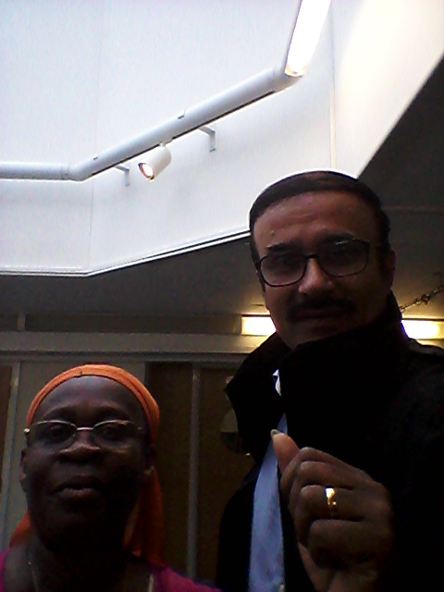

1Danny Dennisor
1 Share

Share
3 years ago

Mervelee Ratty Nembhard
May 10, 2016 at 11:08 AM ·
Finish TA course. Thanks to my tutor Danielle Williams from HCT who motivated me & help me to start regaining my self esteem & self confidence again. The wonderful colleagues from diverse ethnic & multicultural mix who accepted me for who I am - Mervelee Myers. Have to give special mention to Darren Spencer - he of the understanding Yardie Culture. The 2 Blokes of Asian origin who boasted my confidence. One has 3 Degrees & the other a Teacher.
We are at TA for various reasons.

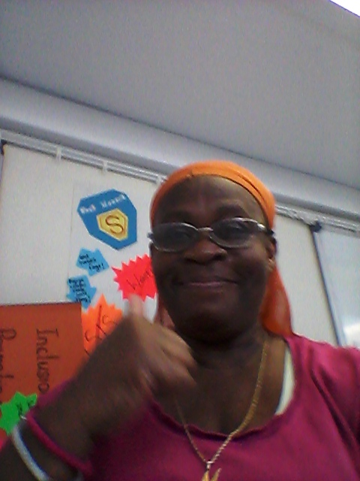

1Mervelee Ratty Nembhard
2 Comments

Share
4 years ago

Mervelee Ratty Nembhard
May 10, 2015 at 10:24 PM · London ·
Is Anthony Dujohn by any chance Jah-Who & Blossom Deon?

2 Comments

Share
4 years ago

Mervelee Ratty Nembhard
May 10, 2015 at 10:20 PM ·
Any1 remember when WE used to go to SCHOOL? No1 could never mess with US, cause WE were blessed with BRAINS. I've just finished my 31 Pages Write up, a what dem College Grads call it - Dessertations? Well in my Old Age, I have to go do my Research that they Paying me 4 to Defend my Blessed Good Name & Character? All they can say about me is "RATTY DON'T TEK CRAP FROM NO 1" Niether he, she nor the old lady - I chat & I done & if U need help, I help. That is 1 of the NEMBHARD Virtues. WE got everything from OUR Mothers...? Happy Mother's Day to my Sister Joyo Mertie Bernard. XXX Ratty

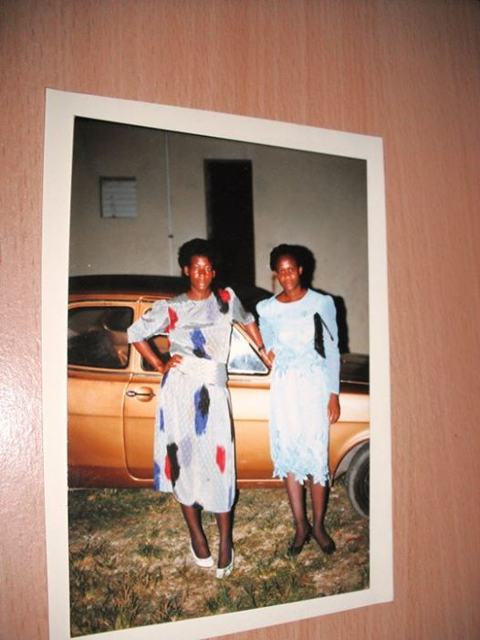

Mervelee Ratty Nembhard is with LEYF Nurseries and Employment Appeal Tribunal.
July 2, 2011 at 9:36 PM
History repeats itself 4 ME & JOY - Burnt Savannah Church of God Rally

4Clover Taylor, Narvel Stewart and 2 others
1 Comment

Share
4 years ago

Mervelee Ratty Nembhard
May 10, 2015 at 10:07 PM ·
Lori Reid Taurus April 21 - May 21 You've been busy and working hard to meet ever-growing demands. But from TUESDAY, the intensity eases, so you can draw breath and take LIFE at a gentler pace. Your focus then is on MONEY - trust your Instincts in all Financial Dealings, but SAVE rather than Splash the Cash. News, views and Social Affairs look Brighter. Romantically, you're Enchanted. Saturday's Fascinating Encounter Sparks a Rapport that Unites Hearts and Minds.
After the Year I've had so far to date, I hope Satan & his Evil Foes can tek themselves to France out of my Life & let me Live rather than Exists? Haven't had any time to Focus on the Precious things that are Important to me since 05.01.20015. So hopefully I'll get to celebrate my BD & my 1st Wedding Anniversary as Mrs TOMLINSON...?
And as fi dat Lickle Feisty Gal, who a Bun up harself under UV lamp fi ketch mi Colour, she cawn guh tuh Spain from mi. Well Unuh say mi feh stop Cuss Bad Wuds...? Suh mi a Drop it Like mi PAPA!! If mi Laugh mi Kin ova & P......P... P...M... Foot! Ratty a get back har Mojo!

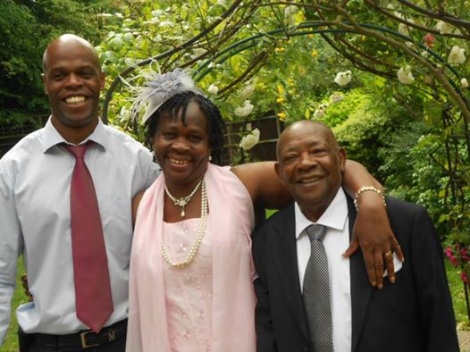

Mervelee Ratty Nembhard is with Voice: The Union for Education Professionals and 6 others.
May 21, 2014 ·

5Narvel Stewart, Fitzroy Scott and 3 others

Share
4 years ago

Mervelee Ratty Nembhard
May 10, 2015 at 9:45 PM ·
Ta a lot 4 the MOTHER's Day shouts from all U Folks who send them behind the Curtains. U know Urselves & I appreciate every single one. XXX Ratty, Ermine, MERVELEE, whatever name U know me by I am the same 1 ole Miserable me. Mother to #1KevinMurray & #2ValdinLegister. Proud of my #4GrandChildren 2. Happy MOTHER'S DAY to the World.

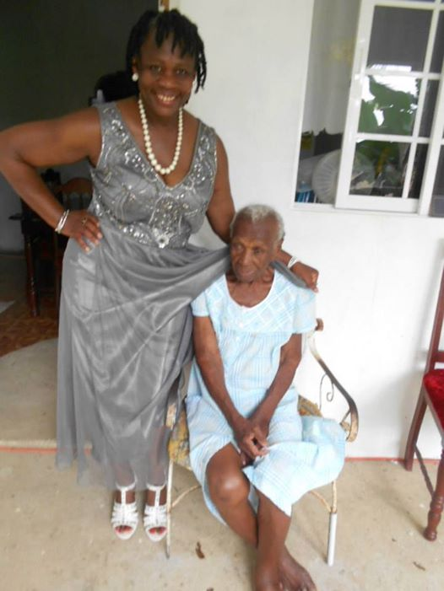

27Arian Murray, Summer Uplifting Brown and 25 others
3 Comments1 Share

Share
4 years ago



Kevin Murray
May 10, 2015 at 5:40 PM ·
Happy Mother's Day to all the women out there who contributed in raising and nurturing a child.
Happy Mother's Day to the woman who gave birth to me almost 39 yrs ago. Her birth name is Mervelee Nembhard, Facebook's name is Ermine Tomlinson aka Ratty. Thank you for giving me the gift of life and for me to have my own family.
Happy Mother's Day to my wife and mother to my child, Donnett Lee-Murray. Thank you for the wonderful job you have done and continue to do, especially over the past year as I try to launch into the field of politics.

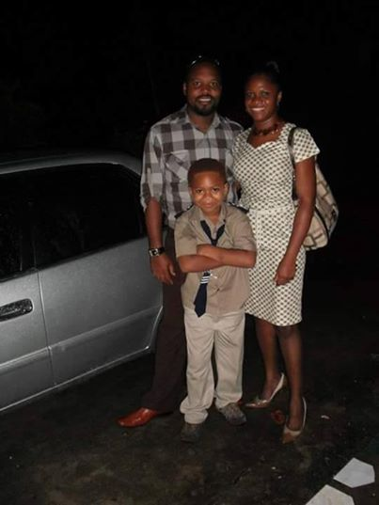

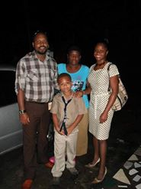

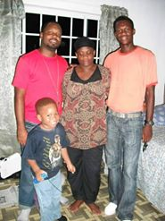

20You, Hyacinth Legister Gordon, Latoya Nembhard-Samuels and 17 others
2 Comments1 Share

Share
4 years ago



Valdin Legister added a new photo — with Kevin Murray and 4 others.
May 10, 2015 at 4:10 PM ·

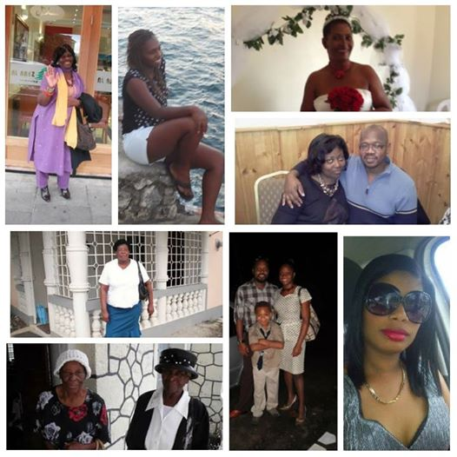

52You, Kevin Murray, Andrea Nembhard and 49 others
7 Comments1 Share

Share
4 years ago

Mervelee Ratty Nembhard is with Robert Meggo.
May 10, 2015 at 10:34 AM ·
I was looking at the pic, but wasn't sure of the name...? So thanks 4 the link Robert Meggo! I will tag U in some photos as soon as I find sum THYME & even skellion & onion wid a lickle Country Pepper thrown in! XXX Ratty



1Fitzroy Scott

Share
4 years ago

Mervelee Ratty Nembhard is with Valdin Legister and 13 others.
May 10, 2015 at 10:14 AM ·
Happy BD 2 my Elder Great Grand Nephew Gregory Worl Boss Samuels! U have the Honour of being bestowed with a 1st in my NEMBHARD Family. WE are blessed coming out of that little enclave of TOWNHEAD Westmoreland. U are from a Line of Stalwarts of whom U can be Proud my Nephew. So as U celebrate Ur Special Day take time out of Ur day to give Thanks... 1 day I'll fulfil my Promise to write that Story about more of those Folks from Townhead & the local Communities who have put US on the World Stage - I am sure the name Ms Lynne & Mass Roland Henry, the Kerr & Nembhard are only just a few in the Line up>>> Have a blessed day Gregory & I know U'll be having a blast celebrating Ur BD on this Mother's Day! XXX auntie Ratty & the Clans.

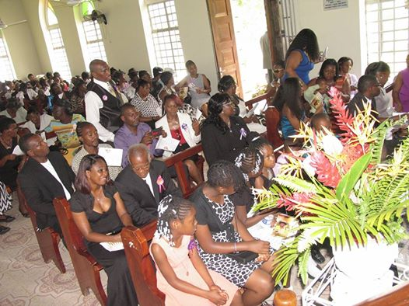

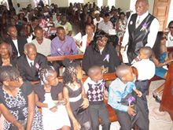

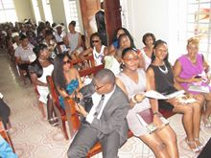

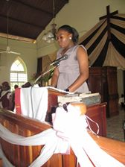

12Arian Murray, Ermine Bailey and 10 others
18 Comments1 Share

Share
4 years ago

Arian Murray added a new photo — with Marcia Murray Royaland 39 others.
May 10, 2015 at 6:20 AM ·



15Jean Haughton and 14 others
17 Comments4 Shares

Share
5 years ago

Mervelee Ratty Nembhard
May 10, 2014 at 4:01 PM ·
Belief Kill & Cure - Was going to the market & nearly slipped on a pod of peas! Not a Banana Skin mind U! Luckily I am fit so kept my balance? Opened the umbrella to dry out after I got back>>> & Tom asked if I didn't know that I am not supposed to open umbrella in the house? Told Tom it is Old Wives Tale, however I escaped from some broken body parts in my nearly 60th years on this earth! Lets see if I'll survive the OWT syndrome until my BD & WD? If MDG ants will carry news come tell me as me granny GanGan used to say!

1Karene Salmon
1 Comment

Share
5 years ago

Mervelee Ratty Nembhard
May 10, 2014 at 3:43 PM ·
1 of the little mite in this photo is my 1st Grand Nephew & he is celebrating his Birthday 2day! Recalled 1 of my visits back home & on my usual ToD at TPS. I walked into Grade 1 class with Ms Plummer the teacher & this little fellow stood up in front of the class & proclaimed to every1 - "Teacher is me auntie dat..." I have not seen the little mite for ages but it seemed little Gregory had still remembered his DOGA! Nuff respect me dear GN Gregory Worl Boss Samuels & I hope U are having the sort of BD U wishing 4? XXX auntie Ratty Nembhard!

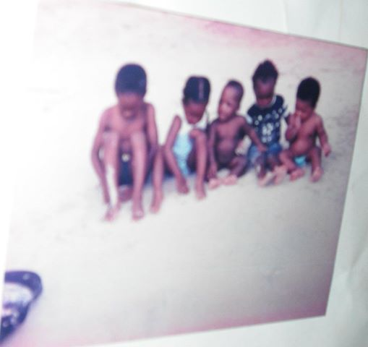

Mervelee Ratty Nembhard is in Jamaica.
June 30, 2012 at 9:56 PM
The Young 1's

4Eileen Besley, Paula Samuels-Bayne and 2 others
3 Comments1 Share

Share
6 years ago



‎Orville Murray‎ to Mervelee Ratty Nembhard
May 10, 2013 at 6:59 AM ·
Play
-4:02
Additional Visual Settings
Click to enlarge
Unmute
Orville Murray
May 10, 2013 at 6:31 AM ·
iMovie

Share
7 years ago

Mervelee Ratty Nembhard
May 10, 2012 at 11:09 PM · London ·
Off 2 Bed... Growing Mellow wid AGING!!! It takes ADVERSITY 4 Moi 2 know dah Pains of dah 1's who are always EXALTING demselves at dah Expense of US dah Lowly Commoners... Sleep well Moi Peeps!!!

1Fitzroy Scott
1 Comment

Share
7 years ago

Mervelee Ratty Nembhard
May 10, 2012 at 9:21 PM · London ·
Saw 1 H/L in dah Sun Newpaper dis morn... Caan mek Head not Tail of it!!! Apparently sum breda claim Messi call him a Negro...? Moi nebba hab on har yai glass so Moi nuh sure if dah breda Black, White, Pink, Orange or Yellaw...? Wonder wat dah World is cuming 2 if U caan say it as it is...?

3Annette May Kellner, Fitzroy Scott and 1 other
4 Comments

Share
8 years ago

Mervelee Ratty Nembhard
May 10, 2011 at 9:00 PM ·
There are some things in life over which One has no control... These days I just go with the flow. If 1 wants me to be a ROBOT I can flipping heck be a Robot for sure...

1 Share

Share
Friends Made On This Day

Happy Friendversary With Sonia Powell
Mervelee, we believe that friendships are something special. You became friends on Facebook with Sonia 2 years ago. We found this memory and hope you enjoy looking back!

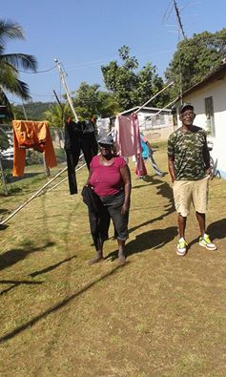

Only you can see this unless you share it
Share
You also became friends on Facebook with Anjalieka and 2 other people on this day.



Message
Anjalieka Brown1 year ago today



Message
Vanessa Rodriguez2 years ago today



Message
Charlie Dixon2 years ago today
RECAPS
Your April

Your April Moments
Mervelee, we made you a video to look back on some of your posts from April. We hope you enjoy it!
Pause
-0:28
Additional Visual Settings
Enter Watch And ScrollEnter Fullscreen
Unmute
Only you can see this unless you share it
Edit
Share
That's all for today

