KD Murray 40 Years 9.8.2016
It is my first son’s 40th Birthday and I am lying in bed unable to sleep as the memories are just repeating themselves in my head, so I think it’s best to do what I do best and document them. It’s hard to know where to begin so I will just write at random and hope whatever I write will make sense to my son as I celebrate 40 years of being as MOTHER. I was/am a carefree Tom Boy who was happy growing up with my extended family in a male dominated household until about the age of 10 years old when my life was destined to change dramatically for no reasons that I could understand at the time. My home in GaGa Street was opened and welcome to everyone because of the Parents I was blessed with from God.
My Parents were Godmother and father to a multitudes of children from across the local communities of Westmoreland, because of the persons they were. They were the no nonsense couple who were role models for everyone. They were held in high esteem in the community where my Parents called home. So now it’s understandable that some things are linked to one’s DNA, because Kevin is so like my FATHER in so many ways. When Kevin was born his Father claimed he looked like my Father. No one had a bad word to say about Ms Lou and Mass Ivan, but instead you would hear stories about the exemplary lives of my Parents from those in the know. However the story about my Parents that I am most impressed with is told by Henry aka Granty Salabie.
Granty said he literally lived at our house because his Mother Ms Ethlyn Grant admired how my Parents raised their children and considered that was the way she wanted Granty to be brought up too. Ms Ethlyn could not give Granty the stability she thought he deserved because of her situation and realised he could get it at my Parent’s home. Therefore when we moved to GaGa Street from near the Townhead Cross Roads, Granty was a permanent fixture at our home. He and my elder Balis grew up like brothers. Although I do not have lots of memories about where I was born at Townhead, I still retain most of the memories from the first day I moved to GaGa Street to the present. I have been trying to document as much as I can, over the past years especially since I came across some challenging experiences in the UK.
I must confess that matter became even more toxic and I have been diverted over the past 2 years to defending myself from the onslaughts of some unscrupulous persons in a corrupt SYSTEM. Because of what the former employers at London Early Years Foundation done to me after I transferred from Luton Street, Edgeware Road North West London to Bird In Bush Southwark. I am still burdened down with clearing my name and restoring my ruined character 2 years after the death of my MOTHER. The thing that hurt me the most is the fact that I was experiencing another bereavement and can’t help wondering why these unfortunate matters only seem to happen to me in South London.
First it happened at Kings Day Nursery Mapother House, Kings College Hospital NHS Foundation Trust. Southwark Council was responsible for starting the campaign of a “witch hunt” that destroyed my career, when I asked for support during my studies with the Open University. Currently I am out of WORK and “struggling with Mental Health Issues” because of another employer. Once more my life is measured by the way I am treated unfairly by others because I do not conform to their stereotypical prejudiced views of the person they expected me to be, to fit their agenda of destruction via DISCRIMINATION. I have been studying people and situations from I was thrown into a life that I thought was different from everyone else I knew from the age of 10 years old.
My Parents were avid and devoted Christians, my Dad more so than my Mum I believe. My Dad lived his life to the Bible’s 10 commandments and more, and I am positive to this day that I became a rebel because my Father’s God allowed him and his family to suffer. This was despite Dad living his life to the Christian principles of his God and the heroes in the Bible. My Mother was the total opposite of Dad in every respects of the world, but I remember Dad went to work and Mama spend the money to run the household. Mama’s management of the family finances was second to none. I guess Mama got her “entrepreneurial skills from being the Banker of the Pardoners” that she ran for decades at home. That’s the primary reasons that I knew the names of so many people from the local communities.
At sometimes or other they would end up at my home either to pay or collect their pardoner draws. Therefore I would know the children, cousins, friends, etc of the persons who were in Mama’s pardoner. I used to collect the money and have to know whose money I collected to tell Mama. And after a time I have no need to ask for a name to write down, it became second nature to know who represented whom. Mama had a strange way of working out the pardoner draws on the calendar and up to the time when I left home her methods of money managements never let her down. Our home was the hub of the community during the time of Phantom Park. So again there is another reasons for me knowing who is who that played sports at Phantom Park back in the days.
Those were the eras when Westmoreland produced some of the best sports personalities as part of the Social Development Commission initiatives. Although I was not a part of the Glory Team that represented Westmoreland at competitions like my brothers, I was otherwise involved. In later years, when my breda Ashter became the Councillor for the Friendship Division of the Westmoreland Parish Council, I was responsible for taking on the Secretarial Role. I started helping him with the writing when he ventured into Politics before he was elected as a Councillor. All he needed to do was tell me what he needs doing and I would write the letters, no need for any editing.
As a child, the first book my Dad brought me was a copy of the Holy Bible and I guess I learned to read after I worked out how to spell my name because of being ridiculed at Sunday School by the bigger girls. It was not my luck, but I just did not seem able to get on with girls like I did with the boys! Because of my Dad preaching as he knew the Bible back to front and could quote the passages from his preaching without hesitations, I know he had a good memory for facts. I guess I inherited more than his Parkinson Disease in many respects as I have a good memory and recall of things I learned or hear. I have to compensate for my Hidden Disabilities I supposed by having a good memory to recall events and stories.
In addition to the Bible I graduated to reading fiction and nonfiction books. Reading for me was an escape from some of the harsh realities of life. I remember distinctly sharing books with Linval Darney aka Ghost Jones other boys who was just friends and like to read as much as I did. Then there were the real life lessons about the Birds and the Bees from my second son’s Dad, but that is another story in itself. I guess I ended up wishing for the kind of happy ever after endings I read about in some of the books, but it never was to be. As I said I was a Tom Boy for most of my life, through the good and bad experiences. My Mum was my “NEMESIS for no reasons that I can say why at the time”, but now I can realise she was trying to protect me.
The least thing I do back then my Mum would give me a beating. She never forget anything and saved up the beatings and give double, so I might as well take it one at a time. My breda Dostan would beg for me when Mama decided to put on the beatings, so she would find her ways around that as well. I could get away with murder from my Father and could outrun him, once I got the head start to be away quickly. Once I manage to run away, I know he’d forget about it, but not Mama. My Dad beat me one and only time for “Cussing Bad Wuds and when he died he dreamt my elder breda Balis about the Bad Wuds Cussing in the yard. Believe me I tried not to curse from then, but if I stub my toes I find myself cussing as that seem to take away the pains.
But my cussing is done under my breath until I get really MAD. I once had this massive temper where anything within hand reach would come sailing. I have had a few such moments to the point where I was reported by my son’s Dad. I don’t know when I decided not to become physical and be verbal instead. But each time I spoke to my son’s Dad he reminded me of the antics I got up to with him. I have since heard other stories that made me realised it was a good thing I curbed that physical aspects of my MADNESS or London Early Years Foundation would have gotten away with making me into that Monster Criminal they set out to do from October 2014 to date. But I will not allow them to get away with murder like KINGS and the STSTEMS done to me before. I know without a doubt who I am and will not become the person they want me to be to fit their agenda.
Mama decided to cut my Tom Boy days short the day she realised I started my Period and I doubt she even realised I entered puberty before that. The strangest thing is this happened after yet another beatings from Mama, so I naturally thought I received a cut from the “fan belt”. When Mama realised what was happening, she put the fear of MEN in me by what she said next. Mama’s warning of “Mark hoe nuh mek no man touch you” was taken literally to mean exactly what Mama told me. Sometimes I have to laugh when I hear these programmes or read and realised I was not the first to have those kinds of experiences because of lack of knowledge by the women folks about teaching their daughters about the facts of life.
So who me, no man was going to touch me, because I did not want to know what was going to happen, after the terse warnings I got from Mama. I rebelled however when Mama tried to stop me being a Tom Boy. Mama was no good at explaining things to me and when I asked her any questions her only answers were “if you nuh know, you soon find out”, yet when I found it she was not always pleased with my discoveries. On reflections I realised that Mama was not taught about life as the female of the species and was not equipped to deal with her daughter’s transitions as a female. Hence one of the reasons I missed having a sister. I know having a big sister would have helped me over the transitional developmental stages of being a girl.
Somehow when I got pregnant I never wished for a girl but a boy and I don’t know if that was strange or part of my experiences. I always said God gave me 2 boys because I don’t know how to deal with girls. With Dad’s illness early onset Parkinson Disease, my life was to change dramatically. I was confused, different and the only outsider who was finding it difficult to fit in. I had grown my full height by the time I was 12 years and one of the tallest girl at Secondary School. I could hold my own with the others because I was always “bright from Primary School”, but everything else was complicated. I felt excluded and was always trying to fit in, and I can remember noticing the differences between me and the girls once I started Secondary School.
I must have been the only girl at school not wearing bras. But my breda Texchus came to the rescue advising Mum to buy bras for me. Somehow growing up with my bredas gave me the confidence to feel more comfortable amongst the boys for some reasons I still don’t understand. I always admire the boys who were my friends and there were some boys who I know I could only be friends with from I was growing up. Listed amongst my boyfriends were Byron Campbell, Bunny Lawrence, Sainty aka Mutt Johnson, Barkey Dixon, Darney Jones, Michael Legister, Lloyd Mercy, Dave Sweeney, Owen McDonald and Steadman Gopaul. We became friends from Primary to Secondary Schools. Some of the friendships fell by the wayside whilst others lasted for a lifetime.
The only one I fall in love with is my second son’s Father. I guess I had no other alternatives but to love him because he took me under his wings. He taught me about the Birds and the Bees and we were first friends before we were lovers. At this stage where I am in my life, I would not think of him other than being a friend, my first LOVE and the Best Father to my son Valdin Legister. I know we are not even as close as we once were and I guess it’s best for all concerned to keep it this way. Some of my other friends have passed on and others have drifted apart. Whenever I go home I still stop to have a chat and a laugh with those I see around the place.
So now I should try and concentrate on the story about my first son as he celebrates the milestone of achieving 40 years of life. I was/is a secretive person in many respects, and will reveal enough of what I want anyone to know about me and my life. I believe “a secret is only a secret” if no one except knows of its existence. Once you reveal that secret to anyone other than yourself it’s no longer a secret. So people can speculate as much as they want, if I don’t want to share my secret, I will keep it to myself. My Mum used to raise eternal hell whenever she sees me chatting to my boyfriends. It was even worse once the day changed to “dusk up” and she sees them lurking about. Mama used to have a good hand at “dashing water” at my friends, but the nagging was worse.
I never paid Mama too much mind however because I was not that way inclined towards any of the boys. And I am sure the boys never let Mama’s nagging bother them and I can swear for Lloyd Mercy in particular. We have a relationship that lasted from our school days to him being in the Army – Jamaica Defence Force. I used to view people from their statuses in life because of my Mum’s views about life. Mama was somehow insecure about her “poverty stricken status” and passed that insecurity unto me. I remember the days I used to say to Lloyd Mercy I don’t think your Mother would like me. He in turn tried to tell what a nice lady his Mum was. I only found out years later that he was right and not to judge people without knowing the facts.
But it is only natural that eventually the time would come when some boys would ignite the “fire in me” and I think and know I was head over heels in love. But it did not last as luck would have it, my brand of being plain at speaking the truths did not always sit well with everyone. Somehow, I find myself at the losing end most of the times because others fail to believe me when I speak the truth. The relationship I started did not last and I experienced rejections when no one believed my versions of events. But I was to face further rejections when the one person I thought I knew rejected me also. So I got involved with another Lloyd M., but no one ever saw us together. Remember I told you I can be secretive when I want to be.
With my Mother’s words of “when you breed don’t bring it in here” and you not staying in here, echoing in my head, I told the Young Man about it. Oh no, I have nothing to worry about because the Young Man convinced me I could not get pregnant with his methods of having sex. I fall for his words “hook line and sinker” because I expected him to know about the Bird and the Bees like my first love. On reflections I blame lots of things that happened on lack of knowledge on the parts of everyone who assumed like my Mum, “if you don’t know, you soon find out”. But I was not amused months later when I missed my period. The long and short of the story I was set for an abortion, after I visited the doctor in Grange Hill and told him what the Young Man said.
I remember the visit to this day because of the way the doctor wind me up saying “your Father is going to kill you now” after he done the test. The doctor told me to ask the Young Man to come and speak to him. Young Man chose Cricket over me and asked me to take his friend Bryan Crosses to talk to the doctor. Knowing the lay of the land and not wanting my name to be “Headline News” I refused to go with the Young Man’s friend in my stubbornness. I guess my son owed his life to his Father’s love of Cricket and not wanting to take responsibilities for his actions of getting me pregnant. That can’t be too much of a bad thing either especially when one is young and not that worldly wise.
My fate was sealed when I visited the doctor with my friend Elaine aka Ms C Kerr and told her to tell Mama “the doctor said I have gas”. Only to hear Mama come out with you have gas nuh, wait until the gas born. You always said you wanted to be nurse, so now you will turn nurse for that baby. I could have gone to school like my other peers Patricia Dunkley, only I became nauseous from the very beginning. I would spit like nobody’s business and vomited every day until just before my baby was born. My first love was a source of comfort to me back then, because by this we had sort of patched up our differences. My class teacher Mr Felix Rose thought I was pregnant for my classmate Owen aka Big O McDonald and the rest of the world thought it was Lloyd Mercy.
If there were any other names being raffled I am not aware. However I got the terse warning from the Young Man Master Lloyd Anthony aka Natchie MURRAY that if the child was not his, I would have to mind it by myself. I must confess that I did not have a smooth pregnancy from the outset and thought I was a goner when I fall at the side of the kitchen after the rain, but that baby was in for the long haul. Once Mama’s friend Mr Spence shared the glad tidings of who the Father was to her, I do not have much memory of his role in my life after that. Suffice it to say we are back in contact after the death of my MOTHER in 2014, when I made some discoveries and enquired to make the contacts. I might be learning more about me that I did not understand from him eventually I hope.
I was scared and terrified of what lay ahead after my decision to keep my child and not have the abortion, but I braved it out. I developed “High Blood Pressure” but managed to be in control with the support from the Health Professionals who I remember with such fondness to this day. Nurse Williams, Ms Puncy and Ms Mac were part of the Health Team at the Townhead Clinic. However I experienced further rejections but must admit that I had this “Support Network” of family and friends whom I will always be eternally grateful to for the rest of my life comes what may. Some have passed on before me like my 2 bredas Ashter and Byron, but they will be remembered for the roles they played in mine and my child’s life.
The list included: My sister-in-law Ms Doreen, Ms Bebe Bennette-Walters, Ms Lynnette Walters-Grant, Ms Cee Kerr, Christine McIntosh, Lenieve aka Puny Holiness, Lorrette Cranston and some of the Young Mothers whom I met on visits to the Pre and Antenatal Clinics at Townhead. The trend worth mentioning here is that most of the persons have baby in the same year as Kevin. Although I have forgotten some of the names of the Mothers, I ca still remember some of the children because they are friends of my own 2 sons.
I met Ms Icy Murray for the first time to talk to at the Clinic where she worked at WISCO – Frome. My impression of her is she is one of the nicest, sincerest persons that one could have the privilege to know. I attended the Clinic to extract my first tooth after becoming pregnant, so yet another transitional development that come with pregnancy along with the morning sickness I experienced for 9 months, until just before I gave birth. Mass Ivan was a riot of good fun and laughter that echoes my Dad who is names Ivan as well. So now you know about that lethal Murray/Nembhard combinations that my son Kevin received from both sides of the family.
I guess once my Parents got over the disappointments of me letting them down by getting pregnant in school, they reverted to being the loving parents especially my Dad whose Parkinson Disease had left him worse for wear. When I “took in – went into labour” early one morning on the 9th August 1976, my breda Byron was home for the Independence Holidays. He accompanied me to the hospital with Ms Bebe and my other breda Ashter. As you will notice both are now deceased as are my Parents and Grandmother. Kevin was born the year my Uncle Dudley was murdered in his yard at Palmetto Pen Clarendon. My baby arrived not long after I was admitted to the Savanna-La-Mar Hospital weighing in at 6 pounds. I had to be kept in for observation because I ruptured something or other and my waters broke days earlier.
I am assuming that my water breaking early must have been the results of all the ice I ate throughout my pregnancy? My sister-in-law took me to stay at her home in Truro until I was hard enough to take care of myself and the baby. My Mum was working hard taking care of her family. She was the bread winner and carer for my Dad. 2 years later tragedy struck my family again when my Mum’s only breda was murdered at his home in Bernard Lodge, St Catherine in 1978. I had only met my Uncle Terah a few years before that at Ms Connie’s shop one day after school. I heard stories about my Uncle but never met him before that time. I knew from correspondences that he lived at March Pen Road St Catherine. Grandma Elsie used to visit whenever she went to Town.
After Uncle Terah’s death I think that’s when we have more additions to the family as we linked up with Ms Adassa Hyde, Janet and Grace Uncle Terah’s family in St Catherine. But my Uncle’s death was to have a negative impact on the Family once again. My grandma took her only son’s death to heart and was stricken after will ill health. Mama now have 2 sick persons to care for on top of working to support her Family, but Mama just got on with the job, without ever complaining about the unfairness of life. I don’t know how my Mama done it but she did, with that steely determination of a WOMAN who loved and cared for her Family. God blessed her with the strengths she needed to carry on despite the challenges. My MOTHER was an exceptional person, no doubt about that.
My son was healthy, but for some reasons he was lagging behind in some of his developmental milestones. I didn’t know the answers and I was also dealing with my situations of having “Hidden Disabilities” that affected me when I wanted to come to the forefront. It was painful when people started being unkind, making fun of me and labelling my child. Although as a Mother I know certain facts about my child, I did not have the knowledge to be able to deal with the matter of his developmental milestones of not talking. So I enlisted the help of the professionals, only to be let down big time. I take matters in my own hands when I started sending my child to school. When the teachers decided he was not talking so he should stay home, I acted and told them no he is going to school because I am paying my money.
I am glad I put my foot down now and did not listen to any of the professionals, or my son’s outcome would be so much different today from the one he has achieved. When I took him to see the Ear Nose and Throat (ENT) Specialists at the hospital, she performed what I considered some little gestures. This was to gain his attention, but if she was stick, wood or stone my son did not see her yet and sat on my lap. The verdict was he is “deaf why he is dumb” and I must make arrangements for him to attend the school for the Deaf in Kingston. Well I was not telling no professionals how to do their jobs, but neither would I allow any professionals to tell me my child was DEAF. I might have fallen for any other reasons for his lack of underdevelopment but not DEAFNESS.
I knew my child better than any professionals and he was not DEAF. That child was a performer from he was little like all young children. He would react to the little transistor radio playing by dancing. How did he know to come running when I called him from next door and all the antics I witnessed him getting up to? I took my child home and dealt with the stigma, labelling and the negative narratives that helped to make me feel responsible for the way my child was. But I still did not give up and in the end my perseverance paid off. The nature nurture did kick in and the lack of stimulations on my part because of my own developmental traumas which resulted in his developmental delays were the catalyst that helped my child.
Mixing with his peers at Basic School made the difference in the early intervention strategies he was not getting at home. The day the Health Team visited his school was the day he spoke out for the first time. I was told he has to make his presence felt by climbing on top of the desk. I guess this the same thing I have to be doing now to get the attentions of the former employers and the SYSTEMS that have set out to ruin my life. That’s why I will forever be an advocate in my #FIGHT4JUSTICE campaign against Social Injustices and Inequalities. I am sure the misdiagnosis must still be recorded at the Hospital somehow, if they are anything like the INCOMPETENT Systems in operations that can set out to DISCRIMINATE against an employee for no legitimate reasons.
Both my sons have had their share of DISCRIMINATION thrown at them and having to deal with the realities is not nice for anyone. Kevin D. MURRAY have had his transitional journeys to look back on with pride at his achievements on the date he was born 40 years ago. He overcome delayed communication developmental transitions at Basic School. Went on to have a Primary School education at Townhead Primary where the generations from my Mother down were schooled. He passed his Common Entrance Examinations and attended Mannings High School. Went to Montego Bay Community College and then University of Technology. He has worked in the Banking Industry and now at the Free Zones Montego Bay.
Kevin was married at the age of 19 years old and became a Father at the age of 29 years old. If he was a hoarder like me, I know my other son Valdin Legister is, he would still have that letter I wrote him when he took the plunge and got married. My mantra still remains, I chose no partner for no one and I refuse to interfere in the lives of anyone either. My son has managed to do much better at choosing a partner than I ever will and kept a marriage going longer than I have done. He is my son and I guess I will always be bias about his achievements because of personal experiences. He did not get the best start in life owing to my own deficits. However I was not born with any of the deficits and limitations, but picked them up along life’s transitional journeys.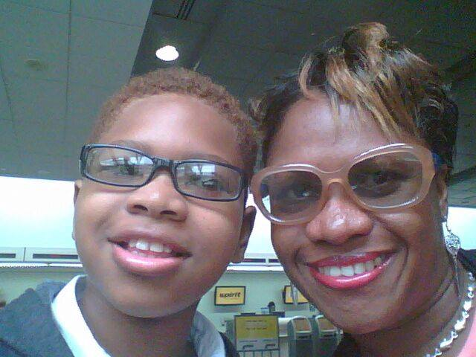
At the same time I am proud of my achievements and I tried compensating my child for the things I know were my responsibilities therefore I felt accountable for giving him that little bit extra. This had nothing to do with the fact that I love either of my children more than the other. The only differences were Kevin MURRAY needed so much more than Valdin LEGISTER and I set out to do my best by both my children. My intentions were misunderstood and misconstrued at one time or the other. However I hope by now there is understandings of the reasons I have to be protective of my first born child. I couldn’t finish this without saying a big thank you to my son’s Auntie Marcia for the support she gave me throughout.
Sometimes I might not always say thank you enough to those persons who supported me no matter how much or little, but I never forget kindness, especially when I was struggling to bring up my children. My second son was always the Mouth Piece for his big breda and I recall the times Ms Icy would tell me that he do all the talking for his breda whenever they come to the house. Although my children were 2 different Fathers, they got treated like Family by both sides – LEGISTER and MURRAY and that meant a great deal to me. I have been in relationships with men other than my children’s Fathers and overall I would consider my children were treated well by these men. They continue to have respectful relationships with them as well.
I guess if they were to choose one person from the lot, I have a feeling I know who would be the recipient. But times have change, some of us moved on and there is no way we can turn the clock back. To be honest I think I LOVE the way my life turned out relationship wise. I am on friendly terms with all those men except for one Sorry Human Being who could only think of getting revenge for something he did not understand. He claims he have his obligations yet he thinks I was going to be gullible to listen to his excuses. He don’t even have the guts to face me, but I am bigger than that. God always work in mysterious ways and although I played the role of a Mother in that mam’s son Teddy Duhaney’s life when he was living at Mass Sim. I was protected from falling pregnant by him. The best thing that could ever have happened to me. Once a coward always a coward like LEYF.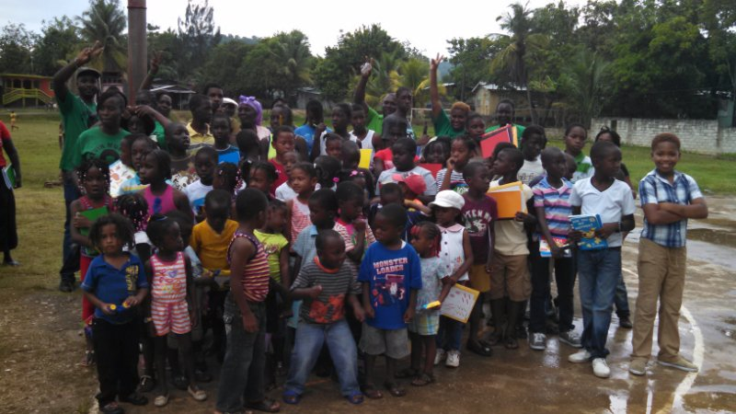
I haven’t spoken to Kevin’s Father in the longest while because I can’t afford to call. He don’t call and have excuses for him not calling, ranging from the real to the impossible. Another thing is I believe Kevin’s Father does not want to move with the times ad get used to the Technology that is the New Motor Bike he had I his heydays. To be honest I don’t recall if I ride on his bike, but I did get a drive in his car once when there was a Strike and I was attending Classes at Mannings. He spotted me waiting at the bus stop and saved me a space in his car.
I thank him for my son and is grateful he helped me to become the person I am today. As for anyone else I hope none of their wives, girlfriends, sweethearts, bit on the sides, etc view me as threats. I am just not interested in them in that way anymore. I have an open mind and one day who knows, I might decide to get up close and personal with someone. To be honest I might have the candidate in mind, but I think I’d better reign in my carnal thoughts for much longer and see what other fishes I can get on my dangling line?
So Kevin D. MURRAY have a happy 40th Birthday. I am as proud of you now as the day you arrived into my life 40 years ago. I am like my MOTHER in a few respects and keep some things hidden away so as not to expose my vulnerability. I wish I could be like Mama and not cry at psychological moments like these. But I am guessing it’s too late now, so I will continue to blubber all over the place if I feel like. 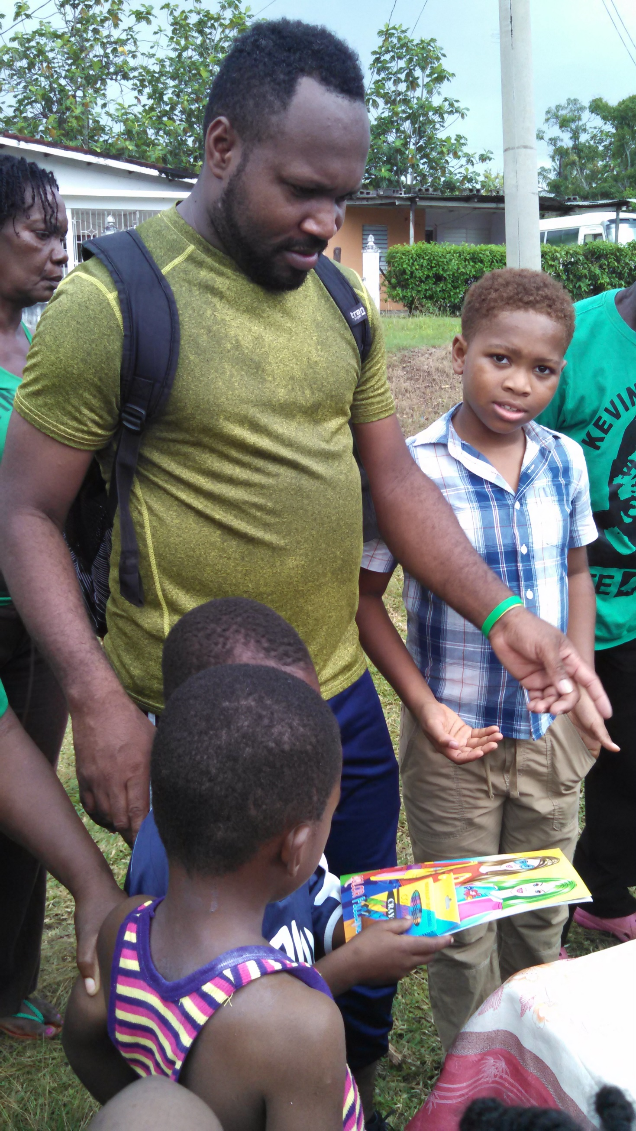 ‘
I am managing my time and wrote this in 6 hours 30 minutes.

