Winsome Duncan Threats 31st October 2017
Since I am still waiting to have that consultations with Joana, I will wait until she has been in touch. In the meantime you can go ahead and do whatever you want to do.
Thanks very much, the Police and Ambulance turned up at my house yesterday. They have seen my husband, who I am carer for. The Police mentioned your name Winsome and keeps telling me to stay away from you. So good luck, I am not sectioned under the Mental Health Act as you expected and never will. London Early Years Foundation (LEYF) did not managed to do it, and neither will you.
But don’t worry I leave you to my GOD, and He will surely be putting out that “Little Light” of yours that you are using to scam people. You are a Terrorist and a CYBER BULLY. You got access to Confidential Information about me via your Illegal Activities of SCAMMING. The net will close in on you soon, don’t worry.
Regards
Mervelee

Sent from Mail for Windows 10

From: Pearl Peaches
Sent: 30 October 2017 03:13
To: Mervelee Myers
Subject: Your book is on its way to you!!!

Dear Mervelee,

A proof copy of your book is on its way to you and will arrive in 7 - 10 working days for your viewing.

Once Joanna has proofed read your book and you have received the final copy, it will be uploaded onto Amazon and this will bring our working relationship to an end.

May I remind you that you have signed an agreement which states in clause 27:

27. In the event of agreement termination both parties will not slander each other on social media, word of mouth or by any other forms of communication.
Currently you are in breech of this. I do want my logo or brand associated with your book due future legal implications. This is your own independent publication. REMOVE any covers with my logo from your social media IMMEDIATELY.

If you continue to slander my name and brand, I will be forced to take the legal route of an injunction out against you. Like others in your past I will not tolerate your verbal abuse and defamatory comments, when all I have done is been supportive of your whole journey even during your meltdowns. The fact that you have disclosed things I've said to you in confidence has broken all trust and future working opportunities. I will make sure you are held accountable and you will be responsible for any more continuation of liable comments in social media.

You need to seek support for your meltdown otherwise you will face being sectioned under the mental health act and i'm sure you don't want to be away from your family.

I hope I've been clear in my communications and you will see I'm being reasonable in completing your independent publications. I have noted your request of not wanting your book changed. Attached is your typeset manuscript.

Regards,

Winsome

an Threats 31st October 2017: Updated - 31/8/2018
#MerveleeMyers response to Winsome Duncan: Author, Artist & Book Confidence Coach. Since I am still waiting to have that #consultations with Joana, I will wait until she has been in touch. In the meantime you can go ahead and do whatever you want to do.
Thanks very much, the Metropolitan Police Service and London Ambulance Service NHS Trust turned up at my house yesterday. They have seen my husband, who I am #carer for. The Police mentioned your name Winsome and keeps telling me to stay away from you. So good luck, I am not #sectioned under the Mental Health Reform Act 2016 as you expected and never will. London Early Years Foundation (LEYF Nurseries - www.leyf.org.uk) did not managed to do it, and neither will you.
But don’t worry I leave you to my GOD, and He will surely be putting out that “Little Light” of yours that you are using to #scam people. You are a #Terrorist and a CYBER BULLY. You got access to Confidential Information about me via your Illegal Activities of SCAMMING. The net will close in on you soon, don’t worry.
Regards
Mervelee
Sent from Mail for Windows 10
From: Pearl Peaches - www.peachespublications.co.uk.
Sent: 30 October 2017 03:13
To: Mervelee Myers
Subject: Your book is on its way to you!!!
Dear Mervelee,
A #proof copy of your book is on its way to you and will arrive in 7 - 10 working days for your viewing.
Anaysis 31/8/2018: How is this possible? Read further down to see how this woman contradicts herself. This is one of the reasons I started having reservations about her during our agreement. At first she was full of praise about my ability to do most of the work on my book. At the time I did not know what caused the changes when she started belittling and undermining me in the fashion of my former employers. It started out with how did you say you use to edit work, your grammer is so bad? I was like what's happening here, and then I started taking stock. Next Winsome wanted me to change my book to one she was dictating to me. I put measures in action to make sure I was adhering to the agreement as you can see from the rest of this email.
Once #JoannaOliver has proofed read your book and you have received the final copy, it will be uploaded onto Amazon.co.uk and this will bring our working relationship to an end.
Analysis 31/8/2018: Maybe when I get to court to get back my money, the judge can explain this to me? She said a proof copy of my book is on its way... So what does she mean by once Joanna has proof read my book...?
May I remind you that you have signed an #agreement which states in clause 27:
27. In the event of agreement termination both parties will not #slander each other on social media, word of mouth or by any other forms of communication.
Currently you are in #breech of this. I do want my #logo or #brand associated with your book due future #legal implications. This is your own independent publication. REMOVE any covers with my logo from your social media IMMEDIATELY.
Analysis 31/8/2018: I will have to go back and read my copy of the agreement to verify this. It's obvious that the Consultant failed to give the Customer a copy of Clause 27 of the agreement. Out of curiosity and thinking out loud, justy wondering if this was added for her by her Employment Solicitor? He is none other than Barrister Ryan Clement http://www.ryanclement.com/, who scammed me out of my husband nine thousand pounds [£9,000.00] to prepare my EAT www.justice.gov.uk/tribunals/employment-appeals/. But God certainly is working in a mysterious way. Because I would have been sold down the drain, the same way that they trying to by www.bwbllp.com to close https://www.facebook/public/Mervelee-Myers.
If you continue to slander my name and brand, I will be forced to take the legal route of an #injunction out against you. Like others in your past I will not tolerate your verbal abuse and #defamatory comments, when all I have done is been supportive of your whole journey even during your #meltdowns. The fact that you have #disclosed things I've said to you in confidence has broken all trust and future working opportunities. I will make sure you are held accountable and you will be responsible for any more continuation of #liablecomments in social media.
Analysis 31/8/2018: The Employment Tribunal is responsible for making me a victim https://www.gov.uk/employment-tribunal-decisions/ms-m-myers-v-london-early-years-foundation-2300047-2016.
You need to seek support for your meltdown otherwise you will face being #sectioned under the mental health act and i'm sure you don't want to be away from your family.
Analysis 31/8/2018: Look no further than www.acas.org.uk/researchpapers for the recommendation to ACAS with Clause 15. But nothing was done. I have had counselling at www.slam-iapt.nhs.uk/southwark and Winsome is/was aware of this. But she is just showing her true colours that she was groomed to be a scammer by Ryan Clement.
I hope I've been clear in my communications and you will see I'm being #reasonable in completing your independent publications. I have noted your request of not wanting your book changed. Attached is your #typeset manuscript. Analysis 31/8/2018: I am willing to face Winsome Duncan in a court of law to trash out this matter. As soon as I am finished with the EAT on the 19th October 2018. I will be emailing Judge Rinder Email judge@itv.com.
Analysis 31/8/2018: Look at the cover of my Book to see who did not adhere to the “Engagement Agreement” signed on the 8th April 2018.
Regards,
Winsome

1 Year Ago
See Your Memorieschevron-right

 Mervelee Ratty Nembhard added 15 new photos.
August 31, 2017 · London ·

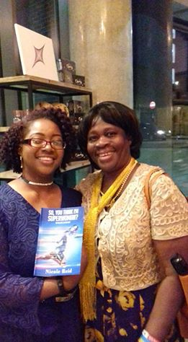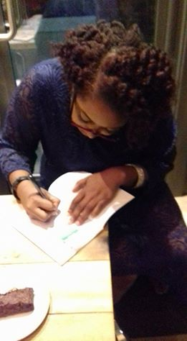
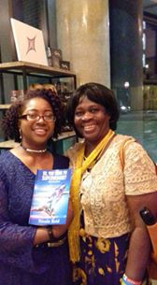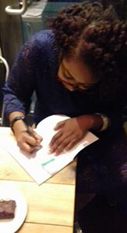
+11

Like. Comment. Share

Comments
Mervelee Ratty Nembhard Is it getting through to Facebook, yet why I am frigging mad at the #indirectdiscrimination from them since November 2016?
Manage

Like. · Reply · 8m
Mervelee Ratty Nembhard What did Facebook do when I reported my concerns about Winsome Duncan: Author, Artist & Book Confidence Coach, removing me as adminstrator on Merveleeconsultancy? Fuck all. But then they have the nerves to keep terrorising me each time some criminals, and trolls went and complained. That's why I am taking a lead from the Daily Express and publish my stories to show how I am using my Fight4justice campaign to show the likes of the Employment tribunals that justice must prevail. Here is the headline on page 6 of the #DailyExpress. "Father slams 'hopeless' Facebook over dead daughter's 'sadist' troll. It's no different from what I have been enduring on Facebook.
Manage

Like. · Reply · 1m
Mervelee Ratty Nembhard Winsome Duncan: Author, Artist & Book Confidence Coach got her ideas to scam me from https://www.gov.uk/employment-tribunal-decisions/ms-m-myer...
Manage

GOV.UK

Ms M Myers v London Early Years Foundation: 2300047/2016

Like
· Reply · Remove Preview · 1m

Write a comment...

 Mervelee Ratty Nembhard. 55 mins ·

Facebook, I am giving you ideas of how to implement and promote community standards. I have been doing this from I was only young, when my Father was struck down with Parkinson's disease. Can you see the child in the photo? That's my son Kevin Murray. He was misdiagnosed with #multipledisabilities. My stories are in cyberspace. That's why I am an advocate of inclusion with my Fight4justice.

@Copyright by Mervelee Myers 31/8/2018.

