Mental Health Issues: Mental Health Act, Disability Legislations, Equality Act 2010/2015
Current and Relevant in the News – Sources: Digital & Print Media, Social Media. My Own Personal Experiences: Publications on Social Media, Work Related Data, Medical Data
Correspondences with the Daily/Sunday Express Newspaper

Dealing with the stigma of Mental Health: Sunday Express Mental Health Crusade
Hi Mr Jeory
I have been following the Mental Health campaign in the Sunday Express over the past weeks with keen interests. This matter is of grave importance to me because of personal experiences I’ve encountered throughout my relatively short life. The reasons I am making contact is to congratulate the team on taking up the fight for people who have been faced with Mental Health issues and do not have any forms of sounding board to air our circumstances and situations in dealing with conditions that are considered as TABOO.
Maybe if I share a brief account of my own personal experiences you will begin to understand why I have become a sceptic of all gift wrapped packages. From an early age I was confronted with the tragedy of witnessing my dad’s decline which lasted for over ten years. He had Parkinson Disease along with some other health conditions. However it was the Parkinson that caused our family the most concerns as it affected every aspects of the family welfare. I can recall the shakes at the beginning, until his total loose of mobility and everything else that is eventually destroyed as a result of the deterioration in his health. As a teenager I began to question my faith, asking why my dad who had lived and served God had to suffer so much. The onus was left on my poor mum to take on the reigns of responsibilities that was once my dad’s as well as her own job as a mother. In the end my mum was faced with caring for my dad and mum who died within a month of each other. My granny eventually succumbed to one of her many strokes.
Imagine my own devastations when I realised my dad’s condition was hereditary, and from an early age I began to get some of the signs and symptoms of Parkinson Disease. To cut a long story short, I immediately have to alter my life, and I know I was prevented from achieving my full potential because of my DNA over which I had no say. Therefore with time I learnt to adapt to my condition and refused to become a VICTIM, and have always been aware of my Limitations. However I recognised I had problems with my family situations and was only able to give it a name DEPRESSION after coming to the UK, and decided to take up studies to improve my prospects of securing gainful employment to make a better life for myself. I always joked about the fact that I managed to pick up all the defects from the both sides of my FAMILY.
Now I have seen in today’s edition about the role expected of workplaces in supporting their employees who have experienced Mental Health. However my arguments are totally against sharing your predicaments with your employers as this can be used to one’s detriment and place a Label of Deficit Model that is used to discredit a person when one is at their most VULNERABLE. At this point am talking from personal experiences when I Self Referred because I was concerned about matters affecting my work, and for which I needed some answers. This was used against me, and in the long run when I needed the support of my GP because I had told him about my Parkinson Disease I was given a kick in the teeth. This caused so much havoc in my life that at one difficult period I thought I would have been swept overboard by the tide of upheavals and emotional baggage I was left to deal with. My unfair treatment further exacerbated my DEPRESSION that I found it hard coping with life. Even thou I had swallowed my better medicine and moved on I am reminded daily of these unpleasant events in my life because they keep reoccurring at work. I have been placed on a system where I am been Networked against, so I cannot break the mould and move on. To make matters worse am now been penalised in my job for doing the work am paid for, and they try to get information about people so that they can used it against them. I can recall when I first came to the UK a friend told me that in the UK never tell others the TRUTH as they can’t deal with truths only lies, and am beginning to see the reality only after too late to my detriments. My life has been turned upside down because of who I am, as well as my knowledge, values and beliefs and I feel trapped without seeing a way out of my dilemma.
Although I will continue following your campaign I can’t help but say I will continue to hold my opinions and keep them to myself, find solutions to my DEPRESSION without getting my employers involved. Anything you say can come back to haunt you at a later date when you least expect it. Even thou I have no one to share my concerns with I would prefer die than involve people at work. This is because when concerns are raised they are shoved under the carpets by inexperienced Managers who lack knowledge, values and beliefs to deal with those concerns. Fore and foremost US older employees are treated with disrespects whilst facing all kinds of DISCRIMINATIONS over which we cannot do anything for fear of been LABELED. Since I do not have a voice and have no one to talk to I will be brave and stop myself from becoming a VICTIM by finding my own remedies. The one good thing about this is I am a very resilient person and refused to give up without a fight, but I won’t make the same mistakes again by challenging Social Injustices and Inequalities. Sticks and Stones may break my bones, but…
Thanks for being my sounding board as this means so much to me especially when am at a low ebb in my life trying to stay in the UK coping with the decline in my mum’s health.

Daily Express Newspaper Mental Health Crusade
Mental Health and Me

Ted Jeory, Lower Thames Street, London, EC3R 6EN
8th April 2012-04-08
Hi Mr Jeory

I’d just like to use this medium to share one of my many experiences about Mental Health and the impact this had on me over the past month. Hopefully you will begin to understand how people like me who suffer from Mental Health still refused to come out of the closet and publicised our conditions to the world. As I know from personal experiences Mental Health comes in many guises and disguises and affects people in a variety of ways. I realised something was wrong with me from my early twenties, but was only able to put a name to my state of mind years later after enhancing knowledge and expertise via studies. My family from my dad’s side has Parkinson Disease in our DNA and being the only girl for my dad amongst 8 children, I was unfortunate to realised I had the traits when I was about 22 years old. Living with Parkinson has put a limit on my reaching my full potential however I had enough ambition and courage not to let this condition take over my entire life without a fight. Suffice it to say that I will be 53 years old in May and my condition has not gotten any worse because I monitored myself, and via self-help strategies have been able to survive without reliant on too much medications (was prescribed Valium) from early. My dad who took sick from his late 40s never recovered until he died aged 62 years.
Since coming to the UK I ensured that I gain a reputable qualification in my line of work, but I now found I would have been better off staying ignorant as there is a Culture of do as I say and not as I do when it comes to social justice and equalities. You are expected to turn a blind eye and do nothing when you witnessed discriminatory practices. Even when you are educated to challenge discriminatory practices, it is not in anyone’s benefit to do so, or else you will be labelled and have to live with the consequences. I now view those 6 years spent studying as wasted years in which I could have pursued something totally relevant, but it was always my wish to educate myself to a certain standard. Living under a cloud because I was prompted by knowledge, values and beliefs to challenge inequalities, I now find that networking can play a big part in how I am empowered to do my work. So because of my experiences I try to keep a low profile in order that I do not upset the applecart as I still need to earn a living to take care of my needs. I am under scrutiny; have to deal with the undermining of my knowledge, values and beliefs; treated with indignity and having to be looking over my shoulders for the next threats to my health and wellbeing.
Despite these conditions I had to act when there was a case of Safeguarding the Vulnerable (Vulnerability Matrix) because it seemed I was the only person with the knowledge to act before it was too late. You see as part of multigenerational working amongst the young children with whom I work and the elderly living in a residential home. There is an outbreak of Chicken Pox in the setting and the children have been visiting the residential home over a period of time in support of the Social Enterprise Initiative Agenda of bringing cheer to the elderly. After the initial outbreak I had warned colleagues about the sensitive nature of taking the children to visit, and when no notice was taken of my warnings I decided to act the next week by making my implicit knowledge explicit. (Studied at the OU) On top of my Degree in Early Years from the Open University, I have a Level 2 Certificate in Health and Social Care. Once more instead of embracing my knowledge and empower me to be forthcoming with my expertise I was viewed as overstepping the boundaries of my authority and have to confront and face more discriminations. Although my advice was taken on board, this was only done in a roundabout way after making me look like I am interfering in matters that do not concern me. However I am aware that I am accountable and responsible for safeguarding the vulnerable whether young or old with whom I come in contact. The children are still coming down with chicken pox so it has not yet run its course. So can you imagine what could have happened if the visits to the home was not suspended.
Despite the discomforts of revisiting past experiences I am happy I acted because I am so aware of the dangers of children who have chicken pox mixing with vulnerable elderly adults whose immune system are no longer intact to overcome the effects of chicken pox. I know from experiences about the necessity to exclude children from the elderly if there is an outbreak of chicken pox. My niece’s grandmother was on vacation in the USA and came into contact with a child her daughter fostered. Her dead body returned to the West Indies for burial, so I did not want to have that on my conscience that I never acted at the appropriate time when it was crucial. My manger is less than 2 years older than my oldest child, and even thou I do not aspire to be in leadership because of my limitations. I know there are lots of contributions I can make to promoting and implementing best practice. However I don’t wish for this to be taken as me overriding my authority, breaching confidentiality or hiding behind anonymity so I am only sharing my experience to show its impact on my Mental Health. I have come across colleagues both young and old who are feeling just as trapped as I am, working in this kind of environment where employees do not have any rights regardless of what the laws and legislations state.
My qualifications are been questioned and imagine my frustrations when I am been ridiculed along with another older colleagues and told our ideas are Old Fashioned. I am the kind of person who used to talk a lot about any matters that are of concerns to me, but these days am further withdrawn because I know my arguments can be taken out of context, twisted and used to pin another Label to me. I suffer from Depression, gone through the Menopause, uncertain about my Status at work and life in general, struggling with minor ailments of Aging but most of all concerned about my elderly mother who is going Senile and so far away from me. I try to do my best by me, but it is not always easy when you are far away from nearest and dearest and lack the support network that would be present if I was in my native country. I asked the irrelevant questions which I know God is not willing to provide the answers, but it is worst for me because I have learnt to mistrust others who only seem to want to climb on my shoulders to reach to the top then kick away the ladder so I don’t even get a start on the rung of success.
At times I can’t seem to see a light at the end of the tunnel. I’ve told my family about my conditions but I doubt very much they understand what I am talking about, as they might only be aware of the, me that is keeping her head above the parapet. The same thing happened years ago when I warned them about my mum going senile. I am so afraid to go down that road I’ve visited before, and I do not have anyone to share my concerns with so have to deal with them by myself. As my son say he got his resilient spirits from me, but it is hard for me here on my own confronting the demons when they rear their heads to attack me. Hope you don’t mind using you as my sounding board by sharing my experiences. At the end of the day this helps to alleviate the pressures that I find myself burdened under from day to day.
Thanks for lending a listening ears.
Yours sincerely
Mervelee Myers.

Evidence of How I was Discriminated Against to Dismiss me from my Work after Allegations and Lies were Discredited.
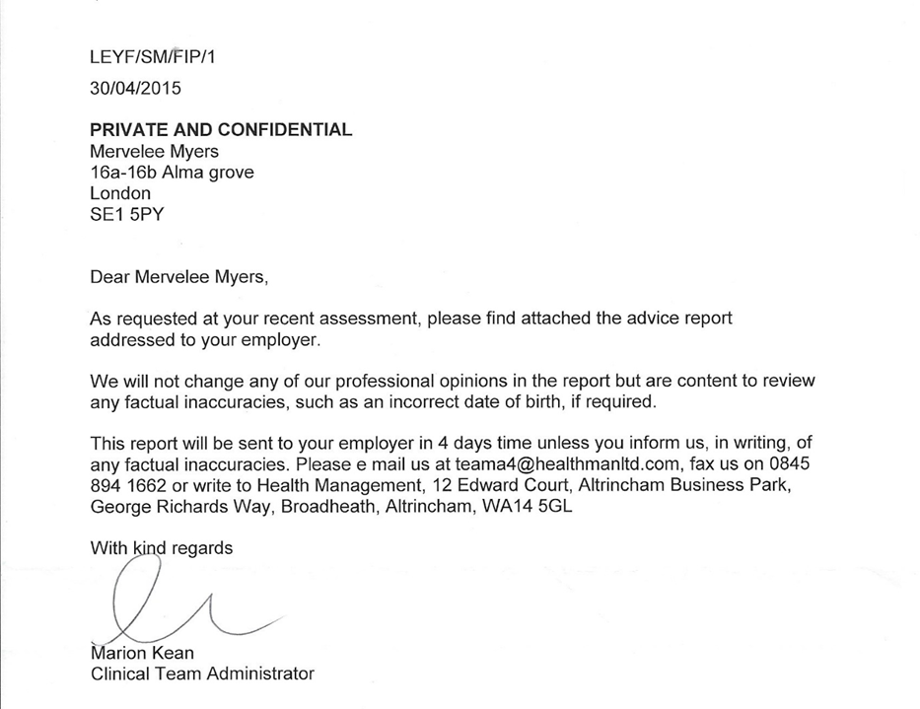

This is it to start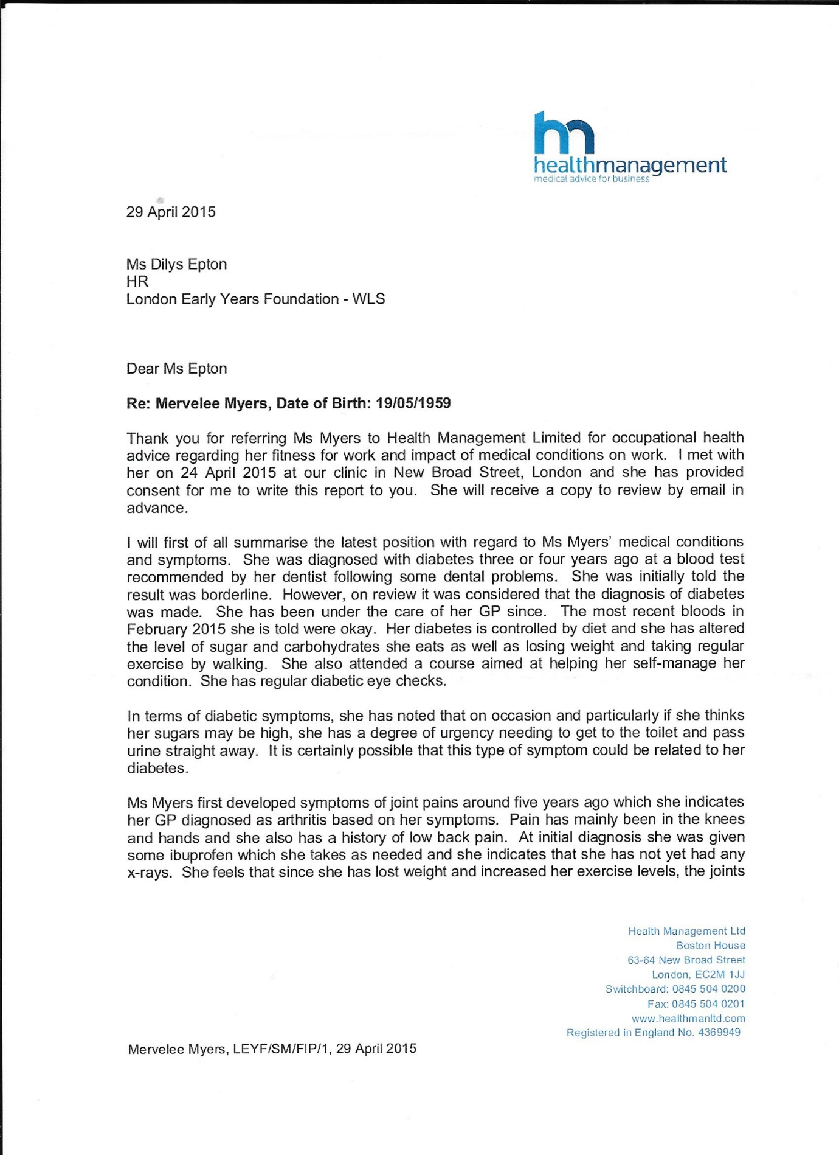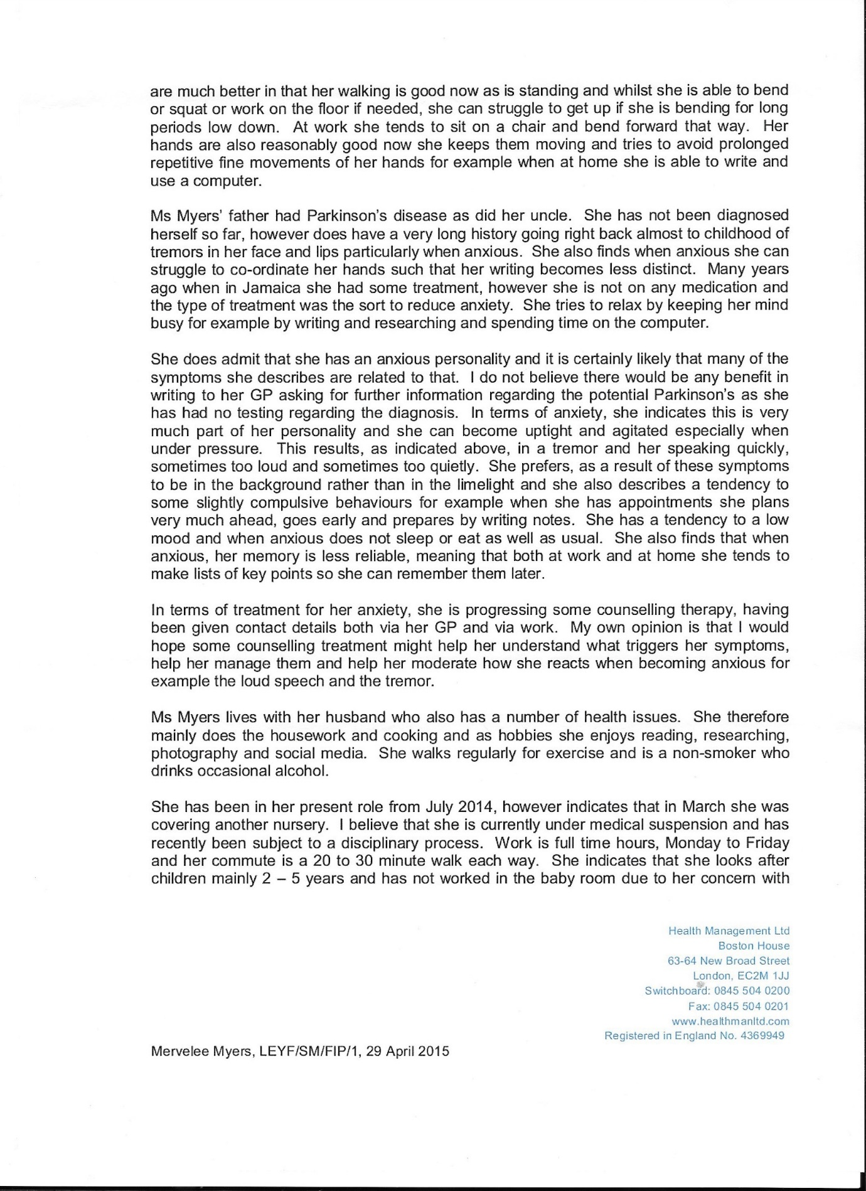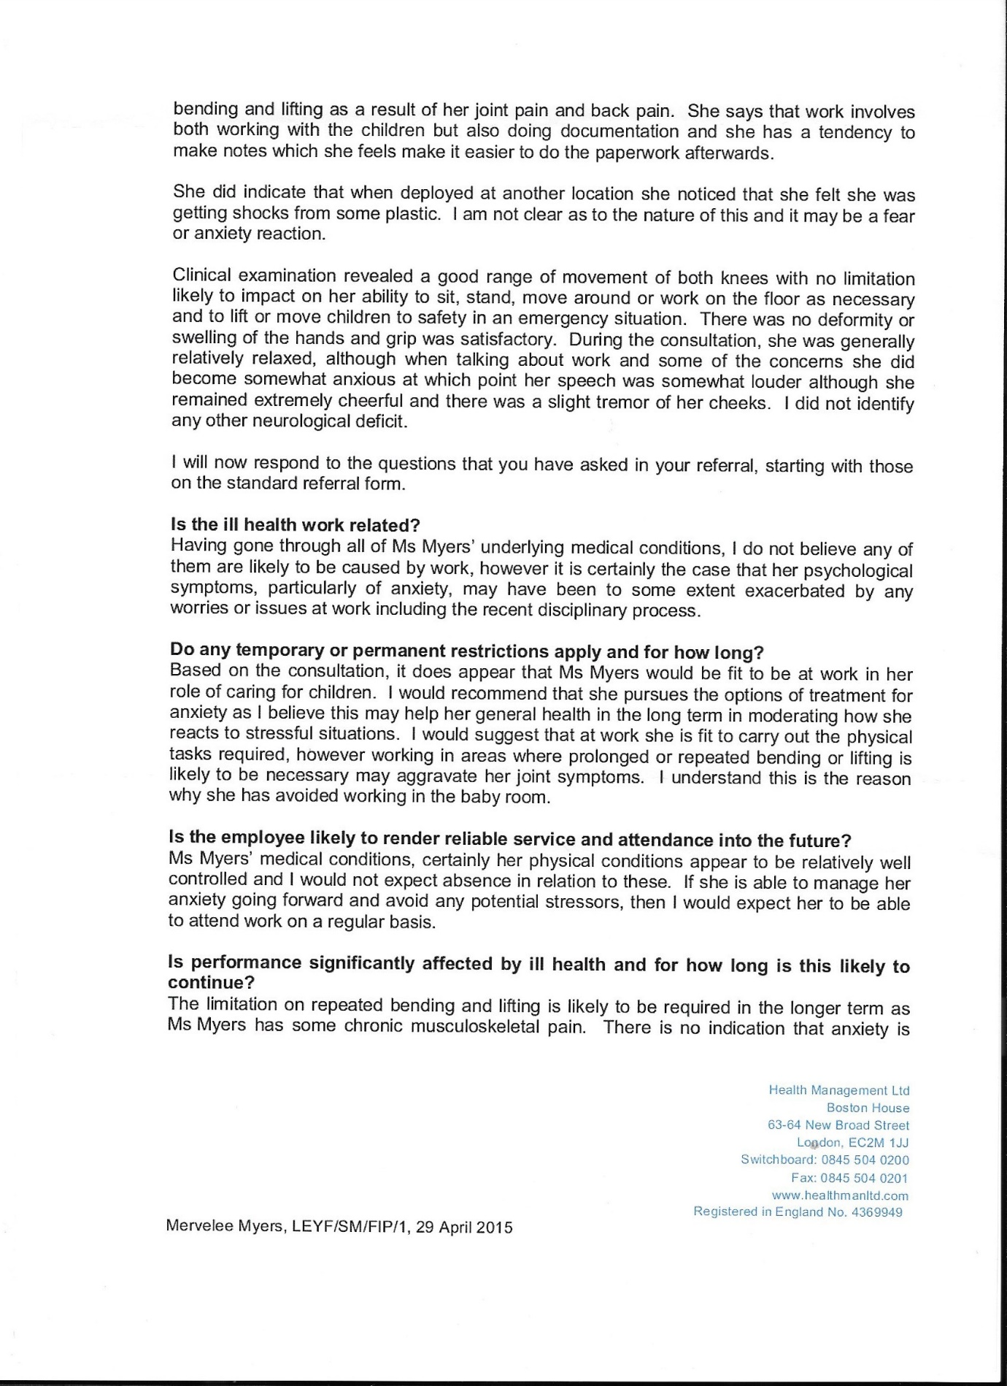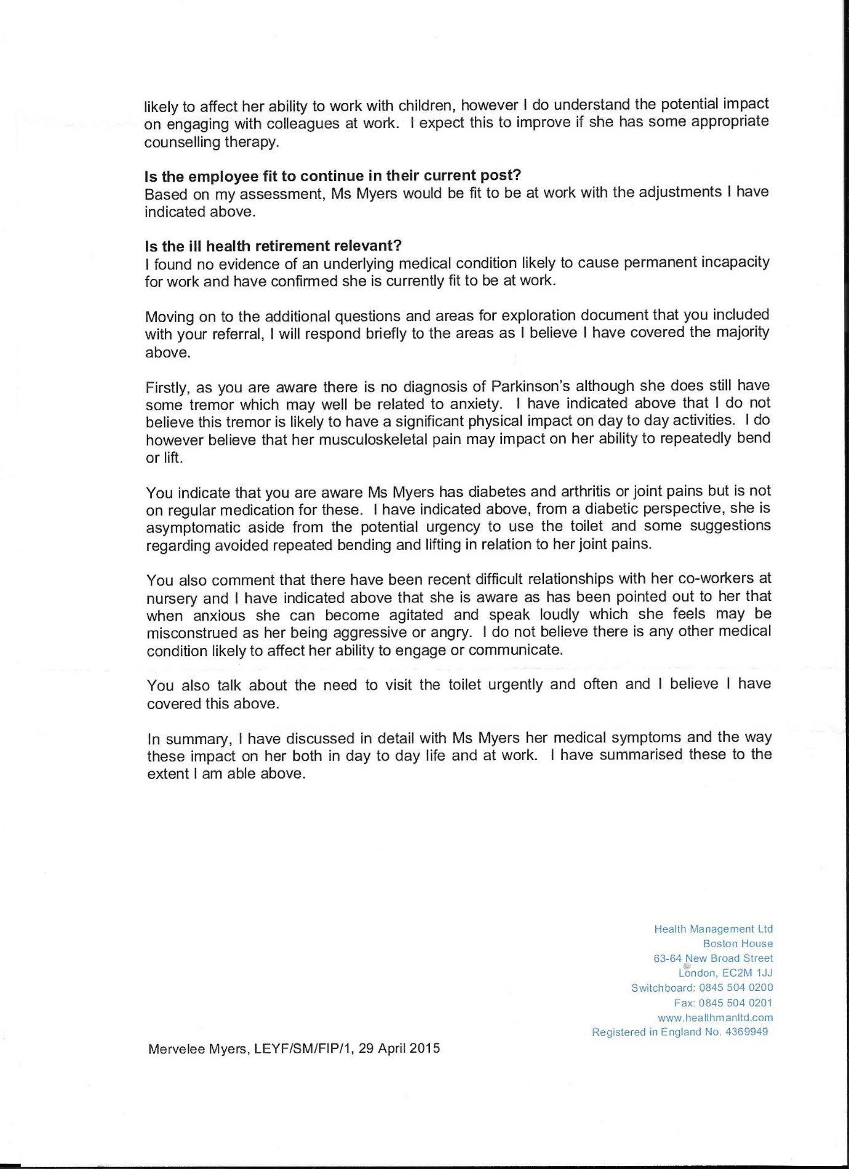
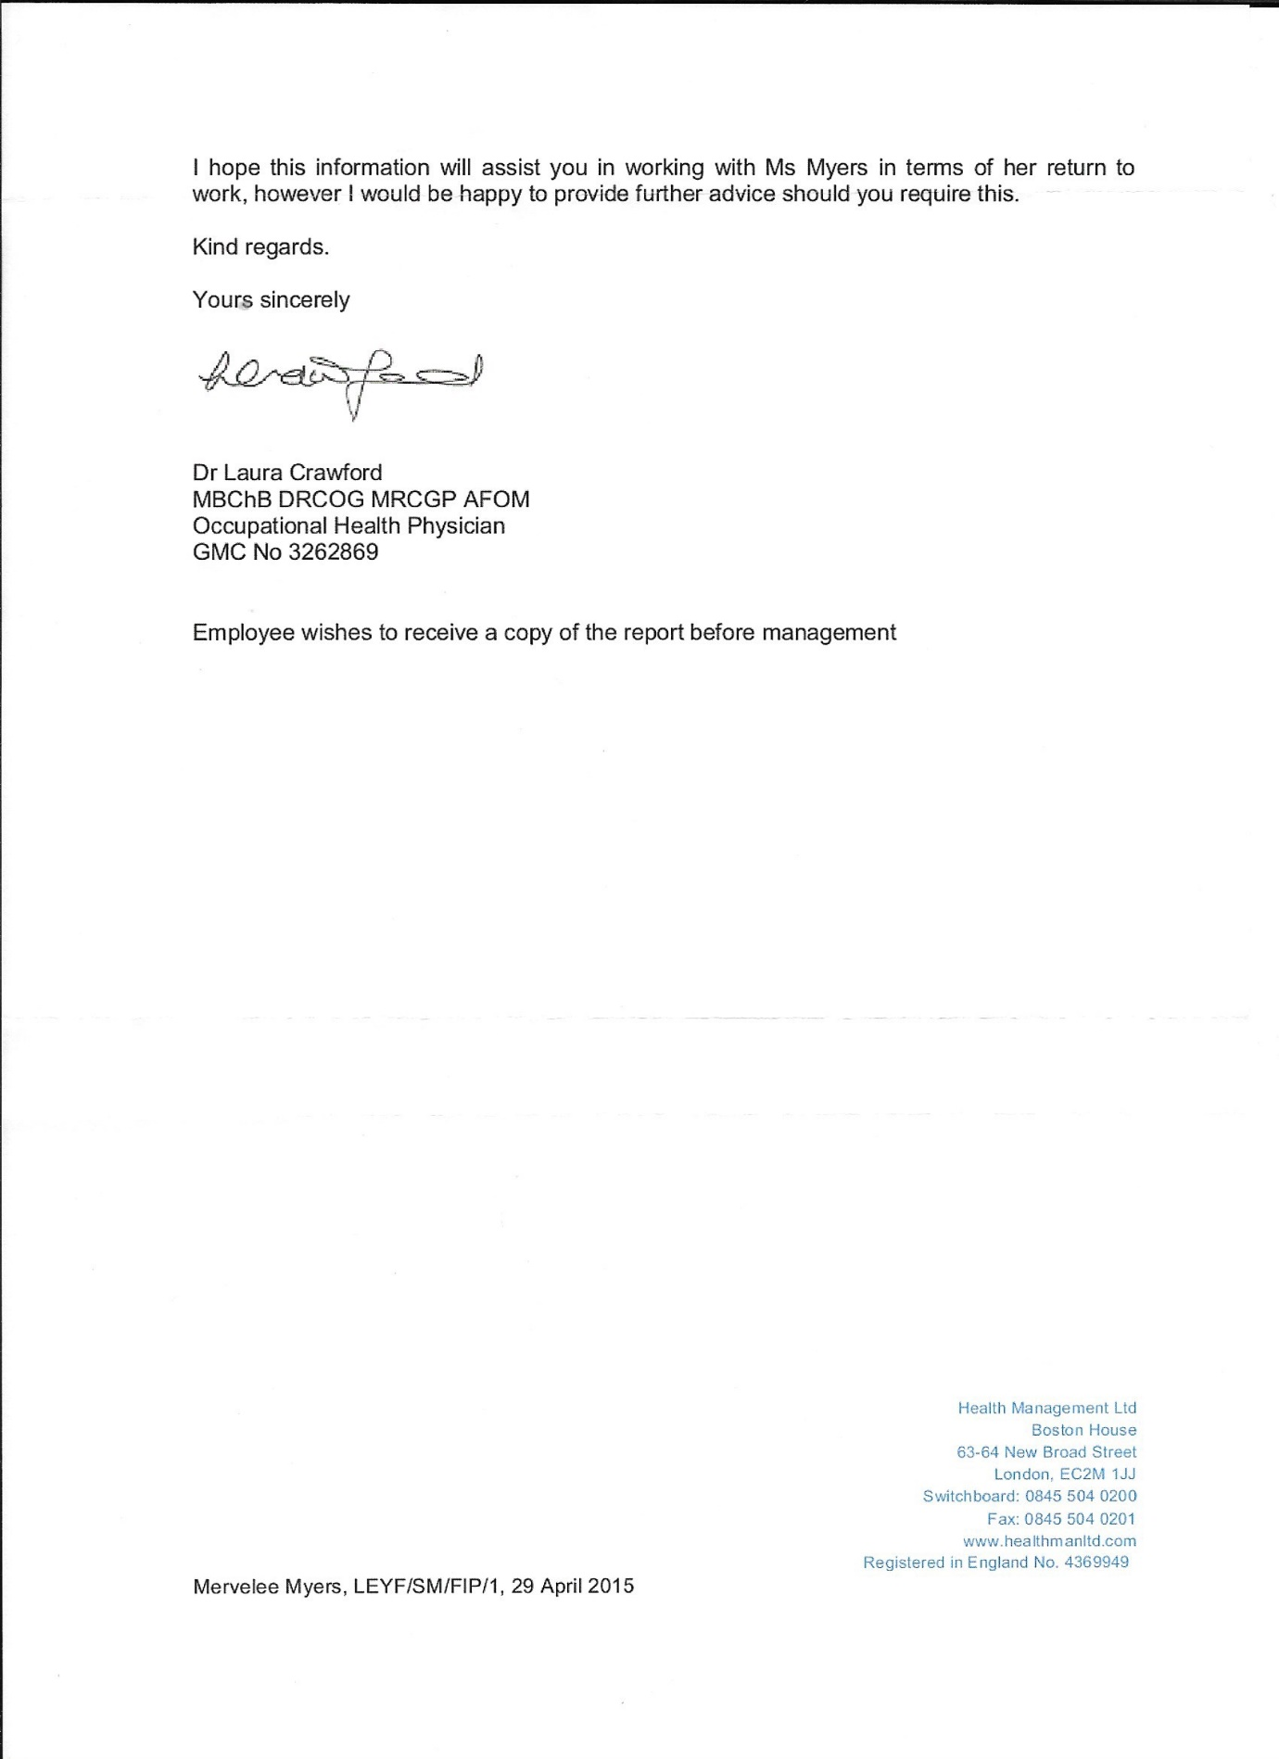

Occupational Health Report.

Southwark Psychological Therapies Service
Middle House, Maudsley Hospital
London SE5 8AZ
Email: sptsadmin@slam.nhs.uk
Telephone: 020 3228 2194
Fax: 020 3228 2473

Private & Confidential 4 March 2016
Mrs Mervelee Myers
LONDON
SE1 5PY
To Whom It May Concern,
I am writing to confirm Mrs Myers has attended 12 counselling sessions at SPTS. Mrs Myers came to our service to receive treatment for depression following a stressful period with her previous employment.
We have now finished our sessions, the last appointment was on the 26/02/2016. Mrs Myers does not require further treatment at SPTS at present.

Yours sincerely
Laura Tinsley
Trainee Counselling Psychologist

Please note we are not a crisis management service and if you have thoughts of harming yourself, feel unsafe and need more urgent help, please go to your local A & E department, contact your GP or call the
SLaM 24-hour information line on 0800 731 2864 Southwark Psychological Therapies Service www.slam-iapt.nhs.uk/southwark

Private & Confidential 8 July 2016
Mrs Mervelee Myers
Alma Grove
LONDON
SE1 5PY
To Whom It May Concern,
Mrs Myers attended 12 counselling sessions at Talking Therapies Southwark. She was referred to our service to receive treatment for depression, which had occurred following a stressful period at work.

Mrs Myers told me she had suffered with chronic anxiety since she was a child. She said she had learnt to manage the anxiety, but it did sometimes affect her ability to write as she has a tremor in her hand. However, Mrs Myers said this had not affected her work life. She said she had been able to manage it and this was evidenced by her long employment history with the company 5 years prior to this recent incident.
Mrs Myers depression seems to have arisen in the context of a difficult period at work. She said she felt unfairly treated and she could not understand how her colleagues had come to form their opinions about her. Mrs Myers had found this experience to be extremely distressing and eventually resigned from her job, as she felt she had no alternative. Following the loss of her job, Mrs Myers became increasingly depressed and she told me she had found it difficult to take care of herself. This has left Mrs Myers with low-confidence, particularly in her work life. Mrs Myers is fearful of going back into work as she anxious about being mistreated and going through a similar situation again. When she was first referred to the service her scores on the questionnaires measuring depression and anxiety were indicative of severe depression and anxiety.
Over the course of treatment we explored the impact of Mrs Myers' work situation and how it had affected her. We explored the impact of this situation on her marriage, where Mrs Myers found it hard to cope as a result of being overwhelmed by the difficulties in her work life. Mrs Myers also said this had affected some of her friendships. Mrs Myers said her family were her main support, but this was only over the telephone due to the distance between them.

As a result of this difficult work situation Mrs Myers understandably struggled to cope with life. However, she has been committed to working through her difficulties and has made improvements to her wellbeing over the course of her treatment. Only reporting mild symptoms of depression and anxiety at the end of treatment.

Yours sincerely
www.slam-iapt.nhs.uk/southwark
Laura Tinsley
Trainee Counselling Psychologist
Please note we are not a crisis management service and if you have thoughts of harming yourself, feel unsafe and need more urgent help, please go to your local A & E department, contact your GP or call the SLaM 24-hour information line on 0800 731 2864

Why I adopted the Daily Express Columnist Mantra? Edited from the Original published on LinkedIn: 26.04.2017!
“Tech Don’t Lie!”
My #Mother used to say "mi nuh nyam rice when it hot, mi wait pon it fi cool?" I told everyone who would listen before that "I am a #Background_Person for the mere fact that I have a diagnosis of #ChronicAnxiety, which I always call my Parkinson's, from the time I reached Puberty, because Parkison Disease is part of my #DNA.
The following is one of the correspondences I shared with the Daily Express Mental Health #Crusade. Happy reading everyone as I apply my Fight4justice campaign showing LEYF Nurseries, the #Establishments and the #Systems not to take liberties with an Empowered Educated Black Woman to the end of her tether, especially when the chips are down... with the excuse that she is #MAD. Because then they will have to deal with the after effects of their #DISCRIMINATION! I am capable of writing my own stories - Books next.
Dealing with the stigma of Mental Health
Hi Mr Jeory
I have been following the Mental Health campaign in the Sunday Express newspaper over the past weeks with keen interests. This matter is of grave importance to me because of personal experiences I’ve encountered throughout my relatively short life. The reasons I am making contact is to congratulate the team on taking up the fight for people who have been faced with #MentalHealthIssues and do not have any forms of sounding board to air our circumstances and situations. I have been using my own early intervention strategies in dealing with my conditions that are considered as #TABOO. But it has not always been easy.
Maybe if I share a brief account of my own personal experiences you will begin to understand why I have become a sceptic of all gift wrapped packages. From an early age I was confronted with the tragedy of witnessing my dad’s decline which lasted for over ten years. He had Parkinson's disease, along with some other health conditions. However it was the Parkinson that caused our family the most concerns as it affected every aspects of the family welfare. I can recall the #shakes at the beginning, until his total loose of #mobility and everything else that is eventually destroyed as a result of the deterioration in his health. As a #teenager I began to question my faith, asking why my dad who had lived and served God had to suffer so much. The onus was left on my poor #Mother to take on the reigns of #responsibilities that was once my dad’s as well as her own job as a mother. In the end my mum was faced with caring for my dad and her mum. My dad and grandma who died within a month of each other were reliant on mum. My granny eventually succumbed to one of her many Stroke.
Imagine my own devastations when I realised my dad’s condition was #hereditary, and from an early age I began to get some of the signs and symptoms of Parkinson Disease. To cut a long story short, I immediately have to alter my life, and I know I was prevented from achieving my #fullpotential because of my #DNA over which I had no say. Therefore with time I learnt to adapt to my condition and refused to become a #VICTIM, and have always been aware of my #Limitations. However I recognised I had problems with my family situations and was only able to give it a name #DEPRESSION after coming to the United Kingdom. After making the choice when presented with the opportunities, and decided to take up studies with first Lambeth College to improve my prospects of securing gainful employment to make a better life for myself. I did not just stop there, I went on to study with the The Open University to become a graduate. I always joked about the fact that I managed to pick up all the #defects from the both sides of my #FAMILY.
Now I have seen in today’s edition about the role expected of #workplaces in supporting their Employees who have experienced Mental Health Issues. However my arguments are totally against sharing your predicaments with your employers as this can be used to one's detriment and place a #LabelofDeficit_Model that is used to discredit a person when one is at their most #VULNERABLE. At this point am talking from personal experiences when I #SelfReferred because I was concerned about matters affecting my work, and for which I needed some answers. This was used against me, and in the long run when I needed the support of my #NHS_GP because I had told him about my Parkinson Disease I was given a kick in the teeth. This caused so much havoc in my life that at one difficult period I thought I would have been swept overboard by the tide of upheavals and emotional baggage I was left to deal with. My unfair treatment further #exacerbated my Depression that I found it hard coping with life.
I was on prescription medication Valium to control my shakes from Jamaica. But I gradually weaned myself, because I did not want to get addicted to it. So when I reached rock-bottom and have nowhere else to turn, I just do what I always done and get on life as best as I could, after the ordeals I experienced in a workplace. This workplace was King's College Hospital NHS Foundation Trust, which colluded with London Borough of Southwark SEND Section, UNISON and Capsticks, Wimbledon to ruin my health. I have not been allowed to forget that I challenged social injustices and inequalities in the workplace that decided to collude with others to #blacklist and #network against me, because I was viewed as a threat to their #incomptences.
Even thou I had swallowed my bitter medicine and moved on I am reminded daily of these unpleasant events in my life because they keep reoccurring at work. I have been placed on a system where I am been Networked against, so I cannot break the mould and move on. To make matters worse am now been #penalised in my job for doing the work am paid for, and they try to get information about people so that they can use it against them. I can recall when I first came to the UK a friend told me that in the UK never tell others the #TRUTH as they can’t deal with truths only lies, and am beginning to see the reality only after too late to my #detriments. My life has been turned upside down because of who I am, as well as my knowledge, values and beliefs and I feel #trapped without seeing a way out of my dilemma.
Although I will continue following your #campaign I can’t help but say I will continue to hold my opinions and keep them to myself, find solutions to my DEPRESSION without getting my employers involved. Anything you say can come back to #haunt you at a later date when you least expect it. Even thou I have no one to share my concerns with I would prefer die than involve people at work. This is because when concerns are raised they are shoved under the carpets by #inexperienced_Managers who lack knowledge, values and beliefs to deal with those concerns. Fore and foremost US #olderemployees are treated with disrespects whilst facing all kinds of #DISCRIMINATIONS over which we cannot do anything for fear of been #LABELED. Since I do not have a voice and have no one to talk to I will be brave and stop myself from becoming a VICTIM by finding #myownremedies. The one good thing about this is I am a very #resilient person and refused to give up #withoutafight, but I won’t make the same mistakes again by challenging Social Injustices and Inequalities. Sticks and Stones may break my bones, but…
Thanks for being my #soundingboard as this means so much to me especially when am at a low ebb in my life trying to stay in the UK coping with the decline in my #MoTHER health.

My Hidden Disabilities & Progressive Conditions
Driven
I struggled with my Hidden Disability that I chose to call my Parkinson’s disease from my childhood. In a nutshell I was all nerves whenever I had to leave my comfort zones of the background to perform normal day-to-day activities in the limelight and under any form of pressures that others take for granted. Therefore in a normal day at school, I’ll perform to the best of my abilities and beat my classmates hands down or tied behind my back in any subjects except mathematics. I’ve never passed a mathematics examination in my life. However I managed to get on with life, doing the basics and surviving. When I sit in a mathematics examination, I’d recalled I was taught the questions peeping out on the sheets, but for the life of me couldn’t make heads nor tails of where to begin.
My #2son’s dad who was one of my mentors, yes he taught me about the bees and the birds because my mum didn’t know how to address the matter, said I’d blocked my mind. When I sat in a maths exam my mind would go blank and I couldn’t recall anything I was taught. I realised too that I had some phobias like not being able to cover my head under the sheets when I go to bed. I never learned to swim even though I come from water area either. There was a dry pond at the bottom of our land where everyone else learned to swim. And not to mention the Middle Wire Pond where all manner of things used to happen. I was basically a Tom Boy until I reached puberty and mum put the fear of God in me about my behaviours from thence. Back then at Primary School, Angie Gordon was one of the only girls whom I’d run behind. And now I know now what I’d not known then or else I’d rebelled to be in Hewling House and not McKoy. Saying that I enjoyed the challenges of being in McKoy House as I never got molly cuddled like some of my peers.
I remember the final year at Townhead Primary School when Ms Loy Welch came to mentor the Hewling House team. She was expecting her baby, but I am sure I never knew anything about that except she had the biggest belly I’d ever seen on anyone. That baby of course is none other than Kim Welch aka Heidi McGann. So back to the story of the young boy who taught me about the birds and the bees. He stayed at his home and looked out for when I was coming across their land using the short cut crossing properties: Phantom Park, Legister Land into Mass Leon Street before going to Tomlinson Land to Babylyn aka Ms T and Lurlene Tomlinson. Once I set eyes on this young man making his way towards me, I’d say foot wey you deh and tek off home?
Mum had told me in no uncertain terms that I should not let any man touch me. Mama in her innocence and wise wisdom wanted to give me advice about how to behave now that I was a young lady and not as a Tom Boy. But in her honest wisdom and good intentions the matter got clouded, and I was left scared out of my wits. I misconstrued what mum told me to mean literally being touched physically hence me running away. Eventually the young man did corner me where I couldn’t run away and explained what mum really meant about being touched. Mama’s touch meant not having SEX, and this was the start of another Legister/Nembhard connection/link up.
The young man decided to take me under his wings and continue my General Science, Health Science and Human Biology educational lessons over the next few years. Our relationships started off being innocent and platonic and later turned into what I called my first LOVE over time. WE just shared our time studying as the young man was passionate about his education and took me along on his journey, mentoring me. He’d come to my house with his books and we’d study and talk about life in general. Now I am wondering if he was sorry for me back then because I was this shy lonely girl. But even if he was, I will always treasure those times when we never had a care in the world and have to get jealous because of LOVE.
My dad on the other hand had matters on his mind when he noticed this young boy spending time with his only daughter. And dad being the dad whom he was spoke to mum, who then spoke to me. Yes believe it or not we were still innocent teenagers who found pleasures in each other’s company without the encumbrances of anything sinister. I guess they don’t make children like they used to in my days anymore? Yes my first love was first my best friend before he became my first love as hard as it may sound. Although I’d had a loving family and a support network to rely on most of my life, I am guessing now that I was shaped by my childhood experiences which I internalised. I must have done this because I knew no other ways and no one noticed my struggles adjusting to growing up.
At the ripe old age of 56 years old after encountering some more traumatic experiences along life’s journey. I am making more discoveries about the unique person who I am to date, and even how I might change as I get older. However I am sure one thing about me will always remain because after battling with some of the demons that blighted my prospects and made me an unwilling victim for the best part of 30 years of life. As an ignorant uneducated person with my past childhood of struggles and sufferings, I am guessing because I am no expert. That I internalised some of the traumas of the sufferings I’d witnessed due to the illnesses and sufferings of my family and taken them as my own. When you add into the pot that we are different in so many ways: only girl, mawgah like a bean pole, ugly with the broadest nose, teased mercilessly, shy always trying to keep myself to myself from prying eyes and a Tom Boy getting up to mischiefs like my bredas.
Then inevitably the bulling is going to be part of my life and something more for me to deal with in my already crowded existence. If you are unable to stand up for yourself then you are doomed and I know this for a fact because I have fought and overcome bullying in my youth. I fought against all kinds of discriminations, win some and lose some and just got on with my life over the things I could not necessarily foresee and change. However when lightening decided to strike twice and unscrupulous persons in authority decided to break the laws and breach my RIGHTS. There is no way I’d allow them to get away with this second time around. Therefore I am on the warpath as an advocate, standing up and protecting the vulnerable from being discriminated against whether directly or indirectly.
Growing up in a male dominated household, everyone else thought I was spoilt being an only girl. But I felt alienated and excluded despite being surrounded by the love of my family and friends, and having a loving family to protect me. The thing I’d always missed most in life was having a sister; older or younger to share those special moments with. When I talk to people who remember me from my younger days, there are always the same themes being reported. I was a shy girl who kept to myself and walked in the corner of the street to avoid talking to people. However I can recall carefree days when I could fit in at school, but not at church. Because church was where the well-to-do went and I didn’t have the Social Status of the material things to fit in. I was mercilessly teased at church because my old fashioned Mama put my hair in a hairnet instead of plaiting it.
The clothes were hand me downs from Grandma’s sojourn to Kingston to visit her well-to-do family. The clothes did not always fit either and all this was because Dad took sick and was made redundant and couldn’t work anymore. Although I can’t recall for certain when the panic attacks started, I remember one day for a dare. I’d aimed and thrown something in an old man’s bag and he claimed to have put a curse on me. Remember I believe in the saying beliefs kill and cure and this might be nothing but another Old Wives Tale, but I never could get what the man said out of my mind. I was fine doing things normally even coming top of the class at Primary School in Grade 5, to the surprises of everyone else. Even Barkey Dixon who swore blind I couldn’t beat him had to eat his words. I was a bright little girl in the words of my former class Teacher Ms Una Perry. Ms Una taught me from very early in life how to meet one of the greatest challenges of my life and I never looked back since. No obstacle was too big for me to overcome, and I never stop learning and will continue to do so until I no longer can.
Dad kept Sunday school classes at home, and I was ok during the sessions we had at home when I was in my Comfort Zones. But I realised that I couldn’t read the Bible out loud on those public occasions as my voice got stuck in my throat. Basically I’d spend all my school days at Primary and Secondary keeping out of the limelight as I did not want to expose my vulnerability. I guess in trying to hide my vulnerability, I ended up creating more problems for myself and developed the ANXIETY (which I call my Parkinson’s disease) that was to blight my life forever. During such episodes my hands shake to the point where my writing was illegible. There is a tremor in my voice and it would catch in my throat and I’d have these panic attacks and my stomach tightened. I was one of the miserable, unhappy and bewildered child/teenager who didn’t understand why I was different from my peers.
I was struggling on my own as I didn’t want to give any more reasons for others to make fun of me and nobody noticed what was happening to me. So I stayed in the background, used bravado to cover up my vulnerability and chose to blame my DNA for something that I could not understand nor change. My friend Joy stammered all through our times at Primary School and her condition could at times be seen to be visible, but she managed to get through her schooling with flying colours. I on the other hand was called all sort of names ranging from worthless and lacking ambitions… When I got pregnant I was devastated and gutted that I’d let myself and my family down. But worse was to come when my child was born and I had to deal with the stigma, stereotyping, labelling, judging and marginalisation that goes hand in hand with having a disabled child (Special Educational Needs and Disability – SEND). The fact I’d considered abortion only made the guilt worse.
Luckily for me and my child I was spared and God fathom a way out for us, so I was not burdened more than I could bare. That is why my vision is to return home whilst I still have the ability, to contribute my knowledge and expertise to the government of whatever party. Becoming proactive in establishing Special Educational Needs and Disability (SEND) Outreach Programmes to benefit children and their families in achieving better outcomes. I have initiated my own Continuing Personal Professional Development Plan (CPPDP) studying to a certain level. I would have loved to further my studies doing the Early Years Professional Status or Early Years Teacher Trainings, but just did not get the opportunity. However I found out that when some in authority see your passion as a threat to their incompetence, as is the case with me and some colleagues whom I know. They will do everything in their power to undermine, disempower and belittle you to keep you from achieving your goals.
Despite qualifications they will keep you at the bottom of the ladder, get you to do their work and take the credit. Then they appoint someone with no qualifications and continue to discriminate against you with their Criterion, Provision or Practice. Because you don’t have a Status on their Hierarchy of Status Ladder they will tell you that whatever you are told by those in authority to do you must do. Even if those in authority are wrong, you dare not challenge them, but you are expected to be the scapegoat as they operate under a culture of blame because you used your initiatives to gain a qualifications whilst they spend their times doing absolutely nothing. If you are an assertive person then you are labelled as aggressive, unprofessional, confrontational, intimidating and lacking empathy. And this is just a few of the tactics they employ to destroy your good name and character that you spend a life time building up.
To get pregnant again just as I tried to get into Teacher’s College laments another old Jamaican saying that “first time is mistake, second is purpose and third is downright careless…” I made sure after looking at my circumstances, making sure there was no third time. Because I told myself if I did not already have a child who inherited my Hidden Disability, I would not be having another who might. There was no way I was going to bring another child into this world to go through the same kind of struggles I have experienced. Despite my deficits and limitations I refused to give up and tried my best for my SONS.
My parents were the architects on whom I patterned my life, because despite the struggles they never gave up and give of their best to family and friends alike. By telling my story and putting it in the public domain, I hope my SONS will begin to understand me a little better as their MOTHER? And if my story can bring some clarity to another family who might be struggling to understand why their child behaves a certain way, seems withdrawn, is seeking to establish bonds in helping them identify who they are supposed to be, my efforts may not be in vain. Mum’s children; dead and alive including me will have a story to tell about her. But it took me years to recognise and understand that unique, courageous strong and fearless woman who was my Mother. Hopefully it won’t take my Sons a lifetime to realise the humble Mother who I am and who is always striving to give the best of myself in providing for the needs of my family.
I got some of the information as part of my RESEARCH, way too late to give mum the honour that she truly deserved, for all the sacrifices she made throughout her life. Mum did not stop to take stock and was always there for her family, friends and anyone else who needed her tender loving care. Because you see mum too had her vulnerabilities that she didn’t talk much about either. The one that came to my attention was part of her thumb that was missing. I only have a vague memory of mum talking about her missing half of thumb once, saying how she came to lose it. But it was only years later when I am doing my Research I noticed some of mum’s mannerisms and realised how much she was sensitive about her missing digit. Mum would always be hiding her thumb and this seemed to be done unconsciously throughout her life.
Later I started looking at her old photographs and noticed that she was always hiding her thumb, tucking away from view from she was young. This convinced me even more that I am my mum’s daughter in so many ways that I’d not thought of and realised before. I’d lived with my Hidden Disability all my life, however I’d found ways to cope and managed, to enable me to live a productive life. When I was at school I avoided doing the things that would trigger my condition and made it hard for me to cope with my limitations. No one likes to be exposed and taken out of their comfort zones especially when we are feeling vulnerable. Like my Mum it wasn’t easy, letting all and sundries be aware of the Hidden Disability that we are mortified about and which make us victims to be pitied.
“The Equality Act 2010 says a person has a disability if they have a physical or mental impairment which has a long-term and substantial adverse effect on their ability to carry out normal day-to-day activities. Physical or mental impairment includes sensory impairments such as those affecting sight or hearing”. I have been living with my Hidden Disability whether anyone wants to call it Chronic Anxiety or join me in giving it my preferred name of (Parkinson’s disease). I’d witnessed dad’s struggles for 10+ years of my life and is aware of the devastating effects dad’s illness had on my life. Dad died a broken man when I was 20 years old and despite his struggles he never once lose his dignity and questioned his GOD. I on the other hand was not prepared to deal with any of my deficits and ended up being the opposite of Dad. I have been even blaming Dad and his God for saddling me with this condition which blighted my life.
Then I know of my uncle’s struggles with Parkinson’s disease and he too died a broken man and would have suffered without the support from his loving sister my auntie Phyllis aka Mellie Nembhard-Salmon who cared for him when he had no one else. We are a close knit family on both sides and always will be there for one another, through thick and thin. That’s why it hurts like hell for some Hurry Come Up Jobsworths who hasn’t got even one iota of humanity in their life can come tag and label me. Anyone who knows me will tell them that I am not uncooperative, unprofessional, intimidating, confrontational and lacking empathy even if I was stark staring Mad. The only reason they are doing this, is to get me out of my job after I have given them some of the best years of my life after making valuable contributions. They gave me the accolades but they are not worth the paper they are written on as they contradict themselves. Because the left don’t know what the right is doing and they are one Organisation. So is it any wonder that everything else crash in this country when it comes to the question of someone being responsible and accountable for safeguarding the vulnerable. Everyone else will be blaming the other person and they hide behind their Policy & Procedures whilst discriminating, harassing and victimising the masses.
Then to stop my progress in sharing my talents, creativity, passion, knowledge and expertise to the world, I am being gagged and told not to say I work with their organisation. I managed my Hidden Disability with lifestyle changes, but was thrown into deeper troubles again which I find hard to accept and believe. The treatment I’d received at the hands of some who were hell bent on destroying me because of my passion to enhance knowledge and expertise the first time around caused me to develop additional Hidden Disability in the form of Depression. I only enhanced knowledge that I know is power so I know I was equipped to prevent another child and their family going through what I went through as an uneducated teenage MOTHER.
However instead of valuing the contributions I made with my qualifications, this caused others to see me as a threat to their incompetence. I developed DEPRESSION as a result and I honestly don’t know when I noticed I’d also started having Obsessive Compulsive Disorders, which I am now being told is worries rather than OCD, just to cope. Despite these 2 additional Hidden Disabilities, I was still in control because I know the triggers for my Hidden Disabilities and avoided them as best I could. With aging I also developed Progressive Conditions linked to my arthritis and diabetes, but like all aspects of my life I was in control. I followed a holistic approach along with my lifestyle changes and worked in partnerships with my GP and other NHS Health Professionals. Yes the same NHS that caused my downfall and stopped my progress to a better career in life. The NHS is good at giving with one hand and taking with the other and these days I only share what I have to and get on with my life.
Anyone knowing me knows that my greatest delight is working so I can maintain my independence and help my family in the bargain. My childhood experiences of growing up in poverty primarily because Dad took sick and was made redundant had an impact on my life. Not being able to reach my potential because of my limitations meant I did not have the chance to get a good job like my peers some of whom I had achieved better educational results. Therefore I firmly believe that education is the key to breaking that cycle of poverty that enslaved us and I have been ensuring that I do my little bit for my family… One of my greatest achievements in life was to work with what I’ve been blessed with to make changes to my life to adjust to my deficits and limitations and reach some of my potentials.
I’d come to the UK and used the available opportunities that I was presented with to empower myself. However each time I tried to use the enhanced knowledge and expertise I gained to stop another child going through what I’ve experienced. Some in authority chose to see this as me showing up their incompetence, saying I am dismissive of authority instead of allowing me to use what I learned to help young children achieving better outcomes. I don’t want another child to reach the age of 56 years old before realising that there might be underlying causes for being the way they are. And there might be help out there that could have made differences in their lives, like I am just finding out. Once before I was penalised for using my knowledge in promoting best inclusive practices that children deserve and parents expect.
Instead of empowering they took my valuable contributions from my studies and credited them as their own. I paid the price with my health and wellbeing which left adverse effects on me. As a result of lightening striking the same place twice and the unfavourable treatment I am once more experiencing. My Hidden Disabilities were triggered and my Progressive Conditions worsened. I was put under more pressures when in order to try and get me out I was given a sanction for somethings I never done and for which others colluded with the knowledge of some in authority to trap me. Then I was signed off on Medical Suspensions whilst they are trying to find ways of robbing me of my Pension. This is the same way my Papa was robbed of the redundant money he should have gotten via the newly established COOP implemented in the Sugar Industry by Mr Horace Levy.
The strangest thing about the COOP was my breda Texchus was one of the Foot Soldiers who worked with Mr Levy in Westmoreland to establish the COOP. Then dad was robbed of his share, which could have made such a difference to our lives. Because of my experiences as a child/teenager, I was very driven to achieve and to help my family in whatever way I could. I remember when I first came to the UK and each time I go to eat, I’d be wondering how my family was getting on at home. I started off my younger breda at Teacher’s College when they were giving him the run around and told him I was helping him so he could in turn help my son. I made sure to study to become a graduate, something I did not achieve in my school days.
I graduated from Open University on 02.05.2009, weeks before my 50th Birthday and I am proud to be a graduate. However I have not been allowed to take credit for initiating my own Continuing Personal Professional Developmental Plan and have to be at the behest of others who always want to dictate terms and play the blame game when it suits them. Now I am been told whatever you have done…? No I did not do anything and all what has been happening to me from January and even from as far back as July 2014 was concocted by an evil Racist woman who feels threatened because of her incompetence. Children needs to be happy and I can’t understand how I was stopping them from been happy…? I was the one promoting inclusive practice and implementing the EYFS Welfare Requirements in meeting the diverse and complex needs of children and working in partnerships with parents. But you claimed that this is your baby, yet you neglected the baby and throw it out with the bath water on the altar of sacrifice. There is an incompetent person in charge and a person with Level 2 qualifications as Lead Practitioner. There is a saying back home that “ears set at wrong place and bush have ears…” But as any Jamaican with any sense will tell you “bush does not have ears, but is a person standing in the bush listening…” When I used to repeat things, my ex-husband used to swear that someone must have told me. But little did he know how I came by the things he said. This is the same way I came by some news that I know about some of the unscrupulous persons who are trying to trap me by making unfounded allegations against me. But one sure fact I know is that God does not sleep nor take too much time from the work He has to do. One day He will be paying each and every one of us for the work we have done. So I guess this person who is telling me Big Old Woman how to act should go try and sort out the Young Child who needs directions before it is too late and she ends up as another Statistics.
The dynamics of the team has been disrupted, but there was no dynamics of any team as those Lead Practitioners were not aware of even the basic requirements of the EYFS…? What team and who are they fooling, there is no team because everyone is resigning and leaving. Agency Staff refused to return and some don’t even return from break. So am I responsible that there is no team when you bundled me out like a Common Criminal to appease the Evil Racist Thugs. And most shocking of all is the place is been run by a Level 2 qualified and Level 5 cannot do anything despite what is written in the contract – Job Title: “You will work as Early Years Practitioner. This job title does not limit your duties with the Organisation and you may from time to time be required to do work that is within your capabilities either on a permanent or temporary basis. You will report to your Line Manager, the Organisation reserves the right to change this”.
That’s why I am beseeching everyone to be aware and take note of the fine prints as they can lead to your detriment when they decided to put you out to grass and take away your Basic Human Rights of providing yourself with food, clothing and shelter, because your face no longer fit and you are past their sell by date…? But not only that your good name and character will be dragged through the mud by some unscrupulous persons who won’t think twice about the impact of what they are doing to your health. When they realised you are strong determined person who will stand up and fight for your rights they then tried to put the blame on you making you a VICTIM to exonerate themselves of the evil wicked wrongs they have done to you. They will tell you to move on… But how the hell can one move on without clearing their name and getting closures?
Although their sanctions has been cut from 12 months to 6 months, and they are acting like they are doing you a favour. Remember that mud sticks and your reputation and good name is at stake. When the allegations were concocted to give reasons to put you out to grass it don’t wash with me. I’ve had to deal with the demons who tried to destroy me, not once but two times now. I am going back and I will not be as naïve as I once was so allowing lightening to strike the same place twice. I will be looking over at my shoulders for the enemies whilst I am getting on with doing what I am passionate about. I am not going to make friends as long as I act professionally and stick to the Job Description. I’ve done my duty to them and their blinking Contract that is worded to catch you out. As this Stupid Union Solicitor told me “It is in the Contract, so they don’t have to prove you have done anything wrong…”? But I did not do any of what they say, so why are you telling me not to defend myself by appealing.
Mark my words I am collecting my evidence, but at the same time heeding the words of my old wiser folks who said “never bite the hand that feeds you…” but somebody will have to take responsibility and be accountable for what was done to my health and emotional wellbeing for almost a year! I am starting with the UNION and work my way round until I can get myself out of their grasps. I did not go to School, College and University for anyone to write my Name on any Bulla Cake and expect mi fi nyam di cussed Bulla Cake and doan notice mi name. And as for those who want to come jump up and threaten me about the PSEUDONYMS that I am using. Well I can bloody well tell them that every single NAME that I use belong solely to I and are registered to me on my Birth Certificate. I am no using any false name and hiding behind anyone to abuse another human being and treat them less than any animal.
I have fallen, got back on my feet, fought many a good fights and lived to tell the tales. I am weak but I am strong because I have lived with adversaries from my childhood days and knows how to be a Survivor even when I am an unwilling Victim. I have empowered myself to overcome the barriers, constraints and limitations that have been a part of my life. We are living in a world where it is the survival of the fittest, craftiest and cronyisms that get you to where some want to get. At the top rung of the ladder and they don’t care who they trample under foot to get there. Some will slit your throat before the water is even warm and sell you out like they done to Jesus. I live by my scruples, the principles, values and beliefs that my Parents instilled in me. And at the end of the day I will use the knowledge by which they are threatened to get them. Because whilst they are busy plotting another’s downfall they are leaving themselves wide opened to scrutiny that they are unaware of. Their story just does not add up and they are contradicting themselves. A house divided by itself will fall.
As I think about celebrating another Father’s Day I have to give thanks to God for the small mercies because I did not have the chance to celebrate anything from a year ago after coming back from Jamaica to bury my MOTHER. So now I am proper celebrating 1 year of missing the Mother who was Our Mother & Father for years after Papa died.

Revival of West Indies Cricket – My Gift from Cricket
As I awoke this morning to the news of a West Indian victory against England, levelling the Test Series. An idea for my next write up is germinating and taking root in my head. Since cricket is one of the sporting past times both at local and international levels in Jamaica and wider West Indies, which has had ups and downs. I guess I can give it as a comparator of my own life, in the West Indies and more recently here in the UK. But before I go any further into my story of the relevance of cricket in my life. I have to make mention about the hobbies, creativity and natural talents which I have been honing over the years that have inspired me to be doing some of the things that I do now.
My passion about the things that are important, empowered me to become an advocate. And I am now using my advocacy using both top down and bottom up approaches surfing the waves going upstream and downstream, gathering information. But you’d better believe that my phobia of having my head covered meant I never learned to swim, and will never be able to do other normal day-to-day activities which some take for granted like driving, etc... Therefore this write up will be dedicated to some exceptional wonderful people who contributed to a period in my life when I had to make some life changing decisions.
These decisions have impacted on my life ever since and are responsible for changing the course and outcomes of my life and my future children and family. Cricket played an important role in the decisions that I was presented with to make a choice. I had the first opportunity to make choices whether to be presented and accept the choice of the most precious gift in life – my first child Kevin Donovan Murray or…? I will start here saying, although I have been living in the UK, 3 days away from 23 years. I have lost none of the qualities that made and identifies me as a JAMAICAN, of which I am proud. Therefore I will shout it from the rooftop that I am a Jamaican True & True and will never change, put “mi neck pon di block and chop it off”?
I have British status and this is necessary, especially when I travel. Because I read recently that our Jamaican passport is not even worth the paper that it is made of? When I am in the UK and depending on the company I am with, I know the roles to play and the persona to take on! However once I set foot anywhere on Jamaican turf, “I gwine fling wey all di Speaky-Spokey and get myself back wid mi Jamaican twang and palava fi mi hearts content”. When I get to Jamaica, I am visiting everyone from the cradle to the grave. I have planned Family Reunions both small and large scales, linking and connecting families, friends and acquaintances near and far. Because in Jamaica, if you do your research almost everyone is only a family member once or somehow removed from being related?
Doing my research, I found out that the HENRY: Mass Roland & Ms Bernice played such pivotal roles in establishing what I now come to know as Social Enterprise right in the centre of Townhead Square. I was born at Townhead just a stone’s throw from the Henry’s business enterprise and moved at age of 4+ years to Ga-Ga Street. Since I have started my write up about the HENRY, and I hope I get to do them the justice they deserve, before Mass Roland is called home to glory to join Ms Bernice. I go back to the focus of this write up which is Cricket and the role that the HENRY played in my reawakening. On one of my visits to the HENRY, and this was probably the last time I saw Ms Bernice? My eyes were drawn to a photograph on the walls and looking at it closely, I realised its significances.
I asked permission because I am now coached in British Standards of Ethical Guidelines and not the Jamaican ways that I’d normally be used to… The Jamaican way is mostly free and for all, without a second thought about anyone else. If any of the HENRY Family is reading this, I’d encourage them to go and secure Mass Roland’s Legacy for the future Generations. Who knows one day this piece of Cricketing Memorabilia hanging on the Ancestral Walls of the HENRY Home might be worth a fortune to the Highest Bidder because no one knows the future? I am wishing my family made more of an effort to secure the Artefacts I’d grown up with – especially the old Spanish “Panya Jar” to tell the stories of our Past?
Seeing the signed Copy of the West Indies & England Cricketing Teams has since caused me to pause and reflect on my life. Recent happenings in my life now cause me to reflect retrospectively and hearing the news of the West Indies win, made me realised I must thank my lucky stars. For the people like Mass Roland and my son’s dad who were Cricketing Fans, or else the destiny of my life would have irrevocable changed forever. I was brought up with certain principles, however I am not one who is going to take the Moral High Ground, judge or condemn anyone about the decisions they made about their life for which I haven’t got a clue. When I got “knocked up – pregnant” in school, I was presented with options which I thought about.
And one of the options was to have an abortion and I went to the doctor of course. I went to doctor “C” and can recalled this day him saying jokingly to me “your dad is going to kill you now…” to relieve my anxiety. When I told him what I wanted he told me to tell the Young Man in question to come and talk to him. Young Man in question said he can’t go, but will send one of his friends with me. Me thinking, but doctor don’t want to speak to his friend because his friend didn’t “knock me up”, he wanted to speak to YOU. At the time I was thinking I can’t deal with another rejection – Cricket was been given priority over me. However I had a decision to make as the rest of my life would depend on it.
Having a reputation and a good name to protect, I weighed up the options. Knowing that if I went to the doctor with the Young Man’s friend, I might as well get a loud speaker to announce from Townhead Cross Roads to Toll Gate…? I made the decision to accept that I’d lose out to Cricket Lovely Cricket, the Love of Most West Indian Men. So I kept my pregnancy and didn’t go with the Young Man’s “Blabber Mouth Friend” and this is not meant as I am been Dismissive of “BRYAN R” wherever You are. This is just the fact of the case WE do chat a lot sometimes without knowing when to draw the brakes, but that’s part of Our Identity and we are loud to boot. I have another friend who never stops, but I know she never says anything to be Malicious as my Mama was exactly like that.
These outspoken persons just speak their minds no matter the consequences. Guess I am like that too… and “I cuss bad wuds in di bargain when my feathers are ruffled, but I am learning to take control like Mama did”? Throughout all my ordeal with deciding what to do with my unplanned pregnancy, I had the never wavering support of my Sister Ms C aka ELAINE KERR who was there from the beginning of my Secret, until I made my decision. I told Ms C to tell Mama the doctor said I had gas, and now it is the turn of my First Love to get a look in. Because he nearly got run over by the Young Man on his big bike. Then it’s Mr B. Spence who told my Mama who the Young Man was.
I remember Mama in her disappointment saying “come talk bout di doctor say you have gas, well when di baby born, you’ll haffi nurse it, because you say you did waan fi tun nurse”? My class teacher Mr Felix Rose was a tower of strength and told me not to give up. He advised me to continue my education after having the baby as he witnessed my potentials. I was so sick or else I could have carried on with my education like Pat Dunkley done because my belly did not show until near the end of the pregnancy. Pat’s child and my son are both August born.
My son was the apple of my dad’s eyes as I was his only daughter. My son’s dad told me our son looked like my dad when he was a baby. My most poignant memories of dad’s last remaining years was seeing him nurturing my son in spite of his PARKINSON’S DISEASE, until he could no longer managed. There were days when dad’s tremors would quieten, and days when the foundation of the space he was at, would literally shake. But he would never let go of my little boy and sang for him, helping me out when I had to do the chores. When my son didn’t talk dad told me it was something in our family, and others have to have operations to release their tongues. My son have faint memories of dad, because dad died in 1980, when he was 3+ years old.
The Moral of the Story is things happen in our lives for various reasons, some of which we are unable to fathom at the time. At the time I thought I’d lost out to Cricket, but Cricket played a pivotal role in the decisions I was to have made. Cricket presented me with the opportunity to be blessed with the precious gift that was to be my first son KEVIN DONOVAN MURRAY. There have been some challenges in both our lives, but I am now accepting those challenges were presented to enable US to develop the instincts and resilience to survive? WE are not quitters and even though I don’t know too much about the MURRAY side, I know KEVIN inherited some of the best traits from my FAMILY and me.
As today as I celebrate the Revival of West Indies Cricket, I can give thanks that there was a Cricket Match in Montego Bay that one Young Man refused to miss, thereby giving life to the next Generation of my Family of whom I am Proud to be a Mother. I know the road is rocky as I journey throughout life and there will be trials and tribulations. But as long as there is life, there is hope and I will continue to live with that hope and rely on God to deliver me like Jonah was delivered from the whale’s belly. Now I’ll have to revisit my past life and get out my Bible and start studying it again. A Bible was the first book my Papa bought me and I went on to pass Bible Knowledge with Credit at the tender age of 12+ years. I am still studying and doing my research and I think I am getting better with age? Long live the principles, values and beliefs that my PARENTS instilled in me and which I have empowered myself to empower generations of Young People to Achieve their Potentials and have better Outcomes.

Setting the Record Straight

I notice some people are trying to rewrite the History of the Nembhard Family so this is my way of making sure my contributions are documented correctly for my present and future generations. Anyone who wants to be Brain washed then I am leaving them to apply critical thinking when evaluating and analysing the History.

- All the money I worked during Population Census covering Prospect went towards fixing the house.
- My 1st visit to England I worked saved my money and came home to spend it.
- When Ashter came home from America it was my money spend to clear his things as those who made promises failed to deliver when the time came.
- When Ashter died I could not afford to make it home but I made sure to send what little money I could afford to help with his funeral. At the time the amount I send was considered lots of money because I was told some people did not bother to contribute.
- Throughout my time here I always make it a part of my duty to send money on a regular basis to help out at home. I can recall one holiday Ervin said he was going to save some of the money and I told him it was to spend to buy food not to save.
- When Ashter’s Insurance money came through I was in Jamaica at the time on holiday. Ervin asked me to lend him some money to put in his account to go get the visa. When time came to go to America to collect the money I had to turn around and pay the fair because there was some arguments about him not being able to take the money out of the account. So I paid 2 times.
- Everyone must have inherited from that money except me as I did not get a penny. I am glad now I never did even though what was taken from me was not paid back.
- When the car was bought here for Byron I had to put money towards its purchase and shipping because of the popularity prices went up. Byron said he would pay me back and I told him not to worry.
- When Ervin said he was going into politics I told him politics was a sideline and he should go to college and I would help him to start with the understanding that he helped Kevin later.
- When Kevin was staying at Texchus I hear talk that I was not contributing but I did not dwell on it.
- Doston always borrowed when I came and never pay back and when he called he never pay back either.
- I paid to start Samantha off at college because I know she did not have a father, and I know that I could have done better with myself if I had any help.
- I gave Ervin £1000.00 to sort his family out when they got their status and £200.00 to help out when Donnett and Kevin visited.
- Everyone know I had to take up Byron’s funeral.
- Doston took $23,000.00 off Kevin saying Ervin was going to pay and all I got was a phone call from my niece saying thanks. When I got there he asked for money in pounds and Ervin said I should give him. Before I left Ms Cee wanted me to lend her money but I refused.
- Each time they fixed the house it gets bad again. I was always saying that we needed to do something about the state of the place. So the last time I tell Ervin forget about the board and we put up a decent house on the property, or else they was going to repair again. My money started the whole thing.

Going to America

When I went to New York in 2006 I discussed the idea of eventually going there to live since I did not have any family here. TOM has been at me to buy property but when I checked out the Bank about the Mortgage I took my mind off it completely as I had no intention of putting myself in trouble.

- When Ervin said he wanted to get on the property ladder I told him I had the money in the bank so he could use it. (£15,000.00).
- When there was some story about Balis and his family I promised to lend him some money and he said he would pay me back when he gets his pay off. I told him the other day I want it when I come so hope I get it.
- I am now realising that most of my family think I owe them something and each time I get there I have to fork out.

They say History have a way of repeating itself and now I realised that some people take me for a fool and think I am not capable of spending my money. It is sad for me to say I realised too late when all my money is gone.
My immediate family is not the only people to get money off me as my philosophy is that money should be used to help those who are in need. I lent money to: Clinton, Joy and Jean to name a few. And I have given money to ex-boyfriends (Lloyd and Michael) because when they had money they gave to me or helped my children in some ways. There is nothing too good for me to give Ms Bebe because I know her kindness.
TOM went and took out an account and that was when I had to disclose about my money because I am paying a loan. He is mad with me because he claims I am an idiot because I give away all my money. When he starts he doesn’t stop and what can I say he may have been right. He was also upset when I started building because he claims I don’t have anything down there. Right now he is the only man I know I can rely on and I am making sure I do the best I can for him because without him I don’t know where I would be today.
I will reserve my opinions about other people and keep them to myself. Just be aware that I am a totally different person from the one I was before I reached 50 years old. You guys are free to interpret anyway you wish. Mum. 24.09.2010.

Updated 11th May 2017
It’s now coming up 7 years since I wrote this and so much have changed. I continue to fork out money like it’s going out of style, but nothing much have changed in the way others treat me when it comes to money. Some of those same persons do not have the time of day for me, even when I could do with some moral support.
Others who come back in my life seems to think they can make use of my vulnerability to feather their nest without thinking of the impacts on my state of mind.
I am glad to say some have changed their ways of thinking and our lives seem to have reverted to the way we were when things were right in the family.
I have benefitted enormously for meeting up with new people who gave me the best advice of a life time to make my status in life so much stable. So thanks to Mr George Scott who I met when I was home for my son’s wedding, who told me to come back to the UK and beg Tom to marry me if I have to? Because of Mr Scott I can say my future is assured financially and I am the happiest I have ever been in my life. I don’t have to worry about financial security as Tom has done that for me.
I am comfortable with the few friends that I have like Chester Pinder, who has been there for me from the time we meet at a Birthday Party on the 22nd November 2008.
The former employers totally destroyed my life after I get back from burying Mama in July 2014. My life will never be the same again. Once more I am wary of so called friends and others who promise to support me when I reach rock bottom. But through it all I have made new friends who come on board to stand by me with the few friends that never wavered, like Winnie Jacques and Mava Black.
I must make mention of Tom’s family who have joined in to make me a part of their family. But I have to make special mention of Trevor and how he helped me throughout my ordeals at the Employment Tribunals.
I refuse to let the naysayers and the trolls on Social Media get to me. But I am disappointed by some of my very own once again. However I refuse to let them get to me as I know lots of what’s been done is not by choice. One day before too long they will realise what it is I am trying to do.

My biggest regret is not knowing more about my mother before it was too late. However thanks to Balis and Ms Connie I was given a picture of Mama that helped me to do a write about for her funeral that left others to have a better understanding of that strong woman who my mother was.
Then everything was made much clearer for me to understand as I had the counselling that helped me deal with the Childhood Traumas that changed my life from the time when my Papa was struck down with Parkinson Disease. Parkinson Disease is part of my DNA and it not only robbed me of my father, but changed the outcome of my life from the time I reached Puberty. The same thing happened again when I lost Mama to Dementia years later.
I know I will never be cured of my Childhood into Middle Aged Traumas that changed the course of my life. However in a sense I am glad for some of the life experiences that taught me valuable lessons in life about how to live up to the old fashioned values and beliefs that I was brought up with. They are the norms of the close knit family and the communities in which I was raised in Jamaica.
However even though I did accept that this was the norms for everyone in the societies we call home during our transitional journeys. I was in for a rude awakening once again when history repeated itself in yet another workplace and I was treated less than an animal. This happened soon after the death of my Mother.
Coming up three years after the death of my Mother, I am yet to be given the chance to grieve properly for the woman who made sacrifices that must have impacted on her overall health and emotional wellbeing as she tried to stay strong in order that she could survive whilst others around her were affected. Only in this way could she be there for her family to carry out what she thought was her duties in the sight of GOD and man/woman.
That’s why I am so happy that I have maybe finally met someone who I can confide in about my situations. Someone who will respect me for who I am and not trying to take advantage of my vulnerability.
I don’t know what the future holds but I know that GOD will work out a way for me to continue making the right choices about every aspects of my life.
If I can give back even half of what my Mother accomplish in her 90 years of life I would have done something significant in helping others in whatever little ways I can.
My ordeals in the UK, will only make me stronger and more determine to help others. I know others really and truly love and appreciate me and I am grateful for that.
Who knows one day I might just find the kinds of commitment from another man that eluded my Mother? All I need to do is be responsible and accountable and I am sure GOD will do the rest.

News Story of the Week
As I was coming from the East Street Market pulling my shopping trolley along in the pouring rain. I could see that the traffic was piling up and slowing down at the traffic lights as there are some Marchers – The March For Homes. From the leaflet I was given I could see they were covering some of the local areas of St Mary’s Churchyard, Newington Butts, Elephant and Castle SE1 6SQ. I put my trolley at the side of the road, got my camera out to get some pictures of the proceedings of course and I was handed a leaflet. Since most of the marchers had gone on ahead, I only got a few, but the one at the end did resonate with me... This was a house made out of what I am assuming is cardboard depicting Social Housing.
This took me back to a time in my life when I was feeling vulnerable as I was left homeless. My homelessness came about from years of experiencing domestic violence and deciding for once in my life that I was going to stand up to the perpetuator. Since I decided for once that I was going to stand up and fight for my rights not to be abused and stop from being the victim. I almost ended up being hurt physically if it was not for the interventions of another person who was present. I am forever grateful for that person who was there for me in my times of need. I lived a sheltered life living with my family before coming to the UK and even when I started experiencing domestic violence I just thought I could not cope on my own. However when push comes to shove, that is when the coping mechanisms kicked in along with the fright, fight or flight theory come into play.
On this day in particular I made use of all 3 to get me through my plight. There were other professionals involved and I was advised to find somewhere safe as a refuge. I was rescued and living in a refuge because after interviews to get housing I did not qualify because I did not fall into any of the criteria – not pregnant, have a disability, etc. And even though my name was on the Council Housing list they could not offer me any support. I was given a list of private home providers and eventually ended up in one of the refuges in South London. I was allocated a key person who worked with me until I found a home to live. I was advised to take actions against the perpetuators of the domestic violence, but chose not to.
I guess I am always a naïve person who took people at face value and never think about doing anything to anyone to make their lives a living hell? I do believe that I am blessed and protected by the spirits of my family who are looking out for me, so I consider myself lucky in certain aspects. Because after no time I was lucky to get my own flat and I am still living here 14+ years later. I was one of the lucky ones to be in employment and I am sure that helped my case in securing the flat as I could pay my way and not be dependent on Social Services. After 3+ months in the refuge I got my flat through one of the Housing Associations that provided Social Housing for persons in my situation.
However I was confronted with the dilemma of having to pay 2 rents as the time I have to start paying rent on the flat would overlap with rent for the refuge. I made the decision to move out of the refuge into the flat even though I did not have any of the basic amenities. At the time I was still doing 2 jobs – early morning cleaning and my other full time as a Nursery Nurse to make ends meet. Therefore because I did not have much time to spare, I moved into the empty flat and started off sleeping on the floor. I spread lots of newspaper and layers of clothing on the floor to protect me from the cold and just got on with it. This was nothing new for me, as anyone who grew up in the West Indies like I did and is from my era can testify to such an experience.
I ordered my bed on my way to work and waited for the delivery and set it up as soon as it arrived. My next door neighbor was a tower of strength and still is to this day all these years later. Because I moved into the flat in December, I ended up having takeaways as I had no cooker, etc. One of my friends who knew of my plight invited me to spend Christmas with her family where I could enjoy the festive seasons that I was accustomed to. I count myself lucky when one of the refuge centre was closing down in Peckham and I was given a few things to furnish my flat. The cooker is still serving me well and although I have gotten rid of some of the stuff. I am sentimental about a small child’s chair that I consider one of the first thing that I owned in my life.
I have to accept that our upbringings are totally responsible for the persons we eventually become as some of my grandparents and parents traits are intact in me. I am a hoarder like my older folks, so find it hard to part with things that I believe others can benefit from. Growing up without having some of the basics that others took for granted have had a great impact on my outlook on life. That is why I fight so hard to hang on to some of the things that I cherish and which mean so much to me. I refuse to take anything in life for granted and is forever trying to uplift myself to break the cycle of poverty that held me back for a significant period of my life. I don’t want the circumstances in which I was born to become the outcomes of my life as I am trying my best to empower myself to bring about change for my family and I.
On the leaflet I got I can see Diane Abbott MP listed as one of the speakers for a discussion on Tuesday 10th February 2015 at Venue: Walworth Methodist Church, 54 Camberwell Rd, London SE5 OEW. I have spent last week getting photos from the Politic Show of her and others as I intend to do a feature. So now I can go and see her in person and hear her views about some of the matters that are important to me in my area of South London. Seeing this reminds me of the time when I went to one of my Housing Association Annual General Meeting and had the fortune to listen to the Rev Rose Hudson Wilkins talking about her life growing up in Jamaica. Strangely enough she talked about the times when she had to spread her bed on the floor to sleep too. I realised we had similar upbringings, but anyone from that era in Jamaica can share their stories about such upbringings.
I was in for an even bigger surprise when we were mingling after the meeting and she asked where in Jamaica I am from. It turned out that we share some things in common other than our upbringings. Her family and mine are from the local area and her grandmother and my mum are related. During her speech she said she would be going to Jamaica to get recordings of her mother telling of her life story to start writing her Memoirs. Each time I witness events like this March along the Road in my local South London, the memories of my life whether good or bad comes back and I have no alternatives but to remember aspects of my life.
Times are certainly changing because I recalled on my first visit when I returned and shared my experiences of seeing people living on the streets it was hard for some to believe it. However almost ending up homeless myself was just another of the experiences in my life that helped me to understand more about some of the issues that we all have to deal with at some stages during our lives. However I am finding that some of us are very insensitive to the diverse and complex needs of their brothers, sisters and fellow human being in times of crisis and we are living in a world where dwag nyam dwag and no one gives a Toss! But how can this be RIGHT? Only God alone has the answers to any of these queries for which I am still searching. No one knows where it will all end as there are so many things happening in this world for which there don’t seem to be an answer.

Comparing Myself to Others to Make Sense of My World
Ron Howard of this World 26th December 2015
I couldn’t help but read the story about Ron Howard in today’s edition of the Daily Express Page 25 www.express.org.uk as these are the kinds of life story that are of interest to me. The headlines states “I WOULDN’T HAVE SURVIVED AS AN ACTOR” in bold types and I had to read to try and make comparisons to my own. I was struck when it was stated that even during his heyday playing Richie Cunningham in Happy Days, he knew there would be no long term Happy Days for him. Ron Howard said “I listened and learned and knew I’d never survived as an actor”. He said there were lots of stuff going on that he did not understand and could not come to terms with. He claimed he was not assertive nor a leader.
I will have to start off with this as I look squarely at aspects of my own life that were a puzzle to me and for which I had no understanding. It is only recently when I am forced to search for answers and go way back to my childhood that some things are beginning to make sense. I did not for a moment understand why I was different and why I had to be the only one of everything all my life. I guess with someone else involved who is not judgemental, I can begin to get a clearer understanding of what and who I am for the very first time in my 56 years of existence. I am slowly coming to terms with all that I am discovering and I am a Survivor and know I can use the answers to help me on my journeys of discoveries. Although like Ron Howard there are lots of things I do not understand, I am at the stage in my life where I am willing to come to terms with some things. Though coming to terms maybe hard, I know I’ve overcome other major obstacles so will do well to overcome others that I need to come to terms with.
In trying to unpick a few sentences that Ron Howard shared about himself as they might relate to me. I too have had to come to terms with certain facts about my very existence. I knew for a fact that because I was affected by my DNA which left me living with a deficit of a “Hidden Disability” that became my limitations. I had to learn coping strategies once I empowered myself to know that I’d have to live with my afflictions until my dying days. Yes I had to come to terms that there would be no big career prospects for me. I just could not perform in the eyes of the public under pressures. But I was always very productive once I found my niche in the background which is my comfort zones. Once I reached my comfort zones, steady the nerves and settled down, I could give of my best when called upon to produce.
Like Ron Howard I listened and learned, knew my strengths and weaknesses, the triggers for my deficits and limitations so that they would not become constraints that prevented me from achieving my individual potentials. Knowing the I could not survive under certain stringent Provisions, Criterions and Practices I opted for what I knew I was capable of coping with. I carried on in the career pathways that represented familiarity, consistency and continuity for me. I am passionate about working with young children and continued in that vein studying to gain a recognisable qualifications despite the odds stacked against me.
I had plans taking my career forward and making a name for myself using the passion I had, but this was not to be. From the beginning my passion to make something of myself so I can give of my best was seen as threats to those in authority. My chances were scuppered by those who colluded and conspired against me to stop me in my tracks. They set out to destroy me and nearly succeeded. I fought back from the brink of defeat and made the most of the limited opportunities left opened to me by those who networked against and black listed me to oblivions.
Despite my determinations to get on with my life, I had to accept my career was going nowhere when despite the only staff shortlisted from the company I applied for a post with. I did not get the job and like Ron Howard I knew my career was going nowhere. That was when I decided to cut my losses, continue doing my best to earn my PENSIONS and find an outlet for the creativity and talents I have wasting. Because the company used me, accepted the accolades, pay lip service about my contributions that were not worth the paper they were written on.

Maria Hudson Re ACAS 2010: Employment Tribunals with KINGS NHS
Maria Hudson
Policy Studies Institute
50 Hanson Street
London
W1W 6UP
Reference #: 2800116

Mervelee Myers rattynem@btinternet.com
Home: 02072310813
Mobile: 07950618083

Tried to respond by email but my correspondence returned so hopefully this arrives before the deadline date in the post.
Just to let You know that I am available to take part in the INTERVIEW if needed. I work at Luton Street London NW8 so arrangements have to be made in advance to find a mutually suitable location. I can be contacted on the above.
Kindest regards.
Mervelee Myers.
Social Media Listings 10.01.2016
LBC Radio
I love to get my teeth into these "Claptraps dt dem come up wid when dem refused to face Reality". Came to this country 23+ years ago. Studied because I know I could do better than what I was doing as a cleaner. Don't get me wrong a job is a job as long as U can earn legal money to get on with Ur life. So after finishing studies, I continued cleaning part time to top up the wages. I pushed myself to study & gained further qualifications. Wanted to carry on but could not get the chance. Lost tract of the amount of jobs I applied for where they told me crap, or not even give me feedback. Reached rock bottom when after being the only 1 shortlisted from the Organisation I was told even more CRAP! Since they hold the handle & I the blade I have to get back to their levels to earn a living. Done the jobs they couldn't do, trained them up & was general dog's body for all & sundry. Then they decided I did not fit the image of the organisation any more & it was time to get rid of me by the hook or crook. Suffice it to say I'd advice U all to go out & buy a copy of Gloria Cameron's Case Dismissed www.gloriacameron.co.uk. Email: Richard@rvsrealtime.com. Then those who don't know what I am trying to get across will know how WE are treated by the Systems via the TOKENISM like this nonsense WE have to be putting up with from some of those who continue to turn a blind eye. If my 1st son did start a family from he got married, I could be GRANDMOTHER to some of the ignoramus who are dishing out Foolishness like the above. Even when U toe the lines because U have to earn a living to provide for Ur basic needs, these clueless Jobsworth who have no clue about Employment Laws & the Equality Act 2010 expect us Older Workers to do all the work whilst they hide behind their so called status to treat us less than animals. So come on Mr PM, maybe it's time for me to make Public that "Open Letter" I wrote about what US workers are facing. I was brought up in the Caribbean where it took a village to raise a child. Now someone who could be my grandchild is given Power to treat me like something that they'd wipe off their shoes if they have the misfortune to step in it? I was offended by what I had to do to get on a course to go retrain in order I may get a job. This is after what those Employers done to blacken my Name, destroy my Character & ruin my Reputation. I hope Mr PM remember what I said about not returning to no "Funded Prison because I am not a CRIMINAL". I am spitting feathers, because if it's the last thing I do I'll be exposing these unscrupulous Psychopaths. Cronies or not I pass caring! I am a PARENT & a Grandparent. Is it any wonder we are having this kind of conversations because children are being influenced by others who were not brought up with any moral principles as children & now they are PARENTS & Leaders... .

Southwark Council
I never learned to swim despite coming from a country described as "Land of Wood & Water". Knew I had a Phobia because I couldn't have anything covering my head. Even the bed sheets when I sleep at nights. So imagine my terror if I had to get under that water even accidentally. However since Behavioural Therapy via Counselling I am learning that lots of what happened to me was governed by "Chronic Anxiety" I developed from Childhood! Wondering if I should seek a Grant to do research about my condition. I am a Qualified Early Years Practitioner who has been made Jobless. I am into writing, researching & would like to gain my Teacher's certificate as a Special Educational Needs Teacher. Any suggestions? I have been reduced to find fulfilment on Social Media as I no longer fit the kind of worker my former Employers want in their Organisation! Not working means I have to be scrounging, so please point me in the right directions for the FREEBIES?
Evening Standard Stabbed 16 year old boy
When I was growing up in the Caribbean I never recalled any of the kind of thuggery that cause so many to lose their lives to guns, knives, etc. Believe me this is happening all over the world & more so where I am from. In my days we would settle a disagreement with a fisticuffs & probably "Lick & Run on the part of the 1 who wasn't a good Fighter". These days 1 has to be so careful not to OFFEND, & for what I don't even have the faintest idea. Young lives taken for what reasons than the egos of others. But I'd entreat the Media to take a look at other crimes that are being underreported... Just finished reading @www.gloriacameron.co.uk Case Dismissed! She had some scaving reprimands to offer to some in authority including the Media that refused to share her story about what she & her family experienced. She started out trying to bring solutions to the disaffected Family. Maybe ES can get some of her advice?
LinkedIn 22.01.2016
TA Course
I have signed up for a 14 weeks Supporting Teaching & Learning In Schools (QCF) Level 2. This is with Islington College/HCT. Yes I guess I have to face up to the realities of the systems which operate to tell me one thing about myself when I know another. But life goes on and I have to accept that every thing in one's life happen for good and even bad times. Therefore I am putting the bad time behind me and grasping out for the good, better and best.
I am moving forward with positive vibes and faith in God to see me through. And if I am honest enough, this is after I stopped long enough to stop "cussing bout mi bad and tek back control a fi mi life". There are a few obstacles in my way that may pose as barriers, constraints and limitations to me completing this programme of studies. 1. I need a school to do at least 30 hours of placements to meet the criteria for the course. I've been trying but no joys to date. Well I know darned well I don't have to spell it out why...?
The other things that became hindrances surrounds my overall emotional health and wellbeing, and what some "Corporate Institutionalised Psychopaths" did to me. When I go back and read their Blog of 15th June 2012, it tells me everything I needed to know about them. Now I have a clear picture in my head how they changed from being the organisation I knew to one that is "LACKING EMPATHY". Maybe if they revisit the Blog, they will witness how "the self-fulfilling prophecy" came about slowly but surely over the years.
They are responsible for robbing me of "my self-confidence and self-esteem" that I'll have to spend I don't know how long to rebuild? And they honestly think they got away with destroying what I spent so many years to build. I now have to start from scratch and force myself "not to be frightened by every shadow and see a Duppy in every movements"?
Let me get back to my main reasons for writing this post. 2. Along with the school to do the placement, I'd like to get a copy of a book. Book title: Supporting Teaching & Learning in Schools By: Louise Burnham & Brenda Baker Publishers: Heinemann ISBN 978-0-435032-03-6. Normally I'd go out to spend my money to buy my own, but my circumstances have changed.
When I get this course over I intend to do "The Specialist Diploma Level 3" and take things from there. Hopefully I will then be able to do my PGCE after doing my research. The good thing about the above 2 courses I don't have to do exams. As of now it's more life as I move forward to conquer and overcome the "Fears of being JUDGED" that the PSYCHOPATHS who labelled me have done to me.
They've blackened my name, ruined my reputations and destroyed my character. However the race is not for the swift, but those who can endure to the end. I am living my life in honour of my "Mother for whom I am regretting not to have known better", because if I did, I'd have had a more enriched life. Mama could not read, but she spell and pronounce. She practiced writing and writing her "r" the old fashioned way. Everything I do these days in in "Mama's Memory" as I look forward to writing another tribute for her 92nd Birth Date.
Let those without any SINS cast the first stone! I wrote my “Homemade Book” that was borrowed on the day SKY News visited. They claimed they would make it into a Teaching & Learning Tool. I have not heard anything about it since. Anyone know about Copyrights & Patents, I’d like to be in the know.
3.2.2016 Killings in Hanover October 2015. 6 Caskets at the Funeral.

I don't have much to say except I feel it for the Family who are left with the Memories of the Horrendous day their Loved Ones were Brutally Murdered. There are VICTIMS everywhere. My uncle TERAH CHAMBERS dad Cardene Chambers was brutally murdered at Bernard Lodge in 1978. My breda ASHTER, now Deceased who was visiting was Roughed up. My Cuz Grace could be no more than 3 years old, so grew up without her Dad. My Grandma took her son's death to heart and did not recover. This left my Mother caring for my Dad & her Mum... 2 years later Dad died, which had nothing to do with Uncle's death. But a month later Gran died of a Broken Heart. Throughout all of this Mama kept all she was going through internalised & never talked about it. However I am sure all the Family were relieved when Dad died a month after Gran. He was released from his suffering of 10+ years. Yours Truly ended up with the Repercussions of the Family Tragedy - Chronic Anxiety. Now some RACIST THUGS think it is ok for them to put me through some Horrendous Experiences that ended up Traumatising me years later. There are many ways in which Wickedness can impact on others. GOD will see this Family through whatever SINS that those CRIMINALS inflicted on them.

Need Your Support 14.2.2016
Tied up with my own personal problems, but I was so damned MAD when my neighbour TESS was left to die on her own. I knew this lady from I moved here. When I realised what was happening, I contacted the relevant authorities to get her the support needed. Social Services contacted me & I expect they sat in their offices & expected me to do their work. Message left on y phone that they would make a visit. To cut a long story short, TESS died. Called the Ambulance & some Jobsworth on the phone asking me stupid questions ie is there a Defibrillator, are U sure she is dead, can U go & find out? But I just told U she is dead. The Police came & had this elderly man who discovered the body interrogating him. I had an assignment for next day, so was focusing as well as keeping abreast of what was happening. Next thing I went out & tried giving information that the elderly man with EAL not able to give. The Police woman didn't even acknowledge me & walk off into the flat. I think to myself then they say I AM DISMISSIVE OF AUTHORITY! But whose or what authority? My Old folks used to say Government don't care how U live, but want to know how U die. I witness that on the Wednesday night TESS body was discovered in her flat after the SYSTEMS LET HER DOWN. Next day SS left a message for me to call them, yes I owe SS an obligation. But when SS finally called I was even more Pissed off by the feeble excuses. How can they say this is a Civilised Society when Elder People are left to die on their own after I made all the efforts to get her help? Mi waan guh home a mi YARD, at least I won't be faced with anything life this!
I've moved from when end of the care - cradle after my EMPLOYERS tried to destroy me treating me like a CRIMINAL paedophile. My health is affected & I am getting counselling. I am without a job & on BENEFITS, but I think all things work for good. I a now the Carer for my elderly husband who will be 93 on 8.3.2016. I am up almost every morning at the crack of dawn to attend to his needs. Don't think I could hold down a full time job. God works in mysterious ways?

My God we need to link up, I never even read Ur story. I am currently in a similar position to Urs & I am determined that someone be held accountable. I am undergoing counselling for what the EMPLOYERS done to me. I wrote 4 Open letters, 1 to government & got response. The Employment Tribunal is messing with my head & I have to write them a letter with the evidence I do exist. Now I am being pushed from pillar to post. I had a similar case when working in the NHS & I didn't consider I was Whistleblowing either. The Union, Legal Services, etc all colluded to work against me. I was made a Statistic & used as a Scapegoat/Victim when I was interviewed for a research. But I was going through my stuff & found the email. Now history is repeating itself as the former Employers whose name U'll see in their own words on my SM decided to destroy me. Reasons they changed & want to take over the world at the expense of the Vulnerable Service Users - children & Service Providers - Employees. Once again the Union sold me out & Legal Advisors taking me for Idiot. If it's the last thing I do I'll expose the whole lot of them. When I am finished the PM can pay for my keep in the funded Prison he is proposing to build in my country. Lets join forces, as it's time this Clique Business is stopped & they put the welfare of the vulnerable first. Fight4Justice until I die. Legal Advisor told me they will take me for Defamation, but I have 2 Folders packed with Paperwork I was taught at the OU to be my "DEFENSIVE PRACTICE". We need to take a stance so Old Folks like Tess don't die on their own after I contacted SS. Vulnerable children with SEND are not left to struggle because Childcare Providers can't be bothered to adhere to current LEGISLATIONS?
Black MP Racism Row! 29th February 2016
I've been mistaken for many things in life & I have possibly done the jobs as well. But I'll lean on the sides of those who thought this was a genuine mistake & expand a bit. When I just came to the UK I'd wonder why people say see U later when I don't even think our paths might cross. There was the case of are U a Christian & I'd say no because I was not baptised as an adult. Only later I understand about the different Religion. But my mortification came when someone keep asking if I was ok, so one day I had to ask the question. Don't I look ok to U? There were lots of things I didn't get even though I came from an English speaking country & had English at GCE O'Level. Don't get me wrong I am well versed in my MT. That's why these days when some of the people who try to stir up TROUBLE using whatever cards, I'll tell them lots of things are due to language barriers where things get misinterpreted, misconstrued, misunderstood, etc. These days I can't be bothered with the arguments. I'll end by saying I was stitched up & sent to the HOC because some unscrupulous Employers were trying to make me into a SCAPEGOAT. I was treated like a CRIMINAL & escorted out of the HOC. I've been trying to get my plight in y Fight4Justice highlighted, but not getting anywhere fast. I wrote 4 Open Letters & got response to 1, but I am buried under with some urgent matter. 1 of the Open Letter was to the Daily Express & it involves Mental Health Issues. Therefore I've got a valid story if anyone out in News Land is interested?
3.3.2016
So many things to be thankful for. On Tuesday I was inches away from a Serious Motor Bike Crash in Battersea Park Road. I took pictures relating to the Emergency Services because it is relevant to my Studies.
Got to class this morning & learnt the Young Man Died from his injuries. I was present when they were cutting the clothes off him & saw his mangled arm. I heard his Groans & saw him in his underwear & when they put him on the Stretcher.
My heart goes out to his Family & I hear it was reported in the Evening Standard. I told U I have the tools to be who/what I want to be as I develop my CPPDP. So I have the Death Machine, Emergency Vehicles & a Long Distance shot of the Accident Scene.
But sadly I still have no time to download my Camera from October 2015. The psychopaths are responsible for this state of affairs from they decided to terrorise me starting January 2014. Only I did not know at the time...?
Remember I'd reach a stage in my life where I was becoming Paranoid. COUNSELLING helped me deal with the Childhood Transitions that affected my life from the Age of 10 years old. What they done turned into Post Traumatic Stress Disorder.
I am back to the days when I was Carefree & jump on the bicycle from Gaga Street Hill Top all the way to Street Gate.
These psychopaths will pay for what they've done to me. The crumbling has started. That Bitch who come stand up in my Face Taunting me, well if I meet her now I'd do exactly what I done then. Ignore her instead of wanting to Knock her to the Ground, but I'd Cuss her RC dat not even Fly woulda did Blow her.
Let dem tan deh play Blame Game now?
Southwark Council Questionnaire 4.3.2016
I'd just like to expand on two recent happenings that have me fuming in my neighbourhood. My partner and I were concerned about my elderly neighbour, so I went through the proper channels to get her the support needed. Unfortunately for her, that was not forthcoming and she was left to die on her own without any assistance. This was despite being reassured by Social Services they'd visit. To add insult to injury Social Services called left a message on y phone the day after she died as if I owed them something. Then when SS did call, SS did not know she died. I had to call the ambulance to and it was like an inquisition. Then when the police came, it was an all night vigil, wasting time trying to collect information about the death that should have been dealt with before. We still haven't heard anything yet about the funeral. I a angry and upset because my partner felt my neighbour's death and I saw him stood at the window crying the next day. I am his carer and he's reached the time of his life when those things matter - 93 years old next week.
The other incident was what I witnessed in the shop when I was trying to support an elderly man. A woman and her child was so disrespectful and tried starting an argument because I was helping the elderly man and her child did not want to wait for him to get out the door first. He was riding his bike in the little space in the shop. We were not raised that way and I guess British Values should start at home, because how can a parent act that way in front of her "bruck bad pickney" as we'd say where I am from. I lost my job because I challenged these sort of social injustices and inequalities. But I made the most of the opportunities I was given in the UK and I'll continue to let my voice be heard as a Multigenerational Advocate.
I do agree that I am responsible for how I age and my story is in the public domain from the beginning of my journey with my disability and health issues. So moving on from where I was almost crippled with arthritis, to being diagnosed with diabetes. I am in the best of health, managing my conditions with the support of the NHS professionals. But I have taken a holistic approach to managing my health. I am now the full time carer for my husband. But I've always been doing one caring job after another from the age of 10 years old when my dad was made redundant.
Nursery World – Graduate Trainings 9.3.2016
Too late for me now as the Powers that be made sure I can't get a job in the Early Years Sector. I am even training to be a TA & can't get a Placement. No doubt about it I was too knowledgeable for my former Em-Ploy-Liars. At 1 stage I was even wondering why I could not access the Nursery World Forum & Nursery World Magazine on SM. But I know its called having Big Wig Friends in High Places?

1st May 2016
Start of my MAY month and Mervelee Myers is just telling it like it is. I don't necessarily give a toss about another's opinion as I intend to go on as I started. Probably if I wasn't documenting some of my Innermost Thoughts I would not have legs to stand on with those CRIMINALS & their Cohorts in Crime against Humanity.
God bless The Open University for my Empowerment & reinforcing my "Defensive Practice". I was taught that a Good Practitioner Must avail ourselves of a Camera, Computer/Laptop and a Laminator. The only one I never got is the Laminator. Therefore I am well equipped to continue with my Pleasures in Life- WRITING!
I have to make some changes in my life and make my HUSBAND my Priority. He was so relieved when I got in Friday night because he thought I was staying over. I told him no I will never go any where, where I can't get home. Luckily I got home because he had a torrid night. Everything is taking their toll on me, but like y MAMA did, I just have to carry on. That's why I reflect on those who supported my MOTHER back in the days.
So today as I struggle to cope with the Challenges coming my way I am grateful. I think back to my Carefree Days when MAMA was furious with some of my Antics & tell me off... So I have a SMILE & think of Mum when I have to strip down & have my 2 Long Tit-Ties (Breast) hanging loose just so I can get rid of the discomfort of having the Heater on Full-Blast because Tom is Cold.
I know it will get worse before getting better! But I am here for the Long-Haul. It is reassuring to know that Tom's biggest Concern is that I am ok. And he don't want to become a Burden to me...? When a person has been Independent & Self-Reliant all their life, it's difficult to be where Tom is in his Transitions. I kind of knows how he is feeling because I have experiences of my Transitions to make comparisons. He rebelled because he was told I write I am a CARER, but that's exactly what I have been all my Life - a CARER like my MOTHER!
Mr SPENCE
In Memory of my MOTHER I'd just like to take this opportunity to give credit where credit is due & salute one of those Persons who rallied around y Mum during the times she was experiencing her many challenges. I have memories of the times when the Persons like Mr Will Coote from Bull-Head used to come visiting PAPA, Mama would hurry up to Tidy up to make the place a little bit more presentable for strangers.
Why...? Because Papa was Bedridden & it takes lots of hard work to keep things going. But not only that Mama's Mother - Gan-Gan was also SICK! But I recalled Mama wasn't that bothered when this Person dropped in to look for my Papa. Maybe it was because my Mum considered him to be in the same League as one of her Sons...? Mum never chat much & I missed a lot.
So today I'd like to take this opportunity to say "Happy 68th Birthday to Mr Spence"! Mama saw something in U which caused her to be able to Talk, Trust & Feel Comfortable & Relaxed in Ur Presence. Sorry I was too Rapped up with my Challenges to take much Notice...? Pity U never kept the link & stayed in touch with Mum, but that's life & sometimes that's how it is meant to be...?
Doston told me U are a Big Belly Man, & despite me trying to visualise the Mr Spence I knew back then I can't?
Have a blessed day & who knows what the future holds? We definitely need to renew acquaintances id only to celebrate that aspects of Mama's Life & Ur involvement.
Was chuffed to find out we were May Born! Enjoy, but don't do anything I wouldn't, but go ahead & have one Draw if U have to...? A little bit of what U fancy is good for U! Give them supn to ponder!
Horoscope
Taurus April 21 - May 21 curtsy of Lori Reid - Express Magazine
For a while you've had to sit and wait, but this week it's all change with new love and friendship. Now it's time to rediscover what really pleases you and to go where your heart leads you. Today's social setting is uplifting and inspires the fresh ideas that you can weave into Tuesday's creativity. Friday sets the ball rolling and you're to forge ahead then by Saturday, you're on your way to success.

Prime Minister Email 19th August 2016
I wrote an Open Letter before and nearly a year later I am on the verge of being made homeless. The DWP has refused to sort out the Housing Benefits I am entitled to. I am continuing to get aggro from the former employers and their cohorts. At the rates matters are going I am fearful of becoming a VICTIM and losing my life like the former footballer. Like him I suffer with Mental Health Issues which was triggered and exacerbated by the former employers.
I am desirous of having this matter sorted by the DWP and Southwark Council with the urgency it requires so my mind can be put at peace that the SYSTEMS are not colluding to destroy me like the former employers have done.
I would be grateful if my case can be looked into so I have the resolutions necessary to enable me to sort my life out. I want to get back into work, but have to adapt the changes needed to do so. In the meantime, I am being left in limbo wondering my next moves.
Awaiting your speedy reply.
Kindest regards.
NB: To find the Response
Put it here

Lost Post to LEYF
Inspired Thinking “Better to fight for something than live for nothing” General George S. Patton (1885-1945)
For those of you who joined my Fight4justice and provided the Support Network that enabled me to reach the audience that are crucial for sharing my stories. Here is my round up for a Festive Season and Christmas 2016 and a Prosperous 2017 New Year.
These are the names I want you to note and if you encounter them in your walks of life, please be reminded of the parts they played in my Discrimination, July 2014 to date. The discrimination that affected my Mental Health and ruined my Career. They were involved in the wholescale Radicalisation and Terrorism that caused me to become a Lone Wolf in self-preservations of my DIGNITY.
In the orders of the Top Down - Bottom Up Plots and Deceits are as follows:
LEYF: CEO, June O’Sullivan MBE – lied at BIB on the 28th January 2015 after the New Year Staff Party when she was invested with her MBE. Turned her back on me on me at Middlesex University on the 19th September 2015 – summary of Snob.
Director of HR & Organisational Development: Neil King – Bully Boy, since left.
Senior Human Resources Adviser: Dilys Epton, was discriminated against by Neil King and Hilda Miller to act unprofessional, sent me LinkedIn request on the 22nd September 2015 – Weakling who is not aware the Medical Referral Form has to do with Disability Legislations.
Senior Programme Manager Learning & Development: Gill Springer, Teach the basics of disability discrimination so aware of the main points in disability discrimination. Is that why at the trainings I was skipped over and the other person told “I will ask you because you are smiling with me…?” Panellist on the Appeal Hearing on 15th May 2015 – Lap Dog
Investigator – Isabella Glen: Manager of 51 place community nursery in London SW1. Investigator on the 13th & 16th March 2015 at BIB. First met at First Aid Training in January 2013– wrote about the EYFS Welfare Requirements as a result on Facebook. Unaware of the EYFS Prime & Specific Areas in regards to Communication & Language - EAL.
Director for Children & Families, Rashid Iqbal: Lead & Manage Nursery Services. Unaware of the CONTRACT, claims that aspects of Laws, Legislations, Codes of Practices & Conducts example email sent to Dilys Epton 14.3.2015 are not his Departments. Uses Racial Profiling in his Discourses and Narratives. An Outsider, got the job via Positive Discrimination – CEO Poodle.
BIB Manager, Lynne Kelly: To deliver Leadership & Management & Implementation of the EYFS. How did she get her Qualifications? When I joined BIB, she have no trainings & knowledge re SEND, but is the SENCO. No understanding of implementing and promoting the EYFS & LEYF Ethos, Core Values & DNA. Has a track record of being a RACIST. Fight out Pat Hennessy, the Youngest Social Worker in South London out of the job provided for her by Pat. Resorted to comparing me to African Margaret who Abused 3 Children, after I attended Rumi’s Wedding. I don’t know who Margaret is/was to this day?
Area Operations Manager, Hilda Miller: The Biggest SNOB, I ever have the misfortune to meet. Used my Work for her 2 Years Old Pilot Projects. Only time she considers I was good enough to be spoken to, until she started the Discrimination.
Head of Operations & Performance Improvement, Neil Best. Was acting with others from the Racial Profiling he got about me to indirectly discriminate against me? That is until I put him right about my EduCare Trainings June – July 2015. Only credible Witness despite his preconceived biases.
Trustee & Panel/Disciplinary: Mary Wynn-Finch, Louise Cooper, (Joelle Lax – Panel & now New Cross Manager), (Beverly Jean-Baptist – Panel & Mickey Star Manager)
Fitzrovia: Interim Manager Maria Goncalves - 2009 that started the discrimination when I joined & got Maria Freeman involved. Resigned after claims of discrimination by staff. Now Manager elsewhere.
Luton Street: Indirect Discrimination Michelle Hoofong & new manager Gemma Manns – Overhear her questioning a Parent about me. Unavoidable absent each time I am to collect my FILE.
BIB: Lynne Kelly, Benedicte Siewe, Jyoti Bharwaj, Flavia Foddai, Carolyn Quirke, Sao Banya, Remi (3 of the staff from my period at BIB left, others resigned, left LEYF or transferred)
Conservatoire: On the job training at BIB Deputy Nicola, Sadie, Tesheba.
HOC: Manager & (Deputy Sharon Dhand – now Manager at Playhouse)
New Cross: Manager (Marion Breslin – since resigned), Deputies Louise Eliasen & Emma-May Reugg, (Crisella Rattary-Brown – transferred to Conservatoire).
Other Leaders & Management: (Alison Stokes Operations Manager, demoted to manager).
Early Years Consultant: Stella Louis – Don’t know me, but allegedly told Lynne Kelly I am a “Negative Influence”. I attended the Nursery World Show 2015 for Stella Louis “Schemas Presentation”, but she was down with “Chickenpox”. I might just attend the Nursery World 2017 to look her in the eyes?
VOICE: Union Solicitor Arwen Makin & Mark Essex.
Advising London: Employment Solicitor.
ACAS Reps: Leave threatening voice mails.
Connex-Education: Automated emails – write & spoke to them about the effects on my Mental Health, still not stopped.
Establishment: Southwark Council SEND Section
Systems: Department for Works & Pensions – if it was left to them l would end up HOMELESS. Still to sort my Benefits. Informed the Employment Tribunals they know nothing about me. Breach of Data Protection Act 1998.
Liz Roberts of Nursery World Forum: Realised I was excluded from participating online & getting emails.
Others will be named in due course.
Anyone who believes they are above the Rules of Law, Legislations, Codes of Practices & Conducts, then they can expect to see their names appearing in my Fight4justice campaign.
18th December 2016

A Typical Day’s Schedule 14th April 2017
A typical day's schedule today so far... Got up, check emails, edit a document, answer emails and do some promotions. Watch/listen to a Brian Tracy #Webinar_Interview...
Make breafast, and for some reasons end up going to the paper shop back and forth. On the 4th visit I ended up going to another shop, the driver did not show and Bob was on the phone...
Done my bit of #Husband_Pampering in my Carer roles. Back on Facebook, before sorting out more Word Document...
Mass Tom said he was given an old Five Pound Note, so he puts on a bet. Coming back from the #Bookies, this thought comes into my head, surely I am worth more than this daily grind?
Reinforces my point about what's the use of my Foundation Degree In Early Years? It took me from 2004-2008 to become a graduate of the The Open University, and another year to gain a certificate in #WorkingTogetherForFamilies in 2010.
Yet as soon as I got transferred to BIB, despite being the recipient of the #CEO_LongServiceAward in October 2014, #BenedicteSiewe claimed that my Qualifications did not count...
The manager #LynneKelly claimed that #SaoBanya told her she had to pull me up about doing my job...
Oh yes, I have been getting this from King's College Hospital, hench the reasons for my first resignation and going to the Employment Tribunal.
Oh yes I am an old hand with my Fight4justice campaign as I am always challenging Social Injustices and Inequalities from I attended Lambeth College.
Hence the reason I am tagged with #DismissiveofAuthority labels. I refuse to suffer fools gladly, once I offer to put them straight about making an idiot of themselves.
That's why I was surprised when I seen the coward that #LynneKelly has since proven herself to be, hence the reason she had to seek counselling for alledged remarks at #RumisWedding...
The silly, incompetent, dunce, unprofessional idiot of a manager decided to alledge that the #EarlyYearsConsultant told her that MERVELEE MYERS IS A NEGATIVE INFLUENCE AT BIB.
Well after attending the Nursery World Magazine Nursery World Show 2017, when the editor #LizRoberts send 2 Young White Men outside to stalk me...
I only worked that out once I had been to the stalls and the appearance of them in the stalls once they thought I was not in sight.
The moral of the story is, never believe everything that you hear. Even more so if LEYF Nurseries are involved.
Thanks Facebook for this platform to document my thoughts for the #BOOK!

My Daughter-in-Law…!
Naheel Brown-Legister 5th May 2017
Life is like a story book. Every page you turn it's something new. Always be the author of your book. Take charge of your life and write the best story for you. Even the best stories get criticised and the best authors didn't write their stories in one attempt, so if in life you fall, pick yourself up and go again. Know that there are many routes to take you to the same place make the best decision based on your circumstances. Be grateful for the differences life offers to every one and hold on to that which is given to you. Endorse and Embrace your strengths and your weaknesses and most importantly enjoy your life. At the end of it all when your story is done you should be happy to write "The End".

I am a Carer 4th December 2016
Multigenerational Working Partnerships
An Only Girl: I was brought up as an only girl with seven (7) brothers. I am the sixth of eight children, so have the privileges of having the statuses of been a younger and older sister. To say all my brothers were protective of me is an understatement, however my exploits are well documented. My upbringing as a Tom Boy until puberty have had a profound effect on why I turned into the Rebel that I am today.
Advocacy: However due to recent happenings in my life, where if I was not a Rebel, I might not have survived, I have started to look at myself differently. But of late I have changed from thinking of myself as a Rebel to that of Advocate. I have worn many hats from my childhood: Informal carer for my younger sibling and extended families. Been an only girl is not the easiest and can lead to me becoming a teenage mother/parent as was evident. Later I was an informal carer helping Mama with the tasks of caring for my Papa and Grandma. I was a formal carer earning my keep as a Household Helper. I was an Apprentice as a Teaching Assistant, which set me on the road to become a Basic School Teacher. I consider myself a loyal Family Member and Friend before I left the shores of Jamaica in my early thirties in June 1992.
It was only natural for me to embrace Multigenerational Working Partnership Approaches when it was introduced to Luton Street part of London Early Years Foundation (LEYF) Nurseries by the CEO June O’Sullivan in 2010. As a Reflective Practitioner who developed the listening ethos after years of studies with The Open University (OU), it was easy for me to play a big part in promoting and implementing the Multigenerational Working Partnership Approaches at (LEYF). The CEO has her vision of how (LEYF) could work in partnerships with other Communities of Practice to support the different campaigns of narrowing the Generation Gaps.
With my qualifications, expertise, personal and professional experiences along with my zest for life as a Social Butterfly, I took on board the CEO projects and contributed to making it the success it turned out to be at Luton Street from April 2010 until I transferred to BIB. My childhood helped me to make Multigenerational Working Partnership Approaches (MWPA) the success it was because of my interactions and socialising with Children, Young People and the Elderly. I was given the responsibilities to apply my Continuing Personal Professional Development Plan (CPPDP) to implement and promote (MWPA) as part of the Early Years Foundation Stage (EYFS) in my roles as EYFS Coordinator and the Special Educational Needs Coordinator (SENCO).
As the More Knowledgeable Early Years Practitioner with a passion for creativity and using my talents to the promotion and implantation of INCLUSION, I wanted to see the CEO dreams become visions of realities. Sharing of those Ethos, Core Values and the DNA of (LEYF), l was always enhancing knowledge, doing research and finding ways to plan the (MWPA) into the EYFS curriculum. My work must be acknowledge as part of how (LEYF) promoted the organisation as a Model of Best Inclusive Practice to the world. Luton Street was used as the template for the (MWPA) from 2010 – 22nd July when I transferred to BIB.
When I transferred to BIB, I carried on from where I left off at Luton Street. Despite the CEO endorsing the (MWPA) that I introduce to BIB, when she visited in November 2014 and realised I continued the work. I was already facing opposition in October 2014 from BIB team. I only realised the enormity of the opposition however in January 2015, when BIB team led by Lynne Kelly and Benedicte Siewe began to act out (LEYF) plots to DISMISS me with the CEO sanction. This sanction was readily put in place by the Area Manager Hilda Miller and Deputy Nicola O’Halloran. Without knowing, I opened a can of worms with my insistence to continue with the implementation of the (EYFS) Welfare Requirements, OFSTED Standards and (LEYF) Ethos, Core Values and DNA, I had contributed to from I joined on the 1st September 2009. BIB staff were offended because I advise and encourage them to do their research re (MWPA) that was the CEO Baby. I was only to learn later about the reasons for my discrimination at BIB, then I was moved on to HOC and finally ended my working life with (LEYF) at New Cross.
My life was turned upside down at BIB, HOC and NCCN. That’s why I know I owe it to everyone to especially the vulnerable, disable, downtrodden, young, old, et al… to keep sharing my experiences. By doing this, others will become aware of what is going on in the wider echelons of society and how they can be affected, if they are not aware. Some of us need to get down from off our pomp and pride and face the truths about what is happening to our Fellow Humans.
This past week, except for going to the Mental Health Group Session at Kings College Hospital on Wednesday 30th November 2016, I stayed indoors. I was busy doing other work that will decide the outcomes of whether I get back into work. Also I need to clear my name, get my reputation and character back from what (LEYF) have done since the 23rd July 2014 soon after I got back from Jamaica to attend Mama’s Funeral. My dilemma started on Sunday 27th November 2016 when Facebook decided to block me. I’d planned to use Social Media to campaign for my son in the Jamaica Local Government Election on the 28th November 2016, but was in for a shock.
I had no alternatives but to stand up for my rights like I have been doing since (LEYF) sent me on Medical Suspension on the 27th March 2015. So after the debacle Facebook unblock me, but not before I told them exactly what I thought of their antics. Taking to Twitter to vent my spleen about the continuing discrimination I was facing because (LEYF) can afford to conspire and collude with others to deny me my basic rights. Now why should (LEYF) have the monopoly to get Facebook to block me for defending my rights not to be discriminated against? This is definitely due to money and power and no doubt about having friends in high places and moving in cliques.
After that incident I faced yet more aggravations, so I ended up been struck indoors for the rest of the week. I only got out on Saturday to put on Tom’s bet on the horses and go shopping. To cut a long story short, I have two encounters that I believe are worth sharing. Walking to East Street Market as per usual, I greet everyone I meet on the street. On greeting this elderly lady I guess she took this as her cue to start a conversation, so I stop to chat with her about life in general. I came away learning that she lives in Nunnhead, she does not like travelling on public transport because they are not reliable and conducive to her disabilities. Most importantly I learned she will be having operations on both of her knees after Christmas.
The second encounter can be summed up as maybe three encounters with the same person. These also happened in the vicinity of the East Street Market. I met this Elderly Lady for whom I am having concerns each time I see her about. She was walking towards me and calling out ‘where is the banana and orange stall, I need to go there and I am not seeing well’. Before taking her hand I asks if she can see the Red Coat I am wearing and tell her to follow me. Realising she is struggling, I offered to pull the trolley for her. I left her at the stall and went on my merry way to get to Iceland, but not before noting she was not dressed appropriately for the cold weather. I had seen her before in a pair of shoes and a bed slippers, but this time she was wearing only bed slippers with short socks and her legs were exposed to the cold.
The Chinese man and African woman stallholders commented that I am a good woman as I pass them. I was on my way from Iceland when I noticed a Stall Holder a Young Man escorting the Elderly Lady to the fruit and vegetable stalls again. Seeing she was in good hands I continue my journeys, but not before I hear another stall holder uttering my concerns. Why is she out on her own, she should not be on her own, it is dangerous. I was standing exchanging thoughts with a friend in the market, telling her about my encounter with the Elderly Lady and my concerns for her. When she came walking along, I told my friend she is the Elderly Lady I am concerned about. We decided to intervene asking where she was going. She wanted to go catch either the number 176 or 40 bus to go home. She was almost at the end of the market leading to Thurlowe Street.
After we convinced her to turn back, this led to another conversation about INCLUSION. Where is her family? Why is she on her own? What kind of relationships does she have with family or friends if any? The list could go on forever… Now this brings me back to my neighbour TESS. I got indoors and of course have to discuss the matter with Tom.
The moral of the story is “WHAT KIND OF WORLD ARE WE LIVING IN?”

6 Years Vanished Without Trace – History repeats itself!
I have been working with the same organisation now for 6 years come September. This is after doing another 6+ years stint with another organisation before they decided that I should be banished at all cost. I was showing them up for what they really stand for by promoting and implementing best inclusive practices from my enhanced knowledge gained via studies and trainings. I have always been passionate about whatever it is I do and have never stopped for a second to think about status, positions or been in with the in-crowd. My only intentions was to get the job at hand done to the best of my abilities. And I would not be afraid to let my implicit knowledge become explicit, standing up for the values and beliefs I was raised/brought up with by my parents.
So although my CV maybe patchy in some places with regards to longevity and staying put, I can say my commitments have stood me in good stead and I can speak for myself if no one else. Because of my experiences over the years, I have since decided that I would stop myself from becoming the defender of everyone else and focus on me. Because although I’d put everyone else before myself, fighting battles to stop the all mighty and powerful taking liberty with the weak, downtrodden, those lacking knowledge and the vulnerable. I did find myself coming a crapper when I was down on my luck and need just a little bit of support. Please take it from me that for reasons known only to themselves, there are some evil perpetuators who are hell-bent on destroying others to suit their inflated egos.
That’s why these days I prefer to hold my own counsel, tread lightly, cross the T-s and dot the I-s, hold my head down and get on with the jobs at hand. Because if one is not prepared to dumb down to suit the ignorant charlatans, they will decide to collude with one another to destroy others like has been done to many who are suffering in silence. If someone don’t walk their foot come and trouble me, I won’t have nothing to do with them. And first time if they step on my foot on purpose and decided to grind me into the ground, I might have something to say and do about it to defend myself. But these days for the sake of survival, I might just decide to grin and bear it for my own salvation. Because no one is going to ever get the better of me to put their evil agenda of destroying me into practice.
Therefore I’ve decided that whenever I am in their presence, I’ll do exactly what my old folks used to tell me “one haffi larn fi kiss arse before dem can kick it”. But because I was told that there are many ways “fi heng puss widout put rope round fi it neck”, I will use the ammunitions I have at my disposals to fight my battles. The good book the Bible states “God could have made the world in 1 day, but he used 6 days and rested on the 7th day”. I have had some horrid experiences which I wish I did not have gone through, but when one is revisited by similar issues over again and again, one has to protect one’s self. That means I will be “playing fool fi ketch wise and wat mi lef know, nuh mek mi right know”, because they will use it to destroy you.
As the saying goes “anything you say can be taken down and used in evidence against you”, so now the table is been turned. The first time when they plotted against me, they paid their high ranking solicitors and union to trick me by taking away my documentations and saying they did not receive then whilst using delaying tactics to get me out. This time around I’ve learnt my lessons from them and topped up with advice from experts in the field. I did not just stopped there, I carried out my research and knows to some extent how they operate and the underhand ways they employ to destroy people who they see as threats to their outdated ways of thinking and doing things whilst breaking the laws. But because they are moving in high society and getting in with the cliques, they think they cannot fall off their perch.
I have lived to hear of instances when concerns that I raised years ago had to be eventually acted upon because there was no way they could be kept under cover any longer. There was just too much hidden under the carpets that were peeking out from the edges. So years after the said organisation were put into measures for failures that I’d bring to their attentions to try and help to make them a beacon to the world. They are now having one of their sights closed down and there must be more to this story than meet the eyes. I encountered other organisations that I can say I was proud to say I was trained by them, but because they lost their focus and the bigger picture. Where are they now? They hit the headlines for the wrong reasons and disintegrated into nothingness. “There are more that will be going the same route because they have lost their humanities and sold their souls to the highest bidders”.
I went through periods of isolations where I was treated less than a human being and my health was adversely affected to the point where I could not carry out normal day-to-day activities. When I sought to get help I was left to wallow in my own sickness caused by some unscrupulous persons. Once again the union that I am paying my dues to have been bought out and working with the evil perpetuators to compound my illness by giving me wrong advice. This only aggravated my conditions and helped pushed me over the edge of despair. I spent 2 months out of a difficult 2014-2015 trying to get my life back together. At the end I decided I was going to wallow in self-pity or get up and fight for my life with all that I am worth. I took the options where I was going to beat them at their own evil game when I realised the magnitudes of their deceits.
I have since fought back from been harassed, bullied and intimidated into becoming a victim. I am now empowered and equipped with the knowledge and expertise to challenge social injustices and inequalities. I had to overcome almost a year of direct discriminations at the hands of some whom I'd trusted and held in high esteem. It was very hard to come to terms with the ill-treatments I suffered at the hands of my detractors. My entire life was affected as I was traumatised to the point where I almost lost my life at the hands of some unscrupulous persons. Having to deal with adversaries all my life, I developed the resilience that saw me through such a torrid time. I was determined not to let the bullies, their cronies and those they had in their pockets get the better of me this time.
I resorted to my well known strategies to overcome my detractors and beat them at their games. I went and found me a tool which tells the story of the person who I am and covered myself in my comfort blanket each time I had to be in their presence. Therefore as before when I used to challenge them by talking about my intentions. I now leave them guessing so they are not aware of what I'll be doing next. I know the pen is mightier than the sword and as of now this will be my weapon in showing that some are evil ruthless people who will stop at nothing to destroy the lives of others. But I will not be resting on my laurels and leaving them to get their dishonest ways of ruining others just because they are viewed as threats to the incompetence of others like themselves. As for those who were disrespectful enough to use and abuse me then say I know nothing.
I am honing my knowledge, expertise and skills to be able to share my own experiences so no one else will have to go through what I've experienced these past years. I guess I have to stop being naive, don't trust anyone who pretend they have your interests at heart and begin to put myself first above all others. I learned at my perils not to become complacent because there are some very horrible persons out there who will stop at nothing to get you down to their levels for no valid reasons whatsoever, other than they are jealous. So these days it will be me, myself and I in all aspects of my life. No more Ms Nice Lady who is willing to help everyone else to the detriment of me.
So since I have vanished off the face of Great Britain in the past few months because they have their agenda when they issued their sanctions and have the union in their pockets. They get the union to call me to tell me not to appeal and when I did they covered themselves hiding behind the biased authority of their documentations written to cover their backs. I know exactly how they operate so nothing new to me here. I was beginning to lose my faith in my fellow human but decided not to let these unscrupulous persons cloud my views because I’ve been blessed all these years despite my challenges. So what did they do 1 month into my return, they got one of my fellow Jamaicans to make allegations to trap me because they had their agenda and time is running out.
So that they are aware I am documenting and keeping every records for my file because no one is going to ruin me to fit their agenda. As for “dat idiot jobsworth who a guh ask mi wat mi mean when mi say dem treat mi like di Yard Gal a Backra Massa Big Yard, him better guh find out wat laws him a bruk before him a come look pon mi under im eye kin”. I am doing volunteering and I have a valid CRB. “I chat patwah an hab ENGLISH as additional language, but I am no idiot like dem. They caused me to have to study ‘The Equality Act 2010’ and know it like the back of my hand. When I do trainings I apply to every areas of my life, meaning I am making the most of their investments in me. Remember I told them I am more than what they take me for and I aim to prove them wrong and “mek dem nyam dem wuds and evil intentions.
The “silly woman who come tell me I am not going to change anything because the venture is her ‘baby, she blinking well threw the baby out with the bath water’ and never stopped to realise she never go pick poor vulnerable baby up”. That “demented woman who claimed she have ‘concerns’ about me might better stop to think where I was sent when I was pushed and bundled out”. I have every piece of little scraps/bits of paper/evidence tucked away for when they might come in handy. Remember I told you I am a hoarder and I take everything from my Mother and Granny. My granny used to say “when lion/tiger get old, dem tek wisp and lead it” but I am older but not a fool like “dem” as God make Moses.
As for that old idiot like myself who come tell me “that’s not what they say about you” when I told her they treated me less than an animal and if I was an animal the RSPCA would be called. Fi har hell a guh hot like fire mi a tell dem because Daniel managed to stay in the Lion’s Den without a scratch. And she is so ignorant that she don’t know that health can be managed holistically without having to be on medically prescribed treatments. I pity the ignorant charlatan lots who so damn fool-fool and dunce if dem get dem name or instructions pon a bulla cake dem nyam it and doan notice dem name. The “hurry cum-up pickney gal who a come asks I wat I mean by ‘defensive practice’ cause mi hab Mervelee Myers FD Open should go and find dat out herself cause dem say dem a authority and I is dismissive a dem”.
As “fi di odda one who expect mi fi teach di idiot jobsworth and when she don’t get it still tell her wat fi duh and asks her permission…” She reminds me of the song “Peel Head John Crow Siddung Pon Tree Top”. And as Bob Marley say “a wonder a who frighten dem…” because dem never get their positions by fair means. And as for me I still refuse to let anyone take too much liberty of me before I find my voice and defend myself. I am no one’s fool to push around when it suits them to make us into scapegoats to appease their bloated bigoted egos. My credentials go before me and as I say I keep my skeletons on the outside of my closets so no one have to go searching. I have paid my dues and more, giving of my best over the ensuing years and I will no longer sit idly by and let anyone else do what they done to me all those years ago and more recently.
The “sell out Jamaican gal who nuh know har bed head from har bed foot, I know who I am and I don’t have to bleach fi look like dem. I doan pretend fi chat like dem either because I know how to act in every situations. So she can siddung deh until dem ready fi har, then she will know which part water walk guh a pumpkin belly” because these people are ruthless. So whilst they are there intent on employing unlawful tactics to trap me, they are leaving themselves opened to dangers without realising. Because how can there be no trace of a person who have served you well for 5+ years. October you are presented with a Long Service Awards by hierarchy. November you are written up about how you are promoting and implementing ethos. January you are written up about what you are doing as part of your Continuing Personal Professional Development Plan (CPPDP).
Then weeks later you are being complained against because they have concerns, they investigated and you are turfed out… Then you are sent home with pay whilst they tried to get the dirt on you. Then there is a Disciplinary and being told by the union who they have in their pockets not to appeal. When you appeal, they used delaying tactics to keep you guessing so you have no legs to stand on. Then they tried to put the reduced sanctions into play with their dirty tricks. I’ll address the Appeal Panels next. But in the meantime I am throwing down the gauntlet because I am not going anywhere until the time is right and conducive to me. “Dem a guh tiyad fi si mi face, but dem nah tek mi out a di race…” I sussed dem out aready knowing they planning a case against me and that’s why my file has gone missing. They have given it to their high paying clients/solicitor to try and come up with some dirt on me and refused to send the documentations for me to get checked. Well it aint my problems because I covered myself by the blood of Jesus Christ.
Do I care if they would to take me off the face of Great Britain in their minds…? Sorry to disappoint them but I am very much present and will starting tomorrow with new beginnings and discovering brighter horizons. I have plans to go back to Jamaica where I come from, but in the meantime they can tell me as often as they like to go back where I come from. But I will be going back when I am good and ready because we are all Quatters who come to Great Britain for the opportunities we never got in our land of birth. I’ll end with a song from the prophet Right Honourable Robert Nesta aka Bob Marley: “DREADLOCKS CAN’T LIVE IN A TENNAMENT YARD…” MANY ARE CALLED FEW ARE CHOSEN…
Closing of the Year 2016
As the old year 2016 is drawing to a close, I would like to take this opportunity to make a heartfelt plea to the powers that be to stop and take a little time to think why an individual like I have to take to Social Media to find a voice. I have been living in the UK now since 1992 and coming from my native Jamaica to what I consider to be the Mother Country and a land of opportunity.
Unfortunately for me and many others the UK have turned out to be the Prison that caused us to realised what it feels like to be many of the characters from the Bible. David and Goliath. Daniel in the Lion’s Den. Lot’s Wife who turned a Pillar of Salt. Pharaoh’s Army drowned in the Red Sea. The Ten Commandments. The Burning Bush. The Leper. Ten Virgins. Sampson and Delilah. Noah’s Ark. Jesus turn Water into Wine. Armageddon.
The start of the New Year 1st January 2017 will bring the 3rd year wedding anniversary of my youngest son. During the time of preparations for the wedding, I arrived in Jamaica on the 22nd December 2013 to January 2014 just before my Mother’s 90th birthday. During the time I spent what was to be the most memorable and poignant moments that I could keep for posterity with Mama. Throughout the time I was there Mama didn’t know her only daughter except for when there were brief glimpses when she asked questions like “Ratty come yet?” “A so you look like mi Mother?” Or she would say “Come mek we chat!”
Realisation came on the day I was returning when she told my son, “she did not come to say goodbye?” I went back said my final goodbye the way, I have been doing for years, and take a foto. I know that would be the last time I would see Mama alive in the flesh. During the weeks I was home, I had to come to terms with the way Dementia robbed me of Mama, the same way Parkinson Disease robbed me of my Papa. The differences with the transitions are that I empowered myself via studies to cope with the Dementia that robbed me of my Mum, because I diagnosed her early onset Dementia.
But no one was there to help me understand Dad’s early onset Parkinson Disease as I was approaching Puberty. End result was I experienced Childhood Traumas that blighted my outcomes in life forever, but I never gave up to this day. From the early days, those were the most difficult developmental transitions that anyone could have experienced. Given the opportunities, I empowered myself via studies, hoping to move up the career ladder, but each time I faced set back. After trying for jobs externally and kept been turned down, I went for an internal post after I got back from holidays in Jamaica in November 2011.
I got the shock of my life when I was the only shortlisted staff from the Organisation, but I was turned down. My Mental Health was affected, but I pulled myself together as I always do and got on with the job. I later tell myself to just be satisfied with what I have and work to get my Pension. From I started with the Organisation on the 1st September 2009 I was using my Intellectual Property to help them become a Beacon to the point where I was fronting Promotional Campaign in the Media. However because of my Hidden Disabilities, I was more of a background person with the credit for my work taken by others, but that didn’t bother me much.
I graduated from the Open University with a Foundation Degree In Early Years, but this didn’t make a difference. I began to establish myself on Social Media, publishing my writings, sharing in online Nursery World Forums, writing to the Newspapers about Mental Health Issues, etc. I was/am passionate about my work in the Early Years Sector. But my life and career were to take turns for the worse after returning from Jamaica to bury Mama. So that no one can get the better of me in my Fight4justice campaign, I have decided to abide by the Rules of Law and do not add any more information.
This is coming from the dictates of those who are hell bent on hiding the truths, cover up their unlawful deeds and try and get away with murder. However the truths are out there in Cyber Space and there is nothing I can do to retrieve them back. In order to protect myself from the onslaughts of those who are trying to destroy me, I have to present my life as an Open Book. Anyone interested are more than welcome to read about my life experiences and make up their mind. No human should be treated the way I was from 23rd July 2014 to 27th September 2015 and to date. I don’t have friends in high places, but God gave me a brain and I have a mind of my own.
Once more thanks for your support as I am looking to move forward into my ADVOCACY campaign in the New Year 2017. My old folks used to say do good and good will follow you and that’s the way I have always lived my life. My life is a testament to how I treat others and expect to be treated in turn.

Blacklisting and Networking – Friends In High Places
On the back of the Prime Minister New Year’s 2017 Message to the nation, let me take this opportunity to challenge those of us, who experienced discrimination to let our voices be heard. It is time we stop accepting that we have to be part of the Silent Minority who suffer in Silence. If you are in any doubt and need the inspirations, motivations, initiatives, etc., to act, look no further than my Fight4justice campaign. My life story is out in Cyber Space because I choose to make my life an Open BOOK so others can benefit. I don’t want anyone else to live the life of torment I did from the time I was approaching Puberty to now. That was a very crucial Developmental Transitional Milestones especially for a Young Girl in a Family of Men/Boys, struggling with her Identity.
Despite the luck of the draw for the hands of Cards I was given, opting out was never an Option. I carried on regardless, even when my uneducated Brain didn’t understand what was happening to me. My family life disintegrated when I was to start another Developmental Transitional Journey to Secondary School and I experienced Trauma. This Trauma came about when Papa was struck down with Parkinson Disease. I changed from Papa’s Little Girl to a REBEL who would Curse, Fight, be Disobedient, etc., because I didn’t know what was happening to me. Worse of all I feared Rejection and see this was a sign of been abandoned by my Father and Mother.
But that was not the case as my Mother had to be strong to take on the roles and responsibilities thrust on her without any prior warnings or time to try make preparations. Sadly I only found out these things via Counselling. Strangely enough I have to get Counselling because of discrimination in workplaces, where I thought I would be safe if I give of my best to try and make a difference with my Intellectual Properties, gained via my own experiences of life, studies and my thirst for knowledge. During those Developmental Transitions, in my head I was becoming the opposite of the person Papa wanted me to be. On reflections, I was blaming Papa for not been there for me when I needed him most.
I started questioning whether I belonged to my parents and Mama’s love for me. But I had the most questions for Papa’s GOD. How could my Papa’s God after the way he dedicated his entire life to living his life from the Bible’s Teaching, allow him to suffer? I went from Puberty into Motherhood a very mixed up Teenager. I was destined to face rejections after rejections and even the loves I thought I have were false promises. For some reasons or other, like what is happening why I am out of work, everyone choose to discriminate against me for their own preconceived prejudice views and opinions about who they think that I am.
The long and short of my story, is that my sons are the products of my unions with two of the most Eligible Young Men from my era. I have no regrets although I did not follow the trend and norms of what was expect of me. So as Mama would say I ended up with “di Patckwork Pickney dem.” If anyone reading my story is expecting to hear at a later date that anything untoward happened in my life, they won’t because I stood up for myself and was too angry for anyone to try anything with me, without my consent. I would probably have ended up beating the hell out of them and not be afraid to go public. If nothing else, my Parents brought me up with Old Fashioned Values and Beliefs, even if I broke some Rules.
I was tested again after the birth of my first son, as my troubled Developmental Transition caught up with me again. My child was Misdiagnosed with Multiple Disabilities as being Deaf and Dumb. I guess this must have been the trigger I needed telling me life was not just about me anymore? I had was to Protect my child from some very Insensitive Ignorant People who treated me like the way I was discriminated against in Society from the age of ten (-10) years old. Take it from me, I know what it feels like to be different from the images of what is considered of BEAUTY. When you are not the Picture Perfect Image with a Straight Nose, etc., be prepared for the discrimination that follows. To then be struck with Childhood Trauma is another story altogether.
Despite Papa’s illnesses, he was in his elements helping his Only Daughter with the care of my son, caring is part of our DNA. If you know me there is no doubt you know my Papa, barring the Angry Person I became when he took sick. I can recall Papa despite the SHAKINGS, singing his hear out for my son and trying to give back some of what I had lost out on. After that I picked myself up on the advice of my former Class Teacher at Secondary School, Mr Felix Rose and went back to Evening Classes at Mannings High School. But I was in for more disappointment, getting Pregnant again. I choose my child over the chance of a Future Career, but I never gave up my dreams.
The Rest Is History as I love to say, as now I can honestly say I made the most defining decisions about choosing to have my SONS even when they were not planned. However I have to make decisions that were to change my life because of my DNA. I choose not to have more children, even before I know anything about EUGENICS or was educated. Sometimes I look back with some amount of regrets, I did not have that Daughter, the Sister that especially my younger Son wanted from Mum. But I didn’t want a child who might possible have to live my experiences, right or wrong, I made that choice.
My Fight4justice is to highlight my experiences and to stop my family going through my life from the time Papa was struck down with Parkinson Disease. Mama had to be the Mother, Father and Carer for the rest of her life, whether she wanted to or not. She never shirked her responsibilities and Duty of Care for anyone who needed her. My children did not escape and have their stories to tell, but I will allow them to do so, when they are ready. However I would like it to be known that social injustices and inequalities exist in all echelons of societies. Some will only take notice of the plights of others only if they are beneficiaries.
Well I am here to say SOD them. I come this far without their support, so I will finish yet another Transitional Journey on my own, no that I am EMPOWERED. I am however sending out messages to the Establishments, Systems, etc., that with my Defensive Practice, I am POWERFUL. Therefore it’s time to stop paying lip services with the Tokenism of Rhetoric and Bureaucratic Red Tape and do something about the likes of me, who have to be using Social Media and Facebook in particular to get JUSTICE.
After the 8th March 2017, I will be putting NAMES in the Public Domain. You have your chances to make amends before then?

9th January 2017.

Taurus-Lori Reid: Taureans are some of the steadiest people in the universe. They are also some of the most loyal. But that loyalty could be strained today if you suspect that others are taking advantage. Call to hear why it's time to take a broader view.
I have been pushed from pillar to post since I got back from #Burying_MAMA. The final #Rejections is the #Abandonment by those I am #Relying on?
My comments have been #Deleted from LinkedIn by those with friends in high places. The got Facebook to #Block me when I was celebrating my #1Son Mr Kevin Murray win as Community Upliftment Programme - C.U.P #Councillor4FriendshipDivision. If I did not take charge with my Fight4justice campaign, I would not have access to my #MemoriesonSocialMedia.
Now the final insults are what have been happening to me since before the #28thNovember2016. I was tagged and labelled with the #Negative_Discourses that exacerbated and triggered my #ChildhoodTraumas.
But history will #Exonerate me. But before that, I am doing my bit to help myself. No one, not even #Jesus_God_HolyGhost can convince me I am someone that I am/is/was not!
Everyone is welcome to their opinions and views on my #LifeExperiences. At the end of the day I aim to #Teach_Lessons to those intent on #ModernDaySlavery in whatever formatts.

27th April 2017 – Re Nursery World - Facebook
Who are those in the NUT calling for this? Maybe some with the attitudes I encountered at my former employers LEYF Nurseries that don't have a clue about the the EYFS #Prime & #Specific areas, much less Ofsted standards, the #RulesofLaw about international, home country, codes of practices and conducts. So then they sanction the discrimination, try to get you out you are unfit to work with children. Stereotype and label us with a reference flagging safeguarding. My former employers is one of the biggest employing #LGBT, yet they do not think twice about using the fact that you are #LGBT to make allegations against their employees when they have their axe to grind. Go do the research to find out about the staff they made allegations against, disciplined and demoted them, but yet they are still employed by them. If they decide to leave, they are given a reference flagging this, some of which are outright lies. My #BOOK will cover this. Don't let anyone pull the wool over your eyes. Time to go back to basics to know about #ChildDevelopment and transitions. Why would anyone want to burden down a child at nursery age with such issues? Then later on who are they going to blame when they develop #MentalHealthIssues. I am waiting for the flashbook about British values? One silly idiot at BIB told me my The Open University qualifications did not count. But most alarming is that she/they were offended when I told them to do the research re #MultigenerationalWorkingApproaches. All some of them do is confuse the issues, because they themselves are confused?

Reference WCS/LEYF 2009

Westminster Children’s Society

27th May 2009.

Reference Re: Ms Mervelee Myers

I have known Mervelee Myers in a professional capacity working as Nursery Officer since 2004. Mervelee Myers was the Group Supervisor at a setting where I started out doing voluntary work as a student. I later worked with Mervelee as a colleague when I was appointed as a member of staff, and she was a mentor, exemplary role model and learning partner who worked from a shared vision. I was inspired and motivated by Mervelee who worked in Early Years for a number of years to develop as a professional to be able to implement and promote best practice as a leader.
Mervelee has enhanced her knowledge and expertise embarking on studies and attending relevant trainings to enable her to support, enhance and extend children’s development and learning across the Early Years Foundation Stage. Ever since I have known her Mervelee prefers to work with and has always worked with the older children. However she is flexible enough and has the knowledge and expertise to plan and organise activities and experiences for children aged between 6 months - 5 years old to facilitate their all round development and enable them to reach their full potential.
Mervelee has studied 2004-2008 to gain a Foundation Degree in Early Years. Throughout studies she covered courses requiring her to plan and organise activities and experiences for the Early Years Core Learning Outcomes (EYCLOs) and Route Learning Outcomes (RLOs). Mervelee used the Mosaic Approach Research Tools in her setting to collate, evaluate and analyse data about planned activities and experiences she implemented to promote children’s development and learning. Mervelee continues to undertake trainings at every opportunity to familiarise herself with the EYFS to keep abreast of changes in current legislation. Her most recent training was ‘Developing Communication, Language and Literacy in the EYFS.
Mervelee uses her initiative to empower herself to develop as a leader and professional. She is dedicated and committed to her chosen career as an early years professional and works from a shared vision, working collaboratively in the team to provide and enabling and affording environment. Mervelee is an advocate of inclusion and is proactive in using the bottom up approach adapting the expert teaching and learning perspectives and approaches of the theorists to support children’s development and learning. She has used aspects from the approaches of the theories of teaching and learning to plan activities and experiences to support children to develop positive dispositions through their own child initiated and planned adult initiated play. She has developed the knowledge and expertise to support children’s diverse and complex needs enabling each child to reach individual potential regardless of ability, disability or giftedness.
I can recommend Mervelee wholeheartedly to the position of Nursery Officer as I can vouch that she has the relevant and necessary knowledge and expertise to do an excellent job. Throughout the years I worked with Mervelee in a variety of capacity, as a mentor, Group Supervisor and study partner I find her to be reliable and stands up for her beliefs without imposing her personal knowledge, values and beliefs on any one. Mervelee is prepared to go the extra mile for her own and the benefit of others. As a reflective practitioner who developed the listening ethos and enhanced knowledge and expertise to take on leadership she values the contributions that each member brings to the team and is good at motivating others. Mervelee believes that she can accomplish and achieve best results working in the background and is willing to share knowledge and expertise for the benefit of all concerned.
Mervelee’s greatest strength is working directly with the children. She has vast creativity and imaginative skills which she used to good effect working with the children to give them ownership of their space, using their work to provide an inclusive and welcoming environment. Mervelee started working at the setting since 5th January 2009 as a Nursery Officer and was given post of Group Supervisor for the 2-5 years old. She has not taken any time of sick since she started.
Mervelee will be an asset to any team that she is a member of. She has all the relevant qualification, experience, skills and qualities that will make her suitable for the post of Nursery Officer.
Yours sincerely
Winnifred Jacques
Deputy Manager.

My Introduction to BIB July 2014

My name is Mervelee Myers and I have been working with young children for many years across continents. I was a Basic School Teacher in the West Indies preparing children for going into Primary School. I am now a qualified Early Years Practitioner after studying in the UK to gain a number of qualifications from reputable institutions. My qualifications are inclusive of certificates in Working with Children and their Family, Foundation Degree in Early Years, Health and Social Care Level 2 and BTEC National Diploma Level 3.
I have worked in other early years settings in the Private Sector across London before starting my employment with Westminster Children Society (WCS) on the 2nd September 2009. I was based in Fitzrovia, until I was transferred to Luton Street Community Nursery now London Early Years Foundation (LEYF) in March of 2010. I have held down roles and responsibilities for which I was accountable being Room Leader for the Toddlers, Person in Charge of a Preschool, Group Supervisor, EYFS Coordinator, Special Educational Needs Coordinator (SENCO) and Behaviour Management Coordinator.
I am wavering my mind whether I should continue with studies…? But my aims and objectives are to return to my country of origin to work from a shared vision to implement and promote inclusive provisions for children with SEN. In the meantime I will continue doing what I consider I am good at by dedicating myself to laying a solid foundation for the young children who are left in my care. I am passionate about working with young children.

Letter re Annual Leave

Lucy Rawlings/Copied to Julie Weiss
London Early Years Foundation, 121 Marsham Street, London, SW1P 4LX
23.06.2013

This is to seek your permission to go on Holidays from Friday 20th December 2013 to January 26th 2014 to Jamaica to celebrate a few poignant occasions in my life. My son is getting married during the Christmas and New Year holiday seasons and I am planning a 90th Birthday celebration for my Mother during the month of January. Although mum’s birthday is not until the 26th of January 2014, I will have to bring the celebration forward to fit in with my son’s wedding arrangements. Therefore I am using the opportunity of killing two birds with one stone and hope I’ll be given the permission to travel home for the stated time frame.
I would like to take the opportunity to check out early flights so I can take advantage of any available deals at the travel agents hence my reasons for making an early start. I have already secured some dates in the diary and spoken verbally about my intentions so I know no one else has so far pre booked the dates am looking at.
I would be grateful to have confirmation of my request as soon as possible so I am aware if permission has been granted so I can make the necessary arrangements for my holidays.
Kindest Regards.
Mervelee Myers.

EYFS Welfare Requirements
Trainings for Empowerment and Upskilling the Childcare Workforce – Updated 6.7.2016
Over the past 3 days – Tuesday 29th – Thursday 31st January 2013 I was privileged to attend First Aid at Work (FAW) training as part of my Job Description with a group of fantastic team players from across the London Early Years Foundation (LEYF) nurseries. This training ensures that as an organisation LEYF is adhering to the Statutory Legal guidelines of the EYFS Welfare Requirements for Safeguarding Children.
First and foremost I must give heartfelt praises to the instructors John and Dave – the Fire Fighters who got us through the 3 days and made darned sure we stepped up to the plate and passed the assessment. Even though I did eventually contracted John’s man flu, who am I to complain? I left feeling so much more empowered and has gained in confidence and self-esteem as I continue on the road to achieving my potential. Big shout out to the assessors Jim and Ron who put us at our ease and made it so much better for us to come out triumphant trainees. After 3 days of trainings, each and every one of us trainees left victorious as we passed the assessment and refused to take on that uncomplimentary label of been RUBBISH.
It was a joy to behold how we came together as a team united under the umbrella of working for a wonderful organisation as LEYF and got through the trainings. Some of the persons on training were meeting together for the very first time, but yet we were so supportive of each other down to the very last end. There was evidence pointing to how well LEYF as an organisation has empowered the employees to take on the mantle of varying roles and responsibilities. Although those of us present at the training were from different echelon on the hierarchy levels we all showed our mettle as individuals from diverse multicultural backgrounds, ethnic and socio-economical mix. I must confess that even though I must have been the eldest in the group I certainly did not feel out of place and was on even keel with everyone.
So in closing I will have to lift my hat (tie head) off to all the participants and if I don’t mention your name please do not feel left out. It was rather amiss of me not to record the names of all you lovely Family members who are united by LEYF. So here goes Novelette – Catherine Bruce, Ezi – Fitzrovia, Jo -?, Alison Stokes & Grace – Lisson Green, Isabella Glen – Bessborough, Salma – Carlton Hill, Nadia, Team Dagenham, The Keep Fit Lady – I’ll be coming for some advice, et al…
So let me give a mighty Big Up shout out for Brand LEYF the company/organisation which made all this possible. As a Social Enterprise LEYF has been bold in ticking all the boxes by unleashing the Hidden Wealth of the Communities in which they operate. LEYF is a force ensuring that all the CAPITALS are implemented and promoted for the benefits of the children, parents and families who use the services that are provided.
I am proud to say that I work for such an organisation and want to continue extolling the work that LEYF has been doing over the years.
Prepared by: Mervelee Myers FD (Open)
Early Years Practitioner
Mervelee

EYFS Welfare Requirements
Trainings for Empowerment and Upskilling the Childcare Workforce – Updated 6.7.2016
Over the past 3 days – Tuesday 29th – Thursday 31st January 2013 I was privileged to attend First Aid at Work (FAW) training as part of my Job Description with a group of fantastic team players from across the London Early Years Foundation (LEYF) nurseries. This training ensures that as an organisation LEYF is adhering to the Statutory Legal guidelines of the EYFS Welfare Requirements for Safeguarding Children.
First and foremost I must give heartfelt praises to the instructors John and Dave – the Fire Fighters who got us through the 3 days and made darned sure we stepped up to the plate and passed the assessment. Even though I did eventually contracted John’s man flu, who am I to complain? I left feeling so much more empowered and has gained in confidence and self-esteem as I continue on the road to achieving my potential. Big shout out to the assessors Jim and Ron who put us at our ease and made it so much better for us to come out triumphant trainees. After 3 days of trainings, each and every one of us trainees left victorious as we passed the assessment and refused to take on that uncomplimentary label of been RUBBISH.
It was a joy to behold how we came together as a team united under the umbrella of working for a wonderful organisation as LEYF and got through the trainings. Some of the persons on training were meeting together for the very first time, but yet we were so supportive of each other down to the very last end. There was evidence pointing to how well LEYF as an organisation has empowered the employees to take on the mantle of varying roles and responsibilities. Although those of us present at the training were from different echelon on the hierarchy levels we all showed our mettle as individuals from diverse multicultural backgrounds, ethnic and socio-economical mix. I must confess that even though I must have been the eldest in the group I certainly did not feel out of place and was on even keel with everyone.
So in closing I will have to lift my hat (tie head) off to all the participants and if I don’t mention your name please do not feel left out. It was rather amiss of me not to record the names of all you lovely Family members who are united by LEYF. So here goes Novelette – Catherine Bruce, Ezi – Fitzrovia, Jo -?, Alison Stokes & Grace – Lisson Green, Isabella Glen – Bessborough, Salma – Carlton Hill, Nadia, Team Dagenham, The Keep Fit Lady – I’ll be coming for some advice, et al…
So let me give a mighty Big Up shout out for Brand LEYF the company/organisation which made all this possible. As a Social Enterprise LEYF has been bold in ticking all the boxes by unleashing the Hidden Wealth of the Communities in which they operate. LEYF is a force ensuring that all the CAPITALS are implemented and promoted for the benefits of the children, parents and families who use the services that are provided.
I am proud to say that I work for such an organisation and want to continue extolling the work that LEYF has been doing over the years.
Prepared by: Mervelee Myers FD (Open)
Early Years Practitioner

Letter of Concerns to OFSTED
To Whom it May Concern
As a parent, I am writing on behalf of my children, the other children and parents who use the LEYF Bird in Bush Nursery at 616 Old Kent Road, London SE115 1JB. My children have been attending the nursery before it was taken over by the current service providers. In the beginning of the take-over I was happy and would describe the provision as providing excellent services once staff the primary resources were brought in. I happened to work in partnership with two knowledgeable staff who were transferred from other LEYF nurseries. They implemented and promoted best inclusive practices meeting the changing needs of the children delivering the EYFS curriculum.
The service providers continued to deliver outstanding quality services to the children and their parents. We were happy with the continuity and consistency of care and the familiarity that the new staff from other LEYF nurseries brought to the team. The nursery team were working in partnerships with the parents and I could drop off my children and leave for work until I collect them knowing they were in good hands and would be well cared for. OFSTED visited in September and after a good OFSTED Report, the quality of services provided by the organisation started gradually going downhill.
Matters began to take a turn for the worse when long standing staff who represented familiarity, consistency and continuity of care. Especially for my children and others who have been attending the setting before the transitions. Were transferred to other settings without any communications to the children or us the parents. When we raised concerns I would say they were not addressed properly and to our satisfactions and I felt our concerns were not treated with the seriousness they warranted. There was always someone ready to make excuses and pass the buck as I am not sure some of the new staff, the Deputy Manager in particular was aware of her job descriptions and job title to deliver the services that are promised in the brochures.
A few of us parents attended a Parents/Staff Meeting in February. We shared our concerns about the impacts the changing situations in the setting is having on the children and us as parents. I somehow feel that the management kept passing the buck and instead of taking responsibilities and be accountable were ready to blame the practitioners. Promises were made to improve taking on board our concerns and addressing them. But instead of the practice getting better, it has gotten worse. Because more staff with whom the children formed bonds and established relationships with have since left the nursery and the children talk about them constantly and asking when they are coming back.
Every day you arrive at nursery there are new faces and most mornings the adult/child ratios are not met. I have counted 2 staff with 20 children in the preschool. There are a number of children with challenging behaviours who are just left running wild and hurting one another. There is no one who seems capable of implementing positive behaviour management and I am worried that a serious accident or incident is going to happen one day and a child will be hurt. Some of the children are scared and don’t want their parents/carers to leave them in the setting.
I am saddened about what I see happening at Bird in Bush nursery and despite sending our concerns to the organisation Head Office. No one seem to take our concerns seriously enough to try and address them to our satisfactions. I noticed the chef who knows my children and caters for their needs is no longer at the setting. Sao was transferred without the children and parents informed. Mervelee who had some innovative ideas of starting a Forrest School Mud Kitchen has also disappeared. She had done a good job in the garden clearing it of the rubble.
Mervelee worked in partnerships with the parents delivering the EYFS and helped my daughter to design Mother’s Day Card for me. Then she did not come back to the nursery, and making enquiries about her was told she transferred to another nursery and will no longer work at Bird in Bush. Agency staff whom the children get to know, no longer come to the nursery. Every day it is disruptive for the children to come to nursery to find a new person. I have reached the end of my tether trying to getting my concerns addressed, and feel I have no other alternatives, but to turn to your agency. To add insult to injury, I understand that 3 more staff have resigned and are leaving. Who is going to be looking after my children?
Therefore I would like your help in finding out what is going on at Bird in Bush. Why is LEYF failing to listen to our concerns and address them? I have been hearing rumours about the inappropriate practices going on at Bird in Bush why there is such high staff turnover. I would be grateful if you could investigate so that I can have peace of mind when I leave my children at nursery. Please make sure you turn up early morning without prior warnings. That is the time of day when there is absolute chaos in the nursery because of staff/child ratio. If not LEYF will network and get staff from the other nurseries to come in and you won’t get the full picture of what I am trying to tell you. Because LEYF is very good at covering up their inappropriate practice of breaching the Welfare Requirements of the EYFS and other guidelines. I have witnessed Bird in Bush nursery going into steady decline since January 2015. My children and all the others and parents deserve better than what they are getting at the moment.
Concerned Parent/Carer.
Address: The National Business Unit, Ofsted, Piccadilly Gate, Store Street
Manchester M1 2WD.
OFSTED Standards:
One of my Key children and Kings Day Nursery Mapother House – Kings College Hospital NHS Foundation Trust.
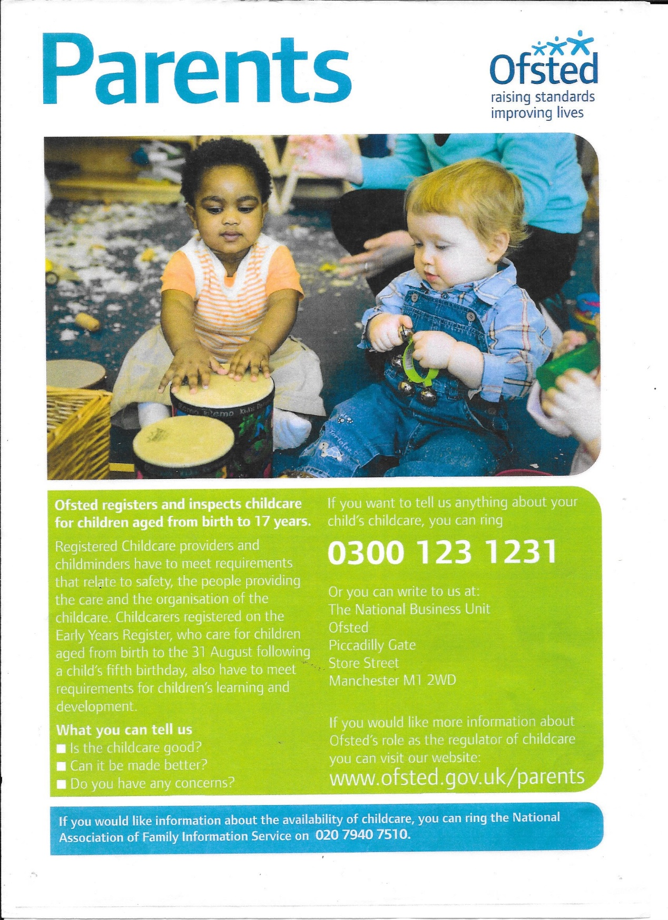
CRB/DBS 1999 – 2015
1. Suitability & Disqualification Checklist 2. Resources for Autism 16.6.2015. 3. Housing Association Agreement - verification 4.Passport 5.Bank Statement 6. Poll Card 7.8.9.10./
1.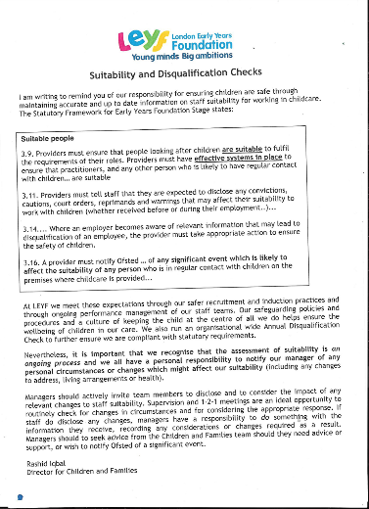2. 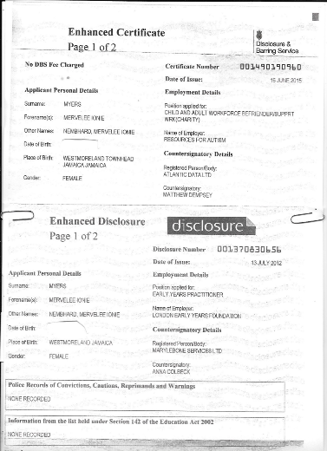 3.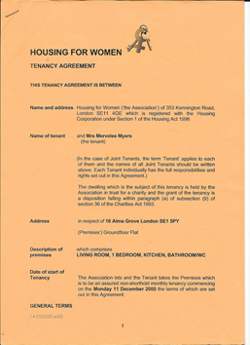
4. 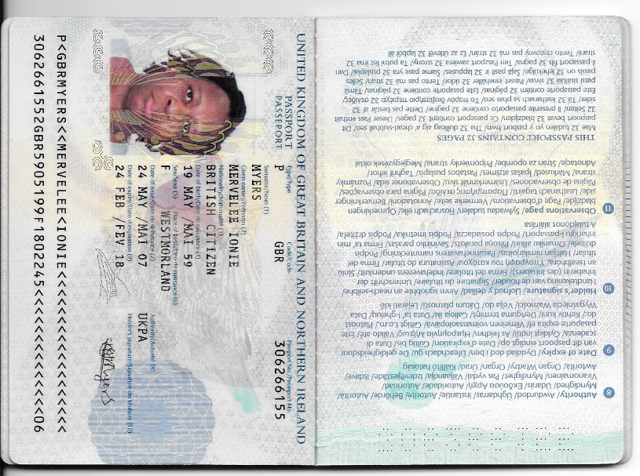 5.
6.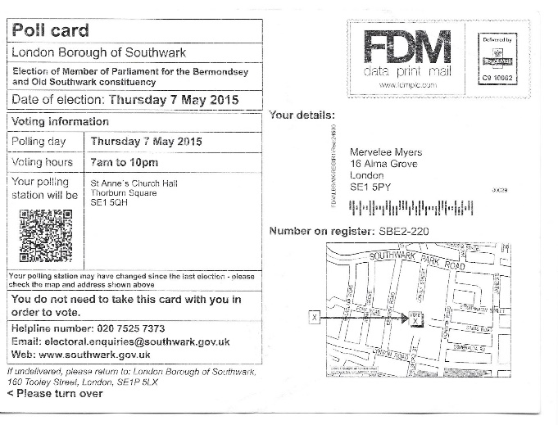7. 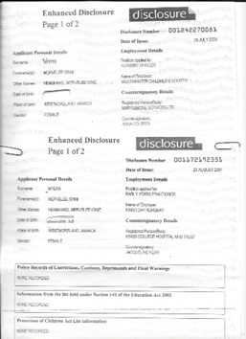
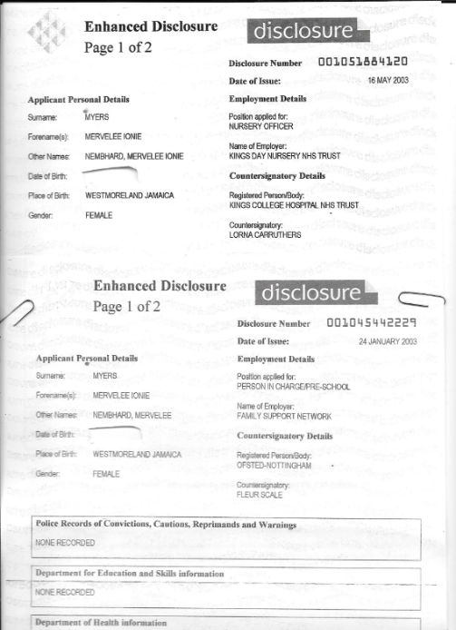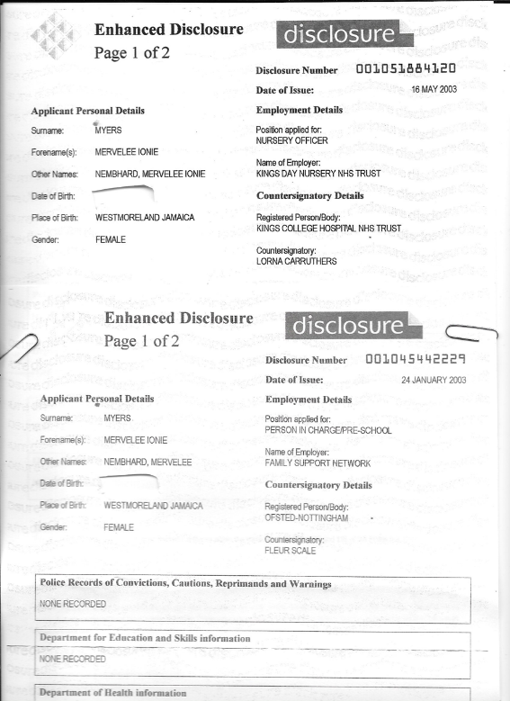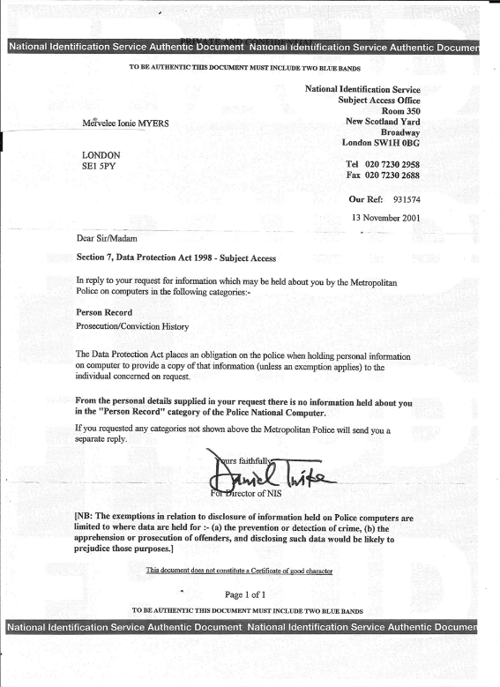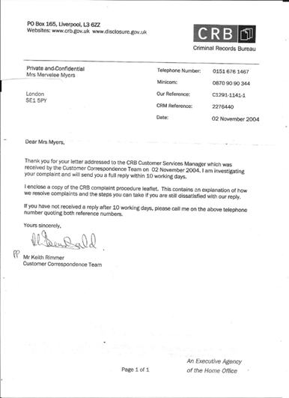
Kings College Hospital
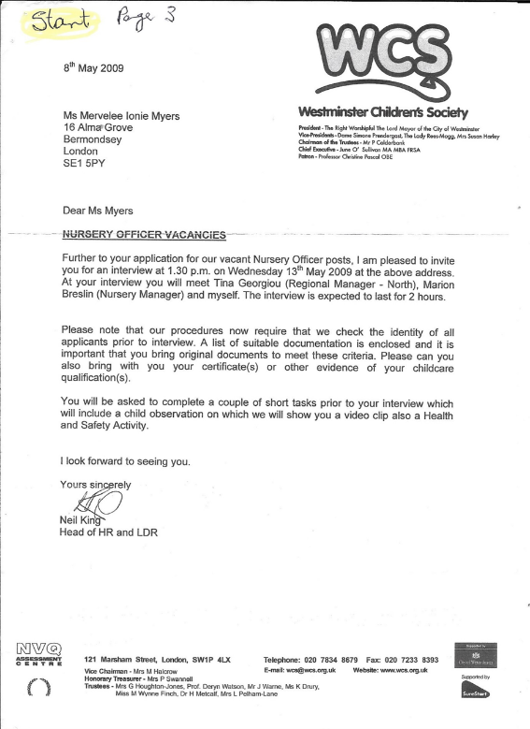
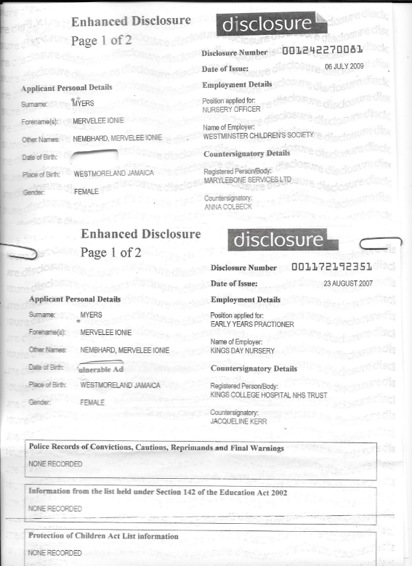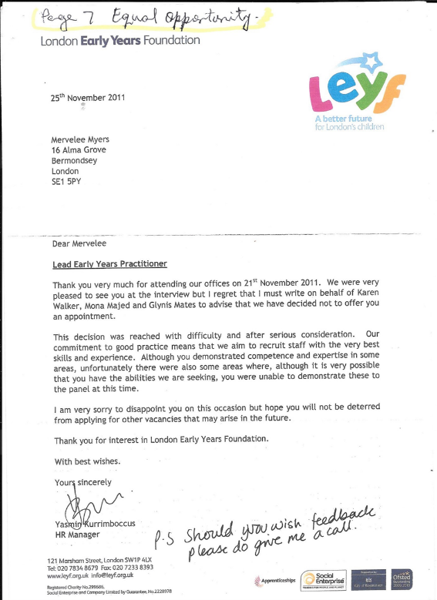
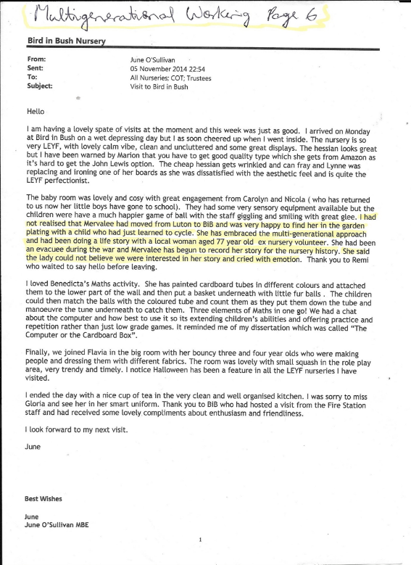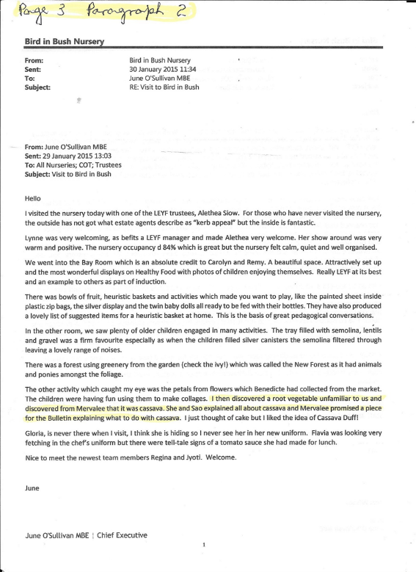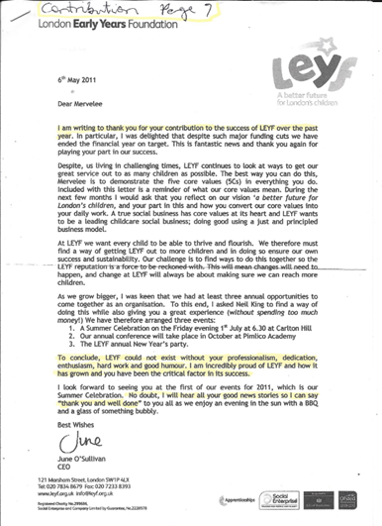
DBS Correspondences: 2004 at KINGS
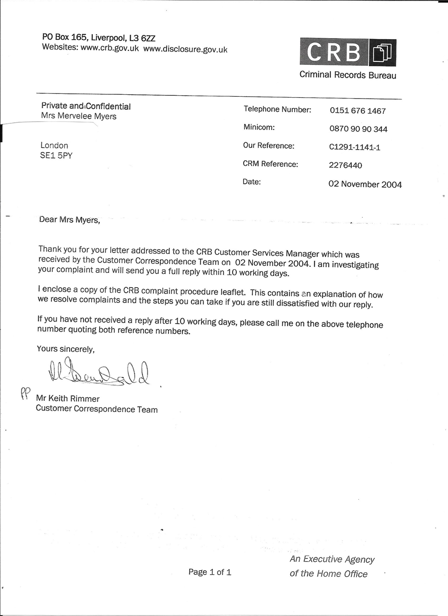
Lambeth Walk Day Nursery 1999 –
1. Noah’s Mum 2. Reference 3. Outing to France with Parent & Colleagues 4. Photos 5.Photos 6. 1st job & Work Experinces Photos. 7. Snaps of Life in UK 1992 - 8. LC certificates
1. 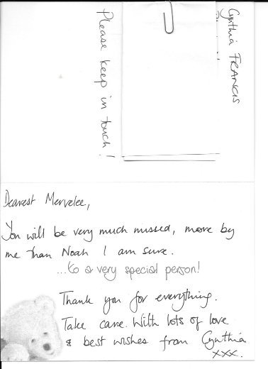2. 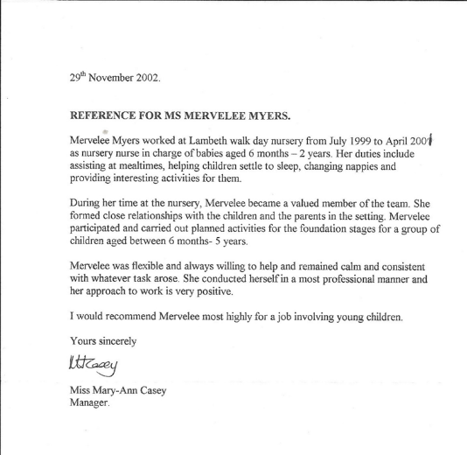
3. 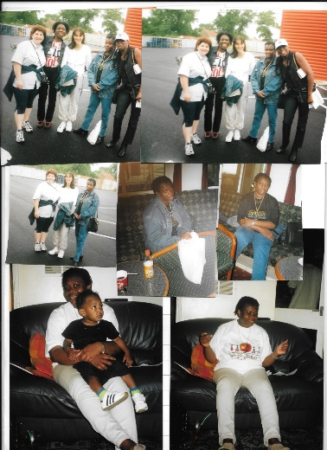 4. 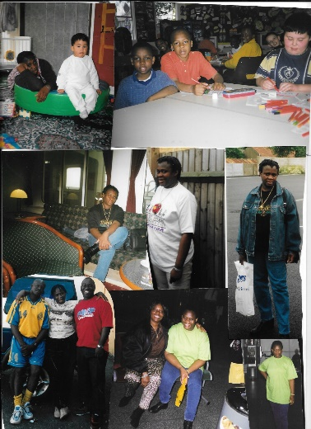 5.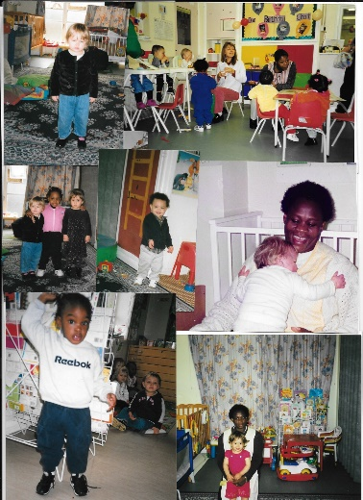 6. 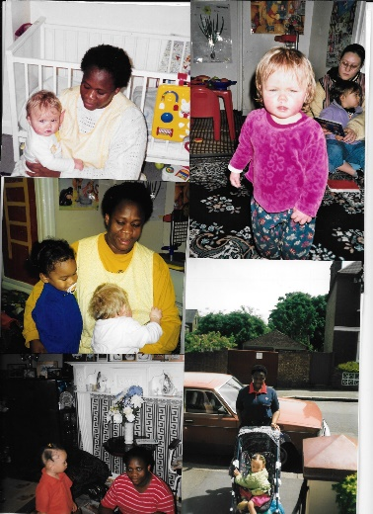 7.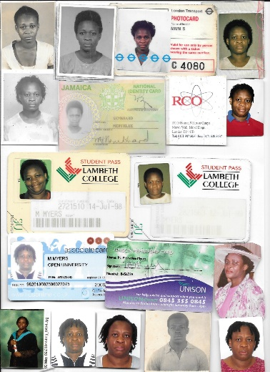 8. 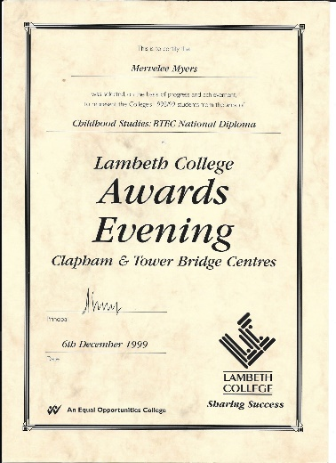
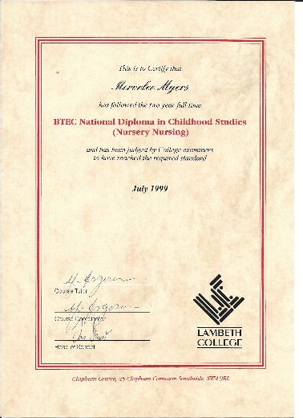Lambeth College

Lambeth College & OU certificates & PDP & Trainings certificates – 1999 - 2015
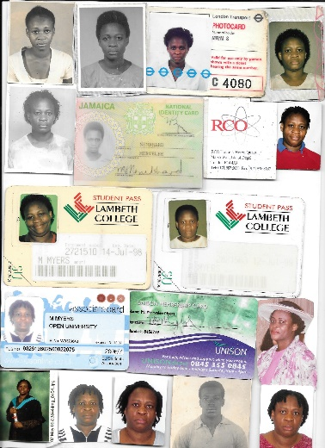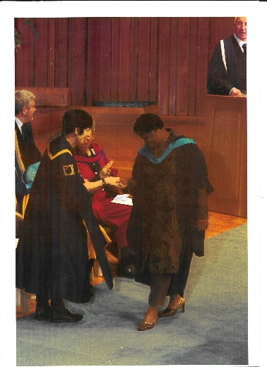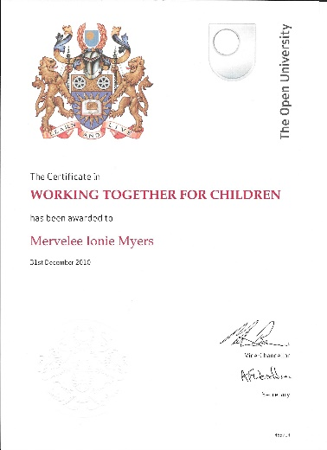

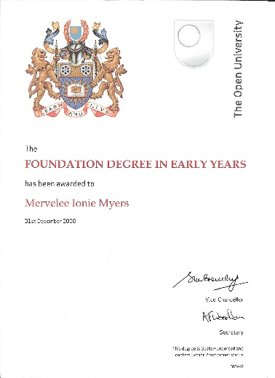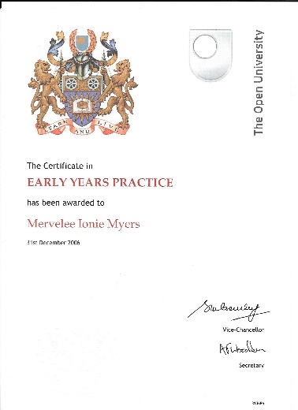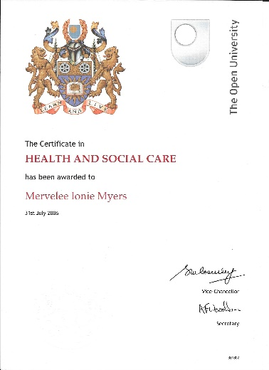
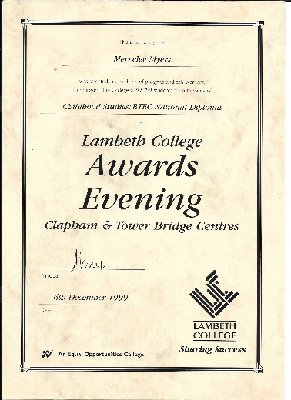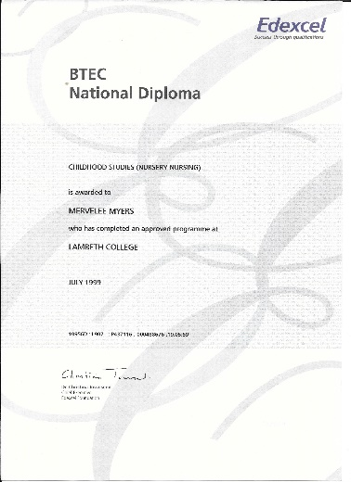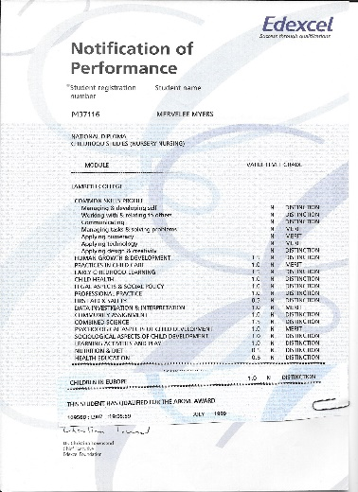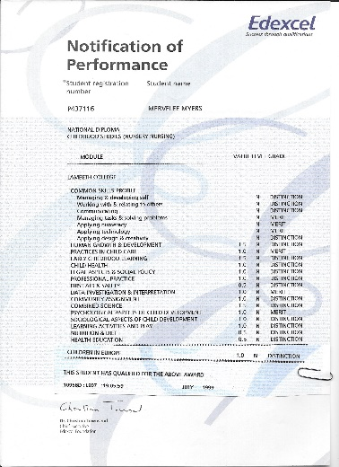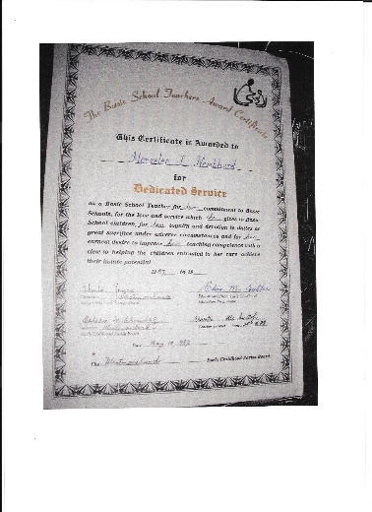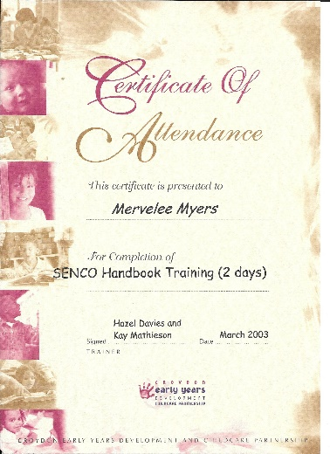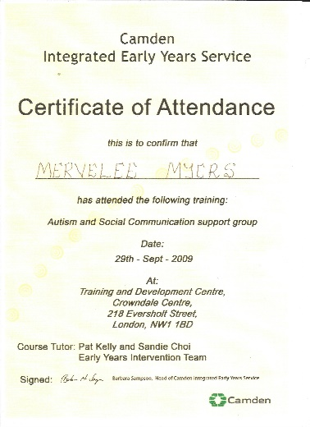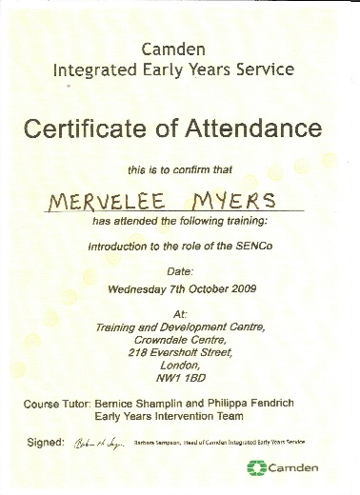
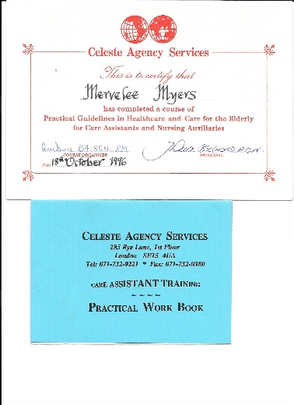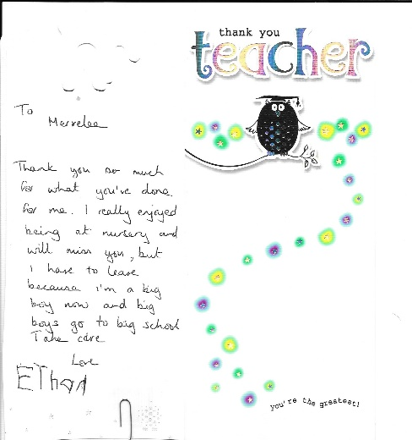

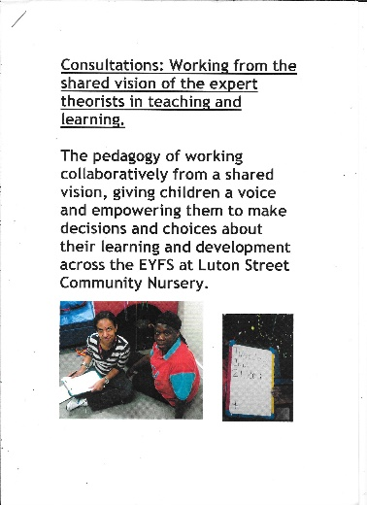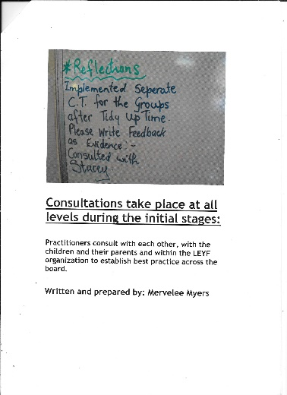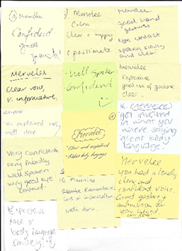
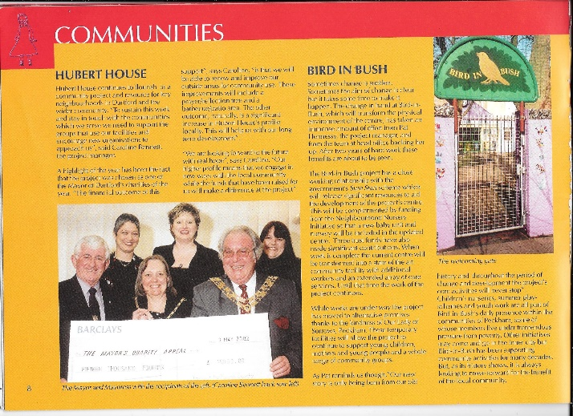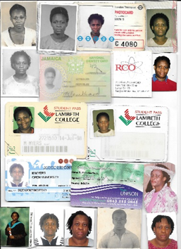
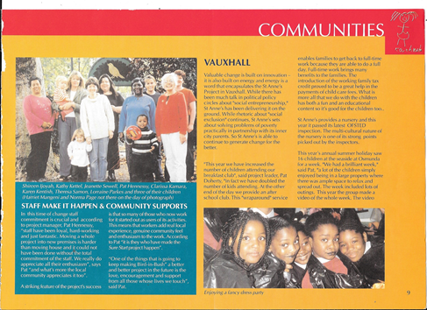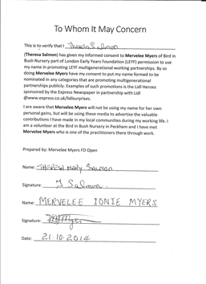
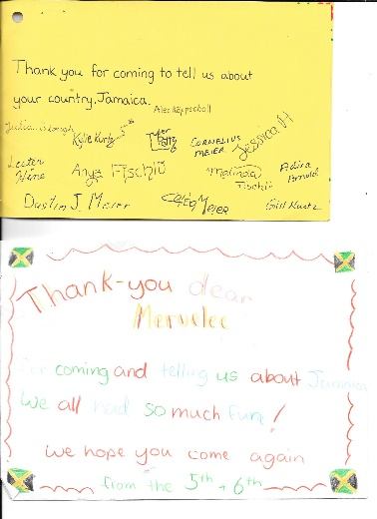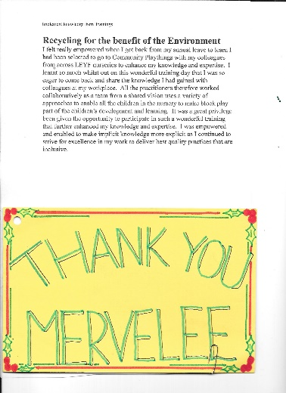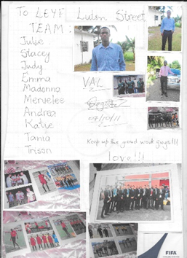
Certificates
Taking a Stance - Refusing to be a VICTIM anymore!
I arrived in the UK from Jamaica for the 2nd time 22+ years ago to what I called a land of opportunity in the Mother Country. I considered myself privileged to be afforded all of the hospitality that came my way throughout the years I have lived in the UK. I have certainly made the most of the opportunities I was granted to uplift myself from the circumstances in which I had existed in for the 1st 30 years of my life before coming here to reside! I had started working on my arrival because back in the days it was relatively easy to get a job regardless of whether one had a skill. I was doing contract cleaning in offices all over London where I met some wonderful people, some of whom were to become lifelong friends and acquaintances. Considering that I had only gained a Secondary School education that was cut short, I was always on the look out to enhance my knowledge as I had ambitions to make something of my life.
When the opportunity presented itself, I grabbed it with both hands and completed a course as a Health Care Assistant when there was a lull in the job market due to the changing of contracts. The Cleaning Contractors with whom I was working had lost the bid and I just could not adjust to the distance I had to travel and the new contractors. I decided to try upgrade myself by doing the trainings, but I realised when I went to do the practical part that this was not the route for me as I could not cope emotionally probably because of past experiences? When RCO got another contract at the BBC in White City near Shepherds Bush and my manager David Barrette contacted me to come back to work with him, I was more than happy to comply. I would get up early in the mornings to go in the City – Oxford Street, to do early morning cleaning in offices. After finishing there I would travel on the underground to get to White City for my full time job as a cleaner.
Whilst working at the BBC in White City, I was responsible for keeping some areas of the children’s work place nursery clean. Being a very observant person, I was very much aware of the happenings around me, so started taking an interests in the nursery. I therefore realised that what was happening in the nursery was similar to the type of work I had done as a Basic School Teacher back home before coming to the UK. After working long hours doing 2 jobs and travelling took their tolls on me, I realised that what I had witnessed in the workplace nursery at the BBC could be another alternative to the cleaning. My mind started working overtime and I began to think of the opportunities available to me if I decided to make one of the most important decisions that could change the outcomes of my future? I set about doing my research, hatching my bet and knowing that the final decisions I chose to make about the route I take, would impact on the rest of my life.
Little did I know what my decisions would mean for me and how much it would take for me to discover myself before finally being empowered to break free from the part in which I was to be cast – that of a Villain! There is an old saying where I come from “if me did know” and as one of my brothers was fond of saying he never used those words, but I unfortunately have had reasons to use them. Well I wish I could say the same because of some of the heartache I have experienced all these years because of my ambitions to change the outcomes of my life. On completion of the research, I decided to go to college to get a qualification working with young children because I had prior experiences as a Basic School Teacher. I enrolled at Lambeth College for a 2 years course and even thou I had applied for a lower course, because I had been out of studies and was not sure how I was going to adapt to being a student again. However when I went to sit the test for entry, the assessors recommended that I take a more advanced level course.
So with the beliefs of the assessors in my ability, I became a student again 21 years after finishing formal education in 1976 at Secondary School. With my new found self-confidence and beliefs in my ability, I attended college and continued doing my part time cleaning job to finance my way through college for the next 2 years. I told myself if I did not do well in my 1st set of assignments, I had no other alternatives than to go back to doing cleaning, but I was determined to succeed despite the odds. Still for all I was more than determined to give my best shots to anything I put my hands to despite the odds that were stacked against me and I took it as a good omen when my “Hidden Disability” did not play havoc with my ability to do the entry test. I was lucky to rekindle the passion and rediscover the thirst I had for learning and the acquisition of knowledge.
I was more than happy to know I was not one of the unfortunate ones who fell by the wayside and had to give up the course for whatever reasons. I was the model student in all of my subject modules except for Computing as this was the 1st time I was actually working with computers. In the 1st year of my studies, my assignments were handwritten and considering that handwriting is not one of my stronger features, I got some sticks from some of the tutors. Put fun and joke aside I am just one of a number of my siblings whose handwriting is almost illegible. I bought myself a 2nd hand computer for the second year of studies and I guess from thence, that was when my love of ICT actually kicked in. Of course in the beginning it was a big struggle for me, but I persevered and is therefore reaping the benefits to this day. I have taught myself most of what I can do, but I still wish I am more ICT savvy nevertheless? However I excelled in other areas becoming mentor for colleagues and felt honoured when they paid me the highest of compliments saying I should be a teacher.
My colleagues claimed that I could break down some of the subject matters into manageable bits so they could understand and make sense, ensuring it was relevant to their studies. My tutors Yvonne Fletcher, Oby Oradu, Robb Webb, Helen, Kate, et al were just some of the most inspiring teachers at Lambeth College, who nurtured all their students to reach their potentials. Some of those tutors recommended that I should go to University after the way how I dedicated myself to my studies putting my energy into completing everything to the highest standards. Unfortunately even if I had wanted to go, I could not go to University at that time because of the turmoil I was experiencing in my personal life. However I graduated from Lambeth College despite being one of the oldest student with a Student of the Year Certificate in 1999. I started a job straight after finishing studies on the recommendation of my course tutor Yvonne at Lambeth Walk Day Nursery.
I had worked in a number of Private settings after leaving college, but I can’t say I had found fulfilment and always had my eyes opened, looking out for the ideal position befitting the knowledge and values I gained from in-depth studies. I eventually got a position that I thought would give me the opportunity to enhance my knowledge and expertise as a Pre-school Leader. As a Pre-school Leader I was lucky to be interviewed by OFSTED, hence my familiarity with OFSTED procedures. Resulting from my OFSTED interview I had to undergo trainings to fill gaps in my knowledge and I benefitted from the trainings. However because the Charity I was working with wasn’t making an impact on the community and the business not going anywhere. I started looking for another job as job security was uppermost in my mind and came across the ideal job advert literally on my doorsteps. I applied and was successful and believed that there began my descent into a Cycle of Discrimination from 2003 until I was forced to resign in 2008.
Despite what happened to me at this workplace I have some treasured memories of some of the children and parents. I have kept the accolades and mementoes I was given as tokens of appreciations to the contributions I made to the children’s learning and development. Since I had embarked on studies with the Open University in 2004 and this lasted until 2010, I also had to fill gaps in my knowledge as part of my Professional Development Plan (PDP) now renamed Continuous Development Plan (CDP). The entire organisation and staff team benefitted from my studies as I was able to introduced best inclusive practices re the implementing of updated Policy and Procedures Documentations and appropriate trainings. As a reflective practitioner who developed the listening ethos, I was challenged as an advocate who worked from a shared vision to be a defender of social justices and equality. Therefore I had the courage of my convictions to make my implicit knowledge explicit for the benefit of the children and families with diverse and complex needs. However my honesty, openness, and willingness to stand up for the basic human rights of the vulnerable children was destined to see me get labelled and stereotyped.
My unfailing dedications to implementing and promoting best inclusive practices to make the workplace a beacon of excellence were viewed as threats to the incompetence of those in authority and leadership. Of course this was the catalyst that would set me on a collision course with those who viewed my knowledge, values and beliefs as threats to their outdated practices, as they refused to adhere to changes in laws and legislations. So they took my offerings from my studies and trainings implementing them as their own without acknowledging or crediting my contributions. When I adhered to the changes in policy and procedures stipulated by the laws and legislations and sought help from those in authority in house and going further afield from other professionals and agencies, the matters were brushed under the carpet and everything remained the same. But my main concerns were the fact that they were liable to use any gullible person as scapegoats when it was crunch time. To avoid this I’d presented my findings from my research studies to management as part of a “defensive practice” to exonerate myself from being complicit in not meeting the needs of vulnerable children.
When I got no results from sharing concerns internally, I followed the convictions of my courage and reported inappropriate practices via the appropriate channels, but nothing was done as I believe the appropriate channels all thought the organisation in question was untouchable. This is what has been happening in this country from the olden days when the concerns of the common people were not taken seriously. Therefore the Local Education Authority, the Local Council, OFSTED and the Trade Union decided to bury their heads in the sand hoping the problems would go away themselves if they pretend that they did not know anything about them. But when it is crunch time these same Official Body & Institutions will be coming out of the wood works pretending that they had no knowledge of what was going on and covering up for each other because they are cohorts operating in the same league. When matters came to a head these said persons colluded making allegations to cover up their incompetence and the fact that they refused to act to protect the vulnerable. This is one of the reasons why I keep saying there will be more cases of Victoria Climbie, Baby P, et al.
As for the cover up in other cases of ABUSES that are being reported, I guess the stories will not be told in my life time and some will be able to get away with what they have done. Because when people who are not power hungry enough to be in authority and leaderships report and raise concerns, they are treated like nobody and others who do not wish their incompetence to come to light will prefer gang up on them to cover up and protect themselves. I know what I am talking about because it happened to me and I nearly sent over the edge. Therefore if you have not stand or worn another person’s shoes who had to deal with certain experiences, please do not judge them. To cut a long story short, after taking a stance and following the convictions of my courage to raise concerns because I was taught that everyone is “responsible for safeguarding…” I was made to suffer for my knowledge and beliefs, as well as trying to protect vulnerable children who were being short changed. If I was not a strong person, who developed the resilience to believe in myself, I would probably have ended up in the Maudsley Hospital without a doubt.
I was listening to a programme on BBC radio 4 when I was off sick and heard this doctor discussing some of his experiences that occurred when he followed his convictions to raise concerns. Strangely enough I had similar experiences when I too raised concerns as the professionals who are supposedly there to protect people like us are trying to impose mental health issues unto us that we don’t have, to explain our behaviours in wanting to protect the vulnerable. By the time they started making allegations and getting all the persons with whom I had raised concerns involved to gang up on me, I began to question my own mentality. Although if I was confronted with the same situations again that I had gone through before to protect vulnerable children and adults. I would adopt the same stance I took all those years ago, but I would approach the matter differently to protect myself from the anguish I went through, and nearly destroyed my life. That is why I am more than willing to advise anyone who is thinking of doing what I did to think twice, long and hard? Deciding to go down that road can have an impact on one’s life from which they never recover. Because you are setting yourself up to facing years of trying times that can send one round the bend and ruin your life.
These days I am more in tuned to others who are experiencing similar circumstances to those that I have been through and lending my support to helping them over the difficult times. Believe me I have witnessed my fair share of heartache across all age groups who have experienced discrimination. Having the courage of my convictions resulted in my good name and character being blackened beyond repairs. However one of the things that hurt me the most is what one former colleague did to me when I was down and out and at the end of my tether. Finding herself in the seat of power she completely forgot our journey together fighting discriminations when it was levelled at her by the same manager who was the author of my downfall. We met at a trainings in Lambeth and ended up starting work at the same place in April 2003. She was more of a go getter who wanted to make the move fast, but the manager was not in support of this and started giving her a rough time. I was there for her lending her moral support when she started her studies with the OU and started getting flak that stripped her of her self-esteem and confidence until she resigned. We had kept in contact despite her leaving and when she told me she was no longer working, I was on the look out to help her.
When I was at the bus stop waiting and saw an advert I walked inside and told them I knew someone who would be interested. From thence I was her support network, mentoring her when she had to go on interviews, writing references and even co-signing for her to get British status. However when I was down and out and needed someone to support me, I just find it hard even after all these years to come to terms with the way that woman treated me when she was the manager. Effectively she had taken the same style of management techniques from our old manager who discriminated against us, and doing the same to me. I think power must have gone to her head for her to turn around and do the same thing that another person had done to her to me. Anyway I bided my time and when another former colleague told me that her organisation was recruiting I applied. The Lord does work in mysterious ways because the manager was the one who told my former colleague that I had gained my Foundation Degree in Early Years and put her unto me to support her.
Luckily for me I got out before things turned nasty as I could see exactly what she was up to. She even went around saying some ridiculous things about me, another case of “kettle calling the pot black” because of jealousy of course. Because I knew I had gone and done my interview and knew even before the interview was over that I had got a job, because they were that impressed with my interview. So all I needed was to get my booked holidays out of the way and I was good to go. I have had my fair share of difficulties over the years from I started working in childcare and education in July of 1999 to the present day. I have attended interviews where the interviewees are surprised to know that I could answer the questions they posed. Since I made the decisions not to turn a blind eye to social injustices and social inequalities I think I have done myself a disservice, putting myself in a position where everyone is prepared to network against me because I took a stance and challenged those who thought they were untouchable.
I have lost track of the number of interviews I have attended, some were not even brave enough to get back to me and others could not even come up with plausible reasons why I did not get the jobs. I have had persons who don’t know anything about me except probably what they have been fed via the sources of networking saying some despicable things about, but I have learned to take everything in my strides. After coming back from one of my visits home and applying for a position, and I was the only candidate shortlisted. I was gobsmacked with the reasons I was given for not getting the job. Since then I told myself that it is pointless applying for any more positions and having to suffer the indignity of having another reason like that for not being taken seriously. Therefore it is not worth the kind of demoralisation that I have been through over the years to try and change the perceptions that others have been given about me. I am more than contended with my life as it is now and I have found other interests to keep me focussed and derived some satisfactions.
My problems with some people at present is the fact that they still want to see me as threats to their positions because of my knowledge, values and beliefs. I have vowed not to apply for any other positions going and even when I made it clear that I have none of the ambitions to be anything other than I am at present, no one seems to want to believe me. Therefore I am still getting the aggravations from those people who can’t believe I don’t want to be in a position to look down on others and treat them less than a human being. I can deal with the people whose intentions are out in the open, but find it hard to deal with others with ulterior motives. The ones who have their hidden agenda, axe to grind and are plotting your downfall, for no other reasons than they are jealous, takes the biscuit. Therefore I prefer to run a mile from them rather than go through what I have gone through during some of the past 22+ years of trying to make a life for myself and my family. So for years I have been trying to get out from amongst certain individuals who have set out to wind me up the wrong way in order that I fall in the trap they have set for me.
I thought I was strong enough to handle anything that came my way, but after that incident in 2008, which resulted in my fall from grace, my confidence and self-esteem were shattered beyond repair. I have had to deal with lots of personal problems which affected my health and emotional wellbeing, but when I realised how I was been stitched up by a certain individual whom I had taken under my wings, mentored and taught her practically all I knew because she is one of us. I began to have a rethink and just could not believe that lightening could be striking the same spot over and over again as in my case. Then when I heard another individual who was in position of authority hiding behind the rhetoric of bureaucratic red tape and abusing her powers and trying to stitch me up too when she thought I was not around. In my estimation I was with that individual all day, so if she had concerns, she should have addressed them with me instead of going behind my back to make enquiries. Since she never had the guts to bring up the matter with me and was using underhand tactics to get her ways, I thought I had to become weary of her intentions towards me as well.
However knowing my luck, if I had taken the matter further, I would more than likely be put in the place of the trouble maker and instigator as I recalled being told that whatever your manager tells you to do you must do. When I asked the question even if they are wrong, I was told yes I must comply. Knowing my temperament and how I get emotional when I am upset I would be accused of having attitudes, being aggressive and using body language to intimidate them! Is it any wonder the society is in the state it is in today? Because when it comes to some there are others who are quick to make excuses for their behaviour, but when it is people who they have attached labels to and stereotyped as so called trouble makers without knowing anything about them, then you are aggressive, etc… So realising that I was once more staring down the barrel of a loaded shot gun, I had no alternative other than to get out before history repeated itself?
I was prompted to take this subject on because of another penultimate day in my life when I knew without a doubt that I have to stand up and fight for my freedom. If I had refused to take that stand to defend myself from allegations and insinuations, then I would forever be looking over my shoulders and always on the run from that cloud which engulfed me from 2003 when I started working at a particular organisation. Anyone who knew me before when I had ambitions to conquer the world and get ahead in my chosen career field would understand why I became a changed person after my experiences which nearly sent me over the edge. Coming back to work in South London since I left in 2009 has been an emotional rollercoaster for me. Therefore I tend to want to keep a low profile so as not to deliberately step on anyone’s toes and upset the applecart. I know time is the master and whatever is done in the dark will have to come to light one day. I am getting older as well and some of the things that were important to me when I was younger, fit and healthy are no longer on my lists of achieving. My parents are dead, my children are grown and doing well, my grandchildren are continuing to fly the flags high and I am contented with my life.
As surely as God is my judge master time is slowly catching up with those unscrupulous individuals, organisations and governing bodies that colluded together and masterminded my downfall and caused me to suffer all these years. Already 3 out of 4 settings run by the same organisations were judged by OFSTED to be inadequate and as God is my judge, I know more heads will be rolling, it is only a matter of time. When the realisation of what was about to happen to me again flashed across my brain, I had no options but to throw all cautions to the wind, stand up and fight to save my good name and my dignity. I had stopped trusting some people, but had decided to put my experiences aside and begin afresh. But once I let my guards down someone with ulterior motives and an agenda had it in her head that she was going to make her marks to get into the good books of officialdom by using me as a scapegoat. But by God she didn’t know who she was dealing with and there was no way in hell I was going to let another upstart turn me into a VICTIM to climb their way up that career ladder like others have done before her!
I had made the decision to do what I have to do to survive, mind my own business and get on with my life, but I began to smell a rotten fish when the queries keep coming hard and fast from one particular person and this really started to get my back up when I was being singled out to be treated like a naughty child. It slowly dawned on me from this person’s behaviour that the rumour and networking mills were wide opened and I am the target because the queries only came after she has being around certain individuals. Even then it didn’t clicked how much this person had it in for me until an innocent incident occurred to do with my health conditions. This person grabbed the chance to play her hands, but she did not know me enough to know that I don’t always take everything lying down. When I heard how the matter was blown out of proportion and realised the stage was set because officialdom was in the next day, I blew my top. Apparently she was well versed into how to go about provoking me into a reaction.
Suffice it to say I dealt with the matter the only way I knew how despite the threats, because I am not easily scared of no one who is prepared to abuse their power of authority and try to make another person’s life a living hell. My parents made sacrifices throughout their lives and had to fight and overcome prejudices. They brought me up to fear God and live by the principles of the Bible, so if I had continued running instead of standing up and fight with the best tools at my disposals, my knowledge, values and beliefs. I fought for my basic human rights not to be discriminated against because another person feels the need to be jealous of me for no apparent reasons. I would be letting my parents, my children, grandchildren and myself down if I did not have the courage of my convictions and stand up for my rights. Although I was getting threatened with hell and damnations for taking a stance, by this time I was so mad and did not give a damn about the consequences.
There was no way in hell I was going to let another self-serving jealous person who felt threatened by my knowledge, values and beliefs and was in the process of doing what others had done years ago to destroy my life get away with it, over my dead body. Now more than ever I will be on the alert and looking in all directions to where the enemy is coming from. My mantra remains no one is my friend, so trust no shadows after dark. I may look like an idiot, but I am afraid to disappoint anyone because I certainly am not an idiot! My dearly departed Mum used to tell me from I was a child “when you see them running on their 2 feet, jump on your 1 & ½ and go on…” I know the race is not for the swift, but those who can endure it to the end. It is a sad indication of what society has come to when some people think it is acceptable to hide behind the rhetoric of bureaucratic red tape, abusing their power of authority and making the lives of persons who are passionate about what they do, want to throw in the towel and give up.
The thing that hurt me the most about this whole matter is the fact that Women stand guilty of discriminating against their sisters as they are dead set against seeing their sisters rise above the parapet, succeed and escape from the circumstances in which they were born. These unscrupulous, jealous women do not care about the underhand methods they used to drag their sisters back down to the bottom rung of the ladder and the impact their actions can have on the persons they are undermining and their families, as long as they can elevate themselves to the top. Hence as my granny used to say “the same stick that lick black snake will lick the yellow one or same knife that stick goat will stick sheep.” I have been looking over my shoulders since that date in 2008 and not because I had done anything wrong, but because I had taken a stance to try and make the difference for a vulnerable child. However the same way how others were let down by the system because some of those who were responsible for protecting the vulnerable preferred to turn a blind eye when concerns were raised.
Then these same persons turn around and used tax payers money to pay for investigations after they closed the gates after the horse bolted. My old folks used to tell me that “you cannot force water uphill because it will come back down and probably drown you?” Now I believe it is time I stop letting ungrateful people stop using me as a door mat. So as of now I refuse to let anyone make me into a victim. I have had years of preparing for my roles in life from an early age and now that some of the most important persons in my life have passed on. I am left with my elderly husband here in the UK and I have had some trying times coping with his health conditions. Therefore when I developed some of those same health conditions, it is only natural that I am going to try my best not to find myself in some of those scrapes that I had to learn to revive him out of. So when someone is going to use my health condition to try and pin something on me because they have an agenda to stitch me up. I am going to fight hammer tooth and nail to regain my dignity at whatever cost. So naysayers better be aware that I am no push over, I am slow but sure and I will get to an enlightening in the end. So when they are digging their pit, I would advise them to do their research and think twice because I am prepared to fight for my Rights not to be a stooge for anyone.
I will end by thinking about some of Bob Marley’s songs one of which I recorded only this year to share on Social Media in celebration of Black History Month – Emancipate Yourself From Mental Slavery. The song that goes with my current situation is – Get Up Stand Up Stand Up For Your RIGHTS. All these things that WE are going through were happening as far back as Biblical Days and the Prophets and Visionaries like Bob Marley were singing and telling US about what we need to do to break free from those Cycles of Oppressions and Discriminations. So no more will I allow anyone to make me suffer to feed their twisted Ego in order to make themselves look better than they really are. From this day forward I proclaim I am covered and washed by the blood of the Lamb. It was a sad day when Adam and Eve decided to eat from the Tree of Good and Evil and realised that they were Naked?

Stuck in a Rut 1st November 2015
This past month since I was once more suspended in order for them to carry out their “vendetta to get me out of earning a living” I find myself stuck in a rut and just not seems able to find my way out of the limbo that I am stuck with. But I give them the final “laugh when they called me into their Central Office for a chat” and believe me I laugh loudly in the 2 idiots face and never made fun to tell them exactly what I think of them – 2 THICKHOES without 1 iota of common sense between the 2 of them. King Kong and Silly Diggle-Diggle are 2 of the Dumbest Persons I come across in positions of authority and leadership who don’t know the first thing about the job they are in charge of even if the jobs descriptions were written in tablets of stones like in Biblical days.
But I don’t know what else I’d expected after knowing what I heard about King Kong and his ilk. When I challenged them for trying to harass, bully and intimidate me by mentioning what happened with the Union Rep who disappeared off the face of the earth after attending the Disciplinary Hearing with me. King Kong got fidgety and asked if I was saying they got in touch with the Union. But King Kong should have hold on to his horse before becoming defensive and exposing himself to be a liar like the Union solicitor who they get to call me to tell me not to resign after they got rid of the Union Rep. Then when I said I would use my Pen that is mightier than the sword to tell my story because might can’t beat right King Kong once again exposed his hands and asked if I was going to use Social Media.
Although they got me to Central Office under false pretence – for a chat, it was nothing of the sort. So they ended up issuing another Suspension with the documentations to come later. So I gave them what they wanted and RESIGNED (see letter). The dirty bitches and bastards then set about spreading more lies about me telling people they sacked me. Then when they were caught out lying they changed the tunes saying I’d left to work with older children. At the same time they were having up to 5 Supply Staff in the setting, breaching their own Policy and Procedures documentations and OFSTED and the EYFS Welfare Requirements. They refused to renew my CRB/DBS, treated me like a criminal after working with them for 6 years, yet they were leaving complete strangers with the children.
Parents complained about lack of continuity, familiarity and consistency, but all they done was make excuses and pass the buck. Because that’s how the system operate as they micro managed in order to meet managerial targets. In their foolish calamitous minds they then panicked and got their solicitors to contact me sending threats. But little did they know that I already knew about the existence of the solicitor. I was reliably informed that my missing file that went AWOL mysteriously after I transferred from Luton Street was in some solicitor’s office for them to try and build a case against me. So I was not surprised when they got the solicitor to show their hands with a threat about Social Media.
The mistake the solicitor made was to let them pull the wool over his eyes without question them further. But I am guessing he is a biased as they all are and not worthy of his title for being taken in by liars and vagabonds judging others when they know absolutely nothing about us. I will let them know now that I am a unique individual who refused to be defined by some corrupt person who don’t have the common sense to question the motives of why one big organisation like the one that employed them would want to take on a single individual like me. But the solicitor made the cardinal sin of not doing his research so ended up in the shit and I consider him to be of the same calibre like them without any spine or backbone.
Although I was thrown by the letter I wasn’t unduly bothered because I knew like the first time I have my documentations to back up my arguments and I learned from my past mistakes. The first mistakes the solicitor made in his threatening letter was to get my address wrong and the rest is history. I have since sat and wrote 4 letters only editing and changing them round a little. I got reply from the people that matter the most, but I’d like to know why the solicitors who were so quick to issue threats have gone quiet all of a sudden. Did the solicitor advised the organisation to withdraw the fraudulent online application made in my name using my email address?
Since I have had similar experiences from others in similar positions before I have to come to the conclusions that this is how these professionals operate and I can’t expect any better from them. But is the solicitor now keeping a low profile hoping I am going to disappear like the Union Rep without trace. Well I’ll be exposing the whole lot of them by the time I am finished because they never stopped to think twice when they set out to destroy me. I am suffering the consequences of their inhumane acts over the past year and they won’t be allowed to get away with it. So I have a paper trail that I will be using to support my arguments of Direct Discriminations and the solicitors will be named and shamed too because I have that one incriminating threatening letter from them.
Maybe they can turn the heat on those evil people who got them to threaten me because when I am finished the public will know about the ratbags that they are who pick on vulnerable people like myself for monetary gains and to appease their inflated egos. I am self-taught and never had much of an education because of the deficits and limitations that caused me not to achieve my potentials, but I am no fool. Dem can walk dem foot come Trouble mi at dem Perils and dem wi find out wey water walk guh a Pumpkin Belly. Anyone keeping up with my life story knows how hard I have struggled to reach where I am today. I have my insecurities but I have managed to live and cope with them my entire life until the evil bitches and bastards take set on me to try and destroy my life with their false allegations and labelling.
But I will not allow them to get away with it over my dead body. So all those who are in on this better be warned because your name will be appearing in the public unless they do the right thing! No living thing deserved any of the ill treatments I endured at their hands for a period of a year. Now I am a shadow of my former self trying to pick up the pieces and moving on with my life and they really believe I should let them get away scot free? No sah nutn nuh guh suh atall. I kept myself circumspect and they walk foot come molest and bother and mistreat me, so they will have to pay the consequences.
I hope one of my grandchildren decided to take up the legal profession. One son is TEACHER & Fifa Referee and the other is Accountant & Aspiring Politician. I am a Mouth Smith with Leanings towards Telling the Truths no matter the consequences. I have paid my dues so time for me to collect my rewards for all the work I done that they didn’t pay me for. I am now unemployed because of them and they think they get away and don’t have to give an account, but they make a sad mistake. Mr Solicitor please don’t think by not answering me that you have gotten away with joining in to discriminate against me! There are many masquerading as wolves in sheep clothing and others who pretend to be who they are not committing white colour crimes. Yet they are quick to point the finger, but I’d admonish them to pick the moat out of their eyes before trying to pluck the beam from the eyes of another.
Enough said evil doers I am coming to get you and I am armed with my paper trails and maybe whilst I am stuck in this rut I might just like to find out if anyone is interested in my story of how the other half persecute the weak and vulnerable and try to make them a victim and scapegoat.

Taking Back Control 27.03.2016
After the ordeals I was put through by the former employers from 23rd July 2014 – 27th September 2015 and there is still no end in sight for the continuing discrimination, I have now reached the stage in my life where I am forced to take back control. On the day that I am remembering my brother BYRON I have no alternatives but to revisit another time and place when I was put through similar discrimination by another former employer which caused the onset of the “Mental Health Issues” from which I cannot escape no matter how hard I try. Back then as now, I warned those evil persons involved in the discriminations about what they were doing to me. But they got away with murder because they thought they were above the laws, had friends in high places who were prepared to cover up for them and I was not as knowledgeable about the laws like I am now.
Having always work from I came to the UK, it felt unnatural and strange when I was out of a job again. Although I was hounded out despite trying for over a year to hang on in there until I sorted myself out so I could move on. I immediately started to get back into working as work kept me going. So once more I found my life in tatters as I’ve always worked sometimes doing 2 jobs just to make ends meet. I had responsibilities and I am one who is accountable in doing my very best for those who are relying on me to deliver. Since the Mother Country was always recognised as one of the countries of opportunities that people from across the contents travel to, to better themselves, I made the most of my chances.
Being able to supply food, clothing and shelter for self and family will enable one to provide the other ingredients for the welfare and wellbeing that make for a better life. Therefore if the basic needs are catered for and met, then naturally contentment of faith, hope and charity will fall into place. Ever since arriving in the UK, I set out to better myself as well as helping members of my family to better themselves via the economic capital I was/am able to contribute. There is this strong urge in me to escape the poverty that dogged and blighted my life from my dad took sick and was made redundant when I was only young.
Therefore once I had the opportunities I set about working and educating myself. Of course I was making up for the missed opportunities that left gaps in my knowledge. My thirst for knowledge far exceeded anything else and I set out to make amends by embarking on studies to gain recognisable qualifications to give me a leg up the career ladder I’d chosen. I’ve spent the best years of my working life laying the foundation caring for and educating young children in my native Jamaica and the UK. I’ve always had ambitions to become a graduate. However I am not cut out for doing examinations as I said to the counsellor.
I have what I’ve always called my “Parkinson Disease” because of some of the transitions I’ve been through from 10 years old. I am learning now not to say I have “Parkinson Disease but Chronic Anxiety” resulting from some of the traumatic experiences from my childhood into adult hood. I usually get frustrated when I am sat in an examination and my brain and other developmental attributes refuse to work together. So the ideas/answers will be floating around my head like a flashbulb going off, but my hands would refuse to corporate and coordinate. Therefore I was unable to control my finer motor skills to write down what was in my head.
I struggled through at times beating myself up mentally each times I failed at the big moments like examinations and interviews. But coming to the UK was going to be the making of me when I discovered the Open University. Studying with the OU gave me the chance to manage my time and work at my own pace. I enrolled and started studies in 2004, became a graduate in 2009 and done my final course in 2010. Despite my achievements my struggles were not over, but I was somehow in control of some of the outcomes of the targets I set myself.
I grabbed the opportunities I was offered with both shaky hands at the time and never looked back. I set the targets in manageable chunks so I would no longer be a failure like in my school days. I was on the road to becoming the person I always wanted to be. I managed to become a graduate just in time before my 50th Birthday in May as my graduation was the 2nd May 2009. After developing my Professional Development Plan throughout my time studying with the OU, I realised I could have been the teacher my colleagues at Lambeth College told me I could become. But over the preceding years to follow I was to look back with a few regrets at the way I was treated by an unjust system.
On reflections however I must conclude that the setbacks I’ve encountered were/are more to do with what my old folks called plain bad mind, grudgefulness and spitefulness on the parts of some. These are the red eye persons who just can’t stand to see others try to better themselves and prosper. They see anyone with ambitions as threats to their own incompetence. They are not prepared to make the sacrifices and the efforts to get out of the malaise and stupor to enhance knowledge and upskill to be better able to perform at their jobs. So they do everything in their power to knock the other person down for trying.
Because they are so afraid of their own ignorance that they believe once another person over whom they have authority upskill themselves and update their knowledge, they will be identified for the frauds that they are. They are only figure heads that are being pulled about like a puppet on a string by some other controlling freak without any iota of sense or knowledge about the roles and responsibilities they are in charge of. So everyone is covering their backs and hoping not to be found out. Then they apply the rhetoric and bureaucratic red tape wrapped up in their stringent Provision, Criterion and Practice to always keep you at the bottom of the career ladder.
They get you to do their work, and don’t think twice about taking the credit as they try sweetening you up with some little flimsy accolade that is not worth the paper it is written on. You train the staff who are then promoted into leadership positions. But strangest of all you have to wait on those you trained to ask their permission to carry out the roles and responsibilities in the job description of the contract you signed all those years ago. When you realised they do not have a clue what they are doing even after you went over the tasks 100 times and told them to go shadow others. Then they decided that they have to collude with those others who are not making progress to make your life a living hell. So the discrimination starts subtly until they ruin your health because they want to get rid of you.
I have had my fair share of encounters with these unscrupulous tyrants over the years. The first time I stand up for my rights and paid the price with a career stopped in its track and have not moved since 2009. My health was impaired and I became Public Enemy Number One in almost every borough in London that I tried to get a job. Eventually I got through an interview where my knowledge and expertise shown through before the end of the interview. However not long after starting what I thought was going to be my ideal job, after years of upheavals and struggles in a workplace challenging social injustices and inequalities and paying the price. I was in for another shocker, when the green eyes monster – Ms Jealousy MG reared her ignorant head.
I started at this workplace with a Foundation Degree in Early Years from the OU in September 2009. I just got on with doing my best and my efforts were rewarded by the professionals who gave me the chance to develop my Professional Development Plan (PDP). I was sent on trainings and I got the chance to work in partnerships and alongside to gain the hands on bottom up approaches that I needed to be able to do the work required. I was mentoring others who were studying as I already pass through all those stages. But I guess as was to be the pattern of my life for the next couple of years, instead of others viewing my knowledge and passion as something to be celebrated, acknowledged and valued. I was once more viewed as threats and was to be targeted and got rid of by fair or foul means. Yet again I was left fearing for my future, emotional wellbeing and the capacity to trust anyone, especially the female of the species.
I was rescued by an unlikely source, a colleague I’d worked with before when she was only a teenager and I starting my first job in the early year sectors after graduating from Lambeth College. I worked at William Wilberforce Lambeth Walk Day Nursery in Kennington straight out of Lambeth College July 1999 – April 2001. I was Room Leader for the Toddlers and I liaised with tutors about students on placements whom I mentored. I see some of those students who have gone on to make advancements in their career and moved up the ladder. Instead I am worse off in this business than when I graduated from Lambeth College in 1999.
After working with this teenage former colleague we eventually ended up working for the same organisation when she recognised me one day when she saw me at the new workplace. If it was left to me I am sure I would not have made the recognition? So she was one of the youngest manager in the organisation and I was happy for her interventions at the time. Because without her timely interventions, vouching for my integrity as a professional, I don’t know what my story outcome would have being. By this time the unfair treatments by the Green Eyed Monster who was joined by another Sorry Excuse for a Human Being were beginning to take their toll on me.
But I was destined to find shelter in North West London at Luton Street Edgeware Road where I was to work for the better part of 4+ years. I was privileged to work with some exceptional professional colleagues, some of whom I mentored, supported and nurtured through the good and bad times along the way. I was always there for them no matter what because by supporting and encouraging them to reach their potentials. I got the satisfactions of being part of their achievements that I was never allowed to gain despite my passion, dedication and contributions to making the organisation the beacon that it was becoming. Looking back I was never given any opportunities in any of the jobs and I kept on moving, hoping I would be recognised for the hard work I contributed, but to no avail.
Usually I’d lick my wounds each time I was turned down or over looked because by this time I was learning to sort of realised that I’d have to cope with the rejections that were bound to come my way. I know to just get on with the job that was expected of me and be grateful I have a job. I was presented with opportunities in Luton Street to work to my potentials once my passion, talents and creativities were identified by my colleagues. But as always I had to learn how to take the good with the bad as there were days when I was knocked from my perch by others just to show how powerful they are with the status they were given. Some of them set out to prove their authority after I mentored and trained them, but by this I learned many valuable lessons and was resilient to cope with any and everything.
As we all know there are stages that we all go through when others are controlling our lives in terms of providing a job. There were times when I reached rock bottom but knew I could not stay down and had to get back up and fight for what I want. There was that time where if I did not develop coping mechanism I might have fallen over the edge of despair, but I overcome and got back on my feet stronger than before. I was the only staff shortlisted from the organisation for a Lead Practitioner Post. I heard about the post at the Staff Conference after returning from holidays in Jamaica November 2011. I had high hopes of getting the job only for the rug to be pulled from under my feet. However I refused to let that keep me down and rise above the challenges making changes to my life to help me develop my Continuing Personal Professional Development Plan (CPPDP). In order to stay one step of the opposition and not let them get to me, I knew I had to be better than them at all times. Therefore I am always enhancing knowledge that is power. I am always doing my research, attending trainings and conferences, whatever there was that were going, I would be in attendance. Because I already know what my vision is and I have plans to achieve my goals in making my dreams become realities.
When I faced the disappointments Y q

Lest We Forget 7th November 2015
As a child growing up in Jamaica, we always celebrated “POPPY DAY” ON THE 11TH November. And although I do not have much memory of this “Remembrance Sunday was celebrated with much zeal to honour those who fought in the “World Wars” and I guess that’s all I can tell anyone about the history of the celebrations back then. That’s why I am going to continue praising the “power of knowledge” and the impact of me “enhancing knowledge has had on my life” from I came to the UK. Fast forward to 23 years ago when I first came to the UK and I am telling anyone that my knowledge was so limited that I can claim I was very ignorant. I am big enough to chat my chat about myself and I refuse to take back any of my chats. Because contrary to what some of those “ignorant detractors” would like to make me out to be, I always was the same person I am today and was yesterday.
Therefore I won’t let any of their “negative discourses” cause me to wonder if I am not the genuine person who left Jamaica 23+ years ago to make the most of the opportunities that I was gifted with. So lest I forget where I am coming from, I am going to continue living my life from the values and beliefs that my parents brought me up with and don’t let anyone tells me I am not genuine. Of course I have to accept my faults and failures as the cussing “bad wuds” and all those other things I do to help me be me, person who I am. As we are about to celebrate another “Remembrance Sunday” and since I have plenty of time on my hands. l think I am entitled to use that time wisely to tell the story of those Jamaican who made valuable contributions to the “World Wars” in their own inimitable fashions.
Now I have to start with the only Jamaican person I knew who fought in the “Battlefields to help secure our Freedom” not to be discriminated against in no shape nor form. Mr Reziel (and anyone is entitled to correct me if I spelt the name wrong) aka “MASSY WELCH” was the closest person I’ll ever come to know who was directly connected to and involved in the “World Wars” and I learned the information from the TV. Therefore here is the proof that every single thing have uses in life. It is down to us the individual to use whatever media for good and not evil/bad. Knowing how much “my parents revered their family ties” I owe it to my mother’s memory to tell the story as little as I know it, about one of her family not related by blood. Although mama is only related to Mr Welch by way of marriage, she was very proud of her links to every single one no matter their status in life.
So let me clarify that mama prided herself on being the cousin of “Mrs URA HEWLING-WELCH” and might give me a sign if I don’t let that knowledge be known. Where I come from in Westmoreland Jamaica, everyone was related in some shape or form. Therefore I am taking “bragging rights” to pay homage to mama’s cousin Ms Ura’s husband Massy Welch, who was a colourful character and figure in our “community of Townhead Westmoreland” Jamaica. It would be amiss of me if I did not mention “Caney, Hewling Town” that was the birthplace of mama and where my sister - Yvonne, mama’s other daughter and her dad – Claudius were buried. Caney was packed with the history of my parents’, family and who is who in the community.
Before I go any further let me salute mama’s cousin Ms Ura and Massy Welch’s offspring and hope they approve of my little story? Those that I have to make mention of are: Loy aka Patrice Scott, Lennon aka Kirk Tallah Welch, Kim aka Heidi McGann and Pam from Mother Hinds clan. Now I set out try and do justice to a story that is close to my heart, especially because of what I’ve had to endure at the hands of some “Racist, Bully, Low Life Thugs” this past year. This is even more harrowing for me because all this started not long after coming back from Jamaica where I’d gone to put mama to rest with all my “loved ones who’d gone on before” and others I trusted gave their approvals and joined in to make my life a living hell.
If I never took the final steps to put an end to my suffering, I might not be here now writing this story in memory of those veterans who make such great sacrifices for us to be here today as free people. I just know enough about the World Wars I supposed to get by in life and back then apart from celebrating “Poppy Day” I doubt very much that it was important for me to learn about the “nitty gritty” of History, Geography or any other subject for that matter because I was not a teacher and probably had a one track mind. Knowing about the history of the World Wars were not that important to me and many more like me. As long as we wear our Poppy to “celebrate the bravery of those men and women who fought and gave their lives to protect our rights to live in a free society” I’d done my bit.
This was enough for me until another year when the usual fuss was made about important dates in the annals of history and I leave well enough alone. Knowing what I know now I blame the powers that and hold them responsible and accountable for short changing us of our education. Because I believe it was downright remiss of them not to have taught us about the feats of the local heroes, living amongst us like Mr Welch, who played such important roles in shaping the world history. It took me coming here to live in the UK when I was already in my 30’s and watching a programme on TV – Ground Force to identify one of the locals from my community to learn that he was a “War Veteran” who sacrificed his life for Queen and country.
Mr Welch was living in the community where I was born, bred and lived until I immigrated to the UK, yet I knew absolutely about his feats fighting in the World Wars. I believe it was a dying shame and someone done Mr Welch and all of us pupils a great disservice for not documenting his life story as part of the curriculum for us to have learned in school. I was living at 17 Denchworth House, Stockwell, London SW9 OBN which is closer to Brixton. As I recall now the TV was on in the background and I swear I wasn’t watching, but identified the voice and turned to look and saw this tall man I recognised to be Mr Welch. So I stopped to pay attention to the programme. Allan Titchmarsh, Charlie Dimmock and Tommy Walsh were doing Ground Force from Curphy Place Mandeville Manchester Jamaica.
The Ground Force Team were in Jamaica refurbishing Curphy Place that is home to the “War Veterans and Retired Soldiers” in Jamaica. What struck me about the programme was the subject that Mr Welch was talking about, his fear of lizards and how he was squeamish about the lizards that was not even near him. I was not aware either that Mr Welch had retired to the Home because I was no longer in Jamaica. And at the time was not taking as much interests in what was going on at home like I am doing now. My information about Mr Welch being a “War Veteran” came about from me watching one of my favourite programmes on the TV. And some organisations in Great Britain was investing in ensuring those who made sacrifices on the behalf of others were duly rewarded when they needed the assistance most.
In the “prime of their life” when some of them were suffering ill health or age was taking its toll on how they were able to fend for themselves, they were provided with the assistance they needed. It was only years later when I got hooked into enhancing knowledge via studies and through my work that I began to learn about the roles played by some of our pioneers like “Mary Seacole” when we celebrate “Black History Month”. That I felt a sense of great loss for some missed opportunities that we were denied as students. I feel we were cheated and short changed as students in Jamaica, because in God’s name why we were not taught the history about the local heroes like Mr Welch who lived amongst us in our community. Mr Welch’s wife was the “Head Teacher” of the Primary School and the family lived in the cottage that was part of the school compound.
And I can’t help now but fume at the waste of some of my precious time being taught about some obscure persons who we could only learn about from text books and try to visualise who they were and what part they played in our life and history. Yet our very own “national treasure who was a hero in his own rights” and was there in person to share his stories with us was not given the opportunity. Not only did we not get to hear first-hand out of the “horse’s mouth” about life on the front line, but we did not get to celebrate their lives and give them the accolades they rightfully deserved. I don’t believe in waiting until a person has died to celebrate their achievements. You might now ask why I then only write about people when they are dead, but if you check you will see that is not really the truth and I can only document stories when I get hold of them.
I am full of good intentions, have started many a stories only for something or other to crap up to get me off my track. I therefore have to set myself targets and meet deadlines in order that I can bring these stories to the public attention. Even when I have time on my hands something always come between me and what I really want to be doing to hinder my progress. As they say time waits for no one and one has to make the most of the time we are given before it is too late and we live in regrets for not accomplishing some of what really matters in life. When I watched that TV programme all those years ago, I never really thirst for knowledge as I later aspired to. I am using my God given talents to make the most of my creativity as some of my research empowered me to go on to achieve so much that give me so much satisfaction and pleasures in life.
I think I have mellowed with the years and I am better off as I can use my knowledge and expertise not only to benefit myself but to enrich the lives of others. That’s why I’ve resolved to do something about addressing the imbalance that were created that caused us not to learn about our local hero, one of our very own who fought in the World Wars to give us access to freedom. I am proud to say my navel string was buried at Townhead where I was born nearly 60 years ago. I was and is pleased/proud as punch when I discovered all those years ago that Mr Welch a community member was a local hero. I recall telling my breda Balis about seeing him on the TV when I spoke to him. I am sure every person in the little pockets of nook and cranny in the communities would like to know about the local heroes who live amongst them.
And probably would have liked to hear Mr Welch told his story to the students and his fellow citizens about his experiences. I know without a doubt that was one of the best ways for those stories to have come alive, instead of us only reading about them in text books. As I said each time I done my research and start my projects to write about the life of another greats before they die the “devil always put a spanner in the spokes” to thwart me but I am vowing to get my own back. During the time when “I was walking away from diabetes” I was walking along the New Kent Road when I spotted a “commemorative plaque dedicated to the Commonwealth men and women who fought in the World Wars” and documented it for future reference. Already a pattern was forming in my mind about the possibilities that might come up for me to use those photographs.
And I also remembered the programme on the TV about Mr Welch. That’s why tonight I am sat at the computer after a tiring day trying to set myself a deadline to finish this story to get it published for tomorrow’ “Remembrance Sunday celebrations” when I can pat myself on the back. Saying I am doing my bit in rewriting history for the future generations of Jamaicans whose parents and grandparents were deprived of being taught the history of persons like Mr Welch. Including some of the greatest Jamaican who played their parts big or small in shaping the world in which we live. I hope the finished product will be as pleasing to others as I have the pleasure of doing my research and writing it. First and foremost this story is in honour of Massy Welch and all those great Jamaican men and women who made valuable contributions to Jamaica in particular and the world in general.
I am sorry that my generation was not taught our history to know about the sacrifices you made to make this world a better place for us to enjoy living in. Because of your unfailing dedicated services to securing our freedom, we are living in a society where we can avail ourselves of the rights that we are entitled to. That’s only one of the reasons I am vowing to fight to the death in exposing those evil people who are hell bent on exploiting the vulnerable in society. Trying to enslave us like in the Slavery Days 200+ years ago. Just so that they can claim superior statuses over us. These people have been caught napping on the job, whilst they are found wanting abusing their power of authority. The think nothing of hiding under the umbrella of their organisation discriminatory practice, criterion and provision to “rule and divide” as they use dirty tricks against us.
They write their Contract with the fine prints that are full of bureaucratic red tape and rhetoric that are meant to achieve unrealistic managerial targets at the expense of the service users and those of us have to work under Slavery. They begin to see others who are not slaves to Contract that say are there in place to breach current laws and legislations. That provide substandard services as threats to their incompetence of delivering inappropriate practice. So they will try and destroy us at whatever to silence us from disagreeing with and challenging them about what is wrong. On the 11.11.2015 I swear to almighty, ever loving, ever faithful, eternal God that I will not sit idly by and let any of those evil, small minded, racist bullying thugs get away with what they did before.
These culprits who are the lowest of the low rattle snakes who made my life a living hell get away with what they are doing to me. In 2003 – 2008 some other unscrupulous pen pushers, done the same thing to me and got away with it because everyone will rather turn a blind eye than deal with the issues at hand. Then later on they pretended as if they were not warned about situations that are caused for concerns. This time I am fighting to the bitter end to stop these ones in their track. I know God is giving me the strength and wisdom to carry on to unveil them so they dare not “tek libatty wid any of God’s anointed chosen children again” and they will think seriously of how they have lighted and ruined the lives of innocent people for their own selfish gains and bloated egos.
By the time I am finished, I give my solemn promise to all of my fellow human who have managed to escape, are forced to stick around like I did hoping they would see sense. Or suffering in silence because they are gagged and when they are “frustrated and provoked into cutting the navel string” and run for their lives. They are encumbered by the negative discourses and literature they write about us called reference” that mean you can no longer find employment. But woe betide those who make judgements about others before even trying to see what is happening because they will eventually do the same. I won’t even touch on those who set out to exploit others like me. When the evil prejudiced hypocrites that enslaved us paid them “blood money and have them in their pockets”. So they think they must join the band waggons of “direct discriminations”.
But fear not I have them in my sights as I collect my paper trails of evidence. Then because they are “weak exploitative cowards” they might end up putting the chains that they used to enslave us around their corrupted necks. Some of them can give the bad treatments, but can’t take it and crumble at the first hurdle. God could have made the earth in 1 day and take off the rest of the time to go brag and boasts about His achievements. But He painstakingly worked diligently 6 days like a slave, ensuring every little details were done to perfection and rested on the 7th day like an architect and celebrated His handy work. So all those who they made scapegoats and victims without a chance to restore their good name and character that they destroy with lying discourses.
Please you can rest assured that despite my ordeals over the past year, I am on the case and God is going to give them their just rewards. Because everyone will be paid for the work they have done on this earth that God made for us all to enjoy, not just the chosen few. As Bob Marley sang “Emancipate yourselves from mental Slavery… None but ourselves can free our Minds…” all of us have a calling in life even thou we might not find out what it is until a certain period throughout life’s journey. My writing is not to fool or pull the wool over the eyes of anyone. I have been writing from my childhood. I credit myself for researching, hearing a story and being able to relate it to my own experiences. Then deciding that sharing my experiences via my creativity and talents might just be the catalyst in helping another person realise that there is light at the end of the darkened tunnel.
Their situation is not unique only to themselves, so they can find the early/late interventions to help them overcome some of the adversities in their lives. That way I don’t have to resort to plagiarising the work of others like has been done to me all this time I’ve worked in the UK. Six years they used my hands to show God, then they decided they had enough of me, because I serve my purpose and is too knowledgeable for them – the dunce bats. So now they have to destroy me to wipe out my contributions to building them up. Making them a beacon that others are proud to talk about more the better for working in partnerships as colleagues, parents or other professionals. I have to accolades presented to me by appreciative parents to tell different stories from the ones they are making up about me the past year.
So prejudiced others who they have cuckold into their corner, please take notes! One of the 1st thing coming to my mind when I see and hear Mr Welch’s reaction to the little lizard, my own reaction was how can a big man like him who fought in the World War be scared/afraid of lizards. I was saying this on the basis of knowing him personally as he was a formidable presence in the community. Anyone reading this and knew him, knows about his physical attributes because “he was as tall as a coconut tree in the air” and as for his intellectual skills well you’d have to go find someone from the “Brissett and Henry rum bar debating society” to fill you in on that aspects of Mr Welch’s knowledge. That’s why I still can’t get it or begin to understand why the powers that be did not make him part of our educational systems educating future generations of Jamaicans.
I am sure I would have benefitted enormously from having the first-hand knowledge about Mr Welch from our text books and hearing him sharing his personal experiences of how he and his fellow brave men and woman from across the Commonwealth Nations made contributions to make us “free at lasts…” in the words of Marin Luther King. I must confess I know hardly anything about Mr Welch, but now that I got a tiny glimpse of the great person who sacrificed his life. For the world to be a free place for us to live, I mourn the missed opportunities that were not afforded him and his comrades to document their contributions in the annals of history. Especially at this time when we are celebrating and honouring the memories of every great man and woman who have done even one little deed of bravery for others to be free of which Mr Welch played an important role.
Now because of my own personal experiences I will have to explore a little bit why Mr Welch might have developed a fear of those lizards that I thought should not be for a big man like him. Some of us have developed one phobia or another holding us captives over a life time. I certainly have my own phobias or as I am won’t to name them “My Hidden Disabilities” going back to childhood. Recently attending a lecture at my old Alma Mata – the Open University re: Neuroscience and the Law. I was dumbstruck by what I was hearing. The reasons being I could identify parallels to my life about some of the issues that were affecting my life for the past year. The more I listened the more it became clear that I had done the best thing I had ever done in my life before. When I took that final decision to save myself and husband from what were imposed on us.
I stopped worrying about how I was going to provide for my own basic needs of providing food, shelter and clothing and thought instead of the slow death I was being forced to endure because my face no longer fit. I had to get out of a situation that enslaved me for 6 years and that was slowly killing me. I realised no job was worth losing your dignity, the self-esteem and confidence you struggled to gain and I had the courage to tell them to sod of and go stick their job… Someone else can join them to suffer like they made me suffer the past year. So most likely something might have affected Mr Welch to cause him to develop a fear of those lizards, who knows? No doubt he might have been left with scars resulting from traumas, but he has taken those to the grave with him too.
Maybe he came back from the World Wars a changed man from the one who set out to defend his country and the Motherland as a young man with dreams, but they were not the realities he expected. This could no doubt have impacted on how he lived his life once returning to Civilian Life. Al things considered, many of us although not having fought in any World Wars, have had to take part in our own personal warfare on many battlefields as we fight our ways out of the “Prisoner Camps” that we are still being enslaved in by the inhumane cowards that are our employers, government, etc that ruled over us. They use the bureaucratic red tape and rhetoric entrenched in their laws and legislations that they construct and named CONTRACT to captivate us.
While they shackled us like when our fore parents journey through the “Middle Passage” and had to kick up rumpus to survive. In order to provide for our basic human needs of food, clothing and shelter we are enslaved by their contracts of practice, criterion and provision. These are placed around our bodies ensuring we fall prey to whatever they want us to do regardless of the consequences and impacts on fragile minds and bodies. Like the vulnerable individuals who were our fore parents. They were torn away from the certainty of consistency, familiarity and continuity of their family and homeland and thrust into an unknown world that did not always understand their need for understanding without first trying to change them to be someone they were not.
Because from day one the cards were stacked against us as a RACE. Some who think they are our superiors still think they have the power to hold us captives. As formidable individuals with strong survival instincts embedded in our DNA. Only the fittest of the fittest and wittiest of our Ancestors who see off their captors managed to use their survival instincts to stay alive despite the mistreatments. Like being packed like sardines in a tin for the Middle Passage journeys. If those experiences that Mr Welch had gone through were documented who knows, maybe I could have benefitted from them. So I didn’t have to stay fighting some inhumane people for an entire year before the penny dropped and I was forced to run for my life.
There is Discriminations at all sections of an unjust society where dog eats dog for survival at the whims and fancies of some with their bloated egos. But fear not, I will be taking them down by the time I am finished if that is the last thing I do, with God’s help of course. And the prayers of those who know me for the person who I am warts and all. From what I know of Mr Welch, he was one of those characters in the community who was an intellect, knowing his Bible back to front and used quotes from said Bible to back up his arguments. Like many of his generations, he was a “Rum Bar teacher/preacher” who shared his views with his peers. Now I am assuming that he might have related his experiences about being a World War Veteran, fighting on the battlefields, but I will never know now, unless it is recorded somewhere.
Mass Astley Smith was responsible for telling me about the exploits of some of those who gathered in the “Brissett and Henry Rum Bars at the famous Townhead Cross Roads” but I am sure I never heard about Mr Welch flying the flags for Hanover/Westmoreland Jamaica fighting in the World Wars. That’s why I am peeved that opportunities were lost to utilize Mr Welch’s knowledge and expertise for the benefit of the future generation including yours truly. Being the husband of the “Head Mistress of the Primary School” I attended, living at the cottage, he was he would have been the right person to help with our education and he was within distance of a captivated audience. I know we would have benefitted no ends from hearing about the experiences of the local hero of Mr Welch’s calibre.
I know what I am talking about because greatness are built into our DNA and I recall when Loy took on such a role training some of the future generations of athletes from Townhead Primary School when she was pregnant with her child Kim Welch. I hope no one is going to come and test me now saying I think I know everything but knows nothing after having me doing their work for 6 years and not even acknowledging my contributions. Then them and them feisty selves tell me I am not to say I work with them and spend the better part of a year hounding me out of my job destroying my health in the processes. But they can continue to try and underestimate me at their perils when they chose to dis me without a cause. They will “haffi pay fi roast and boil and even bun up” to, for the hounding of the innocent person who tried to defend me and paid the price like I am doing.
Once again I am using my Continuing Personal Professional Plan (CPPDP) to share my vision, educate the masses to the perils and pitfalls they might have to confront and overcome throughout their lives. As I tell the stories about local heroes like Mr Welch who played integral parts in our lives, yet we were not made aware of it. That’s why I believe the story I heard from a Jamaican Englishman years ago about the indomitable spirits of our Ancestors. Who journey the Middle Passage and survived so we can tell stories about them down the generations. The story goes, we Jamaican are the way we are because during the Middle Passage the Slaves although packed like sardines in a tin were still rebelling against the unfair treatments. Their captors did not know what to do with the strong willed rebellious ones.
On reaching the shores of Jamaica, they throw the Rebellious Slaves overboard and went on their merry way. As Ms Louise Bennett would a did say “If a lie dem a tell, a nuh me say suh, a suh mi hear it…” And maybe dat’s why mi believe in Anansi Stories because only a Ginnal like Anansi could think on his feet and stay one step ahead of di bastards who set out to enslave and kill out wi roots. Because dem fear our talents and creativity to reinvent ourselves like Brer Anansi him/herself. I guess for the captors they solved the short term problems and thought that was the end of that lot, who didn’t put up with their captors bullying tactics keeping them subdued by use of enforced punishment. But they only started what was to become long term problems later.
I can imagine it was every man and woman for themselves being thrown overboard facing an uncertain death of drowning. But thanks to God those that survived and inhabited Jamaica did not suffer fools gladly and put up with their foolishness forever once they gave them the chance to make amends. Like I done to these Racist Bullying Thugs that mistreated me for a 1+. My fore parents went on to become a thorn in their flesh producing our National Heroes and the Mr Massy Welch’s, who fought our battles for us in the World Wars and later when leaving Jamaica again to seek their fortunes, making a better life for themselves and family. Considering their backgrounds I am certain our fore parents were a mix of proud people out of Africa who combined to make a fresh start in Jamaica and other parts of the world they were shipped to.
With my limited knowledge about history I refused to go down that road because history is well documented for those who want to know about their heritage, roots and cultures. However I will continue telling the stories from my perspectives as I come across the experiences of those who played important parts in my life and I make the comparisons between my life and theirs. Therefore I am using my personal experiences to highlight the plight that some of us are going through as we battle the Wars of Discriminations years after Slavery was Abolished that we face daily in a society that is sometimes only prepared to listen to those who can put a spin on things using the machinery associated with cronyisms.
They therefore hide under the umbrella of big named brands, abusing their power of authority, discriminating against us, making us scapegoats and making us victims to suit their inflated egos. I am here exploding the myth that Discriminations from Slavery has being eradicated and does not exist in Civilised Society, but nothing could be further from the truth. I am one of the most qualified persons, dumped on the Unemployment rubbish heap because I fight for my values and beliefs and the principles I was brought up with by my parents. As well as making my implicit knowledge explicit and challenging social injustices and inequality. But as my granny and mother used to say “dog a sweat but long hair cover it” because it’s only since I have been talking about my experiences that I realised the corrupt system that vulnerable people are still forced to live under whilst pretending life is “coming up roses.
Then they chat from the corner of their mouths what they seem to believe in their prejudicial minds about subjects like “MENTAL HEALTH Issues” that they have absolutely no knowledge about. I swear on the graves of my dead parents even though my papa did not like me cussing, that no one else is going to get away with trying to destroy me by blackening my good name and exemplary character that I developed all these years from my childhood like they did 2003 – 2008, over my dead body. When I stand up for my rights not to be discriminated against this time around I was labelled and targeted like they done my fore parents. They tried to kill me off with a slow death over a period of a year like they done to the Slaves and what they are doing to the innocent vulnerable people in those war torn countries.
I refused to get caught up in anyone’s Religion and Politics except my own, but like in Biblical days these evil people held me captives over a year… My health is adversely affected, my life crumbled despite me giving up my RIGHTS in order that I could survive and provide for my basic needs. They stripped me of my dignity taking away what means the most in the world to me. Then despite me leaving to save my life, they turn around blocking every chance for me to recover. So who the bloody hell can now tell me to turn the other cheek, because not even my papa who lived his life to the Bible teaching would have done. He stood up and told them what he thought of those who went too far, come out from amongst them and be separated. He found solace and comfort somewhere else where others respected him for who he was and not forcing their rhetoric down his throat.
I am getting my life back on track with support from professionals but there are vultures out there waiting to pounce to eat the flesh from my body. Therefore I refused to be exploited anymore and will not fall prey to them. So whilst I repair myself with professional support because I can no longer do it on my own. There are the traumas that although can be repaired and controlled can’t be cured. In the meantime I have developed my own strategies to help me get back to optimum health. I am building up a Support Network so I never ever feel I am alone with my problems and can have others to turn to when I hit Crisis Point. In the meantime Memo to Exploiters: Sod off I don’t need any of you trying to make my situation worse. I am an honest God fearing person going through a period of upheavals in my life, but the detractors are responsible.
All those of you who are consciously or subconsciously prejudiced against people you are prepared to judge can go take a flying jump off somewhere. I am capable of writing my own stories thanks to the “Open University” and all the other people like teachers in particular Ms UNA PERRY from my early years who influenced my life. I might have to accept that because of the prejudices of some who view my knowledge, values and beliefs as threats to their incompetence, I may never work again. But I have no intention of giving up and in the long run someone will have to pay.
Do I hear anyone raising questions starting the debates about Repatriations and Funding of Prisons in Jamaica? I am all for open debates as we enjoy Freedom of Speech unlike those who GAGGED me for exercising my Rights not to be Discriminated against. Then when they finished and couldn’t come up with any legal reasons to overcome me they lied again using their CONTRACT to threaten me and using illegal methods to try and frighten me into submission. But I will still survive to tell my story as I celebrate the life of one local hero from the place of my birth, Townhead, Mr Massy Welch.
If wishing I knew before about your dedication and courage putting your life on the line to give me the freedom that I deserve was something I could back dated, I would gladly do so. But at the same time I might have to argue, that I may not have been prepared and ready like I am now to write even this little story about your life. Coming to the UK has given me the opportunity to shape a life that was blighted and where I never had the self-confidence to change the deficits and limitations that blighted my life. But I am free at last and maybe my experiences over the past year is just another learning curve showing me the resilient person who I am.
Credit of course go to my parents and all the other persons who played their roles in my development, from childhood to where I am now. So I am privileged to use your story the little I know to make others aware of what I am going through. Proud to be a West- More- Light unearthing the story about the life and times of our worthy people for all to appreciate.
On Remembrance Sunday I join hands and heart to salute the memory of that great man who was Mr Welch!
Prepared by: Mervelee Myers
Title: Early Years Practitioner – EYFS Coordinator
Setting: Luton Street Community Nursery (LEYF)
Purpose: Collecting, collating, evaluating and documenting information and data from research to show how the setting’s Multigenerational Working Partnerships can foster closer ties between the ages from Birth to Death ensuring a better quality of life, health and wellbeing for all involved in the processes.
Targeted Provision: Residential Home – 6 weekly blocks of planned adult initiated activities and experiences.
Vulnerability Matrix: Adhere to Ethical Guidelines to safeguard both children and adults from the risk of harm or dangers. Adhere to EYFS: Welfare requirements, LEYF: Policy and Procedures Documentations, Residential Home: Consultations. Outcome: Copy of Memory Book to be prepared and presented to the Residential Home.
Date: February 21, 2012.
The purpose of the Research Questionnaire
The purpose of this Research Questionnaire are compiled to collect and document evidence of how beneficial it can be to both young children and the elderly when integrated working processes and procedures are adapted in communities of practices. The evidence will support LEYF Social Enterprise Initiatives, and in particular the Multigenerational model of reaching out to diverse communities across the ages and the human lifecycles.
Aims/Objectives of the Research Questionnaire
This is to cover the intertwined EYFS areas of development and learning so we can try to work in partnerships with other communities of practice to bring about change for the benefit of the generations. We aim to bring an end to the isolation, loneliness, disengagements and lack of contact with the outside world for elderly residents across all communities.
Questions

- What is your name?

2. Are you male of female?

3. How old are you? DOB:

4. What is your nationality?

(a) If not British when did you come to the UK?

(b) Do you plan to return to your country of origin?
(c) If yes, why?

5. Do you speak any other languages?

6. Do you have any family in the UK or abroad?
(a) Where…?

7. Have you got any wishes, dreams or aspirations that you would like to fulfil?

8. What adjustments if any did you or your family have to change before moving into the home?

9. Would you like to share your thoughts about our changing society down the years?

10. What impacts if any has the children’s visit had on your life?

Integrated multi-intergenerational working partnership
Integrated working across Communities of Practice
Prepared by: Mervelee Myers
Title: Early Years Practitioner – EYFS Coordinator
Setting: Luton Street Community Nursery (LEYF)
Purpose: Collecting, collating, evaluating and documenting information and data from research to show how the setting’s Multigenerational Working Partnerships can foster closer ties between the ages from Birth to Death ensuring a better quality of life, health and wellbeing for all involved in the processes.
Targeted Provision: Residential Home – 6 weekly blocks of planned adult initiated activities and experiences.
Vulnerability Matrix: Adhere to Ethical Guidelines to safeguard both children and adults from the risk of harm or dangers. Adhere to EYFS: Welfare requirements, LEYF: Policy and Procedures Documentations, Residential Home: Consultations. Outcome: Copy of Memory Book to be prepared and presented to the Residential Home as part of integrated working across communities of practice.
Date: February 21, 2012.
The purpose of the Research Questionnaire
The purpose of this Research Questionnaire are compiled to collect and document evidence of how beneficial it can be to both young children and the elderly when integrated working processes and procedures are adapted in communities of practices. The evidence will support LEYF Social Enterprise Initiatives, and in particular the Multigenerational model of reaching out to diverse communities across the ages and the human lifecycles.
Aims/Objectives of the Research Questionnaire
This is to cover the intertwined EYFS areas of development and learning so we can try to work in partnerships with other communities of practice to bring about change for the benefit of the generations. We aim to bring an end to the isolation, loneliness, disengagements and lack of contact with the outside world for elderly residents across all communities.
Carrying out the RESEARCH
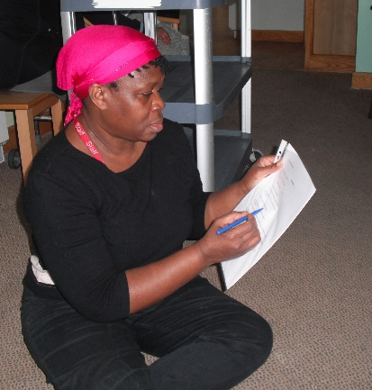 The research facilitator
As the EYFS coordinator at Luton Street Community Nursery, and during one of the six weekly block placements at Penfold Street Residential Home. I decided to carry out a research to document relevant information about how beneficial integrated multi-intergenerational working can be for the children and their practitioners/carers; as well as the elderly people and their care providers.
Collaborative working via Active Involvement: Over the past couple of years the nursery setting and the residential home have been working in partnerships to promote multigenerational integrated working practices across the communities of practices in the locality. On one occasion some of the residents came over to the nursery to have tea and join in a sing-along session with the children and staff. During the current six weeks block placements the children and residents will be supported and encouraged to actively involved and participate in a variety of sessions that are planned to meet the diverse and complex needs of all concerned. As a result there are opportunities to share ideas about how best we can implement and promote integrated working practices as we socialize, engage and interact with residents and staff from the residential home.
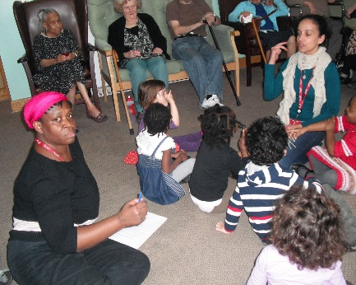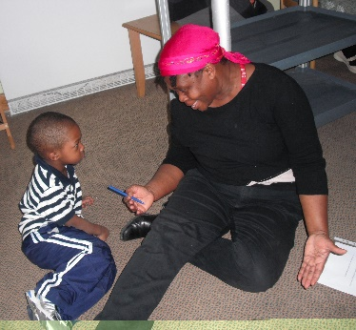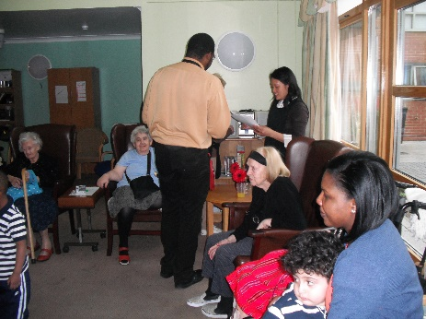
Residential Home Staff: The staff working in the residential home shows their commitments to providing their duty of care and support for the people for whom safeguarding is paramount.
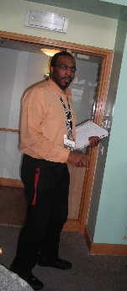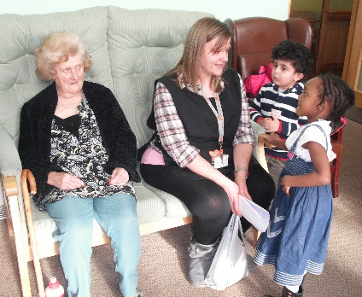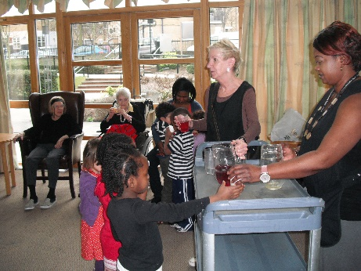
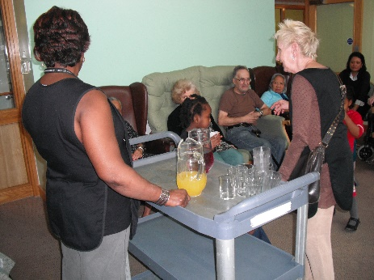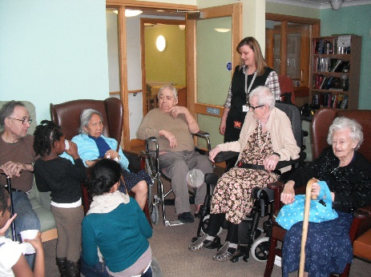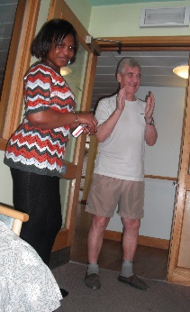
Engagement: The children and practitioners from the nursery are meeting and greeting the residents and staff from the home whilst the Officials of the Residential Home ensure legal and ethical guidelines are being adhered to in order that there are no breaches of statutory guidelines.
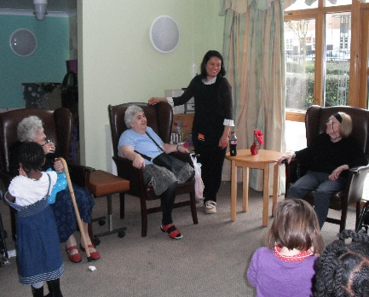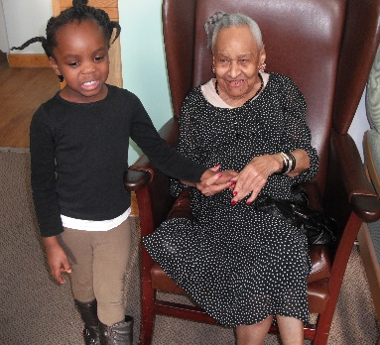
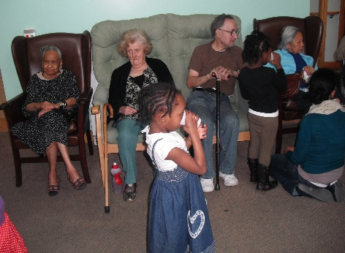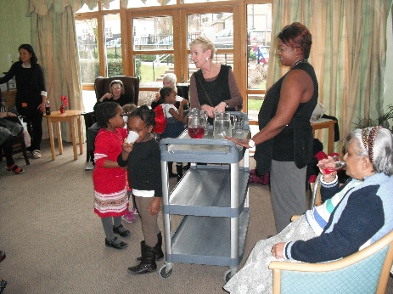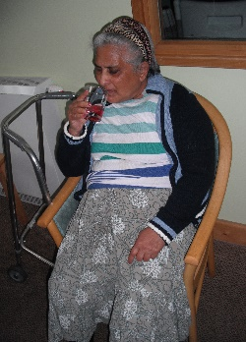
Rodney takes charge: Rodney and the team provide evidence of the importance of having a varied workforce from a wide cross section of society working in any community of practice. The senior worker takes charge of filling in the research questionnaire with help from other staff members as we worked collaboratively from a shared vision.
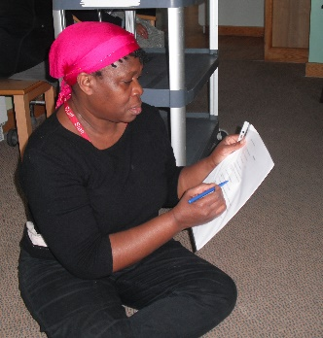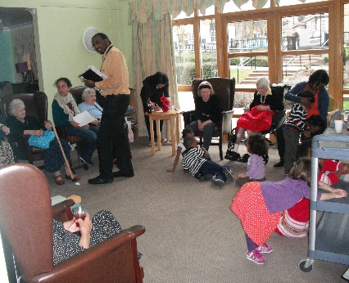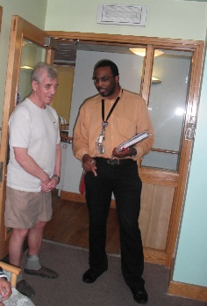
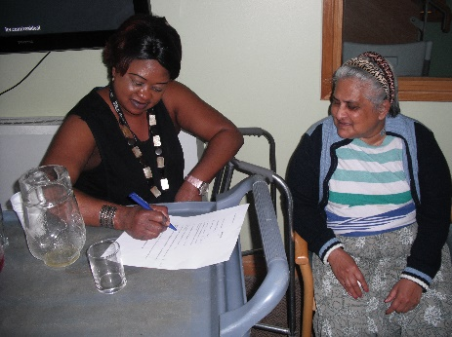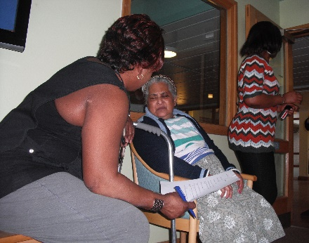
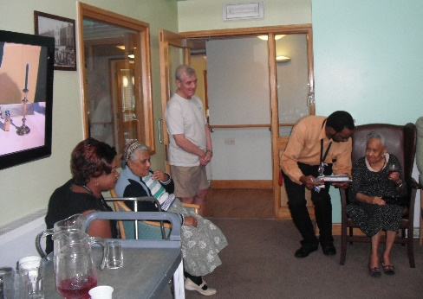 Feeling at home: 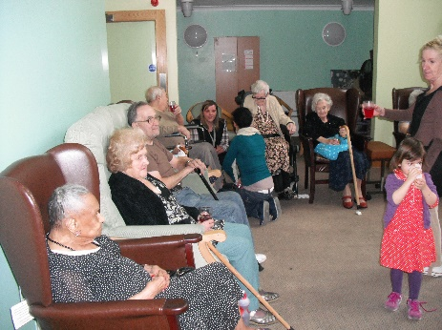
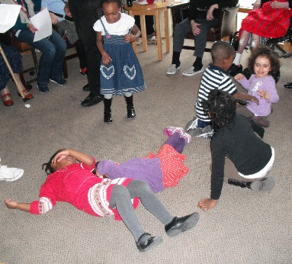 The ideal opportunity is presented for the children and the residents to form bonds whilst getting to know each other during this informal socialization session at the residential home.
Performing for the residents: The children and practitioners engage in a variety of singing and Makaton signing activity as part of the daily session for the
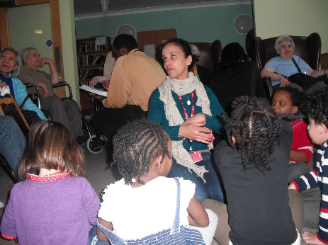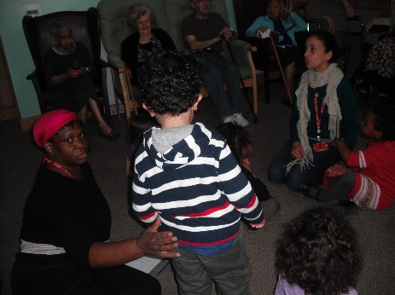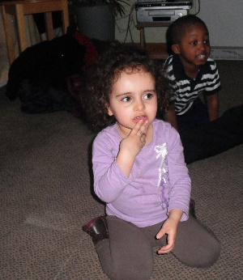
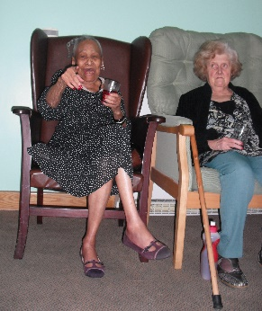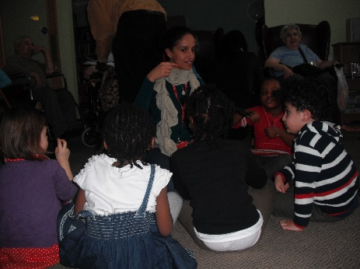
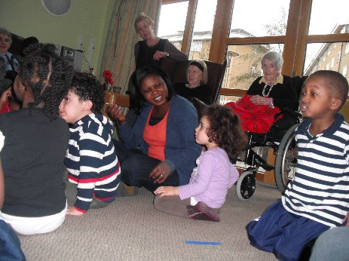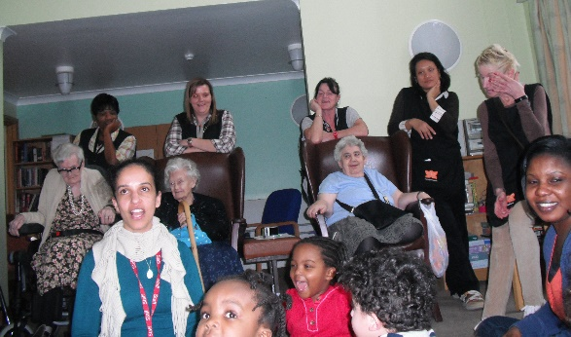
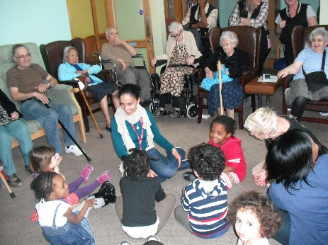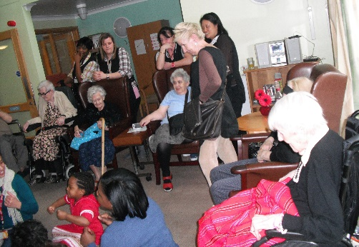
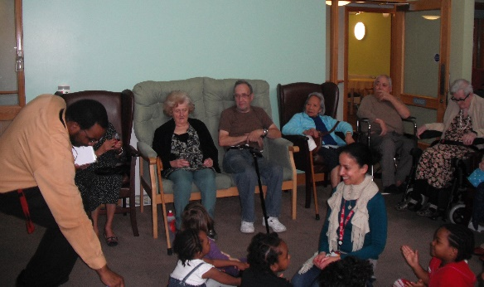 Special Bonds: 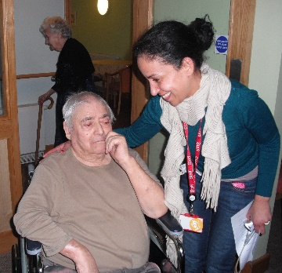
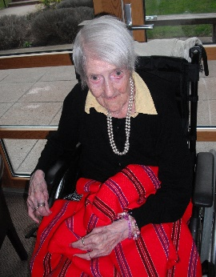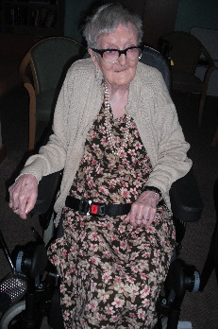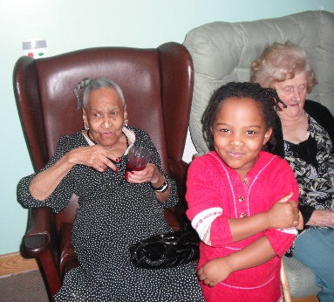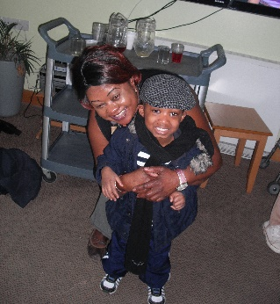
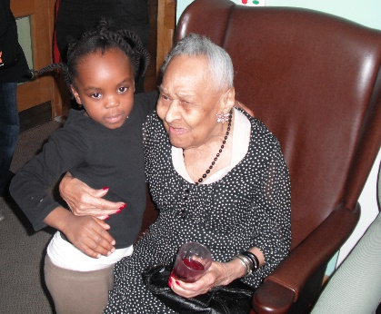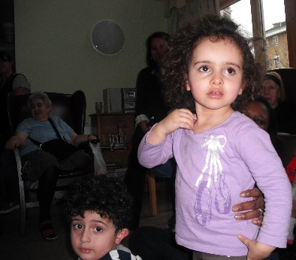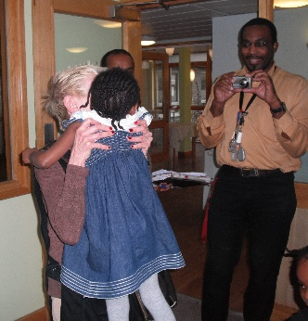
Levels of mobility and autonomy:
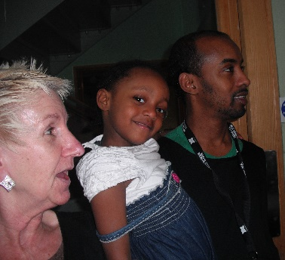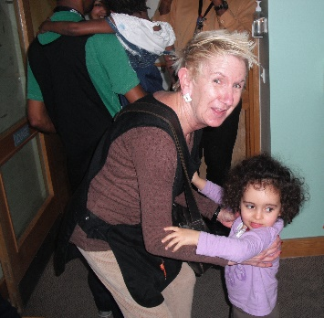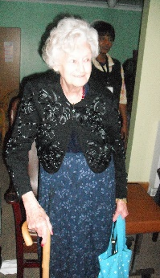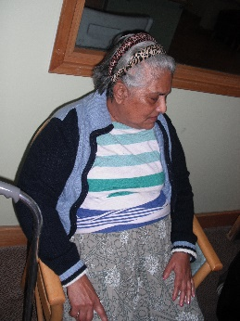

Saying our goodbyes until next visit:
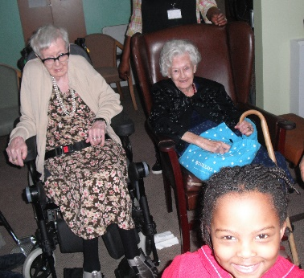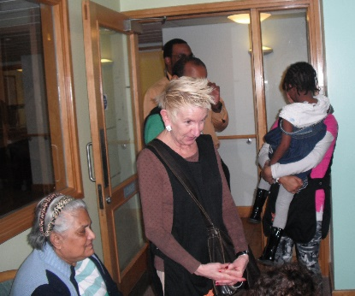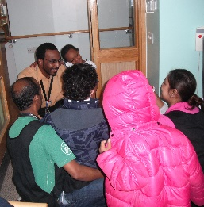
Celebrating many milestones:
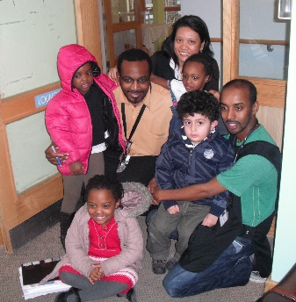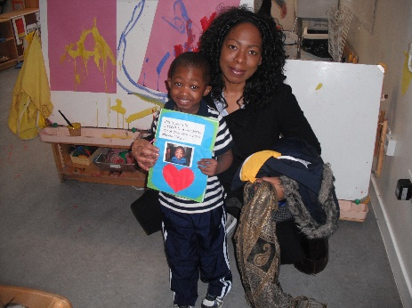
Continuity and consistency of visits
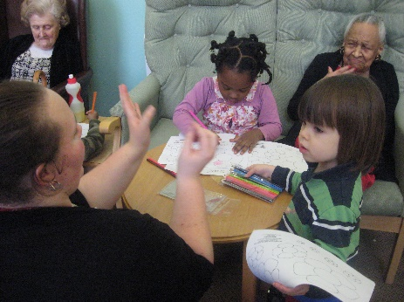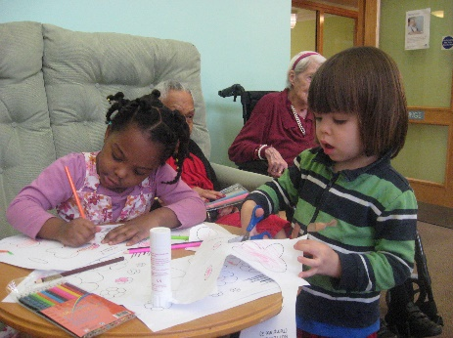
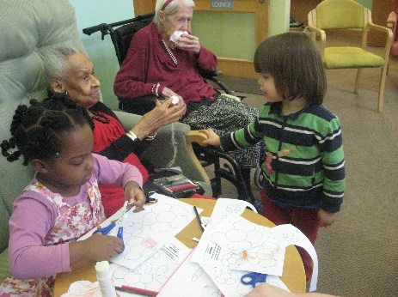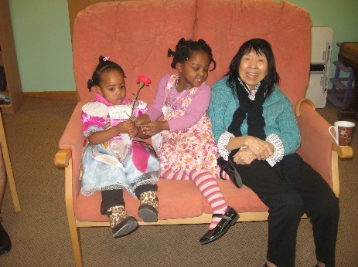
Suspension of visits to Safeguard the welfare of the Vulnerable Residents
Unfortunately for the nursery children and the residents of Penfold Street Residential Home the ongoing program of fostering multi intergenerational partnerships as part of the integrated working in communities of practice had to be suspended. This resulted from an outbreak of Chicken Pox amongst the nursery children and in order to safeguard the vulnerable residents the authorities in Penfold were informed about the impending dangers. However visits have since been resumed with the clearance of the threats of the chicken pox.
Research findings
On the day I attended the Home there was a friendly and inviting atmosphere from the staff and residence who were all glad and seemed happy to welcome the children and staff to their humble abode. The children and staff were welcome to partake of a light snack with the residents and they all seemed to be in fine spirits asking for children who did not make it on this visit. The staff were very cooporative volunteering to fill questionnaires where convenient to facilitate the documentations of as much reliable information as was reasonable achievable.
Data collated showed evidence that the residents are from a diverse socio-economic and multicultural backgrounds with varying stages of needs. Their ages ranges are early 70’s to mid 90’s and whilst some are in need of specialist care others are quite mobile and up and about with various aids like walking frames, etc to support their mobility in getting about in their environments.
As an aging child care worker with an aging mother who is now in the twighlight of her life and suffering dementia at the ripe old age of 88 years old I am in a position to make comparison sension

BIB Nursery:
Theresa Salmon Multigenerational Working Approaches Black History Month October 2014
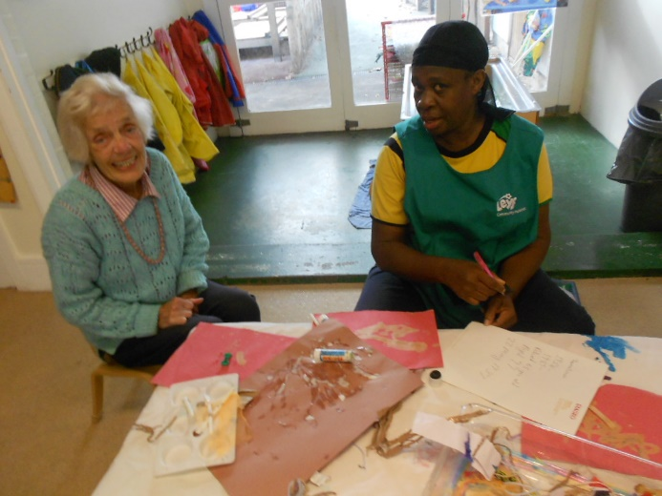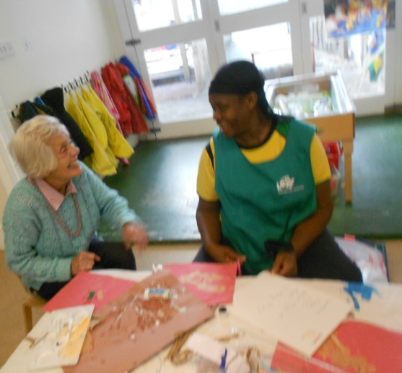
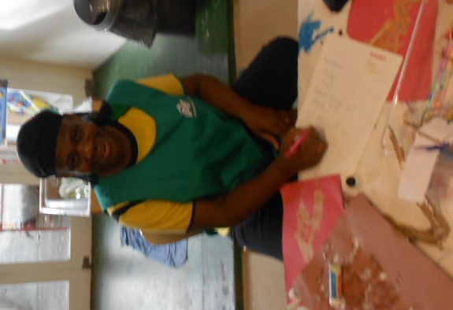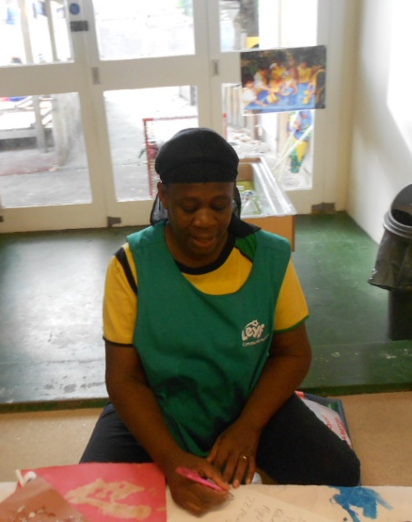
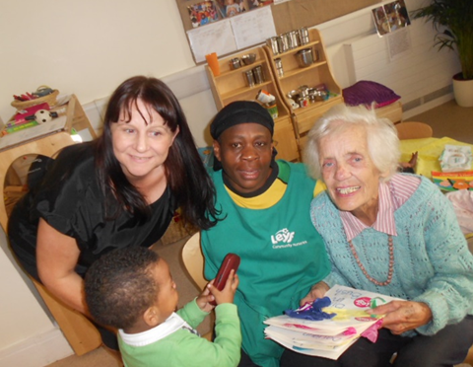
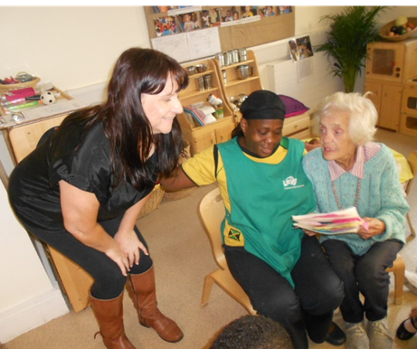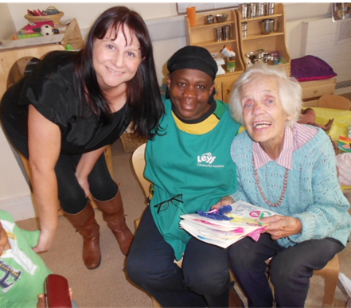
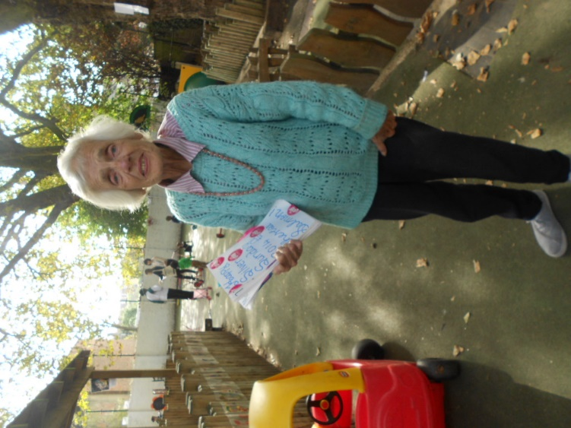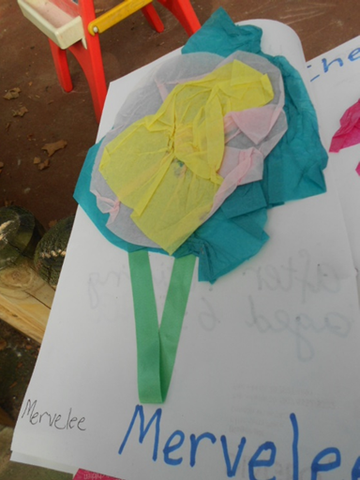
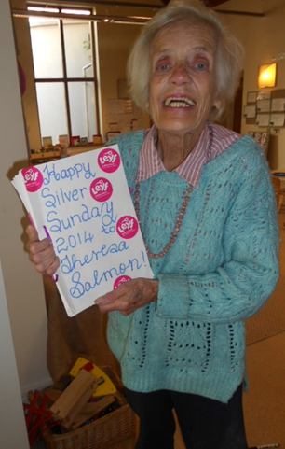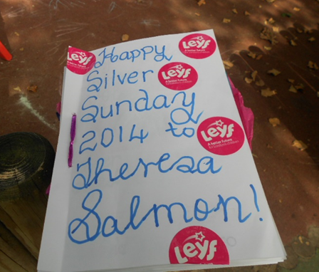
Theresa Salmon Multigenerational Working Partnerships
Preparing for BIB Open Day Celebrations: October 2014
MM joins BIB in photographs at the Open Day
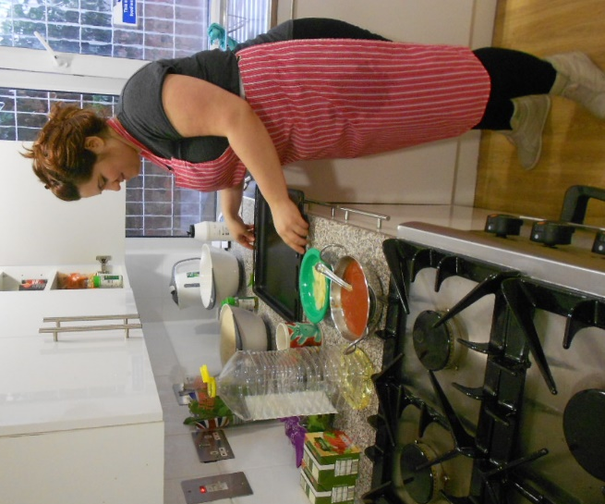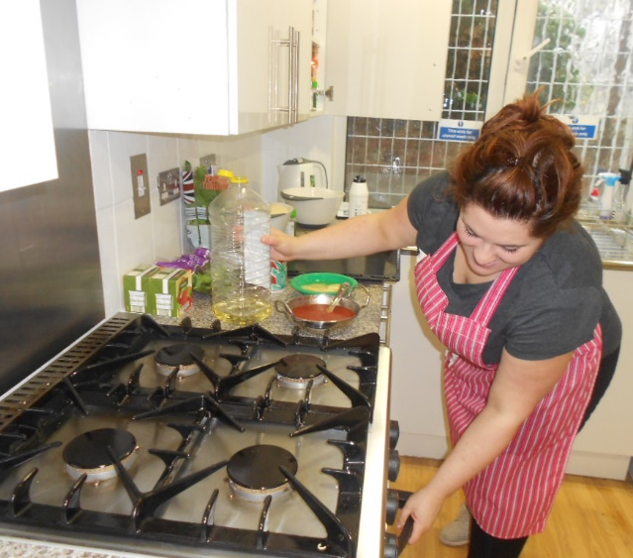
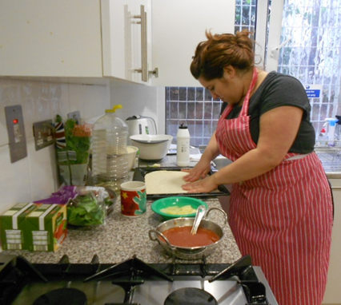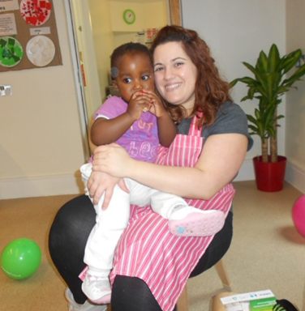
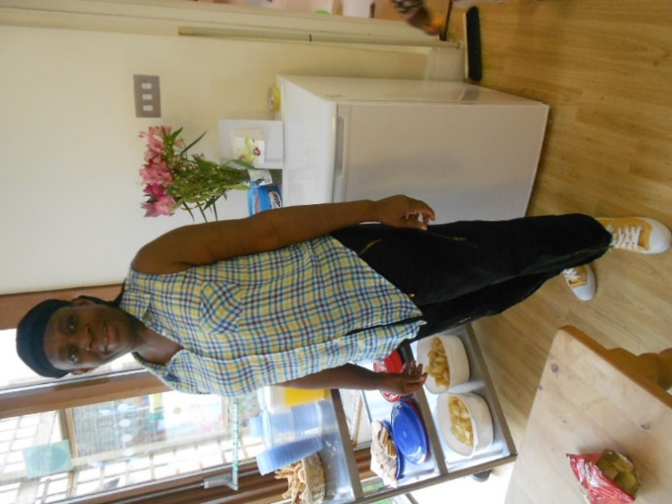
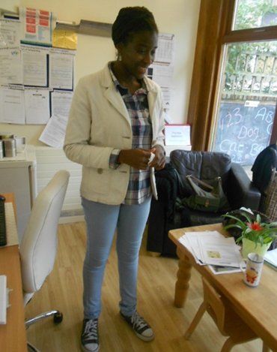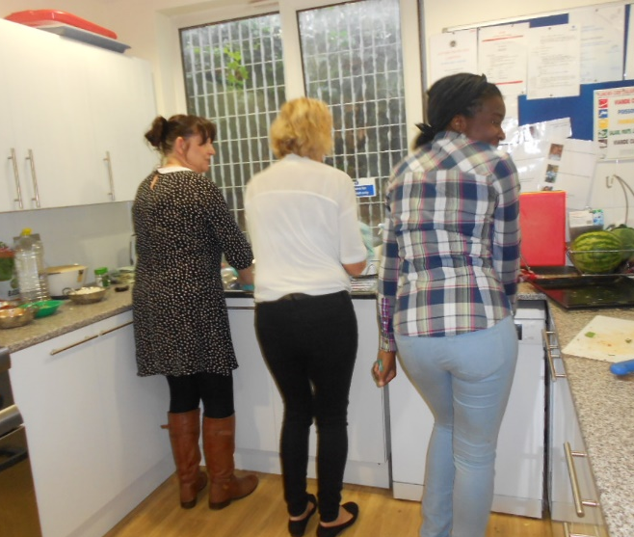
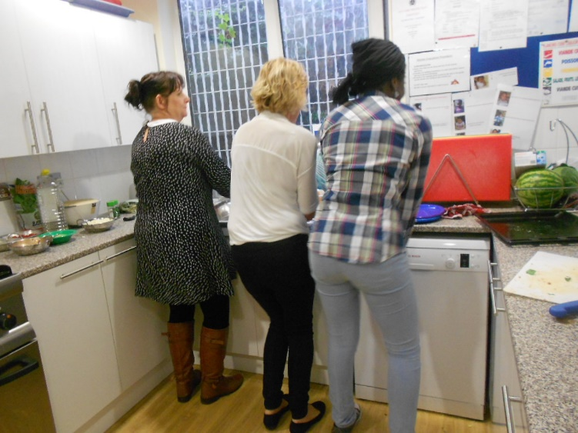
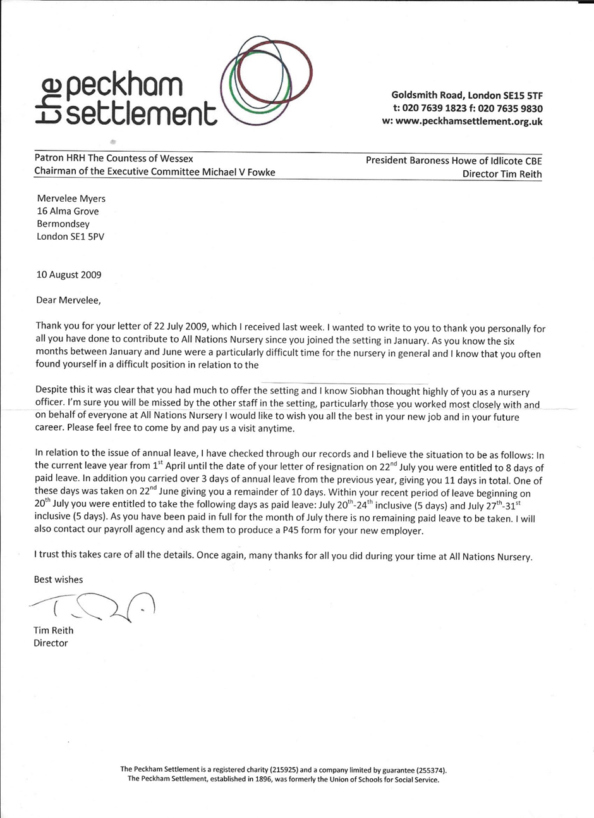

1st of April 2015

Sir/ Madam

Ref: - Mervelee Myers

TO WHOM IT MAY CONCERN

This is to confirm that I have known the above named person for some years back, ever before my daughter started this Nursery and I was very happy when I noted that she was the Key Worker to my daughter.
I have known Mervelee to be a hard working individual who does not hesitate to put in additional time to accomplish the best result. She is dedicated to support other people in many ways. She is very compassionate and always keen to learn new things and never shy away from challenges.
Mervelee is Polite, Friendly, Reliable, Trustworthy, Caring, Accommodating, Impartial and Principled. This attitude was reflected when I have the opportunity to do my daughter’s assessment with her and the way forward for my daughter progress in the Nursery. During the meeting she displayed a very good body language with good communication skills and listening skills and we both concluded with the best positive outcome that will be best for my daughter progress. This has been reflecting in the way my daughter behaves at home.
I also appreciate the support of other staff members of the Nursery because of the knowledge and skills that they imparted to my daughter with good behaviour at home, within the stipulated period she has been very independent to do things, for example, after two weeks in the Nursery she was off the Nappies without potty trained before she commenced. She quickly adapted to go to the toilet with less supervision and wash her hands for hygienic reasons.
In my opinion, and what I always observed when I drop and when I collect my daughter in the Nursery, I realised that she has always been very kind to the children and their families and treat people with respect and dignity.
Please don’t hesitate to contact me for further clarification if needed.
Thanks
Ben. Aluko
otunba_oluwole@yahoo.co.uk (07956554671)

From: Mewe Mechese
Sent: 04 January 2016 18:25
To: rattynem@btinternet com
Subject:
Hi Mervelee,
I'm sorry for not writing sooner but I was busy over the holiday. Please find text below:

To Whom it May Concern
I only worked with Mervelee for a short time at Bird in Bush but in that time I found her to be a competent work colleague.
I attended the wedding of one of our former colleagues, Rumi, which was attended by other work colleagues. I do not recall at any time, Mervelee making any derogatory comments about any staff members.
Regards,
Mewe
Mrs Mewe Mechese
079610 90717
Forever Living Business Owner
http://joinmewe.flp.com
http://meweshop.flp.com
@MMechese
Date: 29/04/2015

To Whom It May Concern
I am very pleased to be a referee for Mervelee Myers who I have known since she moved into my area of South East London in 2011. We established a professional relationship via shared interests; from the day we first met I’ve only seen a smile on her face and with that smile comes warmth.
Mervelee is a very good and happy worker I’ve benefitted much from her experience and knowledge on the occasions we’ve managed to work together. When it comes to the development of child care and child care strategies, she has helped me with the development of a client’s nursery’s website project with sound and useful advice.
Working together, combining our shared interests and information Mervelee helped set up projects in the local community. I find it hard to put across the bright and happy character of Mervelee the pleasure it is to work with her... for this is definitely one of the reasons why I say she is a people person able to relate to adults and children alike.
For me time keeping is of utmost importance... Mervelee has never been late for one of our meetings, which ranges over 20. On occasions I’ve spent quality times debating matters that are closest to our hearts. Due to Mervelee’s upbringing and knowledge I started to get an insight into the things that Mervelee is passionate about..., her dreams her ambitions.
It’s hard to find one as trustworthy and as passionate as Mervelee in her work..., it would be an asset to have this lady in your organisation..., as they say...”Good staff is hard to find”. I can highly recommend Mervelee for the position she is applying for.
Regards.
Miles Smiles
Account Manager GoogleMapManagement.

Depression 14th July 2016
Today I have to tackle a subject that is close to my heart, “DEPRESSION and the spectre of DISABILITY” – Mental and Physical. The reasons are many as I have had to cope with my “Hidden Disability” that were eventually triggered ad exacerbated into this full blown Depression over the years. Yesterday I was paralysed with all the symptoms of Depression resulting from events over which I have no control. Before people start to judge me about issues for which they have absolutely no knowledge, I would entreat them to take a little time to be in my shoes for just a second of my traumatised life. Some might think Depression is the preserve of the Celebrity Rich and Famous. However this is a total myth perpetuated by the Media.
The Celebrities are only knowledgeable about how to use their Mental Health Conditions to benefit their recovery and make money on the side. And they have the Media and Tabloid Press to help them market themselves to a wider audience. As I learned via studies, those who equip themselves with the knowledge about any of life’s issues are the ones who reap the most benefits for themselves and families. That’s why these days I am making it my business to be my own Self-Promotor as no one else is that interested in what’s best for the other individual. My younger brother puts it precisely when he told me to make sure I look out for and do what’s best for me. Without a shadow of a doubt, I can see the sense in what he told me a few weeks ago.
Yesterday I had another Melt-Down as I just could not deal with the amount of pressures directed at me from every corners. I don’t know what I have done to deserve all the bad things that have been happening to trigger the Depression as soon as I think I am in control. I know getting into a state is not good for “mine or my husband’s Disabilities and Progressive Health Conditions”, but when the “Black Dog – Depression” attacks, I have no powers to ward off the attack and just have to go with the flow. Mine and my husband’s entire lives are affected. I can’t eat, sleep or function properly to carry out normal day to day activities. Being his “Carer is detrimental to his overall Health and Wellbeing” if I am in a Depressive State and unable to care for him.
If my husband starts worrying about me, like what happened over the past year from October 2014 to date, then there is every likelihood he starts getting “HYPOS” regularly. If I am unable to perform my “Statutory DUTY of Care”, I am condemning both of us to sufferings that I refuse to think about owing to my “Traumatic Childhood into Adulthood” that changed the course of a promising life. That’s why I probably developed the “Obsessive Compulsive Disorders (OCD) behaviours” as coping mechanisms? I use whatever interventions I can muster to get me going. As I have been letting it known, I Cuss Bad Wuds, like a Trooper to alleviate my “Stress as a form of Therapy”. Barring that I might end up provoked and frustrated into Committing Criminal Offences over the years.
Worse still I would not be able to cope ending up in the Slammer like my brother. The sad thing about my brother ending up and DYING in Prisoner is that he never have the sort of resilience like I do. So he did what he thought was best at the time and went to church to wait for the authorities. My only hope is he had time to reflect on the circumstances that dictated the decisions he had to take, he became remorseful and forgiving for what he was provoked into doing. I on the other hand will never commit a Criminal Act, unless they Criminalise Cussing Bad Wuds? So when I feel down and out and unable to cope, I go into Bad Wuds Cussing Mode so as not to let the “Devil use me to do his will”.
If anyone want to claim responsibilities for my Bad Wud Cussing Modes, they are welcome as I don’t pick, chose nor refuse when I lose control. The things that set me off at any given times is the way matters affect me about the little things like not knowing why I am being singled out for “DISCRIMINATION of the magnitude that happened to me on 2 separate occasions in the UK”. Last week after getting myself out of a spell of Depression, I was so happy with my achievements. I went out into the public domain to celebrate what is good about being British. I was brought back to earth with a bump with a letter on which my whole life depends. This letter contains information about whether I have “a roof over my head or is going to find myself homeless” again.
So I dropped everything to get the matters sorted, because when you have been in certain situations, you don’t want to revisit them. I was at the Job Centre Tuesday and Wednesday, when instinct told me that the information I was receiving was not addressing the questions needing answers, so I got on the telephone. But I have to be “Assertive and when my Disability – Chronic Anxiety is triggered” this bring out the Passive Aggressive in me. Sorry folks I need to go do my Research about how not to be “Passive Aggressive” to anyone. I just discovered that along with all the “Lovely Descriptive Narratives” used to describe me by BIB & LEYF, I am Passive Aggressive. Poopa Jesus if only my Dead Parents would have known what was to happen to their on GIRL, they might have offered some “Protection from the Grave”?
Sadly for me, when I studied I was told that if you are asked any questions pertaining to your job and you do not know the answers, you should promise to find out from someone in authority who should know. A worker should never tell a parent in my job in the early years sector that they don’t know, promise to find out. These days it is the norms for even those in authority not to know the roles and responsibilities in their “Job Descriptions and Person Specifications”. Hence the reasons I am in the position I have found myself in and prone to full blown Depression. My Hidden Disability –which was exacerbated and triggered into Depression came about only because I am passionate about my work and wanted to do my very best as a result of my Obsessive Compulsive Disorder (OCD) behaviours.
The unfair treatments started at “Kings Day Nursery Mapother House” where I worked from March 2003 – November 2008. I started studies with the Open University 2004 after I thought I landed what I considered my Ideal Job. I “intended to retire at Kings or return to Jamaica” whichever came first. However I had no inclinations how my life was to change over the next couple of years, despite me doing everything I thought to protect myself. Part of enhancing knowledge involved me applying and promoting best inclusive practice from studies into the work places I was fortunate to be in. I made contributions to enable Kings to become a Beacon of Excellence in Southwark. I was not prepared for the way my life was to change at Kings.
I must admit I am still naïve, trust, and respect and take each and every individual at face value to be genuine with no axe to grind. But “my naivety always seem to be my downfall” each time the HATERS strike. So KINGS where my Depression was triggered became a distant memory over the years, until I returned to South London after 5 years, and it was like I was schedule to relive my nightmare. Only this time the nightmare was worse than the first, and I have to come to terms with accepting who the perpetuators are in this sordid affair. The things that got to me were the similarities in the events and the persons involved. Like at KINGS, I was used and abused, my knowledge confiscated and used for others to accept the accolades and benefit in their career.
Once they got what they wanted by using me to build up their organisation to Beacon Status, then they set about kicking the ladder down to prevent me from climbing and abandoning me. I wouldn’t have minded if they had left me to pick up the pieces and get on with my life. But no, instead they were intent on total Destructions. “I begged, pleaded, bend over backwards and kiss arses, because I knew my situation”, but to no avail. From studies I now learn about transitions that can impact on one’s life and I have learned the hard way to my detriments. The patterns that run in my “transitions are inclusive of sufferings of sicknesses, bereavements after deaths and then being ganged up on and treated unfairly” on more than one occasions because of my knowledge, values and beliefs.
This happened with my Dad who was struck down with “Parkinson Disease at an early age” – approximately 49 to early 50’s when he was made Redundant from working. Dad lived to the age of 62 years old as “his family witnessed Parkinson Disease stripped him of every shred of Dignity” and made him a shell of his former self. My Uncle Dudley was brutally murdered at his home in Clarendon one Sunday morning was the next to go. We heard of his death on the news in 1976, the year my 1st son was born. My uncle Terah who was murdered at his home in St Catherine at the age of 50 years old was next to go. I heard about his murder on the news as well. He was instrumental, helping to bring about the COOP at Bernard Lodge Sugar Company.
Uncle Terah is the 1st of my relative to be buried on the Family Land. I remember every moment of my Grandmother’s actions as if it is yesterday, on the day they brought her son’s body home to be interred in the yard. This led to my “Grandmother being left Broken-hearted, took his death to heart and succumb to one of the strokes” which took her out of her suffering after 2 years. Grandma and Dad died a month of each other February and March of 1980. When Dad died it was more of a relief to his family than anything else. My brother died at the age of 37 years old in 1994, but I did not get to attend his funeral. He made all his funeral arrangements and I was able to contribute to that financially if not in person.
The thing about it is my brother knew about his eminent demise and made all his plans. On reflections that was “brave of him as he kept going saying he was going to live forever even when he was dying”. Maybe I would have been “Cussing Bad Wuds about being cheated out of life”, at the age when I have such great plans to transform the lives of others? There was the case of my “other brother who died of CANCER”, within 3 months of a 3- 6 months life span. That was one of the most difficult periods of my life because of the upheavals and turmoil contrived by some unscrupulous people with whom I work and their cohorts. I asked for support resulting from studies and this was viewed as threats of the incompetence of some in authorities from some quarters.
When the same patterns of behaviours that happened at KINGS started at BIB - London Early Years Foundation (LEYF) not long after I returned from burying my MOTHER. I was not overtly worried as I thought that these things happened but once they get to know the “Jolly me, who is Mervelee Myers” things would fall in to place. The rest of the story is history for those who have been keeping up to date. I have been thrown into full blown “Depression, have a Nervous Breakdown, had Counselling” and being trying to get back control of my life. But has not been easy and last night I had a relapse. So I am getting threats from left, right and centre and I need to do my RESEARCH about someone’s Intellectual Property before too long.
But not to worry I will get there as I have weathered any storms in my - 60 years on God’s earth. These days I don’t take nothing or no one for granted because people are Fickle. I prefer to do things my way so when I “CUSS to help me be in control of the DEPRESSION”, so I don’t have to commit Criminal Acts, I don’t have to seek anyone’s approvals. If anyone want to “disown me and keep their distance as some have done they are welcome and good luck and good riddance” to them. If they can do without me, I can do without them too and one less thing for me to “Stress about”. My PARENTS to whom I owe any obligations are DEAD and my children can stand on their two feet and be independent of me.
On a sound and positive note I still have my “Best Friend who understand when I explain about my Melt-Downs”, and will not judge me, even if she has to promise to get the “Jaize to wash out my Mouth”? I found another Ally in a Friend who knew me in my “Teens as a Care-Free, Feisty, and Happy Go-Lucky Girl”who I have forgotten I ever was. I am more than grateful for the rediscovery as I am having my morals boasted by this person who probably knows me more than how I remember myself in those carefree days. I know I can rely on someone to be there to tell me to “cry if I feel like crying, pray when I am not too cross with the GOD that keeps putting me in these Soul-Destroying situations and Cuss Bad Wuds” if that help. I know I don’t have to pretend to be someone I am not and I am more than grateful.
Therefore when I am having my “Melt-Downs because I am trying to be in control of the DEPRESSION”, I know I can’t afford to be taken out. Because I have my TOM to think about, and he is affected by the same things that affect me. He is at the stage where the least thing will affect him and I don’t want to have anything on my conscience because of something I should have done and didn’t do because I am DEPRESSED. So my #FIGHT4JUSTICE is for me but more for Tom because he has had to suffer for no fault of his own.
Tomorrow I dust myself off and start all over again. If one has not been in a situation where they experienced any sort of debilitating conditions then they won’t know what I am trying to say. I told the Counsellor that I don’t mind becoming a Case Study in my Fight to cope with DEPRESSION, if it help one person to understand and come to terms with the Demons that try to take over and Destroy Lives. My life have always been an open book and no one needs worry about me claiming anything I share to be my Intellectual Property as I am yet to find out what that is. I am too busy trying to get my life back and beat down the barriers of Ignorance that can cause others to be bias, judgemental, and stereotypical and willingly label others because they are lacking knowledge.
For me WRITING is a form of Therapy that I am using to tell my Story as I share life about one can be affected by matters such as Disability, Love, Caring, Not Caring, Living a Full-Filling Life and just being thankful for the small mercies and blessings that we have been granted by GOD. Yes for anyone wondering, I have a Love/Hate relationship with the GOD whom I don’t seem to understand and know enough about. The GOD that allows the terrible things that happened and led to the DEPRESSION. But yes I sometimes view this as another way GOD is using me to make a difference. I have to take that round about journey to get to where GOD intends me to end up?

Evidence of trying to get out of the Toxic Workplace that LEYF became after transferring to BIB
Mervelee Myers Teaching Assistant Redriff Primary School 14.09.2015
I am hereby applying for the advertised post of Teaching Assistant because I have the qualification, knowledge and experiences that make me suitable for the post. I have worked with young children at Primary School level when I completed one year National Youth Service as a Teaching Assistant. I have first-hand experiences of supporting children helping with my younger sibling, nieces and nephews in a close knit family network. I have two children and was responsible for their upbringing until I left them with family to live in the UK.
I was a Basic School Teacher from 1985 – 1992 working in Early Childhood Education before moving to the UK. As part of my roles and responsibilities I work collaboratively in the team preparing young children for going into Primary Schools. Although I did not attend Teacher Training College, I attended monthly workshops enabling me to work from a shared perspective enhancing knowledge and expertise as part of my Professional Development Plan. The workshops empowered me to carry out my roles and responsibilities and be accountable for laying the foundation for the children in our care, as I developed skills to be a Teacher.
I have been working in the early years sector straight out of College in 1999 after completing two years of studies. I have worked in a variety of sectors including workplace and private day nurseries since I started. I was fortunate to complete placements at Turney Special School where I had the opportunity to gain experiences working with children of all ages who had diverse and complex needs. I recently started volunteering with a Charity as a Support Worker. I am gaining valuable experiences from my volunteering which I hope will one day benefit me in my vision of returning home to use my knowledge and expertise to help with promoting inclusion in my country of origin.
I have been motivated to embark on further studies after working with children who have diverse and complex needs and realising I was quite ignorant about Special Educational Needs at the time. However I was driven to enhance knowledge and expertise primarily because of my own personal experiences. My first child was misdiagnosed as having multiple disability of being deaf and dumb when very young. As a young mother I experienced prejudice, stereotyping and labelling from others because of lack of knowledge. I too was ignorant of the facts that caused my child to be delayed in his talking.
Despite studying and gaining theoretical knowledge I did not have lots of hands on experiences until my placement at Turney Special School to gain practical knowledge needed. Then when I started working and could identify and put the theory to the practical, l wanted to know more about how I could help others from going through similar experiences like I did. I set out to quench my thirst by doing further studies to empower me to have the knowledge and expertise to implement and promote inclusion. As a result of studies I held Lead Practitioner Roles: SENCO and EYFS coordinator, Person in Charge Preschool and Group Supervisor.
My role as key person enabled me to prepare children’s Learning Journeys and Individual Education Plans for those with diverse and complex needs. I work in partnership with parents, colleagues, other professionals and agencies in meeting the needs of children and their families, in my role as SENCO. As EYFS coordinator I plan a balanced curriculum that is tailored to meet the changing needs of all children regardless of SEND, giftedness or with EAL. I covered 0 – 8 years old when I done my BTEC National Diploma in Nursery Nursing.
I started learning ICT skills for the first time at Lambeth College as I was a novice before that. I’ve developed ICT competency over the years teaching myself via trials and errors. I am still willing to learn because I know ICT is and will continue to be the future. I learned via studies with the Open University that in order to get ahead with the job of working with children. One needs a camera, a computer and a laminator and you have accomplished some of your workload. I have learned lots from colleagues who willingly taught me before I became more competent.
Social Media has also enabled me empower myself with my Continuing Personal Professional Development Plan. I gained my Foundation Degree and done the Early Years Core Learning Outcomes (EYCLOs) and the Mosaic Approach Research Tools amongst other teaching and learning pedagogy of the expert theorists and pioneers of Early Childhood Education. My Health and Social Care studies equipped me to be able to have a better understanding of life experiences from the cradle to the grave alongside my own personal experiences of a parent and informal carer for my dad and grandmother.
I have done lots of trainings over the years that equipped me to work with children and families from diverse ethnic and multicultural environments. I am an advocate of inclusion and is proactive in implementing and promoting inclusion to benefit children with SEND and their families. Doing my research and as part of my hobby as a writer who is interested in early intervention strategies scaffolding children’s learning, enabling them to reach their individual potential, I make home learning resources. Resulting from studies and trainings I have been able to apply theory to practical experiences using Makaton, Picture Exchange Communication System, Applied Behaviour Analysis, Visual Timetables and Helicopter Stories to support, enhance and extend learning.
I have a vision to go back home to contribute to developing SEND in my country to benefit the nation as a whole. So I’d like to be given the opportunity to learn all I can in the environment that is conducive to meeting my needs whilst I contribute my knowledge and expertise in supporting children with their development and learning. I have been working constructively as part of a team since 1985. I am a background person because I know I can get more done and be more productive working in the shadows in a supportive role. However I have experiences in taking control of a class if and when the need arises as I have developed transferable skills wearing many different hats in my working roles over the years.
I have been responsible for young children most of my working life as a Basic School Teacher in Jamaica and working in the early years sector in the UK. My own personal experiences gave me a head start. I persevered with my child when even the teachers at his Basic School gave up on him and requested I keep him at home. I was determined that since I was paying, he should be included. That was what gave him the motivation he needed to be like his peers because he did not have any young child at home to model learning on and socialise and interact with. I have been instrumental in using my own experiences to be proactive in applying early intervention strategies to support, enhance and extend children’s development and learning.
My roles as key person, SENCO, EYFS coordinator, Group Supervisor and Mentor gave me opportunities to work in communities of practice with other professional and agencies in promoting inclusion. I adhere to changes in laws and legislations and realises that everyone is responsible for safeguarding children and the vulnerable as stated in the EYFS Welfare Requirements and The Equality Act 2010.
Prepared by: Mervelee Myers FD (Open)
Early Years Practitioner.
Date: 14th September 2015.

IVYDALE PRIMARY SCHOOL

JOB APPLICATION FORM

POST TITLE | Teaching Assistant
CLOSING DATE | 9th July 2015

Please read the ‘Guidance Notes for Applicants’ carefully and study the enclosed job description and person specification before completing this form.

Mr/Mrs/Ms/Miss: Mrs | Are you applying for a job share? Yes No
Surname: Myers | First Names: Mervelee
Address: 16 Alma Grove  Bermondsey  London  Postcode: SE1 5PY | Tel No. (home): 02072310813  Tel No. (mobile): 07950618083
Where did you see or hear of this position? Southwark Council website

EDUCATIONAL / TECHNICAL / PROFESSIONAL QUALIFICATIONS
(Name of institute or professional body in full please)
Where attained | Subjects/Qualifications | Year | Grade
Open University  Celeste Agency Services. Peckham  Lambeth College  Frome Secondary School  Evening Classes | 1. Working Together For Children.  2. GO1 Foundation Degree.  (a) E215. (b) E230. (c) E115. (d) E243.  3. K100. Health and Social Care.  4. E123/4-C37/Level 4.  Practical Guidelines in Healthcare and Care for the Elderly.  BTEC- Nursery Nursing & Student of Year  6 subjects JSC  GCE O’Level – English Language | 2010.  2008 -  2007.  2006.  2006.  1996  1997-99  1992-76  1978-79 | Certificate.  Level 5  Level 2.  Level 4.  Certificate.  Level 3.  Certificate.  Pass.  Pass.
DETAILS OF RELEVANT TRAINING COURSES (including year course) 1. Online Educare Training. 2. The Progress Check at Two. 3. Understanding and Supporting Schemas. 4.

EMPLOYMENT HISTORY
Please give details of all jobs held including part time and unpaid work, starting with your present/last employer.

Employer  (name and address) | Jobs held & main duties | From | To | Salary/Grade | Reason for leaving
1. London Early Years Foundation 121 Marsham Street, London SW1P 4LX.  2. All Nations Nursery Peckham Settlement, Goldsmith Road, Peckham, London SE15 5TF.  3. Kings College Hospital NHS Trust. Mapother House, D’Crispigny Park, Denmark Hill, London SE5 8AZ.  4. Family Support Network. Waterside Centre, 26 Avenue Road, South Norwood, London SE25 4 DX.  5. Asquith Court Lambeth. 50 Groveway, London SW9 OAR.  6. Agency Work  7. William Wilberforce, Lambeth Walk Day Nursery, Longton House, Lambeth Walk, London SE11 6LU.  8. Student – Lambeth College.  9. Contract Cleaners. RCO.  10. Basic School Teacher - Jamaica  11. National Youth Service – Teaching Assistant - Jamaica. | Key person, SENCO, EYFS coordinator, Team member, Multi- generational Representative.  Group Supervisor, Key person, Team member.  Trainee Group Supervisor, Key person, Team member  Person in charge pre- school. Writing policies and procedures and being in charge of colleague.  General daily routines in the nursery when needed. Worked across the Baby Room to the Pre-school.  General duties needed when I was sent on jobs.  Room leader for Toddlers. In charge of colleagues. Liaising with tutors for students on placements.  Studies and work placements.  Cleaning Offices all over London. Where I was influenced to study.  Prepare children to go to Primary School.  Assist the Teacher in the classroom. | 1.9.09  5.1.09  April 03  Sept. 02  July 01  April 02  July 1999  Sept 1997  1992  1984 | July 09  Nov 08  April 03  June 02  June 02  April 2001.  July 1999  2002  1992 | £20,000.00  £18,000.00  £21,000.00  £14,000.00  £12,000.00  Hourly rates.  £9,000.00  N/A | Need a change and chance to use enhanced knowledge and expertise gained via studies and trainings.  Got a better position with increased chances for progressing my career.  Resigned.  Chance to get a position closer to home with job security. The outlook wasn’t good as not many children were enrolled.  Always looking for better chances to progress in my career.  Got a position.  Always looking out for chance to improve myself and career prospects.  Finished studies and got first job as a Nursery Nurse  Focus on job as a Nursery Nurse.  Move to the UK

RELEVANT KNOWLEDGE, EXPERIENCE & SKILLS
Please tell us how your knowledge, experience and skills meet the job requirements described in the person specification. Please refer to guidance notes.

Please continue on separate sheets if required. (No more than 2 further sides of A4)
Do you hold a current driving licence? Full Provisional LGV PCV

If you are a person with a disability, is there anything we need to know in order to offer you a fair selection interview? For example, please let us know if you need wheelchair access, a sign language interpreter etc…

If you are related to an officer or elected member of Southwark Council, please give details:

Surname: First Name:
Address:

Please indicate two people who can provide references, one of whom must be your present employer and the other a past employer:

Name: London Early Years Foundation Name: Winnifred McLeish-Jacques

Address: 121 Marsham Street
London SW1P 4LX Address:

Tel No: 02075923605 Tel No:
Job Title: Job Title: Deputy Manager at time I worked at Peckham Settlement
Please note that if applicant is short-listed for interview, references will be taken up prior to interview.

Are there any restrictions to your residence in the UK which may affect your right to take up employment with Southwark Council? Yes No

If Yes, please provide details:

If you are successful in your application, would you require a work permit prior to taking up employment? Yes No
Applicants should note that failure to declare any restrictions to employment or the need for a work permit could lead to termination of service.

Please return your completed application form via email to: office@ivydale.southwark.sch.uk or by post to: Estelle Currie, Ivydale Primary School, Ivydale Road, Nunhead, London, SE15 3BU.

I declare that the information I have given is accurate and true.

Signed: Date:

Equal Opportunities Monitoring

This ensures that we are employing people fairly. Please tick the appropriate boxes below.

Female Male

Date of Birth: 19.05.1959

Do you consider yourself to be:
(please tick appropriate boxes)

Black United Kingdom

Black Caribbean | Yes
Black African

Asian

Cypriot

Chinese

Irish

White United Kingdom

White European

Other (Please Specify)
Did not say

Sexual Orientation Prefer not to say

Age Prefer not to say

Do you consider yourself to have a disability Yes

If yes, please state nature of disability Chronic Anxiety, Progressive Conditions – Diabetes, arthritis and mobility problems.

The Disability Discrimination Act (DDA) defines disability as ‘A physical or mental impairment which has a substantial and long effect on the person’s ability to carry out normal day-to-day activities’.
Application form

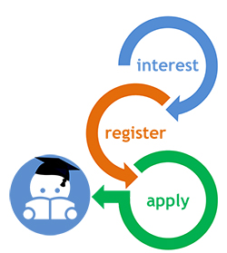
Understanding the customer journey to Initial Teacher Training
The Institute for Employment Studies (IES) has been commissioned by the National College for Teaching and Leadership (NCTL) to undertake research into the customer journey to Initial Teacher Training.

Aim of the research
The National College for Teaching and Leadership (NCTL), an Executive Agency of the Department for Education (DfE), is responsible for ensuring that enough high quality trainees enter teacher training and early years teacher training to secure sufficient supply of new teachers. The NCTL routinely reviews processes and procedures to ensure they are able to meet the targets set by DfE as well as the needs of trainees.
The NCTL therefore wish to understand more about the customer journey, from the perspective of the individuals registering interest and/or applying for Initial Teacher Training (ITT) and/or early years teacher training (EY ITT). This will help NCTL to provide effective support and encouragement to enable individuals to make the right choices for them and, if appropriate, to enter teacher training. This research will explore how and why people enter teacher training, their preferences and the factors influencing their choices, the support that really makes a difference and the barriers and challenges they face. The research will also, for the first time, examine the customer journey of those applying to EY ITT, the new professional graduate pathway for those who want to support the educational development of younger children.

Our approach to the research
The research involves two key stages.
It begins with an online survey with a range of individuals including: those who have registered an interest in teacher training with ‘Get Into Teaching’; those who have applied to ITT through UCAS; and those who have applied for EY ITT through a university, school or provider partnership. In order to contact individuals who will be able to help us and to comply with the Data Protection Act your provider has agreed to send this email on our behalf.
Following on from the survey, individuals can opt-in to take part in additional in-depth telephone interviews or face to face focus groups to further develop our understanding of their journey. These interviews provide the chance for individuals to reflect on choices made and to provide feedback to improve support mechanisms.

How can you help?
If you receive an invitation to participate in the survey about Initial Teacher Training or early years teacher training please do take part, as your feedback will make a difference. You only need to complete the survey once (regardless of who may contact you, this could include your provider, Get into Teaching or UCAS). Please be assured that the feedback you give will be treated as confidential and no individuals will be identified in any research findings. Also please do consider opting in to the follow-up work. Again any information you provide will be treated as confidential, and any contact details you give will only be used to contact you to arrange for the follow-up discussion and will be destroyed at the end of the research in summer 2015.
To thank you for your support, those who complete the survey will be entered into a prize-draw to win one of three prizes, each worth £200 in shopping vouchers; interviewees will receive £15 shopping vouchers, and those taking part in focus groups will receive £25 in shopping vouchers.

Timescale
The research commenced in February 2015. The online survey will take place in March (with the sample drawn in February) and the interviews and focus groups with applicants, registrants and trainees will take place in May and June 2015. Final results will be available late summer 2015.

Contacts
If you would like any additional information about the research, please do get in touch with one of the key contacts for the project:
IES Project Manager
Joy Williams
E: joy.williams@employment-studies.co.uk
T: 01273 763443
Research Manager at NCTL
Sue Porter
E: evaluation.college@education.gsi.gov.uk
IES Project Administrator
Gill Brown
E: gill.brown@employment-studies.co.uk
T: 01273 763409
IES is an independent, apolitical, international centre of research and consultancy in employment policy and human resource management issues. IES is a not-for-profit organisation.
Institute for Employment Studies, Sovereign House, Church Street, Brighton BN1 1UJ, UK
T: 01273 763400 F: 01273 763401 www.employment-studies.co.uk

Croydon
Surrey
CR0 2PZ

17th October 2008
To whom it may concern,
I have known Mervelee since 2003, to present day. From 2003-2005, my son Ethan Sundar was attending the Mapother House nursery. It was during this time, that I recognised that Mervelee was very protective of the children in her care. On numerous occasions, I witnessed Mervelee’s daily interactions with the children as well as other staff members.
I feel that Mervelee contributed to the reputation of Mapother House nursery, as she was thorough in her duties, especially by informing me of the stages of development of my child. In my opinion, her professionalism at work, was never in question, and as to her involvement with the children, I found that she was astute in recognising behaviours of the children, and this I realised was developed through her on-going academic studies. She willing gave up her time, to prepare key stage reports for Ethan, to which I am very grateful. It was these reports that I used as evidence of Ethan’s development, for admission to primary school.
Mervelee and other staff members, attended the christening of my daughter, in 2006, this was after Ethan had left the nursery. My relationship with Mervelee continues, and I am pleased to call her my friend.
Yours faithfully
Mrs Karen Sundar

Extras
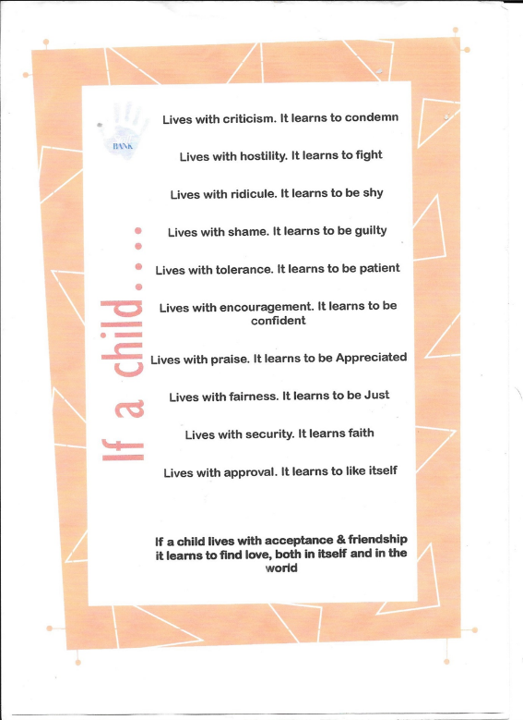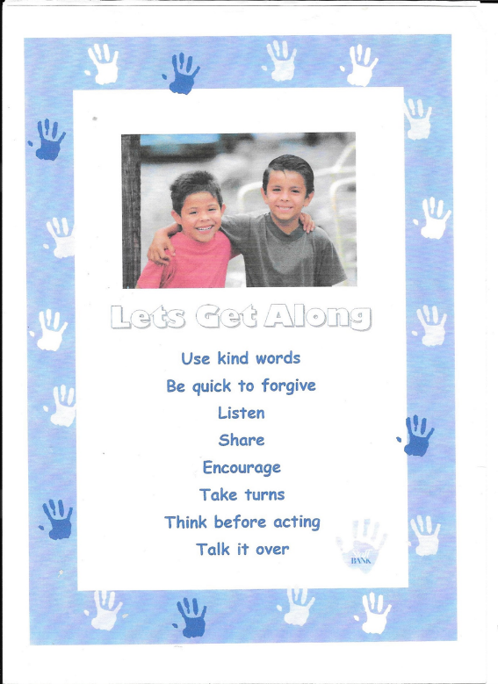
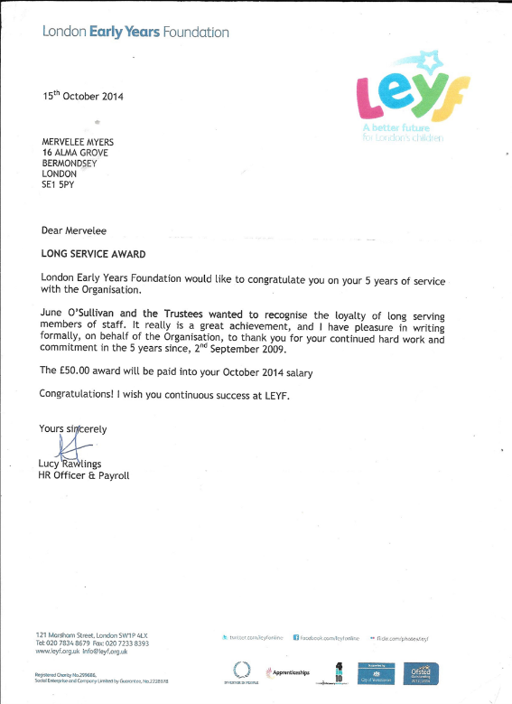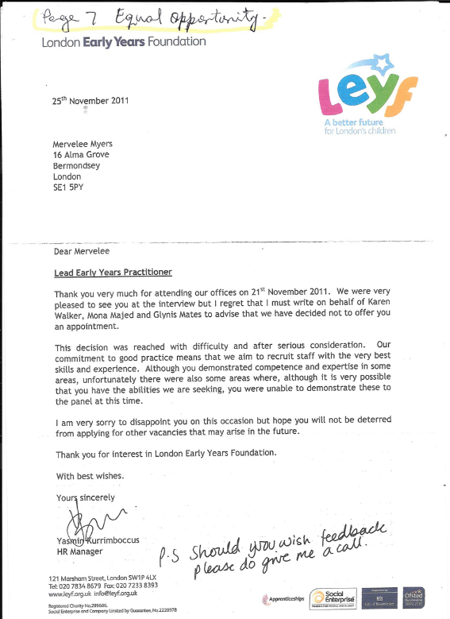
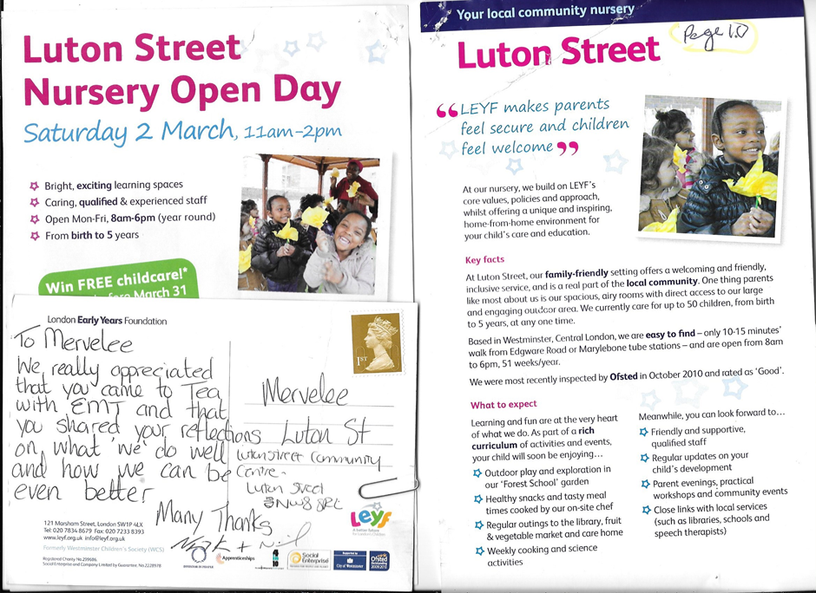
Extra Evidence

Kin Teeth a Nuh LAUGH…? 6.1.2015
I am drawn to touch on this subject because of a few issues that caught my attention recently. Since no one else seems brave enough to tackle the matter that was playing on my mind. I decided to apply my old fashioned values and beliefs and take the bull by the horns and lay my cards on the table face up. I know by doing this I am going against the grains of how some are prepared to conduct themselves for fear of being labelled, stereotyped and ridiculed. I was brought up in an era when I was taught certain common curtesy and these are the norms that I continue to live by to this day. I have never forgotten this little gem “There are 3 little words/phases we all should know. They are good morning, please and thank you. Use them quite often wherever you go. There are no nicer words than these.” Although I was taught them from an early age, I have no memory whether I learned it at home or school? Whenever I remember to teach it to my little charges, they always seem pleased to learn the words. And I was surprised one day, when a parent told me her child came home reciting it.
So to the crux of my present dilemma for which I could no longer hold my tongue as the matter has been eating away at my conscience. So I had no other alternatives, but to address the matter and be done with it. Don’t get me wrong I did not jump in at the deep end either as I am an older and wiser person who is the epitome of discretions. Also living in a diverse multicultural society, I am weary of rubbing anyone up the wrong way like others have done to me in the past without knowing the person involved. Therefore I have taken on the cloak of diplomacy and is very sensitive to the needs of others with regards to age, status, background, sexuality, gender, ability, disability, etc and etc… I work in an industry where communication in whatever forms it is used, is key to providing quality services to service users and providers and other clienteles. Because I work in the health and social care industry with the very young who need to develop certain skills on their journey of early learning from cradle to grave I have had to be proactive in applying the knowledge I gained from studies and trainings to best effects.
Being mindful of not stepping on anyone’s toes intentionally and overstepping the boundaries of my authority. And I am saying this because I encountered problems in the past because some persons think they are above taking advice from lowly placed individuals like myself who do not have a handle attached to our names. But because I know that when certain so-called high up persons who wants to make their names come visiting. I have had experiences where some of these persons will use their power to undermine others just to make themselves look whiter than white. I have been under scrutiny before from other professionals who asks leading questions and then turn around and misinterpreted what was said as they have their own agenda to be in the good books of others. Since I have been there before myself and knows the outcomes when my practices was questioned. I felt it was now down to me as a professional who enhanced knowledge and developed the listening ethos as reflective practitioner to take a step forward and believe in the courage of my convictions to intervene sensitively.
Since this was a matter which I had picked up on, but chose not to say anything because of my past history, but I felt compelled to act when outsiders could pick up on it after just a few hours in the environment. I know what it is to be young and uncertain about your future especially if one has had a sheltered life or even had to cope with some impairments or hidden disability. So when the person was so blatant and outright with her action, by coming into my presence and not having the common curtesy of as much as saying “good morning?” I calmly spoke to her and asked if she had said “good morning” to any of the children and her colleagues as she walked pass? She said no, so I told her that what I was about to say to her should not be taken in a negative light. Instead my only intention in addressing her was to put her on her guard as she, like all of us who work in the setting was under scrutiny and she needs to do better. I know she is only young, but I have seen and worked with young persons who are so courteous and act professionally when it comes to their job descriptions.
I just cannot understand how anyone can work with young children and don’t lose their inhibitions if they have any in the first place? Just imagine a person walking into a place 5 days per week and not greeting neither your colleagues nor the children. But instead your face is made up like when rain set up to fall or as my Mother was fond of saying “yuh face set up lika when washer woman see dutty bungle pon Monday morning?” I grew up knowing that it is the norms to greet everyone you meet and as my parents were under no illusions about the way we were brought up and we either take it or leave it at our perils. In the profession that I have chosen, it is a requirement to be able to communicate with all sort of persons from different strata’s of life in a variety of formats. The EYFS curriculum has the Prime and Specific areas and Communication and Language is one of the areas that young children will have to achieve before they can move on and access the Specific areas. Early years practitioners are supposed to be participant observers and learners in promoting children’s development and learning across the EYFS.
But yet we are finding persons like this young person in the profession who cannot be bothered to open her mouth to utter a “good morning” greetings to her colleagues and the children and thinks that is acceptable. Therefore I have to be wondering what kind of a role model this person is going to be in promoting and implementing activities and experiences to enable children to achieve the basics in Communication and Language when they can’t even bother to open their mouth to greet even the children. Then when you have dedicated your life to enhancing knowledge and expertise so that you are in a position to promote and implement best inclusive practice. They will go out of their way to make your life hell because you refused to be pally and spend your time paying lip service to their inappropriate outdated practices. They refused to adhere to changes in laws and legislations and tell you “we don’t do things like that here and I am in charge.” So what you are in charge, but don’t know the basics about the EYFS curriculum and the early years National Statutory requirements like EVERY CHILD A TALKER (ECAT) that should be documented to know where children are in their Communication and Language development.
There are children being identified with communication and language difficulties and early intervention strategies should be in implemented from the monitored forms. But instead some who don’t have the knowledge prefer to wait instead of allowing another practitioner who don’t have a status to their name get on with the job of promoting inclusive practice. I know from experience not to interfere as I was once asked why I say children have Special Educational Needs when their parents are professionals’ example surgeons, doctors, nurses… Then one OFSTED inspector claimed I had discriminated against children because she heard me saying there is one girl in the group. But then she did not stop to work out why I had said there is one girl in the group and the context in which it was said – On that particular day when I was doing a group activity, there was one girl amongst the boys and comparisons were made. So if one have the courage of their convictions to implement and promote inclusive practice, you have to be prepared to wait because you are not deemed good enough to have a handle attached to your name as you are viewed as threats to the uneducated ignorant ones who get their status by undermining others in their pursuits of getting to the top of the ladder.
Since I have prepared myself, enhancing knowledge with the intentions of climbing up the career ladder but was kicked in the teeth once I put my foot on the first rung. I was battered, bruised and broken as a result that I ended up losing my motivations to go on. One might say that I have “tun worthless and lacking in ambitions” as I don’t wish to go through that experience ever again that I got myself into. I finally managed to extricate myself from my predicament in leading up to 2014 when I witnessed my youngest son for whom I had so much concerns deciding to settle down and get married. When I was home for my son’s wedding I had to come to terms that I had lost my mum as she did not recognised her family anymore and she was just a shell of her old self. So I said my final goodbye and knew I would not see her again in this life. Then a few months later I returned home to bury her. I have since put all my pasts when I almost lost my sanity behind me and decided to be contended with my life, focussing on the things that are of most important to me. I have had experiences with the young, sick and infirmed as well as the dying, so I know what it is to be experiencing conflicting emotions.
Therefore I know how to empathise with the different age groups and remembered my mother saying come let us talk when I visited her. Yet that was all the talking she could do as her memory had gone. Is it any wonder then that the children will treat any persons who failed to be on their level differently from another person who spares the time to greet them cheerfully on arrival in their presence? I have always tried very hard not to take my worries into work with me if I can help it as this can have an impact on the children’s day. I try to adhere to that professional code of conduct of acting as a professional no matter what, in my job. I will confess that I am a very funny person indeed, but knows when to get into character as I wear varying hats to perform my roles. I am willing to grin and bear it and conform to the laws and legislations of my contractual agreements. However outside the confines of those laws I have no obligations to having to be pally with anyone. So if I see you approaching on the right and I am not feeling in the mood for conversation, I might easily cross over to the left to avoid bumping into you?
Therefore I am not expecting to be anyone’s friend outside the confines of my work environment and if any of my colleagues don’t acknowledge me out in the public I am happy with that. But to walk into the same environment day in and day out without the common curtsey of a good morning really is not nice and what I considered part of the norms of the society in which I was brought up. My dad was the kind of person who greeted everyone: young, middle age and old whom he passed on the way. Although these days it is acceptable to call everyone by their Christian names, I grew up in an era when you put a handle to the names of your superiors and those who are older than you. And of course it never hurt me to be courteous, however I think I am hip enough to move with the times and take change in my stride. I have reached and surpassed the stages in my life where I allow much to bother me anymore. Therefore I will let most things that I would usually take any notice of bother me these days. I have taken out a new lease on life and is focussing more on the positive rather than the negative.
But as God is my judge, simply things like not having manners and disrespecting the norms of society cut me to the quit and make me wish for the era when I grew up when good common sense was the order of the day. Instead we are overruled by political correctness where we cannot express our thoughts, views and opinions about issues like this one. We are afraid to challenge inappropriate practices like lapses in professionalisms because somewhere somehow there are someone with an axe to grind and their own agenda who will go out their way to stitch you up so you end up acting out of character. I am talking from experience because she who feels it knows it and I have had my past come back to haunt me recently after I thought I had left it far behind. So once more I am living with the reality that it is best to keep one step of the opposition and do not let your implicit knowledge be too explicit because some ignorant persons might view you as a threat to their status that you have absolutely no interests in.
So unless you want to be in hot water every day and get treated as a NAUGHTY CHILD, take my advice and keep your head low and your knowledge to yourself until you are wanted to do something for others to take the credit. I would advise any young person who is starting out to be on their guard to the pitfalls that are in any industry that they work in. Because everywhere you go there is bound to be one issue or another that will crap up. And as some of my former colleagues have identified, if you are not careful there are some who will frustrate you into giving up if you are not resilient. If you follow some of the things that get thrown at you to break you down you become afraid to challenge discriminations, harassment and bullying culture that is creeping into the workplace and making the lives of some a misery. That is why these days I prefer to err on the side of cautions before standing aside and allowing the very young children to miss out on getting the solid foundation that is key in preparing them for life in a changing society that revolves around the norms of right and wrong and good over evil.
I don’t care if anyone wants to say that I act as if I know too much, but I believe someone have to take a stance to rid the world of the things that are intrinsically bad and detrimental to the fostering of good relationships and what is considered the good of mankind. I will forever be questioning inappropriate practices anywhere in life that I encounter them. There are just too many of us in society who are willing to turn a blind eye so as not to upset others and leave them to get on with the job of doing the things that are not right. That is when we stop to say if only I had known, listened or stopped to investigate, then the outcomes could have been different. I know not saying good morning is not such a big issue after all, but to me there are some things that needs to be upheld if we say we are role models for young children. And I am willing to challenge anyone who behaves otherwise. That is why I am using the media available at my disposal to air my views about matters that are important to me.
I won’t commit the cardinal sins of making the mistakes that I once did by climbing too high like that proverbial monkey and leaving my arse exposed to dangers because I have learned some valuable lessons over the years to keep me well and truly within the boundaries of my authority. But I am one person who believes the truth should be told and it is time some in authority stop making the lives of lesser mortals living hells because of what they believe in. Everyone has a right to their opinions and no one is forced to agree with my views. The same way I don’t think I have to be in agreement with everything I read, hear or being told by any human kind alive. I loved my parents and I am grateful for the way I was brought up, but that don’t say I agreed with everything they say and taught me at the time. And I was brave enough to disagree with them and tell them why I have different views. So writing is one way of dealing with issues that I feel are important to me. I have been writing from as far back as I can remember and for me writing is therapeutic, so I will be writing as long as I am able. But you won’t see me writing about certain issues as I believe there are some things better left in the annals of your memory where they can’t stir up matters that are better left buried and never to be discussed?
Once more my old fashioned values and beliefs and my enhanced knowledge are viewed as threats by some who do not have the courage of their convictions to stand up and be counted for what they believe in. So if someone tells them to jump, they will jump without stopping to formulate a question. I on the other hand might end up jumping, but only after I am told what I am jumping for? I have always being an outspoken person and I will always call a spade a spade as long as I don’t prove otherwise that it is a shovel. That means I am prepared to die for the TRUTH! I have suffered enough and I don’t know when it will end, but I am a SINNER and I know suffering is something I have to learn to live with? I know I will get my reward in heaven when I finally get there to meet with my loved ones. But whilst I am here on earth I still need to earn a living with the God given talents I was blessed with. Therefore I would love to be left alone without someone trying to stitch me up?

Events WB: 04th January 2015 – Documenting Practice that are affecting my Ability to Carry Out Normal Day-to-Day Activities Effectively
Monday 05.1.15: My manager Lynne Kelly came into the Preschool to tell me she needed to speak to me in the office. I told my colleagues and went to the office and on entering there was another colleague, Tehseba present who the manager asked to leave. She asked me to sit down and this was when I noticed that the manager seemed very agitated. She started by asking what I had said about her at Rumi’s wedding and I replied I didn’t know what she was talking about. LK then said “I don’t know what was said, but I hear that you are not happy with the management.” I reassured LK that I am the happiest I have every being for the longest while and reminded her what I had said to her when I started and the way she had reassured me.
LK then reiterated that “I don’t know what was said, but Mewe asked me to speak to you because you are not happy about the management.” I told LK I never heard anyone saying anything negative about anyone in my presence and all we talked about was work experiences in general. LK said she was happy with my work and she had even shown some of it to Marion who photocopied it to take to Central Office. She showed me the Southwark IEP Formats that she received and I asked her to save it to my usb and I would transfer Tayandre’s unto it. I had taken one of my former colleague along and she was upset about the time we were waiting so I was more concerned about her as she had her course work to do. LK said “the only differences we had was the incident with Nicola so she said that to Mewe.
I left the office after reassuring LK that I did not hear anyone saying anything negative about her in my presence! For the rest of the day I noticed a change in the way LK treated me as her manner seemed somehow detached. On Tuesday I was inside the Preschool when LK came through the back gate, but I noticed she did not come through as was usual and went by the side gate. I cannot recalled being spoken to by LK as she spent most of her time in the office. I was due to finish at 5 o’clock, so when it was time I asked Sao if LK was counted in the ratio. I went to the office where I saw LK, Nicola, Lauren and Sadie and spoke to LK about the others needing support. Nicola said Lauren & Sadie would be going home, but LK did not respond.
I went back to the room and is tidying up when LK comes through says to me “Mervelee you will have to stay longer because Carol is on her own” and she went into the Baby Room! I had already counted the ratio and that was why I asked Sao if LK was counted in ratio and anyway Nicola was in, but I did not question that. My reasons for not questioning anything was because of prior experiences and I could feel an atmosphere developing that I did not want to pour fuel on fire. Since I had gotten into trouble on occasions before for challenging and questioning the decisions of others. And I was told in no uncertain terms once that whatever my manager tells me to do I should.
Then when I asked even if he/she is wrong and I was told yes, I have since stayed away from upsetting the apple cart because I could feel the tensions in BIB. Earlier on I had questioned the conduct of one of my colleagues because Stella Louis was due in and Stella had questioned me about her practice. The day in question she came into the store cupboard and saw me and never said good morning. I asked if she had greeted any of her colleagues and the children when she came in and she said no. I told she should not take what I am going to say in a negative light but she needs to start addressing that aspects of her practice, because this is part of her Job Description. I realised however that did not make any difference because she still has not greeted me, but I don’t know for the rest of the team.
Wednesday I noticed the same kind of reactions towards me from LK and not only that I realised others were getting in on the act and I felt picked on Harassed and Bullied only more subtly. I felt as if I was in a cage and everyone watching me from the fringes to see what I am doing. However I was due to bear the brunt of the matter at the Staff Meeting. The meeting started out by staff being told that anyone who didn’t want to there should go now amongst other things and I sat, ate my fruits and refused to be drawn into saying anything. Even when it came around to the feedback from Stella Louis, I refused from taking any of the baits. Because I realised my assertiveness to stand up for my rights only got me in trouble before.
It was all negatives and LK claimed Stella said there was no planning or preparations and people were making it up as they go along. I recalled Stella observing my activity and giving me feedback saying she liked what she saw. The only advice was to be more prepared. The only reason I was not more prepared was because I had come straight from serving the snack to doing the activity. Then Stella offered to help with the cellotape and got it twisted up. I got everything ready the day before as I am always preparing my planning beforehand. Even when I realised there was no cellotape I went into B&M to buy some with my own money because this is how I work.
As the staff meeting continued the more I felt like it was a personal attack on me personally and my practice…, and I have to be justifying myself. Then when LK raised another subject and I chose to share my practice about some of the spontaneous activities I had done and called Sao and Joyti to say what I was doing to motivate the children only that very day. LK said everything had to be planned in advance and I needed to plan in advance and share with the team to implement. I couldn’t help wondering here we go again, because I have been down this road so many times. I was used to speak to OFSTED about my qualifications, work expertise and years of experiences at LEYF. But now that OFSTED visited and BIB got a good report, I was no longer needed. BIB can get on, on their own without me.
From then on everything that I said in the meeting was greeted with a negative retort from LK, who could help showing her disgust of me being at BIB. I asked what was happening with the Groups that LK asked me to prepare as part of my supervision and LK said nobody doing anything about them so they are not working. What LK failed to realise that I had done my part and she failed to do hers in typing them up as she had promised and implementing them? LK asked if she could give them to Joyti to type up and I told her the last decision rests with her as I had done the job she gave me to do and I was no longer responsible.
She said there was no need for me to get offended, but since I didn’t see any reason for me to get offended over a job I had done so the buck did not rest with me, I did not respond. However I had to ask why when LK said something about how much she has to get done and then turn around and said “I know Mervelee don’t believe me?” When it was time for Joyti to feedback you would believe that nothing was going on at BIB before she came. I just sat, listened and did not bother to make any more contributions as I just could not believe what I was hearing. I left the meeting feeling like SHIT, got home and learned my husband locked himself out of the flat and had to be rescued by the kind neighbours. That only compounded my problems 100 folds. I had no one to talk to, did not eat the day before, and did not sleep either as my underlying conditions had begun to kick in.
Thursday I got into work after not having any rest and not able to eat much. I relayed to some of my colleagues that I was feeling emotional and was advised by Benedicte to go home if I wished, but I told her no I would be staying. LK came in and the frostiness towards me was still present as she addressed everyone else except me. The only time she addressed me was to give me a copy of the 2 year old Progress Check she said she found it on the computer. I asked that she saved it to my USB. When I just got in Joyti comes to ask what shift I’d like to do because Benedicte asked her to ask me. I explained to Joyte I already told Benedicte about my circumstances with regards to the shifts so Benedicte should have told her.
When I spoke to Bendicte, she said she told Joyti, but Joyti said Benedicte did not tell her. I honestly don’t know where the mix up come in or if there is language barriers involved. However I noticed Joyti had taken it upon herself to be getting into acting mode with her status especially with me. Because whilst LK was in the room she comes back to ask if I am sure I don’t mind if Joyti typed up the notes I gave her. When I said I have done the job I was asked to do so it is left up to LK what happened with the outcome. She didn’t seem to like my answer and started to argue, but I would not have any of it.
Joyti comes to ask what that was about after LK left and if it was the notes LK was talking about at the staff meeting. I told her yes and she said if I could tell her what it was about. I told her I had done my part and it was in LK court so she should go and ask her. She said she wants me to tell her about. I said I will not be telling you as I don’t want anything I say taken out of context and be misconstrued. The matter is no longer my responsibility so go and speak to LK about it. She went away and later LK comes to me with a clear packet with one page of the notes I had given her and an accident/incident form and asked if that was it?
I told her there were more, about 3-4 pages and she asked if I had given it to her in that pocket and I said no. I told LK I had copied the notes, so I will see if I find them. From the staff meeting I had gotten the impression that history was repeating itself as I am now expected to use my knowledge and expertise that I had paid to go to college and university to give my ideas to others to implement as had happened in KINGS College where I had being used as a scapegoat by people setting up others to make ALLEGATIONS about me. This had resulted in me going through some dark stages in my life where I developed Mental Health issues and almost lost some of my Basic Human Rights. No wonder I began to fret as I did not yet know the extent of what was being cooked up for me?
Whilst I was sat at the table Hilda Miller came in and after she’s finished talking with Joyti, I called her over to ask if the work I had done in K’mari’s Learning Journey was of any help. Throughout the day I noticed that LK keeps coming in and out the room repeatedly and even though she was not talking to me would ask some question of me like are you ok? To which I make sure I answered each time she addressed me as I‘d already worked out something was a foot and I was under scrutiny, feeling as if I am being stalked. Since I’d heard talk at the SM that Stella said I was making up things as I go along when I was doing my focus activity. LK said there was nothing as a Spontaneous Activity and when I mentioned about the Hat Song, she said I should have told my colleagues beforehand what I was doing.
Since I am ignorant I will remain so and don’t bother with justifying my practice as I always come out the loser? Joyti was like a tic in my back as she just coming over asking the same questions I had gone through with her already several times. I noticed she chose to come with me at Circle Time and was not of much help so everything that was happening throughout the week had started to play on my nerves. When I was on my break she comes with the 2 Year Old Progress Check saying LK ask her to show me. I explain LK had spoken to me about it already. While still on break Joyti is asking Benedicte about something but she just didn’t seem able to explain herself to her about what she is talking about.
When she left the room to go get a copy, I told Benedicte she is talking about the EYFS, and she came back with LK copy. I got back from my break and Joyti comes over to tell me that there is a folder that Nicola had left there and when we are doing planning we should put it in there, etc… She said she knows that I like to use the computer, but she don’t use it and it is better to handwrite it and put it in there. I told her LK already knows why I prefer to use the computer. It was plain to me she did not have a clue what she was talking about, re the planning so I took her to the board and showed her the format that is used. I explained that I understand there was to be changes but until the changes happened this is what I am working with.
I linked the daily Focus activity on the planning sheet and explained it all to Joyti and said I am aware of Resource Folders like the one she said Nicole bought. By this time I was beginning to reach the end of my tether with Joyti with the relentless questions, going over what I had gone over before and the comments I hear her making about the children and Tayandre’ in particular after I had shared his LJ with her. I realised I was not the only one being treated unfairly because of lack of knowledge by the staff about SEND and Inclusion. So dealing with my anguish and the Bullying & Harassment that reared its ugly head, I just could not cope with Joyti coming to hound me.
I asked a member of staff to come in with me for Circle Time as I felt I’d be better supported. I carried on doing my work but with a heavy heart as my husband was having some health issues and I didn’t want to burden him with my problems and there was no one to talk to. LK come to tell me I could go home at 5.00 o’clock, but hit me with yet another bombshell – more allegations. She claimed we will have to talk tomorrow because “Gloria told her that….?” When I said “I have not spoken to Gloria?” LK said that someone overheard me telling Gloria that she LK is a COWARD because she asks me to stay over on Tuesday.
I said to LK I don’t know who is trying to do this, and I am feeling very emotional and started to cry. She said if I don’t feel well I did not have to come to work tomorrow and I said no I am coming in because I want this matter sorted out. On Wednesday the day of the SM I had to stay on the floor ½ extra and knew this is compulsory because of the ratio. But on Tuesday when I was asked to stay I knew if LK is counted in the ratio I could go and Nicola was also on the premises, but I never questioned her status to be there. Also because I sensed something was going on I did not want them to give anyone any ammunitions to use against me.
When I got to the office Benedicte was leaning over LK at the desk and as I walked in Benedicte said to LK, I don’t know why I was given Fire Marshal because I don’t know what to do. LK made some reply that I wasn’t even interested in anyway as I believe it was directed at me to answer. Carol had come to me offering me the post saying she knew I would do a good job of it. I told Carol that I was not interested and the young people are the best ones to take on such roles. I signed out, said my goodbyes and left. It was only after events unfolded and I reflected on the whole situations that I realised that LK and Benedicte were in the office collecting and collating evidence for LK to take to the Emergency Meeting on Friday because Benedicte finished early and I left her in the office when I was leaving.
That was the reasons Benedicte told me I could go home when I told her I was feeling very emotional on Thursday morning and LK told me I could stay home on Friday when I told her about my husband and not feeling well. I guess they were hoping to keep me away and that could have been used against me as a sign of weakness and more evidence to pile up against me. Pity they did not spend time to find out about the real me instead of judging a book by its cover? I am going to say now all this is a case of sour grapes on the part of BENEDICTE SIEWE because she seemed to resent my presence at BIB and sees me as a threat to her position as Room Leader as aspiring Manager role.
From I started in July and started advocating about promoting Multigenerational partnerships from I met Theresa Salmon. BS was adamant that we don’t CELEBRATE anything, and when she asked “what is that” in her better than the others voice. I told her to do her research because Multigenerational is the CEO baby and that would boost her CV. I only saw another side of her in October when I decided to get the children involved in celebrating SILVER SUNDAY and she was opposing ever thing I do. Then she started using the excuse that she was SCARED of me when I questioned anything about inappropriate practice. Everything had to be done her way and her attitudes are to say “but I don’t want that, or what is she doing?”
Even at this stage I did not realised she was behaving this way because of her religion. Things only became clear after I got into celebrating Christmas doing activities with the children. And because I know that we are not allowed to put our politics and religion before our Job Description, this must be the cause of her grievances and her way of getting back at me by making up these ALLEGATIONS. I came home and didn’t eat nor sleep well and got up in the night to prepare some questions to take with me to the meeting. Friday I got to work and somehow overheard that LK is coming later as she went to Central Office for emergency meeting. When she is coming through the back gate I saw her struggling and called out to ask if she needed any help.
She said no, came in and never greeted me. When LK never called me about the meeting, I went to say to her when I was going on my break that I need to have a word with her. She said she was advised not to speak to me about the matter, but she could do my supervision. I told her I would come to the office after my break. I went to the office after my break and we done the supervision. LK made some comments about how she felt about what she heard and I said I was sorry for causing her any offence, but I did not hear anyone saying anything negative about her. I was more intent on socialising, taking pictures and trying to get my friend out of her grumpy mood.
LK said they spoke about Margaret and she molested 3 children and she LK had to go get counselling. I said I did not know anything about Margaret or anything to do with anything before I came to BIB and the situation is affecting me as well and I wished I could get the matter sorted and not have it hanging over my head the week end. LK said I should not worry she will be dealing with it herself in here. I left in good faith. Monday the reception was no better and Joyti seems to be on my case more than ever taking on her deputy manager role. I thought LK said there was to be a meeting with her and me and Hilda at 3.00 pm, and HM asked her to have Remi in with her. At 3.20 pm LK comes to get me and we have the meeting. Please refer to minutes from the meeting – but I never got the minutes after asking for it several times.
I explained to LK that I will only be addressing the matter that she raised with me on Monday and what I had said, which I did. So to cut a long story short everything that happened I am blaming on Nicola. Everything else is based on hearsay and from I was a child hearsay cannot go to law. I hardly know are have anything to do with Central Office. Everyone who wished to know knows that the CEO puts in writing that I am doing a feature on Theresa about Multigenerational because it is in a letter June wrote after visiting BIB. I got a letter from the CEO re my 5 years of service, I don’t have contact with Gill Springer for the longest while and I have Julie’s number and has her on LinkedIn…
It is just ludicrous the things that were being said about what I supposed to have said about Central Office. That was when it clicked that was the reason for the Emergency Meeting and why some persons were so smug and cannot make eye contact with me since Monday? We addressed the allegations with some others all that I supposed to have done on Thursday 08th January, but the only one incident I know about is the Sadie one, but it was exaggerated to suit the occasion. So now I am wondering who else they were recruiting to do the dirty work and was this being concocted on Tuesday when I went to the office to ask for cover and saw LK, Nicola, Lauren and Sadie there deep in conversation?
I said my piece about the conflict I thought Nicola started – see Minutes from Meeting – none was given to me in the end. How she set Remi up to rub up the girls in the Preschool where everyone was having a joke at her expense by taking on the roles of hierarchy for the day. And I spoke about the safeguarding issue. I have to reflect after the meeting that someone who was at the wedding has come upon LK vulnerability and is now using me as a scapegoat to get to her. Since I am not one to undermine anyone and is more interested in doing the best to earn a living the best way I can and have no ambitions left to climb up the career ladder. Now the ball is in LK court to find out who that person is with the ulterior motives.
Or as Remi said in that meeting, that LK did not seem to understand, everyone is after someone else’s job? Well I am definitely not after anyone’s job. Tuesday of this week when Joyti thinks that the Lamb to the Sacrifice Machinery was well and truly ready to do the Slaughter she played her hands. Come tell me that I must not sing loud with the children at circle time because she is reading to the children and I AM DISTURBING HER? Well now I decided I am not going to take this lying down because no one is going to let me go through what I have been through before which drove me into DEPRESSION and took away so many years of my life by making more ALLEGATIONS about me. I have no intentions of running away from my Past anymore and is going to stand up and confront my Detractors. Now some person cannot make eye contact with me anymore.
Wednesday comes in and is having a word with Carol and Remi comes in saying to Carol NH grandmother is here. I said to her LK spoke to us about the matter before she left. She keeps saying to Carol again and Carol says why don’t you go and speak to the child’s key person about it. I said to Remi again LK told us about the matter before she went, and she says but she never told me. When I went back to the room Remi is there talking to Sao about the matter and I repeated what I’d told her in the presence of Carol “LK told us about it before she left.” Remi’s response is but LK did not tell me about it and I need to know. I left thinking what is this I am hearing? Anyway she was still talking to Sao until Benedict comes to get her and she was saying it is not 10.00 o’clock yet.
My only concerns in this matter is Safeguarding is Everyone’s Responsibility and LK had given Flavia and I information about the matter before she left and I was not going over her authority. I couldn’t help wondering if Remi was going to call HM like she done on the day when she said Nicola put her in charge and she made a mess about the matter of the father creating a Mountain out of a Molehill? Well since I was never a manager anywhere I won’t make any of those things bother me as I am only responsible for safeguarding the children and any of my colleagues who may be vulnerable?
I must confess that I did witness a change in LK attitude towards me and she was almost back to the vibrant nice person whom welcomed me when I started. I am really relieved and is hoping the relationship can return to some semblance of normality as I did not wish for my husband to hear about what was happening. The reason is after the incident with Nicola, he had told me not to take anything from LK bring home and I had to convince him that despite what happened LK is still a nice manager. He was convinced because he always asked about LK health when he heard she was in hospital. So although the incident impacted on LK, it also impacted on me as well. So hopefully we can genuinely continue to take up from before 04.01.2015 as I can see LK passion and my only intention is to use my knowledge and expertise to support her in providing the kind of services that LEYF advocate in their DNA and shared vision that I am proud to spread in my South London.
Allegations:
Setting the Record Straight – Since there were a number of allegations coming back and forth from WB: Monday 5th January 2015 culminating in a meeting between LK, Remi as the witness and I. Out of that meeting I am hearing about a number of ALLEGATIONS that were made against me. Since some are from the wedding and others from within the setting most of which were alleged to have taken place on Thursday 08th January 2015. I have absolutely no idea where any of these are coming from in particular the ones about unprofessional conduct about things I purported to have said about staff at Central Office as I don’t have any dealings with Central Office team not Gill Springer particular. So might I now have to go back and say I was right about putting up my defensive each time Nicola went to trainings and come back asking me leading questions?
I can only identify one of the persons from the list of in-house allegations to be Sadie as I had asked her to come in with me at circle time to get away from Joyti’s pestering, and I guess Sadie was asked to exaggerate and blow what I said out of context to suit the situation and this must have been done on Tuesday when I went to the office and saw LK, Nicola, Lauren and Sadie mouth in mouth. Now I am wondering how professional was that and if Nicola was once again up to her dirty tricks? I had already come to the conclusion that she had started a vendetta against me. This is a clear case of Discrimination, Harassment and Bullying breaching my Basic Human Rights to use whatever means within my power to prevent myself becoming ill whilst I am trying to earn a living.
Up to the time leading up to the incident I was off work sent home by my compassionate manager LK for 3+ days and when I got back to work had dental problems where I had to extract a tooth. My health was affected as I was not eating properly, and although I could use the excuse of ill health to stay at home, my conscience would not allow me to take unnecessary time off from work once I could make it in and do my part. Ill health had already caused me to be absent from work and I am not one to take advantages of others. At the same time because of previous experiences I know I would not be doing anything about the breaches that had occurred over my Basic Human Rights to stay healthy and be empowered to earn a living so I am dependent on the state, so I licked my wounds and kept quiet.
The only reasons I had asked Sadie to come in with me was because I no longer felt able to cope with Joyti and the children at the same time as her erratic obsessive behaviour towards me was getting on my nerves and I did not want to be alone with her in case I blew my top and said something I should not as I was under lots of stress mostly from her. So I felt safer being out of her way and getting someone to provide that barrier between us as she was hell bent on coming to take me to task over something at the most inconvenient of times. Guess this was her putting on her Deputy Manager’s Hat and treating me as the nobody that I am without a status nor title to my name, but it don’t bother me anymore because I have long given up on wishing to have any sort of title.
Even when Carol asked to be the Fire Warden and I turned her down saying the young people should do it. She said she was disappointed and I let her down. I never said anything negative about anyone and was present when there was talk only about work life in general. Whomever has been making these ALLEGATIONS and since Benedicte was the only other member of staff present other than myself. Then everyone should be aware and understand about my focus in life a part from my passion about my job. I brought copies of my Commendation letter from June the CEO and it is writing that I am doing a write up on Theresa for June’s vision of sharing multigenerational thinking across LEYF.
Since the only person in the team who have a problem about my shared vision about multigenerational is Benedicte because she asked what is that when I told her that is June’s vision and it would do her CV good if she do her research? She said she did not celebrate anything. I am sure she is not happy that I challenged her about her trying to stop US from celebrating CHRISTMAS because she and 1 child are Jehovah’s Witness. On the day of the Christmas play she wanted the children to divert from singing the Christmas songs to ones she chosen, so I told her not to confuse them at that stage. She flounced off saying I know she don’t sing Christmas Carols and I told her I am not expecting her to. Might I now conclude that this is her way of getting back at me by making those ALLEGATIONS as I now know she is the Orchestrator of this plot!
On another occasion she told me my Foundation Degree don’t count and as Room Leader, I have to justify why I do the activities I do to her. And that was when I spoke to Carol and she advised me to come and talk to LK and I did. Benedicte keeps saying she is scared of me. Now I have had feedback that Benedicte was saying things about me before I arrived. And since I wasn’t there I will also treat this as hearsay and knows I can’t take it to law. But just so LK knows that I have put 2 & 2 together and realised that Benedicte must be the one who told LK I am not happy with management even if Mewe confirmed that. Because the person who told me things were said about me said Benedicte said I did not look happy and she told her that I was always like that.
I just got on with my work and that was it although we did not work together for a long time. I have to now come to the conclusion that when I walked into the office on Thursday 8th January 2015 LK & Bendicte were plotting their revenge on the evidence they had concocted to take to the EMERGENCY MEETING as most of what came out in the meeting were dated Thursday and that was the day LK spoke to me again about me telling Gloria she is a Coward. Then when I said I did not speak to Gloria she changed it to someone overheard me telling Gloria. But this time it was because she had asked me to stay. I stayed because I already worked out there was a plot being hatched and I was not going to challenge LK and lose my Rights to earning a living by questioning nor over riding the manager’s authority.
I had previously played in the hands of others and I was not going to let it happen again to me no matter the provocation. As I have said I am an OLDER & WISER person and now that I realised what I am up against I will never lower my DEFENSIVE again! There are still certain matters that I need cleared up as I am not prepared to sit idly by and let any other persons destroy my integrity, blacken my good name and character, ruin my life and rob me of my basic HUMAN RIGHTS not to be Discriminated against, Harassed and Bullied as I go through the processes of trying to keep healthy and living a productive life for as long as is decently possible?
Since Joyti is the author of a number of these ALLEGATIONS and I don’t have a clue why she is acting this way. To protect myself I am going to stop running from my PAST and stand up and fight for my RIGHTS not to be Harassed and Bullied. Anyone who is interested to know about me can go do their research as everything good bad and the indifferences are out in the public and if they need any help, I am more than willing to supply the information because every day I have to come face to face with that OFSTED poster child that is used for raising CONCERNS – Just enter Kings Day Nursery.
Since none of these ALLEGATIONS did not surface until the WB: 04.01.2015 to now, but from I just started and finding my feet – Not doing Observations and having to make promise to HM to rely on me about getting work done. As of now I will not be trusting anyone as the only 2 colleagues who have really being supportive of me are CAROL & FLAVIA. To not doing observations to now am always writing I find this rather tedious as everyone use the best learning styles that suits them to get their work done. I am not one who makes things up as I go along as it was alleged in the staff meeting and although some of my work are spontaneous, I have to keep my little jottings to jog my memory when I am ready to document, record and analyse my work.
Maybe an audit should be done to find out how we work collaboratively as a team documenting evidence in the Learning Journeys and who is planning activities to support, enhance and extend children’s development and learning across the EYFS Prime & Specific areas. This was one of OFSTED recommendations I believe. But it is not in my Job Description to override my authority on any matter that I see not happening. I can only supply the information like I done with the ECAT forms and leave management to implement. I have noticed a few things that are not in line with LEYF practices that I worked and covered in, but all I can do is offer my recommendations and leave well enough alone as I have no intention of undermining anyone.
Thursday 14th January 2015: I witnessed some level of practice today that are beyond questioning and I couldn’t help but lower my defences and offered some sound advice as I tell myself we have to be tolerant if one call themselves a child of God. Joyti needs to be more proactive in doing her job so after talking to her about the child who is settling and what she said to me about presuming. I told her to ask to go to another setting to do shadowing and told her I once worked with Tania Silva at Marsham Street whom she said she met at Deputy Meeting.
Have this brilliant idea about doing a feature about David on his drumming and Flavia said I should go discuss with LK. Have to be a reason why Flavia said that to me. I consulted with LK and spoke to the parent about sharing some of her photos and making a contribution to the story. Noticed from the other day if I don’t speak to BENEDICTE SIEWE she don’t speak to me nor neither does she give me eye contact. Guess she must be running SCARED after what she has done? I did not go on my break at the exact time because I was settling Jayden C. She sent Flavia to say I should be back now by 2.40 even when it was not yet that time. I didn’t question, I just saved the work and went back, because I am not giving anyone anything to use on me.
LK is back to her natural self and I am happy she has moved on from this sordid saga as I realised the pressures she is under and those vultures circling to take away her job. Friday 16th January 2015: LK promised that there would be a meeting between Joyti, herself and me, but I noticed Elaine came from CO and was there with Joyti way passed 5.00 pm. I prepared my lists of issues to be discussed in the meeting and since LK never said anything to me about the meeting, I will take it in on Monday, hand over to LK and tells her she and Joyti can address them. I have no intentions to let these matters be swept under the carpet for them to be dragged out when I am not in a position to defend myself from any ALLEGATIONS.
The same way Joyti could climb down from her high horse and ask me for advice which I offered to support her with from the started only after I had gone to LK to report her for what she said on Tuesday. The same way she could have acted like a professional and not join in with the others who were discriminating against me and making those ALLEGATIONS. As for Joyti’s reactions to the advice I was giving her about the Activity Planning and the learning that was coming out, everything was I know. But when she takes the Activity Planning Form from the board to ask Flavia what the initials meant, I was more than convinced that everything conclusions I had made about her were correct and she must be behaving like that towards me because she is viewing me as threats to her Sacred Position of Deputy Manager.
That must have been the reason Hilda Miller was so rude telling me about if I was capable of being manager I would be. More fool her because I have no pressures on my head unlike her. Only thing I have to do now is to keep my DEFENCES up once more and don’t let them slip, because I have learnt the hard way once more than everyone is out to stab you in the back and are jealous if you are talented and can do something they cannot. I wish every single one of them good, but I will not allow any of them to take away any of my BASIC HUMAN RIGHTS! My health has gone back into free fall and all this upheaval has exacerbated all my underlying conditions and now I am STRESSED. I have gone through the menopause not have a period in ages and being having one now.
Thursday: Jyoti was delegating in the kitchen - Flavia… Flavia was showing and talking about her frustration with Jyoti not seeming to know what to do. This is after her being in the job and should have been settled by this.
Wednesday 21.01.2015 I am invisible as BS comes in with Agency Staff – Ricky and completely overlooked me even thou I am sat facing the entrance. When she went to introduce Gloria that is when she apologised. BS comes to deliver message about Shea being picked up late and stood to asks if I heard what she said. Was tempted to say I am not deaf, but resisted the urge as I knew they are picking at straws to stitch me up. Went to speak to LK about having 12 -3 children on my own and the chaos going on.
Tayandre’ banging, Harry pushing and all round pandemonium. LK said she’d have word with Jyoti about what she said at Emergency Meeting re me coming to LK about what she said and BS will have to speak to me.
Tuesday LK told Remi about what I said at EM, but not about what was said by others. Only learnt who spoke to Remi about what was said at the EM as I thought of others and not LK. I realised when LK mentioned certain facts when I went to talk to her about the situation having 12 children on my own. Photographs of LK and the children – Incy Wincy Spider. Me saying to her next day about getting it up on SM as I’d seen Lisson Green – Bottle stoppers play on FB. Up until that point I had no idea what LK was planning.
LK tricking me into giving her my email saying she have some research she knew I’d be interested in. This was to get access to my LinkedIn, but she didn’t have to do that because I’d given my email to her before. Every time after that when she came to get Flavia is to access my LinkedIn. Recalled once Flavia asking me if it was I who made comment on the posting with Theresa on FB. It was the CEO who encouraged staff to contribute to her BLOG on SM.
Thursday LK told me she’d ask Remi to type up the minutes from the meeting on Friday so I could get them – am still waiting. Lauren came – none of them can look me in the eye. Gloria warned me Lauren is an extra pair of ears & eyes. LK went away, phoned spoke to Sao. Jyoti not in as well. LK comes back with Hilda Miller.
BS came to say HM wanted me in the office. HM said LK came to meeting about to burst into tears threatening to resign…
HM humiliated me, saying me clearing my throat is disgusting and she don’t want to hear it. Threats about disciplinary, etc. Tell me I don’t know anything, putting Luton Street down. She was told by who was there LS barely scrapped through, etc. LEYF is just so and so and BIB don’t have to do multigenerational if they don’t want to.
BIB is her baby… Well the CEO have her baby?
Friday: 23.01.2015 Sadie come in – Back to me all the time, can’t face me after what they have done I suppose? LK told me Thursday I could leave early if I work thru my lunch break.
When am leaving LK ask what I am wearing. Told Jyoti she don’t know yet if she was going to the Staff Party. Rujina brought clothes for the SP because I saw her discussing with Sao. Got there and no one was there and turn up except me.
Nicola said hello and I said I didn’t see anyone from BIB, well she already knew of the plans as only I was in the dark.
CEO came asking for the BIB saying it was good I came to represent them. Took photo with the CEO & Nursery World Trophy, but I guess this won’t be seeing the light of day now.
Monday 26.01.2015: Everything done to exclude me, LK passing information to others and not me. Just got on with the job. Left my camera in my bag. Last week Sao acted as if it was her right to have and use my camera and I am putting my foot down. Flavia asking what colour is zebra crossing – red and white, but if I should tell them to do their research then they feel offended.
Why am I supposed to be always doing every ones work for them and then I get no credit and told I know nothing? Talk on Thursday about ways to save on resources, but HM don’t want to hear about it. LK said that’s how HM like/wanted it.
Decided no one is running me out of my job. Publishing more making sure nothing is negative (see publications on SM).
LK told Gloria no one went to the SP because of low morale. Everyone knew BIB not going to the NYSP on 23.1.15 except me. Tania said she told Jyoti to ask me how to do the Grouping, Home Learning, etc. She went to shadow Tania on the Thursday. I’d already done grouping for LK and don’t know what she done with them.

Documenting Concerns about my Health for BIB Records
To Whom It May Concern
This is just a reminder about my Health Concerns/Conditions that have exacerbated significantly since I joined LEYF in 2009. When I was interviewed for the job, I let it be known about my disability which made it difficult to perform certain tasks well as I have tremors which are underlying health issues of my inherited Parkinson’s disease. I clearly stated that I would prefer not to work with babies because of my worry about coping in case I have one of my episodes. I later developed other health conditions that are part of the aging processes.
In addition to the back problems, I developed sciatica, during the winter months I lose my voice for a brief period. I have arthritis and later diabetes with all the underlying conditions to cope with. All of these conditions are having an impact on my ability to function like when I was younger. When I was in Luton Street the manager ensured I had certain conditions met as part of a Health Plan to enable me to work effectively. I have difficulty sitting down low as I have trouble getting back up and my body pains me.
I also have cramps that cause my body to cease up as well. Before I left Luton Street I asked not to do early shift because my partner, now husband gets hypos and I have to work to get him out of it. So I didn’t want to be put in a position having to make the decision to choose either way. Because I did not want to have that on my conscience, so Julie ensured equal opportunities were in place.
Since I am at BIB I have to be arguing for my case to be heard about working in the Baby Room. Since the starting time is 7.30am and I don’t want to let the team down I spoke to Benedicte and I was given shifts to meet my husband’s and my health needs.
I got in last night 7th January 2015 after a staff meeting to learn that my husband got locked out and because he wasn’t dressed, he could not come to get the keys at my workplace. Luckily he was rescued by the kind neighbours. This affected me and I just didn’t get any sleep. At present my husband is vulnerable as he just had a bereavement that affected him. He is 90+ years and declining in health and I am his main carer, but can’t afford to give up work.
Since there are some misunderstanding about my needs for flexible working/shifts to continue to provide my husband with the support he needs? This is why I feel the need to put my situation in writing so I am given the support I will need in getting flexible shifts to continue doing my job that I am passionate about. Hoping to have an early response.
Kindest regards.
Mervelee Myers - BIB.
30.01.2015

Monday 16th February 2015 Reflections on Past Events. Went back to work after deciding that I will not be staying out until the 7 days the doctor said I could take. After speaking to Gloria, took my little Statutory Note from the doctor, since madam manager was telling me over the phone when I called on Friday what her understanding of the rules are re being off sick. Gloria told me contingent - CO was in attendance again. Well there is another letter from CEO to that effect.
Got in Flavia asking if I heard about Sao, of course I didn’t so she explained – she promoted to Deputy Manager at Brixton. All good for them as I am not interested in any of their positions. No one going to give me any basket to carry water. LK come to asks if I heard about Sao with all the platitudes that go along with it. She promoted Flavia to duty manager because she is there long time and good luck to them, yet she didn’t share that when she was telling me about Sao.
Wonder what that Remi is saying about that, since in the meeting she was saying Remi was deputy and have experience, etc. Serve them right, because Remi don’t realise yet that she not going anywhere like me. Yet Gloria said LK told Remi to apply for deputy post.
Clear case of RACISM:
So Gloria must be right about LK trying to get rid of all the black staff?
Was thinking of contacting CEO to have meeting about what is happening to me and asks for a transfer, but I won’t. Because as Gloria said CEO must be in the know about everything that is happening.
And on reflections the only reasons she worded her letter about me doing write up for the bulleting is to catch me out, if I don’t read the fine print and adhere to their Policy and Procedures. They are all in it together and just look at the way Karen Walker was treated.
Out with the snap of her fingers, because maybe she was stealing her thunder. Poor woman have to resign I guess to save face. If that could happen to Karen Walker, what about a small fry like me who must be flying too fast to show my credentials.
I will go in do my work without any undue stress. I will play the game, collect my pay and contribute towards my Pension. Who knows I might just be lucky enough to win the jackpot, then I can expose the whole lot of them.
Singled Out – Memo to All Staff:
Called on Friday 13.2.15 about returning to work and LK was trying to persuade me I did not have to come back.
Gloria recons she did not want me to come back, but until they can pin something on me there is nothing they can do. Since I overcome the hurdles since 05.01.2015 until today 16.2.2015 I have no intentions of letting them get one over on me. If they want to pay me to do nothing then that’s their look out. What these people done to me is not nice and to make it worse, it happening during the time when they published that Enquire about whistleblowers.
But nothing is going to change and it is a crying shame that people can be so wicked towards their fellow human.
Finally got the chance to take some time off after sneaky visits from CEO & Trustee – (see letter) – Same CEO who told me she told the team off for not coming to the New Year Staff Party and then asking me to take photo of us with the cassava. Then she wrote about me doing write up for bulletin board for LEYF. Well just read the fine print, yet I am being told not to say I work for LEYF by Hilda Miller. HM thinks that the CEO is better than me, yet I have been doing work for LEYF for them all to take the credit (see LS JW request letter).
Trustee Mary Wynne-Finch – (see letter) came the day after CEO and me in my naivety asking who she coming with and they must have heard something good about BIB. This is the same Trustee who said to me at the NSP that she remember me from somewhere and I explained about the display she was interested in at Luton Street – Lucyanna came to say she was interested and she told her I done it.
Rachel Parker was explaining about me working at BIB now, but used to work at Luton Street. Neil King coming to ask if I was ok. All this was just a ploy on their part.
I am glad Gloria put me on my guard about all of them in the know about goings on. They knew BIB would not be going to the party, LK put it down to low morale. Hilda Miller claiming I don’t like authority and if I was capable of being deputy, I’d be given the job. Told her I didn’t apply. Saying I know nothing, but I done great job with Learning Journey and Jyoti will be monitoring them. Well I won’t be doing any more or any less than what I am doing and let’s see what happens.
Dilys saying about telephone contact for counselling that she would give to LK to give me, haven’t received anything to date. Guess they thought they got me left, right and centre when they offered for me to take up Grievance. LK agreeing for me to take time as toil, so I don’t have to rush what I am doing. They must have stood by waiting to hear the call that I had swallowed the bait, and fallen flat on their faces when they got my answer.
Refused to take any of the advice the doctor offered about getting advice from trades union, getting counselling, etc, because I already know the outcomes from those from prior experiences. When the doctor said he is doing his job asking questions about alcohol, drugs and hearing voices I duly gave him the answers because I know what I am about.
As I know from experiences money talks and I am not going to be sold out again. Everyone doing what they have to do to get on in life and I don’t blame them. One day the truth will out though?
Monday
Flavia playing the duty manager role, but I don’t give a toss.
Tuesday 17.2.15 Am not sure if any nappy was done and I don’t ask any questions. If they were done, they were not recorded. Notice AM-C wet from after lunch, told Flavia and she said she hope not. He had the wet clothes on until later when Bez wee himself and I got his bag to change him. Later said to Flavia AM-C is wet, she is doing planning. She stood there and child is standing by her and send him to the bathroom after. I thought she was going to get his bag and change him.
When his dad came Flavia pretended that she was not aware he was wet and said she sent him to the toilet.
Does this ring a bell?
When she leaving she said she done 7.30 – 6 so she had to go as she’d be doing same next day. Good luck to all of them because they have to do the time and pay the price for the positions they are after.
Lick arse and the whole rigmarole, I have done it time and time again to be able to earn my keep.
Telling me about doing dragon with Nabilah, so I give the child the resources and let her get on with it. Asking me to help her put up things, told her no I am not doing any climbing up on heights. Only remember the next day about the article I read about falling.
A Typical Day in my Working Life: Pushed to my Limit – A day of surviving against the Direct & Indirect DISCRIMINATIONS
Wednesday 18.2.15 Got to the door and there was a lady waiting to go in. Bez mum comes to the door, told her she couldn’t let her in as she don’t work here – Parent is being responsible for Safeguarding. I asks her to let me in and then I let in the lady after she told me who she is, etc. Put her in the office and told her I’d get someone to deal with her.
About to go use the toilet, Flavia ask if I was there, told her where I am going.
That’s the exact reason I am not going in there too early as I am not going to give anyone the chance to treat me like no gal on my time any more. When it’s their time, well fair enough as I will have to accept that I will have to kiss arse.
Because the young lady told me we were having visitors, I quickly spruced up the place as there were 2 agency staff in the room.
I am in the process of tidying up when madam deputy manager Jyoti comes to tell me that “I should take responsibility and asks the agency staff to do observations on children…” If she is stick or stone, all now I don’t respond to her yet and carried on with the tidying up.
Simple thing as making play dough, madam deputy is unable to do without a recipe. So she is pottering around asking Flavia and then searching for it.
And yet I was told that in order to do activity I have to plan in advance and nothing can be done spontaneously.
I was still tidying up when I hear madam deputy saying she needs more water to make the play dough and she had to go and get it, so I offered to get it for her.
I was still pottering around tidying up and realised that the agency staff was on his own in the small room with a group of children whilst Ms Duty Manager was showing round the staff from Playhouse.
So I stopped the tidying up and put myself in the room with the agency staff.
Madam Manager came in with her entourage, saying hello and what she likes blah, blah. As usual pure tokenism and paying lip service.
So as Gloria and Ervin say just do my work and get on with it so they have nothing over me at the end of the day. I am still in the room with Nick the agency staff when Louise the other agency staff comes to say Jyoti is calling me? I went and was told that they did not set up the garden so I should go and do it with Nick, but since Louise is right there we went and do it.
I am always the one given the menial chores because I do not have a status on LEYF hierarchy. Surely this is breaching the Contract – Job Title? But if I raise concerns all I end up doing is putting more pressures on myself. Direct & Indirect Discriminations.
Keep reminding the children to go use the toilet as 1 child in particular ran out of change of clothes yesterday. Child went to the toilet, but is wet so I am saying that I am going to get his bag to change him. Madam Deputy went into marathon about how she and madam duty send the child to the toilet and he wet himself so I will have to go and change him.
That’s why I said I was going to get his bag and asking him to go into the changing area. I am changing nappy, Harry just comes into the room and madam deputy asking if I’d change him, responded that he just came in from outside.
Seems as this woman is trying to pull my tongue by starting a ridiculous conversation about irrelevant things. Well she not going to catch me out.
I have been helping taking care of my sibling, nieces and nephews before I became a MOTHER, so I don’t know what it is about changing nappies that I don’t know. At least I am not making excuses about not having had an induction. Once one knows to do a job, the knowledge and expertise don’t just stop because one changes the environment on works in.
Finished changing nappy I was asked to go in with the agency staff and I duly complied. Madam Deputy comes to count the children in the room when she is setting up, and then she comes back again with the mats in her hand. Obvious she not yet able to multitask or even know the children? Madam Deputy is supposed to be guiding the staff on visit, but yet they come asking me questions.
Said I didn’t mind tidying up because I am supposed to be mobile. That of course led to another interrogation – what happen to your foot, etc. So to cut a long story short, I said about my conditions.
Madam Manager introduced Playhouse & Fire Station staff saying I am with LEYF long time so I can tell them about the Learning Journey.
Madam Deputy was sat across the room and must have heard everything as I explain that I’d do the whole group. I said I’d do after coming back from my break.
Finished my break and doing the Learning Journey when madam duty come to say madam deputy says I am to come back as my break is finished. Told her I am not on break doing what madam manager asked me to do. Flavia saying she didn’t know because she was in Baby Room.
Ladies saying I could go because they coming back tomorrow. Well I stood my ground because something different will be happening tomorrow and they had 2 agency and 2 of the visiting staff on the floor. Went and asks LK if she did not let Jyoti know she ask me to go through the Learning Journey with the ladies.
She asking what did she say? LK making excuse that Flavia was in Baby Room, so maybe she did not know. Next time she ask me to do anything, I shall get her confirmation that everyone knows what I am supposed to be doing, so can she let them know. I am fed up of being treated like a nobody!
Tidying up the garden, Jyoti comes to ask where everything go, the plastic tray and even the mats. I bit my tongue, but if looks could kill she’d drop dead by now. Then when she is going is another lists of instructions for me to perform which I took with a pinch of salt. What I have to fucking put up with to earn a living.
Then the Flavia she come tell me about party bags after she’d instructed Nick about them. Got Louise to go call Lynne let her deal with the children’s behaviour in front of the 2 agency staff.
There can be no ambiguity about my role and anyone saying what I did or say.
Hear Amaury’s mum talking to LK and mentioned Jyoti’s name, but don’t know what it is about.

Addressing Issues With Jyoti
WB 05th January 2015 – 15th January 2015.
I extended the arm of professional friendship to Joyti when she started at the setting telling her I worked with LEYF for 5+ years so knows more than most about LEYF work ethos and she was welcome to ask for any help.
After Remi handed over the LJ, she went through the LJ with me and I explained the way how I do my work. I addressed each question and even said to her there are certain things I do not agreed with as the LJ was not being treated as a whole document, but instead all focus was on the observations. She said she spoke to LK about what I said and LK told her someone was coming to address the matter and she would tell her what to tell me.
Joyti admitted to me after her handover with Remi that she was confused and did not know what to do. I offered my support and told her about the LEYF Tracking Children’s Progress 0-5 that each LEYF staff were given a copy. I told her I would try and bring in my copy so she could have a look, but I forgot it. I went into the office to ask Lauren to send of the work I’d done in K’mari’s LJ for Hilda and saw the BIB copy on the filing cabinet and told her about it. Joyti said she read through it and everything was clear and she understand what was to be done now.
I introduced Joyti to the ECAT forms and gave her copy and told her LK is arranging trainings with Early Years Consultant so I will wait for the training so everyone can benefit. However I have had training and knows what to do, but I have to wait on LK.
She looked at Tayandre’s LJ and saw the IEP and ask to take it to copy and I told her she can copy and take, but I would not allow her to take the original out. She showed to Sao and Sao took copy, spoke to me about the fact that she would anonymise it and use it as a learning tool for the children for whom she has concerns. I told Sao I did not mind supporting her if she needed my help. Joyti also showed the IEP to Flavia and I told Flavia I’d help her if she needed me to. I told both Sao and Flavia I was the SENCO at Luton Street so had done trainings about aspects of Special Educational Needs and was responsible for doing lots of documenting information and working with other professionals.
I brought in other training materials and shared with the team and Joyti took her own copies.
Although I explained things to Joyti she keeps coming back to me asking the same question over and over and when I say such and such is not in my remit she said she is asking me because I should know. At this point I was getting the impressions that she thought I was responsible for training her? So thinking I could be of more help to her I handed over K’mari’s and Tayandre’s LJ explaining that Hilda Miller the area manager was using K’mari as one of her project and Tayandre’s was different in that I was documenting evidence because of mine and the parent’s concerns.
I showed Joyti my Activity Planning Folder that I organised and told her I had added the Evaluation part to it when I went to Luton Street and OFSTED recommended it on their visit. When Karen Walker who wrote the Tracking Children’s Progress 0-5 booklet, she had asked permission to borrow and used some of the planning forms.
I explained about the weekly planning and how the focus activity feed into the weekly planning. Each staff is responsible for doing 2 activities per week for the 2-3 & 3-5 age groups. From the focus activity evidence are documented for the LJ. Joyti would question why I do things a certain way and I explained that being with LEYF 5+ years meant everything I do is centred around LEYF ethos and ways of doing things.
Before we went off, I heard Joyti questioning why some children behave certain ways…? I tried to explain the reasons behind the behaviours as I know it would take a little time before she would get to know about each individual child.
I believe I am a very tolerant person and I am prepared to go the extra mile to facilitate anyone especially if they are new to the situation like Joyti. But after coming back from holidays I got the impressions from how Joyti was approaching her work that she is not using her initiatives enough to get to grips with her work. Instead she was relying too much on her colleagues to be spoon feeding her and using her status as Deputy Manager to blag her way through? I found that she kept asking me the same questions about things I had gone through with her several times and which she said she understands. But somehow she just could not seem to get it no matter who explained it to her.
The way she does things can be very disruptive to the routines and leave the children unsettled and I in particular stressed out. I felt I had to be giving her needs for information to do her job priority over meeting the needs of the children. As she would chose the time when you are trying to engage with the children to go over things that were already explained to her. I get the impression that she thinks she has priority to getting her questions answered over the needs of the children. I think by now she should have taken her time to familiarised herself with her Job Description and be more proactive in finding her way around by now. For example she is setting up the table and she keeps walking into the room back and forth with 1 mat at a time asking who is this, is he/she here? All she has to do is get the register and look to see if the child is signed in or out and set a place. These things are happening when I am trying to engage with the children or doing circle time.
One day she commented loudly why is this child so miserable today? The child in question is TAYANDRE’ and I have to say Joyti this is the child I have been sharing information with about my concerns. I am sat at the table engaging with children and Joyti went and takes the LJ, sits at the table and is going through every scrap of information that we went through before and even that which she took copy. Then she has all these questions… What did his parents say? Showed her where parents commented on the 6 Weekly Review. It says here he has French and African language does he speak any of them? Now there is a time and place for everything and since we had gone through the LJ before I thought Joyti should at least be making a profile of the child by then? What really irritated me was the way Joyti kept going through each forms and asking if I had made them up. No I am working with what I have got until I am given the correct ones. Then she is pointing out what are outdated…
I was annoyed that Joyti got up and left the LJ on the table and did not remember to get it and put it away securely. I worked too hard on TAYANDRE’ LJ for anything to go missing because I don’t keep copies on my USB. I do the work and delete to make space. I think Joyti has let the status of Deputy Manager get to her head and have lost her focus on how to accomplish her job. Just going around saying I am this or that status don’t get the job done. Joyti is not the only one either who has let their position go to their head and I am afraid they can rest assured I have no ambitions to be anything than I am so I am not a threat to anyone’s job?
Joyti took to coming to seek me out when I am doing circle time and kind of reminded me of those Inspectors when I went to Primary School. She never contributed anything and just questioning and observing my practice. Then one morning I am doing circle time and she comes in, so since I had been working with Rujina to get Tayandre’, Ify and some of the children settling in from baby room – Adama to join in. I asked Joyti if she would like to take control of the group so I could focus on Tayandre’. She said she would work with Tayandre’, but instead all she ended up doing was keep asking questions about him – why is he not sitting, etc, etc…? So instead of giving my priority to the children Joyti expected me to answer her questions. In my frustrations I said Joyti this is TAYANDRE’ whom I have been sharing information with you about. Even then I doubt very much if Joyti got it?
I just don’t think it was by coincidence that Joyti comes to seek me out when I am doing circle time and is always acting out of sorts whether it was deliberate or she knows it or not. So in the pm when I had to do circle time and had Jayden clinging unto me, I asked Sadie to come in with me as I just could not cope with Joyti anymore. She did come in with Adama but left when Adama did not want to stay.
Sadie who was I am assuming given her role to carry out on Tuesday when I saw 4 members of staff in the office mouth in mouth had done her job, but exaggerated a bit to make it spicier I supposed about what I said? My defence in the matter is I was trying my best not to behave unprofessionally to Joyti because I realised I was STRESSED and at the end of my tether? So I was doing my level best to keep her away from me as by this time she was getting on my Nerves. Yes anyone is welcome to check my file to know why I know when I am liable to behave a certain way if I am unduly provoked? Some of my health conditions caused me to have other underlying health issues that I have to try and control.
Monday 5th Joyti told me about staff meeting and by Thursday her behaviour towards me was just intolerable as she just kept doing these things that was getting on my nerves because by now she was assessing my practice. Then she keeps asking the same questions and did not seem to be getting it. She & Nicola copied some of my work to take to their Deputy Trainings and yet I was hearing things said about me not doing anything. I got the impressions she came back from her Deputy Training to exert her authority wearing her Deputy Manager’s status, but she chose the wrong person to be her target if that was the case. Each time she presented anything I told her that I will do whatever is expected of me when they are implemented by authority.
Thursday whilst on my break and working on the computer she comes to show me the 2 Year Old Progress Check saying LK ask her to show to me. I told her LK had already spoken to me about it earlier and showed me the format and I asked if LK could get it on my USB. She still keeps prattling on so I simply asked if she was finish with what she was saying. She later come to ask Benedicte a question but was unable to formulate it properly, so left to get the book. I said to Benedicte after she left to go find the book that she is talking about the EYFS and she walks in with LK copy. It was funny that Joyti could not formulate a question about the EYFS…?
Later she came out to show me folder that Nicola had given her with planning and advising me what to do with it as Nicola had told her to tell me. I took her again to the Weekly Planning and explained to her how the planning is done again and linking the Focus activity. I said I know that the resource file is a good tool to fall back on, but I would continue using the planning until I was told otherwise. She is telling me that I should just handwrite the activity plans and put in the file Nicola gives her as I don’t have to use computer because she don’t. I told her LK already knows why I do most of my work on the computer.
Monday I noticed Joyti was behaving towards me as if she is my superior and I was there to answer the questions she asked even though I had gone through them with her before. I have to be justifying my practice to her even though I realised there are lots for her to learn. However after what happened the previous week I tried to control mu irritations and not to let my frustrations show.
Tuesday of this week I am doing circle time with the younger children as I prefer to work with them to establish the foundation before they turn 3. Joyti comes to the door and tells me I should be quiet with the children because she is trying to read and I AM DISTURBING HER! Now these are the -3 who are the focus to develop skills in the Prime areas and they are not talking, singing or doing nothing to develop any of those skills.
Since I spoke to LK on Tuesday I realised Joyti has climbed down off her high horse and is treating me differently. That is why today I offered the hand of friendship and told her if she feels I have offended her in anyway, speak to me about it. I advised her to ask for some time away from the setting to shadow a more experienced Deputy when she told me she did not have an induction. This is after I spoke to her about the child who is settling in and she said she assumed…? I told her certain things are covered during settling in and she must not ever take anything for granted.
This is my way of covering my back and I do not intend anything I write here to be used against Joyti as I can appreciate how difficult it can be starting out in a new job. I am still willing to help Joyti and anyone else who need my help in getting the job done, because UNITED WE STAND, DIVIDED WE FALL. I am only interested in giving of my best and working collaboratively in the team.
Allegations: Setting the Record Straight – Since there were a number of allegations coming back and forth from WB: Monday 5th January 2015 culminating in a meeting between LK, Remi as the witness and I. Out of that meeting I am hearing about a number of ALLEGATIONS that were made against me. Since some are from the wedding and others from within the setting most of which were alleged to have taken place on Thursday 08th January 2015 I have now been made aware that some are orchestrated by Joyti. Joyti in particular is the author of a number of the allegations that are made in the setting and I don’t know why she is behaving this way towards me.
To protect myself I have decided to stop running from my past and stand up and fight for my rights. However there are certai9n matters that I need to be cleared up as I am not going to sit idly by and let any other person ruined my life, blacken my name and good character and bring down my high integrity that I worked so hard to achieve. Most of all I won’t allow anyone to rob me of my basic Human Rights not to be Harassed and Bullied as I go through the processes of living my life in a productive manner.
However I must let it be known that the past 2 weeks have impacted on my health, emotional well-being and exacerbated my underlying health conditions. I have gone through the menopause and haven’t had a period over a year. Now I am STRESSED out and bleeding and this is all due to the actions of some UNSCRUPULUS Colleagues who have conspired to make ALLEGATIONS against me. I am hurting and trying to cope with this deceit because all I have done since joining Bird In Bush is to give of my best! It will be very hard for me to go back to that time when I trust anyone because my life was almost RUINED once by unfounded ALLEGATIONS made against me before.
Update: At the New Year Staff Party: I was talking to Tania my former colleague at Luton Street about telling to ask to shadow another Deputy Manager. When I told her I worked with Tania, she said she met her at deputy meeting. Tania told me that Jyoti came to shadow her and she was asking for help with the Home Learning & Language groups etc. Tania said she told Jyoti to ask me to help her because I know what to do. Yet not mention is made of this when they are trying to frustrate me and disempowering so I can’t do my work.

Issues with BIB & Benedicte 19.01.15
After events of the past weeks 04.01.15 – and the Emergency meeting tonight 19.01.15 I have no other alternatives rather than to address the issues with BIB team and Benedicte in particular. Because I know from prior experiences that if I just sit back and let matters take their course one day I might live to regret not acting at my perils? When I visited BIB before starting on 23rd July 2014, I was told that I was to work in the Baby Room because the staff were already assigned and BR is the only place where there is a position. I shared the information with the manager that because of my condition I am unable to work in the BR and Central Office should have this on record, as I had told them about this at the interview. Since then my conditions have gotten worse and I have additional ones now which makes it even harder to manage. I however said I could carry on working in the BR until the matter was sorted out and I was willing to contact CO myself to deal with the matter if the manager wanted me to. The matter was sorted in no time and Rumi went to the BR and me in preschool. Hilda Miller the area manager came and said it was she who said I should work in the BR, but was happy the matter was resolved.
Everyone made me feel welcome and when I spoke to the manager about my situation she reassured me I am in BIB now so there was nothing to worry about. I was the happiest I was ever being for the longest while and I made sure to let everyone know. But I guess I must have been too naïve as usual and trust people too much because before long I realised all was not as they should be. Because I was new in the setting and did not have any key children so was more or less floating between the BR & Preschool I thought I would take the time to get to know the children. When Rumi was transferred to the BR, I took over her key group, but I was using the chance to capture evidence for all the children to put in their LJ because that is how I work. I just don’t see a child as my key child, but consider myself to be responsible for providing the EYFS for all of them to reach their individual potential. So I was in the process of collating evidence especially for the children for whom I had concerns and getting to know them.
I recalled once Sao came to ask me about the observations I was writing and said I should put them in the child’s – Bezaleel’s LJ. I said I had done them rough and the key person could write them up. She claimed that I was to transfer them on the observation forms because I had done it, so I was responsible for writing on the forms. I said I would only do so if I was given time out and she came back to give me the time to do it but not before arguing with me. But I was surprised when LK comes to talk to me and said she was told I refused to do observations and OFSTED would be coming any time soon and they would need to see them. I reassured LK that she could rely on me to get whatever work done as I always stick to my words. On another occasion I made some rough copy of observations and said to Sao that the key person could write them up, but Remi claimed that she did not have any time to waste to write up anybody’s observation they should do it themselves. I noticed however that when Sao wrote an observation for Mthulisi, she wrote it rough and gave it to me to copy on the observation form. I just got on with it and did not make a song & dance about it as she and Remi had done. By then I realised it is one rule for me and another rule for others, so since I was the newcomer I refused to upset the applecart.
Although I tried to capture children in group activities and documented observations, some either don’t take account of them or just leave them where I handed them over. So of late I focus on documenting the information for my key children and get on with the job as I would like to start up making Homemade Books for BIB. But time does not allow as I have to be dealing with one thing or another like making sure I record what have been happening since the beginning of January 2015. I only have 1 observation in Elizabeth’s LJ from Remi, however since Rujina cam she gave me 1 for K’mari. All I done is asked Rujina to write her name on the piece of paper and pasted it on the observation form. Remi said she was given the job of implementing LEYF ethos at BIB, but the others were not supportive and reported her to LK. I noticed the conflicts Remi spoke about especially during Room Meetings when the others told Remi the nursery is not LEYF, but BIB and no one was going to bring anything from outside there.
They did not care where we come from and I just viewed those arguments as the BIB team refusing to move with the time and accepting some of the changes that were expected. I hear Sao using the exact same terms when I explained about taking the CEO Multigenerational Working from Luton Street into BIB. Since Benedicte raised the Multigenerational – Silver Sunday that I promoted celebrating Theresa as a volunteer at BIB as her 1st grievance with me. Because she claimed when she asked me… and she cannot even mention the name – Multigenerational or Silver Sunday – LK have to supply the answer. I told her to go and do her research and she feels that I was rude in saying that to her? The crux of the matter is I find that people interprets things the way they want to suit their arguments. Because I explained to Benedicte that Silver Sunday was celebrating the elderly folks and this is part of Multigenerational.
The CEO is passionate about it and it would be good on her CV if she knows about Multigenerational Working, so it is best for her to do her research. I never for the life of me knew I had offended anyone by telling them to do their research. Because for me research is carried out as part of the job anyway. After listening to what both Benedicte and Flavia had to say tonight about me telling someone to do research, I am flabbergasted and is left to assume that was where I went wrong. Because of me telling Benedicte to do her research about Multigenerational working I am assuming she is carrying a grudge as Carol was the 1 who asked this question in the meeting? I kept wondering why she kept saying “I AM SCARED OF YOU” after I started, but today things are beginning to become much clearer. I noticed that tonight she was so traumatised that she is literally shaking and could not get her words out. Then she is saying things that even if “I Don’t Come To Work Tomorrow…?”
I just can’t imagine what I have done to Benedicte to be getting this sort of reactions from her in a room full of colleagues. So I will now have to make sure I am never alone with her as I don’t want her to make any more ALLEGATIONS against me? I can remember clearly when I made the Book of Cards with the children and decided to extend it to include all the grandparents and Zachary wanted to make the card. Benedicte asked what that was about and when I told her she said “ME AND ZACHARY DON’T CELEBRATE NOTHING”. At the time I thought it was very strange of her but it never dawned on me why as per usual I always take people at face value. I never got any support doing the celebrating and singing for Theresa until after I had finished and called LK to come and join in the photos. Bendicte made up her mind to judge me from I started as she kept saying she is scared of me and during 1 of the RM said she felt we were not giving her the respect she deserved because she is the youngest and she felt she is the only one who should be talking.
All I said at the time was for her to get on with the meeting because I never enquired of anyone’s age when I started. And although she is RL everyone have the right to talk about matters to do with our work as we were not there only to be dictated to. I only became aware of Benedict’s reason for saying why she don’t celebrate anything when Sao told me when I started the Black History Month celebrations and the children were making flags and shape persons to reflect their diverse multicultural identity. Because in the RM Benedicte said we should ask the parent’s permission before we do activities with the children and since I was only doing activities to support, enhance and extend the children’s development and learning across the EYFS. I could not see the reasons for getting permissions. Things only became clear when we started the Christmas activities and Benedict could not stop herself from showing her disapprovals. But because I have worked with colleagues who are Jehovah’s Witness and this is the 1st time I am coming across such reactions.
I had the impressions that we are not allowed to make our religion and politics part of our work, but I could be wrong? Anyway because I am into celebrating all kinds of festival as part of my Job Description in promoting equal opportunity I never for a moment thought celebrating Christmas should be an issue and just got on with the job. The day after Stella visited I was doing the shape people activity with the children when Benedicte come to ask why I was doing that activity. Since I had been doing this activity over a period of time, differentiating it for the age groups. I asked Benedicte if it is the 1st time she saw me doing the activity and she said no but she wants to know what it is about because she is the Room Leader. I asked her if this meant I have to justify my work to her before doing them and I have done studies and trainings to give me the knowledge to provide a balanced curriculum. She said because YOU HAVE A DEGREE IT DON’T MATTER. When I began to justify my arguments about her saying my Foundation Degree didn’t matter she said that is why I don’t talk to you because I am SCARED.
I took her by the shoulders sat her down on a chair and said “I AM A TACTILE PERSON SO I HOPE YOU DON’T MIND ME TOUCHING YOU?” I SAID PLEASE DON’T BE SCARED OF ME, I AM HERE TO HELP YOU AND YOU ARE DOING A WONDERFUL JOB! After I’d finished speaking to her I got Flavia’s attention and asked her to tell Benedict what she told me to do with the shape persons, but I realised Flavia is reluctant to speak to Benedicte. So I explained Flavia told me I could use the shape persons as display in the Maths Area. I tried to fit in as best as I could and thought I was doing a good job implementing and promoting LEYF ways of working at BIB whilst recognising the fact that I am new to the setting so I have to respect the way how the BIB team do their job. I had already brought copy of the ECAT form and given it to LK and she and Mewe promised to look for it on the computer. As far as I am concerned I had done my job and the rest was up to LK. LK later told me that Hilda had brought the ECAT forms over.
When Stella visited LK told me that she was organising ECAT trainings with Stella for all the staff. I introduced the Activity Planning providing a copy for all to see when I done the 1st Focus Activity and started my folder to document evidence of how we support, enhance and extend children’s learning in the areas of the EYFS. OFSTED had picked up on the fact that the 3-5 years old teaching were lacking in the Specific areas. During one of the RM, Benedicte was talking about some matter that came up at her trainings with Garry & Gill re speaking to parents about their children for whom there are concerns. She mentioned Tayandre’ and Abdul and asked what the key persons were doing. I told Benedicte I had spoken to LK the SENCO and Tayandre’s mum about my concerns and what I was planning to do. Some mention was made about the ECAT form as it is on 1 of the observation forms that is used and Benedicte asks “WHAT IS THAT?” I explained what the form was and told of the fact that LK said Hilda had taken the forms in and went to my locker to get a copy to show the team.
I realised Benedicte had a different approach to her work from mine, but I was not there to question her practice only to do my job and try to inspire and motivate the team to work toward LEYF standards that I am accustomed to. So whenever she give instructions like duties for the day I complied and even go a little further helping out where I can as part of the team. During the Christmas seasons when it was her time to do the Circle Time she did not practice with the children, but since I mostly focussed on the younger children I just got on with the job. One day she asked if I think I was confident enough to practice with the children because Flavia was on break. It was obvious from the question that Benedicte was not trying to get to know the person who is Mervelee Myers, but had already made up her mind about me so she was just sticking to her jaundiced view of being SCARED of me, for what reasons only she knows. This came to ahead on the day of the Christmas Play when the children were getting ready and we were practising. During a lull in the practise she asked what was happening and she was going to sing Wriggly Fish.
I told her we should carry on practising the Christmas Songs as we should not be changing at this late stage now it is almost time for the play. She said you know I don’t sing Christmas Carols and I said you don’t have to, and she flounced off. I just cannot understand why Benedicte got so worked up about the Christmas celebrations because I did not noticed ZACHERY’s mum acting in any way different over any of the things she objected to. Zac asked to make the Silver Sunday card to take home when I said it was for grandparents. Mum came in a pointed out the Trinidad flag on the Display Board and talked about it with him. She asked if she could take the Snow person’s cup Zac made that Sao displayed on the window sill home. Benedicte was the one making a big fuss over the whole matter. I realised everyone is afraid to talk about her practice in front of her face, but I have heard whispers that I am not going to repeat about her.
I have always being told from I was little that hearsay cannot go to law and if I say someone say something and they say they did not. It is my word against theirs and that is not what I am about. But I have to make sure I put in writing that lots of things were said before I got to the wedding about work and Benedicte said lots of things about me primarily that I was not happy. And since that was the 1st thing LK said to me on the Monday when she called me to the office I am going to say now that Benedicte is the one who has made up those stories about me saying I am not happy with management along with the other things I was alleged to have said about other staff at CO. I have absolutely no dealings with some of those staff so I don’t know what I could have to say about them. Everyone who reads the CEO letter would know I am writing about THERESA after I have done my Research.
I have been working with LEYF for 5+ years now so I am sorry in case I offend anyone that I do most things the LEYF way and all I was doing is trying to help BIB to work within LEYF ethos, but after what Sao said tonight I will refrain from upsetting anyone. However as a Knowledgeable practitioner I think it is only right that I be allowed to do the job role that is in my Job Description without barriers, constraints and limitations placed in my way. Since I come to BIB I have introduced practice that was not been implement before. Everyone knows that I have been making Homemade Books as part of my practice to show how we carry out certain of the EYFS curriculum and the CEO knows about this. Hence the reasons she endorses the Write up I am doing on Theresa Salmon. Julie my former manager at Luton Street was the one who told the CEO about my projects of writing Homemade Books on one of her visits when we had the media visiting. The CEO applauded my efforts and took one of those books to work on to be used as a learning tool for LEYF. So she knows about my passion and I read her blogs and follow her on Social Media.
At the recent staff meeting I felt picked on and most of what were said were done to belittle and undermine the work I have done over the 5+ years I worked with LEYF and what I since brought to the BIB setting. Only at the time I did not know the reasons for the reactions I was getting. On the Thursday after the SM I saw Benedicte & LK in the office when I was leaving and little did I know what was in motion. The next day I got in and even thou I heard LK had gone to CO for an Emergency meeting, it never dawned on me it was about me until after LK came back & we were supposed to have a meeting, but she said she was advised not to discuss the matter. However during the supervision LK was so distraught about the matter I couldn’t help but apologised if I had caused her any distress. Even then it never dawned on me that Benedicte was the one making ALLEGATIONS about me and this story started from we attended Rumi’s wedding. This only became clear on the Monday when we had the meeting between LK & I & Remi as the facilitator.
I was gobsmacked by some of these allegations and then there were those matters of things that happened in the nursery. I was accused of not doing anything much and all I do is writing. I have explained that in order to do the excellent work especially on the LK, I have to make my jottings as a memory jogger, so when I am ready to write up I have the information to hand. As for Joyti, I realised that she is taking out her incompetency on me and trying to use me for a scapegoat. She goes out of her way to provoke me to get a reaction out of me and has linked head with Benedicte to wind me up. Because how else can I explain that me asking someone if they had finished speaking to me to be RUDE? Then Joyti keeps coming to the door to peep on me in the preschool only to ask me if I was on my own and when I said I am here with 2 children she saw that as not giving the correct answer to her question. Of course before I was aware of this fact everyone was going to LK complaining about me, but when I went to report her saying I am disturbing her, she can’t understand why.
Joyti realised I know what she is up to because since I spoke to LK she changed her tune towards me. Then on Friday when I spoke to her about the child settling in and she presumed….? I told her to ask to go and shadow in another nursery where she don’t have the responsibility of being on the floor She begins to apportion blame saying she did not get an INDUCTION. As far as I am concerned she has been in the setting long enough to pick up tips about how to perform her roles and responsibility by now. She spends her entire days writing in her book and standing round doing absolutely nothing. Then when I am showing her evidence of the children engaging and learning from the enabling environment provided from the planning, she took the planning form down to asks Flavia what the initials I wrote meant. I rest my case that nothing we told her from she came to the setting has sunk in and I don’t know when anything will? She realised I know exactly where she is at so that is why she is disgruntled with me.
I could do what she is supposed to be doing with my eyes closed. And then she has the nerves of hiding behind her status of being Deputy Manager and at the same time abusing her position, but Benedicte is also doing the same and sees a shadow behind every corner waiting to take away her post. They can rest assured because l am not interested in anyone’s position. Since I have learnt or deduced that Benedicte is responsible for those ALLEGATIONS that were made against me and I am adamant that I never said those things I would like it put on record that she must have some axe to grind or have motives for doing what she is doing to me. The only conclusions I can come to after tonight’s meeting is that she felt I have offended her for telling her to go do her research about Multigenerational and I made sure the children celebrated the Christmas Play and because she don’t celebrate anything because she is Jehovah’s Witness then I have done something terrible to her?
She is holding a GRUDGE and she thinks by going to LK with those ALLEGATIONS she could get rid of me. Pity she don’t know I have been through even more than this and I am still fighting on. However I am not just going to sit back and allow her to gang up on me with the rest of BIB team and treat me like an outsider whilst at the same time DESCRIMINATING against me by Harassing & Bullying me, hiding behind some perceived offence of which I did not knowing did any such thing – telling her to do her RESEARCH about Multigenerational?
LK said she did not read the letter I gave to her today in place of the meeting we were supposed to have on Friday with Joyti. Instead she puts it in my file, but how is she able to understand things from my point of view. I hope LK will take the time to read my concerns about all the persons involved in making these ALLEGATIONS about me and reading between the lines. Because if she is not careful some of these same people will be causing trouble for her as they want to take over her job. I have written a full account about the 2 weeks and I intended to give to LK, but I have thought better of it and will be using same as my Defensive Practice because I don’t want to lose tracks of how the events unfolded. One day who knows, LK might need it when they show their hands and come out in the open with their plans?

Nicola
I will never forget what Nicola did to me and this is one of the reasons why I am very weary now of the people who are around and me and endeavour never to let my defensive mask slip again. Nicola abused her power of her authority breaching my Basic Human Rights when I was feeling vulnerable because of my health conditions. She tried to stich me up making false allegations about my professional conduct and the way I do my work. Although I moved on from the incident I believed she came to BIB and tried to cause trouble stirring up conflicts amongst the team and pretending she had the interest of BIB at heart. But all she was interested in was making a name for herself as she tried to curry favour and climb up the career ladder. I can attest to this fact after she visited Henry Fawcett and called back to say how the place was dirty and not was going on there. I was left to wonder what had she gone back to report about BIB. As she came in with her superior airs after OFSTED visited saying nothing was happening. Strangely enough, Joyti came and is saying the same kind of things even though it is evident she haven’t got the faintest clue about practice.
Update: Matters have escalated to the point now where I don’t know what else to do to please everyone concerned. I have even decided to give up my rights just so I can survive, but to no avail.
Prepared by: Mervelee Myers FD Open.
BIB October 2014 to 16 March 2015
1. Long Service Award
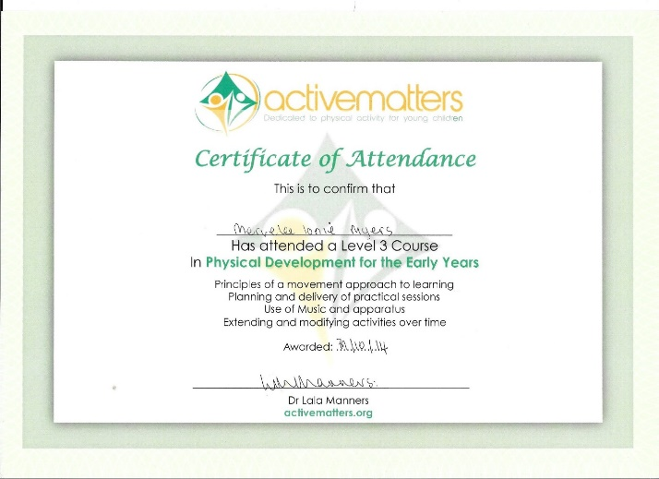
2. Active Matters certificate. 3. Long Service Award. 4. Consent Form – Theresa Salmon.
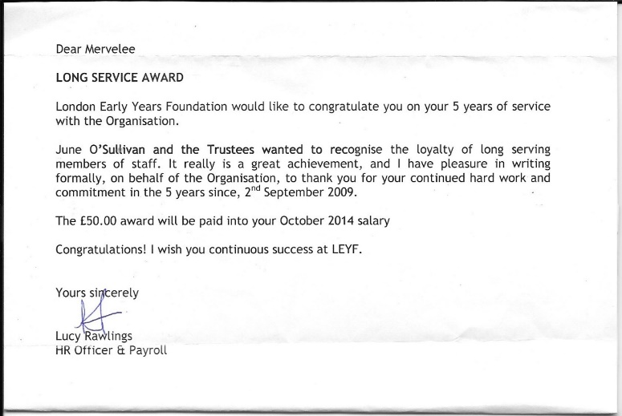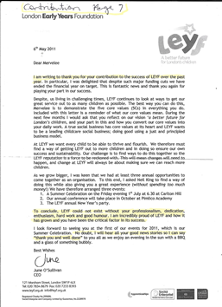
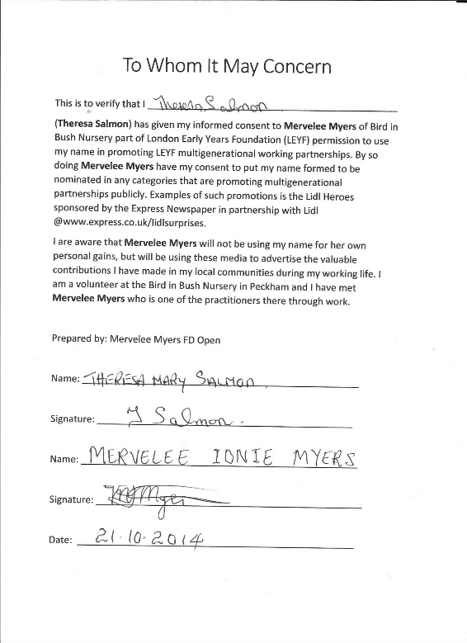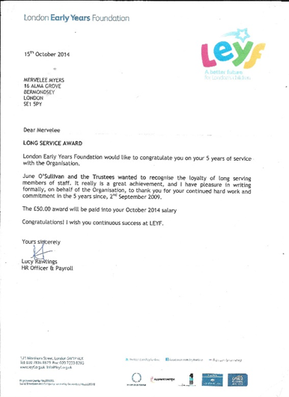
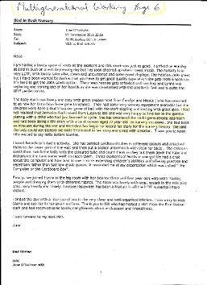
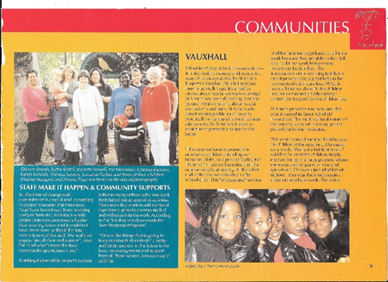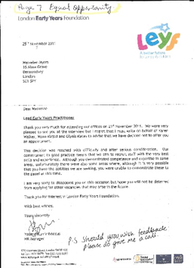
5. BIB Magazine. 6. BIB Magazine article – Theresa Salmon. 7. LEYF CEO Contributions Letter -25.11.2011
8. Long Service Award 15th October 2014. 9. BIB CEO News Letter November 2014. 10. BIB CEO News Letter 30.01.2015
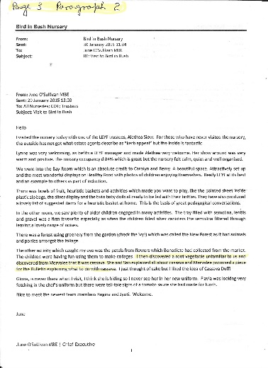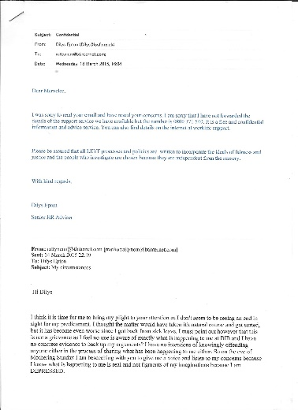 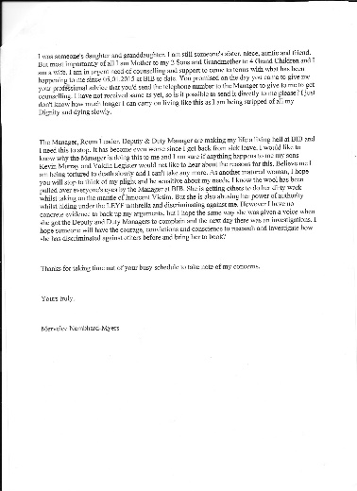 11. Email to HR Dilys Epton 14.03.2015.

Addressing Issues With Jyoti
WB: 05th January 2015 – 15th January 2015.
I extended the arm of professional friendship to Joyti when she started at the setting telling her I worked with LEYF for 5+ years so knows more than most about LEYF work ethos and she was welcome to ask for any help.
After Remi handed over the LJ, she went through the LJ with me and I explained the way how I do my work. I addressed each question and even said to her there are certain things I do not agreed with as the LJ was not being treated as a whole document, but instead all focus was on the observations. She said she spoke to LK about what I said and LK told her someone was coming to address the matter and she would tell her what to tell me.
Joyti admitted to me after her handover with Remi that she was confused and did not know what to do. I offered my support and told her about the LEYF Tracking Children’s Progress 0-5 that each LEYF staff were given a copy. I told her I would try and bring in my copy so she could have a look, but I forgot it. I went into the office to ask Lauren to send of the work I’d done in K’mari’s LJ for Hilda Miller and saw the BIB copy on the filing cabinet and told her about it. Joyti said she read through it and everything was clear and she understand what was to be done now.
I introduced Joyti to the ECAT forms and gave her copy and told her LK is arranging trainings with Early Years Consultant Stella Louis so I will wait for the training so everyone can benefit. However I have had training and knows what to do, but I have to wait on LK.
She looked at Tayandre’s LJ and saw the IEP and ask to take it to copy and I told her she can copy and take, but I would not allow her to take the original out. She showed to Sao and Sao took copy, spoke to me about the fact that she would anonymise it and use it as a learning tool for the children for whom she has concerns. I told Sao I did not mind supporting her if she needed my help. Joyti also showed the IEP to Flavia and I told Flavia I’d help her if she needed me to. I told both Sao and Flavia I was the SENCO at Luton Street so had done trainings about aspects of Special Educational Needs and was responsible for doing lots of documenting information and working with other professionals.
I brought in other training materials and shared with the team and Joyti took her own copies.
Although I explained things to Joyti she keeps coming back to me asking the same question over and over and when I say such and such is not in my remit she said she is asking me because I should know. At this point I was getting the impressions that she thought I was responsible for training her? So thinking I could be of more help to her I handed over K’mari’s and Tayandre’s LJ explaining that Hilda Miller the area manager was using K’mari as one of her project and Tayandre’s was different in that I was documenting evidence because of mine and the parent’s concerns.
I showed Joyti my Activity Planning Folder that I organised and told her I had added the Evaluation part to it when I went to Luton Street and OFSTED recommended it on their visit. When Karen Walker who wrote the Tracking Children’s Progress 0-5 booklet, she had asked permission to borrow and used some of the planning forms.
I explained about the weekly planning and how the focus activity feed into the weekly planning. Each staff is responsible for doing 2 activities per week for the 2-3 & 3-5 age groups. From the focus activity evidence are documented for the LJ. Joyti would question why I do things a certain way and I explained that being with LEYF 5+ years meant everything I do is centred around LEYF ethos and ways of doing things.
Before we went off, I heard Joyti questioning why some children behave certain ways…. I tried to explain the reasons behind the behaviours as I know it would take a little time before she would get to know about each individual child.
I believe I am a very tolerant person and I am prepared to go the extra mile to facilitate anyone especially if they are new to the situation like Joyti. But after coming back from holidays I got the impressions from how Joyti was approaching her work that she is not using her initiatives enough to get to grips with her work. Instead she was relying too much on her colleagues to be spoon feeding her and using her status as Deputy Manager to blag her way through? I found that she kept asking me the same questions about things I had gone through with her several times and which she said she understands. But somehow she just could not seem to get it no matter who explained it to her.
The way she does things can be very disruptive to the routines and leave the children unsettled and I in particular stressed out. I felt I had to be giving her needs for information to do her job priority over meeting the needs of the children. As she would chose the time when you are trying to engage with the children to go over things that were already explained to her. I get the impression that she thinks she has priority to getting her questions answered over the needs of the children. I think by now she should have taken her time to familiarised herself with her Job Description and be more proactive in finding her way around by now. For example she is setting up the table and she keeps walking into the room back and forth with 1 mat at a time asking who this is, is he/she here? All she has to do is get the register and look to see if the child is signed in or out and set a place. These things are happening when I am trying to engage with the children or doing circle time.
One day she commented loudly why is this child so miserable today? The child in question is TAYANDRE’ and I have to say Joyti this is the child I have been sharing information with about my concerns. I am sat at the table engaging with children and Joyti went and takes the LJ, sits at the table and is going through every scrap of information that we went through before and even that which she took copy. Then she has all these questions… What did his parents say? Showed her where parents commented on the 6 Weekly Review. It says here he has French and African language does he speak any of them? Now there is a time and place for everything and since we had gone through the LJ before I thought Joyti should at least be making a profile of the child by then? What really irritated me was the way Joyti kept going through each forms and asking if I had made them up. No I am working with what I have got until I am given the correct ones. Then she is pointing out what are outdated…
I was annoyed that Joyti got up and left the LJ on the table and did not remember to get it and put it away securely. I worked too hard on TAYANDRE’ LJ for anything to go missing because I don’t keep copies on my USB. I do the work and delete to make space. I think Joyti has let the status of Deputy Manager get to her head and have lost her focus on how to accomplish her job. Just going around saying I am this or that status don’t get the job done. Joyti is not the only one either who has let their position go to their head and I am afraid they can rest assured I have no ambitions to be anything than I am so I am not a threat to anyone’s job?
Joyti took to coming to seek me out when I am doing circle time and kind of reminded me of those Inspectors when I went to Primary School. She never contributed anything and just questioning and observing my practice. Then one morning I am doing circle time and she comes in, so since I had been working with Rujina to get Tayandre’, Ify and some of the children settling in from baby room – Adama to join in. I asked Joyti if she would like to take control of the group so I could focus on Tayandre’. She said she would work with Tayandre’, but instead all she ended up doing was keep asking questions about him – why is he not sitting, etc, etc…? So instead of giving my priority to the children Joyti expected me to answer her questions. In my frustrations I said Joyti this is TAYANDRE’ whom I have been sharing information with you about. Even then I doubt very much if Joyti got it?
I just don’t think it was by coincidence that Joyti comes to seek me out when I am doing circle time and is always acting out of sorts whether it was deliberate or she knows it or not. So in the pm when I had to do circle time and had Jayden clinging unto me, I asked Sadie to come in with me as I just could not cope with Joyti anymore. Joyti did come in with Adama but left when Adama did not want to stay.
Sadie who was I am assuming given her role to carry out on Tuesday when I saw 4 members of staff in the office mouth in mouth had done her job, but exaggerated a bit to make it spicier I supposed about what I said? My defence in the matter is I was trying my best not to behave unprofessionally to Joyti because I realised I was STRESSED and at the end of my tether? So I was doing my level best to keep her away from me as by this time she was getting on my Nerves. Yes anyone is welcome to check my file to know why I know when I am liable to behave a certain way if I am unduly provoked? Some of my health conditions caused me to have other underlying health issues that I have to try and control.
Monday 5th Joyti told me about staff meeting and by Thursday her behaviour towards me was just intolerable as she just kept doing these things that was getting on my nerves because by now she was assessing my practice. Then she keeps asking the same questions and did not seem to be getting it. She & Nicola copied some of my work to take to their Deputy Trainings and yet I was hearing things said about me not doing anything. I got the impressions she came back from her Deputy Training to exert her authority wearing her Deputy Manager’s status, but she chose the wrong person to be her target if that was the case. Each time she presented anything I told her that I will do whatever is expected of me when they are implemented by authority.
Thursday whilst on my break and working on the computer she comes to show me the 2 Year Old Progress Check saying LK ask her to show to me. I told her LK had already spoken to me about it earlier and showed me the format and I asked if LK could get it on my USB. She still keeps prattling on so I simply asked if she was finish with what she was saying. She later come to ask Benedicte a question but was unable to formulate it properly, so left to get the book. I said to Benedicte after she left to go find the book that she is talking about the EYFS and she walks in with LK copy. It was funny that Joyti could not formulate a question about the EYFS…?
Later she came out to show me folder that Nicola had given her with planning and advising me what to do with it as Nicola had told her to tell me. I took her again to the Weekly Planning and explained to her how the planning is done again and linking the Focus activity. I said I know that the resource file is a good tool to fall back on, but I would continue using the planning until I was told otherwise. She is telling me that I should just handwrite the activity plans and put in the file Nicola gives her as I don’t have to use computer because she don’t. I told her LK already knows why I do most of my work on the computer.
Monday I noticed Joyti was behaving towards me as if she is my superior and I was there to answer the questions she asked even though I had gone through them with her before. I have to be justifying my practice to her even though I realised there are lots for her to learn. However after what happened the previous week I tried to control my irritations and not to let my frustrations show.
Tuesday of this week I am doing circle time with the younger children as I prefer to work with them to establish the foundation before they turn 3. Joyti comes to the door and tells me I should be quiet with the children because she is trying to read and I AM DISTURBING HER! Now these are the -3 who are the focus to develop skills in the Prime areas and they are not talking, singing or doing nothing to develop any of those skills.
Since I spoke to LK on Tuesday I realised Joyti has climbed down off her high horse and is treating me differently. That is why today I offered the hand of friendship and told her if she feels I have offended her in anyway, speak to me about it. I advised her to ask for some time away from the setting to shadow a more experienced Deputy when she told me she did not have an induction. This is after I spoke to her about the child who is settling in and she said she assumed…? I told her certain things are covered during settling in and she must not ever take anything for granted.
This is my way of covering my back and I do not intend anything I write here to be used against Joyti as I can appreciate how difficult it can be starting out in a new job. I am still willing to help Joyti and anyone else who need my help in getting the job done, because UNITED WE STAND, DIVIDED WE FALL. I am only interested in giving of my best and working collaboratively in the team.
Allegations:
Allegations: Setting the Record Straight – Since there were a number of allegations coming back and forth from WB: Monday 5th January 2015 culminating in a meeting between Lynne Kelly, Remi as the witness and I. Out of that meeting I am hearing about a number of ALLEGATIONS that were made against me. Since some are from the wedding and others from within the setting most of which were alleged to have taken place on Thursday 08th January 2015 I have now been made aware that some are orchestrated by Joyti. Joyti in particular is the author of a number of the allegations that are made in the setting and I don’t know why she is behaving this way towards me.
To protect myself I have decided to stop running from my past and stand up and fight for my rights. However there are certain matters that I need to be cleared up as I am not going to sit idly by and let any other person ruined my life, blacken my name and good character and bring down my high integrity that I worked so hard to achieve. Most of all I won’t allow anyone to rob me of my basic Human Rights not to be Harassed and Bullied as I go through the processes of living my life in a productive manner.
However I must let it be known that the past 2 weeks have impacted on my health, emotional well-being and exacerbated my underlying health conditions. I have gone through the menopause and haven’t had a period over a year. Now I am STRESSED out and bleeding and this is all due to the actions of some UNSCRUPULUS Colleagues who have conspired to make ALLEGATIONS against me. I am hurting and trying to cope with this deceit because all I have done since joining Bird In Bush is to give of my best! It will be very hard for me to go back to that time when I trust anyone because my life was almost RUINED once by unfounded ALLEGATIONS made against me before.
Update:
At the New Year Staff Party: I was talking to Tania my former colleague at Luton Street about telling Joyti to ask to shadow another Deputy Manager. When I told her I worked with Tania, she said she met her at deputy meeting. Tania told me that Jyoti came to shadow her and she was asking for help with the Home Learning & Language groups etc. Tania said she told Jyoti to ask Mervelee to help her because I know what to do. Yet no mention is made of this when they are trying to frustrate me and disempowering so I can’t do my work.

Issues with BIB & Benedicte 19.01.15
After events of the past weeks 04.01.15 – and the Emergency meeting tonight 19.01.15 I have no other alternatives rather than to address the issues with BIB team and Benedicte in particular. Because I know from prior experiences that if I just sit back and let matters take their course one day I might live to regret not acting at my perils? When I visited BIB before starting on 23rd July 2014, I was told that I was to work in the Baby Room because the staff were already assigned and BR is the only place where there is a position.
I shared the information with the manager that because of my condition I am unable to work in the BR and Central Office should have this on record, as I had told them about this at the interview. Since then my conditions have gotten worse and I have additional ones now which makes it even harder to manage. I however said I could carry on working in the BR until the matter was sorted out and I was willing to contact CO myself to deal with the matter if the manager wanted me to. The matter was sorted in no time and Rumi went to the BR and me in preschool. Hilda Miller the area manager came and said it was she who said I should work in the BR, but was happy the matter was resolved.
Everyone made me feel welcome and when I spoke to the manager about my situation she reassured me I am in BIB now so there was nothing to worry about. I was the happiest I was ever being for the longest while and I made sure to let everyone know. But I guess I must have been too naïve as usual and trust people too much because before long I realised all was not as they should be. Because I was new in the setting and did not have any key children so was more or less floating between the BR & Preschool I thought I would take the time to get to know the children. When Rumi was transferred to the BR, I took over her key group, but I was using the chance to capture evidence for all the children to put in their LJ because that is how I work. I just don’t see a child as my key child, but consider myself to be responsible for providing the EYFS for all of them to reach their individual potential. So I was in the process of collating evidence especially for the children for whom I had concerns and getting to know them.
I recalled once Sao came to ask me about the observations I was writing and said I should put them in the child’s – Bezaleel’s LJ. I said I had done them rough and the key person could write them up. She claimed that I was to transfer them on the observation forms because I had done it, so I was responsible for writing on the forms. I said I would only do so if I was given time out and she came back to give me the time to do it but not before arguing with me. But I was surprised when LK comes to talk to me and said she was told I refused to do observations and OFSTED would be coming any time soon and they would need to see them. I reassured LK that she could rely on me to get whatever work done as I always stick to my words. On another occasion I made some rough copy of observations and said to Sao that the key person could write them up, but Remi claimed that she did not have any time to waste to write up anybody’s observation they should do it themselves. I noticed however that when Sao wrote an observation for Mthulisi, she wrote it rough and gave it to me to copy on the observation form. I just got on with it and did not make a song & dance about it as she and Remi had done. By then I realised it is one rule for me and another rule for others, so since I was the newcomer I refused to upset the applecart.
Although I tried to capture children in group activities and documented observations, some either don’t take account of them or just leave them where I handed them over. So of late I focus on documenting the information for my key children and get on with the job as I would like to start up making Homemade Books for BIB. But time does not allow as I have to be dealing with one thing or another like making sure I record what have been happening since the beginning of January 2015. I only have 1 observation in Elizabeth’s LJ from Remi, however since Rujina came she gave me 1 for K’mari. All I done is asked Rujina to write her name on the piece of paper and pasted it on the observation form. Remi said she was given the job of implementing LEYF ethos at BIB, but the others were not supportive and reported her to LK. I noticed the conflicts Remi spoke about especially during Room Meetings when the others told Remi the nursery is not LEYF, but BIB and no one was going to bring anything from outside there.
They did not care where we come from and I just viewed those arguments as the BIB team refusing to move with the time and accepting some of the changes that were expected. I hear Sao using the exact same terms when I explained about taking the CEO Multigenerational Working from Luton Street into BIB. Since Benedicte raised the Multigenerational – Silver Sunday that I promoted celebrating Theresa as a volunteer at BIB as her 1st grievance with me. Because she claimed when she asked me… and she cannot even mention the name – Multigenerational or Silver Sunday – LK have to supply the answer. I told her to go and do her research and she feels that I was rude in saying that to her? The crux of the matter is I find that people interprets things the way they want to suit their arguments. Because I explained to Benedicte that Silver Sunday was celebrating the elderly folks and this is part of Multigenerational.
The CEO is passionate about it and it would be good on her CV if she knows about Multigenerational Working, so it is best for her to do her research. I never for the life of me knew I had offended anyone by telling them to do their research. Because for me research is carried out as part of the job anyway. After listening to what both Benedicte and Flavia had to say tonight about me telling someone to do research, I am flabbergasted and is left to assume that was where I went wrong. Because of me telling Benedicte to do her research about Multigenerational working I am assuming she is carrying a grudge as Carol was the 1 who asked this question in the meeting? I kept wondering why she kept saying “I AM SCARED OF YOU” after I started, but today things are beginning to become much clearer. I noticed that tonight she was so traumatised that she is literally shaking and could not get her words out. Then she is saying things that even if “I Don’t Come To Work Tomorrow…?”
I just can’t imagine what I have done to Benedicte to be getting this sort of reactions from her in a room full of colleagues. So I will now have to make sure I am never alone with her as I don’t want her to make any more ALLEGATIONS against me? I can remember clearly when I made the Book of Cards with the children and decided to extend it to include all the grandparents and Zachary wanted to make the card. Benedicte asked what that was about and when I told her she said “ME AND ZACHARY DON’T CELEBRATE NOTHING”. At the time I thought it was very strange of her but it never dawned on me why as per usual I always take people at face value. I never got any support doing the celebrating and singing for Theresa until after I had finished and called LK to come and join in the photos. Bendicte made up her mind to judge me from I started as she kept saying she is scared of me and during 1 of the RM said she felt we were not giving her the respect she deserved because she is the youngest and she felt she is the only one who should be talking.
All I said at the time was for her to get on with the meeting because I never enquired of anyone’s age when I started. And although she is RL everyone have the right to talk about matters to do with our work as we were not there only to be dictated to. I only became aware of Benedict’s reason for saying why she don’t celebrate anything when Sao told me when I started the Black History Month celebrations and the children were making flags and shape persons to reflect their diverse multicultural identity. Because in the RM Benedicte said we should ask the parent’s permission before we do activities with the children and since I was only doing activities to support, enhance and extend the children’s development and learning across the EYFS. I could not see the reasons for getting permissions. Things only became clear when we started the Christmas activities and Benedict could not stop herself from showing her disapprovals. But because I have worked with colleagues who are Jehovah’s Witness and this is the 1st time I am coming across such reactions.
I had the impressions that we are not allowed to make our religion and politics part of our work, but I could be wrong? Anyway because I am into celebrating all kinds of festival as part of my Job Description in promoting equal opportunity I never for a moment thought celebrating Christmas should be an issue and just got on with the job. The day after Stella visited I was doing the shape people activity with the children when Benedicte come to ask why I was doing that activity. Since I had been doing this activity over a period of time, differentiating it for the age groups. I asked Benedicte if it is the 1st time she saw me doing the activity and she said no but she wants to know what it is about because she is the Room Leader. I asked her if this meant I have to justify my work to her before doing them and I have done studies and trainings to give me the knowledge to provide a balanced curriculum. She said because YOU HAVE A DEGREE IT DON’T MATTER. When I began to justify my arguments about her saying my Foundation Degree didn’t matter she said that is why I don’t talk to you because I am SCARED.
I took her by the shoulders sat her down on a chair and said “I AM A TACTILE PERSON SO I HOPE YOU DON’T MIND ME TOUCHING YOU?” I SAID PLEASE DON’T BE SCARED OF ME, I AM HERE TO HELP YOU AND YOU ARE DOING A WONDERFUL JOB! After I’d finished speaking to her I got Flavia’s attention and asked her to tell Benedict what she told me to do with the shape persons, but I realised Flavia is reluctant to speak to Benedicte. So I explained Flavia told me I could use the shape persons as display in the Maths Area. I tried to fit in as best as I could and thought I was doing a good job implementing and promoting LEYF ways of working at BIB whilst recognising the fact that I am new to the setting so I have to respect the way how the BIB team do their job. I had already brought copy of the ECAT form and given it to LK and she and Mewe promised to look for it on the computer. As far as I am concerned I had done my job and the rest was up to LK. LK later told me that Hilda had brought the ECAT forms over.
When Stella visited LK told me that she was organising ECAT trainings with Stella for all the staff. I introduced the Activity Planning providing a copy for all to see when I done the 1st Focus Activity and started my folder to document evidence of how we support, enhance and extend children’s learning in the areas of the EYFS. OFSTED had picked up on the fact that the 3-5 years old teaching were lacking in the Specific areas. During one of the RM, Benedicte was talking about some matter that came up at her trainings with Gary Simpson & Gill Springer at CO re speaking to parents about their children for whom there are concerns. She mentioned Tayandre’ and Abdul and asked what the key persons were doing. I told Benedicte I had spoken to LK the SENCO and Tayandre’s mum about my concerns and what I was planning to do. Some mention was made about the ECAT form as it is on 1 of the observation forms that is used and Benedicte asks “WHAT IS THAT?” I explained what the form was and told of the fact that LK said Hilda had taken the forms in and went to my locker to get a copy to show the team.
I realised Benedicte had a different approach to her work from mine, but I was not there to question her practice only to do my job and try to inspire and motivate the team to work toward LEYF standards that I am accustomed to. So whenever she give instructions like duties for the day I complied and even go a little further helping out where I can as part of the team. During the Christmas seasons when it was her time to do the Circle Time she did not practice with the children, but since I mostly focussed on the younger children I just got on with the job. One day she asked if I think I was confident enough to practice with the children because Flavia was on break. It was obvious from the question that Benedicte was not trying to get to know the person who is Mervelee Myers, but had already made up her mind about me so she was just sticking to her jaundiced view of being SCARED of me, for what reasons only she knows. This came to a head on the day of the Christmas Play when the children were getting ready and we were practising. During a lull in the practise she asked what was happening and she was going to sing Wriggly Fish.
I told her we should carry on practising the Christmas Songs as we should not be changing at this late stage now it is almost time for the play. She said you know I don’t sing Christmas Carols and I said you don’t have to, and she flounced off. I just cannot understand why Benedicte got so worked up about the Christmas celebrations because I did not noticed ZACHERY’s mum acting in any way different over any of the things she objected to. Zac asked to make the Silver Sunday card to take home when I said it was for grandparents. Mum came in a pointed out the Trinidad flag on the Display Board and talked about it with him. She asked if she could take the Snow person’s cup Zac made that Sao displayed on the window sill home. Benedicte was the one making a big fuss over the whole matter. I realised everyone is afraid to talk about her practice in front of her face, but I have heard whispers that I am not going to repeat about her.
I have always being told from I was little that hearsay cannot go to law and if I say someone say something and they say they did not. It is my word against theirs and that is not what I am about. But I have to make sure I put in writing that lots of things were said before I got to the wedding about work and Benedicte said lots of things about me primarily that I was not happy. And since that was the 1st thing LK said to me on the Monday when she called me to the office I am going to say now that Benedicte is the one who has made up those stories about me saying I am not happy with management along with the other things I was alleged to have said about other staff at CO. I have absolutely no dealings with some of those staff so I don’t know what I could have to say about them. Everyone who reads the CEO letter would know I am writing about THERESA after I have done my Research.
I have been working with LEYF for 5+ years now so I am sorry in case I offend anyone that I do most things the LEYF way and all I was doing is trying to help BIB to work within LEYF ethos, but after what Sao said tonight I will refrain from upsetting anyone. However as a Knowledgeable practitioner I think it is only right that I be allowed to do the job role that is in my Job Description without barriers, constraints and limitations placed in my way. Since I come to BIB I have introduced practice that was not been implement before. Everyone knows that I have been making Homemade Books as part of my practice to show how we carry out certain of the EYFS curriculum and the CEO knows about this. Hence the reasons she endorses the Write up I am doing on Theresa Salmon. Julie my former manager at Luton Street was the one who told the CEO about my projects of writing Homemade Books on one of her visits when we had the media visiting. The CEO applauded my efforts and took one of those books to work on to be used as a learning tool for LEYF. So she knows about my passion and I read her blogs and follow her on Social Media.
At the recent staff meeting I felt picked on and most of what were said were done to belittle and undermine the work I have done over the 5+ years I worked with LEYF and what I since brought to the BIB setting. Only at the time I did not know the reasons for the reactions I was getting. On the Thursday after the SM I saw Benedicte & LK in the office when I was leaving and little did I know what was in motion. The next day I got in and even thou I heard LK had gone to CO for an Emergency meeting, it never dawned on me it was about me until after LK came back & we were supposed to have a meeting, but she said she was advised not to discuss the matter. However during the supervision LK was so distraught about the matter I couldn’t help but apologised if I had caused her any distress. Even then it never dawned on me that Benedicte was the one making ALLEGATIONS about me and this story started from we attended Rumi’s wedding. This only became clear on the Monday when we had the meeting between LK & I & Remi as the facilitator.
I was gobsmacked by some of these allegations and then there were those matters of things that happened in the nursery. I was accused of not doing anything much and all I do is writing. I have explained that in order to do the excellent work especially on the Lj, I have to make my jottings as a memory jogger, so when I am ready to write up I have the information to hand. As for Joyti, I realised that she is taking out her incompetency on me and trying to use me for a scapegoat. She goes out of her way to provoke me to get a reaction out of me and has linked head with Benedicte to wind me up. Because how else can I explain that me asking someone if they had finished speaking to me to be RUDE? Then Joyti keeps coming to the door to peep on me in the preschool only to ask me if I was on my own and when I said I am here with 2 children she saw that as not giving the correct answer to her question. Of course before I was aware of this fact everyone was going to LK complaining about me, but when I went to report her saying I am disturbing her, she can’t understand why.
Joyti realised I know what she is up to because since I spoke to LK she changed her tune towards me. Then on Friday when I spoke to her about the child settling in and she presumed….? I told her to ask to go and shadow in another nursery where she don’t have the responsibility of being on the floor She begins to apportion blame saying she did not get an INDUCTION. As far as I am concerned she has been in the setting long enough to pick up tips about how to perform her roles and responsibility by now. She spends her entire days writing in her book and standing round doing absolutely nothing. Then when I am showing her evidence of the children engaging and learning from the enabling environment provided from the planning, she took the planning form down to asks Flavia what the initials I wrote meant. I rest my case that nothing we told her from she came to the setting has sunk in and I don’t know when anything will? She realised I know exactly where she is at so that is why she is disgruntled with me.
I could do what she is supposed to be doing with my eyes closed. And then she has the nerves of hiding behind her status of being Deputy Manager and at the same time abusing her position, but Benedicte is also doing the same and sees a shadow behind every corner waiting to take away her post. They can rest assured because l am not interested in anyone’s position. Since I have learnt or deduced that Benedicte is responsible for those ALLEGATIONS that were made against me and I am adamant that I never said those things I would like it put on record that she must have some axe to grind or have motives for doing what she is doing to me. The only conclusions I can come to after tonight’s meeting is that she felt I have offended her for telling her to go do her research about Multigenerational and I made sure the children celebrated the Christmas Play and because she don’t celebrate anything because she is Jehovah’s Witness then I have done something terrible to her?
She is holding a GRUDGE and she thinks by going to LK with those ALLEGATIONS she could get rid of me. Pity she don’t know I have been through even more than this and I am still fighting on. However I am not just going to sit back and allow her to gang up on me with the rest of BIB team and treat me like an outsider whilst at the same time DESCRIMINATING against me by Harassing & Bullying me, hiding behind some perceived offence of which I did not knowingly did any such thing – telling her to do her RESEARCH about Multigenerational?
LK said she did not read the letter I gave to her today in place of the meeting we were supposed to have on Friday with Joyti. Instead she puts it in my file, but how is she able to understand things from my point of view. I hope LK will take the time to read my concerns about all the persons involved in making these ALLEGATIONS about me and reading between the lines. Because if she is not careful some of these same people will be causing trouble for her as they want to take over her job. I have written a full account about the 2 weeks and I intended to give to LK, but I have thought better of it and will be using same as my Defensive Practice because I don’t want to lose tracks of how the events unfolded. One day who knows, LK might need it when they show their hands and come out in the open with their plans?
Nicola
I will never forget what Nicola did to me and this is one of the reasons why I am very weary now of the people who are around and me and endeavour never to let my defensive mask slip again. Nicola abused her power of her authority breaching my Basic Human Rights when I was feeling vulnerable because of my health conditions. She tried to stich me up making false allegations about my professional conduct and the way I do my work. Although I moved on from the incident I believed she came to BIB and tried to cause trouble stirring up conflicts amongst the team and pretending she had the interest of BIB at heart.
But all she was interested in was making a name for herself as she tried to curry favour and climb up the career ladder. I can attest to this fact after she visited Henry Fawcett and called back to say how the place was dirty and nothing was going on there. I was left to wonder what had she gone back to report about BIB. As she came in with her superior airs after OFSTED visited saying nothing was happening. Strangely enough, Joyti came and is saying the same kind of things even though it is evident she haven’t got the faintest clue about practice.
Updates:
Matters have escalated to the point now where I don’t know what else to do to please everyone concerned. I have even decided to give up my rights just so I can survive, but to no avail.

Prepared by: Mervelee Myers FD Open.

What is child protection?
‘Child protection is a part of safeguarding and promoting welfare to protect specific children who are suffering, or are likely to suffer, significant harm.’

‘All agencies and individuals should aim to proactively safeguard and promote the welfare of children so that the need for action to protect children from harm is reduced.’

Safeguarding and promoting the welfare of children is defined as:
- protecting children from maltreatment;
- preventing impairment of children’s health or development;
- ensuring that children are growing up in circumstances consistent with the provision of safe and effective care;
- and taking action to enable all children to have the best outcomes

’A child is anyone who has not yet reached their 18th birthday. 'Children' therefore means 'children and young people'
Working Together to safeguard children (HM Government 2013)

Why do we need child protection training?
Although very difficult to accept, child abuse does happen and is unfortunately an all too common occurrence across most cultures and countries. Any child, regardless of age, gender, race, religion, culture or social background may be at risk of physical, sexual or psychological harm and a potential victim of abuse.

There is however evidence to suggest that incidents of child abuse can be reduced and often prevented through implementation of national strategies aimed at promoting children’s rights and reducing the risks of child abuse occurring.

This child protection training course helps to raise awareness of child protection issues, thus helping you to:
- Keep children and young people safe
- Meet legal and moral responsibilities
- Minimise the risks of allegations being made.
- Enhance your knowledge and understanding
- Promote better outcomes

The legal framework
The legal framework for safeguarding and protecting the safety and welfare of children and young people in England is: The Children Act (1989) and the Children Act (2004). The current statutory guidance is Working together to safeguard children (2013).
Organisations should also follow the supplementary guidance What to do if you're worried a child is being abused (2006) and have access to a copy of their Local Safeguarding Children Board's guidance and procedures. This list is by no means exhaustive and further reading is highly recommended.

Which are the main agencies responsible for child protection?
The main statutory agencies responsible for safeguarding and promoting the welfare of children include:
- Children's social care services (Leads on all child safeguarding and protection issues)
- Police (Leads on all criminal investigations)
- Health
- Education
- Children and Family Court Advisory Support Service (CAFCASS)
- Probation
- The Voluntary Sector
But everyone shares responsibility for safeguarding and promoting the welfare of children and young people, irrespective of individual roles.

What are local safeguarding children’s boards (LSCB)?
Local Safeguarding Children Boards (LSCB) are the key statutory mechanism for agreeing how relevant organisations co-operate to safeguard and promote the welfare of children and ensure the effectiveness of what they do. LSCB’s are responsible for a range of statutory functions including:
- The development of child protection policy and practice guidance
- Providing information, training and practice guidance on child protection issues
- Raising awareness of child protection issues
- Participating in the planning of services for children
- Assessing the effectiveness of the help being provided to children and families

However, they are not responsible for investigating safeguarding referrals.

What is Abuse and Neglect?
‘Abuse and neglect are forms of maltreatment of a child. Somebody may abuse or neglect a child by inflicting harm, or by failing to act to prevent harm. Children may be abused in a family or in an institutional or community setting, by those known to them or, more rarely, by a stranger for example, via the internet. They may be abused by an adult or adults, or another child or children.’

The Children Act 1989 states that abuse should be considered to have happened when someone's actions have caused a child to suffer significant harm to their health or development, or is likely to.

Significant harm is defined as ‘any form of abuse, neglect, accident or injury that is sufficiently serious to adversely affect progress and enjoyment of life. Harm is defined as the ill treatment or impairment of health and development.
Working Together to safeguard children (HM Government 2013)

What are the main types of abuse?

Physical Abuse
‘Physical abuse may involve hitting, shaking, throwing, poisoning, burning or scalding, drowning, suffocating, or otherwise causing physical harm to a child. Physical harm may also be caused when a parent or carer fabricates the symptoms of, or deliberately induces, illness in a child.’

Sexual Abuse
‘Sexual abuse involves forcing or enticing a child or young person to take part in sexual activities, not necessarily involving a high level of violence, whether or not the child is aware of what is happening. The activities may involve physical contact, including assault by penetration (for example, rape or oral sex) or non-penetrative acts such as masturbation, kissing, rubbing and touching outside of clothing. They may also include non-contact activities, such as involving children in looking at, or in the production of, sexual images, watching sexual activities, encouraging children to behave in sexually inappropriate ways, or grooming a child in preparation for abuse (including via the internet). Sexual abuse is not solely perpetrated by adult males. Women can also commit acts of sexual abuse, as can other children.’

Emotional Abuse ‘Emotional abuse is the persistent emotional maltreatment of a child such as to cause severe and persistent adverse effects on the child’s emotional development. It may involve conveying to children that they are worthless or unloved, inadequate, or valued only insofar as they meet the needs of another person. It may include not giving the child opportunities to express their views, deliberately silencing them or ‘making fun’ of what they say or how they communicate. It may feature age or developmentally inappropriate expectations being imposed on children. These may include interactions that are beyond the child’s developmental capability, as well as overprotection and limitation of exploration and learning, or preventing the child participating in normal social interaction. It may involve seeing or hearing the ill-treatment of another. It may involve serious bullying (including cyber bullying), causing children frequently to feel frightened or in danger, or the exploitation or corruption of children. Some level of emotional abuse is involved in all types of maltreatment of a child, though it may occur alone.’

Neglect
‘Neglect is the persistent failure to meet a child’s basic physical and/or psychological needs, likely to result in the serious impairment of the child’s health or development. Neglect may occur during pregnancy as a result of maternal substance abuse. Once a child is born, neglect may involve a parent or carer failing to:
- provide adequate food, clothing and shelter (including exclusion from home or abandonment);
- protect a child from physical and emotional harm or danger;
- ensure adequate supervision (including the use of inadequate care-givers); or  ensure access to appropriate medical care or treatment.
It may also include neglect of, or unresponsiveness to, a child’s basic emotional needs.’
What are the signs and indicators of abuse and neglect?
Children often find it very difficult to talk about the abuse they’re experiencing and abusers can also become very skilled at covering their tracks and may appear as very caring people. Therefore you might have to rely on possible signs as an indication of possible abuse. But remember you are not expected to decide which type of abuse a child may be experiencing; this is not the responsibility of any one person.

Indicators of Physical Abuse (Non-  Accidental Injuries)  - Injuries in unusual positions which it’s hard to explain the nature of i.e. back, chest, torso, buttocks, neck, behind ears, inside thighs, face, head, genitals, back of hand  - Injuries inconsistent with the age, abilities or lifestyle of the child  - Finger marks, slap marks, bites, fractures, burns and scalds  - Damage to the mouth such as bruised or cut lips or torn skin where the upper lip joins the mouth  - Clusters of injuries forming regular patterns  - Injuries at different stages of healing  - Object marks, clear outlines of objects  - Child appears frightened  - Explanation of injuries is avoided or inconsistent (child and/or carer)  - Delay in seeking treatment for injuries  - Child behaving aggressively towards others |  | Indicators of Emotional Abuse  - Physical, mental and emotional developmental delays  - Needy or clingy  - Difficulty with genuine trust, intimacy and affection  - Negative, hopeless and negative view of self, family and society  - Low self esteem, deference and resignation  - Change in appetite  - Extremes of passivity and aggression  - Poor concentration  - Difficulty making friends  - Sudden speech disorders  - Unexplained fear, defensiveness, ambivalence  - Emotional withdrawal  - Sleep disturbance  - Carer constantly rejects and ignores the child, depriving them of responsiveness and stimulation  - Carer isolates the child and prevents them building relationships and making friends  - Carer shows little warmth and affection towards the child  - Carers constantly criticises or humiliates the child and appears unable to give praise

Indicators of Sexual Abuse  - A detailed sexual knowledge inappropriate to the age and developmental stage of the child  - Sexually explicit language/behaviour  - Increased frequency of visits to the toilet, bed wetting  - Behaviour that is excessively affectionate or sexual towards other children or adults  - A fear of medical examinations  - A fear of being alone  - Sudden loss of appetite, compulsive eating, anorexia nervosa or bulimia nervosa  - Excessive masturbation  - Sexual approaches or assaults on other children or adults  - Urinary tract infections, sexually transmitted diseases  - Bruising to the buttocks, lower abdomen thighs, and genitals and other rectal areas. Bruises may be confined to grip marks where a child has been held so that abuse can take place  - Drawing pornographic or sexually explicit images or writing about the same.  - Depression  - Low self esteem |  | Indicators of Neglect  - Failure to thrive  - Constant hunger and/or tiredness, malnutrition, steals food  - Poor hygiene  - Frequent accidental injuries and illnesses  - Untreated medical problems  - Developmental delays  - Poor state of clothing  - Unable to make friends, lack of social relationships  - Low self esteem  - Treated differently to other children by their carer  - Carer appears stressed and unable to cope

Always Remember:
- Abuse can be a one off act or it can be something that happens regularly.
- Abuse is often, but not always, a crime.
- Abuse can be perpetrated by anyone anywhere.
- There is often more than one type of abuse in any situation.
- Abuse is not always intentional – it can be the result of often well meaning ignorance.
- We all have a duty to report any concerns or suspicions that a child is being or has been abused.

Responding to disclosures of child abuse and neglect
On occasion children and young people will disclose abuse to the trusted adults who have contact with them. When this occurs it is vitally important that the disclosure is responded to correctly.

Always:  - Remain calm, be available to listen carefully to what you are being told and try not to show any shock or disbelief.  - Listen with the utmost care to what the child is saying  - Inform the child that this information will have to be passed on but only to people who need to know and who will help protect their safety and welfare  - Offer reassurance to the child or young person. Let them know that they were right to inform you, that the abuse isn’t their fault, that they’ve done the right thing and that you are listening to them and treating the information seriously.  - Use a language that the child understands and wherever possible the child’s words to clarify or expand what has been said.  - Make notes of the main points carefully.  - Make a record of any apparent injuries. It may be useful to use a body map to record details of the injuries.  - Inform the Senior Designated Lead Professional or their Deputy in your organisation immediately, unless the disclosure implicates them in any way. If you’re unable to make contact with these people then contact children’s social care services or the police if the child is in imminent danger. |  | Never:  - Make promises – to keep secrets, that you can make everything better  - Ask leading questions or begin to investigate. This may cause unnecessary stress and repetition for the person concerned. It may also invalidate any evidence if required for a prosecution  - Put words in the child’s mouth  - Ask or make children and young people write statements about abuse that may have happened to them. This is inappropriate.  - Stop someone who is freely recalling significant events; allow them to share whatever is important to them  - Contact the alleged ‘perpetrator’ or alleged ‘victim’ (unless you have no choice because they make contact with you)  - Be judgmental (e.g. ‘Why didn’t you try and stop them?’);  - Break the confidentiality agreed between the person disclosing the information, yourself and your line manager.  - Make promises you are unable to keep;  - Rush the child into giving details of the abuse. Your role is to listen to what the child wants to tell you and not to conduct an investigation.

Always Remember:
Monitor, record and consult with your Senior Designated Professional for Child Protection or their Deputy.
If a child is at imminent risk you must not delay.
Contact children's social care services immediately or the police in an emergency.
What should be recorded?
A Full written record of the disclosure should be made as soon as possible on the same day and stored in a secure location until passed to the relevant agency.

Ensure all records are clearly signed and dated and include:
- the time the conversation with the child took place
- the time the record was written
- a clear factual outline of what was said
- details of the child’s body language, etc
- Always attach any initial notes made, body maps etc.
All referral information and decisions, phone calls, discussions and actions should also be recorded and kept with the full record. This should also include a record of any decisions made not to refer the incident, along with the reasons.

Remember your recordings are official documents and may become evidence in the future

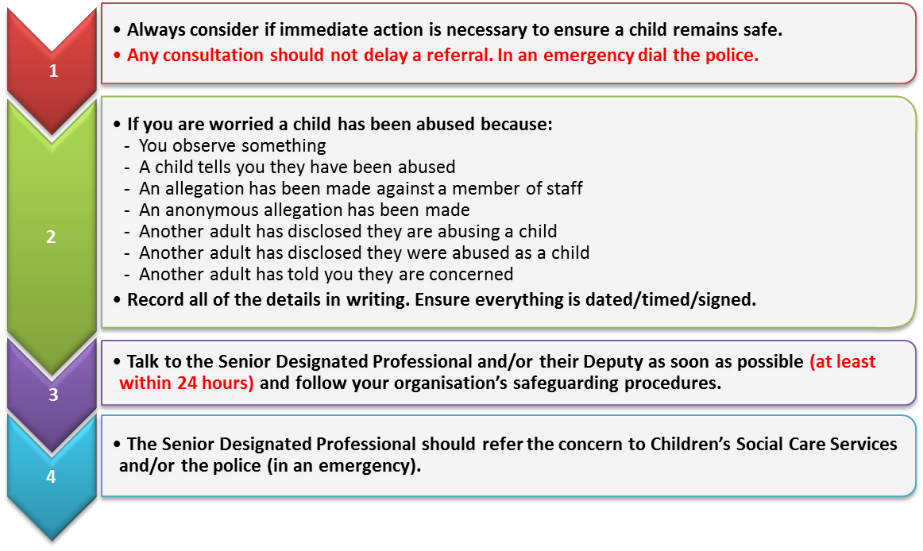
When managing concerns of child abuse and neglect:

Always
consider if immediate action is necessary to ensure a child rem
ains safe.

If not follow steps 1 to 3:

Personal support mechanisms
Dealing with child abuse can be an extremely difficult experience for everyone concerned.
Whilst it’s vitally important to have systems and procedures in place to safeguard and protect the safety and welfare of children it’s also important to think about what support mechanisms are in place to help and support you.
Consider what support mechanisms you have in place.
- Do you have people at work and/or at home you are able to talk to about any personal anxieties you may have?
- Do you have regular meetings and contact with relevant people such as the children’s safeguarding lead person/deputy or a manager with whom you can discuss any concerns or anxieties you may be experiencing?
- Do you have access to relevant information such as organisational safeguarding policies and risk assessments etc?
- Do you have a system in place to ensure your training and development is maintained and kept up to date?

Remember safeguarding and promoting the safety and welfare of children and young people is EVERYBODY’S BUSINESS and everybody can help by:
> Maintaining a child focus <
> Being observant: of children, young people, adults < > Carrying out safeguarding risk assessments <
> Following procedures <
> Monitoring concerns <
> Responding to concerns <
> Recording concerns <
> Consulting with the lead or deputy professional for child protection < > Referring concerns to children's social care services <
> Dialling 999 for the police in an emergency <
> Observing confidentiality with family and friends <

Recommended further reading
What to do if you're worried a child is being abused and Working Together to safeguard children (HM Government 2013)
To follow up this course in more detail, please refer to the documents on our References page.



Volunteer Application Form

Information given in this form is confidential. Your signature gives us consent to hold the details on this form on a database for volunteering purposes only. All information is held in accordance with the Data Protection Act 1998. The Chief Executive is Data Controller under the Act. You have the right to make a formal request in writing for access to personal data held about you to inspect it and have it corrected if it is wrong

Resources for Autism will try to find suitable voluntary work for anyone who applies but due to the work we do it may not always be possible to place volunteers at the time they apply. If this is the case the reasons for not being able to place you will be explained. RfA offer training to volunteers and have a six month minimum commitment for all volunteers.

Name and Address
Name: Mervelee Myers
Address: 16 Alma Grove
Bermondsey
London
Postcode: SE1 5PY
Telephone (home): 02072310813
Telephone (mobile): 07950618083
Email: rattynem@btinternet.com Ratty.Nembhard1956@gmail.com
Alternative/Home Address (Students):
Postcode:

Emergency Contact Details
Emergency Contact Name/Next of Kin: Arnold Tomlinson

Emergency Contact Tel. No.: 07900866032 home: 02072310813

What kind of volunteering might you be interested in?

Activity | Tick if interested
Family Support (working one to one in a family’s home) | x
Driving children/carers to and from sessions
Maintenance/gardening | x
Office work/administration
Fundraising | x
I.T and data base work.

About yourself
Please use this section to tell us anything you think might be useful e.g. why you would like to volunteer, any skills or experience you would wish to use etc. You are welcome to attach extra sheets.
I’d like to volunteer because I believe volunteering is a good way for me to apply some of the knowledge and expertise I have gained via studies and trainings to an area of SEND that I am passionate about. I was always interested in volunteering, but just never got around to doing it and finding the right cause like this.
I was a Basic School Teacher in my native country and been working in the early years sector since July 1999 in the UK. My experience of having a child who was misdiagnosed as being deaf and dumb is the primary reason for me dedicating myself to studies. I dedicated myself to educating myself after settling in the UK because I did not have this chance in my country. I attended Lambeth College where my appetite was wetted for empowering myself and gaining the knowledge to help me make my passion of working with young children become a reality. Once I realised that my knowledge was lacking about some of the things that caused me not to understand about my child’s language delay when I started working in the early year’s sector. I have since studied with the Open University gaining a Foundation Degree in Early Years & a Health and Social Care Level 2 certificate. Whilst studying I covered a module about Inclusion and attended many trainings, workshops and seminars about aspects of SEND and autism in particular. I done trainings covering aspects of Special Educational Needs and the role of the SENCO. I held the role of being a key person and worked as a SENCO in one of the setting for my current employers. I know the basics in Makaton and has done a brief Picture Exchange Communication System (PECS) training although I did not get the opportunity to put the training in practice. I would like to enhance my CPPDP by volunteering to gain a better understanding about SEND and autism in particular, because I work with children on the autistic spectrum.

For your support
Do you need written information in large print or braille?
Do you use a minicom?
Do you have mobility difficulties? Arthritis

General questions
Do you drive? No
Do you have access to a car? No
Do you have any medical disorders or allergies we should know about? (Parkinson disease undiagnosed) Anxiety, Arthritis, Diabetes.

Do you have language skills other than English? No

When would you be available to do volunteer work? (please tick):
Weekday afternoons
Weekday evenings
Weekends | x

How much voluntary work would you like to do, and how often?

Where did you hear about RFA/this volunteering opportunity? Evening Standard

Because much of our volunteering work happens in family homes, access for those with a disability may be an issue. We welcome disabled volunteers where possible but access can be a difficulty. It would be very helpful to have more information about any support needs you might have.
References
Please give the names of two people for us to contact. At least one should have known you for two years or more. One referee can be a personal reference; the other should be an employer or college tutor. We cannot accept references from family members. Employment or education referees must send their reference on headed paper or by work or institution email, NOT personal emails.

Reference 1
Name: Winnifred McLeish-Jacques
Title (Mr, Mrs, Ms, Dr etc.): Mrs
Address: 295 Beechwood Road, Luton LU4 9RE.
Telephone (daytime): 07939349568

Email Address: winni4christ@yahoo.com
Length of time known to you: 10 years
How is this person known to you? Former colleague & Manager

Reference 2
Name: Lynne Kelly
Title (Mr, Mrs, Ms, Dr etc.): Nursery Manager
Address: Bird in Bush Nursery, 616 Old Kent Road, Peckham SE15 1 JB
Postcode: SE15 1 JB
Telephone (daytime): 02076393030
Email Address: birdinbush@lefy.org.uk
Length of time known to you: 23rd July 2014
How is this person known to you? Manager

Disclosure
Volunteers for some roles within RFA will need to be police-checked by way of the Disclosure process through the Criminal Records Bureau (CRB). The process involves disclosure of details of all convictions on the Police National Computer, including spent convictions, and also details of police cautions, reprimands and warnings. It may also include any information previously held on lists maintained by the DFES or DOH (Department of Health). We provide the necessary forms and you receive a copy of any disclosure made by the CRB. The process is confidential, and does not cost you anything.

Signed_____________________________________________________________
Print name___________________________________________________________
Date______________________

Please return this form to Resources for Autism, 858 Finchley Road, NW11 6AB

Charity Registration No. 1061253
Resources for Autism is a Company limited by guarantee.
Registered in England: No. 3326332

RESOURCES FOR AUTISM
EQUAL OPPORTUNITIES IN EMPLOYMENT

MONITORING
RfA is committed to equal opportunities. Ensuring we are genuinely inclusive necessitates the collection of information regarding applicants’ ethnic origin, gender and disability. This monitoring form is detached prior to short-listing decisions. The content of the form is treated in strict confidence, used only for monitoring purposes and will not be used for any purpose other than analysis of effectiveness of Resources for Autism equal opportunities policies and procedures. Completion of the form is not compulsory but we value your cooperation.

EQUAL OPPORTUNITY MONITORING
GENDER

I am: Female
AGE:
Male
Date of Birth…………………………

DISABILITY:

Do you consider yourself to have a disability? Yes/No

Are you registered disabled? Yes/No

Do you have a disability that means you would like help or support at interview?
Yes/No (If the answer is yes please let us know if you are short-listed for interview.)

ETHNIC ORIGIN

I am:

White British Chinese Choose not to say

Black British Latin American

Black African Other White

Black Caribbean Other Black

Indian Other Asian

Pakistani Mixed Parentage

Bangladeshi Other

Date form completed………………………………………



FAMILY SUPPORT VOLUNTEER

Being a Family Support Volunteer can be enormously rewarding. You will provide valuable support, and can make a big difference to people’s quality of life. It will also be rewarding for you. As well as supporting families, you will be learning and developing new skills yourself, and meeting people from all walks of life.

It is not something to be undertaken lightly, though. Supporting families affected by autism is not easy, and not everyone will find that it suits them. Resources for Autism provides a training for Family Support Volunteers, which takes place over the course of 2 evenings per week over 2 weeks, and every volunteer has to complete this before they can begin supporting families. After training, we ask volunteers to commit to volunteering with us for a minimum of 2.5-3 hours per week, for around six months. Plenty of ongoing support is provided for volunteers.

The support provided by volunteers will be identified in a Family Support Plan. This is tailored to the needs of each family, but typically might include the following:

- supporting parents to develop their child’s communication and interaction
- support the development of play, and the parent’s confidence in playing with their child
- supporting parents/providing an extra pair of hands on practical issues that the family identify as priorities e.g. getting out and about
- providing information, and signposting to statutory and voluntary organisations for further information/advice e.g. statementing, benefits, play schemes, respite
- supporting the parent in making links with nursery/school etc, especially at transition times (e.g. entry to nursery; starting school; changing schools)
- providing support to siblings of children with ASC

Role description

Main purpose of role
To provide home-based support and information to families affected by Autistic Spectrum Disorders (ASC) in and around London.

Responsible to: Resources for Autism Volunteer Co-ordinator and Reach Out Co-ordinator

Primary duties:
- to form positive relationships with each family with whom you are supporting.
- to liaise with the Reach Out Co-ordinator and the family on the preparation of Family Support Plans, and adapting the plans as a family’s needs change
- to provide support and information to each family according to their needs and wishes, as agreed in their Family Support Plan
- to keep a written record of every family visit/meeting
- with the family’s consent, to liaise with statutory and voluntary organisations who are also working with that family
- to keep up to date with information relevant to families affected by autism.
- to maintain appropriate boundaries with families and individuals with whom you are supporting.
- to abide by Resources for Autism’s confidentiality and equal opportunities policies
- to liaise with the Reach Out Co-ordinator about appropriate onward referrals (within RFA or to other agencies)
- to attend training provided by Resources for Autism (including Autism Awareness, communication systems, education etc)
- to attend and participate in Volunteer Support Meetings

Qualities and Skills needed by a Reach Out Volunteer

Personal qualities
- Warmth: the ability to form positive relationships with individuals and families who may be going through difficult times
- Excellent communication and interpersonal skills
- Reliability
- Commitment: the training is quite intensive, and after training, we ask all our volunteers to commit to working with us for a minimum of 2.5 - 3 hours a week, for six months
- Empathy and understanding
- A willingness to learn from others
- Self awareness: the ability to reflect on the family-volunteer relationship and your role as a family support volunteer
- A non-judgemental attitude
- The ability to cope in potentially stressful situations, and the willingness to ask for help when needed
- Ability to use own judgement and common sense
- An ability to remain objective and to maintain appropriate boundaries

Skills, knowledge and experience
Resources for Autism provides thorough training for volunteers, and we like to recruit volunteers from all walks of life, but the following would be a helpful background:
- An understanding of autistic spectrum disorders
- Experience of working with children with learning difficulties
- Experience of working with children and families in a paid or voluntary capacity

Other
- The ability to travel to families’ homes, by either public or your own transport (travel expenses will be paid)


Resources for Autism Safeguarding Children and Young People.

INTRODUCTION:

This document is the Child Protection Policy for Resources for Autism, which will be followed by all members of the organisation and followed and promoted by those in the position of leadership within the organisation.

The purpose of the organisation is to provide practical services for children and adults with autism and those who love and care for them.

We know that being a young person makes them vulnerable to abuse by adults and that disabled young people are the most at risk. The purpose of this policy is to make sure that the actions of any adult in the context of the work carried out by the organisation are transparent and promote the welfare of all young people.

If any parent or young person/child has any concerns about the conduct of any member of the organisation, this should be raised in the first instance with the Director who is the Designated Child Protection Manager

This document is written in accordance with ‘Working Together to Safeguard Children’ produced by the Department of Health in 1999.

There is a difference between Child Protection and Safeguarding. The statement below is from the 2010 version of Working Together to Safeguard Children:
‘Effective child protection processes are an essential part of the wider work to safeguard and promote the welfare of children so that the need to protect children from harm is reduced.’

Principles upon which the Safeguarding Policy is based.

- The welfare of a child or young person will always be paramount.
- The welfare of families will be promoted.
- The rights, wishes and feelings of children, young people and their families will be respected and listened to.
- Those people in positions of responsibility within the organisation will work in accordance with the interests of children and young people and follow the policy outlined below.
- Those people in positions of responsibility within the organisation will ensure that the same opportunities are available to everyone and that all differences between individuals will be treated with respect.

CHILD PROTECTION POLICY

1. Immediate Action to Ensure Safety

Immediate action may be necessary at any stage in involvement with children and families.

IN ALL CASES IT IS VITAL TO TAKE WHATEVER ACTION IS NEEDED TO SAFEGUARD THE CHILD/REN:

- If emergency medical attention is required this can be secured by calling an ambulance (dial 999) or taking a child to the nearest Accident and Emergency Department.
- If a child is in immediate danger the police should be contacted (dial 999) as they alone have the power to remove a child immediately if protection is necessary, via Police Protection Order.

2. Recognition of Abuse or Neglect

Abuse or neglect of a child is caused by inflicting harm or by failing to act to prevent harm. Children may be abused in a family or in an institutional or community setting by those known to them, by other young people or more rarely by a stranger.

Physical Abuse

Physical abuse may involve hitting, shaking, throwing, poisoning, burning or scalding, drowning, suffocating, or otherwise causing physical harm to a child. Physical harm may also be caused when a parent or carer feigns the symptoms, of, or deliberately causes ill health to a child whom they are looking after. This situation is commonly described using terms such as, fabricated illness by proxy or Munchausen Syndrome by proxy.

Emotional Abuse

Emotional abuse is the persistent emotional ill treatment of a child such as to cause severe and persistent adverse effects on the child’s emotional development. It may involve conveying to children that they are worthless or unloved, inadequate, or valued only in so far as they meet the needs of another person. It may feature age or developmentally inappropriate expectations being imposed on children. It may involve causing children frequently to feel frightened or in danger, or the exploitation or corruption of children. Some level of emotional abuse is involved in all types of ill treatment of a child though it may occur alone. Creating fear or hatred in a young person that may lead to extremism is classed as emotional abuse.

Sexual Abuse

Sexual abuse involves forcing or enticing a child or young person to take part in sexual activities, whether or not the child is aware of what is happening. The activities may involve physical contact, including penetrative (eg rape or buggery) or non-penetrative acts. This can include non-penetrative acts. They can include non-contact activities, such as involving children in looking at, or in the production of, pornographic material, or watching sexual activities, or encouraging children to behave in sexually inappropriate ways.

Neglect

Neglect is the persistent failure to meet a child’s basic physical and/or psychological needs, likely to result in the serious impairment of the child’s health or development. It may involve a parent or carer failing to provide adequate food, shelter and clothing, failing to protect a child from physical harm or danger, or the failure to ensure access to appropriate medical care or treatment. It may also include neglect of, or unresponsiveness to, a child’s basic emotional and psychological needs, including needs specifically related to their autism..

On Line or E-Abuse

As with any form of safeguarding, the potential risks to children and young people from the use of technology must be recognised and many young people with autism spend a great deal of unsupervised time on computers and may prefer to use email and social media as a communication tool so these must be monitored and taken into account. Risks may include:

•
- Prolonged exposure to online technologies, particularly from an early age.
- Exposure to inappropriate content, images and language.
- Making, taking and distribution of indecent images and ‘sexting’.
- Cyber bullying.
- Grooming for sexual and/or emotional abuse.
- Addiction to gambling and/or gaming.
- Pressure from media and targeted advertising.
- Encouraging extremism, hatred and supporting terrorism

Individuals within the organisation need to be alert to the potential abuse of children both within their families and also from other sources including abuse by members of the organisation and other young people.

The organisation should know how to recognise and act upon indicators of abuse or potential abuse involving children. There is an expected responsibility for all members of the organisation to respond to any suspected or actual abuse of a child in accordance with these procedures.

It is good practice to be as open and honest as possible with parents/carers about any concerns.

However, you must not discuss your concerns with parents/carers in the following circumstances:

- where sexual abuse is suspected
- where organised or multiple abuse is suspected
- where fictitious illness by proxy (also known as Munchausen Syndrome by proxy) is suspected
- where contacting parents/carers would place a child, yourself or others at immediate risk.

What to do if children talk to you about abuse or neglect

It is recognised that a child may seek you out to share information about abuse or neglect, or talk spontaneously individually or in groups when you are present. In these situations you must:

- Listen carefully to the child. DO NOT directly question the child.
- Give the child time and attention.
- Allow the child to give a spontaneous account; do not stop a child who is freely recalling significant events.
- Make an accurate record of the information you have been given taking care to record the date, timing, setting and people present, the child’s presentation as well as what was said. Do not throw this away as it may later be needed as evidence.
- Use the child’s own words where possible.
- Explain that you cannot promise not to speak to others about the information they have shared.
- Reassure the child that:
  - you are glad they have told you;
  - they have not done anything wrong;
  - what you are going to do next.
- Explain that you will need to get help to keep the child safe.
- Do NOT ask the child to repeat his or her account of events to anyone.

3. Consulting about your concern

The purpose of consultation is to discuss your concerns in relation to a child and decide what action is necessary.

You may become concerned about a child who has not spoken to you, because of your observations of, or information about that child.

It is good practice to ask a child why they are upset or how a cut or bruise was caused, or respond to a child wanting to talk to you. This practice can help clarify vague concerns and result in appropriate action. These are open questions and designed to gain information not to lead the child or young person.

If you are concerned about a child you must share your concerns. Initially you should talk to one of the people designated as responsible for child protection within your organisation. In this organisation this person is firstly your group leader or line manager then Catherine Ely Director of Play and Youth services on: 0208 458 3259 or Laky Sahota West Midlands Manager on 07891476837 or Liza Dresner Director on 0208 458 3259. If one of those people is implicated in the concerns you should discuss your concerns directly with Social Services.

You should consult externally with the local Social Services Department in the following circumstances:

- when you remain unsure after internal consultation as to whether child protection concerns exist
- when there is disagreement as to whether child protection concerns exist
- when you are unable to consult promptly or at all with your designated internal contact for child protection
- where there is already an allocated social worker who may have more information.
Consultation is not the same as making a referral but should enable a decision to be made as to whether a referral to Social Services or the Police should progress.

All details will be confidential once shared.

4. Making a referral

A referral involves giving Social Services or the Police information about concerns relating to an individual or family in order that enquiries can be undertaken by the appropriate agency followed by any necessary action.

In certain cases the level of concern will lead straight to a referral without external consultation being necessary.

Parents/carers should be informed if a referral is being made except in the circumstances outlined on p 4.

However, inability to inform parents for any reason should not prevent a referral being made. It would then become a joint decision with Social Services about how and when the parents should be approached and by whom.

If there is already a Social Worker allocated to the family you must try to contact them to inform them of your concerns. If you cannot get hold of them then go through the Local Authority Designated Officer via the usual route and ensure you say that there is an allocated Social Worker. (See appendix 1)

IF YOUR CONCERN IS ABOUT ABUSE OR RISK OF ABUSE FROM SOMEONE NOT KNOWN TO THE CHILD OR CHILD’S FAMILY, YOU SHOULD MAKE A TELEPHONE REFERRAL DIRECTLY TO THE POLICE AND CONSULT WITH THE PARENTS.

If your concern is about abuse or risk of abuse from a family member or someone known to the children, you should make a telephone referral to your local Social Services Office. (see appendix 1)

Information required

Be prepared to give as much of the following information as possible (in emergency situations all of this information may not be available). Unavailability of some information should not stop you making a referral.

- Your name, telephone number, position and request the same of the person to whom you are speaking.
- Full name and address, telephone number of family, date of birth of child and siblings.
- Gender, ethnicity, first language, any special needs.
- Names, dates of birth and relationship of household members and any significant others.
- The names of professionals’ known to be involved with the child/family eg: GP, Health Visitor, School.
- The nature of the concern; and foundation for them.
- An opinion on whether the child may need urgent action to make them safe.
- Your view of what appears to be the needs of the child and family.
- Whether the consent of a parent with parental responsibility has been given to the referral being made.

Action to be taken following the referral

- Ensure that you keep an accurate record of your concern(s) made at the time.
- Put your concerns in writing to Social Services following the referral (within 48 hours).
- Accurately record the action agreed or that no further action is to be taken and the reasons for this decision.

5. Confidentiality

The organisation should ensure that any records made in relation to a referral should be kept confidentially and in a secure place.
Information in relation to child protection concerns should be shared on a “need to know” basis. However, the sharing of information is vital to child protection and, therefore, the issue of confidentiality is secondary to a child’s need for protection.

If in doubt, consult.

This document should be read in conjunction with:
RfA safer recruitment guidelines
RfA whistleblowing policy
RfA complaints procedures
RfA adult safeguarding policy
RfA Concerns Sheets and Body Maps

(Updated and Reviewed June 2015)
Appendix 1:

Some external local contacts:
Most authorities are moving to MASH (Multi Agency Safeguarding Hub) teams and all contact should be via these. Check websites for updated details.

Barnet:
MASH team 020 8359 4066
Out of hours 020 8359 2000.

Birmingham:
MASH : 0121 303 1888
Out of Hours 0121 675 4806

Brent:
Social Care 020 8937 4300
Out of hours 020 8863 5250

Haringey:
Social Care 02084894592/5652/5762
Out of Hours 020 8489 0000

Newham:
Triage Team 020 3373 4600
Out of Hours 020 8552 9587

Southwark MASH:

020 7525 1921
Out of Hours 020 7525 5000

Walsall MAST:
01922 658170
Out of Hours 0300 555 2922

Waltham Forest:
020 8496 2310
Out of hours 020 8496 3000

NSPCC Tel: 0800 800 5000

Childline 0800 1111

IN AN EMERGENCY ALWAYS CALL 999

Resources for Autism

Child Protection

Policy and Procedures

Updated September 2011

CONTENTS

- Section 1

Introduction p4

It is the responsibility of all staff to be familiar with Resources for Autism’s Child Protection Policy

Important Contacts p5
Contact information within RFA and beyond

- Section 2

Key messages p6
All forms of child abuse involve the misuse of adult power over children

Resources for Autism Principles p7
of Best Practice
Good standards of practice to be applied consistently by paid and unpaid staff

Action to take if you are concerned about a child p8

If you are concerned about a child act promptly and follow the appropriate routes of communication

- Section 3

Supervision of children and young people p10

Are children and parents aware of who is responsible for what?

Children’s self protection p10

Teach children that they have rights

Recruitment of paid and unpaid staff p11

A firm recruitment and vetting procedure must be adhered to

- Section 4

Safeguarding children – legislation and definitions p12

Children have a legal right to be protected from harm

Child abuse – categories and definitions p13

Staff should be alert to any signs of distress in a child

Recognising abuse p15

Points to watch for

- Appendix 1 p17
Social Services Contact numbers for London Boroughs

Section 1
INTRODUCTION

It is the responsibility of all staff and volunteers to be familiar with Resources for Autism’s Child Protection Policy and Procedure and to contribute to its implementation.

- Resources for Autism believes that:-
- The safety and welfare of the child is paramount and must over-ride all other considerations.

- Child Protection should be non-discriminatory.

- Training on Child Protection issues will be given to all members of staff and volunteers working for Resources for Autism, as part of their induction, and at regular intervals thereafter.

- This Policy and Procedures document is aimed at all staff of Resources for Autism paid or unpaid and we hope it will answer most of the questions and concerns that you may have on this subject.

- A copy of RFA’s Child Protection Policy and Procedures is kept at 858 Finchley Road and at all external sites used by the organisation.

- Every member of staff and volunteer must make themselves aware of, and have access to, the Policy and Procedures document.

- Be prepared
- Child abuse evokes strong reactions that we all need to recognise. It is normal to feel distress, anger or disgust when faced with a child who may have been abused. In dealing with such matters, it is

- important to be aware of your feelings and seek support from designated staff or external agencies.

- For more information on any area of Child Protection please contact RFA’s designated Child Protection Officer (Liza Dresner)

….The most important message in this document is should anyone be concerned for the safety of a child this should be reported immediately following the procedure as detailed…..

IMPORTANT CONTACTS

Resources for Autism
Child Protection Officer

Name Liza Dresner (Director)
Address 858 Finchley Road,
Temple Fortune
Finchley, NW11 6AB.

Telephone 020 8458 3259

Other RFA contacts

Administrator

Name Helen Birns

Telephone 020 8458 3259

Some external local contacts

Birmingham:

Edgbaston Office Tel: 0121 303 1888
Erdington Office Tel: 0121 464 8022
Small Heath Office Tel: 0121 303 2334
Yardley Office Tel: 0121 303 6541

Child Protection out of hours 0121 675 4806

Police Tel: 0845 113 5000
Barnet:
Social Care Services 02083594066/4097
Emergency - Out of Hours Tel 0208359 2000

Haringey:
Social Care 02084894592/5652/5762
Emergency Out of Hours Tel 02083483148

Enfield:
Assessment Team 02083792507
Emergency out of Hours 02087335070

NSPCC Tel: 0800 800 5000

IN AN EMERGENCY CALL 999

Waltham Forest:
Social Care and out of hours 020 8496 3000

Brent:
Social Care 020 8937 4300
Out of hours 020 8863 5250

Southwark:
020 7525 1921
Out of hours: 020 7525 5000
Section 2
KEY MESSAGES

- Developing an atmosphere of mutual support and care will encourage staff and volunteers to be comfortable about discussing inappropriate attitudes or behaviour.

- Always report your concerns immediately. Never wait to see what happens, as by the time you are completely satisfied irreparable harm may have been done to the child or young person.

- Always ensure that your own behaviour is beyond reproach at all times and never believe that ‘it won’t happen to me’.

- By following the rules of best practice, observing correct ratio procedures and using vetting procedures as laid down, you will help everyone to enjoy activities safely and will have minimised any chances of being inappropriately accused.

- If you have concerns about a child or a young person, or suspect that abuse is taking place it is your responsibility to act upon them as directed by Resources for Autism’s Child Protection Procedures.

- You must never question a child or try to investigate yourself. You could prejudice the case by probing for more information than is given. If an investigation is necessary it can only be handled by Child Protection professionals.

- It can be the case that people who pose no threat are sometimes vulnerable to accusations of abuse. However, false allegations by young children are rare.

- Child abusers can include professionals and volunteers who work with children, such as teachers, doctors, recreational and youth workers.

- Child abusers can also include parents, carers, relatives, neighbours and family friends.

- Child abusers are usually people known to their victims.

…any form of child abuse comes down to the misuse of adult power over children and young people…

PRINCIPLES OF BEST PRACTICE

Resources for Autism works with children and young people who have an Autistic Spectrum Condition (including Asperger Syndrome). This means they may present with highly complex communication difficulties. Extra vigilance is required, therefore, in observing the following principles of best practice:

All adults working with children and young people must:

- Promote the general welfare, health and full development of children and young people and take every precaution to minimise risk of any kind.

- Ensure that all staff and volunteers are aware of, and carry out their Child Protection responsibilities.

- Provide rules on appropriate adult to child ratios and recommended levels of supervision.

- Place all new adult members working directly with children and young people on probation for a minimum period of 3 months.

- Have in place a clearly defined procedure for selecting staff and volunteers.

- Ensure that this procedure is followed, and references are taken up for each and every member of staff and volunteer.

- Provide all members with clear roles and job descriptions.

- Ensure that effective procedures are in place for responding to complaints and allegations of abuse.

- Make sure parents, children and young people know how to voice their concerns if they are unhappy about anything.

- Ensure that children and young people know how to get help if they are worried about anything.

- Ensure that adults in authority never exploit or bully.

- Continue to monitor the organisation’s Child Protection Policy and procedures and take any measures required to improve the system.

- Provide adequate support, training and protection to all volunteers.

- Combat prejudice of all kinds including, racism, sexism, sexuality, religious and disability prejudice.

- Establish strong links with parents.

ACTION TO TAKE IF YOU ARE CONCERNED ABOUT A CHILD

If you have concerns:
If we have concerns we need to assess the level of concern. We will want to share our concerns, and this is done in one of 4 ways depending upon the level of your concern.

If you feel there is an imminent risk of significant harm, follow Route 4 immediately

Route 1
Informal discussion with a colleague who would be able to offer advice or information

Route 2
Formal discussion with a colleague who has been designated for this purpose (eg the RFA Child Protection Officer)

Route 3
Informal discussion with an outside agency eg Social Services, Police or NSPCC. Inform the RFA Child protection officer.

Route 4
Formal referral to an outside agency, usually Social Services, but possibly the Police or NSPCC. Inform the RFA Child protection officer.

Routes 1, 2 and 3 may then lead to a formal referral under Route 4.

If someone tells you that they/someone else is being abused:
- Listen to the child and/or closely observe their presentation/behaviour.

- Let the child know that you are taking what they are saying or expressing seriously.

- Do not attempt to question or interview the child.

- In some situations it may be necessary to advise the child that you will need to tell someone about the problem who will be
able to help them. Do not promise a child that you will keep a secret.

- Make brief notes of what is said, at the time if you can, or as soon as possible afterwards.

- Immediately pass on your concerns to the group leader, your line manager, or the RFA child Protection Officer. If you cannot contact any of these people, contact Social Services yourself and ask them what to do next (Route 4).

- Discuss with the person in charge what to do to protect the person who has told you of the abuse.

External RFA services
- RFA staff working within schools or other external organisations should make themselves aware of the organisation’s child protection policies and procedures. These procedures should be followed if there are child protection concerns.

After a concern has been passed on:

- Work closely with the Child Protection Team and follow the advice they give you.

- Work in close collaboration with all the professionals involved with the child and his/her family. It is the main duty of social workers and police officers to conduct investigations into allegations of child abuse, and to determine whether the threshold of a child protection referral has been met. However, all professionals and agencies involved in working with children have levels of responsibility for keeping children safe and promoting their general
welfare and wellbeing. It may be that after enquiries have been made other
agencies will continue to have a role in this respect.

- If you are invited to a child protection conference it is important that you attend. You will be asked to give information about your involvement with the child and/or his/her family and your view about
whether the child’s name should be placed on the child protection register.

- It is vital that you attend any further child protection review conferences held if you continue to work with the child and/or his/her family.

- Remember that it is important to continue to work with all involved agencies to safeguard the child throughout the child protection process.

Section 3
SUPERVISION OF CHILDREN AND YOUNG PEOPLE

The proper supervision of children and young people is one of the most effective ways of minimising opportunities for children and young people to suffer harm of any kind.

There is a range of practical matters to consider when planning activities, including:

- The number of participants
- The age of participants
- The type of activity
- The environment where the activity is taking place

The basis principles you should always take into account are:

- Have you completed a thorough risk assessment of the venue and activity?
- Have you informed parents of the activities that are being organised?
- Have parents given their consent, where necessary?
- That the ratio of staff to children is appropriate.
- Children and young people should never be left unattended.
- You should know at all times where children and young people are, and what they are doing.
- Any activity involving equipment must have constant supervision, and the equipment should be thoroughly checked prior to use.
- Dangerous/challenging behaviour by children should not be tolerated and should be monitored.
- No photographs/videos/recordings of children can be taken by staff or volunteers except for use by RfA and then only with express permission of parents.
- Photos etc. cannot be taken away from

the premises either in hard copy or by email without permission of the Director.

CHILDREN’S SELF PROTECTION

Children should be taught:

- To say NO if anyone, even someone they know, tries to touch them in a way that frightens them or makes them feel uncomfortable.

- That adults will take what they tell them seriously, and need to know about problems to be able to help.

- That some secrets must be shared.

- That it is right to yell if in danger.

- If asked to go with a stranger, always check with a responsible adult that they know.

- To avoid dangerous situations that make them feel threatened or uncomfortable.

- To tell an adult and seek help.

- To do whatever is necessary in order to protect themselves.

…teach children and young people that they have rights……

….. are children, young people and parents aware of who is responsible for what?

RECRUITMENT OF PAID AND VOLUNTARY STAFF.

Resources for Autism has an appointments procedure during which the prospective employee’s attitudes towards children and childcare, their perceptions about the boundaries of acceptable behaviour towards children, and questions about sexual boundaries and attitudes are explored.

All staff, volunteers or carers, who work closely with children on RFA projects are checked before commencing work (as per appointments procedure), this includes:

- verifying the authenticity of qualifications, references and identity through official documents. history for prospective staff members and reserving the right to approach any previous employer;

- enhanced criminal record checks, through Disclosure/Atlantic Data

- making appointments only after references are obtained

- making all appointments to work with children subject to a probationary period.

SECTION 4
SAFEGUARDING CHILDREN: LEGISLATION AND DEFINITIONS

- ‘Safeguarding children from significant harm’ – What is Child abuse?
“The Children Act 1989 introduced the concept of significant harm as the threshold that justifies compulsory intervention into family life. Under the Children Act 1989 local authorities have a duty to make enquiries, or cause enquiries to be made, where it has reasonable cause to suspect that a child is suffering, or is likely to suffer, significant harm. There are no absolute criteria on which to rely when judging what constitutes ‘significant harm’. Section 31.9 of the Children Act 1989 defines

- ‘Harm’ as ill treatment or the impairment of health or development;

- ‘Development’ means physical, intellectual, emotional, social or behavioural development;

- ‘Health’ means physical or mental health; and

- ‘Ill-treatment’ includes sexual abuse and forms of ill-treatment which are not physical.”

- Children have a legal right to be protected from harm.
Guidance issued by the Department of Health, Home Office and Department for Education and Employment entitled ‘Working Together to Safeguard Children’ sets out how all agencies should work together to promote children’ s welfare and protection. Agencies involved in child protection work include Social Services, Education, the Youth Service, Cultural and Leisure services, Health Services,

Day Care, the Police Probation and the voluntary and private sectors.

Children who have suffered and/or are likely to suffer abuse or significant harm are often considered to be children in need, as well as
children in need of protection. Social services have a lead responsibility for assessing children in need but all agencies involved with a child are expected to contribute. The Department of Health has a framework for conducting assessments.

- Children in need are those considered as:
- children who have suffered and/or are likely to suffer abuse or significant harm

- children in need of protection

- children whose health and development is likely to be impaired without the provision of appropriate services

- children with disabilities

- children looked after by local authorities and whose names have been placed on the child protection register

RFA is committed to the safeguarding and wellbeing of children and young people in its care

CHILD ABUSE – CATEGORIES AND DEFINITIONS

- Child Abusers
Somebody may abuse or neglect a child by inflicting, or by failing to act to prevent harm. All children can become at risk of abuse. Children maybe abused in a family, in an institution or community setting, by those who know them, or, by a stranger.

- They look and act normally, but they are not.

- They think differently and have values not acceptable to the rest of us.

- They will go to any lengths to satisfy their needs.

- They must have power and control over their victims.

- They often say their victims led them on or were willing participants.

- They consciously choose to abuse children and young people.

- Cultural and social factors
Working in a multi-racial, multi-ethnic society requires professionals and organisations to be committed to equality in meeting the needs of all children and families. However, ‘culture’ is never an excuse for abuse and the law exists to protect all children from all cultural backgrounds.

- Children with disabilities
There is evidence to suggest that children with disabilities are at increased risk of abuse and may be especially vulnerable to abuse for a number of reasons. Safeguards for protecting disabled children are essentially the same as for non-disabled children.

- Working Together to Safeguard Children (DoH:1999) identifies four kinds of child abuse:

- Physical Abuse

- Emotional Abuse

- Sexual Abuse

- Neglect

And provides the following definitions for each.

- Physical Abuse
Physical abuse may involve hitting, shaking, throwing, poisoning, burning or scalding, drowning, suffocating, or otherwise causing physical harm to a child. Physical harm may also be caused when a parent or carer feigns the symptoms of, or deliberately cause ill health to a child whom they are looking after. This situation is commonly described using terms such as factitious illness by proxy or Munchausen syndrome by proxy.

- Emotional Abuse
Emotional abuse is the persistent emotional ill treatment of a child such as to cause persistent adverse effects on the child’s emotional development. It may involve conveying to a child that they are worthless or unloved, inadequate, or valued only insofar as they meet the needs of another person. It may involve age or developmentally inappropriate expectations being imposed on children. It may involve causing children to feel frightened or in danger, or the exploitation or corruption of children. Some level of emotional abuse is involved in all forms of ill treatment of a child, though it may occur alone.

- Sexual Abuse
Sexual abuse involves forcing or enticing a child or young person to take part in sexual activities, whether or not the child is aware of what is happening. The activities may involve physical contact, including penetrative (e.g. rape or buggery) or non-penetrative acts. They may involve non-contact activities, such as involving children in looking at, or in the production of pornographic material or watching sexual activities, or encouraging children to act in sexually inappropriate ways.

- Neglect
Neglect is the persistent failure to meet a child’s basic physical and psychological needs, likely to result in the serious impairment of the child’s health or development. It may involve a parent or carer failing to provide adequate food, heating, shelter and clothing, failing to protect a child from physical harm or danger, or the failure to ensure access to appropriate medical care or treatment. It may also include neglect of, or unresponsiveness to, a child’s basic emotional needs.
Neglect may also include a refusal to recognise a child’s autism and to respond appropriately to that child’s needs to the point that a child is denied the right to develop appropriately.

These kinds of abuse and neglect can exist in isolation, or together, in various combinations.

The key factors that may lead to abuse are domestic violence, alcohol and/or substance misuse and parental mental health issues. These factors in a home situation have been proven indicators of potential for abuse. However they are not the only factors and there are many others.

RECOGNISING ABUSE SIGNS, AND SYMPTOMS OF CHILD ABUSE AND NEGLECT

The following list shows some of the more common signs and indicates situations when more expert advice should be sought. It is not exhaustive, the abuse and neglect of children physically, emotionally and sexually can have various derogatory effects on children and be manifested in infinitely different ways.

Neglect:
Physical and emotional neglect includes:
- Nutritional neglect that can lead to significant harm/non-organic failure to thrive.
- Failure to seek medical care or follow medical advice which endangers the child’s life or development.
- Failure to protect a child from physical or social danger for example children being left at home alone, or generally being inadequately supervised by an adult.
- Lack of stimulation, social contact or education where development is severely impaired.
- The demonstration of high levels of criticism and a low level of emotional warmth.
- Failure to provide appropriate standards of personal hygiene, clothing and physical comfort in the home, which can lead to medical problems or illness.
- Anxious or avoidant attachment behaviour sometimes demonstrated by infants who lack confidence to explore their surroundings and constantly cling to their care giver. Infants who roam around aimlessly and seem extremely wary of what is happening around them. Infants in a state of frozen watchfulness.
- Lack of awareness of or appropriate responses to a diagnosis of autism to the extent that the child’s needs are not met and their ability to develop appropriately is restricted.

Physical Abuse:
Careful consideration should be given to bruises around the eyes. Symmetrical bruises are rarely accidental, although they can occur in head injuries.

A simple bruise could be the result of an accident or abuse.
Most accidental falls produce one or two bruises, usually to the front of a child, as they tend to fall forwards. There may be marks on the hands where they have tried to break their fall.
It is relatively uncommon for accidental bruising to occur on the back of a child, or on the mouth, cheeks, behind the ears on the stomach, chest, under the arms, or on the neck, genital or rectal area.

The following injuries are likely to be an indication of non-accidental injury
- Bruising in or around the mouth, especially in small babies
- Grasp marks on limbs and chest of a small child
- Finger mark bruising i.e. 3 or 4 small bruises on one side of the face and one on the other
- Different aged bruising on the buttocks
- Bites – human bites are oval and crescent shaped. If the distance is more than 3 cm across they are likely to have been caused by an adult or child with permanent teeth.
- Burns and scalds with clear outlines or those with a uniform depth over a large area. Splash marks above the main burn. Small round burns that may be cigarette burns.
- Fractures – the most common fractures are to the long bones i.e. arms, legs and ribs. It is very rare for a child under one year to sustain a fracture accidentally.
- Scars – children may have scars but notice should be taken of an exceptionally large number of differing age scars, unusual shaped scars, or large scars from untreated burns or lacerations.

- Some indicators of Physical abuse
- There is a delay in reporting the accident or getting treatment.
- There is a discrepancy between the history and the physical signs.
- More than one history/different stories are given about how the injury was sustained.
- There is a history of previous injuries to the same child or siblings.
- Other signs of poor physical care are evident.
- The family is known to be under severe social stress.
- Families where there is high criticism/low warmth.

Sexual Abuse
Forms of sexual abuse vary from inappropriate touching to full penetration of the vagina or anus. Children may be involved in or exposed to pornographic material, or watching sexual activity.

Signs and Symptoms of Sexual Abuse
- Disclosure
- Genital soreness, injuries or discomfort
- Sexually transmitted disease, urinary or vaginal infection
- Sexualised play or behaviour
- Nightmares
- Wetting/soiling

Children and young people may additionally exhibit

- Depression
- Eating disorders
- Drug and/or alcohol abuse
- Suicide attempts
- Self mutilation
- School/peer/relationship problems
- Obsessional behaviours

Children or young people who have been sexually abused may go on to abuse others if they do not receive appropriate therapeutic help or treatment. Children may be sexually abused by adults, adolescents or other children.
Emotional Abuse
Emotional abuse occurs when a child’s need for love, security, praise and recognition is not met. Emotional abuse usually co-exists with other forms of abuse. Emotionally abusive behaviour towards a child may consist of a parent or carer:

- Being verbally hostile
- Exhibiting rejecting behaviour
- Making continual threats
- Preventing social contact
- Making threats and using forms of punishment that may be psychologically damaging
- Consistently undermining a child
- Scapegoating a child
- Conveying to a child that they are worthless, unloved and/or inadequate
- Imposing developmentally inappropriate expectations on a child

Children who are suffering emotional abuse may exhibit the following, which must be considered in the context of the parent/child relationship:
- Excessively clingy or attention seeking behaviour
- Very low self esteem
- Fearfulness or excessively withdrawn behaviour
- Despondency
- Constantly seeking to please
- Lack of appropriate wariness with strangers/over readiness to relate to anyone
- Excessive self criticism
- Anxious attachment/insecurity
- Eating disorders of various kinds
- Various other mental health problems.

End here
Phone numbers for local safeguarding teams can be found on all local authority web sites

Child B who has SEND: Autism
Nurturing: The plant that was brought from home and the age of my eldest grandchild. It has since died.
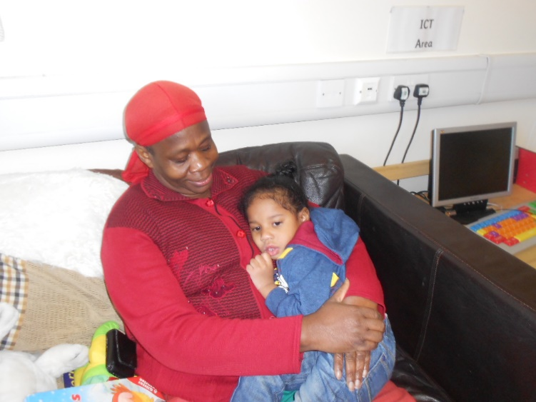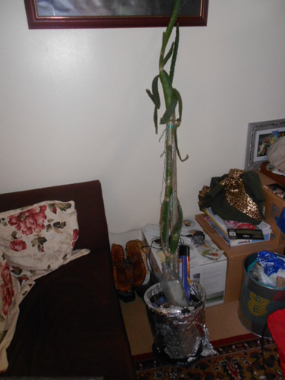
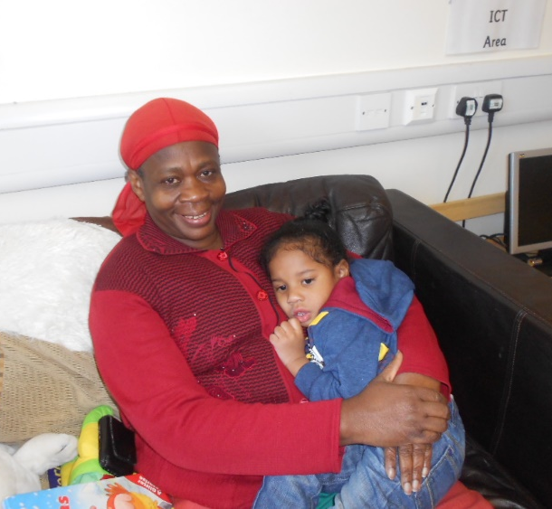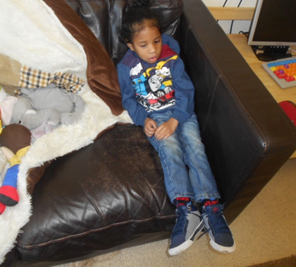
Sadie from Nicola’s team
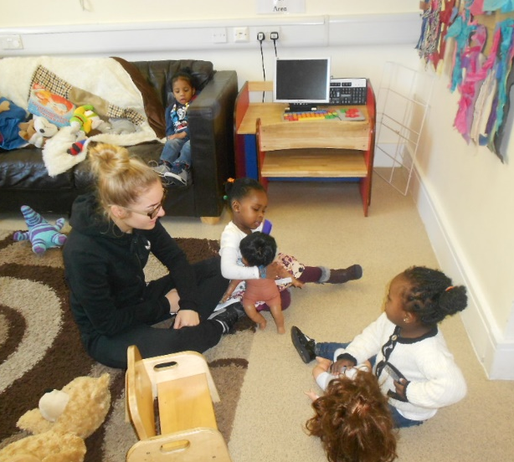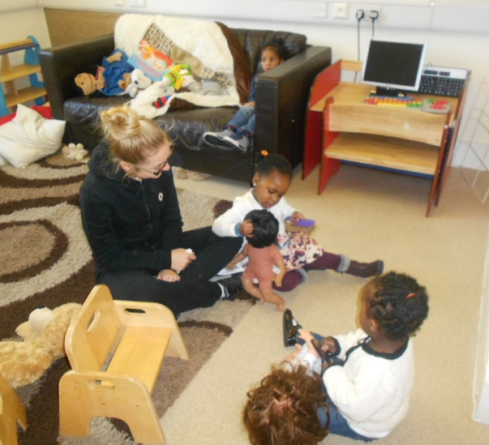
Schemas & Theresa Salmon
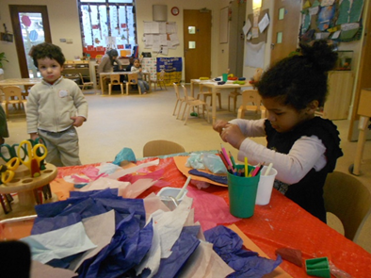
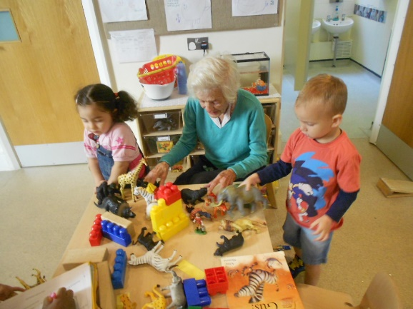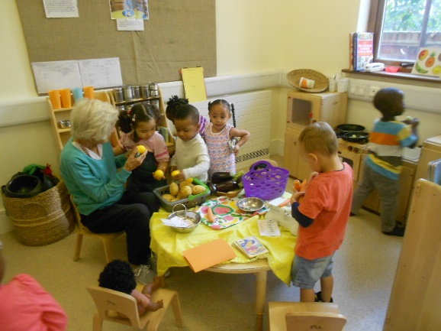
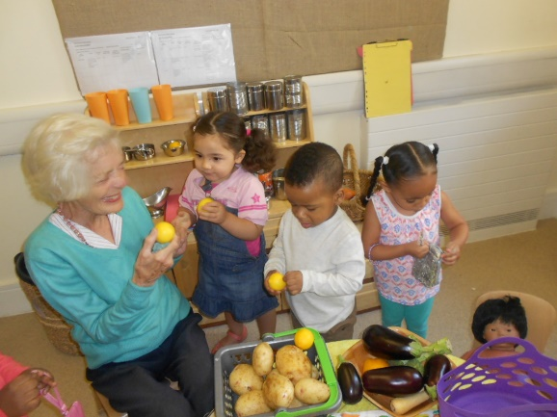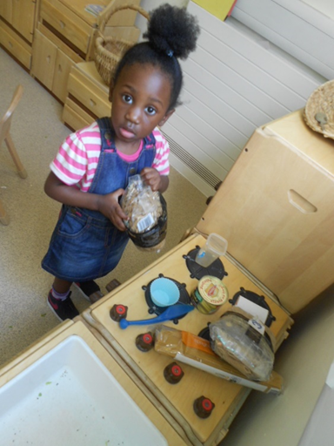
Transporting & Enveloping
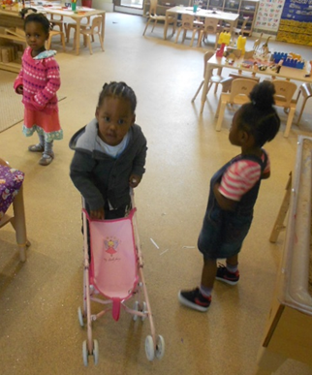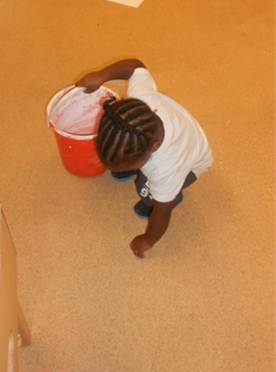
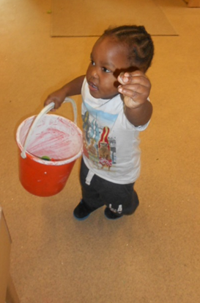 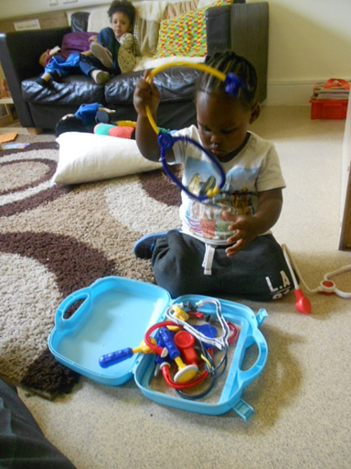 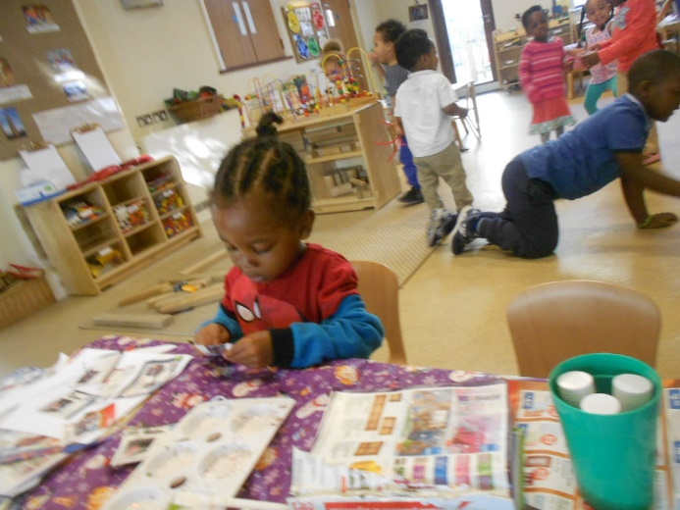  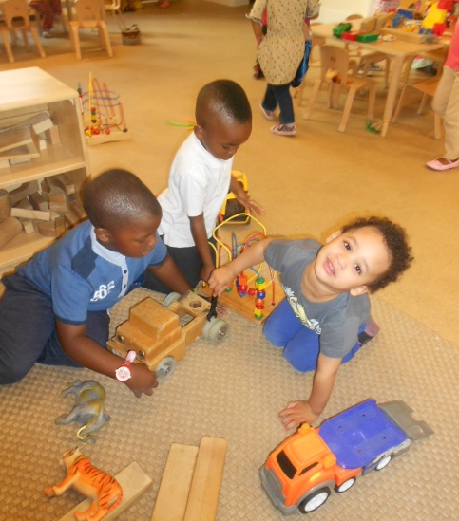 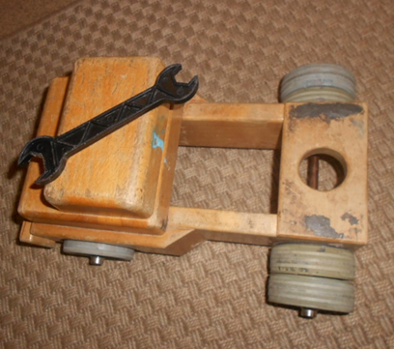 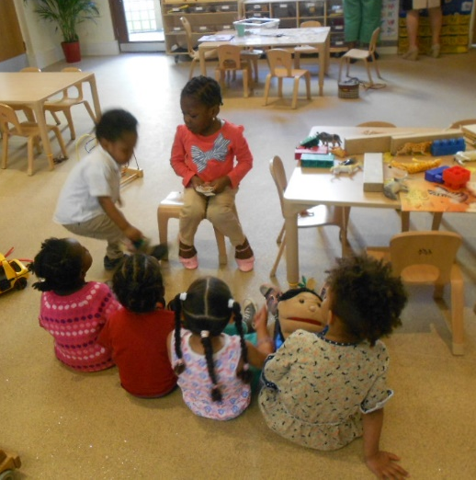 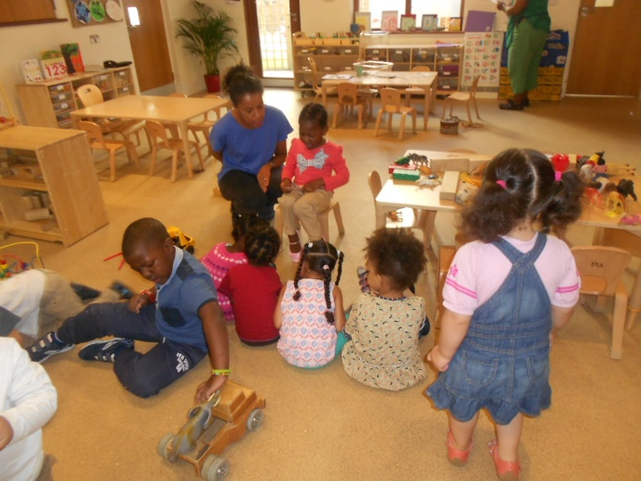 Tayandre’ engages in Shemas

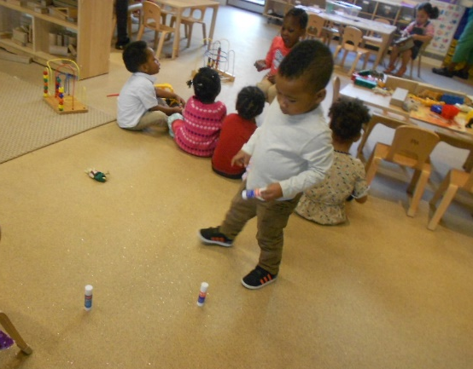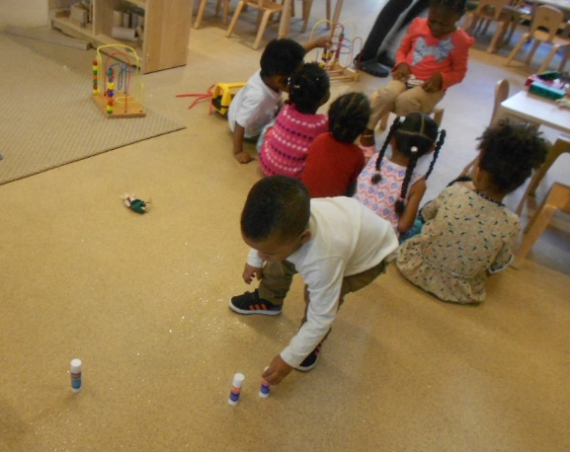
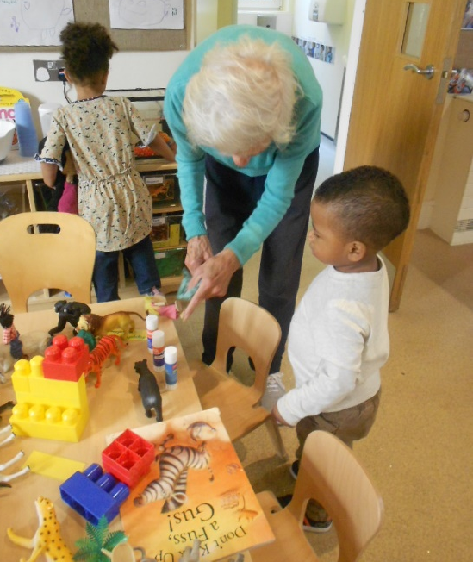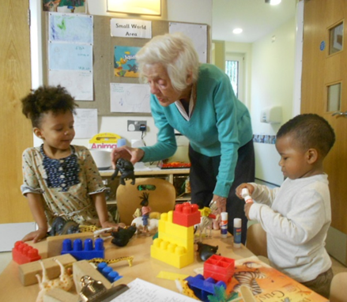
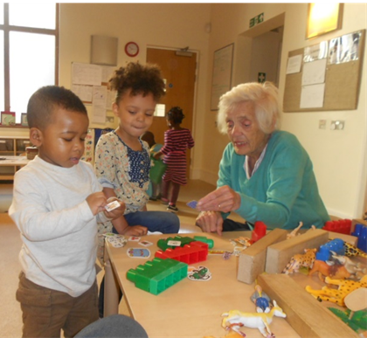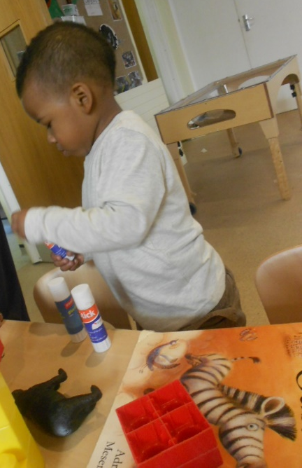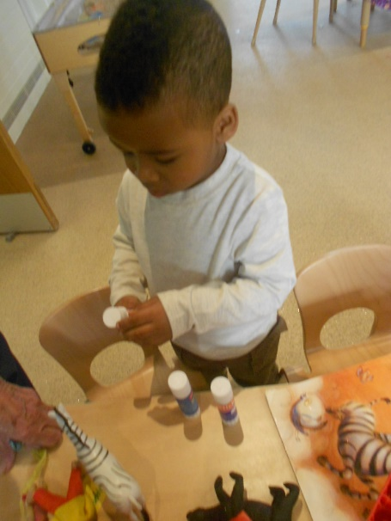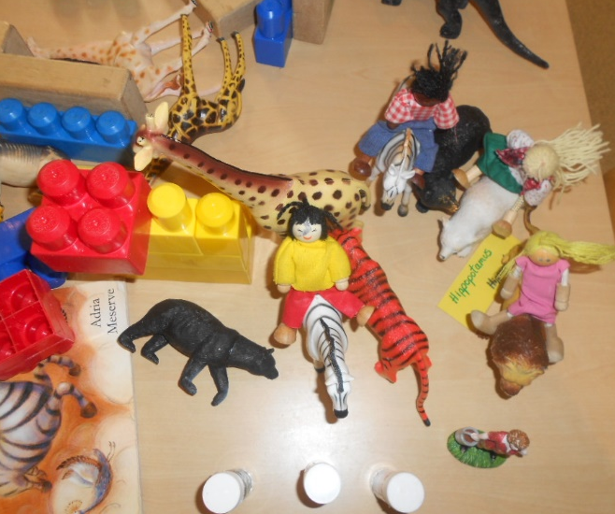
EYFS Coordinator Block Play: Morning Session – Community Playthings
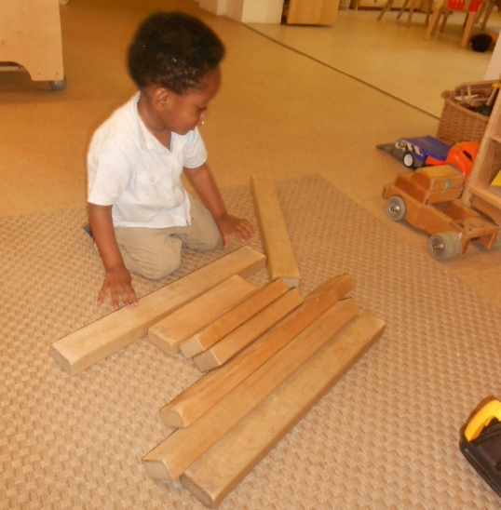
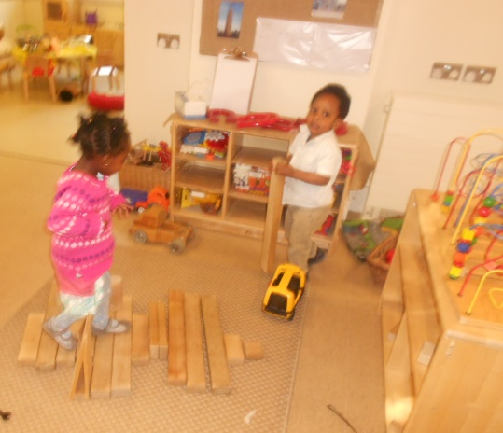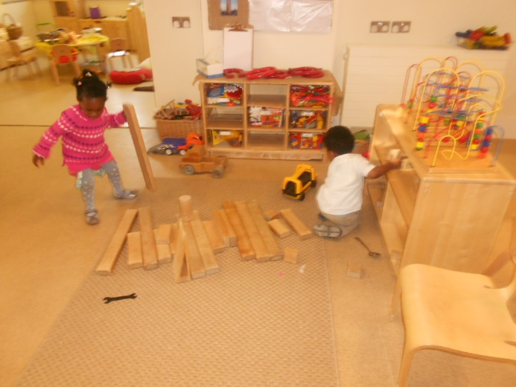
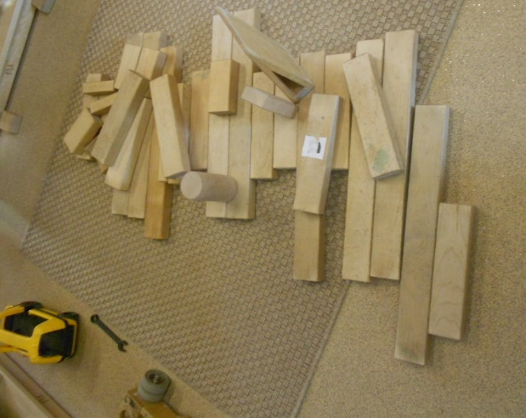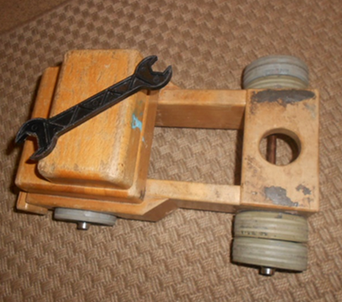
Block Play: Afternoon Session
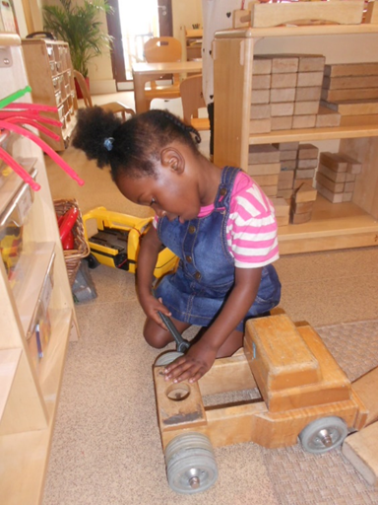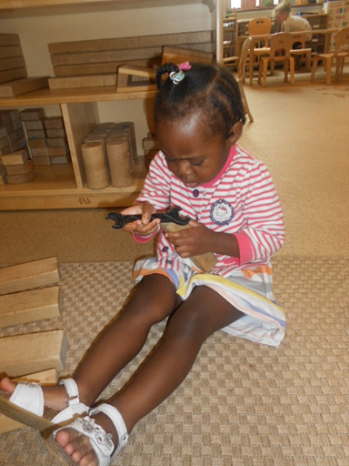
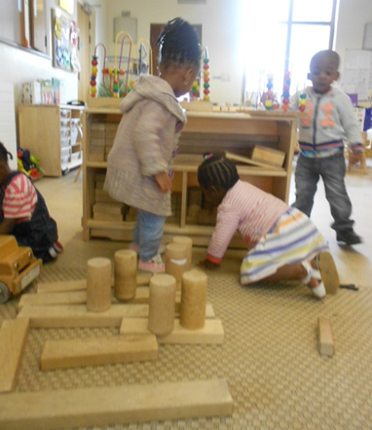
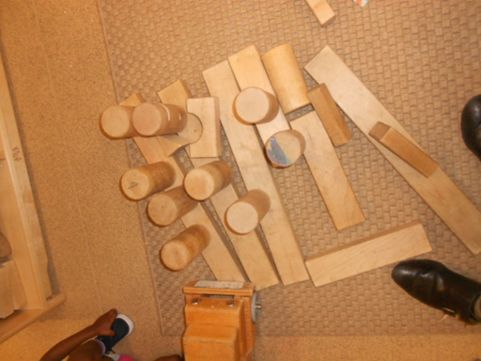
Outdoor Play Promoting Inclusion Tayandre’ Football

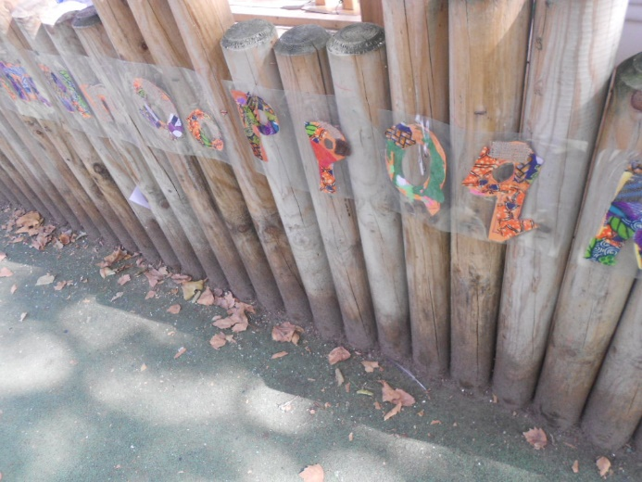
Climbing Apparatus & Slide

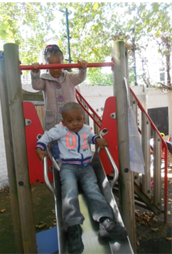
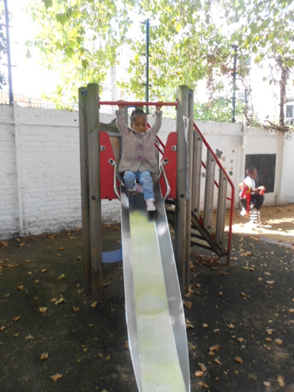

Contract Job Title: Early Years Practitioner. Job Description: EYFS Coordinator, SENCO, Multigenerational Working Practice Coordinator.
Meal Times: Supporting children with SEND & Diverse and Complex Needs:
This child never joined in at meal times before, I was told when I joined BIB. However because of my Qualifications, trainings and experiences, I was able to provide the early intervention strategies to promote inclusive practices to get him to be included when I joined BIB.
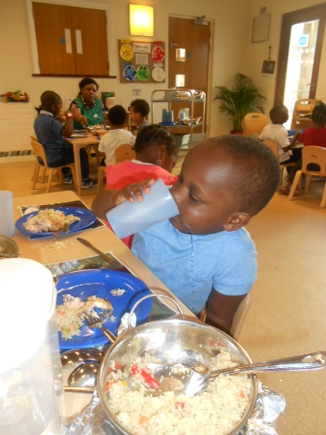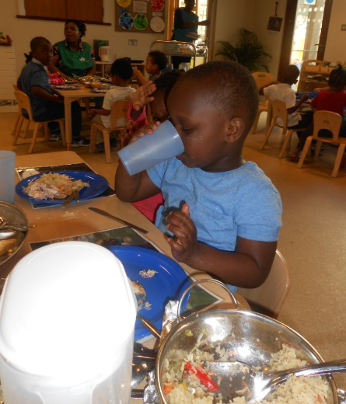
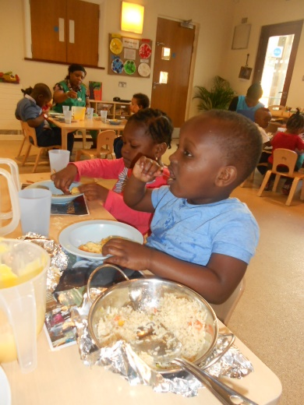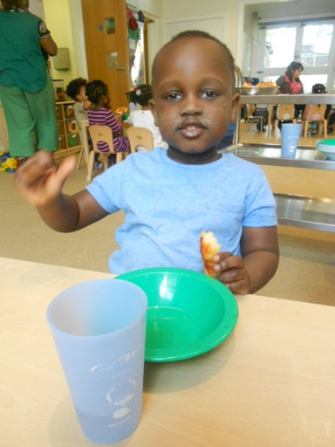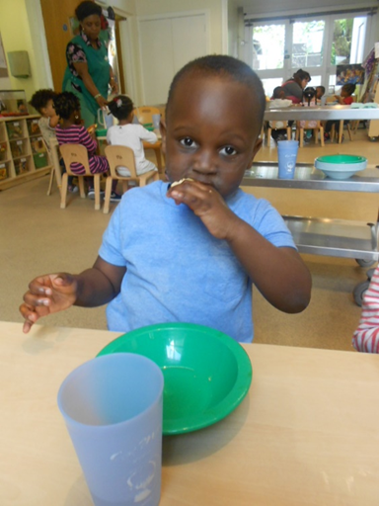
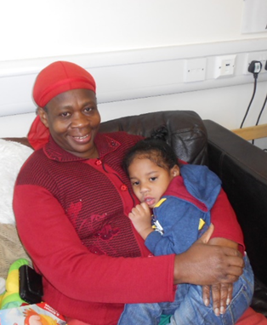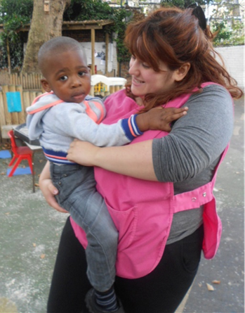
The Role & Responsibilities of the SENCO: There were many children at BIB who were not given access to a balanced EYFS curriculum, because the SENCO who Hilda Miller appointed was not trained and had no knowledge about the roles and responsibilities of the SENCO. The manager Lynne Kelly was the SENCO.


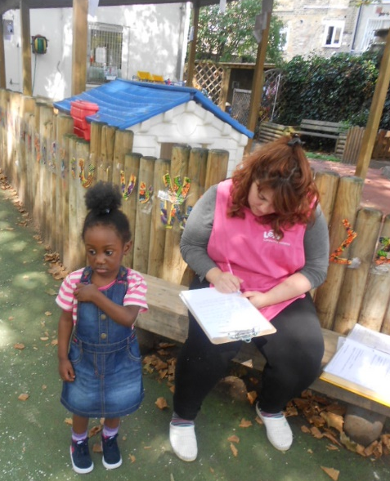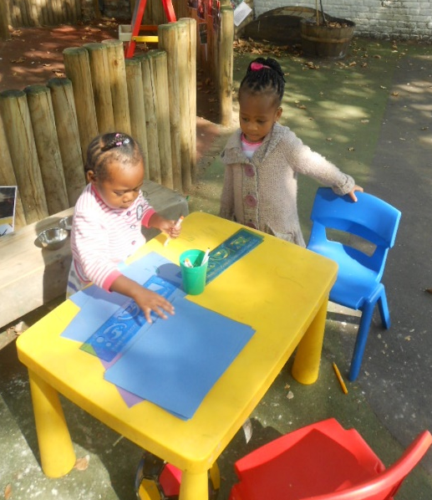
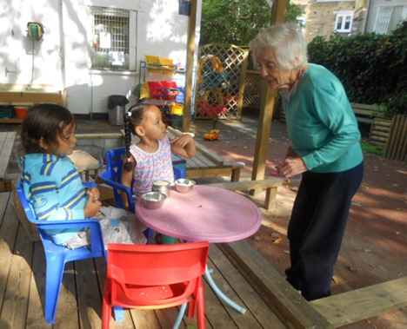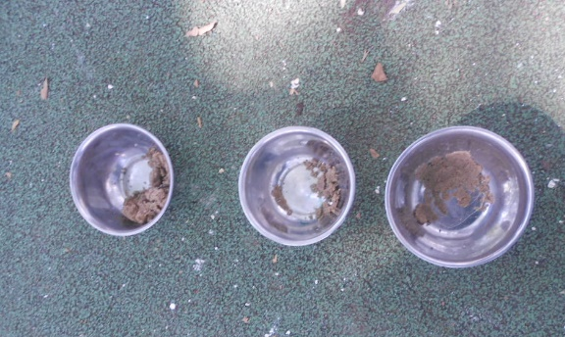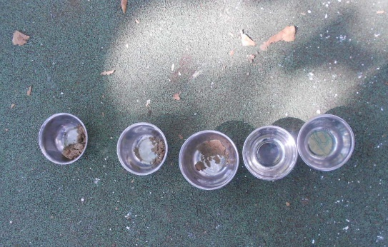


The Equality Act 2010 1st May 2015
Today marks the beginning of a new dawn in my life. 1st May 2015 marks the 3rd birthday of a little child who walked into my life one September morning 2014. On reflections it was really uncanny how this child came bounding up to like we had met each other before. From that moment we formed a lasting bond and with time established secondary attachments over the ensuing months. Meeting this child brought back poignant memories of my own personal experiences with my 1st child. Because as a young inexperienced and uneducated mother, I’d encountered prejudice. My child and I were subjected to discriminations that were to alter the course of our lives.
We were discriminated against by association as I tried to understand and make adjustments to the changes in my life as a teenager who was lacking in knowledge. I encountered prejudice where my child and I were stereotyped, labelled and marginalised by perception for being different. The matter was further compounded when the professionals got involved and a wrong diagnosis made. They proclaimed my child was deaf and dumb after doing what I considered some test that defeated the aims of the outcome? But as a parent who knows my child better than anyone else, I knew my child was not deaf. Although I didn’t know the reasons for him not talking at the time. I had to live with the stigma of having a disabled child who was different from his peers. Thank God my story had a better ending and he only had Communication Difficulties.
Lack of knowledge caused me to blame myself for my child’s condition. Therefore I was now burdened down with an additional cross that I was carrying from my childhood. However I believe that once one takes on certain responsibilities, one has to forget their own deficits and limitations and do the best they can. So I was determined to make the most of what I was blessed with and try to give my child the best. He was the apple of my dad’s eye and his dad did believe my child resembled his granddad? I sent him to Basic School to socialise with his peers and he was happy to go. When the teachers told me to keep him at home because he wasn’t talking, I stood my ground. I told them I was paying my fees, so he had every right to attend.
My child’s, my life and family stories are well documented and he is the reason I have become the passionate advocate of inclusion that I am today. I am always trying to enhance knowledge and expertise as I empower myself to be able to make a difference in the lives of others like myself. Wherever and whenever I can, I’ll be using my enhanced knowledge and expertise to implement and promote early intervention strategies to stop even one child and their family going through the unfavourably experiences that my child and I encountered. My own experiences of growing up with a hidden disability which blighted my early life and even now that I am adult, has taught me not to take anything in life for granted.
My dad used to say “never look on the dress on the woman, but instead look closely at the woman wearing the dress? So before anyone who is hell bent on disempowering others, making allegations and discriminating against them to destroy lives. Lives are being destroyed by others because of their own lack of knowledge and ignorance on their part as they bury their heads in the sand. So I beseech those who are setting out on this destructive pathways of wrecking wrath on others because they are refusing to change with the times. Just take some time out of your busy schedules of pen pushing to keep up with changing laws and legislations, so you don’t discriminate and destroy innocent lives in your ignorance and lack of knowledge. I have been spending my time productively doing my research as I am getting paid as I was rightly told.
Just try and understand and rid yourselves of the preconceived misconstrued notions that are being used to judge, stereotype, marginalise and attach labels that only discriminate against others. Only then will some be able to understand why we are unique individuals in our own rights. The only thing we share in common is the blood running through our veins.
The Equality Act 2010 states “a person has a disability if they have a physical or mental impairment which has a long-term and substantial adverse effect on their ability to carry out day-to-day activities. Physical or mental impairment includes sensory impairments such as those affecting sight or hearing”.
Since the beginning of 2015, I have once again encountered some experiences that resulted in my medical health and hidden disability conditions being exacerbated to the point where I am under this dark cloud. I reached the end of my tether where I could not see a way forward. But relying on my resilience, past experiences of dealing with traumas associated with illnesses of loved ones, deaths, sufferings and healings. I willed myself to get out from under those dark clouds and once more deal with life journeys. I don’t know what tomorrow will bring, but I know if I don’t fight, I will be failing all my loved ones who fought the fight and have gone on before me.
So at the start of this May Month when I hope to celebrate another Birthday, I will dedicate myself to celebrate life with it’s up and downs. I’ll do this in memory of my Uncle Terah Chambers, who was brutally murdered and cut down in the prime of his life, 50 years old because of his dedication to his work. My father Ivan Sandyman Nembhard, who struggled 10+ years with Parkinson’s disease. But who never one day wavered from his values and beliefs and faith in a God who would deliver him from his suffering in the end. My grandma Elsie Adina Saunders-Chambers, who was always there throughout my life. My brother Ashter Serena Urella Nembhard, who was a visionary and packed so much in his 37 years of levity. My brother Walford Byron Alburney Nembhard, who just wanted a little time to accomplish some unfinished business. He asked God not to let him suffer like dad, and was gone within 3 months of being diagnosed with cancer. At the end of the month I will once more join the Race 4 Life team to honour BYRON’s memory and his struggle with cancer. Last but not least my mother Perline Lousie Chambers-Nembhard, who was just an exceptional woman who had to be OUR Mother & Father at one stage of Our lives. In the end all she wanted to do was go to Heaven and Rest.
Time is the Master & I am waiting on Master Time to help me heal as I look forward to celebrating another milestone that I’d thought I’d not reach. Another 18 days to go…?

Key Children at BIB; September 2014
Tayandre’
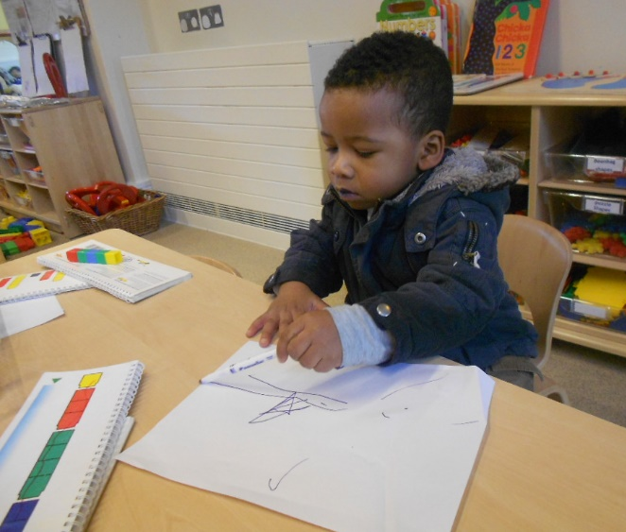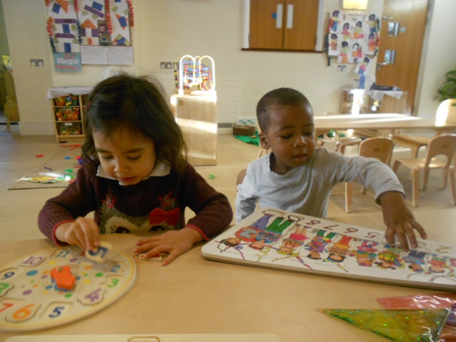
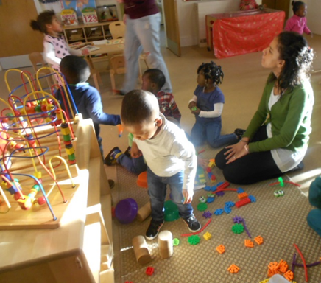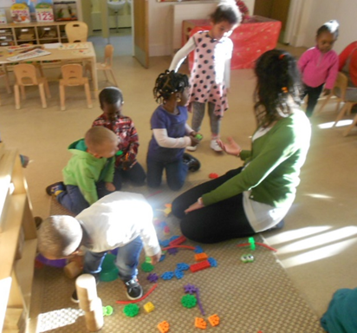
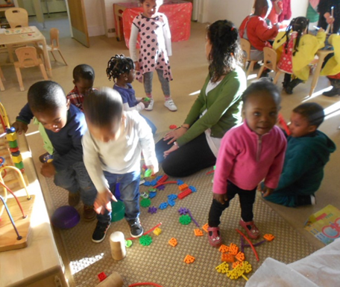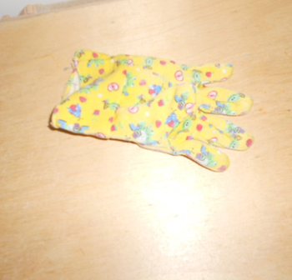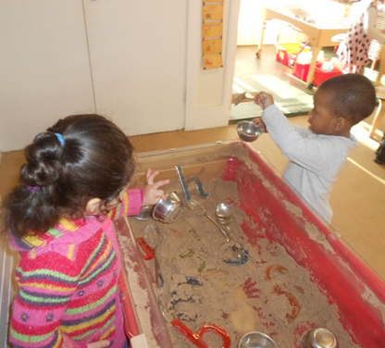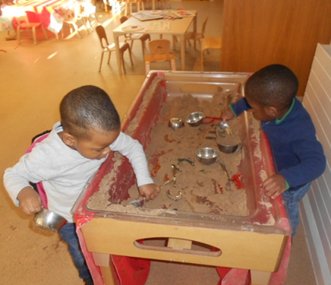

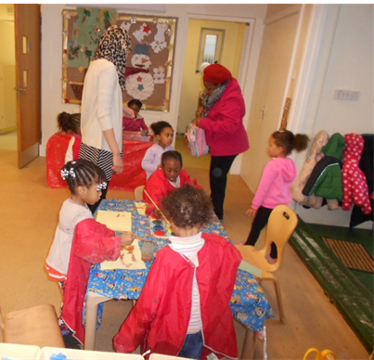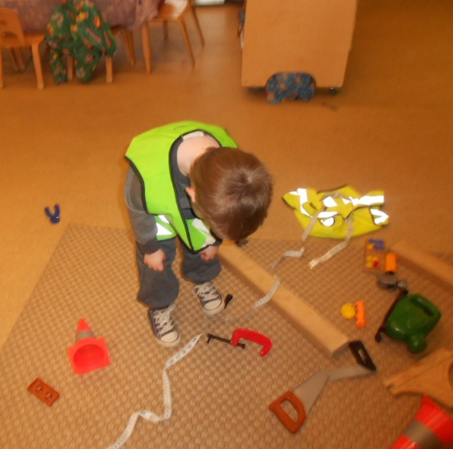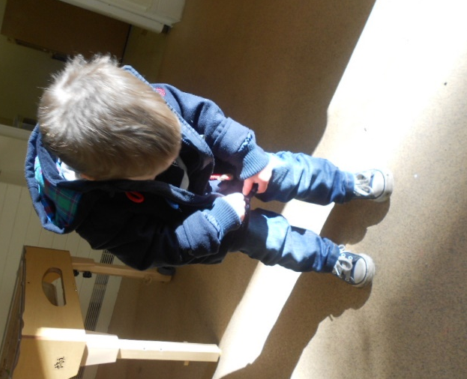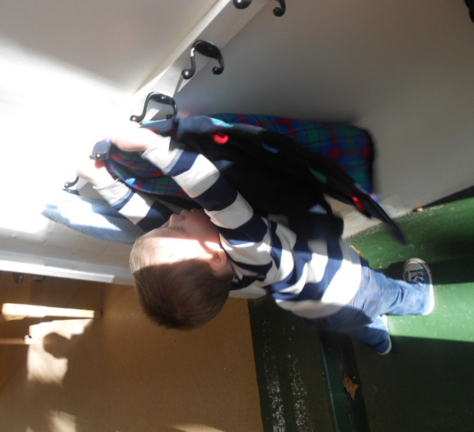
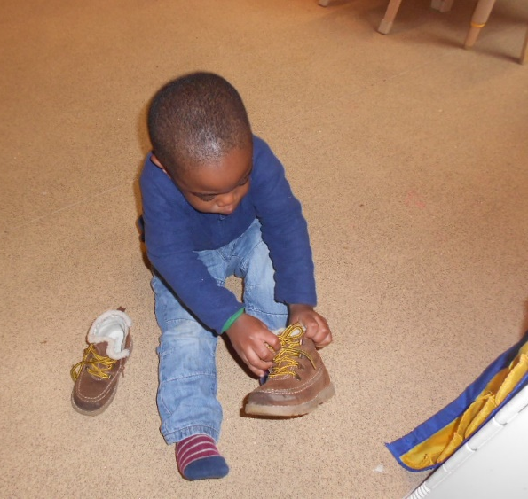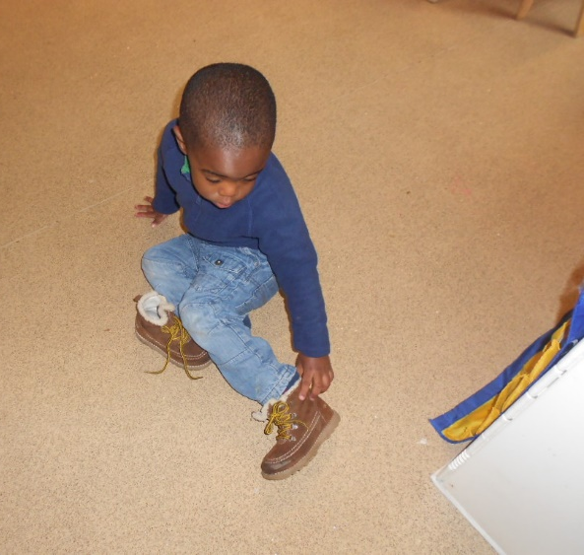

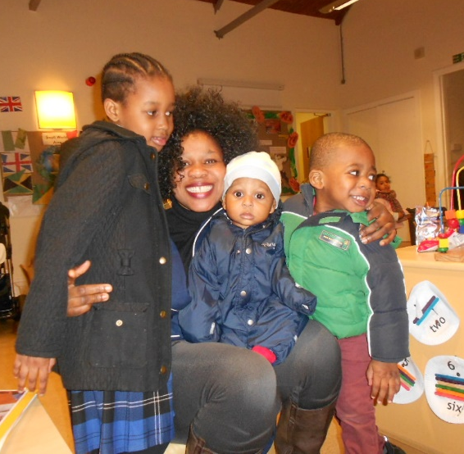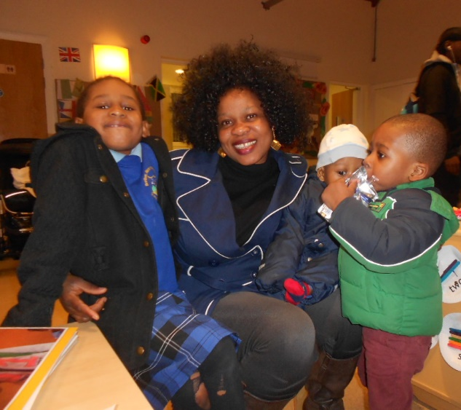
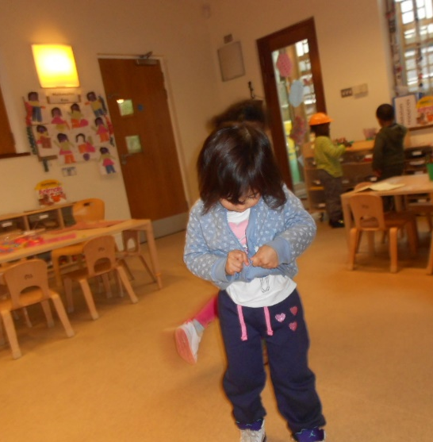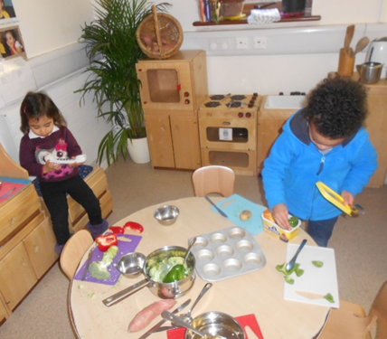
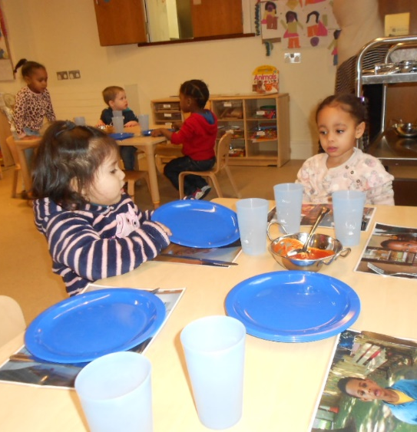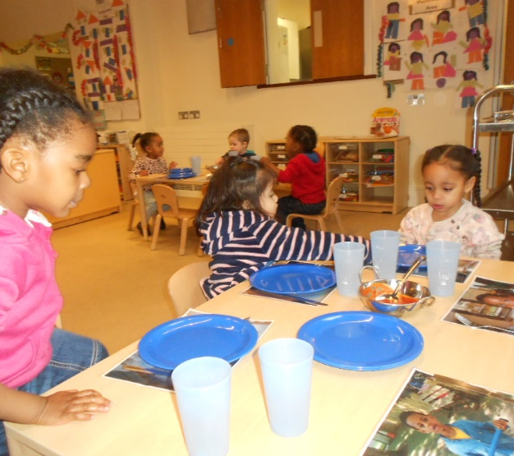
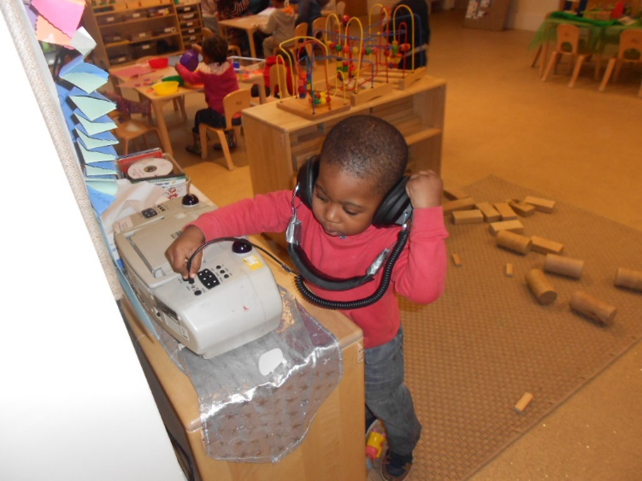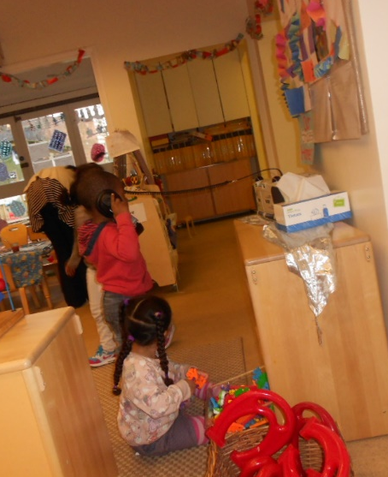
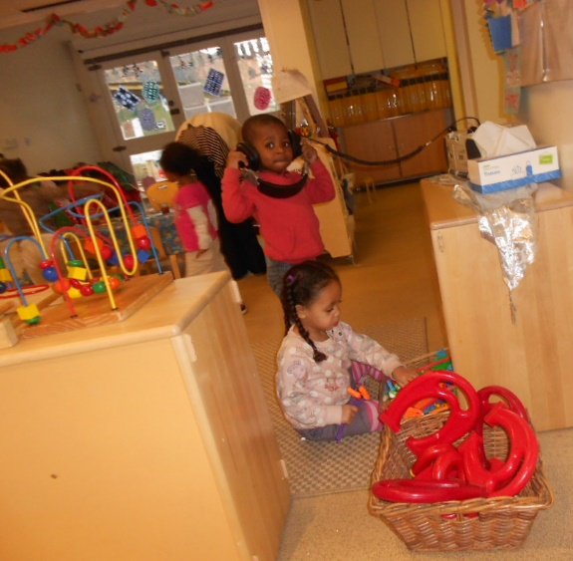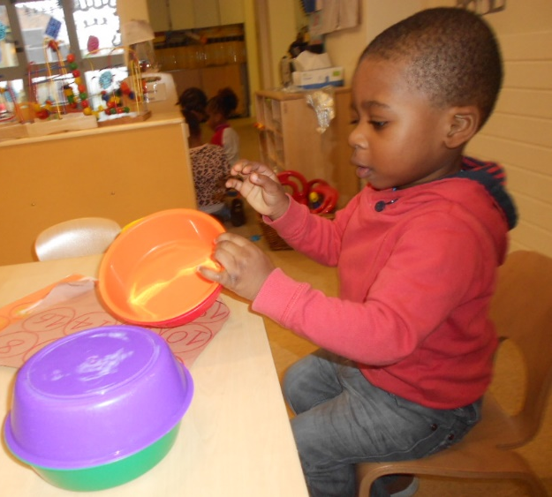
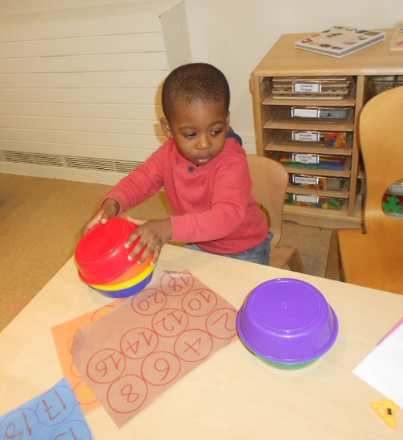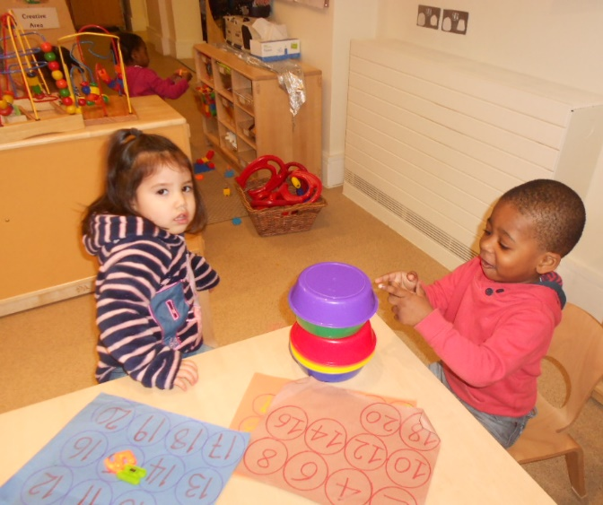
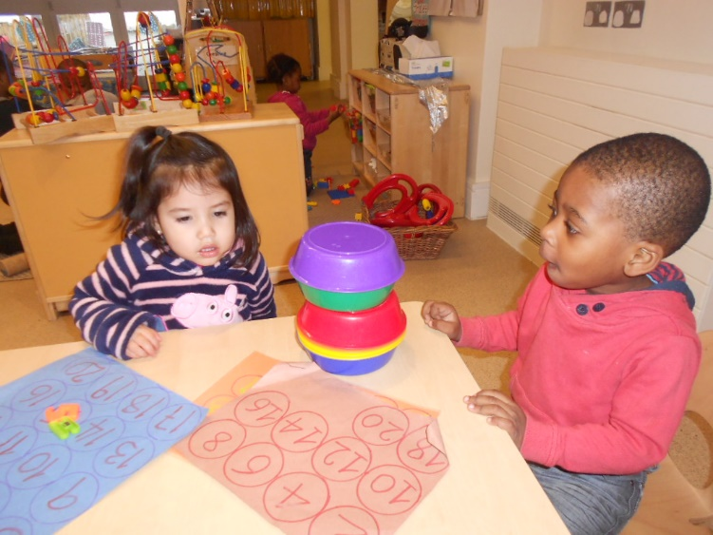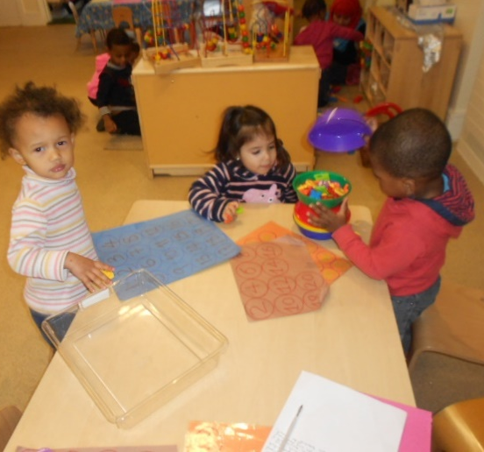
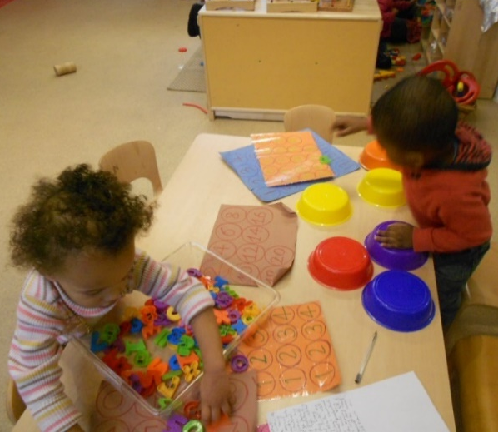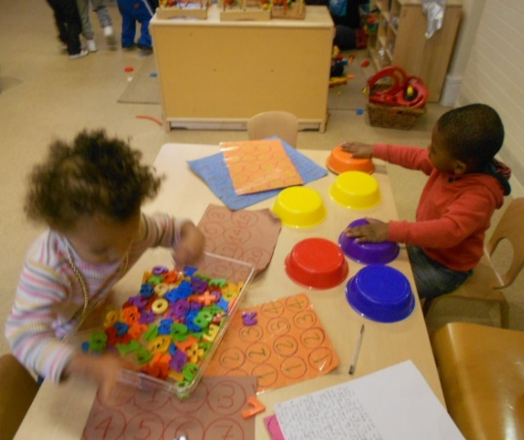
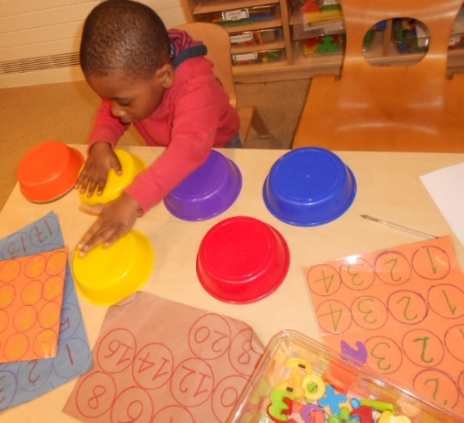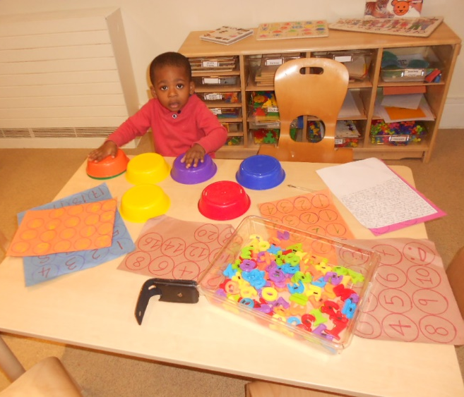
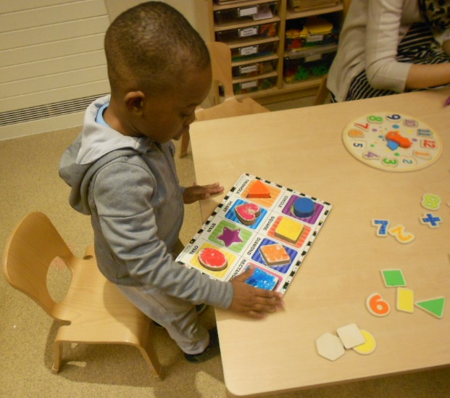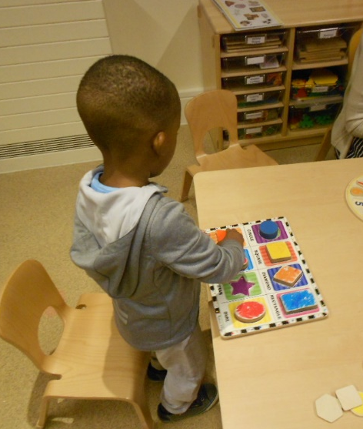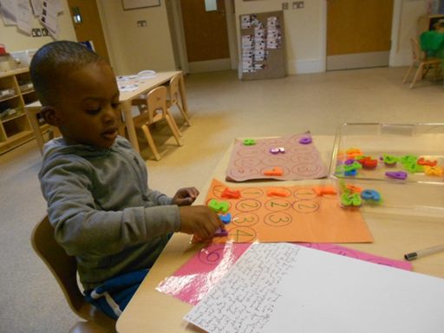
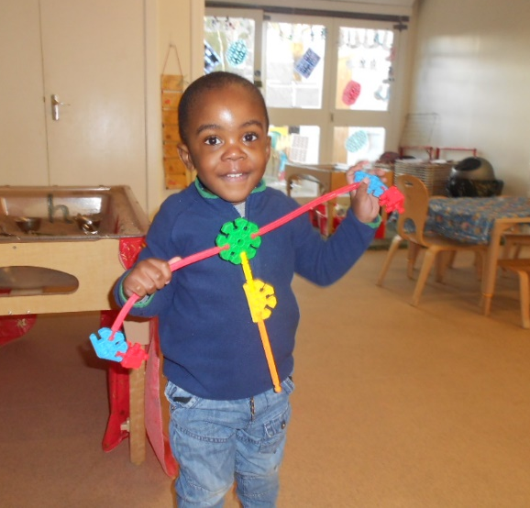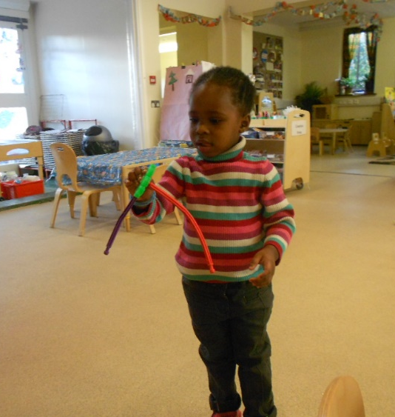

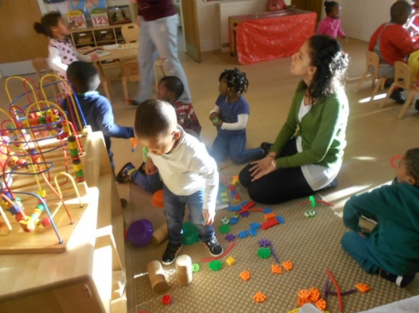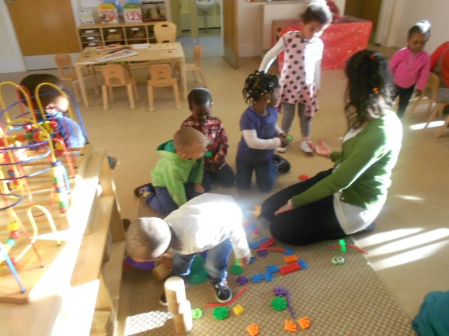
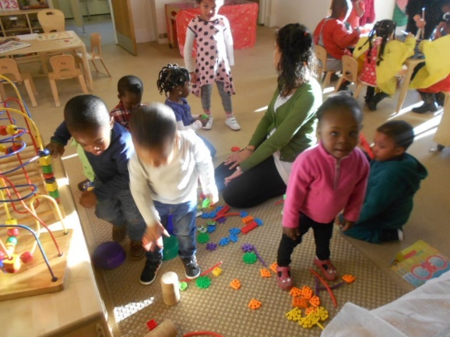
Sand Play:
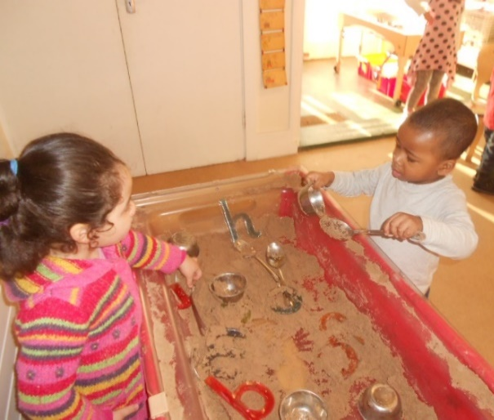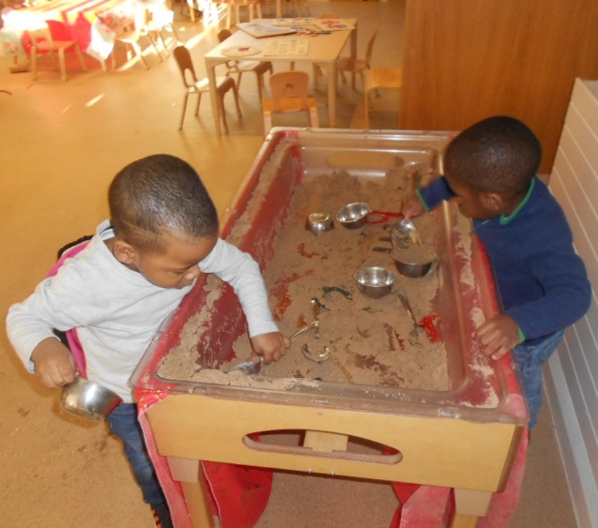
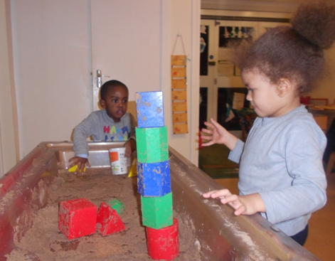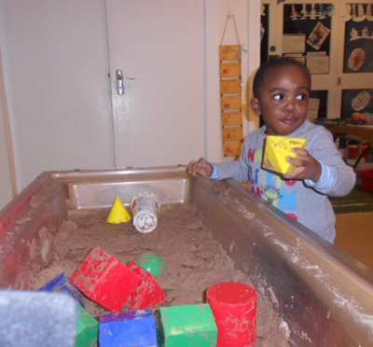
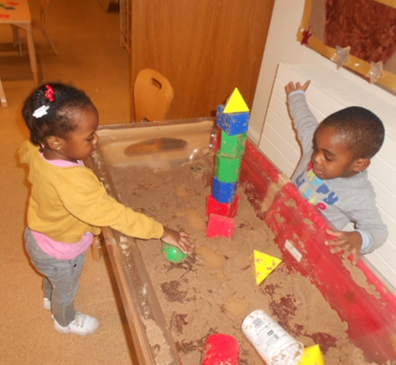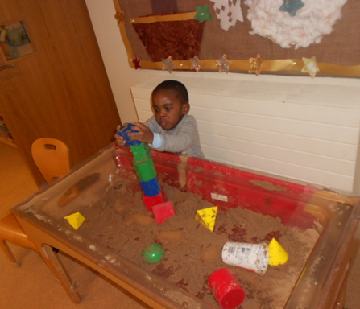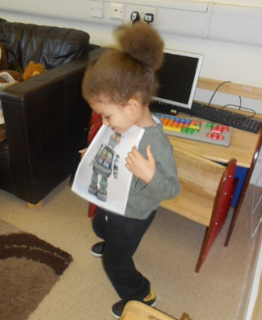
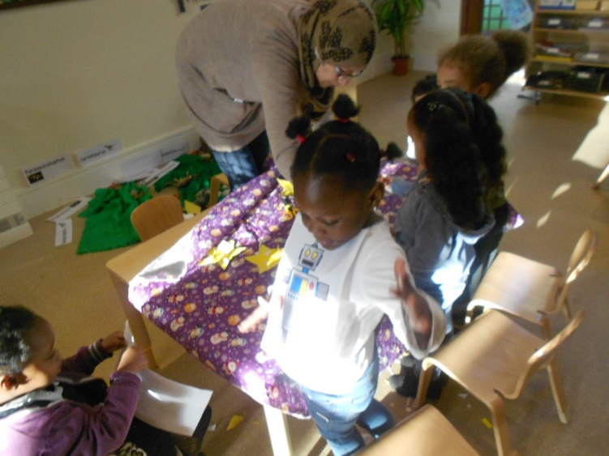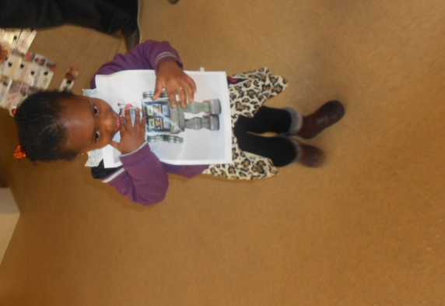
BIB Christmas Celebrations 2014
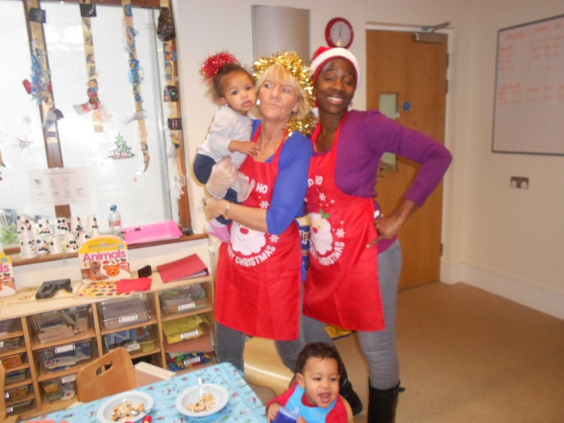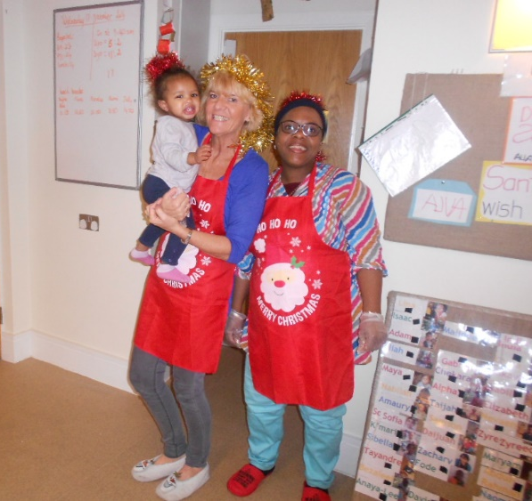

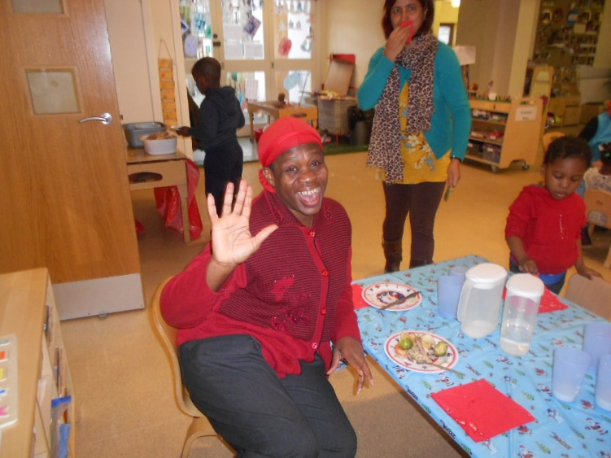  Who is responsible for the changes?

 The CEO June O’Sullivan visits BIB
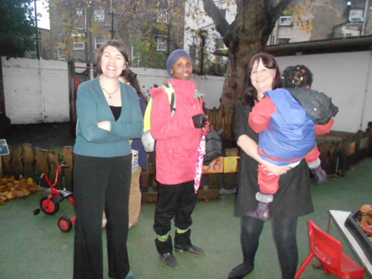
Quality Assurance Coordinator Each One Teach One (E1T1) Marion Breslin from CO visit BIB. Marion Breslin was later the manager of New Cross Community Nursery when I joined on the 2nd June 2014. The manager Lynne Kelly told me Marion Breslin was impressed with the Worry Form and Statement I had written for my key child (Child TA) that she took copies to take back to CO. Marion Breslin resigned from the Organisation soon after I left.
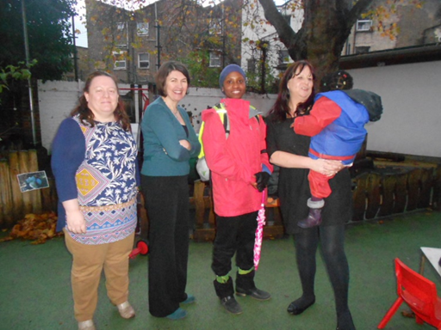
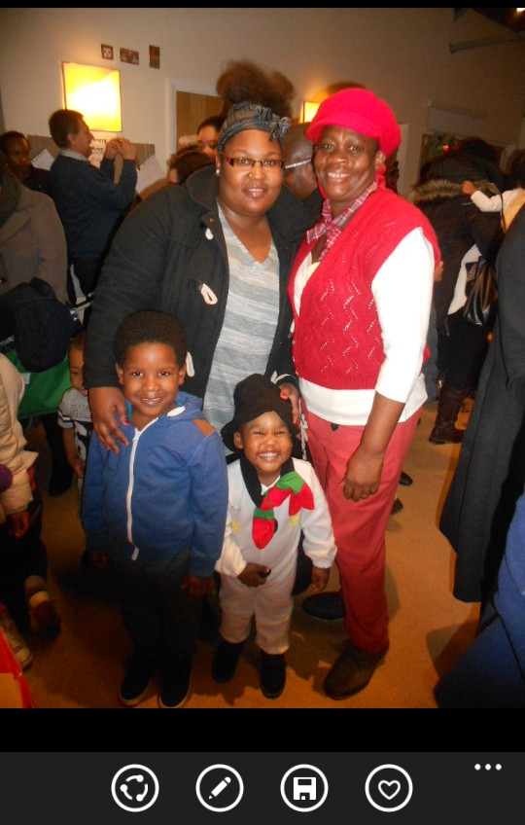
Ends here

Team Building Activity Planning

Prepared by: Mervelee Myers

Target: Professional Development Plan
Date: March 8th 2012.

Purpose of the Team Building Exercise:

The year 2012 will be very eventful for residents of the United Kingdom as well as for all the people worldwide. Therefore as part of the year long celebrations the team is challenged to come up with suggestions and ideas about how best we can apply the EYFS to support, enhance and extend children’s development and learning. These brainstorming ideas will be further build on to promote and implement a balanced curriculum that is tailored to meet the diverse, ethnic and multicultural needs of children, parents and other service users who may use the provision throughout the year.

As the facilitator I believe we can best achieve our aims and objectives for this team building exercise by being grouped in teams to match and benefit the children who are in our focused groups.

Teams:

The following are the teams who will be working together:

Team 1. Under 2’s Emma, Madonna, Andrea.

Team 2. Judy, Katie, Trison.

Team 3. Mervelee, Tania.

Team 4. Julie, Stacey.

The exercise: Teams will relocate to an area of the premises of choice that is conducive to stimulating ideas and suggestions for 15 minutes of brainstorming. After the scheduled 15 minutes the teams will come back to give a brief feedback and evaluate the ideas and suggestions that we come up with.

Ideas/Suggestions: March Focus – St David’s Day 1st, Commonwealth Day 12th , St Patrick’s Day 17th, Mothering Sunday 18th, Lent, Start of British Summer Time 25th , Lady Day – Ascot, etc…

Other significant events: Queen’s Diamond Jubilee, Olympics, Carnival.

Theodora 10th November 2015
Assessment Report
Section A
Likes:
Theodora likes to engage in a variety of activities and experiences that are of interest to her. Each time I visited her home as a support worker in my role as a volunteer of Resources for Autism from when I started in August to date. Theodora will participate in adult led activities and activities that she initiated and those planned by an adult. To date I have planned activities to support, enhance and extend Theodora’s development and learning in accessing a balanced curriculum.
The following is a copy of (Resources for Autism Family Support Plan – Appendix 1) that I used to plan activities for Theodora to participate in during my weekly session: 1. Developing Social Interaction Skills 2. Developing Play Skills 3. Providing Support With Going Out 4. Encouraging Turn Taking & Sharing 5. Facilitating Joint Attention 6. Building Communication Skills.
Support is Paramount for TA to continue making progress with her likes.
Dislikes:
Theodora dislikes being given instructions to enable her to develop learning skills to access the curriculum, when the support worker is spending time with her at home. Without additional support she prefers to do whatever she pleases. She gets frustrated and will act up, crying and behaving in inappropriate manner just to get her own ways. However with the support she has been getting the support worker has been able to change things around putting in plans of actions so Theodora can benefit from the early intervention strategies that are part of the Aims and Objectives of the Support Plan that Resources for Autism provided. If her dislikes are managed properly, by someone with the knowledge and skills to support a child with diverse and complex needs, these dislikes can be changed to empower Theodora to gain better outcomes and reach her potentials.
Support is Paramount in empowering TA to overcome her dislikes and make them part of her development and learning.
Things TA is good at:
Since I started working with her from the first initial assessment with Vesna the Outreach from Resources for Autism. I was really impressed with how keen TA was to engage and socialise with others, showing how she was learning across the curriculum areas. There are lots of implicit knowledge that TA has embedded from school and other communities of practice that she made explicit when I first met her. She has gone on to surpass my expectations in some areas of her development and learning. However she will need additional support to support her to achieve her Zones of Proximal Development (ZPD) via early interventions. TA has engaged with myself and her siblings to accomplish some of the activities and experiences I planned during our sessions after she practised at doing them repeatedly.
Support is Paramount in order for TA to become even better and best at the things she is good at.
What others like & admire:
I was impressed from day one of TA assessment about how excited she was in participating in the activities and experiences that Vesna Glava provided. She showed interests and seemed comfortable and happy with having 2 strangers in her home. She interacted, socialised and engage with the adults as she participated in the activities. However she did not like anyone to invade her space to much in the beginning as she showed her weariness of others. She was happy to do the activities for me to identify how I should be planning to support her, but wanted to do things her way instead of taking turns. In the past months she has totally accepted my presence in her home and I am sure she would do the same for anyone who will be supporting her in the school environment. It won’t happen overnight, but gradually as she takes her time to know the person.
I have only been working with TA a few months and recognised her potentials, therefore getting support in other communities of practice is paramount for her development and learning in preparing her to take her place in society.
How TA prefers to communicate:
Theodora has been using a number of communication methods whenever I am present. I noticed she uses her hands to guide the hands of others at times to do things for her (might be PECS). She seems to be able to relate to things she sees in prints and on the TV to start singing favourite and traditional nursery thymes and songs. She is able to follow prompts and visual cues to join in when I introduce new ideas to the activities and experiences I planned to support, enhance and extend her learning. She uses lots of repetition, saying the same things over and over again. She will answer by repeating what is said to her. She uses visual cues in pictures or on the TV to start a random conversation about prior experiences.
However I notice she will ramble on for ages about things that I or her family do not seem to be able to make sense of. During these times I try to avert her attention to more meaningful activities. I have been using my limited knowledge of (Makaton) to communicate with her and she is receptive of my efforts. She shows interests in literature and environmental prints around her that she relates to. She identifies letters of the alphabet and numbers and will use her fingers to try and trace them. She identifies most letters of the alphabet and numbers into double figures. She sings the alphabet song and names initial letter for words.
She has progressed on to writing letters and numbers which are correctly formed using phonetics of initial sounding and naming same. She uses ICT and is able to play programmable activities on the computer with her siblings. Peppa Pig seems to be her favourite and mostly everything is centred on that.
However she still gets frustrated, moans and cries and I think sometimes this is because she is unable to communicate her needs? I believe some of the inappropriate behaviours might be due to her lack of understanding and making sense of her world. When she is guided she seems to be able to accept that there are other ways to do things instead of throwing a tantrum.
TA can achieve so much with additional support. Therefore the earlier the intervention, the more beneficial for her.
What’s working well?
Home - Since I started working with TA at home providing support on a Saturday 2-5, I noticed lots of progress in her. She has benefited from having a more knowledgeable practitioner with the additional expertise about planning activities and experiences for her. My previous experiences of working in Leadership roles as SENCO & EYFS Coordinator enabled me to identify TA diverse and complex needs. I am equipped to support her parents in helping TA to reach her ZPD by engaging, socialising and interacting with myself and her siblings. When she is participating in activities that I plan for her, I structure the activities so she has time to initiate her own learning and focus on experiences that are of interest to her.
I allow her to have her own me time to do what she prefers to do, but try to involve her sister and myself as participant observer and learner. The knowledge and experiences I bring to my volunteering roles and responsibilities enable me to work with the parents in delivering a balanced curriculum for TA. TA will benefit from having additional support in other communities of practice – school to support, enhance and extend her learning. TA gets lots of support at home, but mum needs a break to focus on the other children as well.
What I identified working well at home can only be beneficial if TA is getting additional support in all the communities of practice she attends.
New things to do/change:
I am working with TA for a period of 6 months as a Volunteer with Resources for Autism and I have seen some results since I started. Because I am not working at present, I don’t mind volunteering my time at TA school until I am back at work to support her in the school if I am needed. Because I know I’ve got lots to offer in her early intervention as a more knowledgeable reflective practitioner who developed the listening ethos.
My interests in SEND is from a personal perspectives. I am considering going back into studies to gain my Teacher Certificates as a SEND Teacher as part of my CPPDP. If I am needed I am more than willing to offer my services. I believe being from the same background and my own personal experiences might enable me to play a bigger role in TA development and learning.
I only spend a few hours once per week with TA and is assigned to her for 6 months. So we should be thinking about the long term. If my additional support can help her to progress, there is no doubt she will do so with support in school.
Aspirations and Goals for the future:
I identified that TA knows lots of things that could add to her development and learning if she gets the additional support of early intervention to reach her individual potentials. She will only benefit from having a Learning Support Assistant (LSA) to give her the support she needed to be included in an inclusive environment where she will be encouraged to meet the targets in her IEP to access the curriculum.
Please provide TA with the support she needs to achieve her goals in the future with early intervention.

Section B
Planned Activities by Support Worker Attached:
Activities:
Day 1. – Saturday 22nd August 2015
Day 2. – Monday 24th August 2015
Day 3. – Saturday 29th August 2015

Section F
Support Worker Plan of Action: Mervelee Myers Contact Information
Mervelee Myers Introduction.
Appendices
- Resources for Autism Family Support Plan

My Assessment, Evaluation & Analysis of Theodora 21st August 2015 –
In my Own Words:
PSE:
I find TA to be a sociable child who seems to be very much attach to her family – mother, sister and brothers whenever I attended her home as part of my volunteering service. I have met dad on one occasion but he seems to be very much a part of her life. The family is close-knit and I can identify with them being from a similar background. TA could be one of my grandchildren and I managed to build up a good relationship with TA and her family. When I started and attended with Vesna Glavas who did the initial introductions to the family. I could identify TA potentials as Vesna carried a number of activities and TA was happy to participate during the assessment. I was amazed at how quickly TA started taking an interest in the activities and her willingness to participate.
I realised that she needed additional support to support, enhance and extend her development and learning. She would get focused on only those activities and experiences of interests and refused to move on. Then she got frustrated, throw a tantrum when she was encouraged, trying to keep the resources she was interested in.
Mum was pregnant at the time, but it seems TA was well adjusted to the changes in her life. TA used the bathroom with minimal support. She feeds herself favourite food of choice and did not seem to be a fussy eater. However mum sometimes feeds her and says she have to hide particular foodstuff from her. Or else she just carries on hiding, moving them from where they are stored and eating them even after having a regular meal.
TA took her time in accepting my presence in her home, even though she did not make any fuss about me being there initially. Over the past months TA has been shown to make some progress in all areas of her development and learning, with the additional support provided. Speaking from the perspectives of a more knowledgeable other, who has been a SENCO/SEND & EYFS Coordinator, I am positive that TA will benefit from having additional support to provide her with early intervention strategies. By giving her additional support that she will not get being part of a big class/group, TA will be able to access the curriculum to reach her ZPD and potential.
TA shows the atypical behaviours of a child diagnosed with autism conditions. Without the additional support she will no doubt struggle in her development and learning. TA accepted the birth of the new baby but is affected by his crying and sometimes have disturbed rest even though they don’t sleep in the same room mum says.
PD:
TA is making some progress after being supported and encouraged to participate with activities and experiences that are planned by the adult from her interests. Activities are adapted to meet her age and stage of development. With supervision, TA carried adult planned and her child initiated activities and experiences using resources that her mum and sibling thought she was incapable of doing. However TA will need additional support to boost her self-esteem and giving her the confidence and reassurance, supporting, enhancing and extending her development and learning to reach targets set out in her IEP.
Since I’ve been working with TA, she uses the scissors with supervision to cut around shapes after asking to use the scissors and practising. She uses pencils for mark-making scribbles and drawing and has gone on to writing the alphabet and numbers from memory. However TA needs the additional support that will enable her to focus, concentrate and participate in activities and experiences to reach her potential.
CL:
TA will need additional support especially so she can access the curriculum in this aspect of her development and learning as she has difficulties in Communication and Language skills. Her autism condition diagnosis seems to affect mostly her CL development as well as some PSE, but I think the PSE are representatives of her frustrations in not being able to communicate effectively with others. So she behaves to get the attention.
Since I started with her I realises that she is internalising things that she learned at school and other communities of practice. From the initial assessment I was impressed with how much she seemed to know and now that I get to know her. Realised that with the right early intervention strategies provided with additional support she will be able to reach her potential with those internal knowledge. The support worker will be able to make them part of her IEP. It was easy to get her to participate once you find out her interest, empower her to initiate her learning and planning activities and interest to meet her changing diverse and complex needs.
I can stress how much TA will need additional support to help her access the curriculum especially in this aspect of the curriculum where she seems to be struggling the most. Therefore early intervention with additional support provided by a more knowledgeable professional will TA to reach her potential achieving targets in her IEP.
TA knows her alphabet and number and takes interests in literature in books, ICT, etc. She knows traditional songs and rhymes and will sing them with prompts she sees in visual cues around her. However she will need support making sense of her world, because when left to her own devices, she lose focus and retreats back into her own world.
She needs support to keep focusing on activities she is engaging with as she tends to stray and lose interests when not supervised. She uses repetitive language and don’t seem able to share thoughts and ideas with others. She answers questions with what is said to her and is always rambling on. TA will benefit from having additional support that is different from that she will get in a class/group of children for some aspects of her development and learning. She needs to develop her Communication and Literature skills in speaking, listening, paying attention and most importantly understanding.
TA has lots of knowledge that with additional support will empower her to access the balanced curriculum that is provided for her diverse and complex needs.

Prepared by: Mervelee Myers FD (Open)
Date: 10th November 2015.
Volunteer: Resources for Autism.
Purpose: Part of my Continuing Personal Professional Development Plan (CPPDP) for my future endeavours.
Start here 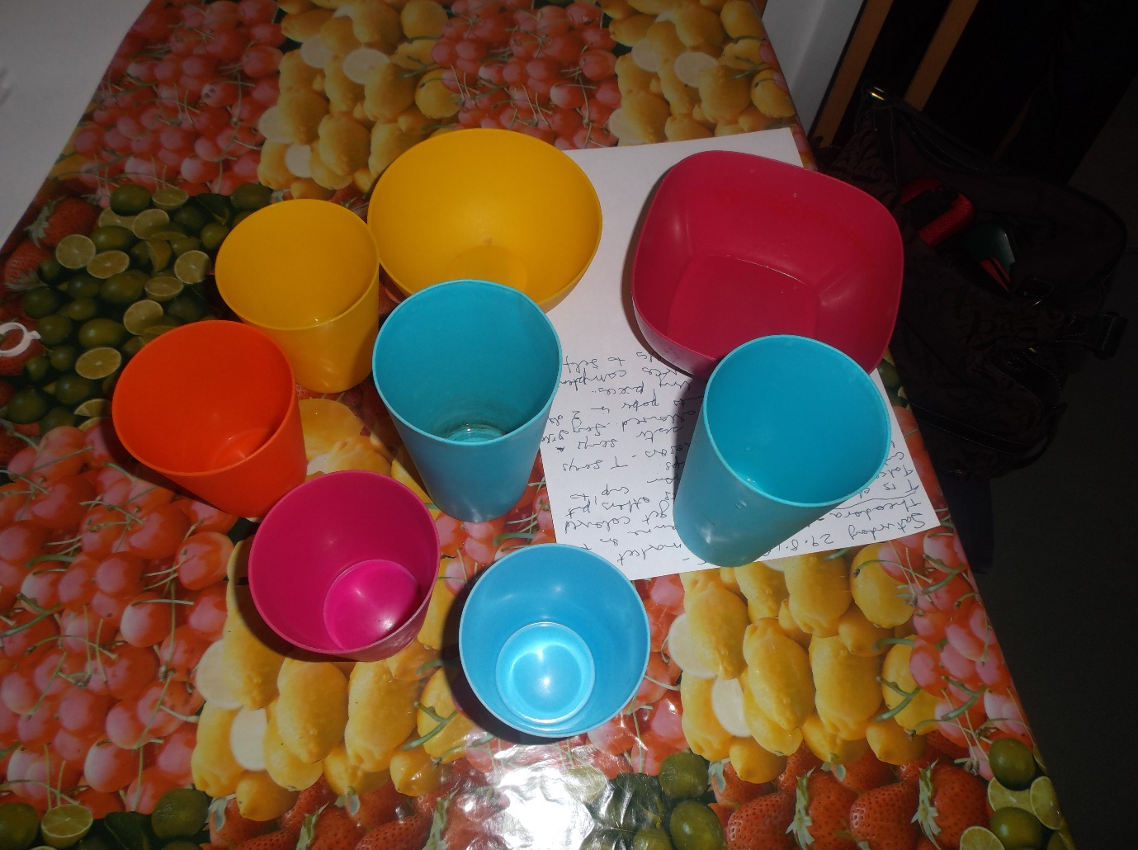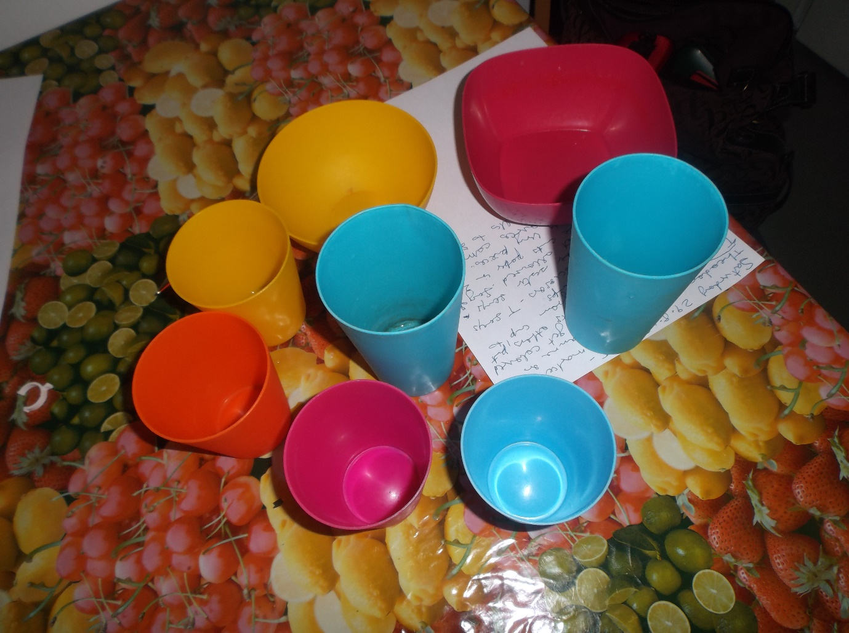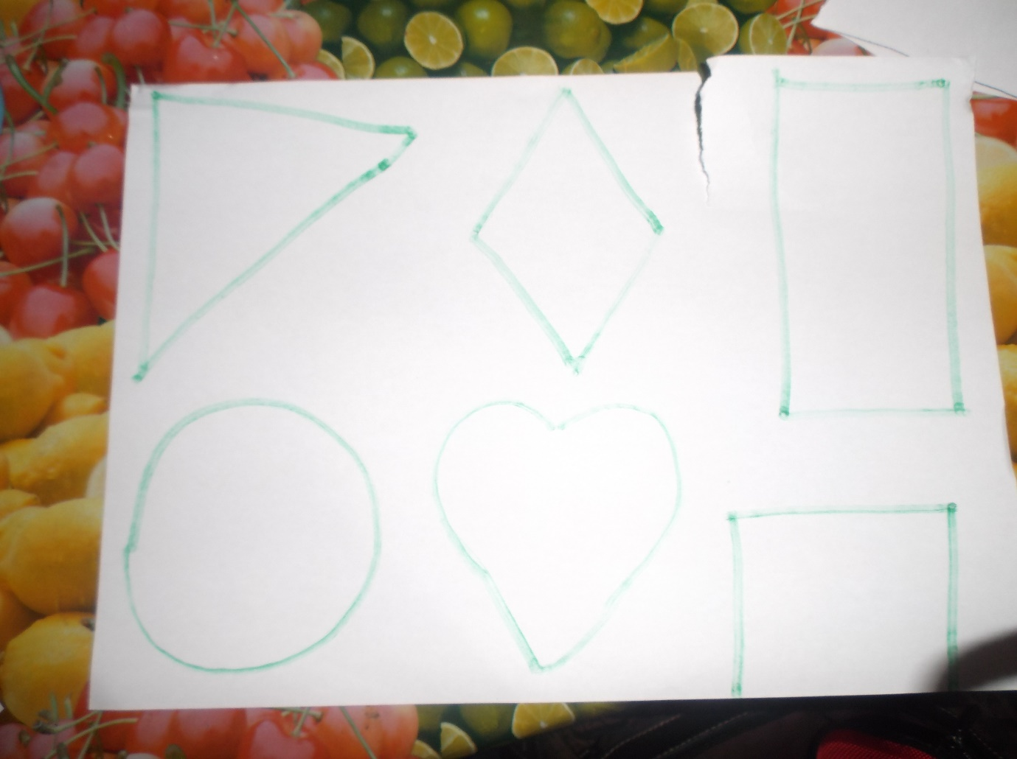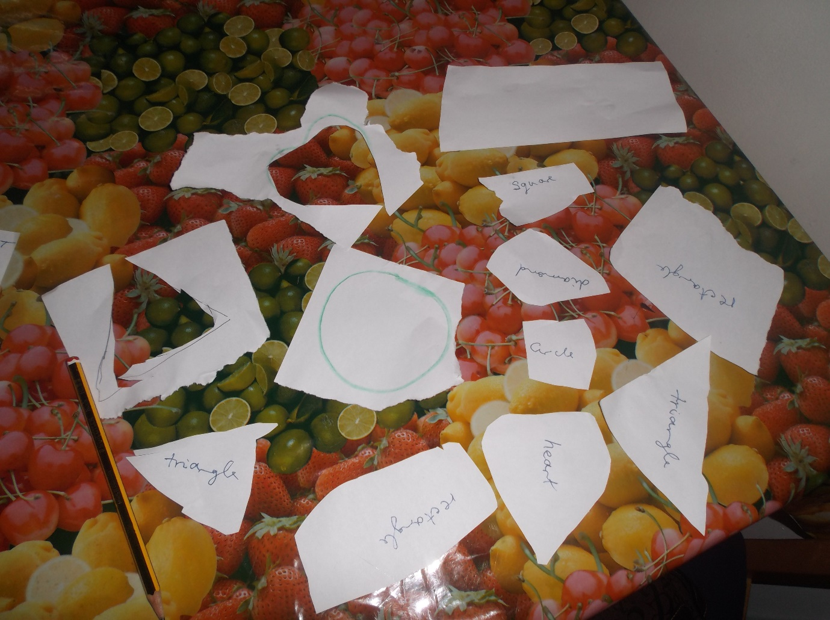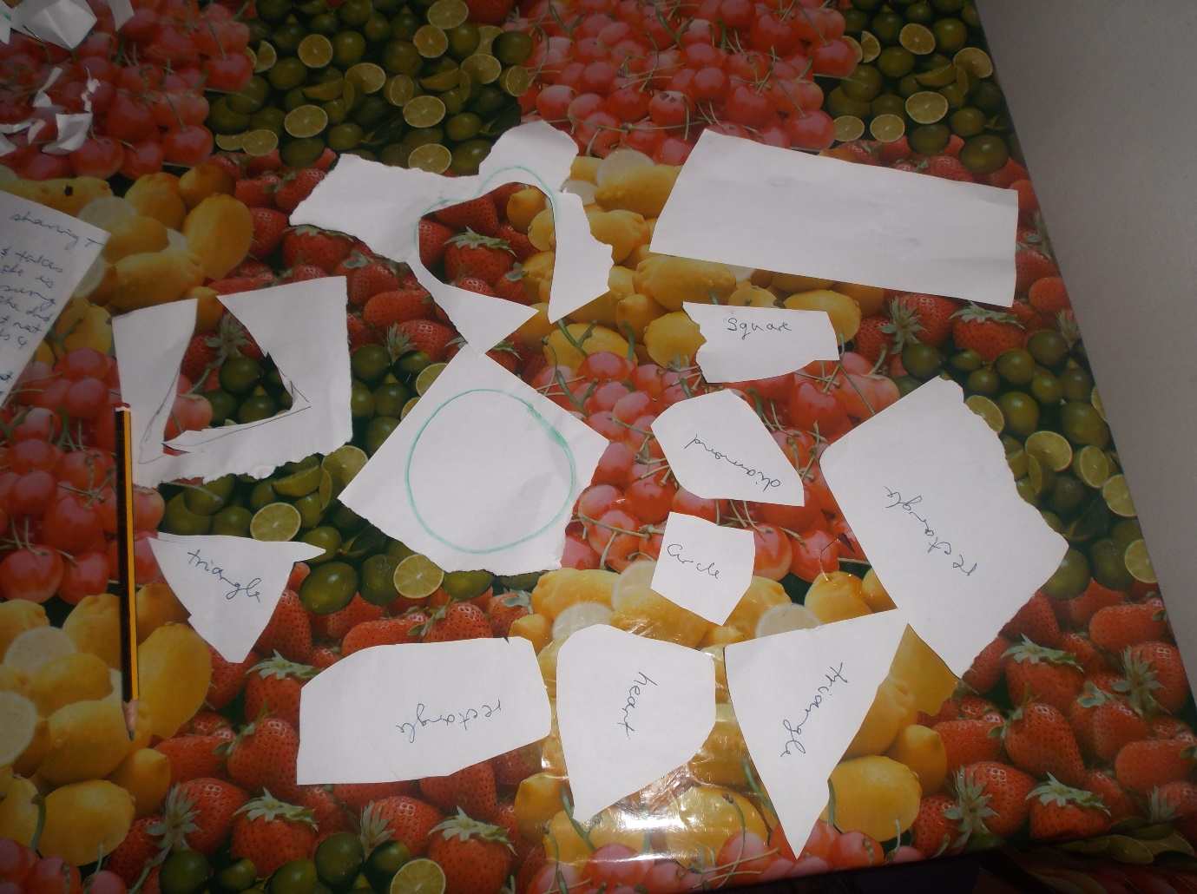
End here

I am my DNA? 8.2.2015
My Mama
I was touched by the story I read in the Daily Express newspaper on Monday 2nd February 2015 – express yourself. Since I am into research so I am in a better place to handle the important matters in my life that will impact on the person I will eventually become in my old age, if I am lucky to live as long as my Mother. I am availing myself of all the necessary information to make it easier for my family to better understand me and therefore, better educated and equipped to deal with me? When anyone ask about the things that are of interests to me, you won’t hear me naming any of the popular programmes on television or social media. Because frankly I am not interested in most of them and do not have the time to watch them either.
Neither will I waste my hard earned cash and valuable money buying those daily gossip magazines because I am not that interested in the lives of A-Z list celebrities who don’t have anything to teach me about life. Instead you will find me focussing on researching and documenting my family history for the future generations, if any of them are interested? I am living with my regrets of not knowing much about some of my ancestors who were the key in making me the person who I am today and will become later on. After reading Sarah King’s story in the newspaper about her husband Andrew, my Mother is the first person who came to mind.
The reason she came to mind is because she is the last of my immediate family to depart this life on 01.06.2014 at the ripe old age of 90. The most significant reason for my Mother coming to mind is the fact that she suffered from DEMENTIA for a number of her twilight years. Believe it or not I am the person who diagnosed her condition from distances away after I had enhanced studies whilst living in this country of opportunity. In addition to my early years studies, I had done an Open University Health and Social Care Level 2 course paid for by the Trade Union at the time. That was when empowering the social care workforce was given top priority back then when I was a student.
I could not help but agreed with the conclusions drawn by one of the Presenters Vicky Hutchin – The Progress Check at Two: getting it right for the child and parents at the recently concluded Nursery World Show 2015 about the scaling down of teaching. I am an advocate of Continuing Professional Development (CPD) because I believe that knowledge is power. And I was empowered to apply my enhanced knowledge and expertise from studying about Child Development to diagnosed Mum’s condition. When I started hearing about her strange un-characteristic behaviours, I realised that something was just not right.
Diagnosing Mum’s condition earlier helped put her on the pathways to getting the care and attention needed to make her life experiences better. The diagnosis enabled my family back home in Jamaica to separate the cantankerous, miserable old woman who always spoke her mind from the little old lady who was a shell of her former self. Although I wasn’t home to play my part as I ought to, as Mum’s only daughter. I was in a better position living in the UK because I was financially secured, having a job that I am passionate about, from which I earned the money to contribute to her upkeep to the very end.
I made it a point of my duty to call home once per week after her diagnosis to speak to her, trying to keep that bond strong and relevant as my Mother’s only girl from a brood of the 8 children she raised to adulthood. She had in fact buried 2 of my Brothers before in 1994 and 2008, her Husband and Mother a month apart in 1980 and her only Brother in 1978. I sort of understand and can empathised with Sarah King about some of the emotions she is experiencing at this time in her life. Even though my Mum could not make head nor tails of what I was saying in the end, I still continued to call to hear her voice.
However I had my moments when after calling home I was left to reflect on my own life because of my earlier experiences of helping Mum to care for Dad and Gran. I would end up in pieces and have to be comforted by my then partner, now my husband. Despite my misgivings and feelings of being totally useless, I couldn’t help but continue calling my Mum. I was comforted by just hearing that melodious laugh of hers and the voice by which she was best known. I guess all of us – my siblings and I have, and our offspring inherited Mum’s laugh in varying measures. That is why I find it so hard when others chose to ridicule me about some of my family traits and cultural heritage over which I have no control whatsoever.
Like my Mum when I am feeling vulnerable about some of my deficits and insecurities, I try and cover them up the way she done her missing digit from her left thumb by tucking it away. I will hold myself to stop my nervous tics and shakes from becoming visible and I will also try not to speak as when I become nervous the words failed to come out or I am so intent on getting them out that that the volume increases. So when I am trying to protect myself, I am not being rude, aggressive, using body language or any of those things that others have problems with. But on a different front anyone from Jamaica uses different body languages and cues to express ourselves in one form or another.
I will conclude by saying my Mother had a very fulfilling life for almost all of her 90 years with us and not many are as fortunate as she was. It was briefly interrupted with her onset Dementia which lasted until she departed this life. I having inherited much of Mum’s indomitable traits and spirits, primarily of which was her Tender Loving Care (TLC) which she reserved for the Young, Sick, Old and Vulnerable amongst us. My sons are of the opinion that I will benefit from Mum’s DNA and I can only hope they are right and I continue to have a productive life as far into my dotage as is reasonably possible. But it is hard to function when other put obstacles in my way.
My Papa
That is why I believe I owe it to the memory of my Father to dedicate this story to him for no other reasons than he suffered a similar fate to Andrew, Sarah King’s husband when he was in his late 40’s. Dad was struck down in the prime of his life as far back as I can recall from when I was a little girl. He was eventually made redundant from his job as a Common Labourer when I was still attending Secondary School and Mum had to take on the mantle wearing many hats as chief bread winner, informal carer and much more over the next 10+ years that dad struggled with his illnesses. It was the hardest thing for me to come to terms with Dad’s illness as I had vivid memories of my Papa who worked hard for his family.
In addition to his full time job as a Common Labourer, he cultivated and planted ground provisions and rice anywhere he could find a spot, to supplement his income. Our home was always filled with a wide variety of fresh food products that we eat to our hearts content. What we did not eat was given away to family and friends in the community as at that time everything was shared out for others to enjoy. Dad was a professional at most things that he put his hands to and everyone would to this day talk about the way he kept up his yard; with the neat edges and grass cut down to lawn levels with his machete.
He volunteered to cut the school yard and cleaned the street that we lived in. I still have vivid memories of Dad balancing the broomstick on the end of his finger tips and the palm of his hand. And his handwriting was just so perfect, especially the way he formed the letter N for his surname, Nembhard. He used his 2 hands to grater the cassava, rubbing the cassava down the side of the grater at the same time in unison. Coming from St Elizabeth meant that Dad introduced lots of the culture to Westmoreland where he eventually settled. He had a concertina that he called a flutetina that he played and he was always playing his mouth organ or whistling along as he was always singing and praising his God in one form or another.
With the onset of his inherited illness, Parkinson Disease, Dad slowly began to have the tremors. At first this was put down to him being sick with his Nerves because he overworked himself? He was used as a pioneering Guinea Pig, testing medication because I am of the opinion that not much scientific knowledge was not available at the time about Dad’s condition? Our home was full to overflowing with all these medications in the forms of these massive tablets, most of which Dad never even took. Over the years the tiny tremors turned into more noticeable shakes, which exacerbated into thunderous earth shattering rumbles that could be seen and heard from near and far.
Dad lost control of his body as every conceivable fibre of his being shook along with the foundation of the bed or chair he was in. Dad’s illness rendered him totally useless in the end to the point where he had to have 24 hour care. Before his slow demise into uselessness, dad continued to be the hardworking man to almost the very end as long as he could get out of bed. He’d go pick up the leaves from the yard, bathe himself with the water Mum placed in the sun to warm and even held my son; rocked him to sleep singing a lullaby. For me Dad’s illness was like a torture as I watched him struggle with his condition getting worse over the ensuing years.
Mum was selfless in her duty of care to him and then Grandma also took sick, after the death of her only Son in 1978, close to Dad’s end. Mum had to go out to work to bring home the bacon and come home to attend to the personal care of both her loved ones; her Mother and Husband. I recalled the last time Dad came out of the house unto the veranda and stayed for a while. He flung one of his foot over the veranda railing and was being his old self as if he had taken a new lease on life and recovered from his illnesses? I guess it might have been Mum in her infinite wisdom who said that this could have been Dad’s final visit to the veranda? She claimed that from experiences this was the case when people gained strength before their time to depart this world.
Mum’s words were spot on because Dad never came back out of his room after that until he died. Mum’s words were the self-fulfilling prophecy because Dad gained his strength to spend his final time on his veranda before becoming bedbound. His condition deteriorated so much that he was a shell of his former self. Dad was a man of slim built, but by the time he died, he had gone down to pure skeleton/skin and bones because he was bedridden. When they came to collect his body to take to the morgue, they thought he had died days before? In a sense he had died, only waiting for the breath to leave the frail body.
His years of sickness had taken there tolls on Mum, but she never once complained and no one ever saw her shed a tear. If she ever did, it was in privacy when no one could witness her weaknesses when her defences were down? I on the other hand was always questioning the wisdom of God in allowing my Papa who lived his life to the Bible’s teaching to suffer so much. I would rant and rave in my heart about this unjust God who could allow my God fearing Papa to go through so much when he didn’t deserve any of it. How could this God whom my Papa worshipped with every fibre of his being allowed him to suffer such indignity in life and then continue to hold him at ransom and not release him to go home and rest?
One of my Brothers used to say if he was alone with Dad, he would help him out of his suffering. That was before I knew anything about euthanasia. That Brother died in 1994 and went to join Dad. Then imagine how I felt when I realised I inherited Dad’s Parkinson as I started to have signs and symptoms for my efforts. Then I couldn’t help but think that my Papa’s God must have been punishing me for something I might have done that I did not know anything about. I am 1 girl of 8 siblings and I picked the shortest straw by inheriting Dad’s debilitating condition – Parkinson disease which caused him to be stuck down in his prime and struggle before he died.
But to be frank knowledge is power and via studies, I have empowered myself with the information as I learnt to accept that I cannot change anything about who my parents are. I have learnt coping mechanisms in dealing with my conditions, however there are times when I feel as if I am swamped with problems to push me over the edge? My one consolation is I was the last person to see Dad before and after he died. I do consider that to be a blessing in disguise as I had gone in the room to greet him before taking my baby son for fresh air.
He was trying to talk to me but by this he’d lost his vocals and I am guessing he was saying his final goodbye to me and the new baby? Mum couldn’t believe when I got back and called out to say Dad died after going back in the room. Maybe one of the factors to cause her disbelief was the fact that Dad died with his eyes wide opened and she closed them. Her first concerns was that Dad did not get a drink of water and was bringing it because she still did not believe he’d died. To be honest Dad’s death was a relief to everyone as we had watched his suffering over the years to the point where we were praying for his release?
Uncaring World of Today
I grew up seeing my parents sharing everything they had with those who were less fortunate than us. And yes although we were dirt poor, there were others who were worse off financially than us. I can testify to the fact that even when we were short of some of the material things in life, we were not short of food. There was always enough food to stave off hunger as Dad cultivated any and everything. That is why I could never ever think of doing anything to take bread out of the mouth of the hungry. Nor deprive them of a roof over their head and most importantly sabotaging their changes of having a fulfilling lifestyle with all the basics that God provided.
When you know your history and the journeys you have travelled to get yourself out of the poverty into which you were born through no fault of your own. You are better prepared to be sensitive to the needs of others, empathise with them and do all in your power to help them overcome and enjoy fulfilling lifestyles without putting obstacles in their way. My family on both sides suffered from a variety of health conditions some of which were to render them helpless like my dad, send them to an early grave or to suffer from long lasting neurological conditions.
Granddad from Mum died at an early age from Cancer, Granddad from Dad must have been the one with the defective Parkinson genes that dad and his sibling inherited. Because Grandma lived to be 96 years old, outliving my Dad by 10 years and burying some of her children. Grandma’s only deficit was that she was accidentally blinded in one eye by her dressmaker Mother when the scissors fell on her when a baby. However that did not impact on her life very much because she was still sewing patchwork quilts and stringing needles without the aid of glasses into ripe old age. Grandma C suffered strokes which finally took her home to glory in her 80th years.
God rest her soul, Mum had dementia towards the end, but she had a fulfilling life nevertheless. Researching my family history have empowered me to shake of the shackles and done so much for my self-esteem and self-confidence. I am more at ease about who I am, and who I might turn out to be as I am aging. I know full well what to expect, therefore there are no surprises for me around the corner. Although I believe that as an only girl, I have inherited most of the defective genes and DNA conditions from both sides of my family.
My research placed me in a place where I am no longer afraid to face the future. I am in control of my own destiny as I can do much to keep healthy longer, until I reach that stage in life like my parents and grandparents before me when my family; children and grandchildren will have to take charge? However it would be great if persons in my situation are supported to make the most of what we have to offer. Instead we are being provoked and pushed over the edge to act out of character that have nothing to do with my DNA for the glorifications of some who don’t give a toss about the vulnerable in the society.
I guess my Papa would encourage each and every one to be our brother’s/sister’s KEEPER!
35th Anniversary of Dad’s Death
On the 35th anniversary of the death of my beloved Father Ivan Sandyman NEMBHARD, I take this time out to reclaim those precious memories of the humble man who was my Papa. When the going gets tough as it has been since the start of 2015, all I can do is bring to the fore; the knowledge, values and beliefs he taught me as his 1 and only daughter. I know challenges there will be, but I know I will have to be strong when confronted by the wiles of Satan in the guises of some of the snakes under grasses who are out to strike.
There is a saying from my culture that say “Bush have Ears”, but as my Dad would say. It is not Bush that have Ears, is the Human Being Standing in the Bush Listening. My Granny would say “The Same Dog that takes out a Bone Will Bring Back One”. I believe it is Standard English to say that “Eaves Droppers never hear anything Good about themselves”. But mark owe I know absolutely nutn bout dis 1 cause I am a Yardie Gal in this instance.
I am Loud Mouth, Brash and in Ur Face, Full of Myself with Attitudes to boot and I will always call a spade a spade no matter the consequences! However I know without a doubt I’d never do anything to deprive another Human Being of their Basic Human Rights as I am too much of my Parents Daughter! They never only think about themselves, but every human beings for whom they could stretch forth a hand of help. If you do your research because my life is an open book and I have decided to place all my skeletons on the outside of my closets so those curious snoopers don’t have to waste their time digging. But I can’t help wishing that the cupboards might tumble dung pon dem and bury dem alive if they chose to go out of dem way to crucify others?
But back to the research, if anyone cares to take up the challenge, they will find that my Papa beats me one time only. The reason was to Cuss Bad Wuds, and I still Cuss Bad Wuds to this day even if I now do so under my breathe? Guess they will find a name for this too in the long run… Body Language, Attitudes, etc, but what happens when I child with hardly any communications skills kiss teeth? Am I to come to the conclusion that that child told me to Kiss her Ass as they would have me believe? Well they say the sins of the Parents visit the 3rd and 4th generations except those who fear the Lord.
My sons have to be very careful as they will have to take on all my transgressions? Since I have inherited my Parents DNA, I am finding it hard to change from the roaring lion into the pussy cat that can hardly purr! Well mek all dem blinking Kettle carry on cussing Pot black and those without blemish can fling dah fus brick enuh hear I! I guess only my Parents would understand my perspectives on life still, since they made me into the person whom I am.
I am a Yardie Gal with the Gift of the Gabs in Chatting Gibberish! Guess is not much I can do about that no matter how hard I try to Change?

Influences of my Life
Communities:
Places: Townhead
I was born in an enclave just below the Townhead Cross Road in the parish of Westmoreland Jamaica. Townhead was always the hub for the other local communities when I was growing up for many reasons. There were a few of local amenities in Townehad like the Primary School, the shops and the Baptist Church all situated in close proximity to the Townhead Cross Roads or Intersections as some people prefer to call it. In the Cross Roads were the three (3) shops, travelling towards Burnt Savannah to the right was the Baptist Church and travelling towards the left is the Primary School.
When I was growing up most of the facilities were to be found on the Church premises. These were inclusive of the Health Clinic and the Basic School that were important for providing services and laying the foundation for those who would not otherwise be able to provide adequately for their children’s early start in life. There was a well in the church yard where people could get water as back then running water was not accessible for everyone. I believe the Townhead Baptist Church is one of the older churches in the area going back ages. My mother was christened there in 1924, married in 1950 and baptized in 1951.
Branching out from the Townhead Cross Roads in either of the three directions are the little districts and little places with very interesting and intriguing names such as Grung Road, Star Apple Tree, Bull Head, Sally & Nancy Pond, Pringle Corner, Brown Yard, Salabie Common, Gooden Land, Blackness, Solas, Cashew Tree, Coot Savannah, Dangra, Top & Bottom Burnt Savannah, Truro, Strawberry, Friendship, Fur Mountain, Rocky Hole, Caney/Hewling Town, Bull Head, Wallbra, Locust Tree, etc. to name some of those that are coming back to mind.
I recalled when I started attending Frome Secondary School, one of my classmates would be mortified when I talked about Grung Road. My School mate would beg me not to talk about Grung Road nor tell anyone that’s where she lived back in the days, but to say we live at Townhead. Oh well my old folks used to say the longer you live the more you learn…? Since I grew up in a household where my parents were down to earth and did not teach us to think that we were better than others, I guess that’s why I am the way I turn out. Instead I am sure my mother in particular have this complex believing she did not measure up because she was poor.
I guess I’ll have to get further in my story to address exactly what I’ve been learning re: my old folks and their sayings. And how I have managed through shear grit and determination to not let the circumstances of my birth determine my outcome in life. Because I have had to fight harder than most to get to where I have reached in life no doubt about that. On reflections I wished I did understand my mother and grandmother a bit more as I know one day I will eventually become like them too. However both of them done their level best to bring about changes in their life. The made sacrifices for their families and I am doing the exact same as I want to make a difference.
Truro
Over by Truro there were places known by some of the most interesting of names that one would snigger at when we were children. Tongue in cheek there was Cocker Swamp and Pala Bottom as words were misconstrued and meanings were ascribed to any and everything. The Truro Housing Scheme was one of the earliest Housing Development in the area to come on stream as part of the Government Initiatives in building Shared Accommodations and enabling residents to own their own homes. There was Pine Cultivations, which was then turned into Fish Farming.
Since this was located over at the back sections of Truro after the Hurricane in 1979 when homes were destroyed some people start the exodus to Truro capturing the available land spaces to make their living quarters. Funding was provided maybe from the International and Government funds to build houses at Truro over by the Back Street areas. Some of the misplaced residents from the other areas then capture the vacant land that was lying idle. The houses were sold to the residents as lots as part of the Government Housing Initiatives.

Later when the area became more popular with the advent of people from other local communities moving to Truro district, the places were given Street Numbers with the Names of popular residents as markers. I am almost sure no one bothers to use those Tongue in Cheek names by which some sections of Truro were called at the time I was running about anymore. Like my classmate who did not want anyone to know she lived at Grung Road, everyone might have gone up-market, as they change and move with the times. These days it seem everyone is prepared to airbrush the bits that they want to keep private and secret out of the record books and the annals of history.
There is much evidence to support the arguments that persons can become misplaced from their homes or other natural habitats for any number of reasons. Truro became a melting pot for people from all areas of Jamaica when the Hurricane struck in 1979. People moved into Truro from Ricketts River- Frome and other communities that might get mentioned in the story. Therefore it is understandable that at some stages of one’s life, one is likely to have to go through some amount of transitions for which they don’t have much choice. One of my breda went to live at Truro in the early days when people were moving there. So I have a long history associated with Truro as well from I was young.
The Health Clinic was later moved from the premises it occupied at Townhead, across the road from where I was born and relocated to Truro as well. I attended the Health Clinic at Townhead when I was pregnant with both of my sons. Back then the local communities were considered idyllic havens and paradise where one could enjoy the best of everything. The saying it takes a village to raise a child was true in every sense. Those were carefree days for me and my children as far as I consider back then.
Names of Interests: Colourful Characters
Throughout most of my life living in Townhead and GaGa Street in particular I have memories of a few characters who were to become legends and whose names became synonymous with folklores from the local communities. It is no surprise then that we are left with a rich legacy of the kind of living these people were accustomed to as they go about leaving reminders for us to emulate and live up to, or better still to shun at all cost. As everyone can understand no two people are the same and everyone live the kind of life that suits them best. Therefore some of the characters could be considered comical with daring sense of brevity and humour. Others were considered as villains, some were remembered as the proverbial Good Samaritan and others were held in awe for their achievements or even lack of. But everyone will be remembered for something or other.
ld to the residents later as part of the Housing Development Schemes.
So travelling the length and breadth of Jamaica and localities of Westmoreland in particular you would hear stories of the characters who were of interests and helped to create stories for our childhood delectations. There was Bull Head a vast property with sections of land for sugar cane which was at one time owned by the one of the local Member of Parliament - MP from Central Westmoreland Mathew Henry aka Mass Matt. Mass Matt was a character in his own rights and I still recall some of the stories that were told about his exploits.
On reflections some might have been made up and embellished to suit the occasions as Jamaican people have a way with making up stories re: our Brer Anansi connections. Mass Matt was married to Ms Brammy the Headmistress of the Townhead Primary School and a member of the Townhead Baptist Church Fraternity of elites as I was won’t to call them when I was younger. Yes of course I am big, brave, bold and old enough now to admit to my own prejudices before I got relevant information about my own family history and connections in Westmoreland.
Because at one stage in my life I was more attuned to my Papa’s Family History than my Mother’s. This was due more to the facts that Papa was a Story Teller who gave us as much facts about his family that he thought we should know. Mama on the other hand was not much of a discloser, and I wish now I’d paid more attentions to the little she shared when she felt in the mood. People worked to earn a livelihood on the sugar plantations, a throwback from the days of Slavery. The other sections and terrains in the hills were used by people like my dad for the cultivating of ground provisions food crops to feed their family.
And later on there were other thriving businesses associated with the changing phases that Jamaica went through economically and otherwise. One of such phases was the Ganja Era when soft drugs was King/Queen and Westmoreland was considered one of the best places to cultivate the good stuff. The hilly terrains were ideal for the cultivation of some of those crops. Of course with regenerations and gentrifications, there always come periods of change and upheavals. I do not necessarily think that some of the changes have been good for the area, but who am I to judge or say…?
I am only one small person with not much influences, but I am glad I still have Freedom of Speech and the medium to share my thoughts. I remember the first time I saw a ganja plant and actually thought it was a young Bamboo Tree. That was how naïve I was back then. I used to take everything at face value and still do today and in that way I get taken advantages of by others who think I am simple. My grandma used to soak the good ganja on rum for medicinal purposes, but there are many other stories to be told about the exploits of the Ganja Industry back home. Some of the tales were good, but when they were horrendous they were.
During that period in the History of Westmoreland was when the reputation of the parish started going downhill to where it is today. There was always the rivalry between the Ganja Farmers that resulted in theft of each other’s cultivations. Others were robbed out of their hard work. But worse was to come when lives were lost. And I can recall that year when some Security Officers were ambushed and killed in Strawberry. That was headline news and everyone from the top was involved. There were instances when criminal elements started hiding out in Westmoreland from the urban areas of Kingston and St Andrew.
As a child we only hear about bad things happening elsewhere, but now a days Westmoreland might be the Crime Parish of Jamaica indeed. There were incidents of close Family friends taken from their bed and brutally murdered by the authority in a case of mistaken identity. But not only that there were shoot outs between the Security Forces and known criminals on the Police Most Wanted List. And yes some of them did frequent Westmoreland, which became a haven for them.
Another name of interest was the Cheddisingh who lived or had relatives with property at the foot of hill of the Burnt Savannah Rise on the way going towards Townhead. Walter Cheddisingh was also another MP for the parish of Westmoreland. But to be honest, I do not know so much about him like I knew the story about others. I was not into taking stock of the history that was to become of interest to me later on.
There were the Dennison of whom Mr Melvin aka Uncle Mel Dennison whom I believe was a Local Councilor and Political Activists as well as wearing many other hats in the communities was well known. He was from my Father’s era and involved in the Townhead Baptist Church until Dad’s departure when he was excommunicated. Mr Dennison was married to a lady for the Mercy Clan another well-known name in the community. His wife’s Parents were known locally as Mother and Father Mercy. The Dennison operated a shop and that was located at the front of the premises at Burnt Savannah.
Mr Dennison must have been one of the luckiest man as when his first wife died he got married the second time to another lady with the same name as the first wife. Lucky man he was to have two wives called Ms Dor. My breda Mass Balis told me that at one stage Brother Walton aka breda Wally rented part of the Dennison’s shop when he was working at Frome market. Mr Wally did business and Mr Wally’s friend John used to run the business whilst Breda Wally continued his job at Frome.
I was chuffed when with the advent of Social Media I was able to identify the mystery person to be Mr Wally’s friend John in the Townhead Baptist Church photograph with my Father. So I am in possession of some very old black and white photos from the past that I ca use to tell the history of my Family and their Friends from the localities. But not only that, I have information about who was the photographer that took the photos all those years ago. More reasons for me to revere the history of my family and the local communities in which I was born and bred.
Townhead Cross Roads/Intersections: 3 Roads to Chose
Grung Road: My Primary School Teacher – Ms Una Perry
The reasons for recalling that Grung Road is a part of me like the way how GaGa Street turns out to be the place that holds the most poignant memories for me is the fact of “where my navel string is buried” after my home birth. I was born just a little distance away from the Townhead Cross Roads where my family lived on rented property belonging to the Ackbersingh Family. I am almost positive that from what I have been hearing about my Family History three (3) of my siblings including myself were born at that property. Therefore there is not much to puzzle over when I am always heading the Townhead Road towards Grung Road the least chance I get.
So Along with a host of well-known families, the Perry family living in the Grung Road regions. Mass Johnny Perry daughter Ms Una is the reasons for my interest in taking stock about the little things in life that turn out to matter the most. Because I was blessed with the fact that one of the most influential Teachers was there to take me under her wings when I needed a little support from a big sister female figure when I was struggling with my identity, growing up as an only girl in my male dominated household. When I encountered one of the biggest challenges of my life and I was feeling left out and about to give up. I have my Primary School Teacher Ms Una Perry to thank for my resilience of not allowing the circumstances of my birth to dictate the outcomes of my life.
The valuable lesson I learned from an early age is that if one wants anything badly enough they will do whatever it takes to achieve their goals and make their dreams become the realities they want out of life. I have not stopped living the lessons Ms Una taught me since. I learned to be thrifty and develop that can do attitude as well as making do with whatever I am blessed with. I have since learn to appreciate that there are others who are less fortunate than I am, so it is my duty to look out for others and not only think about my needs all the time. I am more than thankful for my family and the communities I have the run of. Because the old saying “it takes a village to raise a child” is relevant today as it will always be. The old fashioned values are the principles by which I was brought up.
Other Family Names from the Era
Flemming
Other names of interests from the Grung Road regions were the Flemming – Mass Tanny Flemming and his wife Ms Fleda. The most important information for me was the fact that Mass Tanny Flemming and Mass Phantom were brothers by their mother side. Mass Phantom will need a whole article to written about him for his contributions to selflessly supporting the development of young people’s creative and sporting talents in Westmoreland. He gave his vast property to be used as the Sporting Facilities for the Sport Clubs around the local communities of Westmoreland. After moving from Grung Road where I was born at the age of 4+ years my family moved to GaGa Street which is the Family Seat of the Nembhard from 1963 to date.
Ms Lena
There was Ms Lena from Star Apple Tree and the only significance for me was why did they name the place Star Apple Tree? Some of my memories are becoming blurred, but I will document what I can recall before everything vanish altogether. I don’t even remember who Ms Lena’s family are either.
Moore
There were wife and husband team of Ms Maud and Mass Fourie - Moore the baker. One of the pertinent fact about this couple was the way they suited each other in terms of their stature.
Wilson & Colquhoun
Of course there was Sa Becca Wilson and there is much to be told because I think she might be remembered for being a headstrong woman if nothing else. Some of Sa Becca’s families and other offspring are still to be found at Grung Road and scattered across the Globe like any other family from the local communities of Westmoreland. The Colquhouns are the closest of Sa Becca family that I am in contact with. Our families were neighbours at Grung Road – Townhead when I was growing up.
Ricketts
The Ricketts were another household name in the area. Some of my most vivid memories are the ways my family stick to traditions and of my granny sending my breda Ashter to the Ricketts with specific instructions. Don’t ask me what the instructions were for because I haven’t got a clue. I am not sure but maybe the Rickett’s and my granny might have had some business ties or they run a shop?
Jones
Mr Jones – who my Mother told me was a rich man, but was destined to lose his fortune and died a poor man. Mum used to use Mr Jones as an example of why a person must put themselves first. Because Mr Jones scrimp and save to have the money and yet in the end he did not benefit from the money he accumulated. He ended up dying in the Poor House – Infirmary for the destitute.
Of course in those days some people never flaunted their wealth and there was another such person called Mr Jones who was very rich. But it was said when he bought the meat, he hang it over the creng-creng, (mesh wire hung over the wood fire to dry meat/fish products). It was said each time he was cooking, he would dip the meat in the pot when the water boils to get the flavour and hang it up until the next time. Mr Jones had a lady, and I don’t recall her name now, who was his housekeeper, and helped to look after him when he took sick. His family came to take him after that and the rest of Mr Jones story is part of history that I’d prefer not to rekindle so will leave well enough alone so as not to offend anyone. Because offending is not part of what I am about, and if I intentionally offend anyone I am profusely sorry because I’ve had to deal with anguish in my life and would not wish anything like what I’ve been through on even my worst enemy.
Mass Witney
My most abiding memory of Mass Witney who lived across the road from our house, was of this big strapping man. But at times they would bring him home in a truck, so maybe that was his line of work. His lady was also called Ms Lou, like my mother too.
Campbell & Sinanan
Then there were Ms Campbell and Mass Tat Sinanan – the Business Couple. Mass Tat worked at the West Indies Sugar Company Limited (WISCO), Frome Division. Mass Tat was an entrepreneur in his own rights as a Property Owner who cultivated sugar cane. Ms Campbell was one of the first woman to run her own business empire from her home. I can still recall as a child when she lived in a board house because she was my younger breda’s Amly Godmother and we visited her home regularly. Ms Campbell used to travel to Kingston to buy goods at wholesale prices to sell to her customers.
The MacFarlane
My God mother and Mr Mac were property owners, but Mr Mac was crippled in an accident.
McIntosh Ms Jessie , Dixon Bah Cecil, Ferguson Uncle Dolly, Spence Sa Meme, Kerr
Ms Maud
Ms Maud Tennant for the fact that she eventually developed a disability and was teased at the time is another of those from the Grung Road area that I wish to recall for a variety of reasons that were not of much interest to me at the time. In recalling my granny and some or her eccentricities, I guess she and Ms Maud might have had much in common about the way they go about living their lives. My granny was setin her ways like Ms Maud and would not budge from any of her beliefs even to how she communicated her thoughts and understanding of the things that matter to her in life. On reflections lots of what we did as children, we should not be held accountable for because our actions were done out of sheer ignorance and not spite or malice. Because I am sure every one of us must have joined in to tease Ms Maud about her bulging eyes without knowing the causes for her afflictions. If it is now I am sure someone with the knowledge about these serious matters would have issued some warnings. I can still look back and see how Ms Maud was frustrated and tormented over the matter of her bulging eye socket which was done by us children out of share ignorance. This was due to the fact that no one else thought about the impact on Ms Maud and we did not know any better. Recalling the events of what happened to Ms Maud and realizing that her condition did not just come about overnight. It took a number of years to get to the stage where her face was disfigures by her bulging eye that started out in one and spread to the other over time. So if Ms Maud had listened to the professionals they could have operated on her eye in the first instance to save her from the suffering. But the outcome of her prolonged situation where she had to live and faced up to ridicule also had to do with the fact that she was not educated to the standards to empower her to take control of her welfare. The fact that Ms Maud was not well informed or educated enough might have impinge on the fact why she preferred to believe in the old wives tale of obeah. Thus she refused to let the professionals do their jobs and operate on her. I honestly don’t recall what happened to Ms Maud eventually.
There was Ms Maud Tennant who started out with a little boil on her eye which turned into a massive eyesore that covered her eyes and might have blinded her in the end. She refused to go to the doctors after she was encouraged to have an operation to remove the offending boil. It grew into a massive protrusion which eventually covered her face and made her look like a monster. I am almost certain that I heard stories to the effects that she believed in obeah and someone worked on her. So instead of going to the doctors, she used to spend the money to go to the obeah people, who just nyam out her money and told her foolishness. I know she was teased mercilessly and would react badly to those who teased her. It’s a pity we did not know better at the time or we would have behaved differently to those who were afflicted with any kinds of disabilities or health conditions.
The Ackbersingh
The Ackbersinghs were another household name and my dad and breda Byron used to plant rice called in those days “Coolie Rice” before the advent of political correctness in their pond to supplement his growing family food needs. The Ackbersingh, they owned vast portions of land that they rented out land spaces to families called house spots to put their houses because they could not afford their own land at the time. The Ackbersingh were business people with their own Saw Mill.
My parents rented house spots from them before they could afford to buy their piece of property in GaGa Street. In order for there not to be any ambiguity, let me clarify house spots. From I am aware of my senses my grandmother, GanGan mum’s mother lived with us. Mama never leave her behind as mum would think of her mother as her responsibility. Back in the days children were thought of as pension for their parents so therefore there were reasons to be responsible as you take on your roles of being dutiful and accountable to your parents in providing for their needs when they are no longer able to do so. Saying that my grandmother was an independent woman up until a few years before her death. She was only one of the few female role models in my life as I was from a dominant male household/family.
Social Enterprise!
Townhead Cross Roads
Then at the Townhead Cross Road or intersection there were three (3) business places or shops run by the Henry – Ms Bernice and Mass Roland on one side and the Brissitte and Henry – Ms Lynne opposite with the colvert dividing them.
Mass Roland & Ms Bernice HENRY – The Entrepreneurs of Townhead
I am guessing the advent of the Juke Box Music System was introduced in the Henry business as a form of Social Enterprise in the Local Community from way back. Therefore the Henry must be acknowledged for entrepreneurship in bringing about the kinds of enterprise that brought people from across the communities together and unite people to enjoy each other’s company without the encumbrances of the social class divide that existed at the time at Townhead. The Henry provided a service where everyone from the common person to those of influence could shop for their family needs. There was food, haberdashery and even the Rum Bar section to whet the appetites of those who were that way inclined. Then on weekends and holidays there was the Dance Place where people meet to let down their hair and forget about the cares of the world for a brief period. I understand there were different kinds of music in the Jute Box for whatever the taste of those who love their music. So it didn’t matter if you were a Christian or Worldlian, there was music for everyone to enjoy. All that was needed was the correct change to punch the music to suit one’s mood at the time. I believe that the Henry’s contributions to providing Social Enterprise through their business enterprises throughout the years at Towhead should have special mention and I am hoping I get the opportunity to write that story before too long?
The other two (2) businesses also played pivotal roles in serving the communities as well. More evidence that businesses can flourish in their own rights as long as they are providing the services that are needed by the masses in the communities. I recalled going to both those shops – the Brissitte and Henry to do the main grocery shopping on Saturday and popping out during the week when anything run short. Customers were treated like royalties at the two shops.
I was told by Mass Astley SMITH about the exploits of some of the latter day saints from Townhead and local communities who have their meetings at either the Brissitte or Henry shops when they want to trash out an argument, listen to music to dance on weekends as their forms of entertainments, or just to idle away their time in each other’s company. The best dancers at the time were reputed to be Phillip Dyer (my cousin Jeneve Chambers step-grandfather) and Man Len aka Lenny McFarlane. Mass Astley Smith later supplied me with information about this aspects of Townhead’s history because I have absolutely no memory of most of this…?
Other Influential and Important People of Townhead
Henry
I can recall Ms Brammy living up at the big house which was later sold to the Dunkley. Ms Brammy was the Head Teacher at the Townhead Primary School and before I give misleading information, I am going to use some of my Research resources to cover my tracks on these issues. Therefore Without Prejudice I am reporting that I think Ms Brammy was married to one Henry, got divorced and then got married to the MP Matthew Henry. As God is my judge I am forgetting some of the tittle-tattle I used to hear talked about as a child and younger person. Even Ms Brammy first husband name slip me, but it might come back before I am finished with this. On the subject of the house brought by the Dunkley – Joe who lived in USA, and Mass Papa used to be caretaker is the people who I recall living at that property. One colourful character was Ms Myrtle Trustee and her family that came to live at Townhead, when I was attending the Primary school.
Bucknor
Then there was Mr Buck aka Chambers Bucknor across the road living in an upstairs board house. Mr Buck was considered to be one of the wealthiest men living at Townhead with vast amount of property to his name. Yet he lived a very frugal life according to my folks. My folks used to share the story of how rich Mr Buck was, but he was very astute with his money, so therefore had one Home Sweet Home lamp to serve him upstairs and down. Mr Buck is said to have made valuable contributions to the community and Townhead Baptist Church in particular where he was a member. At Harvest it was said Mr Buck gave a calf that he raised to be sold for contributions to the church coffers. Most of the residents of Townhead never reached the status to be financially viable, much more to own even a cow. However Mr Buck could afford to give a calf to the church each year for Harvest Festival. ived in the big house too.
I am hoping I don’t have many such enemies as those I encountered from 23rd July, 2014 – May 2015 and before that April 2003 – November 2008. Those evil persons became the bane of my life and I will never ever forget what they have done to try ruin and destroy my life. If I was not resilient I might probably have ended up in the equivalent of the Poor House, the Mad House that is Maudsley Hospital. Now I’ll have to go there eventually as soon as there is space for counselling because of what some evil people were allowed to do to me, whilst those with the power turned a blind eye and pretended they did not know what was going on.
There was a standpipe near to Mr Buck’s property laid in porcelain white marble, tiled cistern as well as a big tank where people who did not have their own pipes went to collect water.
Grant & Pringle
There was a Bamboo Leg and I won’t be repeating the story of why he was so called as I refused to speak ill of the dead. However at the time we did things out of a sense of fun instead of spite and there were no malicious intentions involved. Us children would not dare misbehave and act out of characters to our elders, but instead wait until we gather in our little groups. One of the best dress maker of her time, Ms Olga Pringle also resided in that vicinity of Townhead. And Ms Olga who retained her maiden name of Pringle was married to Mr Lloyd Grant. I am wondering now if Ms Olga did considered herself to be a Feminist why she was still known by her maiden name. Mum claimed she was related to the Pringles and once when we were young we would laugh at mum for claiming certain people for her relatives, but I started taking mum serious when I realized the importance of knowing ones roots and heritage. Now I wished I’d spend more time taking note of some of what mum used to tell us about her family. Mum eventually helped to care for Ms Olga when she took sick, even though mum was her elder. Mum went and lived at her house to keep her company and it was only later we realized mum had a special calling, gift and aptitude to do some of the things she done for us her family, friends and even total strangers who needed her tender loving care. Mum has left a great legacy behind and I am sure her children and grandchildren are reaping the benefits of her hard work whilst on earth.
Mrs Frankie
There was Ms Frankie who had a little shop beside the Townhead Baptist Church and we used to go there to buy our treats of greater cakes, baked product, you name it and Ms Frankie sold it.
Ms Airy Ms Airy lived across from Ms Frankie and the biggest guinep tree was outside her gate. This property was later bought by the Stewart - Glendon’s parents. When it was guinep time there would always be lots of excitement around the guinep tree, because Ms Airy would try to stop the children from picking her guineps. Therefore Ms Airy would tie a bottle of blue water to the tree and words would go the rounds that if we eat the guineps something bad would happen to us. But low and behold some Smart Alex would be daring enough to fling rock stone and break the bottle with the blue water.
Because they know that people were very kindhearted and would not do anything to hurt the children back in those days. Sadly I can’t say the same for these Latter Day Saints as the dynamics of the Moral Compass that was part of the Jamaican Society has changed beyond recognition.
Hanson Yard There were the Hanson from Hanson Yard across from the Townhead Baptist Church. One of the biggest character from Hanson Yard was of course Ms Vicky and Balis told me recently that Mama and the Hanson are bonifide family, so more information to add to my archives of documenting. Mr Martin Hanson is still riding his bicycle all over the place. I see him every time I go home.
Latie Mac & Breda Wally There were Latie Mac and Breda Wally whom I always considered to be white when I was little because I did not have the proper yard stick to measure them by. But now I know that in fact they are Mullattoes.
Pinkney There was Manzeek Pinkney whom local legends stated his feet were so big he was supposed to have used them to kotch the cane cart. The Pinkney had property beside the Townhead Baptist Church at the front and running alongside the back. I recalled we got the best guineps along with other fruits like tangerine, mangoes, etc… at the Pinkney property. Errol who is part of the Pinkney dynasty is now one of the business men in Townhead providing employment for the locals.
Knuckle There were two (2) sets of Knuckles and I am not sure if they were related, as some were Mullatoes and the other black. Ms Elsa Knuckle used to prepare our lunch at the Townhead Primary School and Mr Knuckle used to work at Bauxite and owned one of the first minibus in our area appropriately called Treasure Girl. The other Knuckle were Mulalato of which Uwie was a member. I have vivid memories of Uwie and his dad of all that family. The dad was a little short man, but Uwie was a strapping tall man. I think Uwie was a bit eccentric and much of a character and might have some sort of learning difficulties. He was always one cheerful merry soul going about his business.
Cocker There were the Cockers and Mr Cocker was said to be a jeweler, but never taught this skills to anyone else, so he died with this talent instead of passing it on. I recalled him as the Bursar at Frome Secondary School. One of his sisters, Ms Hilda was the Registrar for the locality and her name is on my Birth Certificate. There was another named Ms Sibby, Ms Al, and Joy Cocker aka Banhan’s grandmother worked at the Cocker household. I recalled my grandmother used to be helping out at the Cocker and we carried water for the family from the stand pipe at Pringle Corner. Am sure my granny must have gotten paid for our services?
The Cocker’s home was one of the modern homes built and they moved from another area to live at Townhead. Mr Cocker drove a big car and must have been one of only, a minority of persons to own their own transport.
Nurse Parkin The nurse was definitely a white lady and nurse Parkins delivered many babies in the area. Honest now I don’t know if I was one of her deliveries, but I know for a fact my youngest breda Ervin to be one. It’s funny how at the time you think you know everything you ought to know about your life. Only to come a cropper later when you realized you are missing some vital information. Too late now I am supposed to get the information for a variety reasons like death, etc…
Hinds There were the Hinds who were longtime friends of my family, Mother Hinds and her husband. Mother Hinds and my grandmother died around the same period of time – March 1980. I can still recall the spate of deaths that occurred in 1980 because that’s the year I lost my dad and grandmother, a month apart.
Brown There were 2 sets of Brown of which Cousin Manny and Ms Agnes readily come to mind. The Pringle sisters consisting of Ms Lizzie who had all the children – named Rowe, of which Husky comes to mind? She also had a granddaughter Michele Rowe, who lived by Meme Brown. Ms Lizzie had the house nearer to the Brown property.
Ms Euphie who was deaf and Mabelle who was blind lived together in their own house nearer to the corner going towards the standpipe at the Hall property. There was this talk about the differences between the sisters. Ms Mabelle was big built, her hair was totally grey whilst Euphie on the other hand was petite and every strand of hair on her head was black. Another information of note was although Mabelle was blind she could tell the differences with the money – paper and coins. She used to buy by-products from the McPherson that travelled from Hanover for customers in the area. Just thinking about those by-products of bulla cake, coco bread, corn bread, buns, etc… makes my mouth water - yum-yum.
It was a wonder to me how Ms Mabelle was able to tell the differences between the money. Now with knowledge comes power and I think Ms Mabelle was compensated for her blindness by having some 6th sense to cope with her deficits and limitations in life. Because she used to do everything, the chores of cooking, washing, ironing for herself and sister Euphie. There were other Pringle sisters whom I did not know, but they were buried on the Pringle property in 2 tombs. The end of the road was named Pringle Corner I guess in recognition of the boundaries of their land. Another fact about the Pringle property is how fruitful it was. The commonest fruit was the tangerines that we got in abundance when they were in season and those days we were welcome to help ourselves when we were passing. There was jackfruit as well in abundance at the back of the property. I used to accompany Ms Lizzie sleeping at her house when I was a little girl. Of course she was living on her own by this because her grandson Husky had gone to the USA to his parent.
Mass Joe aka Joseph Jones comes to mind for obvious reasons that he was afflicted with a health condition that we as young children were not totally informed about. Therefore at some stages of our life we used to make fun of him because of our own ignorance and not necessarily out of spite or mean spiritedness. Mass Joe had what was commonly known as a Boson which I presumed started out as a ball in his testicle and left untreated turned into something out of size and all proportions that eventually got the better of him I supposed. From as far back as I can recalled Mass Joe was seen as a comical character in the community because of the way he dressed. He was given the nick name of “Boson Tone Joe” for obvious reasons and I am not here now saying anything to offend anyone knowingly. I am just dealing with the times we lived in and how some people deal with their situations and circumstances. I know for a fact that no one intentionally set out to be unkind to those around us at the time. But there are times when circumstances alter cases and Jamaicans being who we are will come up with some ideas that that are both helpful and a hindrance to our fellow human beings. So of course the more Mass Joe burden became bigger and more pronounced, the more there was talk of things one could do to make him uncomfortable. It had something to do with a feather, but I doubt very much if anyone would have done anything to hurt Mass Joe. I still don’t know if any of this was truth, dare or even old wife’s tale.
I however Mass Joe was the orchestrator of his own downfall because of his own beliefs where his health condition was concerned. Some people just did not believe in the capabilities of the medical profession and preferred to suffer with their conditions until death, no matter how uncomfortable their life was to become as a result. Mass Joe wasn’t the only one to have behaved like that and I am only assuming he made the decision to live out his life burdened down with his condition and suffering the indignity like he did. Otherwise he was a jovial man like all Jamaicans who loved to tell stories of his exploits. I am sure the story about him going to Cuba and climbing callaloo trees must have been made up…?
Mass Joe was not the only person I know to be afflicted with a noticeable condition.
We lived in a world where we did not have much knowledge about so many things that could have made the difference to how we treated our fellow human beings.

Chiney Man, Molly Trout,
Wedderburn of which Cal was famous for walking to and from Frome to deliver the Daily Gleaner.
The Tomlinson, Legister, Gillette,
GaGa Street
Ms Turb, Dixon Yard – Ms Kate, Ms Bebe,
Mammy & Pappy - There was the story about the toad when P. asked M. how come the meat so tuff and M. replied after me never give you any meat, so upon investigation they found that the toad had fallen into the callaloo on the fire.
Grung Thunder because it is said he had this booming loud roaring voice with the effect of rolling thunder.
The Murray, Lewis, Black Rat
Mass Sim the shopkeeper who couldn’t read but never missed anything and was the best for miles around.
The Patrick, Nat Gokul, Dixon, Turner, Ms Fleda Atland, Meem & Diddy Brown, Wagstaff,
Hall with the big property another throwback from Slavery- there is a story about the feast to be told in this one.
Meylor, et al.
Road Leading to School
Salabie, Ms Rachel, Perrin, Hewling, Bernard, England, McIntosh, Willie, Senior, Reid
Ramcharran
After moving to GaGa Street at the age of four (4) a new world began to open for my family. At that time it could have been noted that people who had ambition like my parents wanted to own their own their plots of land to raise their family on. Well this was paramount for my family at least as my dad’s parents did own their own plot of land in Aberdeen St Elizabeth where my dad was born and my mum’s parents family had acres of family land in Brunty and Grange Hill where they were from respectively. Therefore whilst went out to work and he was a firm believer in living his life as dictated by the Holy Bible. He took 1 tenth of his earning for his tith, and the remainder was given to mum who would spend some for the upkeep of the household and tuck a little away for a Rainy Day. In the long run this amounted to much as it is said every little make a muckle. So poor people like my family’s dreams could become realities as they became owners of their plot of land and started placing foot on the first rung of the property ladder.
Schools: I attended the local Townhead Baptist Church Basic School and later Townhead Primary School which was also attached to the church. I next went to Frome Seconday School. Write about the influences of teachers etc in my life……
Church: The impact of church on my life, Why I stopped going to church…lthough my parents were
Although my parents were very poor they had ambition and aspired to bring about changes in their lives by breaking the cycle of poverty which had dominated them for most of their lives, which the majority of poor people with large family experienced. Therefore that old saying “mother have, father have blessed be the child who have his own…” must have resonated with my parents as they did have rich folks amongst their family on both sides. So it must have been some great achievements for my parents to save up to buy their own piece of land despite raising a large family. There are many stories which I can relate from my little corner of Jamaica when I was growing up. Therefore I am using these medium at my disposal to record and document them and I hope you will find them as interesting as they were to me when I was growing up. I will try my endeavour best not to knowingly offend anyone when I retells them. If there are any topics you wish for me to cover please feel free to drop me a line and I will see if they are part of my recollections. In the meantime I shall be rocking my brains to find out anything else that are of interests and can keep the spirit of Jamaica and its history alive. Since I am in the process of learning new skills I hope you will bear with me whilst I fine tuned my craft.
Until my next offering here is a little story to keep you pondering and reflecting on our past history and how they may relate to our lives in this new era. This is the story of Busha and the Crop Over Feast. At the time for the crop over feast Busha called the Georgie the house keeper to give her special advice about the preparation of the food for the workers. The story goes that Busha told Georgie that she should put lots of pepper on the meat and when the workers leave it to go home because they could never eat it because of the pepper they will wash it off and have it to serve several day later. So in Jamaican parlance I guess this was how the conversation went… “Peppa hit Georgie peppa hit suh when dem gone wi wash hit off…”. and n some

LEYF On My Doorstep?
I had worked with Alev Sagnak before and she recommended me to join Westminster Children Society (WCS) in 2009 when I was experiencing some amount of instability in my life. Since that time WCS has changed to London Early Years Foundation (LEYF) and 5 years on am still working with LEYF. However I am more than glad to say I am happy to be back in South London - Southwark after spending 5+ years working in Westminster. The best thing about my changing journey is that LEYF is expanding business from Westminster where the organisation started over 100+ years ago, to literally all the deprived areas of London providing better outcomes for young children. And I am privileged to be working at the Bird In Bush Nursery that is situated literally on my doorstep in South East London. I started my journey in South London working in the early years’ sector after I had completed my studies at Lambeth College 1997-1999.
I am an older and wiser early years’ practitioner who has been embedded with the LEYF ethos from when I joined in September 2009. Now that I have achieved most of what I set out to accomplish as a practitioner enhancing knowledge and expertise via studies and trainings. I am intent on using two of my hobbies – photography and writing to spread the LEYF DNA and my shared vision into my South London and to the world at large. Therefore I am more than prepared to use the knowledge and expertise I fought hard to gain to help spread the philosophy of LEYF as a beacon of good service provider to the UK and wider world. In so doing I will start by giving credit where credit is due to some of the extra ordinarily special persons who have travelled on my journey of discoveries with LEYF.
I am therefore going public so everyone can know that I will always be eternally grateful to those persons for inspiring, nurturing and empowering me to be the reflective practitioner who developed the listening ethos whom I have become to date. Therefore I will have to start off saying a big thanks to Alev Sagnak who told me about the vacancy at WCS and the fact they were recruiting for practitioners with my level of qualifications in 2009. Believe me Alev and mark my words that if I should win the jackpot, I promise to take you out to my native Jamaica for some fun and frolics and to meet my family who are exactly like me. Next on my list are some super colleagues whom I met at Fitzrovia Community Nursery where I first started. They are Candy, Patricia Session, Ezi and Claire the deputy who started on the same day with me. Candy is in for special mention because she took me under her wings as a novice, taught me ICT, how to do the Learning Journeys and write up the Activity Planning Forms.
Only a few weeks after starting at Fitzrovia, I re-established contact with Joelle Lax, now manager at Holcroft Nursery. I had previously worked with Joel when she was only about 17 years old at Lambeth Walk Day Nursery after I graduated from Lambeth College. She recognised me all those years later as soon as she walked into the nursery and saw me. I later learned that Joelle was one of the youngest managers working for LEYF when she was appointed. It would be rather amiss of me if I did not mention working in partnership with other professionals and outside agencies from the Camden Local Education Authority. I was privileged to be given the opportunity to enhance knowledge via trainings and empowered to make my implicit knowledge explicit.
The early years’ teacher who identified my passion in fulfilling my role as a SENCO was forceful in ensuring I got the trainings to do the role to the best of my ability. And she did not just stop there, she taught me about Every Child A Talker (ECAT), Statutory Assessment, Individual Education Plans (IEP), Picture Exchange Communication System (PECS), etc in the short space of time – 6 months that I was at Fitzrovia. I am a believer in change and I was transferred to Luton Street where I was destined to spend 4+ years working with some exceptional, enthusiastic and passionate colleagues. These colleagues were the epitome of professionalism who have the children and their parent’s best interests at heart. Julie Weiss who was the manager is first in line for some special praises as she always showed her appreciations for the work I had done.
Since she had the ears of the CEO she was never stingy in telling her about the good practice that I contributed to, in providing quality standards of work especially my Learning Journeys and Homemade Books. The CEO in turn would be lavish with her praises for anyone whose work was of the highest standards, whenever she popped into any of the nurseries. However in spite of this, this is not to say Julie Weiss and I saw eye to eye, are were in agreement to everything. I guess in hindsight I might now have to blame the generation gap and we never think twice about challenging each other. But we never lost sight of our different roles and responsibilities in the team and gave each other the respect that were merited to do the job. We both knew we were responsible for being accountable for acting and working as professionals no matter our personal take on any matters.
One of the biggest thing I admired about Julie Weiss is the fact that she would admit when she got her wires crossed and apologised for her mistakes. And we were on differing wavelengths about certain matters, but there was mutual respects between us. We were never afraid to call a spade a spade and then moved unto the most important roles of fulfilling our job descriptions. Stacey-Jane Whitfield who was the deputy manager was one of the humblest, down to earth person l had the privilege of working with. She never had the time to bother with some of the airs and graces connected to her status as she always had to go that extra mile in getting the job done. Madonna was a tower of strength who treated me like the big sister I never had. Marcia Girvan cooked up those mouth-watering meals to appease our taste buds. There is Elizabeth Reid, one of the first LEYF apprentice I met at Luton Street and who is a real go getter. This young lady knew what she wanted to accomplish and set out to achieve her goals. She rose to the position of Deputy Manager in Queens Park Nursery.
I worked with agency staff Freda and her daughter and Nichole initially when I started at Luton Street and they were a bunch of true professionals who just got on with the job. Their work were outstanding and comparable to LEYF standards at the time, so it is no wonder that they were relied on when LEYF needed their services. I met Tania Silva at Fitzrovia when she came to cover and we ended up as colleagues in Luton Street until she moved on to become one of the Deputy Managers at Marsham Street. We were privileged to develop some great innovative ideas and using our initiatives to promote and implement best inclusive practice during out time at Luton Street. We were empowered and enabled via our mutual enthusiasm in delivering the pedagogy of the expert theorists to support, enhance and extend children’s development and learning. There is Trison Grant who was an exceptional apprentice and I decided to take her under my wings because she is one of us – Jamaican and I could see her potentials as well as her passion for working with young children.
Katie is such a lovely girl who was only interested in giving of her best, doing her work and planning for her future ahead. I was privileged to mentor some of the students like Suzan Murados and Michelle Hofong to name a few. What can I say about my boy Bryan who I thought had such a bright future ahead of him if he had stuck to his guns and completed his apprenticeship? I honestly believed he had a role to play with “Men In Childcare” and I felt let down that he did not stay. However I am hoping that whatever he is doing he is flourishing and doing something useful with his life and not fallen by the wayside? I am appealing that if anyone knows about him to remind him of the role he played in the last LEYF conference that we attended. Andrea Barnes is another lady with attitudes like myself, but with her heart set in the right place. I am hoping she has managed to get her studying back on track and making using of the God given talents that she is blessed with?
I have to raise my hat to Bianca the apprentice who is such a natural in her role. I am hoping she will be inviting me to her babies’ christening of course, so I can get to dress up in one of my posh frocks? Now that I have hit on an idea about developing some teaching and learning tools to use in the early years, I am thinking about Sandra Delgado who taught me the song that I am thinking of using as my launching pad. As this is an idea in the making, I will have to now get really serious and busy ensuring this is a reality. Surely I have to mention Sunita who helped to sell my credentials about my good practice and using my knowledge and expertise to inspire others to make the most of their opportunities in life. With her spreading the words I eventually got my request for transfer from Luton Street to somewhere local and closer to home become a reality. I cannot forgot Sao who when she came to Luton Street told me about LEYF take-over of BIB and telling me to ask for the transfer to BIB.
Sao has been a tower of strength inspiring me to give of my best, because she too has done studies to a certain level like I have done. Most importantly we do work from that shared vision that the expert theorist recommend. The manager has been very supportive ensuring that she puts certain amenities like the computer in the staff room so I can word process my work and get the job done more effectively. So I have been ensconced and literally camping out on my doorstep with my transfer to Bird In Bush in Peckham South London. Now I am just working a stone’s throw from where I live, I have more time for my personal life as a part time carer for my elderly husband. I also have more me time and I can focus and concentrate on some of the things that are important to me like making links and connecting with the local community that I live in. And for all those other colleagues whom I met whilst I covered in other LEYF nurseries – Carlton Hill, Holcroft, Queensborough, House of Commons, Queens Park, Lisson Green, Mickey Star and Noah’s Ark and those that I attended for trainings.
I am eternally grateful for you allowing me into your settings and sharing your practices with me. Because for every setting that I covered in I came away with some new knowledge and expertise that I did not have before. Now I am indebted and have to talk about the impact of Rachel Parker who accompanied us to that training day out at Community Playthings. She is such an absolute professional who used to attend at Luton Street to do the ITTERS & ETTERS using both top down and bottom up approaches doing her job. I understand that she will be working in South London as an Area Manager and I can only continue to wish her all the best. Because I believe it was because of her I had the opportunity to attend trainings at Community Playthings where I am now working in partnership with the school on a none profit level using my knowledge and expertise to promote my country’s and my family heritage to a wider audience.
Working Partnerships: Although I did not stay long at Fitzrovia to do much other than support a child on the Autistic Spectrum in my role as the SENCO. I was privileged to work with children and their parents from diverse multicultural background. I have worked in partnerships with tutors, assessors, fellow colleagues and placements facilitators since I entered the early year’s sector when I enrolled at Lambeth College 1977 to the present. Now that I am back in South London amongst the majority of people from my own or similar cultures to mine. I can feel the vibes and realised how much I am appreciated and felt really proud when Carol presented me with a star that one of the children made to show her appreciation to my hard work and dedications since I started at BIB. Coming from a time in my life when my hidden disability caused me to stay in the background as I did not want to embarrass myself and lose my dignity, I was able to take centre stage for the Christmas Play and never once stopped to worry about failing. Since living in the UK, I have had opportunities to address my disability and empowered myself to integrate into a tolerant society. By so doing I have had chances to develop my confidence and even though the disability is still part of who I am, I have come out of my shell and is able to do something productive with my life.
An Advocate: I have empowered myself over the years during prolonged studies, trainings and research as I did not only have to deal with my hidden disability, but had to cope with my child who was misdiagnosed. That is why I am an advocate of inclusion thereby doing research into how best to implement and promote inclusive practice to stop even one child and their parents going through what I went through as a young inexperienced mother. I am proud to be a member of the LEYF team who is proactive in shaping the lives of the young children who may need some forms of early interventions to get them pass those initial hurdles that I had to deal with for myself and, with my own child. As the CEO rapped at the 2014 Staff Party, I am proud to be a be-LEYF-er and is more than happy – 5+ years and counting… I am looking forward to spending the next 10 years until my retirement when I will be packing myself off to my paradise in the sun. Hopefully I will be in a position where I can be of service in helping to develop Special Educational Needs and Disability services using some of the vast knowledge I had gained in the UK and most importantly as a LEYF employee?
Benefits of having LEYF on my Doorstep: I can easily pop home if I have an emergency or even check on my husband whose age, ill health and other underlying conditions are causing me much concerns. Working closer to home has really given me greater peace of mind. I have been using some of the time I spent travelling to good effect in particular when I have deadlines to meet working on children’s Learning Journeys. I can come a bit earlier and stay over late as I am no longer in a rush to travel the 2 hours that it once took when I was working far away from home. I am a stickler for keeping promises to myself and others if I set myself any targets or deadlines. I just don’t like to let myself down and my Obsessive Compulsive Disorder (OCD) will not allow me to either. So I am stuck in my routines of giving of my best or left feeling I am letting myself down if I cannot reach my targets. But hey life goes on and so does the work and as long as I can do my little bit to help any child achieve a positive outcome in life I am more than satisfied and know that I am making a contribution to preparing the future generations for their roles in life?
Now that LEYF is literally on my doorstep and I am now working in South London where my journey actually started after being away since 2009. I am looking forward with much glee to continue using my enhanced knowledge in spreading the word about LEYF DNA and ethos as one of the service providers that gained the status of being a beacon of outstanding quality to be aspired to. At Bird In Bush where I believe and feel I am secured in the bosom of people and communities that I feel I am more in tuned with and relate with much better. I know I have finally found the perfect platform to give of my bests in my chosen career of working with young children that I had chosen all those years ago. In addition I have empowered myself so I can indulge in my other passions of photographing and writing? I am looking forward to more changes that will benefit the deprived communities of South London. And most importantly the children and families who will benefit from the changes that are bound to take place in order for there to be progress in the communities through the different capitals.
I am more than contended with my life as it is panning out before me. I am not asking for much else as I honestly don’t think I have much ambitions left to climb up the career ladder, but neither will I become complacent and drop my guards either because of past experiences when I had to come crashing back down to earth with a terrible thud? On second thoughts I would love to win the National Lottery so I can hurry up and return to my native Jamaica. I would be more than happy to focus on working in the area of Special Education and indulging in my passion of writing. So in the meantime I will be carrying on giving of my best at Bird In Bush LEYF that is literally on my doorsteps and trying to motivate myself to develop my expertise in other areas? However I will not be complacent in whatever roles and responsibilities I take on as I am only prepared to give of my best.
I am more than grateful that I have been empowered to put some of the things that once bothered me behind me and move forward with all the enthusiasms that I can conjure up. I know what I am talking about as my old folks were fond of saying “she who feels it knows it?” What more can I say other than we are living in a world where we are not always tolerant and prepared to try and find out how others tick as we are more self-centred and looking out for “me, myself and I!” So in the meantime I am here wondering what changes are going to be taking place by the time I am old and greyer and ready to retire to the LAND of my BIRTH? I have had so much joy when I worked as a Basic School Teacher and that is my primary reason for wanting to go back to make my contributions to Early Childhood Education.
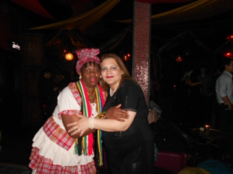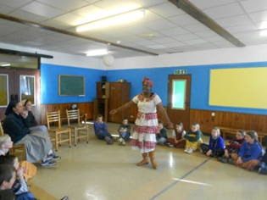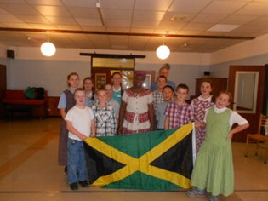
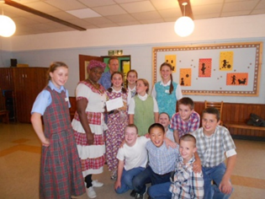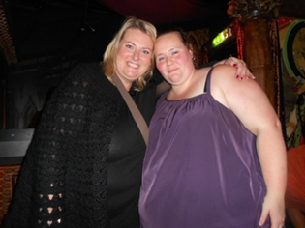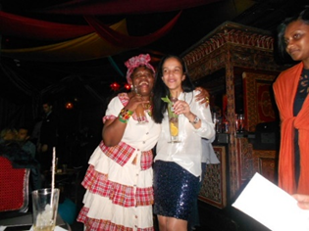
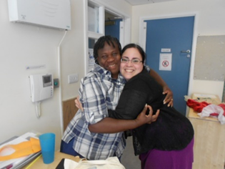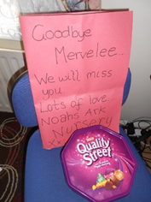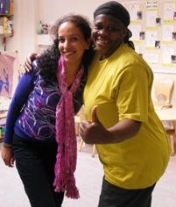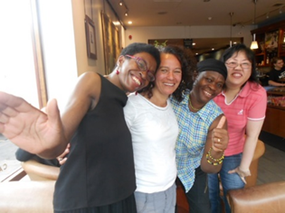
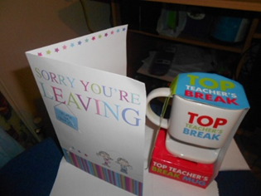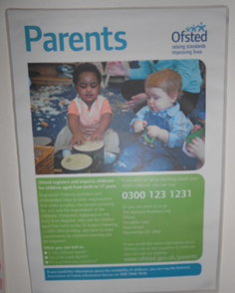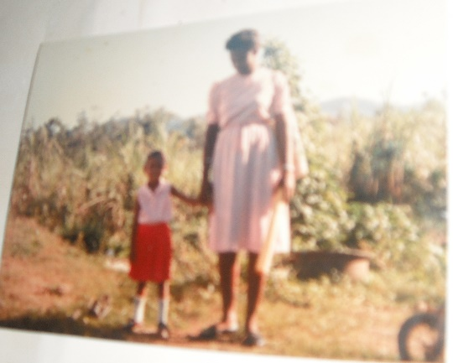
Update: 16.10.2015
I was harassed, bullied and inimidated into removing this article by one of my detractors who told me at the time I knew nothing. She made some other negative comments that I won’t even publicise at this time. Because for someone who knows absolutely nothing about me or the work I’d done during 5+ years of dedicated services was beyond my ken. Now I am defying the bullies and putting the article back and be damned if they wish, for taking a stance for equal rights and justice for the vulnerable. I am celebrating Black History Month and showing I am no COWARD!
I am proud of my heritage as I am discovering the DNA that is part of my Roots. I was told that there was some German Blood, Mullattoo and I am questioning if there was Chinese as well. My cousin Osbourne Nembhardt who is doing Our Family Tree reassured me there is 90% African, some Dutch and Scottish! They are welcome to do their next best because I am a Fighter with the Maroon Blood that Nanny of the Maroons and all the National Heroes used to fight to defend Jamaica the Land of my Birth.
I am 1 Proud JAMAICAN who is going to stand up and fight for my principles, values and beliefs. No one is going to stitch me up and send me back to no Funded Prison 4 Criminals – I am not a Criminal”. I might have a touch of “Mental Health Issues”, but they are responsible for pushing me over the edge!
27th October I celebrate the birthdate of my Father, Uncle and Auntie, 3 of my Grandmother Irene 16 children.

Fight4justice Publication 29th January 2016
LEYF On My Doorstep?
I had worked with Alev Sagnak before and she recommended me to join Westminster Children Society (WCS) in 2009 when I was experiencing some amount of instability in my life. Since that time WCS has changed to London Early Years Foundation (LEYF) and 5 years on am still working with LEYF. However I am more than glad to say I am happy to be back in South London - Southwark after spending 5+ years working in Westminster. The best thing about my changing journey is that LEYF is expanding business from Westminster where the organisation started over 100+ years ago, to literally all the deprived areas of London providing better outcomes for young children. And I am privileged to be working at the Bird In Bush Nursery that is situated literally on my doorstep in South East London. I started my journey in South London working in the early years’ sector after I had completed my studies at Lambeth College 1997-1999.
I am an older and wiser early years’ practitioner who has been embedded with the LEYF ethos from when I joined in September 2009. Now that I have achieved most of what I set out to accomplish as a practitioner enhancing knowledge and expertise via studies and trainings. I am intent on using two of my hobbies – photography and writing to spread the LEYF DNA and my shared vision into my South London and to the world at large. Therefore I am more than prepared to use the knowledge and expertise I fought hard to gain to help spread the philosophy of LEYF as a beacon of good service provider to the UK and wider world. In so doing I will start by giving credit where credit is due to some of the extra ordinarily special persons who have travelled on my journey of discoveries with LEYF.
I am therefore going public so everyone can know that I will always be eternally grateful to those persons for inspiring, nurturing and empowering me to be the reflective practitioner who developed the listening ethos whom I have become to date. Therefore I will have to start off saying a big thanks to Alev Sagnak who told me about the vacancy at WCS and the fact they were recruiting for practitioners with my level of qualifications in 2009. Believe me Alev and mark my words that if I should win the jackpot, I promise to take you out to my native Jamaica for some fun and frolics and to meet my family who are exactly like me. Next on my list are some super colleagues whom I met at Fitzrovia Community Nursery where I first started. They are Candy, Patricia Session, Ezi and Claire the deputy who started on the same day with me. Candy is in for special mention because she took me under her wings as a novice, taught me ICT, how to do the Learning Journeys and write up the Activity Planning Forms.
Only a few weeks after starting at Fitzrovia, I re-established contact with Joelle Lax, now manager at Holcroft Nursery. I had previously worked with Joel when she was only about 17 years old at Lambeth Walk Day Nursery after I graduated from Lambeth College. She recognised me all those years later as soon as she walked into the nursery and saw me. I later learned that Joelle was one of the youngest managers working for LEYF when she was appointed. It would be rather amiss of me if I did not mention working in partnership with other professionals and outside agencies from the Camden Local Education Authority. I was privileged to be given the opportunity to enhance knowledge via trainings and empowered to make my implicit knowledge explicit.
The early years’ teacher who identified my passion in fulfilling my role as a SENCO was forceful in ensuring I got the trainings to do the role to the best of my ability. And she did not just stop there, she taught me about Every Child A Talker (ECAT), Statutory Assessment, Individual Education Plans (IEP), Picture Exchange Communication System (PECS), etc in the short space of time – 6 months that I was at Fitzrovia. I am a believer in change and I was transferred to Luton Street where I was destined to spend 4+ years working with some exceptional, enthusiastic and passionate colleagues. These colleagues were the epitome of professionalism who have the children and their parent’s best interests at heart. Julie Weiss who was the manager is first in line for some special praises as she always showed her appreciations for the work I had done.
Since she had the ears of the CEO she was never stingy in telling her about the good practice that I contributed to, in providing quality standards of work especially my Learning Journeys and Homemade Books. The CEO in turn would be lavish with her praises for anyone whose work was of the highest standards, whenever she popped into any of the nurseries. However in spite of this, this is not to say Julie Weiss and I saw eye to eye, are were in agreement to everything. I guess in hindsight I might now have to blame the generation gap and we never think twice about challenging each other. But we never lost sight of our different roles and responsibilities in the team and gave each other the respect that were merited to do the job. We both knew we were responsible for being accountable for acting and working as professionals no matter our personal take on any matters.
Keeping Abreast of Current Events in my Transitionas to Getting CLOSURES.
If anyone wants to read the rest of this, they will either have to go look for me on LinkedIn or as soon as I get my G+ AddWords and website up. Facebook and any other Social Media Networking Sites I can get myself involved in. Southwark Council, etc is another place to look, however I do not have the time yet to make the impacts that I would like.

Update: 16.10.2015
I was harassed, bullied and intimidated into removing this article by one of my detractors who told me at the time I knew nothing. She made some other negative comments that I won’t even publicise at this time. Because for someone who knows absolutely nothing about me or the work I’d done during 5+ years of dedicated services was beyond my ken. Now I am defying the bullies and putting the article back and be damned if they wish, for taking a stance for equal rights and justice for the vulnerable. I am celebrating Black History Month and showing I am no COWARD!
I am proud of my heritage as I am discovering the DNA that is part of my Roots. I was told that there was some German Blood, Mullattoo and I am questioning if there was Chinese as well. My cousin Osbourne Nembhardt who is doing Our Family Tree reassured me there is 90% African, some Dutch and Scottish! They are welcome to do their next best because I am a Fighter with the Maroon Blood that Nanny of the Maroons and all the National Heroes used to fight to defend Jamaica the Land of my Birth.
I am 1 Proud JAMAICAN who is going to stand up and fight for my principles, values and beliefs. No one is going to stitch me up and send me back to no Funded Prison 4 Criminals – I am not a Criminal”. I might have a touch of “Mental Health Issues”, but they are responsible for pushing me over the edge!
27th October I celebrate the birthdate of my Father, Uncle and Auntie, 3 of my Grandmother Irene 16 children.
Kings College Parents References 2003 - 2008
- Alaister’s Parents. 2. Raphael’s Mum. 3. Email Flora’s Mum. 4. Ethan’s Mum. 5. Ethan’s card. 6. Nebiy’s Parents. 7. Cary’s Parents. 8. Naveen’s Mum. 9. O’Shea’s Dad 10. Rachel’s Mum. 11. Maurica’s Mum 12. O’Shea’s Parents 13. Charlotte’s Dad 14. Adverts 15. Adverts 16. Gloria Reference 17. OU cerificates 18.
- 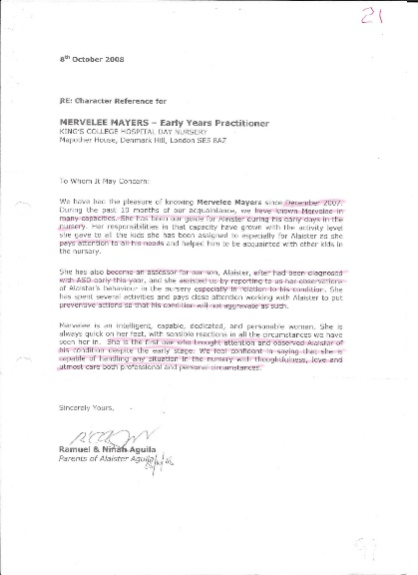 2.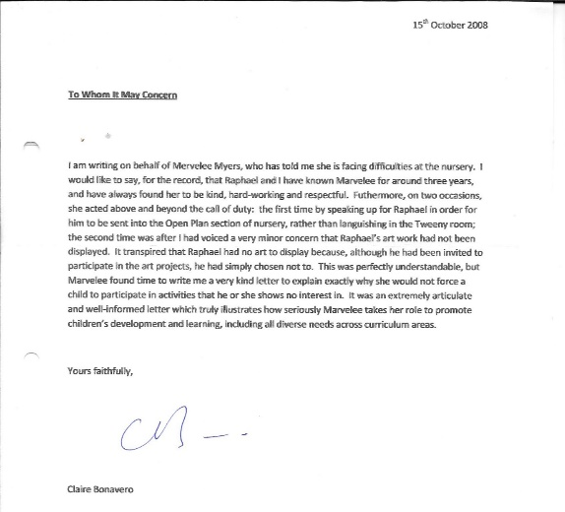
- 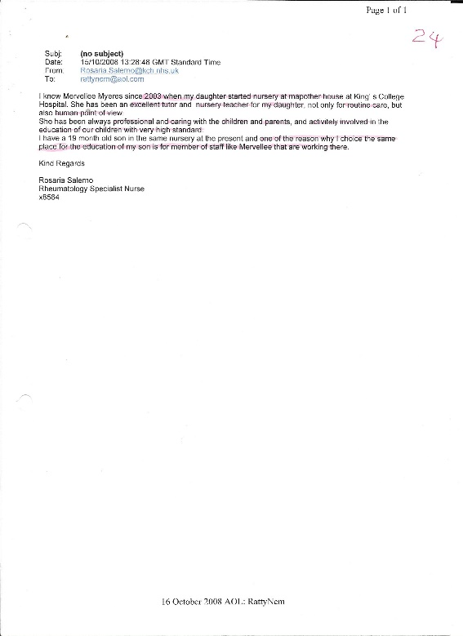 4. 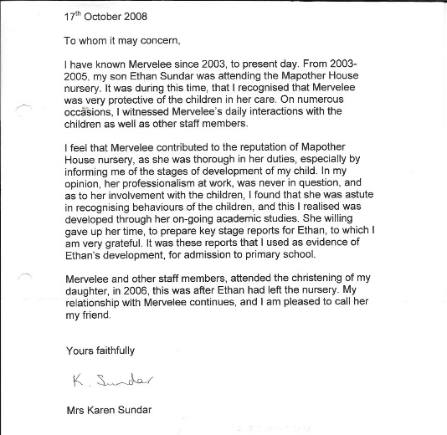
5. 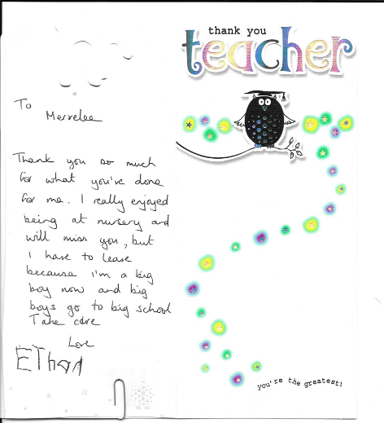6. 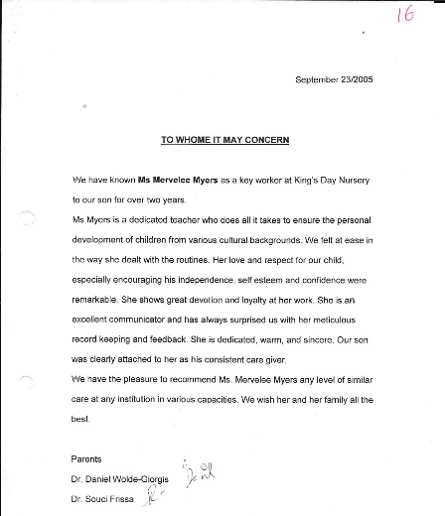
7. 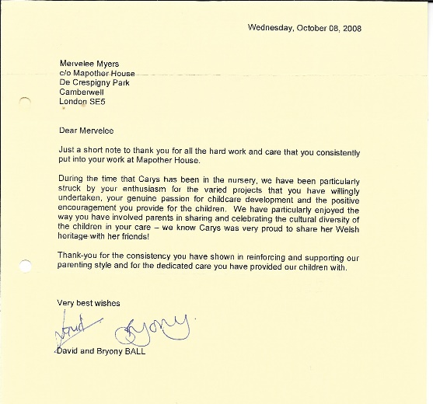 8. 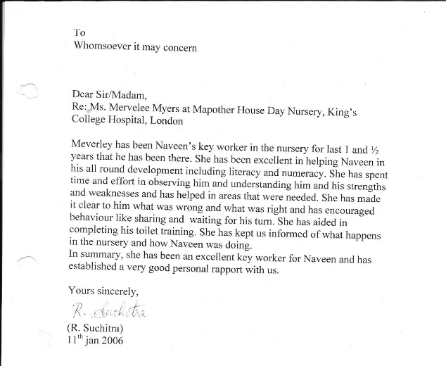
9. 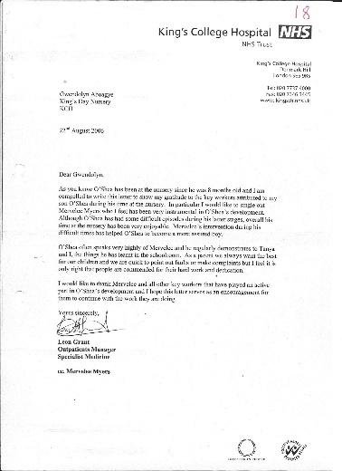 10.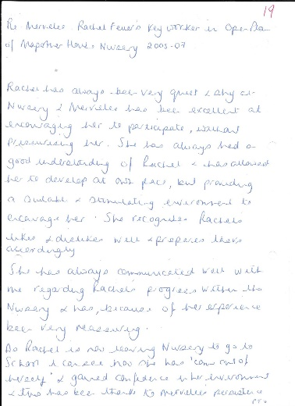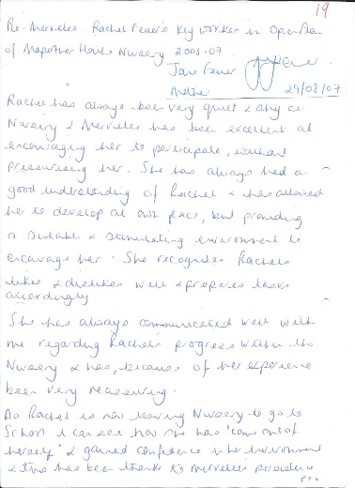
11. 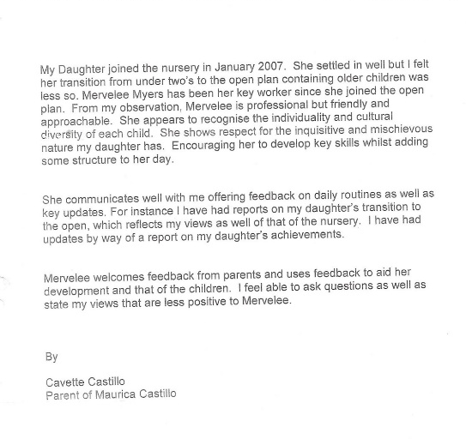 12.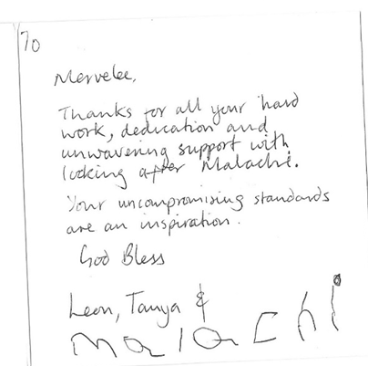

13. 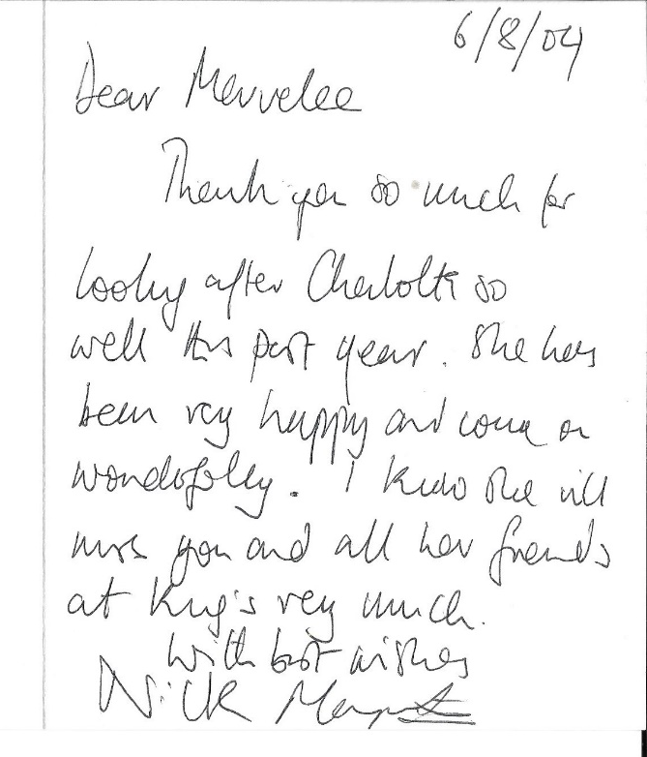
14. 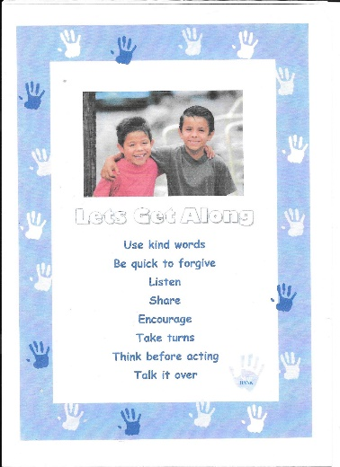 15.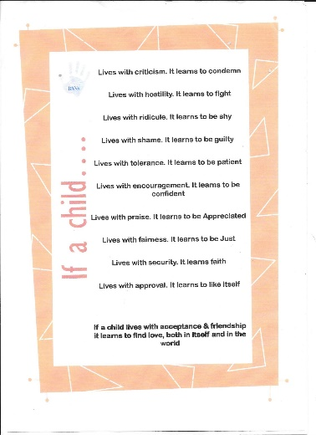 16.
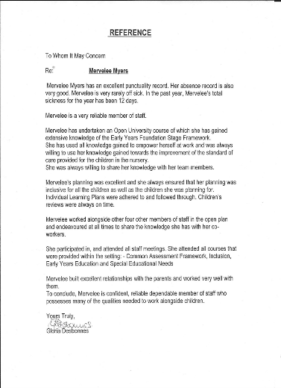
Add me

Luton Street Nursery 2010 – 2014
1. Andrea’s letter 2. LS Graduation 2014 3. Madonna’s card 4. Madonna’s 5. Suzan 6. Khadra 7. Matthew 8. Sinnitta 9. Sunita 10. Sandra 11. Gemma 12. Judy 13. Bianca 14. Manika 15. Michelle 16. Name in Arabic 17. Julie Weise Leaving card 18. Research for CEO – Voice of a Child 19. Nursery Officer Vacancy 20. Lead Early Years Practitioner 21. Mine’s Book contributions 22. EYFS Coordinator Role 23. Contributions to Ethos & DNA 24. Homemade Books 25. Eric’s & Didac’s Christmas cards 26. CEO letter 6.5.2011 27. DBS Policy & Procedures 28. Son’s Support Letter 2011 29. Training certificates 30. PDP – CPPDP
1. 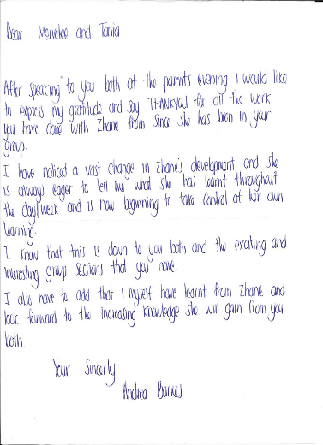 2. 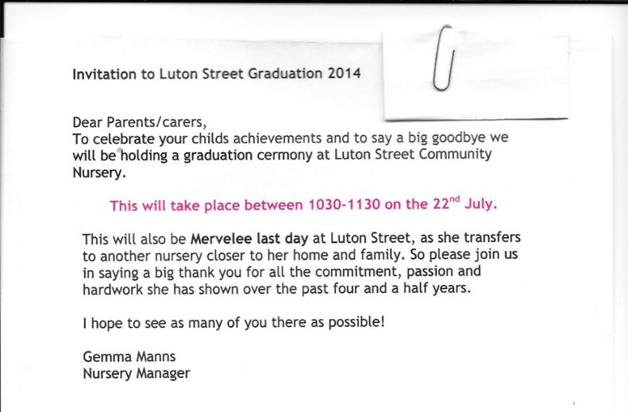 3.
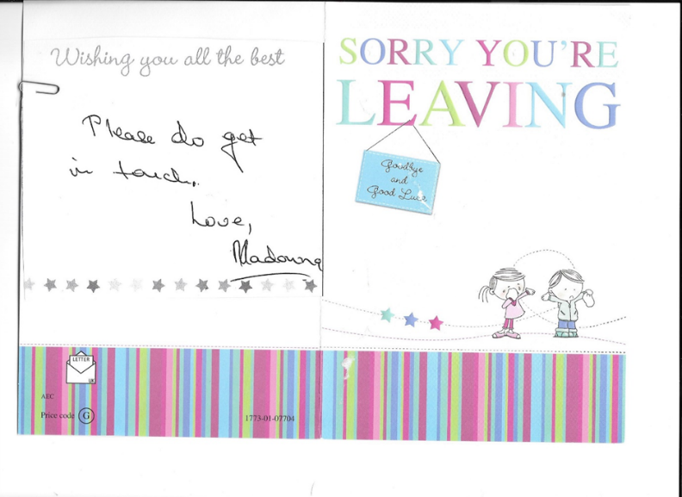
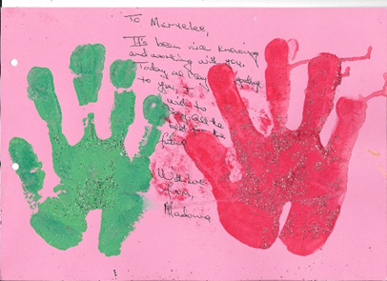 5. 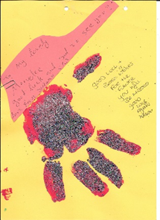
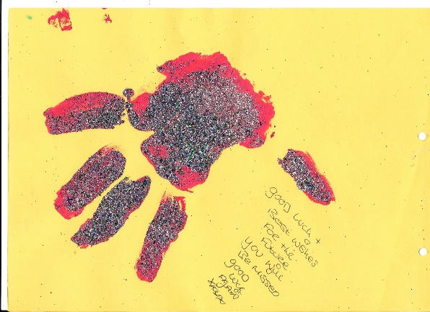 6. 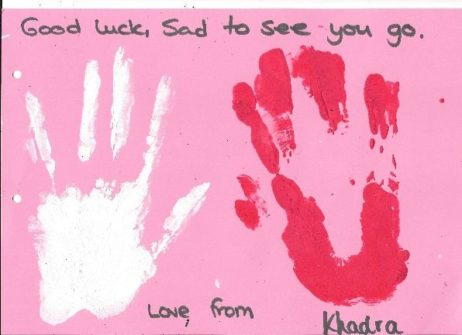
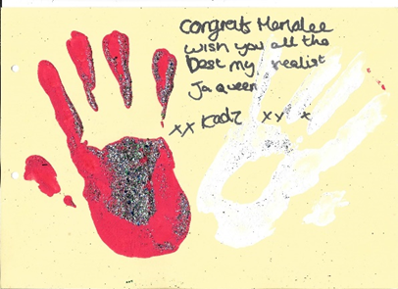 7. 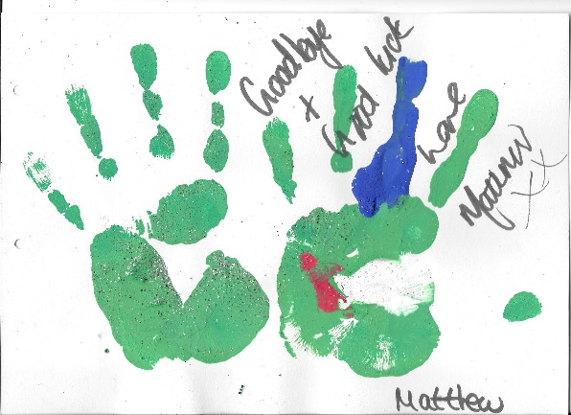 8.
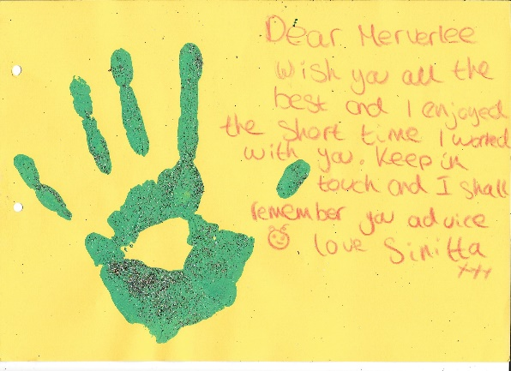 9. 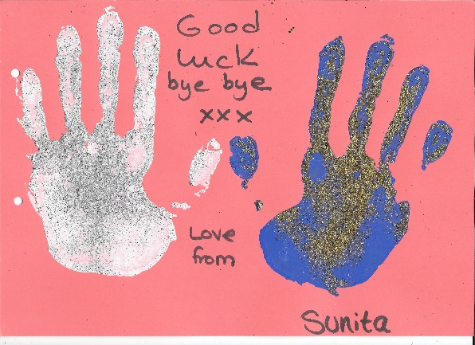 10.
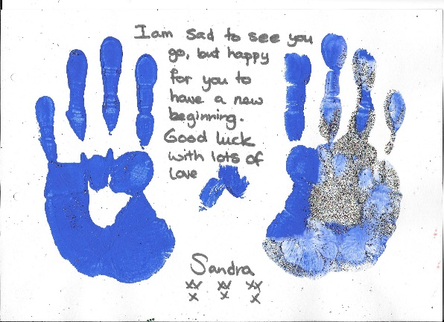 11. 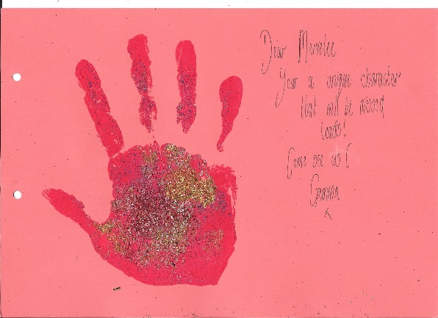 12.
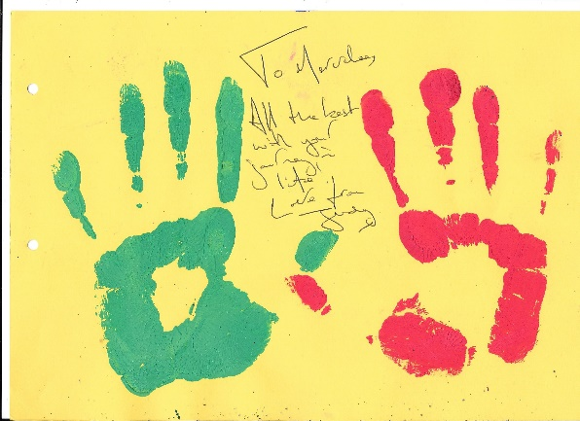 13 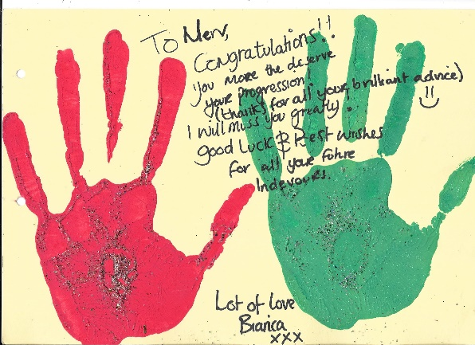
14.
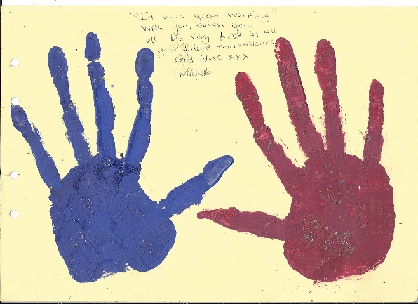 15. 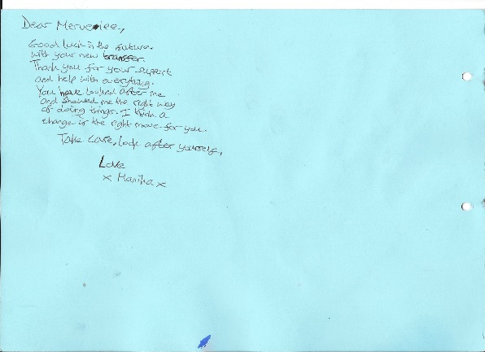
16.  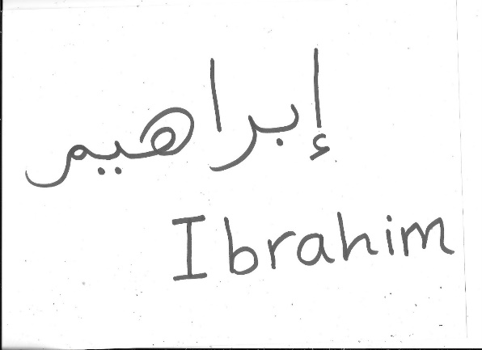17.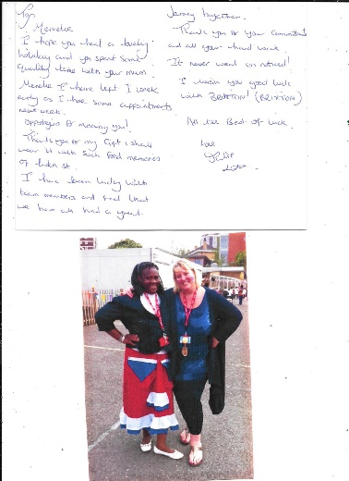 18. 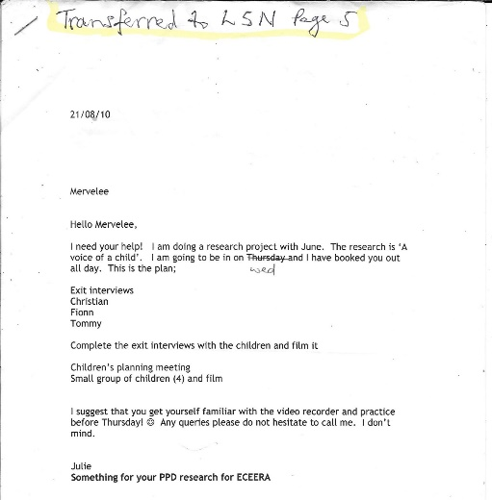19.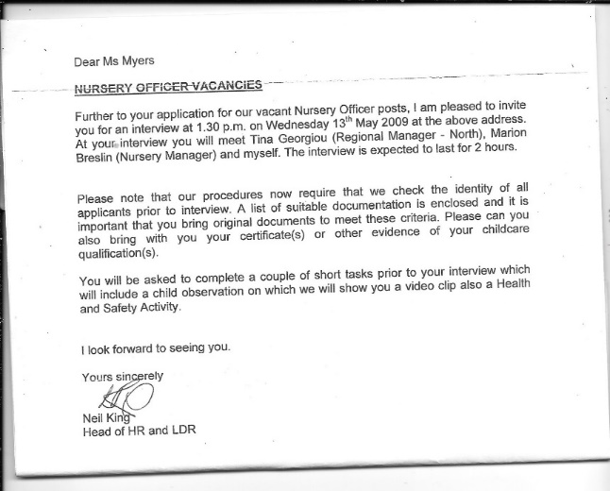20.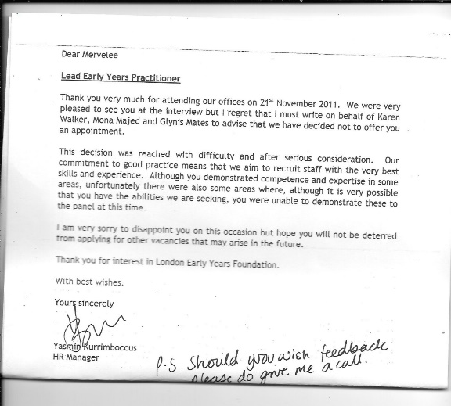 21.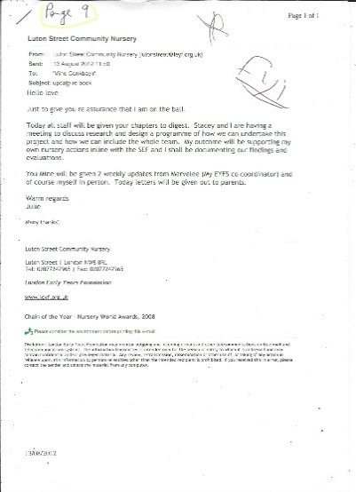 22.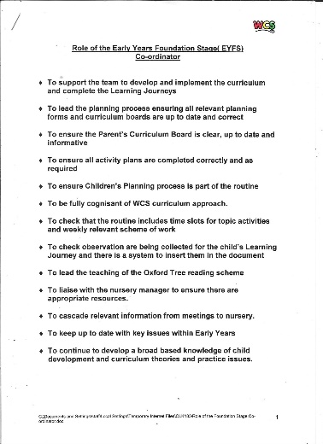23.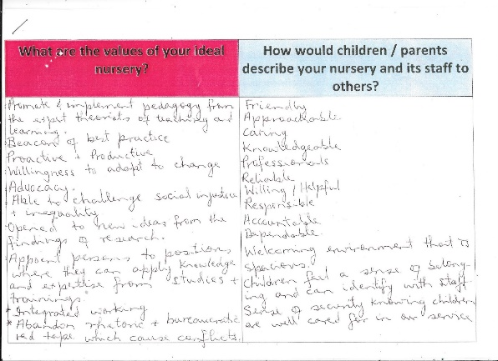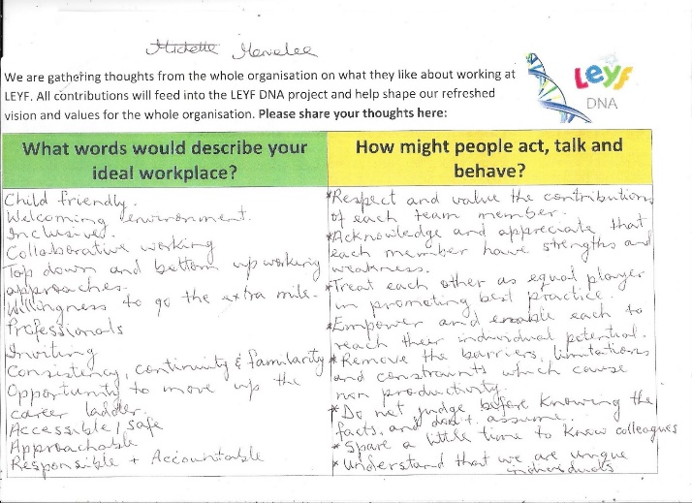 24.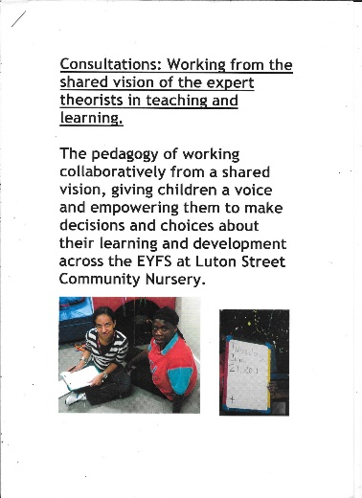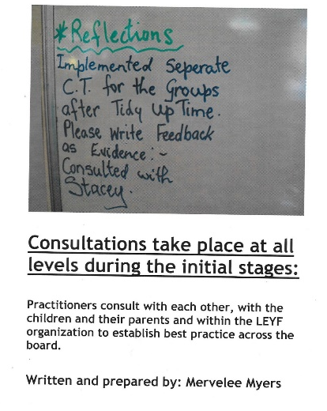 25. 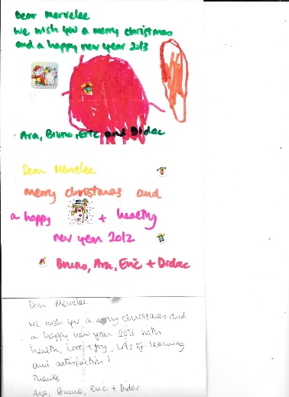 26. 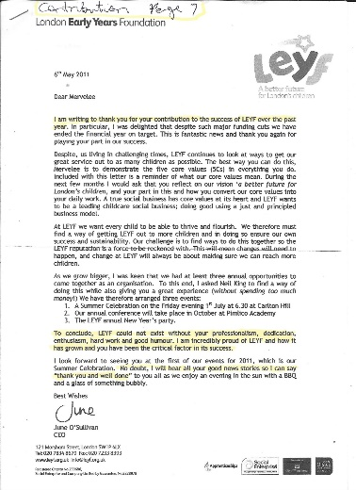 27.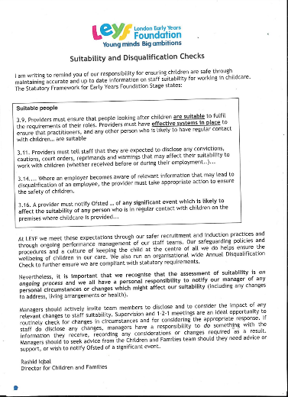 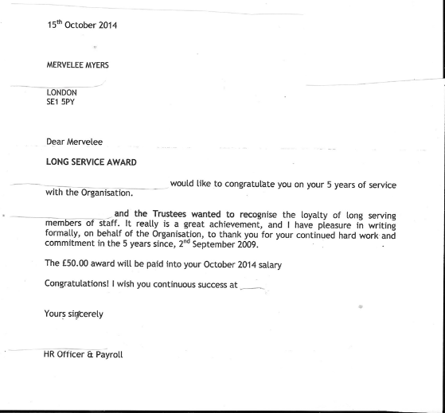 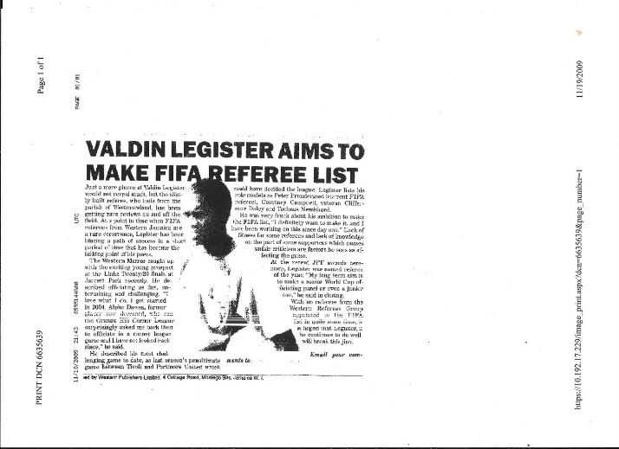
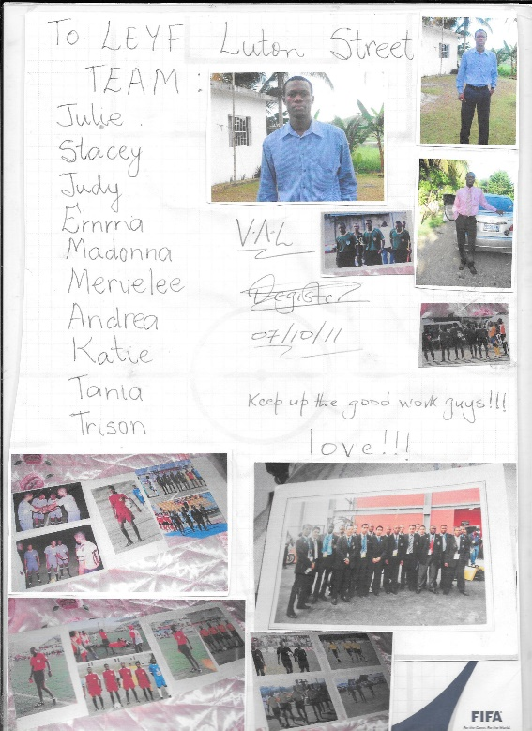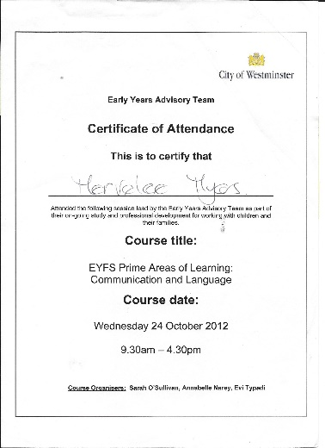

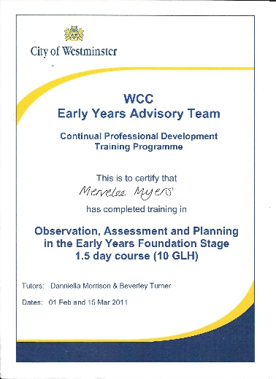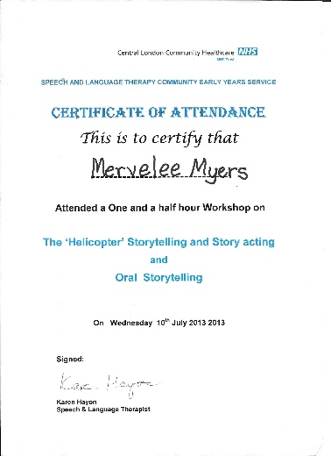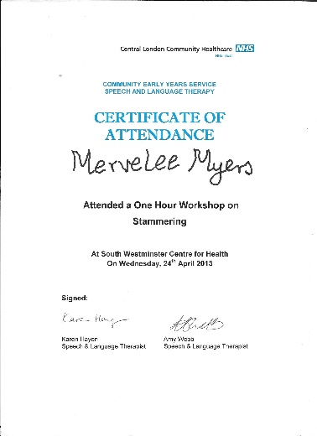Copy this all the way

Correspondences with Dilys Epton January 2015 to
M
Mervelee Myers
16 Alma Grove
Bermondsey
London SE1 5PY
2nd February 2015

Dear Dilys
Thanks for taking time out of your busy schedule to come and explain the procedures to me. I am just writing to let you know that I will not be taking out a Grievance. Thanks for your support in helping me to deal with the procedures.
Kindest regards.
Mervelee Myers FD Open.
Nursery Officer.

Let Those Without Blemish 15.2.2015
There are some current news headlines that really caught my attention lately. I am really fascinated by them as they caused me to reflect on my life growing up in an era when one did not sell their souls to make the headlines at whatever costs to themselves and others in some tabloid newspaper. I can still recall the times when certain behaviours and actions on the part of some would be deemed as taboo and warranted being seen as a blot on the family name and a big scandal that was top of the agenda for the proverbial 9 days, and then whispered about later. And if one was unlucky as I seemed to have become over the past years there are bound to be repercussions that always come back to haunt you when you are at your most vulnerable and have nowhere to turn for advice and no one to support you when you are down and out. You are left light a hare in the glaring headlights that just don’t seem to get dim. Then you ended up asking yourself where did it all go wrong for your life to keep escalating out of control when you least expect it to. I must reiterated before it is misinterpreted or misconstrued that I believe everyone has a right to express an opinion as long as they do not go out of their way to intentionally offend, harass, bully and discriminate. There are some who will abuse their power of authority abusing others along the way without a thought about the impact on the other person’s and their family’s life. Because I have been to some dark places throughout my existence here on earth, I have to say I have much to reflect about, especially these past weeks with the publication of the Enquiry in the National Health Service (NHS). I could have told them about most of what they have come up with, because I have experiences of being Bullied and Harassed when I raised concerns to safeguard the young and vulnerable children whom I worked with and was accountable for protecting them. Since the NHS was supposed to be there to meet the needs of those from the cradle to the grave, I naturally thought I was doing the right thing by sharing my concerns. However this was to spiral out of my control starting a chain of event that is haunting me to this day. I can testify to my life being turned upside down and I could not help but wonder why it have to take another Enquiry to come up with these findings when person like myself have been talking about our experiences over the years. Then again we have to sit back and watch it all happen to us again and again because nothing actually change after these Enquiry are completed and pushed somewhere to gather dust. I like a lot of persons continue to suffer without no end in sight and if we are not careful we are pushed until we eventually have no other alternative rather than to jump to get the suffering to go away. We don’t necessarily have to agree to the views of each other but there should be mutual respects. That is one of the reasons I believe we were born with brains to process information.
Whistleblowers have to be protected by new laws. The latest attempt at introducing a whistleblowers charter is another toothless tiger (“Protection for the NHS whistleblower” February 12). It means nothing if those that bully, intimidate and sack workers aren’t held accountable. You can have all the guardians you like but if there is no legal recourse it’s just window dressing. We need laws to protect whistleblowers with financial penalties and custodial sentences. Syd Vaughan Birmingham Letters - The Daily Express, Number 10 Lower Thames Street London EC3R 6EN Email: expressletteres@express.co.uk (include address & telephone number) Monday 16.02.2015. My story with Kings NHS – from cradle to the grave.
Mental Health Mind 03001233393 mind.org.uk I have been honest and open minded about my psychological battles, fears, weaknesses, which I have – which everybody has. Education is the key – children have to try to find solutions to the religious and ideological differences that threaten to tear our world apart… challenges of a world which need more than ever the power of intelligent, tolerant, open-minded people – Martin Townsend – Daily Express. us
STORIES TO WRITE
How We Celebrate Christmas in my Family – Dad brought case of soft drinks
Fire – Thatched houses in my parent’s generation – houses burnt when killing mosquitoes
Campaign Against Some Adverts in Daily Newspaper
Sunday Express 9.2014 – What those men did for us should never be forgotten – 2014 marks 100 years of 1st World War – Poppy Appeal 880,246 Ceramic Red Poppies each representing the life of a British or Commonwealth Soldier killed in the First World War. Learning about it in school – Express 02086127075 stephen.rigley@express.co.uk
Story of 15 years old who went to War, wrote letter to mum. Died before letter reached home.
Conscripts from Sunday Service on BBC Radio 4 John Rowe Baptist Missionary went to Jamaica 200 years ago. Caribbean people fought in the World Wars and made valuable contributions setting up communities in Britain – Bible scriptures St Mathew: I was hungry and you gave me something to eat… Essence of early friendship is trust. Carl Johnson General Secretary of Jamaica Baptist Union (Federation) Men and women of vision. George Lyle – free man John Rowe – 1814 Sam Sharpe Stranger in a foreign land. Bible scripture: Exodus – Robbed of sense of purpose. Modern day slaves. Backara Massa – Wolves in sheep clothing – let my people go. Dehumanisation of people. Policies and Procedures in place to undermine likes of me and others. Unjust system that is there for the big ones who abuse their power of authority. God’s vision for us …. New identity. Invited on self-journey. Rooted in God. How we relate to others. What it means to belong. Let no one be a stranger. Song: What a Mighty God We Serve.
Dean of Her Majesty – Richard Chartiers. Older worker can also have a key role in teaching younger people about the world of work. 1. I want to stand up for the area that I have lived in all my life, know and love. 2. Get into writing about matters of interests. 3. Vietnam – Song- Jimmy Cliff. 4 Immigrant – know more about English, History/Custom than the English themselves.
Older People: Older people are fed up, they are bored. They don’t want to just sit at home and watch television. Older people are still working also enjoyed far greater job satisfaction than younger colleagues. Retaining experienced staff: There is evidence that suggest work is good for both physical and mental wellbeing… Older people who want to work can still struggle to find jobs. As Judy Finnigan rightly said in her weekly column 27th December 2014 – Better health and longer lives mean we are open to the idea of working later. We just need to make sure that jobs in later life work for us rather than enslave us. Most of us work all the hours God sends in our young and middle years. At first we are ambitious and hungry… Working longer can be a blessing. Schools ‘let down’ over mental health – Early intervention is crucial in tackling mental health problems, which is why school teachers have a major role to play. k
Why I Will Not Tolerate Being Harassed & Bullied! Language Barriers
Coincidences or what…? Phobias I am drawn to touch on this subject that has been at the back of my mind since 2003 when I started working in the NHS. I guess with the current Enquiry that has just being brought to the public domain about the shenanigans in the NHS has really brought home to me the factors that have impacted on my life from thence to the presence. Since the start of 2015 when I thought I had put the past that caused me so much changes that had some devastating effects on my life. That is why I was in for some amount of shocks to my system and just couldn’t believe some of the things that were happening to me during this most horrendous of times that I thought I had left behind. It was like self-fulfilling prophecy once again for me as I experienced some of the similar symptoms which caused me to develop some conditions that were detrimental to my health and emotional wellbeing. I therefore had not alternatives but to once more take myself out of the glare of the spotlights that were be shone on me to try and heal myself and come out better for wear on the other side without losing my sanity as I was slowly being pushed to the end of my tether. That is why I am asking the questions where is the legal framework that are in place to support and protect vulnerable persons who put their necks on the blocks to try and raise concerns to protect the vulnerable from the cradle to the grave. Since I have had 50+ years to study me, and to know who I am. I know no other person will be able to know me like how I know myself and that is why I am trying my best to try and heal myself, so I don’t end up embittered by my experiences. But when one is confronted with the similar experiences time and time again and you know on the life of your loved ones that you would never think to do any such things as are being alleged. Then if one is not careful then one will begin to question their sanity and think they are going mad. If one is not careful, then one will begin to believe as they want one to that there is something wrong with you and then the rot sets in. So since I have had these 50+ years to know what made me tick and I have had similar experiences to those people who are coming forward to share their stories. I have come to the unanimous conclusions that I will have to continue fighting for what I believe in or else I am bound to go under. However I do not consider that I am strong, only that because of prior experiences, I learned to develop the resilience to stand firm, fight the opposition and don’t fall foul to any of the trickeries that they may present to plot my downfall and demise as I once more get depressed from my desperate fight to be free from the bullies and those who subtly harassed and discriminate against me, as they try to make my life a living hell.
Although I grew up in a country that is described as “land of wood and water” and I was surrounded by water most of my life because of where I lived. I always say I’d not go into water that reaches further than my ankles. My reasons for saying this is the fact that I realised that as a neurotic little girl who ended up having some phobias, that I would never learn to swim. However I only learnt this fact in later life why I did not learn to swim. As a child I could not have my head even covered under the bed sheets because I felt as if I was suffocating. Therefore that is why I did not learn to swim like my brothers and friends who learnt to swim in the rivers and ponds in the area. Of course I enjoyed frolicking about in the water because we all went bathing and washing in Middle Wire Pond where the majority of people from all over the communities gather to wash their clothes before the advent of piped water. There was also a dry/water pond at the bottom of our land where fishing and swimming was a natural part of our growing up. Sadly for me everyone else can swim except me.
My Auntie: This week after trying to cope with my life that seemed to be spiralling out of control even though I had tried hard to hold on tightly to the reigns. I just could not afford to let go until I had struggled over the final hurdles. So although my health was deteriorating because my coping mechanisms were no longer in place, as I was not sleeping, eating nor having anyone to share my ordeals with. I just had to get on with life as best as I could and praying that I would not be tipped over the edge as all the underlying health conditions were exacerbated to the point where I was feeling the shakes, having headaches, becoming incontinent and just terrified of what else I would have to confront as the allegations kept on coming fast and thick. The hardest thing was trying to cope outside the home and then coming indoors and covering up what was happening to me so that my experiences could not impact on my husband’s health as well. Or more than likely this could have detrimental impacts on his health as he had so much to deal with himself. He had his bereavement losing his brother and coming down with the cold and having a chest infections. He too is riddled with lots of health conditions and he is not young any more so his defences are not as strong as they once were.

Tuesday 1st July 2014 Additions To History
Mama – Grandpa twin sister also buried up by Hewling Town. Papa – Excommunicated from the Townhead Baptist Church because he stopped at Salvation Army outdoor service at Cross Roads. They called him to offer a word of prayer which he did. The church elders called him for trial, he went told them his mind and did not go back. Papa attended a few churches – Mr Walker, until he found one that suited him. His church was situated all the way in Cook Street Savanna-La-Mar. He rode his trusted bicycle when he attended. He started a Sunday School at our home and we travelled to Sav on special occasions to represent our branch of the church. Papa was held in high esteem by all who knew him and our family. Henry aka Granty Papa Salabie story about how he came to be with our family. Dad was held in high esteem for the way he brought up his family. Mass Hugh Grant and Ms Ethlyn. Uncle Terah. The Lindo – Mother May. At the funeral – turn out. Annette saying she is glad she attended the funeral, she is beginning to understand more. 1. The impact of the funeral – Eulogy & Remembrance. 2. Talking to: Mr Martin Hanson, Eddie Bernard, Armine, Mass Harold. People attended the funeral because of the standing of the family in the community. Young & Old. The final goodbye. Bringing people together. Parent Legacy. Mix up mix up – Michael Legister + Spartan Babs Campbell, Selma Walters. Papa stuck fast to his strong values and beliefs and refused to be intimidated by anyone regardless of their status in life – TBC. Papa had a strong voice sung and played his concertina aka flutina and mouth organ. You could stay for miles around and hear him. Ms Bebe lived at Insella and he could be heard from there. Ms Connie went with papa and mama to get foodstuff where he planted ground provisions over some mountains near to Grange Hill. Granty/Papa Salabie lived with us at Townhead and moved with us to GaGa Street. He grew up like one of the family. Luis Vascianna, Jonathan Ellis, Granty and Balis were best of friends in their younger days. Papa Son – Ms Fran. Granty told me the story about the time my side was pinned up in my nappy when I was a baby.
Then & Now in Townhead. Ms Turb testify – her mum from Barney Side, Cornwall Mountain same like Ms Connie. Dad was Tata Dixon. Claris Parkin – auntie who lived in Cave Valley in Hanover.
Why I Refuse To Let Anyone Take Steps With Me? As a child I was a neurotic little girl who had to be dealing with lots of issues about me that were different and for which I had no understanding. Being an only girl amongst 7 brothers might be the first starting point. And although everyone else were of the opinion that as an only girl, I was pampered, spoilt and the favourite. Nothing could be further from the truth. I knew my dad in particular had a special love for me, but yet I was not his favourite either. I guess from an early age, I knew who was my parent’s and grandmother’s favourite. Strangely enough this was never an issue for me because I believe the same goes for my brothers.

Language Barriers
Report: Wednesday 11th March 2015
Monday: Everyone ignored me most of the time and I noticed that I am being left to do the jobs and keep the children engaged as I am being given orders left right and centre. Couldn’t help but noticed Benjamin Tang situation as staff were ignoring him. He was throwing himself on staff hanging onto their legs to be comforted. He keeps going from the sofa to the bathroom, is either throwing the nappies and wipes about or trying to climb up to the changing mat. I noticed that Rujina did not make any attempts to pick up BT, but she did sit beside him on the chair and tried to engage with him once I commented that I notice everyone is ignoring him. I summarised to one member of staff (LK) when she asked why BT is in the bathroom that the noise is affecting him when there are lots of children near the sofa.
The bathroom might provide some solitude away from the noise and the children and maybe trying to get up on the mat means he can lie down. LK said yes the acoustic is loud and she is going to try and get it fixed. When all the AM session children are in, it can be very hectic especially with Tayandre’ and Kyle around. Because some of the children copies the actions of one another and even the bigger children will be running about if there is no staff to monitor behaviour management and get them to engage at an activity. I noticed that once I am in most things are basically left for me to do and immediately I sat down Jyoti gave me the register to sign the children in. I am very observant and noticed how she corrects the 9 0’clock children I signed, but I don’t say anything. The other thing that is noticeable is the way BS takes a few children to the small room and try to avoid me once I come in and she no longer talks to me either. However I am left trying to cope with the more challenging children. Throughout the day I have everyone giving me orders and I just complied.
Equal Opportunity: I noticed that some children are being treated the same way some staff are treated. A parents bought in a large bag of goodies in party bags for her child’s birthday that she celebrated on Sunday. Those in charge didn’t even acknowledge the child’s birthday and sing for her, but I never intervened because I didn’t want to be involved in any arguments. Everyone is so busy giving me orders that I am beginning to feel like the Yard Gal at Big Massah Yard and there seems to be nothing I can do about it so I am just going along accepting my fate? However I feel frustrated that because of the way I am being treated I cannot get to do the things in my Job Description.
Tuesday from I came into the room before my time to start it is absolute chaos. BS took a few of the older children and goes into the small room and stayed there, once I am in LK left the room. I am trying to monitor the children’s behaviour all morning directing them and holding them by the hand to go and sit down. As soon as one is settled another one is getting into some mischief. Rujina is making Mother’s Day Card at the table and doing an excellent job of promoting inclusive practice as she is getting all the children involved. At one stage I am there saying these children must be tired of hearing my voice because I am the only one trying to engage and socialise with them trying to promote positive behaviour management for their age and stage of development. Benjamin comes in and is yet again unsettled by the noise I am assuming as he keeps going to hide away in the bathroom, but LK seems oblivious to what is happening to him and keeps asking why he is going in there.
I try to settle him as best as I can, but have to be focussing on the other children. In the end Theresa ask if I’d like her to help with him and takes him walking around the room. After a while she sat with him at the maths table holding him on her lap, but is socialising and interacting with him. As soon as he settles I advise Theresa to sit him on the chair. He plays for a while then start becoming upset again so Theresa walks him around and sit at the table with him on her lap rolling play dough. Flavia came in and told Theresa amongst other things that she should not lift him up nor sit him on her lap… I made sure not to get involved even though I had been using some of the same sort of early intervention strategy that Theresa is using.
On Thursday last week I hear conversations going on about BT with his carer & Flavia, and Flavia & BS. And I was told that Flavia was telling LK about me holding BT. This came about because one day in question (Ify’s Birthday) the child was really upset when they all gathered in the graphics area where he usually settled on the sofa waiting for his carer. I had been applying early intervention strategies throughout the day to help him settle. After they’d sing and I got him settled, standing at the door letting him look out. Flavia comes to tell me to go do the cake and she take BT, I told her I’ll keep on until he is picked up since it was not long to go and I have been engaging with him most of the time, so that’s why she complained to LK. Then on Friday when Hilda Miller area manager comes in I hear Flavia talking about BT and saying “this person keeps picking him up…” I made sure not to say anything.
I noticed after Flavia spoke to Theresa about BT, she engages with him, but don’t pick him up again. Later there is an argument between the agency Ricky and Flavia about BT, but I am not aware what was said as I went out as soon as possible to get the children out into the fresh air where they could use up the energy they had running inside. I asks for help to get the children outdoors as I realised some of them would benefit from going out. I went out with a few and they keep sending more children out. Theresa came out but some of the children with challenging behaviour were already acting up so I went to the door to ask BS for another adult. She totally ignored me and walked away. I ask Flavia to send another adult and she said Rujina is coming. Rujina came out and says “sorry Mervelee they spilt the glitter and I was cleaning up.”
I said Rujina that is ok “I am just trying to safeguard the children and myself and make sure you do the same. Rujina is not wearing a coat so I ask if she wants to go get it and she says I am alright it is a bit warm. Ricky the agency staff brings Ben outside and there was such a difference to his behaviour as he is just jumping up and down and making loud sounds. When some of the children go to him, he allows them to cuddle him and then push them away. Message on Board: This singled me out because I had simple questioned about the time of my lunch break on Monday. As soon as the agency staff came back I told LK I was going on break to avoid any argument as I try and avoid questioning any decisions made. The only reasons I am monitoring my breaks is to try and avoid an incident like what occurred with Nicola and me eating the banana. Since 5.1.2015 my health has been affected with some of my health conditions exacerbated and I have been trying my best to keep my conditions under control and not get sick. Situation at work over the past months are not helping.
After Break: I am sat at the table engaging with children playing with the dough. BS refused to talk to me since I came back from sick leave even when I talk to her she totally blanks me. I am sat where BS can see me as she comes out of the Baby Room, but I can hear her calling out for Jyoti. Jyoti is holding Aliah by the hand, stood by the table and is saying “I need someone to change Aliah?” I said to her “there is no reasons for you to be saying that, just ask me to change her” and I got up the same time to go do the job. Jyoti is there saying but you don’t have to change her Rujina can change her too. I said Rujina is not here in this area it is only you and me. I know that Jyoti is trying to find reasons to say I am not doing my job and I am not going to give her the evidence as she believes as Duty Manager, Room Leader and Duty Manager I was there to be given orders by them all.
I think even Rujina was brought in on the act of giving me orders as one day I am in the garden with the agency staff Shakia when Rujina comes to the door to say “MERVELEE I NEED YOU IN HERE NOW!” I replied is it urgent so we come back and tidy up? Because I can’t leave the agency staff on her own. Rujina said no we can tidy up and then come in and the agency staff said what is this I am hearing you can’t leave me on my own, so that’s why I said to her about safeguarding the children and herself earlier on. Safeguarding & Priority: I went into the bathroom to change Aliah but noticed that Jyoti has left the children in the big section unsupervised and is in the home area tidying up. The agency staff Ricky is in the graphics area engaging with children and the big section have children running about because I am not there to direct them to an activity. I went over to Jyoti and says “please could you supervise this area.” She says “I am tidying up because I don’t like to see the place untidy and thanks for telling me” and carried on tidying up.
Orders: Benedicte, Jyoti and Flavia will congregate chatting or tidying up whilst I am left with the agency staff (they are very professional) struggling on my own. Everyone is focussed on giving me orders, do this, do that, you can’t do that, you are singing too loud at circle time and more eerily watching every move I make and reporting everything I say and taking it out of context making allegations against me. Agency staff are saying that they noticed the way I am treated differently and what are the reasons for them doing this. All I can say is I prefer not to talk about it. The agency staff say Rujina crying in the room and Flavia is trying to stop her from going in the room when she wanted to go use the toilet. She said it what she’s seen wasn’t good as Rujina was setting up and crying in full view of the children.
Wednesday I left home early to go to B&M, but since it opened at 9 and I am supposed to be starting at the same time, I went into work. I actually signed in 8.45 because none of the computers are on to tell the time, but when I reached preschool the clock is saying 8.40. Went in sorted out some resources I had started preparing to make Mother’s Day Cards. Since there is only BS and LK in the room and BS is in the kitchen I came out on the floor early. An agency staff whom I had seen in the setting before came in, went to the storage room and comes on the floor. I put the resources for the cards in a container and is engaging with the children. At 9.00 o’clock the AM session children starts arriving and Sofia one of my key children comes in and says “it is my mum’s birthday.” Since I already have the resources ready to do the Mother’s Day Cards, I call Sofia over and said let’s make a birthday card for mum. I modelled learning and got her to do the card, then I got her to start the MDC.
I am encouraging the children especially those who were not in yesterday to make a card because Rujina had been making cards the day before. Nabilah came and sat down and I offered to help her modelling learning so she could do the writing. At one stage the buzzer is going, but because LK is sitting on the sofa, I naturally thought she would respond. I hear her calling my name and BS rushed pass saying I’ll get it, “she never answers the door!” She hurried back and goes over to where LK is and she has the register which was usually kept near the radiator with her. The agency staff is sitting with a group of children doing puzzles and Tayandre’ wants to join in, but Malique keeps pushing him away and hitting him so I went and intervened. I take Tayandre’ with me and after a while he goes back wanting to join in and Malique keeps pushing him away. By this time Kyle is at the table, so it’s lots of pushing, screaming and crying from TA as he insist in joining in. I went back and take TA away, but he is resisting, so I took him with me and says to BS & LK “can one of you please come and help with the children because the agency staff and I cannot cope?” I came back round to the big area and when I see Aliah’s grandma coming takes TA back and asks again, I could see BS chatting to LK and they stopped. Aliah’s grandma went round to greet LK & BS I am assuming and I don’t know if anything is said by her then LK comes over asking what the matter is. Since in the last staff meeting some of the complaints from parents came from Aliah’s grandma saying about staff ratio and the new faces she sees when she drops Aliah off that’s why I am trying to alert them – BS & LK so this can be averted. My only intention is to try and protect the reputation and high standards of the LEYF that I have worked with all these years after hearing all the concerns raised by parents. Some parents are dissatisfied that Sao went without them being informed and even now there has been no communications still given to some of Sao’s key children’s parents. All I can do is direct them to speak to those in authority. LK claims later that she did not hear what I’d said when I came and ask for support?
Telu another agency staff ask if I want her to take TA and she did, taking him to the door. LK comes round and asks what is the matter ( I noticed she is always asking me that even when she is present and sees what happens) I explained to her that I came to asks for help and neither she nor BS acknowledge or responded. She asks if BS never came over and I said no, and I don’t want to be blamed for anything. She said like what, what are you blamed for and starts telling me to calm down Mervelee, calm down… I said I am calm but I am trying to avoid another situation because I see Aliah’s grandma coming in and I am not getting any support. And I am always getting the blame when things go wrong and as is her way, LK is asking like what, so I said you know what LK leave it for now. The children were under no control and I am sending them to designated areas to play when I see them running around in the room. A child like TA copies everything that the other children do, but it don’t help if the bigger ones don’t seem to have any focus and just runs around all the time.
When Flavia is sat serving snack I went to verify from her if the buzzer in the graphics area gives access to the main entrance and she said yes. My reason for asking LK was sat on the Sofa so could let parents in. I’d used it but now wasn’t sure if someone else also let them in? In the last staff meeting certain matters came up and parents were complaining amongst other things about the length of time they were waiting to be let in. LK said we should be aware of arrival and going home time so we can be at strategic locations to let the parents in and I have been using the buzzer in the graphics area. But today LK forgot everything because she and BS were so intent on trying to stitch me up.
Recalled one morning I came in and was ringing the buzzer for ages, I could see Jyoti’s head in the Baby Room and when I eventually got let in Jyoti’s excuse was that she was playing music for the babies so could not hear the buzzer. This left me to wonder what your priority is and even if you are playing music at that time of the morning, why is it so loud to drown out the buzzer? Then when Jyoti wants to stitch me up and frustrate me into acting out of character she come or send one of her cohorts to tell me I am too loud when I am having fun at circle time with the younger children. Benjamin also came in at 9.00 and was getting really upset like he has been these past few days. Because his safe haven on the sofa was occupied he keeps going to the bathroom, chucking the nappies and trying to climb up. Telu asks why he is behaving like that and I assumed maybe he was affected by the noise once I’d check his nappy didn’t need changing.
The other agency staff came in about 10.05, speaks to LK and they left the room. LK comes back and her demeanour towards me changed as she starts “communicating and saying things like we having visit tomorrow from social enterprise…, Kyle’s dad was upset yesterday because his sleeves were wet… She starts busying up like I’d not seen her before and not long after she took some children to the garden. Since it was my day to change nappy I stayed in and got on with the job. I helped to tidy up and went to do circle time with the younger children. Lunch was a bit late today and most of the children did not eat, so all they had is 2 little pieces of bread. I am assuming they ate all the rice pudding because whilst on break I saw staff fetching more from the kitchen. All this week the lunch is very appetising as I ate, but I don’t know why the children are not eating it?
I went on my break the minute the 1st person came back because of what was written on the board yesterday. Came back from break early because I know my every movements are being watched and documented. I am at the point where I am becoming paranoid because everywhere I turn there are eyes watching me. Because of the allegations already made I am trying not to make any mistakes. Noticed today that LK don’t even know the difference between the aprons for water play and painting as she was putting the red aprons on children playing in the water BS has to come and change them. Then she is talking about parents complaining, so how is she going to lead by example. Ever since that incident with the banana I have been getting the blame for everything that goes wrong when there is an Emergency or any other Meeting. I am tired of carrying the can and taking the blame for something that is not my doing.
Nappy: I had just come back from putting Bezaleel’s bag away after changing him when I see BS in the bathroom with a child about to change him. I said to her I am changing so I will change him it’s my turn. She said are you sure and I said yes it’s my turn, she said well you better make sure to change your gloves. I said I know what to do and she said in the most disrespectful tone “1 AM NOT SURE I DON’T THINK YOU KNOW WHAT YOU ARE DOING?” She flounced out and I was about to change the child and not say anything, but then I took the child by the hand, went outside and says to LK I need to speak to you inside. As she is coming in BS said something to her when she said what is this about? She came in I told her what BS said to me and all she can say is we need to calm down everything is getting on everyone’s nerves. I said I have enough of BS being disrespectful to me and I am not going to tolerate her behaviour to me any longer. LK said “SHE SAYS THE SAME ABOUT YOU”. I said to LK I Know I Don’t Have Any RIGHTS and what you people are doing to me in here is making me SICK and I am hiding it from my Husband as I don’t it to affect his health also. Her answer is to ask what is happening to me, so I told her to leave it, I don’t wish to say any more.
Birthday: Much made today of a child’s birthday, yet the same was not done on Monday for another child whose mum had brought in a big bag of goodies. The person making the fuss is BS who famously told me “WE DON’T CELEBRATE NOTHING and wanted to stop the Christmas Carol Singing”. She never engaged in any of the celebrations in the setting, but yet when there is a crowd for her to be on show she is upfront. There is no Equal Opportunity for some children and staff as they get treated differently!
Thursday 12th March 20I5
Today runs along the same pattern of the week in some aspects, however noticed a few changes to yesterday as the register is back in the original positon. Benjamin’s carer came in and I encourage her to take him to his safe haven. BS is in the area and is engaging with him and some other children on the sofa. Later BS comes to do her duty of writing up the board etc, so BT came over to where I am at the table. Since the table wasn’t set after breakfast I put farm animals on and is engaging with some children and BT is standing beside me. Eventually he starts getting upset reaching for me to pick him up and I resist as long as possible to get him to sit on the chair, but he starts stiffen up and is throwing himself on the floor grabbing at my leg. I picked him up cuddle him until he settles and is picking up the farm animals and singing soothingly “Old McDonald…” I gentle eased him to stand on his feet and gradually gets him to sit on the chair and I am giving him objects to explore.
Flavia comes in spoke to Jyoti and didn’t acknowledge me today, so I said “good morning!” Flavia puts her things away came back out and goes over to the graphics area… I am still sitting at the table engaging with BT and others when the chef comes to say that snack is ready, I asks if she don’t mind getting the attention of the staff round the other side. By this time I am the only staff in the big section of the nursery. Same time Flavia came round and I said to her “the chef says the snack is ready.” Time 10.07 She says to me “why are you asking me that of me?” And I replied “why do you think I am telling you?” She responded “well you can tidy up and clean the table.” I was thinking that since the other table is not in use and I am engaging with BT on the other then it is logical to use it instead. I never said anything and as soon as BT walk away from the table I says to her “I am going to the toilet” and went.
After BT is back in the bathroom taking the nappies and wipes and throwing them on the floor like he has been doing the past weeks. Jyoti comes to asks what he is doing in the bathroom so I tells her exactly what I have been telling all the staff who asks me, saying I am of the opinion that because his regular safe haven on the sofa is occupied and noisy then he is taking refuge in there to get away from the noise. She starts a long dialogue about AUTISM. I told her I am just saying what I am saying from the little evidence I have about BT. I asks her if she don’t mind wiping BT nose since I am doing something – sweeping up the cornmeal on the floor because I did slide on it and realised it is slippery. Notice Jyoti don’t even know where to find the basics and goes asking Flavia, so I showed her BT wipes and asks her to use it. I am still sweeping up the cornmeal and I could see LK coming from the Baby Room with Rachel from Social Enterprise, and when I looked there is no staff in the graphics & home area.
Children are jumping from the sofa and others are fighting with the cushions. I could see BS standing at the door in the little room so I went over and says “BS please can you come and supervise the children.” She responded “why don’t you go and do it?” I went back to sweeping up the cornmeal and when I see LK opening the door to come through, I went back and said the only reason I am asking is because LK and Rachel are coming in… BS moved away push the palm of her hand up and shouted at me “don’t talk to me, I don’t want you to talk to me, you are always trying to talk to me.” I went back and say to Jyoti if you don’t mind could you just supervise the children for me? BS went over to LK and left the room and I get another of those looks again from LK. Flavia went over to the area and talk to the children and I said to her after the only thing I said to BS if she could supervise the children.
LK showed Rachel around and leave Flavia to go through the Learning Journey with her. Throughout this time I am trying to manage the children’s behaviour in the room getting them to engage with the activities and resources provided. I have been doing this ever since the last Staff Meeting when the manager said we were not promoting positive behaviour management. I ask a group of boys who were jumping off the sofa to cut vegetables in the home area by staying there and engaging with them. As soon as some had enough and wanted to go others would join as I am trying to make it interesting talking about what we are doing and making vegetable soup. Since today is Rujina’s turn to do the nappy and she is on training, becoming aware that the time had passed, I took on the duty of changing nappy for the day. Amoury was in the toilet wet and I ask LK to bring his bag. He said he didn’t want me to change him so I ask LK if she don’t mind asking him if she can change him and she did. When I am changing the nappy LK comes to ask if I am ok and says she will chat to me later. I’d noticed earlier on she had come to take Telu from the room?
Lunch Time: I observe Zac sat with his eyes close so I waited until he is finished and asks if he is saying his grace. He says no I am praying and I asks if he don’t mind closing his eyes again so I can take a photo and told him I used to do that when I was little. He asks if I used to go to Jehovah’s Kingdom and I say yes. I shared this information with LK saying we can celebrate diversity.
After Lunch: I started doing the Mother’s Day Card yesterday, but did not get much done so I took the resources on my break and made some further preparations. I took the things outside and got the children especially those whose lost day is today to do theirs. I am sat at the table doing the cards, but I was paying attention to the children too. LK is also in the garden planting flowers, Telu is supervising children on the slide. LK came to say she is going to wash her hands and I stop doing the cards giving my full attention to the children. LK came back out with the chef and talking about tomorrow’s menu. LK said she has to go in to do a letter for someone and I said I’ll pack away the cards then. She said not to worry because she is going to get someone to come out, I stop anyway because I’d done most of what I’d wanted to do by then. The chef said she’d stay and keep an eye until the person comes out… Jyoti comes and stands by the door looking out, so I call out to her asking if LK asks her to come out because the chef is waiting to go back to the kitchen. She said BS is coming and after a few minutes she puts her coat on and comes out and the chef goes back in.
I am trying to get another child from upsetting Zyreece who is riding the big bike and untangle the rope on it. Jyoti comes over and says “Mervelee why are you not telling the children to stop throwing the toys?” I said but I didn’t see them throwing the toys, she said you are not doing your work, you should be telling Zac not to throw the toys and not chatting to the chef?” I saw Zac throwing the toys and you didn’t call to him. I said Jyoti since you saw him throwing the toy then you could have called to him and I don’t want to be having an argument with you and walk away to the other side. She said “I will be talking to you about this later because you are chatting to the chef and not doing your job.
Since it is quiet I used the time to write up some cards and finish off Mikayla’s. Flavia left the room, Remi came in and then LK pooped her head in saying Flavia is changing a nappy so not to worry. I said I am not in a hurry and Remi asks what time I finished. Telu came out and I told her it is alright to go because she is agency, but we are regular staff so have to stay. Later another agency staff came over and says she is there for a little while and Remi says one of us can go, I said I will go then, but she said she wants to go because she is in since 7.30. LK come and say no she needs to speak to me before I go, so I can take my things and then go. I said ok I’ll wait in the office when I see her speaking to the lady who is picking up Amoury.
I am sat in the office and Flavia walks in, sits and grins at me saying I am witness. LK comes in said an email was sent by staff member complaining about me and Isabelle from Bessboro would be coming tomorrow to do an investigation. There are other issues like today but she don’t know it will be dealt with then. She claims Flavia is now Duty Manager so that’s why she is there as witness. She don’t know how I am going to react so why Flavia has to be there. All I keep saying is ok… Asks if I am allowed to know the name of the staff and LK said she is not allowed to say and what time is she expected? Ok so I am thinking is this another stitch up like what happened with Nicola? So I am trying to breathe and act as normal as possible and hoping my emotions and the Parkinson’s disease symptoms don’t take over. Maybe this is what LK is expecting as she keeps asking how I am feeling.
I had to be thinking ok so this how I am going to be treated as everyone is giving me orders even when they are not even aware of safeguarding matters. Then when I am trying to safeguard children by asking for support from my colleagues it is not forthcoming. Since Jyoti comes the BIB and there are Meetings, it turns out that everything is my fault and I get the blame. I am accused of not doing anything, but when I tried to implement best inclusive practice and LEYF ethos I am told that we don’t do that here. At the Speech and Language Trainings last night LK talked in public about the Hat Song and how well we saw children engaging when we were doing the exercise. Yet at the staff meeting she said nothing can be spontaneous and have to be planned in advance. But most surprising is I cannot do anything without first running it by my colleagues to get their approvals.
Loosing Focus: World Book Day I am so taken up with what is happening to me at work, but I make sure to read the newspaper and listen to the news. So I hear them talking about it. Went in and spoke to Carol who said she didn’t know about it. Went into preschool and asked if they knew it was WBD and Jyoti said yes we know. Although some of the children are dressed up as their favourite character nothing was done. I did what I could do considering that I don’t get time to focus on those things that l am always so passionate about celebrating. I am always being given orders to do this… and I try to comply as I know I am on thin ice because of the way everyone is focussing on stitching me up.

Mothering Sunday Pleas to Dilys Epton on the 13.3.2015 - DEPRESSION
To Whom It May Concern
On the eve of Mothering Sunday I have no other alternatives left than to take the bull by the horns and plead with the powers that be to afford me some rights. I need to be given the same amount of equal opportunities afforded to others and given a voice to talk about the issues that are affecting me. Since I have been effectively gagged therefore not allowed to discuss my situation with anyone, I just don’t know where else to turn. I have been reduced to keeping secrets from my husband about what is happening to me at work because I don’t want this to impact on his health. Since 05.01.2015 I have been living a nightmare from which I can’t see an awakening. I am at the end of my tether, feeling trapped in this never ending tunnel for which I can’t seem to be seeing a light.
My old folks would say “dog a sweat but long hair a cover it…” and I need to get some disclosures about why I am been treated this way. I am effectively been put through a wringer that is tearing me apart limb by limb. This is causing me slow, painful and excruciating and painful death that I wish would take me now instead of being so long and drawn out. I have suffered enough in silence and since I now recognised that my employers are not aware of my plight? I believe it is only right that I am given a voice and someone spend some time listening to my plight. Westminster Children Society now London Early Years Foundation rescued me in 2009 when I had reached rock bottom and couldn’t see a way out.
During my bitter experiences in 2008 I lost one of my brothers at the age of 56 years old on the 27th March just 2 months after his birthday. I am only a few months away from my 56th birthday and I am becoming paranoid that I am destined to die any time soon. I doubt very much if LEYF is aware of the nature of my plight at Bird in Bush, hence the reasons I have decided to make contact before it is too late. When Dilys came to give me her professional and expert advice, she promised to send on the telephone number so I could get counselling service to the manager. However this was not done and I am yet to receive any of the information she promised to share with me after meetings. And I am being provoked and frustrated daily to act out of character so evidence can be collected for the MANAGER to accomplish her AGENDA.
Therefore I am not expecting this letter to be taken as any forms of grievance as I don’t have any concrete evidence to back up any of my arguments. If you are wondering why I have been through a similar experience like what is happening to me now, so I know the ropes. I am only asking for the rights to put my side of what is happening to me since 05.01.2015 to date at BIB into context. Since the agency staff used the courage of her convictions and her conscience to blow the whistle on the inappropriate practice she witnessed at BIB. This is in line with the Prime Minister David Cameron’s dictates about safeguarding the young and vulnerable whom are entrusted in our care. She wanted to go into the preschool but was prevented from going in but she saw another member of staff crying in front of the children.
This was when she decided that something was terribly wrong on top of other things she witnessed. The MANAGER made sure she did not come back after that. Hence the reasons Lynne Kelly, Jyoti, Benidicte and Flavia have to cook up complaints on Thursday. The thing that are of concerns to me is the speed in which someone was sent to investigate and also to try and stitch me up about the shutter. Well I am going to put it in black and white that as the Deputy Manager who was appointed from December, Jyoti is yet to show that she is fulfilling the roles of a Deputy and Duty Manager. Because up until the time of the incident and I am putting it in black and white that I put the shutter down after 6.05 pm because I recalled telling the agency staff to go about that time.
I was basically functioning by route and offered to open it back once Jyoti commented about it being shut. Jyoti did not comment about it being shut at the time for safeguarding reasons because a child was there after 6.00. But because the nappy sack was still at the door where I’d taken it from the bin. Since Jyoti was taking on the role of duty manager she should have ensured she got someone to show her exactly what to do before. Instead of relying on me who had never performed the role of Duty Manager or being responsible for locking up and securing the building to be telling her what to do. And that was exactly what I was doing because she didn’t know that all the lights should be off and doors securely shut.
Whilst I was ensuring these things were done she was telling me to hurry up because she did not want to miss her train. Behaving as if I was the reason for her being late? In my opinion Jyoti still haven’t taken the time to get to know some of the basic things that she should be doing as part of her job description, because she is so busy following the MANAGER’s dictates to get me SACKED. Although I advised her to go ask to shadow another Deputy and she has gone, I am still in doubt about certain things…? However this is not my responsibility and I have no intention of being disrespectful as I am only the Subordinate to the MANAGER, DEPUTY & DUTY MANAGERS & ROOM LEADERS and although I have a Foundation Degree, a Health and Social Care & certificate in Working with Children and Families they don’t count.
It is now time for my circumstances to be looked at and I am given the same rights to share my concerns about the living hell that BIB has become since coming back to South London. I have tried giving up my rights by accepting the harassment, bullying and intimidation being metered out to me as something I’ll have to learn to live with until it abated. When the Manager came to the Emergency Meeting at Central Office, she came back and told me she would be dealing with the matter at BIB. I am sure LEYF didn’t give her the permission to DISCRIMINATE against me, but she is hiding behind the LEYF umbrella to persecute me to do something unthinkable…? I have been trying to hang on, but I don’t know how longer for. And I have no one to talk to because I have been gagged and I do not have any concrete evidence to prove what is happening to me. Because the Manager have enlisted the support of others to build up false evidence against me waiting to pounce if I make a grievance claim.
Now on Thursday after Jyoti started an argument with me which I walked away from, she threatened to deal with me later and went to join the others sending the complaints to Central Office. My good name, character and reputation have been so tarnished that the allegations were duly believed and I am/was investigated yet I haven’t heard anything about the complaint that the agency staff said she made? Until I am being given a voice how can I be reassured that I will get justice done for all I have been going through since 05.01.2015? Imagine my dilemma, I just lost my mum after a long battle with dementia and when I last saw her alive she didn’t recognised me. But not only that, she needed care 24/7 and was doing everything on herself. I helped as a young mother to care for both my dad and grandma who died a month apart and they too were bed ridden.
I have inherited dad’s Parkinson disease and I am now having to think that I might inherit mum’s condition too. What they are doing to me at BIB meant that I am on the verge of losing my dignity as my health conditions have been exacerbated. I am becoming incontinent and sometimes feel as if I am going to soil myself if I don’t get to the toilet in time because of what they are doing to me at BIB. I am being slowly tortured and set up as I am left on my own with vulnerable children so they can get evidence on me of breaching the Welfare Requirements re: safeguarding. However I am protecting myself like I told Rujina to do on last week by writing things down. They are succeeding in breaking me down as my judgements are becoming impaired.
Since the 05.01.2015 my health have been affected as I am not sleeping nor eating properly and is carrying this burden of hiding what is happening to me from my husband. Although losing weight can be beneficial for my conditions, but the amount I have lost so far is not normal. I am now going to put on record that “I never called the MANAGER a Coward”, but I won’t be putting on record what I think of her now in case someone decides I am being disrespectful to my Superiors? But no one can take it out of my head. On the evening of the Banana Incident when I told my husband about the way she dealt with the matter he was adamant I should never take anything else (she’d given flowers after the OFSTED Inspections) from her home. I kept telling him she is a “Nice Lady” but little did I know what was in store for me.
When I started at BIB Flavia was the most considerate young lady and seemed as sensitive as she complained of being bullied… Now the Manager has given her a post and recruited to join in her campaign of DISCRIMINATING against me. These days everyone is giving me orders left right and centre and even Rujina was in an the act in order that they can say I have been disrespectful to my superiors. After Fridays investigation about me ignoring and disrespecting Jyoti when she asked me to switch off lights and she didn’t even know where some of the switches were. And Flavia saying I speak to her disrespectfully on Thursday and everyone is my superior I can see the stage set for Gross Professional Misconduct charge against me. I did not eat nor sleep well on Friday night, instead sat up and watch Comic Relief.
When I did have a lie down I could not stop crying and trying not to let my husband find out. I decided that I have to make contact to let my situation be known as I don’t think it is…? Now I am leaving the ball in LEYF courts and trying to act as normal around my husband. I am wishing Monday don’t come and the world come to an end before I have to go back in BIB. I am petrified and fearing for my sanity and overall health and wellbeing because the Manager has pulled the wool over everyone’s eyes at LEYF as she and the Room Leader, Deputy Manager and new recruited the Duty Manager are hell bent on torturing me into a slow, painful and undignified death. And please believe me none of this is any figment of my imaginations. But I can’t prove any of it except for what I can recall and is writing down. Whilst I am trying to protect myself from the onslaught since 05.01.2015 I am unable to do the job in my Job Description. I would like to be offered some support in whatever forms available and saved before it’s too late?

Monday 16th March 2015 Report – Sent to Dilys
Since I don’t know my shift because I left on Friday and forgot to check, I left home early for a 9.00 o’clock start. Luckily I did because when I got in at 8.53 and says to Lynne Kelly I don’t know my shift so I come in for the 9.00, she said it seems as if you are psychic? As usual I felt the tension as I walk in, but tried not to be put off too much and carried on as normal as I can. LK in the graphics area yet Benedict S. is still running out of the room to get the door out in the passage and the door is also kept ajar. Remi pop her head in from next door to tell me that Abdel will not be in because he is not well. When I get the chance I pass the information to BS, but she just look at me and don’t respond or acknowledge me so I went back to my job.
Benjamin comes in at 9.00 and Barbara is trying to settle him into the room telling the children – Aliah and others who gather to greet him to let her settle him first. He didn’t want to go down so I offered to take him. I am using early intervention strategies with him throughout to help him settle. I took him to the table with the play dough and is trying to get him to interact. I went to get a bigger chair to sit on, sits him on my lap until he is calmer, then I gently eases him to stand on his feet. Then slowly gets him to sit on the chair. I gave him the round plastic cutter that he is playing with, spinning and then throwing it on the floor. Aliah comes over and is using the play dough to put round his hand, but after a time he starts pushing her away. I have been explaining to the children about BT needs so she knows he needs his space.
After a time BT wanders away, but goes into the bathroom and is doing what I have seen him doing lately. Pulls out the nappies and wipes and throws them on the floor and is trying to climb up. I am watching him and realising he is becoming more agitated and I go into the bathroom and trying to get his attention. He runs hands under the tap and is feeling the soap dispenser then goes back trying to climb up. I lifted him up put him on the mat and he feels it then is crying again so I lift him down. He is getting more agitated, throwing himself and I am conscious there is a protruding piece of skirting and the rubbish bin that could pose a health hazard so I took him out of the bathroom back to the table with the play dough. He is spinning the play dough around on his hand once I got him to settle.
At 10.00 o’clock I wash BT hands and takes him to the snack table and tells Rujina to let him have snack. After he finishes his snack he finds his way back to the bathroom area and I am keeping a close eye on him since I already identified health hazards where could potentially hurt himself. I am trying to understand why he keeps going for the nappies and wipes and wanting to climb up. When he gets agitated he throws himself about and if I am holding him he is stiffening up and head butting me.
Feeling Unwell:
At this stage I am having palpitations and feeling dizzy so don’t want to be holding BT and possible having one of those episodes I’d witness my husband had. To date I’d manage my health conditions so haven’t had any such experience, but is aware of them and that I can be affected. I am standing inside of the bathroom keeping an eye on BT and I can see BS in the kitchen chatting to LK and she has been there chatting for nearly 10 minutes now.
I took BT over to the sofa where I can sit down because he is pacing up and down in the bathroom and is agitated. Some of the children are engaging with him and he is responding. I give him his space once he is settled no longer crying and engaging with the children or exploring/manipulating toys.
Lack of Knowledge about Children’s Diverse & Complex Needs re Inappropriate Practice:
BT wonders away from the area again and goes back in the bathroom and is trying to get BS attention, but she is ignoring him. BS is changing Amaury, but she is not paying him any attention and that is understandable. BS goes to put away Amaury’s bag and BT is following behind her, but she still is not paying him any attention and comes back carrying Ife. BT follows her to the bathroom, jumping up and holding onto her leg. BS is just saying to him you stop now Benjamin, you stop now gesticulating with her finger… 10.50.
BS change BT at 11.00 o’clock but she is not changing him as she would another child on the mat, but he is standing up. There is no form of human contact that I’d noticed with the other children she changed before…? BS takes him to wash hands, BT walking away still crying and BS walks out of the bathroom. BT is following, he falls on the floor and gets up and BS goes into the other bathroom and BT follows her in. BT is still being ignored and he walks over to main entrance door and comes back to go over to Rujina. She says its ok Benjamin indicating with her finger towards him. She makes no attempt to cuddle him and BT stands beside her chair and is crying.
11.04 Rujina says to BT who is still crying, stop Benjamin, stop, Benjamin sit down please Benjamin. He is still crying and she now gives him a cuddle and standing up said in a louder tone Benjamin sit and puts him to sit on the chair. She is now standing beside him and when she sits down BT is standing beside her and crying again. She keeps telling him to sit down and not making any effort to comfort him. (I know the reasons Rujina is refusing to comfort BT is because of the instructions she was given)
Luckily 2 of the more challenging children Tayandre’ and Kyle are not at nursery today else therefore I would find it to be even harder to cope with the situation. As of late it seems that I am left to cope with managing the children’s challenging behaviour whilst others turn a blind eye or in the case of BS takes a few of the older ones to work with.
The manger had one of those meetings recently where I felt everything that wasn’t going right was all my fault again.
Since December all the meetings seem to be about me and saying I should go, I don’t do anything right and I have to share and justify my practice before I implement them. And yes I have been doing my best to comply as this is history repeating itself for me. I was told that I know nothing and I will have to do whatever the Manager, Deputy, Room Leader and Duty told me to do, yet I am more qualified and have worked with LEYF the longest.
I don’t think it was coincidence when I was told by Rujina that she need me to come in now even though the agency staff would be left on her own. But this time I refused and argue my case re safeguarding.
LK is in the kitchen with the window open and I keep having to ask the children not to climb on the chair. I went and remove the big chair but they are now climbing on the skirting. 11.10 BT comes back over to where I am and stands near the chair crying. He goes over to the bathroom after BS but she just ignores him and he is crying. I hold his hand and walks him to the sofa as I am still having palpitations and feeling dizzy.
He is crying loudly and I am trying to soothe him, but he is head-butting me into the stomach and I place a soft toy to cushion the impact.
The children are banging the pots in the corner. I hear a child crying and when I raised up to look where the crying is coming from I could see Ify lying on her back in the corner.
It seems she’d fall back and could not get up in the small space? I call the agency staff Shakia to come and help her and she seems to be ok. Shakia made sure Ify is ok checking her over and taking her to engage with her. I asks the children to stop banging the pots because BT don’t like the noise and they take the toys elsewhere.
I could not help but raise my hand up and say Lord what is happening to me today? I was brought up in a Christian home and is still a practising Christian. I felt the tears coming to my eyes but managed to keep them back. I am still having palpitations and feeling dizzy.
Throughout the time I have BT trying to find early intervention strategies to support him, Jyoti keep passing and looking at me as if making sure she sees what I am doing with BT? Whilst sitting on the sofa I could see someone at the door on the monitor.
BS is passing so I call out to say someone is at the door but she ignored me as usual. The person was there for a good while – later I see Adama so this must have been her mother bringing her in. I ask agency staff to clean Ify’s face as she was eating the play dough and her nose needs wiping.
I am comforting BT continuously trying to get him to sit on the sofa. Each time I eased him off me he starts getting agitated again and clinging to me. I eventually eased him away from me gradually but staying close so there is body contact. BT sits up and is taking an interest in what is going on looking around. I give him a soft toy and the cow and he is exploring the cow and looking around.
Jyoti keeps passing and looking at me, but since she didn’t say anything to me I do likewise. But I know from prior discussions I heard with Flavia talking to Barbara - BT carer, LK and Benedicte, telling Theresa that she should not sit BT on her lap nor hold him.
And telling Hilda Miller the Friday she visited that this person (ME) keeps lifting him up. That this was the reason Jyoti keeps passing and looking at me and the reason why Rujina is afraid to comfort BT. I hear Rujina said 2 minutes to tidy up time and once BT is settled called the agency staff as witness to what I’d done.
I say I am going to the toilet as of late my incontinence had come to the fore and I have to be going often. I come out of the toilet and went over to go check on BT. The agency staff told me BT carer came to collect him and she told her he was with me the whole time from she left him because he wasn’t very happy. It is running a bit late and Rujina is helping to tidy up and doing the sweeping up etc.
Humiliated, Belittled, Undermined by Deputy Manager Jyoti: Deliberate Frustrations & Provocations
I started wiping the other tables that are cleared and I hear when Jyoti says to Rujina that she should leave the tidying up Mervelee can do it. And she drops everything the broom and dustpan and the rubbish on the table same place. I went into the small room and says to Rujina, I am going to ask you a question… Did Jyoti ask you to leave the tidying up for me to do it? Rujina says no Jyoti she told me the agency staff is on her own so I need to come in here. I say to her I might need to come back to you on this.
I don’t mind doing all the duties if needs be because that’s the way I work, the job has to be done and I am at work to get the job I am paid for done. However I noticed since I came back from sick leave that when it is my turn to do duties most things are left for me to do by myself alone. Then when I am with the children I am left with the challenging ones and the agency staff to support me.
Whilst Jyoti, Benedicte and Flavia are tidying up together or chatting away not even to bother with helping with the children and then they turn around and order me to do the chores like washing and tidying up. Then like the incident on Thursday they say I am not doing my job. Because of the situation I find myself in and being warned about their intentions, I just get on with the job since I don’t want to give more reasons for them to complain about me.
Ever since December when Jyoti came and Nicola was still at BIB all LK keeps saying at meetings are Nicola and Jyoti gave feedback that things was not happening and I get the impression that I am to blame.
LK said that she learnt I was not pulling my weight. Yet my work was used by Nicola and Jyoti to take to Deputy Meeting trainings, how weird is that when I am not doing anything? On Monday there were not that many children and some of the challenging ones not in and I wouldn’t let it bother if I didn’t hear Jyoti say what she did to Rujina.
I have been on my own with 13 -3 children and parents came and witness some of the challenging behaviours that they are complaining about. I discussed this with LK before, but as is her way when I talk to her about any of my concerns she push them under the mat and does nothing. Then when it suits her she makes out that I am to be blamed because I am not doing my job.
Malique was not listening, opening the door and lying at the doorway with the door ajar and after speaking to him I get LK to address the matter. He later come asking me to let him help me to set up the table. I’d started inspiring and nurturing the children to develop their autonomy across the EYFS areas giving them responsibilities and each time I set up I’d ask a child to help. But I made sure to support Lynne in setting the boundaries of acceptable behaviours by sticking to her decision where Malique’s inappropriate behaviour was concerned.
There was a note on the door in the cupboard beside one I’d ask Carol to post since she have a voice in BIB and I didn’t. I noticed the cupboard door was continually left opened (mostly by Jyoti) and when I raised concerns, she’d come up with some flimsy excuse.
Then one day I went in the cupboard and Ify was in there on her own and decided to act re SAFEGUARDING. It was not there when I came in to start my shift, so one of the late starters must have posted it there? I am assuming it was meant for me as I am the outsider who came to BIB to promote and implement LEYF ethos and I heard on numerous occasions from the manager that I was not welcome and I should go.
And since it seems that I was not prepared to go willingly, they were ensuring I go even if they had to use underhand tactics to destroy me. It was no coincidence either that I saw another note which I thought was giving me a message. Because whilst I was busy being given orders others were writing on the whiteboard and this note just mysteriously appeared. So I took the time when there was a lull to write up as everyone’s was already in place.

3.40 LK comes to tell me Isabelle is here and will speak to me after she finish speaking to BS. LK said Isabelle called her just before tea and asked if she could come and she invited her to come in.
I know LK is lying because I was on my break when I hear her speaking on the telephone. I guessed who the caller is when I hear LK asking about Aldi, because I was in the office when she told Isabelle that Aldi opens until late and Isabelle said she needed to go shopping and after that her tone changed.
I saw her briefing BS and Jyoti after that so Isabelle coming is no surprise to me. I knew my email to Dilys was received and per usual everyone was told of its content. I am the only one gagged and not allowed to talk about what is happening to me at BIB. One rule for me and another for the others. I notice the way they were all consulting with each other scurrying about and avoiding me. Flavia was not in and no one bothered to inform me why she wasn’t in as I am only at BIB to be at everyone else’s beck and call and do my work as well as theirs so I just get on with it.
4.00 Hilda came to the back door and I let her in ensuring I greeted her warmly and pleasantly. She goes round to the front and then she and Lynne went into the kitchen and the window which was opened was pulled shut. Lynne comes out whilst I am tidying up the home area to say Hilda would like to speak to me in the kitchen so I went in. She ask me to take a seat and say I should go and work at HOC for a few weeks to take the pressure of me if I don’t mind. She starts explaining that they are short staff and agency are not allowed to work there. So I told her I know the situation as I covered there before. She said whatever cost I incurred she would reimburse me. When I am talking to Isabelle and told her I was to go to HOC next day, she said she was not aware of this new development.
After I had reflected on the matter when I got in on Friday and decided to contact Central Office about my situation. I realised CO did not know the half of it and was being cuckold by LK and her cronies. Once they started to do a little research they are bound to give me a voice.
Since I kept the matter from my husband from January, now that I was going to HOC. I had no alternative but to tell him as I had to let him know where I was in case of emergency. He was quite upset about the whole matter and I was shielding him from the worry knowing about my ordeal would bring on him. He broke down on 2 occasions once before I left home and once when I got home. I have to keep reassuring him that things would be alright. This is due to how much I was affected the other time round and the devastating effect it had on me – not being able to get a job and he used the term they are blackmailing you.
I had to correct him and say networking. He has not being himself all week and did not leave the house except on Friday to visit his own home to collect his mail and do some shopping. So I am not the only one affected, my husband is having a hard time of it too.
Everything I witnessed today took me back to 2003 – 2008 when I had similar experiences when I was only doing my job. I ended up being penalised for doing my job and had to pay the price with my health and wellbeing and blacklisted and having people networking against me. So why should I have to relive the agony for trying to do the best for the vulnerable children. I will forgive but I never ever forget an injust!
Someone needs to take the stance to stand up to the bullies who are determined to make the life of others who are passionate about ensuring there are equal opportunities for all to prevail. The same way I am being treated unfairly is the same way some of the children get treated because some chose to put their politics and religion above their job description of promoting equal opportunities for all regardless of colour, class, gender, ability or disability, etc. Staff are more focussed on stitching others up instead of fulfilling their roles and responsibilities and been accountable.
Therefore when I look on LEYF website and see how other settings are promoting LEYF ethos I feel that the children and their families at BIB are short changed. For example World Book Day I went in and said to Carol about it being WBD and she said she was not aware of this.
Went to the preschool and ask if they knew it was WBD and Jyoti replied “yes we know…” and there was where it ended. Some of the children dressed up and I tried to get them involved reading stories and taking pictures but as with the time when I celebrated Silver Sunday for Theresa.
I was on my own again doing what I was trying to promote. And even if I would like to do more I might not have the time after being ordered around by all who have statuses. But even more of note Lynne said an activity nor experience cannot be spontaneous it has to be planned in advance and I have to first consult with others before I can implement any of my ideas.
I tried to capture significant occasions to promote diversity and inclusion. When I am sat at the lunch table and noticed a child with his eyes closed, I realised what was happening. Waiting after the child finished I asked if he was gracing his meal and a conversation started. I graced my meal as a child at school. The child said he was praying and I told him I done that at school. He asked if I’d gone to Jehovah’s Kingdom Hall. I said yes in order not to confuse him and asked if he didn’t mind closing his eyes again so I could get his picture.
I discussed my findings with Lynne, but I doubt very much she picked up the significance of what was happening? I am one for celebrating everything – festivals with the children and their families. When the parent came to collect the child I talked about my discoveries with her. Because although I am not a Jehovah’s Witness, I had managed to dispel a long held myth.
And yes as a Christian we do share something in common that I’d done as a child, regardless of whether I called it grace and the Jehovah Witness child call it praying. There are some long held values and beliefs that are shared across the generations.
I’d like to know what it is about my practice that have changed since LEYF send me a Long Service Award letter in October, endorsed by the CEO. I was even naïve enough to take it in to show to my manager and colleagues. My husband thinks I was silly to do any such thing, but I believe in celebrating the achievements of everyone.
I continued to invest in my own Continuing Personal and Professional Development attending the Nursery World Show and is thinking of attending the SEND Show in October. I am not afraid to put my money where my mouth is, because that is the only way I will be empowered to do my work effectively.
Prepared by: Mervelee Myers FD Open Nursery Officer.
Appendix Attached:
- Memo to Staff
- Staff Meeting Minutes
- Staff Memo
- Nursery World Show 2015
- Notice in Cupboard.

HR |  | HUMAN RESOURCES |  |  |  | 

DISCIPLINARY

POLICY AND PROCEDURE

(Including dismissal procedure)

Author |  | Neil King |  | Version Number | 1.1
Department |  | HR |  | Circulation and storage Instructions | HR File
Policy Reviewer |  | HR Advisor |  | Approval Level | CEO
Date of Approval |  | 01/05/2009 |  | Review Date | 10/10/2015
Amendments
Date | Page/s |  | Description
01/05/2010  01/05/2011  01/05/2012  01/07/2013 | All  All  All  All |  | Reviewed by Neil King  Reviewed by Neil King  Reviewed by Neil King  Reviewed by Neil King

- Purpose and Scope

  - London Early Years Foundation is committed to the highest standards of service delivery. This policy is designed to maintain good working practices and standards of conduct throughout the organisation. The aim is to encourage appropriate standards of conduct rather than to impose penalties. Capability (poor performance) is dealt with under the Performance Management Policy and Procedure and the Performance Improvement Policy and Procedure.

  - London Early Years Foundation is committed to equal opportunities and a fair and transparent disciplinary procedure. It applies to all employees whether permanent or temporary but the organisation will not usually apply all stages of this procedure to employees with less than one year’s service; in these circumstances the probation policy will apply.

- Principles
  - Prompt and positive action must be taken by managers
  - Employees must adhere to the standards expected and achieve regular and punctual attendance.
  - All cases will be handled fairly, consistently, and in line with the organisation’s Equal Opportunities Policy
  - The following procedures must be followed
  - An employee will not be dismissed for a first disciplinary offence, unless it is gross misconduct
  - It may be appropriate for LEYF to suggest a source of support for the employee and the Worklife Support confidential helpline can be contacted on 0800 371 540. This is also suitable for managers who may be dealing with a disciplinary matter. The Manager should keep in contact with the Area Operations Manager and Central Office. Support comes in many ways and is best if it fits the needs of the staff.

- Employee Obligations

  - You are required to comply with the terms and conditions set out in your contract of employment. You must also comply with all instructions whether given verbally or posted on the notice boards, sent by e-mail, or otherwise brought to your attention. You must observe all London Early Years Foundation practices, policies and procedures. Breach of any of these requirements may lead to disciplinary action, up to and including summary dismissal.

- Examples

  - Misconduct
The following list provides examples of offences, which are usually regarded as misconduct. The list is not exhaustive.

    - Damage to London Early Years Foundation property or property belonging to other employees, workers, customers / children;
    - Poor time keeping or lateness (including taking excessive breaks);
    - Unauthorised absence from work, or failure to comply with the notification and certification requirements under the organisation’s sickness absence procedure;
    - Refusal to obey a reasonable instruction;
    - Failure to comply with statutory rules and regulations and organisation practices and procedures;
    - Unauthorised use of the telephone for personal calls;
    - Inappropriate dress
    - Conduct likely to offend other employees, customers / children, visitors, or members of the public; excessive swearing or use of obscene and / or inappropriate language; disregard or neglect of duties; and unauthorised sale of goods on organisation or customer’s premises.
    - Failing to maintain reasonable standards of presentation or appearance.
    - Persistent absenteeism, (a separate Frequent Short-Term Absence Procedure is used by the Organisation.)

  - Gross Misconduct
The following list provides examples of offences, which are normally regarded as gross misconduct. This list is not exhaustive.

    - Physical or emotional abuse of children;
    - Unlawful discrimination of any form and / or harassment or bullying of any person;
    - Theft, fraud, dishonesty, deliberate falsification of records or claims;
    - Fighting, assault on another person or persons or threat of such behaviour;
    - Removing any material or equipment from your place of work without prior permission.
    - The use of excessive bad language or aggressive behaviour on organisation premises, in front of children, parents or towards other employees.
    - Deliberate damage to organisation property or that of a fellow employee, worker, child and/or customer;
    - Incapability through alcohol or being under the influence of non-prescription drugs/substances or possession, use or abuse of alcohol or non-prescription drugs/substances during working hours;
    - Negligence or neglect of duty which causes unacceptable loss, damage or injury or risk of unacceptable loss, damage or injury;
    - Fraudulent or reckless misrepresentation;
    - Acts of insubordination or wilful disobedience of a reasonable instruction;

    - Misuse of the Organisation’s email and/or Internet connection;
    - Unauthorised or negligent use or disclosure of confidential information;
    - Conviction of a criminal offence which affects your suitability to remain employed;
    - Behaviour which breaches mutual trust and confidence or brings you or London Early Years Foundation into disrepute (whether or not committed in the course of work);
    - Acceptance of bribes or other corrupt practices;
    - Serious breaches of safety rules including deliberate damage to or misappropriation of safety equipment;
    - Failure to declare a conflict of interest which prejudices LEYF’s interests; and
    - Working for or having any involvement with a competitor whether as principal, agent, employee, director, officer, worker, consultant or otherwise.
    - Conducting a business, or business activities, whether or not they are for profit, during working hours.
    - Drafting and distributing information or photographs to any media organisation without the prior permission of the organisation.

- The Disciplinary Procedure

  - Day to day supervision of conduct and, attendance will be undertaken by managers on an informal basis and as part of the Performance Management Policy and Procedure. Early discussions may resolve issues before they become serious. Sometimes misunderstandings or avoidable disagreements between members of staff can be at the heart of disciplinary problems. When dealing with matters informally, managers should agree different or improved behaviour with the employee together with a timescale ensuring that there is an understanding that failure to improve might lead to formal disciplinary action. Managers should also agree any necessary organisational support. Informal action should always be attempted in the first instance of cases of minor misconduct. If informal action is unsuccessful then formal action should be taken.

  - The formal procedure is set out below.

- Fact-finding investigation

  - Where a line manager considers that there is a disciplinary matter which needs to be resolved they will initially arrange an informal meeting with the employee as soon as possible At that meeting the manager will explain that the meeting is merely to establish the facts of the situation and ask for an explanation.

  - Following the meeting the line manager will take advice from the HR department

  - If it is decided that formal action will be instituted the HR Director (or in their absence a HR Manager) will appoint an investigating manager. In the case of

The Chief Executive the HR Director will discuss with the Chair of Trustees) who will be the investigating officer.

  - A full investigation will be undertaken which may include, interviewing witnesses as appropriate, preparing their signed statements. They may also need access to computer files or other records.

  - The investigating manager will prepare a written report for the Head of HR and LDR attaching the evidence collated and that will be presented at any interview. Where information is disclosed it should be kept confidential.

  - The HR Director will then take advice and reach a decision as to whether there is a case to answer and thus whether to proceed to disciplinary interview or not to proceed.

  - If the investigating manager believes at any point that a criminal offence has been committed he should contact the HR Department regarding police involvement.

  - Where the HR Manager arranges a formal disciplinary interview the employee should be informed in writing immediately.

- Suspension

  - The organisation reserves the right to suspend an employee on full pay if it considers it necessary at any stage of a disciplinary or investigative process.
    - This will occur where
- London Early Years Foundation property needs to be protected
- It is considered that the employee is a danger to themselves or others or is incapacitated through drink or drugs
- It would assist the investigation

  - Suspension on pay is not a disciplinary sanction and there is no right of appeal against it. The employee will receive the reasons for the suspension in writing. The manager will write to the employee during the suspension period at least every ten days to keep the employee up to date with the progress of the investigation.

  - If, after a period of paid suspension starts the employee would not have been able to attend work because of sickness, full pay under the terms of the suspension will cease and the employee will be paid according to the normal sick pay rules. An employee will still be expected to cooperate with the investigator as much as he can and still provide medical certificates as appropriate. Where the illness come to an end pay on suspension will be continued.

- The Disciplinary Interview.

  - The HR Director or in their absence the CEO or senior manager will decide who should chair the interview and arrange for a member of the HR Department to be present to ensure compliance and to act as note taker.

  - At least five working days notice of the disciplinary interview will be given. The letter will give the following details;

    - date, time and place of the interview, the members of the panel, including the details of the chairman
    - the allegation(s)
    - the possible sanction if the employee is found to have committed misconduct
    - copies of any procedure(s) alleged to have been breached
    - copies of any evidence to be presented
    - information of the right to be represented/accompanied
    - copy of the disciplinary procedure
    - a question about whether the employee has a need for special requirements at the interview
    - information about the right to present a written response at the interview

  - The letter should be handed to the employee wherever possible otherwise it should be sent by registered post to the employee’s home address

  - All reasonable steps must be taken by the employee to attend the meeting. If the employee fails to attend for a legitimate reason, the meeting will be postponed once. If the employee fails to attend without reasonable explanation, the hearing might proceed in their absence. Where the employee fails to attend for a justifiable reason on more than one occasion the hearing might continue in their absence, taking account of such evidence that they can provide.

  - At every hearing the employee has the right to be accompanied by a work colleague or a trade union representative. The employee must inform the organisation who has been chosen. A companion may not answer questions on the employee’s behalf, but may present the case, sum up and respond to views expressed .If the companion is unavailable the hearing will be postponed to a mutually convenient time within the next five (5) working days. Only one postponement will be allowed.

  - The Panel will decide during an adjournment at the end of the meeting whether the employee has committed misconduct. In making that decision he will have regard to all the evidence. The Chair of the Panel must have a reasonable belief that the misconduct took place. The employee will, if present and unless the evidence is complex, be told of the finding and will be asked to make representations regarding any sanction that may be imposed. Where the decision is a complex one the employee will be informed of the decision within three days.

  - There is a right of appeal

  - Failure to attend a disciplinary meeting, including attending without your representative and then requesting a postponement without having notified us as soon as you were aware of their inability to attend, for whatever reason; or to co-operate with an investigation; or report for work without good reason following the commencement of disciplinary action, will itself constitute misconduct, which may be considered alongside the matters originally giving rise to disciplinary action.

- Disciplinary Sanctions

  - First Written Warning

This will give details of the misconduct and the warning given and will inform the employee
- what behaviour that has to improve and in what timescale together with the reasons for the decision,
- the fact that this is the first stage of the formal disciplinary process,
- that a copy will be kept on the personnel file for twelve months and then disregarded
- that within that period it will be taken into consideration if further misconduct is committed which could lead to a final warning or dismissal,
- how the organisation will give support during the period of the warning
- information them of their right of appeal to the Head of HR within five (5) days

  - Final Written Warning

This can be given for an instance of serious misconduct or where there is already a warning on file and will inform the employee
- what behaviour that has to improve and in what timescale together with the reasons for the decision,
- that this is the final stage of the formal disciplinary process,
- that a copy will be kept on the personnel file for twelve months and then disregarded
- that within that period it will be taken into consideration if further misconduct is committed which could lead to dismissal,
- how the organisation will give support during the period of the warning
- their right of appeal to the HR Director within five (5) days

  - Dismissal

    - This may occur where an act of gross misconduct has been committed or where there is already a final written warning current on the file

    - informing them of the reason for their dismissal
    - informing them of their right of appeal to the HR Director within five (5) days

  - In cases of gross misconduct, employment will be terminated immediately and without pay in lieu of notice. It is possible that in some extreme cases of gross misconduct an employee will be dismissed without this procedure having been used at all

- Appeal

  - An employee who wishes to appeal against a disciplinary decision must do so in writing to Head of HR and Learning stating the grounds of appeal. Notice of appeal must be given within five (5) working days of being notified of the disciplinary decision.
  - The appeal hearing will be chaired by a more senior manager with a panel consisting of two other senior managers - none whom were involved in the initial decision.
  - It will take the form of a review of the hearing or outcome unless there are exceptional circumstances which would warrant a rehearing of the complete case.
  - At the appeal any disciplinary penalty imposed will be reviewed but cannot be increased.
  - The appeal hearing will normally be arranged within ten days of receipt of the notice of appeal.
  - The attendance conditions and right to be accompanied at appeal meetings are the same as described under paragraph 8.5 in respect to appeal meetings.
  - The employee will be notified of the outcome together with the reasons for the decision in writing within 5 days of the hearing.
  - The appeal decision is final.

- Implementation of dismissal decisions

  - In the cases of dismissal, for other than gross misconduct the employment will end on the last day at work i.e. this is the day of dismissal. The employee may be paid in lieu of notice. In cases of gross misconduct no notice or pay will be given. If an appeal is upheld, the employee will be reinstated and any pay and benefits will be made up from the termination date to the date of reinstatement.

- Sick Pay

  - Regretfully it appears to have become a common tactic amongst employees in the UK to avoid investigation of possible misconduct or lack of capability, or to try to avoid disciplinary or capability review hearings, by taking time off sick. You should be aware that the organisation may not make any payments for sickness absence in excess of Statutory Sick Pay in cases where you are absent whilst under investigation or when invited to a hearing.
Copy here

HR |  | HUMAN RESOURCES
 |  | GRIEVANCE POLICY AND PROCEDURE
Author |  | Neil King |  | Version Number | 1.0
Department |  | HR |  | Circulation and storage Instructions | HR File
Policy Reviewer |  | June O`Sullivan |  | Approval Level | CEO
Date of Approval |  | 1/4/10 |  | Review Date | 1/12/14
Amendments
Date | Page/s |  | Description
01/04/2012 | All |  | Reviewed by Neil King

GRIEVANCE PROCEDURE

1. Purpose and Scope

The purpose of this Grievance Procedure is to enable any employee of London Early Years Foundation (the Organisation) to raise a grievance or complaint arising out of his or her employment with the Organisation and to have it dealt with speedily and fairly. Employees may use this procedure in good faith, freely and without prejudice to their position in London Early Years Foundation. This procedure applies to all employees, irrespective of their job or grade.

2. Principles

2.1 All genuine grievances will be taken seriously by the Organisation.

2.2 All grievances will be fully investigated and responded to promptly.

2.3 You are expected to work normally throughout the grievance procedure.

2.4 Following the submission of a written grievance, you will be invited to attend a meeting to discuss your grievance. You must take all reasonable steps to attend the grievance meeting. If you fail to attend for a legitimate reason, the meeting will be postponed once. If you fail to attend without a reasonable explanation, the Organisation will conclude that you no longer wish to proceed with your grievance.

2.5 Any matter dealt with through the grievance procedure will remain confidential. However if information gathered for the purposes of investigating the grievance becomes relevant to other procedures then it will be used for those purposes.

2.6 You will be given at least 48 hour’s notice of the date and time of the grievance meeting.

2.7 You will have the right to be accompanied by a work colleague or a trade union representative at the grievance meeting. Your companion may not answer questions on your behalf, but may present your case, sum up and respond on your behalf to views expressed at the grievance meeting. If your chosen companion is not available, the grievance meeting will be postponed to a more mutually convenient time within the next five (5) working days. Only one postponement will be allowed.

2.8 Either before, or following the grievance meeting, a manager will conduct such investigation as is reasonable in all the circumstances. All staff are expected to co-operate fully with investigation into complaints and will be protected from detriment or victimisation for bringing a complaint or supporting someone else in bringing a complaint.

2.9 Following such investigation as is necessary, and the grievance meeting the manager will inform you of their decision in response to your grievance.

2.10 All investigations are initiated on the presumption that the complaint is made in good faith. Complaints which, after investigation, are considered to have been made with malicious intent will lead to disciplinary action being taken against the complainant and anyone who knowingly assisted in bringing a false complaint.

2.11 You will have the right to appeal against any grievance finding.

2.12 Wherever possible, any appeal meeting will be attended by a more senior manager than had the grievance meeting.

2.13 Following any appeal meeting, you will be notified of the Organisation’s final decision.

2.14 Your desired remedy or action to resolve the grievance will be considered but will not necessarily be implemented. Disciplinary action against an alleged offender may be appropriate if a complaint is substantiated. Where this is the case, you will be told that disciplinary action is being taken but will not be given any further detail.

2.15 Sometimes it may be appropriate to transfer employees as working relationships have broken down.

3. The Procedure

3.1 Informal process

You are encouraged to raise minor concerns on an informal basis with your line manager. This means that you will discuss the matter with your manager rather than putting your concern in writing. Your manager will decide on hearing your concern whether they need to conduct research into the matter in order to gather more information. If it is a serious or important concern your manager will also discuss the matter with their manger. Your manager will in due course let you know, what if anything, can be done about your concern.

3.2 Formal process – Statement of Grievance

If you are dissatisfied with the outcome of an informal consultation with your line manager, or consider the matter too serious to be addressed in an informal manner, the formal procedure should be used.

Under the formal procedure, you should send a written statement of your grievance to your line manager (unless the grievance concerns your line manager, in which case the written grievance should be submitted to your line manager’s manager). The written statement should set out your dissatisfaction and the grounds for the grievance. At all stages of the formal procedure your grievance, or appeal, should be set down in writing so that there can be no misunderstanding about the issues. You should also explain what remedy or action you are seeking to resolve your grievance.

The manager hearing the grievance should inform their line manager of the grievance and seek advice from a member of the HR Department.

If the grievance is against the Chief Executive the letter should be submitted to the Head of HR (in their absence the most senior HR Manager) who will liaise with the Chair of the Trustee Board to appoint a trustee to hear the grievance.

3.3 Grievance meeting

As set out above, you will be invited to a grievance meeting to discuss your grievance. When the Organisation notifies you of its finding in response to your grievance, it will also notify you of your right to appeal.

A member of the HR Department may attend the meeting.

3.4 Appeal procedure

If you are dissatisfied with the finding, you can appeal to your manager’s manager (in the case of the grievance being against the CEO then the Chair of the Trustees or another Trustee designated by them). You will be invited to an appeal meeting and the attendance conditions and right to be accompanied at appeal meetings are the same as described under paragraph 2 with respect to grievance meetings. The investigation and outcomes from the grievance meeting will be reviewed and if necessary, further investigation will be instigated by the appeal manager.

You will be notified of the outcome of the appeal. The appeal decision is final and the Organisation’s grievance procedure is exhausted at this stage.
Copy here

Gill Springer Training Evaluation Form 30th July 2015

Programme Title : Making Your Observations Useful
Date: 30th July 2015
Trainer: Gill Springer
Participant’s name: Mervelee Myers

- How did you rate the training overall?
Poor 1 2 3 4 (5) Excellent
- What were your learning objectives prior to taking part in the training?

I just needed to update and enhance knowledge to do with the new updated LEYF resources. Wanted to know I am using the correct formatting as well as working in line with LEYF ethos.

- To what extent were your objectives met?
Poor 1 2 3 4 (5) Excellent
- How would you rate the training in terms of

- Content Poor 1 2 3 4 (5) Excellent

- Format Poor 1 2 3 4 (5) Excellent

- Presentation Poor 1 2 3 4 (5) Excellent

- What is your assessment of the trainer(s)?
Poor 1 2 3 4 (5) Excellent

- Which aspect of the training did you find most useful?

Doing the group activities as this helped me to be able to work from a shared vision collaboratively in a team.

- What else did you think the training could cover?

The training did pretty much cover everything for me, however because I’ve done studies to Foundation Degree, I covered the Mosaic Approach Research Tools. Therefore I have embedded knowledge that I can make more explicit. The training empowered me to be able to work from a shared vision to impart such knowledge in the team.

- How and when do you think you will use what you learned on the training in the work situation?

In every aspects of my work. Can’t wait to get the children in so I can start putting the training in practice.

Any further comments

I have only done 2 trainings to date, this and the Contextualized Child. Would like to get the other training in as this will help me to further carry out my roles and responsibilities. Sorry for the delay in getting this back to you.

End here

Me Nuh Buy Nuh Puss Eina Nuh Bag?
I brave the rain and winds to go do my regular shopping in East Street market, but believe me ESM is not the same as it once was, but as usual I am ME. I greeted people I pass on the way as I was brought up by my old fashioned parents. I popped into the Bookies to collect the little dividend from Tom’s bet last Saturday. And crossed over the road to go to the PO to get information for my hubby about the Pension Scheme that has come on board as he wants to invest. I made my merry way down the road. Walking has become 1 of my greatest love as this is how I managed to help maintain a semblance of good health where some of my health conditions are concerned.
I walked through the market trying to find my money’s worth of things to buy, especially since my hubby TOM is so intent on me getting values for money and saving up what I can for my old age. I saw Mr Peter Tatchell the Gay Rights Campaigner, and greeted him “wishing him a HNY” and he responded in kind. I went to buy some vegetables but decided against it because under closer examinations they were going off. I got some squash and broccoli on a stall and when the bloke held on tightly to the bag, asks him what he thinks I am going to do? Run off without paying him – as I have a heavy trolley and a handbag… And of course he begins to argue and I told him exactly what I think of him… “You are a silly man!” I went to another stall to buy from a young man and he is so professional and the mere fact that he acknowledged me made such a difference. It is worthwhile to know that there are still some very nice persons out there no matter your Job Description as we all have different roles to play in life.
I went to look at yams and when I done the finger pinching test learnt from my old folks in JA, they were already turning black and rotten. I walked ½ way down the market to find my African auntie to check out her yams, but hers were no good. I headed back to the 1st stall, looked and chose 2 yams and asked the bloke to cut them. When he cut the 1st one it is no good. So I decided I am not having them and the bloke begins to argue. I decided to buy 1 big yam for a fair price instead of getting 2 for £5.00 and the bloke now adds 50 pence so I decided to argue as well. The bloke takes the 50 pence back off and I asks him to cut it, but the other bloke is telling him not to unless I am buying. I told them I have chosen it so I am buying, but I work hard for my money and I have to know I am getting value for my money. There is no way I am dragging a whole load of stuff home to end up in the compost, because I might end up spend £5.00 and end up getting £1.00 money worth out of them.
One of my African sister agreed with me and backed up my arguments. I went to Danny’s shop to get a few bits and bobs and heard another of my African breda teasing him about being a Baby Father and I jokingly offered to be God Mother. I saw Michael on my way back and he said I’d promised to give him my mobile phone #. He showed me the newest addition to his family and his recent trip to the USA – we are Jamaicans and living in close proximity in Bermondsey. It’s important to me to keep connected to my own people. I got back in doors only to leave the trolley to go back out to the Bookies to put on Tom’s bet. Because these days he is not as mobile as he’d wished, what with the aging process in full swing. I cooked my hubby’s soup and served him on a tray in the living room whilst he watched snooker or horse racing and any other sports that take his fancy. He was crossed because his idol Ronny O’Sullivan lost the match.
My job is to serve and that is exactly what I do. I went on the internet to check out the information I was given about the Pension and I think some of my duties are accomplished? These days I realised that most of the foodstuff that is bought and cooked in my house either end up spoilt, going in the compost bin, stored in the fridge until it is also thrown out, because I refused to do anything to exacerbate any of my health conditions. My hubby knows I love plantains and he went out and bought them, but I prefer abstain for the sake of my health with the hope that I can maintain a relatively healthy lifestyle as long as is decently possible. I don’t want to rely on anyone for hand-outs either? Where I come from we have practically all kinds of fresh produce to help us maintain good health. I am a real country girl who came from Sugar Belt Country, so I know more than most about getting food stuff straight off the trees or digging them up from the ground and when we buy we buy only the best.
Now that I have sorted out some of the Blinking Foolishness that derailed my Plans since the Past 2 weeks and I can now get back to celebrating my Mama’s Life and the other things that are important to me!
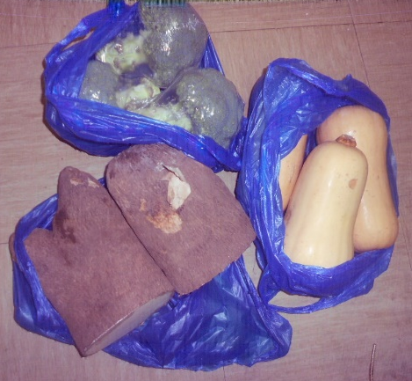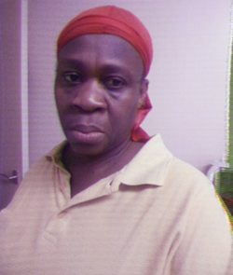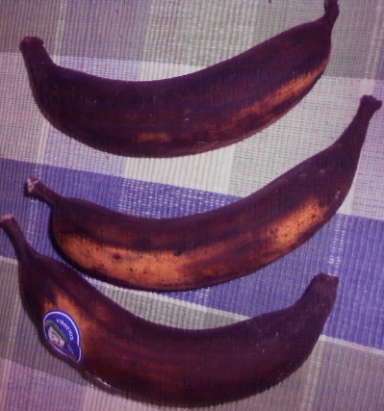
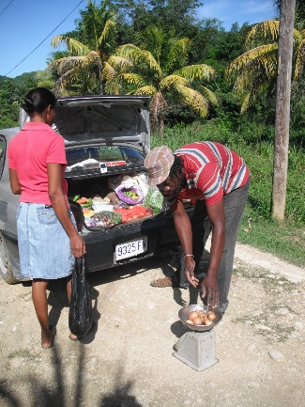
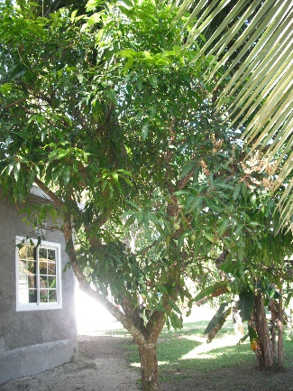 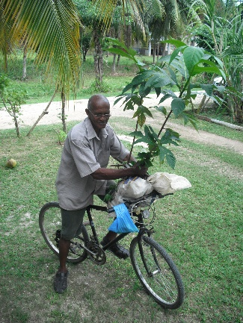 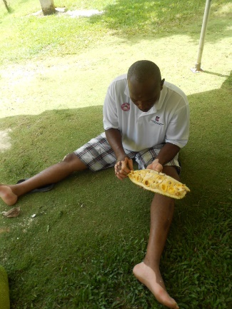 copy to here and more

Mervelee Ionie Myers
16 Alma Grove
Bermondsey
London SE1 5PY
London Early Years Foundation
121 Marsham Street
London SW1P 4LX
27th September 2015
To Whom It May Concern
I am writing with immediate effect to tender my resignation forthwith. After careful considerations and reflections of all that happened since I transferred to Bird In Bush nursery on 23rd July 2014, I realised it is no longer feasible to work with LEYF any longer. Despite giving of my best during my years of services starting on 1st September 2009 I have come to the realisations that nothing I do will return to those times when I was valued as a practitioner who contributed much to making LEYF one of the beacons of early years services.
Since October 2014 I have been through lots of issues as a result of the unfair treatment meted out to me at BIB that impacted negatively on my emotional health and wellbeing. My health has been adversely affected to the point where I was unable to carry out normal day-to-day activities adequately. My disability and progressive medical health conditions were exacerbated as a result of the intimidations, harassment and bullying I subsequently received as a result of me raising my concerns about my unfair treatments. I was sent on Medical Suspension and passed fit to resume my work after my assessment with the Occupational Health Doctor.
However since my return to work I have encountered further Direct Discriminations intended to provoke me into acting as I was labelled in the Disciplinary Hearings: Uncooperative, rude, unprofessional, confrontational, intimidating and lacking empathy. Despite giving up my RIGHTS because I know my situation so I could continue to work to earn a living to provide for my Basic Needs of providing food shelter and clothing for myself. I have to now give priority to mine and my husband’s health and welfare. The situation at work is now affecting both our health and I have to take this into consideration. Last week when he had a HYPO and I had to leave him at home to get to work, I asked for just a little time to give him a call to reassure myself he was ok. However I was not granted this time and had to wait until my lunch time to do so – 5+ hours after leaving home.
With all these recent happenings like that on Tuesday 22nd September at CO, coupled with all the related incident at BIB, I am unable to continue living and working under these pressures. I am close to having a Nervous Breakdown and with my mental health issues of Depression that was exacerbated by the Direct Discriminations at BIB. And with my Chronic Anxiety a condition that I managed to live with and be in control of throughout my life before BIB, making it almost impossible to carry out normal day-to-day activities. I have no alternative but to make my husband of whom I am his full time carer my priority as this situation has been affecting both of us over the past year.
Thanks for the 5+ years of collaborative working partnerships shared before I transferred to BIB.
Kindest regards.

Me and my state of MIND
Folks I don’t want anyone to take this Personal, but just to forewarn you about the state of my mind. I hope this will eventually give you an insight into whom and what I am at the present time in my life. I am currently suffering from DEPRESSION which I have been struggling to keep under control, and believe me it wont get the better of me. However I am putting MECHANISMS in place so that I can eventually get out of the environment that is contributing to exacerbating the condition. Therefore I am making plans to be out of the UK before my 60th Birthday if God decides to keep me on this earth until then. I have some investments which are tied up over the next 4 years without me losing out on any premiums/benefits, so I will be around until then to collect them. The other investments I have I can always settle when am ready. Also I would love to be around for TOM if he should ever need my support. At present he does get on my Nerves, but I have developed a thick skin and refused to let him dig too deep. At the same time he is a Tower of Strength and can be relied on like no one else at close range.

I have made the decision to do as much work as I can with the assistance of TOM, because I know this will go a long way at putting Mama’s heart at peace before God decides to remove her from amongst Us. This is the only reason that I am making the sacrifices to work on the house. I have tied up most of my money for a period so I can earn some interests. TOM has decided to help, but I have to deal with the nagging too. Some times I won’t be able to discuss any matters over the phone when he is around, but will instead use other mediums of communications.

Seriously I don’t care about having much in life as long as I have a room to call my own. But it is my wish to know that there is a decent enough Family Home for the Family to have some sense of security. I have seen my parents struggle to provide a roof over our heads, and I know it was one of ASHTER’S dreams to put up a decent house, so I will be proud to know that I can make those dreams become a reality. All I am asking is that the hard earned money I sent is spent Wisely as TOM keeps harping on about how hard I have to work for the money. He comments every day about the money I lent out, but I won’t be crying over any spilt milk. I am a person who believes in Destiny, and I always say I came to this country for a reason, so now I recognised that it is time for me to pack up and leave before I am beyond repair.

There are forces intent on keeping me down, and am damned if I will let them get the better of me, so at the moment I am learning once more to kiss ass before I can kick it. But don’t worry am making my plans for when I am ready to leave. In the meantime I am just humbling myself and walk with God. Yeah and don’t think that I have not been questioning this same God why Me & my FAMILY have to bear so many Crosses from the time my Papa was struck down with his illness.

All I am asking please take care of my INTERESTS as I want to do what I think is best for my Mum who did so much for US as a Family. Now that am older and wiser I am able to comprehend just how much she has done. May God continue to answer my prayers and keep her from too much pain and suffering? Chat later.
Ratty.

LEYF Alison Stokes 10th November 2015 – via email
Hi Alison
Sorry for just getting back to you because of the Nervous Breakdown I had resulting from the Bullying, Harassment and Intimidation I experienced at CO on my last visit there. Neil King set about to carry out the threats put in place when LEYF and their Solicitors had their Brainstorming Meetings about how LEYF was going to put their Plans of Actions into place to deny me of my Rights to provide for my own Basic Needs. How did I know, because of my FILE that went missing when I left Luton Street and I have evidence of how I tried to get hold of it? Because l tried giving up my RIGHTS over the period of a year hoping LEYF would see sense. On my visit to CO I realised nothing I do would make a difference.
I intended to attend the Meeting to address the Allegations, but unfortunately God dictated otherwise. For your information I joined SM as a result of the CEO asking us when I was at Luton Street to contribute to her Blog. And Julie Weiss was my go between as she shared my professionalism and contributions to making Luton Street a beacon in High Places. We shared views on Nursery World Sites because I was not considered good enough for her to accept me on other Professional Sites. So now the Puss is out of the Bag, and I have a file of evidence in Black & White to verify any claims I make about what I did or didn’t do on Social Media. Hilda Miller bullied me into taking down articles and for me not to say I work with LEYF. I was investigated for a number of Policy of Procedures including SM and nothing came of them, so I don’t understand why another investigation. Instead I expected LEYF to put the final sanction of dismissal in place. Why was this not done and another investigation? I am assuming this was to further make me ill considering my Chronic Anxiety and what the Occupational Health Doctor said about the impact of any Investigations/Disciplinary on my HEALTH. If in doubt go read the Report that LEYF pretended not to have received at the Appeal Hearing. I did not send myself on Medical Suspension to get me SACKED as being MAD as Dilys Epton implied each time we met.
It is rather strange that after attending the #BigChildCareConference when I was endorsed by Professors Chris Pascal & Tony Bertram that I once more had to face other allegations about LEYF SM Policy. Is this about Kettle calling Pot Black because I can represent myself in all situations and promote my ideals and VISION? You might be interested to know that I was the Consummate Professional when LEYF Big Wigs pretended they didn’t see me. So when 1 in particular turned her back on me chatting to her Big Wigs, I waited for her to finish her conversations and greeted her. What did she do? Say she didn’t see me. This is not the first time this particular individual whom I admired and trusted lied or stretched the truth. On a visit to BIB on the 28th January 2015 she told me, she told the Team off for not attending the New Year Staff Party. Only to learn that BIB was given their permission not to attend because I was going.
At the conference another LEYF colleague whom I worked with in Luton Street and taught her so much, editing her work, etc done the same. She didn’t see me, so I am left to conclude that was the way LEYF gave instructions for my treatment. Because I thought I was wrong when it happened on other occasions including the BBQ at New Cross.
As for yourself Alison, we first met at First Aid trainings when you and Isabel Glen were very supportive and helped me to get my First Aid certificates. I will tell you now that my opinion of you and Isabel have changed since this ugly matter concocted by BIB at the instigations of Hilda Miller, Lynne Kelly and Nicola started in October 2015. I have all the information about the way you discriminated against your staff at Lisson Green at the Meeting attended by the 2 NEILS when your team almost caused a riot, out of the horse’s mouth then.
I was the one playing Pacifier telling them that such matters should be discussed internally and Dirty Laundry should not be washed in public. I have since learned so much more about you. As I told Neil King at the meeting I know exactly how LEYF operated after the way they treated Judy Vaughn making allegations about her. I was the one who supported her, remembering details about events that happened. Because I advised her to keep records. So thank you very much for the support, but don’t think if you join in to discriminate against me, I won’t be naming you? In my culture they say you can’t set thief to guard money. If the head of the stream is dutty, it filters dung a bottom.
Wishing you all the best in your continued work at LEYF. Sorry to say LEYF is no longer the organisation I joined in 2009. I will continue to be grateful for the 5 years of excellent working partnerships I had at LEYF and will not bite the hands that feed me. No amount of negativity can erase the memories I have working at Luton Street with wonderful colleagues for 4+ years. But now I have to look out for myself and protect me – El Numero Uno MERVELEE MYERS.
Kindest regards

LEYF 10th November 2015 - via email
Hi Mr King
Just have time to get back to you after you requested I come to see you at CO for a chat. Following my visit I subsequently had a Nervous Breakdown and had to seek Professional Help as a result of the way you tried to harass, bully and intimidate me into “WRITING A RESIGNATION”. I guess God acted bringing me to the brink so I could see sense “no job is that important if it is going to result in my health being compromised and leading to my death” hence the resignation. Now you have got what you wanted and it took LEYF 1 year + to make my life a living hell. In the process my good name was blackened and my character destroyed for what I don’t know.
For your information I am now seeing the counsellor and counselling will last into 2016.
I am not yet ready to go back to work full time because I need to recover from the ordeals that destroyed my health, self-esteem and confidence to be able to carry out normal day to day activities in the job I worked in most of my life by BIB team. This was at the instigation of the area manager Hilda Miller who took a dislike of me for no reasons that I can think of. But I think I have discovered why now?
However I have to earn a living to provide for my basic needs. So I have to get a job, therefore I’d be grateful if LEYF desist from writing “negative References to prospective employers” that are further scuppering my chances for gainful employment. LEYF after not listening to my request about renewing my CRB/DBS, I am assuming went and made online DBS check using my email I am assuming, which was later withdrawn. Now since LEYF claimed after I worked with them 5+ years they did not have a file, I’d like to know what information was included in that online application. When LEYF wanted to DISCRIMINATE against me gathering evidence to tag and label me with the negative discourses in the Outcome of the Disciplinary... And the way you continued to use negative stereotypical labels to verbally attach me at the meeting between Dilys, you and I, I noticed how my information changed on correspondence. I therefore would like to know who made the online application using my email address, the information in that application and the documentations used as well as who verified them.
As I am at it in my quest to continue my search for a job. I done a number of Educare trainings on my return to work after Medical Suspension at Newcross Community Nursery between June – August 2015. Because of the amount of stress I had dealing with both personal and work related because of the way I was targeted. I did not get to print my certificates. I no longer have access to the sites, so would therefore like copies of the certificates sent to my address if you could be so KIND.
Once more thanks for the best 5+ years of working life, I had before the BIB debacle that LEYF failed to address because of their subconscious Prejudices.
Kindest regards.

23 Years of Living in the UK 07.06.1992 – 07.06.2015
Dealing with the Pleasantries & Unpleasantness of Life
Every time I have a brand new or revisited any experiences that may have occurred before in my life, it either does one of two things. This might bring back some poignant and pleasant memories of some incidents or events from my childhood or even something that happened to family or friends. But worse still it might bring back some of the most unpleasant of memories that I prefer to forget. But I guess throughout my life I have had to learn to accept the good with the bad. Because for nearly a year now, since coming back from burying my MOTHER, I’ve had to endure the most horrendous times of my life. The horrible wicked and terrible experiences nearly pushed me over the edge, ruined my emotional health and wellbeing and have negative impacts on my life.
That’s why as I sit down to reflect because I have been tied out to grass with time on my hands to put to good use. I refuse to let the bright lights that are my cognitive and intellectual skills diminish to let them get away with doom and gloom of the self-fulfilling prophecy they instituted on me to try and stop my progress. So since them say the “Devil finds work for idle hands…”? I am fine tuning my grey brain cells using the space, time and money they have given me whilst trying to destroy me, to hone my skills to fight the injustices of an unfair and unjust system. The system that has been put in place by evil unscrupulous persons to destroy the lives of the innocent and vulnerable if they refuse to stoop to their levels of depravity. I have been living in the UK 23+ years and I have been unfortunate to meet up with some depraved persons.
These persons who have no scruples and will do everything in their power to destroy others for no reasons whatsoever, other than envy. I can remember one such occasions back home when my breda ASHTER decided to enter the political arena. I am not sure if he had given any thoughts about what he was entering into nor the adverse effects that this would have on his family and friends in general and him as a whole. But whether he had given it a thought, I doubt very much he would have been daunted by the undertakings and the consequences. Because he was a man of convictions, was principled and believed in himself and whatever he set his sights on achieving.
For those of you following and keeping up with my stories, you’d have already learned that we – my parent’s children come from humble beginnings and a family that have nothing except love. We were as poor as a church mouse, but that did not stop us from having ambitions and visions above our statuses and stations in life. Although both our parents’ family were well to do, our side of the family – mum’s dad and her husband walked away from their family and decided to start lives of their own. The saying “mother have, father have blessed be the child who have his/her own…” comes to mind. That is the mantra that my family live by, even though it was not always easy to achieve our goals.
This resulted from circumstances over which we have no control: like poverty, sicknesses, disability, redundancies, social injustices and inequalities, and the end game of death. Grandad by Mum’s side walked away and leave everything to start from scratch. Grandma was different in that she had visible features that marked her out from others. Grandad from Dad’s side was a philandering womaniser who met his match in the person of Grandma Irene Mills-Nembhard. Grandma had a deficit that was accidentally inflicted when she was a baby and I guess like me, this must have helped to shape her life. She was “blinded in one eye and I suffered from Chronic Anxiety” from early.
She tamed my grandpa putting up the fights of her life showing up the shallowness of her competitors. And grandpa could see past the one eyed woman who was of a strong character, despite his stuffy nosed family not liking her. He made her his wife and they produced 16 children of whom Dad was the 2nd child. Grandpa was jealous of his wife’s relationship with their children I later learned. So as soon as they could, they flew the nest and launched out on their own in separate directions. Some of them settled in the same parish, others went to adjoining parishes and only Dad settled in Westmoreland where I was born. It was sad indeed to hear of the breakup of Dad’s family and some of the children did not reconciled with their dad.
But I guess this state of affairs have been in existence from Biblical days…? Therefore some turned up at different times for his funeral, even when they were moulding up the grave I believe. But as one has their own life experiences like I’ve had to date, one realises and begins to get a better understanding of the complexities of one’s journey through life. Therefore I am proud to say that all of us inherited the best characteristics, determinations, traits, etc… from our ancestors down the ages. That mean we are prepared to make sacrifices and fight to the bitter end for what we want, stand up for our beliefs, argue our points and never back down despite the odds stacked against us.
Although I said I am going to record my memories in a book…, the way life is going, I might not get the chance for that book to see the light of day. I am therefore using the media available to get my thoughts, and life experiences out in the public domain as soon as the ideas present themselves. If I don’t do it now I might never get a second chance. Back to when my breda decided to use his God given talents to make a difference in the lives of the marginalised in the parish of his birth - Westmoreland They did not get much of a representation at the local government levels of politics. He was up for a rough ride and exposing his family to that unopened can of worms that some have used to keep the likes of us down and in our place.
He came from the wrong side of the track for a variety of reasons. And if he was a lesser personality with a different mentality and mind-set, he’d not have taken up the mantle to bring about change. But he wasn’t daunted by anyone nor anything, and he was prepared to come out from under the shadows. Because he was a go getter for the objectives of his visions he aimed to achieve. His determinations was second to none and I was there from the beginning to support him in his vision to bring about change to benefit everyone regardless of political affiliations. As an advocate who because of circumstances beyond my control had to work in the background sharing my breda’s visions.
My recent experiences are bringing back a few unsavoury incidents that happened to me here in the UK that nearly knocked me off my feet never to recover. As a result the Hidden Disability from my childhood was triggered and the trauma caused me to develop DEPRESSION. I have been struggling and fighting my demons ever since and every time I encountered another unfavourable experience, I am pushed even closer to the edge of the abys. However at no time have I ever covered up my conditions nor try to make a secret of them. I was at home one day when from out of nowhere our home was surrounded by Law Enforcement Officers.
But the biggest shock of all came was the fact they came pointing long guns at us. We were bundled out of the house, questioned and manhandled, whilst they carried out a thorough search of every nook and cranny in and outdoors. Whatever they were searching for did not materialised and they left empty handed. I am not putting it past the corrupt bastards not to have planted something at our home, so that was one of our lucky day. Luckily my breda wasn’t at home, probably there might have been a totally different outcome, because he was an outspoken person who would have challenged them and think nothing of the consequences to himself. All they would do is come up with some flimsy excuses for their unethical behaviours.
I know what I am talking about because I know of cases where weapons were planted and innocent people lose their lives because others might have grudges against them. No one will listen to your side of the story and prefer to see you as the monster others make you out to be. Then they are prejudiced against you and contradict themselves in the bargain for reasons only they know about. At the time there was a level of corruption in Jamaica that makes me cross to think about. On reflections I was glad the incident happened after the death of Dad, so he didn’t have to witness such a terrible act of injustice. I am almost sure he could not have handled that kind of experience anyway because he was a SICK man for a very long time.
And we are always trying to protect our loved ones from the unpleasant things in life. I have had allegations made against me since living in the UK and each time I am adversely affected worse than the first time. Apparently the reasons our home was searched and we were treated like criminals was because of an allegation that my breda had guns and ammunitions at home. It was nothing more than a set up because my breda had thrown his hat in the ring to enter politics so he could make much needed changes in the local communities to benefit the poor and needy. My experiences since moving to the UK mean I now have to make comparisons to my breda as each time they tried to make me a VICTIM.
I come out more scarred than the last and my health suffer in the processes. Because of my experiences, I dedicate myself to enhancing knowledge so I can become a beacon for change, making a difference in the lives of those who needed my support. We were raised that way and taught to look out for the welfare of those who are most in need of our love and support and less fortunate than ourselves. However each time I tried to get up on the career ladder I am dealt a cruel blow as there is always someone standing on the wrung of that ladder grinding their feet into my hands so I have to let go and start again from the bottom.
What hurts me the most is the underhand methods and tactics that some in the echelons of authority are willing to apply to blacken another person’s good name, destroy their character and ruin their reputation with their false allegations? The first time this happened my Hidden Disability was triggered and because I was going through the Menopause, DEPRESSION took over my life. I have not recovered since and get bouts when I get stressed out and have to seek medical attention from the Health Professionals.
When one is determined like I am to standing up for what one believes in and be counted not to be treated unfavourably. One can end up feeling excluded and getting the brunt of discriminations, harassment and victimisation from an uncaring set of boffins who are only interested in meeting their own targets. They don’t give a hoot about Welfare Requirements, changes in laws and legislations and will tie you up in their policies and procedures that are written to put you in a bad light and break you to your own detriment. They sing from the Hymn Book and Sankey of “rhetoric and bureaucratic red tape filled with tokenisms” that suit them to make you who they expect and want you to become.
If one is assertive enough to try and implement and promote the knowledge and expertise that the dedicate years of their knowledge to enhance. Then persons like me and other likeminded people are viewed as threats to some as we are labelled aggressive. And they will make one’s life a living hell to be destroyed without even a thought for the welfare of the person involved and the impact on their dependents. As long as they get their ways colluding to destroy you for your integrity and listening to your conscience. It don’t matter if one has given years of their lives contributing, no one will take any of your loyalty into considerations when they set out to get you. Because of past experiences I tend to keep a low profile and do my things from the background where I can perform ant my best and maximise my potentials.
However I will not let anything stop my thirst for knowledge so I can continue to be the best at whatever I have to do. However despite my qualifications I have not managed to shake off that period when I stand up for what I believe in. That was to use my knowledge and expertise gained whilst I embarked on studies to safeguard the vulnerable whilst implementing and promoting inclusion to meet the diverse and complex needs of children and their families. As a result I have had the establishments having a go at me for showing up some of the unpleasant sides of daily living that put vulnerable children and adults like myself at risks. Despite keeping a low profile my name is already in the public domain because I am being networked against and blacklisted.
Some feel threatened by my knowledge that I will uncover their incompetence, so they have to use foul and unorthodox methods of allegations and lies to blacken my good name and character to get rid of me. Although some will pretend that they have no knowledge of what is happening, this is only a smoke screen to keep you in the dark whilst they try to destroy you. When some who had otherwise stick to highest of principles have lost their way to the market forces of meeting managerial targets at the expense of beacons under which they once operate then it’s time for reflections.
Some are now prepared to turn a blind eye: hear no evil, see no evil and do no evil covered in the rhetoric of bureaucratic red tape of tokenism refusing to take responsibility and be accountable. Instead they will use others as scapegoats for their incompetence and leave you to carry the can as they continue a rigid regime of provision, criterion and practice. Take it from me because I have had the experiences, the adverse effects to my health and emotional wellbeing as proof of the social injustices and inequalities that one can face if one is not prepared to sell out your knowledge, values and beliefs to the wiles of Satan.
As a warning I’d encourage others to think carefully about how you are prepared to approach life and the decisions that you make. Because whatever you decide to do can either make or break you and the impact on your health and emotional wellbeing can be life changing. My career has been stuck on hold from as far back as 2008 the same time I lost one of my bredas BYRON from CANCER. There have been many life changing experiences that helped me to become even more resilient since I moved to the UK. I lost track of the number of interviews I’ve attended, some didn’t even have the decency to get back to me with feedback. Others couldn’t find a legitimate reason why I did not get offered the job I applied for.
After doing an interview where I was the only one shortlisted from the Company and was given pure drivels for not getting the job, I threw the towel in and decided that was it. I refused to waste any more of my precious time, I settled myself to be content with what I have got, working and saving up for my PENSION. I had to swallow my pride when I was always passed over and only got asked to do jobs for others to take the credit. But I have become accustomed to the things like this that I have been doing all my life. When my breda ventured into politics I was the one who done all his writings and I developed a love of writing from Primary School.
So it is no wonder to me that my creativity and talents are being fed from my experiences in life as I journey to documenting my history for the future generations of my family. Because I can’t change much in my life as I don’t have the resources to do so, I am content to go with the flow. I’ve had experiences where my DEPRESSION was triggered and when I am in such states where I am adversely affected. It is very devastating as I am engulfed and transported to places I don’t imagine anyone would understand.
Because if you have not stood in a person’s shoe, please don’t try judging them before trying to walk that journey that has been a part of their life. However despite all of this I have never wallowed in self-pity for myself for long and do what I can to bounce back and get back on my feet. Now to pour salt into old open wounds there are some who are prepared to contradict themselves handing out accolades one minute and the next colluding with others to blacken your good name, tarnish your character and make sure you are totally ruined so you can’t pick up the pieces. They don’t give a toss about depriving you of your Basic Human Rights and will take bread out of your mouth, leave you destitute to walk the streets with your naked arse exposed and chatting to yourself.
Then they tell you to remove all associations of your connections with them once they have gotten the best out of you. Although they are saying that they do not have any records of you over a certain period and would like you to quietly disappear. It is impossible for me to do this when MUM of a face has been splashed over the Public Media in their publicity campaigns. So if they can remove me from their records good luck to them for trying. Then they talk about multigenerational and treat you as if you are a Common Criminal and Mentally Unfit. They gagged you whilst they gang up with others to destroy you and they don’t listen to a word you are telling them even when you present the evidence.
Then you start worrying if you will be living to see your next birthday as the memories of bygone experiences come flooding back. Despite the trials and tribulations I continue to rise above them, but when one is burdened down with so many Hidden Disabilities and Progressive Conditions linked to aging it is not always easy to perform at your best like when one is younger. It is sad to reflect on the fact that half of this year has been taken away from me, and I almost ended up in the Maudsley Hospital and nearly died. I am aware of what goes on at the Maudsley Hospital because I once worked in Mapother House for the better part of 6 years where I experienced discriminations, harassment and victimisation which triggered my DEPRESSION.
Yet despite paying my dues to get support in situations like I have experienced, I was sold out by the unscrupulous Union UNISON to the highest bidder like I have once again by VOICE. There is no justice for the poor, weak and vulnerable no matter where in the world you happen to live. I was advised by an advocate that what is happening is affecting others like me all over the UK. He encouraged me not to give up and let anyone get away with discriminating against me. Therefore that advice refuelled the fire in my guts to stand up for what I believe in and honour the values and beliefs that my PARENTS instilled in me.
Only by these tokens will I be able to advocate for equal rights and justice for every vulnerable child and adult who needs that little bit of support to make the difference in their lives. I have rights like anyone else and I have never broken the laws, taken anything that don’t rightfully belonged to me and never acted unprofessionally, confrontational and intimidating and being uncooperative. But most frightening and disturbing is to accuse me of lacking empathy. I have been accused of many things because some don’t take the time to know and find out about the person who I am and what make me tick. To have others judging, marginalising, stereotyping and putting me into a pigeon hole is bad enough.
But for anyone to try again to blacken my good name and character and trying to ruin me, taking bread out of my mouth and leaving me to suffer is really hurtful and hard to come to terms with. Then they tell you that we are all responsible for safeguarding and to report… Well I’d advised anyone to take certain actions at your perils unless you have strong constitutions to deal with the consequences. Don’t be fooled by their whistle blowing policies and procedures, because you will end up holding the can as always. Everyone else is out looking after their best interests.
Twenty three (23) years of living in the UK has been good to me with regards to some favourable outcomes and achievements. However there are some experiences that contributed to almost ruining my life and leaving me with some life changing conditions which I could well enough do without. I told my SONS that now I understand why some people returned to their country of origin from whence they came mad as a Hatter because of what they had to go through just to earn a livelihood. No one to talk to and share their problems with as they are bombarded into lowering their morals just to fit into the right crowds or a clique. But the cruellest fates of all some people who returned to their country of origins do not get the opportunity to enjoy the fruits of their labours.
Envious, bad minded, grudgeful red eyes people take away what they worked hard for and don’t care a hoot. My intentions is to return to my country of origins before I am too old. To make valuable contributions using some of my knowledge and expertise I’d initiated my Continuing Personal Professional Development Plan in making a better place for children like myself who had a rough start in life through no fault of our own. Early Interventions are the key to lots of what affects children’s ability to achieve their potentials to make something of their lives before too late. So whilst I am celebrating the highs with the lows, I am doing everything in my power over the next couple of years to making my dreams and visions become realities for the future.
I know this can only happen with God’s continued blessings of good health and the ability to enhance knowledge and expertise to maximise my potentials. In the meantime however I believe I have certain Basic Human Rights to which I am entitled and I hope I will be given the opportunity to continue doing what I am best at without others expecting me to be forever under their thumbs and living in their shadows just so they can prove an elusive point to themselves that they have the power of authority and status to make the lives of us mortal a living hell just because we don’t always share the same views and are different in our ways of thinking critically about life’s journey that we undertake daily.
Therefore I have since decided to cast off the naivety in which I usually cloaked myself taking people at face value. Because I will never be that uncooperative, unprofessional, confrontational, intimidating and lacking empathy as some Jobsworth are making me out to be. I will continue to be the person whom I know myself to be and not that one whom they pinned those unflattering words, labels and stereotypes unto and would like me to become. I have spent 23 years of my life in the UK where some got the best out of me and now that they feel they don’t have any more use for my service they are ready to use underhand methods to put me out to grass with nothing to show for those years of hard graft.
I am left with a bitter taste in my mouth but I guess my expectations must have been set too high. Despite that I will be using the skills I developed under their tutoring whilst they set about robbing me to give them a taste of their own medicine exposing them for the White Collar Criminals that they truly are. Fraudsters who made online applications using my email address. Then cry wolf-wolf like the boy in the story I read as a child. I have since learned not to trust anyone except my MOTHER only because she is DEAD. Because there is an enemy lurking in every corner, nook and cranny to get me. One thing I will not do is allow anyone to trample all over me and take away what is rightfully mine.
Not over my dead body and as I take the time to reflect once more after yet another ordeals. I hope not to be around the next seven (7) years to be revisited by the seven (7) year curse that must have been placed on me by I don’t know whom or what? In order not to be dismissive of authority and be derogatory about the Ignorant Uneducated Minions who did not gain their places by Merit, I’ll rest my case and leave for another time when something take my interests.
Twenty three (23) years off Mixed Emotions living in the UK.

Career Change – LSA Training – School Placement - Networking

Mervelee Myers
16 Alma Grove
Bermondsey
London SE1 5PY
The Head Teacher
C/O Primary School
24th January 2016
Dear Sir/Madam,
I am enrolled on a course with Islington College and HCT Supporting Teaching and Learning in Schools for the next 14 weeks. In order for me to complete and pass the course, I will have to complete at least 30 hours of on the job work experience in a school placement.
I have been researching schools in the local communities and I am aware that your school has excellent reputation with local parents for supporting children’s overall development and learning. Because I have to complete a number of modules and I’ve discovered from your recent OFSTED Report about the school’s reputation in promoting inclusion. I’d be grateful if you would consider offering me a place at your school to do my placement. I know I’ll be able to gain theoretical knowledge and practical experiences from your staff team to help me with my studies.
I have a wealth of knowledge and experiences from working as a Basic School Teacher in the West Indies. I studied in the UK and has gained various qualifications and holds a Foundation Degree In Early Years. I’ve worked in the early years sectors and needs to gain experiences working with school aged children. I can provide qualifications records if needed. I have current DBS that is registered online.
I hope you will consider me doing my placement at your school as I have much to offer, whilst I am developing my Continuing Personal Professional Development Plan (CPPDP) to get back into work.
Yours sincerely
Mervelee Myers FD (Open)
Telephone: 02072310813
Mobile: 07950618083
Email: RATTYNEM@BTINTERNET.COM

HCT Group
To Whom It May Concern
C/O HCT Group
14th August 2016
Dear Sir/Madam,
I am a qualified and experienced Basic School Teacher from my country of origin Jamaica and I have done the apprenticeship as a Teaching Assistant for one year in a Primary School setting. I have various Educational Qualifications from schools and also study at Evening Classes. I have experiences as an Informal and Formal Carer with the Young and Elderly from Jamaica as well.
I have been living in the UK since 1992 where I have worked and studied to gain recognisable qualifications in the early years Workforce Sector since 1997. As can be viewed from my CV, I have completed Studies and Trainings with a number of Educational Institutions and Training Providers from 1997 to date the most recent been Islington College and HCT Group. I completed the Competence Based Qualification (QCF) Pearson Edexcel Level 2 Certificate in Supporting Teaching and Learning in Schools.
After completing the course I undertake Volunteering, shadowing my Tutor Danielle Williams to gain experiences in teaching with the new batch of students. I was inspired and motivated to volunteer by the tutor Danielle Williams from she identified my qualifications and my passion for working with young children. Then the assessor Pauline Peart also advised me to try and go forward to gain experiences for my Continuing Personal Professional Developmental Plan (CPPDP). I have always wanted to gain the Early Years Professional Status after completing the Foundation Degree in Early Years, but never got the chance.
I am not currently working at present, but is carer for my elderly husband. I would like to get back into employment part time so I can continue to assist my husband with the care he needs. Despite the qualifications and wealth of experiences I have not had the opportunity to undertake trainings to become a Teacher nor an Assessor and is desirous of making this part of my CPPDP for the Future.
I have been researching opportunities in the local communities’ educational providers’ since I resigned from my last employment with London Early Years Foundation (LEYF). However I am unable to take on any of the training opportunities offered due to lack of funding. Since my association with HCT via studies and volunteering, I would be grateful of the opportunities to continue my studies with the organisation as I see where I could benefit in furthering my CPPDP. The programmes on offer at HCT are more tailored to my needs, much better than the other Training Providers I research.
Via my own personal experiences of studies and volunteering, I realise HCT is ideal and have the reputation within the local communities for supporting the overall developmental needs of anyone in need of the services provided by HCT. Since I have to be thinking about a change of career from the early years sectors because of personal circumstances of having Disabilities and Progressive Health Conditions, and I’ve discovered from your recent IMPACT Report 2016: Changing times, lasting impact about HCT Group reputation in promoting inclusion. I’d be grateful if you would consider offering me a place with your Organisation to do my studies for my Teaching and Assessor’s Certifications.
I know I’ll be able to gain theoretical knowledge and practical experiences from your staff team, volunteering and attending placements to help me with my studies. I have a wealth of knowledge and experiences from working as a Basic School Teacher in the West Indies. I studied in the UK and has gained various qualifications and holds a Foundation Degree In Early Years. I’ve worked in the early years sectors and needs to gain qualifications and experiences working with school aged children, young people and adults for the career change I am embarking on in the future. I can provide qualifications records if needed.
I hope you will consider me doing my studies with your Organisation as I have much to offer, whilst I am developing my Continuing Personal Professional Development Plan (CPPDP) to get back into work.
I have current DBS that is registered online. Enhanced Certificates: Disclosure & Barring Service.
- Position: Child and Adult Workforce Befriending/Supporting Worker (Charity) Name of Employer: Resources for Autism – Date: 16th June 2015
- Position: Child and Adult Workforce Nursery Officer (Early Years: 0-5 years old) Name of Employer: Network Recruitment Solutions Limited – Date: 20th October 2015 – Registered Online

Yours sincerely
Mervelee Myers FD (Open)
Telephone: 02072310813
Mobile: 07950618083
Email: RATTYNEM@BTINTERNET.COM

Maria Hudson
Policy Studies Institute
50 Hanson Street
London
W1W 6UP
Reference #: 2800116

Mervelee Myers rattynem@btinternet.com
Home: 02072310813
Mobile: 07950618083

Tried to respond by email but my correspondence returned so hopefully this arrives before the deadline date in the post.

Just to let You know that I am available to take part in the INTERVIEW if needed. I work at Luton Street London NW8 so arrangements have to be made in advance to find a mutually suitable location. I can be contacted on the above.

Kindest regards.
Mervelee Myers.

Mervelee Myers
16 Alma Grove
Bermondsey
London SE1 5PY
Telephone: Home –
02072310813, Mobile –
07950618083, Email:
rattynem@btinternet.com

Special Educational Needs Section
4th Floor, Hub 3
PO Box 64529
London SE1P 5LX
01st July 2016
To Whom It May Concern
Re:
Education, Health and Care Needs Assessment of Theodora’s Special Educational Needs under Part 3 Section 36 of the Children & Families Act 2014 and Regulation 6 of the SEND Regulations 2014.
I MERVELEE Nembhard-MYERS/Tomlinson would like to take this opportunity to bring to your attention receipt of what I consider to be threatening correspondences from Southwark Council for which I do not have the slightest clue? Because I do not have a clue why the Council have decided to write to me for information regarding the above named child I would therefore like for the Council to put in writing detailed, specific clarifications with the ambiguities removed so I know exactly what it is I need to address.
Failure on the part of Southwark Council to present the reasons for their demands and clarifications as soon as is decently possible to me will result in me seeking Legal Advice about my Human Rights. I must inform you that I do not like the tone in which the letter was written with what I consider to be threats of the nature that is beginning to exacerbate my DISABILITIES – Chronic Anxiety. I do not understand what is meant by the paragraph in the letter “In view of the STATUTORY time limits, we MUST request that you send this advice by the date stated above”.
Could you please inform me what Southwark Council intend to do if I do not comply with the request by the deadline date of 7.7.2016? Sending me this letter at such a difficult time in my life has only served to bring back painful memories of the time in 2008 when Southwark Council colluded with others in South London to DESTROY my Life and ruined my Career. Southwark Council left me opened and VULNERABLE to be black listed and networked against from 2008 to the present. Therefore I have to now question whether Southwark Council is at it again. Reverting to type and up to no good where I am concerned.
Southwark Council is responsible and accountable for the predicaments I now find myself in once again. Out of a job and on BENEFITS, a situation that is Soul Destroying for my Self-Worth and the person I fought to become when I undertake studies with the Open University 2004 - 2010. Resulting from studies, I sought the Council’s support with my Professional Development Plan (PDP) now Continuing Personal Professional Development Plan (CPPDP), only for Southwark Council to join with Kings Day Nursery Mapother House to destroy my career. Now Southwark Council that helped to destroy me considers me a colleague, I find this rather cringe worthy and smacking of TOKENISM.
My involvement with Theodora and her family was as a volunteer with Resources for Autism. Because of my vision of promoting inclusion so another child and their parents do not have to go through what I and my child went through because of my own lack of knowledge and that of professionals. Southwark Council thought it was within their powers to collude with Kings College Hospital NHS Foundation Trust when I worked at Mapother House Day Nursery to set me up. Same like what is happening to me now since I transferred back to South London working with London Early Years Foundation (LEYF) July 2014 to present.
My passion for promoting inclusion is even more focused hence the reasons I am involved with Theodora and her Family. I volunteered to support the School in preparing her Education, Health and Care Needs Assessment when her Mother informed the school about my knowledge and the work I done with her child via volunteering. If you are interested you can now do your Research and will come up with information about me. Please take careful note of children Varul Sinha and Alaister Aguila for whom I had concerns when I contacted Southwark Council. Varul Sinha became a Poster Advert for OFSTED and every time I come in contact with the advert it brings back painful memories of Kings and Southwark Council, especially since the current debacle with LEYF.
To this day I can still remember the details Sarah Kennedy wrote in those correspondences. As Southwark Council set out to make out I was unprofessional for wanting to apply the knowledge I was gaining via studies with the Open University to implement best inclusive practices. Although I became frustrated and chuck out some of the paperwork I have enough to prove my arguments of a conspiracy against me by the SYSTEMS. I am left with a bitter taste in my mouth that the DISCRIMINATION resulted from sheer unprofessional misconducts on the part of some at Southwark Council including Sarah Kennedy and Iyoda who viewed me as threats to their incompetence like Glendalyn Aboagye at Kings.
Since nothing have changed since my misfortune to challenge the inappropriate social injustices and inequalities at Kings, I find myself fighting to clear my name once again. At the same time despite being amongst the more knowledgeable practitioners, I have to undertake trainings to qualify for targets imposed on me by Jobsworths like some of those at Southwark Council who colluded to ruin my career 2008 onwards. I decided to retrain and is unable to get a placement in a school to complete the Teaching Assistant course I done to find myself back into work. Not even Theodora’s school replied to the application. But now you lot have the nerves to send me such a letter as this, questioning my professionalism, especially now.
I am awaiting your earliest response to my queries relating to the letter and if it is not addressed then Southwark Council will be on my LIST of those in the SYSTEMS that will be EXPOSED for their continuing DISCRIMINATIONS against VULNERABLE EMPLOYEES. Maybe this letter can help me at the Employment Tribunals as evidence I am a Corporative, Professional who is Committed to applying the top down bottom up approaches of the Experts in promoting inclusion as part of British Values. I am Courteous, Persuasive and Empowering using my own Initiatives Assertively and have the Empathy from my own Life Experiences to help bring about Change in line with the Every Child Matters Agenda.
I am aware of the importance of Consulting with and Empowering children and young people to reach their individual potentials. Working in Partnerships with Parents and other Professionals, developing Positive Relationships working in Communities of Practice. My “Defensive Practice” will prove that I am indeed a professional. The more knowledgeable practitioner who developed the listening ethos, and not the person Southwark Council colluded with Kings to destroy in 2008. Because Kings with the collusion of Southwark got away with DISCRIMIATION another employers think they can get away with the same thing, labelling and stereotyping me and destroying my HEALTH in the process.
I am on a mission to stop DISCRIMINATION in workplaces with my #FIGHT4JUSTICE campaign. Sarah Kennedy said I was not a Professional because children did not have “Selective Mutism or Global Delay Syndrome” when I was using the knowledge gained at Lambeth College and the Open University to become a Graduate. Most of my work are resulting from my own personal experiences of TRUAMAS and having to deal with these as a young MOTHER. I was responsible for helping Kings to become a Beacon of Good Practice and then I was set up. I was affected as the DISCRIMINATION triggered my “Hidden Disabilities”.
Now LEYF set out to do the same thing Kings done after using me to build and promote their organisation. So for your information I submitted the educational information/reports to Theodora’s school after working in partnership with the parents adhering to British Ethical Guidelines. Information shared with the school was verified by Theodora’s mother Catherine Aikore, who introduced me to the school. MY WORK BELONG TO ME and I did not breach any of the laws, legislations, guidelines, codes of practice and conduct in obtaining them. So I don’t understand why everyone else think they have rights to MY WORK for their own benefits.
I will leave no stones unturned to get to the bottom of why Southwark Council decided to contact me at this time. I am beginning to smell a rat and I do not like the stench. Please let me have the information I asked for before the 7.7.2016.
Maybe Southwark Council should go back to their FILES to paint the picture that I am trying to paint of me and my involvement in South London Early Childhood Sector before they DESTROYED MY CAREER.
The following should refresh your memory:
- Reports: The Early Intervention Team Dated 30th July 2006 with attachments
- Education Human Resources educationrecruitment@southwark.gov.uk Dated 26th October 2006 Our Ref 223 – ED 05 Re: Reference Request for Augusta Foster. Tania Baltakova Education Recruitment tania.baltakova@southwark.gov.uk
- Re: Reference for Augusta Foster 3rd November 2006
- Note from Samira Zahabi - Alaister Aguila’s Key Person Dated 10th October 2008
- Special Educational Needs Section Tel: 02075254278 John Smith House 144-152 Walworth Road London SE17 1JL www.southwark.gov.uk www.southwarkpct.nhs.uk Re: Alaister Aguila Dated 14th April 2008 Sonja Cole Systems Support Officer – SEN
- Subject: Re: Safeguarding - Date: 23/11/2007 10:07:25 GMT Standard Time From: RES_SW_EX441@southwark.gov.uk To: RattyNem@aol.com Claudette Jacobs Executive Officer Southwark Safeguarding Children Board Email: Claudette.jocas@southwark.gov.uk Tel. 02075250389
- I am unable to come up with any correspondences for Iyoda and Sarah Kennedy because as I said I chuck everything out in my frustrations. But who knows, now I have time on my hands, I am not working I might come up with more evidence to prove my arguments.
- Parents Letters of Supports re KINGS: In case you are doubting me I have copies of the documents in my possession.
- In due course I might come up with more information about others at Southwark Council who colluded to DESTROY me 2006 – …
Looking forward to your favourable response. Hopefully this matter will be addressed to help me to move on with my life.
Kindest regards.
Yours sincerely

Mervelee Myers FD (Open).
Early Years Practitioner/Volunteer/CARER.

Response to Southwark Council re Theodora 14.07.2016
Thanks very much for your prompt response to my query. Although I am still not clear about the reasons I was contacted, because I understand the child’s Education, Health and Care Needs Assessment was already completed and approved. I am satisfied with the efforts made by the professionals to address my concerns.

Therefore because I had a similar experience with Southwark Council years ago and was put under pressures to address the concerns I had asked for support with during studies with the Open University. I thought this was another case of History repeating itself. I am under extreme pressures now as then and could not help but becoming PARANOID about the reasons for the DEMANDS. My entire life was turned upside down, resulting in my career ruined and me ending up with Mental Health Issues. I left Southwark from 2009 and since I got back, things got from bad to worse. Now I am not working again ad going through the same issues as back then. I need to sort my life out as I have had to get COUNSELLING to deal with what has been happening to me in Southwark since October 2014. I have not worked since September 2015.

I will accept the findings with reservations and may come back for further clarifications in the future when I have dealt with the pressing matters I am addressing.

Kindest regards.
Mervelee Myers.

Mervelee Myers FD (Open)
Plan of Action

Volunteering re: Resources for Autism

Qualification/Experiences:

Mervelee Myers FD (Open) – Early Years Practitioner: Experienced Early Childhood - Basic School Teacher & Childcare & Education Worker since 1985.
Contact Information:

Home Address: 16 Alma Grove, Bermondsey, London SE1 5PY. Emails: rattynem@btinternet.com Ratty.Nembhard1956@gmail.com Home: 02072310813. Mobile: 07950618083.
Work Address: Home 16 Alma Grove Bermondsey, London SE1 5PY. Telephone: 07484168572. Web: http://www.myvision.org.uk/index.html
Next of Kin:

Husband: Arnold Ebenezer Tomlinson Mobile: 07900866032
Volunteering Providers:
Resources for Autism

Contacts: Vesna Glavas Reach Out Coordinator - Email: vesna@resourcesforautism.org.uk Mobile: 07806771413. Address: Resources for Autism 858 Finchley Road, London NW11 6AB. Telephone: 02084583259 Fax: 02084583222 Web: www.resourcesforautism.org.uk
Prepared by: Mervelee Myers
Date: 23rd August 2015

Luck of the Irish & Determination of the Jamaican – Happy St Patrick’s Day 2016
Let’s get one thing straight before I am side-tracked by the emotions involved with getting my “Fight4Justice” into full flow, and bring some closure to this sordid matter. My “Fight4Justice” has become my passion over the past year and with the help of the professionals involved, I can say I’ve benefitted from counselling. However I am still so consumed by the social injustices and inequalities that have been directed at me over the years that I just don’t want to “puke, but VOMIT”! The Extremists, Terrorists, Tyrannical, Radicalised, Institutionalised and Corporate Psychopaths that “tek a set pon” me from as far as 23.07.2014 when I transferred from North West back to South London have much to answer for.
But on reflections and considering the “nitty-gritty”, things that used to happen from after I came back from Jamaica – January 2014. I am inclined to say the plots to destabilise and destroy me, must have been implemented before I got back to Luton Street. To be told on 15.03.2016 a year to the date I was forced to ask for the “gag to be removed from my mouth” and for them to take responsibility for their actions. I am therefore surprised to hear someone who is supposed to know better, saying that my “FILE was not sent because of an error on the part of the new manager”?
I had no alternatives but to put him straight about their “policy and procedures” and for him to stop “teking mi fi one empty headed big head bud like his friend the HR”. So Ms new manager who celebrated two years in February, just so you are aware that you are now the “scapegoat for that little misdemeanour of not sending my FILE” over to BIB. But it is a bit “ironic that they have started to confess” as the plots start unravelling. Because I recalled saying on the day I was due to leave - 22.07.2014 when the new manager magically disappeared and took the keys to the filing cabinet with you. How can the keys to the filing cabinet be taken, what if there is an “emergency”? Suffice it to say that if this is not correct, then the new deputy is responsible for giving me that information.
I began “to smell a rat” soon after I was requested on LinkedIn, because it was claimed I had so much to say. Not long after I caught the said same new manager asking a parent a funny question about Social Media after “we celebrated a colleagues’ birthday on the 28.05.2014. Before that, one of my fellow Jamaican was set to target me, and she certainly did after she was given the Duty Manager’s post. She never stop “tek set pon mi like when ticks tek set pon cow nether regions” until I left. But I am sure by this there was such a “high turnover of staff as the organisation was losing its beacon status” that it had stopped operating under the Duty Manager Induction Programme I was introduced to in 2009.
Just to refresh their memories, none of these policies and procedures were being adhered to by the “Tyrant’s Staff where the Baby was Abused and thrown out with the Bathwater” at the South London site where I was transferred to on the 23.07.2014. Each time I recall what they done to me, my “blood goes to boiling and I pledge not to let them get away with what they’ve done to me” and countless others. The difference between me and some of these countless others is that they did not operate my “Defensive Practice” so they never had a leg to stand on. They set out to destroy the lives of others after they used and abused them.
Each time I hear about another staff that was frustrated, provoked and traumatised into resigning after giving so much of themselves to this organisation. I am more determined than ever that they should not be allowed to cover up what they have done to me stretching from 23.07.2014 – 27.09.2015. There were more injustices from September 2009 – date that were subtly covered over because I was not aware and those I was aware of, I could do nothing about. I am declaring “WAR on those “Carried-away-Evil-Over-confident-Lost-Extremist-Yobbish-Frauds” that enslaved me from 01.09.2009 – 27.09.2015 taking me for a “stupid-empty-mug”.
My “Fight4Justice” comprises all those that have been traumatised into taking cover for fear of retributions to them and their family. I am more determined now more than ever to expose them for what they are. I gave them enough time to come to their senses and “smell the coffee”, but they did not want to listen nor talk. I already told them that the “Pen is Mightier than the Sword and Might can’t Beat Right”. So they have friends in high places who they think are going to be always there giving them the sanctions for them to “Commit MURDER”, but they never think about the person who is Mervelee Myers?
By now they should know that I am not afraid to question God Almighty if S/He is male, female or both, if the need arise. Therefore I need to go back some ways to the beginning of my history. I am “upping the history lesson” and clarifying just a few pertinent facts. I want it to be known that I no longer believe that “Christopher Columbus discovered Jamaica”. Oh yes he was sent on a “Voyage of Discovery” by the King and Queen of Spain in the 3 ships – Nina, Pinto and Santa-Maria. But when Senor Columbus “tun up pon di shores of Jamaica” there were inhabitants already walking round semi naked and enjoying everything the island had to offer. Hence Jamaica’s Motto “Out of Many One People”.
If what I and many more vulnerable people are going through at the “new intakes of corporate psychopaths in workplaces” all over Great Britain is anything to go by, then we can begin to imagine what is happening all over the world. Because there was always someone ready and willing to discriminate against their fellow human beings because they think they are superior. The word EUGENICS comes to mind because there was a particular person who thought she was better than lots of us. The US included all those of us who were there for ages making valuable contributions before she wormed her way in under false pretence.
But that Psychopath did not think when she decided that she “did a go tek set pon mi fi deprive mi of mi RIGHTS” that I was going to stand up to her. The Racist bullying thug that she and those she frightened into doing her dirty works are one and the same. But I am more surprised and ashamed of those who gave her sanctions to treat us like less than dirt. I am wondering who is sorry now, as they are trying to keep her out of sights until this matter blows over. But believe me it won’t just like that. More than likely many inhabitants discovered in the new world were used and abused, hence their demise and extinctions.
And I believe this woman without “an iota of sense” who set about to get rid of the staff she met when she joined the organisation, could never be thinking she would get away with the wrongs she done. She never gave a second thought to the havoc she was creating in the lives of others like me, as she tried to claim her glory of discovery like the Adventurers? Don’t get me wrong I am not demonising, undermining or sullying the good names of anyone who done their bit throughout history. But how can they expect to treat another human being like what was done to me and not expect that I was going to rebel.
After I made valuable contributions to making this organisation a “Beacon of Quality Practice” as a role model for service providers and an advocate of service users. But what did I get for my contributions from 01.09.2009 – 27.09.2015, but “unadulterated discrimination of the vilest” that I am still trying to come to terms with. I was hounded soon after I helped to over-turn the OFSTED report that says they were “RUBBISH”. This hounding lasted from October 2014 on my transfer back to South London where it seemed every “incompetent have it in fi mi because mi brighter and more knowledgeable than dem”. I’ll have to write that BOOK about South London eventually, giving names of the evil perpetuators of social injustices and inequalities.
Back in South London I was pulled from “pillar to post, sanctioned by the Top Dogs in the establishment” as they watched me slowly being destroyed. I’d “slaved for this organisation without any forms of compensations except some that were not worth the paper they were written on” because they think I am “GLADIS”? Despite giving of my best, I was kept underfoot and brought out only when they can use me to front their campaigns of climbing up the ladders. Because you see they stopped being compassionate and wanted “world domination to become the biggest in the early year’s sector”.
Anyone happen to remember Kid’s Company? Because up until January 2014, after coming back from my #2son’s wedding, I can still recall when I was still part of their organisation. I still have video of the New Year Staff Party when Top Brass were pretending to be like US. Then by the time I got back to South London I could no longer be myself amongst those who claimed they were not part of the organisation. Even then I was not aware the psychopaths had taken over. So in trying to destroy me they colluded to blacken my name – Mervelee Myers, ruin my reputation and leave my character in tatters over a period of a year from I attended a wedding on the 04.01.2015.
They tried every Policy & Procedures in the Contract and when they could not come up with any evidence, set out to trap me, begging me to take a GRIEVANCE. When that did not work, they send in false allegations in the forms of complaints on Thursday 12.03.2015 after the manager lied about preparing letter for parent by 3.00pm. Then an incident was staged, I was delayed later to get me to act out of character, but little did they know I can operate under many fronts and choosing the appropriate hats to wear for my performance. What did the “Blind-Folded Big Wigs @CO” done, but put their stupid plan in action to DISMISS me by sending one of their “institutionalised psychopaths” to carry out investigations.
But if the investigator was anything like me, she would have taken note of our meetings when we done “FIRST AID TRAININGS @HOLCROFT”. The rest of this sorry debacle is history as I ended up with a sanction reading “Uncooperative Unprofessional, Confrontational, Intimidating, Rude and Lacking Empathy”. As time went by and they “used their feet to tie their hands”, more negative stereotyping were added along the way like MAD and CRIMINAL-PAEDOPHILE. The cheek of them, but I already told them that if they are not careful, they will be “nyaming dem wuds in upper/case letters, washed dung wid jaize dat mi Parents used fi threaten fi use wash out mi mouth when mi CUSS Bad Wuds”?
So despite keeping me underfoot all these years, and at the bottom of the career ladder, I managed to get on with developing my Continuing Personal Professional Development Plan (CPPDP). I started with the organisation with a Foundation Degree in Early Years from the Open University that I got when I decided I was determined to be a “Graduate before my 50th Birthdate” and I accomplished that. In 2010 I got a Certificate in “Working With Children and Family”, but this did not make a difference and they continued to keep me at the lowest levels. Despite all of the holding back, not allowing me to do the “Early Years Professional Status and other trainings to be Assessor to support the Apprenticeship Scheme” recommended by the LS manager, I am still better than them.
The knowledge I have in my “little finger after developing my (CPPDP) is more current, relevant and conducive to promoting the British Values of the UK. This is more knowledge and expertise than what all of them in Leadership and Management Roles put together have between them at CO and in the organisation. If anyone thinks I am joking go ask certain Solicitors, former employees and those they used and abused about them. The question is was it worth it in the end to “tun eina di Corporate Psychopaths dat dem become”?
Friendships Formed From Shared Experiences
One of my husband’s best friend is Jerry who is Irish and I’ve heard stories of their friendships from they met in a country that can be unkind to “Foreigners on their arrival”. Some of us came here to better ourselves and go back, others come with their family and do not intend to return. But I am looking forward to going back. In the meantime until I am ready I am sure I am entitled to enjoy my RIGHTS as a Law abiding Citizen. Instead because of the prejudice and biases of some who managed to fool those I thought were honourable well thinking individuals, into wanting to take over. They and their organisation have been turned upside down. After coming to South London to perform Ethnic Cleansing, they think they are going to get away Spanish Free like that Spanish Jar?
No sah dem mek a sad mistake, because ask anyone and they will tell you I am very generous, forgiving and tolerant to a point… But after that all hell a guh bruk loose, so dem did better off mek sure say mi did Stiff Stone DEAD. Now I am on their case!!!! They won’t make the mistake of not recognising, seeing, knowing my name again as long as WE both shall LIVE?

Background History
Now I have to have a reason for everything I do, linked to the various transitions in my life from 10 years old to the ripe Old Age of -60. I grew up hearing some likely stories about my family, and these stories were likely to be told because of a variety of occasions, so there were the “Ben Johnson days and others when we were just looking for ways to entertain ourselves” because we did not have the mod cons due to the fact my family was “Dirt Poor”. Or everything in the house was used up and they cooked everything left to make a meal to starve hunger and we gathered together as a family to kill time and be who we are naturally. One such story was about my Grandfather, Mama’s Dad.
My Mother wasn’t much of a talker, but I remember her telling me the story in its entirety after she developed DEMENTIA. The story goes somewhat like this, in the following vein, but the thing I remembered most from the story will live with me forever. Because I realised that for my Mother this was her first missed opportunity to “break that cycle of poverty” by which her life was to be dominated. I took Mama telling that story as yet another “learning curve about human nature” that I was unaware of before. The story told by Mama was that her Father and his Cousin were the poorest amongst the family. One day one of them was visited in a dream and told about the fortune that was to come their way to get them out of the poverty.
So without fail Grandpa Claudius and his Cousin Mr Bernard made their way to the designated spot where they were to be gifted with their fortune. At the appointed time as was revealed in the dream my Grandpa and his Cousin witnessed the spectacle of a life time. There appeared out of the River a “Spanish Jar aka Panyah Jar” coming to the surface. In their excitement at seeing the Spector of the Apparatus in all its Glory they called out to each other in unisons “a Panyah Jar Banny Boy, a Panyah Jar Claudy Boy”. Mama said the instance they mentioned the name Panyah Jar they heard a whirling sound and the Spector disappeared back into the River sinking to the bottom.
I am of the mind believing they should not have mentioned the name of the Spanish Jar and that might have been the secret to getting what was in it. However if they were given those instructions in the dream, both forgot. That was the end of Mama’s dream to get out of the poverty that was to dog her life and that of her family for a very long time. Although Mama never gave up, stopped to feel sorry for herself in the face of adversity. She never ever forgot the misfortune of her family’s bad luck to lose everything that could have changed her life during the twinkling of an eye. There was a “Panyah Jar” at home that Grandma Elsie kept her water in, and it got taken to a school my “younger breda” was teaching and never got taken back home.
I doubt very much that it could have been the same one that disappeared with “Mass Claudy and Missa Banny treasure like a thief in the night” however.
Secondary School
My next encounter to do with SPANISH was at Secondary School where Spanish was my chosen Foreign Language Subject. I consider myself not to have done too badly at Spanish back in the days knowing the basics. From I come to the UK I keep promising myself to do something about developing this aspect of the knowledge I am lacking, but each time something is bound to crop up. Now that they claim my FILE which disappeared like the Spanish Jar has returned and Mr Solicitor says it is this THICK… They can look in it to see where I said I wanted to do some Spanish studies in one of my supervision.
But now more than ever I want to learn Spanish so when I CUSS that woman who came to the organisation and created havoc, I can translate from English to Patois to Spanish. After she thought “she could bottom me” on the 10.09.2015 calling me into meeting with my Mother’s namesake – Louise. Then running away from the onslaught that I gave her without telling her a swear word, she threatened that they should move me from where she is Area Manager. Then she got the “Frazzled – said Mama’s namesake – Louise to make complaints that I was aggressive to her when she asked me to bring DBS. What “damned fools are they by not allowing me to renew my DBS” and expecting me to bring mine from another organisation after they treated me like a Paedophile Criminal.
I had the last laugh when the Criminals incriminated themselves using my email to make online application. Now Madam Senorita Hitler Mugabe Sillier who threatened the Brain-Washed Clueless-Evil-Orator the Orchestrator of Lying when she visited BIB on 28.1.2015. Madam Brutal Enemy of Brave-Open-Minded-Forward-Thinking-Fellow-Professionals told me that she told them off for not attending New Year Staff Party when she was getting her MBE. They have now decided to send the Builder of Spreading Lies, destroying entire Families and Mashing up the Organisation that has been in operations over 100+ years into turmoil, into hiding. Are they hoping that by doing so this horrible matter of DESTROYING my life will go away?
Well they have another thinking coming. Because I’ve identified her as the “Poisonous Bitter Cassada” that she asked me to write about for their bulletin to trap me in their PLOTS to DISMISS me. I have every little scrap of paper that is my “DEFENSIVE PRACTICE”. I can catalogue the dates and times from the NYSP when I picked up the first betrayal and that helped pushed me over the edge on the 28.01.2015 at BIB when she visited with the new Trustee. She even asked to take photos with me and the Cassava, but I am very good at acting as I learned very fast once I am betrayed. I was getting the warning about her part in what was happening to me at BIB, but just could not believe!
Then 07.08.2015 I was now HI and she could barely say the Hi to me, so I went and acted “di Fool fi Ketch Wise” singing and dancing “wid di” Steel Band as I could identify with the Players in the Band and not some of the Stuffy Nosed Excuses at the BBQ . On the 17.09.2015 at Middlesex University this “Bared Faced Woman” told Mervelee Myers she did not see me after coming to stand right in front of me, turning her back on me to chat to her Big Wig Institutionalised Psychopaths. But she didn’t know that by this time I discovered the “trickster and gullible person” she had become when she allowed the CON-Kiss-Ka-Doses to wind her way into the organisation and implementing and promoting her pedagogy that had nothing to do with providing better outcomes for deprived children and their families.
I am sure all those WOMEN who were forced to run for cover are enjoying what’s going on in the organisation as “God made Moses and was crucified for our sins on the Cross”? This “Con-Woman” is now transferred out of South London where she carried out Ethnic Cleansing; upset, frustrated and caused long standing staff to resign; make a bloody fool of the organisation and thinks she was going to get away with hounding Mervelee Myers. Well I gave them all the chances to do the right thing and now they are adding “insult to injury by pouring salt into the open wound”, so I will lick my wounds as I try not to fall back into the DEPRESSION that nearly took me away. And I will continue my Fight4Justice so no one else will have to go through what I went through because they think they are above the laws and have friends in high places.
More Jamaican History
If we revisit our Jamaican History we learn about the Arawak Indians, and more recently I am hearing about the contributions made by the Tainos. There were the Europeans – British, English, Spanish, Germans; Asians – Indians, Chinese; Africans and Jamaica has a melting pot of people from all the Continents of the world to boast about. Hence our “Motto Out of Many One People you get mi”? Some of our Ancestors were of the “Brer Anansi - Ginnal” types; there were “di Licki-Licki” types; those “dat slit your throat” before the water warm; those “dat wuck hard fi mek ends meet” out of life; and there are “di wutliss” ones who believed they are owed by everyone else.
The Middle Passage
I heard stories about my fore parents which made my Fight4Justice the more worthwhile as some of them put their lives on the line and made sacrifices in order that they could survive. So what I am going through pales insignificantly to what they had to go through back in the centuries. However I and my fellow citizens should not be treated worse than some of our Ancestors because some biased, prejudiced and racists extremist terrorist believe they can get away with radicalising others who don’t know better to do their dirty work of discriminating for them. I have to laugh when l hear about why Jamaicans are the way we are.
If the claim to rebelliousness are not true, don’t blame me, but I am taking credit for being the offspring of rebels. The story goes that the most rebellious of the Slaves were thrown overboard in Jamaica as punishment. So we had an uphill struggle in our Fight4Survival. In the words of the Prophet Bob Marley – Buffalo Soldier – Old Pirates Yes They Rob I… We Jamaicans will give you all the chances you need to atone for your sins and make amends. We practice what we preach like Jesus Christ that was crucified on the Cross. But after that you are welcome to as much rope that is needed to hang their Careless-Evil-Omnipotent self. They can’t do any better as they are Merchants of-Bullying/Badminded-Empty-Headed-Loyal-Empathic-Less- Yellow-Bellied-Followers of the Institutionalised-Corporate-Psychopaths.
My Ancestors were the oppressed Jamaicans who gave me my Multiple-Identities. There were the African Slaves; the Asian Indentured Servants; European Backra Masters who later became the Maroons and National Heroes and Heroine of Jamaica. I am proud to say I am from a long line of WOMEN who made sacrifices and fight for what we believe to be right. Therefore I am no longer prepared to “Kiss the Arse” of the former employers that set out to use and abuse me over the years. But to add insult to injury turn around doing everything in their power to DESTROY me. They leave me to live on the street and “nyam outa garbage pan” that I done nothing to deserve.
My Mama used to say “you haffi larn fi kiss arse before you can kick it”? Well I’ve kissed enough arses since I arrived in the UK. I had to do the kissing of arse for no other reasons than some were/are threatened by my knowledge and values. So in the words of my dear departed friend CAL “I am going to kick their arse and go pay for it”, but instead of paying for it “I AM PREPARED TO GO TO PRISON”. I am entitled to 3 meals per day, free accommodations and I am positive any Reasonable Adjustments will be made for my DISABILITY? I’ve waived my Rights to Anonymity and made my Life an Open BOOK. I am sure former colleagues from 1.9.2009 – 27.9.2015 can find some relevant information re the Data Protection Act 1989.
I am generous enough to offer to train the “Numb-Skulls at CO to review and update Policy & Procedures to current standards” free of charge! Anyone who can relate to my story are welcome to join my campaign – Fight4Justice. You don’t have to go public, I’ll respect your “Rights2Privacy” as I adhere to British Ethical Guidelines, as one needs to remember this is about British Values. But please bear in mind I can lead the horse to the water but can’t force it to drink? My Granny used to say “mi kotch up pon eye lash, if dem blink me drop off”, and a it yah now! Well me tek mi time tek myself from off dem eyelash from 27.09.2015, but dem won’t lef mi fi get on wid mi life. So I’ll have to find out how best to teach them about BRITISH VALUES?
Look out for other instalments in the Endearing Saga of Mervelee Myers teking di Fight4Justice to dem! This is my only way of not allowing the Black Slave/Dog called DEPRESSION TO MESS ME UP COMPLETELY.

LEYF 1.9.2016 Reflections
Since today 22.9.2016 is 1 year since LEYF Nurseries decided to strip me of every shed of my Dignity & take away their WORK, think I should reflect on my life on Social Media today of all days. I have got my WS pretty much how I want it & will get down to the editing once I am more settled & relaxed. I need to do more Research to define the Comparators. I got only part of the ITV Tonight Programme & will have to go to itv.com/tonight to find out more. If my memory serves me right, some people are prone to get the wrong end of the story when it comes to MM. So there was a time when I made mention of #ASHTERDaughter mother Rose & someone without reading & understanding decided to accuse me of spreading gossip & rumour on Facebook. By now U might be aware how that one ended. Then there was the case of my own who thinks I should not put my own on SM? That didn't end too good either. Then there was the case of the IMF bloke & the Maid & that didn't end any better either. Again there was the case of my own - But I don't have nothing to hide & has always been open & honest about my Mental Health Issues even b4 I have the knowledge to understand. Well that didn't end that good either? The good thing about me is that I am exactly like my MOTHER & GRANNY b4 me. There is nothing I can do about it, except to try curb the Kiss Teeth, Cut Eyes, Body Language, Sing when the Spirit take me, Throw/Drop my Words, CUSS, throw/fling anything within me hand reach & if I did have Money like CAL, kick them & go Pay for it? So the last person to BLOCK me pon z Book Face is the FC dat never did mean mi any good from the time we met... U know di ones dem call USERS - but I give them enough rope fi heng DRS everytime! I am at the stage in my life, where if they can do without me, I can do without them moreso. Don't come tell me about NEGATIVITY, because U don't stop to find out why I have to be negative? The same way our Young People are carrying around Chips on their Shoulders & not realising that our own Fore Parents were Responsible for Selling out their Sisters & Brothers for MONEY. That's why I refuse to take any Blood/Sweat/Tears Money. Allow anyone to tell me that Money counts more than my Principles. So yes on the day I reflect on what LEYF has done to me & the Persons who are too Scared to speak out, I will now try & move on with my Life. I #Forgive, but don't #Forget!
BIB Parent Navica
Oh I nearly forget this one: The Person send me her foto in what I thought was good faith knowing what I am doing with it. If I had known I would have clarified myself & refuse to use it on SM, but I didn't. The Person even promised to support me with my ETC against LEYF Nurseries when I saw her in East Street Market & told her what they were doing to me. Next thing I know (Satan always attack me when I am at my lowest ebb) I get a message when I was STRESSED out. I apologised, blah, blah, blah... The next thing I get some Raw Chaw Dutty Bad Wuds, not even me in my MAD Head State could match them. So now I am accused of taking People's INTELLECTUAL PROPERTY. As of today 22.9.2016, whether they be FAMILY or FRIENDS, I WILL MAKE SURE know where I stand b4 I encroach, open DRM & tek dem 2H10F & interfere eina nubady IP?
Turkey
So I live to fight another day, it's going 12 Midnight in the UK. I am minded to go do my Research about Turkey? When U get an #Intuition, just don't delay. Oh I just turn up my head & look at some of my fotos from King's College Hospital, Mapother House Day Nursery 2003-2008. I see my Key children & the little boy from Turkey. I remember the first day he came to nursery & somehow he just sticks on to me. I could communicate with him & he couldn't communicate with me? My colleagues wouldn't support me, I was doing my duties & looking after him at the same time, he just cling unto me. Don't know God spoke to me & I start read him this story & he manage to identify a character & my Voice must have comforted him somewhat? Before long this child settled and he would never leave me alone. His Mother bought me a Trinket Jewellery from Turkey & I have never worn it. So I think I am going to match it up, dress up & go enjoy myeslf? At least I have my fotos as my Mementoes of those wonderful moments in my life to keep me company & give me comfort? My last time with my #GentleGiantofaBreda. Proud to say I can honour his #Memory with the #Promise I made him on his Death Bed.

LEYF Manager’s Messages On Website
Lynne Kelly BIB 10th November 2016
A message from the manager
My name is Lynne and I have been at Bird in Bush since 2001, taking over as Manager in 2013. We offer a bright and spacious environment which develops children’s confidence and social skills. We have a passionate team who give each child the personalised attention they need, and encourage the children to take an active role in planning activities. We work in partnership with parents and are a much loved part of the community – the building is from the 60s and many of our parents came here themselves! My favourite moments are seeing the children transition to school feeling confident and eager to learn! We're very proud of our nursery and would love to show you around! Please get in touch to arrange a visit.
We're located in Peckham, providing care for children from 3 months to 5 years. We're open 8am to 6pm, 51 weeks a year.
A message from the manager
Hello, I'm Anjali and I have been the manager at House of Commons since 2010. Our workplace nursery is unique, catering exclusively for parents or carers with a permanent parliamentary pass who are either a Member of Parliament or their staff, House of Commons or PICT employee, House of Lords Peer or their staff, Press Gallery Media or Whitehall Parliamentary pass holder, or Contractor situated on the Parliamentary estate. I take great pride in the historic location of our nursery; our family-friendly setting is bright, inspiring and situated on the Parliamentary Estate. I enjoy exploring the outdoors with the children as I believe the natural world offers an abundance of opportunities to learn. The children also benefit from daily trips to the parks and other places of interest. We receive lots of positive feedback on our friendly and approachable staff. I'm very proud of our nursery and would love to show you around! Please get in touch to arrange a visit.
We're located in Westminster, providing care and education for children from 3 months to 5 years. We're open 8am to 6pm, 51 weeks a year.

A message from the manager

My name is Joelle, I have worked for LEYF since 2001. I was at my previous nursery for twelve years and we received an OUTSTANDING from OFSTED and the LEYF ‘Fun’ Award in 2015/2016. I grew up in New Cross so was delighted to have the opportunity to manage New Cross Community Nursery as I am passionate about the local area! The nursery is already a vibrant part of the community and has already made its mark on the local area since its opening in June 2015! We have a highly qualified staff team; practitioners' knowledge and skills help to support and extend children’s learning to their full potential. Practitioners are particularly skilled at supporting children during their transition period which is extremely important as this separation between parent and child needs to be planned well in order to ensure children adapt well to their new environment. The forming of secondary attachments is a crucial foundation for children's learning journeys. The nursery is situated in a beautiful building, with four play rooms that all have direct access to outdoor space. There are extensive grounds which the children love to explore on a daily basis! We benefit from having a real urban city garden, in which the children can enjoy a range of stimulating experiences such as growing and exploring nature first hand. This is just one example of keeping our children fit and healthy from an early age to ensure they have the best possible start in life. We also benefit from having an onsite chef, who produces nutritionally balanced food on a daily basis and enjoys running cooking groups with the children! We're very proud of our nursery and would love to show you around! Please get in touch to arrange a visit.

We are located in the borough of Lewisham a couple of minutes walk from New Cross station, providing care and education for children from birth to five years. We're open 8am - 6pm, 51 weeks a year.

A message from the manager
My name is Stacey-Jane and I joined LEYF in 2003 as a practitioner, after a lot of hard work I became manager of Fitzrovia at the beginning of 2014. I also have the Early Years Foundation Degree and Early Years Professional Status (EYPS). Fitzrovia is a small nursery with a real family feel and welcoming and nurturing staff. We have separate areas inside and outside for the under twos, and access to a larger playground just outside the nursery which builds the children’s physical skills. We go on regular outings and have an annual nursery family trip to Broadstairs beach in Kent. The memory that really makes me smile is one of the children telling me they didn’t want me to go back to visit my old nursery because they would miss me! We're very proud of our nursery and would love to show you around! Please get in touch to arrange a visit.
We're located in Bloomsbury, providing care and education for children from birth to 5 years. We're open 8am to 6pm, 51 weeks a year.

A message from the manager
Hi my name is Elizabeth and I have been working for LEYF since 2008 where I joined as an apprentice and have worked my way up through the training and development offered by LEYF. We are a small, intimate, family friendly nursery which offers outstanding learning opportunities that help to challenge and extend children’s development and promote independence. Queen's Park nursery is a two story building with two separate rooms; one for our under twos and one for our over twos. The nursery has an open plan spacious layout which is bright, welcoming and reflects all areas of development. We have two garden areas where children have the opportunity to develop physically and to learn about gardening and healthy eating in our garden centre. We have a passionate team who are extremely knowledgeable and experienced and this is reflected in our recent 'Outstanding' Ofsted grade. We embed LEYF's values and beliefs in everything we do; we offer fun learning and development opportunities for all children, with a spiral curriculum supporting and extending children’s development helping them to reach their full potential. We are brave in the way we act as child advocates and include children in planning meetings, ensuring their voices are heard. We inspire our children to be the best they can be, and support home learning to help inspire our parents extending their child’s education. We are nurturing in the way we support our children right from the beginning from the settling in stages, through harmonious relationships with staff and keyworkers throughout all their transitions and celebrating children’s achievements. We're very proud of our nursery and would love to show you around! Please get in touch to arrange a visit.
We are located in West Kilburn, providing care and education for children from birth to 5 years. We're open 8am to 6pm, 51 weeks a year.

A message from the manager
Hello, I’m Selamawit and have been at Carlton Hill since 2009 and took over as manager in 2014. My favourite memory during that time is helping a child with special needs secure extra hours to match his one to one sessions. It was a long process but worth it when it ended so well, I felt very happy that we were able to make a difference to the life of a child and his family. Our family-friendly setting offers a stimulating, fun environment where children grow and learn together. Parents really like our wonderful outdoor space, which gives children first-hand experience of growing their own produce and flowers. We're very proud of our nursery and would love to show you around! Please get in touch to arrange a visit.
We're located in Maida Vale, providing care and education for children from birth to 5 years. We're open 8am to 6pm, 51 weeks a year.

A message from the manager
Hi I'm Saudaa and I have been with LEYF for a few years now, recently becoming manager of Conservatoire when it opened in January 2015. The nursery is set in a historic Grade II listed building. In partnership with The Conservatoire multi-arts complex the children enjoy music, dance and art - a truly unique experience! The children make daily use of our beautiful outdoor play area filled with opportunities to explore, learn and play. The nursery space has brand new toys and equipment with endless possibilities for children to be creative and imaginative in a safe environment. We're very proud of our new nursery and would love to show you around! Please get in touch to arrange a visit.
We are located in Greenwich, providing care and education for children from birth to 5 years. We're open 8am to 6pm, 51 weeks a year.
A message from the manager
My name is Tania, I have been working for LEYF since 2008 and have been Nursery Manager at Brixton Community Nursery from February 2015. Our nursery is family friendly and welcoming. We also have a great location in the vibrant and exciting centre of Brixton, where we take our children on regular outings such as to the market or local parks in the community. Brixton nursery has a well-resourced environment, designed to suit the needs of each individual child in our care. My favourite memory at Brixton is when I helped a SEN child to secure a LSA to support her needs. Working in partnership with another social enterprise (GLL) enables us to share ideas, it also means we are able to promote the importance of health and fitness to our children and families. We're very proud of our nursery and would love to show you around! Please get in touch to arrange a visit.
We provide care and education for children from birth to 5 years and are open 8am to 6pm, 51 weeks a year.
A message from the manager
My name is Mark and I joined LEYF as Holcroft Nursery Manager in September 2016. From the second I walked through the door, Holcroft really stood out to me as a friendly, family focused nursery with a caring and nurturing atmosphere. Based in the heart of central London, our children and families are at the centre of everything we do – with our ambition to be an integral part of our local community. I have been working with children for the last ten years in a range of settings including primary schools, special needs and behaviour provisions and most recently managing Ofsted 'Outstanding' nurseries. I am excited to be joining the LEYF family, who have such a strong passion for outstanding childcare and a focus on the quality of their provisions. I have a big passion for making sure that my settings work closely with parents, to work together at ensuring every child feels settled, happy and able to develop their individual personalities. As a manager, I still love being able to go in to the rooms with our children, and particularly enjoy delivering musical movement activities – giving children the opportunities to explore whole body movements and sound with instruments. We're very proud of our nursery and would love to show you around! Please get in touch to arrange a visit.
We're located in Marylebone, providing care and education for children from 14 months to 5 years. We're open 8am to 6pm, 51 weeks a year.

A message from the manager
Hello, my name is Conor and I am the nursery manager of Lisson Green. I started working at Lisson Green as a Deputy Manager in February 2014 and was appointed as the nursery manager in October 2015. I joined LEYF in 2009 and have a range of experience working across several LEYF nurseries in a variety of roles. I hold a NVQ Level 3 qualification in childcare learning and development and I am working towards my foundation degree in Educational Psychology. I believe that working with children is a privilege, not just a job. Our nursery parents entrust us with the most precious thing in their lives (their children) and it’s our responsibility to ensure that we nurture them, inspire them, teach them to be brave, and while doing all of this we have fun! At Lisson Green we aim to support every child to reach their full potential though a unique, differentiated curriculum that can suit the needs of each child. We have a friendly and inclusive environment spread over three unique play rooms which each support a different age group of children. We also have a wonderful urban outdoor environment where children can explore a range of fun learning experiences. We're very proud of our nursery and would love to show you around! Please get in touch to arrange a visit.
We are located in Marylebone, providing care and education for children from birth to 5 years. We're open 8am to 6pm, 51 weeks a year.
A message from the manager
I’m Beverley and I've been with LEYF since 1995 and have been the Manager of Micky Star since 2009. Our family-friendly nursery is warm and welcoming, and a real part of the local community. Parents particularly like how we celebrate current events and include the whole family. We have lovely large and spacious rooms, and a fabulous outdoor space which includes a new covered learning area. We share this with the children's centre and another local nursery, and it's great to have those links with other early years establishments in the area. A memory that particularly stands out for me is of a child who left the nursery to move abroad with her family, and when returning to visit the UK begged her parents to take her to see the nursery as she missed it so much. We're very proud of our nursery and would love to show you around! Please get in touch to arrange a visit.
We are located in Paddington, providing care and education for children from birth to 5 years. We're open 8am to 6pm, 51 weeks a year.

A message from the manager
My name is Aine and I have been Manager of Noah’s Ark since 1993! My most memorable moment is when I showed Princess Diana around the nursery when it first opened, and having the third child of a family recently join the nursery - which is very unusual! I also have very fond memories of my own daughter attending the nursery until she was 4 and a half. Our nursery is unique as it is bright, spacious and family-friendly. We’re also a real part of the local community. We're very proud of our nursery and would love to show you around! Please get in touch to arrange a visit.
We are located in Shoreditch, providing care and education for children from birth to 5 years. We're open 8am to 6pm, 51 weeks a year.
A message from the manager
Hi, I'm Sharon and I've been with LEYF for 17 years and recently joined Playhouse nursery as manager. Playhouse is a nursery situated in the Moonshot Centre in Fordham Park. My passion has always been to provide great opportunities for young children to learn and develop in exciting, fun ways. Playhouse provides that opportunity with its amazing outdoor space, dens, vegetable patches and mud kitchens in which children will enjoy learning. One of my greatest moments was watching a child with SEN take her first steps when doctors had said she would never walk, that was a great reminder of why I work in early years. We're very proud of our nursery and would love to show you around! Please get in touch to arrange a visit.
We're located in New Cross, providing care and education for children from 3 months to 5 years. We're open 8am to 6pm, 51 weeks a year.
A message from the manager
Hello, I am Maria and joined LEYF in 2003 and Warwick Community Nursery in April 2015. Warwick Nursery has a bright and spacious indoor environment with two well-resourced outdoor areas, enabling children to be confident learners and make independent choices. The nursery is well established in the community and has strong links with local schools and children’s centres. The team at Warwick is very committed to fulfilling the children’s potential as they build strong relationships with parents and families. As a team we are very proud of our achievements in delivering good practice. A real memorable moment in my career is when parents comment that their children see us as their best friend. We're very proud of our nursery and would love to show you around! Please get in touch to arrange a visit.
We are in Westminster within easy reach of Royal Oak and Warwick Avenue stations. We care for children aged from birth to 5 years and are open 8am to 6pm, 51 weeks a year.

Medical Referral
Questions:
What illness / adverse medical conditions does she have?

The illnesses that I have are 1. Parkinson disease inherited (undiagnosed) & Obsessive Compulsive Disorder – OCD (linked to my Hidden Disability), severe muscle cramps & back pains, abnormal Pap smear, sciatica, arthritis, diabetes (diagnosed).
Although I am willing to admit to having medical health conditions that affect me, there is no way that I consider any of my health conditions to be adverse in the way that adverse is defined in the dictionary. My understanding of adverse as described in the Collins Dictionary is something that is 1. Unfavourable. 2. Antagonistic or hostile. I therefore refused to agree for anyone to make me out to be someone that I am not on the say so of others who have plotted to make my life a living hell since I transferred to work with them on the 23rd July 2014. I worked for LEYF since 2nd September 2009 and has been receiving accolades up to the 30th January 2015 from no other than the CEO (see letters). Therefore I have records attesting to the favourable outcomes I produced over the years. I have been an adversary of LEYF and upon transferring to BIB intended to continue as an advocate sharing the LEYF vision documented in the Ethos, Core Values & DNA.
I have been sharing my knowledge & expertise with the BIB team in a friendly manner (see OFSTED report). Instead of working from a shared vision in a collaborative team, BIB started their campaign of being hostile to me because of information they were given that I am moody and unfriendly. The BIB campaign to discredit me was put into full gear after my attendance at a former colleague’s wedding. From the 05.01.2015 my life changed and was turned into a Living Hell from which I can’t seem to escape. In order not to make a fool of myself I have resorted to relying on my OCD to help me get over the hurdles I faced all my life. The treatment I received have exacerbated my disability and medical conditions to the point where I find it difficult to leave home.
What is the extent of each of her illness / adverse medical conditions and how long have they lasted?
- Parkinson disease: I realised that I inherited Parkinson disease from I was in my early 20’s because of getting signs and symptoms I’d seen in my dad’s conditions helping to care for him throughout his 10+ years of illness. Dad was made redundant from his work as a Common Labourer in his late 40’s. My Parkinson disease only started affecting me since 05.01.2015 because of the treatment received by BIB team. I am almost useless & unable to do my work since because the tremors are too much for me to control? That is when my OCD kick in as a part of my coping mechanism.
- Back Pains: I had developed my back conditions after an accident in my early 20’s. When I came to the UK in 1992, I had a few episodes where I was affected and could not get off the bed. These episodes occurred in the colder weather and I was treated by the GP. However when I was going through the menopause I had reoccurrences of being unable to get out of bed because of severe pains.
- Sciatica: I had episodes of sciatica when I was working at Luton Street Nursery and was treated by the GP. I recalled one parent buying me some special socks which she said would help.
- Cramps – Muscle Contracts: However I have muscle contracts from I was a child & now that I am older gets affected every day and mostly at nights. The effects are more noticeable at nights when I have to jump out of bed to release the muscles when they cease up. My muscles can cease up & my ankles swollen for up to 2 weeks like when I travel to Jamaica for holidays. All I can do to relieve the cramps is to steam and rub them, wear flat shoes and rest the feet until they get better. My hands are also affected to the point where the fingers cave in & I am unable to hold anything in my hand.
- Abnormal Pap Smear Test: I had an abnormal Pap smear test in 2004, and I had to make adjustments to the way I do my work by not doing any lifting of children for a brief period. I carried on doing Pap smear every year after that instead of the regular 3 years until when I was given the all clear.
- Arthritis: I developed arthritis also whilst at LSCN. At one stage I could hardly walk and it took me ages to get from point A-B. My knees were swollen and it recently occurred when I covered in House of Commons Nursery 17 – 27.04.2015. This resulted from the amount of pressures of walking & pushing double buggy with 2 children, sometimes 2 times per day. And also having to ensure I look after children holding unto the buggy, which I found challenging especially when I am anxious.
- Although this is not the first time I am noticing this, I was getting shocks from the plastic climbing frame & beds whilst I was at HOC. Even thou I pointed this out to 3 staff including the Deputy Manager, they all told me to carry on because it never hurt anyone. The DM even tried to start an argument saying I am not doing the job I was asked to do. I have been noticing recently that my body & bones hurt if I bump any part of my body on any surfaces of late. The Manager at HOC also tried to start arguments on the pretext I wasn’t following instructions & treated me like a Common Criminal on the last day I was there. This was the day Dilys the HR sent me home on paid leave to rest from my ordeals. The next day I found a letter to attend Disciplinary Hearing. When I asked for clarifications of the terms & conditions of being sent home & was told I am on Medical Suspension. I am in limbo as I am not clear where I stand with my employment & this has affected my disability & medical conditions.
- Diabetes: I manage my diabetes with diet and exercise and keep to the GP & other Professionals advice in taking control of my health with all the underlying conditions.
Are they related to her work?
Yes all the conditions that have resurfaced and affecting me resulting from my treatments at BIB make it difficult for me to do my work effectively and to my potential. I am DEPRESSED along with all the other signs & symptoms that are associated with my Disability & Medical & Health Conditions (see email to Dilys)! And I am being provoked with allegations made against me to get me sacked so I can’t earn a living. This affected the way I am able to do my work, because I am scared for my emotional health & wellbeing. I am doubtful whether I’ll be able to trust anyone not to put me through another ordeal like this 3rd time around. I have faced REJECTION before from childhood and although I tried not to let it bother me it does.
What treatment is she receiving, and, whether or not the treatment is likely to be successful?
- I was prescribed VALIUM from Jamaica & similar medications in the UK for my Anxiety & Tremors. I only decided to say I had a disability when I identified Parkinson disease from the signs & symptoms of my dad’s illness & I needed to fill forms to do studies (see GP letter). I decided to wean myself off the medication once I studied Health & Social Care and realised the implications for my long term health and overall wellbeing. I managed my (Anxiety) Parkinson disease by trying to avoid situations that would exacerbate the underlying conditions.
- I only take prescribed medications for my other health conditions if and when needed. I buy over the counter medications to help with other conditions like the cramps & pains (rubs, etc..)
- I was never prescribed medications for my diabetes but managed with the NHS programmes with my GP & other Health Professionals (see evidence).

What is the likely effect on the employee if she were not receiving medication on to her ability to carry out normal day to day activities? Please provide details and / or examples of the types of activities affected.
Since I was not prescribed medications for some of my medical conditions and I had weaned myself off the VALIUM because I did not want to be reliant on it to be able to cope with daily life. The medication did not play any part in how I am able to carry out day to day activities.
- Parkinson disease: However under extreme pressures, I am unable to do certain activities associated with my disability (see GP letter).
- My ability to control my finer & gross motor skills are severely impaired because I get tremors, my body goes into spasms and shakes uncontrollable.
- My ability to communicate effectively are impaired as my speech & voice maybe affected, where it fails to come out or it sounds like I am shouting because I have no control.
- I get palpitations when I feel as if I am going to faint and I feel hot and bothered. I can’t relax, unable to sleep or eat properly, I get fidgety, and in trying to control myself it can seem as if I am acting out of character to someone who is not aware of the signs & symptoms of my hidden disability – Parkinson disease.
- Incontinent: But most embarrassing is the urge I get to use the toilet over which I have no control. Matters have gotten so bad of late that I am afraid to leave home in case I lose my dignity and wet myself. To my utter shame and dismay I have wet myself before when I could not get to the toilet on time. The situation I find myself in is not conducive of helping me to manage my Parkinson & Diabetes. With the Parkinson getting hungry does not help & will cause the tremors to be more visible. If I am unable to stick to my diet & exercise then I won’t be able to control my diabetes and keep up with my health regime. I might even go into a hypo & fall into a coma which I am scared of. If I can’t maintain my health then I’ll have to be signed off sick. There are several underlying conditions stemming from my disability & medical conditions which will impact on day to day activities. I reached the menopause, but start bleeding again occasionally since the problems at BIB.
- DEPRESSION is the biggest & most significant of the lot. Not eating & sleeping properly since 05.01.2015 might cause me to have a hypo, effects of Diabetes. I am aware of the effects of hypo because my husband used to get them before I know how to manage. Depression is also linked to Parkinson disease, diabetes & the menopause.
- Additional work like what I had to do 2 weeks at HOC caused my Arthritis & Cramps to act up and my knees swollen – affect my Mobility. Putting additional pressures on my feet with the walking caused the Cramps & now tenderness in my Bones that cause additional Pains & Swellings.
- I was getting shocks from the plastic equipment & although this happened before, I am not aware of the causes of the shocks.
- Activities affected: A. Mobility – body control, walking, sitting, body tremors, taking longer than usual to do things when I get stressed or agitated and standing. B. Communication – speaking clearly, comprehension, expressing & understanding thoughts & sharing ideas, focusing and writing. C. Maintaining my Dignity – Feel the need to use the toilet, not always able to leave the children to go to the toilet when I need to. D. Judged & Discriminated Against - constantly being undermined and belittled caused me to lose all the self-confidence & self-esteem I built up over the years after overcoming a similar incident when allegations were made against me. That was when I lost all fate in myself and thought I was the person they were trying to make me out to be with the allegations.
- I Self-referred to Occupational Health. Now that I am back in South London where I almost lost everything I’d worked so hard to achieve including my job & sanity. I am facing the same thing once again and this has severely affected my overall health and wellbeing.
- However this time I feel that they want to blame everything on my Hidden Disability – Parkinson Disease & me not taking medications for my other health conditions.
Whether these effects are substantial, and have or may last in excess of 12 months?
I have had my hidden disability – ANXIETY from childhood – school days when I experienced similar signs and symptoms that I am now having (see above). I identified same to be Parkinson disease based on my dad’s and uncles long struggles with the illnesses before they died. Dad died aged 61 years old & was made redundant from work in his late 40’s. He was sick for 10+ years & I had to help mum to care for him throughout his sickness until he died a broken man. At the back of my mind I have always been scared that I will find myself like my dad and dreaded this. Work is what keeps me going and I believe keep the Parkinson disease at bay for so long.
- I was severely affected by dad’s illness especially when I realised I inherited his illness & that caused me not to reach my full potential as a student. I however managed to come to terms with my conditions and overcome some of my deficits and limitations and make the most of my life to date. But these past months at BIB have set me back to my school days when I was struggling with knowing I have a condition that blighted my prospect in life. I am fearful whether I will be able to work to the best of my ability as I am worried I am going to be stitched up again to lose my good name and character that I built up these past 5+ years working at LEYF since I left South London. I somehow feel cursed that now I am back in South London history is repeating itself and I have to go through this again.
- I would never do anything to cause me not to work because I had a hard time when dad took sick & work is what is keeping me going and my disability not to take over my life and leaving me useless like dad. But now what they have done to me makes me scared, because I not only have to cope with my hidden disability – Parkinson disease. But also my other conditions that I developed resulting from aging & the DNA I was born with.
- I have lived with my conditions and managed to have a productive life before all this happened to me since my return to South London (see letters re CEO).
- I know over the years I have had to cope with bereavements, but I am sure I have not been affected by any of those that are recent. The only bereavement that affected me was that of my dad from whom I inherited Parkinson disease. I returned from Jamaica after burying my mum in July 2014 & transferred to BIB where all the problems that are now affecting my health started.
- The first incident was when I was eating a banana when I was not feeling well so my sugar level stay stabled. Then everything seemed to happen after that because I was assertive about standing up for my Basic Human Rights.
Might there be an underlying medical condition that causes the relationship difficulties that result from her colleague’s perceptions and interpretations of her behaviour and body language and the fact that others have told her they are frightened to approach her?
- Any underlying medical conditions I have are from the conditions I have stated above and they have not affected my relationships with anyone before to my knowledge. However I consider myself to be an assertive, open minded and outspoken person who will take a stance and become an advocate for anything for which I have strong beliefs in. I was transferred to BIB after 5+ years of service with LEYF (see CEO letters & Louise Cooper). I was REJECTED, treated like an outsider and before I came I understand that a picture & caricature was painted of me that I failed to recognise.
- The cards were already stacked against me and no matter what I do, I could not reverse the opinions of me, but I was and is never like the way they are portraying me. I have evidence to support my arguments and different views from the BIB team (see Parents & colleagues letters).
- I suffered from a host of underlying conditions from my medical conditions and DEPRESSION is the most challenging. However I considered myself to be a resilient person who overcame so many limitations & deficits in my life from I was a child that I would not let anything spoil my chance of living a productive life. Because this is the only way I can keep my health conditions & disability from deteriorating and causing me to end up like my dad.
- Working and my other hobbies of researching & writing, etc, keep me going and without being able to provide for myself and family would cause me to sink into DEPRESSION from which I can’t recover. Now what they have done to me at BIB have set me back & I am fearful someone is going to use underhand allegations to set me up. Therefore I don’t feel I can trust anyone at LEYF anymore. Because I found out they were all in it to set me up, even though I have been working with the company 5+ years & BIB taken over 1 + years now. After all I have done the past 5+ years making valuable contributions I am disappointed that I am facing more REJECTIONS.
The likely date when she will be fit to resume full duties as a carer of small children?
Not up to me. But the thought of going back amongst those persons who colluded against me is filling me with dread and making my symptoms worse. Because my hidden disability – Parkinson disease will deteriorate with me aging and I have developed other health & medical conditions with age I find it difficult & harder to control my conditions. I doubt very much anyone will be considerate of my conditions to do an interview to get a new job. Since I worked with LEYF that invested so much in my Continuing Professional Development Plan and they are prepared to REJECT & cast me aside. Because others choose to be judgemental of me, I don’t see myself with a future of getting back into work. I dedicated all my life working with young children ensuring I studied to be able to do my job to the best of my ability. But all this and my life is in tatters now, because of what they done to me at BIB.
Whether or not she is likely to experience any recurrence of her current illness?
My current illness was brought on by what was done to me since I transferred to BIB. I managed to control my disability and health conditions to lead a productive life, working to keep myself going. Now all this have been taken away from me in the most Discriminatory manner and I have no say over the matter.
Are there any adjustments to the work arrangements or workplace that we should consider to assist in her return to work?
I turned down the transfer to HOC nursery when I was asked to transfer, because I covered there and realised I would not be able to cope with some of the work arrangements. Transferring to BIB was ideal for me in every way and beneficial to my health conditions and personal life. My husband is elderly and have a number of health conditions too and I am his main career. There were no problems with the work environment at BIB. My emotional health and wellbeing only got affected once the BIB team led by the manager ganged up against me and decided LEYF have to sack me because they don’t like what I stand for. Implementing and promoting LEYF ethos, core values & DNA to BIB (see Louise Cooper). Knowing about the campaign against me and how LEYF operate towards their employees, I find it difficult to trust anyone anymore and go back to go through what I am going through now?
Please advise us how her medication might affect the work situation.
I have always let it be known about my deficits & limitations with regards to performing certain duties because of my disability & medical health conditions. I was never been reliant on medication for any of my disability and medical conditions. Therefore medication would not affect my work situation in any way. I managed my time compensating sometimes using my own time to do some of the duties that I find challenging. That’s why I have benefitted so much from my transfer to BIB.
Appendix:
- CEO letters
- OFSTED report
- Email re Dilys
- GP letter
- Diabetes Checklists
- Colleagues & Parents letters
- Louise Cooper
- Correspondence re Parkinson’s disease
Prepared by:
Mervelee Myers FD (Open)
Early Years Practitioner.
Date: 23.04.2015.

Open Letters Correspondences
Open Letter To LEYF Solicitors 15.10.2015
Making the most of my opportunities
It is with a sad heart and tears in my eyes that I am sitting down to write this letter to highlight my plight. Because once again I find myself in a situation where I am being penalised for my knowledge, values and beliefs and I have no say in the outcome. I was drawn to contacting the LEYF Solicitors to highlight my plight after experiencing a year of “Direct Discriminations” by my former employers who because I am now being contacted on their behalf. Since I am in the public’s eye, but might not necessarily be known for any other reasons than those that the employers are peddling of me since I transferred to a new site they recently took over. After they decided they got the best out of me and I am no longer of use.
I would like to take the time to introduce myself briefly, using my talents and creativity in the form of my “Continuing Personal Professional Developmental Plan – CPPDP” that they are trying to stop me developing. I would also like to let it be known what my vision is for the future. I am an advocate of inclusion with the dreams of going back to my beloved country – Jamaica to make valuable contributions to developing the “Early Childhood Education and SEND” in particular. I do not want another MOTHER and their child to go through the experiences I did as a young uneducated parent nearly 40 years ago. My name is Mervelee Ionie Myers formerly Nembhard and I am currently married to Arnold Ebenezer Tomlinson since 21st May 2014.
I have been living at 16 Alma Grove, Bermondsey, London SE1 5PY since 4th December 2000 after a “brief spell living in a refuge” and not 16a -16b as the employers use when it suits them. I was made “homeless after suffering years of domestic violence” and had to run for my life when my ex-husband became abusive and “threatened to kill” me one evening after coming in from work. As a result of my experiences I have had to find early intervention strategies via studies and trainings to cope with my “hidden disability that I always called Parkinson Disease”. I was diagnosed with “Chronic Anxiety” in 2006 when I had to do an exam as part of my studies with the Open University. It was only via studies that I realised that my “Hidden Disability” which I had throughout my childhood prevented me from achieving my full potential.
Therefore even though I was a bright child from Primary into Secondary School education, I did not achieve my potential. Because I was unable to “perform under pressure” I was left feeling totally worthless and without a sense of purpose. I had to live under a cloud with this shadow hovering over me, making it almost impossible to live a normal life. However I did my best and struggled through life that was froth with much that I had to overcome. I just could not understand why I was different and I suffered as a result of my lack of knowledge. Therefore I have to now credit the “Open University” for equipping me to deal with and get on with my life. It was whilst studying at the OU that I learned about developing a “Defensive Practice” something I’d always done before however.
I got the opportunity to live in the UK when I met my ex-husband on one of his visits back home – Jamaica. I first came for a visit, went back, returned living here from June, got married 20th October 1992 and has always worked. Being able to work to provide for my “basic needs empowered me to overcome the poverty” in which I was brought up because of no fault of my parents but circumstances beyond anyone’s control. I started doing “Cleaning Jobs with Contractors” because at first I believed that was all I was capable of doing. I took a break after I was out of work to do a “Care Assistant Training Course” in 1996, but went back to cleaning. I realised that working in an institution which reminded me of my father and grandmother’s suffering was not for me because I could not “cope emotionally” with caring for the elderly, sick and infirmed.
My own personal experiences of helping my “mother caring for my father and grandmother who died a month of each other” in 1980 had already taken tolls on my life. I went back to cleaning, but was inspired when working at the BBC by what I witnessed when I went to “clean the workplace nursery bathrooms”. I was a “Basic School Teacher” back home, so I was familiar with what was happening in the nursery. I told myself that I could do better than what I was doing as a “cleaner” and made the decision to do something about my situation. I’d gone for an interview for a job in a nursery before, but did not get the post. I decided to get the relevant qualifications to better my prospects. I enrolled at Lambeth College in September 1997 -1999 to gain “qualifications in childcare and education”.
And because I was not entitled to any help with my studies, I carried on doing part time cleaning to pay my way. After my initial doubts because I knew I was not a good student from prior experiences and a matured student long out of education. I struggled through school because I was unable to perform under pressure. Although I managed to pass some examinations, I might have had a better outcome in life. I was unable to get a proper job like my peers even though I’d done well at school. So I ended up burdened with “mental health issues” which I had no knowledge of at the time because of my “Hidden Disability of Chronic Anxiety that I called Parkinson Disease”. My father was struck down with “Parkinson Disease from an early age” and I only ever recalled him being ill from my “early teens”!
I had to take on additional responsibilities, do without lots of things that was the norms for my peers and “helped mum care for dad who was sick for over a decade”. This situation with my family had some negative impacts on my life. I only managed to sort myself out after coming to the UK and enhanced knowledge via studies. I was able to take control of my life as I resolved to make the most of my deficits and limitations without becoming a victim. I have always been a “Background Person” as I can get much done in my “Comfort Zone” where I am not pressured to perform under the critical glare of anyone who might not understand about my conditions. Because I know me best, I try my best to operate without the pressures that cause me to fail.
Penalised for my knowledge, values and beliefs
I graduated from Lambeth College after my initial doubts with “BTEC National Diploma & Student of the Year Certificates” and my tutors recommended that I go to university. However even if I’d wanted to, I couldn’t have gone at the time, due to my marital personal problems. I done a placement at “Turney Special School where one of the teachers recommended that I should try to get a job” with the school because of my “professionalism and empathy for children with SEND”. My personal experiences struggling with my hidden disability and then having a child as a teenage mother who was wrongly diagnosed with multiply disabilities prepared me to cope with SEND children and their family. I was lucky to get a job as a “Room Leader” straight out of college on the recommendations of one of my tutors at a Private Day Nursery.
I was still doing part time cleaning and working full time to supplement my income. Because I had responsibilities for helping to school my children and I promised my younger brother to support him through “Teacher’s College” as well. By this time I was continuing my search for the ideal job and once I got that thirst for studying to enhance knowledge, I wanted to carry on. I thought I’d found the ideal job working in the NHS in 2003 - 2008. I told myself I’d work in that job until I retired or ready to go back home – Jamaica. I’d already had “My Vision of returning home to contribute to Early Childhood Education and SEND in particular” which laid the foundation for my passion, working with young children. Once I was settled in the NHS job, I enrolled with the Open University to continue studies in 2004.
One of my courses – Health and Social Care where I learned about the humanity of dealing with children and the elderly from “cradle to the grave” was paid for by the Union I was advised to join by my then partner now husband. It was whilst doing the Health and Social Care course that I learned about some of the “strategies and coping skills” that I actually apply and implement to turn my life around. However I was destined to be confronted and beset with barriers, constraints and limitations from early, once I decided to embark on studies to improve my prospects in life. I adhered to current government, OFSTED and EYFS Welfare Requirements laws and legislations. Ethical guidelines from the Open University and my own knowledge, values and beliefs that were instilled in me.
But instead of being valued for my contributions to making the “Nursery a Beacon of Best Inclusive Practice” I was viewed as a threat to their outdated practices. Throughout my time of 6 years I was “treated unfairly” and even though I sought support from the Union, they turned against me when I needed them most. Finding I couldn’t cope after my “health was affected” during the period of time when I had a sudden loss”, death of my brother at 56 years old. I had no recourse but to “Self-Refer to Occupational Health” because I began to believe the “allegations they were making up against me to be true”. I was declared fit to return to my job, but the unfair treatment continued. Because once any organisation have it in for you, you can’t do anything to wipe the slate clean and redeem yourself.
I tried my best, but couldn’t cope as I was having “palpitations, going through the menopause and getting some of the signs and symptoms linked to the changes and I was depressed”. So I had no other recourse but to resign in order that “I could manage my hidden disability and health conditions. I made the “mistake of taking the employers to the Employment Tribunal” and if I knew then what I know now I wouldn’t have done. The Union I paid my fees to, did not give me any support, and after asking me to send in evidence of my ordeals claimed they did not receive them and dropped the complaints. Instead they colluded with the employers because they were all in it together. From experiences I now realised that this is how the system works and small persons like me don’t have a chance.
The Union Representative who accompanied me to the “Hearing was so scared”. She agreed to everything that they said without saying a word on my behalf. Then after the hearing she “called me at home to tell me what they would charge me with and that she resigned” her post. I am sure that must have been conflict of interests for her to be told immediately after the hearing and for her to resign, scared out of her wits. That was the “kind of brick wall I came up against” when I decided to take the employers to the “Tribunal” as no one would support or offer me any advice. All the agency and professionals, LEA, Council, OFSTED, CAB, Solicitors, etc… either joined in “driving me to despair” or refused to provide me with any representations.
So I was left to fend for myself, preparing my case and representing myself at the Tribunal. Considering my “Hidden Disability and the Depression” I’d developed resulting from the “unfair treatments when I thought I was going mad”. As well as experiencing changes linked to the menopause, palpitations leaving me to end up in the “outpatient department” at the hospital, I couldn’t cope. The employers got their “Big Named Solicitors” who used underhand tactics of delaying and saying they did not received documents I’d sent. They claimed they did not have anyone to deal with the case and did not comply with some of the dictates of the Tribunal.
At the last minute they made an offer of a settlement to get to me on the day of the “Hearing so I had no time to consider and make a decision”. I was offered a minimal sum by the “Courts” after the case and even had to ask for them to pay me after they claimed they did. I was “shaking in court that the judge exclaimed I was unable to open the folder” but no account was taken of my situation. Although I had documentations, I could not prove my case because I had no knowledge about the “Legal Jargons” involved. I knew without a shadow of a doubt that I did not do anything wrong and only wanted a “better outcome for the vulnerable children” I worked with. And was applying and promoting best inclusive practice learned via studies.
Social Injustices and Inequalities
But little did I know the impact on my emotional health and wellbeing, my “stance to be an advocate for the vulnerable” and standing up for my rights would have on my life. The experiences of going to court during and after my health issues and bereavement took a toll on my life. In trying to restore my good name and character that the employers blackened and destroyed, I was “blacklisted” in the UK by the Local Council, NHS and other organisations the NHS had contacts with. Even the doctor who was required by law to give me a “Doctor’s Certificate” refused. I picked up the pieces, decided to get on with my life, but I was in for the shock of my life, when it came to my attention what the employers did to my reputation.
I lost tracks of the amount of interviews I attended and was told the same old story. Some of them didn’t even bother getting back to me to give me feedback and I remembered being called not to attend one interview for some strange reasons. But still I pushed my luck hoping one job would turn up. The “penny only dropped” when I was asked at one interviews if I was going on lots of interviews lately. However I still continued knowing with my qualifications, dedication and passion for the career pathways that I’d chosen that someone would identify the genuine person that I am. Even when I got 2 jobs I was still looking for the ideal post to suit the qualifications I’d spent 6 years of my life to gain, but to no avail.
I once more went back to feeling hopeless, worthless and less of a person and had to contend with my “DEPRESSION” that affected me at intervals since I went through the “menopause” but I am a “resilient person” who decided that I have to bounce back and not be overcome by matters over which I have no control to change. I had seen my mother taking charge when my father took sick, had to grow up early helping mum to take on the added responsibilities taking over the household chores whilst mum went out to work. Then she came back home and was an informal carer for dad and grandma. I became a teenage mother and had my 2 sons by the time I was 20 years old, so had to learn about life the hard way.
Accepting My Status & Making The Most of My Opportunities
After my harrowing ordeals with my employers in the NHS, I was left licking my wounds, but having to provide for my own basic needs. I quickly got another position where I was been short changed. I was not getting paid the amount the job was advertised for and when I enquired I was made to feel inadequate. I was lucky enough to be consulted by a “former colleague” who needed help with her studies. When I told her of my plight, she told me there was vacancy at her organisation. I applied, got through the interview and was given a post to start after I returned from my holidays. I was lauded at the interview and told I got the job even before the interview was completed. The director started telling everyone in the office how good I was.
As you might notice I am very good in certain situations, yet unable to perform under others because of my “hidden disability” that can play up out of the blue without any warnings. I started working 1st September 2009, at a site in Fitzrovia before transferring to Luton Street, Edgeware Road in April 2010. I worked at Luton Street until July 2014 after coming back from Jamaica to bury my “MOTHER” who died 90 years old after suffering with “Dementia”. When I went to Jamaica in January 2014 for my youngest son’s wedding “my MOTHER did not recognised me, her only daughter”. That was something I had to come to terms with, but I was more than prepared for this journey in my life because I studies. I was the one who “diagnosed mum’s condition” years before from hearing about her behaviours.
However on the day I was leaving after 5 weeks, realisation and recognition came to mum briefly. She told “my son, she did not come to say goodbye” and that was my final goodbye for my MOTHER and I. I took my last photo of her dressed in a pink gown, draped in the white mesh curtains at the window for my archive. I got back from Jamaica and was transferred to a site nearer home because of mine and my husband’s “Progressive Health Conditions” and I’d been waiting on my request to be accepted. Throughout my 5+ years at Luton Street I think I had a “collaborative working relationships with everyone from the top to the bottom” of the organisation. I have some of the written mementoes, documents and photographs that are evidence of my contributions to building an organisation that is “a beacon” in the early years sector.
I believed my contributions were valued and acknowledged and made me feel that I was part of an organisation delivering “quality services”. I considered myself privileged to be making a difference in providing meaningful outcomes for the children and families who they catered for. I will not state that during this period with the organisation everything was “honky dory” but I worked with a manager who was very understanding of my plight during my 4+years at Luton Street. We never always “see eye to eye are in agreement some of the times”, but she was a true professional who was not afraid to admit when she got things wrong and tried to make due amends.
I must admit I worked with some exceptional colleagues during my time at Luton Street. I covered in other nurseries and was made to feel welcome and valued for my contributions. If I could have done otherwise I’d have continued working there, but duty called and I had to move on. I performed my final duties doing what I do best, preparing and updating children’s Learning Journeys and School Transfer Reports. I handed out the Graduation Certificates and said goodbyes to the children, parents, colleagues and well-wishers at a leaving celebration. As I sit here writing I am concerned about my husband’s health and is further burdened with what is happening to him because of me. Yet I have done nothing to be ashamed of or wrong to be treated this way by the employers.
My Life Turned Upside Down
I started working closer to home where it took me ½ an hour the most to walk to work and I was more than happy after all the years of commuting. In the beginning everything seemed alright because they needed the knowledge and expertise I brought to the setting. I was empowered so I knew how to relate and talk to professionals as I have been doing this from I started working in the early years sector. I held numerous positions from Room Leader, Preschool Leader, Group Supervisor, SENCO, EYFS Coordinator to representing the organisation at Trainings, Conferences and Workshops in the 6 years I worked with them. However once OFSTED visited and they got the desired outcomes things began to change for me.
My life was “turned into a living nightmare and upside down” from which I couldn’t seem to escape until I plucked up the courage to resign on the 27th September 2015. This state of affairs started in October 2014 when I was eating a “ripe banana so I could carry on normal day-to-day activities and not fall sick on the job”. A “deputy manager who had an axe to grind” started the fuss which resulted in me experiencing another couple months of “DIRECT DISCRIMINATION” at the hands of my colleagues, manager, area manager and the entire hierarchy in the organisation. I was treated like a criminal and memories of the past experiences in South London where all my trials and tribulations started began to affect me.
My “hidden disability and progressive health conditions” began to exacerbate and I started becoming “paranoid” and had to seek medical attention. Despite my doctor telling me to seek help, the memories of what happened when I sought support before prevented me from doing so. I carried on hoping my 5+ years of contributions would see me through as the setting was newly taken over by the organisation. But I reflected now and just can’t believe how naïve I still am, because I am always seeing the good in others, but they can’t see the good in me. By this time they used me, took all I had to offer the organisation and began to see me wanting to update my Continuing Personal Professional Development Plan as threats to their status of being in authority.
Only one colleagues had the courage of her convictions to stand up and not join in to treat me unfairly and she paid the price. All the others joined in discriminating against me out of fear because like when I was working in the NHS, they were threatened. She was stitched up same like I was, suspended and faced a “Disciplinary” which resulted in a sanction – Final Written Warning. Since my sojourn at that site most of the staff left after me because of the inappropriate practices and breaches of OFSTED, government and EYFS Welfare Requirements and Statutory Laws and Legislations. Yet when I was there, they made false allegations I was the cause of the problems.
Anyone who decided to support me ended up meeting the same fate like myself and colleague. The Union Representative ended up leaving his job after accompanying me to the Disciplinary Hearing in April and bringing out some discrepancies to their attention. Since this is the 2nd time this is happening to me I can’t help but wonder why this is the outcome if anyone have the courage of convictions to take a stance for equal rights and justice. When I tried to get in touch with the Union Rep after he’d left me the day of the hearing saying he’d be in contact, there was no response. Then when I got the Disciplinary Hearing Outcome I tried again to no avail. I sent emails copied in others from the Union and still I got no response.
I was about to try calling the Union Rep again when I got a call on my other phone from the Union Solicitor. The Union Solicitor told me that I should not appeal the outcome. There was nothing more the Union could do for me, but I should keep in touch to let them know how I was getting on. I tried reasoning with her, but she claimed she’d discuss the matter with the Union Rep. When I asked for the advice to be put in writing she changed her tune completely. This is the second time around that “UNIONS I paid to represent me” do this to me, so I am left with no alternative but to conclude that this is the way “VULNERABLE PERSONS LIKE ME ARE TREATED” BY UNIONS.
There were some other disagreements with other members of the Union Team, but I got another Rep to accompany me to the Appeal. Horrors of horror despite agreeing to meet up early to discuss the case before hand, he was late. He came to the Appeal without any documents despite me sending in them in before and after the Hearing. I put in a Grievance to the Union, but they claimed they did not prove any of my complaints. I went back to work after a Medical Suspension and asked for the “Reasonable Adjustments the OH Doctor recommended” to be put in place. But instead they were focused on winding me up and treating me less than an animal. And when I did not fall for their tricks, they then started treating me like a CRIMINAL.
They tried every tricks in the books hiding behind the umbrella of the organisation’s Policy & Procedures in the CONTRACT I signed to trap me. In the end they breached their own Policy and Procedures and the EYFS/OFSTED Welfare Requirements and current Laws and Legislations. My DBS/CRB was not renewed despite me reminding them from my return to work on the 2nd June 2015 that it expired in July. Then when I challenged them for discriminating against me, they asked me to bring the current CRB that I have volunteering with another organisation for them to copy to put on my file. But this is even stranger than fiction because they are claiming after 6+ years working with them, they don’t have a file for me.
I was excluded and isolated even further and when I stood up for my rights not to be treated less favourably than others I was penalised and made to feel less than a human being. Knowing of my circumstances, hence the reasons I decided to keep my head down and get on with the job because I was “blacklisted and networked against” therefore buried down in a job without any career advancements. This has been the bane of my life although I am qualified and experienced than some in leadership positions. The last time I applied for a post with the company that I knew I was capable of doing. I was the only one shortlisted from the company, yet I did not get the post.
The decisions and the excuses given nearly pushed me over the edge as I was “depressed for days causing my husband concerns about my welfare”. Upon my recovery, I vowed not to go back to that place ever again if I could help it because it’s not a nice place to be. So I decided to carry on doing my best and earning to provide for my basic human needs and saving towards my pension. I told myself not to apply for another post to go through the utter humiliation that I went through before. I was good enough to do their work for them, but not good enough to get a foot on the career ladder. I’d mentored colleagues doing Foundation Degrees, Leadership and Management courses and students on placements.
I was given time out to write articles for Publications, prepare Assignments to be presented at Conferences by those in authority and positions of hierarchy. I was lead in their media campaign because I am a professional who knows what I am doing and even represented the organisations at Functions and Trainings. I had to work with other Agency and Professionals and prepared documentations that those in authority were unable to do. But I just got on with the job because I’d come to the organisation already qualified to Foundation Degree in Early Years Level, certificates in Health and Social and Working Together For Children.
I wanted to carry on studying to gain my “Early Years Professional Status” but was not afforded that opportunity as there was a selection process of cronies and those the deemed meet their criteria. I needed an outlet for my creativity and work gave me that opportunity to showcase my knowledge and expertise. I documented children’s development and learning making them into “Homemade Books”. One of my books was taken with the “promise it would be built on and used as a developmental tool” for the company. I showed it to the “news anchor” when she visited showcasing issues in the early years sector on SKY NEWS. Since I had no means of doing this I was quite happy to agree, because by been in the news I was getting recognised for the work I do.
Even if I am behind the scenes because that’s where I am at my best and I get recognised by the public who sees me on the news and remembered when they see me in person. I’d update my Continuing Personal Professional Developmental Plan attending trainings, conferences and workshops at my own expense. I was encouraged to join “Social Media” by the CEO to contribute to her “Blogs” and used Social Media since to develop my “CPPDP”. But when it suited them I was told to remove my publications and not to say I work with the organisation by the “area manager who started a campaign of harassment, intimidation and bullying” even before meeting me. She went and told the team before my transfer negative and derogatory things about before I even started.
This was the “yardstick” that was used to measure me throughout my year of ordeal when I was treated as an outcast, excluded, isolated and made sick. Now I am waiting on counselling from the NHS. I was and is always passionate about my work with young children and I was always enhancing my knowledge doing research. However what was done to me at BIB and later at New Cross on the instigation of the area manager is more than cruelty. I told the HR Representative when she had meeting with me at HOC that “if I was an animal, the RSPCA would have rescued me from BIB, yet everyone at CO knew what was happening to me and done nothing until my health was damaged almost beyond repair” but the campaign only got worse to destroy me.
Because I was only in control of changing the circumstances of my birth so that they don’t impact on the outcomes of my life. This was the case way into my 30’s because of lack of knowledge about my “hidden disability and the DNA that I was born with” which I could not change even if I wanted to. My own personal experiences when my 1st child was misdiagnosed with multiple disabilities which caused me to suffer further ridicule. Propelled my thirst for knowledge so I could stop even one family and child going through my experiences as a young mother. And that’s why I have taken this stance to implement and promote inclusion and fight for the rights of the vulnerable like myself in society.
My life since coming back to South London to work where all my problems started has been filled with nothing but total despair. Despite having 5+ years with the organisation giving of my best. And the new site was newly taken over, the organisation sided with the staff to “Directly Discriminate” against me to the point where my health was severely affected. This was over a prolonged period and when I realised that everyone at Central Office knew what was happening and colluded to ruin my health. It pushed me over the edge and now I am on the “NHS waiting list for counselling” and not sure when I’ll be seen. The organisation not only ruined my health but started a “campaign to blacken my good name and destroy my character, what’s left of it” because of some who decided they should put labels on me.
Despite giving up my “RIGHTS” because I know my situation, I was frustrated, provoked and pressured on several occasions to act the way I was labelled at their Disciplinary Hearing & Appeal. However at not times did I fall for their tricks as I learned my lesson that I have to give up my rights in this society where “dog eat dog” and survival is based on outsmarting your oppressors. I only became aware of the implications for my welfare after attending the Open University AOUG Awards Presentation and listened to the lecture on 2nd October 2015. The Lecture was about Neuroscience and the Law and I could identify how I was affected over the past year resulting from my “health conditions and disability” to act in the ways I am labelled in their “Disciplinary Outcomes”, so they can gather evidence for their plans/agenda to SACK me.
My arguments are however why were these causes for concerns not flagged up as far as 28th January 2015 when the CEO and a Trustee visited and wrote that I’d be writing for their website. Another Trustee turned up the next day 29th and everything was “hush-hush and I in my naiveté commented something good must be happening at BIB for there to be so many official” visits. I was given due support in my situations by the UNION, after starting out so good assigning me a “Professional Union Representative” who advised me and accompanied me to the hearing. However I will be reserving my opinions of occurrences after I attended the Hearing and Appeal. I know as well as all those others involved what took place and I will be leaving matters at that stage.
I know my conscience is clear and I am “telling the truth about everything that happened to me from I transferred to BIB in July 2014 after coming back from Jamaica to bury my MOTHER and coping with bereavement” that was not easy for someone in my position. I have not had time either to deal with Mama’s death because I have been trying to adjust to the disruptions to my life since October 2014 when I was eating that banana. Worse still I was told there was nothing the Union could do for me because I signed the CONTRACT. I questioned why I could not challenge the false trumped up allegations and it was claimed the employers did not have to prove I’d done the acts I was accused of.
This is the second time around that “UNIONS I paid to represent me” do this to me, so I am left with no alternative but to conclude that this is the way “VULNERABLE PERSONS LIKE ME ARE TREATED” BY UNIONS. I went back to work after a Medical Suspension and asked for the “Reasonable Adjustments the OH Doctor recommended” to be put in place. But instead they were focused on winding me up and treating me less than an animal. And when I did not fall for their tricks, they then started treating me like a CRIMINAL. They tried every tricks in the books hiding behind the umbrella of the organisation’s Policy & Procedures in the CONTRACT I signed to trap me.
In the end they breached their own Policy and Procedures and the EYFS/OFSTED Welfare Requirements and current Laws and Legislations. They claimed in the investigations that they had concerns about me. Yet they send me to HOC a place where staff have to gain High Security clearance to work for obvious reasons (I have documented evidence of my 2 weeks at HOC if anyone intend to deny they send me there. If needs be I’ll be using them as evidence to clear my name as well. I will not sit idle by and be GAGGED the way I was previously. I am just giving them enough time to come to their senses and see how they have destroyed me, making me unable to get on with my life).
My DBS/CRB was not renewed despite me reminding them from my return to work on the 2nd June 2015 that it expired in July. Then when I challenged them for discriminating against me, they asked me to bring the current CRB that I have volunteering with another organisation for them to copy to put on my file. But this is even stranger than fiction because they are claiming after 6+ years working with them, they don’t have a file for me. I was excluded and isolated even further and when I stood up for my rights not to be treated less favourably than others I was penalised and made to feel less than a human being.
Driven To The Depths of Despair
Knowing my situation because of prior experiences and outcomes when I was brave enough to follow the convictions of my conscience and challenged social injustices and inequalities, I kept myself circumspect. I’d been through many emotions as I sent out requests to professionals on LinkedIn to get a job. I registered on job sites and started filling application forms. Then I evaluated my situation and considered that because I am on waiting list for counselling I’d stick it out until after that. I done training and started volunteering, keeping my options opened because I realised that the organisation was hell bent on seeing me as a “Bogey Person” despite my 5+ years of dedicated services and contributions in building the company. I admitted it was time to take my timely leave and started applying for jobs once more.
But it seemed as if I was NOT moving fast enough for them so they started tightening the screws using “3rd Party to do the dirty work so I couldn’t claim DISCRIMINATION”. Virtually giving up all my rights there was nothing left for me to do. But they had a deadline re: the 6 months sanction that was running out, so the machinery went into full swing. My health was affected and that of my husband. I reached the stage where I was not getting much sleep because my husband was getting “HYPOS” and I had to attend to him. I then had to go into work to deal with the aggravations, frustrations, provocations, baiting and downright discrimination that I had to put up with. I was gradually being drained of every ounce of “dignity and self-respect” I’d built up over the years after learning how to cope with my deficits and limitations.
Everyone was getting on my case but I could not afford to give in. I was warned after seeking advice from the professionals about what they might be up to. I tried to stick to my side of the bargain giving up my RIGHTS so I could provide for my basic needs. They did not sack me because they could not find any grounds after almost a year of provocations. So I was called to Central Office again and I only worked out they wanted me to “RESIGN” after I left. When I didn’t I was given another suspension. I told myself to stick it out as I had an interview coming up on the 24th. I never got the job and on the 27th September 2015 I realised I was having a “Nervous Breakdown” as my whole body was shaking, I had palpitations and my mouth was dry.
After consulting with one of my brothers on the phone because I couldn’t let my husband know what was happening to me. I had to make the decision to resign for my own health and that of my husband. As I am writing this they are out there still blackening my good name and destroying my character. I am one of the “most Qualified Early Years Practitioner” yet I am out of a job and they have up to 5 Agency Staff in the setting. I taught some of those who are now in senior authoritative posts and I am still at the bottom of the ladder taking orders from others because I don’t have a status. Then I have to ask permission from those I taught to do my job.
If I don’t they claim I am dismissive of authority. I reached the end of my tether and signed up with agency waiting for jobs to provide for my basic needs. But I am now realising they might not be willing to give me REFRENCES if the feedback I am getting from the agencies are anything to go by. But surely I must have made some contributions even for the 5 years of dedicated services before my misfortune to be transferred to BIB and then New Cross where the DISCRMINATIONS were subtly increased. I signed up for Job Seekers Allowance, but I am not sure I am well enough to take on a full time job at present. I am still worrying about my husband’s health as he is still getting hypos. He is worrying about what is happening to me.
I have become “paranoid and is almost unable to cope with “carrying out normal day-to-day activities” as I am not getting enough rest and I am DEPRESSED again. But no one wants to know my story. However I am taking my time for actions to be taken by those who are responsible. Then I will take my case to the public for them to decide. I will be using my empowerment that I initiated as part of my CPPDP to highlight my plight. The survival instinct is very much a part of me or else I would not have made in thus far in life and as I am proud to keep saying “I AM MY DNA” and will not give up without a fight.
Disappointed
But I think I might be getting a “beating for them to provide my references”. I have never claimed benefits before because I’ve always worked and I don’t necessarily want to find myself in that boat. Because I pride myself on earning my keep to take care of my needs and leave benefits to those less fortunate than I am. But the bills need paying and I don’t wish to be homeless so I have to fall in with the only alternatives I am left with. I had to do without lots of things when I was growing up because my father was sick from I was in my early teens at Secondary School. My mother had to become the breadwinner and carer for her family, taking on dad’s roles and responsibilities. Then when my grandmother took sick after the brutal murder of her only son, mum had 2 sick to care for.
She never flinched nor give up hopes during her struggles in life. As mama’s helper, I learned transferable skills from early in life to help me cope. However the impact on my health was 2 fold as I developed “hidden disability that I called Parkinson Disease, but was later diagnosed as Chronic Anxiety”. My life was blighted as a result of my early experiences and lack of knowledge hindered my being able to reach my potential and better myself earlier in life. This is the reason I am writing this open letter to the UNION for my plight to be investigated and looked into without further delay. And I can rely on them to help me get the justice I deserve.
I have tried every avenues to get the matter sorted and because my life and that of my husband depend on the outcomes I am beseeching the UNION to act now and investigate what is happening in a society that is supposed to be inclusive. There are many people out there who are in similar situations like mine, but are too scared to speak out. It is not fair for some to hide behind the protective umbrella of their organisations, pulling the wool over the eyes of government because they have friends in high places. I am only raising my concerns because without me doing so there is going to be another “Kids Company” on the government’s hand for them to account for.
When I started working with them they were inclusive and providing for the needs of everyone that use the services. However they have missed the bigger picture and now running after status and meeting managerial targets to be in top brackets with their cronies. In the process they are trampling everyone else in the ground and give no thoughts to staff like myself who have given of their best. They cover their unprofessional conduct under the umbrella of bureaucratic red tape and rhetoric and get their big time solicitors to drive fear into us. Since I don’t wish to return to Jamaica to be incrassated in the funded prison I want the UNION to act to help me protect my good name and character as I have paid my dues.
I am not one for biting the hands that feed me, but I have had enough over the past year and can’t take no more. My reputation is at stake so I have to look fire since I have raw meat. I am not giving up the fight because I will not sit idly by and let others destroy me like they tried to do before. If I have to I’ll use my knowledge and expertise in the forms of my creativity and talents to get justice for myself and all those who has been treated like this. I will go public and let the citizens decide the outcome. I will no longer tolerate being treated like a CRIMINAL especially in this month of October celebrated as Black History Month. My fore parents fought to give me my freedom, but I am still enslaved by some who refused to accept me for who I am.
Each time I signed a contract to provide for my basic needs I am enslaved by it. I am fighting on behalf of my 2 Sons & 4 Grandchildren to bring about changes starting now in October 2015. I don’t want any other person to go through my experiences without having early intervention I discovered late in life. When I get back to Jamaica to share my VISION of SEND then I can be proud of my legacy of taking a stance despite the hurdles…
Updates
I have just received my results from my health checks and my sugar levels have gone up therefore I’ll have to get treatments to get it back in control. I prided myself before on being in control of my disability and health conditions. Because I was not on medication and only needed to take medications when my symptoms become severe and unbearable. I am now paranoid and unable to function properly before I resigned. I got to my street and walked pass my house. I am stood at the pedestrian crossings and unable to cross the road as I was rooted to the spot with fear and couldn’t move. The motorist had to blow me and indicate that I should cross. The employers that I gave years of dedicated services to are responsible for ruining my health.
This came about when I transferred to BIB and the area manager, manager, 2 deputies and other colleagues ganged up and decided that I MUST BE SACKED. THE employers did nothing to support me despite my years of services. Instead they colluded to make me sick by making allegations against me to sack me. When they could not find any valid grounds to sack me, they then tried to frustrate me and in order to save my life and that of my husband I had no alternative but to RESIGN. So now I am on the road to recovery hoping to put my life back together.
Maybe it is time for the employers to come clean and tell the SOLICITORS the full story about why they are treating me this way and destroying my life! Whilst you are at it, please take some time to imagine yourself in my shoes for even a minute of the life I have led to reach this stage in my existence. My father was sick for over a decade from he was in his 50’s. 1 of my brother died at 37+ years old and the other at 56 years old. My life has been blighted but I never gave up despite the challenges I faced. However this is more than I can bear and I don’t know how longer I can go on.
Prepared by: Mervelee Myers FD (Open)
Date: 13th October 2015
Address: 16 Alma Grove, Bermondsey, London SE1 5PY.
Contacts:
Home Telephone: 02072310813. Mobile: 07950618083.
Email: RATTYNEM@BTINTERNET.COM
EMAIL: RATTY.NEMBHARD1956@GMAIL.COM

Open Letter To The Union
Making the most of my opportunities
It is with a sad heart and tears in my eyes that I am sitting down to write this letter to highlight my plight. Because once again I find myself in a situation where I am being penalised for my knowledge, values and beliefs and I have no say in the outcome. I was drawn to contacting the Union to highlight my plight after a former colleague introduced me and encouraged me to join at either The Nursery World Show or SEND Show. Since I am in the public’s eye, but might not necessarily be known for any other reasons than those that the employers are peddling of me When they decided they got the best out of me and I am no longer of use. I would like to take the time to introduce myself briefly, using my talents and creativity that they are trying to stop me developing.
I would also like to let it be known what my vision is for the future. I am an advocate of inclusion with the dreams of going back to my beloved country – Jamaica to make valuable contributions to developing the “Early Childhood Education and SEND in particular. I do not want another MOTHER and their child to go through the experiences I did as a young uneducated parent nearly 40 years ago. My name is Mervelee Ionie Myers formerly Nembhard and I am currently married to Arnold Ebenezer Tomlinson since 21st May 2014. I have been living at 16 Alma Grove, Bermondsey, London SE1 5PY since 4th December 2000 after a “brief spell living in a refuge”.
I was made “homeless after suffering years of domestic violence” and had to run for my life when my ex-husband became abusive and “threatened to kill” me one evening after coming in from work. As a result of my experiences I have had to find early intervention strategies via studies and trainings to cope with my “hidden disability that I always called Parkinson Disease”. I was diagnosed with “Chronic Anxiety” in 2006 when I had to do an exam as part of my studies with the Open University. It was only via studies that I realised that my “Hidden Disability” which I had throughout my childhood prevented me from achieving my full potential. Therefore even though I was a bright child from Primary into Secondary School education, I did not achieve my potential.
Because I was unable to “perform under pressure” I was left feeling totally worthless and without a sense of purpose. I had to live under a cloud with this shadow hovering over me, making it almost impossible to live a normal. However I did my best and struggled through life that was froth with much that I had to overcome. I just could not understand why I was different and I suffered as a result of my lack of knowledge. Therefore I have to now credit the “Open University” for equipping me to deal with and get on with my life. It was whilst studying at the OU that I learned about developing a “Defensive Practice” something I’d always done before.
I got the opportunity to live in the UK when I met my ex-husband on one of his visits back home – Jamaica. I first came for a visit, went back, lived here from June, got married 20th October 1992 and has always worked. Being able to work to provide for my “basic needs empowered me to overcome the poverty” in which I was brought up because of no fault of my parents but circumstances beyond anyone’s control. I started doing “Cleaning Jobs with Contractors” because at first I believed that was all I was capable of doing. I took a break after I was out of work to do a “Care Assistant Training Course” in 1996, but went back to cleaning. I realised that working in an institution which reminded me of my father and grandmother’s suffering was not for me because I could not “cope emotionally” with caring for the elderly, sick and infirmed.
My own personal experiences of helping my “mother caring for my father and grandmother who died a month of each other” in 1980 had already taken their tolls on my life. I went back to cleaning, but was inspired when working at the BBC by what I witnessed when I went to “clean the workplace nursery bathrooms”. I was a “Basic School Teacher” back home, so I was familiar with what was happening in the nursery. I told myself that I could do better than what I was doing as a “cleaner” and made the decision to do something about my situation. I’d gone for an interview for a job in a nursery before, but did not get the post. I decided to get the relevant qualifications to better my prospects. I enrolled at Lambeth College in September 1997 -1999 to gain a “qualification in childcare and education.
And because I was not entitled to any help with my studies, I carried on doing part time cleaning to pay my way. After my initial doubts because I knew I was not a good student from prior experiences. I struggled through school because I was unable to perform under pressure. Although I managed to pass some examinations, I might have had a better outcome in life. I was unable to get a proper job like my peers even though I’d done well at school. So I ended up burdened with “mental health issues” which I had no knowledge of at the time because of my “Hidden Disability of Chronic Anxiety that I called Parkinson Disease”. My father was struck down with “Parkinson Disease from an early age” and I only ever recalled him being ill from my “early teens”!
I had to take on additional responsibilities, do without lots of things that was the norms for my peers and “helped mum care for dad who was sick for over a decade”. This situation with my family had some negative impacts on my life. I only managed to sort myself out after coming to the UK and enhanced knowledge via studies. I was able to take control of my life as I resolved to make the most of my deficits and limitations without becoming a victim. I have always been a “Background Person” as I can get much done in my “Comfort Zone where I am not pressured to perform under the critical glare” of anyone who might not understand about my conditions. Because I know me best, I try my best to operate without the pressures that cause me to fail.
Penalised for my knowledge, values and beliefs
I graduated from Lambeth College after my initial doubts with a “Student of the Year Certificate” and my tutors recommended that I go to university. However even if I’d wanted to I couldn’t have gone at the time, due to my marital personal problems. I done a placement at “Turney Special School where one of the teachers recommended that I should try to get a job” with the school. I was lucky to get a job as a “Room Leader” straight out of college on the recommendations of one of my tutors at a Private Day Nursery. I was still doing part time cleaning and working full time to supplement my income. Because I had responsibilities for helping to school my children and I promised my younger brother to support him through “Teacher’s College” as well.
By this time I was continuing my search for the ideal job and once I got that thirst for studying to enhance knowledge, I wanted to carry on. I thought I’d found the ideal job working in the NHS in 2003. I told myself I’d work in that job until I retired or ready to go back home – Jamaica. I’d already had “My Vision of returning home to contribute to Early Childhood Education” which laid the foundation for my passion working with young children. Once I was settled in the NHS job, I enrolled with the Open University to continue studies in 2004. One of my courses – Health and Social Care where I learned about from cradle to the grave was paid for by the Union I was advised to join by my then partner now husband.
It was whilst doing the Health and Social Care course that I learned about some of the “strategies and coping skills” that I actually apply and implement to turn my life around. However I was destined to be confronted and beset with barriers, constraints and limitations from early, once I decided to embark on studies to improve my prospects in life. I adhered to current government, OFSTED and EYFS Welfare Requirements laws and legislations. Ethical guidelines from the Open University and my own knowledge, values and beliefs that were instilled in me. But instead of being valued for my contributions to making the “Nursery a Beacon of Best Inclusive Practice” I was viewed as a threat to their outdated practices. Throughout my time of 6 years I was “treated unfairly” and even though I sought support from the Union, they turned against me when I needed them most.
Finding I couldn’t cope after my “health was affected” during the period of time when I had a sudden loss. I had no recourse but to “Self-Refer to Occupational Health” because I began to believe the “allegations they were making up against me to be true”. I was declared fit to return to my job, but the unfair treatment continued. Because once any organisation have it in for you, you can’t do anything to wipe the slate clean and redeem yourself. I tried my best, but couldn’t cope as I was having “palpitations, going through the menopause and getting some of the signs and symptoms linked to the changes and I was depressed”. So I had no other recourse but to resign in order that “I could manage my hidden disability and health conditions.
I made the “mistake of taking the employers to the Employment Tribunal” and if I knew then what I know now I wouldn’t have done. The Union I paid my fees to, did not give me any support, and after asking me to send in evidence of my ordeals claimed they did not receive them and dropped the complaints. Instead they colluded with the employers because they were all together. The Union Representative who accompanied me to the “Hearing was so scared”. She agreed to everything that they said without saying a word on my behalf. Then after the hearing she “called me at home to tell me what they would charge me with and that she resigned” her post. I am sure that must have been conflict of interests for her to be told immediately after the hearing and for her to resign.
That was the “kind of brick wall I came up against” when I decided to take the employers to the “Tribunal” as no one would support or offer me any advice. All the agency and professionals, LEA, Council, OFSTED, CAB, Solicitors, etc… either joined in “driving me to despair” or refused to provide me with any representations. So I was left to fend for myself, preparing my case and representing myself at the Tribunal. Considering my “Hidden Disability and the Depression” I’d developed resulting from the “unfair treatments when I thought I was going mad. As well as experiencing changes linked to the menopause, palpitations leaving me to end up in the “outpatient department” at the hospital, I couldn’t cope.
The employers got their “Big Named Solicitors” who used underhand tactics of delaying and saying they did not received documents I’d sent. Then at the last minute they made an offer to get to me on the day of the “Hearing so I had no time to consider and make a decision”. I was offered a minimal sum by the “Courts” after the case and even had to ask for them to pay me after they claimed they did. I was “shaking in court that the judge exclaimed I was unable to open the folder” but no account was taken of my situation. Although I had documentations, I could not prove my case because I had no knowledge about the “Legal Jargons” involved. I knew without a shadow of a doubt that I did not do anything wrong and only wanted a “better outcome for the vulnerable children” I worked with. And was applying and promoting best inclusive practice learned via studies.
Social Injustices and Inequalities
But little did I know the impact on my emotional health and wellbeing, my “stance to be an advocate for the vulnerable” and standing up for my rights would have on my life. The experiences of going to court during and after my health issues and bereavement took a toll on my life. In trying to restore my good name and character that the employers blackened and destroyed, I was “blacklisted” in the UK by the Local Council, NHS and other organisations the NHS had contacts with. Even the doctor who was required by law to give me a “Doctor’s Certificate” refused. I picked up the pieces, decided to get on with my life, but I was in for the shock of my life, when it came to my attention what the employers did to my reputation.
I lost tracks of the amount of interviews I attended and was told the same old story. Some of them didn’t even bother getting back to me to give me feedback and I remembered being called not to attend one interview for some strange reasons. But still I pushed my luck hoping one job would turn up. The “penny only dropped” when I was asked at one interviews if I was going on lots of interviews lately. However I still continued knowing with my qualifications, dedication and passion for the career pathways that I’d chosen that someone would identify the genuine person that I am. Even when I got 2 jobs I was still looking for the ideal post to suit the qualifications I’d spent 6 years of my life to gain, but to no avail.
I once more went back to feeling hopeless, worthless and less of a person and had to contend with my “DEPRESSION” that affected me at intervals since I went through the “menopause” but I am a “resilient person” who decided that I have to bounce back and not be overcome by matters over which I have no control to change. I had seen my mother taking charge when my father took sick, had to grow up early helping mum to take on the added responsibilities taking over the household chores whilst mum went out to work. Then she came back home and was an informal carer for dad and grandma. I became a teenage mother and had my 2 sons by the time I was 20 years old, so had to learn about life the hard way.
Accepting My Status & Making The Most of My Opportunities
After my harrowing ordeals with my employers in the NHS, I was left licking my wounds, but having to provide for my own basic needs. I quickly got another position where I was been short changed. I was not getting paid the amount the job was advertised for and when I enquired I was made to feel inadequate. I was lucky enough to be consulted by a “former colleague” who needed help with her studies. When I told her of my plight, she told me there was vacancy at her organisation. I applied, got through the interview and was given a post to start after I returned from my holidays. I was lauded at the interview and told I got the job even before the interview was completed. The director started telling everyone in the office how good I was.
As you might notice I am very good in certain situations, yet unable to perform under others because of my “hidden disability” that can play up out of the blue without any warnings. I started working 1st September 2009, at a site in Fitzrovia before transferring to Luton Street, Edgeware Road in April 2010. I worked at Luton Street until July 2014 after coming back from Jamaica to bury my “MOTHER” who died 90 years old after suffering with “Dementia”. When I went to Jamaica in January 2014 for my youngest son’s wedding “my MOTHER did not recognised me, her only daughter”. That was something I had to come to terms with, but I was more than prepared for this journey in my life because I studies. I was the one who “diagnosed mum’s condition” years before from hearing about her behaviours.
However on the day I was leaving after 5 weeks, realisation and recognition came to mum briefly. She told “my son, she did not come to say goodbye” and that was my final goodbye for my MOTHER and I. I took my last photo of her dressed in a pink gown, draped in the white mesh curtains at the window for my archive. I got back from Jamaica and was transferred to a site nearer home because of mine and my husband’s “Progressive Health Conditions” and I’d been waiting on my request to be accepted. Throughout my 5+ years at Luton Street I think I had a “collaborative working relationships with everyone from the top to the bottom” of the organisation. I have some of the written mementoes, documents and photographs that are evidence of my contributions to building an organisation that is “a beacon” in the early years sector.
I believed my contributions were valued and acknowledged and made me feel that I was part of an organisation delivering “quality services”. I considered myself privileged to be making a difference in providing meaningful outcomes for the children and families who they catered for. I will not state that during this period with the organisation everything was “honky dory” but I worked with a manager who was very understanding of my plight during my 4+years at Luton Street.
We never always “see eye to eye are in agreement some of the times”, but she was a true professional who was not afraid to admit when she got things wrong and tried to make due amends.
I must admit I worked with some exceptional colleagues during my time at Luton Street. I covered in other nurseries and was made to feel welcome and valued for my contributions. If I could have done otherwise I’d have continued working there, but duty called and I had to move on. I performed my final duties doing what I do best, preparing and updating children’s Learning Journeys and School Transfer Reports. I handed out the Graduation Certificates and said goodbyes to the children, parents, colleagues and well-wishers at a leaving celebration. As I sit here writing I am concerned about my husband’s health and is further burdened with what is happening to him because of me. Yet I have done nothing to be ashamed of or wrong to be treated this way by the employers.
My Life Turned Upside Down
I started working closer to home where it took me ½ an hour the most to walk to work and I was more than happy after all the years of commuting. In the beginning everything seemed alright because they needed the knowledge and expertise I brought to the setting. I was empowered so I knew how to relate and talk to professionals as I have been doing this from I started working in the early years sector. I held numerous positions from Room Leader, Preschool Leader, Group Supervisor, SENCO, EYFS Coordinator to representing the organisation at Trainings, Conferences and Workshops in the 6 years I worked with them. However once OFSTED visited and they got the desired outcomes things began to change for me.
My life was “turned into a living nightmare and upside down” from which I couldn’t seem to escape until I plucked up the courage to resign on the 28th September 2015. This state of affairs started in October 2014 when I was eating a “ripe banana so I could carry on normal day-to-day activities and not fall sick on the job”. A “deputy manager who had an axe to grind” started the fuss which resulted in me experiencing another couple months of “DIRECT DISCRIMINATION” at the hands of my colleagues, manager, area manager and the entire hierarchy in the organisation. I was treated like a criminal and memories of the past experiences in South London where all my trials and tribulations started began to affect me.
My “hidden disability and progressive health conditions” began to exacerbate and I started becoming “paranoid” and had to seek medical attention. Despite my doctor telling me to seek help, the memories of what happened when I sought support before prevented me from doing so. I carried on hoping my 5+ years of contributions would see me through as the setting was newly taken over by the organisation. But I reflected now and just can’t believe how naïve I still am, because I am always seeing the good in others, but they can’t see the good in me. By this time they used me, took all I had to offer the organisation and began to see me wanting to update my Continuing Personal Professional Development Plan as threats to their status of being in authority.
Only one colleagues had the courage of her convictions to stand up and not join in to treat me unfairly and she paid the price. All the others joined in discriminating against me out of fear because like when I was working in the NHS, they were threatened. She was stitched up same like I was, suspended and faced a “Disciplinary” which resulted in a sanction – Final Written Warning. Since my sojourn at that site most of the staff left after me because of the inappropriate practices and breaches of OFSTED, government and EYFS Welfare Requirements and Statutory Laws and Legislations. Yet when I was there, they made false allegations I was the cause of the problems.
Anyone who decided to support me ended up meeting the same fate like myself and colleague. The Union Representative ended up leaving his job after accompanying me to the Disciplinary Hearing in April and bringing out some discrepancies to their attention. Since this is the 2nd time this is happening to me I can’t help but wonder why this is the outcome if anyone have to courage of convictions to take a stance for equal rights and justice. Knowing of my circumstances, hence the reasons I decided to keep my head down and get on with the job because I was “blacklisted and networked against” therefore buried down in a job without any career advancements. This has been the bane of my life although I am qualified and experienced than some in leadership positions
The last time I applied for a post with the company that I knew I was capable of doing. I was the only one shortlisted from the company, yet I did not get the post. The decisions and the excuses given nearly pushed me over the edge as I was “depressed for days causing my husband concerns about my welfare”. Upon my recovery, I vowed not to go back to that place ever again if I could help it because it’s not a nice place to be. So I decided to carry on doing my best and earning to provide for my basic human needs and saving towards my pension. I told myself not to apply for another post to go through the utter humiliation that I went through before. I was good enough to do their work for them, but not good enough to get a foot on the career ladder.
I’d mentored colleagues doing Foundation Degrees, Leadership and Management courses and students on placements. I was given time out to write articles for Publications, prepare Assignments to be presented at Conferences by those in authority and positions of hierarchy. I was lead in their media campaign because I am a professional who knows what I am doing and even represented the organisations at Functions and Trainings. I had to work with other Agency and Professionals and prepared documentations that those in authority were unable to do. But I just got on with the job because I’d come to the organisation already qualified to Foundation Degree in Early Years Level, certificates in Health and Social and Working Together For Children.
I wanted to carry on studying to gain my “Early Years Professional Status” but was not afforded that opportunity as there was a selection process of cronies and those the deemed meet their criteria. I needed an outlet for my creativity and work gave me that opportunity to showcase my knowledge and expertise. I documented children’s development and learning making them into “Homemade Books”. One of my books was taken with the “promise it would be built on and used as a developmental tool” for the company. I showed it to the “news anchor” when she visited showcasing issues in the early years sector on SKY NEWS. Since I had no means of doing this I was quite happy to agree, because by been in the news I was getting recognised for the work I do.
Even if I am behind the scenes because that’s where I am at my best and I get recognised by the public who sees me on the news and remembered when they see me in person. I’d update my Continuing Personal Professional Developmental Plan attending trainings, conferences and workshops at my own expense. I was encouraged to join “Social Media” by the CEO to contribute to her “Blogs” and used Social Media since to develop my “CPPDP”. But when it suited them I was told to remove my publications and not to say I work with the organisation by the “area manager who started a campaign of harassment, intimidation and bullying” even before meeting me. She went and told the team before my transfer negative and derogatory things about before I even started.
This was the “yardstick” that was used to measure me throughout my year of ordeal when I was treated as an outcast, excluded, isolated and made sick. Now I am waiting on counselling from the NHS. I was and is always passionate about my work with young children and I was always enhancing my knowledge doing research. However what was done to me at BIB and later at New Cross on the instigation of the area manager is more than cruelty. I told the HR Representative when she had meeting with me at HOC that “if I was an animal, the RSPCA would have rescued me from BIB, yet everyone at CO knew what was happening to me and done nothing until my health was damaged almost beyond repair” but the campaign only got worse to destroy me.
Because I was only in control of changing the circumstances of my birth so that they don’t impact on the outcomes of my life. This was the case way into my 30’s because of lack of knowledge about my “hidden disability and the DNA that I was born with” which I could not change even if I wanted to. My own personal experiences when my 1st child was misdiagnosed with multiple disabilities which caused me to suffer further ridicule. Propelled my thirst for knowledge so I could stop even one family and child going through my experiences as a young mother. And that’s why I have taken this stance to implement and promote inclusion and fight for the rights of the vulnerable like myself in society.
My life since coming back to South London to work where all my problems started has been filled with nothing but total despair. Despite having 5+ years with the organisation giving of my best. And the new site was newly taken over, the organisation sided with the staff to “Directly Discriminate” against me to the point where my health was severely affected. This was over a prolonged period and when I realised that everyone at Central Office knew what was happening and colluded to ruin my health. It pushed me over the edge and now I am on the “NHS waiting list for counselling” and not sure when I’ll be seen. The organisation not only ruined my health but started a “campaign to blacken my good name and destroy my character, what’s left of it” because of some who decided they should put labels on me.
Despite giving up my “RIGHTS” because I know my situation, I was frustrated, provoked and pressured on several occasions to act the way I was labelled at their Disciplinary Hearing & Appeal. However at not times did I fall for their tricks as I learned my lesson that I have to give up my rights in this society where “dog eat dog” and survival is based on outsmarting your oppressors. I only became aware of the implications for my welfare after attending the Open University AOUG Awards Presentation and listened to the lecture on 2nd October 2015. The Lecture was about Neuroscience and the Law and I could identify how I was affected over the past year resulting from my “health conditions and disability” to act in the ways I am labelled in their “Disciplinary Outcomes”, so they can gather evidence for their plans/agenda to SACK me.
My arguments are however why were these causes for concerns not flagged up as far as 28th January 2015 when the CEO and a Trustee visited and wrote that I’d be writing for their website. Another Trustee turned up the next day 29th and everything was “hush-hush and I in my naiveté commented something good must be happening at BIB for there to be so many official” visits. I was given due support in my situations by the UNION, after starting out so good assigning me a “Professional Union Representative” who advised me and accompanied me to the hearing. However I will be reserving my opinions of occurrences after I attended the Hearing and Appeal. I know as well as all those others involved what took place and I will be leaving matters at that stage.
I know my conscience is clear and I am “telling the truth about everything that happened to me from I transferred to BIB in July 2014 after coming back from Jamaica to bury my MOTHER and coping with bereavement” that was not easy for someone in my position. I have not had time either to deal with Mama’s death because I have been trying to adjust to the disruptions to my life since October 2014 when I was eating that banana. Worse still I was told there was nothing the Union could do for me because I signed the CONTRACT. I questioned why I could not challenge the false trumped up allegations and it was claimed the employers did not have to prove I’d done the acts I was accused of.
This is the second time around that “UNIONS I paid to represent me” do this to me, so I am left with no alternative but to conclude that this is the way “VULNERABLE PERSONS LIKE ME ARE TREATED” BY UNIONS. I went back to work after a Medical Suspension and asked for the “Reasonable Adjustments the OH Doctor recommended” to be put in place. But instead they were focused on winding me up and treating me less than an animal. And when I did not fall for their tricks, they then started treating me like a CRIMINAL. They tried every tricks in the books hiding behind the umbrella of the organisation’s Policy & Procedures in the CONTRACT I signed to trap me.
In the end they breached their own Policy and Procedures and the EYFS/OFSTED Welfare Requirements and current Laws and Legislations. My DBS/CRB was not renewed despite me reminding them from my return to work on the 2nd June 2015 that it expired in July. Then when I challenged them for discriminating against me, they asked me to bring the current CRB that I have volunteering with another organisation for them to copy to put on my file. But this is even stranger than fiction because they are claiming after 6+ years working with them, they don’t have a file for me. I was excluded and isolated even further and when I stood up for my rights not to be treated less favourably than others I was penalised and made to feel less than a human being.
Driven To The Depths of Despair
Knowing my situation because of prior experiences and outcomes when I was brave enough to follow the convictions of my conscience and challenged social injustices and inequalities, I kept myself circumspect. I’d been through many emotions as I sent out requests to professionals on LinkedIn to get a job. I registered on job sites and started filling application forms. Then I evaluated my situation and considered that because I am on waiting list for counselling I’d stick it out until after that. I done training and started volunteering, keeping my options opened because I realised that the organisation was hell bent on seeing me as a “Bogey Person” despite my 5+ years of dedicated services and contributions in building the company. I admitted it was time to take my timely leave and started applying for jobs once more.
But it seemed as if I was NOT moving fast enough for them so they started tightening the screws using “3rd Party to do the dirty work so I couldn’t claim DISCRIMINATION”. Virtually giving up all my rights there was nothing left for me to do. But they had a deadline re: the 6 months sanction that was running out, so the machinery went into full swing. My health was affected and that of my husband. I reached the stage where I was not getting much sleep because my husband was getting “HYPOS” and I had to attend to him. I then had to go into work to deal with the aggravations, frustrations, provocations, baiting and downright discrimination that I had to put up with. I was gradually being drained of every ounce of “dignity and self-respect” I’d built up over the years after learning how to cope with my deficits and limitations.
Everyone was getting on my case but I could not afford to give in. I was warned after seeking advice from the professionals about what they might be up to. I tried to stick to my side of the bargain giving up my RIGHTS so I could provide for my basic needs. They did not sack me because they could not find any grounds after almost a year of provocations. So I was called to Central Office again and I only worked out they wanted me to “RESIGN” after I left. When I didn’t I was given another suspension. I told myself to stick it out as I had an interview coming up on the 24th. I never got the job and on the 27th September 2015 I realised I was having a “Nervous Breakdown” as my whole body was shaking, I had palpitations and my mouth was dry.
After consulting with one of my brother on the phone because I couldn’t let my husband know what was happening to me. I had to make the decision to resign for my own health and that of my husband. As I am writing this they are out there still blackening my good name and destroying my character. I am one of the “most Qualified Early Years Practitioner” yet I am out of a job and they have up to 5 Agency Staff in the setting. I taught some of those who are now in senior authoritative posts and I am still at the bottom of the ladder taking orders from others because I don’t have a status. Then I have to ask permission from those I taught to do my job.
If I don’t they claim I am dismissive of authority. I reached the end of my tether and signed up with agency waiting for jobs to provide for my basic needs. But I am now realising they might not be willing to give me REFRENCES if the feedback I am getting from the agencies are anything to go by. But surely I must have made some contributions even for the 5 years of dedicated services before my misfortune to be transferred to BIB and then New Cross where the DISCRMINATIONS were subtly increased. I signed up for Job Seekers Allowance, but I am not sure I am well enough to take on a full time job at present. I am still worrying about my husband’s health as he is still getting hypos. He is worrying about what is happening to me. I have become “paranoid and is almost unable to cope with “carrying out normal day-to-day activities” as I am not getting enough rest and I am DEPRESSED again. But no one wants to know my story. However I am taking my time for actions to be taken by those who are responsible. Then I will take my case to the public for them to decide. I will be using my empowerment that I initiated as part of my CPPDP to highlight my plight. The survival instinct is very much a part of me or else I would not have made in thus far in life and as I am proud to keep saying “I AM MY DNA” and will not give up without a fight.
Disappointed
But I think I might be getting a “beating for them to provide my references”. I have never claimed benefits before because I’ve always worked and I don’t necessarily want to find myself in that boat. Because I pride myself on earning my keep to take care of my needs and leave benefits to those less fortunate than I am. But the bills need paying and I don’t wish to be homeless so I have to fall in with the only alternatives I am left with. I had to do without lots of things when I was growing up because my father was sick from I was in my early teens at Secondary School. My mother had to become the breadwinner and carer for her family, taking on dad’s roles and responsibilities. Then when my grandmother took sick after the brutal murder of her only son, mum had 2 sick to care for.
She never flinched nor give up hopes during her struggles in life. As mama’s helper, I learned transferable skills from early in life to help me cope. However the impact on my health was 2 fold as I developed “hidden disability that I called Parkinson Disease, but was later diagnosed as Chronic Anxiety”. My life was blighted as a result of my early experiences and lack of knowledge hindered my being able to reach my potential and better myself earlier in life. This is the reason I am writing this open letter to the UNION for my plight to be investigated and looked into without further delay. And I can rely on them to help me get the justice I deserve.
I have tried every avenues to get the matter sorted and because my life and that of my husband depend on the outcomes I am beseeching the UNION to act now and investigate what is happening in a society that is supposed to be inclusive. There are many people out there who are in similar situations like mine, but are too scared to speak out. It is not fair for some to hide behind the protective umbrella of their organisations, pulling the wool over the eyes of government because they have friends in high places. I am only raising my concerns because without me doing so there is going to be another “Kids Company” on the government’s hand for them to account for.
When I started working with them they were inclusive and providing for the needs of everyone that use the services. However they have missed the bigger picture and now running after status and meeting managerial targets to be in top brackets with their cronies. In the process they are trampling everyone else in the ground and give no thoughts to staff like myself who have given of their best. They cover their unprofessional conduct under the umbrella of bureaucratic red tape and rhetoric and get their big time solicitors to drive fear into us. Since I don’t wish to return to Jamaica to be incrassated in the funded prison I want the UNION to act to help me protect my good name and character as I have paid my dues.
I am not one for biting the hands that feed me, but I have had enough over the past year and can’t take no more. My reputation is at stake so I have to look fire since I have raw meat. I am not giving up the fight because I will not sit idly by and let others destroy me like they tried to do before. If I have to I’ll use my knowledge and expertise in the forms of my creativity and talents to get justice for myself and all those who has been treated like this. I will go public and let the citizens decide the outcome. I will no longer tolerate being treated like a CRIMINAL especially in this month of October celebrated as Black History Month. My fore parents fought to give me my freedom, but I am still enslaved by some who refused to accept me for who I am.
Each time I signed a contract to provide for my basic needs I am enslaved by it. I am fighting on behalf of my 2 Sons & 4 Grandchildren to bring about changes starting now in October 2015. I don’t want any other person to go through my experiences without having early intervention I discovered late in life. When I get back to Jamaica to share my VISION of SEND then I can be proud of my legacy of taking a stance despite the hurdles…
Prepared by: Mervelee Myers FD (Open)
Date: 13th October 2015
Address: 16 Alma Grove, Bermondsey, London SE1 5PY.
Contacts:
Home Telephone: 02072310813. Mobile: 07950618083.
Email: RATTYNEM@BTINTERNET.COM
EMAIL: RATTY.NEMBHARD1956@GMAIL.COM

FAO:
Carole Ann Rice, Fredrick Forsyth, Nick Ferrari, Martin Townsend, Ann Widdecombe, Vanessa Feltz, et al.

When I asked for the advice to be put in writing she changed her tune completely. This is the second time around that “UNIONS I paid to represent me” do this to me, so I am left with no alternative but to conclude that this is the way “VULNERABLE PERSONS LIKE ME ARE TREATED” BY UNIONS. I went back to work after a Medical Suspension and asked for the “Reasonable Adjustments the OH Doctor recommended” to be put in place. But instead they were focused on winding me up and treating me less than an animal. And when I did not fall for their tricks, they then started treating me like a CRIMINAL. They tried every tricks in the books hiding behind the umbrella of the organisation’s Policy & Procedures in the CONTRACT I signed to trap me.
In the end they breached their own Policy and Procedures and the EYFS/OFSTED Welfare Requirements and current Laws and Legislations. My DBS/CRB was not renewed despite me reminding them from my return to work on the 2nd June 2015 that it expired in July. Then when I challenged them for discriminating against me, they asked me to bring the current CRB that I have volunteering with another organisation for them to copy to put on my file. But this is even stranger than fiction because they are claiming after 6+ years working with them, they don’t have a file for me. I was excluded and isolated even further and when I stood up for my rights not to be treated less favourably than others I was penalised and made to feel less than a human being.

Open Letter To The Government
Making the most of my opportunities
It is with a sad heart and tears in my eyes that I am sitting down to write this letter to highlight my plight. Because once again I find myself in a situation where I am being penalised for my knowledge, values and beliefs and I have no say in the outcome. I was drawn to contacting the government to highlight my plight after reading about the Prime Minister’s recent visit to Jamaica. Since I am not in the public’s eye, I would like to take the time to introduce myself briefly and let it be known what my vision is for the future.
My name is Mervelee Ionie Myers formerly Nembhard and I am currently married to Arnold Ebenezer Tomlinson since 21st May 2014. I have been living at 16 Alma Grove, Bermondsey, London SE1 5PY since 4th December 2000 after a “brief spell living in a refuge”. I was made “homeless after suffering years of domestic violence” and had to run for my life when my ex-husband became abusive and “threatened to kill” me. As a result of my experiences I have had to find early intervention strategies via studies and trainings to cope with my “hidden disability that I always called Parkinson Disease”. I was diagnosed with “Chronic Anxiety” in 2006 when I had to do an exam as part of my studies with the Open University.
It was only via enhanced knowledge that I realised that my “Hidden Disability” which I had throughout my childhood prevented me from achieving my full potential. Therefore even though I was a bright child from Primary into Secondary School education, I did not achieve my potential. Because I was unable to “perform under pressure” I was left feeling totally worthless and lacking in ambition. I had to live under a cloud with this shadow hovering over me, making it almost impossible to live a normal life like my school mates. However I did my best and struggled through life that was froth with much that I had to overcome. I just could not understand why I was different and I suffered as a result of my lack of knowledge.
I got the opportunity to live in the UK when I met my ex-husband on one of his visits back home – Jamaica. I lived here from June 1992 and got married 20th October 1992 and have always worked. I started doing “Cleaning Jobs with Contractors” because at first I believed that was all I was capable of doing. I took a break after I was out of work to do a “Care Assistant Training Course” in 1996, but went back to cleaning. I realised that caring was not for me because I could not “cope emotionally” with caring for the elderly, sick and infirmed because of my own personal experiences of helping my “mother to care for my father and grandmother who died a month of each other” in 1980.
Therefore I went back to cleaning, but I was inspired when working at the BBC by what I witnessed when I went to “clean the workplace nursery bathrooms”. I was mesmerised by what I witnessed in the nursery. I was a “Basic School Teacher” back home, so I was familiar with what was happening in the nursery. I told myself that I could do better than what I was doing as a “cleaner” and made the decision to do something about my situation. I’d gone for an interview for a job in a nursery, but did not get the post, so I decided to get the relevant qualification. I enrolled at Lambeth College in September 1997 -1999 to gain a “qualification in childcare and education.
And because I was not entitled to any help with my studies, I carried on doing part time cleaning to pay my way. After my initial doubts because I knew I was not a good student from prior experiences. I struggled through school because I was unable to perform under pressure and although I managed to pass some examinations, I might have had a better outcome in life. I was unable to get a proper job like my peers even though I’d done well at school. So I ended up burdened with “mental health issues” which I had no knowledge of at the time because of my “hidden disability of chronic anxiety that I called Parkinson Disease”. My father was struck down with “Parkinson Disease from an early age” and I only ever recalled him being ill from my “early teens”!
I had to take on additional responsibilities, do without lots of things that was the norms for my peers and “helped mum care for dad who was sick for over a decade”. This situation with my family had some negative impacts on my life. I only managed to sort myself out after coming to the UK and enhanced knowledge via studies. I was able to take control of my life as I resolved to make the most of my deficits and limitations. I have always been a “Background Person” as I can get much done in my “Comfort Zone where I am not pressured to perform under the critical glare” of anyone who might not understand about my “hidden disability”. Because I know me best, I try my best to operate without the pressures that cause me to fail.
Penalised for my knowledge, values and beliefs
I graduated from Lambeth College after my initial doubts with a “Student of the Year Certificate” and my tutors recommended that I go to university. However even if I’d wanted to I couldn’t have gone at the time, due to my marital personal problems. I done a placement at “Turney Special School where one of the teachers recommended that I should try to get a job” with the school. I was lucky to get a job as a “Room Leader” straight out of college on the recommendations of one of my tutors. I was still doing part time cleaning and working full time in the nursery to supplement my income. Because I had responsibilities for helping to school my children and I promised my younger brother to support him through “Teacher’s College” as well.
By this time I was continuing my search for the ideal job and once I got that thirst for studying to enhance knowledge, I wanted to carry on. So I was on the lookout for the ideal job which I thought I’d found working in the NHS. I told myself I’d work in that job until I retired or ready to go back home – Jamaica. I’d already had “My Vision of returning home to contribute to Early Childhood Education” which laid the foundation for my passion working with young children. Once I was settled in the NHS job, I enrolled with the Open University to continue studies. One of my courses was paid for by the Union I was advised to join by my then partner now husband.
However I was destined to be confronted and beset with barriers, constraints and limitations from early once I decided to embark on studies to improve my prospects in life. I adhered to current government and Welfare Requirements laws and legislations, ethical guidelines from the Open University and my own knowledge, values and beliefs. But instead of being valued for my contributions to making the “Nursery a Beacon of Best Inclusive Practice” I was viewed as a threat. Throughout my time of 6 years I was “treated unfairly” and even though I sought support from the Union, they turned against me when I needed them most. Finding I couldn’t cope after my “health was affected” during the period of time when I had a sudden loss.
I had no recourse but to “Self-Refer to Occupational Health” because I began to believe the “allegations they were making up against me to be true”. I was declared fit to return to my job, but the unfair treatment continued, because once any organisation have it in for you, you can’t do anything to wipe the slate clean. I tried my best, but couldn’t cope as I was having “palpitations, going through the menopause and getting some of the signs and symptoms linked to the changes and I was depressed”. So I had no other recourse but to resign in order that “I could manage my hidden disability and health conditions. I made the “mistake of taking the employers to the Employment Tribunal” and if I knew then what I know now I wouldn’t have done.
The Union I paid my fees to, did not give me any support, instead the Union Representative who accompanied me to the “Hearing was so scared”. She agreed to everything that they said without saying a word on my behalf. Then after the hearing she “called me at home to tell me what they would charge me with and that she resigned” her post. That was the “kind of brick wall I came up against” when I decided to take the employers to the “Tribunal” as no one would support or offer me any advice. All the agency and professionals, LEA, Council, OFSTED, CAB, Solicitors, etc… either joined in driving me to despair or refused to provide me with any representations. So I was left to fend for myself, preparing my case and representing myself.
The employers got their “Big Named Solicitors” who used underhand tactics of delaying and saying they did not received documents I’d sent. Then at the last minute they made an offer to get to me on the day of the “Hearing so I had no time to consider and make a decision”. I was offered a minimal sum by the “Courts” and even had to ask for them to pay me after they claimed they did. I was “shaking in court that the judge exclaimed I was unable to open the folder” but no account was taken of my situation. Although I had documentations, I could not prove my case because I had no knowledge about the “Legal Jargons” involved. I knew without a shadow of a doubt that I did not do anything wrong and only wanted a “better outcome for the vulnerable children” I worked with.
Social Injustices and Inequalities
But little did I know the impact on my emotional health and wellbeing, my “stance to be an advocate for the vulnerable” and standing up for my rights would have on my life. The experiences of going to court during and after my health issues and bereavement took a toll on my life. In trying to restore my good name and character that the employers blackened and destroyed, I was “blacklisted” in the UK by the Council, NHS and other organisations the NHS had contacts with. Even the doctor who was required by law to give me a “Doctor’s Certificate” refused. I picked up the pieces, decided to get on with my life, but I was in for the shock of my life.
I lost tracks of the amount of interviews I attended and was told the same old story. Some of them didn’t even bother get back to me to give me feedback and I remembered being called not to attend one interview for some strange reasons. But still I pushed my luck hoping one job would turn up. The “penny only dropped” when I was asked at one interviews if I was going on lots of interviews lately. Even when I got 2 jobs I was still looking for the ideal post to suit the qualifications I’d spent 6 years of my life to gain, but to no avail. I once more went back to feeling hopeless, worthless and less of a person and had to contend with my “DEPRESSION” that affected me at intervals since I went through the “menopause” but I was a “resilient person” who decided that I have to bounce back and not be overcome by matters over which I have no control to change.
Accepting My Status & Making The Most of My Opportunities
After my harrowing ordeals with my employers in the NHS, I was left licking my wounds, but having to provide for my own basic needs. I quickly got another position where I was been short changed. I was not getting paid the amount the job was advertised for and when I enquired I was made to feel inadequate. I was lucky enough to be consulted by a “former colleague” who needed help with her studies. When I told her of my plight, she told me there was vacancy at her organisation. I applied, got through the interview and was given a post to start after I returned from my holidays. I was lauded at the interview and told I got the job even before the interview was completed. The director started telling everyone in the office how good I was.
As you might notice I am very good in certain situations, yet unable to perform under others because of my “hidden disability” that can play up out of the blue without any warnings. I started working 1st September 2009, starting at one site in Fitzrovia before transferring to Luton Street Edgeware Road in April 2010. I worked at Luton Street until July 2014 after coming back from Jamaica to bury my “MOTHER” who died 90 years old after suffering from “Dementia”. When I went to Jamaica in January 2014 for my youngest son’s wedding “my MOTHER did not recognised me her only daughter”. However on the day I was leaving after 5 weeks realisation and recognition came when she told “my son, she did not come to say goodbye” and that was my final goodbye for my MOTHER and I.
I got back from Jamaica and was transferred to a site nearer home because of mine and my husband’s “Progressive Health Conditions” and I’d been waiting on my request to be accepted. Throughout my 5+ years at Luton Street I think I had a “collaborative working relationships with everyone from the top to the bottom” of the organisation. I believed my contributions were valued and acknowledged and made me feel that I was part of an organisation delivering “quality services” to make a difference in providing meaningful outcomes for the children and families who they catered for. I will not state that during this period with the organisation everything was “honky dory” but I worked with a manager who was very understanding of my plight during my 4+years at Luton Street.
We never always “see eye to eye are in agreement some of the time”, but she was a true professional who was not afraid to admit when she got things wrong and tried to make due amends. I must admit I worked with some exceptional colleagues during my time at Luton Street. If I could have done otherwise I’d have continued working there, but duty called and I had to move on. I performed my final duties doing what I do best, preparing and updating children’s Learning Journey and School Transfer Reports. I handed out the Graduation Certificates and said goodbyes to the children, parents, colleagues and well-wishers.
My Life Turned Upside Down
I started working closer to home where it took my ½ an hour the most to walk to work and I was more than happy. In the beginning everything seemed alright because they needed the knowledge and expertise I brought to the setting. However once OFSTED visited and they got the desired outcomes things began to change for me. My life was “turned into a living nightmare and upside down” from which I couldn’t seem to escape. This state of affairs started in October 2014 when I was eating a “ripe banana so I could carry on normal day-to-day activities and not fall sick on the job”. A “deputy manager who had an axe to grind” started the fuss which resulted in me experiencing another couple months of “DIRECT DISCRIMINATION” at the hands of my colleagues.
Only one colleagues had the courage of convictions to stand up and not join in to treat me unfairly and she paid the price. She was stitched up same like I was, suspended and faced a “Disciplinary” which resulted in a sanction – Final Written Warning. Knowing of my circumstances, hence the reasons I decided to keep my head down and get on with the job because I was “blacklisted and networked against” therefore buried down in a job without any career advancements. The last time I applied for a post with the company that I knew I was capable of doing. I was the only one shortlisted from the company, yet I did not get the post. The decisions and the excuses given nearly pushed me over the edge and I vowed not to go back to that place ever again if I could help it because it’s not a nice place to be.
So I decided to carry on doing my best and earning to provide for my basic human needs and saving towards my pension. I told myself not to apply for another post to go through the utter humiliation that I went through. I was good enough to do their work for them, but not good enough to get a foot on the career ladder. I’d mentored colleagues doing Foundation Degrees, Leadership and Management courses and students on placements. I was given time out to write articles for Publications, prepare Assignments to be presented at Conferences and even represent the organisations at Functions and Trainings. I had to work with other Agency and Professionals and prepared documentations that those in authority were unable to do.
Because I’d come to the organisation already qualified to Foundation Degree in Early Years Level, certificates in Health and Social and Working Together For Children. I’d update my Continuing Personal Professional Developmental Plan attending trainings, conferences and workshops at my own expense. I was passionate about my work with young children and I was always enhancing my knowledge doing research. Because I was only in control of changing the circumstances of my birth so that they don’t impact on the outcomes of my life. This was the case way into my 30’s because of lack of knowledge about my “hidden disability and the DNA that I was born with” which I could not change even if I wanted to.
My life since coming back to South London to work where all my problems started has been filled with nothing but total despair. Despite having 5+ years with the organisation giving of my best. And the new site was newly taken over, the organisation sided with the staff to “Directly Discriminate” against me to the point where my health was severely affected. This was over a prolonged period and when I realised that everyone at Central Office knew what was happening and colluded to ruin my health. It pushed me over the edge and now I am on the “NHS waiting list for counselling” and not sure when I’ll be seen. The organisation not only ruined my health but started a “campaign to blacken my good name and destroy my character, what’s left of it” because of some who decided they should put labels on me.
Despite giving up my “RIGHTS” because I know my situation, I was frustrated, provoked and pressured on several occasions to act the way I was labelled at their Disciplinary Hearing & Appeal. Once more another Union which I am paying my dues to for support in situations like this turned against me after starting out so good assigning me a “Professional Union Representative” who advised me and accompanied me to the hearing. The Union Solicitor called me up “telling me I should not appeal the Disciplinary Outcome”. Worse still she told me there was nothing the Union could do for me because I signed the CONTRACT. I questioned why I could not challenge the false trumped up allegations and she claimed the employers did not have to prove I’d done the acts I was accused of.
When I asked for the advice to be put in writing she changed her tune completely. This is the second time around that “UNIONS I paid to represent me” do this to me, so I am left with no alternative but to conclude that this is the way “VULNERABLE PERSONS LIKE ME ARE TREATED” BY UNIONS. I went back to work after a Medical Suspension and asked for the “Reasonable Adjustments the OH Doctor recommended” to be put in place. But instead they were focused on winding me up and treating me less than an animal. And when I did not fall for their tricks, they then started treating me like a CRIMINAL. They tried every tricks in the books hiding behind the umbrella of the organisation’s Policy & Procedures in the CONTRACT I signed to trap me.
In the end they breached their own Policy and Procedures and the EYFS/OFSTED Welfare Requirements and current Laws and Legislations. My DBS/CRB was not renewed despite me reminding them from my return to work on the 2nd June 2015 that it expired in July. Then when I challenged them for discriminating against me, they asked me to bring the current CRB that I have volunteering with another organisation for them to copy to put on my file. But this is even stranger than fiction because they are claiming after 6+ years working with them, they don’t have a file for me.
Driven To The Depths of Despair
Knowing my situation because of prior experiences and outcomes when I was brave enough to follow the convictions of my conscience and challenged social injustices and inequalities, I kept myself circumspect. I’d been through many emotions as I sent out requests to professionals on LinkedIn to get a job. I registered on job sites and started filling application forms. Then I evaluated my situation and considered that because I am on waiting list for counselling I’d stick it out until after that. I done training and started volunteering, keeping my options opened because I realised that the organisation was hell bent on seeing me as a “Bogey Person” despite my 5+ years of dedicated services and contributions in building the company. I admitted it was time to take my timely leave and started applying for jobs once more.
But it seemed as if I was NOT moving fast enough for them so they started tightening the screws using “3rd Party to do the dirty work so I couldn’t claim DISCRIMINATION”. Virtually giving up all my rights there was nothing left for me to do. But they had a deadline re: the 6 months sanction that was running out, so the machinery went into full swing. My health was affected and that of my husband. I reached the stage where I was not getting much sleep because my husband was getting “HYPOS” and I had to attend to him. I then had to go into work to deal with the aggravations, frustrations, provocations, baiting and downright discrimination that I had to put up with. I was gradually being drained of every ounce of “dignity and self-respect” I’d built up over the years after learning how to cope with my deficits and limitations.
Everyone was getting on my case but I could not afford to give in. I was warned after seeking advice from the professionals about what they might be up to. I tried to stick to my side of the bargain giving up my RIGHTS so I could provide for my basic needs. They did not sack me because they could not find any grounds after almost a year of provocations. So I was called to Central Office again and I only worked they wanted me to “RESIGN” after I left. When I didn’t I was given another suspension. I told myself to stick it out as I had an interview coming up. I never got the job and on the 27th September 2015 I realised I was having a “Nervous Breakdown” as my whole body was shaking, I had palpitations and my mouth was dry.
After consulting with one of my brother on the phone because I couldn’t let my husband know what was happening to me. I had to make the decision to resign for my own health and that of my husband. As I am writing this they are out there still blackening my good name and destroying my character. I am one of the “most Qualified Early Years Practitioner” yet I am out of a job and they have up to 5 Agency Staff in the setting. I signed up with agency waiting for jobs to provide for my basic needs, but I think I might be getting a “beating for them to provide my references”. I have never claimed benefits before because I’ve always worked and I don’t necessarily want to find myself in that boat. Because I pride myself on earning my keep to take care of my needs and leave benefits to those less fortunate than I am.
Disappointed
But the bills need paying and I don’t wish to be homeless so I have to fall in with the only alternatives I am left with. I had to do without lots of things when I was growing up because my father was sick from I was in my early teens at Secondary School. My mother had to become the breadwinner and carer for her family, taking on dad’s roles and responsibilities. Then when my grandmother took sick after the brutal murder of her only son, mum had 2 sick to care for. She never flinched nor give up hopes during her struggles in life. As mama’s helper, I learned transferable skills from early in life to help me cope. However the impact on my health was 2 fold as I developed “hidden disability that I called Parkinson Disease, but was later diagnosed as Chronic Anxiety”.
My life was blighted as a result of my early experiences and lack of knowledge hindered my being able to reach my potential and better myself earlier in life. This is the reason I am writing this open letter to the government for my plight to be investigated and looked into without further delay. I have tried every avenues to get the matter sorted and because my life and that of my husband depend on the outcomes I am beseeching the government to act now. There are many people out there who are in similar situations like mine, but are too scared to speak out. It is not fair for some to hide behind the protective umbrella of their organisations, pulling the wool over the eyes of government because they have friends in high places.
I am only raising my concerns because without me doing so there is going to be another “Kids Company” on the government’s hand for them to account for. When I started working with them they were inclusive and providing for the needs of everyone that use the services. However they have missed the bigger picture and now running after status. In the process they are trampling everyone else in the ground and give no thoughts to staff like myself who have given of their best. Since I don’t wish to return to Jamaica to be incrassated in the funded prison I want the government to act to help me protect my good name and character.
I am not one for biting the hands that feed me, but I have had enough over the past year and can’t take no more. My reputation is at stake so I have to look fire since I have raw meat. I am not giving up the fight because I will not sit idly by and let others destroy me like they tried to do before. If I have to I’ll use my knowledge and expertise in the forms of my creativity and talents to get justice for myself and all those who has been treated like this. I will go public and let the citizens decide the outcome. I will no longer tolerate being treated like a CRIMINAL especially in this month of October celebrated as Black History Month. My fore parents fought to give me my freedom, but I am still enslaved by some who refused to accept me for who I am. I am fighting on behalf of my 2 Sons & 4 Grandchildren to bring about changes starting now in October 2015. When I get back to Jamaica to share my VISION of SEND then I can be proud of my legacy of taking a stance despite the hurdles…
Prepared by: Mervelee Myers FD (Open)
Date: 13th October 2015
Address: 16 Alma Grove, Bermondsey, London SE1 5PY.
Contacts:
Home Telephone: 02072310813. Mobile: 07950618083.
Email: RATTYNEM@BTINTERNET.COM
EMAIL: RATTY.NEMBHARD1956@GMAIL.COM

Open Letter To The Express Newspaper
Making the most of my opportunities
It is with a sad heart and tears in my eyes that I am sitting down to write this letter to highlight my plight. Because once again I find myself in a situation where I am being penalised for my knowledge, values and beliefs and I have no say in the outcome. I was drawn to contacting the Express Newspaper Group to highlight my plight after being converted to reading The Express introduced by my husband. Since I am in the public’s eye, but might not necessarily be known, I would like to take the time to introduce myself briefly. I would also like to let it be known what my vision is for the future. I am an advocate of inclusion.
My name is Mervelee Ionie Myers formerly Nembhard and I am currently married to Arnold Ebenezer Tomlinson since 21st May 2014. I have been living at 16 Alma Grove, Bermondsey, London SE1 5PY since 4th December 2000 after a “brief spell living in a refuge”. I was made “homeless after suffering years of domestic violence” and had to run for my life when my ex-husband became abusive and “threatened to kill” me. As a result of my experiences I have had to find early intervention strategies via studies and trainings to cope with my “hidden disability that I always called Parkinson Disease”. I was diagnosed with “Chronic Anxiety” in 2006 when I had to do an exam as part of my studies with the Open University.
It was only via studies that I realised that my “Hidden Disability” which I had throughout my childhood prevented me from achieving my full potential. Therefore even though I was a bright child from Primary into Secondary School education, I did not achieve my potential. Because I was unable to “perform under pressure” I was left feeling totally worthless and without a sense of purpose. I had to live under a cloud with this shadow hovering over me, making it almost impossible to live a normal. However I did my best and struggled through life that was froth with much that I had to overcome. I just could not understand why I was different and I suffered as a result of my lack of knowledge.
I got the opportunity to live in the UK when I met my ex-husband on one of his visits back home – Jamaica. I lived here from June, got married 20th October 1992 and has always worked. I started doing “Cleaning Jobs with Contractors” because at first I believed that was all I was capable of doing. I took a break after I was out of work to do a “Care Assistant Training Course” in 1996, but went back to cleaning. I realised that caring was not for me because I could not “cope emotionally” with caring for the elderly, sick and infirmed because of my own personal experiences of helping my “mother caring for my father and grandmother who died a month of each other” in 1980.
I went back to cleaning, but was inspired when working at the BBC by what I witnessed when I went to “clean the workplace nursery bathrooms”. I was a “Basic School Teacher” back home, so I was familiar with what was happening in the nursery. I told myself that I could do better than what I was doing as a “cleaner” and made the decision to do something about my situation. I’d gone for an interview for a job in a nursery before, but did not get the post. I decided to get the relevant qualification. I enrolled at Lambeth College in September 1997 -1999 to gain a “qualification in childcare and education.
And because I was not entitled to any help with my studies, I carried on doing part time cleaning to pay my way. After my initial doubts because I knew I was not a good student from prior experiences. I struggled through school because I was unable to perform under pressure. Although I managed to pass some examinations, I might have had a better outcome in life. I was unable to get a proper job like my peers even though I’d done well at school. So I ended up burdened with “mental health issues” which I had no knowledge of at the time because of my “Hidden Disability of Chronic Anxiety that I called Parkinson Disease”. My father was struck down with “Parkinson Disease from an early age” and I only ever recalled him being ill from my “early teens”!
I had to take on additional responsibilities, do without lots of things that was the norms for my peers and “helped mum care for dad who was sick for over a decade”. This situation with my family had some negative impacts on my life. I only managed to sort myself out after coming to the UK and enhanced knowledge via studies. I was able to take control of my life as I resolved to make the most of my deficits and limitations without becoming a victim. I have always been a “Background Person” as I can get much done in my “Comfort Zone where I am not pressured to perform under the critical glare” of anyone who might not understand about my conditions. Because I know me best, I try my best to operate without the pressures that cause me to fail.
Penalised for my knowledge, values and beliefs
I graduated from Lambeth College after my initial doubts with a “Student of the Year Certificate” and my tutors recommended that I go to university. However even if I’d wanted to I couldn’t have gone at the time, due to my marital personal problems. I done a placement at “Turney Special School where one of the teachers recommended that I should try to get a job” with the school. I was lucky to get a job as a “Room Leader” straight out of college on the recommendations of one of my tutors at a Private Day Nursery. I was still doing part time cleaning and working full time to supplement my income. Because I had responsibilities for helping to school my children and I promised my younger brother to support him through “Teacher’s College” as well.
By this time I was continuing my search for the ideal job and once I got that thirst for studying to enhance knowledge, I wanted to carry on. I thought I’d found the ideal job working in the NHS. I told myself I’d work in that job until I retired or ready to go back home – Jamaica. I’d already had “My Vision of returning home to contribute to Early Childhood Education” which laid the foundation for my passion working with young children. Once I was settled in the NHS job, I enrolled with the Open University to continue studies. One of my courses was paid for by the Union I was advised to join by my then partner now husband.
However I was destined to be confronted and beset with barriers, constraints and limitations from early, once I decided to embark on studies to improve my prospects in life. I adhered to current government, OFSTED and EYFS Welfare Requirements laws and legislations. Ethical guidelines from the Open University and my own knowledge, values and beliefs that were instilled in me. But instead of being valued for my contributions to making the “Nursery a Beacon of Best Inclusive Practice” I was viewed as a threat to their outdated practices. Throughout my time of 6 years I was “treated unfairly” and even though I sought support from the Union, they turned against me when I needed them most. Finding I couldn’t cope after my “health was affected” during the period of time when I had a sudden loss.
I had no recourse but to “Self-Refer to Occupational Health” because I began to believe the “allegations they were making up against me to be true”. I was declared fit to return to my job, but the unfair treatment continued, because once any organisation have it in for you, you can’t do anything to wipe the slate clean. I tried my best, but couldn’t cope as I was having “palpitations, going through the menopause and getting some of the signs and symptoms linked to the changes and I was depressed”. So I had no other recourse but to resign in order that “I could manage my hidden disability and health conditions. I made the “mistake of taking the employers to the Employment Tribunal” and if I knew then what I know now I wouldn’t have done.
The Union I paid my fees to, did not give me any support, instead the Union Representative who accompanied me to the “Hearing was so scared”. She agreed to everything that they said without saying a word on my behalf. Then after the hearing she “called me at home to tell me what they would charge me with and that she resigned” her post. That was the “kind of brick wall I came up against” when I decided to take the employers to the “Tribunal” as no one would support or offer me any advice. All the agency and professionals, LEA, Council, OFSTED, CAB, Solicitors, etc… either joined in driving me to despair or refused to provide me with any representations. So I was left to fend for myself, preparing my case and representing myself.
The employers got their “Big Named Solicitors” who used underhand tactics of delaying and saying they did not received documents I’d sent. Then at the last minute they made an offer to get to me on the day of the “Hearing so I had no time to consider and make a decision”. I was offered a minimal sum by the “Courts” after the case and even had to ask for them to pay me after they claimed they did. I was “shaking in court that the judge exclaimed I was unable to open the folder” but no account was taken of my situation. Although I had documentations, I could not prove my case because I had no knowledge about the “Legal Jargons” involved. I knew without a shadow of a doubt that I did not do anything wrong and only wanted a “better outcome for the vulnerable children” I worked with. And was applying and promoting best inclusive practice via studies.
Social Injustices and Inequalities
But little did I know the impact on my emotional health and wellbeing, my “stance to be an advocate for the vulnerable” and standing up for my rights would have on my life. The experiences of going to court during and after my health issues and bereavement took a toll on my life. In trying to restore my good name and character that the employers blackened and destroyed, I was “blacklisted” in the UK by the Council, NHS and other organisations the NHS had contacts with. Even the doctor who was required by law to give me a “Doctor’s Certificate” refused. I picked up the pieces, decided to get on with my life, but I was in for the shock of my life.
I lost tracks of the amount of interviews I attended and was told the same old story. Some of them didn’t even bother get back to me to give me feedback and I remembered being called not to attend one interview for some strange reasons. But still I pushed my luck hoping one job would turn up. The “penny only dropped” when I was asked at one interviews if I was going on lots of interviews lately. Even when I got 2 jobs I was still looking for the ideal post to suit the qualifications I’d spent 6 years of my life to gain, but to no avail. I once more went back to feeling hopeless, worthless and less of a person and had to contend with my “DEPRESSION” that affected me at intervals since I went through the “menopause” but I am a “resilient person” who decided that I have to bounce back and not be overcome by matters over which I have no control to change.
Accepting My Status & Making The Most of My Opportunities
After my harrowing ordeals with my employers in the NHS, I was left licking my wounds, but having to provide for my own basic needs. I quickly got another position where I was been short changed. I was not getting paid the amount the job was advertised for and when I enquired I was made to feel inadequate. I was lucky enough to be consulted by a “former colleague” who needed help with her studies. When I told her of my plight, she told me there was vacancy at her organisation. I applied, got through the interview and was given a post to start after I returned from my holidays. I was lauded at the interview and told I got the job even before the interview was completed. The director started telling everyone in the office how good I was.
As you might notice I am very good in certain situations, yet unable to perform under others because of my “hidden disability” that can play up out of the blue without any warnings. I started working 1st September 2009, at a site in Fitzrovia before transferring to Luton Street Edgeware Road in April 2010. I worked at Luton Street until July 2014 after coming back from Jamaica to bury my “MOTHER” who died 90 years old after suffering from “Dementia”. When I went to Jamaica in January 2014 for my youngest son’s wedding “my MOTHER did not recognised me, her only daughter”. However on the day I was leaving after 5 weeks realisation and recognition came. She told “my son, she did not come to say goodbye” and that was my final goodbye for my MOTHER and I. I took my last photo of her for my archive.
I got back from Jamaica and was transferred to a site nearer home because of mine and my husband’s “Progressive Health Conditions” and I’d been waiting on my request to be accepted. Throughout my 5+ years at Luton Street I think I had a “collaborative working relationships with everyone from the top to the bottom” of the organisation. I believed my contributions were valued and acknowledged and made me feel that I was part of an organisation delivering “quality services”. I considered myself privileged to be making a difference in providing meaningful outcomes for the children and families who they catered for. I will not state that during this period with the organisation everything was “honky dory” but I worked with a manager who was very understanding of my plight during my 4+years at Luton Street.
We never always “see eye to eye are in agreement some of the times”, but she was a true professional who was not afraid to admit when she got things wrong and tried to make due amends. I must admit I worked with some exceptional colleagues during my time at Luton Street. If I could have done otherwise I’d have continued working there, but duty called and I had to move on. I performed my final duties doing what I do best, preparing and updating children’s Learning Journeys and School Transfer Reports. I handed out the Graduation Certificates and said goodbyes to the children, parents, colleagues and well-wishers at a leaving celebration.
My Life Turned Upside Down
I started working closer to home where it took me ½ an hour the most to walk to work and I was more than happy after all the years of commuting. In the beginning everything seemed alright because they needed the knowledge and expertise I brought to the setting. However once OFSTED visited and they got the desired outcomes things began to change for me. My life was “turned into a living nightmare and upside down” from which I couldn’t seem to escape. This state of affairs started in October 2014 when I was eating a “ripe banana so I could carry on normal day-to-day activities and not fall sick on the job”.
A “deputy manager who had an axe to grind” started the fuss which resulted in me experiencing another couple months of “DIRECT DISCRIMINATION” at the hands of my colleagues, manager, area manager and the entire hierarchy in the organisation. By this time they used me, took all I had to offer the organisation and began to see me wanting to update my Continuing Personal Professional Development Plan as threats to their status of being in authority. Only one colleagues had the courage of convictions to stand up and not join in to treat me unfairly and she paid the price. She was stitched up same like I was, suspended and faced a “Disciplinary” which resulted in a sanction – Final Written Warning.
Anyone who decided to support me ended up meeting the same fate like myself and colleague. The Union Representative ended up leaving his job after accompanying me to the Disciplinary Hearing and bring out some discrepancies to their attention. Knowing of my circumstances, hence the reasons I decided to keep my head down and get on with the job because I was “blacklisted and networked against” therefore buried down in a job without any career advancements. The last time I applied for a post with the company that I knew I was capable of doing. I was the only one shortlisted from the company, yet I did not get the post. The decisions and the excuses given nearly pushed me over the edge and I vowed not to go back to that place ever again if I could help it because it’s not a nice place to be.
So I decided to carry on doing my best and earning to provide for my basic human needs and saving towards my pension. I told myself not to apply for another post to go through the utter humiliation that I went through before. I was good enough to do their work for them, but not good enough to get a foot on the career ladder. I’d mentored colleagues doing Foundation Degrees, Leadership and Management courses and students on placements. I was given time out to write articles for Publications, prepare Assignments to be presented at Conferences by those in authority and positions of hierarchy. I was lead in their media campaign because I am a professional who knows what I am doing and even represent the organisations at Functions and Trainings.
I had to work with other Agency and Professionals and prepared documentations that those in authority were unable to do. But I just got on with the job because I’d come to the organisation already qualified to Foundation Degree in Early Years Level, certificates in Health and Social and Working Together For Children. I needed an outlet for my creativity and work gave me that opportunity to showcase my knowledge and expertise. I documented children’s development and learning making them into “Homemade Books”. One of my books was taken with the “promise it would be built on and used as a developmental tool” for the company. Since I had no means of doing this I was quite happy to agree.
I’d update my Continuing Personal Professional Developmental Plan attending trainings, conferences and workshops at my own expense. I am always passionate about my work with young children and I was always enhancing my knowledge doing research. Because I was only in control of changing the circumstances of my birth so that they don’t impact on the outcomes of my life. This was the case way into my 30’s because of lack of knowledge about my “hidden disability and the DNA that I was born with” which I could not change even if I wanted to. My own personal experiences when my 1st child was misdiagnosed with multiple disabilities which caused me to suffer further ridicule. Propelled my thirst for knowledge so I could stop even one family and child going through my experiences as a young mother.
My life since coming back to South London to work where all my problems started has been filled with nothing but total despair. Despite having 5+ years with the organisation giving of my best. And the new site was newly taken over, the organisation sided with the staff to “Directly Discriminate” against me to the point where my health was severely affected. This was over a prolonged period and when I realised that everyone at Central Office knew what was happening and colluded to ruin my health. It pushed me over the edge and now I am on the “NHS waiting list for counselling” and not sure when I’ll be seen. The organisation not only ruined my health but started a “campaign to blacken my good name and destroy my character, what’s left of it” because of some who decided they should put labels on me.
Despite giving up my “RIGHTS” because I know my situation, I was frustrated, provoked and pressured on several occasions to act the way I was labelled at their Disciplinary Hearing & Appeal. Once more another Union which I am paying my dues to for support in situations like this turned against me after starting out so good assigning me a “Professional Union Representative” who advised me and accompanied me to the hearing. The Union Solicitor called me up “telling me I should not appeal the Disciplinary Outcome”. Worse still she told me there was nothing the Union could do for me because I signed the CONTRACT. I questioned why I could not challenge the false trumped up allegations and she claimed the employers did not have to prove I’d done the acts I was accused of.
When I asked for the advice to be put in writing she changed her tune completely. This is the second time around that “UNIONS I paid to represent me” do this to me, so I am left with no alternative but to conclude that this is the way “VULNERABLE PERSONS LIKE ME ARE TREATED” BY UNIONS. I went back to work after a Medical Suspension and asked for the “Reasonable Adjustments the OH Doctor recommended” to be put in place. But instead they were focused on winding me up and treating me less than an animal. And when I did not fall for their tricks, they then started treating me like a CRIMINAL. They tried every tricks in the books hiding behind the umbrella of the organisation’s Policy & Procedures in the CONTRACT I signed to trap me.
In the end they breached their own Policy and Procedures and the EYFS/OFSTED Welfare Requirements and current Laws and Legislations. My DBS/CRB was not renewed despite me reminding them from my return to work on the 2nd June 2015 that it expired in July. Then when I challenged them for discriminating against me, they asked me to bring the current CRB that I have volunteering with another organisation for them to copy to put on my file. But this is even stranger than fiction because they are claiming after 6+ years working with them, they don’t have a file for me. I was excluded and isolated even further and when I stood up for my rights not to be treated less favourably than others I was penalised and made to feel less than a human being.
Driven To The Depths of Despair
Knowing my situation because of prior experiences and outcomes when I was brave enough to follow the convictions of my conscience and challenged social injustices and inequalities, I kept myself circumspect. I’d been through many emotions as I sent out requests to professionals on LinkedIn to get a job. I registered on job sites and started filling application forms. Then I evaluated my situation and considered that because I am on waiting list for counselling I’d stick it out until after that. I done training and started volunteering, keeping my options opened because I realised that the organisation was hell bent on seeing me as a “Bogey Person” despite my 5+ years of dedicated services and contributions in building the company. I admitted it was time to take my timely leave and started applying for jobs once more.
But it seemed as if I was NOT moving fast enough for them so they started tightening the screws using “3rd Party to do the dirty work so I couldn’t claim DISCRIMINATION”. Virtually giving up all my rights there was nothing left for me to do. But they had a deadline re: the 6 months sanction that was running out, so the machinery went into full swing. My health was affected and that of my husband. I reached the stage where I was not getting much sleep because my husband was getting “HYPOS” and I had to attend to him. I then had to go into work to deal with the aggravations, frustrations, provocations, baiting and downright discrimination that I had to put up with. I was gradually being drained of every ounce of “dignity and self-respect” I’d built up over the years after learning how to cope with my deficits and limitations.
Everyone was getting on my case but I could not afford to give in. I was warned after seeking advice from the professionals about what they might be up to. I tried to stick to my side of the bargain giving up my RIGHTS so I could provide for my basic needs. They did not sack me because they could not find any grounds after almost a year of provocations. So I was called to Central Office again and I only worked they wanted me to “RESIGN” after I left. When I didn’t I was given another suspension. I told myself to stick it out as I had an interview coming up. I never got the job and on the 27th September 2015 I realised I was having a “Nervous Breakdown” as my whole body was shaking, I had palpitations and my mouth was dry.
After consulting with one of my brother on the phone because I couldn’t let my husband know what was happening to me. I had to make the decision to resign for my own health and that of my husband. As I am writing this they are out there still blackening my good name and destroying my character. I am one of the “most Qualified Early Years Practitioner” yet I am out of a job and they have up to 5 Agency Staff in the setting. I taught some of those who are now in senior authoritative posts and I am still at the bottom of the ladder taking orders from others because I don’t have a status. Then I have to ask permission from those I taught to do my job. If I don’t they claim I am dismissive of authority. I reached the end of my tether and signed up with agency waiting for jobs to provide for my basic needs.
Disappointed
But I think I might be getting a “beating for them to provide my references”. I have never claimed benefits before because I’ve always worked and I don’t necessarily want to find myself in that boat. Because I pride myself on earning my keep to take care of my needs and leave benefits to those less fortunate than I am. But the bills need paying and I don’t wish to be homeless so I have to fall in with the only alternatives I am left with. I had to do without lots of things when I was growing up because my father was sick from I was in my early teens at Secondary School. My mother had to become the breadwinner and carer for her family, taking on dad’s roles and responsibilities. Then when my grandmother took sick after the brutal murder of her only son, mum had 2 sick to care for.
She never flinched nor give up hopes during her struggles in life. As mama’s helper, I learned transferable skills from early in life to help me cope. However the impact on my health was 2 fold as I developed “hidden disability that I called Parkinson Disease, but was later diagnosed as Chronic Anxiety”. My life was blighted as a result of my early experiences and lack of knowledge hindered my being able to reach my potential and better myself earlier in life. This is the reason I am writing this open letter to the Express Newspaper for my plight to be investigated and looked into without further delay. I know from reading The Express Newspaper that this paper stand for equal rights and justice for all regardless of colour, class, creed or race. And I can rely on them to help me get the justice I deserve.
I have tried every avenues to get the matter sorted and because my life and that of my husband depend on the outcomes I am beseeching the EXPRESS NEWSPAPER to act now and investigate what is happening in a society that is supposed to be inclusive. There are many people out there who are in similar situations like mine, but are too scared to speak out. It is not fair for some to hide behind the protective umbrella of their organisations, pulling the wool over the eyes of government because they have friends in high places. I am only raising my concerns because without me doing so there is going to be another “Kids Company” on the government’s hand for them to account for.
When I started working with them they were inclusive and providing for the needs of everyone that use the services. However they have missed the bigger picture and now running after status and meeting managerial targets to be in top brackets with their cronies. In the process they are trampling everyone else in the ground and give no thoughts to staff like myself who have given of their best. They cover their unprofessional conduct under the umbrella of bureaucratic red tape and rhetoric and get their big time solicitors to drive fear into us. Since I don’t wish to return to Jamaica to be incrassated in the funded prison I want the government to act to help me protect my good name and character.
I am not one for biting the hands that feed me, but I have had enough over the past year and can’t take no more. My reputation is at stake so I have to look fire since I have raw meat. I am not giving up the fight because I will not sit idly by and let others destroy me like they tried to do before. If I have to I’ll use my knowledge and expertise in the forms of my creativity and talents to get justice for myself and all those who has been treated like this. I will go public and let the citizens decide the outcome. I will no longer tolerate being treated like a CRIMINAL especially in this month of October celebrated as Black History Month. My fore parents fought to give me my freedom, but I am still enslaved by some who refused to accept me for who I am.
Each time I signed a contract to provide for my basic needs I am enslaved by it. I am fighting on behalf of my 2 Sons & 4 Grandchildren to bring about changes starting now in October 2015. I don’t want any other person to go through my experiences without having early intervention I discovered late in life. When I get back to Jamaica to share my VISION of SEND then I can be proud of my legacy of taking a stance despite the hurdles…
Prepared by: Mervelee Myers FD (Open)
Date: 13th October 2015
Address: 16 Alma Grove, Bermondsey, London SE1 5PY.
Contacts:
Home Telephone: 02072310813. Mobile: 07950618083.
Email: RATTYNEM@BTINTERNET.COM
EMAIL: RATTY.NEMBHARD1956@GMAIL.COM
FAO:
Carole Ann Rice, Fredrick Forsyth, Nick Ferrari, Martin Townsend, Ann Widdecombe, Vanessa Feltz, et al.

Life Can Be What You Make It! 28.8.2016
Being a Carer:
I am drawn to write this article because of my current occupation of being a “Carer for my Elderly Husband for which I don’t have a choice” at the present time. The past weeks and most important of note is the last few days that caused me to examine my life and reflect on my existence from as far back as memory will allow me to document and recap. This came about for a number of reasons some of which are to do with my “Disabilities and Progressive Health Conditions”. The disabilities which have plagued me from early childhood into adulthood have always been a bone of contention, because most of the times they are the “Hidden Disability” that stay out of sight of the naked eyes and only come to the fore when I am under pressure.
Therefore now that I have time on my hands because I am no longer in employment and have not worked since I was forced to resign my job to save my life and that of my husband, or face a bleak future. Through no faults of my own that I can think of that are plausible, I have all the time in the world given to me by the former employers London Early Years Foundation (LEYF) and the unjust SYSTEMS – Trades Union, Legal Advisory Services, etc. that are in operation and colluding with the former employers to destabilise, me to think about my life. So there comes a time for reflections about the life experiences and the transitional journeys I have travelled over the years to end up where I am today.
My reflections have left me to come to different conclusions that I am not alone in any of the transitions I experienced whether good or bad, and through no faults of my own. I have to accept that by some means unknown to me, God have devised plans to help us along the transitional journeys so that life is made more bearable. God’s devised plans might be to prepare us for the roles and responsibilities we are to take on in later life, as we learn about how to be accountable. Therefore we are given the tests to learn from our own experiences that we encounter to enable us to be accountable for ourselves and others. I know from experiences that no two transitional journeys might ever be the same.
However I know there are parallels by which one can make comparisons. I am talking about my “personal experiences as an informal and formal carer for the young and the elderly” throughout my life to date. The realisations have now being brought home to me about my “Father’s steadfastness in his Christian principles and beliefs that never falter” even when I could not understand why God allowed Dad to suffer for 10+ years. But my Father was not the only one to suffer, my entire family was affected and I was the one who was affected the most and bear the scars for the rest of a life filled with “traumas that I did not understand” nor have no ways of knowing the reasons.
Learning By Examples:
Roles, Responsibilities and Accountabilities:
My life has been full of examples from I became aware of my existence, the knowledge to take a long hard look at life experiences and the understanding to store the poignant memories at the back of my mind for future referencing. Without realising the role of the “Informal Carer was thrust upon me unwittingly from an early age” to be exact the day my youngest sibling was born on the 11th November 1966 at home. The Nurse visited, carried out her roles and responsibilities as a professional and left the family to get on with the job that was their “DUTY to perform from thence” in bringing another child into the world. But my parents were up for the job as they were for caring for the other eight (8) children born to them before.
I still have poignant memories of my proud Father playing his roles on the day, taking is baby son out to show to the world. Whilst the weary Mother recuperated and rested from her labours and ordeals. Carrying a baby for nine (9) months is not one of the easiest occupation for some of us women to endure and bear. But my Mother being the strong woman whom I would only discover that she was when it was much too late to appreciate, actually went through the processes nine (9) times throughout her child bearing years. This was from the age of twenty two (22) – forty two (42) years of her reproductive life time. Luckily for me “Mama wasn’t a quitter like me or I would not be part of my exceptionally wonderful dysfunctional family”.
I gave up after my second (2nd) child because I just could not deal with the adversities and challenges I saw ahead of me. There went my girlie dreams of getting married to my first love and having the 2.2 children – two boys and two. And not unbalanced like my parents with me being the only surviving girl from nine (9) children that they were fortunate to conceive and raise. If only life was that easy and we were allowed to work out our lives to order, then I would have had my dreams come true. I started off with the two (2) boys but there was no guarantee I would end up like my parents, and the rest is history.
Because I started off on the wrong footing having what my Mother called “the Patchwork Children (di Patchwuck Pickney dem)” and not married. I was later left to having to make some serious decisions because of the transitions that were to impact on my life and that of my children. All this resulting from the DNA I inherited as well as the transitions from childhood to adulthood. Honestly there are some longings, about the transitions that changed my life and caused me to make some of the life changing decisions about my future. However, I have no regrets about the decisions I made from early not to have any more children.
And despite having a few steady relationships, I never was given any of the incentives that could convince me to reverse my decisions not to have more children. Not even when my youngest child expressed his wishes that he would have like his Mother and Father to give him a Sister. Now that is how selfish I am when it comes to doing what I consider what is in my best interest and that of the family whom I love and want only the best for as well. Therefore I will not dwell on my regrets of not having a daughter. Instead I will “focus on the blessings of having two (2) daughters-in-laws” as an extension of my own children from the wives of my two (2) sons.
Learning Skills for Life:
The period from when my youngest sibling was born to the next three (3) years, I would consider the most poignant and happiest times for me as far as my memory will allow me. Because during that time there were more additions to the “Family Tree by way of my eldest sibling – in fact there were three (3) additions”, two nephews and a niece all born in 1966. I can still recall some of the “Family Rituals and Traditional Rights” that were bestowed on two (2) of the grandchildren when they visited as my Family and my Father in particular continue to follow his “Family Traditions” in earnest. I can recall with startling distinct clarity that the new arrivals would be showered with gifts and made welcome to the family circle.
As I said those were the best times of my earliest memories of being part of this wonderful family unit. From stories told by my Father, I knew he and his siblings did have difficult relationships with their Father, but their Mother would be there to shield them from the wrath of their Dad. This was one of the primary reasons Dad figured he and his siblings subsequently left home to start their own lives away from their Dad. Some of the separations lasted for life times, so therefore Dad tried as best he could to maintain the traditions of keeping his family united. Because of his own personal experiences of growing up in a “dysfunctional family” situation that brought about separation and the parting of ways, he did not want that for his own family.
I doubt very much there were proper reconciliations by some of the family members with their own Father, from the stories Dad told about his Family. My life was/is a replica of my Father in that I endeavour to live my life as an example of him from his teachings about his knowledge, values and beliefs. So yes I did consider it was my DUTY and responsibility to take my youngest sibling to the Health Clinic held at the local church premises of the Townhead Baptist Church. I guess everything else must have come naturally, especially “when one is an only girl and expected to adapt the norms of the society” of learning to carry out one’s roles and responsibilities that are considered tradition.
When one grew up in a male dominated household like I did, things just fall into place as the norms and you learn about taking on the roles and responsibilities without even thinking about them. I had my Grandmother and Mother who were the role models, modelling teaching and learning for me as participant learner and observer. I was never allowed to get away from doing my duties. I grew up therefore getting on with my lot in life, even when I was prone to grumbling about the unfairness of growing up in a male dominated household. I would be doing the chores, helping with my younger siblings and even showing my resentments of having to do some of what was expected of me because I am a girl.
And believe me I was one of the “Feistiest person to be found anywhere”, but I have my Grandma and Mother to thank for that of course. Whilst my Father was upholding the “Bible’s teaching of Soft Answer turned away Wrath” my Grandma and Mum would be telling you their minds and couldn’t care less what you make of them and their miserableness. I guess this is now classed as “Passive Aggression in this Political Correctness” world of taking away one’s Freedom of Speech? Being born at a disadvantage of being the only surviving girl, second from last I had to fight my own battles from an early age. Because I have to develop my own defence mechanism that is part of how I managed to survive when the odds are stacked against me.
So to say I was a stubborn girl who wanted to do what I please when I chose and not my parents expected of me, was an understatement. Although I wanted the freedom to do what I chose when I wanted my Mum in particular would have none of it, and did not spare the rod and spoil the child. Therefore credits to my Parents and Grandma, my upbringing was well balanced as they knew where to draw the lines and reign me in before I got out of control. As my granny used to say “chicken a guh big, you can seeit from the foot” and to this day I still haven’t a clue what gran meant by that saying, but she was never wrong. Despite what some might have thought, “I was not that Spoilt Brat because I was an only girl” as my Mum knew exactly where to draw the lines.
Even if she had to keep me in control by letting me know she was the adult and my mother, with a few beatings thrown in for good measures. I am more than thankful I wasn’t allowed to have my own way and get away with being the wayward child who would have become an irresponsible adult. If my parents didn’t take their “Parenting responsibilities seriously, and take me in hand from early” I might have had a totally different outcome to the one I have now? It was only later that I began to have a better understanding of some of the terms my “Old Folks used to explain their take on life” when they were unable to say explain explicitly like how it was written in the text books.
Because although some of our parents were not intellectuals, they have their own life experiences to fall back on. So when my Grandma say “Pig did ask ein Ma wat mek it mouth long so”? Pig Mooma Hog response was “bambye you wi see or grow come see” only make sense and is of relevance to one’s family tradition when you experience certain situations. Because as the years pass, I realise how much my Mother morph into Grandma. Now that I am aging and going through further transitions, some of which both my Grandma and Mother have experienced, I am coming to the conclusions that there is no denying that I am the replica of Mum and Grandma put together. So Grandma’s Old Sayings are relevant to me in many ways as I travel this journey called life.
Informal Carer:
I was thrown into the role of “Informal Carer when my youngest sibling was born and I will be doing caring roles in some capacity for the rest of my life” that much I know. In role reversal someday, someone might have the responsibility of being my “Carer in either paid or unpaid capacity”, like happened in my family. From 1966 when my youngest sibling was born, I take on the role of informal carer. I was helping at home with the chores so my Mother could get on with her roles and responsibilities soon after the birth of my youngest siblings when my Father was struck down with Parkinson Disease. Resulting from Dad being made redundant from his job as “a Common Labourer”, Mum had to take on multiple roles and responsibilities in order that she could be accountable for meeting the needs of her family.
Therefore I learned from an early age to play my part by carrying out my roles and responsibilities to help my Mother and lighten her responsibilities for which she was accountable. By the time my nephew was born in 1969, the roles and responsibilities increased as one of my breda and I used to spend some Saturdays at his Mother’s home keeping an eye on him and his older siblings. This was so the Mother could go and collect the Child Maintenance for the other children from their Father at Georges Plain. As more nieces and nephews arrived in the family my roles and responsibilities increased somewhat as I have to do my part whenever I was needed.
Childhood Into Teenage Into Adulthood Traumas:
Dad’s early onset Parkinson Disease and his subsequent struggles with that and other disabilities was to have a devastating impact on my life. I was left traumatised throughout my childhood from the age of ten (10+) years old to adulthood, up to a year ago when I turned 56 years old. The most horrible experiences between (10+) years when I have no knowledge about the “Hidden Disabilities that created havoc with my life” that prevented me from reaching my potentials was something I struggled to understand. However having similar experiences in workplaces where I am supposed to have been protected by the international laws, home county legislations and codes of practices and conducts on separate occasions have done much damages in exacerbating and triggering the Hidden Disabilities of “Chronic Anxiety that have been diagnosed by the professionals” to tick the boxes.
Because everyone else thinks I am not in tuned to my own needs and my body functions’. I was diagnosed as suffering from Chronic Anxiety in 2006 for the purposes of “Data Protection and Confidentiality”, when I was due for an examination to gain yet another qualification. Although I know I inherited my Dad’s Parkinson Disease and have always said “I have the traits because of the traumas”, everyone keep telling me that I can’t say I have Parkinson Disease because I was not diagnosed. But I don’t need a diagnosis to know that I have the DNA and traits that caused me to be who I am, “the Carrier of Parkinson Disease” that I inherited from my Dad. I know for a fact that my Dad’s youngest breda also suffered the same fate as Dad as he inherited Parkinson Disease.
This is the same way “I knew that my eldest child did not have multiple disabilities when the professionals misdiagnosed him as been deaf and dumb”, without even taking into considerations that I know my child better than anyone else. The diagnosis was made on the basis that my child who was meeting the Ear Nose and Throat (ENT) Specialist for the first time did not pay any attention or mind to any of the tricks she got up to. Instead, he sat on my lap without taking any interests in her antics whatsoever, because she was a total stranger and not part of his world, that he needed to make sense of. So I have been doing my research because of my own personal experiences of dealing with my child who did not have the best of start in life.
This was again due because of my own traumatic experiences coping with the disabilities that struck my Dad down leaving him incapable of working. Over the next (10+) years he was destined to becoming a shadow of his former self. Losing all of his dignity and self-respect and becoming dependent on others to provide for his every needs and personal care for the rest of his life. Resulting from the unfair treatments I experienced in work place environments from 2004 to date, my Hidden Disabilities – Chronic Anxiety were exacerbated. This eventually trigger the Mental Health Issues that are now my struggles with Mental and Physical Disability that is classed as a “Protected Characteristic outlined in the Equality Act 2010” because I have Parkinson Disease traits.
It don’t matter that I have not been diagnosed, I know what my experiences were as I was an informal carer helping Mama to care for Dad and my Grandma in the later stages. This was prior to both my Dad and Grandma dying a month apart in February and March of 1980. My Chronic Anxiety stemmed from the traumatic experiences that I had when Dad was struck down with disabilities and my family was left to suffer the consequences of the turmoil and pick up the pieces. I am assuming as this has not being backed up by any research that being an only girl with all my insecurities might have triggered the Chronic Anxiety that plagued my early life from ten years old to my adulthood of fifty five (55) years.
The same way that research have proven that it takes up to five years for a diagnosis of Parkinson Disease to be made is the same way I am saying that I do not need a professional to diagnose me as having Parkinson Disease. So I am of the opinion that I was adversely affected because I was an only girl and did not have that support network to see me through my ordeals. Therefore the fact I did not have a sister to help me over those transitional developmental hurdles of reaching puberty, feeling as if everyone and the whole world was against me, because I was different did have an impact on my sense of belonging.
Motherhood:
My roles and responsibilities as informal carer for my youngest sibling, nieces and nephews and helping Mum with Dad was going to become handy later on in my life when I went through yet another transitional stages. My biggest roles and responsibilities nevertheless came about when I got pregnant in Secondary School before I completed my education in 1976. This was one of the most difficult periods of the transitions that I had to endure, falling pregnant before I finished my schooling. My dreams were shattered as I felt I had let myself and my parents down. There were the additional burdens for my Mother because Dad was sick for about seven (7+) years by this with Parkinson Disease that was robbing him of every vestige of his dignity.
Mum was the bedrock of the family, going out to work ad coming home to care for her sick husband. Becoming pregnant propelled me into becoming more of “Dad’s and later Grandma’s Carer” whilst Mama was out working, earning money to provide for the basic needs of her younger children. Because Papa was struck down soon after his youngest child was born with a number of “Health Conditions but the Parkinson Disease was to have the most devastating impacts” on him and the family’s existence for the next decade. By the time I was attending Secondary School, Papa’s illness was taking a toll on the family fortunes and emotional wellbeing. His long illness would change the dynamics of the family forever.
Impacts of Rejections:
Somehow I don’t always seem to have been able to fit in from my Dad took sick as I changed somewhat from the carefree Tom Boy that I was, to someone who was always expecting the worse to happen to me and my family. I always felt like an outsider who is intruding on other people’s happiness and togetherness. I was not always made to feel welcome, included and appreciated and always feeling I have to prove myself to others before getting accepted and the approval to join in. So whenever I feel like it is me against the world because no one but myself seems to be aware of what was happening to me. When I tried and couldn’t live up to the high expectations and standards of others, I withdraw into myself and pretended to be invisible.
I kept myself to myself, pursuing my dreams and doing my best to finding answers to why I was different. I guess from an early age I felt the need to find my own early intervention strategies as I was expected to prove myself at all times and did not want to end up a failure and worthless as some were making me out to be. Maybe I started developing the attitudes as forms of self-preservations to stop myself getting hurt from the certain rejections I encountered at every stages of my life. But having my children who are my responsibility, meant I was more than accountable for others, other than myself. I have weathered many storms to reach where I am in life and accomplished some of my visions and dreams that I thought would not become reality.
Setbacks and Redemptions:
I have fought and overcome some battles to find my place in the society that I would like to be the place where others are not treated differently because of their “Protected Characteristics of they have committed a Protected Act” to safeguard the vulnerable amongst us. Each time I try to do something to bring about changes in society, I experienced the knock on effects of an unjust society where some chose to judge others by their own blinkered, prejudiced and superficial standards of what they think are the norms as measured by themselves and their cronies.
I have subsequently have had to give up my basic human rights in order that I can exist in this unjust society where “dog eats dog and only the fittest of the fittest survive”, under the most testing of their faiths. But there comes a time when one has no alternatives and is left to examine one’s life from every conceivable angle. We have to take steps to make some drastic changes. And I have done exactly all I can to bring attentions to the social injustices and inequalities that can affect some of us. Especially how we are empowered and enabled to earn a living via employment in a workplace environment. On two separate occasions I have encountered toxic workplace environments that have squeezed the lifeblood out of me because of my knowledge, values and beliefs to live by my principles.
Transitions and Bereavements – Deaths:
Two (2+) years after the death of my Mother, I have been forced to take stock of my life. Some of the horrible experiences I encountered in yet another “workplace left me violated, stripped of my dignity, crushed, battered and bruised both mentally and physically”, yet if you were to listen to those responsible, the former employers. One would think they are the innocent victim of a “Raving Insane Monster Lunatic Criminal” by which I was tagged. Although I pleaded with the powers that be to act on their conscience, their humanity and the laws and legislations entrenched in the CONTRACT I signed on 7th October 2009, no one was willing to listen to me.
Instead I was “ridiculed judged, isolated, stereotyped, targeted, lambasted, labelled and made to feel less than a human being” because of the egoist psychopaths who took control of London Early Years Foundation (LEYF), whilst I was away attending my #2son’s wedding in December – January 2014. Little did I know that LEYF had concocted a plot sometimes between the time I went for my Son’s wedding and my Mother’s funeral to DISMISS me from their employ in 2014? Yet they continued playing the games and using tokenisms to fool me into believing they were the same employers like when I started in September 2009.
This all happened soon after I returned from burying my MOTHER in Jamaica and transferred back to one of their new sites at Bird In Bush (BIB), in Southwark, South London where I have not worked since September 2009 after I left Kings Day Nursery Mapother House after six (6) years of unstinting services. This was eventually tarnished by the allegations that were used to destroy me when KINGS colluded with Southwark Council Special Educational Needs Section 4th Floor, Hub 3, PO Box 64529, London SE1P 5LX. That’s why in May 2016 when Southwark Council decided to play the same “dirty tricks” that they played on me in 2007 - 2008 when I was finishing my studies and trying to cope with my breda being struck down with “Colon Cancer and died at the age of fifty six (56) years old” by sending me demands.
With threats about: Education, Health and Care Needs Assessment Special Educational Needs Part 3 Section 36 of the Children & Families Act 2014 & Regulation 6 of the SEND Regulations 2014. I made sure to “call their bluffs” as I am well prepared to defend myself with my Continuing Personal Professional Development Plan (CPPDP) of empowerment that I have undertaken. Since I was “drawn and quartered and my career ruined” because of shear incompetence by those who colluded to destroy me at KINGS, I have been on my guard. Ever since my encounter with KINGS, UNISON and Southwark Council I have not lowered my defences and my “Defensive Practice” is always in place for protection from the DISCRIMINATION I am encountering with LEYF once again.
Because of the unfair treatments lasting from October 2014 until when I was forced to resign on the 27th September 2015, I have made some startling discoveries about who I am and the reasons for my very existence. I have learnt more about the reasons for my traumatic transitions from the age of ten (10+) years to when I am fifty six (56) years old, the age my breda died on the 27th March 2008. With counselling I have managed to sort and clear my head of some of the foggiest and unclear reasons why I am this strange enigmatic, eccentric person that I am. I am not totally healed of the demons that will be rearing their demonic self to get me laid low when I am least expecting and don’t want the bother to pick myself up.
I know I will never go back to that place before my Dad was struck down with Parkinson Disease and the promise I had shown to becoming a different person and making something of myself. I am accepting of myself for the person that I am, but there is this tinge of regret in me that I never got to be the person I could have become. That’s why after all my struggles, I know that I will not let the circumstances of my birth, the transitions of ill health, disabilities, deficits, limitations, deaths, bereavements, lack of opportunities and DISCRIMINATION dictate the outcome of my life.
My FATHER walked from St Elizabeth in search of a new start and better beginning and a new life when he separated from his parents. As the saying goes Mother have, Father have, Blessed be the Child that have His/Her own. In his long struggles with Parkinson Disease and other Ill Health Conditions my Father never gave up his love of his family, his Christian beliefs ad principles nor his zest and longing for life to be with his family until his final breathe left his body. As for my Mother, she was an exceptional Woman. No amount of words can tell the story of the sacrifices she made for her Family and Friends from she was born at Caney on the 26th January 1924 until her death in GaGa Street on 1st June 2014.
Everything I do is in honour of my PARENTS so my #FIGHT4JUSTICE will go on forever and ever. But I still have hopes that one day LEYF would have been big enough to take responsibilities for the way they colluded with others who did not know me to DISCRIMINATE against me and exacerbated my Mental and Physical Disabilities which triggered my Mental Health meltdown. Because in spite of the fact that I have Mental and Physical Disabilities from Childhood at no times did this stop me from getting on with carrying out normal day to day activities. That is until October 2014 when LEYF plotted to DISMISS ME FROM THEIR EMPLOY.
The rest is history, but I cannot let go until I have had the closures I need as to why. Despite both LEYF and Southwark Council using platitudes saying they have learned from their mistakes, nothing could be further from the truths. Therefore I will let the laws take their courses. But this time I have learned valuable lessons from my vast experiences of how the SYSTEMS work. So therefore I know I cannot afford to be complacent or trust anyone as once more it is me by myself against the world.

Lessons of Life 31.8.2016
Who Cares?
I am prompted to cover this topic resulting from some of my most recent real life experiences over the past few weeks and the lessons of the past that empowered and prepared me to cope with whatever challenges and adversities I will be encountering over the foreseeable future. Starting with the most recent I think it is appropriate to document, evaluate, asses and then try to make sense of everything happening around me and the impacts that they may eventually be having on me as a person with disabilities.
Yesterday I was back and forth from the Hospital to the Doctor’s Surgery to get my health and disability conditions sorted. Since I was diagnosed with borderline diabetes in March of 2012 and for a brief relapse thereafter, I have always managed to keep in control of my health. None more so than because of the experiences I have had dealing with my husband whenever he goes into a hypo. My early childhood experiences of coping with the traumas caused by disabilities and long term illnesses resulted in me developing Hidden Disabilities that are of Mental and Physical natures as stated in the Equality Act 2010.
Caring is embedded in my DNA as I have been learning to take on caring roles and responsibilities and be accountable from an early age. Therefore there is no doubt whether I have to care for others at all costs. Sometimes too I have to care for others as a detriment to myself, but I guess I would not have it any other ways. I grow up to witness my MOTHER and FATHER caring for their families in many different ways and I am no different. However when the former employers to my kindness for weakness and set out to discriminate against me by plotting to destroy my career so I am unable to provide for my own basic needs, then I have no alternatives, but to take a stand. My stance is now my campaign #FIGHT4JUSTICE that will run and run until I get some closures.
Disability – Mental & Physical Impairments!
The Equality Act 2010 states that a person has a disability if s/he has a physical or mental impairment, which has a substantial and long term adverse effect on his/her ability to carry out normal day-to-day activities. Although I lived with my Hidden Disabilities from the age of ten (10) years old and somehow managed to get on with life. I was thrown into an abyss of in/direct discrimination to my realisation after I came back from burying my MOTHER in 2014. To be honest and after my ordeals that affected my mental and physical health over the next months from October 2014 until I was forced to resign, I came to the conclusions I was targeted.
Being the type of person who I am, I am very trusting, take people for who they are, treat them with respect, but at the same time there is some amount of vulnerability which I know cause me to be naïve and can fall victim to the unscrupulous with their own axe to grind. Because I have been confronted with experiences of a lifetime that exacerbated my Hidden Disabilities and triggered them into full blown mental and physical impairments, I have to make sure I take care of myself and those to whom I have a duty of care and are responsible for and accountable to.
Despite my own disabilities, I am now the “Primary Carer” for my elderly husband. Therefore I am extra vigilant ensuring I take my duty seriously in safeguarding his welfare. At the same time, I have to make sure I take care of myself as well. However I have not been in employment since I was forced to resign from the job on the 27th September 2015. The former employers set out on this campaign to deny me my “Basic Human Rights” to provide for my basic needs of providing: food, shelter and clothing for myself and for those I have some responsibilities to assist financially with gaining an education.
The underhand tactics the former employers adopted is to blacken my good name, ruin my reputation, compromise my character and destroy my career with their contingent Contract from October 2014 – September 2015. I was left with no alternatives but to do my research about the intentions of the former employers and came up with the evidence that I was targeted even before I knew it. This plot was put into place as far back as soon after I came back from my son’s wedding in January 2014. I have bee to hell and back at the hands of the former employers.
Although I tried to move on, I experience direct and indirect discrimination from the union – VOICE – Membership No: 00165628 that is still charging me dues for representing my interest and advising me even when I am not working. Like before when I had done “a Protected Act as part of my duty to safeguard children on the Vulnerability Matrix” I was networked and blacklisted. So in applying for jobs, attending interviews with the intentions of getting out of the toxic work environment, I was never successful.
Then when I was finally forced out of the job, I have some prospective employers and Recruitment Consultants treating me with such disrespects over the telephone, I have to wonder what I ever did to deserve any of what was happening to me. But to go on interviews and not even hearing back about the job was yet another nails in the coffin that is the career I worked so hard to try and achieve. Worse was to come when the Employment Agency I signed up with demanded I write an explanation for the six (6) lines of Reference the former employers wrote with “one key word Safeguarding highlighted” after six (6) years of dedicated services.
This came with many accolades over the years and a Long Service Award in October 2014. The same October 2014 when the full scale discrimination started at BIB. Despite the written explanation to the Agency I am still to be called with a job offer. However I am being sent the same automated jobs despite me deleting them after realising there was no substance to them. But worse was to come from this Agency when they sent me email with offer of money if I recommend people to them. I have contacted them to say how insensitive I thought they are, but I am still getting the automated emails. So in due course I will be making their deceits public along with their lack of empathy to the plights of vulnerable workers in my situation.
Oh yes I find myself dealing with those I consider “EXPLOITERS” and I think at some stage I will have to devote a whole article about my experiences with them. The exploiters like the former employers who get you to do their work whilst taking the credit. Use your qualifications and experiences for the blueprint to promote their organisations whilst taking away your rights because of the contingent CONTRACT that you signed giving away those rights. Apply their contingent Procedures, Criterions, Practice to keep you tied to their contingent Contract or else they destroy your career. But if an employer is allowed to make allegations about an employee and destroy their career like is done to me and others, why is that employer keeping the employee in their employ?
Changing Career:
I have always worked with young children and find the work so reward because of the passion I have for especially providing “early Intervention strategies for children with Special Educational Needs & Disabilities (SEND). Of course all this is due to my own personal experiences of struggling with my “Hidden Disabilities from childhood and having a child who experienced some Developmental Delays – Transitional” until the age of about 4 years old. After my ordeals in the workplace at Kings Day Nursery Mapother House – Kings Collee Hospital NHS Foundation Trust 2003 – 2008 during the time I was studying with the Open University.
Then Southwark Council Special Educational Needs Section and the union UNISON colluded with KINGS to destroy my career and my life has never been the same again. But as always I learn from my mistakes and refused to let others get away with the levels of discrimination I endured. So when I went to Peckham Settlement under the management of a former colleague – Agusta Foster who I have always bend over backwards to help when she faced discrimination. I realised she was intent on abusing her power of authority implementing the same inappropriate practice to the staff team, I made my early exit.
Therefore when the former employers London Early Years Foundation (LEYF) started, I gave them enough chances to realise their mistakes and decided they would not get away with the discrimination over my dead body. The rest is history, I have not worked since 27th September 2015 and despite all I have done to get back in employment I am no closer to achieving my goals. Since that time there have been challenges due mainly to the authorities and powers that be failing to carry out their duty towards me. Therefore I am unable to control my disabilities and focus on my roles and responsibilities of caring for my husband.
The levels of aggravations I have been getting from the Department for Works and Pensions (DWP), Southwark Council Revenues and Benefits Service is enough to frustrate anyone without my kinds of mental and physical disabilities to commit themselves. But the former employers LEYF did not achieve their “evil PSYCHOPATHATIC intentions and no one else or the Systems will get me to commit Criminal Offensive for them to put their plans into action. I already informed the government in my Open Letter that I will not be going back to Jamaica to no Funded Prison.
I informed Bates Wells Braithwaite LEYF solicitors in an Open Letter in October 2015 backed up with the evidence that I was a victim of discrimination that I would not sit idly by and let anyone else or any SYSTEMS destroy me like was done before. The corrupt Union VOICE was also sent an Open Letter and so is the Daily Express Newspaper that claim they champion Mental Health Issues. In light of the above I have been taking lessons from the professionals in their fields about developing my (CPPDP) into becoming an ADVOCATE in my #FIGHT4JUSTICE campaign. So the change I decided to change career although not seeming to be working in my former career in the early years sector seem to be bearing some fruits.
Because I am sharing my experiences so others do not make the mistakes and the pitfalls I am having to deal with. I did not chose for my life to be this way, but if others fail to adhere to the laws, legislations, codes of practices and conducts, and the Contract they write then there is not much else for me to do than show them that I am not as simple as I may look. I developed some disabilities during my transitions through life however I have never allowed these disabilities to stop me reaching my potentials. I tried at all stages to overcome the adversities and limitations that caused me not to accomplish my dreams, but I never wanted to be a burden on anyone or the SYSTEMS.
Realising I am approaching sixty (60) years old and not fifty (50) like when I graduated from the Open University and with my disabilities, I think it’s time I throw in the towel and forget about gaining any more Qualification and Training Certificates. What the hell am I supposed to do with them apart from parading them all over Social Media? The SYSTEMS already decided I will not be getting a job that is befitting of my Qualifications anyway. I have no intentions of going back into a workplace environment where I will be treated like a caged circus animal either. So I think it’s time I hang up my working gloves and take on other roles and responsibilities to keep me focus in my new role as carer for my husband.
The Perils of Aging & Disabilities
This morning after getting out of bed at the crack of dawn to sort out my husband so he don’t go into another hypo, I realise that it’s a good thing I don’t have a job. Otherwise I would not have been able to be focusing my full attention to his needs. It was only in September 2015 just before I resigned that I had was to rush out to get to work for the early shift before he recovered fully from another hypo. I informed the manager Marion Breslin about my situation and asked for some time to check he was ok.
As a matter of fact I should not have to be going through these lengths if LEYF did not chose to breach the Contract I signed on 07th October 2009 when they withheld my FILE with the confidential Data about mine and my husband’s disabilities and the roles and responsibilities I have towards us as a couple. When Marion did not respond, I rephrase the question, realising she might have thought I needed time to leave the premises to go home to check on him. I explained I needed to make a telephone call.
Because of the situation I was in at work at this time, I did not want to push my luck. Already they were collecting evidence, all of which were “Allegations and Lies to say I breach the Contract” but they could not get anything to stick. Imagine my chagrin when Marion still acted as if she did not hear me by acknowledging me. With my “Chronic Anxiety that was turned into DEPRESSION” I was on tenterhooks wondering if my husband was alright. I was never allowed the opportunity to make the call to find out about my husband until I went on my lunch break hours later.
I was in turmoil wondering how I would ever be able to live with myself if anything had happened to him because of the contingent Contract that means I was neglecting my “Duty of Care for my husband and that made me become even more vulnerable” on top of what LEYF was doing from my transfer to BIB. Since the start of my ordeals at BIB, my husband locked himself out of the house and had to be rescued by kind neighbours and this added to exacerbating my disabilities.
Contentment in the Face of Adversities and Challenges
After performing my duty of care as my husband’s primary carer he said I should go back to bed. Because once he is risen from the hypo he can manage himself. Got up later and he wanted special breakfast of fry up and I duly complied. When I went to open the curtains, he’d gone to put the food recycling out. I questioned him and realised he is losing track and not as alert as he once was, so thought today is Friday. I am noticing some other little things about him as well, but he still wants to be as independent as possible.
Sometimes he can be annoying but I am trying my best not to be offended by anything he does. So in a sense I am glad I don’t have to be worrying about going to work and worrying about him. His short term memory is slowly going, as he forgets things he is told over the telephone. He can’t find things in front of him and accuses me of removing them. He is concerned about his younger breda for whom he is responsible because he is going blind. I would be grateful if I did not have to be worrying that I am going to be made homeless because the relevant authorities are failing to do their jobs and then pass the buck.
So as I try to find other ways to keep focus and don’t lose my passion for developing my Continuing Personal Professional Development Plan (CPPDP) I will continue doing my very best to be the best that I can be on providing the best care that my husband will need in his twilight years. I know he is relying and depending on me not to let him down and I won’t as long as God give the peace of mind and strengths to carry out. But my #FIGHT4JUSTICE goes on more so in his honour, because of what he said to me over and over again when I am struggling to come to terms with what the former employers have done. He said this is not about Money, but about PRINCIPLES.
1st September 2009 – 27th September 2015: Dates for Reflections
How LEYF Abused the Power of their Authority to Deprive me of my Basic Human Rights. LEYF send three (3) copies of Reference to prospective employers but I am choosing to publicise one because of the way they colluded with LEYF to blacklist and network against me, thereby breaching my Equality of Opportunities as outlined in The Equality Act 2010. All others in the SYSTEMS that operate unlawfully pondering to LEYF because they have friends in high places will be named and shamed in due course. I will not be gagged and since I have documents dating back to Kings Day Nursery Mapother House – Kings College Hospital NHS Trust, I will leave no stones unturned in ensuring lessons are learned from what they done to me from 2003 to date.
The Reference
From: London Early Years Foundation To: Fatmata Youngah
121 Marsham Street Connex Education
London f.youngah@connex-education.com
SW1P 4LX
19 October
Dear Fatmata Youngah
Reference for Mervelee Myers
Mervelee Myers was employed by LEYF as an Early Years Practitioner from 1st September 2009 until 27th September 2015 when she resigned of her own accord during a Disciplinary Investigation before any disciplinary action had been considered. This was unrelated to Safeguarding.
During her time with LEYF Mervelee worked at several of the LEYF Nurseries the last one being New Cross.
Yours sincerely,
Dilys Epton
Senior HR Advisor.

Self-Help Strategies – Therapies of Writing
By completing this article today, I am managing to pull myself out of the DEPRESSION that I have been fighting because of the fact that I have not being able to find myself back into work nearly a year ago since my resignation. I informed Dilys Epton about the factthatwork keep me going after my truamatic childhood resulting from Dad's sickness with Parkinson Disease. The Occupational Health Docotor informed LEYF about the impact of the Disciplinary on my Health. I should not have had to go through the mind changing experiences from October 2014...
Scammers Again
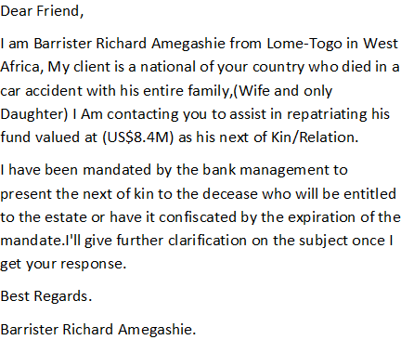
Scammers.
LinkedIn Views about Carer roles 23.10.2016
Thanks for reaching out! I'd love to hear more about this. Hi as you might realise I have been doing caring for most of my life in one capacity or other from the age of seven when I helped with my younger siblings. Being an only girl in a male dominated household I believe helped prepare me for my caring roles and responsibilities. I have worked in early childhood education from my native Jamaica. Studied and gained numerous qualifications from the Open University and Lambeth College. I even done the Health Care Assistant trainings. Now I am carer for my elderly husband as well as trying to manage and control my own disabilities. I am always interested in gaining new skills and updating my knowledge to develop my Continuing Personal Professional Development Plan (CPPDP). But honestly I see myself as an advocate sharing my own experiences as an informal and formal carer, to support others in any way I can. Thanks for taking an interests in what I do and asking my opinion.
My Insights after visit to Community Plaything 26th October 2016
I will have more to share in the future. Community Playthings UK agreed to video some of my #Sessions for me to use for my #FutureInitiatives. Need the #Website sorted for me to be up & running. But as soon as the year is finished with LEYF Nurseries, I can dedicate myself to my #Passion? I have had one of the longest Transition, but it was worth it in the end. I made some of the most revealing #SelfDiscoveries about the #RealMe. I am more than happy & proud of Me - faults, flaws, etc, etc, & all! I can't reiterate the fact that #FamilyMustStick2Gather no matter what. Of course there will be #Disagreements, but some times we need to overlook & move on. That's why my #FIGHT4JUSTICE is to get #Closures, so I can move on with my life & focus on the things I am passionate about the most. My #2Sons Kevin Murray & Valdin Legister & their Families. My #Siblings & extended Families & of uttermost importance those #Friends I have met at various transitions in my life from Childhood to Older GrandMother. For all those who have been on this #Journey with me thru thick & thin, my sincerest #Appreciations. I was so touched today by the outpouring of #LoveSupport I received at Community Playthings UK, that is another way of restoring what I lost from the mistreatments of LEYF Nurseries that tried to destroy my life. I am on the mend & I promise myself to get over this sordid episode in my life & move on. Because if I don't LEYF Nurseries & the corrupt #Systems will continue to be my #Jailer & I don't intend to be kept a #Prisoner any longer. I want to go out there & enjoy life like I used to. Therefore folks it's time for #Reflections! I do this in honour of the #MOTHER that I didn't really know until it was way to late to make amends?

Ping Wing show – Black History Month celebrations 30th October 2016
Attended Ping Wing show at the Karibu Education Centre, 7 Gresham Road, Brixton, London SW9 7P last night. The turn out wasn't great, but the #Edutainment was more than inspirational. I was privileged to be in the company of Yasus Afari, Dervan Malcolm, Uncle-syd Basefm, #LesofTradition, the #Blackstone, et al... But now I have to wait to get internet b4 I can share some of what I accummulated to the world. I am not working because of LEYF Nurseries & the #SYSTEMS are complicit in trying to stop me from getting what I am due. Now I would think I would be getting benefits for my #Loyalties, but instead I am expected to pay over the top for services from the #InternetProviders. No way, I am already living from #Hand2Mouth & lost my dignity of been #AnIndependentWoman.
But I hear Ping Wing asking for help to continue putting on his shows to Educate Us in this #BlackHistoryMonth that is coming to a close. However I would like to dispel this myth, and asks everyone with some amount of clout to get on board so we can retain our Cultural Heritage to be passed down to the #FutureGenerations. So that when those who are #Passionate like Ping Wing & those who came out to support him decide to put on a show, there are not more #EdutAIners than #Patrons at such events? Therefore as Yasus Afari was trying to get across to the auduence, we need to do our #Reseach and know about our history. Looking forward to the visit of Mutabaruka, as I have not been privileged to be in his company. In the words of the great Bob Marley we need to "Emancipate ourselves from Mental Slavery..." so the #Oppressors like LEYF Nurseries can't get away with denying us of our #Rights and treat us less favourably than an #Animal. The animals have the RSPCA London South East Branch, but I was never given a #Voice from October 2014 when I asked for support. Instead the #SYSTEMS colluded & conspired with LEYF Nurseries to #Destroy me. But as I have always said, the "Pen is mightier than the Sword & Might can't beat Right"?

Appeal 13th May 2015
Key Appeal Points:

Disciplinary Procedure:
1. Page 1: I raised queries about none clarifications of the Disciplinary because the Union Rep Darren Mahon had raised them and asked for clarifications from the Panel. Since I am not that learned about legal matters, I just brought it up because I realised that the Panel did not know and had to seek clarification from HR which came near to the end. However Rashid did explain in the end, but I doubt at that time I was able to take any information in, which I explained to the Panel because I was so anxious and stressed out? I had done my research and prepared my Appeal myself without any legal advice and is therefore sorry for any ambiguities that may have been included. At the same time I will try and address them here so they are clearer to understand by both myself and the Panel this time. This is after I’ve had adequate time without any interruptions to do my RESEARCH thoroughly again now that I am not feeling under so much pressure.
My arguments:
Re: Breach of Provision, Criterion or Practice.
My arguments for questioning whether LEYF might have breached their own Policy and Procedures will be detailed because of the different Policy & Procedures presented before the final one resulting in the DISCIPLINARY. Therefore the following should be taken into considerations:
1 (A). Page 1: “The Equality Act 2010 states that although Provision, Criterion or Practice are not defined by the Act, but should be construed widely so as to include, for example any formal or informal policies, rules, practices, arrangements or qualifications including one-off decisions and actions”.
The manager Lynne Kelly at BIB directly and indirectly discriminated against staff sharing “protected characteristics” by Harassment and Victimisation which caused Rumi to resign her post not long after I started at BIB. I’d seen Rumi in tears several times and when enquiring of her health, she refused to discuss the matter with me. However after resigning, she told me the reasons for leaving and invited me to her wedding. (Equality Act 2010 states that unwanted conduct related to a ‘protected characteristic’ is not directed at the particular but at another person or no one in particular). Before and after Rumi left in December 2014 and up to the time on 16.03.15 when I was unceremoniously bundled out of BIB and sent to House of Common nursery I’d been trying to get someone to listen to my pleas that I needed support to deal with my medical health conditions and disability that were exacerbated and worsening causing my Progressive Mental Health Conditions to prevent my from carrying out normal day-to-day activities at work and home (Equality Act 2010).
Re: Shared Protected Characteristic - Race
Racial group share ‘protected characteristics’ and the Equality Act states all racial group are protected under the law.
1 (B). Page 1: The manager started a campaign of direct and indirect discriminations, harassment and victimisation from as far back as (28.11.2014 see Memo to all Staff). This resulted from an altercation which occurred over me eating a Banana to stop my medical health conditions and disability preventing me from carrying out (‘normal day-to-day activities’ Equality Act 2010). The Memo to Staff is self-explanatory as LK is segregating staff, the chef and myself for 2 incidents that happened at times when the chef and I were not present on the separate occasions. Instead of dealing with both incidents professionally, LK instead issued threats of DISCIPLINARY to all staff. But the chef and I were the victims, who are been harassed as will be proven later. Although I was not present when the incident with the washing occurred so I can’t say much about that. In my case it was the Banana and I was issued with verbal threats at the meeting with Nicola and LK.
Re: Progressive Conditions
Those with fluctuating or recurring effects will amount to disability in certain circumstances (Equality Act)
1 (C ). Page: I felt harassed and victimised in the (Staff Meeting Minutes 07.12.2014) as LK directly and indirectly discriminated against me, singled me out in the meeting saying things that caused my medical health conditions and disability to affect me thereafter, which don’t do much for controlling my emotional health and wellbeing by the things she was saying. I felt humiliated and rejected when she told me I should leave because no one wanted me at BIB. LK claimed that Stella Louis told her that activities were not planned and was made up as I go along. Since Stella had observed me doing the activity – “Wrapping Christmas Gifts” and offered to help with peeling the cello tapes and gave me constructive criticism. I tried explaining this in the Staff Meeting saying the activity was planned, but LK didn’t want to hear.
Because of my (OCD, hidden disability of getting anxious under pressure, and not able to write legibly - Equality Act 2010) I am always prepared so as not to be caught off guard as this can trigger my medical health conditions and disability. I went to B&M to buy resources with my money, planned the activity, but was delayed doing the activity because of serving the SNACKS. Stella’s constructive criticism was to advise me to be more prepared next time, but she was pleased with what she observed overall. So I was shocked when LK brought up the negative feedback and the meeting was directed at me. In trying to justify my practice LK keeps patronising, ridiculing and undermining me, until I gave up (see paragraph 6 Staff Meeting Minutes). I just thought from the warm welcome I’d received in July to what LK said to me that night, I felt worthless (Equality Act 2010 says direct discrimination is unlawful, no matter what LK’s motive or intentions, or regardless whether the less favourable treatment by LK is conscious or unconscious). Whenever my medical health conditions and disability are triggered I normally shut down and finds it hard to “carry out normal day-to-day activities”.
Equality Act 2010 states that it is “Direct discrimination if LK treats me less favourably because of my association with the chef who has ‘a protected characteristic’ and the association with me need not be permanent”.
1 (D). Page 1: I got home that night to discover my husband locked himself out of the house collecting a delivery before he got dressed. He was rescued by the neighbours and that affected me because he suffers from a few medical health conditions as well and is reliant on me to help with his care. The Equality Act 2010 states that discrimination by association can occur in various ways and as my husband part time carer, this information about him being diabetic was shared when I updated contact information (Staff Personal Records 13.06.2009). Since the Banana Eating Incident, my husband had started to become concerned about what was happening to me at BIB. So in order not to worry him, because he’d had recently had a bereavement, I kept what was happening to me at BIB from him. I finally had to tell him when I was transferred to HOC nursery.
Re: Victimisation – ‘Protected Act’.
1 (E ). Page 1: The Equality Act 2010 states that it is victimisation for LK to subject me to a detriment because I had done ‘a protected act’). I can only assume that because Stella Louis asked me where I’d worked before and I told her and she works with the organisation “KINGS College NHS TRUST” then that is the reason she gave LK negative feedback about my practice? I felt humiliated at the time and thought the Staff Meeting was held to undermine the contributions I’d made at BIB and LEYF in particular and from that night I was disempowered (paragraphs 2, 6, 9 of SMM – 7.12.14).
Re: Harassment
The Equality Act 2010 states that by instructing, inciting and inducing BIB team LK is engaging in unwanted conduct which has the purpose of violating my dignity, and creating an intimidating, hostile, degrading, humiliating or offensive environment for me.
1 (F). Page 1: 05.01.2015 was when my nightmare started at BIB full-scale after attending Rumi’s wedding and the impact on my emotional health and wellbeing is more than I can bear and is affecting my health making me unable to carry out normal day-to-day activities. Although I have been trying to get support by raising concerns (Notes re Jyoti & Benedicte) the BIB team has been instructed, directed and induced by the manager LK to discriminate, harass and victimise me, influenced by Benedicte who seems to have some hold or influence over LK.
The Equality Act 2010 states generally detriment is anything which I might reasonably consider changed my position for the worse or put me at a disadvantage. As far back as when LK had discussions with Stella Louis and I was stereotyped by Stella I was humiliated in the Staff Meeting and I was not made aware of the negative feedback Stella gave until I read them in (Investigation Report – 28.3.15). I received the Investigation Reports that I previously had no knowledge of with the instructions to attend the Disciplinary Hearing by post on 28th March after Dilys HR came to see me at HOC and gave me wrong information about sending me home to rest with pay from my ordeal. Since 05.01.2015 LK has instructed BIB team and staff from another (LEYF nursery Nicola, Sadie, Lauren and Tesheba) to make allegations against me. This was so she could carry out the threats of DISCIPLINARY (see Memo to all Staff).
1 (G). Page 1: Threats of DISCIPLINARY from 28.11.2014 by LK caused my Progressive Conditions that are hidden disabilities to be triggered: Chronic Anxiety, Depression, Paranoia and Obsessive Compulsive Disorders to start affect how I am able to carry out my normal day-to-day activity at work and home (Equality Act 2010). LK lied saying Mewe told her about discussions at the wedding that I was not happy with management, etc to put Mewe in my bad books I am assuming? I reassured LK that I thought WE had established a professional relationship of manager and practitioner that I felt I could talk to her about my concerns after how she welcomed me to BIB and I briefed her about not working in South London since 2009. I thought the matter was sorted, but being an observant and intuitive person I realised that LK’s attitude towards me changed and she was doing little things to frustrate me by her unprofessional behaviours and conducts to me. Even the Agency Staff who came regular noticed the way BIB team treated me unfairly and commented about it.
Re: Instructing, causing or inducing discrimination.
Equality Act states that it is unlawful to instruct someone to discriminate against, harass or victimise me because I have medical conditions and disability. Or to instruct BIB team to help her do unlawful acts.
1 (H). Page 1: One evening week of 05.0.1.2015 I’d asked Sao the Duty Manager if LK was counted in ratio and being told yes, I went to ask if she could come and cover me. When I got to the office LK was there with (Nicola, Sadie and Lauren) and I went back to the preschool. When LK eventually came she said she had to go in with Carol so I had to stay over and I did. I’d already checked ratio (Duty Managers Induction Programmes) that I’d started at Fitzrovia Community Nursery and done at Luton Street Nursery, so knew I could go, but I refused from challenging LK as I realised she was putting the plans in place to launch DISCIPLINARY (Memo to all Staff) and I wasn’t falling in her trap. I felt uncomfortable coming to work, and my medical health conditions and disability started affecting me, but I was trying my best to cope.
On another evening as I came out ready to go home LK came over to me in a threatening manner and said Mervelee, “We’ll have to have a Meeting because I hear you told Gloria I am a coward”! This was said in front of the children and staff and feeling myself getting emotional I went into the toilet (the Equality Act states that unwanted conduct which is a form of harassment which has the purpose or effect of violating my dignity or creating an intimidating, hostile, degrading, humiliating or offensive environment for me).
Re: Unwanted Conduct
The Equality Act states that unwanted conduct covers wide range of behaviours including spoken or written words of abuse, acts affecting my surroundings or other physical behaviours.
1 (I) Page 1: After calming myself sufficiently to leave I came out of the bathroom, went to the office and tried reasoning and pleading with LK telling her that she should stop letting others feed her with gossip and what she was doing to me was making me sick, but she was intent on what she was doing and wouldn’t listen. I left work feeling really low and trying to avoid the parents coming in so they could not see I am crying (Equality Act 2010 states a serious one-off incident can also amount to harassment).
1 (J). Page 1: LK tried all kinds of tactics instructing BIB team to make allegations so she could find ways to launch DISCIPLINARY, but each time it failed. There were 2 times she tried to use the Social Media Policy and Procedures when she got the Area Manager Hilda Miller to come down. Because LK chats so much and is not aware of Confidentiality, she let slip what her PLANS were and I was put on my guard by someone who did not agree for BIB to discriminate, harass and victimise me (Equality Act 2010 states unwanted conduct related to a ‘protected characteristic’ does not have to be directed at the particular worker but at another person or no one in particular – Chef and me Racism).
The 2nd occasion when Hilda Miller came was because of a Publication on LinkedIn that talked about the BENEFITS of Working Close to HOME. I’d gained permission from the persons whose photographs I used and some others are on Social Media. LK tricked me into getting my email even though I’d given it to her to send me photos from BIB Christmas Party, just so she & Flavia could check Social Media. She done this because I told her about the publications I’d posted, because I am always sharing with LK about my PASSION and my VISION and the work I do on Social Media. At LSN we were encouraged to contribute to the CEO Blog (see copy).
LK told me she wanted to share some Research Materials that I’d be interested in, only she was checking Social Media to find evidence that I’d breached the Policy & Procedures. HM came and told me to take down what I’d published and I should not say I work with LEYF. When I tried to reason saying WE were encouraged to contribute to the CEO Blog, I was rubbished and humiliated. Because instead of dealing with the concerns I’d raised about the way I was been treated that was affecting my medical health conditions and disability (Notice re Jyoti & BS). LK prefers to take the things I’d done out of context, misconstrued and misinterpreted them when representing them to LEYF to put her plans of getting me out of BIB in place. When BIB team went to Mewe leaving party, I’d collected colleague’s email and shared photos with them privately. I am not friends with any BIB team on SM.
Re: Victimisation
The Act prohibits victimisation. Victimisation for LK to subject me to a detriment because I had done ‘a protected act’ or because LK believes that I may do ‘a protected act’ in the future.
1 (K). Page 1: By this time I realised that nothing I do, could be right no matter how hard I tried. There was an Emergency Staff Meeting directed at me where I was stereotyped, labelled, marginalised, humiliated and made to feel an outsider as I was rejected by all at BIB at this time. The only exception was Gloria the Chef who tried to motivate me to keep going when I was feeling down, because she was aware of the plans BIB had to get me sacked. I was shocked at the things I heard coming out of the Emergency Meeting and thought it was pointless trying to justify myself to anyone any more. That was when I realised that there was Language Barriers between Benedicte S, Flavia and Joyti and I. But the next day LK tried to set up REMI against me saying I’d said negative things about her because she was not at the Emergency Meeting. I had to convince REMI that LK have an agenda, and at the time I was not aware that REMI had gone and done the same thing setting up LK against me? Therefore LK had put her plans in place to launch a DISCIPLINARY instructing and inciting BIB team to discriminate, harass and victimise me without me knowing – Equality Act 2010 states that a serious one-off can also amount to harassment).
Re: Shared Protected Characteristics.
‘Because of’ a protected characteristic. The Characteristic needs to be a cause of the less favourable treatment, but does not need to be the only or even main cause.
1 (L). Page 1: One morning I came into work after LK said we were to have a Meeting and was told she went to Emergency Meeting at CO. When she came back I approached her about the Meeting because she did not speak to me. By this time since 05.01.2015, she kept acting like a Spoilt Brat, acting unprofessionally towards me (Equality Act 2010 states that although provision, criterion and practice are not defined they should be construed widely so as to include, example any formal or informal policies, rules practices, arrangements or qualifications including one-off decisions and actions). She tried and avoid me and don’t acknowledge me by speaking to me directly until there is a Meeting where I get blamed for everything that is not happening at BIB. I approached her since she did not acknowledge me and asked her about the Meeting and she said she was told not to talk to me about the incident. However LK said she was told to do my Supervision.
Re: Direct Discrimination.
Direct discrimination is unlawful, no matter what the employer’s motive or intention, or regardless of whether the less favourable treatment of the worker is conscious or unconscious. Employers may have prejudices that they do not even admit to themselves or be unaware that they are treating the worker differently because of ‘a protected characteristic’.
1 (M). Page 1: At the (Supervision) LK seemed to be very agitated and although she told me she was asked not to discuss the matter with me she kept on and on… LK said she had to go to CO to get counselling because they were talking about Margret at Rumi’s wedding and she ABUSED children. However I had no knowledge of anything that happened before I came to BIB, so whatever was discussed I wouldn’t be interested. LK said CO told her to deal with the matter at BIB anyway she liked and she was going to show me who is COWARD (Equality Act 2010 states that by treating me unfavourable making allegations to CO team about malicious gossip Benedicte passed on to LK about conversation at RUMI’s wedding is victimisation and the Act prohibits Victimisation). I only learned since I got the Disciplinary in the Investigation Report that LK asked BS to write report about Rumi’s wedding and it was sent to Dilys HR at CO, so all this time CO were given alleged information that caused prejudices? My arguments are the Central Office team were given information to stereotype me and caused me to be treated less favourably. Therefore when I raised concerns about the unwanted conduct and behaviours of some of BIB team towards myself and children with SEND the Central Office team did not take my concerns seriously and act on them (emails & report to Dilys).
Re: Indirect Discrimination.
Indirect discrimination applies to all protected characteristics’ apart from… This may occur when an employer applies an apparently neutral provision, criterion or practice which puts workers sharing ‘a protected characteristic at a particular disadvantage.
1 (N). Page 1: By the time the Supervision was finished I was fearing for my Sanity after hearing LK voicing what she was going to do to me to make me leave BIB. LK claimed the (Notes re: Jyoti & BS & Publications from Social Media was at CO) where they were trying to find evidence for DISCIPLINARY. Right up to this stage I wasn’t unduly worried about Social Media because I’d studied with the Open University and abided by British Ethical Standards. And LK told someone that they couldn’t find anything on me for a DISCIPLINARY all she was trying. I’d taken photos ensuring I downloaded on the computer at work. LK even had to enlist my help to send the photo of Theresa Salmon and the children to CO to go up on SM.
Re: ‘Protected Characteristics’
Protected characteristics include age, disability, race… Racial groups share colour and are protected from unlawful discrimination under the Act. The Act states that a person have a disability if they have a physical or mental impairment which has a long-term and substantial adverse effect on their ability to carry out normal day-to-day activities. Physical or sensory impairments such as those affecting sight or hearing.
I am hereby contending and arguing as part of my Defence that LEYF Breached their Policy & Procedures and Contract by authorising the manager at BIB LK to discriminate against me, harass and victimise me from when LK visited CO and was told to deal with the matter any way she wished. LK did not only discriminate against me, but the chef Gloria as well because she did not agree with BIB team treatment of me. One day when I witnessed a stand-off between 2 headstrong women – LK & Gloria, I defused the situation by taking the trolley to the Baby Room because the chef was washing up. But LK was doing everything to frustrate Gloria to act out of character like she was doing to me.
By not listening to my arguments and aiding LK in trying to find DISCPLINARY Procedures to dismiss me from my job meant that some of my Basic Human Rights were breached under the Human Rights Act. As a result my medical health and disability have been exacerbated and worsen since 05.01.2015 making it difficult for me to carry out normal day-to-day activities at work and home. Furthermore when I asked for support in the form of reasonable adjustments, none was forthcoming as LEYF continue to apply neutral provision and practice GAGGING me, leaving me to the discrimination, harassment and victimisation at BIB and later at HOC (emails & correspondence to Dilys HR, correspondence to LK).
The Equality Act states direct discrimination is unlawful, no matter what the employers motive or intention, or regardless of whether the less favourably treatment to me is conscious or unconscious. Employers may have prejudices that they do not even admit to themselves or may act out of good intensions or simply be unaware that they are treating me differently because of a protected characteristic.
Although I’d provided information about my medical health and disability conditions from I started at LEYF and continued updating. There is no evidence in the way I was been treated since 05.01.2015 up to when I attended the DISCIPLINARY HEARING that any due regards was taken to check my files to ascertain what I was saying was correct and not a figment of my imagination. Therefore leaving me at BIB for so long until my medical health and disability conditions were exacerbated which triggered my mental health conditions is evidence that LEYF breached their Policy & Procedures by not making reasonable adjustments. By giving LK the authority to treat me unfavourably there was indirect discrimination at BIB against the chef and I when Gloria did not agree to the discrimination, harassment and victimisation planned for me to get me sacked. I ended up feeling responsible for the unfavourable treatment to Gloria and her daughter which caused the chef to cry. My DEPRESSION was triggered when I encountered similar experiences when I’d done ‘a protected act’ to save my good name and character. And I was affected again going through the menopause and then when I got diabetes. So on top of my (Chronic Anxiety see GP letter), I had a lot to be dealing with.
Re: Detriment
Generally is anything which the individual might reasonably consider changed their position for the worse or put them at a disadvantage.
1 (O) Page 1: One day LK said we were to have a Meeting and Remi was to be there as Mediator as HM the Area Manager was unable to attend. During the Meeting a number of allegations were again made by BIB colleagues whom LK refused to name as she read from them. I refuted all the allegations except one that I refused to comment about. Although I had asked Sadie to come in with me and told her why I needed the support – so I don’t have Jyoti coming to frustrate me. She’d taken some of what I’d said out of context and misinterpreted it to suit LK’s purpose of collecting evidence. However if LK had spared the time to read the concerns I’d raised as part of my DEFENSIVE PRACTICE, she’d realised I’d mentioned how Jyoti was frustrating me and I was STRESSED. I realised that when I’d gone to the office and seen the (4: LK, Nichola, Sadie and Lauren) the evening when LK tried to set me up to challenge her, they were making plans to trap me?
After the Meeting LK said Remi would write the Minutes so I could get my Copy, because Staff made allegations against me. Every day LK keeps saying I’ll get it tomorrow but I never got it. But I was not surprised that there was no minutes for me because I witness lots of inappropriate practices at BIB re the Welfare Requirements of the EYFS – DOCUMENTATION. When I enquired about certain of the (Equality Act 2010 re Provision, Criterion or Practices) I was told by Benedicte “WE DON’T DO THAT HERE”. Since LK admitted that she did not have trainings nor have the knowledge to fulfil some of her ROLES & RESPONSIBILITIES, I just went ahead and do them after first informing her of my intentions and giving her anything that she should authorise (see Worry & IEP Forms Continuing Personal Professional Development Folder ) for key child for whom I have concerns. However LK was very patronising saying things like “We have some clever people at BIB now, but I am making corrections”? There was no follow up on anything that is done and Resources are put at strategic locations, yet no one done trainings or know anything about them. At Supervision LK claimed Marion copied it and took to CO.
Re: Contract - Job Title:
You will work as a NURSERY OFFICER. This job title does not limit your duties with the Organisation and you may from time to time be required to do other work that is within your capabilities either on a permanent or temporary basis. You will report to your Line Manager. (Since have an updated Job Title of NURSERY PRACTITIONER)
1 (P) Page 1: At a Room Meeting BS was talking about information passed on by Gary Simpson at CO, about things to be promoted and implemented at the setting, but BS couldn’t explain. Knowing it was to do with the ECAT forms and Early Intervention, I explained and when they still didn’t get it went to my locker to get the relevant forms. I’d brought in relevant formats for Activity Planning, etc and give to LK and asked her to see if Mewe could find it on the computer since I am used to having all the resources on the computer at Luton Street. I found it strange that although there were information on a board in the hallway yet no one even knew what the ECAT form looks like and what it is used for. Since Remi had started implementing some of her practice as a long time LEYF worker at BIB instructed by HM the Area Manager, I carried on with what I was used to at Luton Street. At LSN I was the SENCO & EYFS coordinator (see training certificates – correspondences re Sandie Choi Inclusion Teacher – Camden).
Re: When can Employers be Assume to Know about a DISABILITY?
If an employer’s agent or employee (such as an OH adviser or HR Officer) knows in that capacity, of a worker’s disability, the employer will not usually be able to claim that they do not know of the disability, and they cannot therefore have subjected a disabled person to discrimination arising from disability.
1 (Q) Page 1: When Dilys came to offer me to take out a Grievance, I discussed with her about the issues coming out of one of the Emergency Meetings re the alleged offences I’d caused Benedicte and Flavia by encouraging them to do Research about Multigenerational Approach (CEO letters 05.11.2014). I’d apologised for the misunderstandings and explained it was my passion for promoting and implementing LEYF ethos that had caused me to want to introduce some of the best inclusive practice from LSN (see parents letter – Ashmita’s mum). I don’t think Dilys was really interested in anything I had to tell her because LK & Benedicte had already prejudiced her mind against me. I might have taken up the Grievance even though I knew it was fraught with risks if I was given enough time to prepare.
Dilys told me I had to let her know by Monday at 4.30 pm if I was going to take the Grievance and when I pleaded that I had to be at work so could I sent it later…? She was adamant that she would not change the time. If I decided to take the Grievance, I’d had to send it in the next day, so I weighed my options and decided not to. Because I could see the pitfalls and since BIB and LK had collected their statements/evidence, I was leaving myself opened to a DISCIPLINARY, so I declined. The Equality Act talks about the Relevance of Reasonable Adjustments – Employers can often prevent unfavourable treatment which would amount to discrimination arising from disability by taking prompt action to identify and implement reasonable adjustments.
In the space of the same day, I was presented with 2 Policy & Procedures document because another allegations was made against me. There was a Grievance and a Behaviour Management and my world just seemed to be falling apart and I felt like the animal caught in the headlights of the on-coming traffic with nowhere to turn. I couldn’t help but cry as I just couldn’t see a way forward. Dilys promised to send telephone number to LK so I could get COUNSELLING. All this time I was GAGGED, so had no one to speak to, and I refused to tell my husband what was happening to me so as not to worry him? I went to the doctor after Dilys came and talked to him and got some time off. When I was due back, LK was trying to keep me away, but I returned. On returning I started clearing the garden as I’d promised to set up a Forrest Schooled Themed Mud Kitchen that I’d discussed at the Parents/Staff Meeting. I’d collected resources at the (Nursery World Show 2015).
1 (R). Page 1: There was an Investigation after BIB staff instructed by LK made complaints about me that was sent in by 3.00 o’clock on Thursday and the Investigation carried out by Isabel Glen was done by Friday the next day. I was told about the Investigation after LK used delaying tactics to keep me back so she could collect evidence that I act out of character and unprofessionally, but I did not fall in the trap by LK & Flavia. The next day I was delayed getting to work because my husband wasn’t well and when I got in LK asked if I was sure I wanted to be there? I replied yes I have to be here and went to the cupboard to put away my stuff (see Memo to all Staff). When I am in the cupboard LK came in all flustered and said Mervelee I did not mean that the way it sounded. What I mean is you can go home after the Investigation if you are not feeling well.
I was the last person to be called and felt so terrible because all my medical health and disability conditions were triggered it was hard for me to articulate some of my experiences since I started at BIB and the discrimination, harassment and victimisation started. I began to have palpitations and felt faint. I’d had similar experiences before and was admitted to Accident & Emergency after seeking advice and told to go to the Hospital (I’d done ‘a protected act) when I had similar experiences at Kings College Hospital NHS Trust. I left from work to the hospital and was kept in for observations (see Staff Personal Records 13.6.2009). I never leave until after 6.30 pm considering I have my diabetes and other health conditions to think about. Since 05.01.2015, my whole world was turned upside down and I wasn’t eating and sleeping properly.
By the time Dilys came to offer me to take out Grievance, I was DEPRESSED and all my Progressive Conditions and hidden disabilities were affecting me. I was hiding things from my husband and worrying that I could have an HYPO because I wasn’t able to carry out my normal day-to day activities of caring for myself properly at home and was working under unfavourable conditions at work. I was presented with more allegations and also given a Behaviour Management Policy, piling on the pressure re DISCIPLINARY that was causing my medical health and disability hidden Mental Health Conditions to make it difficult for me to carry out normal day-t-day activities. However no one was listening to my pleas that I’d not intentionally set out to offend anyone at BIB, but came with the passion of sharing LEYF ethos and core values that I had developed 5+ years working with LEYF.
Re: Discrimination by association can occur because I am carer to my husband who has ‘a protected characteristic’.
1 (S) Page 1: I came home and send (email to Dilys HR) about needing to be given a Voice to talk about what was happening to me at BIB. At the DISCIPLINARY Hearing when the Union Rep Darren Mahon put in a mitigating plea about me asking for support and the time it took for a response and there was no follow up. The PANEL chair Rashid claimed he did not know about the email. Yet that email was sent 2 weeks before I was charged with the DISCIPLINARY. If my file was checked since it later emerged that LEYF is saying they are not aware of my “protected characteristic”, the information would have been found. The Equality Act states that Employers can often prevent unfavourable treatment which would amount to discrimination arising from disability by taking prompt action to identify and implement reasonable adjustments.
Re: Reasonable adjustments Relevance of reasonable adjustments
Equality Act 2010 - In order to avoid discrimination, it would be sensible for employers not to attempt to make fine judgements as to whether a particular individual falls within the statutory definition of disability, but to focus instead on meeting the needs of each worker.

1 (T) Page 1: Monday I was aware of everything happening around me because I hear conversations, but because I was GAGGED, I had to abide by the rules of (Confidentiality Policy). However LK and BIB team were engaging in instructing and inducing each other to continue making false allegations against me and lying about why Isabel Glen was coming back. Apparently BIB were given information that I’d complained, and whilst I was GAGGED, BIB had the freedom and voice to continue with the discrimination, harassment and victimisation against me. Hilda Miller the Area Manager came and told me she was sending me to HOC to take the pressure off me until the matter was sorted. However when I told Isabel Glen the Investigator about this new development, she didn’t know about it.
I met someone on the road who told me that they were informed that I’d not be working at BIB again because I’d complained. All I was doing was to use the available resources (Whistleblowing Policy & Procedures) available to me to try and preserve my Basic Human Rights (Human Right Act) and take back control of my life that was spiralling out of control and which could lead to me having some serious health issues that could incapacitate me for the rest of my life. I began to have memories of my dad who had Parkinson’s disease, my grandma who suffered strokes before she died, my brothers who died at young ages, one from cancer and the other I will not disclose at present and my mum who had dementia. Being my husband career I know the effects of falling into a HYPO. At times it’s hard for me to leave the house and if I do I am scared of losing my dignity some times.
Re: Modifying Disciplinary or Grievance Procedures for a Disabled Worker
In some cases, a reasonable adjustment will not succeed without the co-operation of other works. Colleagues as well as managers may therefore have an important role in helping ensure that a reasonable adjustment is carried out in practice. Subject to considerations about confidentiality, employers must ensure this happens. It is unlikely to be a valid defence to a claim under the Act to argue that an adjustment was unreasonable because staff were obstructive or unhelpful when the employer tried to implement it.
1 (U) Page 1: When I’d put in for transfer because of my ‘protected characteristic’ I was asked to go to HOC, but because I’d covered there and realised that I would not be able to manage, I’d decline the offer. By sending me to HOC without finding out from me the effects such a transfer would have on my protected characteristic, Hilda Miller the Area Manager breached my Basic Human Rights without even realising. If HM had consulted with instead of bundling me out of BIB, without the knowledge of Isabel Glen the Investigator, I could have informed her why it would be difficult for me to carry out normal day-to-day activities. Even if I’d tried to argue my point, I’d no doubt be humiliated like she did before and told that because I don’t have a Status on LEYF Hierarchy Model, I did not have a say.
HM said some derogatory things to me about how she would give preference to Jyoti over me, once when she came to talk to me after she was hoodwinked by LK who went again crying crocodile tears stereotyping me. HM acknowledged I’d done excellent work on the Learning Journeys one of which she was using for her 2 year old Pilot Project, but yet I did not have a say in promoting and implementing inclusive practice once (see BIB OFSTED) came and went. HM told me I knew nothing and I was not coming to BIB to spoil her Baby, because LSN where I was coming from was nothing, because she was informed by someone who was there that we just scraped through the OFSTED.
Re: Contributions & Loyalty - Provision, Criterion or Practice.
Not defined by the Act but should be construed widely so as to include for example any formal or informal policies, rules, practices, arrangements or qualifications including one-off decisions and actions. What is meant by reasonable step? Effective and practicable adjustments for disabled works often involve little or no costs or disruptions and are therefore very likely to be reasonable for an employer to have to make. Even if an adjustment has a significant cost associated with it, it may still be cost effective in overall terms - for example, compared with the cos of recruiting and training a new member of staff – and so may still be a reasonable adjustment to have made.
1 (V). Page 1: Now who is loyal to LEYF I don’t know, but I thought all LEYF staff were working for the same outcomes. Then I realised why BIB kept telling Remi and I that we were not taking anything from where we are coming from to BIB because they are not LEYF (see letters). Is it any wonder I end up at the LEYF New Year Staff Party on my own, even after Rujina brought her clothes to attend and was sent home? Then Nichola send information to LK that I was on my own and she came to BIB next day ridiculing my loyalty to LEYF. Maybe it should be made known who authorise BIB that they did not have to attend the party & then we know who is an ASSET to LEYF, making valuable contributions and focused on spreading LEYF to the World at Large (check photos of LEYF NYSP).
When I first transferred to LSN, LSN got published planting & reaping potatoes as part of St Patrick’s Day celebrations. I’d gone on to get LSN published in the Nursery World (see NW Publications). This was my putting back into LEYF some of the investments made by Candy, Patricia Sessions and all the other staff at Fitzrovia Community Nursery who helped my Induction in LEYF ways of working (see Patricia Session letter). I took copies of the Nursery Wold Magazine on holidays to Jamaica to share my pride in working for such a wonderful Organisation. Because LEYF rescued me from a life of an Uncertain Future when they gave me a job in 2009. It was thanks to a former colleague whom I worked with at Kings College NHS Foundation Trust when I thought I’d reached rock bottom. I’d been rejected for so many posts because I’d done the right thing acting on the values and believes I’d been raised with and challenged DISCRIMINATIONS and done ‘a protected act’ (see OFSTED Contacts).
1(W) Page 1: I would prefer to forget my treatment at HOC because it is in the (Medical Referral Occupational Health Report). I’ll end by saying the discriminations, harassment and victimisation only got worse because I was out of my comfort zones and was even more fearful of losing my dignity. However to be treated like a Common Criminal on the day 27.3.15 when Dilys came to see me by the Manager at HOC was beyond the par and I am sure the Security witnessed what was happening to me? The Manager breached LEYF contract that every person who entered the building has to be vetted and that’s why Agency Staff could not go to work there. To say she had to escort me out of the building because I did not have a PASS was ludicrous. Her excuse was there was a High Security presence. Is she telling me the Security were not doing their jobs after I was at HOC since the 17.03.15? As for her and some of the staff behaviours and conducts to me, I can only assume because once again I have no evidence for what was happening to me at HOC except my Defensive Practice of documenting and recording. I am always thriving to be the best I can be by always enhancing knowledge to empower me to give of my best in all aspects of my (Continuing Personal Professional Developmental Profile) as the only forward as I apply the top down/bottom up approaches to give of my best where my contributions were valued and acknowledged before I transferred to BIB (see letters - LYEF).
Re: Direct Discrimination by Association.
Equality Act states if employer treats a worker less favourable because of workers association with another person who has ‘protected characteristics’. Discrimination by association can occur in various ways – where worker has a relationship of partner, carer, or friend of someone with ‘a protected characteristic. The association with the other person need not be a permanent one – Children with SEND and other additional needs – Disability as ‘a protected characteristic’ – (see Complaint to Dilys) and the chef Gloria – Race as ‘a protected characteristic’ being discriminated, harassed and victimised because she did not agreed to what BIB were doing to me.
1 (X) Page 1: The final straw came when Dilys failed to believe anything of what I was trying to get her to understand that was happening to me at BIB. She kept saying that’s not what they say about you. All I wanted was someone to please stop a minute to stop judging me off the say so of others who hardly know me. Because when I spoke about my former manager Julie Weise, Dilys told me about her happy news of becoming pregnant. At least Dilys could have spared the time to ask JW about me? I had to make comparisons to being treated worse than an animal and if I was an animal the RSPCA would be called. I did make the same reference at the DISCIPLINARY Hearing, but everyone looked at me as if I was MAD, because the Panel had only one intention and that was to find a SANCTION that would result in me getting the SACK to breach one of my basic Human RIGHTS.
My life has been put on hold and I am missing some key dates that I should be celebrating with my Family & Friends, but instead I am worried sick and trying to clear my name and character from this onslaught by some who can’t take time out to forget the PRUJUDICE that clouded their judgements and make them go back to becoming the Person they were before the hood was drawn over their eyes.
1 (Y). Page 1: I was told in no uncertain terms, not to APPEAL, but I owed it to myself, my 2 Sons, 4 grandchildren, brothers & Family, Friends & Acquaintances to stand up for my values and beliefs. This is the 3rd time now I am having to go through something of this magnitude that could destroy my life and I am hoping it’s the last. Because I just can’t cope again as my ‘protected characteristic’ including all the Progressive Conditions which take control of my life are taking their toll because I am no longer young. My only consolation is that my mental faculties – cognition and intellect are serving me well…? Then I can compensate my HUSBAND for the tears he shed, the sufferings he’s been through with me since 17th March 2015. Hopefully I can put all this behind me as WE celebrate Our 1st Year of being Husband and Wife. I rest my Case.
Re: Declarations
I am not here to seek vengeance on anyone, only to get some closures and removed the Barriers, Constraints and Limitations that have been placed on me since 05.01.2015. If I learned one lesson from my journey through life so far is to forgive, but not forget. If a person done you one good, take that one good and cover all the bad. LEYF rescued me from a life that was worse than death, so therefore I am not going to let these unhappy past months take away from all the benefits I’ve enjoyed at LEYF that made my life almost complete and fulfilled. My only regret is that LEYF took so long to listen to my pleadings and give me a VOICE. Therefore I’d hope LEYF is going to put the reasonable adjustments in place by offering TRAININGS to my BIB colleagues. I don’t wish anyone to lose their jobs, only lessons to be learned so no one else goes through what I’ve been through these months and robbed me of all this precious time. I am still LEYF 100%.

2 Page 1: Disciplinary Action at LEYF
My additional arguments in defence of my Appeal is that there were no true basis for the Disciplinary Hearing that was launched resulting from the Investigation because the matter should have been dealt with internally by the manager LK in the first place. But the only reasons the manager could not deal with them is because she is responsible for instructing, inciting and inducing some of BIB colleagues to make allegations against me to frustrate me to leave my employment voluntarily or get me sacked.
In considering the allegations and action taken against me, I know that BIB has become set on a path from 05.01.2015 in convincing my employer that I am a different person from the one who has given 5+ years of dedicated service. Since BIB are set on this path of getting me sacked no matter whatever I have done or not done. No amount of justifying my contributions, applying my knowledge and expertise in implementing and promoting best inclusive practice since I arrived at BIB have stopped them trying to get me sacked. Therefore I believe the adverse finding against me regardless of the impartial and thorough investigation having taken place. The findings that were made have no evidential substance and I have fully explained what happened on the days in questions as well as provided other pertinent information that are relevant to the case.
I further firmly submit that my years of dedicated services and contributions to LEYF, commitment to my work and input since my transfer should have been considered by the Panel. I have had years of exemplary services without any adverse finding on my record and this should have been a factor that the Panel took into consideration in deciding to issue me with a final written warning. In addition I feel that I have been unfairly treated in regards to complaints that I have made in the work place, particularly a recent complaint that I made about a child with SEND that everyone is ignoring. I feel that every time I raise concerns some of BIB staff gang up on me in order to make me stop making complaints. This shows an inconsistency in treatment. I also feel because I raised concerns I have been treated differently. To date as far as I am concerned nothing has been done about my complaints.
For the reasons stated above I consider that an impartial position was taken to impose a final written warning was not fair or reasonable towards me. The Panel did not fairly consider all the facts and ignored relevant facts as I have noted above. When the Union Rep asked about making reasonable adjustments ensuring I had support re the email I’d sent to Dilys at HR, Rashid said he had no knowledge of the email.
In inciting others to make allegations against me so she can collect evidence against me, I have had occasions when LK tried to find evidence that I breached a number of Policy and Procedures. She instructed Benedicte to submit written statements about allegations that I purported to have made about LEYF staff at Central Office and former colleagues. But I consider BS statements to be either consciously or unconsciously malicious because she is prejudice against me. Therefore she has misconstrued and misinterpreted my arguments for her own agenda of getting me sacked as she threatened to resign if LK didn’t get me sacked. BS claimed I had made nasty comments about my Manger, Central Office Team and Former LEYF Colleagues, but I done no such thing. And as I reported to Isabel Glen during the Investigation, I think there are questions of language barriers between some of BIB colleagues with English as Additional Language (see Investigation Report) and myself.
When I arrived at the wedding with my friend who is also a former colleague at Kings College Hospital NHS Foundation Trust (see OFSTED Contacts – Varul), there was a discussion already in progress. Most of what was been discussed was irrelevant to me because I did not know the persons and was only at BIB a few month. As the discussion was about work in general, I talked about my experiences at another workplace and some former colleagues. This had nothing to do with LEYF and BS got the wrong end of the stick. The manager later said she was upset because they talked about Margret and she abused children and what was said at the wedding caused her to go seek counselling. LK claimed that she was advised by Central Office to deal with the matter any way she chose and that was when the harassment, bullying and intimidation started full scale. I have had to live with that OFSTED poster everywhere I turn knowing all I did was trying to use my knowledge and expertise gained via studies (see CPPDP) to promote and implement best inclusive practice to meet the diverse and complex needs of children.
When I started deciding to use my Defensive Practise because the manager refused to act on my complaints, she then enlisted the help of the Area Manager. But not even then was I made aware about any of the allegations that were sent to Central Office and now I am not sure if the Area Manager and Central Office were given the correct information regarding the matter. I only became aware of the magnitude of the allegations that LK instructed, incited and induced others to commit discrimination against me after reading the Investigation Report that was the basis for the Disciplinary. But in addition to trying to get me sacked making up false allegations, other forms of inducement were presented that could lead to disciplinary actions and I refused to accept. Because of prior occasions when I had done a “protected act” (Equality Act 2010) because of having a “protected characteristic”, I had failed. This only happened because I could not provide any concrete evidence to support my claims. The UNION that I’d paid my dues to failed to represent me so I had lost trust in the SYSTEM that let me down when I was VULNERABLE. Therefore when Dilys HR came to offer me the chance to take out the Grievance, I declined. Because I was not being given enough time to prepare.
Thereafter LK and the BIB team tried other ploys going through the Policy & Procedures to find one that would result in a final written warning. Therefore they directly and indirectly discriminated against me as the unfavourable treatment which they engaged in victimising, intimidating and harassing me to the point where my Progressive medical health and disability conditions were triggered. Caused me to be unable to carry out my normal day-to-day activities at work and at home (see email to Dilys HR). Without probably knowing the magnitude of the discriminations that affected my medical health and disability conditions at BIB. (The Equality Act 2010) states that LEYF might have contributed to BIB direct discrimination against me that is unlawful regardless of the motive, or whether the less favourable treatment of the worker is conscious or unconscious. The Act says that employers may have prejudices that they do not even admit to themselves or may act out of good intentions – or simply unaware that they are treating me differently because of a “protected characteristic”.
My closing argument on this is that the manager Lynne Kelly and the BIB team influenced by Benedicte set out to discriminate against me directly and indirectly without taking my “protected characteristic” into consideration. (The Equality Act 2010 – 2.12) states that a person has a disability if they have a physical or mental impairment which has a long-term and substantial adverse effect on their ability to carry out normal day-to-day activities. Physical or mental impairment includes sensory impairments such as those affecting sight or hearing.
They harassed and victimised me whilst trying to strip me of my Basic Human Rights to earn a livelihood to help me maintain a good standard of life that will help me control my medical health conditions and disability. They provided false information to LEYF causing the issuing of a number of provisions (Equality Act 2010) in the forms of Policy and Procedure documentations that would lead to Disciplinary resulting in final written warning and no reasonable adjustments were made to support me in coping since 05.01.2015.

Claims of Bullying, Harassment and Intimidation
3. Page 1: See detailed information provided in Disciplinary Procedures 1 & 2 Page 1.
Reference:
I want it placed on record that I’d not set out intentionally to be dismissive of anyone, but I’d reached the end of my tether and no one was prepared to listen to me. Because by this time the discriminations, harassment and victimisations I was experiencing from 05.01.2015 was more than I could bare and my “Defensive Practice” was the only way I could defend and protect myself.
However others including: Lynne Kelly, Benedicte, Nicola, Jyoti, Sao, Stella Louis, Flavia & Hilda Miller were in the meantime dismissive of the Contributions I made to LEYF. This was after HM claimed the work in my key child’s Learning Journey was excellent. HM used the work and liaised with me about what she needed to do her 2 years old Project. After she told me, she was not going to put me before her Deputy Manager. But worse than all is when HM told me, I MUST NOT SAY I WORK FOR LEYF.
Jyoti was the one who came and started saying I am LOUD, then the others joined her and were dismissive of my Jamaican heritage, roots and culture.
Loyalty to LEYF: Why was I the only BIB staff to show up at LEYF New Year Staff Party? Is this not proof that BIB did not adapt to the change (see Growing Pains - Louise Cooper). They kept telling Remi and I, we should not come with LEYF ideas because they are not LEYF, but BIB. The Area Manager told me BIB did not have to do Multi-generational if they don’t want to (see CEO letter 05.11.2014).
Comparators: Equality Act 2010
On 2 occasions I made comparisons about my treatment at BIB to “Protected Species” of Animals. When I did at HOC, all Dilys could say was Disgusting, but yet she said “THAT’S NOT WHAT THEY SAY ABOUT YOU”?
At the Disciplinary Hearing I repeated and no one took notice of what I was saying. Then when I talked about the effects on me when I was the last to see my Dad alive and first to realise he’d died. The Panel looked at me as if I was Mad and accused me of not having no EMPATHY!
Maybe it’s time for some of US to go back to becoming the reflective practitioners who developed the listening ethos. I learned this from studies with the (OU 2004 – 2010), but my whole life experiences meant I had first-hand experiences to learn about all the qualities that made me PASSIONATE about caring for vulnerable children and adults from cradle to the grave.
I believe it’s time for US to stop judging each other and believing we are better than one another because of STATUS. More top down and bottom up approaches are needed to solve the problems we are facing in the workplaces.
Lynne Kelly the Manager and Benedicte the Room Leader are RACIST & AGIST who have the whole of BIB under their thumbs at Ransom and I will not be taking back any of this. So yes I am being DISSMISSIVE of both, but I am within my RIGHTS to be so after the living hell they put me through since 05.01.2015!
Refutes the Testimony of all the Witnesses
4. Page 2: I am standing by my arguments that the Panel has stereotyped and discredited my name for no good reasons than they didn’t take the time to do a thorough research about me after my 5+ years working with LEYF. Instead they took all the information that BIB team supplied because BIB team were prejudice against me and threatened to get me sacked by fair or foul means (see Memo to all Staff). Although there was a thorough investigation carried out some of the relevant information were not examined about concerns I’d raised using my Defensive Practice (see notes re Jyoti & Benedicte).
4A. Page 2: No I would not and knows how to meet the diverse and complex needs of each unique child (see Parents letters - Tayandre’s Elisabeth & Ashmita). Whenever I am not at Nursery the children are always asking of me and welcoming me when I return. Not to talk about my years as a Basic School Teacher and formal & informal roles. I have been working in partnership with (Community Playthings see correspondences) since LEYF sent me on a training trip led by Rachel Parker.
4B. Page 2: Yes because LK refused to act about any concerns I raised and presented a false representation of the facts to CO as LK & BS put plans of getting me Sacked into place. Even HR was given information which resulted in victimisation when I tried to implement LEYF ethos and core values working 5+ years with LEYF (see Louise Cooper: Learning Journeys, EYFS, SENCO, trainings). LK confided that she did not have the knowledge & expertise to fulfil some of her roles and knowing nothing has changed in early years since I started working in 1999. I know I cannot override the authority of the Structured Hierarchy in place. From prior experiences that cause me to experienced discrimination, I’d not make the same mistakes again and via studies I learned about Defensive Practice. My Defensive Practice is only one of the ways I can protect myself from the discrimination, harassment and victimisation that has been affecting my medical health and disability conditions which makes it difficult to carry out normal day-today activities (see OH Medical Referral).
4C. Page 2: Yes evidence from the Investigation should be re-examined with relevant information about inappropriate practices at BIB scrutinised. Lack of knowledge and failure to adapt LEYF DNA and make changes is one of the main reasons there is so much problems at BIB. I only became aware about some of the allegations made against me after receiving the DISCIPLINARY to attend the Hearing. CO staff including Dilys HR were already stereotyping me because of some of the allegations sent to CO about me and they were either misconstrued or misinterpreted because of Language Barriers on the part of BS the main informant. Therefore (Equality Act 2010 talks about Employer’s prejudice to workers without knowing…).
4D. Page 2: This is the first time I was aware that Stella Louise was one of the witnesses. I met SL briefly a few times at BIB fleetingly in passing. We discussed ECAT trainings which I’d already done at LSN. On one occasion she observed me doing an activity and gave me constructive criticism and positive feedback. I was so impressed when I realised she wrote Books about Schemas that I signed up to attend (Nursery World Show 2015) after missing it a few years running when I realised she was doing a Seminar. So many of BIB children were learning via Schemas that I wanted to enhance my knowledge. So I’d like clarifications SL said that or it has to be construed as Hearsay? At no time was I rude in the presence of any professionals at BIB and in my professional role. I was taught how to “Dance a Yard & before I go Abroad by my parents being a JAMAICAN”.
Health Conditions
5. Page 2: I am sure the Medical Referral OH that I done should clarify most of this. However I have to say if the Manager LK at BIB was not so intent and busy putting her plans into place to get me sacked some of my Basic Human Rights would not have been breached leaving me to lose my DIGNITY. I’d addressed my medical health and disability conditions as recently as when she done my (Supervision). LK knew the measures I went through to get my file from LSN as I visited 2 times and then asked her to contact CO ensuring information got sent to BIB. I know even LK didn’t realised the importance of having my file as it contains information that was relevant. When one has to go through all the health checks like I & my husband have to undergo, we understand the importance of the meaning of a holistic lifestyle and making changes to maintain better qualities of life (NHS health checks – DESMONDS, etc).
My only arguments is the way I was slowly being rejected by LEYF in that they couldn’t even bother getting my address right that even my husband noticed. He kept asking why they keep writing your address like that 16A-16B. Does that mean LEYF had made decisions that were foregone conclusions about my Life that could impact on my medical health and disability? With LK getting CO staff to come down each time allegations were made offering threats in the forms of Policy & Procedures that could lead to DISCIPLINARY & eventual SANCTIONS only served to trigger my medical health and disability conditions (see OH Medical Referral). That can be the only reasons no one seemed to know about the information in my file about my ‘protected characteristic’ of having a disability with the Progressive Conditions and Hidden Disabilities linked to my medical health and disability. My file should contain the following: (GP letter, Contract, Updated information, etc). I therefore have to ask if LEYF is now saying they have no knowledge of my medical health conditions and disability.
And although it is part of Provision, Criterion or Practice in my Contract to agree to a Medical, I’d told Dilys when she visited me at HOC on 27.03.2015 that I’d self-referred before so knows the procedures. Dilys chose not to believe anything I said as by this time she was either consciously or unconsciously prejudiced against me because of stereotyping from BIB. I am glad I done the Medical because the doctor was such a Professional who help to alleviate my FEARS and advised me about Counselling Therapy and other measures I can get on the road to recovery. I can only hope reasonable adjustment will be made in compliance of the Equality Act 2010 at BIB? Otherwise I’ll have to take advice given by other professionals to take out a GRIEVANCE to get back control of my life at work.
5A. Page 2: My ability to carry out normal day-to-day activities were not unduly affected the past 5+ years I worked with LEYF. Julie Weise my Manager at LSN ensured reasonable adjustments were in place (see Card – January 2014) to enable me to do my work. However there were times when I got STRESSED and went to the (GP letter 2014) who signed me off to get the rest I needed, as I am aware of the triggers that affect my medical health and disability conditions. Therefore I’d make sure to try and keep in control of maintaining a healthy lifestyle to help me cope. Other than that I was given all the support I needed before to do my work. I only was unable to do this once the discrimination, harassment and victimisation started at BIB from 05.01.2015 instructed and directed by LK & BS. Then Jyoti was drafted in and lastly Flavia because poor Flavia had no other options and was herself a VICTIM.
5B. Page 2: The fact that the chair Rashid did not even know about the (email I send to Dilys HR) when the Union Rep Darren Mahon brought it up at the Disciplinary Hearing is testament to the fact everyone at LEYF was now focused on getting me SACKED by fair or foul means using whatever Policy & Procedures they could find. Dilys told me at HOC 27.03.2015 that she was concerned about my HEALTH because I had no other alternative than to resort to using the Whistleblowing & Confidentiality Policies to get her attention. But somehow I believe Dilys thinks I am MAD because of some of the things she kept saying to me about the Defensive Practice I adapted to share my concerns about inappropriate practices at BIB (see Report re child with SEND - Dilys).
6. Page 3: Since I’d requested use of the computer as part of reasonable adjustment to enable me to carry out normal day-to-day activities when I started at BIB. This was relayed to the Inspector (see OFSTED report) as features of effective practice at BIB and the OFSTED Inspector spoke to me directly and I spoke about other benefits of working closer to home as these were reasonable adjustments granted by LEYF with my transfer (Equality Act). I am always opened and honest about my hidden disability, deficits and limitations, so not allowing them to stop me carrying out normal day-to-day activities (see GP letter 2006, Contract, Updated Information, Supervision).
6A. Page 3: Since coming to BIB, I am positive Jyoti has been deliberately trying to frustrate me and this is triggering my Progressive conditions and hidden disability. I’d raised my concerns with LK verbally about Jyoti’s behaviours and conducts on me, but LK refused to act as she only says “that’s not what they say about you”, Dilys says the same thing too? When I resorted to my Defensive Practice, LK said she puts the notes in my file (see notes re: Jyoti & BS, Memo on whiteboard re children’s interests). Therefore everyone at BIB prefers to bury their head in the sand as they were busy trying to get me SACKED instead of taking heed of my concerns about my medical health conditions and disability.
6B. Page 3: I am positive Jyoti did not understand about the children with SEND either? As she seemed to have the relevant qualifications, but not the knowledge and expertise to know how to use them. Coming from a background having first hand experiences about SEND and studying and training to enhance knowledge and expertise (see CPPDP), I know what I am talking about.
Closing Nursery Incident
7. Page 3: Misconstrued – I did not say any such thing because I am aware of the Hierarchical Structure that is part of Provision, Criterion or Practice in any Organisation and since I started at LEYF 2009 there have been no changes. Even so I was told by the Area Manager HM that she would not support me over the Deputy Manager, therefore I know the rules and would not dare to breach them by challenging anyone with a STATUS above me (see Contract 2009)! Since I was warned about the plot being hatched to SACK me after coming back from Sick Leave, my colleague told me to be aware and do everything I was asked to do. Therefore I did not challenge the Manager, Deputy Manager, Room Leader nor the Duty Manager. Even Rujina was giving me orders and I complied because by this time I did not know who was making allegations against me. The only persons for sure who I knew were supporting me are: The chef – Gloria who gave me moral support because she knew what I was going through. Ricki, Shakia and Tolu – Agency Staff noticed how I was treated and commented about it. But because I was GAGGED, I could not talk about it.
7A. Page 3: Jyoti asked about the shutter, I apologised and volunteered to open it back. I had the BABY and Jyoti took the nappy sack out and brought it back. Before that night there was no arguments about any aspects of practice and the nappy sack in particular, because there was clear understanding about what needs to be done. The only reasons issues arose is because Jyoti and I were closing the nursery for the first time and (Equality Act states there were one-off decisions and actions to be taken that neither Jyoti nor myself were prepared to deal with before the incident). At no time did I tell anyone to do any jobs themselves that they asked me to carry out (see Staff Meeting Minutes). This was just another incident that was being used to collect evidence to get me to have any kind of DISCIPLINARY to get me SACKED. By this time my medical health and disability conditions were triggered and I was paranoid around BIB team and couldn’t relax. I know they were trying to get me, because this information was shared with the chef, Gloria. I felt I was caught in oncoming traffic and nowhere to hide at BIB.
8. Page 3: l did not dispute anything and wouldn’t challenge any of BIB team in the Hierarchical Structure above me because I know LEYF’s the same way I know Maslow’s. Since by this time I know BIB wanted me SACKED, I was just working by instinct telling the Agency Staff she could go at about 6.10. It just never occurred to me to ask Jyoti’s permission and I know Jyoti was not aware that as the Duty Manager she was responsible and accountable for making one-off decisions of Provision, Criterion or Practice stated in the (Equality Act). I was doing my job by instinct (see Duty Manager’s Induction Programme) and did not set out to intentionally undermine the Deputy Manager. This is practice I am used to and never stopped to think otherwise. When you worked with LEYF as long as I have you tend to just develop certain knowledge and skills. (Contract – Job Title) states in part that that it does not limit your duties with the Organisation and you may from time-to-time be required to do other work that is within your capabilities either on a permanent or temporary basis.
9. Page 3: Again my arguments are taken out of context. I’d done all I can/could to help induct Jyoti at BIB sharing my practice as a LEYF worker with 5+ years dedicated service (Long Service Award letter – 15.10.2014). I advised Jyoti to go and shadow one of the Deputy, which she did. It’s time Jyoti needs to be more proactive taking responsibility and be accountable for her own Continuing Personal Professional Development Plan and stop making excuses. I’d helped to induct Jyoti about all aspects of (Equality Act - Provision, Criterion or Practice) at BIB so she should be aware about the Safety Latch on the Gate to be able to make one-off decisions in meeting the (Welfare Requirements of the EYFS) re Safeguarding. When she took the nappy sack out (she never asked me to), she returned saying she did not know how to get out to put it in the bin. She wanted me to come and show her, but I had the BABY at the time, so she went off in a HUFF to put it back and write in the Communication BOK. If Jyoti was acting professional, reasonable and not rushing to go home, I could easily show her how to open the Safety Gate? I learned via studies (OU Qualification certificates 2004 – 2010) about different approaches. Therefore I was using my knowledge and expertise to apply top down/bottom up approaches in getting the job done. It is not enough for Jyoti to be using bureaucratic red tape and rhetoric of being Deputy Manager, making excuses not to fulfil her Contractual Job Title of Deputy Manager. She keeps saying I am asking you because you should know, you have worked with LEYF all these years. Yet she not taking into consideration, I am also in a new environment and taking my time to adapt to the changes. However with the discrimination, harassment and victimisation, I was finding it difficult to carry out normal day-to- day activities by this time. BIB by this time was blaming me for everything as a means to getting me SACKED (see Investigation Reports).
10. Page 4: Evidence at all LEYF nurseries that I covered and the 3 that I was based for any length of time – Fitzrovia where I started with LEYF, Luton Street where I spent 4+ years and BIB where I’ve been transferred since 23rd July 2014. My Defensive Practice and treasuring the things that are Important to me ensures I keep Memorabilia. This is also part of my OCD that I keep on top of my work without too much undue pressures.
(Letters & Cards & Trainings: Contract re Job Title. Duty Manager’s Induction Programme. Patricia Sessions. Julie Weise – 21.08.2010, 13.08.2012, Jany 2014. Luton Street – Supervisions, Staff Interview, LSN Graduation 2014, Staff Leaving Book & Madonna’s Gift, Ashmita’s mum’s. CEO – 06.05.2011, 15.10.2014, 05.11.2014, 30.01.2015. BIB OFSTED Report & Supervision. Nursery World Show 2015. LK Investigation Report. Elizabeth’s dad &Tayandre’s mum).
10A. Page 4: Shared vision of setting up Forrest School themed Mud Kitchen at BIB with colleagues and parents. Went in 3 days in a row in my own time to clear the GARDEN of rubbish collect over years (Investigation Report) Jyoti claimed I’d signed in early and trying to use that making allegations against me. Yet I’d discussed this at Parents/Staff Meeting and got approval from the Manager LK to go ahead with the Project. I am segregated and at the beck and call of all BIB staff who didn’t offer to help clearing the garden. However I am given orders to do the menial chores and singled out verbally & in writing (see photo on white board re Lunch Break & Note in Cupboard). Then LK, BS, Jyoti and Flavia undermines my contributions and are patronising in the things they say to me verbally and written (Staff Meeting Minutes & Investigation Report).
11. Page 4: Anyone who knows about my medical health and disability – re: Progressive Conditions & Hidden Disabilities underlying conditions such as Anxiety & OCD. Knows those compulsions mean certain things have to be done to a certain standards of perfections for me because I don’t want to get blamed when things go wrong. Jyoti was rushing me to hurry when I am trying to help in closing down the nursery securely. The Blame Culture at BIB had already triggered the underlying medical health and disability conditions (Notes to LK re Jyoti & BS).
Behaviour Management in Nursery Garden
12. Page 4 -5: The chef was in the garden discussing menu with the Manager LK and volunteered to stay until the cover LK said she was sending out came. This shows that the chef is aware of Safeguarding which must be part of her Job Title working with young children & vulnerable adult I am assuming?
12A. Page 4-5: I did not see the lego bricks being thrown or I’d deal with the matter (CPPDP & trainings).
12B. Page 4-5: At no time did I recall seeing Jyoti turning from looking at the Garden to look inside, so I am assuming children inside were sleeping in the BABY Room & others were outside because it was a lovely day.
12C. Page 4-5: When Jyoti came out in the Garden, she was arguing and I chose to walk away saying I am not arguing with you. By this time my medical health and disability conditions were progressively worsening and managing my health via holistic lifestyle changes I am aware of the triggers. Therefore I won’t do anything to unduly lose control if I can help it? I guess Jyoti realised I was not falling in her trap act unprofessionally to send in the COMPLAINTS that LK & BS were in the office writing to send to CO, that’s why she threatened to “Deal with me Later”?
12D. Page 4-5: Bendicte was not in the garden and was probably in the office with LK writing the Complaints that LK claimed was a Report for Parents when she left the Garden to go inside? The Complaint launched the Investigation next day that led to the DISCIPLINARY.
13. Page 5: There was nothing going on inside the nursery for Jyoti to act unprofessionally about because from the time when LK said she was going in to write letter for parent and Jyoti stood at the door. I called out to her asking if she was asked to cover the chef, she said she was waiting for BS. However she acted unprofessionally outside. She was the one saying I was not doing my work, talking to the chef and issuing threats about getting me later – that must be referring to the COMPLAINTS LK & BS preparing in the office?
14. Page 5: Yes because some of the incidents in the Complaints happened on different occasions (see Investigation Reports). The Manager should have dealt with them internally from the day or next they happened if they were considered to be BREACHES re SAFEGUARDING and not wait so long after using them for DISCIPLINARY to get me SACKED.
14A. Page 5: BS was not in the garden during the incident, so she must have been in the office with LK preparing the Complaint to send to CO by 3.00 pm (LK told me that’s why she needed to go inside and would send cover out). Even though BS wasn’t in the garden like at Rumi’s wedding BS was stirring up trouble making allegations that were untrue about me because BS threatened to RESIGN if LK did not SACK me.
14C. Page 5: Since 05.01.2015 I was segregated and left to deal with the more challenging children. On the day in question, I was on my own with a child with SEND who needed reassurance, and at the same time having to supervise the open plan area. All the other staff were in the sections where I could not see them.
14D. Page 5: On reflections and looking back on the events of the week and Thursday in particular, I have no options but to come to this conclusion. The behaviours and conduct of FLAVIA in particular was out of character. But Flavia was also a VICTIM who had no other choice but to act as she was instructed so as not to end up like Rumi who was forced to resign and the chef Gloria who had a DISCIPLINARY because she didn’t agree with what was happening to me at BIB.
15. Page 6: BIB were given information about the person I am supposed to be before I came to BIB. No one tried to try and know the person who is different from the stereotype. I consider myself to be a sociable person who made every effort to fit in at BIB. I use my hobbies – photography, research and writing to help me maintain a balance and therefore I was not unduly affected by my medical health and disability conditions (went to Mewe’s leaving do & take emails to share photos). I am not friends with anyone at BIB on Social Media. My life has been turned upside down since 05.01.2015 under LK instructions and this discrimination, harassment and victimisation is what trigger my medical health and disability progressive and underlying hidden disabilities of anxiety, OCD, Paranoia & DEPRESSION (see emails Dilys HR & Medical Referral OH). OH gave me advice about getting help, but reasonable adjustments will have to be made by BIB to support me too (Equality Act 2010).
16. Page 6: The Manager told me she is the SENCO, but is waiting for training and have no knowledge and expertise about some of her roles and responsibilities. Since I’d done studies & trainings (sees CPPDP 1999 - 2010) and LEYF invested in empowering me to enhance my knowledge and expertise (Correspondences re: Sandie Choi Inclusion Teacher – Camden Council, OFSTED report BIB, Worry Form & IEP, Supervision).
16A. Page 6: Fact because although they might have the qualification, they do not have the knowledge and first hand experiences to promote and implement inclusive practices. However there are barriers, constraints and limitations imposed using the Hierarchical Structure (see Staff Meeting Minutes). I have to gain permission from Manager, Deputy, Room Leader and Duty Manager to use the knowledge and expertise I’d spent years studying to gain (OU Qualifications). Flavia imposed restrictions on the ways some children with SEND are to be treated which is failing to meet the diverse and complex needs of individual children, therefore not knowing BIB is discriminating against these children by association stated in the (Equality Act 2010) because they share ‘protected characteristic’ of disability.
17. Page 6: Agency staff like Ricki, Tolu and Shakia are highly qualified and have experiences of working with SEND children and children with diverse and complex needs. Although I enquired and found out Tolu and Shakia do not want permanent positions, I encourage LK to ask Ricki to apply as she would be an asset to LEYF. Rujina and I ask her to apply, instead when Ricki reported inappropriate practices she witnessed at BIB, LK ensured she did not come back to BIB. LK don’t know it but in the Equality Act this is discrimination by RACISM that is ‘a protected characteristic’ of victimisation because Ricki reported about a ‘protected act’.
17A. Page 6: BIB team needs training in order that they can make reasonable adjustments in meeting the diverse and complex needs of children with SEND and other additional needs. Lack of knowledge means that without trainings they cannot implement and promote best inclusive practice (see CPPDP, correspondence re Sandie Choi, NHS trainings, Nursery World Show 2015).
Incident at Snack Time
18. Page 6: Misconstrued and misinterpreted – Supervising children in the main open plan section of the building. Supporting child with Autism who was very distressed and I couldn’t see what was happening in the other parts of the building. Flavia gave strict instructions about the child so everyone ignored the child when he needed reassurance (see Concerns to Dilys).
19. Page 7: Fact hence BS keeps saying she is SCARED of me without being able to give valid reasons. This was said at Rumi’s wedding to a mentor I’d met when I started studying at Lambeth Colleague to gain my first qualifications. This person was a former colleague of BIB. I realised Nichola was stereotyping me each time she went to Duty Managers’ Meeting and came back asking personal questions about my work and personal life. I tried my best to fit in attending Mewe’s leaving do and sharing photos via emails that were given to me (can be verified because I still have emails). I attended the BIB Christmas Party and had a good time with those who bothered to attend.
19A. Page 7: LK was so taken aback when I turned up at BIB Xmas Party, she took my photo and send it to me via email. She kept referring to her neighbour who is JAMAICAN, but I am not sure what that means? I was the only BIB staff to turn up at LEYF New Year Staff Party, and I am sure no one was able to tell I was having trouble at BIB once I am out of that environment that BIB created to stereotype me?
19B. Page 7: Jyoti was the one who started belittling, undermining and sawing I was LOUD, preventing me from doing my work and then the rest of BIB preschool joined in. Remember in Emergency Staff Meeting, one BIB staff said “I don’t care where you come from you are too LOUD and you not going to behave like that here”. That was when the ganging up started. I always thought I’d had a sense of humour to go with my personality (see LEYF letter re Contributions – CEO).
20. Page 7: LK was very patronising when I done (Worry Form & IEP & ECAT) for key child for whom I have concerns. Although LK told me she had no trainings for her role as SENCO, she was very patronising saying “I have some bright clever people here, but I am doing corrections” after I’d done the Worry Form & IEP and gave to her! When it suits her that’s when LK said I work with LEYF for many years so can…? Yet when 2 nurseries visited LK undermined the BIB preschool room saying “only the Baby Room got Outstanding from OFSTED (see Staff Meeting Minutes) because of Carol”.
20A. Page 7: Parents complained at the last Parents/Staff Meeting I attended about their dissatisfactions with aspects of practice that they were not happy with.
20B. Page 7: Was asked to do groups, etc (see grouping list ideas) and LK said she’d type and implement. Then when LK wanted to lay blame she started acting unprofessionally towards me by disempowering me because she did not carry out her end of the targets she set.
21. Page 7-8: I will let the parents of present and past key children have their say about this: (Parent’s Letters – Ashmita, Elizabeth, Tayandre’). I have also being working in partnerships with a school after going to Community Playthings for training with LEYF – (see correspondences Community Playthings).
22. Page 8: The Medical Referral to OH addressed this without a doubt now I hope and I can once more claim back my INTEGRITY that was being destroyed with my good name and character since I arrived at BIB. I shouldn’t have to suffer so much and have my Basic Human Rights taken away from me before anyone would spent a little time to give me a VOICE (notes re Jyoti & BS to LK, verbal communications to Hilda Miller & Dilys & emails & concerns to Dilys). The notes re Jyoti & BS were sent to Dilys at HR, but because LK had prejudiced CO about me I was left to face discrimination, harassment and victimised. When the chef did not agree to BIB discrimination of me there was indirect discrimination when the Manager LK applies a neutral provision, criterion or practice which put both the chef Gloria and I at a disadvantage (Equality Act 2010) This indirect discrimination was on the grounds of RACE as we both face DISCIPLINARY resulting in Sanctions of FINAL WRITTEN WARNING. Therefore I faced further discrimination, harassment and victimisation and breached of my Basic Human Rights when my medical health and disability were affected, preventing me from carrying out normal day-to-day activities.
23. Page 8: Clarifications, I said I don’t wear a watch, so is not necessarily aware of how much time I spend. I go when I need to and is mindful of my duty of ensuring adult child/ratio re safeguarding. I only noticed reading the Investigation Report that BIB was timing my every move. Since BIB is the cause of Breaching my Basic Human Right and Equality Act 2010 they should be ashamed of discriminating, harassing and victimising me against a number of the Equality Act ‘protected characteristics’: Disability, Age, Race. When I used LEYF Confidentiality and Whistleblowing Policy & Procedures to Defend myself I faced further discrimination when I was bundled out of BIB and sent to HOC. Being sent to HOC made my Progressive Conditions and Hidden Disability even worse as I was out of my Comfort Zones where I was in Control of my Medical Health and Disability Conditions.
24. Page 8: I was always in control of my medical health and disability conditions working in partnerships with my GP and other NHS support network (see GP letter re: Stress, DESMOND). I only lost control and unable to carry out normal day-to-day activities since 05.01.2015.
25. Page 8: Addressed in Medical Referral OH. I should not have been put through the Stress of the DISCIPLINARY because I have been trying to get someone to listen to me from when Hilda Miller and then Dilys came to have Meetings with me. And even at the Disciplinary Hearing the Union Rep Darren Mahon asked for clarifications and brought up the matter of emails I’d sent to Dilys HR. The chair of the PANEL flippantly in what I consider to be “I don’t want to hear that manner, said I don’t know anything about the emails”. If only someone had spared the time to listen to my concerns I’d not have to lose all these months out of my life and having my Progressive Conditions and Hidden Disabilities exacerbated to the point where I will have to take time out to recover. I managed my health and disability conditions holistically and made lifestyle changes. Now I will have to start all over again and conquer ANXIETY, DEPRESSION, OCD, and PARANOIA & MISTRUST OF OTHERS.
26. Page 9: Yes but not only Snack time, the whole of Thursday leading up to the Complaints which launched the Investigation by Isabel Glen. Because BIB instructed by LK (see Memo to All Staff) made threats about DISCIPLINARY. Benedicte influenced LK because she took a dislike of me, saying she is not working with me because I came to BIB to promote and implement LEYF ways of working (see Louise Cooper, CEO letter 05.11.2014). During (Staff Meeting) that was directed at me, LK told me I should go. When I did not go voluntarily, BS went to Rumi’s wedding, came back and made allegations about things I did not say about LK & other LEYF former colleagues & CO staff. At the same time LK started instructing and inciting BIB & Nichola, Sadie, Lauren and Tesheba to make allegations about me, involving CO to get me SACKED, but despite everything they couldn’t find evidence that I breached my Contract. LK got rid of the chef via DISCIPLINARY because she was the only one who did not agree with what BIB was doing to me. LK told someone she had to SACK me because BS had written her Resignation. In the end they came up with the Complaints that led to the DISCIPLINARY. At the same time plans were afoot to get rid of me saying I was incompetent to carry out my normal day-to-day activities (see Investigation Report). BIB were raising concerns about my health despite the information presented and concerns raised (see notes re Jyoti & BS, Supervison) about the effects of behaviours and conduct on my medical health conditions and disability.
Incident with changing a child
27. Page 9: Benedicte needs to stop and reflect on why she treats others the way she do, because I believe there are some underlying issues in her life she needs sorting out before it’s too late for her redemption? BS treats elders, colleagues and some of the children with utter contempt and I am not sure if she is even aware of her behaviour and conduct? I’d recommend that LEYF gives her the support she needs by offering trainings, hoping there are redeemable qualities in her. Because BS is only young and I do not wish for her to be left alone to cope with her deficits and limitations as I still believe there is good in every one of God’s children. It is common knowledge that BS bullied Flavia, Rumi and Remi and BS influences the Manager’s decisions. The manager have people pulling this way and that and I am still going to say as I said to my husband after the Banana Eating Incident, LK is still a “Good Person at Heart” even after what she put me through these past months.
I shy away from confrontations for personal reasons.
28. Page 9: When anyone has gone through certain experiences in their lives that is the only time they will know about the lives of others. When I was at LSN Judy Vaughn did not understand me, but because of my photographic memory of remember things, and I believe that is my Brain compensating because my deficits & limitations means at times I can’t write. JV was off because of allegations and I do not know the facts because of Confidentiality. But when there was an Investigation, I recalled some advice I’d given her about safeguarding matter when she was on Duty Manager. When she came back to work she burst into tears and is talking to me. As I reached out to her I recalled she told me not to invade her space so I withdrew. She told me to forget about that and I reassured her. When I went to LSN JV was with a Bloke, but I could see she was struggling, even to the point of self-harming but I didn’t know why. I went on holidays and came back to hear JV came out and is now a Lesbian, so I worked out JV was struggling with her sexuality at the time when I assumed she was self-harming. The only way I could reach out to JV that day was to share my Secret with her, I had a BISEXUAL brother. This had split my Family, but that didn’t stop me from supporting him and standing up to the Bullies beside him. He went away to a more Tolerant Society USA, but when he got SICK, he came back to JA to live out his days, he knew he was DYING. My brother never had a chance once he was back in JA & he was bullied until he committed himself. He died in PRISON. I keep this private in respect of his children and grandchildren and I am only sharing this because I know I live in a tolerant society and people can talk openly about their sexuality, because I’ve listened to Gary Simpson. Therefore on top of my other experiences that is Public Knowledge, I’d never go out of my way to intentionally do anything to harm anyone and cause them to suffer.
29. Page 10: The PANEL did not know about any other information except the bits they’d taken from the Investigation to get me SACKED as can be seen from the DISCIPLINARY Outcome of Final Written Warning on my File for 12 Months. With my medical health conditions and disability, there was no way I could survive even a week of BIB. Then to compound matters the Union advised me not to APPEAL. I had to take matters in my own hands that further exacerbated my Progressive Conditions & Hidden Disability.
30. Page 10: I think I managed Mama’s death like I coped with all the others of my loved ones who passed. More so now that I have come to terms with my own Mortality. Anyway my Mother is my Mother especially when I am an only GIRL who was not at home with MUM most of the times since I moved to the UK. Therefore I don’t think it bothered too much because BIB did not know my Mum like LSN did just hear me talking about her like I did all my Family. (Julie Weise card January 2014) JW left me a card because she was going to finish at LSN before I came back from JA when I went to my Son’s wedding. That’s the sort of professional relationship I had with JW and yet we know when to remove the professional barriers for personal touches.
31. Page 10: I believe everyone has a right to their own opinion. But when BS went back from Rumi’s wedding and reported I said nasty (see Investigation Report) things about former LEYF colleagues and CO staff she got it wrong and that’s why I am saying there is Language Barriers at BIB. I’d said things about former colleagues (see OFSTED Contact) but BS listened just long enough because she had her own agenda and axe to grind to get me SACKED so put her plans in place.
31A. Page 10: LK used those labels saying wherever LEYF have the “BAD APPLES” they bring Us to BIB.
31C. Page 10: The ball is in LEYF court to answer the questions, all I can say is I will be forever grateful to LEYF for giving me a job when no one else would and I was at Rock Bottom. This matter at BIB has dented my Confidence & Self-Esteem, but I am still a Resilient Person and Know I can rise to the Challenges to make a Recovery. It might not be as Speedy as when I was Younger, but I have the Incentives to do so and I MUST. I hope others will reflect on why they can’t be tolerant of others and make this world a better place. I am not looking for REVENGE, just CLOSURE and move on with the SANCTION that is causing my SICKNESS removed because I can’t function like this.
32. Page 11: Whoever wrote this Mervelee alleges she feels treated like a ‘Yard Girl”. Is definitely not a Jamaican nor knows anything about my Culture, Heritage, Roots or Patois. They’d know I’d not say Girl, but “GAL/GYAL”. To cut a long story short a “SLAVE”, and I won’t even bother go into that because I might end up having fi guh get DUTTY & I don’t want fi lose all what my Parents taught me about learn fi dance a yard before you go abroad. I know how to do both – Dance a Yard and Abroad. I know when to be a Yardie & when it’s time to take off the Yardie character and be a British. Another lesson in Jamaican Parlance I don’t wear the Yard clothes go to Church.
I was Brought up with Moral Principles of Wrong and Right!
I just need some time to get back to being myself without being judged and stereotyped! I have faced discrimination, harassment and victimisation which nearly pushed me over the edge and caused my “Hidden Disabilities” which are the underlying “Progressive Conditions” of my “Medical Health and Disability Conditions” to become exacerbated and worsen in 2004, 2008 and since 05.01.2015. On all the occasions I have been let down by a “System” that I Paid Money to, to Provide Support When I Needed it Most. But on the 3 Occasions and now more than the other 2 I can’t believe Lightening could Strike me again and again. Therefore I refuse from putting my TRUST in any System again to be Discriminated, Harassed and be Victimised. So yes I APPEALED despite the THREATS/WARNINGS cloaked as in my Best Interest and finally is being Listened to?

Prepared by: Mervelee Myers FD (Open)
Appendix
- Memo to All Staff – 28.11. 2014 - Page 2 & 4 & 18
- Staff Meeting Minutes - 07.12.204 - Page 2 & 3 & 22 & 23
- Staff Personal Records – 13.06.2009 - Page 3 & 10 & 20
- Notes re Jyoti & Benedicte – Concerns – Page 3 & 5 & 7 & 8 & 18 & 21
- Investigation Reports – 28.03.2015 - Page 3 & 15
- Duty Manager’s Induction Programmes - Page 4
- BIB Supervision - January 2015 - Page 6
- Emails to Dilys HR – Various - Page 7 & 8 & 10 & 20
- Reports to Dilys HR – Re Concerns – SEND -Page 7
- Publications –Re Social Media - Page 7
- Photos – Re BIB - Page 7
- GP letter – 2006 - Page 7
- CPPDP Folder – 1997 - - Page 9 & 16 & 21 & 22
- Contract – Job Title - 07.10.2009 -Page 9 & 10 & 21
- Training certificates – Camden LEA - Page 9
- Correspondences re – Sandie Choi Inclusion Teacher – Camden LEA – Page 9
- CEO letter – LSA 05.11.2014 - Page 9
- Key child’s parent letter LSN - Page 9 & 18
- Nursery World Show 2015 – 07.02.2015 - Page 10 & 18
- Confidentiality Policy – LEYF -Page 11 & 20
- Whistleblowing Policy – LEYF -Page 11 & 20
- OFSTED Contact re Varul Singha – 2003-4 -Pages 13 & 15
- BIB OFSTED Report – September 2014 - Page 12
- LEYF NYSP – 23.01.2010 - Page 12
- Nursery World Publications - Page 13
- Colleague’s letters - - Page 13
- Medical Referral re OH - 24.04.2015 - Page 13
- Parents Letters – LEYF - Page 9 & 17 & 18
- Growing Pains - Louise Cooper – LEYF - Page 17
- EYFS & SENCO trainings Page 17
- NHS Health Checks – Diabetes – 2011 -Page 18
- Julie Weise Card – January 2014 - Page 19
- GP letter – 2014 - Page 19
- GP letter 2006, Contract 2009, Updated Information 2010 – Page
- Memo on white board re children’s interests - Page 20
- Lambeth College & OU certificates 1997-199 & 2004-2010 – Page
- Letters, Cards & Trainings Page
- Julie Weise letters – LSN 21.08.2010, 13.08.2012, Jany 2014 – Page
- LSN Supervision – JW 2010 – 2013 - Page
- LSN Gemma Manns – March 2014 – July 2014 – Staff Interview
- LSN – Graduation – July 2014 July - Page
- LSN Staff Leaving Book, Madonna’s Gift – July 2014 - Page
- CEO Letters 06.05.2011, 15.10.2014, 05.11.2014, 30.01.2015
- Community Playthings Correspondences - Page 18 & 26
- NHS Health Checks & GP letter 2014 Page 20
- Photo of whiteboard notice & Note in Cupboard – 16.03.2015.

Appeal re Disciplinary Hearing 07.04.2015

Alleged Incidents:
- That your behaviour and conduct in the nursery has at times been unprofessional, confrontational, rude and intimidating.
- That this behaviour has been displayed in front of children.
LEYF have in writing that I should be aware that these alleged incidents are considered gross misconduct and if having heard all the evidence the Panel decides that disciplinary action should be taken a possible sanction could be a final written warning.
Since the Trade Union Representative Darren Mahon had to get clarifications before the start of the Disciplinary Hearing about aspects of LEYF Disciplinary Policy and Procedure Documentations. I would just like to know now if the Panel consisting of 3 LEYF Managers; Rashid Iqbal – Director for Children’s Families (Chair), Beverley Jean-Pierre – Nursery Manager and Joelle Lax – Nursery manager have avail themselves of all LEYF Policy & Procedure Documentations involving aspects of the Contract that I signed with Westminster Children Society (WCS) now London Early Years Foundation (LEYF) on 13.06.2009. After attending the Disciplinary Hearing and finding out that the (Chair) of the Disciplinary Hearing was not even aware of LEYF Policy under which I was being disciplined. Therefore I will have to state my case for appealing against the outcome as you have presented it to me in writing.
Gross Misconduct and Misconduct:
I believe that because I was called to the Disciplinary Hearing charged with Misconduct, but you stated the alleged incidents are considered Gross Misconduct. And although the Union Rep had challenged this before the start of the meeting, the Panel did not seem to have a clue about the differences between Misconduct and the Gross Misconduct that I was subsequently charged with. I am basing my arguments on the fact that despite the Union Rep challenging the sections of the Policy & Procedure, the (Chair) was not aware of the differences. He said he had to clarify with HR, but he never gave any feedback until the Hearing was almost completed. I find it strange that the (Chair) can be chairing a meeting of such magnitude that have an outcome on the life of myself, without being aware of LEYF Policy and Procedure that I am disciplined by. I have to conclude owing to the fact that the clarification about what section I was disciplined under was not made known until the end meant that the hearing was carried out under the umbrella of Gross Misconduct instead of Misconduct from the beginning. LEYF therefore breached their own Disciplinary Policy & Procedure when I was called to the Disciplinary Hearing to answer to charges which were unclear to the Panel in the first place.
Disciplinary Actions – Sanctions:
I have no recollections of every going through any Disciplinary Actions before at LEYF, so I would like clarifications of how you have come to the decision about the Final Written Warning that has been imposed by the Panel. Or am I to assume that this is a set up and another way to frustrate me to walk off the job because despite trying since 05.01.2015 and not finding any valid reasons this Disciplinary is your final recourse. The Discriminations inclusive of bullying, harassment and intimidation that I have been facing have been going on since I was transferred to Bird in Bush 23rd July 2014. Although I have always been an outspoken person who speaks out about matters that affect me, I have always conducted myself in a professional manner using the Defensive Practice I learned from studies when all other measures failed.
Therefore I find that by saying I am unprofessional, confrontational, rude and intimidating the PANEL is stereotyping, judging, marginalising and blackening my name and character for their own purpose (see colleague’s reference – Winnie). There are written statements in which LK claimed that other professionals namely Stella Louis Early Years Consultant claimed I am a negative influence, supporting my arguments about stereotyping and judging me. Because Stella Louis only met me briefly on a few occasions, one of which was to give me positive feedback about an activity she observed me doing. Since I am hereby refuting all the allegations that have been brought against me as being trumped up to set me up for the agenda of BIB team. I am going to say as a Basic School Teacher & Preschool Leader as well as undertaking Lead Roles since working with LEYF, I would never act unprofessionally in the presence of children. If I have matters to address I’d talk to the manager first and if nothing is done I’d resort to documenting as part of my Defensive Practice (see letters re Jyoti & Benedicte to LK).
LEYF Disciplinary Policy & Procedure for Misconduct, 4.1.8. – Conduct that is likely to offend other employees.
I am going to state my case without intentionally offending anyone, being dismissive of authority but instead show how I go about justifying my practice promoting and implementing LEYF ethos, Core Values and now DNA over the past 5+ years of my employment as a reflective practitioner who developed the listening ethos. I will briefly address matters that came out of the Disciplinary Hearing based on questions that were asked by the Panel which might have an impact on my Appeal.
Health Conditions:
Since I communicated about what I am proud to call my hidden disability (Parkinson disease) verbally at the interview Wednesday 13th May 2009 and subsequently in writing thereafter, as late as my supervision in January 2015. I am concerned that the Panel did not spare some time to go through my file to get the facts right about Health Conditions. My Parkinson disease did not impact on my work over the past 5+ years since I have been working with LEYF. My health conditions and disability have only been exacerbated since the BIB team started treating me worse than an animal and this has caused me not to function to the best of my ability. My arthritis and diabetes conditions I got after I started working at Luton Street Community Nursery – LEYF and this comes with age.
The manager Julie Weise put a Care/Contingency Plan in place for me to enable me to work to my full potentials whilst I was at Luton Street. Those who needed to know were informed about my disability and health conditions from I transferred. I had to declare to the manager why I found it difficult to work under certain conditions. And since writing was a crucial part of my job, I had to let it be known about my Parkinson disease (see GP letter 2006 & info forms). I never mentioned in that hearing about my Parkinson been ongoing for 5 years, so I don’t know where that information came from. Although I have never had a diagnosis, I know from in my early 20’s what my disability is. I realised that the format for LEYF meeting with Hilda Miller, investigation with Isabel Glen, meetings with Dilys Epton – HR and the Disciplinary Hearing itself was structured to gather and impart information that LEYF wanted to hear.
There was no interest in anything that I had to say that would help to clarify my position and clear my name. I am therefor refuting all the allegations outlined below to be trumped up in the matter of a day triggering the investigation. During this time I was gagged and had no recourse to getting any advice whilst others were given the freedom to plot against me and put me in this difficult position where my health, character and good name has been slowly destroyed. I barely able to leave my house in case I end up losing my dignity in public wetting myself as I have time when I am incontinent. The manager LK & Benedicte are responsible for engineering all this from the time I started at the setting based on information they received about me from LEYF employees I am assuming.
Incident 1: Closing the nursery
Since I’d done all I could to impart the knowledge and expertise I’d gained working for LEYF for 5+ years repeatedly to the BIB team. And when I’d exhausted every available avenues at my disposals in supporting Jyoti’s integrations into LEYF culture, ethos, and DNA I’d made sure to give her advice about how she should go about getting additional help to empower and enable her to have a smooth transition into LEYF. However she did not seemed to have benefitted from any of my support and started trying to undermine the work I have been doing these past 5+ years (see Staff Meeting Minutes & Memo). There was another time when she was telling me that I did not have to use the computer to do my work and I explained my reasons for using it in some instances.
When she insisted that I did not use the computer, comparing herself & writing to mine, I further explained that LK, my colleagues & OFSTED knew why (see letter re issues with Jyoti). Jyoti did not avail herself of the opportunities available to help her to accomplish her roles and responsibilities as a Deputy Manager. She always have some excuses for why she was not able to do her work and at the end I asked both the manager and area manager who was responsible for training her? Since I started at LEYF 5+ years ago I’d always used my initiatives, enhanced knowledge and prior experiences to get on with the job. At Fitzrovia I was just given a run through about how to set & turn off the alarms and given keys to open & close the premises. I completed some of the Duty Manager’s listings, yet I am not sure this was part of Jyoti’s procedures at BIB.
On the evening in question, I was just applying some of the knowledge and expertise I’d gained over 5+ years working at LEYF to ensure the work was done to LEYF quality high standards (see Duty Managers Induction Programme). Although I was not a Duty Manager, I’d almost completed the training whilst working at Fitzrovia. I was given keys to the premises to access the building because especially when I was on an early I’d be the 1st one at work to open, activating/deactivating the alarm system. Jyoti’s only concerns that I am going to reiterate again was for me to take out the nappy sack because she thought that as the deputy that was beneath her. There is also the question about safeguarding and why was Jyoti not aware about the safety latch on the outside gate. Jyoti believed I was at BIB for her to give me orders because she is deputy and I didn’t have a status.
The only reason she could not get outside to put the nappy sack in the bin was because she did not know there was a SAFETY LATCH on the gate. Jyoti in turn expected me to know and tell her everything because she claims I am working with LEYF long time. In the Disciplinary Hearing Jean the manager asked me 2 questions that I thought reinforced my arguments about Jyoti thinking I was beneath her therefore she could order me to carry out duties that were beneath her. 1. Why I did not seek permission from the Deputy to send the Agency Staff home after 6.00pm? 2. Why did I not give the child to the Deputy and go take the nappy sack out? The answers are obvious which I gave to the Panel– the Deputy was not aware that she could send the Agency Staff home and the Deputy went out to put the nappy sack out, but have to return with it because she was not aware of the safety latch on the gate.
Am I then to think because Jyoti is the Deputy and I don’t have a status, then I should not carry out my work to the best of my abilities? I repeat I have been working with LEYF for the past 5+ years. Knowing my deficits and limitations, if I am asked to do a job, my OCD would ensure I am able to get it done properly without making a fool of myself, like Jyoti did that evening. Therefore my arguments remain that safeguarding and the shutter being pulled down did not enter into the Deputy’s thinking at the time. Yet the PANEL don’t take into considerations that I was relatively new at BIB and although I was transferred to BIB to help share LEYF culture (see Growing Pains – Louise Cooper). I too was taking into consideration that I have to take my time to integrate into BIB to promote LEYF DNA (see letters dated 6th May 2011, BIB visit 05th November 2014 & 30.01.2015).
I have always made a point of duty to go the extra mile in doing my work and giving of my best in every aspects of my personal and professional life (see parents & colleagues letters – Patricia, Elizabeth, Ashmita). Jyoti was the one telling me to hurry up because she didn’t want to miss her train whilst I was busy ensuring the premises was securely locked up. By this time I was warned about the concerted, conspired intentions of some of the BIB team who said they would not stop until I am sacked, so I tried to comply doing whatever was asked of me (see supervision report). I have not held the post of manager, deputy nor duty manager in my 5+ years working at LEYF, but I have fulfilled & taken on Leadership roles and responsibilities without making a song and dance about them (see my CPPDP Portfolio, JW letters – re Projects).
Anyone who knows and works with me knows that they can rely on me to support them if I can in any way (see letters from Community Plaything, City and Islington College – 02.10.2009, letter re June’s Project “Voice of Child – 21.08.2010). I shared all the knowledge & expertise I gained via trainings & research which LEYF invested in me over 5+ years of employment. I took everything to BIB to support the team in overcoming some of the GROWING PAINS that Louise Cooper wrote about (Louise Cooper – TeachNursery.com) I have been giving of my best in every possible way I can spending my time ensuring work is provided for the Area Manager Hilda Miller to do her project with 2 years old.
I have gone ahead and just do the work I am capable of doing based on my studies, trainings and research so there is proper documenting going on (see parent’s letters, Worry Form & IEP, Camden LEA – Sandie Choi Inclusion Teacher 09.10. - 10.11.2009). Because the BIB team including the manager LK is still waiting on some basic trainings (see OFSTED report). So in what way can anyone say I have not being cooperative and helpful since coming to BIB (see supervision report, Long Service Award – 15th October 2014)? Is the PANEL now prepared to admit that all the records I have of my contributions to implementing & promoting quality best inclusive practice is not worth the paper they are written on? After 5+ years then everything they have told me is a myth shrouded in rhetoric and bureaucratic red tape when it suits them and that is the primary reason for challenging and appealing against the Disciplinary Outcome.
Incident 2: Behaviour Management in the nursery garden
I was accused of talking to the chef and not doing my work immediately Jyoti walked out into the garden and this was not the case. This is clear evidence of Jyoti trying to set me up staging the confrontation that I am charged with. The chef was out in the garden talking to the manager who left to go inside. Therefore she was only in the garden waiting for the cover to come out so she could go back to the kitchen. But Jyoti waited at the door for several minutes looking out and at no stage was she looking inside. So who was acting unprofessionally when I asked if she was coming out to cover for LK? Jyoti said she was waiting on Benedicte and I will now have to ask where was Benedicte? Helping LK to draft the letter of complaint, because Benedicte later backed up Joyti story about what was happening in the garden when she was never in outside, but in.
The chef volunteered to stay on ensuring the adult/child ratio re safeguarding was met when the manager LK claimed that she had to go in to write a letter for the parent by 3.00 o’clock. I did not see the children throwing the bricks (lego), and since Jyoti could identify the child whom she said was throwing the bricks. I think it is her responsibility as well as mine to manage children’s behaviour. We are all responsible for safeguarding children and I was busy ensuring the child who was on the big bicycle with the rope twisted around it was safe. I am sure Jyoti does not know that because there is only one big bicycle, and all the children want to ride it. We (Agency Staff & I) have had to implement early intervention strategies in the form of a timer to manage the children’s behaviour taking turns. I am almost sure that somehow the language barrier which I spoke about might have come into play here when Jyoti claimed the children were throwing bricks, and they were not bricks but legos.
The legos were placed on the mat for the children to play with and I am going to repeat I did not see when the legos were been thrown as Jyoti claimed she saw. If I did I am sure to have dealt with the matter appropriately. I am positive now that the manager LK went in to write the complaints that were sent to Central Office that same day and not any letter for parents as she claimed. That is the only reasons when I am walking away from the argument that Jyoti was trying to start, she threatened that “I AM GOING TO DEAL WITH YOU LATER”. Here is another case when Jyoti was acting unprofessionally, confrontational, rude and trying to intimidate me with threats. Since Benedicte was not in the garden when the incident occurred I don’t understand her arguments about the incident at all, or else it was already planned before it happened.
Benedicte’s interpretations of the incident only goes to prove my arguments that there were concerted, conspired intentions from in the morning when I saw Flavia speaking to Jyoti to set me up. By now everyone should know and it is presented in the investigation done by Isabel Glen that I talk with my body and this is not something I know how to control or I would. The same thing was said at the time of the Banana Eating Incident only that was not the case because I had the folder/register in 1 hand & pen in the other. So yes there is a conspiracy to exaggerate about everything I do, from the way I talk, look, accusing me of body language, etc… This was the 3rd incident in the space of the day that occurred before 3.00 o’clock when LK claimed she had to get a letter written to send off. Surely this is no coincidence? The evening in question I was delayed and asked to stay behind so LK could put her final plan of the day in place, but I did not fall in the trap.
She sent me to the office where I saw Flavia sitting and without saying anything to Flavia she said she is there as WITNESS. I realised that LK kept trying to wind me up to get a reaction by some of the things she kept saying: 1. I don’t know how you are going to react? 2. How are you feeling about the complaints? 3. You don’t have to come in if you are not feeling well. I made sure to say as little as possible except ask a few relevant questions. The letter of complaints were sent after an Agency Staff reported about inappropriate practices she witnessed that caused her to be concerned. She was told that there would be an Investigations. Yes there was an investigations which had absolutely nothing to do with what was reported. LK made sure that the Agency Staff did not come back to the setting.
On the evening when we had Speech & Language trainings, I heard the Agency Staff asking LK if she will be needed. LK told her that the nursery would be quiet, yet the next 2 days there were more new faces. Since this is an Agency Staff whom I considered to be very professional, I’d told LK to see if she could get her to apply for a job and come on board as she would be an asset to the team. Another thing is the Agency Staff had become a source of continuity, consistency and familiarity for the children, issues that the parents complained about since the constant changes when SAO left and they were not informed.
Behaviour management has been an issue since I started at BIB and I seem to be always left to deal with the more challenging children. However this is not a problem for me because I have done studies and is always attending trainings, doing research and updating my knowledge and expertise to implement and promote inclusive practice to meet the diverse and complex needs of all children (see Nursery World Show schedules 2015 & my –CPPDP Portfolio). However instead of working collaboratively as a team at BIB everyone just do what suits them and then there is a culture of blame where it is someone else’s responsibility (see Minutes from Staff Meeting & Staff Memo). I have been implementing and promoting early intervention strategies to meet the children’s changing diverse and complex needs because I have the knowledge and expertise to do this. And I have been working from a shared vision with those who wished to work collaboratively with me.
Since the team at BIB seem to think it is my sole responsibility to manage children’s behaviour I believe that is why I am always left with the children with the most challenging behaviours to manage and cope with I supposed. Well maybe as a result of not being able to come to a conclusion as to the specifics of what occurred, I would ask that the Panel find out who from the BIB team have been implementing and promoting early intervention strategies from studies, trainings and research to support, enhance and extend children’s development and learning across the EYFS at BIB. Why is nothing being done about aspects of National Statutory Requirements like the ECAT forms & Learning Groups were not yet being used up to the last time I was at BIB on 16th March 2015? I have drafted the Groups as 1 of the responsibilities from supervision and gave to LK who said she’d type it up and implement.
Another thing to consider here is why I am able to get support from the Agency Staff in promoting best inclusive practice, but not from my BIB colleagues? I am sure the answers will be coming out one day soon, because I was judged, stereotyped, undermined even before I set foot over BIB threshold. Like the children everyone is unique and no 2 individuals will have the same learning styles. I accepted that I have my hidden disability and more recently health conditions that put pressures on me to do my job. However I am aware of my deficits & limitations which I have never tried to hide and I have never used them either as an excuse for not fulfilling my roles and responsibilities in my Job Description. However I find that there is favouritism at BIB towards staff as well as the children who are treated differently.
Incident 3: Incident at snack time
I am going to state from the beginning that I find the views of the Panel to be very biased as they were only interested in hearing what they wanted to hear to get on with job that was started by the BIB manager LK & Benedicte to get me sacked from as far back as when I started (Don’t worry all this will have to come out – so the evidence will be provided). Might I now conclude that I was the only staff supervising all the children playing in the main part of the building, whilst others were out of sight? Since I don’t know for certain I am assuming they were busy plotting for the complaints to come later on as they all stayed out of my presence. I noticed even before that day, only the Agency Staff were working collaboratively in partnerships with me in meeting the diverse and complex needs of the children especially when it is busy.
Agency Staff been asking why no one was working with me as a team and I was left on my own to deal with the more challenging children. I had to say I could not discuss the matter as by this time I was gagged. I noticed others would take a small group and disappear leaving me with the more challenging ones. Most of the time this was due to the fact that lack of knowledge and ignorance about methods of teaching and learning meant they were unable to support, enhance and extend children development and learning. I am not one to rest on my laurels and is always doing my research and attending trainings to empower me (see Nursery World Show 2015). Because I came into BIB and was seen as an outsider, everyone was up in arms about the LEYF Ethos, Core Values & DNA I brought to BIB. Because I was already stereotyped, judged and marginalised as being moody and not happy, everyone just decided that was who I am without getting to know me (see Ashmita’s mum letter & LEYF letter Luton Street Graduation & Staff Leaving Book).
The only exceptions to the rule was Flavia who was very sensitive. Because she experienced her fair share of bullying when she started at BIB. This was discussed openly when Dilys came to do the DNA trainings at BIB. However Flavia has changed her attitudes and behaviours towards me because she has to survive at whatever cost and the manager LK presented her with the Duty Manager post. This was after SAO got promoted so LK could get Flavia to do her biddings of getting me sacked at whatever cost. I am not usually one to go blowing my own trumpet most of the times, but I believe in fair play and acknowledging the contributions of every single member of the team regardless of qualifications, ability or disability. And I believe I have contributed my fair share in establishing, implementing and promoting LEYF every chance I get over the past 5+ years.
Quoting from Growing Pains by Louise Cooper “Staff from other LEYF settings were transferred over to Bird in Bush to support the cultural integration of the nursery and the rise in occupancy, which is currently 70 percent thanks to the great reputation the nursery has now built in the local community. The hard work of the nursery manager and team was rewarded in September last year with a ‘good’ OFSTED inspection result, 5 months on from the initial registration as LEYF”. Now I consider myself along with Remi who was transferred before me to have made valuable contributions to promoting LEYF DNA, but our contributions are not acknowledged nor valued except when it suits the manager like when she is keeping Emergency Staff Meeting at the request of parents who raised concerns and needs me to back her up with my knowledge and expertise.
Again when there are visitors, she don’t mind putting me in front to cover and I am always proud to represent LEYF sharing my knowledge which I gained from the investments in my Continuing Personal Professional Development Plan – CPPDP (see letter, emails & reference from Community Plaything). I am therefore going to challenge this notion about me not exercising sufficient empathy towards all the children. I am the one who is investing in my own CPPDP in meeting the complex and diverse needs of children regardless of ability/disability (see NWS 2015 schedule). My passion for working with young children came from my own personal experiences as a teenage mother who was lacking in knowledge and expertise in the beginning. Hence my dream to become a graduate by the time I was 50 years old (see PDP Portfolio).
If my elder son had not decided that he wanted the whole package of a career & a place of his own before starting a family. I probably would have been a grandmother to some of my BIB colleagues if he had become a parent at an early age like me. He has been married since the age of 19 years old. My nephew who was born prematurely after I came to the UK in 1992 has diverse and complex needs. He has limited speech, he never walked because his lower body never developed, and so his feet are like fins. He is still in nappy and needs care & supervision 24/7. I never go to Jamaica without taking time out of my busy schedule to visit him and he has his ways of communicating with me once he worked out who I am (see photos). Going back to my own personal experiences of being a teenage Mother without the knowledge to understand what was happening to my 1st child taught me even more about empathy after my own childhood experiences of feeling rejection as an only girl.
By the time my child was wrongly diagnosed, I was blaming myself. Then I had to deal with the stigma, stereotyping and guilt that having a child who was thought to be deaf & dumb bring. I was at the time helping to care for my dad who was struck down with Parkinson disease from his late 40’s. Grandma was also sick, so mum was the bread winner for the family. I stayed at home caring for dad & grandma during the day whilst mum went out to work. By the time dad died I had another child when I was 20 years old. Dad & Grandma died a month apart in 1980 and I was having to cope with everything going on in my life. But the support network of my family, friends and local communities was always there to fall back on. Then in 2014 I visited Jamaica 2 times, 1st for my 2nd son’s wedding & next to bury my mum. During the time I spent for my son’s wedding, I said my goodbye to mum who didn’t recognise me due to having dementia. Mum was still mobile but unable to use the toilet.
Unless she had an accident on the way, she was still capable of preserving her dignity by going to her room that had now become her toilet to ease herself. She was doing everything on herself at this stage. Therefore I am trying to put myself in mum’s shoes where my health was concerned and I was scared of losing my dignity in front of BIB colleague who are responsible for the deteiorations of my health. So at all times I was worried I might wet or soil myself. So I’d advised the PANEL to have another rethink before come telling me about EMPATHY. Now to get to the crux of the matter and everyone knows about some of my health conditions that sometimes cause me not to be able to function and carry out my work to the best of my abilities at times. However I have never allowed my disability and health conditions to stop me doing my work if I can help it.
Since 05.01.2015 my disability and health conditions are exacerbated because of the Campaign to get me SACKED led by LK & Benedicte. I have put in write how my health has been affected part of my Defensive Practice to LK. This is because she took no notice of me when I spoke to her about the way my life has changed. At my supervision she told me she was given the permission to treat me as she wished because of some gossips that Benedicte went back and told her after the wedding. This is why I am saying Bendicte and others at BIB with EAL are misinterpreting what they hear and using things for their own agenda (see LK statements re report from Wedding sent to Dilys). I only became aware that Dilys and others at Central Office were holding certain information about until I read the Investigation Reports. Now I have to come to the conclusions that is the reasons for some of the strange happenings at BIB since the 05.01.2015.
Because of the treatment since 05.01.2015 I become incontinent needing to go to the toilet often (see reports to LK re Jyoti & Benedicte). Since that was the first time I went to the toilet that morning coming in, I was bursting to go crossing my legs and used the chance to go and empty my bladder. There have been times when I just narrowly missed wetting myself and therefore losing my Dignity. I never ever go in that toilet without first telling someone I am going. And as to say I was in there for 10 minutes, I don’t know because I am not clock watching like Benedicte, Jyoti & Flavia. As for the way the Panel as a result of the information coming out of the investigations is portraying me, I don’t recognised MERVELEE IONIE MYERS in any of those caricature. Now I am developing this fear of leaving the house because sometimes I can’t control my bladder. When I was at House of Commons I had to make sure I empty my bladder before and after when going to the park. I should not be living like this and this further health condition was brought on by the STRESS I encountered at BIB.
And maybe Neil King can search his memory to when I came to do my interview when he was walking around the office telling everyone how good I am. Joelle Lax can go back to the time when we worked together when she was only a teenager to find the person who I am and not the one who I am been portrayed to be since arriving at BIB. Did JL not vouch for me as being a GOOD WORKER which supported my transfer to Luton Street when I was having problems at Fitzrovia with the manager Maria Goncalves? I covered in her nursery at Holcroft so what fault did she find with me then? All I am going to end by saying is the incident at snack time was also pre-planned to fit into the complaints that would trigger the investigations. Because this was the last & only options left opened after all other avenues were exhausted to get me SACKED on the dictate of Benedicte & Lynne Kelly.
Incident 4: Incident with changing a child
I am only concerned that this incident that happened on the Wednesday instead of the Thursday was used instead of the one that happened with Bendicte on Thursday. I am therefore assuming it was used because Benedicte is trying to bolster up her claims about how SCARED she is of me. Since I was warned about the conspiracy to set me up in BIB, I always tried my best to keep out of Benedicte’s way and not to be left on my own with her. She too also kept her distance (case in point the incident that happened on the Thursday –see investigation report) and as soon as I am in the setting she takes the children as far away from me as is reasonable possible. So on Wednesday when the nappy changing incident took place I was never near to her other than to communicate with her that I would change the child since it was my turn and I was changing nappy. She was in the changing area and I was outside the door of the preschool.
Benedicte was the one whose behaviour was unprofessional, confrontational, rude and intimidating and she was doing this in front of the child she had in the changing room. The Panel can accept her arguments about being cheeky instead of being downright RUDE, DISRESPECTFUL & have no MANNERS & DUE Regards for her Elders. I was brought up by my parents to be respectful of everyone no matter their age & status in life as respect is a 2 way street. However Benedicte acted towards Remi and me (LEYF –transferred staff see Luton Street Graduation Notice 2014 & Colleagues Leaving Book) and treated us as if she was better than us and we were beneath her. Benedicte chose to make a Bogey person out of me to suit her own agenda. After trying my best to change her perceptions of me, I have given up and will not bother. Because this might only end up making the matter worse.
Everyone who takes the time to know me will realised that I am a private person, but that don’t stop me from being a fun loving person who likes to socialise, have a laugh with a wicked sense of humour and is always engaging in my hobbies of photographing and writing. My family & friends are my world and I will always have time for people who don’t think they are above and better than me. So sorry Benedicte for not meeting the caricature that you have built up in your head about who you’d like me to be. I have more experience at the end of my fingertips about being an Informal & Formal Carer helping with the upbringing of my 2 younger siblings because we learn at out mother’s feet. Taking care of my extended family nieces & nephews before becoming a Mother.
I worked as a Domestic Helper & a Basic School Teacher before coming to the UK. But anyone who had the experiences I gained helping my Mother to care for my sick Father & Grandmother when I was a young Mother of 2 at the age of 20 years old have much to teach the younger generations. Just think of my Mother having 2 sick people on her hands who were bed bound & bed sore & wasting away by the time they died a month of each other. Then to have my Mother developing Dementia and not knowing her own 1 daughter is another story in itself. I once more had to treat my mum when I last saw her in January 2014 like a child meeting her every intimate needs. So imagine how galling it has been for me to have the BIB team treating me the way I have been treated since 05.01.2015, less than an animal that is so revered in the UK.
And yet because of prior experiences I decided to forfeit my rights (see letter to Manager re Jyoti & Benedicte) because I didn’t want to find myself in the situation I am stuck in again, because I was there before. I went though some life changing times then and they are even worse now. Therefore I make sure to do everything in my power not to be in this situation that BIB placed me in now (see emails to Dilys). Yet the PANEL did not know about the emails when Darren Mahon the Union Rep bought up the matter. So how can they be giving me an outcome from the Disciplinary if they are not aware of the concerns I have raised about the effects on my health and wellbeing since 05.01.2015. Unless you have stand in another person’s shoes, shared similar experiences and lived a life like I have, I am challenging the PANEL about the outcomes of this trumped up Investigations that led to the Disciplinary Hearing. I came straight back from burying my mum to transfer to BIB and if anyone was listening to me, they would have heard about my ordeal.
Yet I did not think I needed support because I’ve been through such ordeals from early in my life and I am a resilient person. I talked about the happy moments of visiting Jamaica 2 times in 2014, for my 2nd son’s wedding in January where I spent quality time with mum saying my Goodbyes because I knew I would not be seeing her alive again. Going back to bury her having the support network of family, friends and the local communities. Most important of all was attending the graduation of my eldest grandchild who won a scholarship to 1 of the prestigious High Schools in Jamaica. And to make me even more proud is to witness him being the Valedictorian, standing at the podium reading. This is something I will never be able to do despite my knowledge and expertise because I am only able to perform in the background (GP letter).
None of BIB team who were intent on setting me up were interested to show any concerns about or be supportive although I doubt they have an iota of sensitivity towards me. Instead they were only interested in getting me sacked. I dare anyone to judge me on the evidence that come out of the Investigation & all the other trumped up allegations coming out of BIB. I have been made out to be a Monster that I don’t recognise. The effects on my health are just unimaginable and I would like to know why. My lifetime experiences as a child, an informal/formal carer, young Mother and wife have contributed to the making of the humble simple unassuming person who I am today. I resent the way BIB team with support from some at LEYF have conspired to destroy my life.
What do they expect to achieve doing this? Therefore I’d like to know why LK has gone around labelling Remi & me as BAD APPLES. And talks about wherever LEYF have the Bad Apples they dump them at BIB. I don’t talk for Remi but myself, if LEYF have me in their employ these past 5+ years and consider me as a Bad Apple, I don’t see or think of myself as one. Maybe some explanations should be forthcoming. Then the PANEL have the audacity to come talk about I am Dismissive of Authority and said Derogatory things about my Superiors. But where did LK & BIB team get their information about me?
I am therefore left to resort to my Jamaican Proverbs of “Kettle a Cuss Pot Black”. My granny used to say “yuh Han eina Tiger Mouth yuh Tek Time Drag eh Out”? Maybe Darren Mahon the Union Rep is beginning to understand what I meant by that now. I have always being proud of my Identity, Jamaican Heritage, Roots & Culture, suh if yuh Tek di Hog outa di Mud, Bathe & Put on White Clothes Pon di Hog, Di Hog a Head Back Straight Fi di Mud fi guh Wallah. So now maybe Rashid might begin to understand what I meant about being treated like “di Yard Gal ah Backra Massah Big Yard” because that was the way I was treated these past months at BIB. I told Dilys & the PANEL that when I was a child we had a Pet Dog that lived with us until she died and was buried. We do not revere animals like in the UK. However there were rich people in Jamaica who imported Chicken Back to feed their dogs. Then the economy got so bad that poor people could only afford to buy Chicken Back for their staple diet. The way I was treated at BIB, if I was an animal the RSPCA would have been called long time ago. I rest my appeal case.
Mervelee Myers FD (Open)
Appendix:
- Winnie’s reference
- Letters re Issues Jyoti & Benedicte
- GP letter 2006
- Staff Meeting Minutes/Memo
- Duty Managers Induction Programme
- Growing Pains – Louise Cooper
- Letters dated 06.05.2011, 05.11.2014, 30.01.2015
- Parents & Colleague’s letters – Patricia, Elizabeth, Ashmita
- Supervision Report – BIB
- Julie Weise letters – 21/08/2010, 13.08.2012.
- CPPDP Portfolio
- Letters re Community Plaything, Islington College, Projects
- Correspondence re Sandie Choi Inclusion Teacher – Camden, Worry Form & IEP
- OFSTED report – 2014
- Long Service Award – 15.10.2014
- Nursery World Show 2015 Schedules
- Minutes from Staff Meeting, Staff Memo
- LEYF letter, Luton Street Graduation 2014, Staff Leaving Book & Madonna Gift
- Community Plaything emails & Reference
- See Photos
- See LK Investigation Statement re Report written by Benedicte sent to Dilys
- See emails to Dilys

Mervelee Myers FD (Open)

Appeal Outcome 19.05.2015 – Neil King HR Director
I am writing with reference to the Appeal Outcome letter dated 15.05.2015. In the findings you stated “The Appeal Panel considered the evidence of your occupational health report and you agreed with the findings: that you are physically fit to work with children, but that you suffer from anxiety, with the recommendation that counselling would give you the support to overcome this”.
My arguments:
I will therefore be arguing my case that the basis for the Outcome of the Appeal is based on the PANEL interpretations of the Medical Health Occupation Health Report, the Medical Referral that was sent in by Dilys Epton HR (OH Report 28.4.15). On the visit to (HOC 27.3.15) Dilys Epton told me she would not have time to send me a copy before sending it off and she’d read it over the phone. Dilys Epton further gave me misleading information, giving me the impression I was finally being listened to, saying she is sending me home with pay to rest from my ordeals. Only for me to find a Disciplinary the next day (28.3.15) at my door.
When the union advised me to find out what grounds I was sent home under, Dilys Epton clarified saying Medical Suspension in an email and letter, because I told her I want things in black and white. The only reasons I was sent to OH was, because after trying since the (05.01.2015) to get me Disciplined and eventually sacked from my job at the behest of BIB (Memo to all Staff 28.11.14). No evidence could be gathered from the allegations made that I’d breached LEYF Provision, Criterion or Practice. So the next best bet was to try get me out on medical as being incompetent.
But unlike the Union Solicitor (Arwen Makin) who told me not to appeal and further exacerbated and triggered my Hidden Disabilities and Progressive Conditions. The OH doctor was a true professional and refused to be biased or acted unprofessionally in any ways. With the Panel saying I am physically fit to work with children, but that I suffer from anxiety, with the recommendation that counselling would give me the support to overcome this – my Hidden Disabilities and Progressive Conditions. Therefore I will be arguing my case from my RESEARCH of The Equality Act 2010, The Human Rights Act, LEYF Provision, Criterion or Practice and OH Report as well as my personal experiences from my childhood to date.
London Early Years Foundation:
I have been working with LEYF since 1.9.2009, starting at Fitzrovia Community Nursery, before transferring to Luton Street Community Nursery April 2010. I covered in a number of LEYF nurseries in between and LEYF invested in my Continuing Personal Professional Development (CPPDP 1997 – 2015). I went on training to (Community Playthings correspondences: 9.11.12 – 7.4.15) and continued working in partnerships sharing knowledge and expertise in communities of practice.
However since my transfer to BIB (23.7.14), my entire life changed until, I no longer recognise myself as the person I was before that. I have been facing constant discrimination, harassment and victimisation from the time I refused to divulge information about my personal life until I was eating a banana so my Progressive Conditions did not stop me carrying out normal day-to-day activities. Since the incident I’ve been threatened with Disciplinary and CO was copied in.
My life was turned upside down once (OFSTED 25.9.14) visited and I worked collaboratively in the team and predicted the outcome. Thereafter I was humiliated constantly, verbally abused and the warm welcome I’d received withdrawn (Staff Meeting Minutes 7.12.14). Despite being in control of my medical health and disability conditions, working with my (GP and NHS Professionals 2.4.14), since and before working at LEYF.
Once I transferred to BIB, I have lost all my dignity, my good name (CEO LSA: 15.10.14) and character because of the discrimination, harassment and victimisation, aided and abetted by those hiding under the umbrella of LEYF. The discrimination at BIB put pressures on me, making it difficult to carry out normal day-to-day activities re my (Contract 7.10.09). The Equality Act 2010 states “A person has a disability if they have a PHYSICAL or MENTAL Impairment which has a long-term and substantial adverse effect on their ability to carry out normal day-to-day activities”.
My life changed dramatically for the worse which was to have adverse effects on my medical health and disability conditions from the (04.01.15) when I attended the wedding of a former BIB colleague Rumi. Without my knowledge a campaign of discrimination and victimisation was started by Benedict, who stereotyped me, passing malicious information about me to the Manager Lynne Kelly. LK instructed (Investigation Report 28.4.15) BS to pass on such information to CO and CO was prejudiced against me despite me having an unblemished Long Service Award record.
The Equality Act states that “Direct discrimination is unlawful, no matter what the employer’s motive or intention, or regardless of whether the less favourable treatment of the worker is conscious or unconscious. Employers may have prejudices that they do not even admit to themselves or may act out of good intentions – or simply be unaware that they are treating the worker differently because of ‘a protected characteristic’. Matters got worse from the 05.01.2015, when there was an all-out campaign directed by LK, with aid of Nicola and her team – Sadie, Lauren the Indian Young Lady and some CO staff.
Area Manager Hilda Miller, Dilys Epton HR and Trustee Mary Wynne-Finch visited BIB as a result of BIB stereotyping me (IR 28.3.15: LK, BS, Jyoti, Flavia statements). In my naivety when Trustee Mary Wynne-Finch visited the day after the (CEO Report 30.1.15 & another Trustee), who visited on 28.01.2015. I was saying something good must be happening at BIB. Only to have the rug pulled from under my feet and told that I was the target. I was segregated by this time and labelled moody, unfriendly and a BAD APPLE, based on information given to BIB by Nicola that she got from Hilda Miller and others at deputy training meetings at CO.
Hence the reason she started prying into my personal and private life and setting me up when she saw me eating the banana. I’d enlisted Nicola’s support to get the children crackers, but she chose to leave the room and told me to do it myself, just to go to LK with news. When Nicola came back, I apologised for eating the banana when she held my hand and told me I should not be eating in front of the children.
But even though I’d apologised that was not enough for her. Instead she insisted on continuing invading my personal space, holding unto my hand and verbally abusing me. Saying I should have asked her permission to eat the banana. I was suffering from the stresses of being off sick, then having to deal with a splintered tooth from the extractions which meant I wasn’t eating properly. Nicola did not help matters in the way she went about humiliating me and making me feel like a naughty child.
The way LK dealt with the situation telling me Nicola was deputy left me thinking I was worthless as far as they were concerned. I was only useful to help BIB get a good OFSTED report and then I was dispensable. But the way BIB and LEYF was going about doing it was like a slow death. Blackening my good name and destroying my character and ruining my reputation that I’d established the past 5+ years at LEYF (see CEO LSA 15.10.2014).
I had to take on the additional burden of feeling responsible for the discrimination faced by the chef Gloria (Investigation 11.3.15). Because she took her time to know before judging me like BIB done and defended me when BIB tried to set me up because I am different. The chef Gloria paid the price for defending me with a sanction of a final written warning despite been set up by LK and Carol. And once Gloria was out of the way, I was left on my own without any forms of support and felt even more ostracised, isolated and segregated as the discrimination intensified.
BIB with the aid of Nicola and CO staff tried to set me up hiding under the umbrella of LEYF Provision, Criterion or Practice. Allegations were made and several efforts made to Discipline me under LEYF Policy and Procedures Documentations, but no evidence was forthcoming. The Social Media, Grievance and Behaviour Management Policy and Procedures were used, and CO staff were lurking outside BIB in meetings to set me up.
If anyone had spared the time to get to understand me, some had access to my SM where I was using my (CPPDP OU 2004-2010) to tell mine and my Family story and what made me tick as a person who managed to overcome some of my DEFICITS & LIMITATIONS despite the odds stacked against me. Instead some tried to destroy me instructing and colluding with BIB to continue with the DISCRIMINATION. This came about after I got back from Jamaica after burying my MOTHER and transferring to BIB.
In the end complaints which are total fabrication of the truth was sent to CO on (Thursday 12.3.15 and Friday 13.3.15) an investigation carried out by Isabel Glen. Despite contacting LEYF for support (emails & report Dilys 14.3.15) none was forthcoming because CO discriminated against me. Despite my 5+ years of unblemished service to LEYF (colleagues & parents letters). I was advised by the Union VOICE not to appeal, so had to do all the work myself leading to more stresses and strains that impacted on my disability.
Human Rights Act:
I told Dilys about my self-referral to OH before when I was facing similar allegations and I’d done ‘a protected act’. However Dilys as HR should have been aware of my medical health and disability conditions because I’d logged all information in my file and updated as appropriate (GP: 18.7.09, 2.4.14. Parkinson Disease UK: 6.10.08. Staff Personal Record: 13.06.09. Contract: 7.10.09. Emergency Contact: 13.4.10. BIB Supervision: January, 14. WPO Counselling: 1.4.15. OH: 28.4.15).
The Equality Act states “If an employer’s agent or employee (such as an OH adviser or HR Officer) knows in that capacity, of a worker’s disability, the employer will not usually be able to claim that they do not know of the disability, and that they cannot therefore have subjected a disabled person to discrimination arising from disability”. Therefore where information about disabled person may come through different channels employers need to ensure there is a means – suitably confidential and subject to the disabled person’s consent – for bringing that information together to make it easier for the employer to fulfil their duties under the ACT.
I made trips to Luton Street Community Nursery to collect my file because I knew it contained important information about me. When I didn’t get it, I enlisted the help of LK to have the information sent to BIB. I know I had to consent to OH because it’s stated in my contract, but if Dilys had listened to me, instead of being prejudiced because of the stereotyping, labelling and stigmatising information that BIB gave her.
LEYF would not have had to breach some of my basic Human Rights allowing BIB to hide under the umbrella of LEYF Provision, Criterion or Practice. By gagging me (see email 14.04.2015) and not giving me a voice by taking my concerns seriously about the adverse impact on my medical health and disability conditions. LEYF indirectly discriminated against me by continuing to apply an apparently neutral provision, criterion or practice which puts workers sharing ‘a protected characteristic’ at a particular disadvantage. Therefore the chef Gloria was affected as well, same as children with SEND and additional needs most of whom are boys of African and Caribbean descent.
Because LK admitted to me that she did not have the knowledge and wasn’t trained to be a SENCO (trainings Camden LEA 29.9.09, 7.10.09. Correspondences re: Sandie Choi EY Inclusion Teacher 9.10.09 – 11.12.09). LEYF has done nothing to prevent and stop the discrimination, harassment and victimisation I have faced since I reported my concerns. Instead some in authority joined in to try and sack me. And when that failed tried getting rid of me on medical grounds as being incompetent. 5+ years of loyal dedicated services to LEYF wiped out by BIB with the help of some in LEYF, because of prejudice.
At the moment I am physically living in my toilet and is fearful of losing my dignity if I have to leave home. Then the Panel consisting of Gill Springer, Mary Wynne-Finch, Louise Cooper and Yasmin Kurrimboccus is telling me I am physically fit to work with children after recommendation of counselling to give me support to overcome anxiety which is a part of me that I’ve lived with 55+ years of my life. I would advise the Panel to go back and read the OH report since it was read in a hurry to find out what are the reasonable adjustments that were recommended.
Other than that they can go RESEARCH the EQUALITY ACT 2010, and I am not being dismissive of authority, just applying my Continuing Personal Professional Development Plan (CPPDP) that I enhanced since coming from Jamaica in 1992, as an uneducated young mother of 2 with my Chronic ANXIETY which I prefer to call my PARKINSON’S DISEASE. I was misleadingly sent home to rest from my ordeals and thought I was been listened to only to realised I was been set up (Dilys – HOC 27.3.15) her words not mine. With the Medical Referral, which later turned out to be a Medical Suspension.
Then the next day I received the Disciplinary in the post and became aware of some of the allegations that were made hence the reasons LEYF was trying to use various Policy & Procedures documents to get me sacked. Luckily for me the OH professionals (Medical Health Report 30.04.2015) did not sell me out like VOICE the union Solicitor Arwen Makin who told me not to appeal. The Disciplinary only helped to make my Hidden Disability & Progressive Conditions worse and it is based on lies by BIB (Investigation Reports LK, BS, FF, Jyoti, Tolu).
Tolu is the only one who done the investigation came out with any ounce of credibility because she said she refused to return to BIB because of the inappropriate practice. And please note the frictions between BS, Jyoti and me, yet I am the only one to be DISCIPLINED. Where is the justice in this…? But no one will listen to me because LEYF has been prejudiced by BIB. I have complied with my contract, however I’ve been advised that LEYF is using a common trend in Great Britain to get rid of me as being incompetent on medical grounds.
The advocate Joe Sykes states by doing this LEYF breached my Human Rights pretending they are unaware of my disability and is continuing to provide a neutral provision, criterion or practice. It is my basic Human Rights to continue doing the job I’ve been doing 5+ years to cater for my basic human needs of food, shelter and clothing (CEO letters 2010 - 30.01.2015 re my contributions to LEYF). Without facing the discrimination, harassment and victimisation I have done since transferring to BIB. Instead unfavourable treatments at BIB triggered my Hidden Disabilities of Chronic Anxiety, OCD and Depression.
As well as my Progressive Conditions of arthritis and diabetes with all the underlying symptoms. Therefore I have been unable to carry out normal day-to-day activities at home and work since 05.01.2015 because of BIB. I have since lost all of my self-esteem and self-confidence that I built up, overcoming my childhood deficits and limitations. I managed my medical health and disability conditions with my GP and other NHS Professionals (Parents & Colleagues Letters – LSCN & BIB) until I went to BIB and my life was destroyed.
Worse of all I am now a recluse in my home as I literally live in my toilet suffering from STRESS INCONTINIENCES that BIB caused. My family life has been taken away and at times my husband for whom I was his carer have to take care of me now.
Occupational Health:
The OH report should be self-explanatory, but as usual it seems no one spent any time to go through its content thoroughly to find out the implications for reasonable adjustments. Because at the Appeal Hearing the PANEL asked to halt the hearing to read my copy saying they didn’t get one. Without prejudice this is what I called a blatant barefaced lie, because the letter (30.04.2015) stated “As requested at your recent assessment, please find attached the advice report addressed to your employer”.
This another instance of the left don’t know what the right is doing at LEYF, because Rashid Iqbal claimed he had no knowledge of the (emails Dilys 14.3.15) I’d send asking for support with my DISABILITY. Throughout the time I transferred to BIB and has been asking for support when I first realised the magnitude of the seriousness of the matter that I was confronted with. LEYF preferred to turn a blind eye to the unfair treatments and all the concerns I raised about inappropriate practice at BIB and the way I and others of my race and with disability were treated.
Dilys did not listen to any of the arguments I put forward to absolve myself and kept saying that’s not what BIB say about you. Even when I gave examples about the pet dog we had in our family as a child. That lived with us, died and was buried and the way animals were revered in the UK, but not in Jamaica. She didn’t know I could manage my health conditions without medications and treated me as if I was mad for not taking any medications for my conditions (NHS Health Programmes & GP letters July 2006 – 10.09.2015). LEYF was more interested in judging me on the biases of BIB team instead of on the 5+ years of dedicated services I’d given at Luton Street (LS Book of Cards, Graduation Invite 22.07.2014 & JW notes April 2010 – January 2015).
LEYF refused to address any of my concerns to date and prefer to push them out of the way and pretend they did not happen and I did not share my concerns. Andy Garwood the union rep who took over from Darren Mohan, agreed with me that it should have been read before the meeting, and the meeting not adjourn for the Panel to read. I am not being dismissive of authority, but if I am it’s about time, based on the initiatives I put into my own (CPPDP OU 2004- 2010) based on my RESEARCH (Job Title 7.10.09).
It is written in the OH report that reasonable adjustments should be put in place to aid my return to work. Because I am PHYSICALLY fit to work with children. However I’d like note to be taken about what the OH report said about colleagues and the impact just talking about my ordeals have on me (Medical Report 29.04.2015), even when I am away from BIB. The Equality Act states “Employers can often prevent unfavourable treatment which would amount to discrimination arising from disability by taking prompt actions to identify and implement reasonable adjustments”.
The Act says “Discrimination against a disabled person occurs where an employer fails to comply with a duty to make reasonable adjustments imposed on them in relation to that disabled person”. Since Dilys Epton HR pretended LEYF was not aware of my medical health and disability conditions and I complied with my contract agreeing to OH. It is now up to LEYF who owes me a duty of care as an Employer. Who left me at BIB until my Hidden Disabilities and Progressive Conditions have left me almost unable to leave my home?
And unable to carry out normal day-to-day activities to start making the reasonable adjustments. If LEYF is in doubt what their duty of care is towards me, I refer them to the Human Rights Act & the Equality Act 2010. Because I use the time LEYF is paying me for to do RESEARCH, therefore enhancing my (CPPDP).
Panel:
I agree with the OH report that I am PHYSICALLY Fit to work with children, but what about the section in the report that mention the impact on me just talking about my colleagues at BIB. Therefore I want the PANEL to provide the evidence that I am MENTALLY Fit to carry out normal day-to-day activities. I have lived 55+ years of my life coping with and managing my medical health and disability – Hidden Disabilities of OCD, Depression and Chronic Anxiety that I prefer to call PARKINSON’S DISEASE because of Family History.
I managed to carry out normal day-to-day activities 5+ years at LEYF and working with (GP and NHS 2006 - 2015) to be in control until I transferred to BIB. I have put out every efforts to get counselling, even before going to OH. Because I realised BIB caused my Hidden Disabilities and Progressive Conditions to be triggered and worsened and lose control. I asked for support from when I realised I could no longer manage on my own (emails Dilys 14.3.15), but none was forthcoming because no one took me serious and continue to stereotype me (Notes to LK re: Jyoti – 15.1.15 & BS – 19.1.15).
Now the Panel in their delusion is telling me that recommendation is for me to get counselling. To support me to overcome the ANXIETY that has been part of Mervelee Ionie Nembhard-Myers since I was born 19. 05.1959, or the effects of issues in my childhood. Is LEYF therefore telling me that they will not be working with me as their DUTY of CARE in putting the Reasonable Adjustments in place? The Reasonable Adjustments recommended by Occupational Health Doctors, that they breached my Human Rights to send me. Because LEYF already have all information about my DISABILITY, but is refusing to send my file to BIB.
Ideally I would like to return to work because as the OH report states I am PHYICALLY Fit to work with children. And as I told Dilys at HOC (27.04.2015), working is what keeps me going from progressing into a steady decline like my dad and uncle before because of Parkinson Disease in our DNA. Even when they were sick and shaking, they carried on working as long as they could. However I am not MENTALLY Fit to work with Adults – BIB staff who have treated me worse than an Animal as I kept saying over and over again. If I was an Animal the RSPCA would have been called long time at BIB.
But instead I was left for everyone else to give me orders and treat me like a SLAVE instructed by the Manager Lynne Kelly and Benedicte with sanctions to Hilda Miller the area manager from CO. Now LEYF needs to inform me what is their DUTY OF CARE IN SUPPORTING ME BACK TO MENTAL HEALTH & RETURN TO WORK? Maybe LEYF can get the WPO Counselling to speed up my Appointments with the hope that Counselling can support me to overcome what BIB done to me since 23.07.2014 that led to me becoming a SHADOW of my FORMER SELF.
My Family:
I was someone’s only daughter, only sister, niece, auntie, cousin and friend. Most importantly I am someone’s MOTHER, mother-in-law, Grandmother and WIFE. BIB has taken away most of my life since I transferred there 23.07.2014 and I am suffering.
My parents brought me up with old fashioned values, beliefs and principles by which I have lived my entire life (Ashmita’s mum letter). Therefore my own personal experiences would not allow me to treat another human being or even an animal that is revered in Great Britain the way I was treated at BIB.
There is an old Jamaican saying “that you haffi larn fi dance a yawd before you guh abroad…” I have had some terrible experiences since moving to the UK which almost destroyed me totally and now I am looking for equal rights and justice that I deserved from my ordeals at BIB that destroyed my life leaving me a recluse. What more does LEYF want me to do?
Prepared by:
Mervelee Myers FD (Open)
Date: 19th May, 2015 on my 56th Birthday.

Meeting held on Wednesday 13th May 2015 at Central Office, 121 Marsham Street, London, SW1P 4LX

Panel: Louise Cooper (LC) – Director of Business Development
Gill Springer (GS) – Learning and Development Manager
Mary Wynne-Finch (MYF) – Trustee

In attendance: Mervelee Myers
Andy Garwood – Union representative (Voice)

LC started with introductions and explained the appeal process. It was acknowledged that MM had brought a representative to the appeal meeting with her.

LC went through the process that the panel were not going to look at whether appeal brought new evidence that could change the sanction. The outcome of this meeting is the final decision and there is no right to appeal after this.

LC went through Andy’s role in the meeting.

LC moved on to say we will go through the 4 incidents as stated in the appeal letter.

MM states that her general point for appeal is a complaint that was made on Thursday and on Friday there was an investigation. MM feels that the complaint was made up for them to have a disciplinary on her. They have tried to made a disciplinary to get rid of her. A colleague said she would resign as can’t work with her and this was the final measure is to get her sack.MM states nothing happened as it had been said.

LC asked MM to give an example bullying and harassment that has happened.

MM responds by stating the occasion of eating a banana in the room. MM had meeting with her manager about this. MM shows the panel a letter that was given to all staff regarding this in November 2014. MM felt this was her first disciplinary, in a staff meeting she also felt she was singled out and things were said about which made MM feel not welcome anymore. MM shows minutes of staff meeting.

LC asks MM to clarify what was said in the minutes

MM states that things were said in the meeting have not been written down. MM shows the minutes. MM discusses her Open University course and had a letter when under pressure cannot write.

LC states to MM you have introduced your health and I understand you have a report from Occupational Health are you happy for the panel to read this whilst MM has a break.

LC thanks MM for showing the report. LC summarises the content of the report that MM is physically fit for work and arranging anxiety counselling.
MM has contacted EAP regarding counselling as the Dr said it would help her and is now waiting for an appointment.

LC now reverts back to appeal letter and the second incident of closing of nursery asks MM to summarise her appeal.

MM states it was a case of Jyoti and herself closing nursery for the first time. MM usually closes up with others who know what to do it went wrong with Jyoti she did not know what to do Jyoti was rushing she had fob ready. The nappy sack was ready to throw out. MM was waiting until the last baby was collected and would show Jyoti afterwards.

GS did you say to her you were waiting for the baby to be collected?

MM states yes, told her what need to do first, try not to create an argument but things need to be done correctly or they would have had to come back. MM states she told her, trying to help to induct her. When she was behind, MM suggested to shadow another deputy.

LC asks MM how was she with her?

MM states she put the shutter down and Jyoti had stated why this has been done as nappy sack had not been put out.
MM said I’m sorry and I put the shutter back up. Jyoti then put nappy sack out.
Joyti lost track of where the latch was came back with the nappy sack. MM states she couldn’t do it with the baby.

GS asks why MM couldn’t you go out with the baby?
MM states she did not think of that at the time as had already showed her. Had Jyoti had a little patient would have showed her after. Have tried to help Jyoti to induct her as she is new.

LC now moves on to next allegation – behaviour management in the garden
LC states to MM if she could you tell the panel her grounds for appeal on this incident.

MM states the incident did not happen like it has been stated in the report. MM explained that she had come back from my break and Lynne was in the garden. Lynne needed to do a letter so she was going to send someone out to cover, in the meantime the chef stayed until someone came. Jyoti came to the garden and MM asked if she had come to cover. Jyoti had her back to the room MM thought there was no children she just stood there she then came out and told MM she was not doing her job as a child was throwing Duplo.
One boy playing on bike and had a rope caught in the wheel of the bike.
Calling a boy who was throwing the Duplo – joyti mixed up the boy’s name. MM did not see him do this and said to Jyoti why did you not speak to him.
Jyoti said to MM why are you not doing your work as there was a child throwing Duplo.
MM carried on with what she was doing as she did not want to escalate things.

GS asked MM to clarify who was there was MM talking to the chef and where were all the staff and children at this time?

MM states she was in-between the 2 of them the Chef was near the sand pit towards the gate. The Duplo was nearest to MM.

Panel asks as you were in the garden do you think your focus should be everywhere

MM states yes but did not see the child who was throwing the Duplo.

MM feels that it was Jyoti as well her responsibility but MM did not see this happen and did not want to start and argument. If Jyoti saw this could she could have called to the child

GS states that it could be your response to Jyoti was why she got upset with you waving arms.

MM states she honestly did not have an argument with her.

The chef had already gone back inside
GS asks if it could be seen as dismissive as you had walked away

MM understands how this could be perceived by walking away, MM didn’t want to be rude but she didn’t want to end up in a state. MM states she knows what triggers her anxiety and will stay in the background if lots of things are happening.

GS askes MM if she spoke to Jyoti has this is what she said was to happen.

MM states no she didn’t she was on the 5 p.m. shift and was preparing children for mother’s day. MM spoke to Lynne in the office. Flavia was in the office and she stated she was there as a witness. When Lynne returned to the office she states staff have put a complaint about her and an investigator is coming tomorrow. Flavia was in the room therefore she didn’t know how to react, MM asked who made the complaint but Lynne explained that Isabel will tell you everything tomorrow. MM said very little and Lynne kept asking her if she was ok worried about what happened.

GS ask MM to clarify that Lynne spoke to MM not Jyoti

MM agrees

LC states that the agency heard raised voices which contradicts what you had just said.

MM states when the pressure is on the volume (voice) does go up – I am not disputing this I am aware of that.

LC now moves on to the incident at snack time. What are the main points of MM appeal?

MM states she was in the main part of the room working with a group of children in particular one child who has special needs. On the day in question MM was at the table with some children and there were other children on different tables doing activities. MM was the only person in the ‘big’ area. There were other staff in the room but in a different area and could not be seen. The chef comes out to say snack is ready. MM states to the chef can someone else come and help. At this point Flavia comes round and MM informs her that snack is ready. To which she states “why are you telling me that”.
MM knew she needed support to help get ready for snack Flavia says you can tidy and clean up yourself. Flavia took a child who needed a clean. As the child with special needs had settled MM informs Flavia she is going to the bathroom. On her return all had been tidied away and were serving snack. As far as MM was concerned she did not have any argument with Flavia.

Appeal Notes May 15 Final – Neil King

GS asks was there more than 1 adult in the main room

MM states only she was in the main area

GS asks how many children in the area

MM states there were 3 lots of tables does not recall number of children. There were 4 children on her table.

GS states it is possible for 3 tables with 4 children on each

LC asks did you tell Flavia you could not do snack time for a certain reason.

MM states yes I told her I needed her help because Benjamin was there.

The snack incident was in the morning and the garden incident was after lunch.

LC now moves on to the nappy incident

MM states what Benedict said did not happen. MM explains that a child had leaked on his clothes so MM finished changing him and put his wet clothes on his peg when MM returned Benedict was in the changing area. MM said I will change her as it’s my turn. Benedict states to MM about changing her gloves to which MM responds that she knows what she is doing.
MM speaks to Lynne about what was said by Benedict but Benedict had already spoke to Lynne.
MM state to Lynne that she will not tolerate her speaking like this. Lynne said this was what they say about you.

LC asked MM about the statement given by Benedict that you had touched her and invaded her space.

MM explained she was doing work on displays in the maths area. Benedict asked her about this as she needed to understand what she was doing as room leader.
She has told Benedict to ask her about what she is doing. Benedict asked her permission if she can touch her Benedict is scared of her but doesn’t know why

LC asks is there anything else about the nappy incident that anyone would like to add.

LC asked if anyone had anything to add before they adjourn

Andy – union representative states MM has worked for LEYF for 5 years and she refutes all the accusations.
Suggest removing the final written warning
More of misinterpretation and unfortunate circumstances
MM is going to do counselling
Mediation needed in the nursery to prevent miscommunication and building bridges

MM states one of the things that has affected her is having this thing hanging over her.
MM is aware level of voice is high, and trembles.
Feels she has been misinterpreted. Not confrontational wouldn’t want to trigger anything can be emotional.
MM states she is not blaming them it’s a lack of knowledge would not want to be unprofessional.

LC adjourned the meeting. On reconvening LC stated that the panel needed more time to consider the details and will contact MM with the outcome. LC ended the meeting and thanked all for attendance.

Meeting held on Wednesday 13th May 2015 at Central Office, 121 Marsham Street, London, SW1P 4LX

Panel: Louise Cooper (LC) – Director of Business Development
Gill Springer (GS) – Learning and Development Manager
Mary Wynne-Finch (MYF) – Trustee

In attendance: Mervelee Myers
Andy Garwood – Union representative (Voice)

LC started with introductions and explained the appeal process. It was acknowledged that MM had brought a representative to the appeal meeting with her.

LC went through the process that the panel were not going to look at whether appeal brought new evidence that could change the sanction. The outcome of this meeting is the final decision and there is no right to appeal after this.

LC went through Andy’s role in the meeting.

LC moved on to say we will go through the 4 incidents as stated in the appeal letter.

MM states that her general point for appeal is a complaint that was made on Thursday and on Friday there was an investigation. MM feels that the complaint was made up for them to have a disciplinary on her. They have tried to made a disciplinary to get rid of her. A colleague said she would resign as can’t work with her and this was the final measure is to get her sack.MM states nothing happened as it had been said.

LC asked MM to give an example bullying and harassment that has happened.

MM responds by stating the occasion of eating a banana in the room. MM had meeting with her manager about this. MM shows the panel a letter that was given to all staff regarding this in November 2014. MM felt this was her first disciplinary, in a staff meeting she also felt she was singled out and things were said about which made MM feel not welcome anymore. MM shows minutes of staff meeting.

LC asks MM to clarify what was said in the minutes

MM states that things were said in the meeting have not been written down. MM shows the minutes. MM discusses her Open University course and had a letter when under pressure cannot write.

LC states to MM you have introduced your health and I understand you have a report from Occupational Health are you happy for the panel to read this whilst MM has a break.

LC thanks MM for showing the report. LC summarises the content of the report that MM is physically fit for work and arranging anxiety counselling.
MM has contacted EAP regarding counselling as the Dr said it would help her and is now waiting for an appointment.

LC now reverts back to appeal letter and the second incident of closing of nursery asks MM to summarise her appeal.

MM states it was a case of Jyoti and herself closing nursery for the first time. MM usually closes up with others who know what to do it went wrong with Jyoti she did not know what to do Jyoti was rushing she had fob ready. The nappy sack was ready to throw out. MM was waiting until the last baby was collected and would show Jyoti afterwards.

GS did you say to her you were waiting for the baby to be collected?

MM states yes, told her what need to do first, try not to create an argument but things need to be done correctly or they would have had to come back. MM states she told her, trying to help to induct her. When she was behind, MM suggested to shadow another deputy.

LC asks MM how was she with her?

MM states she put the shutter down and Jyoti had stated why this has been done as nappy sack had not been put out.
MM said I’m sorry and I put the shutter back up. Jyoti then put nappy sack out.
Joyti lost track of where the latch was came back with the nappy sack. MM states she couldn’t do it with the baby.

GS asks why MM couldn’t you go out with the baby?
MM states she did not think of that at the time as had already showed her. Had Jyoti had a little patient would have showed her after. Have tried to help Jyoti to induct her as she is new.

LC now moves on to next allegation – behaviour management in the garden
LC states to MM if she could you tell the panel her grounds for appeal on this incident.

MM states the incident did not happen like it has been stated in the report. MM explained that she had come back from my break and Lynne was in the garden. Lynne needed to do a letter so she was going to send someone out to cover, in the meantime the chef stayed until someone came. Jyoti came to the garden and MM asked if she had come to cover. Jyoti had her back to the room MM thought there was no children she just stood there she then came out and told MM she was not doing her job as a child was throwing Duplo.
One boy playing on bike and had a rope caught in the wheel of the bike.
Calling a boy who was throwing the Duplo – joyti mixed up the boy’s name. MM did not see him do this and said to Jyoti why did you not speak to him.
Jyoti said to MM why are you not doing your work as there was a child throwing Duplo.
MM carried on with what she was doing as she did not want to escalate things.

GS asked MM to clarify who was there was MM talking to the chef and where were all the staff and children at this time?

MM states she was in-between the 2 of them the Chef was near the sand pit towards the gate. The Duplo was nearest to MM.

Panel asks as you were in the garden do you think your focus should be everywhere

MM states yes but did not see the child who was throwing the Duplo.

MM feels that it was Jyoti as well her responsibility but MM did not see this happen and did not want to start and argument. If Jyoti saw this could she could have called to the child

GS states that it could be your response to Jyoti was why she got upset with you waving arms.

MM states she honestly did not have an argument with her.

The chef had already gone back inside

GS asks if it could be seen as dismissive as you had walked away

MM understands how this could be perceived by walking away, MM didn’t want to be rude but she didn’t want to end up in a state. MM states she knows what triggers her anxiety and will stay in the background if lots of things are happening.

GS askes MM if she spoke to Jyoti has this is what she said was to happen.

MM states no she didn’t she was on the 5 p.m. shift and was preparing children for mother’s day. MM spoke to Lynne in the office. Flavia was in the office and she stated she was there as a witness. When Lynne returned to the office she states staff have put a complaint about her and an investigator is coming tomorrow. Flavia was in the room therefore she didn’t know how to react, MM asked who made the complaint but Lynne explained that Isabel will tell you everything tomorrow. MM said very little and Lynne kept asking her if she was ok worried about what happened.

GS ask MM to clarify that Lynne spoke to MM not Jyoti

MM agrees

LC states that the agency heard raised voices which contradicts what you had just said.

MM states when the pressure is on the volume (voice) does go up – I am not disputing this I am aware of that.

LC now moves on to the incident at snack time. What are the main points of MM appeal?

MM states she was in the main part of the room working with a group of children in particular one child who has special needs. On the day in question MM was at the table with some children and there were other children on different tables doing activities. MM was the only person in the ‘big’ area. There were other staff in the room but in a different area and could not be seen. The chef comes out to say snack is ready. MM states to the chef can someone else come and help. At this point Flavia comes round and MM informs her that snack is ready. To which she states “why are you telling me that”.
MM knew she needed support to help get ready for snack Flavia says you can tidy and clean up yourself. Flavia took a child who needed a clean. As the child with special needs had settled MM informs Flavia she is going to the bathroom. On her return all had been tidied away and were serving snack. As far as MM was concerned she did not have any argument with Flavia.

Edited
GS asks was there more than 1 adult in the main room

MM states only she was in the main area

GS asks how many children in the area

MM states there were 3 lots of tables does not recall number of children. There were 4 children on her table.

GS states it is possible for 3 tables with 4 children on each

LC asks did you tell Flavia you could not do snack time for a certain reason.

MM states yes I told her I needed her help because Benjamin was there.

The snack incident was in the morning and the garden incident was after lunch.

LC now moves on to the nappy incident

MM states what Benedict said did not happen. MM explains that a child had leaked on his clothes so MM finished changing him and put his wet clothes on his peg when MM returned Benedict was in the changing area. MM said I will change her as it’s my turn. Benedict states to MM about changing her gloves to which MM responds that she knows what she is doing.
MM speaks to Lynne about what was said by Benedict but Benedict had already spoke to Lynne.
MM state to Lynne that she will not tolerate her speaking like this. Lynne said this was what they say about you.

LC asked MM about the statement given by Benedict that you had touched her and invaded her space.

MM explained she was doing work on displays in the maths area. Benedict asked her about this as she needed to understand what she was doing as room leader.
She has told Benedict to ask her about what she is doing. Benedict asked her permission if she can touch her Benedict is scared of her but doesn’t know why

LC asks is there anything else about the nappy incident that anyone would like to add.

LC asked if anyone had anything to add before they adjourn

Andy – union representative states MM has worked for LEYF for 5 years and she refutes all the accusations.
Suggest removing the final written warning
More of misinterpretation and unfortunate circumstances
MM is going to do counselling
Mediation needed in the nursery to prevent miscommunication and building bridges

MM states one of the things that has affected her is having this thing hanging over her.
MM is aware level of voice is high, and trembles.
Feels she has been misinterpreted. Not confrontational wouldn’t want to trigger anything can be emotional.
MM states she is not blaming them it’s a lack of knowledge would not want to be unprofessional.

LC adjourned the meeting. On reconvening LC stated that the panel needed more time to consider the details and will contact MM with the outcome. LC ended the meeting and thanked all for attendance.

Appendices: Re Investigation Meeting
Appendix 1: Page 1 Lights
I was the one who told Jyoti to put the bathroom light off because she had closed the door and left it on. I explained to her about ensuring everything was secured and then she told me I could put it off myself. We were still in the preschool. Whilst I was busy ensuring the nursery was securely locked down, with doors closed firmly, windows latched and lights turned off Jyoti was busy telling me to hurry up because she did not want to miss her train. This is one of the benefits I talked about working close to home, therefore I don’t have to be rushing. It takes me only 20 – 30 minutes to walk home.
My main concerns is why did they not see fit to take the incident to be serious and it was not reported from the next day? Jyoti’s concerns was to order me to take the nappy sack out and why I’d shut the shutter and not take it out. By this time everyone thought I was at BIB to be ordered around and I usually complied. My old folks used to say “if U hand in tiger mouth U tek time drag it out” and by this time I was treading on quick sand. However that didn’t prevent me from resenting the fact that I was being treated like the “Yard Gal at Backra Massah Big Yard Who had to do all the Menial Duties or Else I’d be treated like the Slaves for Dissenting and Disobeying the orders of my MASTERS”.
But because of what I’d worked out to be a Plot to Discredit me, I held my Tongue and Complied within Reasons to those who were placed above me & knew how to use their Status to put their Agenda into Practice. Jyoti has been at BIB since December and there are still certain duties in her Job Descriptions that she hasn’t come to grips with yet. But then she and the manager cover her incompetence by making out in meetings that I don’t know what I am doing. And because I don’t have a status then I should not try to promote and implement best inclusive practice I’d gained from studies and LEYF investing in trainings I’d attended.
Appendix 2: Page 2 SEND concern & IEP
SEND is personal to me, hence the primary reason I embarked on studies to enhance knowledge. I am the one who done the Worry Form and the IEP for one of my key child when I identified concerns. When I visited at BIB for my briefing before starting Lynne told me Hilda had appointed a SENCO, but the person was not trained. When I started at BIB I discovered that Lynne is the SENCO. So since she told me the SENCO was not trained I told her I was SENCO at Luton Street and I don’t mind using my knowledge to promote inclusion, which I did. I shared my findings with Lynne and after consultations with the parent and Lynne prepared the document.
When Jyoti started she was impressed with the document, took copies and shared with the others. Lynne also told me she showed it to Marion who took copies back to Central Office? Whilst I was off sick Hilda also used one of my key child for her 2 year old project. And she’d asked me personally to make sure I keep the Learning Journey updated especially when she was using it for presentations. This is where knowledge gained via studies about the use of camera, laminator, printer/copier, etc becomes validated as I consider myself an expert in producing outstanding documentations.
Appendix 3: Page 2 Banana Incident
I did not feel Lynne handled the banana incident professionally as she seemed to have lost sight of the facts and kept saying I won’t allow you to talk to Nichola like that. Do you know that Nichola is a Deputy Manager in LEYF and worked for them before? Then when I stood my ground and insisted that Nichola is not going to speak to me with disrespect either she ended up issuing threats about Hilda coming the next day and there was to be a meeting with Hilda. But even though Hilda came there was no meeting. I would have preferred to have that meeting so an independent person could view the facts? When I told my husband about the incident he was cross and warned me to be weary of Lynne. But I kept reassuring him she is a nice lady, if only I’d known?
Appendix 4: Page 3 Being Responsible
If it came over that I said I was not responsible because I am not a Duty that wasn’t the case. I said Jyoti was acting as if I was responsible for her being late and that was why she kept telling me to hurry up. And she was only late because of the child and I was not responsible.
Appendix 5 Page 3 - 4 Thursday Incidents
3 incidents happened throughout the course of the day from 3 staff who are in Authority. Therefore this was no coincidence. The thing that left me in total shock and beggars belief is the fact that some of these things were allowed to happen when we had visitors – Rachel from Social Enterprise? Then Lynne done what she always done to illicit information by using underhand methods – She tricked me into giving my email once when she was in a hurry to go snoop saying she had some research materials that she knew I would be interested in.
All she did was send a message hi… so she could get access using shortcut route. Yet my email is on the system and in her personal contacts since I gave it to her to send me photos she took when we went to BIB staff party. I am always sharing anything I intend to do and getting Lynne’s approvals before doing them anyway. Then when the 2 nurseries visited I’d seen a scope to promote shared working partnerships to go on the LEYF website and told her what I was doing.
I ended up couldn’t finding the piece of paper I was writing on which was in a book I had shown to her. I started thinking I was going mad. Monday morning I got in and the piece of paper I was looking for was on top of the photocopier. Lynne said she was coming in on the Saturday after the Friday when the piece of paper went missing and I began to seriously fear for myself at the hands of Lynne when I saw the piece of paper?
Appendix 6: Other Issues
I am going to accept that other issues that I raised are not relevant to the investigations and leave them at that. However as soon as I find some time I’ll be documenting them. As I have told you I learnt via studies about the importance of a camera, laminator, etc in enhancing and extending one’s Professional Development Plan. I also learnt via studies about adopting a Defensive Practice and I have continued to use and rely on this ever since.
Thanks very much for taking time out of your busy schedule managing one of the LEYF nurseries to carry out this Investigation so promptly. I am eternally grateful and can only wait now for the outcome so I can continue focussing on the job that I am passionate about. I have spent the majority of my life working with young children and this is where my passion lies.
I am missing all those lovely children and their parents at BIB with whom I have managed to establish bonds and professional working partnerships. As an advocate of inclusion I want to continue the job I have started of trying to stop even one parent going through the anguish I went through as a young mother. And in addition I want to start the gardening project to be a beacon for LEYF. I identified this from I started and shared my vision with Lynne and the others. The parents are all for this initiatives when I introduced my vision at the last staff meeting.
Yours truly
Mervelee Myers FD Open
Nursery Officer.
21st March 2015.

Appendix 12.05.2015
1. Memo to All Staff – 28.11.2014 - Pages: 2, 4, 18. Staff Meeting Minutes – 07.12.2014 – Pages: 2, 3, 22, 23. Photos of WB Notice re: Lunch Break. Memo on White Board re: Children’s Interests – 04.03.2015 – Page: 20. Note in Cupboard - 16.03.2015
2. Staff Personal Records – 13.06.2009 - Pages: 3, 7, 10, 20. GP Letter – 18.07.2006. Parkinson’s Disease Society UK – 06.10.2008. Contract 07.10.2009. Emergency Contact – 13.04.2010. GP Letter – 02.04.2014 - Page: 19. WPO Counselling 01.04.2015. Medical Referral OH – 24.04.2015 – Page: 13.
3. Notes to Manager re: Jyoti – WB: 05 – 15.01.2015. Benedicte S. – 19.01.2015 - Pages: 3, 5, 7, 8, 18, 21.
4. Investigation Reports – 28.03.2015 – Pages: 3, 15.
5. Duty Manager’s Induction Programmes – September 2009 – Page: 4.
6. BIB Supervision – January 2015 – Page: 6.
7. Emails to Dilys HR – Various – 14.03.2015 – Pages: 7, 8, 10, 20.
8. Reports to Dilys HR re: Concerns – SEND – Page 7.
9. Publications re: Social Media – Pages: 7, 13.
10. Photos re: BIB – Page: 7.
11. CPPDP Folder – 1997 – Pages: 9, 16, 21, 22.
12. Contract – Job Title – 07.10.2009 – Pages: 9, 10, 21.
13. Training Certificates – Camden LEA – 29.09.2009 & 07.10.2009 & 19.10.2009 – Page: 9, 17.
14. Correspondences re: Sandie Choi – Camden LEA EY Inclusion Teacher – 09.10.2009 – 11.12.2009 – Page: 9.
15. Key Children’s Parents Letters & Notes LSN – Pages: 9, 18.
16. Nursery World Show 2015 – 07.02.2015 – Pages 10, 18.
17. Confidentiality Policy – Pages: 11, 20.
18. Whistleblowing Policy – Pages: 11, 20.
19. OFSTED Contact re: Varul Sinha – 2004 – 2008 – Pages: 13, 15.
20. BIB OFSTED Report – September 2014 – Page: 12.
21. LEYF New Year Staff Party 23.01.2015 – Page: 12.
22. Colleagues & Parents Letters – LEYF - Pages: 9, 17, 18.
23. Growing Pains re Louise Cooper – LEYF – Page: 17.
24. NHS Health Checks – Diabetes – Page 18.
25. Julie Weise Letters & Cards & Photos – LSCN 21.08.2010, 13.08.2012, January 2014.
26. Gemma Manns LSCN – March – July 2014 – Staff Interview & Graduation – July 2014.
27. CEO Letters 06.05.2011, 15.10.2014, 05.11.2014, 30.01.2015.
28. Community Playthings Correspondences – 09.11.2012 – 07.04.2015. – Pages: 18, 26.
29. Lambeth College & OU Certificates & Trainings – 1997-1999, 2004-2010 &
30. Luton Street Staff Leaving Book & Madonna’s Gift – July 2014.
31. Basic School Teacher – Jamaica & Informal Carer 1966 - .
32. Miscellaneous.

Prepared by:
Mervelee Myers FD (Open)
Early Years Practitioner.

Appendix
(1.A) GP letter - 18.07.2006, (1.B) Contract – 07.10.2009
(1.C) Staff Personal Records – 13.06.2009
(2.A) Emergency Contact Form - 13.04.2010
(2.B) Safeguarding – 27.03.2012
(2.C) Vulnerability Matrix – 24.07.2012
(3.A) Luton Street Graduation Invitation – 22.07.2014 (3.B) Julie Weise Leaving Note - January 2014 (3.C) EMT Tea - 2014
4. Patricia Sessions Reference – September 2009 – April 2010
[5.A] GP Sick Note - 02.04.2014 [5.B] NHS – 01.08.2015 [5.C] NHS – 10.09.2015 & Notes of meeting with HM [5.D] Counselling – 23.10.2015
6. CEO Blog 15.06.2012
7. LS manager JW notes (7.A) 21.08.2010 (7.B) 13.08.2012
8. SENCO – (8.A) 07.10.2009 (8.B) 29.09.2009
9. Emails Inclusion Teacher Camden – (9.A) 15.10.2009 (9.B) 22.10.2009
10. Email 02.10.2009 – mentoring.
(11.A) PECS training - 17.11.2009 (11.B) Understanding Statutory Assessment Procedures 21.10.2009
12. SENCO Qualifications & Training Certificates: (12.A) SENCO Handbook – 03.2003 (12.B) Inclusive Story Telling (12.C) Stammering – 24.04.2013 (12.D) Helicopter Storytelling & Story Acting & Oral Storytelling - 10.07.2013 (12.E) Speech & Language Development in the Early Years – 11.03.2015 (12.F) SEND Code of Practice -12.06.2015 (12.G) Family Support Volunteer – 16.07.205
13. Evidences: (13.A) Community Plaything (13.B) SEN Conferences (13.C) Nursery World Shows
14. Letter 25.11.2011 – Lead Early Years Practitioner Post - LEYF
15. Social Media – (15.A) Ethical Guidelines – 21.10.2014 (15.B) SM Publication – LEYF on my Doorstep – 16.10.2015
16. LS Supervisions extracts from my FILE- LS - JW – 2010 - 2013
17. My Introduction Memo at BIB – July 2014
18. Kings Day Nursery – NHS Foundation Trust – E215 Permission Agreement Form – 27.07.2007
19. Parents letters: (19.A) Tayandre’ (19.B) Elizabeth
20. (A) Duty Manager’s Induction Programme - September 2009 (20.B) Job Description & Personal Specification
21. CEO Long Service Award letter – 15th October 2014
(22.A) Colleague Sally McNicholas letter (22.B) Louise Cooper article
23. Qualifications (23.A) Basic School Teacher
(23.B) Preschool Leader – Enhanced Disclosure -24.01.2003 (24.A) NC Supervision 28.08.2015
(24.B) LEYF Supervision Policy
25. Qualifications & Trainings: (25.A) Lambeth College – July 1999, 06.12.1999 – 2015
(25.B) LEYF 30.07.2015 (25.C) Edu-Care Online Trainings – 11 certificates June – August 2015
(25.D) Resources for Autism
26. OU certificate: (26.A) 31.07.2006 (26.B) 31.12.2006 (26.C) 31.12.2009 (26.D) 31.12.2010
27. BIB Staff Meeting Minutes 07.12.2014
28. BIB OFSTED transcript
29. Parents & Colleague’s letters @ 4
(30.A) Memo to ALL Staff – 28.11.2014 (30.B) 04.03.2015
31. (A) Celebrating with Lauren on completion HM Project – Key child’s Learning Journey
32. Copy of Spontaneous Activity & Experiences – EYFS
33. CEO letters: (33.A) 05.11.2014 (33.B) 30.01.2015 (33.C) 06.05.2011 (33.D) 01.11.2013
(34.A) BIB complaints 12.03.2015 (34.B) Investigation Reports 13.03.2015
(35.A) OH Medical Health Report – 29 – 30.04.2015 (35.B) My Medical Question & Answer
36. BIB Supervision - January 2015
37. Resignation -27.09.2015
38. Letters to LK re Benedicte Siwe January 2015
39. Understanding Child Abuse as part of Safeguarding – LEYF P&P extract
40. Emails to HR Dilys 14.03.2015 re Discriminations – Gagged at BIB
41. Concerns to Dilys re Whistle Blowing at BIB (41.A) 14.03.2015 (41.B) 16.03.2015 (41.C) Defensive Practice -16 - 27.03.2015 at BIB & HOC
42. Appendix re Investigation Meeting – 21.03.2015
43. Social Media – LinkedIn – It takes a village to raise a child
44. Letter re Concerns to LK – Addressing Issues with Jyoti – January 2015
45. Dilys Epton – Outcome of HOC Meeting 27.03.2015
(46.A) Investigations re chef Gloria & Daughter -11.03.2015 (46.B) Defensive Practice – Reasons not to override my Authority in the Workplace
(47.A) Union VOICE – (47.B) Cain & Cochran – Payment Schedule – Independent Solicitors
(47.C) Equality Advisory Support Service
(48.A) Invitation to Disciplinary Hearing – 27.03.2015 (48.B) Hearing Outcome – 13.04.2015
(49.A) Confirmation Appeal Hearing – 29.04.2015 (49.B) Appeal Hearing Outcome – 15.05.2015
(49.C) Appeal Hearing Outcome
50. LEYF Solicitors correspondences -24.09.2015
(51.A) Open Letter to LEYF Solicitor – 13.10.2015 (51.B) re DBS – 28.10.2015
(52.A) Connex-Education – 19.10.2015 References (52.B) Response to Connex-Education re query – 01.11.2015
53. Grievances: [53.A – BIB] [53.B – Reasonable Adjustments – Disability] (53.C) Condensed Grievances BIB & Reasonable Adjustments
54. Emails to New Cross Nursery: (54.A) 06.09.2015 (54.B) 08.09.2015
55. Neil King Emails: (55.A) Online Edu-Care – 10.11.2015 (55.B) Transfer – 26.05.2010
(55.C) Resignation confirmation – 29.09.2015
(56.A) Neil Best Emails (56.B) Notes of Allegations by Crisella & Deputy Emma 56.C) 02.07.2015, 16.07.2015
(57.A) Homemade BOOKS – EYFS 2009 - 2015 (57.B) SKY News – Promotions & SM (57.C) My Contributions (57.D) CEO – (57.E) Apprenticeship (57.F) CPPDP (57.G) Community Plaything – Other Communities of Practice
58. CRB/DBS 16.06.2015 59. My SON Acknowledgements of my Colleagues
60. Rousing LEYC CO Consciences: (60.A) Dilys Epton - 02.02.2015
29.03.2015, 30.03.2015, 31.03.2015, 17.04.2015, 23.04.205, 21.05.2015
29.05.2015, 22.06.2015, 28.10.2015
(60.B) Alison Stokes – 10.11.20015 (60.C) Holidays – Legal Position – 18.02.2011
(60.D) Emails & SM
61. SM Networking LinkedIn: (61.A) Professors Chris Pascal & Tony Bertram
(61.B) Charity Meet Up – Dawn Newton (61.C) NPL4Kids Ltd – Gemma Bailey
62. Empowered by the Open University: AOUG Awards & Lecture 02.10.2015
(62.A) CPPDP – (62.C) Talents & Creativity
63. DBS Correspondences: (63.A) Union (63.B) LEYF Solicitors (63.C) LEYF – changes the Goal Post re my Address
64. Mewe Text 65. LEYF Pay Advice
The Equality Act 2010
1. Qualifications 2. Disability – Protected Characteristic 3. Protected Act – Whistle Blowing
4. Provision Criterion Practice 5. Reasonable Adjustments 6. SEND Code of Practice
7. Equality Advisory Services

Neil King re: Grievance 14th May 2015
Hi Neil this is to give prior notice that whatever the outcome of my APPEAL I will be lodging a GRIEVANCE AGAINST BIB nursery as soon as I prepare it. The grievance will be under DISCRIMINATION, HARASSMENT and VICTIMISATION on the grounds of “PROTECTED CHARACTERISTICS and a PROTECTED ACT” re: The Equality Act 2010 as well as breech of my Basic Human Rights re: The Human Rights Act. Since I managed to carry out normal day-to-day activities working with LEYF from 01.09.2009 despite having my Hidden Disabilities of Chronic Anxiety, Depression and OCD for 5+ years without any adverse effects. The unfavourable treatment at BIB worsen my Progressive Conditions and exacerbated my medical health conditions and disability to the point where I am finding it difficult to carry out normal day-to-day activities at work and home.
Cast your mind back to the last time we met at Luton Street Community Nursery before my transfer to BIB. I am sure when some of the others were making an uproar about their managers and practices. I was one of the pacifier saying those matters should have been discussed internally before discussing in public…? If you do then that will tell you all you need to know to why I am lodging this Grievance against BIB. Whatever the outcome of the APPEAL I’ll not be abandoning my job despite the advice given by VOICE the union not to appeal. If I find another job that is conducive to my circumstances, then for peace of mind and in order not to go through what I’ve experienced since 05.01.2015, I will consider my options? Working is what keeps me going, etc… with my Hidden Disability coping with my Chronic Anxiety from childhood. In advising me not to appeal VOICE the union is leaving me to the mercies of a System that is trying to stop me earning a living and the mechanisms I used to keep me going after 5+ years of dedicated loyal services to LEYF.
Because LEYF rescued me, giving me a job in 2009 when no one else would because I’d done ‘a protected act. I still feel a sense of loyalty despite my treatment since transferring to BIB. So I am sending this information to let you be aware, so I am beseeching you to heed my foolish advice. It is time for a shakeup when everyone who wants only the best for LEYF to take the time to find out what’s going on at BIB. Presently the news on the ground is LEYF name is slowly becoming MUD in the area of South London where I live and BIB is situated. The majority of parents whose children attend BIB are fed up with practices at LEYF and threatening to take out their children from BIB. LEYF is getting the blame because the parents are saying LEYF is not listening to their concerns and acting on them. You can decide what else they are saying considering they are mostly from African and West Indian backgrounds, etc…?
In case you are thinking I breech my GAGGING orders, I have not. I live in the area and bump into parents whose children are good at spotting me for my distinct head tie. Parents want to know why I was taken away after the children got used to me. They were told I am working in another nursery, so I say I might be coming back…? Finally am I responsible for the spate of RESIGNATIONS at BIB – 3 that happened? It’s time for LEYF to stop burying their heads in the sand and take on the mantle of applying top down and bottom up approaches recommended by the experts to help solve the issues at BIB. If you don’t act fast, the good name that LEYF established over 100+ years ago will be tarnished even more, because mud sticks. Already LEYF reputation in South London is going down because of BIB. I have no intentions of overriding my authority or being dismissive.
I am just reverting to some of the old fashioned values, beliefs and principles instilled in me by my parents. Take me out of JAMAICA, but you cawn tek Jamaica out of mi? LEYF have invested in my CPPD over 5+ years I work with you. All I am intending is giving something back to LEYF the Organisation that gave me a life back in 2009 when I reached the end of my tether. Over to you MR. KING.

BIB Evidence of Discrimination
Contract with London Early Years Foundation (LEYF)
Introduction: This agreement is made between:
Employee “you”: MERVELEE MYERS, of 16 ALMA GROVE, BERMONDSEY
LONDON SE1 5PY, and
Employer “we or us”: London Early Years Foundation, whose registered office is at 121
Marsham Street, London SW1P 4LX. (The ‘Organisation’).
There are no collective agreements that apply to the terms and conditions of your employment.
Start Date
Your employment will commence on the 1st September 2009 and will continue until either party brings it to an end. This Contract can only be terminated in accordance with the details given within this Contract.
Continuing the Contract I signed on the 7th October 2009 at BIB in 2015.
Somehow the (the ‘Organisation’) lost sight of the fact I was not starting a “New Contract” when I transferred to BIB on the 23rd July 2014, from Luton Street.
Job Title
You will work as a NURSERY OFFICER. This job title does not limit your duties with the Organisation and you may from time to time be required to do other work that is within your capabilities either in a permanent or temporary basis. You will report to your Line Manager, the Organisation reserves the right to change this.
Location
You will be based at the (Organisation’s Head Office at 121 Marsham Street, London SW1P 4LX/ FITZROVIA COMMUNITY NURSERY).
Hours of Work
Your normal hours of work are 40 hours per week across 5 days (Monday to Friday). You will not be expected to work before 07:00 or after 19:00. Currently we operate 08.00-18.00. During this time we will try to allow you a paid lunch break of 45 minutes. However the needs of our children must come first and this means that you will be required to remain on site during your lunch break period on some days in order to maintain the correct staff/child ratios. On occasions we may not be able to allow you to take a lunch break at all. Your manager will inform you if this is necessary and it is a condition of service that you comply. You will not be able to leave early if you chose not to take your lunch break or if you have been required to work it.
The English Courts
This Contract is made within the jurisdiction of the Courts and Employment Tribunals of England and Wales and shall be governed by the law of England and Wales.
The Contract is inclusive of Sections 1 to 33 and was signed “On behalf of Westminster Children’s Society (the Organisation) on the 17th September 2009.”
Contract Sections 1 - 33
Job Title: Early Years Practitioner Mervelee Myers FD (open) - The more knowledgeable practitioner who developed the listening ethos–Lambeth College: 1997 – 1999. The Open University: 2004-2010.
Qualifications & Experiences: Teaching Assistant & Basic School Teacher- Jamaica. UK: BTEC National Diploma – Nursery Nursing, Care Assistant, Health And Social Care, Foundation Degree in Early Years, Working Together For Children, Volunteer, Carer
Roles & Responsibilities: EYFS Coordinator, SENCO, Multigenerational Working Approach Coordinator.
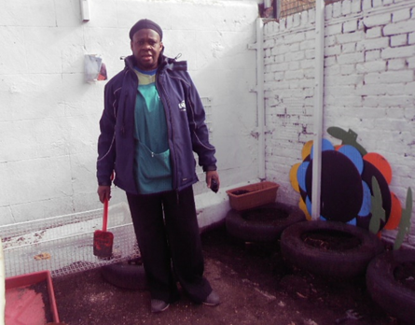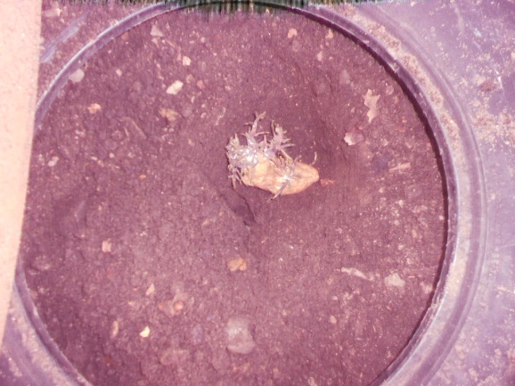
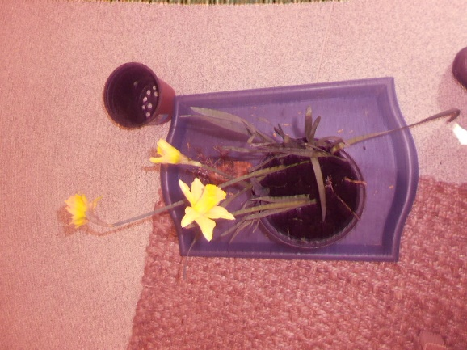
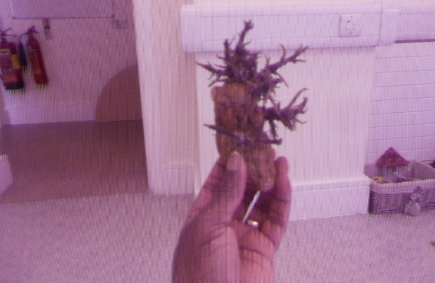
Implementing the EYFS Prime & Specific Areas:
Prime Areas: Personal, Social and Emotional; Physical; Communication and Language Development
Specific Areas: Literacy, Mathematics, Understanding the World, Expressive Arts and Design Development.
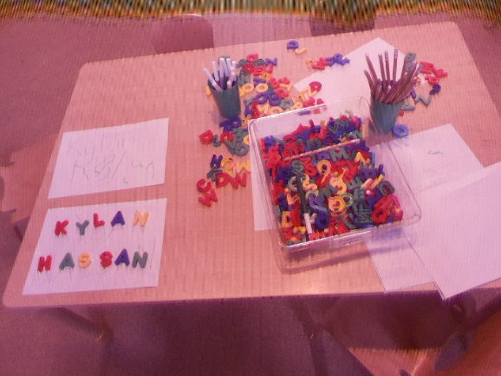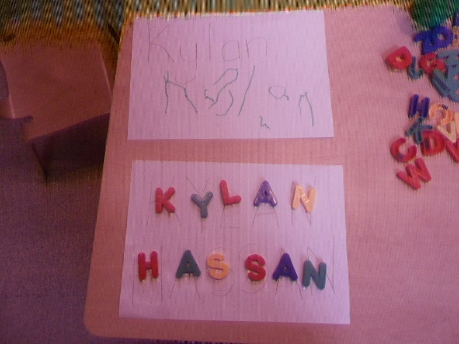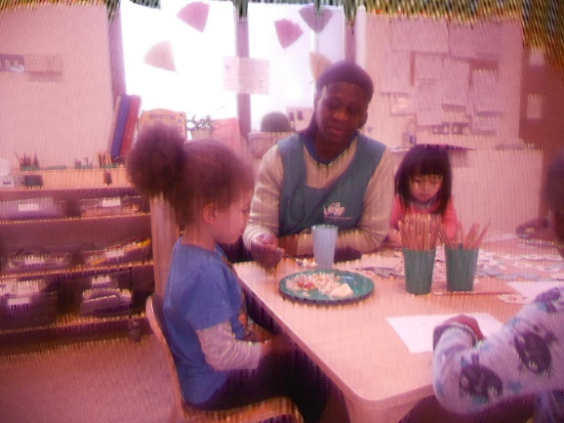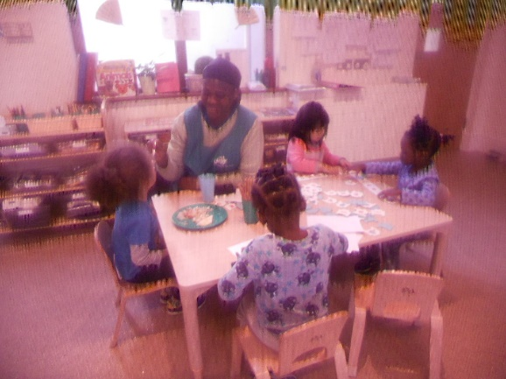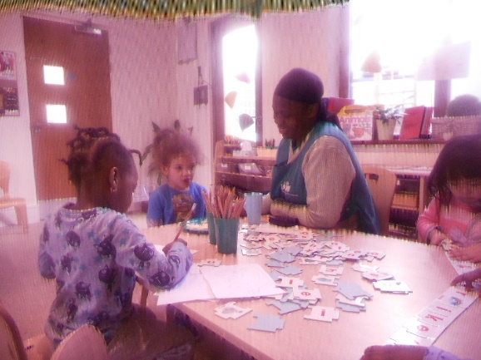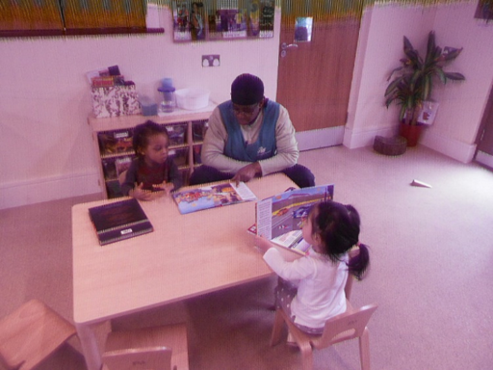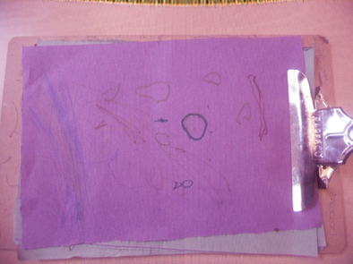
The EYFS Welfare Requirements: The Characteristics of Effective Learning and the prime and specific Areas of Learning and Development are all interconnected.
The Key Person: The Unique Child reaches out to relate to people and things through the Characteristics of Effective Learning, which move through all areas of learning. 1. Playing and exploring. 2. Active learning. 3. Creating and thinking critically.
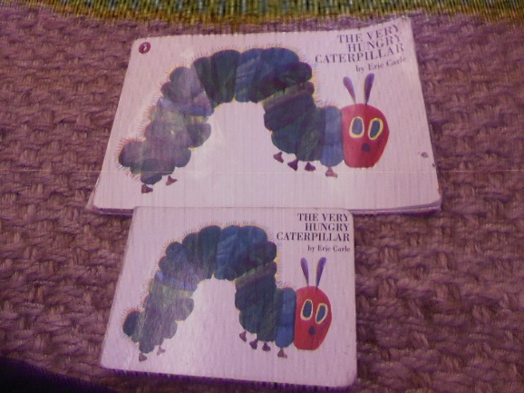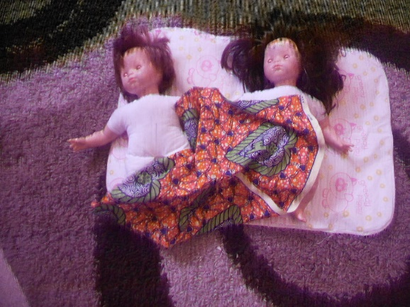
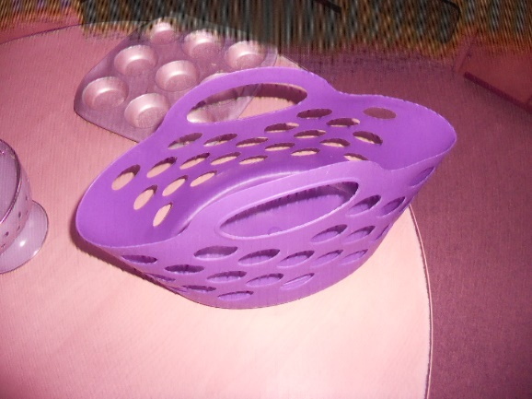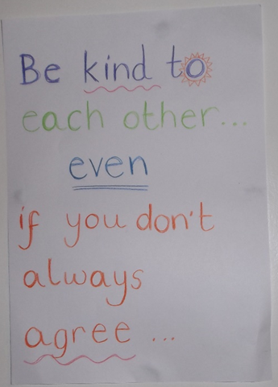

Contingent Provision Criterion Practice at (LEYF): Whilst I was busy implementing and promoting the Early Years Foundation Stage (EYFS) and London Early Years Foundation (LEYF) Ethos, Five (5) Core Values and the DNA from my years as an Early Years Practitioner from the 1st September 2009, starting at Fitzrovia Community Nursery. Transferring to Luton Street Community Nursery April 2010 where I was the EYFS Coordinator, SENCO and Multigenerational Working Partnership Coordinator. Covering at other (LEYF) sites and tranferring to BIB on the 23rd July 2014. I ended up been made a scapegoat after receiving the CEO Long Service Awards on the 15th October 2014 by (LEYF) Central Office staff who sanction the BIB team to directly and indirectly discriminate against me from I arrived at BIB. I was then sent to HOC whilst they tried to find reasons to make me reduntant as being unfit for work. This was after they could not come up with any evidence I breached the CONTRACT I signed in 2009. When I was passed fit to go back to work by the Workplace Occupational Health Professionals. I was transferred to New Cross Community Nursery where the discrimination intensified and they tried to make out I am a CRIMINAL to dismiss me.
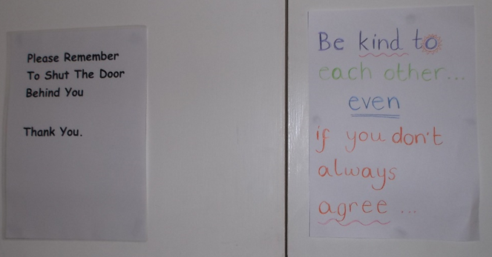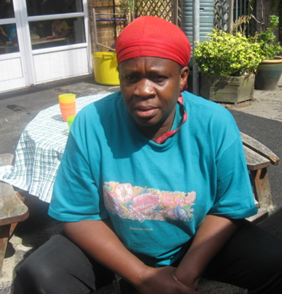
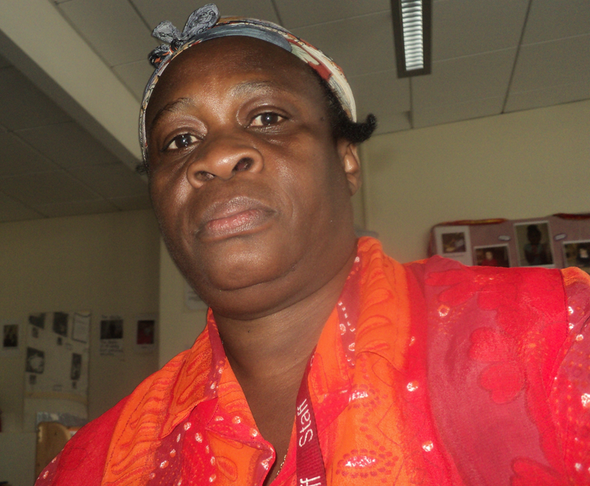
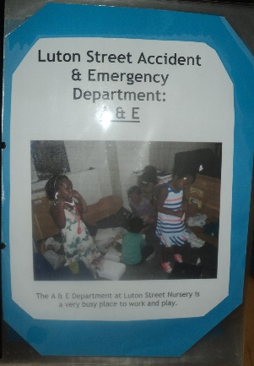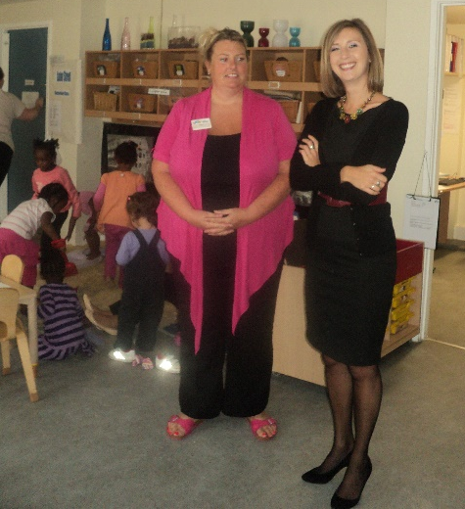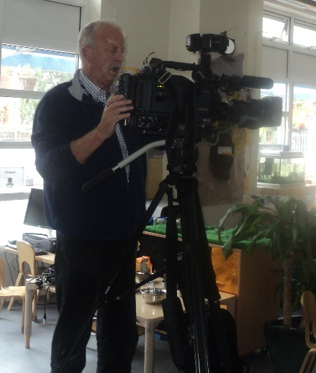
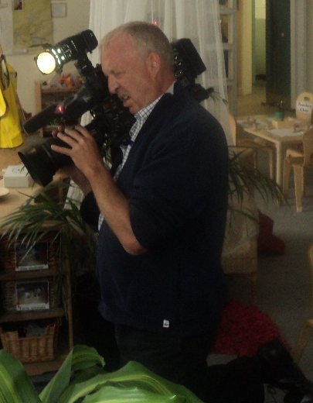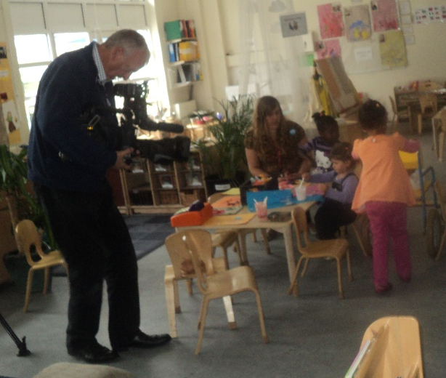
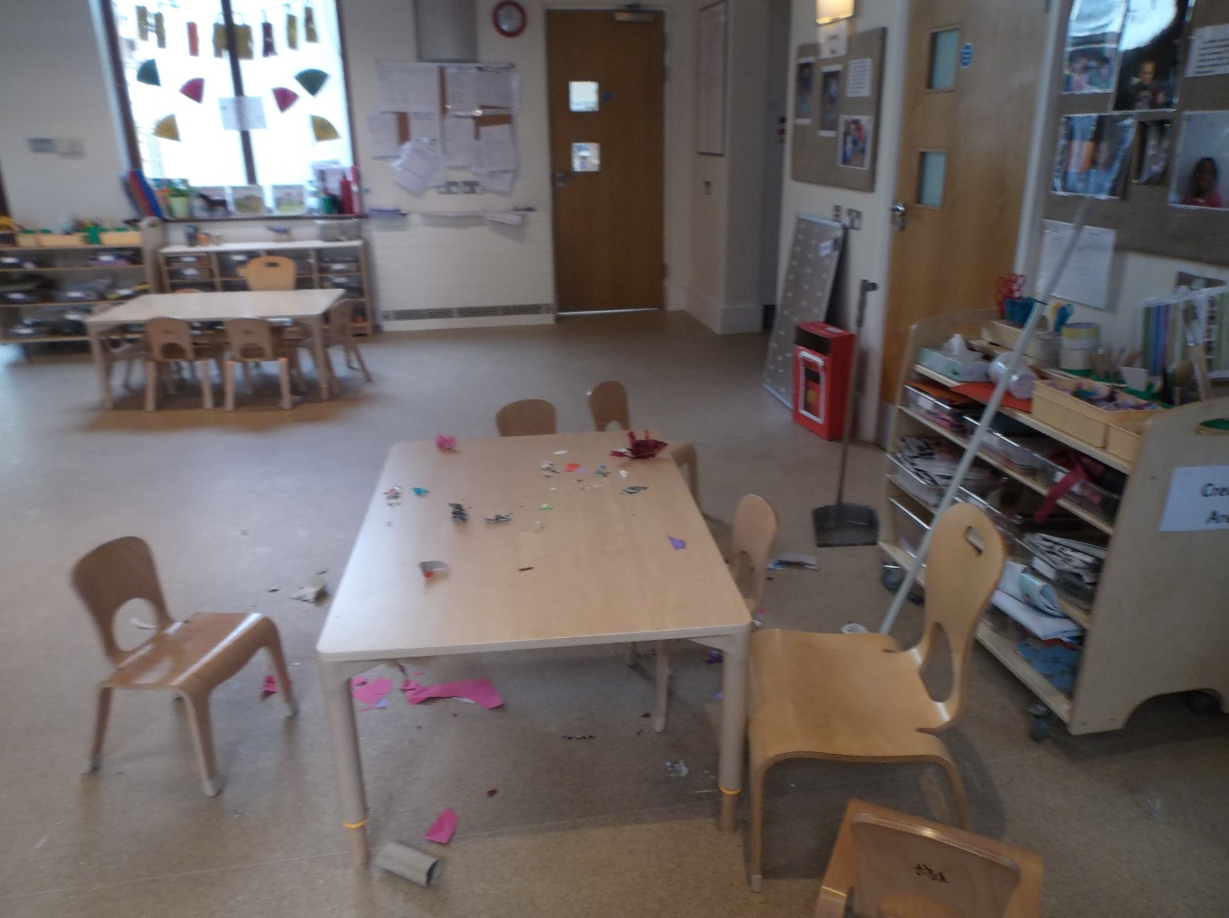
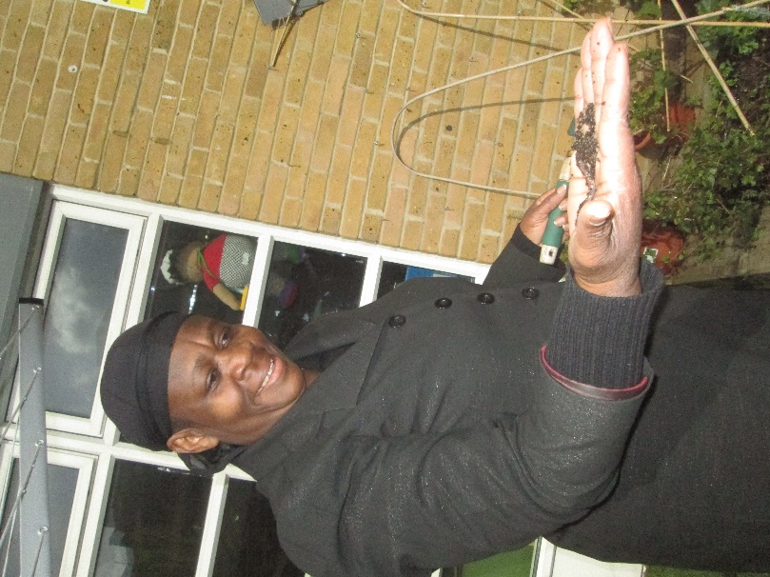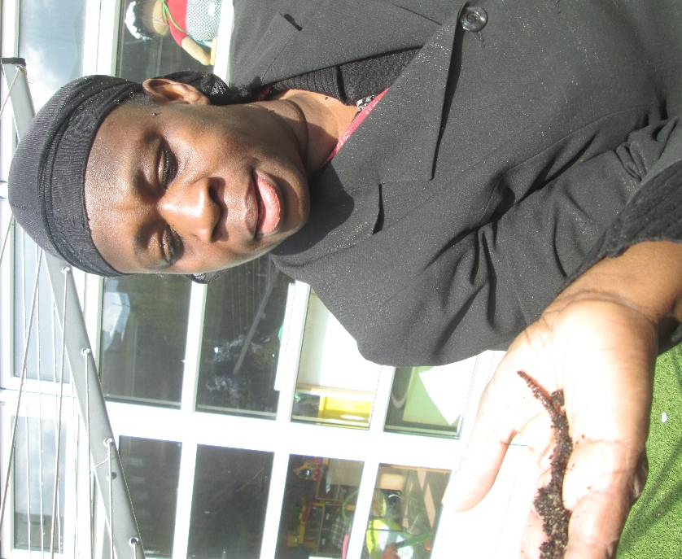
Compare the differences from Luton Street & BIB, the way I was treated.
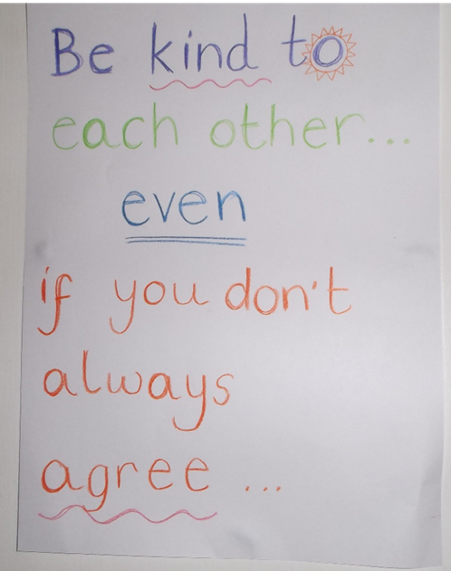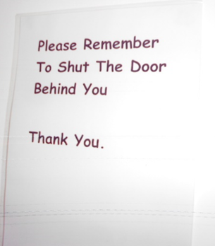
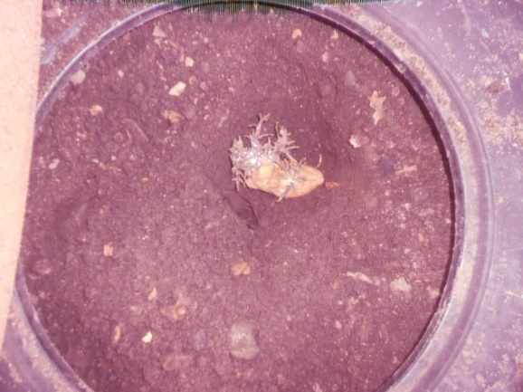
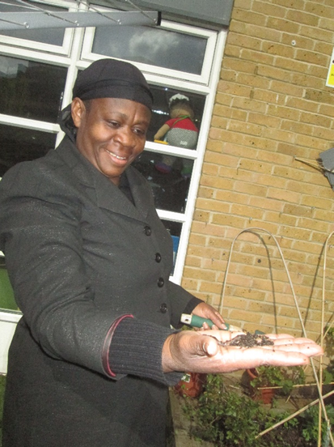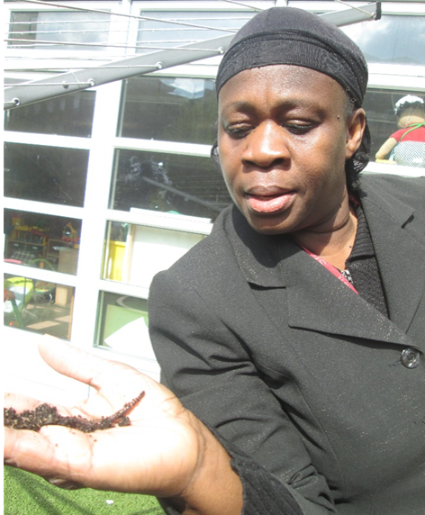
add this

Dear Neil

I am registering my interest in applying for transfer to the new nursery in the Houses of Parliament in September 2010.

Working Hours

I will be flexible to work the extended opening hours during Parliamentary sessions when the nursery opens in September because by October I will have completed studies, and sit the examination in October 2010 to gain my Bachelors Degree in Early Years. My intention after this with regards to studies is to spend an additional 6 months doing studies to gain Early Years Professional Status. Of course this will have to be finalised after I gain the Degree and have done some remedial work to improve my mathematical skills.

Excitement and Challenge

I relish the excitement and challenge of working in the new nursery to be situated in the Houses of Parliament as I believe I have innovative knowledge and expertise gained from studies to contribute to the team. After gaining the Bachelors Degree in October I will be equipped with additional enhanced knowledge and expertise that will enable me to promote London Early Years Foundation’s ethos of being a Social Enterprise, whilst continuing in the role of Nursery Officer working directly with the children. I believe my greatest strength is working directly with the children on the floor so I would like to be considered for transfer. Studies have challenged me to examine my implicit knowledge, values and beliefs to make them explicit. As an advocate of inclusion I have gained theoretical knowledge from the experts to enable me to work collaboratively in teams from a shared vision to promote best practice. I have innovate ideas that I can contribute to the new team and the organisation’s ethos and philosophy of providing care and education to children from diverse, ethnic, multi-cultural and socio-economic backgrounds.

Since starting employment at LEYF I have had the opportunity to attend a variety of trainings to enhance my Personal Professional Development Plan. Therefore this is another fantastic reason why I belief joining a new team would empower me to use those knowledge and expertise gained from the investments of providing staff with trainings. I have only being empowered to implement and promote some of the theoretical knowledge and expertise I gained from studies (2004-2010) to my practice since I started working with the organisation. This has only become a reality because I have been given the opportunity to work in partnership with a range of professionals and other agencies. I would like the challenge of using these newly acquired skills in a new team where I will be given roles and responsibilities that match my qualifications, experience, abilities and skill. I vision myself in the new team working collaborative to implement top-down and bottom up approaches from the experts to benefit the children and the organisation in particular to be providing knowledgeable practitioners to the children workforce in line with the Children Workforce Development Council (CWDC 2009).

Enhanced Security Checks

I have experience of working in environment where I have to get additional enhanced security checks including credit reference, background and counter-terrorist checks. I have not committed myself in any way sine to the best of my knowledge.

Reliability

My record of reliability is outstanding in every aspect of my work ethics. I have been working in Childcare and Education over the past 30 years both in my native country and the UK. I have over 12 years experience working in a variety of multicultural early years environment in the UK. I have acquired excellent leadership qualities and skills when I took on the lead roles and responsibilities in a number of work environments where I was relied on to be accountable in using my initiative to promote best practice and be a role model for the team. I gained Student of the Year certificate when I first embarked on studies in the UK as a matured student.

Straight out of college I worked in a private day nursery where I was Room Leader for the Toddlers room. I had to liaise with tutors of students on placements providing feedback on performances on the students for whom I was a mentor. In another work place I was Person in Charge/Pre-school and had the added responsibility of having the keys for the setting so I was accountable for ensuring that I get to work on time to open the premises and organise the environment as the setting was located in a hall, as a shared facility. The resources had to be stored after each session and then arranged each morning before the children arrive.

I had the role of Group Supervisor in 2 other settings, one in particular I had to wear many hats as a more knowledgeable practitioner, who is able to multi-task, use my initiative and think outside of the box. As a student who was challenged to examine knowledge, values and beliefs I became an advocate of inclusion, worked from a shared vision and to promote best practice. I was instrumental in getting trainings for my colleagues as I had to review and update my Professional Development Plan to meet the aims and objectives of studies to gain recognisable qualifications. I have been a role model and mentor for students and colleagues and had trainings from City and Islington College to support colleague doing studies. I am a bit of a perfectionist with an Obsessive Compulsive Disorder (OCD) which I use to my advantage of getting things done to a high standard or else I am not satisfied with my work efforts.

Excellent Customer Service Skills

My years of working in childcare and education gave me the opportunity to hone my skills in customer care. I have worked in partnership with parents/carers, colleagues, other professionals and agencies and the wider communities as part of studies. As a key person I have had to make connections with children, develop positive relationships with parents and valuing and respecting them as their children’s primary carer and first educator. As a Named Person for Safeguarding ensuring that colleagues get trainings to enable them to do their work effectively to implement and promote best practice. Sharing concerns with people in authority and updating and reviewing Quality Assurance Files in line with changes in current legislations. As a SENCO maintaining contact with other professionals and agencies, and working in partnership with professionals from multi- agency teams.

Good Communication Skills

I attained English Language at JSC and GCE O’Level from my country of origin. As a continuing student who is on the verge of gaining a Bachelors Degree in Early Years I have covered many modules when I submitted Tutor Marked and End of Assignments Course, sat examinations, engage in Tutor Groups Forum and Student Networking via the internet, as well as attending monthly tutorials. I have excellent oral and written communication skills, and I am developing competencies at using ICT to develop my practice.

Excellent Understanding of the Early Years Curriculum

My understanding of the Early Years Curriculum is excellent as I have the opportunities to hone knowledge and expertise working in a variety of early years settings over the past 12 years and witnessing changes and adaptations to early years frameworks and curriculum guidance. Studies to gain recognisable qualifications empowered me to implement theoretical knowledge and expertise to justify my practice and leave them opened to scrutiny. I have implemented the Mosaic Approach Research Tools to my practice resulting from studies. I have covered the Early Years Core Learning Outcomes (EYCLOs) and Route Learning Outcomes (RLOs) to collate, evaluate and analyse Data about working in teams with parent/carers, colleagues and other professionals and agencies to make changes to promote best practice. I have recently since starting work with the organisation had knowledge and experience of documenting evidence for the Early Childhood Environmental Rating Scales (ECERS). I have competencies in planning the curriculum to promote children’s development and learning and their overall wellbeing to achieve the Every Child Matters agenda. I have documented Learning Journeys, prepared Individual Education Plans and reviewed them with parents, key person and the Inclusion Teacher. I am learning Makaton and have some knowledge of using Visual time tables and the Picture Exchange Communications System (PECS).

Personal Reasons

I am spending lots of time commuting and additional expenses on travel that I can hardly afford. Hope my application will be considered.

Mervelee Myers. May 26, 2010.

The Manger/Deputies
New Cross Community Nursery
77 Amersham Road London SE14 6QQ
6th September 2015
Re: Hospital Appointment & CRB/DBS Check
Hospital Appointment:
I would just like to follow due protocol set out in my Contract of reminding you about my NHS Hospital appointment scheduled for the 10th September 2015 at 10.00 am. I gave notice of this appointment over a month ago by taking the letter in to be copied. However I realised that I am on the shift rota for an 8.00 am start on Thursday. I am mindful that this might be a mistake and would like you to make alternative arrangements so I am not counted in ratio and can attend my appointment.
CRB Check:
When I resumed worked in June I informed both Deputies Emma and Louise that my current CRB would expire in July. I was told that they would be in contact with Central Office for me to be contacted to get the matter sorted. I have since had several conversations with both Deputies reminding them that I still did not hear anything from Central Office. I eventually lost track and now it is September and the CRB expired.
Supervision:
During supervision the 28th August 2015 I informed the manager Marion for the first time about telling the 2 Deputies from I started in June that my CRB will expire in July. And to date I’ve not had it sorted even after several reminders and being informed they contacted Central Office about it. Marion said she’d inform Central Office and a week after the supervision I am still waiting to hear from them. I am therefore using this medium to bring to your attention the fact that my CRB expired from July and would be grateful if the proper procedures could be put in place for me to do the CRB in line with my contract. I know it has been a busy time with the transitions into the new setting and sometimes the most relevant things can get missed along the ways. But I wished to play my part as a professional who is responsible and accountable for my own Continuing Personal Professional Development Plan adhering to OFSTED & LEYF Welfare Requirements of Suitability and Disqualification Checks.
Looking forward to an early reply in addressing my concerns.
Kindest regards.
Yours truly
Mervelee Myers FD (Open) Early Years Practitioner.

New Cross Nursery 2.6.2015 – 22.9.2015
- Allegations by Crisella & Deputy Emma 2. Record of meeting with HM & Louise 3. Supervision 4. DBS Checklist Policy & Procedure 5.Marriage certificate 6. OH MS Report 7.8.9.10.
1. 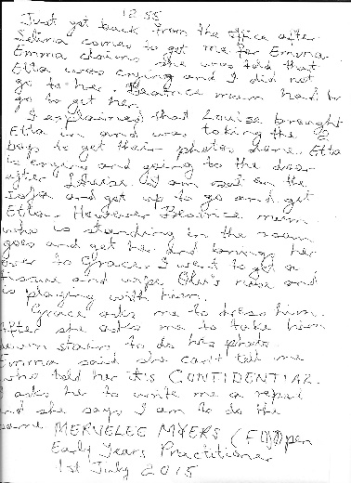 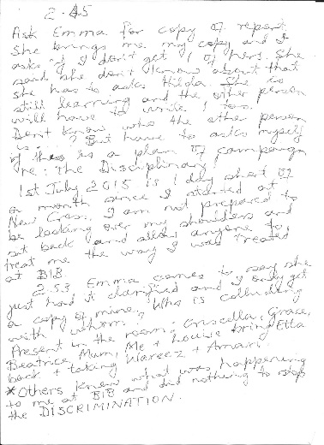 2.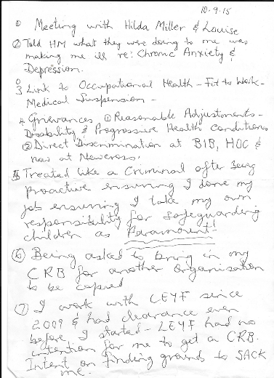
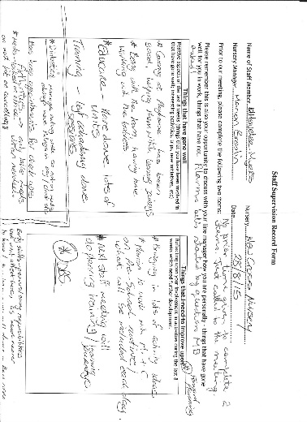 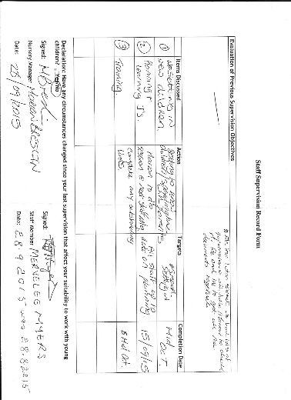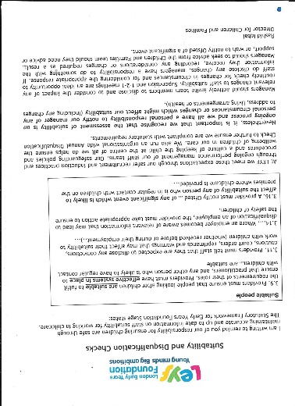 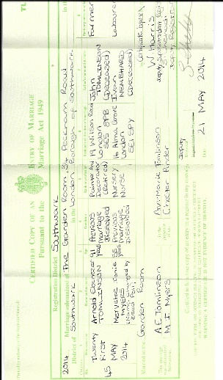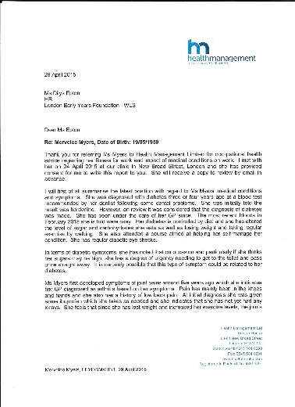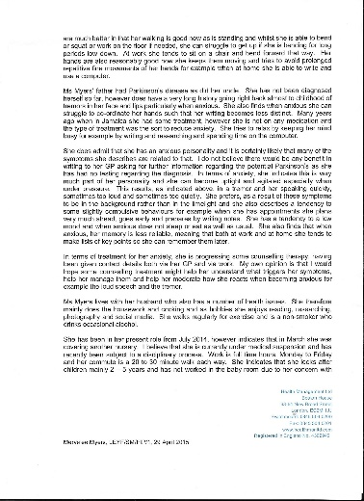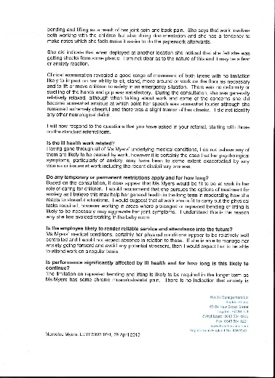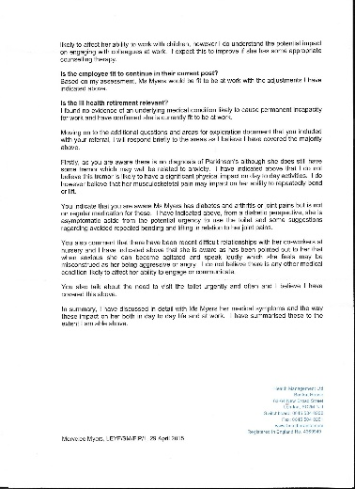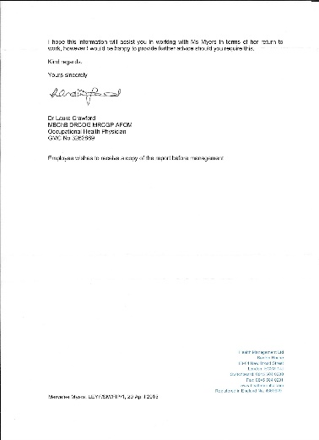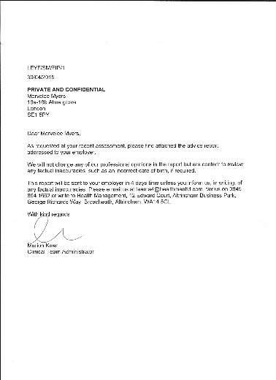 End here

Notes of 1st Allegations at New Cross 1.7.2015 Files 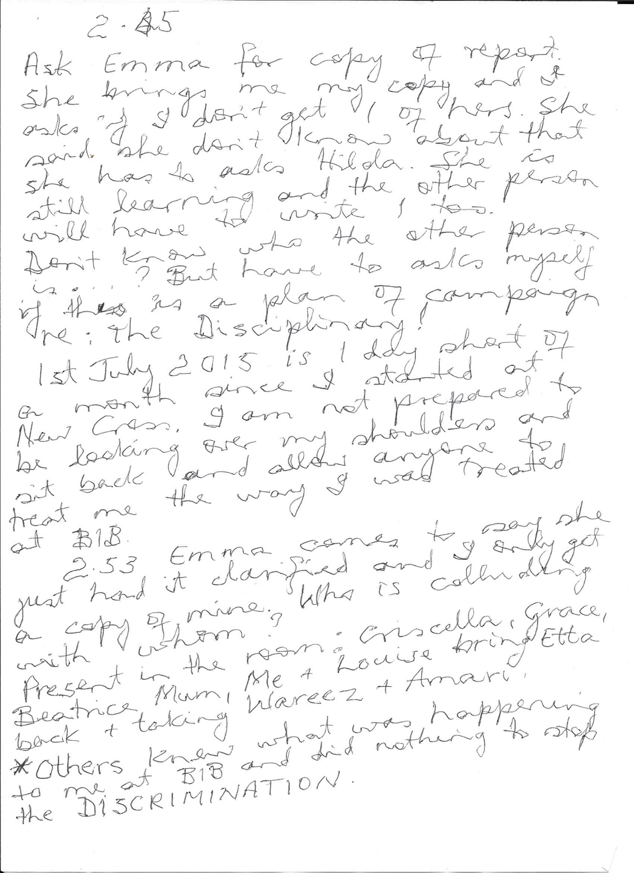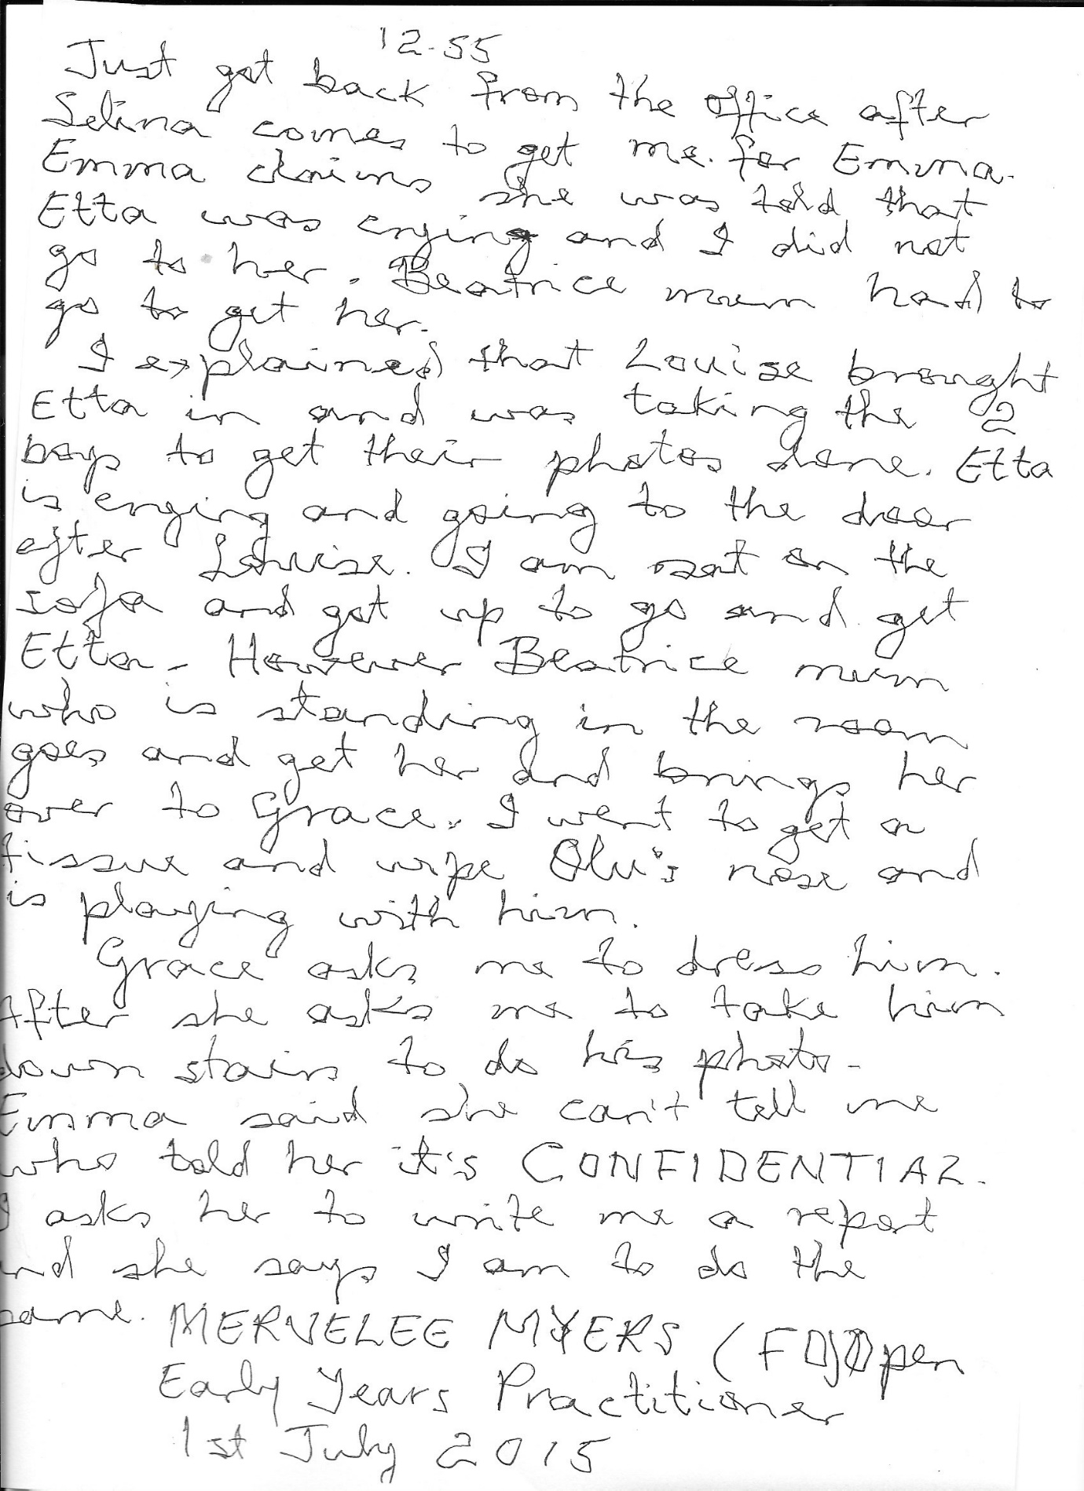
End here

BIB Monday 16th March 2015 Report
Hilda Miller came at 4.00 o’clock, I let her in. She and Lynne Kelly locked up in the kitchen and when I am tidying up LK comes to tell me HM wants to speak to me in the kitchen. That is before I went to speak to Isabel Glen. HM said I should go and work at House Of Commons for a couple of weeks to take some of the pressure off me. She said they are short and she can’t use agency and I told her I know because I covered there before. HM said to let her know if I incurred any expense and she will reimburse me. When I am talking to Isabel, she said she was not aware of that development.
Tuesday at HOC March 17, 2015:
Met child Elsie at HOC on Tuesday and she just chatted away and played with me from I walked in the room. I mentioned to someone that she has my grandmother’s name and that’s probably why we bonded on sight. Most of the children just cried when they see me. I am pulled from pillow to post with the explanation that I am there to cover so I have to float. I said I didn’t mind because I am here to serve as long as I am not permanent in the Baby Room.
Asked to do extra time.
Going to the Park I was going to ask for the taller buggy, but think better of it and stick with the one I was given. Child Oscar that is holding to the buggy is crying and Feyi keeps asking what happened? I say nothing happened. In the end they have to take him off my buggy because he is not used to me. Pushing the buggy around was difficult for me, but on top of that I am given orders to do this, do that – keep children awake, make sure shoes don’t fall off, etc. I tried my best and the Security were helpful when I am struggling with the buggy inside the building.
Wednesday March 18, 2015:
Saw Contingency Plan for a child and realised I needed one in place, but no one seemed to know about this. I didn’t want to complain so I tried my best.
Shock Hazard:
Supervising children on slide in the small room on my own and door is closed. When I go near slide it shocked me. But it’s even worse when it goes through the child, so I went and told Feyi. She said I should go back it happens to everybody. I tried to stop child falling and got shocked and had to recoil nearly dropping the child, so I went back to inform Feyi and she said I am to carry on nothing she can do. But I can open the door if I want to and I did. I am still supervising the children but standing back in case I have to support a child, but is really getting concerned.
Nabila puts her head through the outer door and I told her about getting shocks, she said it happens to everyone. I am watching the children but keeping a little distance from the slide so as not to get any more shocks.
Sharon – deputy manager comes to the door so I got her attention. Told her I am getting shocks from the slide and it’s even worse when I touch the children on the slide and nearly dropped one child. She said it happen to everybody and it not going to hurt me. I am trying to explain that I am not comfortable with the situation because I don’t want to put any of the children in danger… Without allowing me to finish, she asked “are you telling me you are not supervising the children then?” I said I have been here all this while, I told Feyi and Nabila about my concerns and I am not comfortable nor confident doing this. She said ok we’ll take them out but can you make sure you engage with them and I am thinking here we go again.
I know without a doubt that she had got her briefs on how I am to be treated? From Sharon’s attitude towards me from I entered the nursery on Tuesday I sense something wasn’t right. I’d covered at HOC before and met some of the staff, but this time the reception was so icy. No one actually spoke to me except for Feyi who gave me orders as the room leader. Later when we came back from the park, Sharon came and said to me “if I asks you to do anything and you can’t, will you let me know” and that confirmed my suspicion that she reported the matter about me refusing to supervise and engage with children? In return she must have been told about my health conditions.
Going to the park Feyi said I should use the taller buggy because it was easier to manage. So why did they not think of that yesterday?
Yesterday and today children fall over on the hard concrete surface running and got big grazes.
The way Feyi giving me orders you’d think I was an idiot and didn’t know what I am doing and is a new recruit, but I just get on with the job like when in BIB. I find her manner patronising – when I ask anything of her eg leave the children with me who don’t mind me playing with them. She would say I don’t know, they soon get use to you.
Saw Rashid coming back from park, he acknowledged some of the staff.
Back from park security door on the little lift taking up the buggy fly opened part way up. Ashley have hand on it and is saying to Feyi, children did not push it and that was scary, thank God I have my hand on it.
At lunch Phoebe saying how tired she is
I was knackered and for the 1st time in the longest while I had to have a nap at break time.
Was left on my own with children for 5+ minutes with children.
Breaching LEYF & OFSTED Welfare Requirements re: Safeguarding.
Then to find out later that the manager LK at BIB claimed during the investigations that she had concerns about me was just too much. Once more I was been stitched up again like the time at KINGS – 2003 – 2008 when I was made SICK resulting from the Direct Discriminations I encountered.
Other professionals who did not know me are alleged to have said things about me that I considered unprofessional and without any merits as claimed by LK the manager. (Stella Louis – Early Years Consultant) All the staff at BIB including Nicola’s team are given their briefs to make allegations against me and I am feeling like the hare caught in the headlights without anywhere to turn.
15th October 2014 I was given Long Service Award. 05th November 2014 CEO stated in letter about not knowing I was at BIB and coming there and seeing me. (See copy of letter November 2014) about me embracing the multigenerational ethos. 28th January 2015 on another visit to BIB with a Trustee, CEO wrote another letter (see copy) about me writing a piece about the cassava for LEYF bulletin board.
CEO told me that she told off BIB team for not attending the New Year Staff Party. I was later informed that BIB got permission from CO not to attend because they were trying to build a case against me. So without prejudice the CEO deliberately lied to me and attended BIB to stitch me up with her letter about writing a piece for LEYF Bulletin (30.01.2015). I’d written 2 articles and published on LinkedIn promoting LEYF (see articles – LEYF on my Doorstep &…). But Hilda Miller told me to remove them and not to say I worked with LEYF. So I did but have since republished one and waiting to do the same with the other.
29th January 2015 another Trustee Mary Wynne-Finch visited BIB, and I in my naiveté not knowing the reasons for the visit said to the manager Lynne Kelly “something exceptional must be happening at BIB why so many VIP are visiting”. I only learned later that I was the target for the VIP who were visiting as everyone were fed erroneous information about misdemeanours I had committed. Only I was the only one in the dark as the wool was being pulled over my eyes whilst they collected their evidence. The evidence to give me a sanction and I believe the sanction is the same one they hand out to everyone whom they made allegations about when LEYF want to get rid of us, or have us where they want us.
Campaign of harassment, bullying and intimidation continued and BIB transferred their angst to the Chef Gloria when she refused to join them in discriminating against me. She ended up being suspended, faced a Disciplinary and given a Sanction like mine.
I was escorted out of HOC like a criminal by the manager Anjili on the 27.04.2015 when Dilys came to try and set me up. She stated that HOC was on High Security Alert and I could not be left to find my way out on my own. This is after I worked at HOC from the 17.04.2015 until 27.04.2015 when Dilys came to send me home she claims with pay to rest from my ordeal.
I don’t know who is deluding whom, but everything I’ve written down happened to me and not a figment of my imaginations. Because Dilys, BIB and everyone else seem to think I am mad, but I am 100% sure I am not. I am experiencing mental health issues as a result of the treatment at BIB, but I resolve to fight back and get better because I am a resilient person.


`

A guide to your Independent Medical Assessment (IMA)

What is occupational health?

The occupational health service is an independent, confidential health service provided by Health Management Ltd. Your organisation has a duty to care for your health and safety at work and is committed to developing a healthy workforce.

The occupational health service is delivered by a team of health professionals who have training in occupational medicine, the branch of medicine that deals with the relationship between your work and your health. Working to high professional standards, you can expect the team to treat you courteously and with respect for your privacy and dignity.

Our aims are to:
- Enable the rehabilitation of employees returning to work following ill health.
- Assist employees to achieve good health by providing health advice and support.
- Prevent employees from becoming ill as a result of the work they do.

The occupational health team will also work in partnership with you and your employer to resolve issues in the workplace that might have an adverse effect on your health. Together we hope to ensure that your well-being at work is maintained and given the priority it deserves.

Will this assessment replace the care I am receiving from my doctor/specialist?

No, the OH service is not responsible for your medical care. That continues to be the responsibility of your own GP or Specialist.

The OH team may co-ordinate with your GP to ensure continuity of care but they do not replace his/her service. However this will only ever be done with your consent.

Your appointment details

If you have been referred to the occupational health service, Health Management will arrange an appointment for you to see a doctor close to where you live or work. Sometimes it may be necessary to travel further depending on the availability of appointments in your area.

Consultations take between 30 minutes and an hour. Sometimes a little longer if the issues are complex. Your HR or line manager will pass you details of your appointment confirming the date, time, location and name of doctor.

Should you require assistance upon arrival at your IMA please inform us prior to the appointment and we will organise the appropriate provision.

If you are not sure why you have been referred, please ask your HR/Manager to clarify this.

Your HR/Manager will also have additional information regarding confidentiality of your information and your rights which they will share with you.

Prior to your assessment Health Management may have written to the doctor who is due to see you (an occupational physician or, in some cases, a different type of specialist) to explain the circumstances to your referral and to clarify the questions that the consultation is intended to address it.

If you are not happy for this to occur then you should advise your line manager or your HR representative immediately, but this may mean that Health Management is not able to gather the information that they would need in order to advise on your case and in those circumstances your employer would not have the benefit of occupational health advice which is unlikely to be in your best interests.

Please note that should you not arrive for your appointment we will need to inform your organisation of the missed assessment and this will also result in a charge to your organisation too.

What information should you take?

In order to obtain the best advice from the medical assessment we would recommend where possible you consider taking the following information for the examining doctor:

- Details of any current prescription medication from your doctors.
- Copies of any relevant health information, such as diabetic glucose monitoring diaries, peak flow diaries for asthmatics, mood diaries for psychological disorders if relevant.
- Names of any specialists you are under the care of and details of any forthcoming outpatient appointments or operation dates awaited.
- If you have had any recent reports of investigations, blood tests, X rays or scans, it would be very helpful to know if these demonstrated any abnormalities. (you may wish to ask your GP about this).
- Details of how long your current medical certificate runs if relevant.

If you wear glasses or a hearing aid then please do bring these with you

When you arrive

Please ensure that you bring your appointment letter to your assessment.

Please try to arrive in good time for your assessment. If you are delayed it may not be possible for the doctor to see you that day and another booking may need to be made. This will result in a cancellation fee being incurred by your employer.

Please note that children are not allowed to be present during the assessment, and there are no childcare facilities available.

Your medical assessment

The doctor will first discuss with you what their role is, explain the purpose of the assessment and the confidential nature of the assessment.

The doctor will have received details from Health Management concerning your illness and reasons for the referral. They may well ask you questions about your job role and then they will assess your specific health issues.

The doctor will also ask you to complete a consent form, which asks for your consent to release a medical report about the assessment to Health Management and designated officers within your organisation.

In many cases, the consultation will include only a relatively short medical assessment and will rarely require a full physical examination.

During your assessment the physician may undertake a limited physical examination. If you would prefer a chaperone to be present, in case that is required, you are welcome to bring a suitable person with you for your appointment.

Is the assessment confidential?

As with all medical professionals, the occupational health team work within strict guidelines regarding medical information and confidentiality.

Your explicit consent is required for all the stages identified on the consent form without which an Occupational Health Report cannot be produced to your employers.

Your line manager/HR has additional information on this point should you require any clarification

Please be aware another clinician may audit your case for quality purposes to ensure all our clinicians work to best practice standards and to participate in national clinical audit. When this is undertaken anonymised information may be provided but this will not contain any personal identifiers and will not be linked to any individual and no personal data is shared.

What happens next?

Following the consultation, a medical report will be sent to Health Management, normally within 5 working days, which will be interpreted by the occupational physicians at Health Management who will have detailed knowledge of your organisation and work practices. The Health Management Occupational Health Doctor will provide a report without unreasonable delay and in a manner which is not biased towards the employee or the employer.

He or she will send a report to your HR/Manager, or designated referrer, which will answer the questions raised in the referral, and usually contain a brief description of
your illness, recommendations about the sort of work for which you are fit and any adjustments to your duties which are needed on medical grounds.

Usually the report will cover questions about the likelihood of you rendering reliable service and attendance to your employer in the future and whether your case can be managed administratively in line with the organisation’s procedures and policies.

The examining doctor will summarise his/her conclusions to you at the end of the consultation; and in the case of HML run clinics may write directly to your employer covering the issues above.

Should you wish to receive a copy of the management report before or at the same time Health Management sends it to your employer, please let the examining doctor have your email address so that this can be added to the consent form. If you do not have an email address please advise the examining doctor of your postal address.

Disciplinary Hearing
Incidents with Mervelee Myers 23/3/2015
As far as my recollection goes on this incident, I had shared information from I started at BIB that I intended to set up a Forrest School Themed outdoor space with Mud Kitchen. On the day in question I’d come back from sick leave and started cleaning up the outdoors space after sharing this fact with everyone. I’d learned from prior experiences not to just go ahead and introduce any ideas without first getting clearance from my manager. Because I was on a late shift, I’d given 1 hour of my time each morning to clear the garden of the rubbish that piled up over the years. I’d spend 1 hour in the garden and be inside in time to start my shift at 10.00 am. I had collected resources from Nursery World Show February 2015 to help me with setting up the project.
When Jyoti approached me about why I’d signed in early I explained to her about working in the garden (see photographs). However it is normal for me to come in early or leave late when I have deadlines to meet. Case in point when the area manager Hilda Miller asked me to update key child’s Learning Journey that she is using as a project (see photographs). I am not a stickler for time like others to go home especially since transferred to work closer to home. I have addressed this matter elsewhere so just to clarify some points. I noticed how everything is timed specific to the last details and this is so totally wrong, but in order to collect evidence to get me sacked the manager Lynne Kelly briefed everyone. If the records of evidence collected so far are checked you will see a pattern.
I was promised copy of minutes of a meeting with LK, Remi and me which never materialised, even LK said I needed to know who were making allegations. Since Jyoti didn’t know the proper procedures because even after I’d gone through the basics with her from she started in December 2014. She still did not grasp what was expected of her in her Job Description. I was the one who advised the agency staff at about 6.08 pm that she could go home and it was after then I put the shutter down, so I am not too specific about the time except it was after 6.00pm.
After getting a little frustrated with Jyoti because no matter how long I went through LEYF working practices with her and she failed to understand what was expected of her. I asked the manager who was responsible for training her and this was after I told her to ask to go and shadow another deputy. On one occasions when I gave her information about the settling in procedures for her new key child, she told me I have to go and asks LK, “I don’t know because I did not have an induction?” Yet after 5 years of working with LEYF, I am expected to sit around and do nothing whilst others like Jyoti who is new to LEYF takes forever to grasps the basics about working practices. Then they have the audacity to talk about I am dismissive of AUTHORITY, whose authority might I ask?
This is nothing new to me because when I went to LSN, I just went in and did my job from past experiences. Another young lady came after me (Katie – 20 yrs old) and the 1st week I saw her distraught and upset threatening to resign because she was blamed for an accident. I advised her not to resign because it wouldn’t look good on her CV. I begged her to persevere so it shows how she can develop resilience under trying circumstances in the workplace. She took my advice and hang on and is now pursuing her dreams studying and working.
Another recruit came to LSN (Rebecca aka Becky) and the next week she tendered her resignation because she had no induction and did not have prior experiences of working in the field to fall back on. She send a report to Head Office but as is the norms, things get swept under the carpet.
One of the agency staff Ricky from Protocol complained to CO about inappropriate practices on the 10th March 2015. They told her there was to be an investigations, but the investigations was about the chef. The same chef who got suspended because she did not agree to what LK & BIB & some of LEYF CO team were doing to me.
Gloria ended up paying the price and I feel totally responsible for this state of affairs. Then LEYF used the Policy & Procedures to GAG me so I cannot talk about what is happening to me. Even when I went to the doctor and he advised me to contact the Union, I wasn’t sure about this. LK made sure Ricky did not come back to the setting, because I hear Ricky talking to her on the 11.3.15, we had speech & language training. She told Ricky the nursery would be quiet, but I saw a new agency staff come in, and by this time the children got used to seeing Ricky in the setting. I understand this is the way LK operates, if agency staff raised concerns, she makes sure they never come back to work at BIB.
I beg to differ on this matter as I am always doing my fair share and extra. However everyone seems to have a problem with the way I capture my evidence in order that I can document, record and collate information to carry out my Job Description. If in doubt check the Learning Journeys, EYFS Curriculum Planning, Worry & IEP Forms, etc. I asked the manager when I started at BIB to install a computer to enable me to do my job because my writing is not the best due to my Parkinson disease. Unlike others who made things up as they go along, I write little notes as aid memoirs when I am ready to document.
I spent my lunch time typing up those notes whilst they are fresh in my memory. There are times when I come in early or leave late depending on my shift just to get work done as I am a stickler for ensuring I do the best I can for the job I get paid to do. When Jyoti did comes to the conclusion that she has stated in the last paragraph? Was this after I’d gone through showing her my practice as a LEYF employee with 5 years services (see Letter). At my interview, I knew I’d got the job before it was completed and Neil King was telling everyone in the office how good I was.
I’d studied and gained my Foundation Degree & other qualifications before I started at (Westminster Children Society – WCS now London Early Years Foundation - LEYF) because I wanted to be a graduate by the time I was 50 years old. I started at Fitzrovia where I was given a fight by the manager MG and area manager MF because I stood up for my rights to do my job without being harassed, bullied and intimidated which I considered discriminations. I realised from then that there was a culture of discriminations.
But because of prior experiences which resulted in me being black listed and networked against, I just had to do the best I could to keep my job. I had lost track of the amount of interviews I’d attended without any success. I was relieved to be transferred from Fitzrovia, when a former colleague I’d worked with at Lambeth Walk Day Nursery Joelle Lax vouched that I am a good worker. Luton Street became a safe haven for me as the manager Julie Weise saw my potentials and empowered me to get on doing what I am good at. I covered in so many of LEYF nurseries I have lost tract of some of them before coming to BIB and if there were any complaints about my practice, I was not informed.
Has Jyoti been made aware of the information I shared with the manager about the impact her treatment is having on my health and wellbeing? When I gave the documentations to LK, she told me she put it in my file. I was wondering what use it will be in my file if she is not reading it and talking to Jyoti about the impact on me.
The Manager
Why was my health issues not passed on?
There are records of me telling LEYF about my Parkinson condition initially on my file because I told them at the interview. Later I put the same in writing, because although my Parkinson is not diagnosed, I’d always fill forms saying I have a disability.
In fact I came for an initial visit before my actual start date on the 23rd July when I was informed I’d be working with Carol in the Baby Room. My health issues was not as easily sorted as Lynne is saying here, because she keeps insisting that I have to work in the Baby Room when I started because this was where she have the vacancy. I told her I am willing to start in the Baby Room until the matter is sorted as she claimed she was not aware of my health conditions. I told her if she wasn’t able to sort the matter out I was willing to contact Central Office myself because they are aware of my situation.
In the end Rumi was moved to the Baby Room and me in the preschool. However it took ages for my file to be transferred from Luton Street and after attending a few occasions and couldn’t get it I gave up. One of the excuses given for me not being able to collect when I visited was the manager had gone to CO for meeting and took the keys to the cabinet with her. Another time I was told she is away on annual leave and took the keys with her and I questioned that kind of practice when it comes to aspects of the EYFS Welfare requirements. I think after I decided I wasn’t making another trip to LS, they were scanned over to LK?
The 1st time I met the area manager Hilda Miller was when she and LK called me to a meeting to say a parent had complained about a comment I’d made to a child soon after starting. Fact of the matter I recalled very well what happened. The children were taken out on an outing and when the child came she didn’t want to come to the preschool room with Remi & myself (who are new). The child was taken into the Baby Room with Carol who is a familiar member of staff. When I said no conversation had taken place HM said it was up to me to introduce myself to parents, etc…
I had done that in writing on the board (see copy). Being new to the setting I understand it would take a little time to form close bonds with the children and work in partnerships with the parents effectively. The parent later told me she had raised concerns before she got to know me and I reassured her I understand and HM & LK spoke to me. I think from beginning it was seen that I am an assertive person who stands up for my rights as long as I can justify my practice and I was resented for this. This only came about because I empowered myself via studies and trainings so is not afraid to challenge others who are not prepared to work within the guidelines of the EYFS Welfare Requirements.
I can’t identify myself from this statement from LK either because although I might have been a bit reserved just coming back from Jamaica after burying my mum in July, I told about visiting Jamaica 2 times in 2014. I consider myself to be an outgoing and friendly person (see photo that LK took at BIB Xmas Party & Mewe Leaving do). I had not worked in South London since 2009 when I joined LEYF and although I did not go into details, I told LK about my past experiences. LK told me I should not worry because I am with her now and everything would be alright. I only get nervous under extreme situations despite my Parkinson disease, which I have managed to control holistically and with lifestyle changes after I enhanced knowledge.
When did I stopped being proactive?
I introduced my practice working with LEYF where they invested in trainings to BIB. I was the SENCO at Luton Street and I’d had feedback from LEYF that the Westminster Local Education authority was happy with work I’d done. Coming to BIB I realised some of the Policy & Procedures regarding Documenting were not in place so I set about introducing them to the manager & colleagues. Because although there were information about certain aspects of practices to be found around the setting neither the manager nor the team knew anything about them. I introduced the ECAT forms amongst others when the receptionist Mewe was still at BIB and ask that they look for them on the system. LK said HM brought them in and they were to be implemented after she arranged training with Stella.
I went ahead and do the Worry Form & IEP for 1 key child for whom I had concerns after consultations with LK and the parents when LK told me she was not trained to be the SENCO. I handed it over to LK and all I got was “we have some bright staff in BIB, but I am making some corrections”. I thought LK was very patronising, but knowing my situation and being back in South London where I’d had a traumatic experience, I just carried on with the work.
Another important EYFS Welfare Requirement re safeguarding that was not adhered to was the documenting of Accidents/Incidents and when I questioned was told we don’t do it here – BIB. I get the impression that LK was just a figure head who left most things to Benedicte who made the rules in BIB and I am not sure if BS was getting her dictates from HM? There were so many other things that were not done the way I was used to at Luton Street and other nursery I’d covered. After trying to implement and not getting any support, I went ahead and do the work as stated in my Job Description. By this time I’d given up on going anywhere with my career and working for my PENSION instead.
The small incidents that happened in October – November 2014 was me promoting and implementing LEYF ethos celebrating the CEO vision of multigenerational working (see photos). I did not know at the time that by celebrating Silver Sunday, acknowledging Theresa’s contributions as a former CABRINI worker and now LEYF volunteer that I was offending anyone. I ensured the trend continued with children taking cards home for their grandparents. I was left to do the celebrations by myself as the other staff did not bother to join in. In the end I got LK to come and join in the celebrations when we sang for she is a Jolly Good Fellow and presented her with the book of cards.
As the manager why did LK and her team not more proactive in promoting and implementing LEYF DNA? Because they don’t consider themselves to be LEYF and HM the area manager gave them the go ahead to be like this. HM told me in no uncertain terms that BIB is her BABY and I wasn’t going to come there and changed anything. Everything I suggested was declined with the saying HM won’t like it and that’s the way HM wants it. So not having a status and being weary from prior experiences I tried to abide by the rules, but felt frustrated being disempowered once again.
Main Incident
I have addressed this elsewhere, but I need to clarify LK reasoning. I had no issues with Nicola other than I thought she was prying into my private life so refused to give her information she was seeking. Nicola did not ask me why I was eating a banana in front of the children either. She said I wonder why you were eating the banana meaning she was watching my every moves and could have come to find out the reason for me eating the banana. Instead I asked Nicola to get the children crackers when I realised 1 child might have seen me eating the banana. I did not have the banana in full view either, but in my apron and have tiny bits. Nicola said to me I was wondering, so that meant she had seen me eating the banana and could have intervened before I asked for her help? She did not help anyway and asked me to go get the crackers for the children myself and left the room.
I asked Flavia whose shift was finished to help me and she did. This incident occurred after LK had sent me home sick and on return to work the next week extracted a tooth which made it hard for me to eat properly. Mindful of my condition and having to deal with my husband who sometimes get hypos, I did not want to have to go through what he went through especially at work. I know myself better than anyone else and I knew how I was feeling why I started eating the banana.
When Nicola came back after I presumed she went to report to LK and spoke to me, I apologised for eating the banana and asked if she knew I have Diabetes. But it was the way she continued to behave that upset me – you should have asked me to let you leave the room, you should not be eating in front of the children, but who would be looking after the children? And no children actually saw me eating, I took it upon myself to ask for help to get them something to eat because I knew I was eating. But I realised the stage was set to discredit me from as far back as then.
When I got home and told my husband, he forbade me to take anything else (see photos) flowers from LK home. I keep on insisting LK is a nice lady to him. However when we attended the BIB Xmas party and I heard a discussion about Nicola, I made sure not to say anything, purely on the grounds of things I heard she had said about BIB and other LEYF settings she visited. I realised that there was no loyalty to LEYF as a united team instead some like Nicola & Hilda Miller were only about their status in the company. Yet because of my situation and knowing if LEYF did not give me a job I’d lost out on being able to earn a living, has remained loyal and grateful. Instead I am the 1 who is going through this again?
Wedding
Since I was told a totally different story at the time and only heard in drib and drabs about what happened at the wedding later, I’d like to spend some time clarifying this aspect of LK report. When LK called me to her office on Monday the 5th January 2015 I could see she was clearly upset. LK said Mewe (receptionist) called her and she didn’t know I was not happy with the management at BIB. I reassured her and said my only little concern was the banana issue and I’d moved on by then. And I am honest enough to raise any concerns I have with her if I wasn’t happy after the way she welcomed me at BIB.
All I am going to say about the wedding issue here now is when I arrived with my friend a former colleague from my job in South London working for the NHS. There was a conversation in progress with current LEYF and former BIB staff. My contribution to the conversation was to say my opinion of LK had gone down a little bit, but I still consider her to be a nice lady. I recalled sharing why I never said anything at the Xmas party when others were having their say about Nicola.
The only other person who was discussed and of whom I have any knowledge is Rumi who invited us to her wedding. The gist of the conversation was she had to resign from her job at BIB because no one gave her much support. I hardly knew Rumi as I started 23rd July and she finished in December, and some of that time, she was off work sick. I witnessed her in tears on numerous occasions and when I enquired of her health and wellbeing she refused to talk. I could empathised with Rumi because I went through a phase like that too. I appreciated the fact that she thought so highly of me, inviting me to her wedding. Since most of the conversations was about matters for which I had no knowledge before I came to BIB, I just got on with enjoying my hobby of photography and socialising.
Ex Colleagues – Benedicte Story
Any ex colleagues whom I spoke about would have been those from my former work place Mapother House Day Nursery, Kings College Hospital where my friend still works. I still keep in contact with some of my former colleagues, but not the ones who treated me the way LK & her cohorts at BIB are treating me now. So who is Benedicte to judge me about my behaviour and saying nasty things when she got the wrong end of the stick? Hence my reasons for saying there is language barriers between Jyoti, Benedicte, Flavia and I. The fact that Isabel said they speak fluent English does not mean they spend time listening and paying attention to understand what the speaker is saying.
Might I refer those in authority to the EYFS Prime Area of Communication and Language to prove my point? For the 2 they have EAL and this might be the same reasons others have come to the conclusions and made claim that I am dismissive of authority. They spoke in the Emergency Meeting we had about communication that they were offended when I told BS to do her research about multigenerational working. But for us in the business that we do research is part of the Job Description.
Then I am being told that my Foundation Degree don’t matter and I can’t do my work before getting approval from them, because I don’t have their status. I am questioning JB, BS, FF understanding of English because of the way they approach their work, the questions they ask and not even making the effort to do research about aspects of their work. Then they expect that I should do the research and teach them. But even stranger is the fact that because I am LEYF for 5+ years they are only willing to take on what they think is useful to them and disregard the rest.
I’ve heard Jyoti asking over and over for information about planning, LJ’s, etc which she is given daily and which she failed to grasp. Then when she read an article able the CEO, she came to ask me what CEO means. Well I rest my case and I am tired and frustrated of spoon feeding Jyoti and others how to do their work and then they bear a grudge against me for my knowledge and expertise.
I was not informed about any of what was put in writing to Dilys until I got the letter to attend the Disciplinary Hearing on the 28.03.2015 after being sent home with pay to rest from my ordeals.
However from that day my life became a living hell at BIB. I was coming to the end of my shift one day and being aware of Policy & Procedures working with LEYF for 5 years, I asked SAO the duty manager if LK was counted in ratio. I went to the office to ask LK if it was possible to come to cover me and she was in with Nicola, Lauren & (Sadie) Nicola said her 2 staff finished at 5.00pm so they would be going. LK eventually came to the preschool, goes into the Baby Room and comes back to say I have to stay on because she is going in with Carol who have 3 babies.
And although I know the ratio was covered, I choose not to challenge LK because I could see the pattern that was developing after the wedding as she was trying everything to try and get me for Professional Misconduct. Another day I was getting ready to leave when LK comes to tell me we will have to have it out because someone told her she heard me and the chef Gloria talking about her in the kitchen and called her a coward. I said to LK I have not spoken to Gloria. I was overcome with emotions, started crying and saying to LK I don’t know what they are trying to do to me, but she must stop from listening to the troublemakers.
I am now wondering if the time when LK said she was with 2 staff wasn’t the evening I went to the office and saw LK, Nicola and the 2 staff. And could this be the time when LK was plotting with them to gather evidence in the campaign to discredit me. Because it was soon after that when all these allegations were being made and there was a meeting for which I am still waiting for the minutes from Remi after LK attended an Emergency Meeting at CO and was advised how to deal with me she said.
The 2 staff mentioned are the same whom I have been giving inspiring feedback about having a bright future in LEYF. Also I was nurturing them sharing my practice of working 5 years with LEYF with them (see photos). I even shared my concerns about their colleague Tehseba with them and heard that Nicola spoke to her and also the CEO on a visit said anyone without a Sense of Humour would not do well in LEYF. Most of my break time was taken up with writing up my observations on the computer whilst they were fresh in my mind (see LJ’s, Activity Planning, etc). Since the incident with the dirty towel there was not much chatting by me with anyone because I keep being warned about being careful who I talk to and I realised there was a whispering campaign and everyone observing my practice, saying I am not contributing.
By this time I was becoming paranoid as I realised I was being spied on by everyone from every angle and it was causing my health conditions and disability to affect me emotionally and physically. Yes I’d asked one of the young ladies to join me at circle time explaining I did not want Jyoti to be with me because she was driving me to distractions. Instead of being able to do the job I had to be explaining things to her which I did already. Instead of focusing on the children I was focusing on Jyoti and there were new key children whom I was settling who needed my attention.
Staff Meetings
I felt Staff Meetings were called to undermine, belittle and make me feel incompetent as well as to give me a clear message that I was not welcome at BIB. The tones of the meetings were all directed at me. In the 1st such meeting (see minutes) LK showed her true colours the way she expressed herself. All left for her to do was call my name Mervelee Myers directly, because everything was pointed directly at me. She claimed Stella Louis (I will be addressing more about SL as soon as I get there) had fed her information about activity that was made up as the person go along. When I confirmed I was observed doing the activity and it was on the planning she didn’t want to know.
Anyway SL had given me a totally different feedback. Each time that I tried to justify my practice, LK would counteract. Then when I am sharing about this spontaneous activity I’d done, she said activity can’t be spontaneous, they have to be planned in advance and I 1st have to share with colleagues and get their approvals. Since I am not the expert I’ll let them decide, because this is the problem I found with the workplaces of late. I studied to a certain level and because of the systems in practice, I am not empowered to apply the enhance knowledge and expertise I gained via 7 years of studies, so I try not to offend anyone.
Yet at the Speech & Language training we did on the 11.3.15 I was the 1 getting the practice activities right because I only needed to refresh prior studies and trainings. LK admitted that the activity I done with the hat teaching the children so much when she was in the room with me. The children have taken ownership of it and initiate their own learning. It helps to promote inclusion especially for children with SEND and other additional needs. Now this is the same activity that LK said could not be spontaneous…?
Concerns for Health & Welfare
All I am saying on this matter at the moment is I am very opened and honest about my Health and Welfare (see copy of email) because I always willed myself back to being positive after I’ve been down, but what about LK? From my recent research into LK I have come up with some findings which LEYF as a provider of services for the Vulnerable Children and Adults need to be aware of. So might LEYF not be trying to use underhand methods to try and get me out of my job whilst the person who need their attention is LK? Other persons who might pose safeguarding risks to the vulnerable also have free access to LEYF premises. So might this not be LEYF responsibility to act now to avert a crisis that might reach the relevant authority and become PUBLIC?
I am grateful that LEYF save me from being ruined by giving me a job when I was down on my luck because of no fault of mine other than I’d raised concerns. However I am not prepared to sit back 7 years later and let LEYF send back to where I was 7 years ago because of LK & her BIB cohorts.
Since LK and LEYF are so concerned about my health and welfare and have a duty to all their staff, WHY DID HILDA MILLER SENT ME TO HOC? Was this to get me more DEPRESSED because I’d refused to be transferred there after realising I wouldn’t be able to cope after covering there? And is that why I was escorted out of the premises by the manager who told me there was Heavy Security presence. Then she never even think when she told me the reason she was escorting me down was because I didn’t have a PASS.
So is she telling me that the Security at HOC were not doing their jobs? I am wondering how the Security would feel about knowing this? Is the Powers that Be at LEYF thinking about the implications of sending me to HOC? Because only staff who are Security Cleared are allowed to work at HOC, and LK & LEYF are concerned to the point where if I am not sacked BIB staff are going to resign. And LEYF is now trying to “set me up” using Dilys words when she came to see me at HOC on Friday 27th March 2015. I made it clear to Dilys that I knew exactly what Occupational Health is because I Self-Referred before, so it was no mystery to me.
Then I was treated like a common criminal and escorted out of HOC. I am wondering what the Security were making of the situation, because I could see them taking a keen interests. But you know what I was professional enough to go and bid them goodbye and thank them for helping me when I was struggling with the buggies. And I am sure they noticed that I walked out with a Valid piece of Evidence that I was at HOC.
Stella Louis
I would like for Stella Louis to address this discussion which LK claimed to have had with her about me. Because this is hearsay I’d like to have some clarifications from SL please. I have never met SL before coming to BIB and the 1st time it was briefly in the garden when we exchange greetings and talked about ECAT trainings. The next time was when she observed me doing an activity for which she gave positive feedback and constructive criticism about being better prepared which I took on board.
She also asked my opinion about a member of staff practice and when I was reluctant she encouraged me to be honest with her. The next time I saw her at BIB it was only to say good morning. I told SL when she asked that I worked in KINGS before and she said she is working with them, so wondering if this have anything with what LK claims she said, if she did? Could Stella have gone back to KINGS to make enquiries about me and continue the trend of networking against me or did LK take her saying out of context?
I even made sure to enrol for her seminar at the Nursery World Show 2015, when I realised she writes about Schemas and I see so much of the children with schemas at BIB.
25th February 2015 - SM
Can LK please explain why she was relying on a certain person to come and hold her hands at the meeting?
My understanding from the SM is totally different from LK and it happened the week after I got back from being off sick for a week because of the treatment I got at the hands of LK and BIB team.
- Most concerns coming out of the meeting was to do with lack of communications about changes happening in the nursery – SAO sent to Brixton and parents and key children not informed.
- The amount of new faces that were coming to the nursery and the impact on the children especially those who take longer to get used to strangers.
- Staff ratio especially early morning when children are dropped off by parents or grandparents.
- Having access to the nursery (I raised concerns 1 morning when I was stood for ages, could see Jyoti in the Baby Room). Jyoti told me she was playing music for the babies so did not here the buzzer. For there is justifying and prioritising your practice, but I guess they wouldn’t understand my old fashioned values and beliefs in the way I work. Better still I do not have any Status.
- LK mentioned about putting ourselves at strategic position for drop off and pick up, but I noticed after the rhetoric and bureaucratic red tape, those dictates only apply to me when she wants to get evidence to say I am not doing my job (She never let the parent in from the buzzer in the graphic area either).
- 1 parent in particular was asking detailed questions of the deputy manager and writing the answers.
- When I introduce my vision of starting the garden projects parents were supportive and agreed to offer resources for the Mud Kitchen.
- I have since accepted that nothing I do now will ever be good enough for LK & BIB team because they want me out of there at whatever cost even if they have to destroy my good name and character in the process. But I am determined to unearth the truth for the sake of those Vulnerable children who need protecting and their parents for whom I owe a duty of care. There has to be reasons why LK & BIB team have taken a dislike to me, and I know for a fact Benedicte hates the very ground that I walk on.
- I can’t help now but wonder if this have anything to her being mixed raced?
Staff not Talking to Mervelee
Mervelee Myers is holding LK responsible for this state of affairs in the nursery because after she came back from an Emergency Meeting at CO she claimed that she was advised to do my Supervision and not discuss anything else. But she couldn’t help talking about what she was going to do and how she had to go for Counselling. She kept saying they talked about Margaret at the wedding and Margaret abused children. I have no knowledge of who Margaret is and the impact she had on LK why she had to go for Counselling.
So now I can’t help wondering if something about me reminded LK of Margaret and hence the reason I am being treated this way? Because I know without a doubt that LK has put up the staff to be harassing, bullying and intimidating me as well as whole scale DISCRIMINATIONS. And I have now been made aware that CO team knew and sanctioned BIB team not to attend the New Years Staff Party because of what was reported about incidents at the wedding. Hence the reasons why certain persons came to talk to me at the NYSP and subsequent visits by Trustees and others soon after.
Yet I attended the NYSP and felt like a fish out of water and when Nicola reported to LK that I was sitting on my own LK could report back to another staff that it served me right. This showed my unfailing loyalty to LEYF & the CEO in particular whom I admired as a Lady of Worth because we shared some similar values and life experiences. That’s why at 1st I said I wasn’t going to get my photo done with the Nursery Chain of the Year Trophy & CEO, but thought better of it.
I am feeling more hurt, disappointed and devastated knowing CO was in on the act and knew BIB was not attending and got the approval not to go. Does this not then prove my loyalty to LEYF and my arguments that BIB don’t think of themselves as LEYF and HM is more about being on an ego trip of me, myself and I rather promoting LEYF ethos & DNA.
Then they have the audacity to say the way I write about them, well I believe every words I have written because they are nothing but the truth.
Area Manager
BS said even if I don’t have to come to work tomorrow. I felt really bad that I was having that impact on a young lady in whom I’d seen so much potentials.
I had also reassured her when she kept saying she was SCARED of me. I discussed the matter with LK and thought it best to put my side of the matter in writing hoping to get it across better because I never met HM until that time when she spoke to me about what parent said (see above). However I heard things said by others about her and realised the staff were terrified of her. I believe in getting to know a person before making judgements and jumping to conclusions. I find that although HM kept her distance with me and this could be due to her status I don’t know? If she needs me to do any work she would speak directly to me and I would reassure her to rely on me.
I believe everyone is an individual and we are unique in our different ways. I am a person who likes to find my bearings whenever I go to a new place, but the staff (I don’t know who) complained to LK about me before I even had time to settle. Thereafter HM spoke to me about the Learning Journeys. Eventually when we had OFSTED and I predicted on the day that we’d get a Good with Outstanding Features and it came to pass. HM showed her appreciation of my hard work and commented that I was her New Best Friend.
When I was off sick, LK phoned me at home to say HM was using 1 of my key children to do her project and she was impressed with the work I’d done. As I said HM was not a sociable person towards me, but she’d come directly to me if she needed my help. She came to the cupboard 1 day and said she had to do a presentation on Thursday so needs me to update the child’s LJ and I promised to do my best. I came to work early, left late and worked at home until late to get the work done. She said Ricky would be coming in 1 day so to ask him to scan the work over.
However Ricky wasn’t able to do it and the job falls to Lauren and that was when I was giving her an insight into how I do my work. We ended meeting HM deadline and I celebrated taking (see photos) of our collaboratively partnership working. HM called spoke to Carol and passed on a message of thanks for me which I accepted graciously.
Since when I take my concerns to how I was treated and LK wasn’t taking any notice of me. I had written a report about Jyoti to LK which she said she put in my file. After the Emergency Meeting in the setting when I realised the magnitude of what the TEAM was saying I decided to put in writing my issues with Benedicte whom I believe to be the main instigator of my situation at BIB. This is after the reaction from 1 of her colleagues when I get stressed and emotional every things gets muddled. I told LK about putting my concerns in writing because I learned from prior experiences to say to others what I am doing before doing it.
Blogs
Social Media is used to connect professionals who network sharing best practice and I have had conversations on SM with the CEO we are members of groups like Nursery World. I always anonymise anything I put in the public domain and knows about Confidentiality & Social Media Policy & Procedures. However 1 CEO of Early Years Consultancy – Laura Henry wrote a piece in EYE Magazine about using SM to further Continuing Personal Professional Development Plan (CPPDP). Most of my blogs is about my personal experiences as a child to my adulthood. I have shared this information with LK, but she only chose to view it in a negative light once she had an axe to grind for some perceived wrong I am supposed to have done her.
Hilda Miller on the other hand was very dismissive of me, undermining and belittling my work. She said I did not know anything because if I knew anything I would be the deputy. I told her I never applied for the position because I knew my limitations. She ranted and raved at me about how BIB is her Baby and I wasn’t going to do anything to spoil it. She said I am talking about Luton Street where I came from and she was told that LS just scraped thru the OFSTED.
She said BIB didn’t have to do anything that other LEYF nurseries do if they don’t want to. So she was just reinforcing what was being said by BIB that they are not LEYF so don’t have to do the things that represented LEYF ethos & DNA that I was trying to promote and implement.
HM also humiliated and striped me of my dignity, saying when I clear my throat she didn’t want to hear it because it was disgusting and basically putting me down as a person.
That was when I realised that all the whispers I had been hearing about her when I came to BIB were true. Everyone including LK was scared stiff of her, but I didn’t scare easily. However I decided to take down the blogs since I didn’t want to give HM any power over me. She claimed I should not say I work for LEYF even after I’d recently received a Long Service Letter from the CEO in October (see letter). One of the blogs was about the benefits to me of working close to home (see copy).
New Years Staff Party
There was to be a New Years Staff Party for all where the CEO would receive her MBE. They all planned to attend, but on the night I ended up at the party by myself. After that the CEO and 1 of the trustees attended BIB and she told me she told BIB team off for not attending. The next day Mary Wynne-Finch another trustee turned up and I in my naiveté was saying to LK something wonderful must be happening at BIB for us to be having these visitors 1 after the other.
I’d met Mary when I was at Luton Street when she showed interest in a display I’d done. I met her again at the NYSP and she spoke to me, but did not know at the time I was targeted because of report LK asked Benedicte to write and which was sent to Dilys.
So I was under scrutiny from after the 4.1.2015 the day after Rumi’s wedding.
It was only when someone put me on my guard that I became aware that these visitors were coming to BIB for what LK said was reporting to Dilys Human Resources after the wedding and for which I was not informed. LEYF staff were seen congregating outside the nursery premises, because every angle LK used to get me didn’t work. Next day I got into work and saw Dilys in the office, later I was called to a meeting.
Dilys outlined some information and told me I have options to take out a grievance. She gave me deadlines and when I query the times, telling her I have to be at work, she said I have to get it to her at the time she specified. So I asked for toil, but I did not take her up on the grievance because I have been through a similar experience and knew they already made allegations and although I know what is happening to me, I have no concrete evidence to back up my claims.
Then they would launch a Disciplinary without me having legs to stand on. I knew I could not fall fowl of anything as I needed to earn a living and because of past experiences, I would not be able to get another job out there at my age. Work is what keeps me going and part of my rehabilitation from my health conditions and disability. I thought after that things would go back to normal, but I was in for a mistake and they got worse.
This is where I am now with my life as I believe as Dilys said in her own words. “I am not here to set you up and do you trust me?” LEYF is now trying to get rid of me on the grounds of being incompetent to do my job after being unable to come up with any other valid grounds. Dilys told me that she was sending me home with pay to get some rest after trying to get information to do a Referral to Occupational Health. When I asked if I was going to get the referral to read before she sent it off, she said no she didn’t have the time and would be reading it to me over the phone.
That was when I started thinking what the rush was. During our conversation she kept saying that will come up in the Disciplinary, but I don’t have anything to do with it. She made statements like that was not what they said about you and I am concerned about you from the things you have written.
Then she surprised me when I told her that I was not on medication for my health conditions and disability. I told her although I was prescribed Valium from my 20’s for my anxiety-tremors, I’d stopped taking after doing studies in the UK. I resorted to lifestyle changes and holistic approaches as I did not want to be addicted to prescribed medications.
I think Dilys in her role as Head of HR committed the cardinal sin when she asked if my doctor knows I am not on medications for my diabetes. Even in far flung regions of underdeveloped countries like Jamaica knows you can control some health conditions without medications. 2 of my brothers have diabetes, but 1 like me is not on medication. The other have other underlying conditions which means he has to take medications.
And then Dilys has the heart to tell me that I might not have PARKINSON Disease because I self-diagnosed. It is situation like these when they say I am dismissive of authority. Does Dilys know the amount of money the NHS is saving when I can manage my health conditions without relying on medications? I doubt very much she does and that’s why I might seem dismissive of authority who can’t even spare a little time to do research as part of their Job Descriptions. I bend over backwards to share my knowledge and doing the job that I am not even responsible for, but I know if I don’t do it, it won’t get done. But this is the rewards I get for my passion, dedication and hard work in the bargain.
I was treated like a common criminal on Friday, being escorted out by the manager at HOC. Dilys told me she sending me home with pay to get rest. When my husband came home and saw me he asked if I was suspended I said no, sacked I said no. I kept telling him I was sent home with pay to rest from my ordeals. Next morning there was a letter from CO inviting me to a Disciplinary and that’s when the penny dropped. I have to tell my husband I am suspended and I was really upset.
What is happening to me since the 05.01.2015 has impacted on every aspects of my life and I am being penalised for doing the job I am paid to do. My home life is in turmoil as my husband is worried and taking out his frustrations on me. I am concerned about his health and wellbeing as well as mine. I am a resilient person dealing and coping with all sorts of adversities from my childhood to date. But this is the biggest challenge I have to face to date and all I want is to see it end so I get back my life to some normality.
Equal Opportunity
Talk about my brother ASHTER and Judy from Luton Street who they made allegations about. Not given the job even though I was the only candidate shortlisted from LEYF, to let them see I am not to be judged.
Jyoti
This is where I will have to be honest and sum up what I think of Joyti in a nutshell and don’t get me wrong I not being dismissive of authority. Since BIB team have already made their judgements about me nothing I do would be good enough for them. All I am going to say I have a good relationship with all the staff prior to Jyoti coming to BIB except Benedicte who claimed she was scared of me. Matters only started going wrong after Jyoti joined and she started finding fault with everything I do.
But even more strange she only started this after I’d spent my time sharing my practice over the last 5 years working with LEYF. I thought it odd at 1st when she asked questions and say things like I am asking you, you should know. In some circumstances I had to direct her to the manager because it had nothing to do with me. That was when I asked LK who is responsible for training her.
I honestly think by this time Jyoti had let her status get to her head. If she was listening, paying attention and trying to understand she would have picked up about me coming in to do the garden. I am not 1 who comes in 10.00 o’clock to start my 10.00 o’clock shift because my Obsessive Compulsive Disorder (OCD) that is linked to my health conditions and disability would not allow it.
This just proves my point about Jyoti telling me to hurry up because she didn’t want to miss her train on the night a child was collected late. LK didn’t help matters either when she tried to disempower me and saying those she given status would be the ones running the place. Then when she is struggling to come up with an answer like at the last Staff/Parent Meeting she calls out come on Mervelee, you know what I am talking about.
I have gotten used to being used by others since 2004, when I started studying with the Open University because I have no other choice.
If Jyoti needed to supervise children inside why was she looking outside for the duration of the time she was stood at the door?
Why does Jyoti have to interpret everything I do in a negative manner to suit her own perceptions of who she would rather I become?
I am hereby challenging Jyoti’s versions of events because I feel this was planned between LK, Jyoti, Benedicte and Flavia. 3 incidents happened on the same day. I have clarified this in writing. Before the incident with Jyoti happened LK left to get someone to cover her because she needed to go write a letter for a parent by 3.30.
Jyoti came to the door as a look out and then waited before coming out to say I wasn’t doing my job. I walked away, but she threatened to deal with me later. Before my shift finished I was asked to stay behind and then later told staff complained about me and there was to be an investigation the next day. LK was deliberately trying to get an unfavourable response from me whilst in the office with her and Flavia.
But I did not fall for the bait this time like with the banana incident.
Are copies of the shifts kept?
Because I only do 2 shifts 9 & late since I requested not being able to do early. I am surprised with Jyoti’s statement about not being a team player and won’t even waste my time trying to address her biased assumptions.
Flavia
Since I also addressed this in writing I’ll just briefly touch on the matter. Flavia’s statement is nothing but blatant lies and I have no reservations in saying it exactly as it is. When I started at BIB, Flavia was one of the more sensitive member of the team and from speaking with her, realised she had her issues with others when she started at BIB too. I gradually came to hear stories once we started practising for the Christmas Play from others about the behaviour of a particular member of the BIB team.
Flavia raised a number of issues about practices at BIB with me in confidence.
When Dilys came to do the DNA training Flavia talked openly about the situation between her and Benedicte when she started at BIB. I have heard from other staff that Benedicte’s behaviour can be quite haughty verging on bullying, intimidating and harassing others.
And I have witnessed that myself especially with REMI and when she used to keep group meetings, because she believes she is the only one to make decisions as she is Room Leader. I however do not stand for nonsense and will challenge unprofessional behaviours no matter your status.
Toilet: I have times before this incident at BIB when I can become incontinent. However since the incident it is even worse and I need to use the toilet regularly. I put in writing the effect what is happening at BIB is having on my health. Sometimes I feel as if I will lose my dignity in front of others if I don’t get to the toilet on time and that day was 1 such day when I needed to get to the toilet.
Since LK promoted Flavia to duty manager, she has been recruited by LK to join the BIB team who are discriminating against me. Therefore I will be given orders by Flavia to do this and that and because I know my situation and I was warned that those are some of the tactics that will be used to say I am not doing my work. I just get on with the orders when they are dished out by LK, Jyoti, Benedicte and Flavia and even Rujina is in on the act too. But I know I can’t win so I just complied to make my life a little easier.
Flavia has changed beyond all recognition from the girl who I met when I started at BIB. From what she told me about her mum, her mum would surely be disappointed with her now. But I’ll leave her alone to live with her conscience.
Benedicte
I addressed this as well but will briefly clarify. This is a figment of Benedict’s imagination. BS was outside when I was changing the child and I came back from putting his clothes on the peg to see BS inside about to change the other child. Here is where I am saying everyone has their arguments down to time specific details as although I didn’t check time there was no way I would be taking 20 minutes to change the child who’d only leaked on his clothes when he went to toilet.
When I came back from putting the clothes on the peg BS was in the bathroom and I stood outside to speak to her and did not go near her at all. So how can she be saying I was in her face?
What does she mean by being cheeky and having to say it? I have experienced only disrespect from BS ever since I came to BIB. It is recorded in the information I shared with LK. If my elder son had started having children the age when I started BS could probably be my grandchild? I was not raised that way and I make sure I am respectful to each and every one regardless of age, etc…
I’ll leave others to be the judge of this statement about the gloves. But are we not supposed to challenge each other inappropriate practice if and when they occur. Are is BS telling me her way of doing it is to be cheeky as she said.
Why if she is scared of me as she is claiming she never asked LK to raise this safeguarding re Health and Safety issue with me?
Here is my proof that BS has been saying she is SCARED of me ever since I started at BIB, yet I have yet to hear from her or anyone else why this so.
It is time for BS to clarify what she means by I am INTIMIDATING. When did she ever challenged me and about what? All she has ever being is rude to me and Remi because she believes as LEYF staff we should not be promoting and implementing LEYF ethos and DNA.
Touching BS:
As for touching BS there was an occasion when Stella came and BS was asking me why I had done certain activity and made a display. I told her Flavia had advised me that the work I had done “Shapes People” could be displayed on the maths board. She however wanted to know why I had done them with full explanations, because she was of the opinion they were done as part of celebrations. I explained that this was a project I’d started supporting and extending children’s learning and it had been going on for some time.
BS said as the Room Leader I have to tell her why I done them because she didn’t know in case SL asked her. I explained I can justify my practice why I’d done the activity and I know what I am doing because I studied.
BS said although you have a Degree that don’t matter because I am the Room Leader.
I told her my Foundation Degree is important to me so it does matter and I said if you need to know why I do things don’t be afraid to ask me, I am here to support you. BS said I am SCARED. I turned to BS and said do you mind if I touch you I am going to talk to you, but I am a very tactile person. BS said ok and I put her to sit on the chair touched her shoulders and said… You are doing an excellent job as Room Leader and I can see your potentials so you have far to go in LEYF. Please don’t be scared of me, I am here to support you.
I later discussed the matter with LK and told her how I had approached the issue with BS.
If Isabel the investigator was listening, paying attention to what I was saying to her about BS then she might recalled that I actually demonstrated using the chair how I’d put BS to sit touching her shoulders and begging her to talk to me and not be scared. I’d 1st asked BS permission before touching her however because of a similar situation with a colleague at Luton Street nursery (I will be talking about this at the Hearing).
Gloves: I find BS argument rather confusing and difficult to understand. Since she was so SCARED of me, I see this as her creating an opportunity for a confrontation. She has been keeping her distance from me and even when I speak to her she don’t acknowledge me. Yet all of a sudden BS is doing & saying things for me to act out of character to bolster up their evidence to paint the picture they want of me. At 1st I decided not to say anything, but thought better of it and went to LK to get her to come inside so I could talk to her. But she stopped long enough with BS to hear what she had to say before coming in.
Since BS is saying she reported to HM why has HM never spoken to me at any times when she visited. The same thing happened at the banana incident when LK threatened that HM is coming in next day and there would be a meeting.
Is HM going to now say she is intimidated by me too, like she done to others who were forced out of their jobs by HM & LK? Another set up I am now assuming in light of Dilys argument on Friday 27th March when she came to give me my discharge to go home with pay and rests from my ordeals. Next morning the Disciplinary arrived in the post. By now I am sure they must realise I am no FOOL. I have my limitations that restrict some of my ability to act out in the public, but once I am in the background without pressures I can defend myself with my documentations and “DEFENSIVE PRACTICE”.
Benedicte is a LIAR
BS was nowhere in sight when Jyoti and I had the conversation on Thursday. Therefore I have nothing else to say about her statement to the effect. I have written a statement about this incident.
Could someone please explain to me in heaven’s name how BS see the body language she is talking about. Although I do put on performances when I am ready, I would like this clarified.
Please read the communication I gave to LK where I think I clarified this issue about BS.
Language Barriers
This is why I believe there are language barriers between myself and some of the BIB staff team as they totally interpreted everything I say differently from the information I am trying to give out.
Dilys visited re Grievance
When Dilys visited suggesting I take out a grievance I discussed with her about the issues that I only discovered at the Emergency Staff Meeting. I apologised if I’d unknowingly offended anyone and tried to clear up the matter.
Judy Vaughn Story
Judy’s struggle with her sexuality. Seeing evidence of self-harm. Allegations made. Me recalling events which helped cleared her of the allegations. Her bursting into tears and saying she needs to talk about what was done to her. Me about to comfort her and remembering she said I’d invaded her space. She didn’t like me when I started at LSN. Sharing my personal experiences so I could give her the support she obviously needed at the time. Judy seeing me in a different light since then.
Tolu Evidence
Since Tolu didn’t sign her statement I am going to consider it as hearsay and hearsay cannot be admitted into law. Therefore it does not have any bearings any anything as far as I am concerned. In light of further evidence about inappropriate practice at BIB which have come to light, I might have to call the Agency to give evidence about information they were given about issues raised about BIB and the manager LK.

Appendix
I sent some documents in the package which I think might be of use to clear up some of the points raised by those who gave evidence at the investigations.
- Doctor’s Letter – 18.07.2006
- WCS Staff Personal Records – 13.06.2009
- Emergency Contact Form 13.04.2010
- Long Service Award – 15.10.2014
- Memo to all Staff – 28.11.2014
- Staff Meeting Minutes – 07.12.2014
- CEO Memos – BIB
- CEO Memos –BIB
- Nursery World Show 2015 – 02.02.2015
- Staff Memo – Jyoti – 04.03.2015
- Email reply re Dilys – 18.03.2015
- OFSTED Report
- Article – Growing Pains – LEYF re Staff transfer
- Note off door – 17.03.2015.
I have tried to address each point raised in the investigation reports to the best of my ability with the hope that this will be of further assistance for your attendance at the Disciplinary Hearing.
Thanks for your continuing support.
Prepared by: Mervelee Myers – FD Open

Bates Wells Braithwaite – LEYF Solicitors

By email: rattynem@btinternet.com

Dear Madam
London Early Years Foundation (“LEYF”)
We act for LEYF and have been instructed following the disclosure of a number of defamatory posts that you have made on your Facebook and LinkedIn and social media accounts.
We understand that following an internal meeting yesterday you were suspended from your employment pending a disciplinary investigation into alleged gross misconduct. As part of that suspension you were told that you should not communicate with any third party about the investigation or the allegations against you. You were specifically warned not to publicise these allegations or any comments about the organisation on social media.
At the meeting you were given a further copy of the organisation’s Social Media Policy.
It has now been brought to the attention of the organisation that you have posted at least 15 posts which contain reference to LEYF and your teammates. You have changed the name LEYF to LEAF and you refer to all of your teammates by their initials, but it is apparent that you are referring to your employer and your work-mates. Your LinkedIn account also confirms that you are an employee of LEYF.
Your posts are defamatory, are likely to bring the reputation of the organisation into disrepute and are in breach of the organisation’s Social Media Policy. These actions are also a breach of the organisation’s disciplinary policy.
Accordingly, our client requires that you immediately desist from making any further posts which identify or may identify LEYF or any of their employees.
Our client also requires that you remove any previous posts from Facebook and LinkedIn which refer to the current investigation, your employer (referred to in your posts as LEAF) and any references to your co-workers and team members.
Our client takes such breaches of its Social Media Policy extremely seriously and therefore requires your written undertaking that you will not continue to post defamatory comments or any information about the Company during this investigation. If this written undertaking is not received by close of business on 29 September 2015 and all of the previous posts have not been removed by this date, our client will have to consider taking formal legal action to ensure that they are removed and to prevent you from further making such defamatory posts.
The Company also reserve its rights to bring further internal proceedings in respect of your conduct to date in any event.
Our client trusts that you will abide by their internal policies and will not now do anything further to make the current situation any worse.
We await hearing from you further.
Yours faithfully

Bates Wells Braithwaite

Arguments of Constructive Unfair Dismissal, Race & Disability 2nd January 2016
My arguments for claiming Direct and Indirect Discriminations without prejudice from July 2014 to September 2015 that led to the Constructive Unfair Dismissal are laid out in the document as follows. I will be claiming under the grounds of RACE & DISABILITY laid out in The Equality Act 2010 after seeking advice from Legal Sources, paid & unpaid. Evidences are contained in the (Appendixes) that will be attached separately.
Race & Disability:
Initial visit to Bird In Bush Nursery
1. Met BIB manager Lynne Kelly who told me I’d be working in the Baby Room.
Response: I told her that as part of my Contract it was agreed I work with Older Children because of my Disability & Progressive Health Conditions – Back Pains, Sciatica, Cramps, Arthritis & Diabetes. (Appendix 1. GP letter 18.7.2006, Contract 2009, Staff Personal Records 2009) - Disability
2. LK told me the only vacancy was in the Baby Room so if I can’t work in BR she can’t accept me at BIB.
Response: Told LK if she can’t sort the matter, I was prepared to contact Central Office. I’d declared my Disability & Back Pains from my interview in May 2009 before I signed Contract.
I’d updated Emergency Contact Forms in line with LEYF Policy & Procedures & always adhere to changes in current laws & legislations (Appendix 2. Emergency Contact Form 13.4.2010, Safeguarding, Vulnerability Matrix, @ BIB & New Cross Supervisions January -28.8.2015) – Race & Disability
3. LK said LEYF CO did not tell her about my Disability & Health Conditions – Breach: Equality Act 2010 Provision Criterion Practice
Vulnerability Matrix: Resulting from my Personal Development Plan (PDP) over the years, I equipped myself to carry out normal day-to-day activities re my Contract, Job Title/Descriptions to safeguard vulnerable children & adults (Appendix 2. notes 27.3.2012, 24.7.2012)
Interpretations in line with Events of Constructive Unfair Dismissal: Without prejudice & careful reflections on events until my resignations ties in with the discriminations I experienced at BIB & New Cross. And must be the only reason I could not get my File from Luton Street Community Nursery on my last day 22nd July 2014. All subsequent efforts via correspondences & visit did not make any difference (Appendix 3. LS Graduation Invite, JW & Neil King)
Conspiracy, Plots, Direct & Indirect Discriminations:
1. Without prejudice I am assuming the new manager Gemma Manns must have been in on the PLOTS to get me Dismissed now I have time to reflect. Therefore I have to conclude there was a Conspiracy to dismiss me before I left LS. There were a few incidents that just did not add up. But when I overheard GM questioning a parent I was taken aback by the underhand way in which she went about the questioning. Even the parents was offended by GM questioning. I refused to challenge GM because I have prior experiences of being told not to challenge nor question the decisions of those in authority even if they are wrong Fitzrovia Community Nursery – Maria Goncalves & Maria Freeman – (Appendix 4. Patricia Sessions Reference) - Race
2. I know I was being targeted along with the Apprentice Bianca - Race.
3. At the time I did not know the reasons. I was under lots of Stress, with my Mother’s deteriorating conditions & did visit Jamaica 2 times in 2014 (Appendix 5. GP Sick Note 02.04.2014) - Disability.
Breach: If GM had concerns about my practice I’d expected her to raise her concerns with me as we worked together the entire day. Instead she acted unprofessionally in the way she went about questioning the parent. I refused to challenge her despite hearing her conversation with the parent.
4. GM made Social Media LinkedIn request which I accepted before I heard her questioning the parent. GM had obviously gone through my Social Media, because she claimed I have “So Much To Say”! By this time I was publishing on Social Media Professional Forums - Constructive Unfair Dismissal
Continuing Professional Development Plan –
1. I joined Social Media Professional Forums at the insistence of the CEO to make contributions to her BLOG (Appendix 6. CEO Blog 15.06.2012).
2. I encouraged other LEYF colleagues to join SM – LinkedIn as a result of the good relationships at LS.
3. LS manager Julie Weise move in the CEO circles & shared good practice with her about my professionalism & commitments to LEYF.
Breach: Area Manager Hilda Miller discriminated against me directly & indirectly. (A) In trying to find evidence I’d breached the Social Media Policy & Procedures she copied from my LinkedIn – Constructive Unfair Dismissal. (B) Told me not to say I work with LEYF & to delete everything from SM about any connections with LEYF - Race. (D) HM did not asks any other LEYF staff to delete their SM re working with LEYF – Race & Equality of Opportunity. (E) I joined Social Media before transferring to BIB or even have knowledge of HM.
Contract – Job Description
1. Ever since I started at LEYF and even more after transfer to LS, I’ve been doing work re my Job Description as part of my CPDP (Appendix 7. JW Emails: 21.08.2010, 13.08.2012) - Constructive Unfair Dismissal.
Provision Criterion Practice
1. I did not get my FILE on the last day at LS. New deputy Matthew said GM went to meeting at CO & took keys with her.
Breach: (A) I asked how could the manager take the keys out of the Nursery, what would happen if there was an EMERGENCY? The Equality Act 2010 – (B) I left in good fate as at this time I never thought anything was more than what they seemed. A genuine mistake. Constructive Unfair Dismissal
The Equality Act 2010 & Human Rights Act – Equality of Opportunity
Started at Westminster Children Society (WCS) now London Early Years Foundation (LEYF) with Foundation Degree in Early Years from the Open University in 2008. I am only ever given Leadership Status when LEYF is in dire straits and there is no one else to do the jobs. I never got the opportunity afforded to others, even those I mentored, to progress in my career – Race, Disability, Constructive Unfair Dismissal.
1. At Fitzrovia Community Nursery I was appointed SENCO, trained as Mentor & was to undertake Picture Exchange Communication Systems (PECS) & Understanding Statutory Assessment Procedures trainings. (Appendix 8. SENCO – 29.09.2009, 07.10.2009)
2. Correspondences via emails from Sandie Choi Inclusion Teacher, Learning & School Effectiveness, Children Schools & Families, Camden. Emails (Appendix 9. 15.10.2009 – 22.10.2009)
Breach: 1. The Early Years Teacher saw my potentials as I’d discussed my vision with her… I was given the support needed to develop my Professional Development Plan (PDP) as I wanted to continue studies to gain further qualifications in Special Educational Needs & Disability (SEND). That’s when the manager Maria Goncalves started direct and indirect discriminations against me. She got support from the area manager Maria Freeman - Race.
2. Maria Goncalves set out to harass, intimidate & bully me to get the post of SENCO back & do the trainings. MG was studying for her Foundation Degree at the time and wanted to develop & show her PDP. MG got parents to make allegations against me & got Human Resources involved to get me Sacked.
Community of Practice & Professionalism: 1. I was lucky to keep my job when I got transferred to LS. Race & Constructive Unfair Dismissal
2. Joelle Lax manager at Holcroft Nursery vouched for me to MF, because we worked together at Lambeth Walk Day Nursery when she was a 17 year old & I, was the Toddler Room Leader.
Luton Street Statuses
I was only taken seriously as a Qualified Reflective Practitioner who developed the listening ethos after I proved by the work I continued to do. The manager Julie Weise identified my qualities later & appointed me to Leadership Roles & requested I be trained for other Posts. LEYF never afforded me the chance to further my studies to move up the career ladder - Race
1. SENCO: Worked with other Professionals, undertake trainings, initiated my own CPDP (Appendix 10. Email 02.10.2009 – Mentoring) Race
I was only given posts after trials & errors with staff not qualified/trained to do the job. I was always overlooked when the post is to be filled. Then because of High Staff Turnover I’d eventually have to take on the post - Race.
Breach: Contract, Job Title/Description (Appendix @ 1 & 18) – At no time did LEYF adhere to the terms of the Contract/Job Description where I was concerned (Appendix @ Complaints, Investigation Reports & Disciplinary Hearing & Appeal Outcomes) – Constructive Unfair Dismissal, Disability, Race.
Barriers, Constraints, Limitations:
However when it suits LEYF my duties were limited, constraints & barriers put in place as I would have a status one day & none the next. I was refused the chance to do further studies & trainings to move up the career ladder (Appendix 11. PECS – 17.11.2009, Understanding Statutory Assessment Procedures).
2. EYFS Coordinator: Planning Meeting, Articles for Publications, Homemade Books, Multigenerational, LEYF Representative at Trainings, Conferences & Meetings. (Appendix 12. Evidence: SENCO, Qualifications & Training certificates – 2003 – 2015)
3. However I take responsibility initiating my own Personal Development Plan (Appendix 13. Evidence: Community Plaything, Mark Allen Group, Nursery World Shows, SEN Conferences, etc.,)
4. Applied for Lead Early Years Practitioner. Turned down. Only LEYF staff shortlisted. Not considered good enough, even though I’ve taken on & carried out many roles over the years. (Appendix 14. Letter 25.11.2011 Lead Early Years Practitioner).
Breach: Not being considered good enough for the post left me feeling worthless and good for nothing. I’d lost self-confidence & self-esteem which drove me back into Depression. I had to make decisions about my future and find ways to use my Creativity & Talents. RACE & DISABILITY.
Social Media: Started contributing to SM Forums as a means of making valuable contributions that I was not otherwise afforded (Appendix 15. SM LinkedIn & Ethical Guidelines – Theresa Salmon, LEYF on my door step). My SM is Public & when BIB tried to find evidence to SACK me that I breached LEYF SM P&P none was forthcoming at the time. Constructive Unfair Dismissal
4. JW requested for me to be trained as Assessor to support the Apprentices. (Appendix 16. Supervision 14.11.2012 @ LS Supervisions extracts from FILE 2010 -2013)
Collaborative Working Partnership at Luton Street Without prejudice I must say I had a collaborative working partnership at LS. Staff were from diverse cultural, ethnic backgrounds & social class. We did not always agree & were professional enough to challenge each other practice. We supported each other to be the best that we could become professionally.
BIB Nursery – 23rd July – 16th March 2015
1. When I started at BIB on 23.07.2014 in the Baby Room, the Room Leader Carol was a Nursery Assistant, studying. Race
2. I agreed to start in the BR with Carol as RL until Lynne Kelly could sort out my placement. I am flexible and can deal with change despite my Disability & Progressive Health Conditions Contract - Disability
3. Met Hilda Miller, area manager for the 1st time when she came to BIB and called me into meeting with LK. Constructive Unfair Dismissal
4. HM claimed that parents raised Concerns about me. I was alleged to have made comments to a child about “We Fall Out Again…” I’d not made any such comments and don’t know where this was coming from. Race
5. HM said there were complaints about my professionalism and I was responsible for introducing myself to the parents.
6. I’d done all I needed to do in the short space of time I was at BIB (Appendix 17. Introduction Memo on Staff Board –)
7. Without prejudice I’d confided in LK why I had not worked in South London since September 2009 in good grace.
Consistency, Continuity, Familiarity:
1. On the day in question staff took group of children to the Farm. I was not informed and Remi said neither was she until the actual day when I arrived at work.
2. Remi & I the newest to the team were left behind in the Preschool when the child was brought in by her parents. She was not yet used to me and did not want to stay with us. She was taken to the BR with Carol.
3. I was surprised when I was called into meeting with the area manager HM & LK. I could not understand what I had done that was so serious to warrant that meeting?
4. I couldn’t help but start to worry as I’d had a rough time in South London 2003 -2008 (Appendix 18. Kings Day Nursery ‘Protected Act’) and I just did not want to get caught up in another situation like that ever again.
5. I’d got out of it when MG & MF tried to discriminate against me at Fitzrovia Nursery where I started with LEYF. A former colleague Joelle Lax, LEYF manager spoke up for me.
6. I could not cope with going through another episodes. Disability & Race
Roles, Responsibility & Accountability:
1. HM claimed I was responsible for introducing myself to the Parents & Community. I’d written my introduction, photo was on the Staff Board & I was gradually taking my time to know the parents/carers (Appendix 19. BIB Parents letters - Tayandre’ & Elizabeth)
2. HM claimed responsibility for the mix up, which room I am to work in & apologised.
Breach of Contract – Provision, Criterion & Practice: I was not given an Induction by LK nor any other BIB staff. However this is regular practice at the LEYF sites I worked in to date:
Initiating my PDP: I am always responsible & accountable for my own PDP as I have the experiences & embarked on studies & trainings all the time throughout my personal & professional life.
(A) At Fitzrovia I was given a key to open the Nursery the 1st day I started & a copy of the (Appendix 20. Duty Manager’s Induction Programme) to study.
(B) At LS there were more Agency Staff than LEYF staff. JW was having Health & Personal Problems and I did not meet her until probably the 3rd week of starting.
(C) It was the norms at LS, because Becky started after me & resigned 1 week into her job. She claimed LS was her 1st job and the practice was not what she expected. Becky told me she reported her findings to CO but to my knowledge nothing was done.
Breach: This was recurring norms at LEYF as Agency staff Ricky reported inappropriate practices at BIB during March 2015. LEYF pushed those matters under the carpet & failed to deal with them appropriately.
Response/Actions: Anything I can’t change without resorting to taking my concerns to CO, I’d avoid. You will be labelled as TROUBLE MAKER & your life becomes a living nightmare like mind did 2 times 6 years apart! This was my experiences at KINGS & now LEYF, more so after my transfer to BIB.
(D) The same thing happened with Katie when she was held responsible for a Safeguarding issue to do with a serious accident. I had to encourage her to stay to build her CV
Inducting Jyoti & others into LEYF Ethos, Core Values & DNA
As a LEYF employee with 5+ years of service (Appendix 21. CEO Long Service Award) I ensured to promote & implement the EYFS & LEYF inclusive practice at BIB.
1. I inducted the new deputy Jyoti (Appendix @ Contract, Job Title/Description).
2. Responsible for sharing LEYF Core Values, Ethos & DNA to visitors – German, Trustees & CO, Staff Meetings, Community Involvement – Open Day, Other LEYF settings, OFSTED (Appendix 22. (A) Sally McNicholas letter, (B) Louise Cooper article).
LEYF Staff with Knowledge & Experiences
I was used by BIB to share my status as Long Time LEYF staff with OFSTED.
1. Qualifications (Appendix 23. (A) Basic School Teacher & (B) Preschool Leader)
2. Promoting Inclusion – (Appendix @ Key child’s parent statement)
Adhering to EYFS Welfare Requirements, OFSTED LEYF & changes in Current laws & legislations:
I’d contacted LS about coming to collect my File on the day I had Annual Leave & NHS Hospital Appointments DECS Eye Test.
1. Travelled to LS after sending Email to collect File I was forced to leave behind on 22.07.2014.
2. This time the excuse was pathetic & beggar’s belief – Matthew the deputy at LS said he’d not seen the email I sent. Gemma Manns the manager was away on A/L & taken the keys with her.
Breach: I was unable to collect my FILE which contained confidential information about my Disability & Health Conditions (Appendix @ Grievances) - The Equality Act 2010
3. At this time however I had no knowledge why I was unable to get hold of my File from LS. Constructive Unfair Dismissal, Disability, Race
Response: Since I’d used my time to go all the way to LS to collect the FILE, I told Matthew to ask GM to arrange for the File to be sent to BIB.
Breach: LEYF did not adhere to their P&P in ensuring my FILE transferred to the new settings. LEYF could not put the contingency plans in place to meet needs as a duty of care re the Equality Act 2010 & Human Rights Act.
I studied The Equality Act 2010 when I was on Medical Suspension & the ACT states employers should have facility for storage of Confidential Information about employees.
I work with LEYF 5+ years before transfer to BIB (Appendix @ 3.) LS showed their appreciations sharing their thoughts in a Staff Book of Cards, Personal Gifts).
Provision Criterion Practice: I explained that GM was breaching the P&P in case of any emergency. But I knew no one could do anything about what was happening least of all Matthew. LEYF operates a system where the likes of anyone without a Status cannot challenge or question their AUTHORITY whatever they decided to do.
I was told by MF not to question anything my manager told me to do. Even if they are wrong. Clear evidence of Plan in place why I could not have access to my File after 4+ years working with LEYF.
1. When LK said she did not get my FILE from LS & OFSTED could visit any time. I asked her to ask CO to intervene as I was not going back to collect it at LS.
2. Thereafter LK told me it was scanned to her at BIB
3. However without prejudice during supervision with Marion Breslin at New Cross (Appendix 24. NC Supervision 28.08.2015 & LEYF Supervision P&P). MB told me LK told her, she never got my FILE from LS Constructive Unfair Dismissal.
Patronised by BIB
1. During initial visit to BIB I told LK I was the SENCO & EYFS Coordinator at LS. LK told me HM appointed staff to designated post already. I was not told who had which roles.
September I was settled in the Preschool & having key children settling in.
1. Had concerns about children. Some with diverse & complex needs & others of whom I was not sure as their needs were not visible to the eyes (Appendix 25. Qualifications & Trainings Certificates – 1999 - 2015)
2. During settling in 1 Parent shared her concerns about her child & because of Personal Experiences I could empathise with her. However because I studied with the Open University (Appendix 26. OU certificates - 31.07.2006 – 31.12.2010) I could deal with the concerns from a personal perspective as well as professional as a reflective practitioner who developed the listening ethos.
3. Working within the P&P of LEYF Contract I reported my concerns & consulted with the manager LK as the child’s key person.
4. LK now informed me she is the designated SENCO appointed by HM the area manager. LK said she was not trained & have no experiences as a SENCO.
5. I asked LK permission as the child’s key person to work with the parents to prepare a Statement (Appendix @ 8, 9, 10). The Inclusion Teacher Sandie Choi had taught me what I needed to know about preparing Statements & IEP.
6. I was designated SENCO at LS (Appendix @ LS supervisions – these are in my FILE). I prepared the Statement myself & put LK as SENCO & I as key person & give to LK to verify.
7. Jyoti did not complete the (Appendix @ 20. Duty Manager’s Induction Programme) nor an Induction, as she started end December & the incident re Safeguarding occurred in February 2015
Undermined Belittled & Humiliated: Without prejudice I felt as if LK set out to be deliberately patronising as she walked through the preschool into the kitchen. “Oh we have some clever staff transferred to BIB now. I am reading the Statement, but I have to make some corrections”. Race
Response to myself: Here we go again what correction LK is making when she says she has no experiences or trainings to be a SENCO (Appendix @ Tayandre’s Mum letter).
Breach: Despite having the knowledge via years of studies (Appendix @ 1999 - LC, 2004 - 2010 OU, Trainings 2014.) I was not given any Leadership Post at BIB (Appendix 27. Staff Meeting Minutes). I am always expected to do the work and others take the credit. Constructive Unfair Dismissal & Race & Disability.
OFSTED Visit
LK brought all the staff flowers to show her appreciations for a Good OFSTED report. I’d predicted the outcome saying BIB would get GOOD with Outstanding Features (Appendix 28. BIB OFSTED report extract).
LEYF Leaders
1. I met Rashid Iqbal Head of Children Services properly for the 1st time at BIB. Met him briefly at the New Year Staff Party January 2014.
2. Whenever OFSTED visits other LEYF staff including Leaders will visit the setting on the day to give support during the inspections & give feedback
3. Dilys Epton visited BIB at an Open Day event. 2nd time I was meeting Dilys since she visited LS with MF to tell me, my application to House Of Common Nursery was not accepted. I always wondered why 2 Senior LEYF staff had to travel all the way to LS to turn down my transfer. I knew very well the answers – they expected to hear me complaining. MG had prejudiced MF against me & MF told everyone what a horrible & dreadful person I was without knowing me. Constructive Unfair Dismissal & Race.
Black History Month celebrations – October 2014
As part of the EYFS I celebrate all festivals & have never knowingly set out to offend anyone re their Politics, Religion or any other ways if at all possible.
1. At some point I told LK why I’d not worked in South London since I started at LEYF in September 2009
2. The memories of my experiences caused me to become emotional in light of the meeting with HM re Parent’s allegations. Allegations were made at previous workplace when I raised concerns about inappropriate practice. I was studying & had to develop my Professional Development Plan (Appendix @ OU certificates 2004 – 2010). Race, Disability, Constructive Unfair Dismissal trigger my Mental Health Issues in 2008. I was always weary of finding myself in such situations again.
3. LK comforted & reassured me everything would be ok at BIB
Long Service Award
I received my Long Service Award in the post and was very pleased with being acknowledged. I thought I was doing the right thing sharing with my colleagues at BIB. My husband told me that it was not a good idea. Never thought anything untoward at the time. I guess I might be very naïve and can only see the good in others. I love to share & help others to reach their potentials (Appendix 29. Parents & Colleagues letters @ 4).
1. I thought nothing at the time about LK questioning me of the benefits I am entitled to.
2. Recalled telling her my holidays would increase to 28 days because of the time I signed the Contract.
3. LK was moaning about her Benefits & saying she is thinking of asking for pay increase now BIB got Good OFSTED.
4. LK asked if I was entitled to Sick Pay (Appendix 30. Memo to ALL Staff 28.11.2014, Staff Memo 4.3.2015). Only later when I put 2 & 2 together after what happened to me at BIB July 2014 – 16th March 2015 that I began to see the threats of Disciplinary in the Memos. Disability, Race, Constructive unfair Dismissal.
Nicola & the Banana Eating Incident
Nicola came to BIB on the day of OFSTED in September with other staff including Ricky – LEYF deputy manager.
1. Nicola is returning LEYF staff after career break. Nicola was training at BIB to be deputy in new setting soon to be opened in South London.
2. At 1st I found her questioning to be of interest about my 5 years as LEYF staff.
3. However I found out otherwise as her questionings became intrusive into my private & personal life that have nothing to do with work. Race, Disability, Constructive Unfair Dismissal
4. Each time she returned from Deputy Training Meetings I was bombarded with questions. She kept asking if I was happy at BIB. Race & Disability
Breach: Indirect & Direct Discriminations
1. Without prejudice I learned later HM started rumours & gossips about who I was before I started at BIB. I was not a Happy Person according to HM. That’s why Nicola keep asking if I was happy at BIB. I never met HM before but she was already prejudiced against me. Race, Constructive Unfair Dismissal.
2. However there is a culture of cliques, hierarchy & authoritarians of elites at LEYF. They meet to discuss others who are not considered good enough for their circles. Things go around like Chinese Whispers.
3. This was further borne out during meeting with HM, LK & me when HM told me that she heard all about me from LS. BIB is her Baby & I was not coming from LS to BIB to make any changes. HM claimed she was told LS just scraped through OFSTED. I know nothing as far as HM was concerned. (Appendix @ 33. Long Service Award, CEO letters: 6.5.2011, 5.11.2014, 30.1.2015) did not bear testaments to my working life at LEYF however.
4. This was after HM used my Key Child’s Learning Journey to do her Project. The only times she spoke to me was when she wanted me to update the work so she could get it to continue her Project (Appendix 31. Examples of my work - Learning Journey - celebrations)
Harassed, Bullied, Intimidated & Set up by Nicola
I was aware that because I refused to ponder to Nicola’s intruding in my private life, her attitudes towards me changed.
1. Started adapting Superior Airs of Deputy Manager giving me orders.
2. Each time she went to Deputy Meeting, she came back directing her superiority at me. Telling me how to do my work.
3. However Nicola would take my work that she copied from the computer to Deputy Meeting to present as her own (Appendix 32. Copies of EYFS, Brainstorm Activity – Hat Song)
4. I tried to carry on acting as a Professional because I am used to others using my work without acknowledging my contributions – (Appendix @ PDP 2003 to present).
5. If they do, I later find out it was not worth the paper it was written on (Appendix 33. CEO letters BIB 28.11.2014, 30.1.2015). Constructive Unfair Dismissal
6. If I challenged inappropriate practice & stand up for my Basic Human Rights not to be discriminated against, I always end up the loser (Appendix 34. (A) BIB Complaints 12.3.2015 (B) Investigation Reports 13.3.2015).
Banana Eating Incident the Implications
I was off sick because of complications with my health conditions. Then I had to extract a tooth that was splintered in my gum. This left me unable to eat properly for a while. I could easy well use my Rights to be off sick and stayed home. But knowing the staffing situation I came into work. I manage my health conditions with diet and exercise (Appendix 35. [A] Medical Health Report 30.4.2015, [B] BIB & [C] NC Supervisions [D] My Medical Referrals Q&A)
1. Without prejudice I was eating a ripe banana hidden away in my apron pocket. Realised a child might have seen me eating the fruit and asked Nicola to help me get the children something to eat.
2. Nicola told me to go get it myself and walked out the room, muttering I was wondering…
3. I went but could not find the crackers, asks colleague Flavia who was finishing her shift if she could help me.
4. Nicola came back in the room, walks over to me, held on to my hand, says “Mervelee you know you should not be eating in front of the children”? Equality Act 2010 Indirect Discriminations – Provision Criterion & Practice
5. I apologised, but Nicola kept on and on, so I asked if she knew I have DIABETES. Breach: It seemed Nicola would prefer for me to have a hypo or drop DEAD before she let go of her Deputy Manager’s status. Lack of knowledge cause these kinds of breaches in workplaces (Appendix @ SM 13.1.o
6. That didn’t make a difference and even thou I apologised she kept on saying “Mervelee you should have asked my permission to go eat the banana, I am your deputy”. Disability, Race, Constructive Unfair Dismissal
7. I said if you were doing your deputy’s duty, you could have enquired of me what was happening when you muttered you were wondering. I told you about my missing tooth & not eating properly.
8. Instead you wait for me to ask you to help me get the children food and you couldn’t be bothered.
9. You nor the children did not see me eating either that’s why you were wondering until I asked you to get them food to eat. I realised the child might have sense I was eating. Direct Discrimination “Protected Characteristic – Disability
10. Nicola left the room again & comes back with LK
11. I was explaining to LK what happened when Nicola said she held my arm because I was fling my arms about
12. I was incensed & there were raised voices. LK said we should stay behind to sort the matter as parents were coming in.
Breach:
(A) I was eating the banana because I felt I was getting sick. Everyone knows I have food & drink that I travel with in case I need to eat (Appendix 36. BIB & NC supervisions)
(B) If my FILE had not gone missing from I left LS, they’d be aware of my Disability & Health Conditions
(C) I informed everyone about my Disability & Health Conditions
(D) Nicola was picking at straws to put the PLANS they had to SACK me into actions. However I was not aware of the Plots to SACK me even before I left LS until much later. Constructive Unfair Dismissal, Disability & Race
Meeting re Banana
(A) Without prejudice I was incensed when Nicola continued lying about the reasons she held onto my hand when she came back into the room. This was because I was throwing my arms about and out of control and she held my hand to calm me down.
(B) I was explaining that there was no way for me to be flinging my hands about as she kept saying to justify provoking me.
(C) I have the folder in my left hand, the pen in my right and I was going across to put the folder where it is kept. I’d just signed a child out that was collected.
(D) Nicola continued with her exaggerations of how I was out of control and she felt threatened by me (Appendix @ BIB Complaints & Investigation Reports).
(E) I told Nicola exactly what I thought of her for scheming and lying. I let her know I am aware of her agenda and why she kept intruding to find out about my private & personal life & asking if I am happy at BIB.
(F) LK starts getting haughty with me saying she was not going to allow me to talk to Nicola like that as Nicola is deputy at LEYF (Appendix @ Memo to All Staff & Staff Meeting Meetings)
(G) LK continued with her threats that HM was coming to BIB next day & there was to be a meeting.
My Response: I am not afraid of HM, so I can defend myself in the meeting.
(H) I retaliated & ask LK so Nicola is deputy & I am nothing, so Nicola can treat me with disrespects. If Nicola didn’t invade my personal space, she’d not have felt my tensions. I have Parkinson disease (Appendix @ 1. (A) GP letter 2006).
(I) I was emotional, a state I am unable to control when I am stressed, under pressures & not in the best of health because of my Disability & Health Conditions.
(J) Nicola claimed she was unaware of me having Diabetes & seemed surprised about me saying I have Parkinson disease.
(K) Nicola seemed genuinely concerned & started crying, apologising for upsetting me.
(L) We talked over the issues & went our separate ways.
(M) LK claimed she’d send me a text saying how brave I was dealing with the issues. I never got the text.
The Equality Act 2010
This was the start of the unfair treatments I was to experience at BIB from October 2014 – 16.03.2015 when I was pushed out to HOC on the 17.3.2015 - Constructive Unfair Dismissal, Disability & Race.
1. Information to be shared with those who needed to know – Disability & Health Conditions
2. FILE with relevant information was not released after I left LS & up to the time I resigned from LEYF at New Cross Nursery Breach: LEYF failed to adhere to their own P&P & current laws & legislations
3. Why did LEYF not send my FILE to BIB? Constructive Unfair Dismissal – It is clear now what the Motives were! At (Appendix @ Supervision 28.08.2015) Marion Breslin told me LK said she did not get my FILE from LS.
4. HM did come to BIB next day. Nothing was said to me by either LK or HM & there was no meeting
Conclusions from Banana Eating Meeting
Direct Discriminations: (A) Nicola stereotyping me saying I was out of control & flinging my arms about.
(B) LK issuing threats about HM & in November (Appendix @ Memo to All Staff) CO copied in.
(C)This resulted from HM harassing, intimidating & bullying BIB team into submission to toe the line. BIB was institutionalised by HM – (Maybe LEYF can explain why there is such a high staff turnover & there is social & ethnic cleansing – Equality Act 2010).
Indirect Discriminations: (A) Nicola labelling & judging me even thou I shared information about my Disability & Health Conditions.
(B) Deliberately exaggerating my actions to score points.
(C) LK implying I am nothing after I was awarded a (Appendix @ Long Service Award) because LEYF refused to support my CPPDP.
Multigenerational Working
I arrived from LS intent on continuing with my passion of implementing & promoting LEYF: Ethos, Core Values & DNA as a LEYF Employee with (Appendixes @ CEO letter 5.11.2014, 30.1.2015).

Involving me in what I don’t know about – Threats of Disciplinary
I personally knew nothing about the issues in the Memo To All Staff. I was away on Sick Leave at the time. However LK used the Memo to issue threats in the form of Disciplinary. The CEO – June O’Sullivan, Area Manager HM & Head of Children’s Services were copied in (Appendix @ Memo to All Staff – 07.11.2014).
1. This was directed at the chef Gloria & I because we were the only 2 staff off Sick - Disability & Race.
2. I wasn’t even aware of the arguments between Carol, Gloria & Nicola, because I was off Sick at the time. But LK was using that to get at us.
Gloria: because of the disagreements with Carol, Nicola & Gloria.
Me: because I stand up for my rights not to be bullied, harassed & intimidated by BIB. Constructive Unfair Dismissal, Disability & Race
3. I pointed out to Gloria at the time where in the Memo was directed at me & her. RACE
4. There was Disciplinary for Gloria & me in April 2015. Constructive Unfair Dismissal, Disability & Race
5. Gloria was set up by LK & Carol that she stole food. LK & Carol broke into Gloria’s locker when she was off sick. They later placed food in the locker, claiming Gloria put it there to take home. Race & Constructive Dismissal
Breach: Direct & Indirect Discriminations by BIB manager LK with the knowledge of the CEO, Rashid Iqbal – Head of Children’s Services & Hilda Miller – Area Manager.
Days after the CEO wrote a letter about my contributions to BIB I was issued with Threats of DISCIPLINARY. This later turned out to be Self-fulfilling Prophecy when both the Chef Gloria were suspended & given 12 months Final Written Sanctions at Disciplinary Hearings.
I was on Medical Suspensions from 27.03.2015 – 02.06.2015. I was passed fit for work. However LEYF did not stop frustrating, provoking & hounding me until I was having a Nervous Breakdown. I had to resign for my own emotional health & wellbeing - Race, Disability, Constructive Unfair Dismissal.
Multigenerational Working
I arrived from LS to BIB intent on continuing with my passion of implementing & promoting LEYF: Ethos, Core Values & DNA as a LEYF Employee with all my credentials of Contributing to LEYF after starting working 01.09.2009. I carried on developing my CPDP from where I’d left off at LS (Appendixes 1 - ).
However if I’d known what LEYF had planned to stop my PROGRESS & DESTROY me, I might have decided to JUMP instead of going through the DISCRIMINATIONS from October 2014 to 27.09. 2015 when I RESIGNED (Appendix 37. Resignation) to save myself from a Nervous Breakdown. Constructive Unfair Dismissal, Disability & Race
Continuing Personal Professional Development Plan
I applied knowledge & expertise as a Designated SENCO, EYFS Coordinator & all round Cultural Ambassador at LS to my practice at BIB. I implemented EYFS Welfare Requirements & LEYF Policy & Procedures from my Job Title in the Contract I signed in 2009.
Theresa Salmon
- Celebrated Theresa Salmon as a Volunteer
- Celebrated Silver Sunday for Grandparents
- Grandparents – I was getting orders from Family to make designated Cards for the Children’s Grandparents on both sides
- Contributed to promoting LEYF - Social Media campaign

Breach: EYFS & LEYF Provision, Criterion & Practice – The Equality Act 2010
I was the only BIB staff involved in planning & implementing the celebrations in meeting the EYFS curriculum & LEYF P&P (Appendix @ CEO letters 5.11.2014 & 34).
Some BIB staff refused to participate claiming they did not celebrate anything. Others were scared of joining in in fear of being DISCRIMINATED against. I was not aware of the reasons for their not supporting me until later (Appendix 38. Letter LK re concerns re Benidicte Siwe).
BIB employed stringent & hostile environment & put up barriers, constraints & limitations to prevent me doing my normal-day-today activities. (Appendix 39.Understanding Child Abuse as part of Safeguarding).
Transition of LEYF Staff: The Equality Act 2010 Contract/Job Title/Description – Indirect & Direct Discriminations
BS telling me that my Foundation Degree In Early Years – OU 2004 - 2008 did not matter. I must get her permission before I carried out any of the EYFS curriculum activities & experiences I planned.
BIB staff telling Remi & I that they are not LEYF (Appendix @ CEO letters & Louise Cooper). We must not bring any of LEYF ideas to BIB.
BS & Flavia saying I offended them by asking them to do research re: Multigenerational Working (Appendix @BIB Complaints & Investigations Reports)
Stella Louis undermining me labelling & judging me without knowing me allegedly as reported by LK (Appendix @ 27. @ 34.)
Response: I put this down to Language Barrier & Ignorance. RESEARCH is part of CPPDP. (Appendixes 1 - )
Disempowered, Excluded, Ostracised, Humiliated, Threatened, Labelled, Stereotyped…
- Memo to All Staff - November 2014 – Constructive Unfair Dismissal & Race Equality Act 2010 ‘Protected Characteristic’
- CO were aware of the Indirect & Direct Discriminations instigated from the beginning at BIB. Equality Act – Employers are subconsciously & consciously prejudiced against employees
- Without prejudice I am claiming DISCRIMINATIONS on the part of the employers to get rid of me before I left LS. That’s the only reason my FILE went missing & it did not follow me to BIB.
- Staff Meeting – December 2014 – Meeting was directed at me personally. LK told me I was no longer welcome at BIB & I should go. Constructive Unfair Dismissal – Indirect & Direct Discriminations
- Personal attack on my integrity, qualifications & ability to carry out normal day-to-day activities Equality Act I was not allowed to carry out normal day –to-day activities re the EYFS that I planned. Others were empowered to do them. I was left to cope with the more challenging children & do the menial chores.
- Tried explaining about Spontaneous & the Christmas Activity observed by Stella Louis. LK did not give me chance to justify my practice.
- Equality ACT ‘Protected Act’ Consultant Stella Louis gave me constructive criticism about the activity. She questioned me about where I worked before & said she currently works with the Organisation in her role as Consultant.
- Without prejudice I am claiming Stella Louis Discriminated against because I done ‘a Protected Act’ in 2008. This was when I experienced years of Discriminations by my previous employers.
- They later started a campaign of Blacklisting & Networking against me.
- LEYF is now doing the same.

Breach: Job Description & Job Title I am more qualified & experienced long time LEYF employee who was treated like an APPRENTICE when it suits LEYF. LEYF set out on a well-orchestrated PLOT to SACK me after I was no longer considered to meet up to who they want their employees to be. I had to be SACKED at whatever cost to my Disability & Health Conditions.
Campaign lasted from October 2014 – 27.09.2015 when I was forced to RESIGN (Appendix 40. Emails to Dilys). Constructive Unfair Dismissal, Race & Disability.
EYFS Celebrations – Festive Christmas Seasons
I never knew anyone given preference to put their Religion & Politics before their work before from I started working in the UK
1. I celebrated all festivals to meet the EYFS Welfare Requirements of delivering a balanced Curriculum to enable children to reach their potentials.
2. I was taken aback when BIB were on tenterhooks about celebrations from I started celebrating Black History Month, etc.… But never thought much of it
3. I was left on my own to get on with celebrating Multigenerational Working with Theresa Salmon. I got LK involved taking the photos (Appendix @ SM. Theresa Salmon’s Consent). I adhered to Ethical Guidelines from studying with the OU.
4. All was made clear when FLAVIA started preparing the Christmas Play & ask for my support. Only then was I aware of BS acting strange.
5. I was informed of the reasons.
6. BS told me I have to get her permission to carry out the EYFS & I must not do anything before first explaining to her my reasons for doing it (Appendixes @ Staff Meeting Minutes).
7. BS was exempted from joining in with the celebrations from I started at BIB
8. Had the nerves to undermine my Qualifications & Long Service Status asking if I was sure I am confident enough to practice with the children when FLAVIA was not available.
9. On day of the Christmas Play got upset because she wanted to divert from the Christmas Play. I advised her not to confuse the children by singing other songs just before start of the PLAY. BS flounced off saying I know she did not sing Christmas Carols.
Response – Justified my Practice:
1. My Qualifications & Long Service Award status.
2. Told BS I was not expecting her to sing Christmas Carols. Equality Act 2010 –
Labelled, Stereotyped, Judged, Ridiculed BS said she was SCARED of me from I started at BIB
1. Not being told by BS & others why BIB decided to adopt the attitudes they did towards me.
2. BS & other BIB staff allowed to gang up on me cohered by LK & HM can get away with DISCRIMINATING against me directly & indirectly
3. HM said BIB is her Baby & I was not to come from LS to try & change anything at meeting between me, her & LK. Equality Act 2010 LEYF putting PLANS in place to SACK me. Not aware of PLANS at the time
4. HM said BIB did not have to celebrate Multigenerational Working & anything else I’d celebrated at LEYF before if they don’t want to. Breach: Practice Criterion Practice – EYFS Welfare Requirements & LEYF P&P
Jamaican Neighbour: LK kept referring to her Jamaican neighbours, but I did not pay much attention at the time.
BIB Christmas Staff Party: I usually dress up in everyday clothes and tie my head for work. Some of my colleagues had never seen me away from work environment except for 1 occasion at Mewe Leaving Party. I dressed in AFRICAN garments because Mewe is NIGERIAN. I have clothes from other cultures as I love to claim what I call my “Mix-up-Mix-up DNA & Identity” (Appendix @ SM)
1. LK was surprised when I arrived at the Christmas Party & did not stop talking about how good I looked. People were taking photos & I asked her to send me the 1 she took of me. I took her admiration for genuine compliments at the time when I said I am nearly 60 & she said I looked better than her & she was not yet 50. But later I was to reflect that the discriminations started from as far back as October – Race & Disability
2. LK & BIB Discriminations of me later caused me to look for the reasons for the DISCRIMINATIONS that was instigated after I attended Wedding on 04th January 2015 & lasted until I was pushed out of BIB on 16th March 2015 (Appendix 40. Email to HR Dilys Epton 14.3.2015). Constructive Unfair Dismissal, Race & Disability
3. Discriminations continued at HOC – 17.03. – 27.03.2015 Constructive Unfair Dismissal, Race & Disability
4. Discriminations continued whilst I was at Home on Medical Suspension from Dilys Epton – Indirect
5. Discriminations continued at New Cross Community Nurse from 02nd June 2015 – 27th September 2015 – Constructive Unfair Dismissal, Disability, Race.
Tittle Tattle: At the Staff Christmas Party when talk turned to Staff Practice at BIB & LK & Carol were sharing their opinions of Nicola. I made sure not to say anything. Carol & LK were the most vocal about Nicola & her practice that they thought were not up to scratch.
Reasoning for not Participating: I was in the office 1 evening helping LK to promote BIB on LEYF websites re THERESA SALMON & her volunteering (Appendix @ CEO letter 5.11.2014). LK spoke on the phone & later told me of the conversations between her & Nicola. I was shocked to hear what Nicola told LK about Henry Fawcett Nursery that she was visiting. That confirmed my suspicion that Nicola is a SPY after what I was told in confidence about how she operates, setting staff against staff (Appendix @ Memo to All Staff) & the way she tried to stitch me up. Colleagues hear her slagging off LK & the way she tried to intrude into my private & personal life.
1. I was not used to this sort of talk about the Organisation from I started at LEYF
2. HM said negative & derogatory things about me, my practice & LS where I spent 4+ years of my working life at LEYF.
3. I was coming in contact with New Breed of Staff recruited at LEYF & I just did not understand how they operate. LEYF was becoming a “Dog Eat Dog Organisation & staff were being Institutionalised into becoming who they were not in order to keep their jobs (Appendix 41. Concerns to Dilys re Whistle blowing 14.03.15, 16.03.15, Defensive Practice – 16- 27.03.205)
4. HM, Nicola & BIB were treating LEYF as a big competition & the tactics being used against other settings & staff were somewhat new to me.
Breaches:
1. Contract
2. LEYF Policy & Procedures (Appendix 42. Re Investigation Meeting – 21.03.2015)
3. Continuing Professional Development Plan (Appendix 43. SM – Publications)
4. EYFS.
5. The Equality Act 2010
6. Human Rights Act
New Deputy: At 1st Jyoti was receptive to all I offered to help with her transition to BIB. Before too long I witnessed the changes. Without prejudice I have to conclude that she was instigated to discriminate against me like all of BIB. Jyoti also seemed threatened by my knowledge & expertise as I showed up her INCOMPETENCE (Appendix 44. Letters to LK re concerns about Jyoti).
1. Encouraged Jyoti to ask to shadow another Deputy when she is not working in ratio (Appendix @ Contract/Job Title/Description, @ Duty Manager’s Induction Programme)
2. I inducted Jyoti when she told me she did not have one. New staff not getting induction until much later is the NORMS at some LEYF settings Breach of Provision Criterion Practice
3. Asked LK & HM during 1 of the meetings, who was responsible for inducting Jyoti?
4. I am expected to just get on with the job by LEYF. Whist they issued me with some Letters that are not worth the paper they are written on to keep me toing the line… Or put me to face Public Campaign & Promoting LEYF resulting from my Qualifications & Expertise. With false hope of better to come (Appendix: Trainings, LEYF Representations, CEO letters, Media, Publications, Promotions, JW letters, LS Graduation invite, LS Book of Cards, OFSTED, Lead Early Years Practitioner Post, Parents & Colleagues letters & Social Media – September 2009 – September 2015).
5. Then after they used & abused me they make allegations to destroy my character, ruined my reputations & blacken my good name (Appendix 45. (A) Medical Suspension (B) Disciplinary Hearing) – Allegations, BIB Complaints, Investigation Reports, Union, Emails, Grievances, DBS correspondences, Solicitors letter)
6. HM said Jyoti was taking over even thou I have years of Services, trained in LEYF ethos, core values & DNA.
7. HM joined LEYF staff who directed me to do work for them to take the credit (Appendix @ JW notes)
8. Now I’ve come to the conclusions that LEYF is trying to prevent me from using my creativity & talents as part of my CPPDP despite stalling my career from I started in September 2009 (Appendix 46. SM, Union, Connex-Education, Solicitor’s letter, DBS correspondences, etc.)
Rumi’s Wedding: Stitched up by Benedict Siwe (Appendix @ 31) Visitors at Rumi’s wedding were engaged in talks from I got there. There were conversations about Workplaces in general which I joined in. I spoke briefly about experiences at former Workplace because I had my colleague at the wedding (Appendix 47. ‘Protected Act’ & ‘Protected Characteristics’).
Anyone who knows me know I am a Social Butterfly. I am into Writing & Photography, part of my CPDP. I decided to find a FOCUS once I accepted my CAREER was not going anywhere after I applied for post at LEFY & Turned down (Appendix @ 25.11.2011). My self-confidence & self-esteem reached rock bottom & I had to pick myself up after experiencing DEPRESSION again.
I know I am responsible for initiating my own CPPDP, so set about doing so with support from SM. By this time there was LEYF Social Media P&P that I adhered to. I asked JW permission to post something that she communicated about me when I was on Annual Leave (Appendix @ SM Ethical Guidelines –). I’d adhered to Ethical Guidelines from studying with the OU 2004 – 2010 (Appendix @ KINGS). Most of my studies were done at Kings. I applied the Ethical Guidelines to SM.
BIB 05.01.2015 Indirect & Direct Discriminations – PLOT/AGENDA enacted RACE & DISABILITY
1. Without prejudice LK lied & continued to lie about (Appendix @ Mewe letter) & happenings she claimed were reported to her
2. LK Starts verbally harassing, bullying & intimidating me – from 05.01.2015 about what she claimed was reported to her from the wedding
3. LK Instigated, cohered & encouraged BIB to discriminate against me
4. I only realised Statements were sent to CO about the wedding when I received the Disciplinary Notifications on 28.03.2015
5. Chef Gloria put under pressures to lie about the wedding by LK & HM. When Gloria did not join in she got stitched up as a THIEF & suspended. Suspension resulted in a Disciplinary of 12 months Sanctions of Final Written Warning (Appendix @ Memo to ALL Staff November 2014)
7. Gloria’s daughter got drawn in when she was directly & indirectly discriminated against by LK & Carol (Appendix @ 46. Michele manager at Stockwell Investigation 11.3.2015)
8. The Agency Staff Ricky (Appendix 46. @ OFSTED) reported BIB to CO for inappropriate practice she witnessed – Everyone is responsible for Safeguarding Vulnerable Children & Adults.
9. New staff Rujina was seen crying in front of the children by Ricky who was going inside. BIB staff tried to stop Ricky from going in the Preschool (Appendix @ Disciplinary Hearing & Outcomes).
10. CO misled Ricky that there was to be an Investigation. This is how LEYF operates from I started with them at Fitzrovia. When one raised CONCERNS, they are PREJUDICED against, labelled Troublemaker & DISCRIMINATED against by the P&P in the CONTRACT that is used as a noose around one’s neck. LEYF does nothing to address CONCERNS (Appendix @ Emails to Dilys 14.3.2015, Letters to Union, Grievances, Resignation, Open letter to LEYF Solicitor).
11. LK testing me to challenge her Authority making sure I have to stay after my shift was finished
11. I stayed just to be working within the limits of the CONTRACT even when I know the ratio was covered. (Appendix 48. VOICE the Union said the employers do not have to prove I am guilty of Allegations against me. They are written in the CONTRACT) The Equality ACT 2010 Provision Criterion Practice.
Margarete The first time I recall hearing about Margarete was on 05.01.2015. When LK called me to the office, she showed signs of distress & seemed upset & agitated. LK kept saying they talk about Margarete at the wedding. I had no knowledge who Margarete is/was
Conclusions about Margarete: I was to come to the conclusions later that somehow LK was putting me in the place & sees me as Margarete. (More about Margarete - RACE)
Meeting with LK, Remi & I in office HM was to be at the meeting but Remi was asked to stand in instead
1. LK made allegations about the wedding – Indirect & Direct Discriminations
2. LK keeps changing the story about the wedding – 1st she said Mewe, then she claimed staff overheard me telling Gloria in the kitchen
3. Other allegations were brought forward by LK who said staff wrote them & gave to her
4. I was aware of only 1 of the incidents brought up at the meeting – I’d asked Sadie to come in with me when I was doing Circle Time because Jyoti was winding me up & I was getting STRESSED (Appendix @ 1 (A) & @ 5). Sadie agreed with me about how Jyoti worked and without prejudice by the time LK got to her she changed her story. Sadie exaggerated what I’d said to put me in a bad light.
5. LK promised Remi would write up the minutes from the meeting so I could get copies for my records
Breach: I managed my Disability holistically from I done Health & Social Care Level 2 studies at the OU (Appendix @ ). I did not want to get addicted to Prescribed Medications of Valium & Sleeping Tablets.
Later I worked with the GP & NHS Professionals to manage my Disability & Health Conditions. I am aware of the TRIGGERS (Appendix @ GP letters 2006 & 2014) that make me unable to carry out normal day-to-day activities effectively. I was under extreme pressures from October 2014 when I was eating a ripe banana out of sight so as not to get SICK at BIB.
LEYF do not always adhere to P&P with regards to running of the organisation in line with current Laws & Legislations (Appendix @ Grievances, OH Report, Disciplinary Hearing Outcomes)
I was never given the Minutes of the Meeting despite asking several times.
Other Meetings from January at BIB & HOC
1. LK would go away & come back with HM & Benedicte would be sent to come & get me to go to the office – Direct & Indirect Discriminations.
2. I started having Stress Incontinences from January 2015 - Disability
3. HM set out to humiliate me each time she comes to BIB – Treated me like I was nothing & told me I was DISGUSTING for clearing my throat.
4. I am unduly affect by my DISABILITY when I am stressed & under pressures
5. HM & LK slowly wear me down by the way they ganged up & got BIB with help from Nicola & her Team of (3 Lauren, Sadie & Taseba) to discriminate against me until I was pushed out on 16.03.2015 to HOC
6. HM made me feel worthless & I’d lost my self-confidence & self-esteem to progress & carry out normal day-to-day activities. I was spending my time looking over my shoulders & trying not to fall Victim to the PLOTS against me.
The Equality ACT 2010 HM went out of her way to discredit my contributions to LEYF September 2009 – September 2014.
1. Without prejudice I now have to conclude that HM must have been responsible for my FILE not leaving LS.
2. Told me to remove ALL my Work from Social Media
3. Not to say I work with LEYF
4. I joined SM at the insistence of the CEO to contribute to her BLOG
5. I encourage others to join SM
6. CEO took 1 of my Homemade Books to improve on as Teaching & Learning Tool for LEYF
7. I work on Projects
8. LEFY used me to promote the Organisation on SM, Publications, Media, Community Plaything, Mark Allen Group, OFSTED
Underhand Tactics: LK used underhand tactics to get FLAVIA to go into my SM.
1. I asked for emails from colleagues who attended Mewe’s Leaving Party & shared the Photos.
2. LK was given my email when I asked her to send me photo she took of me at the BIB Staff Christmas Party
3 LK told me she had Research Materials she knew I’d be interested in & just sent a blank email so she & FLAVIA could have access to my SM
4. My SM is PUBLIC as I don’t have anything to hide
5. Despite BIB & LEYF trying from January 2014 they did not come up with evidence I’d breached the CONTRACT & any P&P.
6. Reasons BIB plotted making false allegations
LEYF New Year Staff Party 23.01.2015
1. I was only BIB staff to attend
2. Rujina brought clothes in to attend, LK stopped her from attending
3. LK asked what kind of wig I was wearing, ridiculing me in Jyoti’s presence
4. Jyoti asks LK if she was attending & she said yes in my presence
5. Nicola at the party texting LK that I was seated on my own
6. LK come to work making fun of me with BIB 25.1.2015
7. Without prejudice LK told the chef, Gloria CO gave BIB permission not to attend when Gloria told LK BIB would get in trouble for not attending
8. CEO was presented with her MBE
9. Took photos with the CEO & Nursery World Awards Trophy
10. Without prejudice CEO deliberately lied to me about telling BIB off for not attending (Appendix @ CEO at BIB on 28.01.2015). CO gave permission to BIB not to attend
11. Without prejudice CEO tried to set me up when she wrote in the letter about me writing article about cassava for Bulletin Board. She insisted on taking photos with me.
12. I’d published on LinkedIn promoting LEYF re LEYF on my Doorstep (Appendix @ 15 SM, CEO letter 5.11.2014).
13. HM asked me to remove all publications about LEYF, but I’ve since republished
14. Trustee Mary Wynne-Finch visited BIB on the 29.01.2015 day after CEO visited.
15. I was naïve enough to say to LK that something good must be happening at BIB for us to be getting important visitors.
16. I was in total shock when I learned ALL the visitors were coming to try collect evidence to SACK me.
17. Without prejudice I was informed that CO staff came to BIB & had meetings out of the premises without coming into BIB.
18. Without prejudice I was informed BIB staff were having celebration party because LK promised LEYF was going to SACK me.
19. Without prejudice LK tried to stop me coming back to work when I was off SICK. To say I was unfit to carry out normal day-to-day activities.
Emergency Meeting at CO: I got to work one morning & was told LK was not in she’d gone to CO for Emergency Meeting. There was to be a meeting with LK & me that was prearranged. After she got back from CO, I asked her to keep the meeting as I could not bear the pressure of this meeting hanging over my head (Appendix @ 1 (A) GP letter 2006 & @ 5 GP Sick note 02.04.2014).
1. Without prejudice LK told me CO told her not to discuss the matter with me, but to keep the Supervision
2. Without prejudice LK was showing signs of distress & agitations when she called me to the office to keep the meeting & this behaviour & attitude was how LK treated me after the 5.1.2015 when there were talks about Margarete – I had no ideas who Margarete was at this stage
3. Despite telling me CO told her not to discuss the matter about Rumi’s Wedding without prejudice LK kept on & on…
4. Without prejudice LK said she had to go to CO for Counselling because they talked about Margarete at the wedding & Margarete ABUSED children
5. Without prejudice LK issued threats saying CO told her to deal with me however she liked
6. Without prejudice LK said when she is finished with me, I will see who is COWARD
7. Without prejudice LK kept issuing threats the more she talked about MARGARETE that I was becoming concerned about her & what she might do to me
8. Without prejudice LK just could not seem to control herself in my presence
9. LK managed to do the (Appendix @ BIB Supervision) after I tried to reassure her I’d done or said nothing at the wedding about BIB.
10. Without prejudice I did not know or hear about Margarete until LK mentioned her name to me.
11. After the Supervision LK was even more distant towards me & went out of her way to avoid me. She no longer walk through the Preschool to go to her office & did not speak to me if she could help it.
12. However without prejudice LK & Benedicte would keep spying on me & making me feel like a caged animal.
13. Without prejudice I was left on my own to manage the more challenging children & ordered around to do the menial chores (Appendix @ Staff Meeting Minutes).
14. Without prejudice I would never treat anyone I work with like the way I was treated from October 2014 – September 2015 no matter what.
15. I became sick again & visited the GP
16. I was given contact details to get Professional support by the GP who was concerned that I keep in good health because of my Disability & Health Conditions.
17. Without prejudice I understand Benedicte Siwe was celebrating because LK told her LEYF was going to SACK me when I was off SICK.
HR Dilys Epton’s Role
Without prejudice I was GAGGED & had no 1 to talk to, despite a parent noticing something was wrong & offered a listening ear (Appendix @ Parents letters, @ Dilys Emails). I got to work early as usual before the start of my shift one morning. When I entered the office to sign in Dilys Epton was sat in the corner of the office with the lights off. LK was not in & came much later. Without prejudice I was informed Dilys was at BIB because of me. The campaign to collect evidence was still in full swing. Without prejudice the chef who was concerned about what was happening to me at BIB & was hearing about the PLOTS was always putting me on my guard. Without prejudice she told me to hold my head down & get on with my job because they couldn’t find any evidence I’d breached the CONTRACT. Otherwise I’d be DISMISSED already. BIB & CO were using all sorts of PLOTS to get false evidence. They asked the chef, Gloria to write statements.
1. Later LK comes to get me from the floor that Dilys wanted to speak to me
2. Without prejudice Dilys made some allegations & I denied them re Behaviour Management & gave me the P&P
3. Without prejudice DE offered me to take out Grievance & set a deadline
4. Without prejudice I asked DE to give me more time to prepare the Grievance if I was to take her up on the offer.
5. Without prejudice DE declined
6. Without prejudice I made my mind up there & then that this was a trap
7. I was upset by the allegations & very emotional & tearful
8. Without prejudice DE called me back & told me I could get support & she’d send the information to LK to give to me when she gets back to CO
9. Even if I wanted to take the GRIEVANCE I did not get the time to do it – Have to be at work, care for my husband & I was stressed out with my Disability & Health Conditions.
10. Developed Stress Incontinences
12. Could not discuss with husband as I did not want to worry him – suffering on my own.
13. Had to wait to speak to my family abroad on the telephone
Chronic Anxiety: I am unable to carry out normal day-to-day activities when I am affected by the Disability & Progressive Conditions.
1. Suffering from Stress Incontinences from 5.1.2015 brought on by the indirect & direct Discriminations at BIB (Appendix @ Letters to LK re Jyoti & BS)
2. Gagged – suffering in silence, but BIB were fed information about any concerns I raised to CO via Dilys
3. Agency Staff noticed & commented about the Discriminations
4. When I was off Sick & phoned to return, LK tried to get me not to come to work
5. LK did not know about the Self-Certificate to be signed
6. BS threatened to resign
7. LK promised BIB she’d get LEYF to sack me
8. BS celebrated in the garden when LK mistakenly informed BIB LEYF sacked me
9. I felt responsible for the way the chef Gloria & her daughter got treated for standing up for me
10. HM & LK asked her to write notes I’d said things at Rumi’s wedding
11. Gloria was not present at the wedding at the time
Closing of Nursery: This incident was fabricated as BIB tried to find evidence to sack me that was part of the PLOTS started before I left LS.
Breach:
LEYF breached the (Appendix @ Duty Manager’s Induction Programme) because the Deputy Jyoti was asked to close the nursery in February 2015 before she’d completed her Job Description. When I started at BIB, I introduced LEYF working models, ethos, core values & DNA as (Appendix @ Long Service Award). BIB was resistant to change to LEYF ways of implementing & promoting best inclusive practices (Appendix @ Louise Cooper article).
1. Deputy whom I inducted & introduced to LEYF ways of working & encouraged her to ask to shadow another deputy had not closed the nursery before (Appendix 48. Complaints, Investigation Reports, Disciplinary Hearing Outcomes, BIB Grievance).
2. I’d done Duty Manager’s Induction Programme from I started at LEYF in 2009 (Appendix @ 20).
3. Although I was not Duty Manger at BIB, I retained the knowledge & expertise gained after 5+ years of (Appendix @ 20) & closed the nursery with the manager LK & other BIB Duty managers before the debacle created by Jyoti (Appendix @).
4. Without prejudice I was instructing Jyoti about the Locking up Procedures, but she was in a hurry & not aware of her duties as designated Deputy & Duty Manager at the time (Appendix @ concerns to LK re Jyoti)
5. By this time I was regulated to doing the menial chores and not expected to apply my knowledge of being a Long time LEYF employers with 5+ years services into actions (Appendix @ 25) because I did not have a status
6. Without prejudice neither Jyoti nor LK nor LEYF said anything to me about this matter re Safeguarding until it was brought to my attentions in the letter for Disciplinary (Equality Act 2010 Provision, Criterion, Practice)
7. Without prejudice BIB & LEYF could not come up with any evidence to put the PLOTS of DISMISSAL into play by (Appendix @ October when I was given LEYF Long Service Award). The incident instigated by Nicola when I was eating ripe banana so I could carry out normal day to day activities.
8. November Memo to All Staff re threats of Disciplinary CO copied in.
9. CEO letter re Multigenerational Working.
10. December Staff Meeting Minutes when I was singled out & humiliated.
11. Without prejudice I am claiming Other Professionals – Stella Louis were involved in Discriminating against me (Equality Act 2010 ‘protected act’).
12. January Rumi’s wedding & CO involvement in prejudicing against me.
13. CEO letter re Bulletin Board 28.1.2015.
14. Trustee Mary Wynne-Finch visit 29.1.2015 & HM visits & threats.
15. February HR Dilys Epton visits
CPPDP – Neurosciences & the Law – Research: Series of Frustrations & Provocations – Equality Act 2010 - Direct & Indirect Discriminations
1. Without prejudice Jyoti’s lack of using her initiatives for her own self-development from she started at BIB in December 2014, gave staff reasons to be concerned. She subsequently expected me, telling me I must teach her as a long time LEYF staff (Appendix 49. @ Disciplinary Hearing Outcomes).
Breach: As far as LEYF is concerned I must give up all Rights to use my Knowledge & Expertise other than to promote LEYF (Appendix 50. LEYF Solicitors letter/email). I started at LEYF September 2009 as an OU graduate with Foundation Degree In Early Years. Despite my Contributions (Appendix @ CEO letters, JW correspondences, LS Graduation Invite, Colleagues & Parents letters, OFSTED report, Supervisions, SM, etc.) my career was stalled.
2. Without prejudice Jyoti, BS & Flavia Language Barriers re English as Additional Language (EAL) were barriers (Appendix @ LEYF P&P)
3. Without prejudice I was prevented from carrying out normal day to day activities re Contract/Job Title/Description as LEYF collected evidence I am unfit to do my job (Appendix @ OH Medical Report)
4. Without prejudice BS shouted at me in Tolu’s presence & treated me with contempt from I arrived at BIB. Had the nerves to try laugh off her attitudes & behaviour as being Cheeky (Appendix @. Complaints, Investigation Reports)
5. Without prejudice BS set up incident with nappy changing
6. Without prejudice Flavia set up Snack time incident – set up
7. Without prejudice there was EYFS Welfare Requirements & Safeguarding & Whistle Blowing concerns re children with SEND & Benjamin Tang in particular – (Appendix @ Emails to Dilys)
8. Without prejudice LK set up scene & lied about the complaints on 12.3.2015
9. Without prejudice why were none of the concerns in the (Appendix @ Complaints & Investigation Reports) ever flagged & brought to my attention before despite my experiences at BIB July 2014 – 16.03.2015 when I was pushed to HOC? I raised those questions to (Appendix 51.LEYF Solicitors in Open Letter). I wrote 4 Open Letters & got response to 1.
10. Without prejudice Jyoti created scene which I walked away from after LK lied & went inside to plan with BS & Jyoti before Jyoti came outside (Appendix @ Complaints & Investigation Reports)
11. Without prejudice LK used tactics to keep me back after shift finished 12.03.2015 – LK expected me to react the way I was labelled in the (Appendix @ Disciplinary Hearing Outcomes) & I refused
12. Without prejudice BIB & LK indirectly & directly stereotyped me into being a Monster & CRIMINAL who Abused children like Margarete was supposed to have done (Appendix @ Complaints & Investigation Reports)
13. Without prejudice LEYF subconsciously & consciously discriminated against me despite 5+ years of exemplary services (Appendix @ CEO letters 15.10.2014, 5.11.2014, 28.1.2015 & Disciplinary Hearing Outcomes)
14. Without prejudice the Disciplinary & Appeal Hearings were Witch Hunts as the Panels did not considered any of the documents I’d prepared with my arguments to defend myself (Appendix 47. @ Solicitor’s Bill & my prepared documentations).
15. Without prejudice OUTCOMES are already prepared & ready to be dished out when LEYF decides one’s face does not fit those they want to work in the Organisation (Appendix @ High Staff Turn Over).
16. Without prejudice I’d like the chef Gloria to be called as Independent Witness to testify about her Discrimination at BIB – Equality Act 2010 ‘Protected Characteristics’.
17. Without prejudice why did the BIB staff including Flavia (Appendix @ Complaints & Investigation Reports) decided to resign from BIB & LEYF?
19. HM claimed I was responsible for disrupting the dynamics & balance at BIB & I was not going to New Cross… (Appendix @ Dilys Return to Work Agreement).
20. Without prejudice there is Social & Ethnic Cleansing at BIB in South London (Equality Act 2010 – Race, EYFS Welfare Requirements, Equality of Opportunity)
13.03.2015 Lynne Kelly Plots thicken
1. Without prejudice LK asking if I was sure I wanted to be at work when I got in after sorting my husband – another hypo 13.3.2015
2. Without prejudice LK comes back saying she did not mean what she said the way it came out
3. Without prejudice LK tried all the tactics to keep me away from work to say I give up my job – Constructive Unfair Dismissal
EYFS – Mother’s Day Cards 13.03.15 As usual I made sure the children had a balanced curriculum (Appendix @ Job Title/Description, JW letters & Supervision)
1. Stayed late for the Investigations conducted by Isabel Glen – Disability & Race.
2. Without prejudice consideration should have been given to my Disability & Health Conditions as I was the last staff interviewed.
3. Was having palpitations, feeling dizzy & unwell - Disability.
4. Without prejudice no considerations were taken about my Disability & Progressive Health Conditions from October 2014 – 16.3.2015 at BIB - Disability, Race, Constructive Unfair Dismissal.
5 Without prejudice my FILE was still missing because LEYF did not allow me to get it when I was leaving LS. They have PLANS to DISMISS me (Appendix @ Complaints & Investigation Reports, LEYF Solicitor’s letter
14.03.2015 – Mother’s Day in the UK Sent HR Dilys Email re my plights at BIB & treatments of children with SEND (Appendix @ 41)
1. The Union Rep Darren Mahon talked about the way this was handled at the Disciplinary Hearing (Appendix 48 @Disciplinary Hearing 7.4.2015)
16.03.2015 – BIB: All hell broke loose on Monday. The Equality Act 2010 ‘Protected Characteristic’.
1. Isabel Glen phoned, LK started lying again, knew LK was talking to Isabel Glen from conversation about Local shop she advised IG about during the (Appendix @ Investigation) on Friday when LK was closing up
2. Without prejudice IG came back to finish the Investigations although she told me she’d give me prior notice
3. Everyone on tenterhooks leaving me to be in charge again
4. Without prejudice HM came & LK & her locked away in the kitchen – plotting – Direct & Indirect Discriminations
5. Without prejudice LK came to say HM wanted to speak to me. HM said she was sending me to HOC to get away from the stresses & strains that were affecting me at BIB
6. Without prejudice HM said I’d be reimbursed for any extra charges incurred
7. Without prejudice IG concluding the Investigations told me she was not informed about new developments
8. Had to tell my husband about happenings at BIB that I was hiding from 05.1.2015
9. This caused him lots of distress that impacted on his Disability & Health Conditions
HOC 17.03.2015: I was not made to feel welcome at HOC even though I’d covered there before when I worked at LS – Disability & Race
1. Did not meet the manager on the first day, but without prejudice, staff I knew from when I covered ostracised me
2. Manager called me to meeting after she attended meeting at CO with HM & without prejudice she discriminated against me from the very beginning
3. Without prejudice I suffered days of hell from 17 – 27.03.2015 at HOC & my husband was affected
4. Continuation of the treatments at BIB without prejudice at HOC (Appendix @ OH Medical Report, Grievance Reasonable Adjustement)
5. Whilst at HOC Isabel Glen sent copy of Investigation Reports via deputy manager (Appendix @ My Copy of Investigation Report) for me to sign
HR Dilys Epton 27.03.2015 HOC: Dilys Epton tried to trick me at HOC. Without prejudice Dilys Epton was up to no good from she visited BIB re complaints about Behaviour Management. Offering me to take out Grievance, because that was the only options LEYF had left to try DISMISSING me re breach of Contract at BIB.
1. When I pleaded my case saying maybe she’d understand because we are of similar age groups.
2. DE was lacking empathy as all she did was further ridiculed me – sticking to the prejudice at BIB. DE attitudes further triggered my Disability & Health Conditions
3. I did not know at this time BS from BIB had written statement about Rumi’s wedding that CO had in their possession
4. Made comparisons to my pet dog & the treatment I got at BIB, but DE preferred to believe what she claimed she was told by BIB
5. The RSPCA would have rescued me, instead LEYF left me at the hands of BIB & later New Cross (Appendix @ Memo to All Staff 2014 – 2015) until my health affected (Appendix @ Resignation)
Medical Suspension 27.03.2015 –Treated like a Criminal
1. Without prejudice Dilys tried to set me up at BIB & HOC
2. Without prejudice DE lacks understanding & knowledge befitting her role as HR re Employment, The Equality Act 2010 & Equal Opportunity in the workplace
3. Manager said she had to escort me out of HOC
4. HOC manager claim I did not have a PASS – Is she saying the Security were not doing their jobs after I worked at HOC 17 – 27.3.2015
Breach: LEYF refused to adhere to current laws & legislations. BIB & LK claimed (Appendix @ complaints & Investigations) that they had concerns about me. LEYF was negligent in sending me to HOC knowing of the concerns LK & BIB raised about me. It is Security Requirements that HOC staff have to be Security Cleared to work at HOC nursery. Dilys Epton claimed she was concerned about my Mental Health & alluded to me being MAD during the meeting at HOC on 27.3.2015.
5. Manger said there was High Security – Am I the reasons for the High Security
6. Without prejudice I felt harassed by HR Dilys constant contacts by telephone & emails re Information she’d already passed on to me about the Medical Referral (Appendix @ Dilys Emails) HR DE constant uncalled for contacts further trigger my Disability & Health Conditions
7. Attended Occupational Health Medical Report (Appendix @)
Disciplinary 28.03.2015 – 07.04.2015 Underhand Tactics by LEYF
1. Found copy of Letter (Appendix @ Disciplinary Hearing) posted through Letter Box on 28.3.2015
2. Husband commented before about change in address on correspondences (Appendix @ New Cross supervision, LEYF P&P DBS Suitability Checklists)
Seek Advice & Support: I’d spoken to my GP about my experiences at BIB.
1. I was given contacts for support & the GP advised me to contact my Union, but I was sceptical about the Union because of prior experiences (Appendix @ 16 ‘Protected Act”, @ 25, @ 28).
2. Without prejudiced I hoped LEYF would see sense after I’d worked with the Organisation for 5+ years & received a (Appendix @ 19). I had just joined BIB that was new to LEYF & their ways of working (Appendix @ 20, @ 26, @ CEO letters 5.11.2014, 28.1.20015, @ 32)
3. Without prejudice I’d contacted HR Dilys Epton (Appendix @) hoping to get a resolutions with the issues affecting my Disability & Health Conditions to become triggered
4. Without prejudice I’d have to become a (Appendix @ Emails to Dilys P&P Whistle Blower) reporting concerns in the forms of my Defensive Practices to get her attentions about inappropriate practices at BIB. Even then CO & Dilys Epton refused to act to SAFEGUARD vulnerable children & adults
5. Without prejudice HR Dilys claimed at HOC on 27.3.2015 she was concerned about me from the Whistle Blowing Concerns, hence the reasons for Medical Referrals.
6. Without prejudice LEYF labelled me as being MAD from the prejudices of BIB (Appendix @)
7. Without prejudice I was labelled a CRIMINAL by Lynne Kelly, BIB, New Cross & LEYF from 04.01.2015 when I attended Rumi’s wedding until I resigned on 27.09.2015.
8. Without prejudice although I was been warned about LEYF, I failed to understand the magnitude of my situation until too late
9. Without prejudice I was basically trapped, caught between the devil & deep blue sea. My health was ruined (Appendix @ Medical Report & NHS Counselling).
10. Without prejudice LEYF was doing everything to make sure I was UNEMPLOYABLE (Appendix 52. Connex-Education) References & Response to Queries
VOICE the Union: I Contacted VOICE on 28.03.2015
1. Spoke to the Union Solicitor & told her about my situations
2. Given Darren Mahon as Union Rep
3. Darren advised & accompanied me to the Disciplinary Hearing on 07.04.2015 (Appendix @ Disciplinary)
4. Darren raised concerns about aspects of the written Disciplinary (Appendix 48. Disciplinary Hearing Outcome)
5. How LEYF dealt with my concerns (Appendix 55 @ Emails – Neil King, Dilys) is indications of how the employers failed to adhere to P&P & current laws & legislations.
Disciplinary Hearing Outcome: Tried to contact Union Rep after Disciplinary Hearing via personal contacts & VOICE without success (Appendix @ VOICE correspondences)
1. VOICE the Union Solicitor called me at home on my mobile to tell me not to APPEAL.
2. Told different story when I asked for her advice to be put in writing.
3. Told Darren Mahon left VOICE
4. Andy Garwood new Union Rep
5. VOICE did not support me to prepare for the Appeal Hearing (Appendix @ Solicitor’s Pay Advice)
6. Mark Essex & Arwen Makin VOICE solicitor caused my Disability & Health Conditions to worsen
7. Andy Garwood showed up at Appeal Hearing without any of case files shared with VOICE to defend my arguments.
8. AG told me the Solicitor told him LEYF would not change the Disciplinary Outcome – Prejudices – Equality Act 2010
9. Without prejudice I have had no support from VOICE since Darren Mahon the Union Rep who promised to get me a “PACKAGE” was either pushed or jumped as a result of collaborations between the EMPLOYERS & VOICE to SACK me on trumped up false allegations.
10. VOICE told me the Employers did not have to prove I done anything of what I was accused of – CONTRACT.
11. I know what I am dealing with as a result of the same kind of treatments in another workplace (Appendix @)
12. Reasons I gave up my Rights at BIB & did not pursued the Grievance offered by HR Dilys in February 2015 (Appendix @ 60)
13. Without prejudice I am aware how EMPLOYERS treat staff like myself whom they consider pose threats to their incompetence (Appendix @ Kings & Disciplinary & Appeal Hearings).
Sought Independent Advice ACAS, Solicitors & THE Race Relations (Appendix @ 47
1. Paid to draft Professional Appeal Letter because I was feeling to stressed out & not sure I could cope - Disability
2. Luckily I’d prepared my own because the Solicitor’s arrived in my mailbox not leaving me with enough time to meet the 5.00 pm deadline.
Medical Referral & Occupational Health Report
- I was declared fit to return to work.
- OH doctor recommended Reasonable Adjustments (Appendix @ Medical Report)
Appeal Hearing
Without prejudice I firmly believe the employers have something to do with Darren Mahon no longer working with VOICE the Union.
1. Attended with Andy Garwood who failed to show for the appointment to discuss the case before the Hearing.
2. AG showed up with 2 long hands & none of Case Notes – VOICE did not see fit to equip him to support me.
3. VOICE prejudice AG against me
4. AG told me he did not think the employers would be taking any notes about my prepared Defence Documents & they did not
5. AG took copy of my Defence Arguments with him
Appeal Panel
1. 3 Panel members were lacking empathy
2. Panel claimed they did not read the Medical Report & asked for adjournment to go read it.
3. Even AG was taken aback by their admission they did not read it before the Hearing
4. Proof of how LEYF treated me throughout my ordeal from October 2014 – September 2015.
5. Panel took no notice of my Prepared Defensive Arguments.
6. More evidence that LEYF have a prepared Outcome for all their P&P/Contract Disciplinary Hearing Outcomes (Gloria the chef to be called as Witness)
7. Panel claimed to reduce the sanction of 12 months (Appendix 49. @ Appeal Hearing Outcome) to 6 months based on (Appendix @ Medical Report).
8. From the beginning – Disciplinary Hearing 7.4.2015 Panel showed lack of knowledge about Employment Laws, The Equality Act 2010 & LEYF Equality of Opportunity P&P.
9. Evident from Union Rep Darren Mahon asked for clarifications in the (Appendix @ Disciplinary Hearing Outcome) documentations & (Appendix 60 @ Emails I sent to Dilys) re my Disability & Health Conditions
10. Without prejudice LEYF showed contempt of current Laws & Legislations, their own P&P in the way they hounded their EMPLOYEES into getting SICK & unfit to carry out normal day-to-day activities (Appendix @ NHS Maudsley Hospital @ Medical Report).
11. Panel behaved as if LEYF was not responsible for sending me on Medical Suspensions, from where I attended Occupational Health to get the Report that passed me fit to return to work (Appendix @ Medical Report & Question & Answers).
Back to Work Agreement: Attended Back to Work Meeting at CO with Area Manager Hilda Miller & HR Dilys Epton (Appendix 60 @ Emails Dilys)
1. Gave prior warnings of my intentions of putting in Grievances (Appendix 53. Grievances) to HM & DE
2. Without prejudice HM tried to stop me putting in the Grievances (Appendix @ Emails re Dilys)
3. Without prejudice HM continued with the direct & indirect discriminations accusing me of the allegations made by BIB (Appendix @ Complaints & Investigation Reports).
4. I challenged HM telling her I was not going to allow her to get away with harassing bullying & intimidating. Of course HM don’t like when her authority is questioned, but I wasn’t prepared to back down when I know I did not Breach my CONTRACT
5. LEYF did not adhere to the Back to Work Agreement (Appendix @ Emails to Dilys & @ 54. Emails to New Cross Nursery)
New Cross Nursery 02.06.2015 Started at NCN after initial meeting with HM at CO with HM & DE
1. Met HM at NC on 2.6.2015 & introduced to Deputies Louise & Emma
2. Met other NC staff except the manager Marion Breslin who was on annual leave
3. Informed the Deputies Louise & Emma my CRB/DBS would expire in July & keep on reminding them.
4. Applied for CRB/DBS with Resources for Autism & received CRB/DBS dated 16th June 2015 via the post
5. Done trainings with Resources for Autism, I applied to volunteer when I was on Medical Suspensions
Grievances (Appendix @ 53 [A] Grievance BIB [B] Reasonable Adjustments) – Disability Current Workplace New Cross
Indirect & Direct Discrimination – Race Without prejudice I was told HM claimed that she was putting the chef Gloria & I to work at New Cross Nursery where she could keep eyes on us.
Crisella & Emma Allegations 30th June 2015: Crisella made allegations & I was not happy with the way the deputy Emma dealt with the matter (Appendix 56. @ Emails Neil Best)
1. Crisella was chosen to discriminate against me. That way I could not claim RACISM like I’d done at BIB (Appendix @ Grievance BIB)
2. The chef Gloria also claimed Racism at BIB-
Correspondences Neil King & Neil Best
1. Emails re Grievances – King & Best (Appendix 55. Neil King)
2. Emails re allegations (Appendix 48. Neil Best)
3. Without prejudice Neil King asked me to condense my Grievances (Appendix @ Grievances @ Neil King) into 1 page each. But I find it hard to do this Equality Act 2010 Provision, Criteria, Practice.
4. LEYF do not always abide by the CONTRACT that employees sign (Appendix @ Contract) as my FILE could not be accounted for after I left LS in July 2014 transferred to BIB.
5. One rule for employees & another rule for LEYF (Appendix @ 1. [A] Contract @ 3. Luton Street Graduation Invite @ 6. CEO Blog @ 15 Social Media @ 19 @ 20, etc.)
Preserving my DIGNITY The Return to Work Agreement (Appendix @ Emails to Dilys) & the (Appendix @ Grievance Reasonably Adjustments) were not adhered to despite the meeting between the area manager HM & NCN manager Marion Breslin.
The only solutions to my dilemma was to bring in spare clothes.
MB left me on my own downstairs with the toddlers, the age group LEYF agreed I was not to work with in the Return to Work Agreement.
All I had was the telephone to call if I needed help.
I was embarrassed when help did not come in time & I leaked on myself before I could get to the toilet. I bring in spare clothes to put in the locker to preserve my dignity.
Bereavement & Loss: Seeing my mother who had dementia in January & the way she tried to keep her dignity despite her conditions (Appendix 60 @ Emails to Dilys) were a catalyst to what I was going through at BIB, HOC & New Cross.
For LEYF to leave me in the situation I found myself despite asking for support affected me where I lost all my self-confidence & self-esteem.
Whilst I was on Medical Suspension the Stress Incontinences were so bad, I could hardly leave home.
CO Training: Was reduced to finding a Comfort Blanket after my ordeals at the hands of the Employers & BIB
1. Wore my T-shirt to CO to tell myself I am not the person I was labelled in the Disciplinary & Appeal Hearings
2. Felt spied on each time I attended CO for any reasons – CEO, Head of Children’s Services – Rashid Iqbal visited on the same day
3. Called to CO for meetings on days when it was busy & I have to sit out in the Public where everyone passed & I felt like Daniel in the Lion’s Den
4. Found a Photo of me & children in the entrance to the bathroom & couldn’t help feeling it was placed there to give me a message.
5. Without prejudice I can swear it was not there before when I attended trainings
6. Without prejudice on the day I attended trainings with Gill Springer, Neil King came to the Training Room & were chatting about me. I have endured these kinds of behaviours and attitudes ever since my ordeals began at BIB in October 2014 when I was eating a banana so as not to get sick & not able to carry out normal day-to-day activities
7. These kinds of behaviours towards me trigger my Disability & Health Conditions
Online Edu-Care Trainings: I made sure to do the (Appendix 55. @ Emails – Neil King – Edu-Care Online Trainings) to keep in line with LEYF P&P re EYFS Welfare Requirements. However not all of New Cross Staff completed the trainings because my colleague Crisella said she failed the first course she attempted and could not be bothered.
Breach: LEYF applied drastic Provision Criterion Practice putting constraints, barriers & limitations in place to prevent me carrying out normal day-to-day activities to SACK me (Appendixes 1 - )
1. I started at LEYF with Foundation Degree from the OU, but not allowed to progress in my career.
2. Those I mentored progressed up the career ladder
3. LEYF made sure I could not develop my CPPDP to progress my career nor benefit from being proactive in initiating & empowering myself (Appendix @ Social Media, Community Playthings, Connex-Education, LEYF Solicitors, Lead Early Years Practitioner Post 2011)
August 2015 I spent most of August off using up my annual leave. I attended work during compulsory occasions like the BBQ on 7.8.2015. Throughout these dates when I had to go in to work I made sure to adhere to the P&P re NHS & Health Checks Appointments (Appendix @ Contract – Hospital Appointments).
1. I gave Deputy Emma my NHS Breast Screening Appointment on 07.08.2015
2. On return from A/L I gave Emma my NHS Diabetic Eye Check Appointment.
BBQ New Cross Community Nursery 07.08.2015 BBQ was always a Social Occasion when I get to meet up with colleagues I’d work with at other sites or covered in their settings. This time I was left feeling like a “Fish Out Of Water” by the very persons I’d least expect such behaviours from. I was left feeling gutted.
1. The CEO seemed to forget my name & when she did manage to greet me it was “HI” as if she didn’t know who I was.
2. A colleague I’d mentored, trained & edited her work snubbed me in the presence of others when I tried to greet her. She was busy going in the group with the LEYF Top Leaders.
3. I’d recently met one of my former colleague’s team at training & asked her to extend my greetings. The colleagues was saying to her manager “She Is Saying Hello”, but the manager just pushed passed us, eager to go join her fellow LEADERS.
4. Met one staff who recognised my name (Appendix 57. Homemade Books, SKY News & the CEO) from my work at LS
5. Embarrassment caused me to go join the Musicians – Steel Band, singing & dancing.
EYFS Balanced Curriculum Despite being one of the more qualified staff (Appendix 55. @ Emails re Edu-Care trainings) I was always treated like an Apprentice when it suits LEYF so as not to afford me Equality of Opportunities (Appendix @ LS Supervision & Lead Practitioner Post).
- Matters got even worse after the OFSTED inspection at BIB & my knowledge & expertise seemed to have become indispensable & I was no longer welcome (Appendix @ Memo to All Staff @ Staff Meeting Minutes @ Complaints @ Investigation Reports @ Disciplinary & Appeal Outcomes)
- I thought I’d settled in well at New Cross until without prejudice Crisella a fellow Jamaican was used to discriminate against me directly & indirectly because the chef Gloria & I raised concerns about RACISM at BIB.
- Crisella told me I MUST NOT TALK IN MY JAMAICAN ACCENT because none of the children attending the setting were Jamaican
- I refused to take the bait & ignored her provocations & frustrations.
- Crisella made allegations to Emma & Emma said she was new Deputy & had to wait for HM to tell her what to do (Appendix 56 @ Emails to NEIL Best – my notes).
Rasta Mouse I found it rather amusing one day when one of the children asked Crisella to read Rasta Mouse and she could not read the written words in the book. But I refused from saying anything. Without prejudice Crisella told me that she was not aware of Rasta Mouse Books & would have to ask & learn to read them.
1. This is the same Crisella who told me not to “Speak in my JAMAICAN Accent because none of the children are Jamaican”.
2. When I plan the EYFS activities & experiences to implement & promote inclusion, Crisella tell me I can’t do them I have to get permission. Like at BIB, I was without a status despite my qualifications & experiences
3. I am asked by other staff to do activities & experiences promoting Cultural Diversity because they don’t possess the knowledge & expertise to do same (Appendix @ Community Plaything correspondences)
New Cross Nursery Supervision 28.08.2015 Marion Breslin manager at NCN breached LEYF Supervision P&P when she called me to do the (Appendix @ NCN supervision, LEYF Supervision P&P) without any prior notice.
1. Without prejudice MB told me that LK told her she did not get my FILE from Luton Street.
2. Alarms bells started ringing resulting from some of the question MB asked
3. I had nothing to hide despite the way how LEYF was trying to destroy my LIFE
4. I remembered about the CRB/DBS I’d keep reminding the 2 Deputies about that I’d still not get to do.
5. I was off on A/L or covering in other nurseries so had completely forgotten about it.
6. I brought the matter to MB attention for the first time (Appendix @ 22)
7. I was however not unduly concerned because I have a (Appendix 58. CRB/DBS 16.06.2015)
8. Whilst out on Medical Suspension 27.03.2015 – 02.06.2015 I’d done Volunteer training with Resources for Autism. I am in the process of finishing my Volunteering to get my Reference to add to my CV.
9. But I am positive this won’t make much difference to my situation because of what LEYF has done to blacken my NAME, destroy my Character & ruin my Reputation (Appendix @ Kings). I have endured years of being Blacklisted & Networked against for doing (Appendix @ ‘Protected Act’ – Whistle Blowing - Safeguarding)
10. Without prejudice LEYF have money & can afford to pay to destroy me. The Union is not supporting me & other Legal Personnel are doing the same & I can’t get any representations.
11. I used my initiatives to try finding work via Professional Networking (Appendix 61. @ Social Media – LinkedIn - NPL4Kids Ltd, Charity Meet Up, etc.) to even try & get my VISION of sharing my knowledge & expertise. But I do not have money to pay for the courses.
12. I reached out via SM to find JOBS but to no avail.
Counselling I had (Appendix @ 5 [C] Counselling) coming up so was hoping to get it out of the way because l did not expect a New Employer to give me the time off to attend Counselling & I would have to do the Probationary Periods. In the situation I found myself after struggling from October 2014 to show the EMPLOYERS that I could not have changed (Appendix @ Complaints @ Investigation Reports). I eventually decided to cut my losses & get out because LEYF was determined to DISMISS me after they ruined my reputation, destroyed my character & blackened my name. But not only that my career was being destroyed so I can’t get another job (Appendix @ 52. Agency Connex-Education References & Explanations)
Applying for JOBS: I was left with no alternatives but to start applying for jobs. I got an interview, but was told although the interview went well I did not have the experience. I know because I’d done a ‘Protected Act’ & I was blacklisted & networked against I was in the position where I’d given up all hopes of furthering my career.
DBS - Barring & Disqualification Checklist: I noticed the P&P in the staff room sometimes after I’d done the supervision with MB on the 28.08.2015. It was place beside the staff notice board
1. Without prejudice it was not there before the supervision.
2. Research is part of my CPPDP therefore I am always making 100% sure that I adhere to changes in current laws & legislations (Appendix @ Neil Best Edu-Care trainings)
3. I got copy of the P&P & in light of the questions MB asked at the supervision asked for advice.
4. My brother who is a Teacher pointed out the implications of the P&P with my situation at work.
Adhering to Currents Laws & Legislations – Staff Rotas: On Friday I ask Deputy Louise about the shifts, but had to wait until I got home to view via Email 6.9.2015. I was on the Rotas for Early for my NHS appointment 10.09.2015
1. Because it was a Friday I contacted NCN via email to ask that my appointment be sorted & reminder about DBS
2. It was a week since the supervision & no one contacted me.
Treated like a CRIMINAL On early shift & carrying out normal day to day activities as usual. Hear Crisella saying a child needs changing & offered to change him. This was nearer time for me to finish my shift & go home at 3.45pm
1. Crisella say she will have to change the child I can’t do it.
2. Without prejudice I never thought much about what Crisella said until she started acting sheepish & told me “Emma said I am not allowed to change or be on my own with the children” she Crisella must make sure she watch me – RACE, Constructive Unfair Dismissal
3. Crisella claimed Emma told her I don’t have a CRB/DBS
4. Crisella said I should not let Emma know she’d spoken to me about it
5. Other staff were shouting out in the presence of new parents & children that Mervelee should not change or be left with children
6. Parents were looking at me as if I’d committed a CRIME
7. Although I did not have DBS for LEYF, through no fault of my own, I have a valid (Appendix 58. DBS 16.06.2015) for Resources for Autism
8. Emma who was new to LEYF, on probation, did not have a DBS. But she was left on her own & changing babies. Even Emma was designated to give me orders because I do not have a status at LEYF when it suits LEYF to DISCRIMINATE & make me out to be a CRIMINAL.
9. LEYF was trying to say I’d gotten married & changed my address without telling them. That way they could dismiss me on the (Appendix 63. @ DBS Suitability Checklist).
10. Hence the reasons MB (Appendix @ Supervision 28.8.2015)
Breach: LEYF supervision P&P to get me out because the Sanction in the (Appendix @ Appeal Outcome) was running out. MB tried other tactics (Appendix @ Emails to NCN 8.9.2015) to get me on Safeguarding.
Whistle Blowing – via Email 8.9.2015 – Defensive Practice By now I’d reached the end of my tether for l just could not take any more of the treatments that were making my husband & I SICK.
1. My husband was having hypo almost every day
2. I sent an (Appendix @ 54 New Cross Emails) summing up some of the DISCRIMINATIONS I’d faced at New Cross.
3. Despite being the oldest staff, with years of experiences & one of the more qualified practitioners I was treated by the manager Marion Breslin, Deputy Emma, colleagues Crisella & Selena with utter disrespects & contempt that I struggled to come to terms with their attitudes & behaviour.
4. No amount of working hard at trying to change their opinions of me helped.
5. Their attitudes to me further exacerbated my Disability & Health Conditions (Appendix @ OH Medical Report @ NCN Supervision).
10.09.2015 Meeting with Hilda Miller & Deputy Louise at New Cross I was not feeling the best (Appendix 5. @ NHS appointments) but I know the situation with staffing. After coming in from my appointment I was called by Deputy Emma to the office.
1. HM & Deputy Louise were present.
2. HM began to directly & indirectly discriminate against me verbally.
3. Accusing me of misdemeanours & ordering me about what I could & could not do as an employee of LEYF.
4. Without prejudice I listened to her ranting & ravings as the PROFESSIONAL I know I can be when the situation warrants without a doubt that I am.
5. When it was my turn I made sure she listened to all I had to say.
6. I spoke to her affording her with due respects re her position as area manager.
7. But I told her I was not afraid of her & told Louise to make sure she writes everything I said down.
8. HM mocked me saying I said I know everything, but I should know I could not be left on my own or change children. I do not have a DBS.
9. But I have a valid DBS (Appendix 58. CRB/DBS) & it is not my fault if LEYF failed to adhere to their own P&P (Appendix 63 @ DBS Barring Checklist).
10. When HM realised I covered myself with my “Defensive Practice” (Appendix @ Hearing Outcomes) she was even more disrespectful & tried to GAG me.
11. Without prejudice I was not having any of this from her.
12. HM used me to do her work (Appendix @ 31. Lauren with Learning Journey) like I’d being used from I started at LEYF September 2009 with a Foundation Degree In Early Years from the Open University.
13. I continued with my CPPDP (Appendix @ 55. Edu-Care trainings)
Deputy Louise 10.09.2015 Louise tried to play the VICTIM at the end of the day. Advising me that HM was their manager & they were my manager so I must do whatever HM asked. I don’t know what HM said to Louise why she was playing the VICTIM. Like I was to be blamed for whatever LEYF failed to implement – Breach: EYFS, OFSTED, Laws & Legislations
1. Without prejudice Louise told me HM could make our lives difficult if she wanted to.
2. I knew what was coming when she had a favour to ask of me, so I told her no before she asked.
3. Louise asks me to take my CRB/DBS in for her to copy to put on my FILE.
4. Without prejudice HM put Louise up to this, but I wasn’t budging.
5. My CRB/DBS for my Volunteering was not for LEYF.
6. I did not have a FILE from I left LS.
7. LEYF think they could treat me like a CRIMINAL.
8. Refuse from sending me a link to update my DBS so they could have grounds to DISMISS me.
9. Change my address on correspondences when it suits them to say I did not adhere to P&P (Appendix 63 @ DBS Barring & Disqualifications Checklists).
Trainings at New Cross – Provocations & Frustrations I witnessed LK going out the door & leaving it opened when Deputy Emma called her back to close it. Already LEYF tried to collect evidence to DISMISS me re Safeguarding (Appendix @ Complaints & Investigation Reports, @ Emails to New Cross)
1. HM & LK left the building together & HM realised I’d seen & heard what happened.
2. When HM & LK came back in HM came out to the garden.
3. Without prejudice HM came up to my face invading my space telling me I must stop doing the planning until after break & engage & interact with the children because the Agency Staff did not seem to know what she was doing.
4. It was near time for me to finish my shift for the day & not my fault LEYF did not renew my CRB/DBS.
5. I was trying to write the planning for the next day, a requirement for my (Appendix @ 1. Contract/Job Title/Description).
6. HM was intent on provocating & frustrating me to act like I was labelled & tagged in (Appendix @ Disciplinary Hearing Outcomes).
7. There were 30 LEYF staff training at NCN who she could call to give evidence against me.
8. I refused to fall to her PLOTS to DISMISS me as time was running out since the sanctions.
9. Without prejudice despite having my FILE which they refused to release after I left LS & keeping Brainstorming Meetings, LEYF could not come up with evidence I breached the CONTRACT.
10. I’d not had a VERBAL nor WRITTEN Warning throughout at LEYF before I transferred to BIB into the Plots concocted by Lynne Kelly & Hilda Miller to dismiss me & take bread out of my mouth

HM Direct & Indirect Discriminations Without prejudice I was informed that after the meeting on 10.09.2015 when HM could not find any grounds to DISMISS me. HM finally threw in the towel.
1. HM claimed she was not prepared to work with me any longer.
2. HM asked for me to be transferred to another site that she was not Area Manager.
3. No other AM wanted to take me on.
4. LEYF decided they would DISMISS me to sooth HM bruised egos because I stood up to her DISCRIMINATIONS.
5. Without prejudice HM likes to discriminate against others as she is nothing more than a BULLY.
6. But if you stand up to her she can’t take strong minded persons who are prepared to fight for our RIGHTS.
7. Am sad to say this is how LEYF decided to operate to become the biggest.
8. This is a sad indication of where LEYF has taken the Organisation in meeting managerial targets.
#BigChildcareConversation 19 September 2015 I registered for this after I got back from A/L & saw it posted in the Staff Room. I consider such occasions as part of my CPPDP & have being an active contributor to Professional Networking Forums since the CEO asked staff to join SM to contribute to her BLOG.
1. Without prejudice at the Conference I finally confirmed what I was in denials about, despite being told the facts on numerous occasions.
2. I was snubbed blatantly by the CEO.
3. I was sat at the table when the CEO approached the group, turned her back & engaged in conversations with others.
4. I waited until the CEO finished talking to the group & greeted her.
5. The CEO told me she did not see me.
6. Tania Silva who came & stood chatting to a group later turned & said she did not recognise me either.
7. This certainly wasn’t good for my morals when my colleagues who I’d worked with all these years were ostracising me (Appendix 59. Son’s Acknowledgement of Colleagues).
Continuing Personal Professional Development Plan – Networking I decided to use my talents & creativity to empower myself to get away from the feelings of Being a Failure & Worthlessness that contributed to my Disability & Mental Health Conditions. I’d experienced this even more acutely after I was the only shortlisted LEYF staff (Appendix @ Lead Practitioner) & was turned down.
1. I used Social Media to fill the gaping void.
2. I was networking at the #BigChildcareConversation on 19.09.2015 when I met (Appendix 61. LinkedIn Professors Chris Pascal & Tony Bertram).
3. I shared my VISION about what I’d like to achieve for the future.
4. From my ordeals started at BIB & LEYF set the PLOTS to DISMISS me, LEYF staff visited my SM including HR Dilys Epton.
5. Without prejudice I don’t know what they were looking for as some were anonymous.
6. None of LEYF staff send me a request until 22.09.2015 when 1 came from meeting at CO & realised Dilys Epton sent me a request (Appendix @ 61).
7. I have to ask myself why did Dilys Epton send me a request on the date I am being called to CO for meeting about Social Media P&P
8. Anyone who wishes my SM Statuses & Publications & chose to say it is about them, then it’s up to them.
9. Social Media is a form of Cognatic Behavioural Therapy that I use as part of my Counselling even before I started attending Counselling. So anyone with a “GUILTY CONSCIENCE” IS welcome to take ownerships of what I’ve written without prejudice. My SM is dedicated to my Family & Friends & I don’t have time for others who are trying to destroy me (Appendix 62. @ SM, Community Plaything, CPPDP, etc).
22.09.2015 CO Meeting This day was another that was unsettling as my husband had another hypo (Appendix @ NCN Supervision) His elbow caught me in the eye. I was not getting enough rest. I was delayed again for work.
1. I got in to work & MB told me Neil King wanted me to come to CO for a chat.
2. By this time I’d stopped trusting LEYF.
3. My health was affected to the point where I was afraid of my own shadow.
4. I stood at the traffic lights & unable to cross the roads & one evening walked past my own doors before someone told me what I’d done.
5. I made sure to visit home on my way to CO to warn my husband where I was going.
6. LEYF caused me to become PARANOID as I fight not to become the Person they were saying I’d become (Appendix @ Disciplinary Outcomes)
Dilys Epton & Neil King CO Without prejudice suffice it to say that Dilys Epton seemed more like a reluctant participant at the meeting like the day at the Return to Work Agreement with HM in May. Maybe by this time Dilys Epton’s conscience was bothering her to having to sit in these meetings where she witnessed another fellow human being treated the way I was. I came away from the meeting feeling sorry for Dilys Epton, but even sorrier for myself.
1. When I ask her to make sure she write down everything I said DE said “Mervelee look I am not writing anything”!
2. NK however set out to directly & indirectly discriminate against me.
3. NK produced print out from my Facebook Page.
4. NK became defensive when I asked relevant questions about the Union Rep Darren Mahon
5. NK tried to bully, harass & intimidate me into writing a RESIGNATION.
6. If LEYF was adhering to their P&P, The Equality Act 2010 & Employment Laws they would know I am unable to write under such conditions (Appendix @ 1).
7. NK wanted to force me into writing a Resignation without having time to think about it (The Equality Act 2010).
LEYF Operations I have personal 1st hand experiences of how LEYF operated towards staff they no longer want in the organisation. The case of Judy Vaughn is a classic case when LEYF used allegations to cower staff into toeing the lines.
1. On this occasion I was in a position to support JV because of the “Defensive Practice” I operated throughout my professional & personal working life.
2. LEYF will think nothing of breaching their own P&P, current laws & legislation re The Equality Act 2010 when they want to implement their PLOTS.
3. Since I was at BIB accused of upsetting the dynamics of BIB.
4. Most of the staff even those who joined in to discriminate against me have resigned & leave LEYF or shunted to other settings with promise of promotions that never came about.
5. Without prejudice the chef Gloria predicted that no Black staff would be left at BIB.
6. Gloria’s words became fulfilling prophecy.
Resignation When I am stressed & experiencing the kinds of Disability, Mental & Health Conditions I was experiencing from October 2014 – September 2015. I was having a Nervous Breakdown despite me trying to hang on to my job. I gave up my RIGHTS, but that wasn’t enough for LEYF. LEYF wanted me gone & did not care what tactics were used to get rid of me. My brother told me over the telephone to resign when he realised the state I was in.
Indirect Discriminations Continue at New Cross Without prejudice LEYF was still blackening my name, running my reputation & destroying my character spreading malicious gossips & rumours that they SACKED me.
1. Then they changed saying I’d left to work with older children. Without prejudice I believe (Appendix @ LEYF Solicitors) might have been giving them tips since I contacted them about my plight
2. LEYF was clutching at straws from I left LS in July 2014 trying to DISMISS me.
3. LEYF come up with Social Media P&P to try & trap me to DISMISS me.
5. I’d done more to promote LEYF with SM as I go about developing my CPPDP.
6. LEYF chose to claim my SM to be about them because LEYF know they are guilty of DISCRIMINATING against me even before I left LS (Appendix @ Missing FILE, Contract, Supervision P&P).
More threats LEYF got their solicitor to contact me. Without prejudice I was not surprised because I was reliably informed my FILE was in the solicitor’s possession & CO staff meet frequently to brainstorm how to DISMISS me. Time was running out so LEYF resorted to provocations & frustrations. When those tactic did not work LEYF went back to the CONTRACT
Research I attended my Alma Mata (Appendix 62. AOUG Awards & Lecture on 02.10.2015) at the OU & learned about Neuroscience & the Law. I identified myself & my circumstances during the Lecture & spoke to the Lecturer who gave me advice.
References LEYF continued to discriminate against me by the References they wrote. LEYF blacklisted & networked against me to stop me finding another job to provide for my basic needs. Without prejudice LEYF told one of the Agency that the reference was for Addressee only. I’d already seen a copy of the reference (Appendix 52 @ Connex-Education)
DBS Office I was contacted by DBS about an (Appendix 63. Online DBS application). Online application was made using my email address to LEYF. I did not make that application. Without prejudice this application must have been made by LEYF with intentions to put DBS Barring & Disqualification P&P in place to DISMISS me & withdrawn after my resignation.
I would like to know who filled the forms pretending to be me & what forms of identifications were used to verify. LEYF claimed they did not have a FILE for me after I left LS in July 2014. LEYF need to explain how my FILE went missing from their safe keeping. Some of the DISCRIMINATIONS I experienced in the UK (Appendix @ Kings, SM Publications) contributed to my Disability – Mental Health affecting me in 2008 when I was going through the menopause.
Childhood & other experiences contributed & can exacerbated my Disability – Mental Health – DEPRESSION. Being treated like a criminal after being PROVOKED & FRUSTRATED to act like the Person I was labelled & stereotyped in (Appendix @ Complaints, Investigation, Disciplinary Outcomes) pushed me over the edge. This brings back unpleasant memories of my brother who was Provoked until he committed a CRIMINAL act. He died in PRISON.
My life is an open BOOK, however I am still mindful & sensitive of the needs of others & rather to focus on myself, without talking about things that can cause others anguish.
Update Social Media Stacey-Jane Whitfield Post on SM 13.01.2016 re Lunch Break clarifies my arguments about LEYF nonadherence to their own P&P, changes in current laws & legislations re The Equality Act 2010.
1. I started at Fitzrovia Community Nursery where Stacey is now manager.
2. The area manager Maria Freeman when she joined with the manager Maria Goncalves to directly & indirectly discriminate against me told me I did not have to get a “LUNCH BREAK because LEYF paid for it”.
3. I worked with Stacey at Luton Street where I was diagnosed with Diabetes.
4. When the new manager Gemma Manns started & LS had OFSTED, I was expected to be on the floor until the Ofsted Inspector left.
5. I had to ask to be given a break when I started feeling SICK.
6. Even though I was not feeling my best (Appendix 60 B. @ Alison Stokes- email re Investigation, SM), manager at Lisson Green called me back on the floor before my break was finished.
7. This is how the SYSTEMS operate everywhere & not just inclusive to LEYF.
8. My ordeals at BIB started because I was eating a ripe banana out of sight of the children so as not to fall sick on that day in October 2014.
9. Nicola the deputy in training used that to put the PLANS LEYF had in place to DISMISS me from my job despite (Appendix @ Long Service Award).
10. Some Employers would prefer staff to Fall SICK or drop DEAD on their jobs if they have a vendetta against you to DISMISS one from their jobs & that’s what happened to me from October 2014 – September 2015 when I resigned.
Breach: LEYF therefore operated stringent Equality Act 2010 - Provision Criterion Practice in order to DISMISS me from my job from I transferred from LS July 2014 – September 2015
Summary RACE & DISABILITY
BIB I am summing up my arguments on the fact that Lynne Kelly of BIB started a campaign of Discriminations against my RACE & exacerbated my DISABILITY & Health Conditions with the expectations LEYF would DISMISS me soon after I started at BIB in July 2014.
Without prejudice & for reasons I am not in possession of the facts, LK once worked with a Nigerian Practitioner, Margarete at BIB. Whatever happened between LK & Margarete at BIB might have had an impact on LK.
Soon after I transferred to BIB LK started portraying & projecting the experiences with Margarete unto me. However I had no ideas at the time for her & BIB staff attitudes & behaviours towards me.
LK played out her dislike & fear of Margarete to me from the very first time she mentioned Margarete to me. LK said on 05.01.2015 that they talked about Margarete at Rumi’s wedding. LK told me (Appendix 64. Mewe text) Mewe another Nigerian former worker at BIB called her to tell her about what I’d said at Rumi’s wedding.
LK kept changing the story about what happened at Rumi’s wedding to suit her justifications of discriminating against me.
On another occasion LK told me staff (I worked out she was talking about Remi another Nigerian colleague) told her she overheard me telling the chef Gloria she is a Coward. LK contradicts herself because at times she claimed I’d called her a Coward at Rumi’s wedding & then she said Remi overheard me telling the chef in the kitchen. I am not sure which is which.
LK tried to pressure the chef Gloria to make false statements that she hears me calling her a Coward at Rumi’s wedding. When it was proven by BS & others that Gloria was not at the wedding at the time of the conversations, LK tried to get the chef Gloria to make false statements I’d called her a Coward in the kitchen.
Gloria & her daughter experienced Discriminations at BIB because Gloria would not agree to the demands of LK & HM to lie about me.
LK said she had to go to CO to get Counselling because of what was said at Rumi’s wedding about Margarete. Did LK disclose to LEFY what the situation was with her & Margarete?
Why did LEYF allow BIB to prejudice them about me since I’d given 5+ years of dedicated services? Why did LEFY refused to act & flagged up LK & BIB concerns since CO were given a written report after I attended Rumi’s wedding on 04.01.2015 by BS on the instructions of LK?
During the supervision LK claimed Margarete ABUSED children at BIB. LK threatened me verbally during the supervision despite telling me LEYF told her not to discuss the matter with me. LK appeared distraught, unable to control her emotions & seemed scared of me.
LK made me feel like a Caged Animal as she kept shouting at me without reasons, creeping up on me to see what I was doing & trying to find ways to trick me. LK set up BIB & Nicola & her team against me to make allegations.
LK prejudiced LEYF CO staff against me from she told Benedicte Siwe to write false allegations about Rumi’s wedding against me. LK would go to meetings in good fate & come back with HM who tried to harass, bully & intimidate me.
LK was very good at playing the VICTIM & tried to make me a Scapegoat of her INCOMPETENCE.
HOC Staff I knew at HOC ostracised & excluded me even when I covered there before - Race. I was expected to take children out to the park sometimes 2 times per day & found it difficult to push the double buggies – Disability.
I had further to travel to get to work & was worried about losing my dignity as I developed Stress Incontinences at BIB – Disability.
The manager whom I met for the first time, went to a meeting at CO & came back putting what she was told into practice – Race & Disability.
I was treated with utter contempt & even less of an Apprentice by HOC staff. I was called to do the menial chores - Race.
By now I began to lose my sense of identity as a Qualified LEYF staff with years of Services – Race & Constructive Unfair Dismissal.
The manager said she needs to escort me out of HOC because I did not have a Pass – Race & Constructive Unfair Dismissal.
The manager said there was High Security Presence at HOC on 27.03.2015 – Race.
Dilys Epton treated me less than an Animal when I tried to reason with her about my case at BIB – Race & Disability.
Dilys did not know her job as a HR about Employment & The Equality Act. Without prejudice Dilys made reference to me being unstable because I told her I was not on medications for my Disability & Health Conditions – Race & Disability.
Isabel Glen made reference to me not taking medications & she not being able to decide if that impacted on the alleged misconduct that resulted in the Disciplinary Hearings & Sanctions – Disability, Race, Constructive Unfair Dismissal
Medical Suspensions – Race, Disability, Constructive Unfair Dismissal.
New Cross The discriminations continued right up until I had no alternatives but to resign – Constructive Unfair Dismissal, RACE & DISABILITY.
Summary Constructive Unfair DISMISSAL: I would like LEYF to present evidence to support why I was given the SANCTIONS in the Disciplinary/Appeal Hearing Outcomes. I worked with LEYF from September 2009 & implemented & promoted LEYF until my transfer to BIB in July 2014 & after (Appendix @ SM, etc.)
Apart from a brief period of uncertainty at Fitzrovia when I just started, I had a good working relationship with LEYF CO staff, managers & deputies I worked or covered in their settings. Colleagues, students & other professionals I worked with. Now I’d like LEYF to provide the evidence showing I am the person they labelled, stereotyped, etc. in the Outcomes.
Details for those from whom I’d like Information to support my Arguments:
Southwark Psychological Therapies Service WWW.slam-iapt.nhs.uk/soutwark sptsa@slam.nhs.uk
Chef Gloria James c/o New Cross Nursery
Colin Smalling Mikayla’s Dad: 07832477087
Bernice & Kundisai Mthulisi Parents: 07780455880

Appendix
1. (A) GP letter - 18.07.2006, (B) Contract – 07.10.2009, (C) Staff Personal Records – 13.06.2009
2. (A) Emergency Contact Form - 13.04.2010, (B) Safeguarding – 27.03.2012, (C) Vulnerability Matrix – 24.07.2012
3. (A) Luton Street Graduation Invitation – 22.07.2014, (B) Julie Weise Leaving Note - January 2014, (C) EMT Tea - 2014
4. Patricia Sessions Reference – September 2009 – April 2010
5. [A] GP Sick Note - 02.04.2014 [B] NHS – 01.08.2015 [C] NHS – 10.09.2015 & Notes of meeting with HM [D] Counselling – 23.10.2015
6. CEO Blog 15.06.2012
7. LS manager JW notes (A) 21.08.2010 & (B) 13.08.2012
8. (A) SENCO – 07.10.2009, 29.09.2009,
9. Emails Inclusion Teacher Camden - 15.10.2009, 22.10.2009
10. Email 02.10.2009 – mentoring.
11. (A) PECS training - 17.11.2009, (B) Understanding Statutory Assessment Procedures 21.10.2009
12. SENCO Qualifications & Training Certificates: (A) SENCO Handbook – 03.2003, (B) Inclusive Story Telling, (C) Stammering – 24.04.2013, (D) Helicopter Storytelling & Story Acting & Oral Storytelling - 10.07.2013 (E) Speech & Language Development in the Early Years – 11.03.2015, (F) SEND Code of Practice -12.06.2015 (G) Family Support Volunteer – 16.07.205
13. Evidences: (A) Community Plaything (B) SEN Conferences (C) Nursery World Shows
14. Letter 25.11.2011 – Lead Early Years Practitioner Post - LEYF
15. Social Media – (A) Ethical Guidelines – 21.10.2014 (B) SM Publication – LEYF on my Doorstep – 16.10.2015
16. LS Supervisions extracts from my FILE JW - 14.11.2012
17. My Introduction Memo at BIB – July 2014
18. Kings Day Nursery – NHS Foundation Trust – E215 Permission Agreement Form – 27.07.2007
19. Parents letters – Tayandre’ & Elizabeth Parents letters
20. (A) Duty Manager’s Induction Programme - September 2009 (B) Job Description & Personal Specification
21. CEO Long Service Award letter – 15th October 2014
22. (A) Colleague Sally McNicholas letter (B) Louise Cooper article
23. Qualifications (A) Basic School Teacher (B) Preschool Leader – Enhanced Disclosure -24.01.2003
24. (A) NC Supervision 28.08.2015, (B) LEYF Supervision Policy
25. Qualifications & Trainings (A) Lambeth College – July 1999, 06.12.1999 – 2015 (B) LEYF 30.07.2015 (C) Edu-Care Online Trainings – 11 certificates June – August 2015 (D) Resources for Autism
26. OU certificate 31.07.2006, 31.12.2006, 31.12.2009, 31.12.2010
27. BIB Staff Meeting Minutes December 2014
28. BIB OFSTED report
29. Parents & Colleague’s letters @ 4
30. (A) Memo to ALL Staff – 28.11.2014 (B) 04.03.2015
31. (A) Celebrating with Lauren after completion of work – HM Project – Key child’s Learning Journey
32. Copy of Spontaneous Activity & Experiences – EYFS
33. CEO letters (A) 05.11.2014, (B) 30.01.2015 (C) 06.05.2011 (D) 01.11.2013
34. BIB complaints 12.03.2015 & Investigation Reports 13.03.2015
35 (A) OH Medical Health Report – 29 – 30.04.2015 (B) My Medical Question & Answer
36. BIB Supervision - January 2015
37. Resignation -27.09.2015
38. Letters to LK re Benedicte Siwe January 2015
39. Understanding Child Abuse as part of Safeguarding – LEYF P&P extract
40. Emails to HR Dilys 14.03.2015 re Discriminations – Gagged at BIB
41. Concerns to Dilys re Whistle Blowing at BIB (A) 14.03.2015 (B) 16.03.2015 (C) Defensive Practice -16 - 27.03.2015 at BIB & HOC
42. Appendix re Investigation Meeting – 21.03.2015
43. Social Media – LinkedIn – It takes a village to raise a child
44. Letter re Concerns to LK – Addressing Issues with Jyoti – January 2015
45. Dilys Epton – Outcome of HOC Meeting 27.03.2015
46. (A) Investigations re chef Gloria & Daughter -11.03.2015 (B) Defensive Practice – Reasons not to override my Authority in the Workplace
47. (A) Union VOICE – (B) Cain & Cochran – Payment Schedule – Independent Solicitors (C) Equality Advisory Support Service
48. (A) Invitation to Disciplinary Hearing – 27.03.2015 (B) Hearing Outcome – 13.04.2015
49. Confirmation Appeal Hearing – 29.04.2015 (B) Appeal Hearing Outcome – 15.05.2015 (C) Appeal Hearing Outcome
50. LEYF Solicitors correspondences -24.09.2015
51. (A) Open Letter to LEYF Solicitor – 13.10.2015 (B) re DBS – 28.10.2015
52. (A) Connex-Education – 19.10.2015 References (B) Response to Connex-Education re query – 01.11.2015
53. Grievances [A – BIB] [B – Reasonable Adjustments – Disability] (C) Condensed Grievances BIB & Reasonable Adjustments
54. Emails to New Cross Nursery (A) 06.09.2015 (B) 08.09.2015
55. Neil King Emails: (A) Online Edu-Care – 10.11.2015 (B) Transfer – 26.05.2010 (C) Resignation confirmation – 29.09.2015
56. (A) Neil Best Emails (B) Notes of Allegations by Crisella & Deputy Emma (C) 02.07.2015, 16.07.2015
57. (A) Homemade BOOKS – EYFS 2009 - 2015, (B) SKY News – Promotions & SM (C) My Contributions (D) CEO – (E) Apprenticeship (F) CPPDP (G) Community Plaything – Other Communities of Practice
58. CRB/DBS 16.06.2015
59. My SON Acknowledgements of my Colleagues
60. Rousing LEYC CO Consciences: (A) Dilys Epton - 02.02.2015, 29.03.2015, 30.03.2015, 31.03.2015, 17.04.2015, 23.04.205, 21.05.2015, 29.05.2015, 22.06.2015, 28.10.2015, (B) Alison Stokes – 10.11.20015, (C) Holidays – Legal Position – 18.02.2011 (D) Emails & SM
61. SM Networking LinkedIn: (A) Professors Chris Pascal & Tony Bertram, (B) Charity Meet Up – Dawn Newton, (C) NPL4Kids Ltd – Gemma Bailey
62. Empowered by the Open University: AOUG Awards & Lecture 02.10.2015 (A) CPPDP – Talents & Creativity
63. DBS Correspondences: (A) Union (B) LEYF Solicitors (C) LEYF – changes the Goal Post re my Address
64. Mewe Text
65. LEYF Pay Advice

The Equality Act 2010
1. Qualifications
2. Disability – Protected Characteristic
3. Protected Act – Whistle Blowing
4. Provision Criterion Practice
5. Reasonable Adjustments
6. SEND Code of Practice
7. Equality Advisory Service

Advocacy LinkedIn Publications
Advocacy 14.07.2015
I grew up in an era – 1960’s – 1970’s when as far as I am concerned everyone else was responsible for looking out for the welfare of one another. Although I grew up knowing of or having some awareness about some of the more horrendous “bogey person stories i.e.: the Wicked Stepmother; Motherless or Fatherless Orphaned Children; Dirt Poor Families; etc. …” I was cocooned in a world where I have that family support network around me even though I might have fallen into any one or more of the aforementioned category by rights of the circumstances of my birth and later transitional circumstances beyond mine or my family’s control. The vulnerable and underdogs were usually protected and have someone to champion their causes and help to cater for their needs.
Of course there were the odd run-ins with family and friends, but misunderstandings were talked over and differences sorted as soon as one had time to stop sulking and listen to reasoning. I am sure there were snobs, unkind and ignorant people who expected the status quo to remain the same no matter how hard some tried to change the course of their underprivileged lifestyle. From as far back as I can recall people have been travelling the globe looking for opportunities to change their outcomes in life. The main countries that Jamaicans travelled to seek their fortunes when I was a youth are the USA, the UK and Canada. It was puzzling for me to notice or hear about the eccentricities of some of those who travelled to the UK, either when they returned on holidays or back home for good.
When I reflected on those from the UK compared to those from the USA, the comparisons were mind boggling and totally contrasting. The UK residents would scrimp to save every last penny whilst on holidays. The USA residents on the other hand would flash, splash and splurge every penny they come with. When they were leaving they’d give away everything and go back with the last piece of clothes on their back. People back home would call the UK residents English, describe them with unflattering idioms like “they are mean, mad and have money.” There were always the flippant comments made about not “staying too long to come home before one gets mad” but not to the person’s face.
Some would comment “I don’t want to go to the UK because the people come back stark staring mad.” Now that I have been privileged to be living in the UK, I can honestly say l have a different take on the matter. Fast forward years later now I am living in the UK and made the most of my opportunities. I’ve worked hard sometimes doing two jobs, or studying full time and working part time to realise my dreams. Then when I finished college I worked full time in the early years sector and part time as a cleaner to make ends meet. Because at the time I had responsibilities here in the UK contributing to the household. But I had dreams to change the lives of my family whom I’d left home, one step at a time.
When I first arrived in the UK, each time I sat down to eat, I’d stop to wonder if my family had enough food to eat. I was horrified to witness the wanton waste and could always remember the saying “wishful waste bring woeful want” that was part of growing up and learning to be economical with what we were blessed with. I worked extra hard to send money home to help with my children’s upkeep and to support my extended family in whatever little ways I could. Then when my youngest breda was at a cross roads in his life about the career pathways he should choose after working in “Insurance and Banking”. I advised him to go to Teachers College and started him off at college, with the expectations that he would do the same for my first son.
Because that was how I know family were able to assist one another in breaking that “cycle of poverty” in which my family was born. After working with “Cleaning Contractors and then doing a Care Assistant course” when I started getting the run around when contracts changed hands. I realised that I did not have the stomach for taking on the role of a Care Assistant role, so on completion of the course I went back to cleaning. My manager, David Barrett was more than willing to have me back working with him at a new contract that RCO got on the other side of London. Although they say “self-praise is no recommendations” I am more than capable of writing my own CV and Reference if it comes to the test.
I was taught transferrable skills from an early age that I adapted to every aspects of my life. I was and is still hard working, reliable responsible and accountable in any work situations that I undertake. And my work ethics paid dividends as I was to benefit in many ways and helped me to get on where others might falter. I used to travel from home in Brixton/Stockwell to Oxford Street doing early morning cleaning in offices. On completing the early morning job, I’d get on the Underground Tube, travelled to work at BBC TV Centre in Shepherds Bush doing full time cleaning in offices. This was where I spotted my opportunity to get an insight into another alternative career pathways that I could veer towards.
When I went to clean the toilets in the “workplace nursery”, I’d spared a few minutes observing what was going on around me. I realised what was going on in the nursery was similar to what I once did as a Basic School Teacher and Teaching Assistant as an Apprentice. That was when the idea started taking shape and I decided that I’d save up to send myself to college to get a recognizable qualification. Although I was a Basic School Teacher, I did not have any qualification because I did not finish Secondary School. I was a bit unsure and apprehensive about my decision, because I’d been out of education for a long time. I was also not one of the best students because of reasons that I’ve placed in the public domain- my Hidden Disability.
My excellent work ethics have always ensured that that I was held in high esteem by managers and I was rewarded with extras for my hard work and dedication. The same happened when I went to college as I was always willing to go the extra mile and offer my support to those who needed a little bit of help. My college colleagues all said that I could have been the tutor in those subjects that I excelled at, because I could break down and explain things in bite sized chunks for them to understand. My tutors also encouraged me to go to university because I had the potentials. But I could not have thought about university at the time because I was experiencing personal problems in my marriage.
However my hard work at Lambeth College, putting my head to my studies paid dividend. I graduated with a Student of the Year Certificate and a BTEC National Diploma Level 3 Certificate in Nursery Nursing. I was headhunted straight from college and my tutor Yvonne Fletcher/Whittaker send me to a job. I started right after finishing classes, July 1999 to work at Lambeth Walk Day Nursery as a Room Leader in the Baby and Toddlers Room. Starting my first job as a qualified Nursery Nurse was a dream come true for me and right there I could see my vision to change the course of my outcomes in life taking shape. And as Carole Ann Rice said in her page in the Daily Express Newspaper 13.07.2015 – “If one wants to make their vision a reality then do it…”
I must confess that I was always driven all my life because of some of the experiences I’d encountered and for which I did not have the knowledge to deal with. Although I had visions of making something of my life from I was very young, those visions were becoming nightmares. I just did not have the knowledge about certain aspects of myself that caused me not to be able to achieve my potentials. Therefore because of my Hidden Disability and not having the support to overcome or control them. I was unable to provide the actions and interventions needed to turn my daydream into the vision I envisage. And even worse without actions my visions became nightmares that trapped me for a very long time – in my early 30s.
However I had the opportunity to try and turn my life around once I arrived in the UK and had time to do my research about resources that were available to me. Like many of the immigrants who came to Great Britain, so they say for 5 years, I worked very hard for the first 5 years. I never lost track of my vision and was determined to make those dreams into realities. As Ms Rice stated “anything precious worth aiming for demands belief, dedication, heartache and hard work” and I was more than willing to put my shoulders to the wheels. It was only via studies that I began to make some discoveries about the real me. Once I started studying I empowered myself to change the outcomes of my life, and even if it took me another decade+ years.
At least I was relieved to find out that there was absolutely nothing wrong with me, I am only different like some of the other inhabitants who make up the world in which I live. I became aware of the “Hidden Disability that blighted my early life into my 30s”, preventing me from achieving my potentials. So with my past histories behind me, struggling all my life because I was different in so many ways. Having a child as a teenage mum, who was misdiagnosed with disabilities, did not help my situation in any ways either. Believe me I know from very early in life about how being different can make one’s life a living hell here on earth and I would not wish this on even my worst enemy.
Therefore once I had the resources, I was spurred on to find solutions to my situations and how to go about making changes. Equipped with my new found knowledge I was determined to unleash my strengths to make my visions become the realities that I had dreamed about all my life. I wanted to find disclosures about the issues that had prevented me from flourishing and becoming a prisoner of my creativity and talents. I recalled when I enrolled for college, I’d signed up for a lesser qualification because I thought that was what I could manage. But when I went to do the initial assessment, God was on my side and helped me to write a good essay which impressed the assessors. I did not experienced any of the shakes that usually prevented me from getting things done in time given periods and under pressures.
My love of reading and writing have always been a part of me, but I excelled and performed better in the background. I guess I’d always found solace in reading and writing from an early age to fulfil my dreams of being able to do something well, even if in the background. The only limitations in my education was and still is my inability to grasp mathematics in any shape or forms. Hence I have never passed a mathematics examination in my life. However as my educational attainments can verify, I’ve managed to get through life making the most of my “deficits and limitations using early intervention strategies” of whatever means are available to me. Whereas when I was in Jamaica I missed out on a few opportunities because there was nothing I could do about my Hidden Disability.
I’d missed out so many times even to getting a place at Teacher’s College because of my Hidden Disability. This meant I was unable to perform under pressure so unable to do well in examinations. So when I have only x amount of time to write an examination paper, the ideas would be reeling around in my head. But I could not control the tremors that prevented me from writing them down in the specified time. Therefore my life was blighted in many ways that caused me to buy into some of the negative stereotypes and labelling that were attached to me. Those negativity helped to make my life even harder to cope with as it is hard to accept that one is viewed and talked about as been “worthless and good for nothing”.
Living in the UK gave me another lease on life that I’d not have had if I was still in Jamaica. I could work as many hours that I could cope with and take up studies like I’d done. There was no limits to what I could achieve once I’d done my research and found out what my best options were. Once I started that journey into studies I was empowered and began to know what I could do to change the outcome of my life. That time when I decided to enrol at college became the turning point in the person who was to become the new me. So via studies I was equipped and realised the resources available and I took control of my life and have made some of the changes to my life which meant I have not looked back since September 1997 - 1999.
As the philosopher GOETHE said “whatever you can dream you can do, begin it…” and I have not looked back since September 1997. Mindful of my deficits and limitations I play to my best interests.
I therefore opted to study with the Open University after I finished Lambeth College, where most of the modules and subjects I choose were assignments and End of Course Assignments – (ECA). Of course I ended up having to do examinations that were compulsory aspects of some of the courses and I had no other alternatives. I am happy settling for a pass in my examination which is good enough for me because of my limitations and deficits. I knew I had many hurdles to overcome, but I was determined not to give up. I however made sure I secured a job in the NHS before I decided to study with the OU as I was always looking out for what I thought was the ideal position. I thought I would be spending the rest of my working time at KINGS, either until retirement or returning home to Jamaica, whichever was first.
My achievements over the years therefore have been more meaningful to me for a variety of reasons. Because only I know how much I have had to fight to overcome and take control and be in charge of my deficits. Only by taking charge and be in control was making my dreams become reality and the visions I’d always prayed for. I’ve had to overcome and surpass many of the experiences over the years to get to where I was when I first enrolled in Lambeth College. One philosopher stated that “boldness has genius, power and magic in it” and since I had the tenacity to carry on when the going got tough (and it did) I know I have done my best to achieve as much as I have to date. It was like the flash bulb that went off in my head in 2002 when I made one of several discoveries that kindled my thirst for knowledge.
Since I’ve spent some of my working life as a Basic School Teacher in Early Childhood Education back in my native Jamaica, I wanted to continue with my passion in life. This passion is working with young children, helping to lay the foundation for their early education. When I was Person-in-Charge of a Preschool in South Norwood, Croydon I came across an article in the Nursery World. Despite studies at Lambeth College and doing my Community Assignment about Speech and Language and Communication Difficulties, because of personal experiences. I’d done placement at Turney Special School in Lambeth and one teacher in particular was impressed with my work and interests. She advised me to apply for a position at the school.
However once again like when I’d done the Care Assistant Training course, I realised that I was unable to do a full time job working with children with such wide variety of diverse and complex needs. Emotionally I was not equipped and unable to cope because of my past childhood experiences, dealing with the long term illnesses of my dad and grandma. Although I’d done the studies – theories and the placements – practical, and I was now working with young children. Nothing prepared me for actually seeing the theory and practical unfolding before my eyes when I read the Nursery World article. It is what I will always call my flashbulb moment, because as has been proven by the expert theorists in their research about “Autism spectrum”.
There are no two persons who might exhibit the same atypical features. When I took my findings to the attention of the Family Support Network director I had to get on with documenting the evidence. I worked in partnerships with the parent- child’s mum, who was a foreign student. Like a few parents of children with autism whom I had the good fortune to encounter via work and therefore studies, the mother had no knowledge about her child’s condition. She could not understand why he was behaving the way he had, and neither did I at this stage of my own development and learning as a Nursery Nurse. The studies I’d done only became real to me when I could actually see the practical aspects of the theories been acted out in front of my eyes.
The doctor on the other hand was aware of the condition and was grateful to have information from other informed sources. The information was used to help with the child’s diagnosis and I’ve kept every little bit of relevant information from the Nursery World article because I am a hoarder. My past experiences with my own child as a young mother of course would have something to do with why I choose to provide all the necessary information needed, adhering to ethical guidelines. Because my first child was misdiagnosed with “sensory disability of being deaf and dumb”. At the time because I was dealing with some transitional traumatic issues of my own which I had no knowledge about, it was a trying and baffling period in my life.
Therefore I’d do my best to go the extra mile in providing the information so that another parent didn’t have to go through what I went through. It was another few years after I’d secured a job where I thought I was in the right place that I embarked on studies with the Open University - 2004. I used the study periods to enhance knowledge and hone my skills and expertise so I could continue to provide quality services to those who needed it the most because of lack of knowledge or even how to access services. Studying empowered me to hone my skills, getting the first hand practical experiences on the job, liaising with colleagues and other professionals, working in partnership with parents/carers over the years.
The additional bonuses was the benefits I got studying with the Open University, because most of my fees were paid along with other benefits thrown in. I am more than proud to say the Open University afforded me with the opportunity to become a graduate with the type of study materials tailored to meet my needs. My passion for working with young children and my thirst for knowledge to be able to help make a difference in the lives of the children and their families has always being part of my shared vision. Therefore being empowered enabled me to have the knowledge to deal with or come up with some of the issues that confronted me earlier on in my life. I know without a doubt I have come a very long way.
I can show that even in awful circumstances there can be better outcomes for everyone involved with early intervention that is key. Over the years I’ve had some glorious moments in my working life that I would like to treasure forever and highlight. Yet there are some other horrendous times that I’d prefer to forget, but one is not necessarily allowed to. There is a belief that one has to come to terms with their past in order to move on to the future. Therefore at this stage in my journey through life I am going to try and put the horrendous moments behind me and focus on the things that are more worthwhile to me. Because there are some that I need to get out of my system and not dwell on those that nearly destroyed my life.
At present there are some issues I am dealing with to get my life back on track. I refuse to stoop to the levels of those misguided prejudice persons who colluded to ruin my life without any valid reasons. I was used and abused, my valuable contributions taken for the gains of others to benefit. And once they’d had enough of me, tried to throw me out on my nose. My old folks used to say as soon as they’ve taken all the best years of your life and the contributions that one has to offer, they will discard you like rubbish without even a second thought.
As philosopher GOETHE said “Whatever you can dream you can do, begin it. For boldness has genius, power and magic in it.” I dare myself to begin that journey of recovery because I need to heal myself. I have the courage to overcome adversities and become even a better person than the one I was before I had that orchestrated downfall perpetuated by some unscrupulous persons. Although they won’t admit the fact, there are lots of intentional prejudice directed at others for no valid reasons whatsoever. In this life one has to be ever so careful, because if I never had my runs-in with certain people, I’d not become aware of what was happening out there in the big bad world.
In this big world one can be judged, stereotyped, marginalised and treated less than an animal for being different with the blessings of the “top brass”, just because they are given the power to abuse their authority. I am who I am and I never pretended to be someone who I am not. I am prepared to call a spade a spade in the context of all probability and be prepared to deal with the consequences. I have studied with the Open University that taught me some valuable lessons. I learned about “Ethical Guidelines…” and that’s why all the tried they tried they could not get me breaching any of their Guidelines written in their contracts.
I always adhered to the Ethical Guidelines involved in all aspects of my life. I was taught to adapt a “Defensive Practice” in all my dealings and since I’d been doing that all my life previously, I only became more proficient at doing same. I had always written down and kept every relevant scraps of information written down just in case it might come in handy one day. That was what saved me during my acrimonious divorce, but unscrupulous solicitors tricked me during my Employment Tribunals Case and robbed me of my paper works in 2009 - 2010. That’s why I am being extra vigilant in everything I do safeguarding my Confidential Data and other documentations that might be all I can rely on to save me in case of another Employment Tribunals.
I was taught that a camera, laptop/computer and laminator are very essential tools in one’s Personal Professional Developmental Plan (PDP). I have embraced many of the knowledge and expertise I gained via my life’s journey and made the most of them to have a better quality of life in all I do. If only they knew the obstacles I’ve had to overcome to reach this point in my life they would be ashamed of themselves. But I wouldn’t stake my life on this making a difference to their campaign to destroy and ruin at all cost without a thought to the effects on the other person’s life. My life is an open book and I ensure to keep my skeletons on the outside of the closets so there is no need for anyone to go searching and breaking down the closet doors to find whatever dirt they need on me.
But you’d be surprised how low some will stoop to do their evil deeds of keeping others down. Doing my research has left me in no doubt about the lengths some will go to, to ruin and destroy others for no valid reasons… However as they will find out and at much cost to my health and emotional wellbeing, I am not prepared to sit idly by, put up with the foolishness that they pass off as Political Correctness for the sake of it. Whilst they stand quietly by and allow others to treat one less favourably than an animal. If animals are not treated with due respects before long someone with a conscience was bound to call the RSPCA. But when it comes to the treatment of some human beings they will turn a blind eye to the mistreatment.
The screws will be tightened until one is broken and unable to cope, then they will say I told you the person was so and so…? They already have the language and discourses written down in their contracts and say there is nothing you can do to defend yourself. So if someone with an “axe to grind decided to gang up on you making allegations” to destroy one, they will tell you because it is in their contracts they don’t have to prove one has committed any of the allegations. I am therefore wondering if anyone has gotten my drift so far, because I am only now learning that is how they go about destroying the good name and character of those they want to get rid of without valid reasons.
If you have not stood in the shoes of the person who is on the receiving end of the mistreatment, don’t even try to think you can travel the miles and miles that, the person has to walk to get away from the torturers. But I am resting assured in the words of my old folks that “whatever one sows that’s what they will reap.” Each and every one of us will be rewarded for the work we have done. I’d exhort everyone to do all the good they can to all the people they can in the world, because they’ll never know who will be doing them a good turn when it is needed the most. I’ve been to hell and back on two separate occasions whilst living in the UK, and each time I was let down by the Organisations and SYSTEMS, I paid to represent me and look out for my best interests.
As this is an ongoing event in my life, I am busy dealing with the aftermath of the effects and consequences on my life. Anyone who knows me, knows that I am not a quitter. I have survival instincts that have seen me come through before and I intend to overcome the obstacles once more. My life has been filled with these up and down moments, but I’ve never ever stayed down, as I am a fighter. Therefore I have been picking myself back up each time I was knocked down, dusted myself off and getting on with this business called life. Because man/woman don’t dead, don’t call him /her duppy. There are some who want things both ways, but not prepared to listen to the voice of the small person who gave of their best in the prime of their lives.
Instead they’d prefer collude with the unscrupulous to ruin and destroy because they are fiercely protective of their own rights, but contemptuous of the rights of others. But time is the master and anything that goes around usually comes around again. Therefore one will be treated less than an animal over a period of time whilst they target you using every medium, keeping you gagged by that piece of paper you signed your name to because you have no other alternatives. One has to get on with this business called life: living and following the dictates so one can survive. I’ve been reliably informed since my own ordeals that many have had similar experiences to mines and they have been treated like second class citizens in the country that they adapted as home away from home.
There is no acknowledgement of their contributions and if there are, it is mere tokenisms to tick the boxes as it is not worth the paper it is written on. They have power without responsibility and refused to take their roles seriously and be accountable for their own actions. They should be made to grow up, instead they are given the power to ruin the lives of others whilst they are protected from scrutiny. How can it be right and just for others to leave one at the mercies of others to tear you apart limb by limb and then they justify the discriminations as being part of their laws and legislations - CONTRACT. So what about the rights of the person who is wronged and the impact such injustices have had on their life?
Food for thoughts I supposed, because in order to survive under Babylon’s Wicked and Unjust Regime you have to forfeit your rights. Another day another story and another incident of the bullying tactics to destroy the vulnerable. My life is not my own and I am depending on Jesus to see me through in everything that I do. Since I am almost there in my journey through life reaching the age that I am today and being a productive part of the human race. I once thought that I’d not reached this far and having the good health I am blessed to be enjoying despite the everyday niggles that are a part of the aging processes. Almost two years of my life has been taken away by wicked evil unscrupulous persons without an ounce of humanity in their DNA.
But I am an overcomer who can record what is happening to me so others might not fall in the traps that were laid for me. I will endeavour to continue the fight so others are warned of the pitfalls I dropped into along the ways. For me, giving up is not an option, with my dreams and as long as God continues to bless me with relatively good health, I will see my dreams become visions of reality. Because I am vowing to do this for my 2 Sons, 4 Grandchildren, Extended Family and Friends who are relying on me to help out in whatever little ways that I can.
As CS Lewis (1898-1963) says “You are never too old to set another goal or to dream a new dream”!
I will continue in the inspired thinking of US author Harry Golden (1902-1981) “The only thing that overcomes hard luck is hard work”.
Therefore I will continue to “Take my work seriously, but never myself” in the words of Dame Margot Fonteyn (1919-191).
But they can rest assured that they will not be depriving me of the Pension I am due… Because I have worked damned hard to earn every penny of it.
If they don’t believe that I am serious, they can come “TEST ME”! I have no intentions of lower my standards or selling out my principles for the blood, sweat and tears money of my fellow colleagues who are/were forced to endure the social injustices and inequalities imposed by us in the CONTRACTS of unscrupulous Psychopathological Egoist Employers and their corrupted cohorts Solicitors, Unions, Legal Advisors scattered in the SYSTEMS.

Resources for Autism Training Resources

Cultural abuse

Cultural abuse makes reference to the type of abuse that children may experience that is often justified or condoned based on traditional family practices or community expectations.

- The practice of Female Genital Mutilation (FGM), for example, is often cited as a religious requirement, however it is not stated in any spiritual text that it should be performed. What is known about the practice of FGM is that within the cultures where it is practiced girls are expected to have the procedure done in order to ensure that they marry later on in life without the stigma of impurity. It is said to enhance their desirability to the future would-be husband; hence the practice is a cultural tradition.
- Another example of cultural abuse may be the view that a girl child within a Caribbean family should start cooking and cleaning for all the family at a very young age (often nine or ten years old) on a regular basis, as a means to teach her how to provide and care for her future family later on in life. If such practices prevent the girl from focussing on education, enjoying play and socialising this could amount to abuse based on cultural practices.
- Some issues are linked to both faith and culture and are abusive in their manifestation. An example of this is the practice of not educating girls due to the religious belief that they are inferior to boys. This might be how the family roles have been adhered to through generations, so even if a family is no longer overtly religious they may still uphold traditions based on ancient spiritual teachings or
behaviours.

Faith abuse
- Faith based abuse refers to the abuse of children by those who have power due to their faith or religious affiliation and who utilise this power to have a negative influence on either the child directly or in order to impact on the child via parents/ community. The abuse that children may experience at the hands of rogue or manipulative faith leaders/guiders and others within the setting may involve sexual abuse, physical abuse, emotional abuse and neglect. The abuse may take place within a religious setting or other venue where the faith leader/guider is able to continue within their role as a faith leader/ guider.
- Parents and carers of children may be influenced by faith leaders to take abusive action towards their children in order to cleanse their spirit of a bad habit or correct negative behaviour.
- Children may be neglected within faith settings due to lack of understanding in terms of the child’s specific needs. For example the faith setting may not appreciate that the child could find loud and animated praying quite scary, as their parents may seem to be in a vulnerable place during this process which could leave children feeling insecure.
- Other settings may not have a specific meeting space for children and they may be exposed to information and actions by adults which they are too immature to process or understand, i.e. ‘the church members going into spirit and falling on the floor or speaking in tongues’.
- Neglect can also be experienced in these settings due to very long services and or faith gatherings at hours when children require sleep. Parents and carers may also abuse children due to misguided beliefs about what their faith or religion demands of them in relation to a child’s behaviour, ability or attitude towards the child.
- Some children may be required to fast beyond a capacity which is healthy for them. Others may be forced to attend a faith gathering when they are at an age where they can decide that they no longer wish to follow this belief or take part in the faith practices.
- Faith based child abuse linked to a belief in spirit possession or children branded as witches refers to the abuse of children and young people who are believed to be taken over by an evil spirit or who have become possessed by an evil spirit. When children are deemed to be evil by the faith group and or the parent/carer, this can place the child in grave danger if those in the community firmly believe that children can be possessed. The number of children deemed to be spirit possessed is still quite small in comparison to the number of children abused in other ways. The consequences of such an accusation is often life threatening and exposes the child to extreme physical, emotional and sexual abuse and ultimate neglect. The type of abuse the child may experience can be very disturbing such as having pepper rubbed into orifices of the body and given non-edible things to eat, or otherwise starved, hence it is crucial that action is taken to protect children as soon as possible.
- Child abuse within religious and spiritual settings is as a direct result of the exploitation of power by adults and or older young people within those settings.

For all volunteers we have to carry out a DBS check, volunteers will be asked to pay a refundable fee of £10.00 to have this done and have the money returned to them once they have started placement. Volunteers get their own copy of the DBS and can use it elsewhere where allowed. The process is very simple but a check can take anything between ten days to ten weeks to be completed and returned. It does not necessarily prevent you from taking up a volunteer role. If you have already had one carried out in the last 6 months this could be accepted pending discussion and or risk assessment. Applicants, who are not already a member of the Update Service, can subscribe on the DBS' website www.gov.uk/dbs-update-service within 14 days of their certificate being issued, this will allow you portability in the future

Applicant Identification
The number of documents required will depend on which route is being followed. When enough documents have been selected, the system will notify you. Original documents must be produced for the identity check. At least one document must verify the applicant's current address (documents containing addresses are marked with *) and one document should display the applicant's date of birth.
Document Category1
   | A Current Valid Passport (Any Nationality)
   | Biometric Residence Permit (UK)
  A Current Driving Licence (UK) (Full or provisional) - Isle of Man /Channel Islands; Photo card only (a photo card is only valid if the individual presents it with the associated counterpart licence; except Jersey) *
  An Original BRITISH Birth Certificate (UK) - issued at the time of birth (less than 12 months from the date of birth); Full or short form acceptable including those issued by UK authorities overseas, such as Embassies, High Commissions and HM Forces. (Photocopies are not acceptable)

Document Category 2a - Trusted Government/State Issued Documents
  Birth Certificate (UK and Channel Islands) - (issued after the time of birth (more than 12 months from date of birth) by the General Register Office/relevant authority i.e. Registrars - Photocopies are not acceptable).
  Marriage/Civil Partnership Certificate (UK and Channel Islands)
  A Current Driving licence (UK) - (old style paper version) *
  A Current Non-UK Photo Driving Licence (valid for up to 12 months from the date the applicant entered the UK)
  Adoption Certificate (UK and Channel Islands)
  Fire Arms Licence (UK and Channel Islands) *

Document Category 2b - Financial/Social History Documents
  Bank/Building Society Account Opening Confirmation Letter (UK) *
  Letter of Sponsorship from future employment provider (Non-UK/Non-EEA only - valid only for applicants residing outside of the UK at time of application) *
  EU National ID Card
  Cards carrying the PASS accreditation logo (UK and Channel Islands)
  Letter from Head Teacher or College Principal - (16/17 year olds in full time education - (only used in exceptional circumstances when all other documents have been exhausted). *

The following documents must have been issued within the past 12 months:
  P45 certificate statement (UK & Channel Islands) *
  Council Tax Statement (UK & Channel Islands) *
  Mortgage Statement (UK or EEA) - (Non-EEA statements must not be accepted) *
  British Work Permit / VISA (UK) (UK Residence Permit) (valid up to expiry date)
  P60 certificate statement (UK & Channel Islands) *
  Financial Statement - e.g. pension, endowment, ISA (UK) *

The following documents that must be less than 3 months old.
  Bank/Building Society Statement (UK and Channel Islands or EEA) (Non-EEA statements must not be accepted) *
  Credit Card Statement (UK or EEA) (Non-EEA statements must not be accepted) *
  Correspondence Documents from
  Benefit Statement - e.g. Child Allowance, Pension *
  A document from Central/ Local Government/ Government Agency/ Local Authority giving entitlement (UK & Channel Islands) - e.g. from the Department for Work and Pensions, the Employment Service , Customs & Revenue, Job Centre, Job Centre Plus, Social Security. *
  Utility Bills Such As
  Electricity Bill/Statement *
  Gas Bill/Statement *
  Water Bill/Statement *
  Telephone Bill/Statement (Not Mobile Telephone) *

Name of client | Theodora Aikore | D.o.B.
Date support started | 21.08.2015

Commitments that we can expect from you and your volunteer:
The volunteer will visit once a week for a minimum of six months at a regular, convenient time agreed between you.
You, the client/parent/carer, should inform your volunteer and Reach Out Coordinator of any important changes to your visits and support your volunteer to get the best out of their visits.
The volunteer will spend time getting to know you and your family and will support you in the following ways:
Aims | Skills
Befriending for the client/service user | Building appropriate relationships
Befriending for the client/service user | Developing social interaction skills
Befriending for the client/service user | Enjoying individual time (for the client/service user)
Befriending for the client/service user | Developing play skills
Befriending for the client/service user | Providing support with going out
Befriending for the client/service user | Encouraging turn-taking and sharing
Befriending for the client/service user | Building self- and other awareness
Befriending for the client/service user | Facilitating joint attention
Befriending for the client/service user | Building communication skills
Befriending for the client/service user | Building self esteem and self confidence
Befriending for the client/service user | Enjoying recreation
Befriending for the client/service user | Building self help skills and independence
Respite for parents and carers | Having time for yourself (the parents or carers)
Respite for parents and carers | Having support with outings and activities
Respite for parents and carers | Receiving support and information (family visit from RfA staff member to talk about any difficulties and support strategies)
Respite for parents and carers | Having someone to talk to who understands

What the volunteer will do - strategies and ideas:
Structure the session. Use a visual time table. Plan activities at home as well as outings. Include siblings when possible. Keep language to minimum and have clear boundaries and rules.
Introduce turn taking games, you can use cause-effect toys activities for that, like filling – emptying, jumping-stopping, making noise, music with improvised instruments, singing, simple copying me games, action songs etc. Plan outings and take T to the park or for walks to the library etc.
Keep language to minimum. Speak in short and clear sentences.
Use every opportunity to get T use language and express herself verbally, i.e. when she wants something, do not guess what she wants, but wait for her to use words or an approximate sound before you give her a wanted item. Same for activities you do together. I.e when she is on the swing, make pauses with suspending her in the air waiting for her to say ‘more’ or ‘push’ Use declarative language, avoid questions!
Label what you see. If a child is crying you can say ‘crying’, ‘sad’.
Introduce sharing and turn taking games again saying ‘’Theodora’s turn’’, ‘’Marvelee’s turn’’ include siblings when possible.
Until the volunteer builds a safe relationship with the service user, a parent or carer will remain responsible and present during visits, whether at home or on an outing.

This will be regularly reviewed by the Reach Out Coordinator in conjunction with parent or carer and where and when appropriate they will authorise a change to this arrangement
Signed (Client/parent/carer)
Print name
Signed (RFA Reach Out Coordinator)
Print name
Signed (RFA family support Volunteer)
Print name

I have read, understood and agree to this family support plan.

Volunteering Resources for Autism 22nd August 2015

- 6 Months Volunteering Programme 22nd August 2015 –
Client:
Catherine Aikore parent/mother of Theodora
Start Date:
Friday 21st August 2015.
Mentor:
Meeting with mentor Vesna Glavas at home of the client at 2.00pm for introductions to the family and assessment of Theodora’s needs.
Brief Description of Child:
Theodora is a four (4) years old female child who is living with her parents and 3 older siblings at 84 Roffo Court, Boundary Lane, SE17 2FP. Theodora is said to have reasonably good language and play skills. She likes going out and being in the playground. If she can’t get what she wants, she gets frustrated and can lash out. Her mother Catherine is her main carer and she struggles with giving enough attention to all the children. (This information was supplied to me via email from Resources for Autism)
Initial Visit:
From our initial visit – my mentor Vesna & I, Mervelee Myers the volunteer, it has been established that Theodora possessed many learning and developmental skills than has been stated from the above mentioned statements. Throughout the assessments on Friday, Theodora showed interests in and participated in the activities that Vesna provided to stimulate her as part of the assessment.
Resources Introduced: Vesna introduced (1.) A coloured, sorting and matching shape set. Theodora immediately showed interests, she focused on engaging with Vesna in doing the activity and used a variety of communication skills as she initiated her own development and learning. (2.) The same level of focused attention was witnessed when Vesna introduced the sorting and matching puzzle pieces. (3.) The sensory book was also another source of interests for Theodora. (4.) Vesna introduced the microphone and Theodora shared her communication skills by using it to interact with Vesna. It turned out Theodora has her own microphone, which she plays with. However she showed more interest in the new microphone and seems to want to keep it instead. She handed hers to me when I tried to exchange with her.
Catherine shared her concerns and some of her expectations from having the support from Resources for Autism. Mum is thankful for the support that has been provided by the practitioners at the nursery that Theodora attends.
Exchange of Information:
The client and I exchanged information before Vesna and I left the premises.
Day 1:
Saturday 22nd August 2015
Arrived: 1.50 – 5.20
Programme of Activity:
- Getting to know Theodora and her family
- Where is Theodora in her development and learning
- How can I support and contribute to Theodora’s development and learning and her overall progress to reach her individual potentials
- Working in partnership with the family.
Initial Assessments – Consultations & Observations:
Theodora seems to be very attached to her mother and pays attention to her most of the time. She shows affection, kissing and cuddling up to her whenever mum initiates personal contacts. Theodora is observed carrying out instructions given to her by her mum. Although she seems capable of manipulating the iPad she was given, she tends to expect her sister Treasure to do it for her whenever she intervenes. She uses Treasure’s hands to put on hers as she manipulates the iPad. She makes sounds along with whatever she is listening to. Some of the sounds are audible and intelligible to understand. When I question her, she responds sometimes. She tries to sing “Row-Row- Row Your Boat” when mum prompted her. When I join in and introduce different animals in a sing-a-long example “lion and asks what sound the lion makes she roars”. Whenever she does anything special mum encourages her to praise herself and she applauds by clapping her hands.
Theodora carries out instructions and goes to get the TV remote control when mum asks her to. She uses the toilet independently. Eats independently, but seems to have a preference for certain foods. If mum don’t encourage her she will only eat those food that she likes. Mum shows that she is aware and knows how to provide for Theodora’s diverse and complex needs. Mum tries to get Theodora to engage with her siblings in social situation when they are eating. She encourages her to sit at the table and do not wonder about as she seems to want to do. Theodora seems to thrive on praises and encouragements and mum supports her every efforts.
Notices that when Theodora don’t get her own way, she shows some amount of frustrations and puts her hands over her ears. Other than that she seems to be very calm and seems clued in to her mum who gives her lots of attention. Theodora does initiates her own learning some of the times, humming traditional nursery rhymes and songs. She seems to like when the adults join in…? She uses lots of repetitive language most of the time and mum says she retains what she has heard for ages. She was given an icicle and kept saying “mum says no icicle” whilst eating. Mum explained that is as a result of her sister telling her no icicle when she keeps taking icicles out of the freezer. She does make an effort to talk, however the language is not always clear for me to understand yet.
Away from the home environment:
Mum seems to be very protective of all the children, but more so Theodora. She decided to show me a shorter way to her home and accompanied me. She took Theodora and Treasure with her and gave her as much freedom on the back streets. However mum held her hand whenever we are crossing the road. Theodora seems to accept being out in the outdoors environment with her mum and sister and myself as the additional outsider. I am yet to find out how she would react if mum is not around her. On the way, Theodora is humming a rhyme I’d not heard for a long time 1, 2 buckle my shoe. She started saying “1, 2…” and paused seeming to be waiting for a response. When I joined in to supply the words “buckle my shoe” she carried on with the counting part as I supplied the words up to… “a big fat hen”.
Evaluation: Although this is my first day and I decided to get to know Theodora and her family as best as I can. I could identify the potential that Theodora has for progressing in her overall development and learning. Instinctively I started introducing the limited Makaton that I know. Although she did not respond, so I am not sure if Makaton is used in her nursery, she looked at me. I am looking forward to applying the knowledge and expertise I have gained via studies, trainings and my own personal experiences to support, enhance and extend Theodora’s development and learning over the next 6 months.
The fact that Catherine is open and honest about her situation will enable and empower me to give of my best to provide Theodora with the support she needs to reach her individual potentials. She shows that she knows a lot and with the support and encouragement she will accomplish so much more.

Prepared by: Mervelee Myers FD Open
Status: Early Years Practitioner & Volunteer.

Day 2:
Monday 24th August 2015
Start: 2.45 – 5.30
Parents Partnership:
Consulted with mum on Saturday about her needs and how I can support the family beyond the call of volunteering duties adhering to ethical guidelines and safeguarding procedures of the volunteering facilitators Resources for Autism. Arranged with mum about making up time for Saturday that are already booked re work and other personal commitments.
Days Actions:
On arrival Theodora and her sister are asleep on the sofa and mum explained they had a day out for an appointment. The children are tired and needed to rest. Mum shared some discussions between her and her husband about Theodora. Mum said she’d allow Theodora to sleep until 4.00 o’clock then wake her. At one stage Theodora opened her eyes, looked out, pulls the cover over her head and went back to sleep. At 4.00 o’clock Theodora opens her eyes, pulls the cover back over her head and is looking around without mum waking her up. Mum encourages her to stand up and she does, repeating “stand up”. I tried saying hello to her once she is fully awake, but she did not respond.
Mum encourages her to go to the toilet, but she does not seem to be interested and seems to be getting frustrated. She is making sounds and covering her ears with her hands. (Covering her ears and make sounds seems to be her way of showing her frustrations when she don’t wish to do something she is asked to). Theodora is standing in the passage, before walking off to go upstairs. Mum asks her not to go up because she wants her to come eat rice. I went and tried encouraging her to go use the bathroom. She stands in there then comes back out without using it, so I gave her, her privacy.
She comes back into the living room and mum asks if she wants to eat rice. Theodora says “yes”, and I asks if she wants to eat chicken and she responds “yes”. Mum allows her to sit with her on the sofa and is trying to get her to eat. Mum starts off feeding her before putting the rice on the spoon and encouraging her to feed herself. However she takes mum’s hand and holding it puts the rice in her mouth (Can identify hand over hand strategies used in Picture Exchange Communication Skills – PECS). Mum perseveres with putting rice on the spoon, leaving it on the side until she starts feeding herself independent of mum’s support.
Theodora eats most of her rice and all of her chicken, but gets up dropping the chicken bone on the carpet. Mum encourages her to pick it up and put it in the bin and she did. I encourage her to go wash her hands (using Makaton) and her sister helped her in the bathroom. Mum tells me about how her sister Treasure supports her all the time in and out of the home environment. When they were travelling on the bus and passing the River Thames, the sister talks with her about the water and swimming. As Theodora sits watching the TV, she mentions “water and swimming” and her mum says see she remembers from her sister telling her.
I waited for them to finish, then asks (Theodora if she knows any songs about water and swimming). I introduce 5 Little Ducks and as before Theodora joins in at the intervals. Mum is surprised that she knows the song and can join in. She relates some stories about what happen at nursery and the practitioner’s response. Although Theodora do not always participate actively at nursery, she comes home and shares her learning with her mum most of the times. Theodora goes to the kitchen and comes back with 3 coloured cups. She is holding the cups to her ear and making sounds. I am trying to engage, socialise and interact with her, showing interests in what she is doing.
When she continues holding the cups to her ear, I asks what you are doing with the cups Theodora… Pausing and giving her time to respond, before saying is it your telephone? Mum demonstrated telling and showing me that she knows her colours. Theodora only started to focus once she lost interests in what she is looking at on the TV and join in the activity with her mum. Mum added another cup to the 3 Theodora brings from the kitchen to prove her argument to me about her knowing her colours.
Early Intervention Strategies:
Once Theodora and her mum finished and she was otherwise engaged, I applied knowledge and expertise from studies and trainings giving mum tips. I advised mum about some of the strategies she can use to support, enhance and extend Theodora’s development and learning across the EYFS areas.
- Common Household Objects:
- Theodora’s Interests
- Repetitions
- Other Communities of Practice
Common Household Objects:
Prime and Specific areas of the EYFS:
Mathematics: – counting, stacking, sorting, matching, add/subtract, compare, size, shapes.
Knowledge of the World: – iPad, water play - full/empty, pour, measure.
Expressive Arts & Designs: Recycling Resources for modelling - playdough, drawing, writing – crayons, pencils.
Literature: Scraps of paper, pencils, crayons. Use of language to describe what we are doing. Naming the objects.
Personal Social Emotional: Taking turns.
Physical: Encourage doing things for herself.
Communication and Language: Lots of repetition, singing, increasing Vocabulary/Language adding 1 word example red + cup + is big, Theodora uses repetition to make sense of her world in how she is processing information of language.
Recommendations: Waiting to get the resources from Resources for Autism and other resources from the school to be able to work in partnership with the parents, Resource for Autism and other Team around the Child – (TAC) for the next 6 months.
Time to Leave – Theodora’s Response: As I am about to leave I am trying to get Theodora to say bye. Instead she says to her mum “shoes) and is trying to get her mum to get up from the sofa. She puts her arms around mum trying to life her and when mum gets up heads towards the door. Mum helps her to get her slippers and both of them accompany me to the door. Although Theodora did not say bye, she “waves her hands” as I left and waited for me to go through the gate. She seems to accept me being in her home and did not seem worried that I was invading her space.
Continuing Personal Professional Development Plan – (CPPDP):
Informed mum I might not have time to do a detailed report once I am back at work. But I will try depending on my workload.
Prepared by: Mervelee Myers FD (Open)
Status: Early Years Practitioner & Volunteer
Day 3
Saturday 29th August 2015 Time: 2.15 – 6.30
Establishing Boundaries & Set Rules for Theodora: On arrival Theodora just eaten, but seems upset and mum explains she wants to eat bread but she wants her to stick to a routine. Mum takes the bread from her again and reassures her.
PSE: I asks her to give mum a kiss and she does.
Mum & Son goes shopping: Mum asks me to stay with the other children whilst she takes one child with her to do the shopping.
Identified Fears: After mum leaves Theodora is running around in the living room so I asks her to stop and encourages her to sit on the sofa. She obeys sitting then saying “sorry” and when I asks ‘are you ok” she says “yeah”. Theodora is visibly upset covering her eyes and making sounds whilst looking at the TV, moving from the living room to the kitchen area. Her sister explains that she is upset by the new programme on the TV.
Early Intervention Strategies: I explain to Treasure that I will take Theodora in the kitchen and find an activity for her to do. I got the coloured cups out and puts them on the table. I allow Theodora to initiate her own development and learning with the cups. She puts them in order, holds 4 cups between her fingers in 1 hand and lifts them up, she gets more cups, picks a little object from the floor and is throwing it from 1 cup to the other. I put 2 bigger cups on the table and is encouraging her to count. But she is not showing much interests.
Additional Activities: EYFS –
Physical: I asks for plain paper and got a scissors from the cupboard and is cutting. Theodora says “paper and scissors” so I reinforce her communication skills by asking ‘do you want to do cutting”? Her sister says ‘maybe she is not allowed scissors, so I tell her I’ll supervise her’. Theodora holds the scissors between her thumb and pointer finger and cuts the paper the long way down the middle. She spends long period cutting the paper into tiny pieces.
Outcomes: Theodora handles tools competently focusing on the activity she is interested in doing. She continues talking to herself. When I use camera to take the photos (Ethical & Safeguarding Guidelines EYFS Welfare Requirements – children are not included in photographs and I explained to Treasure)
Theodora says “cheese” on hearing the click of the camera. Theodora choses another sheet of paper and is cutting it, but because it’s wet the scissors not cutting through. I tell her the paper is wet, she feels it with her hand, tries to cut and gives up after a while and pushes the paper away when she reaches the wet area. I give her the bits I’d gathered up from the floor and she cuts until she tears off the edge and carries on cutting.
Time: 3.00 pm Focused Activity:
I decided to set Theodora an activity so started drawing shapes on a piece of paper. Theodora names the shapes as I draw them. I asks if she would like to cut around the shapes. She says “yes” and is trying as she cuts the triangle and rectangle but not around the circle. Instead it came out like a square. I draw more shapes and asks if she wants to cut, and she carries on cutting out each shape naming them. She however did not seem able to cut around the bigger circle either. Realising she is losing focus I asks her to give me the scissors. She once more wonders off again to the living room.
Time: 3.15 Theodora stops showing interests and wonders back to the living room to watch TV. I share the cut outs with Theodora’s siblings and Treasure is surprised that she could cut out the shapes. Treasure asks to keep the shapes.
PSE: Treasure is putting lip gloss on when Theodora comes back to the table and her sister shares with her. Theodora puts the lip gloss on and says “lipstick on”. She goes to get the packet with the lip gloss and her sister takes it away and she cries. The sister gives it back to her, but asks if she wants bread. I encourage her to say ‘thank you, using Makaton’ and she says “thank you”. Treasure says children should not eat butter bread in living room and Theodora goes to sit at the table in the kitchen.
Mentor & Role Model: Theodora has her sister Treasure to model learning and mentor her in reaching her potentials when she is in the home environment.
Extending Activity:
CL & Maths: I folded the scraps of paper and is encouraging Theodora to count. Treasure writes 1 – 18 on a strip of paper and says to me ‘let me show you, then says Theodora count’. Theodora identifies 1 -12 before “saying 3 when she reaches 13”. I tried matching numbers to objects.
PSE: Theodora goes to use the toilet and her sister says she will go with her and I reminds her to wash her hands.
Time 3.55: and Theodora goes back to the living room.
Time 4.00 pm: Theodora comes over to the kitchen and says “time to go home” so I explain I have to wait until her mum comes back. Her sister says ‘the lady has to wait until mama comes’. She has been wanting to go upstairs and I keep telling her mum says she is to stay with us.
Time 4.10 pm: Trying to keep her occupied to stop her going upstairs.
& L & EAD: Get more paper and writes her name on it and gives her to scribble on. She draws a line down the paper and cross it at the top, made a big circle and a little circle before making marks all over the paper, transferring the pencil from hand to hand. Sister gives her cup to draw around and she still transfers pencil from hand to hand to draw around the cup, but right seems to be her preferred hand for managing the pencil. She holds the pencil in pincer grasp.
Time 4.25 pm: She goes back to watching TV. She is repeating some of what she hears. She is looking at the pictures on the book, so I start singing ABC song and she joins in. I points at the letters on the pocket of sweets and she names each letter.
Emergent & Established Knowledge Identified: After 3 visits I realised Theodora has accomplished to the end of the EYFS curriculum across Prime and Specific areas. There are some communication delays, however they are embedded and she will join in when others support, enhance and extend her development and learning. She shows interests, can maintain focus for long periods and will persevere with an activity of interests until she achieves an outcome.
Prepared by: Mervelee Myers FD (Open)
Status: Early Years Practitioner & Volunteer.

6 Months Volunteering Programme 22nd August 2015 –
Client:
Catherine Alkore parent/mother of Theodora
Start Date:
Friday 21st August 2015.
Mentor:
Meeting with mentor Vesna Glavas at home of the client at 2.00pm for introductions to the family and assessment of Theodora’s needs.
Brief Description of Child:
Theodora is a four (4) years old female child who is living with her parents and 3 older siblings at 84 Roffo Court, Boundary Lane, SE17 2FP. Theodora is said to have reasonably good language and play skills. She likes going out and being in the playground. If she can’t get what she wants, she gets frustrated and can lash out. Her mother Catherine is her main carer and she struggles with giving enough attention to all the children. (This information was supplied to me via email from Resources for Autism)
Initial Visit:
From our initial visit – my mentor Vesna & I, Mervelee Myers the volunteer, it has been established that Theodora possessed many learning and developmental skills than has been stated from the above mentioned statements. Throughout the assessments on Friday, Theodora showed interests in and participated in the activities that Vesna provided to stimulate her as part of the assessment.
Resources Introduced: Vesna introduced (1.) A coloured, sorting and matching shape set. Theodora immediately showed interests, she focused on engaging with Vesna in doing the activity and used a variety of communication skills as she initiated her own development and learning. (2.) The same level of focused attention was witnessed when Vesna introduced the sorting and matching puzzle pieces. (3.) The sensory book was also another source of interests for Theodora. (4.) Vesna introduced the microphone and Theodora shared her communication skills by using it to interact with Vesna. It turned out Theodora has her own microphone, which she plays with. However she showed more interest in the new microphone and seems to want to keep it instead. She handed hers to me when I tried to exchange with her.
Catherine shared her concerns and some of her expectations from having the support from Resources for Autism. Mum is thankful for the support that has been provided by the practitioners at the nursery that Theodora attends.
Exchange of Information:
The client and I exchanged information before Vesna and I left the premises.
Day 1:
Saturday 22nd August 2015
Arrived: 1.50 – 5.20
Programme of Activity:
- Getting to know Theodora and her family
- Where is Theodora in her development and learning
- How can I support and contribute to Theodora’s development and learning and her overall progress to reach her individual potentials
- Working in partnership with the family.
Initial Assessments – Consultations & Observations:
Theodora seems to be very attached to her mother and pays attention to her most of the time. She shows affection, kissing and cuddling up to her whenever mum initiates personal contacts. Theodora is observed carrying out instructions given to her by her mum. Although she seems capable of manipulating the iPad she was given, she tends to expect her sister Treasure to do it for her whenever she intervenes. She uses Treasure’s hands to put on hers as she manipulates the iPad. She makes sounds along with whatever she is listening to. Some of the sounds are audible and intelligible to understand. When I question her, she responds sometimes. She tries to sing “Row-Row- Row Your Boat” when mum prompted her. When I join in and introduce different animals in a sing-a-long example “lion and asks what sound the lion makes she roars”. Whenever she does anything special mum encourages her to praise herself and she applauds by clapping her hands.
Theodora carries out instructions and goes to get the TV remote control when mum asks her to. She uses the toilet independently. Eats independently, but seems to have a preference for certain foods. If mum don’t encourage her she will only eat those food that she likes. Mum shows that she is aware and knows how to provide for Theodora’s diverse and complex needs. Mum tries to get Theodora to engage with her siblings in social situation when they are eating. She encourages her to sit at the table and do not wonder about as she seems to want to do. Theodora seems to thrive on praises and encouragements and mum supports her every efforts.
Notices that when Theodora don’t get her own way, she shows some amount of frustrations and puts her hands over her ears. Other than that she seems to be very calm and seems clued in to her mum who gives her lots of attention. Theodora does initiates her own learning some of the times, humming traditional nursery rhymes and songs. She seems to like when the adults join in…? She uses lots of repetitive language most of the time and mum says she retains what she has heard for ages. She was given an icicle and kept saying “mum says no icicle” whilst eating. Mum explained that is as a result of her sister telling her no icicle when she keeps taking icicles out of the freezer. She does make an effort to talk, however the language is not always clear for me to understand yet.
Away from the home environment:
Mum seems to be very protective of all the children, but more so Theodora. She decided to show me a shorter way to her home and accompanied me. She took Theodora and Treasure with her and gave her as much freedom on the back streets. However mum held her hand whenever we are crossing the road. Theodora seems to accept being out in the outdoors environment with her mum and sister and myself as the additional outsider. I am yet to find out how she would react if mum is not around her. On the way, Theodora is humming a rhyme I’d not heard for a long time 1, 2 buckle my shoe. She started saying “1, 2…” and paused seeming to be waiting for a response. When I joined in to supply the words “buckle my shoe” she carried on with the counting part as I supplied the words up to… “a big fat hen”.
Evaluation: Although this is my first day and I decided to get to know Theodora and her family as best as I can. I could identify the potential that Theodora has for progressing in her overall development and learning. Instinctively I started introducing the limited Makaton that I know. Although she did not respond, so I am not sure if Makaton is used in her nursery, she looked at me. I am looking forward to applying the knowledge and expertise I have gained via studies, trainings and my own personal experiences to support, enhance and extend Theodora’s development and learning over the next 6 months.
The fact that Catherine is open and honest about her situation will enable and empower me to give of my best to provide Theodora with the support she needs to reach her individual potentials. She shows that she knows a lot and with the support and encouragement she will accomplish so much more.

Prepared by: Mervelee Myers FD Open
Status: Early Years Practitioner & Volunteer.
Day 2:
Monday 24th August 2015
Start: 2.45 – 5.30
Parents Partnership:
Consulted with mum on Saturday about her needs and how I can support the family beyond the call of volunteering duties adhering to ethical guidelines and safeguarding procedures of the volunteering facilitators Resources for Autism. Arranged with mum about making up time for Saturday that are already booked re work and other personal commitments.
Days Actions:
On arrival Theodora and her sister are asleep on the sofa and mum explained they had a day out for an appointment. The children are tired and needed to rest. Mum shared some discussions between her and her husband about Theodora. Mum said she’d allow Theodora to sleep until 4.00 o’clock then wake her. At one stage Theodora opened her eyes, looked out, pulls the cover over her head and went back to sleep. At 4.00 o’clock Theodora opens her eyes, pulls the cover back over her head and is looking around without mum waking her up. Mum encourages her to stand up and she does, repeating “stand up”. I tried saying hello to her once she is fully awake, but she did not respond.
Mum encourages her to go to the toilet, but she does not seem to be interested and seems to be getting frustrated. She is making sounds and covering her ears with her hands. (Covering her ears and make sounds seems to be her way of showing her frustrations when she don’t wish to do something she is asked to). Theodora is standing in the passage, before walking off to go upstairs. Mum asks her not to go up because she wants her to come eat rice. I went and tried encouraging her to go use the bathroom. She stands in there then comes back out without using it, so I gave her, her privacy.
She comes back into the living room and mum asks if she wants to eat rice. Theodora says “yes”, and I asks if she wants to eat chicken and she responds “yes”. Mum allows her to sit with her on the sofa and is trying to get her to eat. Mum starts off feeding her before putting the rice on the spoon and encouraging her to feed herself. However she takes mum’s hand and holding it puts the rice in her mouth (Can identify hand over hand strategies used in Picture Exchange Communication Skills – PECS). Mum perseveres with putting rice on the spoon, leaving it on the side until she starts feeding herself independent of mum’s support.
Theodora eats most of her rice and all of her chicken, but gets up dropping the chicken bone on the carpet. Mum encourages her to pick it up and put it in the bin and she did. I encourage her to go wash her hands (using Makaton) and her sister helped her in the bathroom. Mum tells me about how her sister Treasure supports her all the time in and out of the home environment. When they were travelling on the bus and passing the River Thames, the sister talks with her about the water and swimming. As Theodora sits watching the TV, she mentions “water and swimming” and her mum says see she remembers from her sister telling her.
I waited for them to finish, then asks (Theodora if she knows any songs about water and swimming). I introduce 5 Little Ducks and as before Theodora joins in at the intervals. Mum is surprised that she knows the song and can join in. She relates some stories about what happen at nursery and the practitioner’s response. Although Theodora do not always participate actively at nursery, she comes home and shares her learning with her mum most of the times. Theodora goes to the kitchen and comes back with 3 coloured cups. She is holding the cups to her ear and making sounds. I am trying to engage, socialise and interact with her, showing interests in what she is doing.
When she continues holding the cups to her ear, I asks what you are doing with the cups Theodora… Pausing and giving her time to respond, before saying is it your telephone? Mum demonstrated telling and showing me that she knows her colours. Theodora only started to focus once she lost interests in what she is looking at on the TV and join in the activity with her mum. Mum added another cup to the 3 Theodora brings from the kitchen to prove her argument to me about her knowing her colours.
Early Intervention Strategies:
Once Theodora and her mum finished and she was otherwise engaged, I applied knowledge and expertise from studies and trainings giving mum tips. I advised mum about some of the strategies she can use to support, enhance and extend Theodora’s development and learning across the EYFS areas.
- Common Household Objects:
- Theodora’s Interests
- Repetitions
- Other Communities of Practice
Common Household Objects:
Prime and Specific areas of the EYFS:
Mathematics: – counting, stacking, sorting, matching, add/subtract, compare, size, shapes.
Knowledge of the World: – iPad, water play - full/empty, pour, measure.
Expressive Arts & Designs: Recycling Resources for modelling - playdough, drawing, writing – crayons, pencils.
Literature: Scraps of paper, pencils, crayons.
Personal Social Emotional:
Physical: Encourage doing things for herself.
Communication and Language: Lots of repetition, singing, increasing Vocabulary/Language adding 1 word example red + cup + is big, Theodora uses repetition to make sense of her world in how she is processing information of language.
Recommendations: Waiting to get the resources from Resource for Autism and other resources from the school to be able to work in partnership with the parents, Resource for Autism and other Team around the Child – (TAC) for the next 6 months.
Time to Leave – Theodora’s Response: As I am about to leave I am trying to get Theodora to say bye. Instead she says to her mum “shoes) and is trying to get her mum to get up from the sofa. She puts her arms around mum trying to life her and when mum gets up heads towards the door. Mum helps her to get her slippers and both of them accompany me to the door. Although Theodora did not say bye, she “waves her hands” as I left and waited for me to go through the gate. She seems to accept me being in her home and did not seem worried that I was invading her space.
Continuing Personal Professional Development Plan – (CPPDP):
Informed mum I might not have time to do a detailed report once I am back at work. But I will try depending on my workload.

Day 3
Saturday 29th August 2015 Time: 2.15 – 6.30
Establishing Boundaries & Set Rules for Theodora: On arrival Theodora just eaten, but seems upset and mum explains she wants to eat bread but she wants her to stick to a routine. Mum takes the bread from her again and reassures her. PSE: I asks her to give mum a kiss and she does.
Mum & Son goes shopping: Mum asks me to stay with the other children whilst she takes one child with her to do the shopping.
Identified Fears: After mum leaves Theodora is running around in the living room so I asks her to stop and encourages her to sit on the sofa. She obeys sitting then saying “sorry” and when I asks ‘are you ok” she says “yeah”. Theodora is visibly upset covering her eyes and making sounds whilst looking at the TV, moving from the living room to the kitchen area. Her sister explains that she is upset by the new programme on the TV.
Early Intervention Strategies: I explain to Treasure that I will take Theodora in the kitchen and find an activity for her to do. I got the coloured cups out and puts them on the table. I allow Theodora to initiate her own development and learning with the cups. She puts them in order, holds 4 cups between her fingers in 1 hand and lifts them up, she gets more cups, picks a little object from the floor and is throwing it from 1 cup to the other. I put 2 bigger cups on the table and is encouraging her to count. But she is not showing much interests.
Additional Activities: EYFS –
Physical: I asks for plain paper and got a scissors from the cupboard and is cutting. Theodora says “paper and scissors” so I reinforce her communication skills by asking ‘do you want to do cutting”? Her sister says ‘maybe she is not allowed scissors, so I tell her I’ll supervise her’. Theodora holds the scissors between her thumb and pointer finger and cuts the paper the long way down the middle. She spends long period cutting the paper into tiny pieces. Outcomes: Theodora handles tools competently focusing on the activity she is interested in doing. She continues talking to herself. When I use camera to take the photos (Ethical & Safeguarding Guidelines EYFS Welfare Requirements – children are not included in photographs and I explained to Treasure) Theodora says “cheese” on hearing the click of the camera. Theodora choses another sheet of paper and is cutting it, but because it’s wet the scissors not cutting through. I tell her the paper is wet, she feels it with her hand, tries to cut and gives up after a while and pushes the paper away when she reaches the wet area. I give her the bits I’d gathered up from the floor and she cuts until she tears off the edge and carries on cutting.
Time: 3.00 pm Focused Activity: I decided to set Theodora an activity so started drawing shapes on a piece of paper. Theodora names the shapes as I draw them. I asks if she would like to cut around the shapes. She says “yes” and is trying as she cuts the triangle and rectangle but not around the circle. Instead it came out like a square. I draw more shapes and asks if she wants to cut, and she carries on cutting out each shape naming them. She however did not seem able to cut around the bigger circle either. Realising she is losing focus I asks her to give me the scissors. She once more wonders off again to the living room. Time: 3.15 Theodora stops showing interests and wonders back to the living room to watch TV. I share the cut outs with Theodora’s siblings and Treasure is surprised that she could cut out the shapes. Treasure asks to keep the shapes.
PSE: Treasure is putting lip gloss on when Theodora comes back to the table and her sister shares with her. Theodora puts the lip gloss on and says “lipstick on”. She goes to get the packet with the lip gloss and her sister takes it away and she cries. The sister gives it back to her, but asks if she wants bread. I encourage her to say ‘thank you, using Makaton’ and she says “thank you”. Treasure says children should not eat butter bread in living room and Theodora goes to sit at the table in the kitchen. Mentor & Role Model: Theodora has her sister Treasure to model learning and mentor her in reaching her potentials when she is in the home environment.
Extending Activity:
CL & Maths: I folded the scraps of paper and is encouraging Theodora to count. Treasure writes 1 – 18 on a strip of paper and says to me ‘let me show you, then says Theodora count’. Theodora identifies 1 -12 before “saying 3 when she reaches 13”. I tried matching numbers to objects. PSE: Theodora goes to use the toilet and her sister says she will go with her and I reminds her to wash her hands. Time 3.55: and Theodora goes back to the living room.
Time 4.00 pm: Theodora comes over to the kitchen and says “time to go home” so I explain I have to wait until her mum comes back. Her sister says ‘the lady has to wait until mama comes’. She has been wanting to go upstairs and I keep telling her mum says she is to stay with us.
Time 4.10 pm: Trying to keep her occupied to stop her going upstairs. P & L & EAD: Get more paper and writes her name on it and gives her to scribble on. She draws a line down the paper and cross it at the top, made a big circle and a little circle before making marks all over the paper, transferring the pencil from hand to hand. Sister gives her cup to draw around and she still transfers pencil from hand to hand to draw around the cup, but right seems to be her preferred hand for managing the pencil. She holds the pencil in pincer grasp.
Time 4.25 pm: She goes back to watching TV. She is repeating some of what she hears. She is looking at the pictures on the book, so I start singing ABC song and she joins in. I points at the letters on the pocket of sweets and she names each letter.
Emergent & Established Knowledge Identified: After 3 visits I realised Theodora has accomplished to the end of the EYFS curriculum across Prime and Specific areas. There are some communication delays, however they are embedded and she will join in when others support, enhance and extend her development and learning. She shows interests, can maintain focus for long periods and will persevere with an activity of interests until she achieves an outcome.

Culture of Harassment & Bullying & Intimidation & Disempowerment
My Personal Experiences at LEYF
Started at Fitzrovia Community Nursery 02.09.2009 with the new deputy.
Working with Babies:
Although I’d asked during my interview not to work with babies because of my hidden disability that I’d spoken about I was placed with the babies. I was questioned at the time by Neil King who asked if I had epilepsy and I explained about my Parkinson disease that is inherited. I knew I had it from my early 20’s. However when I was transferred to Luton Street, the area manager Maria Freeman told me that I would be working with the older children. That means everyone should be aware of my expressed wishes not to work with the babies because it has been in writing from as far back as May 2009 that I consider myself to have a disability – Parkinson disease.
Was asked to take on role & responsibility due to qualifications by the interim manager Maria Goncalves – SENCO. I decided the most appropriate role for me was to be the SENCO because the New Deputy chose the EYFS Coordinator post. Resulting from the designated role of SENCO, I went on to do trainings with the Local Educational Authority (LEA) to enable & empower me to fulfil the roles and responsibilities as a SENCO. I also done In-House Trainings & Practice as part of my Personal Professional Developmental Plan (PPDP) to fulfil my roles and responsibilities to be accountable.
Local Educational Authority – Camden
Trainings
- PECS: Picture Exchange Communication System (accredited) 19.10.2009. I did not attend the PECS trainings however because the manager thought she should be doing the trainings and not me. This led to the disagreement when she started treating me differently from when I started. As a result I sent her a letter asking her to sort the matter out and I would not tolerate her harassing and bullying me. The matter got even worse when the manager got the Area Manager Maria Freeman involved. Eventually it was a relief when I was transferred to Luton Street Community Nursery.
- Understanding Statutory Assessment Procedures 21.10.2009. The same thing happened with this like the PECS, the manager took over.
Local Educational Authority – Camden
Inclusion Teacher Sandie Choi – In-House Trainings
- Correspondence – IEP targets & strategies 09.102009
- Intervention Grid (no 7 on the SA form) 15.10.2009. Additional Dates Friday 6th November – 11th December 2009
- Monitoring of IEP 22.10.2009
- No 7 Intervention Grid 10.11.2009.
Reasons for Transfer:
I was transferred to Luton Street Community Nursery solely because I challenged the manager on the way I was treated when she wanted to do the trainings instead of me. She claimed that the Inclusion Teacher was sending messages directly to me instead of her. After that she started making allegations saying a parent complained about her child’s nappy not changed, but I had nothing to do with it at the time. Then the Area Manager would turn up out of the blue to have meetings with me. I was put on my guard about the Area Manager’s way of doing things if they do not like you by one of my colleagues, so knew to keep my head low. Also knowing my predicament caused me to be extra vigilante in not doing anything to upset the applecart.
I’d told the manager about my prior experiences and I believed she used that against me when it suited her. I know without a doubt that I was blacklisted and being networked against because I stood up for my rights to do my work and to safeguard and protect the vulnerable children for whom I owe a duty of care in another setting. The manager claimed I was telling staff what to do and blamed me for everything even when I had no knowledge of it. The Area Manager would visit out of the blue to have meeting with me that would last for ages. These meetings would take the forms of interrogations. I would dread when the Area Manager turned up as she became my tormentor.
I recalled once saying to her, the AM that I did not have a break yet and her telling me I don’t have to get a break. Although I knew that was against the law, I couldn’t say anything because that would fan the flames and make things worse for me. I never had a proper supervision at Fitzrovia because the manager couldn’t do it and each time the AM was scheduled to do it, it never happened because she could not make it. I was accused about writing, and all I’d done which is part of my practice is to make little jottings as aid memoir to help me do my work. I started applying for jobs, went to do interviews, but just could not get any jobs. I knew the reasons for me not getting any jobs was because of being blacklisted and networking.
Finding myself in a sticky situation, I had no other alternatives but to toe the lines as I could see no other way out. I was stitched up again because I questioned inappropriate practice re children/staff ratio because I was not in authority. Thereafter I learned not to override my authority, so as to keep myself out of trouble with the powers that be. It reached the stage when I was dreading going to work and was relieved when I got transferred. I was gone the next day without even a goodbye to the children, parents and my colleagues. Before I left Joelle Lax told me about talking to someone in confidence about what was happening to me. She was the one who the Area Manager said vouch for me telling her I am a good worker.
For this to happen again to me in similar fashion at BIB is like history repeating itself.
Broken Door: Resulting in parents asking questions about safeguarding. Parents writing message in Communication Book. Children/staff ratio during settling in. Parents deciding not to take the placement because of children/staff ratio. As the key person I was blamed for parent not taking up placement. Apprentice – mentor not trained to give the support needed.
Mentoring: Foundation Degree
When I started at Westminster Children Society (WCS) now London Early Years Foundation (LEYF) in September 2009. I already have my Foundation Degree along with some other qualifications from the Open University & Lambeth College. I went on to gain a certificate in Working with Children & Families in 2010 with the OU. I have a Portfolio of all my Qualifications & Training Certificates to prove my credentials from my years as a Basic School Teacher in Jamaica to present.
- See Portfolio Qualifications, Trainings & Volunteering - 1986 – 2015.
Because I’d already gained my Foundation Degree (See Portfolio) when I started at Fitzrovia, I was asked to mentor a colleague, Ezi who was doing her Foundation Degree. I had to undertake mentoring training from the representative of City and Islington College, Marisha Grant who was responsible for the Foundation Degree trainings with LEYF staff.
- Mentoring Training at Queenspark - Marisha Grant 02.10.2009.
When I was transferred to LSCN, my former colleague who introduced me to WCS asked if I could be her mentor as she was doing her Foundation Degree too. Knowing the situation that developed at Fitzrovia with the Area Manager and myself, I told her to get permission from the AM. I was flabbergasted when I heard some of the things that AM was supposed to have said about me. Asking my colleague where she knew me from. She never granted her permission for me to mentor the colleague. My arguments is how can people be saying such horrible things about others whom they know absolutely nothing about. If they don’t like you believe me they can make your life hell, because I have been the victim several times. Colleagues at Fitzrovia were complaining about MG who was the Interim Manager at the time. However because they knew the system everything was whispered. The New Deputy did not lost long. The Apprentice had to do extra sessions and missed out on the chance to get a job because they would not release her.
Luton Street Community Nursery:
Your reputation follows you when you work with LEYF as the rumour mill is always at work fulltime. And they don’t tolerate assertive qualified practitioners like myself who call a spade a spade no matter what. When I started at LSCN I had to put a stopping to the marginalisation that I witnessed towards me and tried to nip it in the bud. I addressed the matter in writing, but as with matters before, everything is always my fault (see letter). They operate as a clique with buddies and cronies in the hierarchy order of things. I recalled one person who was fond of saying LEYF don’t like qualified people who knows more than them.
Staff Coming & Going: When I started at LSCN there were more Supply Staff than regular staff and what seemed like a high staff turnover. Supply Staff were doing the job that regular staff were supposed to be doing. I started and just rushed straight in doing the job that needed doing. It was days later that I was shown around the premises – induction by a trainee. The team showed their true colours when they expected me contribute to leaving for a staff whom I’d only met briefly. I had no problems contributing, but it was the way things were communicated to me to me that I objected about.
asked to take on role & responsibility due to qualifications by the manager - SENCO
Lana Florentino: Hello, my name is Lana Florentino, you are through to the Equality Advisory Support Service. We are able to offer non-legal advice on the Equality Act 2010 and the Human Rights Act 1998. Have you used this service before? If so, can you give me your reference number please?
Mervelee Myers: 150427-000040
Lana Florentino: Good afternoon Mervelee - please bear with me while I read up on your reference.
Lana Florentino: From your case notes I see that we have advised you on discrimination arising from disability at work - how can I assist you today?
Mervelee Myers: I have been through disciplinary & appeal after I was advised by union not to appeal. I went thru Medical Suspension, been to OH & now they give me return date to go back to work. I am still not happy with the outcome & informed them that I will be putting in a grievance as advised.
Lana Florentino: What has your employer suggested & What is the outcome you are looking for?
Mervelee Myers: My good name & character destroyed and blackened after 5+ years working with the co. I am been transferred to another site, but its farther away from home. If I didn't look thru the OH report and asked what help they were offering for me to return to work as part of reasonable adjustments, I wouldn't hear from them
Mervelee Myers: They took 6 months off but I am still being accused of the allegations that were total lies. 3 staff resigned since I was bundled out but I am the 1 accused of disrupting dynamics of the team. I feel worthless as no 1 prepared to listen to me, despite my years of exemplary service.
Lana Florentino: I appreciate your situation, however we cannot confirm what is reasonable under the reasonable adjustment duty of the Equality Act 2010. At this stage I would suggest contacting ACAS who give advice on employment law and who can possibly assist you with early conciliation.
Lana Florentino: http://www.acas.org.uk/earlyconciliation
Lana Florentino: Have you contacted them as yet?
Mervelee Myers: I spoke to them b4 & will contact them after. What I need to know is I was advise to put in the grievance to cover myself because I don't want to go to Tribunal route. I will not allow them to take away my pension after giving my services b4 I got Progressive Conditions & they caused my Hidden Disabilities to be triggered by not listening & taking actions for my concerns.i
Lana Florentino: I understand - that is the whole point of early conciliation - to avoid taking the issue to an Employment Tribunal. Hopefully they can mediate with your employer to some to an agreement that is suitable for you both.
Mervelee Myers: What can I do about paying my dues to the union & not getting proper representations. I have been called back to work but I still have 6 months sanctions cut down from 12 months. They are putting the onus on me to get counselling to overcome my Chronic Anxiety that is part of me. I lived with it & managed it until what they done to me over period of months. I've sort counselling as recommeneded. If it has to be paid for, who is responsible?
Lana Florentino: Basically the cost of the reasonable adjustment must not be passed onto disabled clients.
Mervelee Myers: Ok thank U very much. I will be going back to work because I can't afford to lose my pensions, but is it worth my while putting in the grievance to cover myself from being set up again. It happened b4 & another union done the same thing to me leaving me without support.
Lana Florentino: You are welcome and hope all goes well.
Mervelee Myers: U still haven't answered the question abt the grievance please/
Lana Florentino: It might be worthwhile for the pure reason that it will be on file and hopefully then they will uphold your grievance.
Mervelee Myers: Ta much

16 Alma Grove
Bermondsey
London SE1 5PY

London Early Years Foundation
121 Marsham Street
London SW1P 4LX
Date: 27th May 2015

Dear Dilys Epton, Neil King, Rashid Iqbal, Hilda Miller.
Subject: Direct Discrimination re: Disability, Race, Age.
Please accept this letter as a formal grievance.
I am writing after my recent Disciplinary Hearing, Appeal Hearing Outcomes and Medical Referral OH to bring to your attention the issues that have been affecting my medical health conditions and disability since 23rd July 2014 at BIB nursery. The Equality Act 2010 states that a person has a disability if she has a physical or mental impairment, which has a substantial and long term adverse effect on her ability to carry out normal day-to-day activities. Although I have tried to resolve the matters since January 2015, using verbal and written communications to the BIB manager Lynne Kelly. And later bringing to the attention of Area Manager Hilda Miller and Dilys Epton, the HR as part of my “Defensive Practice”.
I am not satisfied that my concerns have been addressed properly. I have been labelled, judged, stereotyped and prejudiced against resulting in me enduring months of discrimination, harassment and victimisation resulting in my Hidden Disabilities and Progressive Conditions been triggered and worsened. Although I was told that the system is fair, I however am disagreeing on the basis that there are many contradictions. I will be basing my arguments on the 5+ years of working with LEYF to the past few months at BIB where my good name and character was blackened by lies concocted by the BIB team. In order for me to move on befitting the kind of person who I am, I need to exonerate myself from the blot that was placed on my name and that of the only person who offered me any support and kept me sane from being declared unfit for work by the Medical Referral to Occupational Health.
Disability.
The Equality Act 2010 states that there is no need for me to establish a medically diagnosed cause for the impairment. What is important to consider is the effect of the impairment, not the cause. I have no other alternatives rather than to bring a formal grievance to resolve the matters that are taking tolls on my emotional health, wellbeing and disability. The unfair treatment I received robbed me of my dignity and taken away my self-esteem and self-confidence I spent 55 years of my life building up despite my Hidden Disability. I am left feeling worthless because BIB made me into a monster and LEYF turned a blind eye and allowed them to do this to me. This is despite presenting me with a Long Service Award in October 2014 and the numerous other recommendations I have.
Bureaucratic Red Tape and Rhetoric
Although Provision, Criterion or Practice is not defined by the ACT, it should be construed widely so as to include, for example any formal or informal policies, rules, practices, arrangements or qualifications including one-off decisions and actions. At the Disciplinary Hearing the Union Rep Darren Mahon had to ask for clarification about the section of the Policy & Procedures that I was disciplined under – Gross Misconduct or Misconduct.
The Chair Rashid Iqbal did not know and had to refer to HR and the clarification only came near to the close of the Hearing. Because of LEYF Hierarchal Structure, if one does not have a status it’s hard to implement and promote the EYFS Welfare Requirements in meeting the diverse and complex needs of children and their families and workers with medical health and disability conditions. When there are failures then I am the one who ends up getting blamed by BIB Manager LK applying rigid Provision, Criterion or Practice saying I am Dismissive of Authority and not doing my work.
However I learned via (OU studies -2004-2010 - CPPDP) about top down and bottom up approaches of the experts. I am only allowed to apply these when it can benefit others (Julie Weise & CEO letters & Learning Journeys), but my contributions will be undermined and I am humiliated when it suits BIB (Staff Meeting Minutes – 7.12.14).
Throughout the Disciplinary and Appeal Hearings I noticed on a few occasions the PANEL was unaware of pertinent facts that are important to the case like the above. Rashid claims as the Chair of the Disciplinary Hearing, he did not know about the (email 14.03.15) sent to Dilys about me needing support with my medical health and disability conditions after experiencing discrimination, harassment and victimisation at BIB since 05.01.15.
As a long standing worker with 5+ years of (CEO Long Service Award 15.11.14) I was disempowered (Contract Job Title - 07.10.2009) so as not to carry out normal day-to-day activities, so evidence could be collected to Discipline me (Memo to all Staff – 28.11.14) as LK threatened verbally and in writing. LK copied in the Area Manager HM, Head of Children’s Services Rashid Iqbal and the CEO June O’Sullivan.
Therefore it should be taken into account that the Equality Act states “Direct discrimination is unlawful, no matter what the employer’s motive or intention, regardless of whether the less unfavourable treatment of the worker is conscious or unconscious”. Employers may have prejudices that they do not even admit to themselves or may act out of good intentions – or simply be unaware that they are treating the worker differently because of ‘a protected characteristic’. BIB send information to CO which caused LEYF to discriminate and victimise me as a result.
The indirect discrimination at Central Office started when (LK & BS- IR -13.3.15) instructed and induced BIB to stereotype the chef Gloria and me sending misleading information about discussions at Rumi’s wedding. At the Appeal Hearing the Panel claimed not to have read the OH report, although it was sent to Dilys who made the Medical Referral. There was no modification of the Disciplinary procedures for me as stated in The Equality Act 2010, and I felt patronised, humiliated, undermined and belittled throughout.
Being aware that my inherited (Parkinson’s disease), Chronic Anxiety, Depression and OCD are Hidden Disabilities and Progressive Conditions that will worsen over time. I told you on your visit to me at (HOC nursery 27.03.2015) that working helps to keep me going and stops me going into a steady decline like my dad. However having to go through the Appeal Hearing affected me even worse and instead of being supported by implementing the reasonable adjustments recommended by OH.
I feel as if my medical health and disability conditions are now being used to further discriminate against me and making me a victim of my Hidden Disabilities. In the (Outcome of the Disciplinary Appeal Hearing 15.05.2015) it is stated that the Appeal Panel considered the evidence of your Occupational Health Report and you agreed with the findings: that you are physically fit to work with children, but you suffer from anxiety, with the recommendation that counselling would give you the support to overcome this.
However my arguments are that the Panel stated that they did not read the report and asked for a break to read my copy. If the Panel had familiarised themselves about my medical health and disability conditions that are documented in my file. It would have been understandable that I have lived with my Chronic Anxiety from childhood and there is no way counselling is going to do the magic job of supporting me to overcome the Anxiety I’ve lived with 55 years in a few months.
The fact that the OH says I am physically fit does not include that I am mentally fit. The Equality Act 2010 – Meaning of disability: “A person has a disability if she has a physical or MENTAL impairment, which has a substantial and long term adverse effect on my ability to carry out normal day-to-day activities”. The OH doctor stated in the (OH Report 24.4.15) that I was relaxed and calm until I started talking about my colleagues.
I have managed my medical health and disability conditions throughout my 55+ years of life (Statement of Fitness to Work 02.04.15). I have been working with my GP and other NHS Health Professionals from as far back as before I came to the UK. However the discriminations, harassments and victimisations which I experienced at BIB since 05.01.2015 is what caused my Hidden Disabilities and Progressive Conditions to be triggered and worsen. Therefore I was unable to carry out normal day-to-day activities at work and home.
Instead of planning to work with me in putting the reasonable adjustments in place to aid my return to work, the onus is on me to change the person I have been for 55+ years of my life. The Equality Act 2010 states that “if an employer’s agent or employee (such as an OH adviser, or HR Officer) knows in that capacity, of a worker’s disability, the employer will not usually be able to claim that they do not know of the disability, and that they cannot therefore have subjected a disabled person to discrimination arising from disability”.
“Therefore where information about disabled people may come through different channels, employers need to ensure there is a means – suitably confidential and subject to the disabled person’s consent – for bringing that information together to make it easier for the employer to fulfil their duties under the ACT”. (GP: 18.7.06, Parkinson’s Disease Society UK: 6.10.08, Staff Personal Records: 13.6.09, Contract: 7.10.09, Emergency Contact: 13.4.10, GP: 02.4.14, BIB Supervision: 1.15, Email-Dilys HR: 14.3.15, WPO Counselling: 1.4.15, Medical Referral OH: 24.4.15).
Despite Dilys HR sending me to OH because she did not believe anything I told her about my medical health and disability conditions. The ways she spoke to me each time we met, she gives the impressions that she thought I was MAD, as she keeps saying every time we meet, I learn something new about you. Dilys’ innuendoes only serves to cause my Hidden Disabilities and Progressive Conditions to be triggered and worsened. No one believed me when I said it was the discriminations at BIB that made it difficult for me to function as I was busy protecting my dignity and vulnerability.
Therefore no prompt actions were taken to identify and implement “reasonable adjustments” even since the OH recommended it. Because the Panel claimed not to have read the report. Twice the Panel did not make themselves familiar with the information available about my medical health and disability conditions. And that’s exactly how BIB is run because neither the Manager nor the rest of the team are working under the EYFS nor LEYF guidelines and does whatever they please. That is why they claim I am dismissive of authority (CEO letters: 5.11.14, 30.1.15)
The Act says Discrimination against a disabled person occurs when an employer fails to comply with a duty to make reasonable adjustments imposed on them”. Instead LEYF is imposing on me to get Counselling as though I am the one alone who is responsible for making reasonable adjustments for my medical health conditions and disability conditions. And LEYF don’t have a duty of care towards working with the BIB team and me to stop the discriminations that are triggering and worsening my Hidden Disabilities and Progressive Conditions some of which I lived with and coped with from childhood.
At the HOC I spoke about the lifestyle changes I made which kept me going as I thought my disability would have worsen by now. Because I have experiences of seeing both dad and my uncle struggling with Parkinson’s disease before dying early. I compared the treatment I received since transferring to BIB to being treated less favourably than an animal that is revered in the UK. And although I’d had a family pet that lived with us and died of old age, animals were not revered in Jamaica like the UK.
I said if I was an animal, the RSPCA would have taken actions to end the cruelty to the animal long ago. However all Dilys kept saying when I made reference to my treatment at BIB is “that’s not what they say about you”. Therefore in light of this direct discrimination where I was treated less favourably than my colleagues at BIB because of my disability. I was not considered a member of the team because I was labelled as moody and unfriendly and a Bad Apple. However this was far from the truth as I consider myself to be sociable person.
I attended Mewe’s leaving do and shared the photographs with everyone who gave me emails including BS who was later to incite others to harass, bully and intimidate me. I was in attendance at BIB Christmas Staff Party where the manager LK was so impressed with me that she took photos of me and said I looked much younger than my age (Age: Equality Act 2010). At the time I thought it was a compliment, but found out later it was not from the things she told the chef about me.
I felt acknowledged, valued and respected when Rumi whom I’d known for a short period at BIB invited me to her wedding along with colleagues. Before I arrived I learned that BS had been telling others stories about me that she heard from LK and Nicola (Race). The story was I am moody, unfriendly and a BAD APPLE. One of BS former colleagues at BIB who had mentored me when I did a placement at her workplace when I started studying at Lambeth College, told BS that from she knew me I was very private and got on with my job.
Now I have to conclude that because of the things BS heard about me she decided to be judgemental, labelled, stereotyped and marginalised me without even trying to know the real me (Age, Race). Therefore BS just decided she was scared of me without having valid reasons for being scared. When I started at BIB, I was appalled at the way Remi was treated by BIB team. In taking time to find my way around and attending Room Meetings, I soon learned the reasons. BIB team did not accept the change that occurred and did not consider themselves to be LEYF.
Therefore when mention were made by Remi or I, (Race) about what we used to do at our LEYF settings, there were arguments to the effects that we are BIB and not LEYF. This now leads to the (LEYF-NYSP -2015) New Year Staff Party where I felt like a fish out of water ending up there by myself. I knew Rujina brought her clothes in to attend because I saw her showing them to Sao. However on the evening I was the only BIB in attendance. I later learned that people in authority (CO) had given their consent for BIB not to attend and this was because of me (Race). Yet when I was leaving work, LK asked what kind of wig I was wearing, long or short?
Nicola fed back to LK that I was there on my own and LK’s response was that it served me right. The next day LK was at BIB telling others about my humiliation because Nicola told her I was sitting on my own. But I was not, as others invited me to sit at their tables. Noah’s Ark team encouraged me to stay longer when I was about to leave. I circulated and socialised with other LEYF staff and Rachel Parker remembered I’d worked in LSCN and attended trainings at Community Playthings with her.
So despite BIB didn’t want me, there were others who remembered me from LSCN or if I covered at their nursery. This only proves my point that BIB didn’t consider themselves to be LEYF and I who has given 5+ years of loyal dedicated services to LEYF with an exemplary Long Service Award has been facing discrimination, harassment and victimisation since 05.01.2015. My 5+ years of dedicated service to LEYF (LSA – 15.10.2014 - CEO), has not been taken into considerations.
There were plans and threats made by LK to get me sacked (Memo to all Staff – 28.11.2014) because the manager and BIB team decided that I was not welcome any more. This was after working collaboratively in the team and BIB had a Good OFSTED Report that I predicted (OFSTED – September 2014). I must mention that although I felt harassed, bullied and intimidated from the incident with Nicola when I was eating the banana (Disability).
Gradually things got worse when BS took dislike to me for some reasons that only she knows. She has since expressed her total loathing of me to others to the point where she shouted at me not to talk to her, moving away and holding her palm out to me in a threatening manner (Disability, Age, Race) in the presence of adult and children.
BIB empowered Benedicte:
Flavia spoke to me about issues with BS when she was bullied and even spoke out at the DNA training conducted by Dilys. I realised that FF was still suffering from being bullied by BS because of the way they react to each other. I witnessed the way BS conducted Room Meetings and the way she spoke to the team as she shows respects for anyone. She once told us that she should be the only one talking in the meeting and we are supposed to listen to her, and because of that she felt she was not respected because of her age. I challenged her saying I never asked anyone their age and we are all entitled to have a voice and share practice during Room Meetings.
I am a reflective practitioner who developed the listening ethos, therefore I am empowered to implement and promote best inclusive practice to meet the changing diverse and complex needs of children and their families and my vulnerable colleagues (Sandie Choi Inclusion Teacher Camden – September – December 2009). However BS is always saying others, even I don’t know what we are doing. We have to justify our practice to her because she is Room Leader.
I also witnessed Rumi crying on numerous occasions and when I enquired of her health she refused to speak about it. Having personal experiences before at work resulting in me getting Depression, I was concerned for her emotional health and wellbeing as she was always crying and trying to cover it up (Disability). I experienced similar discriminations to Rumi when I felt like crying (Staff Meeting Minutes – 7/12/14) when I was singled out and humiliated. In order to control my disability I ended up doing what I do using coping mechanisms (Ofsted raising standards improving lives -2004).
Rumi’s Wedding:
I was honoured to be invited to Rumi’s wedding after knowing her such a short time and could identify with her being a mother and grandmother (Colleague’s & Parent’s Letters & Others) . I’d planned for the wedding, not realising how much my life was to have changed since the 04.01.2015 (Disability, Race, Age). When I got to work on the 05.01.2015 and LK came to get me from preschool, saying she wanted to speak to me. I could not have envisaged how much this was to impact on my life.
LK claimed Mewe phoned her to saying that I was not happy with management at work, etc…. However LK was misleading me and telling outright lies on Mewe (Investigation Report –LK). Because in the (IR) LK stated she’d asked BS to write reports of allegations about things I was supposed to have said at the wedding and it was sent to Dilys at CO. BS made some lurid claims about what I was supposed to have said (IR – BS - 13.3.15). The allegations are made up just like those in the complaints that led to the Investigations.
I later learned LK wanted the chef, Gloria to admit she’d heard me saying things about her at the wedding and BS and Sao had to say Gloria wasn’t there at the time. Then LK deliberately lied again when she claimed she was told I was talking to Gloria in the kitchen. But Gloria denied hearing any such things being said by me, and I said I wasn’t talking to Gloria. That was when LK started her campaign of discriminating against Gloria out of spite (Race). I felt responsible for the discrimination, harassment and victimisation Gloria and later her daughter went through and it was affecting her health.
I felt responsible because Gloria was supporting me against BIB, as we shared some of the same values and principles that are embedded in our (Race). I reassured LK that I had developed a strong relationship with her as my manager where I felt I could talk to her about any concerns. I told her the only thing I’d said was “my opinion of her had dipped a little bit because of the way she handled the Banana Incident (Disability), but she is still a nice lady”. I thought that was the end of the story, but I noticed that LK’s attitudes and conducts towards me had changed.
Thereafter she went out of her way doing things, testing my reactions to carry out her threats of (Disciplinary -28.11.14). I knew I had to be extra vigilant because I’d lost my dignity (Disability) during the Banana Incident and exposed my vulnerability to both her & Nicola. So when LK tried to wind me up, I refused from challenging her, because I knew she is the manager and the final decision rests with her (Job Title – 2009). Then one evening as I was told I could go and I went to get ready.
LK approached me in a threatening manner in the presence of children and adults and said we need to have a meeting. LK claimed someone overheard me talking to the chef and called her a “coward”. This was after she tried setting me up to challenge her, even though I know I could leave because the ratio was covered. However LK was lying again even if someone told her that story. Because on the 5.1.15 she wanted Gloria to admit that she heard me calling her coward at Rumi’s wedding and today she changed the story.
I was very emotional and asked LK why someone is doing this to me because I have not spoken to the chef. In the office I could see she was upset when she said they were talking about Margret and that Black woman (Race) abused children. Because I’d done ‘a protected act’ before, I could understand LK being upset, but I didn’t have any knowledge of anything that happened at BIB before I started working there. I told her if anyone spoke about Margret, I’d not be interested because I don’t know who she was. I am of the opinion that something about me reminds LK of Margaret hence one of the reasons she dislikes me (Race).
That was when my medical health and disability conditions started becoming exacerbated and I started getting anxious because of LK behaviours and conducts to me (Disability). LK instructed the BIB team and Nicola and her team to start making allegations against me. From thence I was watched every move I made and I begin to feel trapped and didn’t have anyone to turn to.
I couldn’t tell my husband what was happening to me at work because I didn’t want to worry him. There was an Emergency Meeting and when I heard the things that were being said about me, after the Staff Meeting that was held in December where I felt humiliated and literally told to go by LK as no one wanted me at BIB.
The New Deputy:
I felt I had no alternatives but to put in writing how the discriminations, harassments and victimisations I was getting from (Jyoti – 15.01.15) at BIB was affecting me to the manager. Because LK refused to act when I shared my concerns verbally. During the Emergency Meeting that was the 1st time I heard BS made threats about resigning. When I gave LK the lists of concerns re: Jyoti, she said she put it in my file. I commented how she is going to know my concerns if she is only putting it in my file and not reading and addressing them as the Manager.
By the time I gave her (BS -19.01.15) one, she left to go to a meeting and came back with the Area Manager Hilda Miller. By this time LK & Nicola planned with the other LEYF team from Nicola’s setting to make allegations about me in order that she could collect evidence to get me sacked (Memo to all Staff). During one such meetings with Remi & I, after LK went to an Emergency Meeting at Central Office. LK who was supposed to have a Meeting with me claimed she had to go and get counselling because of what was said at Rumi’s wedding about she and Margret (Race).
Yet when I asked for support when Dilys came to offer to take out Grievance none was forthcoming. And when Dilys HR responded to my email, there was no follow up. Darren Mohan the union rep brought that up at the Disciplinary Hearing and the chair Rashid Iqbal claims he had no knowledge about the emails. LK said at CO they told her not to say anything to me about the incident, but to do my supervision. However LK could not help boasting about what she was told to do to me at CO during the supervision.
I began to fear for my sanity (emails to Dilys HR & MR OH 28.03.15) and pleaded with LK not to let anyone spoil the good relationship we’d established. But she refused to listen and kept on talking about how she is going to show me who is the “coward”, etc… and CO gave her the authority to deal with me as she wished in the setting (Disability, Age Race). During the Meeting with Remi LK made the claims about allegations which staff had reported to her which I denied.
Except for one which I admitted I’d reached the end of my tether and asked Sadie to support me. So I didn’t have to deal with Jyoti and the challenging children at circle time. By this time I’d expected Jyoti to be more proactive using her initiative to get to grips with carrying out the roles and responsibilities in her job descriptions, but she only makes excuses. There was only one thing that happened, which Sadie took out of context to suit the purpose that LK instructed her. And I’d address the matter in the notice to LK about how Jyoti was stressing me out with her unreasonable demands (‘Protected Characteristics’ & ‘Protected Act’).
When I should be focussing on the children, she expected my undivided attentions. LK said Remi would be doing the Minutes from the Meeting for me to get a copy because allegations were made against me. But every time I asked about it, it never materialised. This is the way BIB operated as there was no proper documentations going on. When I made enquiries, I was either told, we don’t do it here, or they have no knowledge about it (Equality Act Provision, Criterion or Practice).
Allegations:
LK said the Early Years Consultant Stella Louis would be doing trainings. But I was aghast to learn when I received the Disciplinary after the (Investigation Report – LK – 28.3.15) carried out by Isabel Glen that SL had told LK that I am a negative influence on the team (Protected Act). SL had therefore discriminated against me by undermining my ability as a qualified practitioner who had promoted and implemented LEYF ethos at BIB and the EYFS (EYFS Coordinator & SENCO). Here is evidence that LK and SL must have networked about me because I’d done ‘a protected act’.
When SL observed me doing an activity with the children – wrapping Christmas gifts, she offered to help with peeling the cello tape and gave me positive feedback and constructive criticisms, saying she liked what she observed. I was not prepared because I had to do the snack then go do the daily planned focussed activity. This is more evidence that I was treated like a “Yard Gal/Slave” by everyone by this time (Race). And I only knew SL since I met her at BIB and I told her where I worked before in South London, (Kings College NHS Foundation Trusts – ‘Protected Act’).
One of my former colleagues was at Rumi’s wedding with me and I only spoke briefly about my experiences with former colleagues at Kings as there was a discussion at that time about workplaces in general and experiences. At no time did I say anything nasty about LEYF CO team & former LEYF colleagues as BS said in the (IR – 13.3.15). This is the yardstick that LEYF has taken to judge me by and become prejudiced towards me. Hence authorising LK to stay under the umbrella of LEYF and instruct BIB to discriminate, harass and victimise me.
I believed SL had gone back to network about me like what Nicola was doing and the (Equality Act 2010 states that I am being victimised as a result of past experiences). That is the reason for the hostile reactions I got from LK at the (Staff Meeting) when my contributions were undermined and I was disempowered at BIB (CEO letters – 2011 – 2015). From thence barriers, constraints and limitations were put in my way to stop me doing my normal day-to-day activities.
The discriminations triggered my medical health and disability without me being able to control my Hidden Disabilities and Progressive Conditions (Disability). LK instructed and incited the team to discriminate, harass and victimise me for BIB to collect evidence saying I was not doing my work in order that I get the sack (Memo to all Staff). Then Jyoti would try winding me up complaining I was singing too loud when I am doing circle time. In the Emergency Meeting, I was stereotyped Sao saying “I don’t care where you come from we don’t do things like that here”?
I am used to applying my knowledge and expertise to implement the EYFS (CPPDP – 1997 – 2015). Lack of knowledge on Jyoti’s part about children with SEND meant she kept making inappropriate comments that are discriminating and victimising those children with diverse and complex needs most of whom are young black boys (Disability, Race, Age). I had tried sharing my knowledge and expertise with Jyoti about individual children’s needs because I done studies & trainings, but she never seemed to grasps the facts.
Jyoti thinks all she needs to do and say “I am the Deputy Manager” without doing the work. The way she kept on was very frustrating and triggering my medical health and disability conditions. Also the way I was been treated by BIB team meant my Depression had kicked in with all the underlying conditions (email Dilys HR – 14.3.15). Realising I was under scrutiny affected the way how I was able to carry out my normal day-to-day activities and my work began to suffer as I couldn’t work to my potentials (Disability).
Concerns re Segregation:
When I realised everyone was complaining about me and these were being logged, I then put my concerns in writing about (BS – 19.01.15) behaviours and conducts towards me and left it for LK. She send for others from Nicola’s nursery to continue her campaign of discrimination against me. I was put on my guard about the reason Lauren was called to come and make allegations whilst LK left saying she was going to Area Meeting and came back with Hilda Miller. LK took the notice I’d written and went to complain. HM came and keep meeting, humiliating and undermining me in the process even when she used my key child’s work to do her project.
HM told me that although I’d done a good job applying transferable skills to BIB, they don’t have to do anything I am introducing and implementing from other LEYF nurseries I’d worked or covered before (trainings: SENCO, EYFS 1999 – 2015). HM also told me that no matter what happens at BIB, she will always back her Manager, Deputy Manager, Room Leader and Duty Manager over me. I told her I know not to override my authority (Job Title). However from I started studying with the Open University everywhere I work, I am asked to do the work without being acknowledged (LEFY Post & Julie Weise Letters – 2010 – January 2014).
Investigations:
When Isabel Glen came to do the Investigation, I shared this information about the way I was treated by Hilda, but Isabel left it out of her report I believe to cover up. However since when Michelle came to do the (Investigation about the chef, Gloria – 11.3.14) I’d mentioned it and she told me she wasn’t covering that but I should make sure I talk about it to the relevant people.
I have always been open, honest and spoken about my medical health conditions and disability to anyone who would listen (GP letter –18.07.2006, Staff Personal Records – 13.06.2009, Emergency Contact Form – 13.04.2010, 02.04.2014, Supervision – January 2015, Medical Referral OH – 24.04.15). On the day in question because my sinus was playing up and I keep having to clear my throat, HM keep telling me I was disgusting for clearing my throat. When my Hidden Disabilities and Progressive Conditions are triggered I do not have much control. That’s why I don’t get into situations where my vulnerability is exposed and I lose my dignity.
By this time I was unable to control my medical health and disability conditions and was experiencing chronic stress incontinence. When I am anxious however there are a few underlying conditions linked to my medical health and disability conditions over which I have no control. I spoke about my hidden disability at my interview and after, put this in writing when filling forms each time I updated information. I’d add anything that is new with my health as soon as is appropriate.
Therefore I find that Dilys is complicit in colluding with BIB team in discriminating against me, treating me unfavourably because of things arising in consequence of my disability stated in the Equality Act 2010. Dilys somehow thinks that not being on medication might have adverse effects on how I am able to carry out normal day-to-day activities. Also she obviously thought that this impact on the alleged behaviours and conducts made by BIB team. Hence the reasons for agreeing to discriminate against me based on the lack of knowledge about the Human Rights Act, SEND and the Equality Act 2010 by the BIB team.
That’s the reason she asked if my GP knew I wasn’t on medication when she visited me at HOC 27.3.15. At the Disciplinary Hearing the Chair was not aware that I’d informed Dilys I was (DEPRESSED – email 14.3.15) and needed counselling because of the discriminations at BIB. By so doing LEYF is saying they are unaware of my disability. The same kind of discriminations, harassment and victimisation that was meted out to me at BIB because of my medical health conditions and disability are experienced by some of the children with SEND and other additional needs.
Because ignorance and lack of knowledge by BIB team is the reason they can’t accept differences in people other than themselves. This is due to lack of knowledge on the part of the managers and practitioners. Flavia told staff that her key child who has autism should not be reassured and comforted when he gets distressed, he should be left to his own devices (Report to Dilys – 11.3.15). However Flavia was challenged by an Agency Staff Ricky from Protocol, who later complained to CO about the inappropriate practices she witnessed at BIB. This resulted in the AS not asked to come back to work at BIB (Race).
Promoting and implementing early intervention strategies for this child was one of the complaints resulting in me being labelled as lacking “Empathy” in the Disciplinary Outcome? When I started LK who is the SENCO stated she did not know what to do because she did not have trainings (trainings SENCO, CPPDP 1999 - ). Jyoti the deputy said she was not given inductions when I was mentoring her about her role as key person in settling in a key child (Job Title - 2009, Mentoring – 02.10.2009).
Then they turn around and disempower me, BS saying my Foundation Degree don't count (Disability, Age) because I’d done it long ago. SL saying I am a (Protected Act) negative influence, LK saying I can’t do a spontaneous activity and Jyoti telling me I am singing/talking too loud and should hand write instead of using computer (Disability, Race). Staff who are less qualified than I are empowered because I do not have a status giving me orders to carry out, resulting in me not having the time to perform the roles in my Job Description. When I raise my concerns I am accused of being dismissive of authority for using the knowledge and expertise gained from 7 years of OU studies.
When I introduced LEYF DNA, Ethos and Core Values after 5+ years working and contributing, I am discriminated, harassed and victimised for doing my job. At the same time my work is used by others as best practice when it suits them. At the Hearing I spoke about the effects on my childhood seeing dad struggling with his disability as he was made redundant in his late 40’s. I am scared of not being able to provide for myself and my family, some whom are relying on me because I made promises to my brother on his death bed to help with my niece’s schooling. I spoke about being a young mother of 2 and having to help mum to care for dad 10+ years as well as my grandma.
Dad and grandma died a month of each other in 1980 when I was 20 years old. And I was the one who saw him for the last time before he died a broken man, who never gave up his values and beliefs. I came back from burying mum to start at BIB and I believe I was coping well. Because I have my experiences that helped me become a resilient person coping with all life threw at me. Therefore I would like for an end to be put to the allegations that LK has been instructing the BIB team and others to make against me leading up to the Disciplinary Hearing. The Equality Act 2010 states that I am discriminated against when the Employer treats the disabled person unfavourably.
Despite the fact that I have been a worker at LEYF for 5+ years with an excellent record of loyalty, getting a (Long Service Award -15.10.2014). Since my transfer to BIB my life has been made a living hell and I end up with a sanction of a final written warning. My good name and character has been blackened once more because I am doing my job (Ofsted raising standards improving lives 2004). BIB is responsible for my medical health and disability conditions of Hidden Disabilities and Progressive Conditions which I managed to control since I started at LEYF to become exacerbated. As a result I have developed Stress Incontinences – where I feel I am going to poo and wet myself if I don’t get to the toilet quickly (Notes re: Jyoti & BS).
The outcome of the Disciplinary has resulted in my medical health conditions and disability worsening to the extent where I am unable to perform to my potential. The fact that the complaints made by 3 colleagues, were instigated by LK and sent to Central Office resulted in an investigation. This happened after LK tried other ways to get me sacked and didn’t succeed. The Equality Act 2010 stated that I should not be treated less favourable than my colleagues.
I was discriminated against when BS threatened to resign and LK told another staff that she had already written her resignation. In order to pacify and appease BS, LK had gone directly to other (Central Office) LEYF staff in authority who promised that I would be sacked. On reassuring BS of my sacking there was a celebration in the garden. 2 staff were upset about the celebrations and questioned BS what she was going to get when they cause me to lose my work and unable to provide for my basic needs. Therefore when I was off sick LK tried to influence me not to come back to work in a hurry.
I guess this was to bolster her arguments that I am incompetent and unable to do my job. As she claimed in the (Investigation report – 28.3.15) she was concerned about my health and wellbeing. But if she was concerned about my health as she claims, why did she not address my concerns re: (Jyoti, BS, my Supervision) instead of keeping instructing others to make allegations against me to get me disciplined (Memo to all Staff). On top of that she kept going to CO with more lies and allegations to set up to get sacked.
Provision, Criterion or Practice:
BIB supplied false and malicious information to CO for them to sack me using various Policy & Procedures that would lead to Disciplinary that she threatened (Memo all Staff – 28.11.14). Social Media Policy, Grievance Policy and Behaviour Management to try and get me sacked. I could have taken up Dilys HR on the Grievance, but I was gagged with the Confidentiality Procedures after Dilys came to advise me about my Rights.
I bargained for time to prepare the (Grievance Policy) but was not allowed as I had to carry out my normal day-to-day activities even though I was suffering from my Hidden Disabilities and Progressive Conditions. Having done ‘a protected act’ before I was aware of the chances I was taking because the only evidence I had was my “Defensive Practice”. By this time CO was already prejudiced against me (IR – LK & BS – 28.3.15) so I know I would not be able to prove my arguments and declined.
I however asked for support because at that time I was breaking down as I was DEPRESSED & ANXIOUS (emails & Reports Dilys HR). I had to therefore use LEYF Whistleblowing Policy to report concerns about inappropriate practice at BIB. Yet Dilys claimed she was concerned about my Health for raising the concerns, hence one of the reasons for the Medical Referral to OH (IR 28.3.14 – LK) also saying she was concerned about my health.
My basic Human Rights were breached even though I knew I had to agree to the OH because it is in the (Contract – 7.10.09). I was bundled out of BIB and sent to HOC by HM on the 16.3.15 when Isabel Glen came to complete the (IR 16.3.15). My medical health and disability conditions worsen at HOC (OH MH Report – 28.4.15) as I was treated like a Common Criminal. If I was consulted instead of bundled out without a voice I could have explained to HM why I’d find it difficult carrying out normal day-to-day activities and the adverse effects on my disability.
The same thing happened now with advice I was given over the phone by the Union, not to put in an appeal after the outcome of the Disciplinary. I am also making comparisons to similar advice I was given by Dilys when she came to see me at HOC. I was told that I was been sent home with pay to rest from my ordeal after she told me about getting my consent for a Medical Referral. When I asked about seeing the report, she told me that she’d read it over the phone as she did not have time to send it to me.
She told me she was not there to set me up and asked if I trust her. I offered my hand saying being of similar age meant we understand each other better than the BIB team. No mention was made about me going for Disciplinary or being on a Medical Suspension. I only knew about this when I went to my door the next day and got the post. After sending an email to Dilys to put in writing the terms and conditions under which I was sent home, that was when I heard about Medical Suspension. Dilys was also economical with the truth about what we discussed at HOC.
House of Commons:
Throughout my time at (HOC 17- 27.3.2015) I was discriminated against, treated unfavourable and felt harassed and intimidated, but in particular by the Deputy & Manager. I find it almost impossible to carry out my normal day-to-activities because my medical health and disability conditions were exacerbated. Because I was out of my comfort zones where I had the toilet in close proximity, I felt I could lose my dignity. They wanted to leave me on my own with the children who were not used to me yet and crying. When I am around the children and they cried, I was constantly asked what happened why they are crying. Any fool would know why they are crying, but not the staff who seem to be looking for reasons to blame me for something.
Treated like a Common Criminal:
On the (27.3.15) in particular the manager treated me like a common criminal, escorting me out of the building, stating there was a High Security Presence (Disability, Race). The manager claimed she was escorting me out because I did not have a PASS, so is she saying that the Security at HOC were breaching their contract? Only LEYF staff who are Security cleared can work at HOC and since LK BIB manager claimed she had concerns about my health and wellbeing, why was I sent to work there (Investigation Report LK 28.3.15)?
I had also sent Dilys an email about being DEPRESSED and needing counselling after what was happening to me since 05.01.2015 at BIB, yet they send me to HOC! The Equality Act 2010 states that accounts should be taken if I avoid doing things which may cause pain, fatigue, substantial social embarrassment, or because of loss of energy and motivation (OH Medical Referral 28.03.2015).
I have since gone through the appeal and have the outcome which is final. However in the Appeal Hearing the Panel asked to read my copy of the OH Medical Referral and I was questioning the union rep Andy Garwood why they came to the meeting without reading it since it was sent to HR. Dilys was the one who asked for my consent to do the Medical Referral, and although I told her I knew what OH was about because I’d self-referred before. I had to agree to OH because it is in my (contract – 07.10.2009).
The Appeal Hearing is putting sanctions in place that I am however not sure I’ll be able to manage re counselling. I have spent the past 55+ years of my life living with my Chronic Anxiety – (Parkinson’s Disease UK). I’ve made lifestyle changes and adapted a holistic approach as part of early intervention strategies and coping mechanisms to manage my medical health and disability conditions, even since I started at LEYF.
Therefore I’ve managed over the past 5+ years to carry out normal day-to-day activities with the reasonable adjustments of my former Manager at Luton Street Julie Weise. JW worked with me to develop a Care/Contingency Plan to enable me to carry out normal day-to-day activities and perform to my potentials (Statement of Fitness for Work 02.04.2014). OH Medical Referral 28.03.2015 which Dilys send me to attend came up with some reasonable adjustments to be put in place.
The doctor in identifying that I am physically fit for work talked about the impact talking about my colleagues at BIB have on me at her office. This is where LEYF is trying to deny that they are unaware of my DISABILITY which is not only physical but MENTAL – Chronic Anxiety, OCD, Depression (emails & reports Dilys 14.3.15). I explained to the Appeal Panel that because of my medical health and disability conditions I’d find it hard to function with the threat of the Disciplinary Sanction hanging over my head. Although my OH report and Chronic Anxiety are taken into mitigation. The Panel is telling me that going to Counselling will be able to cure me of my Hidden Disabilities one of which I lived with 55+ years of my life (Appeal Outcome 15.5.15).
The Panel have not taken any account of the OH statement for making reasonable adjustments by training the BIB team about meeting the diverse and complex needs of children and adults in promoting inclusion and providing inclusive provisions (Equality Act 2010 – Provision, Criterion or Practice). I have informed LEYF that I am putting in a Grievance since I was advised that this is the only way I can be in control of my life once more without fearing the threats of discrimination, harassment and victimisation from BIB. I will not be abandoning my job like I done the other time because I could not cope with the discriminations.
Therefore LEYF can do what they will, and I will die on the job before giving up my Basic Human Rights. Because if I am to get a sanction of a final written warning, then it is only fair that the other parties be given the same. I did not do any of the allegations coming out of the (IR -28.4.15) and it was planned in the space of one day at BIB, by the Manager and the others. Complaints sent to CO, and the next day there was an Investigations. Then on the Monday following me asking to be given a voice to say what was happening to me because I was gagged. The Area Manager HM bundled me off to HOC without realising she’d discriminated against me by not paying attention to my medical health and disability conditions.
Race:
The Equality Act 2010 states that racial group share colour – All racial group are protected from unlawful discrimination under the ACT. Direct discrimination occurs when a person treats another less favourably than they treat or would treat others because of ‘a protected characteristic’.
I am focusing my grievance on Race because of the discrimination, harassment and victimisation faced by the chef, Gloria who had a Disciplinary Sanction of Final Written Warning because she did not agree to join in with BIB to discriminate against me. After Rumi’s wedding Gloria faced discrimination and even though I tried to defuse the matter by taking the trolley to the Baby Room, LK still went and started an argument with the chef in the kitchen. LK used the same kind of tactics and provocations she used to try and bring disciplinary (Memo to all Staff) to Gloria and me, once Gloria did not agree to join BIB with the discriminations.
Then after LK realised the chef was not falling in her traps, LK turned on Gloria’s daughter and caused her to cry. LK discriminate, harass and victimise everyone who don’t agree with her inappropriate and unprofessional working practices. Rumi was always crying when I started at BIB and trying to cover it up and not talk about it. However once she put in her resignation she felt free to talk about the things that affected her at BIB and prevented her from carrying out her normal day-to-day activities.
Ricki the Agency Staff reported BIB to CO about inappropriate practices. I hear Ricki asking LK if she was going to need her the next day (Speech & Language trainings – 11.3.15 – Michelle) came to do the Investigation re: the chef. I hear LK telling Ricki BIB would be quiet so she wouldn’t need staff. Yet the next day there was another new staff from the agency and Ricki has not being called back to BIB. Ricki had represented familiarity, consistency and continuity for the children in particular those whose parents raised concerns about the changes and new faces without LEYF sharing information. Comparisons were being made with the previous owners and there was talk that standards had fallen because LEYF was not listening to Parents Concerns and Addressing them (Parents/Staff Meeting).
The Equality Act states the characteristic needs to be a cause of the less favourable treatment, but does not need to be the only or even main cause.
Rumi had to resign her post because she could not cope with the discrimination, harassment and victimisation at BIB to carry out normal day-to-day activities.
Flavia too was a victim as she complained about being bullied by BS and Carol. Flavia is still a victim because LK gave her the post of Duty Manager so she could instruct and induced her to discriminate against Gloria, Rujina and me. Flavia have since resigned. So is it me who is stressing her out as she’s claimed before I was bundled out of BIB by HM and LK?
Rujina was seen crying on the floor in front of children and adults, on several occasions by Ricki the Agency Staff. That was the reason she reported BIB to CO. CO told her there was to be an Investigation, but Michelle was sent to investigate the chef. Nothing was done about concerns raised by Ricki. Now Rujina has resigned because she can’t cope with being bullied and harassed any more by BS and Carol.
Ricki was not allowed to come back to BIB because she reported inappropriate practices. I’d encouraged LK to ask Ricki to join LEYF because I knew she would be an asset to the BIB team.
Agency Staff refused to come back to BIB because of inappropriate practices (IR 28.3.15 – Tolu). Some of these Agency Staff who were qualified and have experiences working with children with SEND and other additional needs were the only ones helping me to implement and promote inclusion at BIB. LK and BS promised one Agency Staff permanent position if she agreed to do what she was asked. The Agency Staff reported BIB to her agency and did not go back. BIB have a bad reputation coming from agency staff who work there. One went to work and did not return from lunch break.
Shared Protected Characteristics:
Flavia does not have the knowledge and expertise as BT key person to implement and promote best inclusive practice of early intervention strategies. Children with diverse and complex needs are not getting access to the EYFS to meet their needs to empower them to reach their individual potential. Yet because LEYF and BIB don’t give me a status, I am disempowered and constraints, barriers and limitations put in my way to stop me from fulfilling roles and responsibilities in my (Job Title & CPPDP).
Because BIB refused to get trainings to promote and implement early intervention strategies to meet the diverse and complex needs of children with SEND and other additional needs. I am therefore requesting that the reasonable adjustments recommended by OH, be put into place to meet the needs of children and adults who work or use the services provided by LEYF. Most of the children with SEND and other additional needs are boys and of African and West Indian heritage. There I am sharing protected characteristics with them. The protected characteristics are disability and race.
The Manager and Deputy Manager were always making inappropriate comments about the children and their parents without realising that they were discriminating against the children because of ‘a protected characteristic’. LK kept saying things about her neighbours whom she claimed are Jamaican. From the time I went to the BIB Christmas Party, LK was gobsmacked about how different I looked. After that she’d be asking questions about what I intend to wear if I mention I am going out. On the day when I was leaving she asked if I was wearing long or short wig to the LEYF New Year Staff Party.
Age:
Indirect discrimination applies to all protected characteristics. The Equality Act states this may occur when an employer applies an apparently neutral provision, criterion or practice which puts workers sharing a protected characteristic at a particular disadvantage.
The manager kept making reference to how good I look and making comparisons that she is not yet 50 years old and I look much better than her. Then when I do the work that she said she is not trained to do she claims that I have some Bright staff in BIB in a patronising manner but she is making corrections.
LK is not capable of implementing and promoting inclusion to meet the diverse and complex needs of the children and their families who attend BIB. Because as she admitted to me she has not had trainings, nor does she possess the knowledge and expertise despite her qualifications. So I think she should continue managing which I have absolutely no interests in and empower me to get on with the roles and responsibilities of my (Job Title).
HM indirectly discriminated against me sending me to HOC where I found it difficult to carry out normal day-to-day activities because of my Hidden Disabilities and Progressive Conditions. Some of my Progressive Conditions are age related. However the neutral provision at HOC meant I could easily have lost my dignity and exposed my vulnerability because of the changing practices of going out sometimes 2 times a day. The toilet was not in close proximity to get to if I needed it in a hurry and I was always worried about what could happen to me.
The Banana Incident: The first incident that occurred happened because I was eating a banana. I had gone through a period of ill-health (losing my vocals –Progressive Condition) which occurred every year once the weather changed from I came to the UK. The manager had sent me home sick and on returning to work had to extract a tooth which was causing me lots of discomforts. The extraction had been unsuccessful and I was left with splinters in my gum which caused me to have difficulties eating.
Mindful that I have diabetes I was trying to monitor my health and not letting it affect my work. So when I felt my sugar levels going low, one evening when I was on the late shift. Because of my Obsessive Compulsive Disorder (OCD) I always make prior preparations in order that I can be in control of my situations. I was eating a banana which I kept out of sight of the children. However realising that one child might have realised I was eating the banana, I asked a colleague to get the children some crackers.
But instead of getting the crackers, she said I was wondering? And said I should go get it myself and left the room. I asked another of my colleagues for support and she assisted me even though her shift was finished and she was about to go home. When the colleague returned to the room, she came over to me and putting her hand on mine said “Mervelee you should not be eating in front of the children”. I apologised for eating the banana, even though the child did not actually saw me and asked “Nicola do you know that I have diabetes”?
Her response was she didn’t know, but she was still insisting that I should not be eating the banana in the children’s presence. Since I’d apologised I thought she was stretching the point a bit and was not taking the fact that had told her about extracting the tooth before and not eating properly as well as informing her about my diabetes. Nicola insisted on telling me about her position and status which I took exceptions to and started defending my reasons for eating the banana. We both stopped the conversation when the parent entered to collect a child.
Nicola went to report to the manager who came to talk to me. The manager said we could stay behind to sort the matter out because parents were coming and going collecting children. In the office Nicola claimed that I was waving my arms about aggressively and that’s why she came to hold my arm. I explained that could not be the case because when she walked back into the room, I’d just signed a child out. I had the register in one hand and the pen in the other coming around the table to go put the register on the side where it is kept.
Realising Nicola was making stories up, there was a heated discussion and some things began to make sense to me. I told her I realised why she was exaggerating the matter to suit her agenda. I told LK that now I realised why she keeps coming back from her Deputy Manager’s Meetings and asking me personal questions. Once I stopped answering the personal questions she started treating me differently, hence her watching every moves I made. She saw me eating the banana before I asked her to get crackers for the children and she didn’t even support me.
The manager Lynne Kelly started taking sides saying that I should not talk to Nicola like that because she is a deputy manager at LEYF and used to work with them before. LK then threatened that the area manager Hilda Miller would be coming next day and there was going to be a meeting. I told Nicola that next time she should not invade my space, because in coming close to me, she might have felt my tensions because I have Parkinson disease.
By this time I was very emotional and tearful as this is an underlying condition. I don’t know what if anything Nicola knows about Parkinson disease, but she asked “do you have Parkinson, I didn’t know” and started crying. We resolved the matter giving each other hugs and I left LK and Nicola to go home (October 2014).
Transferred:
I’d asked for transfer for a considerable time because of my Progressive Conditions and personal health linked to aging and that of my partner (now husband). I’d heard 2 people talking about the new nursery opening in Brixton at LSCN (JW Card Jany 2014) and wanted to go there. Therefore when I was asked to transfer to HOC, I asked if I had a say in the matter. Because I’d gone to cover there and realised that I just could not manage the day-to-day working conditions, I declined the transfer until Brixton opened. Then when 2 staff from BIB came to visit Luton Street, I was told about BIB and asked to transfer there.
I went to bury my mother in Jamaica, spent a week at LSCN finalising key children’s Learning Journey and Transfer to School Reports (Graduation 2014, Staff Leaving Book, Madonna’s Gift, Ashmita’s Mum Letter). I went for an initial look around at BIB and was told that I would be working in the Baby Room. I told LK that I could not work in the BR because of mobility problems and she said the vacancy was in the BR and she did not know about my medical health and disability conditions.
I informed LK that I don’t mind covering in the BR but not long term, and if she wants me to I could get in touch with CO about the matter of my health. I started on the 23rd July 2014 in the BR and stayed there until Rumi was put in the BR and I to preschool. However as a result of the moves Rumi had some experiences where she was off work sick or I’d see her crying. When I enquired if she was ok, she refused to talk about it. The area manager came once and had a meeting with LK and me.
HM claimed a parent had made allegations about something I’d said to their child to the effects that “we’d fallen out again” but I never had that conversation. HM claimed that it was down to me to introduce myself to the parents, etc. But I’d done exactly that, by writing about myself to put on the notice board (see notice). Because of prior experiences when I done ‘a protected act’ and my former Manager at Kings College Hospital NHS Trust had instructed colleagues and parents to make allegations against me, I was a bit weary after not working in South London since 2009.
I was slowly taking my time to getting to know the children and parents as I did not want to seem to be overly pushy. However this did not seem to be quick enough as I was reported to LK for not doing my work even before I knew the children and where I was working was sorted out fully. I was made to feel welcome by LK and the BIB team because from Sao came to visit LSN, my colleague Sunita informed her about my practice. When I started I began to apply my knowledge and expertise to implement and promote best inclusive practice.
Being Honest & Open Minded:
Since I’d been honest and open minded when I started at BIB and told LK at induction that I had not worked in South London since 2009. Although I didn’t go into full details, I’d given a picture of my experiences and was very emotional because of the memories. She’d reassured me and said not to worry I was home now (August 2014). I noticed the changes towards me however, once Nicola came on the day BIB had OFSTED to support the team. Each time she went to Duty Manager’s Meeting she’d come back questioning me about specific incidents in my work life or relationships so I refused to indulge her.
Thereafter she’d be asking me questions about how I felt working at BIB. I only learned later that she’d be asking certain questions of me because of information she’s heard about me from other sources. BIB manager LK was told that I am moody and unfriendly and she in turn passed this around to BIB and others. I was stereotype, marginalised, judged and labelled because of things that were said about. LK then started labelling me as “the bad apple, everywhere LEYF have the Bad Apples, they bring them to dump at BIB”.
BS started saying she is “scared of me and was not able to say why”. LK claims the Early Years Consultant told her “I am a Negative Influence… (LK Investigation Report) In Emergency/Staff Meetings, Meetings with Area Manager/Human Resource) I was ridiculed, demoralised, stereotyped, disempowered and told to go as I was not welcome at BIB (Staff Meeting Minutes, Memos, Notice). HM also told me that I don’t know anything and if I knew anything I’d be the Deputy Manager when I asked who was training Jyoti. Dilys came to offer for me to take out Grievance and knowing I didn’t have evidence to back up any Grievance claims. Then when l asked for support to get counselling it wasn’t forthcoming (emails).
Resignations:
There is high staff turnover at BIB with 3 resignations since the last time I was working there. I met parents and their children, the children still recognising me and pointing me out to parents. The word on the ground is LEYF is not listening to the concerns that parents are raising and addressing them. Parents were informed that I am working elsewhere. There is no continuity of care, familiar staff and consistency in delivering the Welfare Requirements of the EYFS.
In the meantime every efforts are being focussed on depriving me of the Rights to earn a living to take care of my Basic Human Needs. My character and good name has been once more destroyed by BIB because I am doing the job I spent all these years enhancing knowledge and expertise (OU 2004 -2010) to provide better outcomes for young children and their families. My health is affected and I am worried about the effects on my life. Therefore all I am asking for is the discriminations, harassment and victimisation I have experienced at BIB be investigated and I am allowed to get on with my life.
The Equality Act 2010 (the Act) states that it is unlawful to directly discriminate against an employee by treating them less favourably because of their protected characteristics of disability, race and age.
I have tried resolving this matter using a variety of communication methods including my “Defensive Practice” that I learned studying with the Open University. There have been Room Meetings, Staff & Emergency Meetings, 1-1 Meetings with the Manager, Meeting with the Manager, Remi and me. Notes re: Jyoti and BS. Meetings with Area Manager, LK and me. Meetings with Dilys HR, LK and me. Investigations – re: Gloria the chef – Michelle. Isabel Glen re: Complaints sent in Thursday and she came Friday and then came back Monday 16th March after I sent email to Dilys HR about needing to be given a voice. CEO and Trustee visited 28.01.15 and Mary Wynne-Finch visited on 29.01.15. Bundled out of BIB to HOC by HM – enduring 2 weeks of medical health and disability conditions that worsen my Hidden Disability and Progressive Conditions. Treated like a Common Criminal. Mislead about the reasons I was sent home at HOC – 27.3.15. Disciplinary in post 28.3.15. Disciplinary Hearings & Appeal. Consultations with Union – Daren Mahon represented me at the Disciplinary Hearing and disappeared into thin air. Union Solicitor Arwen Makin advising me not to APPEAL. Got advice from ACCAS, Equality & Legal Professionals & Advocate. Medical Referral OH. Andy Garwood represented me at the Appeal Hearing. Correspondences to CO re: my intentions to put in Grievance and Reasonable Adjustments. Letter re: LEYF Duty of Care in supporting me to go back to work – Neil King and Louise Cooper.
Return to Work Meeting:
At this meeting I get the impressions from what I was told that I have to give permission for others to read my OH Medical Report. However I understand that since I was considered unfit for work that I was sent on a Medical Suspension, the result of the OH should be available on “who needs to know” as in meeting Data Protection and Confidentiality. My good name and character has been blackened and destroyed after complete lies made up against me by BIB. Yet I am being told that the System is fair. Well I am in disagreement to this because my past 5+ years of LEYF was never taken into account. Once I get this off my chest because it also affects my Hidden Disabilities, I will be able to move on with my professional life which was destroyed over the past months. I will be keeping my head down and working to the best of my ability as part of my rehabilitations, but it is hard to come to terms with the fact that there is no justice for me after all these years of loyal and dedicated services.
But I am not satisfied with the outcome. Consequently, I would like to formally raise my concerns through a grievance in accordance with the company’s grievance procedure. The reason for this is to investigate my concerns, then try and resolve these issues as soon as possible.
I understand that a grievance meeting will be arranged in which we can discuss this matter and in order to resolve the concerns which I have raised. However I am not interested in attending any such meetings unless I will be given a voice and someone is willing to look at my documents as the Appendix in my Appeal. I know the Appeal is final and I just want to move on with my life. However I’d like this grievance kept on my file as part of my “Defensive Practice” and not be swept under the carpet like my other concerns. I did give prior written warning that I would be sending in this grievance regardless of the outcome of the Appeal.
I look forward to receiving your response in writing within 14 days of receipt of my grievance.
Yours sincerely,

Mervelee Myers FD (Open).
Early Years Practitioner.
16 Alma Grove
Bermondsey
London SE1 5PY

London Early Years Foundation
121 Marsham Street
London SW1P 4LX
Date

Dear Dilys
Subject: Direct Discrimination re Disability
Please accept this letter as a formal grievance.
I am writing after my recent Disciplinary Hearing outcome to bring to your attention the issues that have been affecting my medical health conditions and disability since July 2014 at BIB nursery. The Equality Act 2010 states that a person has a disability if she has a physical or mental impairment, which has a substantial and long term adverse effect on her ability to carry out normal day-to-day activities. Although I have tried to resolve the matter since January 2015 using verbal and written communications to the BIB manager and bringing to the attention of Dilys the HR.
The Equality Act 2010 states that there is no need for me to establish a medically diagnosed cause for the impairment. What is important to consider is the effect of the impairment, not the cause. I have no other alternative rather than to bring a formal grievance to resolve the matter that is taking a toll on my emotional health, wellbeing and disability. At the Disciplinary Hearing the Union Rep Darren Mahon had to ask for clarification about the section of the Policy & Procedures that I was disciplined under – Gross Misconduct or Misconduct.
The Chair Rasheed Iqbal did not know and had to refer to HR and the clarification only came near to the close of the Hearing. There was no modification of the Disciplinary procedures for me as stated in The Equality Act 2010, and I felt patronised, humiliated, undermined and belittled throughout. Being aware that my inherited anxiety (Parkinson’s disease) is a progressive condition that will worsen over time. I told you on your visit to me at HOC nursery 27.3.15 that working helps to keep me going and stop me going into a steady decline like my dad.
At the HOC I spoke about the lifestyle changes I made which kept me going as I thought my disability would have worsen by now. Because I have experiences of seeing both dad and my uncle struggling with Parkinson disease before dying early. I compared the treatment I received since transferring to BIB to being treated less favourably than an animal that is revered in the UK. And although I’d had a family pet that lived with us and died of old age, animals were not revered in Jamaica like the UK.
I said if I was an animal, the RSPCA would have taken actions to end the cruelty to the animal long ago. However all Dilys kept saying when I made reference to my treatment at BIB is that’s not what they say about you. Therefore in light of this direct discrimination where I was treated less favourably than my colleagues at BIB because of my disability. I was not considered a member of the team because I was labelled as moody and unfriendly. However this was far from the truth as I consider myself to be socialable person.
I attended Mewe’s leaving do and shared the photographs with everyone who gave me emails including Benedicte who was later to incite others to harass, bully and intimidate me. I was in attendance at BIB New Year Staff Party where the manager LK was so impressed with me that she took photos of me and said I looked much younger than my age. I felt acknowledged, valued and respected when Rumi whom I’d known for a short period at BIB invited me to her wedding along with colleagues. Before I arrived I learned that Benedicte had been telling others stories about me that she heard from LK and Nicola.
The story was I am moody, unfriendly and a BAD APPLE. One of Benedicte’s former colleagues at BIB who had mentored me when I did a placement at her workplace when I started studying, told BS that from she knew me I was that kind of person. Who was very private and got on with my job. Now I have to conclude that because of the things BS heard about me she decided to be judgemental, labelled, stereotyped and marginalised me without even trying to know the real me.
Therefore she just decided she was scared of me without having a valid reason for being scared. When I started at BIB, I was appalled at the way Remi was treated by the BIB team. In taking my time to find my way around and attending Room Meetings, I soon learned the reasons. BIB team did not accept the change that occurred and did not consider themselves to be LEYF. Therefore when mention were made by Remi or myself about what we used to do at our LEYF settings, there were arguments. These arguments were to the effects that we are BIB and not LEYF.
This now leads to the (LEYF-NYSP -2015) New Year Staff Party where I felt like a fish out of water ending up there by myself. I knew Rujina brought her clothes in to attend because I saw her showing them to Sao. However on the evening I was the only BIB team member in attendance. I later learned that people in authority had given their consent for BIB not to attend and this was because of me. Nicola fed back to LK that I was there on my own and LK’s response was that it served me right. This only proves my point that BIB didn’t consider themselves to be LEYF.
I on the other hand had given 5+ years of dedicated service to LEYF, but there were plans afoot to get me sacked because the manager and BIB team decided that I was not welcome any more after they had a Good OFSTED Report. I must mention that although I felt harassed, bullied and intimidated from the incident with Nicola when I was eating the banana. Gradually things got worse when Benedicte took a dislike to me for some reasons that only she knows. She has since expressed her total loathing of me to others to the point where she shouted at me not to talk to her, moving away and holding her palm out to me in a threatening manner.
Flavia spoke to me about issues with Benedicte when she was bullied and even spoke out at the DNA training conducted by Dilys. I witnessed Rumi crying on numerous occasions and when I enquired of her health she refused to speak about it. Having personal experiences before at work resulting in me getting Depression, I was concerned for her emotional health and wellbeing as she was always crying and trying to cover it up.
I was honoured to be invited to Rumi’s wedding after knowing her such a short time and could identify with her being a mother and grandmother. I’d planned for the wedding, not realising how much my life was to have changed since the 04.01.2015. When I got to work on the 05.01.2015 and LK came to get me saying she wanted to speak to me. I could not have envisaged how much this was to impact on my life. LK claimed Mewe phoned her to make allegations that I was not happy with management at work, etc….
I reassured LK that I had developed a strong relationship with her as my manager where I felt I could talk to her about any concerns. I told her the only thing I’d said was my opinion of her had dipped a little bit because of the way she handled the Banana Incident, but she is still a nice lady. I thought that was the end of the story, but I noticed that LK’s attitude towards me had changed. Thereafter she went out of her way doing things testing my reactions and I knew I had to be extra vigilant because I’d lost my dignity during the Banana Incident and exposed my vulnerability to both her & Nicola.
So when she tried to wind me up, I refused from challenging her, because I knew she is the manager and the final decision rests with her. Then one evening as I was told I could go, LK approached me and said we need to have a meeting because somebody told her I’d called her a “coward” to the chef. I was very emotional and asked LK why someone is doing this to me because I have not spoken to the chef. In the office I could see she was upset when she said they were talking about Margret and Margret abused children. I told her if anyone spoke about Margret, I’d not be interested because I don’t know who she is.
That was when my medical health and disability conditions started becoming exacerbated and I started getting anxious. From thence I was watched every move I made and I begin to feel trapped and didn’t have anyone to turn to. I couldn’t tell my husband what was happening to me at work because I didn’t want to worry him. There was an Emergency Meeting and when I heard the things that were being said about after the Staff Meeting that was held in December where I felt humiliated and literally told to go.
I felt I had no alternatives but to put in writing how the treatment I was getting from Jyoti & Benedicte at BIB was affecting me to the manager. Because LK refused to act when I shared my concerns verbally. That was the 1st time I heard BS made threats about resigning. When I gave LK the list of concerns she said she put it in my file and I commented how is she going to know my concerns if she is only putting it in my file.
By this time LK & Nicola planned with the others LEYF team from Nicola’s setting to make allegations about me in order that she could collect evidence to get me sacked. During one such meeting with Remi & I, after LK went to an Emergency Meeting at Central Office. LK who was supposed to have a Meeting with me claimed she had to go and get counselling because of what was said at Rumi’s wedding about she and Margret. LK said at CO they told her not to say anything to me about the incident, but to do my supervision.
However LK could not help boasting about what she was told to do to me at CO during the supervision. I began to fear for my sanity and pleaded with LK not to let anyone spoil the good relationship we’d established. But she refused to listen and kept on talking about how she is going to show me who is the “coward”, etc… and CO gave her the authority to deal with me as she wished in the setting. During the Meeting with Remi LK made the claims about allegations which staff had reported to her which I denied.
There was only 1 thing that happened, which Sadie took out of context to suit the purpose. And I’d address the matter in the notice to LK about how Jyoti was stressing me out with her unreasonable demands. When I should be focussing on the children, she expected my undivided attentions. LK said Remi would be doing the Minutes from the Meeting for me to get a copy because allegations were made against me. But every time I asked about it, it never materialised. This is the way BIB operated as there was no proper documentations going on. When I made enquiries, I was either told, we don’t do it here, or they have no knowledge about it.
LK said the Early Years Consultant Stella Louis would be doing trainings. But I was aghast to later learn after the Investigation carried out by Isabel Glen that Stella had told LK that I am a negative influence on the team. Stella had therefore harassed me by undermining my ability as a qualified practitioner who had promoted and implemented LEYF ethos at BIB. When Stella observed me doing an activity with the children, she gave me positive feedback and constructive criticisms, saying she liked what she observed.
And since I only knew Stella since I met her at BIB and I told her where I worked before I believed Stella had gone back to network about me like what Nicola was doing and the Equality Act 2010 states that I am being victimised as a result of past experiences. That is the reason for the hostile reactions I got from LK at the Staff Meeting when my contributions were undermined and I was disempowered at BIB. From thence barriers, constraints and limitations were put in my way to stop me doing my day-to-day activities. This was for BIB to collect evidence saying I was not doing my work in order that I get the sack.
Then Jyoti would try winding me up complaining I was singing too loud when I am doing circle time. Lack of knowledge on her part about children with SEND meant she kept making inappropriate comments that were belittling to those children. I had tried to share my knowledge and expertise with Jyoti about individual children’s needs because I done studies & trainings, but she never seemed to grasps the facts. The way she kept on was very frustrating and triggering my anxiety. Also the way I was been treated by BIB team meant my Depression had kicked in with all the underlying conditions.
Realising I was under scrutiny affected the way how I was able to carry out my day-to-day activities and my work began to suffer as I couldn’t work to my potentials. When I realised everyone was complaining about me and these were being logged, I then put my concerns in writing about Benedicte’s behaviour and conducts towards me and left it for LK. She send for others from Nicola’s nursery to continue her campaign of discrimination against me. LK left saying she was going to Area Meeting and came back with Hilda Miller.
LK took the notice I’d written and went to complain. HM came and keep meeting, humiliating and undermining me in the process even when she used my key child’s work to do her project. When Isabel came to do the Investigation, I shared this information about the way I was treated by Hilda, but Isabel left it out of her report I believe to cover up. I have always been open and spoken about my medical health conditions and disability to anyone who would listen. On the day in question because my sinus was playing up and I keep having to clear my throat, HM keep telling me I was disgusting for clearing my throat.
When I am anxious however there are a few underlying conditions linked to my medical health and disability conditions over which I have no control. I spoke about my hidden disability at my interview and after put this in writing when filling forms each time I updated information. I’d add anything that is new with my health as soon as is appropriate. Therefore I find that Dilys is complicit in colluding with BIB team in discriminating against me, treating me unfavourably because of things arising in consequence of my disability stated in the Equality Act 2010.
Dilys somehow thinks that I not being on medication might have an adverse effect on how I am able to carry out day-to-day activities. Also she obviously thought that this impact on the alleged behaviour and conduct made by BIB team. Hence the reasons for agreeing to discriminate against me based on the lack of knowledge about SEND and the Equality Act 2010 by the BIB team. That’s the reason she asked if my GP knew I wasn’t on medication when she visited me at HOC. At the Disciplinary Hearing the Chair was not aware that I’d informed Dilys I was DEPRESSED and needed counselling.
The same kind of unfavourable treatment that was meted out to me at BIB because of my medical health conditions and disability are experienced by some of the children with SEND. This is due to lack of knowledge on the part of the managers and practitioners. Flavia told staff that her key child who has autism should not be reassured and comforted when he gets distressed, he should be left to his own devices. However she was challenged by an Agency Staff who later complained to CO about the inappropriate practices she witnessed at BIB. This resulted in the AS not asked to come back to work at BIB.
Promoting and implementing early intervention strategies for this child was one of the complaints resulting in me being labelled as lacking “Empathy” in the Disciplinary Outcome? When I started LK who is the SENCO stated she did not know what to do because she did not have trainings. Jyoti the deputy said she was not given inductions when I was mentoring her about her role as key person in settling in a key child. Then they turn around and disempower me, Benedicte saying my Foundation Degree don't count. Stella Louis saying I am a negative influence, LK saying I can’t do a spontaneous activity and Jyoti telling me I should hand write instead of using computer. Staff who are less qualified than I giving me orders to carry out resulting in me not having the time to perform the roles in my Job Description. When I introduced LEYF DNA, Ethos and Core Values after 5+ years working and contributing, I am discriminated and victimised for doing my job. At the same time my work is used by others as best practice when it suits them.
At the Hearing I spoke about the effects on my childhood seeing dad struggling with his disability as he was made redundant in his late 40’s. I spoke about being a young mother of 2 and having to help mum to care for dad 10+ years as well as my grandma. Dad and grandma died a month of each other in 1980 when I was 20 years old. And I was the one who saw him for the last time before he died a broken man, who never gave up his values and beliefs. Therefore I would like for an end to be put to the allegations that LK has been instructing the BIB team and others to make against me leading up to the Disciplinary Hearing. The Equality Act 2010 states that I am discriminated against when the Employer treats the disabled person unfavourably. Despite the fact that I have been a worker at LEYF for 5+ years with an excellent record of loyalty, getting a Long Service Award on 15.10.104. Since my transfer to BIB my life has been made a living hell and I end up with a sanction of a final written warning.
The outcome of the Disciplinary has resulted in my medical health conditions and disability worsening to the extent where I am unable to perform to my potential. The fact that the complaints made by 3 colleagues, were instigated by LK and sent to Central Office resulted in an investigation. This happened after LK tried other ways to get me sacked and didn’t succeed. The Equality Act 2010 stated that I should not be treated less favourable than my colleagues. I was treated unfavourably when Bendicte threatened to resign and LK told another staff that she had already written her resignation. In order to pacify Benedicte LK had gone directly to other LEYF staff in authority who promised that I would be sacked. On reassuring Benedicte of my sacking there was a celebration in the garden. Therefore when I was off sick LK tried to influence me not to come back to work in a hurry. I guess this was to bolster her argument that I am incompetent and unable to do my job as she claimed in the Investigation report she was concerned about my health and wellbeing
The same thing happened now with advice I was given over the phone not to put in an appeal after the outcome of the Disciplinary. I am also making comparisons to similar advice I was given by Dilys when she came to see me at HOC. I was told that I was been sent home with pay to rest from my ordeal after she told me about getting my consent for a Medical Referral. When I asked about seeing the report, she told me that she’d read it over the phone as she did not have time to send it to me. She told me she was not there to set me up and asked if I trust her. I offered my hand saying being of similar age meant we understand each other better than the BIB team. No mention was made about me going for Disciplinary or being on a Medical Suspension. I only knew about this when I went to my door the next day and got the post. After sending an email to Dilys to put in writing the terms and conditions under which I was sent home, that was when I heard about Medical Suspension. Dilys was also economical with the truth about what we discussed at HOC.
Throughout my time at HOC 17- 27.3.2015 I was treated unfavourable and felt harassed and intimidated, but in particular by the Deputy & Manager. I find it almost impossible to carry out my day-to-activities because my medical health and disability conditions were exacerbated to the point where I felt I would lose my dignity as I was constantly humiliated. On the 27.3.15 in particular the manager treated me like a common criminal, escorting me out of the building, stating there was a High Security Presence. The manager claimed she was escorting me out because I did not have a PASS, so is she saying that the Security at HOC were breaching their contract? Only LEYF staff who are Security cleared can work at HOC and since LK BIB manager claimed she had concerns about my health and wellbeing, why was I sent to work there? I had also sent Dilys an email about being DEPRESSED and needing counselling after what was happening to me since 05.01.2015 at BIB, yet they send me to HOC! The Equality Act 2010 states that accounts should be taken if I avoid doing things which may cause pain, fatigue, substantial social embarrassment, or because of loss of energy and motivation.
I know what it is to be judged and want to let it be known that being able to be productive and by working kept me going. This Disciplinary has had a negative impact on my emotional health, wellbeing and disability even more so that you are dragging your feet over the matter.
The Banana Incident: The first incident that occurred happened because I was eating a banana. I had gone through a period of ill-health (losing my vocals) which occurred every year once the weather changed from I came to the UK. The manager had sent me home sick and on returning to work had to extract a tooth which was causing me lots of discomforts. The extraction had been unsuccessful and I was left with splinters in my gum which caused me to have difficulties eating. Mindful that I have diabetes I was trying to monitor my health and not letting it affect my work. So when I felt my sugar levels going low, one evening when I was on the late shift. Because of my Obsessive Compulsive Disorder (OCD) I always make prior preparations in order that I can be in control of my situations. I was eating a banana which I kept out of sight of the children. However realising that one child might have realised I was eating the banana, I asked a colleague to get the children some crackers. But instead of getting the crackers, she said I was wondering? And said I should go get it myself and left the room. I asked another of my colleagues for support and she assisted me even though her shift was finished and she was about to go home.
When the colleague returned to the room, she came over to me and putting her hand on mine said “Mervelee you should not be eating in front of the children”. I apologised for eating the banana, even though the child did not actually saw me and asked “Nicola do you know that I have diabetes”? Her response was she didn’t know, but she was still insisting that I should not be eating the banana in the children’s presence. Since I’d apologised I thought she was stretching the point a bit and was not taking the fact that had told her about extracting the tooth before and not eating properly as well as informing her about my diabetes. Nicola insisted on telling me about her position and status which I took exceptions to and started defending my reasons for eating the banana. We both stopped the conversation when the parent entered to collect a child.
Nicola went to report to the manager who came to talk to me. The manager said we could stay behind to sort the matter out because parents were coming and going collecting children. In the office Nicola claimed that I was waving my arms about aggressively and that’s why she came to hold my arm. I explained that could not be the case because when she walked back into the room, I’d just signed a child out. I had the register in one hand and the pen in the other coming around the table to go put the register on the side where it is kept. Realising Nicola was making stories up, there was a heated discussion and some things began to make sense to me. I told her I realised why she was exaggerating the matter to suit her agenda.
I told LK that now I realised why she keeps coming back from her Deputy Manager’s Meetings and asking me personal questions. Once I stopped answering the personal questions she started treating me differently, hence her watching every moves I made. She saw me eating the banana before I asked her to get crackers for the children and she didn’t even support me. The manager Lynne Kelly started taking sides saying that I should not talk to Nicola like that because she is a deputy manager at LEYF and used to work with them before. LK then threatened that the area manager Hilda Miller would be coming next day and there was going to be a meeting. I told Nicola that next time she should not invade my space, because in coming close to me, she might have felt my tensions because I have Parkinson disease. By this time I was very emotional and tearful as this is an underling condition. I don’t know what if anything Nicola knows about Parkinson disease, but she asked “do you have Parkinson, I didn’t know” and started crying. We resolved the matter giving each other hugs and I left LK and Nicola to go home (October 2014).
Transferred: I’d asked for transfer for a considerable time because of my personal health and that of my partner (now husband). I’d heard 2 people talking about new nursery opening in Brixton and wanted to go there. Therefore when I was asked to transfer to HOC, I asked if I had a say in the matter. Because I’d gone to cover there and realised that I just could not manage the day-to-day working conditions, I declined the transfer until Brixton opened. Then when 2 staff from BIB came to visit Luton Street, I was told about BIB and asked to transfer there. I went to bury my mother in Jamaica, spent a week at LSN finalising key children’s Learning Journey and Transfer to School Reports (see graduation 2014). I went for an initial look around and was told that I would be working in the Baby Room. I told LK that I could not work in the BR because of mobility problems and she said the vacancy was in the BR and she did not know about that. I informed LK that I don’t mind covering in the BR but not long term, and if she wants me to I could get in touch with CO about the matter. I started on the 23rd July 2014 in the BR and stayed there until Rumi was put in the BR. However as a result of the moves Rumi had some experiences where she was off work sick or I’d see her crying. When I enquired if she was ok, she refused to talk about it. The area manager came once and had a meeting with LK and I. She claimed a parent had made allegations about something I’d said to their child to the effects that “we’d fallen out again” but I never had that conversation. HM claimed that it was down to me to introduce myself to the parents, etc. But I’d done exactly that, by writing about myself to put on the board (see notice). I was slowly taking my time to get to know the children and parents as I did not want to seem to be overly pushy. However this did not seem to be quick enough as I was reported for not doing my work even before I knew the children and where I was working was sorted out fully. I was made to feel welcome by LK and the BIB team because from Sao came to visit LSN, my colleague Sunita informed her about my practice. When I started I began to apply my knowledge and expertise to implement and promote best inclusive practice.
Being Honest & Opened: Since I’d been honest and opened when I started at BIB and told LK at induction that I had not worked in South London since 2009. Although I didn’t go into full details, I’d given a picture of my experiences and was very emotional because of the memories. She’d reassured me and said not to worry I was home now (August 2014). I noticed the changes towards me however, once Nicola came on the day BIB had OFSTED to support the team. Each time she went to DMM she’d come back questioning me about specific incidents in my work life or relationships so I refused to indulge her. Thereafter she’d be asking me questions about how I felt working at BIB. I only learned later that she’d be asking certain questions of me because of information she’s heard about me from other sources. BIB manager LK was told that I am moody and unfriendly and she in turn passed this around to BIB and others. I was stereotype, marginalised, judged and labelled because of things that were said about. LK then started labelling me as “the bad apple, everywhere LEYF have the Bad Apples, they bring them to dump at BIB”. BS started saying she is “scared of me and was not able to say why”. LK claims the Early Years Consultant told her “I am a Negative Influence… (see LK Investigation Report) In Emergency/Staff Meetings, Meetings with Area Manager/Human Resource) I was ridiculed, demoralised, stereotyped, disempowered and told to go as I was not welcome at BIB (Staff Meeting Minutes, Memos, Notice). HM also told me that I don’t know anything and if I knew anything I’d be the Deputy Manager when I asked who was training Jyoti. Dilys came to offer for me to take out Grievance knowing I didn’t have evidence to back up any Grievance claims. Then when l asked for support to get counselling it wasn’t forthcoming (see emails).
The New Deputy: When
Rumi’s Wedding: The
Allegations: Jyoti
Investigations: bn klc
House of Commons: BIB on 1
Treated like a Common Criminal:I was made to feel welcome by LK and the BIB team.
The Equality Act 2010 (the Act) states that it is unlawful to directly discriminate against an employee by treating them less favourably because of their protected characteristic, (i.e. your race, disability, sexual orientation etc.)
I have tried resolving this matter (insert here how you have tried to reach a resolution. Who you spoke with and when) but I am not satisfied with the outcome. Consequently, I would like to formally raise my concerns through a grievance in accordance with the company’s grievance procedure. The reason for this is to investigate my concerns, then try and resolve this issue as soon as possible.
I understand that a grievance meeting will be arranged in which we can discuss this matter and in order to resolve the concerns which I have raised. I also understand my right to be accompanied in this meeting by a colleague or trade union representative.
I look forward to receiving your response in writing within 14 days or in line with the company’s grievance procedure.
Yours sincerely/faithfully, (delete as appropriate)

(Your name)

Condensed 7.6.2015
Grievance of Reasonable Adjustments – via email & post
I have lived with my Chronic Anxiety (Parkinson’s disease) because of knowing it is inherited. I managed to take control of my Hidden Disability throughout my life from childhood and lived a reasonable good life going to school and getting an education to Secondary level. Despite my Hidden Disability I attended college and the Open University undertaking studies within my capabilities with my Hidden Disability in mind. I gained recognisable qualifications and worked throughout doing a variety of manual jobs like cleaning before working full time with young children in the UK. I started working with London Early Years Foundation on 02.09.2009 at Fitzrovia Community Nursery where I took on roles and responsibilities stated in my Job Description Contract. I undertake trainings both internally and with the Local Educational Authority to enable to carry out normal day-to-day activities.
I was transferred to Luton Street Community Nursery in April 2010 and carried out normal day-to-day activities within my Job Title. At no time was I unable to carry out normal day-to-day activities because of my Hidden Disability of Chronic Anxiety. I informed LEYF about my disability verbally at the interview and then putting in writing, updating the information. Whilst at Luton Street I developed other Progressive Conditions that are part of the aging processes. However the manager Julie Weise work in partnership with me to provide a Contingency/Care Plan to enable me to carry out normal day-to-day activities without too much adverse effects and disruptions to my work.
I also worked with my GP and NHS Professionals to help with managing my health so there was no adverse effects preventing me from working to my full potentials. There were times when I had to go to my GP for support and I’d be back at work in no time. At no time whilst I was at Luton Street was I a liability and unable to do normal day-to-day activities. I covered in other LEYF nurseries and had good working relationship with colleagues. Once I transferred to Bird in Bush Nursery that was when I started having difficulties carrying out normal day-to-day activities because of the unfavourable treatment I received at the hands of the Manager who instructed BIB team to discriminate against me.
As a result of this unfavourable treatment, my Hidden Disabilities of DEPRESSION, Stress and OCD were triggered which made it almost impossible to carry out normal day-to-day activities. However the Progressive Conditions that worsened as a result of the unfavourable treatment caused me to develop STRESS INCONTINIENCES which meant I was scared of losing my dignity and this caused my Hidden Disabilities to be even more affected to the point where I was unable to take proper care of myself. Then when I brought my concerns to others I was taken out of BIB and send to HOC which only compounded my Hidden Disabilities and Progressive Conditions and made the situation even worse for me.
Considering the fact that I managed to keep control all my life making lifestyle and holistic changes so I could live a productive life. Most importantly carrying out normal day-to-day activities until I transferred to BIB. I know the Medical Referral Occupational Health recommended that Counselling will help me to deal with some of the symptoms of the Chronic Anxiety, and I have been trying to get the support needed. Because if I don’t have to live my life like this I think I can be more productive and have a better outcome. However to say that I have agreed to get counselling to support me to overcome my Hidden Disability that I have lived with and managed all my 55 years until I went to BIB is unrealistic and putting pressures on me. I am unable to cope with the pressures, but I am sure I will be able to overcome the stress incontinences soon with sensitive support.
There needs to be sharing of information about my disability on who needs to know to support me.
Grievance Discriminations
Lynne Kelly the manager at BIB instructed the BIB team and others to carry out a campaign of discriminations, harassment and victimisation against me soon after I transferred to BIB. Despite having 5+ years of exemplary service at LEYF once the manager set out on her campaign in cohorts with Benedicte S to get me sacked. Nothing I could do or say in my defence was good enough to be taken seriously by others that my health was affected. As a result I was unable to carry out normal day-to-day activities.
When others did not agree to join in the manager’s campaign to get me sacked by discriminating against me making allegations that were not true to discredit my good name and character. The manager turned against the individual and discriminated against them to get them out of BIB. As a result of the discriminations my health was adversely affected leaving me unable to work to my potentials and carrying out normal day-to-day activities. I was gagged and unable to get support as a picture was painted of me as a monster and no one was prepared to listen to my concerns. The fact that the manager made up the allegations with 3 members of BIB team on Thursday and sent it in and an investigation was done the next day is an indication that the manager did not act professionally and carried out her in line with LEYF Policy and Procedures.
Some of the allegations in the complaints that were sent in on the Thursday happened weeks or days before and the manager did not address them. Even when I reported the incident with changing of the nappy LK did not address it and it was reported wrongly in the investigation to show me as the monster BIB wanted me to become. I have had my good name and character blackened and ruined by a number of persons as stated in the Investigation Reports. I am still maintaining that I did not do any of the things that they alleged and accused me of in their statements. The unfavourable treatments were responsible for triggering my Hidden Disabilities and Progressive Conditions which I managed to control and being able to live a productive life carrying out normal day-to-day activities until I transferred to BIB.
Since I have been disciplined for doing what I considered to be the roles and responsibilities in the Job Title of the Contract I signed in 2009. I am therefore asking for LEYF to carry out an investigation on the running of BIB. Because if I have to be disciplined for doing my normal day-to-day activities at BIB as stated in the Job Title, then others at BIB should go through Disciplinary for not carrying out their jobs. All I have done whilst I was at BIB was to do the jobs I was asked to do by the manager, area manager, deputy manager, room leader, duty manager and fire marshal.
Although I have a Foundation Degree in Early Years and is aware of the Job Title Contract stating “This job title does not limit your duties with the Organisation and you may from time to time be required to do other work that is within your capabilities either on a permanent or temporary basis. You will report to your Line Manager, the Organisation reserves the right to change this”. Therefore at no times have I ever override my authority as I know I have to carry out normal day-to-day activities and abide by the rules of the Organisation. However that did not stop me from sharing my knowledge and expertise with the team after first liaising and consulting with the manager, deputy, room leader, duty manager and fire marshal.
I knew what my status is and abide by them even challenging others because of lack of knowledge and expertise. However at no times was I uncooperative, unprofessional, confrontational, and intimidating and lack of empathy towards the children and adults. But I cannot say the same for others at BIB, but I know it’s not their fault. They never had the trainings and knowledge to be able to fulfil some of their normal day-to-day activities. Trainings are recommended.

CRB/DBS
Suitability and Disqualification Checks
To Whom It May Concern
This is to bring to your attention a few of the issues that are causing me some levels of concerns and affecting my medical progressive and disability conditions. Considering my recent experiences over the past year when I was treated less unfavourably than others after 5 years of dedicated services. And even thou I was aware of my Basic Human Rights, having gone through a similar experience years before in South London. I decided to keep a low profile hoping that my records of dedicated, professionalism and contributions to the organisation would speak for themselves on my behalf. And the matter would be resolved so I could get back to doing what I do best, sharing my professionalism and passion for working with young children.
Unfortunately no such luck as I was dragged from pillar to post over the next ensuing months. Others who did not appreciate the 5+ years of dedicated services I’d provided colluded and conspired against me, putting me through a year of hell. As a result of the prior treatments that are similar in nature and when I sought help the entire system turned against me. In the end I faced exclusion, prevented from progressing in my career and networked against as my good name was blackened and my character destroyed. My whole life was affected and I experienced mental health issues and had to self-refer to Occupational Health at Kings College NHS Foundation Trust in 2008. However I was declared fit to continue with my work with young children.
The recent occurrences that I experienced after transferring to a setting – BIB closer to home affected me emotionally, psychologically and physically. To the point where I was traumatised and almost unable to carry out normal day-to-day activities. I only asked for the transfer because of my own progressive health and disability conditions and from my concerns for my husband for who I am his part time carer. Otherwise I’d have stayed at the setting where I enjoyed 5+ years of services working with colleagues whom I held in high esteem, and who were supportive of my diverse and complex needs. Of course I will not therefore be wasting my time going over the old territory that I already covered.
Because if so-called professionals want to “make a fool of themselves and their organisation, burying their heads under the carpet and turning a blind eye to those who hide under their umbrella and abuse their powers of authority. Who am I to tell anyone how to do their jobs in case I am accused of being “dismissive of authority and my superiors”? When l attended colleague and studied with the Open University I was taught to use my initiative and let my implicit knowledge become explicit. However these days I have been gagged and bound not to or else I’ll be branded, labelled, stereotyped and marginalised for my efforts and being hit with a “final written warning sanction” even though I have had 5+ years of exemplary services.
Therefore I am only interested in self-preservations and the instinct to survive in a world that has not been very kind to me recently and in the past. So I will be doing all in my powers in preventing anyone else entrapping, setting me up in the words of one in higher authority, putting me in any compromising situations again. Whilst I am at it the EYFS Welfare Requirements “states everyone is responsible for safeguarding children and the vulnerable”. Because of the unfavourable treatments and none representations from those I paid my hard earned money to in the past and presently to support me in my times of needs - UNIONS. Considering the impact on my health in both instances, I am determined not to become an economic and social burden on the state.
Therefore as per my Basic Human Rights, I’d like to be able to earn my livelihood in a safe and secured environment where I do not have to face the kinds of direct discriminations I did two times running in two different environments that promised to protect me. Then on top of that the Unions deprived me of my rights by ganging up against me. Therefore I have to come to the conclusions that this is the way UNIONS operate against vulnerable workers like me when they are needed to support us in our causes not to be discriminated against! I’ve consulted with other professionals so I am not just going about defending myself based on my own ignorant interpretations of the laws and legislations and the contract I signed, so I can continue to carry out some of my fundamental basic human rights.
I am mindful of what I was told by the UNION Solicitor Arwen Makin of VOICE about not having to prove I’d not committed any of the trumped up allegations. Because it is written in the contracts they don’t have to prove I’d done anything wrong. Therefore I have to conclude that anyone with an axe to grind and a grudge like what happened at the place I transferred to – BIB can just go ahead and blacken my good name and ruin my character to suit their egos and the laws don’t come into play. When I started at the new site I asked to transfer to, everything was ok for the first few months until after OFSTED. Then all hell broke loose only I wasn’t aware of what was happening until too late to protect and defend myself. As a result of the trumped up allegations, complaints were sent in one day – Thursday 12th March 2015 and Friday 13th March 2015 there was an investigation.
I was shocked and devastated by what I was hearing. On the eve of Mothering Sunday Saturday 14th March 2015 I sent an email to HR Dilys Epton telling her of my plight. I sent an email because by this time I was gagged and suffering in silence. Despite Dilys Epton promising me to send me information to get support when she visited BIB on the 30th January 2015 when she tried to entrap me into taking out a GRIEVANCE, no support was forthcoming. The Monday 16th March 2015 Hilda Miller came and she and Lynne Kelly were locked away in the kitchen before I was bundled out to another setting where staff have to have Enhanced Security Clearance to work, once more on false promises. From the Complaints and Investigations the manager who lodged the complaints claimed she had CONCERNS about me. These complaints came after I was given a Long Service Award in October 2014. November my name appeared in a News Bulleting written by the CEO. The same CEO who wrote she was not aware of my transfer to BIB. But yet I was given a Memo with threats of DISCIPLINARY with the CEO, Area Manager and Head of Children’s Services copied in by the BIB manager in November. This only came about because I stood my grounds against Lynne Kelly and Nicola not to be bullied in October. My photograph was featured in an Article in one National Publications about transfers and the Company Ethos of supporting New Settings with Transitions. This article was written by Louise Cooper. Again my name was mentioned in a News Bulleting on the 30th of January 2015 after the CEO visited on the 28th January 2015. But stranger than fictions there was another visit by Trustee Mary Wynne-Finch and I was naïve enough to say to the manager Lynne Kelly something good must be happening at BIB for there to be so many visits from the echelons in the organisations. Not knowing everyone at LEYF were by this time involved in the Vendetta & Plots to DESTROY me? Now I’d like to know why the organisation buried its head in the sand and didn’t flag up any of the concerns raised at the new setting I was transferred to before the allegations/complaints and subsequent investigations that led to the disciplinary?
In case they think I am mad and unfit to do my job as they are trying to brow beat me with and undermine my competence, I am not making any of this up as I have everything in WRITING in the Investigation Reports. I only became aware of these concerns when I got the letter to attend the Disciplinary Hearing. I returned to work after two (2) months Medical Suspensions when I was misinformed and misled at a Meeting that I was being sent Home with Pay to Rest from my Ordeals and Plans were being put into place to trick me. In the words of the person keeping the Meeting HR Dilys Epton “Mervelee I am not here to set you up”, but that’s exactly what was happening until I got in touch with the Union VOICE that advised me to seek clarifications. The next day I got a letter through the door with the Outcome of the Complaints sent in one day and Investigations the next.
During the Medical Suspension I attended a Disciplinary Hearing with the Union Representative Darren Mohan. An Outcome of a Sanction – a Final Written Warning was the Outcome. I attended Occupational Health and was declared Fit to return to Work. The Union Rep disappeared without trace and the Union Solicitor Arwen Makin advised me NOT TO APPEAL. I went ahead and appealed and got the Sanction lowered from 12 to 6 months. However they pretended that they were doing me a favour trying to place the blame for what happened on my Hidden Disability and Progressive Health Conditions instead of putting the recommended Reasonable Adjustments in place.
I gave notice I would be putting in a Grievance against the setting where I was Directly Discriminated against and Others in Authority knew what was happening to me and done nothing to stop the unfavourable treatments. Instead they tried to find Evidence to indict me of breaching the Contract, but none was found. I attended Back to Work Interview with Hilda Miller and Dilys Epton at CO where agreements were made. I had to requests these before they were sent to me and this followed the same kinds of pattern of unprofessional practices from Dilys Epton and those on the Panel of the Disciplinary and Appeal Hearings. They all showed they did not have a clue about anything to do with workplace matters and employment laws. Within one day short of a month of my return to work at New Cross, Allegations were made by Crisella as she and Deputy Emma were influenced by Hilda Miller. When I challenge the notions and reasons behind the allegations I was told by the Deputy Manager Emma that she “is new and don’t know what to do, so will have to call the Area Manager to tell her what to do. Since others – Hilda Miller is “Bragging that I am being kept under her Nose…” That is the reasons why she comes to provoke and frustrate me each time she visits New Cross.
Am I therefore to assume this is just part of the AGENDA to get rid of me in the time specified 6 months of the Sanction? In light of the matters I agreed at the Return to Work Meeting in June after the Medical Suspension. I informed those in authority that my CRB expires in July 2015 from I started on 2nd June 2015 and kept reminding them – Deputy Louise and Emma. I’ve been making timely reminders ever since, but still no one bothers to do anything about my concerns until I lost track with the matter what with getting back in the busy flow of working life. However at the most recent Supervision on the 28th August 2015, my memory was jolted by a question I was asked. “Have you done anything since you signed those papers in June to bar you working with children”? So once again I bring up about the expired CRB to the manager Marion Breslin.
Since a week has passed since the Supervision and no one has been in contact, I am taking it upon myself to be responsible for safeguarding the young children I work with and not put myself in any compromising situation that can bar me from working. I’ve always worked with children and knows no other ways of earning a living and working is what keeps me going and preventing me from being overcome by my hidden disability and progressive health conditions. Because since seeking legal advice I can’t help but notice the trends that the ADVOCATE, CAB, Employment Solicitor and a MANAGER in the know about how EMPLOYERS operate warned me about.
My Basic Human Rights are being breached and what is being done to me is Direct Discrimination, whilst there is an Agenda afoot to build a Case against me. Frankly I am tired of the whole rigmarole of a situation that is not doing anything for my health and emotional wellbeing. I don’t know how longer I can tolerate being stalked like a condemned criminal, because I have not done anything wrong during my 6+ years of service to deserve any of the unfavourable treatments I am experiencing since I transferred in July 2014 after coming from “Burying my MOTHER” and I’d like this to stop NOW! The CAB Solicitor told me to go in do my work and don’t let them get me on Safeguarding because I am done. So considering the Sanction, recent Allegations and more recently Issues being made over a matter that I could not be held responsible for and for which I challenged the person and place the blame where it belonged.
The issue was changed to something else, than when I asked the person why I was not signed in and left to be picked on. She claimed it was because of a totally different issue. I am left to come to the conclusions that the matter was discussed by the two (2) individuals beforehand. The same way there is no track of my FILE from I left Luton Street and transferred to BIB, everyone trying to pretend that I don’t exist and trying to frustrate me in the hope that I’ll disappear like the Union Rep who vanished into thin air. Please don’t think I have not come to the conclusions after the DIRECT DISCRIMINATIONS over the past year that I am no longer welcome. I’ve been trying to get out, but because I am being networked against because I challenged the Bullies and stood up to them before, my career has been doomed since.
I am not going to go until I find a position that is conducive to my needs and I can provide for my needs. Therefore I am giving notice in writing that my CRB/DBS expired from July 2015 as you might not be aware even though I made every effort to pass the information on since my resumption to work in June. So if as you are claiming no one can give an account of my missing FILE and that might be the reasons you are unaware the CRB/DBS expired. Then I am doing my job as a Professional who is responsible and accountable in line with the Contract I signed in 2009. I hope I’ll be directed to the relevant authority so I can complete my CRB/DBS without further delays.
Failure to allow me to do my CRD/DBS and having me in your employ without a valid CRB/DBS is in breach of your own Suitability and Disqualification Checks listed in your Policy & Procedures Documentations. Since I was continually told to follow due processes when I made the Grievances against BIB site and for Reasonable Adjustments by Neil King and Neil Best. I am only reminding you of your duty and responsibility re SUITABLE PEOPLE. I am hoping this matter can be resolved so I can get back to focusing on the job I am passionate about instead of having to be covering my back preparing “DEFENSIVE PRACTICE” like this document. I must remind you that I have not breached any of the policies and procedures in the CONTRACT I signed and have a valid DBS as a volunteer with Resources for Autism dated 16th June 2015.
I have no axe to grind because I was taught never to “BITE THE HANDS THAT FEED ME” but at the same time I was taught that “IF YOU HAND EINA TIGER MOUTH YOU MUST TEK TIME DRAW IT OUT”. I have to carry on wucking as Yard Gal a Big Massah/Missis Big Yard cause I don’t have any other alternatives. I need to earn my PENSION and since I have never breached my contract I will not let anyone bullied me into walking out of the job I love because there is not much I can do to change the tidal wave that is directed at me.
Prepared by: Mervelee Myers FD (open)
Date: 6th September 2015.

New Cross Community Nursery
77 Amerham Road
London
SE14 6QQ
8th September 2015

Re: Third Party Instructions
FAO: Manager Marion Breslin, Deputy 1 Louise, Deputy 2 Emma
I Mervelee Ionie Myers would like to bring to your attention some of the pressing matters that are causing me concerns and thereby exacerbating my diagnosed CHRONIC ANXIETY. Since some of these issues have arisen around the time when I was in a month of my 6 months sanction. When 1 of my colleagues went and made allegations on the 1st of July 2015 that I was not attending to a child who was crying to Emma. Emma in turn told me she had to be advised by her supervisor the area manager Hilda Miller how to deal with the matter because she is new and in training. Although I acted as if I did not know who the person was who made the allegations was, because I did not hear her and hearsay cannot go the court. However I can assume who the person is based on the adults who were in the room at the time, who left and entered as well.
I have since noticed that I am been given instructions by way of a 3rd Party on important Matters to do with work. However I was not unduly bothered before because I now know not to override my authority in any of these matters. Since I resumed work after the 2 months Medical Suspension on the 2nd June 2015, I’ve informed the 2 Deputies about my CRB/DBS expiring in July. I kept on and on expecting to be contacted by Central Office to get it done. During my 1st supervision on Friday 28th August with Marion the manager I informed her about it for the first time. She told me she’d contact CO and after a week I put my request in writing ensuring I am adhering to OFSTED & LEYF Welfare Requirements for safeguarding children in line with Suitability and Disqualification Checks.
That’s why I felt demoralised today when after I worked carrying out normal day-to-day activities from the start of my shift at 8.00 am – 2.50. Then when 1 of my colleagues mentioned that a child needs changing and I offered I was hit like a bolt of lightning out of the blue. Criscella told me I could not change the child’s nappy, she has to do it. When I enquired why, I was told that I don’t have a CRB. Emma informed Criscella yesterday that I was not allowed to do nappy. I can reassure you that I am not raising concerns because I have nothing better to do with my time. However because of the SANCTION I have on my RECORDS resulting from what was done to me at BIB over a prolonged period of time. I prefer that if Manager/Deputy have any concerns about my work and me on a whole they should go about dealing with the matter in a professional manner.
I just cannot handle another episode like what happened at BIB. And I can assure you that I will not be sitting back idly on my laurels and go back to BIB experiences over my dead body. Yesterday at the end of her shift Emma came down and said that all I need to do about my Hospital Appointment is to change shift with Criscella. She kept on rambling on about mistakes being made, etc… Later when Criscella asked me about the matter I explained as best as I could. My arguments on this issue where information is being passed to me by the 3rd Party who is Criscella is I am not being dismissive of authority. But I think it would have been more professional if Emma could have told me at the same time she addressed the Hospital Appointment that I should not change the children until my CRB came through.
Louise told me in the morning that she Emailed CO to get the matter of my CRB sorted and later she phoned down to enquire about my email address. Up until that time nothing was said to be about not changing the children or anything else for that matter to do with the expired CRB. The way I see things happening recently makes me feeling as if I am being stalked because once more I see some staff preying on me like what was happening at BIB. Last week I got in 15 minutes early and was waiting to sign in. Emma asked if I could start 10 minutes early because she needed to show the Apprentice round. I was still waiting to sign in when Emma insisted that I go ahead and she’d sign me in so I asked her to sign me out for the day before because I remembered when I got through the gate. She told me she’d done it yesterday.
I was in the Baby Room when Marion comes to the door and asked if I’d sign in. I explained about Emma asking me to start early and she’d sign me in. Marion wasn’t satisfied with my answer so I had to defend myself saying I was not at fault, I was only obeying the instructions given to me by the Deputy Emma and expected her to be responsible and accountable in doing her part. Marion then take a different tact asking if I’d come in before or after the Apprentice. I was the last person to come in and no one else had gone through the gate. Marion claimed the gate was left unlocked. I can swear on my Dead Parents Graves that the gate was not left unlocked because of my Obsessive Compulsives Disorder (OCD). When Emma comes back from the office I asked if she’d signed me in and she said she forgot.
I told her because she forgot, Marion was picking on me. Emma said Marion was picking on me because I left the gate opened and not because she’d not sign me in. Well I did not bother to stretch the argument. Since I am the one who has been proactive acting professionally ensuring I abide by OFSTED Welfare Requirements & LEYF Safeguarding Policy and Procedures because no one bothered to act on the fact I’d informed them from as far back as 2nd June 2015 that my CRB would expire in July. I am hereby requesting that I be not put into any compromising situations during the tenure of the rest of my employment. Until my CRB comes through I will not be changing any nappy as Emma told Criscella to relay to me yesterday. I will not be left on my own with any child/children. And I’d appreciate it if information sharing can be relayed to me other than Criscella as 3rd Party.
From past experiences I know that 3rd Party sharing of information can turn out like CHINESE WHISPERS. Where by the time it reaches to me, it is taken out of all context and loses its content entirely. As of now I’d like to be spoken to verbally by the Manager/Deputies, emails – addresses that I supplied, text messages – Mobile # supplied, Messages on my Home Telephone # supplied, or letter to my Home Address that I will remind you: 16 Alma Grove Bermondsey London SE1 5PY and not 16A – 16B that it has been changed to recently.
If it is of any relevance I’ve recently being married to my Long Term Partner Mr Arnold TOMLINSON. But I am still using MERVELEE IONIE MYERS because that’s the name on my Paper works. Apart from the trumped up allegations that they cooked up in BIB resulting in the Sanctions on my Records/File that seem to have dropped off the face of the Earth, I know of no other reasons why I can’t work with Vulnerable Children and Adults.
Prepared by: Mervelee Myers FD (Open)
Early Years Practitioner
Date: 8th September 2015.

Facebook/Social Media Publication
Wo/Man a Plan & God a Wipe Out! 15. 9.2015 –
An Extract from my Facebook Update
No one could wipe the biggest grin off my face today after the horrors I’d experienced the past weeks. I was praising God, Jah-Rasta-Far-I, & all the other Deity that is worshipped out there. I was motivated after reading Carole Ann Rice article in the Daily Express to fight the negativity called FEAR that Enslave us if we are not strong & live up to our convictions not to be Cowered by those who are Moral Cowards. On Sunday Tom & I had 1 almighty row & the biggest bust up since we met 14+ years. I was mad as hell when he let his fear of what they are trying to do to me get the better of him & lost his better judgements. The poor man was so concerned and overcome with fear of what they could do to me that he told me I should take my CRB in for them to copy.
My poor Tom didn’t know what hit him when I got Dutty & kick off as I let rip left, right & centre. Sorry it had to take supn like this for him to know exactly who I am & he will not dare cross me again as long as we both shall live. But it hurts like hell to know these evil wretches/brutes can be doing this to my Family & I. By the time I got up about 5 o’clockish on Monday morning & ready to leave home, I’d gone to the toilet 4 times. My Stress Incontinence was back full flow that even Tom is concerned. He’d not spoken to me since I blew my top on Sunday f-ing & blinding like a True Jamaican Bad Wud Cussa until my angers subside. I packed spare clothes, tell Tom not to worry, because if they think I am not turning up they made a sad mistake.
I told him if I piss & shit up myself I’ll clean-up & carry-on back on the floor. On the bus I am keeping my legs crossed & the #21 terminates at New Cross Bus Garage. I waited & the next #21 terminates & I am thinking with my legs crossed, blinking hell, I am going to lose my DIGNITY & piss pon mi foot. But as God would have it #136 came, I boarded & got in just in time. I recalled my School Days when children would be called Piss Up & Shit Up & I have a story that is too close for comfort when I am feeling vulnerable, that I’d rather forget. Throughout the day I was dragged from pillar to post by the Missis Give Hard-ASSES. Ratty Nembhard doan give a Rat’s Arse because these days E. Mervelee I. Myers- Tomlinson is an Empty Vessel waiting to be filled.
These days I won’t let any1 know what I am thinking & just keep calm & carry on as they say. But I am seething inside Kicking Against the Prick as I take the Piss in my Head of the stupid Intellectual Imbeciles. Some of the Crab Lose-ASSES did not get where they are at by fair means. Dis Yardie Yard Gal just got on wid di Wuck as l haffi earn mi kep eina Backra/Miss-Use Big Yard. Wi nuh tan like dem wey lib pon thin air, cigarettes & cups of tea. Suffice it to say I lasted out the day wid the cussed facetyness dat mi haffi put up wid. I kept 1 step ahead of the wretches, kinning teeth & sucking up to dem whilst tekking di Piss out a di Idiots dem in mi head. But I could see others wilting under the pressures & felt sorry for them.
My Gran used fi say “Mi kotch up pon Eye Lash & if dem blink mi drop off”. Well mi intend fi Kotch up pon dem Rass claat Eye Lash until supn else come mi way & if dat nuh materialise dem haffi guh put up wid mi. Or else white squall might haffi tek dem bloody eye mek dem can see mi when dem a galang wid dem antics. & if mi did hab Powers dem eyes would look like fi Ms Maud T. Cross my heart & hoping nutn sinister happen to my Loved Ones & those who wish me well. Because in 2008 when the same Evil Cowards put on the pressures I couldn’t handle it & had to run like a Bullet from the Starters Gun. But everything happen in our lives to teach us supn, so I am more than ready for these Lot’s Wives.
Got in & my TOM was supportive & I recognise that he is only acting because he is concerned & very much affected by what they are doing to me. I took out my Paperwork & showed & explained to him because he never used to pay attention to what I was saying. There is no way they are entitled to copy my Papers & they’d be breaking the law. So since I don’t exist after 6+ years they can go find my File where they take it to their High Paying Solicitors to plant the Dirt on me. Because I keep copies of everything & I know who had nervous breakdowns, had to run for their lives & daubed with Shit to Destroy them like they are doing to me. Madam got rid of all who are Strong, Knowledgeable & surround herself with the Numbskulls who don’t know Shit different from Clay. If some1 committed an Act, why are they still around…? There was the Who-Haw about Men-In-Childcare but where are they now…?
Today reinforces my belief in the true & living God who is my creator, master & lord because God turn the enemies amongst themselves to tear each other apart. God is showing them signs & wonders to repent of their evil ways & leave the innocent to prosper. Whilst they are busy plotting everything is rabbling around them & they can’t see. Suffice it to say what is hidden from the wise & foolish is revealed to the babes & suckling. I was pushed from pillar to post as they are left chasing their tails & in exasperations giving me dutty looks. But if only they know how much the feelings are mutual. I love them like when Fire tek Dry Bush a big common & fire a guh bun dem & dem hell a guh hot.
Despite my own waywardness God is always putting me in the mix to see when they taking their foot tie up dem hands all the times. So the Stupid Idiot Hog Muddler & the Cowardly Lie-Inn Smelly Nelly Killer heading out & by the time the LK turn & eyes & see me… Gosh she practically ran out leaving the door opened behind her…. The 1 who threw the Baby out with the bathwater was ahead. Flabby Beach whale EMR the 1 I like to call Madam Give Ord-ASS had to call back Madam Coward to close the door. Oh all hell bruk loose cause I was chuckling like nobaddy’s business from the bottom of my belly. Madam Flabby claimed her Big Boss told her to remove her bikini clad Pork-a-Way self from off Professional Site b4 she could accept her Friendship Request & she had to remove her OWP as well.
Oh la-la this is the same Coward who claimed she had concerns about Mrs Mervelee Myers & they all colluded to break my spirts & destroy my character & blacken my good name nearly a year ago. Because they view me as threats & I was eating a ripe banana. But it seems they haven’t learned & this same Boss lied to me when she said she told them off for not turning up when she got her letters – Madam Bruk Em, if they are threats to Ur climb up the ladder… Yet the dried up bitch who a go under UV lamp fi ketch colour even when she nuh like wi… Long Haired Freaky People Need not Apply, Nuh Waan Nuh Ole Nigga Nuh Ras-Ta-Far-I. I guess she realised or was told that I witnessed what happened with the door & her lap dog of a protégé called back & my little missives about door left opened recently.
So Madam Dry Foot Hog Muddler come back to come provoke, taunt & frustrate me. She come out in the garden invading my personal space & in my face saying the Agency Staff not doing much so I must stop planning until lunch time. Now this is nearly 3.00 o’clock so I don’t know which lunch time she a chat bout. I calmly say yes HM I’ll do whatever you say. I could have said much more like if they had not breeched the laws there would be no need for the Agency Staff or maybe they made another mistake 2 many like my Hospital Appointment. But I kept my cool & don’t let any1 pull my tongue. Guess she was expecting me to challenge her because she heard & knows from last Thursday 10th September 2015 day of my appointment that I don’t always take crap from Stupid Idiots & will stand up & defend myself.
But she have 30 cronies to back her up because she told me I am SICK when I mentioned about my Chronic Anxiety. I am once more throwing down the gauntlet that the Pen is mightier than the Sword & that Pen will defend me against them every time. I am not afraid of any1 & Hog Muddler is the least of my problems. They can do what they frigging want to do now after they got the Best of 6 Years of me.
Neuroscience & the Law! Research on why I have to adapt Survival Skills to help with the Difficulties of Bereavement & the Pressures I’ve been undergoing the Past Year!
I already told them they can interpret at will. If the cap fit them they are welcome to wear it. Empty Vessels make the most noises and Kettle sometimes cuss Pot Black. If they did not have guilty consciences why are they taking ownerships of updates on my Facebook? I don’t have time for them and whatever they want to get up to in their lives. But it’s unfair for them to treat me this way to break my SPIRITS. I can’t retaliate in kind like them despite the provocations and frustrations. So I do the next best thing and for me this is THERAPY so I do not fall in their traps to KILL me off and try to say I do the unthinkable.

23.08.2016 Kevin Murray to the World Jamaica Observer Newspaper

Been trying to upload this for ages. Ah ha Patient Grandma come up Trumps but not Donald! Young Kevin Murray to the World. My breda Dostan called to tell me the good news & a me dat haffi go search & find? #ProudGrandpa have to show London Early Years Foundation (LEYF) what MERVELEE MYERS is about! I have laid many Foundations, but none more important than for my #1Son Kevin D. MURRAY when he did not get the best start in life. Hence the reasons I am an Advocate of Inclusion. I shared my VISION with the 2 Professors Chris Pascal & @Tony Bertram at Middlesex University Leyf Day Nurseries Young Minds Big Ambitions Conference on the 19th September 2015. By the 22nd I was called to LEYF CO for meeting with Director of HR Neil King & Senior HR Dilys Epton. When I stood my ground, refused to write a Resignation under duress, I was issued with another Suspension. The rest is History & yes my Advocacy has develope into my campaign #FIGHT4JUSTICE. Well will have to wait for the outcomes, because I have not WORK since 27th September 2015 because of LEYF... Now I am on the verge of becoming HOMELESS because of the unjust SYSTEMS. LEYF didn't break me in 2+ years & I refused to succumb to the Social Injustices & Inequalities in a Society where Money can buy Principles.

Correspondences with Dilys Epton
Re: Return to Work Agreement - via email
At my recent return to work agreement on the 26th May 2015, I asked for whatever was discussed between Dilys HR Representative, Hilda Miller Area Manager and Mervelee Myers Early Years Practitioner to be recorded in writing and sent to me. To date I am still waiting to receive the agreement as promised by Dilys.
I also requested that the stuff I have in BIB nursery to be returned to me and Hilda said she would collect same. Since I’d requested for the stuff to be returned to me from when Dilys visited me at HOC on the 27.03.2015 and she said she’d make the arrangements. I also brought the matter to the attention of Rashid Iqbal at the Disciplinary Hearing, so I believe it is time for me to get those things now. I have the key for the locker and told Hilda Miller this on the 26.05.2015. I’d like also to list that the LEYF jacket and my 2 indoor plants be returned in addition to the other stuff. Some are in the locker and others in a bag near the locker.
On Tuesday 9th June 2015 the Manager Marion said the Deputy Louise told her I had shown her my First Aid Badge. I was trying to explain to Marion that although I try to do all the trainings there are some Roles and Responsibilities I am unable to be in charge of as Designated Person especially if they involve certain minute details… She however didn’t seems to understand what I was trying to explain to her and kept saying as a qualified member of staff I’ll have to be responsible… When I enquired if she knows of my situation, she claimed she did not. I advised her to speak to Hilda as there are certain information that she needs to be informed about. I thought this was part and parcel of the Return to Work Agreement.
In light of this discussion between the Manager and myself and for there to be no further AMBIQUITY about my “Return to Work Agreement”. I would be grateful if relevant information about my situation could be shared with those who “Need to Know” to avoid another fiasco like what happened at BIB. I am not going to sit idly by and allow any other persons to tag and label me like the Disciplinary Hearing Panel and Appeal Panel have done. And then to be told that whatever I have done at BIB…? Because I did not do anything at BIB and therefore do not want anyone else to stress me out to trigger my Hidden Disabilities and worsen my Progressive Health Conditions.
I am very happy with my present transfer to New Cross Nursery and is looking forward to working collaboratively as part of the team. But in order for me to move on with my life and don’t feel I have to be looking over my shoulders for the next allegations. Information needs to be shared with those who “Need to Know” so I can feel comfortable and have my life return to normal.
Thanks for taking time out of your busy schedules to address my concerns.
Thanks for your prompt response.
Mervelee Myers FD (Open).
Early Years Practitioner.
Date: 14th June 2015.

Cover Letter #1 Job Search 15.10.2015
I am an experienced Early Years Practitioner who was formerly a Basic School Teacher from my country of origin. I did 1 year National Youth Service as a Teaching Assistant in a Primary School setting. I studied at Lambeth College and The Open University gaining qualifications up to Foundation Degree in Early Years standards.

I have transferable skills from early in my life helping to take care of my younger siblings, nieces and nephews. I spent years learning at the hands of my mother about caring for the elderly, sick and infirmed as both dad and grandma were bedridden for a period of time. As a teenage mother I learned to care for the vulnerable from the cradle to the grave before I was 20 years old.

I have a wealth of experiences working in the early years sectors straight out of Lambeth College since 1999. I worked as Room Leader for toddlers. I was a Preschool Leader, Group Supervisor and Key Person. I took on roles and responsibilities of Mentor for colleagues doing Foundation Degrees and students on placements. I help posts as SENCO and EYFS Coordinator, represented my employers on Trainings, at Conferences and written articles for Websites and Publications.

I am proactive and uses my innovative initiative to develop my Continuing Personal Professional Developmental Plan. I broadened my horizons doing research, trained as a Volunteer because I am an advocate of inclusion. I have a dream to continue my trainings to qualify as a Special Educational Needs Teacher so I can make my vision become a reality.

Correspondences re DBS LEYF online application

To Whom It May Concern
Thanks for the email informing me about the withdrawal of online DBS for LEYF that has been withdrawn on my behalf. This is just to inform you that I MERVELEE Ionie Nembhard-MYERS did not make the online request for the DBS that was attributed to me. Therefore I would like the relevant authorities to carry out an investigation in this serious matter on my behalf as I am been driven to despair and reach the end of my tether. Already I have been through lots of upheavals in my life over the past year at LEYF since I transferred to a new site.
I have been having ongoing dialogues with LEYF from 2nd June 2015 after my return to work being on Medical Suspensions for 2 months. I informed LEYF my CRB was due to run out in July and despite several reminders LEYF did not corporate with me to apply for a new DBS because LEYF had an agenda. Subsequently I was treated like a criminal in the workplace, by the employers I worked with for 5+ years giving my dedicated services to make valuable contributions to the organisation the was a beacon. Despite being passed fit to carry out my day-today activities by the Occupational Health doctor and for reasonable adjustments to be put in place. LEYF did not carry out their part of the bargain and my life was made a living hell as the discrimination continued unabated.
The unfair treatments and me having to be fighting for my rights, letting my voice heard so as not to be treated impacted on my health. I had no other alternatives but to resign after a year of trying to work with my employers LEYF in sorting the matter out. So for your information I had no knowledge about when this online application was done. In a recent meeting on the 10th September 2015 with the area manager, she claimed the links was sent to my email and I should check my junk mail. I checked all the way back to the 2nd June when I first raised the matter and couldn’t find any links.
I am therefore asking if I should not have had some input in providing information, documentation, etc as proof of evidence of my identity for that online application that was allegedly made by me for LEYF. Since LEYF started a campaign of blackening my name and destroying my good character after working for them 5+ years. They send me on Medical Suspension, made false allegations against me which ended up with me getting a disciplinary final written warning. I have started looking for jobs and LEYF is further trying to destroy me by sending negative references about me. I intend to take this matter further because I have no intentions of letting LEYF getting away with what they are doing to me and done to others before me. Therefore I might be needing a copy of that online application in order that I can take my case forward.
Kindest regards and thanks for getting in touch.
Yours sincerely
Mervelee Myers

Mervelee Myers (FD) Open.

VOICE the Union
22nd October 2015. For your information. You might be interested to know that I did not make this online application. I have been having dialogues with LEYF from my return to work on 2nd June 2015 about my CRB that was running out in July. I was subsequently treated like a paedophile and criminal by LEYF after they refused to renew my CRB. To save my life from the onslaught of “Direct Discriminations” that was causing me to have a “Nervous Breakdown” I had no alternatives but to resign. Since I do not have the “Legal Knowledge” I would like to know who made the online application and what information was included in the application. Since LEYF has continued their campaign to blacken my name, destroy my character and ruin my entire life, I’d like to know what actions to be taken. I am just fed up about the whole blinking matter. I know LEYF says that I am unprofessional, incorporative, rude, confrontational, intimidating and lacking EMPATHY. And although they don’t include in the Disciplinary that I am mad. But as I told the first Union Rep Darren Mahon, I know exactly how they operate when they set out to destroy lives. I would like you to get to the bottom of this and find out who made that online application on my behalf. And also what information was included in the application, because no one asked me to supply any information for that online application.
Regards
Mervelee Myers.
Mervelee Myers (FD) Open.

Martin Bunch LEYF Solicitor 28th October 2015
Just so you know I will not be leaving any stones unturned until I get to the bottom of this matter. Voice the union I paid my hard earned money to for advice is at it again. So as of now I will not be having any more dialogue with them. Voice solicitor Arwen Makin told me not to appeal and gave me some other advice why I MUST not. The Union Rep Darren Mahon who gave me his professional support when he was assigned to my case disappeared off the face of the earth after accompanying me to the Disciplinary Hearing and bringing out relevant discrepancies in their files.
I have no legal knowledge but I prided myself on the enhanced knowledge and expertise I gained from the opportunities I was afforded, 23 years of living and working in the UK. I empowered myself and was inspired to use my knowledge to make valuable contributions to making LEYF a beacon. That is until they decided to trample all over vulnerable people like myself because of their egos of getting where they want to reach despite the impact. LEYF has lost sight of the bigger picture and as I’ve stated before you should ask them to be honest and open to you about my 6 years of working with them.
In the meantime I am keeping a paper trail. Despite my deficits and limitations I prided myself on the qualities I have developed as part of my CPPDP that make me the person who I am. And I will be using all the weapons at my disposal to fight to the end. After 6 years of working with LEYF, Dilys Epton can only provide a few words for my reference. I had to end up resigning to save my life, so LEYF got what they wanted. It took them a whole year to win their agenda, yet they are hell bent on continuing to blacken my good name and destroy my character to suit their egos. In that way I will not be able to provide for meeting my basic human needs of providing food, shelter and clothing essentials of my Human Rights.
You might be interested to know that I have now got my 1st appointment to attend counselling as a result of the Direct Discrimination that LEYF carried out over a drawn out period of a years – October 2014 when I transferred to BIB after a year when I experienced lots of upheavals in my life. BIB team with the blessings of CO team are responsible for ruining my health and making me a shadow of my former self. The years I spent building up myself after the deficits and limitations of my childhood was wiped away by BIB with permission from LEYF hierarchy.
You are welcome to do as you please Mr Solicitor because I already knew what was coming when my file went missing after I left Luton Street... I hope you won’t pay me the disservice treating me like a FOOL like LEYF has done after 6 years working with them. Might can’t beat RIGHT and the Pen is Mightier than the Sword in my situation.
Kindest regards.
Mervelee Myers.

Email to Dilys Epton 28th October 2015.
Maybe you might like to reflect on my last meeting with yourself and Neil King at CO. I told you lot I knew exactly how you operate. When I told you Dilys Epton to make sure you write certain relevant information down. You were subdued and claimed you were not writing anything down. Neil King on the other was another kettle of fish and I had to reflect that I don’t know what kind of leaf he had rolled up or smoked beforehand to get the courage to come try bully, intimidate and harassed me into writing a RESIGNATION. Because that white pen that he claimed was mine was not. Then he kept on asking if I was going to write anything and I told him when I am in the state I was in I am unable to write (the evidence is in my file that’s gone missing). You both said you were leaving the room for 5 minutes for me to think and came back asking if I’d written anything.

But what resonated with me was the way Neil King became defensive and began to CONFESS when I raised certain issues re: the union VOICE, etc... I guess LEYF thought I would be running scared when they got their Big Money Solicitor to get in touch! But sorry to disappoint you lot I wasn’t. I was just recouping so I could defend myself. I already had to deal with some unscrupulous individuals from all sector of society so I know exactly what I was up against and to expect. I told Dilys at the meeting at HOC about my life stories from childhood to date. But she was more interested in the negativity she’d heard about me from BIB. My life is an open book and I keep my skeletons on the outside of the closets so no one has to bother go do the searching. I believe in making life as easy as possible for myself and others.

I have a copy of the few lines of Reference Dilys wrote and I am telling you lot that I need to earn a living to provide for my basic needs. I have 6 years of service with LEYF, 5 of which I am sure I must have made valuable contributions. If you are in doubt, I can give you access to my file that I am keeping updated. I will end by saying LEYF have more to lose than I do and I am also thinking of the employers who are relying on you. But if you continue with the vendetta you started when I transferred to BIB, I promise you LEYF won’t be hearing the last of this!

You got me out after spending a whole year of Direct Discrimination. You might just be interested to know that I am having my 1st counselling session with the professionals in a matter of days. More evidence to back up my story. Maybe I should start writing that Book and submit it to collect some accolade or other. What do you think? I am sure by now you must realise this is not the ravings of a Mad Woman. I have mental health issues, but I managed them like all other deficits and limitations in my life from I was born, until I went to BIB. LEYF is responsible for what happened to me from I went to BIB to push me over the edge. If you are not careful, then I might just have to tell my story to the world. Because I am a generous and forgiving person and might just take those 5+ years into consideration. But if LEYF is intent on destroying me, I can play the game with the Weapons I have gathered over 6 years.
Regards.
Response to VOICE re: DBS online application 28th October 2015

Hi Deborah
It seems to me that ever since Darren Mahon disappeared off the face of the earth after accompanying me to the Disciplinary Hearing, no one at VOICE can offer me any advice. The solicitor called me advising me that I should not appeal the outcome of the disciplinary outcome. When I asked her to put same in writing like I was advised to ask my employers when they send me on Leave with pay to rest from my ordeals. The solicitor too changed her tune and wrote something different. I have had differences of opinions since with Mark Essex, Andy Garwood and Deborah Lawson who turned down my grievance against VOICE.
Since I was not trained legally, but to Foundation Degree in Early Years qualification levels, I find it absurd that Voice is asking my advice about how to do their jobs. I paid my money all this time so I did not have to go through what I am going through now. I thought it was the responsibility of the union to advice and represent my interests not to be discriminated against and tripped of my dignity. Not to be treated less favourably than others because of my ability, disability, colour, class nor race, but it seems I am surely mistaken.
Voice has done nothing to support me since I attended the Disciplinary Hearing at LEYF Central Office accompanied by Darren Mahon who pointed out some discrepancies. The union rep not only pointed out the discrepancies but also lack of actions on the part of LEYF when I asked for their support re the impact on my health (see email on the eve of Mothering Sunday March 2015). Since Voice wants to bury their head in the sand and try to cover up the issues as if they are not aware of them, then I will leave well enough alone. I am sure when I contact others they will be able to give me the relevant advice I needed to move forward. I had to pay my hard earned money to get the same when Voice solicitor Arwen Makin choose to give me misleading advice not to APPEAL. She subsequently told me Voice could not do anything else to support me, so you can continue along that line of arguments then.
Unlike your advice that LEYF applied for online DBS on my behalf and I don’t know how you come to that conclusions after claiming you read the supporting documents I sent in. I have contacted the DBS office and like I who is a Novice and have not much Legal Knowledge already knows. No one else absolutely no one else can make an on line application on behalf of another. Therefore for LEYF to apply on my behalf, they had to have had some documentations from me to verify my identity. Since LEYF claimed they don’t have a file for me, they did not corporate with me with renewing my DBS after giving them sufficient warnings it was running out. But most demeaning and destroying for me was the way I was treated like a CRIMINAL by them not renewing my DBS after working with them for 6 years.
I was told by the DBS office that no one else can apply on my behalf, so I don’t know where you get your cuckold information from. Are you therefore telling me anyone can make an online application for anything in the name of another person. I have experienced FRAUD before so is weary of others doing anything to flare up my CHRONIC ANXIETY and other Mental Health Conditions. Just so you are aware, which you should because my documents were sent to Voice. I was passed FIT to continue my work, but LEYF has done nothing since my return on the 2nd June 2015 to make me sick.
I was on waiting list for counselling and will be having my first session soon. More evidence in my paper trails of “DEFENSIVE PRACTICE” I was forced to keep up as a result of the collaboration I identified once more between some in authority that pick on the VULNERABLE. But I am damned if I am going to let anyone else get away with making me a VICTIM again and blacken my good name and destroy my character.
I have taken my case to higher authority and Voice contributions to ruining my health will be highlighted along with LEYF. Now Voice and LEYF can do their next best because they are in league with the devil!
Regards
Mervelee Myers FD (Open)

Fight4Justice 9.12.2015 Publication

Radicalised: My Own Personal Views
Question?
What’s the difference of a couple 28 & 29 years old who the FBI say were long term Fan-A-Ticks and a group of Racist/Thugs who hounded another fellow colleagues to the edge of despair?
I found the answer today in the Daily Express Newspaper, the Newspaper my TOM introduced me to when we got together in 2001. The express.co.uk stated that the couple had been radicalised for “quite some time” and the former colleagues were given the sanction to hound their colleagues from July 2014 to September 2015. The hounding started straight after the victim came back from burying her mother in a faraway country. Over a period of time, having to cope with her mother not knowing her when she spoke with her on the telephone. The last time the victim visited, her mother did not recognised her in January 2014 (JW Leaving Note).
The mother suffered from dementia in the latter stages of her life. The victim was transferred to a new site where the colleagues were given permission to treat her less favourably than an animal. If the victim was an animal the RSPCA would have been called to come to her rescue. Yet the organisation hide under the umbrella of their Laws & Legislations to abuse their power of authority and subconsciously and consciously prejudiced against the victim because of malicious rumours and gossips. These rumours were started by a person with EAL (Bendedicte Siewe) with an axe to grind and the area manager Hilda Miller who thinks she was better than us common people set BIB staff to discriminate against me.
The reasons these persons have axes to grind were:
- Benedicte Is ashamed of part of her identity as Mum is White French and Dad is Black African and (BS) hates Black People
- I reminded the other Racist Thug Lynne Kelly of someone who committed “a protected act”! I was always compared to African Margaret who abused 3 children. The reasons she claimed she had to go to LEYF CO to get counselling in January because they spoke about this person at Rumi’s wedding
- But although I was always mistaken for someone of the person’s nationality, we only shared “protected characteristics”. I never met this other Nigerian lady, so have no knowledge why I reminded (LK) of this person who she kept claiming abused children in my presence from I attended Rumi’s wedding.
- Or maybe (LK) the person who decided to discriminate against me and got BIB to make my life a living hell is “nursing a guilty conscience”?
- I don’t know how she sleeps after what she did to Pat Hennessy the Lady who established BIB from her own dedication and passion to use her knowledge and abilities as one of the “Youngest Social Worker in South London to provide a different outcome for children with diverse and complex needs. (PH) is said to have rescued (LK) and saved her from domestic violence, and she repaid her making allegations against her that caused (PH) much anguish. No wonder (LK) has to turn to Drinks to numb the Pains of what she done to (PH) and all the other employees that she discriminated against at BIB.
- Now I am beginning to understand why she had to do what she done to me. She did not really need the coaching from that unscrupulous Hilda Miller.

Learning my Crafts from the Professionals in their Trades:
Newspapers & Social Media – Continuing Personal Professional Developmental Plan (CPPDP)
Although I am not such an avid follower of this particular Newspaper – Express News anymore, I still buy it for TOM. I take time to read as for me it is a Teaching Toll that is helping me to “hone my skills as an Investigative Journalist”. Now I am being helped to find answers to some of the matters that I once pondered over. Because I am coming face to face with some of my own experiences. I am getting the answers to why some organisations can get away with driving vulnerable persons like myself to the edge of despair. I was left at the mercies of some bullying thugs who treated me less favourably than the dog in those signs that the first wave of immigrants came face to face to “No BLACKS, No IRISH, and No DOGS”.
Animals have since moved up a notch on the list of protected species curtesy of the RSPCA. I told one silly ignorant Jobsworth, LEYF HR Dilys Epton that if I was an animal the RSPCA would have rescued me before from my ordeals at BIB. All the woman did was turn up her pointed nose and said in her nasal voice “Mervelee that’s not what they said about you”. I am concerned about the things you write to me. Stupid woman I am only sharing my concerns and that’s why there is a “Whistle- Blowing Policy”. But they are more interested in proving I am MAD, hence the comment “the more I meet with you, the more I know about you”.
Sorry to disappoint you madam, “Stuffy Nose” but is that why after you’ve been trawling through my Social Media to find evidence I breached the CONTRACT, you decided to send me request after I connected with other Professionals. The request was sent on the day I was called to CO to have words with Bully Boy Neil King in the words of New Cross manager Marion Breslin. What is it, are you feeling lonely and have they decided to give you a taste of your own medicine at LEYF? I am taking notes of the amount of times you claim to be away from work for some mundane reasons each time I contacted you for some reasons or another.
I am hoping by the time LEYF decided to chuck you out on your “Stuffy Nosed” because you are not trendy enough to promote their DNA, you will have to undergo COUNSELLING like I am doing after what you have done to me. Strangely I am getting the counselling from the same “Beacon of British Society” that started the Discriminations that led to my “Mental Health Issues”. I worked at Kings Day Nursery Mapother House from April 2003 – November 2008 before I was forced to resign to save my health and sanity. I am also taking lessons from other organisations that will only “pay lip service and jump on bandwagons to seem caring”. They will champion the causes of some and not others.
So where is the justice in championing the causes of the celebrities who can pay their way to put more money in their pockets? Whilst the down trodden are left to find their own campaign in their #FIGHT4JUSTICE. I was surprised when I came across correspondences with the Express Newspaper about “Mental Health Issues” dating back 2013. I sent one of my Open Letters to the Express Newspaper highlighting my plight with the former employers, but not even the curtsy of acknowledging receipt of my correspondences like the Prime Minister’s Office done. Instead the Express Newspaper has taken me off their mailing list like was done by Nursery World Forum after I made my unfair treatments by LEYF in the public domains.
The correspondences represents more of my “Defensive Practice” that I intend to put in the public domain to support my claims that I am an innocent victim of LEYF that was treated abominable from July 2014 until the present as I go about trying to clear my name. I have been keeping abreast of current affairs in particular those that are relevant to my circumstances and one that comes to mind is the NHS Inquiry: The NHS professional Doctor Ragg Mattu – the doctor who won his case at Employment Tribunals, is reported that he may never work again.
I know the same will apply to me after having to become ADVOCATE, and not allow another employer to get away with what KINGS and the SYSTEMS got away with when my Mental Health- Disabilities were triggered and exacerbated. So I will quit studying after completing the Teaching Assistant course to focus on Advocacy. I will leave no stones unturned in my quest #FIGHT4JUSCTICE in exposing LEYF and any other Organisations and that think they can get away with treating their fellow human being less than a protected species from the animal kingdom. I intend to start a BLOG to share my experiences with the world as soon as I am finished with the Employment Tribunals where I am expecting to get the justice I rightly deserve after what I endured at the hand of the former employers and their corrupt cohorts.

When I read stories about “FOUND: The Poignant War Diary of the Young Boy” in the Daily Express. I am also reading CASE DISMISSED by Gloria Cameron MBE, An Ordinary Jamaican Woman, An Extraordinary Life. How inspiring to make comparisons and know I am on the right track with one of my Hobbies – Writing & Photography. This will help me better understand why after Gloria Cameron arrived in Great Britain in 1955, one year before my Husband (TOM – Arnold Tomlinson). They both settled in South London as it seemed South London was where some of the Jamaicans ended up calling home. In 2015 there is “ETHNIC CLEANSING happening under TOM’S nose in South London” at BIB LEYF nursery in Peckham. And it is happening to him directly and indirectly as his whole life is been affected.
A year after I narrated the Christmas Play at BIB, then months later I was deprived of my Basic Human Rights of earning a living despite declared fit to work after they tried to get me out as unfit. For two months 27th March 2015 – 2nd June 2015 I was tricked and sent on Medical Suspension whilst they tried to get evidence I’d breached their “Draconian Brutal Laws & Legislations - Contract”. This person Senior HR Dilys Epton whom I pleaded with on the grounds we are of similar age so she would understand me better than those “Bigoted Green Shoots” tried to “set me up, her words not mine”. The organisation, I pay my money to for advice gave me a VOICE at first with support from the “Best Union Rep Darren Mahon” who accompanied me to the “Kangaroo Court- Disciplinary Hearing”.
By the time Darren Mahon picked out the inconsistencies and ambiguities and called for clarifications, his fate was sealed even before we left the hearing at LEYF CO. The “Kangaroo Court - Investigation” was called one day after complaints were sent in to CO and the next day an investigation by Isabella Glen. Then by the time I made the pleas on the “Eve of Mothering Sunday” in the UK for the gag to be taken out of my mouth and they should listen to me in an email attachment to HR Dilys Epton. The information was passed around like Chinese Whispers as is the norms at LEYF. I was the only one gagged and expected to adhere to the Contract Sections Data and Confidentiality and other policies and procedures involved.
By the time I got to work on Monday the 16th March 2015, BIB were warned and more plans in place to entrap me into committing myself. When they still could not get anything on me that I breached their Contract, I was shipped out to a place where one has to be VETTED – HOC at the House of Parliament. Yet they claim they had concerns about me and my health. I was treated like a Criminal and I am sure the Security were observing the drama especially on the final day 27th March 2015 when HOC manager escorted me out of the building. I was the consummate professional going to say my goodbyes and thanking the Securities for the help they offered especially when I was struggling with the buggies. Some days I had to take children out to the park two times per day.
Without prejudice I have never known anyone to disappear without trace in a matter of days like the Union Rep Darren Mahon did. The Union Solicitor Arwen Makin called to tell me not to appeal and when I asked her to put same in writing she changed her tune. Without prejudice that Union consist of a bunch of unscrupulous persons that take away the VOICE of the vulnerable whose money they take under false pretence. Sad to say that’s how Unions operate from my own experiences. It happened before 2003 – 2008 when I worked at KINGS and UNISON was involved. Lightning strikes again 2014 -2015, this time with VOICE. I had to smile the other day when I met a former colleague who told me what the Union is getting up to at her workplace, KINGS where they done me the worse injustices imaginable and they are voting with their dues.
She claimed they didn’t know what was happening to me, but I know that is “stretching the truth a bit”. Colleagues at KINGS were threatened into submission and had to join in discriminating against me to keep their jobs. In the end some of the former colleagues at KINGS could not deal with the discrimination they faced after letting themselves be led astray and resigned when they faced the same kinds of treatment that they were inveigled to administer out to me. History has a habit of repeating itself where I am concerned because the same happened at LEYF. Remi, Rujina, and Flavia resigned from BIB soon after they helped to get rid of me from there and I understand Jyoti has tendered her resignation too. Others at BIB like Sao were pushed out on the pretext of promotions which never materialise.
At New Cross the manager Marion Breslin became the first casualty as she resigned after I am guessing she could no longer put up with what was been done to her by LEYF. Marion Breslin, Tina G. and Neil King were the Panel that interviewed me in May 2009 when I applied for a post at LEYF. Tina G. since stepped down as area manager and is managing a setting in Barking and Dagenham. Marion Breslin resigned so something must be fundamentally wrong at LEYF now for all these things to be happening all of a sudden. Yet Hilda Miller claimed I upset the dynamics of the team at BIB and LEYF gave the sanction for BIB to DESTROY me. But I am sure some could not cope with the institutionalisation of turning LEYF into the corporate psychopath that it has been turned into by the hierarchy that want to become the biggest in the early years sector.
The head of the stream is dirty, so it filters down to the bottom led by the CEO – June O’Sullivan, Head of Children Services - Rashid Iqbal, Human Resource Director - Neil King, Area Manager - Hilda Miller, Louise Cooper, Trustee – Mary Wynne-Finch, et al… By applying the top down bottom up approaches and if I had any say in the matter I’d say Rachel Parker and Gary Simpson are the only two decent staff left at LEYF CO in leadership posts. All the others are hangers on who have to dance to the tunes of the DICTATORS. All the professionals with integrity who joined LEYF at whatever levels were frustrated into leaving or jump before they were pushed in a similar manner to mine.
Maybe instead of the seven (7) years destructions, I am stuck with the six (6) years? But my old folks used to say “Liars and Thieves walk hand in hand”, when you can get away from a thief, you can’t get away from a liar. One can recoup what is stolen, but it is hard to prove yourself when a Liar plans and tells lies on others. Now “My Best Equal has become My Bitterest Enemy” please remind me to tell the Story about Bitter Cassada & Sweet Cassava for their Bulletin. This was after Hilda Miller told me that I must not say I work or have any association with LEYF when she tried to set me up from January 2015 after I attended Rumi’s wedding and the plot was put in place with ALLEGATIONS made to destroy me.
The CEO even asked “fi tek di fotos wid mi posing wid di cassava for emphasis to make the set up seem more authentic. And believe me after the many deceptions of this woman who have changed like a “Green Gwaannah” from when I knew her in 2009 up until the 23rd January 2015 at the New Year Staff Party. Amnesia is setting in, I can’t recall if the name is April, May, June or July or even “U Lie…” for what to reasons? I can only recall the “Big Whopper of a LIE” I was told on the 28th January 2015. Is it any wonder I find it hard to trust some persons especially those you admired before. I feel betrayed and let down from those persons I expected to know and act better!
I only found out who were in on the plans concocted from 04.01.2015 after I attended Rumi’s wedding “wid di Judas Iscariots & Traitors. From being honoured in October 2014 for 5 years Long Service, I was almost hounded to my DEATH at BIB sanctioned by CO and the CEO. I was tagged and labelled as thus: Being Uncooperative, Unprofessional, Rude, Intimidating, Confrontational and LACKING EMPATHY by the same Liar and her cohorts who failed to practice what she writes in her BLOGS! In case they need reminding please refer to 15 June 2012 17.33. And I quote ‘Finally, I was reminded how easily labels are applied, and so much harder to remove’.
No amount of Bleaching Products can get rid of the way they’ve blackened my good name, ruined my reputation and destroyed my character. LEYF spend from 23rd July 2014 to my resignation 27th September 2015 and all when I resigned they were still at it. I tried reasoning with LEYF about what they were doing to me, but they refused to listen. LEYF thought they were above the laws. Yet I still can’t find the answer to why LEYF decided to DESTROY my health in order to stop me working and taking pleasures doing the things that keep me going in life? I joined Professional Social Media because I was encouraged to comment on the CEO BLOG, but now they are trying to use it to say I breached their Social Media Policies & Procedures.
Now that I have time I am digesting every little morsel of things to read. I am beginning to understand a little better why some of the things are going the way they are. I have been reduced to being lied to, by the same people who no longer know my name when they look down there “Snobbish Nose at me and address me as Hi”. On some occasions they pretend as if they don’t see nor recognise me. Turn their backs on me because they’d like me to be invisible. Pushed me out of the way to join their high class society cliques because they no longer need me to help them up the career ladder and promote their work. Little did they know I was keeping my “Defensive Practice” updated? I took notes of every bit of the “Chinese Whispers” that were flung about when they meet up to “crucify others” and even sacrificed themselves to be where they are.
But I was brought up well by my parents despite being poor and I have “plaster for every stinking bruk out swore foot”. I waited patiently until the CEO finished her chat with her Big Wig Colleagues, some whom I mentored and also pretending not to see me. I went over and greeted her with the due reverence she is owed by Status-less MERVELEE MYERS. When they realised they couldn’t bottom me, they are still blighting my prospects. So they write a Reference consisting of 6 Sentences including “… has nothing to do with SAFEGUARDING”. So why the emphasis on SAFEGUARDING, do they think Mervelee Myers is a Big Head Bud?
Six (6) years of services and that’s all I can get from HR Dilys Epton! Now I am Mrs MYERS to Director of HR Mr Neil King after they tried to stitch me up with DBS Baring & Disqualification Checklist. That was after Marion Breslin breach the Supervision Policy & Procedure on the 28th August 2015 in her haste to discriminate against me with their contingent Contract. Despite my deficits and limitations I am well versed in certain departments because I have to compensate. Therefore my memory serves me well at all times and is still doing good for the time being. So when Marion Breslin breached LEYF Supervision policy and procedures by having that supervision on the 28th August 2015 to put their plans into actions, I was on the alert.
I was rather taken aback when Marion asked if I’d done anything to bar me working with children since I started at New Cross. But God works in mysterious ways, His wonders to perform. Because I was alerted to feeding Marion with the relevant information which she wrote on the form. God helped me to exonerate myself and left their plans with gaping holes that could not be filled no matter how hard LEYF tried. The matter of my missing FILE was addressed and Marion Breslin told me Lynne Kelly told her she never got my FILE from Luton Street. LEYF applied for DBS using my email address and how silly I thought it was an “offence to impersonate another”.
This goes back to HR Dilys Epton trying to set me up saying she did not have time and I had to do online Medical Referral. Yet I was sent home with pay to rest from my ordeals and Dilys kept calling me up for no reasons and being feisty talking about how LEYF is paying me blah-blah… So where did they get information for the online application as they claim they didn’t have a FILE for me from I left Luton Street, Edgeware Road North West London 22nd July 2014. My FILE was with their So-Less-Haters Bates Wells Brathwaite the solicitor LEYF got to send me threatening letter and email on the 24th September 2015 after the visit to CO to have words with Bully Boy Neil King and Cowering Wilting Silly Ignorant Dilys Epton the Clueless HR.
Once I sat down to send BWB my letter pointing out LEYF errors and making the case for my defence, the Case BWB and LEYF were making when they meet up for their Brainstorming Meetings fell apart. No wonder BWB withdrew from the case and realised that LEYF is unscrupulous and abusers of the vulnerable. But what LEYF need to remember is that “Mervelee Myers always was a Hoarder”. I learned about developing a “Defensive Practice” when I studied with the Open University. That’s the same “Defensive Practice” that the silly idiot Pickney, Joelle Lax that I knew when I just graduated from Lambeth College and went to work at Lambeth Walk Day Nursery asked me about on the 7th April 2015 at the Disciplinary Hearing.
Knowledge is Power and ignorance is bliss to all those at LEYF. Because whilst they have me doing their work, promoting the organisation and short paying me whilst keeping me underfoot to stop my progress up the career ladder, I was busy developing my CPPDP. I am determined now more than ever to get justice for every single person who has been treated unfavourably at LEYF and any other workplaces like I have experienced. I am going to expose LEYF to the world using Social Media for who and what they are - COWARD BULLIES! I am not afraid to take on any of their cohorts who believe they can become unscrupulous and sell out those of us who pay our hard earned cash for support and advice.
Therefore the union VOICE is next in line for similar treatments. Because VOICE is nothing better than a highway criminal that is taking bread out of the mouth of an orphan who does not have anyone responsible for providing them with the basics of life. Which are food, clothing shelter and love to survive.
I am dealing with them one at a time, as I no longer have a job. I am home caring for my elderly husband and therefore need a focus in life to keep the grey cells ticking over. I would hate to lose what I have – my creativity because of being inactive. So to keep my “Mental Health Issues” at bay, LEYF can keep looking out for the instalments as they come rolling off my PRESS. I think I have learned enough to give back something to those who would benefit from my experiences and knowledge of how to overcome adversities in life?
My MOTHER used to say “mi nuh nyam rice when it hot, mi wait pon it fi cool”. Well as time goes on the more dirt I will get to dish on LEYF. By so doing LEYF will get a taste of their own bitter sweet medicine. Because if they did not have anything to hide why are they now taking such measures to cover their trails. It’s too late now and since I have the skeletons on the outside of my closet I am not bothered what anyone wants to do. At least the “Open Letter” I wrote to Wells Bates Braithwaite convinced them that there was something rather “fishy about LEYF and started to smell the stench” coming from LEYF and their corrupted cohorts.
Giving LEYF Enough Rope to Hang Themselves!
The question remains where was my FILE from I left Luton Street Community Nursery on the 22nd July 2014? When I tried to collect it on the day, the new Deputy Manager Matthew was left holding the can to tell me the new Manager Gemma Manns went to CO and took the keys to the cabinet with her. Why was it so important for the new Manager to be away from Luton Street after the efforts she made to plan the graduation on my last day for the community to wish me their send off? Then when I sent an email before visiting in my own time to collect it in August 2014, the same new Deputy Matthew was left to tell another fib or two. The Manager Gemma Manns was on annual leave and took the keys with her, and they did not see the email I sent.
Wow so what about the Contract Sections and if there were any emergencies, how would they get hold of confidential information in line with Data Protection Act? Contract Section 16. Confidentiality states in part: At no time should confidential records or documents be taken off the premises except for purposes of official meetings. This includes financial information, children’s learning journeys, and information on data keys and staff records. Yet my FILE went missing from before I left Luton Street on the 22nd July 2014 to when I resigned 27th September 2015.
At the Preliminary Hearing on the 15th March 2016, the Respondent Solicitor Mr John Fenton informed me that he has seen my FILE and it is this thick (indicating with hands). So why did the Respondent refused me access to my own FILE with confidential data from the time they concocted their plots to dismiss me from their employ? My FILE contain the confidential data which would enable the Respondent to adhere to Sections 6: Hours of Work, 12: Absence From Work, 15: Our Expectations of You, 17: Disciplinary Policy and Procedure, 18: Grievance Policy and Procedure, 19: Performance Improvement Policy and Procedure, 22: Equal Opportunities, 23: Harassment and Bullying, 25: Email and Internet, 26: Use of Personal Internet and Social Media Networking Sites.
That way there would be no ambiguities, misconstructions and misinformation about the status of my disability, health and any other confidential data. Section 28. Data Protection: You consent to the Organisation processing data relating to you at any time (whether before, during or after your employment) for the following purposes. You hereby explicitly consent to the Organisation processing sensitive personal data (within the meaning of the Data Protection Act 1998) relating to you at any time (whether before, during or after your employment) for the following purposes.
Yet the Respondent went ahead and committed Fraudulent Offences in trying to trap me with Section 30. Change of Circumstances: You are required to notify the Organisation of any changes to your circumstances, including but not limited to your name, address, telephone number, next of kin, emergency contacts, bank details and right to work in the UK. The rest of this saga will be played out in public as I have to become an ADVOCATE in my #FIGHT4JUSTICE.

Fight4justice Campaign 10.12.2016
I know I owe to all who have so graciously been supporting my Fight4justice campaign since I decided to go public in reaching a wider audience by sharing my experiences. Everyone needs to get explicit and clear insights of the reasons that I am steadfast about getting justice for the discrimination perpetuated against me by the former employers – London Early Years Foundation (LEYF), the establishment and the systems. It began to my knowledge when I transferred to BIB from Luton Street soon after returning from burying my MOTHER in July 2014.
Mama was the Solid Rock who despite the many challenges she faced throughout her 90 years with us, never shirk or stint on her responsibilities. She started out as the daughter caring for her father when he was struck down with Stomach Cancer. She lost half the digit of her thumb for which she was self-conscious to her dying day. She give of her best as a Sister, Friend, Wife, Mother, Grandma and Informal Carer until she too needed others to be there for her when she was struck down with dementia.
My transfer to BIB was to be wrought with the challenges that were to eventually help me to understand so much about myself and the Hidden Disabilities I experienced from childhood. But this was to come much later when I was pulled apart by (LEYF) and have to rely on the NHS Professionals to support my transitions from the childhood traumas into adulthood that blighted my life. But the challenges only serve to make me a better empowered person. The more knowledgeable practitioner who developed the listening ethos who can take a stance with my Fight4justice to stop discrimination in the workplaces and other echelons of society.
I intend to take up advocacy to enable me to stop Modern Day Slavery Practices as a result of the barriers, constraints and limitations I encountered at (LEYF). At BIB, I was welcome long enough for them to exploit my Qualifications, Experiences and Continuing Personal Professional Development Plan (CPPDP) to get an unsatisfactory OFSTED overturned. Then the plots started in earnest that were planned before I left Luton Street to go to Jamaica to bury Mama. I was sent to HOC, and then to New Cross when the plots to get me out as unfit for work backfired. But then they tightened to screws from 2nd June – 27th September 2015, when I have to resign to save my life.
Here are the catalogue of events that led to me taking up Advocacy with my Fight4justice campaign because of (LEYF):
January – March 2014: (A) Back from my son’s wedding and attended (LEYF) New Year Staff Party for the first time. Not attended before because of what Maria Goncalves and Maria Freeman done to me at Fitzrovia in September 2009 – April 2010. (B) Met Rashid Iqbal for the first time at the (NYSP). (C) Colleague’s disrespects led to me feeling excluded and demotivated after having to cope with Mama’s dementia during the weeks I spent with her for my son’s wedding. I knew I would not see her alive again, and we said our final goodbyes.
February 2014: Noticed the constant pressures I was under from colleagues. Done the Picture Exchange Communication Systems (PECS) training that I arranged before I went for my son’s wedding. This was overdue from October 2009 and the reasons that I was pushed out of Fitzrovia. This was also the start of the direct and indirect discrimination I was to encounter with (LEYF). But because of what happened previously when I had done a “Protected Act” and taken a stance, my career was put on hold and my life turned upside down. The Establishment set out to Blacklist and Network against me from 2008.
March 2014: Changes in Management Structure & Transitions. Everyone trying to show their Status and stamp their Authority for the organisation to note.
There were changes at the top: The new Area Manager - Shirley Paddick, Manager - Gemma Manns and Deputy Matthew at Luton Street with everyone jostling for positions. I stuck to doing what I always done and got on with the job. But that didn’t stop me noticing that some of the Top Executives: Karen Walker and Dearbhala were out… There was meeting with: Marion Breslin about getting Outstanding OFSTED. As a steady ship I was the one at Luton Street who was on spot when the OFSTED Inspector arrived, welcomed her and got the new manager who seemed to be shell-shocked.
So I carried on knowing the OFSTED outcome would almost solely be reliant on me with my Qualifications & Expertise. The OFSTED Inspector made mention of how I did not wait for her to ask me about my practice, but showed by my working how I implemented and promoted the EYFS. There were EMT Meeting: with Neil King and the Neil Hart. I have the thank you note as part of my Defensive Practice. Because after I left Luton Street, I was refused access to my FILE.
April 2014: By this time everything I was going through started taking a toll on me so I went back to the National Health Service (NHS) to get the support I always relied on and was signed off with Stress. But not before I realised there was a plot afoot to frustrate me.
May 2014: I overheard the new manager questioning a parent and I thought, how unprofessional and underhand. Knowing my experiences before when I was stitched up, I decided to push for the transfer I was waiting for, for ages. There were meetings with: Darrel Lowden and Tina G, but I was getting nowhere as the evasive tactics continue. Then I think Tina G who was stepping down from her post as Area Manager to Manager must have thought she saw a way to continue to exploit me and requested I transferred to HOC. But I stood my ground as I had covered at HOC and realised I would not be able to function with my disabilities. There was no way I would be putting myself in such a situation. I was lied to about Brixton, despite me hearing April Rawlings and Stacey-Jane Whitfield discussing its imminent opening.
Demotion Again: I was the SENCO and EYFS Coordinator appointed be manager Julie Weiss with recommendations I access trainings to be an Assessor for the Apprenticeship Schemes from as far back as 2012. At a meeting with Ricky Bullen, who was reviewing Learning Journey, he asked why I was not the Lead Early Years Practitioner. Knowing they have their plots to get rid of me, LEYF bring in Sandra Delgado from Carlton Hill to take over the SENCO role.
The duty managers: Sunita and Michelle Hoofong were now elevated above me and Michelle was selected to do the Each One Teach One (E1T1) training to be rolled out. Yet I was the one doing the work as per usual. Sunita applied for a Deputy post and the feedback from Darrel Lowden was that she had picked up qualities that were not conducive to Leadership at Luton Street from the manager Julie Weiss. By this time I was fed up with the levels of disrespect I was getting from colleagues at Luton Street: Michelle Hoofong, Suzane Murados, et al whom I mentored and trained.
But to make matters worse others who were elevated to Leadership like Tania Silva thought they could come back to Luton Street to push me around and I was having none of it, because I never ever take crap from anyone… Sunita got a job with the NHS at a place I once applied for, but I knew because of the Blacklisting and Networking I would not get it, but it was worth one final try before giving up.
BIB visited Luton Street: When BIB team of Sao Banya and the chef Gloria visited Luton Street, Sao Banya told me about the vacancy at BIB when I told her I was waiting on transfer. She was impressed with the quality of my work, especially the Learning Journeys. When she was leaving she came back to tell me to ask for the transfer to BIB. That’s why I am disappointed about some of those who colluded at BIB to discriminate against me.
June 2014: Mum died and I returned to Jamaica for her funeral.
July 2014: On my return my transfer to BIB was granted, but not before I had to tie up all the lose ends at Luton Street: 21.7.2014 - Initial visit to BIB, 22.7.2014 - Luton Street graduation. 23.7.2014 - First day at BIB. I never thought nothing of me not been able to take my FILE with me when I was leaving Luton Street until much later. The Rest Is History, but I am making sure my story is told, so others don’t fall in the same traps.
The rest of the story has been documented across Social Media since (LEYF) decided to make out I am a CRIMINAL and treat me like a fool. But my Fight4justice campaign is to make others aware of the pitfalls out in the societies that we have to live in as we try to make the best of what we are given to make our lives what we would like to achieve. I will start with those at the top at LEYF who sanction the discrimination that nearly cost me my life and triggered the disabilities which left me at my most vulnerable.
BIB: CEO – June O’Sullivan, Rashid Iqbal, Hilda Miller, Dilys Epton, Isabella Glen & the BIB team carried out the dirty work. HOC: Manager Anjilie & Deputy Sharon Dhand & the team who shunned me. New Cross: Management team – Marion Breslin, Louise, Emma-May & some of the Team. CO: Neil King, Rashid Iqbal, Louise Cooper, Gill Springer, Mary Wynn-Finch, Beverly Jean-Baptiste, Joelle Lax, Neil Best
The Establishment: DWP, HM Inland Revenue
The Systems: Legal Advisors: Advising London & CAB, Voice the union, Connex-Education, HCT Group
LEA: Southwark Council, Schools,
Charities: Aged, Resources for Autism, Community Playthings
All those involved were prepared to LIE their way, trampling over the vulnerable as they tried perverting the course of justice.
In the end (LEYF) get Facebook to block me, but didn’t reckon with my (CPPDP) that I have been using to empower myself.
For all those who are looking from behind their hands in fright of repercussions, can rest assured that my Fight4justice will not discriminate. I am out to get justice for all!

Fuming re Injustices 2.3.2016

Just got back from the paper shop and is fuming, but I've benefitted from my counselling at the Southwark and Maudsley NHS Southwark Psychological Therapy Services with Laura Tinsley. Other than that it might be a case of the ambulance and police being called to the scene at Bob's shop off Southwark Park Road beside HAB. I woke up this morning saying how I am going to turn over a new lease of life and celebrate what's being good in my life and dedicating myself to doing the best I can for everyone. But it seems God decided to test my commitments to serving him?
In the shop as usual and is browsing through the headlines, as I love to be in the know, not only from reading the Daily Express. See this elderly man coming with his shopping in one hand and walking stick in the other. I stood holding the door for him to get out. Along comes this family of four, little boy on bike coming in the shop. Old man said "out of the way" to which mother respond "if only some would hurry up", barging past the man? My response "think of him, he is elderly and frail, he can't hurry any faster". I am still holding door opened and little boy rides bike in the shop.
Anyone knowing Bob's Corner Shop knows it's tiny. I commented "if only some parents would teach their children some manner" and went to get my paper. Transactions took place at the counter, man who looks like he could be the woman's son left after she argued with him. Mum went back towards the door, little boy told him what I said, so she came back. Looked me from head to foot and commented "some people should mind their own business". If she was stick or stone, I did not respond, I waited for her and "her bruck bad pickney dem fi leave Bob's shop".
Then I vent my spleen, because I have to get things off my chest. Bob said all you was doing was helping the old man. I told Bob my husband will be 93 years old next week and he is in a similar situation. Bob said she was having argument with her husband. The poor man looked well Hen Pecked, and if her behaviour to him in public is anything to go by, I pity the Poor Soul when he is at home. She probably use her dirty knickers and beat him around the face. The Young Cow looked dishevelled and unkempt. I am guessing those are the parents the schools are complaining about?
If my #1son Kevin started a family when he got married I could be grandmother to a 20 year old. I told Bob if she thinks she was bad, she should do more than just look and chat, and I'd "knock her out". I'd experienced similar attitudes and behaviours from colleagues October 2014 - 27th September 2015, and the sorry saga still goes on. The employers sanctioned the discriminations that affected my Mental Health and then they tried to make out I am a monster, Paedophile CRIMINAL. Because they think they are above the laws and have friends in high places.
Then the DWP claimed I did not exists and that resulted in another spate of writing letters. I am not going to sit back and let any other organisation and their cohorts make me a scapegoat and VICTIM of their incompetence and failures. I am putting my neck on the line with my Fight4Justice. My life has been changed beyond repairs by these unscrupulous psychopaths and they will not be allowed to get away over my "Dead Body". As I set out celebrating the life of my Grandmother Elsie Adina Saunders-Chambers, I'll take my inspirations from the first strong female role model in my life.
Yesterday I was in Battersea Park Road where a horrific accident occurred with a Motor Bike Rider. That reminded me of some of the ordeals I was put through 04th January 2015 - 27th September 2015. I became paranoid and was almost unable to function to carry out normal-day-to-day activities. I told my counsellor Laura Tinsley I'd put my life on the line for my values and beliefs. So I am back to being an "Advocate from Cradle to the Grave". Anyone who don't like what I stand for, can go and have a good look at themselves in the mirror.
As for those who were pretending, they were always the psychopaths they have showed up themselves to be. Maybe that's why the Solicitors saw through them and dropped their case when I send off my Open Letter with Attachments. Then I questioned how can someone used my email to make online applications. I am totalling up every single complaints, etc from January - September 2015. The most telling was 18th March 2015 and the 10th September 2015 when they claimed I refused to bring my DBS from Resources for Autism to them.
Silly Moos, why did I not have a current DBS after I worked with you from September 2009? Where is my FILE containing confidential information? I am wondering if they are aware of the Data Protection Act, because that was part of the EduCare online trainings. I am going to finish my assignment as I am updating knowledge. Good luck to the Intellectual Ignoramus Dunce Bats? My Granny used to tell me "Chicken a guh Big, U seeit from the Foot". Suh a it yah now!
I am back stronger, braver and bolder!

Dawn Newton Charity Meetup 18th November 2015
This brings back such poignant memories for me for many reasons. Coming up to my youngest brother's birthday I started writing a tribute, so had to reflect on my life experiences. My dad took sick when my brother was 3 years old and died when he was 13. Dad struggled with Parkinson Disease which was to define him for 10+ years. At one stage mum was caring for 2 sick her husband and mother. They died a month apart in 1980. Mum lived to be 90 years old and in between that time became the village carer. The last years of her life she had dementia. I was only able to diagnose her dementia after doing studies with the Open University. I completed a Level 2 in Health and Social Care. As an early years practitioner I was part of the multigenerational team that worked in partnership with an Elderly People's Home. It was humbling to have those wonderful experiences of the joys of bringing the 2 generations together. When I went home for my son's wedding mum did not recognise me in 5 weeks I spent. But she came around when I was leaving, long enough for me to say my final goodbyes. It was hard being an only girl and mum not recognising me. I've come to terms with all the experiences in my life. The saying once a man twice a child will be our mantra if we live to be my mum's age. Then again sickness is no respecter of persons and we have to be thankful for the cards we draw. I am a better person for my experriences and I can apply them to my daily life. Therefore I'll always try to be in the know so I can make a difference.

Charity Meetup #5 12th April 2016
Charity Meetup Guest Blog Interview
Hi Dawn
I am going to try my hand at writing this blog so I get the necessary experiences from the experts in their field about setting up my own BLOG. I have always wanted to do a BLOG and think I have come up with the ideal ideas for my BLOG. Therefore I am using this opportunity as my launch pad and hoping that I will be given some constructive criticism and feedback on my journey to becoming a BLOGGER? So here goes and I know you will be able to help me in starting my own BLOG. You are welcome to edit this before publishing it to your Blog. Thanks for the honour of starting out!
What was your experience of the event?
My experience of the event was fraught with me having to make some serious decisions as a result of my workloads even when I don’t have a job any more. I was overloaded with tiredness from days before which meant I nearly did not attend. Because I did not have time to make the prior arrangements about finding the venue. I ended up wasting valuable time trying to find my way when I left out late. With determinations and guts of asking randomly along the route, I was pointed in the right directions so my perseverance paid off in the end.
Whilst looking for the venue this young lady walked pass me and we eventually ended up the same place. On our way downstairs we consoled ourselves with the fact we were a team as two unreliable who were unable to find out way to the party. Both of us were in good company sharing similar virtues of arriving late, but better late than never. Because if I had not attended I would have missed out on one of the best Charity Meetup since I started attending at Holborn. I was just in time to catch the tail end of the Panel discussion, but gleaned some information from the question and answers going back and forth.
Then it was time for a break and me to meet up with others in the audience even if briefly. I thoroughly enjoyed the lecture given by the Doctor. I would not have missed this for the world. When I attended the OU Awards Ceremony and Lecture on 2nd October 2015 www.aoug.org.uk I was privileged to sit in another lecture about Neurosciences and the Laws. The lecture at the Open University was a total eye opener, therefore it was fascinating to have another lecture about Neurosciences and the impact on my brain. I learned so much about the impact of Neurosciences on my brain and my entire life. At the Open University my curiosity got the better of me and I waited my turn to chat to the eminent Lecturer about my discoveries. I used the OU Lecturer’s advice to help turn my life around after a not very nice experience that I had to deal with.
Coming off the back of meeting two eminent Professors Chris Pascal and Tony Bertram at the Big Childcare Conversation at Middlesex University on Saturday 19th September 2015. I felt acknowledge and empowered to develop my Continuing Personal Professional Development Plan (CPPDP) to make my vision become a reality. Professor Chris Pascal is the Director of Centre Research in Early Childhood (CREC) and Professor Tony Bertram is the Research Director and Executive Director of CREC) They delivered the keynote: OFSTED and Quality at the conference.
The Charity Meetup Lecture is more inept covering so much more than I could hope for. Therefore the information shared by the Doctor allows me to understand even more about aspects of my life that were shrouded in mystery and went a long way in feeding me with more information that I can use to declutter my brain. I intend to follow up on this lecture as well as trying to find more me time to do the things that are important to me. I especially connected with the elderly person on the scooter as I am reaching that stage in my life when I am proud to be included in the Silver Granny’s. I am proud of my Silver Granny Status and which to share my achievements via the media that are available since I lost the privileges to do so via my WORK in employment.
What was your highlight?
The highlight of the #5 Charity Meetup have to be when I was taken out of my comfort zones by checking my phone. I was expected to do a dance and momentarily nearly lost my confidence. But bingo I did manage to come back to reality, leave my anxiety of making a fool of myself in front of others. I realised I am almost back to the person I was before the trials and tribulations I am experiencing took over my life. So thanks to going out to the Charity Meetup, I am on the road to recovery. I know some of the lecture by the eminent Doctor sunk in and is giving me the chance I need to show myself that I am in charge of my destiny. Talking to some of the regulars who I’ve been meeting since I first attended has been of such help in building back my confidence and self-esteem that I lost along the way between July 2014 and now.
It was really of value travelling on the bus with one of my fellow attendees who I met on my first time at Holborn. It was a pleasure sharing experiences about child care and parenting skills to just the rudimental every day happenings in the lives of two busy women. Charity Meetup is my way of making the links and meeting like-minded person. I am so glad Dawn and I had the privileges of being colleagues in a former workplace.
What advice would you give other people considering attending?
The advice I would give to anyone who is considering attending is to hurry up and get on board. Charity Meetup is a fun loving, informative, let your hair down kind of environment where you would be welcome. The persons I have met are all down to earth individuals with their own unique styles. Those especially whom I met and are always present will go that extra mile to reassure you and make you feel welcome time and time again. I have had the most wonderful of experiences attending Charity Meetup and I a positive you will too. Just take the first steps and before very long, like me you will be looking forward to finding out the date for the next event? Dawn is an exceptional organiser and her infectious enthusiasm for what she does so well will quickly rub off on you. So make it a date and look out for the next Charity Meetup date please.

Tell us a little more about you.
I consider myself a Mad Hatter whose presence is all over Social Media. My life is an Open Book and I am more than willing to share enough of me that I believe the public is entitled to know about me. The rest of my life in particular that may involve sensitive information about others that may impact on them, I prefer to keep under lock and keys. I love to use this metaphor that I keep my secrets on the outside of my closets so no one has to go searching. The rest is history. I have a dream to return to Jamaica to share my knowledge and expertise with SEND.
Please include any links and social profiles.
I am liable to crop up in the most unusual of places on Social Media as I am always looking for the next adventures. So far I am on Facebook, LinkedIn, Twitter, WhatsApp, and Skype…
Prepared by: Mervelee Myers FD (Open)

Curriculum Vitae
Personal Details
Surname: Myers
First name: Mervelee
Home Tel.: 02072310813. Mobile: 07950618083
Email: rattynem@btinternet.com
Education & Professional Qualifications
Subject/Qualification Place of Study Grade/Result Year
Working Together For Children OU Certificate 2010
GO1/Level 5 OU Foundation Degree in Early Years 2008
E215/ E230 OU Pass 2008
E243/ E115 OU Pass 2007
K100/Level 2 - Health & Social Care OU Certificate 2006
C37/Level 4 – Early Years Practice OU Certificate 2006
BTEC/National Diploma Level 3 – Nursery Nursing & Student of the Year Lambeth College Certificates 1999
Practical Guidelines in Healthcare & Care for Elderly Certificate 1996
Training Courses
Course Title Training Provider Duration Year
Online: An Introduction to Child Protection. ChildProtectionCompany.com Barnet LSCB. 1 day 2015
Online: EduCare for Education Trainings. London Early Years Foundation. Days 2015
Autism An Introduction. Resources for Autism 1 day 2015
Social Communication & Play. Resources for Autism. 1 day 2015
The Progress Check at Two: Understanding & supporting schemas. Nursery World Show 1 day 2015
Activematters Dr Lala Manners 2 days 2014
Helicopter Story Telling & Story Acting & Oral Storytelling. CLCH - NHS Westminster 1 day
2013
Stammering. CLCH - NHS Westminster 1 day 2012
EYFS Prime Areas: C&L Westminster 1 day 2012
Observation Assessment & Planning- EYFS (10 GLH) Westminster 2 days 2011
Introduction to the role of the SENCO Camden 1 day 2009
Autism & Communication support group Camden 1 day 2009

Employment History
London Early Years Foundation (LEYF) 121 Marsham Street, London SW1P 4LX. 01.09.2009 - 28.09.2015.

All Nations Nursery Peckham Settlement. Goldsmith Road Peckham, London SE15 5TF. 05.01.2009 – July 2009.

Kings College Hospital NHS Trust. Kings Day Nursery Mapother House, D’Crispigny Park, Denmark Hill, London SE5 8AZ. From April/2003 - November/2008.

Family Support Network, Waterside Centre, 26 Avenue Road, South Norwood, London SE25 4DX. From Sept/2002 - April/2003.

Asquith Court Lambeth, 50 Groveway, London SW9 OAR. From July/2001- June/2002.

Mrs. Mioara Istrate. William Wilberforce, Lambeth Walk Day Nursery, Longton House, Lambeth Walk, London SE11 6LU. From July/1999 - April/2001.

Basic School Teacher – Jamaica West Indies.

References: Can be provided if and when needed from suitable candidates.

Prepared by: Mervelee Myers FD (Open)
Early Years Practitioner & Volunteer & Carer.

Curriculum Vitae

Personal Details

Surname: Myers
First name: Mervelee
Home Tel.: 02072310813. Mobile: 07950618083
Email: rattynem@btinternet.com

Educational & Professional Qualifications
Subjects/Qualifications | Places of Study | Grades/Results | Years
Pearson Edexcel Level 2 Supporting Teaching & Learning in Schools | STORM Family Centre - HCT | Certificate of Unit Credit | 2016
Working Together For Children | OU | Certificate | 2010
GO1/Level 5 | OU | Foundation Degree in Early Years | 2008
E215/ E230 | OU | Pass | 2008
E243/ E115 | OU | Pass | 2007
K100/Level 2 - Health & Social Care | OU | Certificate | 2006
C37/Level 4 – Early Years Practice | OU | Certificate | 2006
BTEC/National Diploma Level 3 – Nursery Nursing & Student of the Year | Lambeth College | Certificates | 1999
Practical Guidelines in Healthcare & Care for Elderly |  | Certificate | 1996

Training Courses
Course Titles | Training Providers | Duration | Years
Online: An Introduction to Child Protection. | ChildProtectionCompany.com Barnet LSCB. | 1 day | 2015
Online: EduCare for Education Trainings. | London Early Years Foundation | Days | 2012-2015
First Aid Essentials | EduCare | Hours | 2015
Basic Food Hygiene | EduCare | Hours | 2015
Equality & Diversity | EduCare | Hours | 2015
Health & Safety in Education | EduCare | Hours | 2015
Fire Safety in Education | .EduCare | Hours | 2015
Child Protection in Education | EduCare | Hours | 2015
Safeguarding Vulnerable Young People | EduCare | Hours | 2015
The SEND Code of Practice | EduCare | Hours | 2015
Data Protection | EduCare | Hours | 2015
An Introduction to Data Protection | EduCare | Hours | 2012
NSPCC Programme – Child Protection Awareness in Education | Educare | Hours | 2012
Family Support Volunteer | Resources for Autism | 6 Months | 2015-2016
Working with Families | Resources for Autism | 1 day | 2015
Safeguarding Children & Vulnerable Adults | Resources for Autism | 1 day | 2015
Autism An Introduction. | Resources for Autism | 1 day | 2015
Social Communication & Play. | Resources for Autism. | 1 day | 2015
The Progress Check at Two: Understanding & supporting schemas. | Nursery World Show | 1 day | 2015
Activematters | Dr Lala Manners | 2 days | 2014
Helicopter Story Telling & Story Acting & Oral Storytelling. | CLCH - NHS Westminster | 1 day | 2013
Stammering. | CLCH - NHS Westminster | 1 day | 2012
EYFS Prime Areas: Communication & Language | Westminster | 1 day | 2012
Observation Assessment & Planning- EYFS (10 GLH) | Westminster | 2 days | 2011
Introduction to the role of the SENCO | Camden | 1 day | 2009
Autism & Communication support group | Camden | 1 day | 2009
Mentoring | Islington College & LEYF | 1 day | 2009
Multigenerational Working – Elderly Care & Inclusion | LEYF |  | 2010 -
Working in Partnerships with Childcare & Children Workforce | Community Plaything | Periodical
Basic School Teacher | Jamaica Early Childhood Foundation | Monthly | 1986 - 1992
Teaching Assistant | Ministry of Education - JA | 1 Year
Update Knowledge via ICT | Research - CPPDP |  | 2015-2016
The Equality Act 2010 | Online - Internet | Months
British Values 2014 | HCT | Weeks | 2016
Counter Terrorism & Security Act 2015 | HCT | Weeks | 2016
Teaching Volunteer | HCT | Months | 2016
Writing & Photography | CPPDP | Years | 2010-

Employment History
London Early Years Foundation (LEYF) 121 Marsham Street, London SW1P 4LX. 01.09.2009 - 27.09.2015.

All Nations Nursery Peckham Settlement. Goldsmith Road Peckham, London SE15 5TF. 05.01.2009 – July 2009.

Kings College Hospital NHS Trust. Kings Day Nursery Mapother House, D’Crispigny Park, Denmark Hill, London SE5 8AZ. From April/2003 - November/2008.

Family Support Network, Waterside Centre, 26 Avenue Road, South Norwood, London SE25 4DX. From Sept/2002 - April/2003.

Asquith Court Lambeth, 50 Groveway, London SW9 OAR. From July/2001- June/2002.

Mrs. Mioara Istrate. William Wilberforce, Lambeth Walk Day Nursery, Longton House, Lambeth Walk, London SE11 6LU. From July/1999 - April/2001.

Teaching Assistant: Townhead Primary School, Westmoreland, Jamaica WI.

Basic School Teacher: Townhead Basic School, Westmoreland, Jamaica West Indies.

References: Can be provided if and when needed from suitable candidates.

Prepared by: Mervelee Myers FD (Open)
Early Years Practitioner, Volunteer, Informal Carer.

Another Social Media Publication

I, E. MERVELEE I. NEMBHARD-MYERS-TOMLINSON is the mother of two (2) sons aged 39+ & 36+ both of whom I had by the time I was twenty (20) years old. On reflections I had my two children before the age when my Mother even had her first child. Mama had her first child at the ripe old age of twenty (22) years old. As was the norms back in the days, we all helped to care for our younger siblings, nieces and nephews and anyone else in the village. I am grandma to four (4) grandchildren aged 13+, 11+, 10+ and 6+. I have responsibilities for helping with educating one of my dead brother's daughter. I made him a promise on his death bed.
I was a Basic School Teacher from my days in the West Indies working in Early Childhood Education. I helped to prepare the children for Primary School Education. And I am damned proud to say I done 1 damned hell of a good job. Because I have the accolades and reminders from some of those whom I was responsible along with others for laying a solid foundation as confirmation. I also done one year of National Youth Service as a Primary School Teaching Assistant, so can say I taught children who are now grandparents themselves.
I came to the UK and made the most of my opportunities and would one day like to go back to my Born Land whilst I am still capable... To use some of the knowledge and expertise I gained to implement and promote INCLUSION – Special Educational Needs and Disability - SEND. I have a VISION that no other parent and their child should go through the experiences I had because of lack of knowledge that was prevalent when I had my first child in Jamaica. I have therefore been preparing myself for that day, doing the best I can with what I have been blessed with by almighty God.
That is why today I am throwing down the gauntlet to those who think they are GOD and going to try and destroy my Vision by plotting my Downfall to suit their bloated egos. I am not afraid of anyone for that matter because only God can judge me and I am clean and pure in God's sights. So whatever games they are playing and agenda they have up their sleeves they can now come clean. For my own self-preservation I have to now go PUBLIC and let them do what they want to do now.
My old folks taught me not to "bite the hands that feed me", but at the same time if someone is going to give me poison that is going to KILL me, I am not going to accept it. My granny Elsie Adina used to tell us that if anyone gives her food and keep talking about it then she'd "bring it back up and tell them to take it...". I was told that whatever my superiors told me to do, I MUST do. When I asked even if they are wrong I was told yes. This was when I just started in September 2009 and the reasons I was transferred to Luton Street because the then interim manager Maria Goncalves could not cope with my knowledge. So she got the area manager Maria Freeman to harass, bully and intimidate me. This is the situation that we are existing in today as those who are given statuses for which they did not work for are given sanctions to make the lives of other who are passionate about our jobs a living hell here on earth. I adhere to the laws and do not override my authority, but at the same time it's just so much I can take!
When I went to college, I was taught to use my initiatives. However these days the stupid idiot charlatan’s jobsworths will tell you not to be proactive and use your initiatives. Because by doing so you are dismissive of authority. They expect you to teach the "hurry come ups who can't string three (3) words together to form a sentence" and then turn around and ask their permission to tell you to do what you taught them. But no matter how much you teach them they never get the gist and will do everything to cover up their incompetence.
I have lots more to say on this matter, but in light of the fact I went for my Annual Diabetic Eye Screening Test... Was feeling woozy and then had to go in to face the Bullying Dragon... I am feeling TIRED. As long as this wretched Intellectual Imbecile knows that no "Duppy don't frighten me" and I am going to stand up and fight hammer, tooth and nails for "WHAT I BELIEVE". Then she can bring it on, because I already told my SONS they better be prepared to bury me! Why should I stand idly by and let someone treat me like JENNY SAVILLE?
Then this Stupid Woman have the nerves to come tell me that I am sick and I must go to my doctor. Well we will be finding out who is Sicker, me or her/them. Because they do not know that you can manage your health without medications. And they are hell-bent on using my vulnerability against me like they did before. But although I have Mental Health issues, I am in control, I can't however say the same about some of them. They think I am an idiot like them? Maybe they need to find out "wey wata walk go a Pumpkin Belly". Dem a guh tiyad fi see My Ugly Mug in di place, now di ball eina fi dem court!
I am back where I was a couple months ago because of some spineless unscrupulous People who have taken out their stomachs and stuffed it with straws. Since I don't intend to go down without a fight I will be enlisting support from the Public to stop them destroying my HUSBAND and I in their campaign of destructions. I will be going Public, defending myself and using every piece of Documentations in my possession to help me take back control of my life. My survival depends on anyone out in the public domain with any amount of humanity, a conscience and beliefs in a true and living GOD to come to my rescue.

If everyone who knows me on Social Media can join me in defending myself I'd be eternally grateful. I'd like to get out of the clutches of these Evil People if someone could think of my plight and offer me a JOB. The money is not the most important thing, as long as I am earning enough to tide me over and keep me occupied I can manage. Working is what keeps me going and I am dedicated, passionate, reliable, trustworthy and a believer in giving the best of me to any causes that promote inclusion for all.

If every one of my Facebook friends can share my story and spread the word about my Plight then this will stop them in their track of destroying another Human Being who they keep in their vice grips of running for their sanity and life or being kept underfoot like they have done to me and numerous others.

PLEASE LOOK INTO YOUR CONSCIENCE AS YOU CONSIDER MY PLIGHT. I AM DEPENDING ON YOU ALL! I am prepared to go down fighting and refused to become a VICTIM like they once made me years ago. These people are wicked and there are more persons out there who are being affected by them but are cowering in fright. Maybe this is the time to come forward and be counted.

Whilst they are concentrating their energies on destroying me and the principles I stand for, they are losing sight of the bigger picture. They are breaching every laws in the UK and Europe and the World but hiding under the umbrella of their authority because they have friends in high places.

When I started working in Early Years I recognised one reputable organisation in the news lately, because they one of the beacons providing support and care for the vulnerable and needy children and families but they too last sight of the bigger picture as fame and fortune got the better of them. But where are they now? Their demise came about because they lost sight of the bigger picture and all sense of their humanity in promoting equal rights and justice for all. The Baby was thrown out with the bath water whilst they were busy joining the cliques of officialdom and not paying attention to those they trample on to get to the top to be with the in-crowd.

I'll be back and if I have to start naming NAMES I will! Because no one is going to Victimise me and treating me like a Jimmy Saville character. Oh yes I am not always seen with a Fake Smile plastered across my face, but that don't give any one the rights to judge me for that. I always say there are some jobs I'd not apply for if certain criteria had to be fulfilled. I do what I am PASSIONATE about.

Already I am back getting the SHAKES, not sleeping nor eating properly. Just imagine the impact on my Health Conditions? I've never experienced a Hypo, but I am not far from one now. And I have to get on with carrying out day-to-day activities so they don't say I am incompetent at my job. Now I will be watching to see who will be rallying to my CRY of support!

I still have to get on with my life through the STRUGGLES of Victimisation that I am facing. So I am off to do my shopping and go do my Volunteering because maybe this is the only options I have left to save myself from those Unscrupulous BASTARDS & BITCHES who are intent on destroying me. They could not get me out with their CONTRACT, etc, etc... So now they are resorting to ruining my Health and frustrating me to quit under the Pressures that are once more taking the tolls on me.
This is how they Divide and Rule. I still can't come to terms that some can use the ambiance presented at a Wedding to continue their Campaign of Hate that started when I stood up and refused to be victimised because I was eating a Ripe Banana so as not to become sick. I have every piece of Report contained in that Investigation carried out after the trumped up Allegations when they exhausted all that was written in their CONTRACT to get me on breaches. Then they got the institution, VOICE the union I am paying fees even though I am not working in their pockets to advise me not to APPEAL. But I did appeal... Remember I know exactly what they are up to and I will be putting everything in the PUBLIC Domain so people with a Conscience can split the differences and come to a verdict on why I am been treated like a Common Criminal and my Health ruined in the hope of destroying me. I am getting out with my Life intact, but they won't be damaging my good name and character any further if I have anything to say about the matter. Only God is going to solve this matter for me and I know He will. It's only because right now I am thinking of the injustices involved!

BWB Solicitors 23.12.2016

Mervelee Myers
16 Alma Grove
Bermondsey
London SE1 5PY
Bates Wells & Braithwaite London LLP
10 Queen Street Place
London EC4R 1BE

27th December 2016

Dear Sir/Madam
I would just like to take this opportunity as a matter of curtesy to acknowledge the fact that despite London Early Years Foundation (LEYF) trying to mislead you into taking up their case against me, you did not. I am thankful that you did see sense and identified the discrepancies in their arguments that caused you to send out email/letter to me on the 24th September 2015. Otherwise your Law Firm might be forever linked to the incompetent, corrupt and unprofessional organisation that (LEYF) has become since late 2013 or there about?
In retrospect, I wrote an “Open Letter” in October 2015, one of four that were also sent to the UK Government, the Union VOICE and the Daily Express Newspaper. Although there were no acknowledgement of the letter and the attachments, I am satisfied that my arguments were taken into considerations why services were withdrawn from (LEYF). I sent in the second correspondences after learning that my email was used for online DBS application which was withdrawn.
I was sent an introductory email on the 09th March 2015 by Mr John Fenton re: Agenda For Case Management At Preliminary Hearing as the Defence representing (LEYF). When I met Mr Fenton on the 15th March 2015 and he asked for a consultation after the Hearing, the first thing I asked about was (LEYF) Solicitors that contacted me on the 24th September 2015. He failed to address my query, and brushed the matter aside. This would turn out to be how Mr John Fenton go about the Employment Tribunal matters until the 21st December 2016 when he admitted that he is not a Solicitor and has never told anyone he is.
Mr John Fenton left me with the impressions that he is a Solicitor and in my correspondences, I refer to him as the “Respondent’s Solicitors”. You might be wondering the reasons why I am contacting you about this matter. I am trying to make this as specific to the point, because you were the first to contact me re my grievances with (LEYF). I have since been using your information in my Fight4justice campaign on Social Media. And owing to information that recently came to light, I would like to make an attempt to correct any misrepresentations of the facts I placed in the public domain.
In the future even if I decided to mention Bates Wells Braithwaite, I will ensure that the public is aware that the company acted professionally in all matters dealing with the correspondences during the time you represented (LEYF) so there are no ambiguities in the role you played. As yet I still do not possess the legal knowledge or expertise to carry out the work of representing myself that was forced on me since 27th September 2015, when I resigned. I am just learning willy-nilly, as I go along, and that’s why I think I will be trying to go into ADVOCACY, because I have met so many former employees with similar experiences to mine.
I have been dealing with Mr John Fenton from 9th March 2016 as (LEYF) Solicitor. However even I was perplexed by some of the things he’d done as the case progressed. Without prejudice I am sure I was doing a better job preparing my case from the beginning than he was doing. We were in court for 20 – 22nd December 2016 hearing, with the Respondent Barrister Ms Jones. Like Mr Fenton told me when he decided he wanted to talk, he was there to advise me, offering me a Commercial Settlement.
Mr Fenton said he knew I could not deal with the STRESS of going to court, so I asked if he’d seen my FILE. The only place Mr Fenton could have got information about my disabilities is from my FILE that was withheld from me before I left Luton Street Community Nursery on the 22nd July 2014. Despite making attempts to collect it, I was never successful. I left (LEYF) employment with getting access to my FILE in the end. I already know how unscrupulous Solicitors and Unions work, because this is the second time I am encountering such practices. That’s why they will not be allowed to get away this time round, as I am empowering myself to expose them for what they are.
Well Ms Jones introduced herself as (LEYF) Barrister, but saying she was there to advise me, just like Mr Fenton did at our first meeting. The pattern was a well establish one, if I was gullible enough to take the bait. She said the offer was still on the table, but the case would be struck out. Ms Jones admitted to the courts she did not prepare the case, my witness statements was packed with lies and I did not comply with the Judge’s Orders, so it was waste of time and money and she did not want me to question the witnesses. I might ask questions that are irrelevant.
When the judges did not strike the case out, the Barrister claimed she was not feeling well. She later asked my Step-Son if he had legal trainings. The next day I turned up at court and the Barrister was absent. The clerk of the courts told me she called in saying that she have contagious sickness from yesterday and her doctor placed her under quarantine, not to leave home for forty eight (48) hours. The case was adjourned but not before I was once again gagged by (LEYF). However I complied on the grounds that the gagging could only start on the 21st December 2016, because I have materials in Cyber Space that I can’t retrieve.
The lifting of the “OATH” was so that (LEYF) could get to talk to me to try give up and sign my rights over to them. In the process that’s when Mr John Fenton said he is not a Solicitor and has never told anyone that he is. He seems to have developed the same memory loss he mentioned in the ET3 form about me. Now I realise why the Barrister came to court without preparing the case and continuing with the discrimination started on the 23rd July 2014 when I transferred to BIB. I am just giving prior warnings why I might have to refer to the correspondences of the 24th September 2014 to defend myself in court and in the public domain.
I set up my Fight4justice Page and intends to branch out into Advocacy after the case is finished on the 3rd March 2017. I am hoping to refer to the company as operating under the remit of the International Rules of Law, Country Legislations and Codes of Practices and Conducts in turning down (LEYF) as a client.
Once again thanks for listening to me and giving me a voice to tell my side of the story before jumping to conclusions when no one else would, because I am not a legal entity. I am eternally grateful and will continue to be proactive in using my experiences in helping righting the social injustice and inequalities perpetuated against the vulnerable employees by employers like (LEYF). I will be promoting the company as professionals to be emulated throughout the rest of my campaigns.
Kindest regards.

Yours sincerely

Mervelee Myers FD (Open)

Community Plaything Darvell School Partnership Working
Community Plaything 9.12.2015
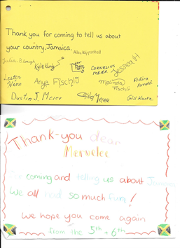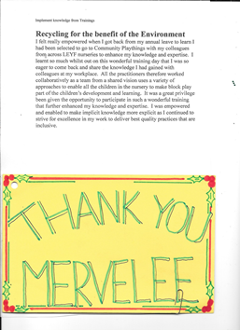

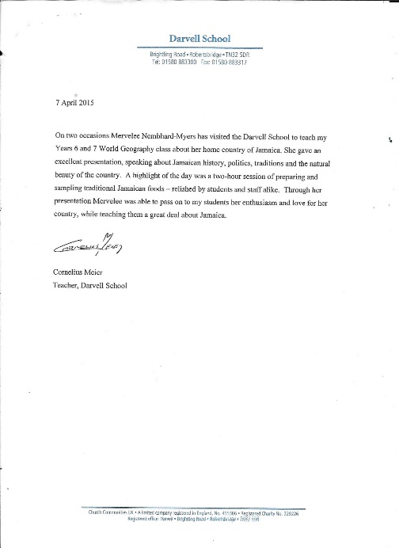 Darvell School

Mervelee Myers
16 Alma Grove
Bermondsey
London SE1 5PY
Mr Cornelius Meir
Teacher Darvell School
Brightling Road
Robertsbridge
TN32 5DR

9th November 2016

Deleting of Video

Dear Mr Meier
Further to your telephone call on Saturday 5th November 2016 re my video on Social Media. I have had time to reflect and think about the conversation and what I can understand that you are asking of me. I understand that you are asking me to delete my video because it makes reference to London Early Years Foundation (LEYF). In the conversation you claim that Darvell School and Community Plaything are separate and parents are not aware of my visits. You further went on to say that the video was very hurtful and you are asking for me to delete it. Who is the video hurtful to might I venture to ask?
Therefore I am of the opinion that the video in question is the one I made on the Wednesday prior to attending Darvell School to do the presentations. If this is not the facts of the matter I would be grateful for your clarifications. Since I did not make that video on Darvell School premises, I refuse to delete it. Also I would like you to clarify why you stated that the Community Plaything as an organisation parents were not aware of me coming to Darvell School. When I ask about the video that was made on the Wednesday I done the presentations, you claim that you would be discussing this with the Head Teacher.
What I would like to know also if at this late stage when you called on Saturday, why have the Head Teacher not given his approval for the making of the video? Because you said you have to discuss it with him and I thought that was approved before. The Head Teacher came into the classroom and the dining area during the presentations. One of the pupils in the class is the daughter of the Head Teacher, therefore everyone is contradicting themselves. I am surprised that you allow (LEYF) to get you to stoop to their unprofessional levels that are akin to INSTITUTIONALISED CORPORATE PSYCHOPATHS.
After much reflections, I have come to the conclusions that the only reasons that you made the call to me on Saturday was at the instigations of London Early Years Foundation (LEYF) that is continuing the DISCRIMINATION that destroyed my health. Cause me to be out of a job from the 27th January 2015, blacken my name, ruin my reputation and destroy my character. All this with the conspiring and colluding of friends in high places and the SYSTEMS I thought were in place to support me. Now I am very disappointed to say I have to add you to the lists of those that are collaborating with (LEYF) to discriminate against me.
Lest we forget how I came to have done presentations at Darvell School for the third time a few Wednesdays ago. I attended Community Plaything with the former employers (LEYF) for a training for the first time. I am positive I was only invited back because of my professionalism that I displayed at the training sessions. Over the years that I came to do the presentations I asked verbally for permission to video some of the sessions, adhering to Ethical Guidelines which is part of my Continuing Personal Professional Development Plan that became part of the Defensive Practice from my studies with the Open University.
As a matter of fact the first visit when I done the Harry Belafonte Day Oh Song was videoed by you using my camera. The second visit I was given permission to video the act that was done. Each time I took photographs of the cooking sessions and these have been on my Social Media profiles since. Because of what (LEYF) have done to me, I lost my self-confidence, self-esteem and the ability to make informed decisions as I do not want anyone else to alleged that I acted unprofessionally and try make me out to be a CRIMINAL. That’s why on this visit, I ask permission about getting some of the sessions videoed as part of my CPPDP, so I could use the video to promote myself and to get back into work.
It was agreed over the telephone the criteria for the videoing on the Wednesday I attended Darvell School to do the presentations. At no time did I use either my camera or mobile phone to photograph and take any images of the children, Darvell School or Community Plaything. Because the decision was made by you and the photographer Martin, which sessions were to be photographed and videoed? Therefore I finding it rather strange that you are telling me that you will have to discuss the matter with the Head Teacher. Since I have come to the conclusions that (LEYF) have gotten to you to continue with the DISCRIMINATION and do their dirty work…
I am therefore going to put in writing that I am expecting you to stick to the agreement we made over the telephone, and I am given a copy of that video to help me in finding a job. The video contains my INTELLECTUAL PROPERTIES that can be of support in helping me to get back into work. Therefore since you seem to have lost your moral compass so soon after my visit and pondering to (LEYF) prejudices, I will demand my rights not to be directly or indirectly discriminated against by anyone. Because of the collaborative working partnerships between us over the years, I am willing to be respectful of those strong held values and beliefs I have of the company.
Meeting your mother and hearing her stories about her life which bear much similarities to mine, I am prepared to be forgiving. But I am asking that the copy of the video that was made MUST be sent to me as soon as is reasonable possible, or else I will be adding your name to the list of those that have joined (LEYF) by discriminating against me. I will not only be adding your name, but also making this public when the appropriate time arrives. (LEYF) made my life a hell here on earth soon after I come back from burying my MOTHER in Jamaica and it has not stopped.
Now I am very sad to know that someone who I respected all these years can stoop so low as to allow (LEYF) to let them act against their better judgement. So as there are no misunderstanding about the contents of the video, I will make a list of some of the sessions that were photographed and videoed. Photos were taken of:
- Some of the resources in the classroom
- Resources in the kitchen
- Me peeling the Sugar Cane
- Children working at stations: kneading the dough, etc.
- Me cooking
- In the Eating Area
- Me singing tribute Song to my Mother
- The children saying what they got from the presentation & me attending the School
- Photographs with the group outside
Now you can explain why you told me that parent did not know about my involvement with the School. Maybe you are forgetting that each time I come to Darvell School I was in attendance at the group session and introduced to the Community. So are you saying like (LEYF) that you breached your own Policies & Procedures by having me coming to Darvell School on three occasions and parents did were not informed? (LEYF) mistake was to refuse me access to my FILE from before I transferred from Luton Street back to South London where I was treated less favourable than an animal. Then they say they were not aware I have disabilities. My health was destroyed with their contingent policies and procedures in the Contract I signed on the 7th October 2009.
The rest is history, but I will not leave myself open to the DISCRIMINATION by (LEYF) and which you seemed only too happy to join. I feel the way I have been treated by the conversation that was relayed by telephone on Saturday have caused me to become DEPRESSED and leaves me questioning my self-worth. As stated in the video I was on the road to recovery especially when I got the invitation to come back to Darvell School to do the presentations. But in one telephone conversation on Saturday, I was set back months into my recovery. I offered myself for research and will be attending a session tomorrow Wednesday 9th November 2016 at Kings College Hospital NHS Foundation Trust & Maudsley Hospital.
Maybe I might get some insights into why you chose to collude with (LEYF) to set back my recovery. Does this have anything to do with money and power? I have the money that was given to me and honestly I am thinking of finding a worthy cause to give it to. I just don’t want to keep it and spend it for myself as it will bring back very sad memories of the way I was betrayed by you and whoever else is involved in this sordid affairs.
With all due respects I am expecting to hear from you in the next two weeks when I will be given my copy of the video. The terms which were discussed between us by telephone.
Awaiting you earliest response.
Kindest regards.
Mervelee Myers (FD) Open

Telephone - Home: 02072310813
Mobile: 07950618083
Email: rattynem@btinternet.com

Mrs Mervelee Myers
16 Alma Grove
Bermondsey
London SE1 5PY
Mr Cornelius Meier - Teacher
Darvell School
Brightling Road
Robertsbridge
TN32 5DR I
22nd March 2017
Reference: Intellectual Properties 26th October 2016
I am hereby taking this opportunity once again to give due notice that I would like to have receipt of my Intellectual Properties that were recorded/videoed during my visit to Darvell School on the 26th October 2016.
Since I have already put in writing to you at Darvell School about the contents of the video that I am expecting to receive, I would be grateful if this could be dispatched to me without delays. I would be grateful if it could sent in the best ICT/Technical package that will enable me to use it to get back into work. I communicated that the reasons I wanted to get the video done was with the hope of showcasing my qualifications, experiences, creativity and expertise working with children and young people to support my transition back into work.
To date I have not received any further communications after I was contacted by telephone saying the parents were not aware of my visits to Darvell School. I was asked to delete a video I had made at Robertsbridge Station and Without Prejudice this was the doing of London Early Years Foundation (LEYF). LEYF has been thrown their weight around getting other company and organisations into colluding and conspiring with them to continue the discrimination that caused me to resign from my job. You are aware of the circumstances why I am not working and the tribute song I done for my MOTHER summed it up. That’s why I am going to stick to my guns for copy of the video to be released to me.
If I can’t get the video amicably, I will resort to seeking Legal Advice about how to go about getting it. For old time’s sakes and considerations of the good working partnerships we have had over the years are the reasons why I am giving you the chance to deliver the video. Non-compliance of delivering the video will mean I will be putting the full story in the public domain as well as taking the matter to court.
Awaiting a favourable response.
Kindest regards.

Mervelee Myers FD (Open)

Curriculum Vitae

Personal Details

Surname: Myers
First name: Mervelee
Home Tel.: 02072310813. Mobile: 07950618083
Email: rattynem@btinternet.com

Educational & Professional Qualifications
Subjects/Qualifications | Places of Study | Grades/Results | Years
Pearson Edexcel Level 2 Supporting Teaching & Learning in Schools | STORM Family Centre - HCT | Certificate of Unit Credit | 2016
Working Together For Children | OU | Certificate | 2010
GO1/Level 5 | OU | Foundation Degree in Early Years | 2008
E215/ E230 | OU | Pass | 2008
E243/ E115 | OU | Pass | 2007
K100/Level 2 - Health & Social Care | OU | Certificate | 2006
C37/Level 4 – Early Years Practice | OU | Certificate | 2006
BTEC/National Diploma Level 3 – Nursery Nursing & Student of the Year | Lambeth College | Certificates | 1999
Practical Guidelines in Healthcare & Care for Elderly |  | Certificate | 1996

Training Courses
Course Titles | Training Providers | Duration | Years
Online: An Introduction to Child Protection. | ChildProtectionCompany.com Barnet LSCB. | 1 day | 2015
Online: EduCare for Education Trainings. | London Early Years Foundation | Days | 2012-2015
First Aid Essentials | EduCare | Hours | 2015
Basic Food Hygiene | EduCare | Hours | 2015
Equality & Diversity | EduCare | Hours | 2015
Health & Safety in Education | EduCare | Hours | 2015
Fire Safety in Education | .EduCare | Hours | 2015
Child Protection in Education | EduCare | Hours | 2015
Safeguarding Vulnerable Young People | EduCare | Hours | 2015
The SEND Code of Practice | EduCare | Hours | 2015
Data Protection | EduCare | Hours | 2015
An Introduction to Data Protection | EduCare | Hours | 2012
NSPCC Programme – Child Protection Awareness in Education | Educare | Hours | 2012
Family Support Volunteer | Resources for Autism | 6 Months | 2015-2016
Working with Families | Resources for Autism | 1 day | 2015
Safeguarding Children & Vulnerable Adults | Resources for Autism | 1 day | 2015
Autism An Introduction. | Resources for Autism | 1 day | 2015
Social Communication & Play. | Resources for Autism. | 1 day | 2015
The Progress Check at Two: Understanding & supporting schemas. | Nursery World Show | 1 day | 2015
Activematters | Dr Lala Manners | 2 days | 2014
Helicopter Story Telling & Story Acting & Oral Storytelling. | CLCH - NHS Westminster | 1 day | 2013
Stammering. | CLCH - NHS Westminster | 1 day | 2012
EYFS Prime Areas: Communication & Language | Westminster | 1 day | 2012
Observation Assessment & Planning- EYFS (10 GLH) | Westminster | 2 days | 2011
Introduction to the role of the SENCO | Camden | 1 day | 2009
Autism & Communication support group | Camden | 1 day | 2009
Mentoring | Islington College & LEYF | 1 day | 2009
Multigenerational Working – Elderly Care & Inclusion | LEYF |  | 2010 -
Working in Partnerships with Childcare & Children Workforce | Community Plaything | Periodical
Basic School Teacher | Jamaica Early Childhood Foundation | Monthly | 1986 - 1992
Teaching Assistant | Ministry of Education - JA | 1 Year
Update Knowledge via ICT | Research - CPPDP |  | 2015-2016
The Equality Act 2010 | Online - Internet | Months
British Values 2014 | HCT | Weeks | 2016
Counter Terrorism & Security Act 2015 | HCT | Weeks | 2016
Teaching Volunteer | HCT | Months | 2016
Writing & Photography | CPPDP | Years | 2010-

Employment History
London Early Years Foundation (LEYF) 121 Marsham Street, London SW1P 4LX. 01.09.2009 - 27.09.2015.

All Nations Nursery Peckham Settlement. Goldsmith Road Peckham, London SE15 5TF. 05.01.2009 – July 2009.

Kings College Hospital NHS Trust. Kings Day Nursery Mapother House, D’Crispigny Park, Denmark Hill, London SE5 8AZ. From April/2003 - November/2008.

Family Support Network, Waterside Centre, 26 Avenue Road, South Norwood, London SE25 4DX. From Sept/2002 - April/2003.

Asquith Court Lambeth, 50 Groveway, London SW9 OAR. From July/2001- June/2002.

Mrs. Mioara Istrate. William Wilberforce, Lambeth Walk Day Nursery, Longton House, Lambeth Walk, London SE11 6LU. From July/1999 - April/2001.

Teaching Assistant: Townhead Primary School, Westmoreland, Jamaica WI.

Basic School Teacher: Townhead Basic School, Westmoreland, Jamaica West Indies.

References: Can be provided if and when needed from suitable candidates.

Prepared by: Mervelee Myers FD (Open)
Early Years Practitioner, Volunteer, Informal Carer.

Community Plaything Visit 2016
Hi Helen & the Team

I am getting myself ready for the visit to fit in with the date that is most convenient for you.

I am preparing some songs, poems and stories from the Caribbean to get everyone involved in the day's activities. Then we can round off with music and some dancing. I wouldn't say I am verse in doing all the new dances that are more suited to the younger generations like the Ney-Ney. But I am still prepared to do what I can in the spirit of the moment.

I will come prepared to do cooking that is simple and easy to fit in with the allocated time frame. I will bring the saltfish, ackee and plaintains. Of course you can get selfraising flour for frying, the cooking oil, onions, sweet peppers and tomatoes. Of course I will bring some spices.

I will come dressed in my Traditional outfit and bring along some artefacts. I am so looking forward to the day.

However I would like the School permission to video some or all of the activities we do...? That is so I can document evidence of my abilities to do presentations as part of my Continuing Personal Professional Development Plan. I am looking for innovative ways to earn money as I am not in paid employment at the moment.

As I have said I will make the arrangements from my end. All I need for you to say that the last Wednesday in October 2016 is the best options.

Kindest regards.

Mervelee Nembhard-Myers

Connex Eeducation re Dilys Epton Reference
Mervelee Myers
16 Alma Grove
Bermondsey
London SE1 5PY
Connex-Education
The Old Truman Brewery
91 Brick Lane
London E1 6QL
1st November 2015
To Whom It May Concern
Please find the information requested re the reference from London Early Years Foundation (LEYF).
History of working at LEYF: 01.09.2009 – 28.09.2015
Start Date: Westminster Children Society (WCS) 1st September 2009 at Fitzrovia Community Nursery - April 2010
Covered at other LEYF Nurseries: Holcroft, Carlton Hill, House of Commons, Queens Borough, Queens Park, Mickey Star, Lisson Green, Noah’s Ark, Playhouse – 2009 – 2015
Transfers: (1) From Fitzrovia Community Nursery - Luton Street Community Nursery – April 2010 – July 2014.
Reasons: Manager took my enthusiasm for sharing my knowledge in the Role of SENCO she appointed me to as threats to her own lack of knowledge after the Early Years Teacher decided to empower me sharing knowledge and expertise to do the job. Because I challenged the unfair treatments not to be harassed, bullied and intimidated when carrying out my job, I was targeted, labelled and victimised. However I worked as a professional collaboratively from a shared vision (see former colleagues reference – Patricia Sessions – appendix 1).
Transfer: (2) From Luton Street Community Nursery - Bird In Bush: Spent the better part of my time working with LEYF at Luton Street Community Nursery – April 2010 – July 2014. I have 2 folders of evidence of my work that can be seen if necessary to prove my contributions of fulfilling the Job Description for the CONTRACT I signed in 2009. (Relevant copies of evidence of contributions – April 2009 – July 2014 – appendix 2).
Waiting for Transfer:
I applied for transfer for years when HOC first opened and requests sent out for practitioners to apply. I thought I was accepted when I was visited by 2 Persons in authority at Luton Street Community Nursery. HR Dilys Epton & Area Manager Maria Freeman only visited to question why I’d applied for a transfer. I thought it was clear why I’d applied in my application as the notice was there for anyone who wished to do so. My application was not accepted and I leaned from prior experiences at Fitzrovia, when Maria Freeman was involved to be weary of getting on the wrong side of her. I was warned about how she operated and had personal experiences after that as lots of negative things were said about me because I was not their cronies.
At this time I did not know Dilys, but things go round at LEYF like Chinese Whispers. With no other choice, I carried on working at LSCN after applying for numerous jobs and had to come to terms with the rejections that I would never get another job because I’d challenged inappropriate practices as I was taught to do at College/University. I covered in HOC and realised I could not have managed with my health conditions anyway. So when I was literally been forced to take up a post there after I’d applied again for transfer closer to home, I declined the offer.
Transfer: (3) Bird in Bush Nursery From 23.07.2014 – 17.03.2015 – House of Commons. I applied for Brixton when I heard it was taken over by LEYF, but got news of a setting that was even closer to home that was taken over – BIB. I was happy when I was eventually transferred there. I joined the BIB team bringing along my enthusiasm and ethos I’d been empowered with as a long time LEYF employee with years of dedicated services to an organisation I considered a beacon, despite the few flaws. Because no matter where anyone venture in life, they will never ever find the ideal anything – personal or professional situation! Once I done my best working collaboratively from a shared vision to help BIB get a good OFSTED, my troubles started after.
To be exact it was October 2014 when the problems started at BIB because I was eating a banana to enable me from getting sick so I could carry out my normal day-to-day activities. (See Long Service Award – appendix 3). Matters were left to escalate out of control to the point where I became sick and was fearing for my sanity and life in general (see letter/email to Dilys – appendix 4). Because I then take a stance not to be gagged and Discriminated against whilst they tried to gather false evidence to SACK me from the job I’d done. I faced further Direct Discriminations and the entire LEYF organisation colluded and were in cohorts. But I only learnt about this later.
False Allegations to blacken my name & ruin my character:
Staff at BIB were aided and abetted by Central Office staff to Directly Discriminate against me, so they tried every Policy & Procedures in the CONTRACT to get me SACKED on the request of colleagues at BIB & CO staff who decided they wanted me out by fair or foul means. So they made up false allegations on Thursday, sent it to CO and by Friday they carried out a so-called investigation. Because I asked for them to remove the gag (see appendix 4) and to carry out an investigation, I was shipped out the Monday to HOC. I faced further Direct Discriminations because the area Manager Hilda Miller gave them directions how to treat me unfairly.
House of Commons:
They claimed in their investigations they had concerns about me, yet they sent me where staff has to be vetted to work. While they have their so called concerns CO big wigs were visiting BIB (see CEO’s letters November 2014 & January 2015 – appendix 5) yet I was not informed about these concerns. They were not flagged and anything done about them until I received the Disciplinary Letter. Of course this was after I was sent home to rest from my ordeals with pay and I went to the door the next day to find the letter summoning me to the Disciplinary. My Union advised me to find out the grounds under which I was sent home and learned that it was a Medical Suspension.
Dilys tried to trick me into signing an agreement over the telephone and told me when she visited me at HOC she wasn’t trying to set me up, but that’s exactly what she was doing (see letter re HOC visit - appendix 6). To cut a long story short, I had a Union Rep who supported me at the Disciplinary Hearing and brought out some discrepancies. He disappeared off the face of the earth since after promising he could get me a PACKAGE if I didn’t feel up to working with LEYF again. The Union solicitor then turned against me advising me not to appeal the Disciplinary Outcome, but I did. She claimed the employers did not have to prove I’d done anything wrong because it is in the CONTRACT I signed. When I asked her to put what she told me in writing, needless to say she LIED.
Transfer: (4) New Cross Community Nursery 2nd June 2015 – 28th September 2015
I am currently at loggerheads with LEYF and the Union and I won’t let them get away with what they’ve done to me and countless others. I was passed fit to go back to work, yet LEYF continued with the charade to try to get me out by fair means or foul. Because of my situation, I gave up my RIGHTS and tried to provide for my basic needs under challenging circumstances. But LEYF carried on with the Direct Discrimination and the Union turned a blind eye and offered no support. LEYF threw everything at me to get me to quit, but because by this time I was on the waiting lists for counselling I was concerned that no other employee would give me the chance to get myself back together after the way LEYF treated me causing me to suffer from ill health.
However I reached the end of my tether when LEYF refused to renew my GRB/DBS despite giving them prior warnings on my return to work on 02.06.2015 that it was running out. I was treated like a paedophile and criminal which further affected my mental health issues that I was awaiting counselling on. However I still decided to give up my Rights and see the difficult situations out. Luckily I started making contingency plans and asked one of Connex-Education Supply Staff to give me the contact information for her agency. I refused to accept the Disciplinary Outcome because the Occupational Health doctor had put Reasonable Adjustments in place.
I put in a Grievance against BIB and a Grievance for the Reasonable Adjustments to be put in place. But like everything LEYF used delaying tactics, pushed my concerns under the mat and carried on with the Direct Discriminations. Only this time they tried to cover their tracks using 3rd Parties to do the dirty deeds. When I decided enough was enough and carried on with my “Defensive Practice” Hilda Miller the Racist area manager who orchestrated all of what happened to me from I transferred to BIB came to have a meeting with me (see letters Newcross– appendix 7). When I stood up for my RIGHTS not to be harassed, bullied and intimidated by anyone, she put the machinery in place to get rid of me.
I understand she claimed she is not working with me… The rest is history. I was called to CO to have a chat with the Director and when I got there it was Neil King and Dilys Epton. They tried bullying me into resigning and when I didn’t, they made more threats and gave me another suspension, saying they would send it in the post. Because this is how LEYF go about doing their dirty work and I have evidence of others they treated exactly like me and I won’t let them get away with it. The false allegations that they made and had to climb down when I appealed stated that the Appeal is a Final Written Warning hence an Instant Dismissal. So I don’t understand why they was going through another Suspension and not sacking me…?
I decided I was going to fight to the end but had to RESIGN when I was in the process of having a Nervous Breakdown. Matters took its toll on my health (see Resignation – appendix 8). LEYF then lowest of the low when they made an on line application for me after they refused before and treated me like a criminal. I worked with them 6 years and yet I had Agency/Supply Staff supervising me because I could not be left on my own. I had another GRB for the organisation I was doing volunteering with and then they wanted me to bring it in for them to copy. This is the same reasons why the Union is telling me that LEYF can apply online for a DBS for me (see letters – DBS/Union – appendix 9).
LEYF and the Union are abusing their power of authority and because I signed a CONTRACT, that does not mean I should be ENSLAVED by others who choose to flout the laws and legislations of Great Britain. Now Connex-Education can begin to have an insight into why I have to get myself back to good health before I can go back to work full time and find myself having to deal with another harrowing experience like what I’ve been through the past year. This is not the first time and although I am qualified I am been networked against because LEYF will try to destroy vulnerable staff like me who they see as threats to their incompetence (see letter re Post – appendix 10).
I have started my COUNSELLING and I hope with time I can heal so I am able to return full time to doing what I’ve done most of my life, working with young children. That’s my passion in life, laying the foundations so no other child and their parent have to go through what I went through with my child. LEYF and the Union are damned for all I care and any decent person with any shred of Humanity will see them for who they really are. LEYF was once a beacon but have since changed in a dog eat dog society.
If they set out to destroy me, I’ll return the favours, but I have to earn a living so will keep a low profile if they don’t trouble me. Maybe they deserved to be warned if you think so. I am more concerned about the people like myself who are relying on them for their employment otherwise LEYF and the Union can go to hell. After my ordeals at their hands I am entitled to say what I think of them after the way they have made my life hell over a period of a year. My soul has been cleanse now I get this off my chest.
As a result of what is happening in my life I have to seek help to carry on with my life so have to put my CV for public scrutiny. Therefore I find some persons are trying to exploit me for their own gains. They asks why I resigned and when I told the truth, they then treat me like LEYF done and this only makes me feel worse as they promised to get back in touch and don’t bother. There are others who are offering me some measly sums, I’ve done interviews and don’t get feedback because the highest qualified is level 3. I am offered a post and with my qualifications I am offered less than the living wage, yet LEYF thinks it is ok to write a negative reference of 5+ sentences after I worked with them 6 years. They get what they wanted and I resigned, but surely I am entitled to move on with my life without them jeopardising my chance to provide for my basic needs out of spite. I did not start this War, so I won’t allow them to win the Battle. I will fight with every weapons at my disposals to protect my good name and character that they tarnished and tried to destroy.
Appendix
1. Former colleague’s reference/Email re Maria Goncalves re my concerns
2. Relevant copies of contributions
3. Long Service Award
4. Correspondence re Dilys/Email my concerns - Health
5. CEO letters re BIB/ LEYF Parents
6. Letters re HOC
7. Letters Newcross
8. Resignation/Counselling Appointment
9. Letters DBS/Union
10. Letter re Post - Discrimination

Prepared by: Mervelee Myers FD (Open)

Mervelee Myers
16 Alma Grove
Bermondsey
London SE1 5PY
Connex-Education
The Old Truman Brewery
91 Brick Lane
London E1 6QL
9th November 2016

To Whom It May Concern
This is to once again give due notice to Connex-Education and their subsidiary to refrain from sending emails to me about noreply@connex-education... Since I contacted Connex-Education before via emails about taking me off their mailing list and no one is taking notice, I am exercising my rights to have this done in the next two weeks or I will be seeking Legal Advice.
From I registered with Connex-Education I have been asked to write reports about the reasons for the Reference written by Senior Human Resources Dilys Epton from London Early Years Foundation (LEYF) that I complied with. Connex-Education in choosing to not respect my wishes to be removed from their mailing list is breaching my Human Rights and the Data Protection Act 1998 by exacerbating and triggering my disabilities of CHRONIC ANXIETY and DEPRESSION. Connex-Education do not think I am professional enough to be sent on jobs, but they can ask me to refer people to them to get jobs.
If Connex-Education do not desist from sending me emails that are repetitive for non-existent jobs, then I will be taking further actions and putting them in the Public Domain as conspiring and colluding with (LEYF) to keep me out of work.
Once more please accept my apologies for thinking that Connex-Education is a reputable and professional organisation, but no they are in cohorts with (LEYF) to discriminate against me indirectly.
Thanks for taking note of my concerns and the way l am been affected by the continuing emails that don’t give me any chance of getting a job.
Awaiting your response.
Kindest regards.
Mervelee Myers (FD) Open
Telephone: Mobile: 07950618083
Email: rattynem@btinternet.com

Mervelee Myers
16 Alma Grove
Bermondsey
London SE1 5PY
Connex-Education
The Old Truman Brewery
91 Brick Lane
London E1 6QL
9th November 2016

To Whom It May Concern
This is to once again give due notice to Connex-Education and their subsidiary to refrain from sending emails to me about noreply@connex-education... Since I contacted Connex-Education before via emails about taking me off their mailing list and no one is taking notice, I am exercising my rights to have this done in the next two weeks or I will be seeking Legal Advice.
From I registered with Connex-Education I have been asked to write reports about the reasons for the Reference written by Senior Human Resources Dilys Epton from London Early Years Foundation (LEYF) that I complied with. Connex-Education in choosing to not respect my wishes to be removed from their mailing list is breaching my Human Rights and the Data Protection Act 1998 by exacerbating and triggering my disabilities of CHRONIC ANXIETY and DEPRESSION. Connex-Education do not think I am professional enough to be sent on jobs, but they can ask me to refer people to them to get jobs.
If Connex-Education do not desist from sending me emails that are repetitive for non-existent jobs, then I will be taking further actions and putting them in the Public Domain as conspiring and colluding with (LEYF) to keep me out of work.
Once more please accept my apologies for thinking that Connex-Education is a reputable and professional organisation, but no they are in cohorts with (LEYF) to discriminate against me indirectly.
Thanks for taking note of my concerns and the way l am been affected by the continuing emails that don’t give me any chance of getting a job.
Awaiting your response.
Kindest regards.
Mervelee Myers (FD) Open
Telephone: Mobile: 07950618083
Email: rattynem@btinternet.com

CAR: Contract, Allegations, Reference – 06.08.2016
Social Injustices & Inequalities – Direct & Indirect DISCRIMINATION
Contract
Each time I hear of yet another of the social injustices and inequalities that put me in the positions that I have found myself in at the hands of unscrupulous employers, I can’t help but “chomp at the bit”. This is 2016 when we should all be enjoying our freedoms but instead we are living in a society where some have the power to enslave us, whilst having the various laws, legislations, codes of practices and conducts as the legal tools that they can apply to protect them from prosecutions and exposures in Section 33. The English Courts. Resulting from experiencing DISCRIMINATION in workplaces on separate occasions over a period of years, I have decided that I need to take the stance ad let my voice be heard.
I have to “make the sacrifices to become an advocate” by setting up my campaign #FIGHT4JUSTICE in order that I can share my STORIES to the world. After “coming a crapper yet again in a toxic vitriolic work environment” I know I have “a DUTY to use my Defensive Practice” to assist others. If by sharing my story I can let others become aware of the pitfalls that are out there waiting for them to trip up. I will feel satisfied that I help to stop even one of my fellow human beings from having to suffer as I have done at the hands of unscrupulous employers and their corrupt cohorts. Everything that I have been sharing these past two years are relevant to me, so therefore I “will not be silenced with a gaging order” no matter the monetary offers.
I am all about principles and nothing to do with monetary values as some would like me to believe. I was brought up in a Christian home where the knowledge, values and beliefs were instilled in me by my parents and father in particular to stand up for the principles of right over wrong. By this way of teaching from my Father, I was able to sit and pass “Bible Knowledge with credit” by the age of 12 years old whilst still attending Primary School. Therefore this is saying much about the “British Values 2014” that became law. In essence I don’t need another piece of legislations to tell me about my Civic Duty as a Citizen of any Society I live in. My life have always been that of caring for my family, friends and even strangers I meet along the way like many of the Biblical Stories I was brought up to emulate.
I am sure by now everyone should be familiar with my story from 2003 – 2008 at Kings Day Nursery Mapother House, part of Kings College Hospital NHS Foundation Trust at Denmark Hill London. I will therefore have to “fast track to the present situation”, where I am not working since I was forced to resign from London Early Years Foundation (LEYF). Because if I don’t share my story the world will not be aware of what is going on with vulnerable employees who do not have any support nor a Voice to tell their stories for others to become aware. I want the world to know and understand that despite the fact, some are making public gestures saying they have changed, learned from their mistakes, etc., nothing could be further from the truth.
I have been taking avid interests in issues of work related matters that are similar to mine since I was forced to resign from LEYF on 27th September 2015. My research have turned up some revealing “myths of disproportionate magnitude” that beggar’s belief. I have attended conferences, lectures, book launches, etc and the themes coming out is that the UK has become a better place for “Ethnic Minorities as a Diverse Multicultural Society”, but nothing could be further from the truths. Reading Mrs Gloria Cameron MBE Book “CASE DISMISSED” tells me so much about what can happen to even the best of us with our good intensions.
However Mrs Gloria Cameron is of the opinion that things have changed since her days of persecutions by the corrupt SYSTEMS in operation in her time. But I have to “dissuade Mrs Cameron of that myth”, because not much have changed. Instead the SYSTEMS have become more adept at covering up the social injustices and inequalities perpetuated by the corrupt Egotistical PSYCHOPATHS operating in all echelons of society who refuse to share the power with others despite not having the qualifications and dispositions for the office they hold. The two times I have been involved in workplaces where Discrimination are rife, I realised that employers have been coached into how to use the laws, legislations, codes of practice and conduct in the form of a CONTRACT to enslave employees.
By so doing the employers have powers written in their Contract to strip employees of our Basic Human Rights as stated in Article 14 of The United Nations Convention on the Rights of the Child (UNCRC). The (UNCR Article 14) states that it is a basic entitlement of humans to enjoy their rights and freedoms without discrimination on any grounds. Yet Mrs Cameron and others are of the opinions that things have changed for the better for her grandchildren in the UK. Whenever I talk and listen to others talking about their plights in workplaces at whatever levels in the UK, I am hearing about stories that are similar or even worse case scenarios than mine. Because of my situation and my determination to have a voice, not to be silenced with a gag that is paid for by the blood, sweat and tears of fellow employees.
There are information via my researches coming to my attention about other cases of Discrimination in the workplaces. I am totally appalled and devastated by some of the things I am hearing about from the past and presently. Where there are cases of injustices by any employers to an employees, I am left in a “mad rage” that is not good for my state of “chronic anxiety” that trigger and exacerbate my Mental Health Issues, of which Depression is recurring, more so since the most recent episodes of discrimination by the SYSTEMS. I have coped with and managed my “Hidden Disabilities” from the age of 10 years old. I lived a relatively uncomplicated life knowing my capabilities to achieve my potentials despite my “deficits and limitations” that have always been a part of my DNA.
I managed to function giving of my best, until the former employers (LEYF) set out on a campaign to blacken my name, ruin my reputation and destroy my character. That was until I decided to give (LEYF) a taste of their own bitter/sweet medicine with my #Fight4Justice campaign. So (LEYF) have resorted to hiding under the umbrella of their Contract to try and destabilise my health with their contingent policies and procedures. For another employee that do not possess the sort of “resilience I gained resulting from personal experiences from the age of 10 years old” I am here wondering about the effects on other vulnerable workers? I can tell anyone that the past two years have been the worse of my – 60 years of life.
I am going to hold (LEYF) responsible and accountable for what they allowed others to do to me at BIB, HOC and New Cross nurseries from October 2014 to the 27th September 2015 when I had no other alternatives but to resign to save my life and possibly that of my husband’s. Despite my resignation, LEYF did not see it fit to mediate with me when I wanted to have conciliation with them. And anyone who knew me and my brand of work before my transfer to BIB, will know that I give of my best as I am a stickler for perfection. Because of my OCD, I would consider myself a failure if I did not give the maximum. LEYF and their unscrupulous cohorts take me for an “idiot like they know themselves to be” and would not listen to my bargaining pleas. Because I know I would be unable to deal with the STRESS.
But now that they realise they are not dealing with a fool that is as INCOMPETENT as they are, they are ready to insult my integrity. LEYF Solicitors that first contacted me “Bates Wells Braithwaite” certainly took heed when I decided to send them an “Open Letter” one of four I wrote to highlight my campaign #FIGHT4JUSTICE. I am determined that no other employers should get away with what Kings College Hospital NHS Foundation Trust done to me between April 2003 – November 2008. Then the SYSTEMS join in to rob me of my Human Rights. Honestly I thought that LEYF would be true to their words about what they agreed in the Back to Work Meeting and the Grievances I issued after my ordeals at the hands of BIB, HOC and the false allegations that led to the Complaints, Investigations and Disciplinary/Appeal Hearings.
Now instead of learning from their mistakes as they promised (LEYF) is grasping at straws and passing the buck. LEYF and their unscrupulous cohorts are hoping to break my resolves not to see my #Fight4Justice campaign through to the end. But hell would have to freeze over first, and I am positive even if God have it in for me, He will make sure LEYF is served with their just desserts for what they have done to countless other employees over the years. LEYF is going to be held up as an example for others not to abuse their powers of authorities. (LEYF) is therefore relying on their outdated Contract to rescue them from breaching the Employment Laws.
Despite there been 33 Sections in the Contract I signed with Westminster Children’s Society (WCS) now London Early Years Foundation (LEYF) on 07.10.2009. The Contract starts off stating: There are no collective agreements that apply to the terms and conditions of your employment. Section 4. Job Title states: You will work as a Nursery Officer. This job title will not limit your duties with the Organisation and you may from time to time be required to do other work that is within your capabilities either on a permanent or temporary basis. You will report to your Line Manager, the Organisation reserves the right to change this.
My change of fortune since I was transferred to Bird In Bush (BIB) South London from Luton Street North West London have become a “bone of contentions” with (LEYF) and myself for no reasons that I can understand to date. I can only come to the conclusions since the DISCRIMINATIONS by LEYF and me taking time to examine the facts that this was a well-orchestrated plot to destroy my career, making sure I cannot gain employment anywhere in the UK ever. Unbeknown to me (LEYF) concocted a “plan to dismiss me from their employ” without me knowing about it. This plot was put into place soon after my return from burying my MOTHER in Jamaica in July of 2014, even before my transfer to BIB.
The plot started with the new manager at Luton Street Gemma Manns using underhand tactics to frustrate me into acting unprofessionally. Because it is a well-known fact I am a “no nonsense person who stands up for my rights” as long as I know I am in the right. The first incident came about when I overheard Gemma Manns questioning one of my key children’s parents about Social Media. Then when she realised my presence acted as if nothing had happened. I did not challenge her because I already know of the consequences, which triggered my chronic anxiety in 2009 at LEYF. I was told by an area manager Maria Freeman not to challenge my manager even if she is wrong. This came about because I challenged the interim manager at Fitzrovia Maria Goncalves when she decided to discriminate against me.
Although I started at LEYF with a “Foundation Degree in Early Years from the Open University”, I was not allowed to advance up the career ladder, until I resigned 6 years later. Instead I was labelled, stereotyped and tagged as a troublemaker because I was more qualified than the interim manager and I was viewed as threats to their incompetence from the very beginning. Resulting from the stress I experienced and prior experiences from another workplace, already know I was on a “slippery surface” where my health was concerned. Therefore I could not afford to do anything to scupper my chance of earning my upkeep.
The Contract Section 7. Probationary Period: During your first six months in your post you will be on probation and as such your performance in your role will continually be assessed and reviewed by your manager, and you will be given feedback on your progress. At the end of this period (or as soon as possible after that), there will be a formal review of your performance with your manager. At this stage your position will be confirmed, your probation extended or your employment terminated. My interpretation of the Contract is that the interim manager at Fitzrovia started a campaign to stop my probation extended to employment from as far back as 2009.
As far back as 2009 LEYF have been breaching their own Contract as far as I am concerned. Contract Section 6. Hours of Work. On occasions we may not allow you to take a lunch break at all. Your manager will inform you if this is necessary and it is a condition of service that you comply. You will not be able to leave early if you chose not to take your lunch break or if you have been required to work it. By not allowing staff to have a lunch break for any reason is a breach of the Contract and International Laws especially for an employee that have disabilities and other progressive health conditions. I am forever grateful for the saying “it’s not who you know, but who knows you”! Because my professionalism came to my rescue when a former colleague I worked with at William Wilberforce, Lambeth Walk Day Nursery, vouched for me.
The person is Joelle Lax who joined LEYF soon after we parted company at William Wilberforce. She worked her way up to becoming one of the youngest Managers for LEYF working at Holcroft Nursey. Although our paths did not cross after that, she recognised me when she saw me at Fitzrovia the first time in 2009. Therefore it was a real shock to the system for me when these same professionals from Top to Bottom who are part and parcel of the hierarchy at LEYF decided to sanction the full-scale DISCRIMINATION that destroyed my health from October 2014 to date. They have not let up and is continuing hence the reasons I am without work since my resignation in September 2015. LEYF have friends in high places and is hoping to continue pulling the wool over their eyes.
Therefore I do not understand how LEYF can be talking about Section 22. Equal Opportunities: The Organisation is an equal opportunities employer and we are committed to ensuring within the framework of the law that the Organisation’s workplace is free from unlawful discrimination on the following grounds: 1. Colour, ethnic background ad race or national origin 2. Gender 3. Religion or belief 4. Disability 5. Marital status 6. Age 7. Sexual orientation 8. Trade union membership. We seek to ensure that all our employees achieve their full potential and that all employment decisions are taken without reference to irrelevant or unfairly discriminatory criteria.
We have adopted our Equal Opportunities Policy as a means of assisting us to achieve these aims. We will endeavour to ensure that all our employees are aware of their responsibilities regarding the equality of opportunity for all. It is the responsibility of each individual to ensure that every employee is treated in a fair and consistent manner. We shall also offer employment, career progression and training opportunities to all employees regardless of their membership of the groups shown above. Compliance with this policy is a requirement of your employment.
Nothing in LEYF Contract was of any support to help me control the Mental Health “psychological impairments” that are inclusive of “cussing bad words (wuds), writing and photography, and even making a fool” of myself. However since I discovered after attending “counselling that writing is an effective therapeutic” method, I will make use of the writing. I have always been “reading and writing from a young age” and because of my attention to details have been saved from some very life changing situations over the years.
My “defensive practice” have come to my rescue many a times when I was left at the mercies of some unscrupulous persons who tried to take advantages of my “Hidden Disabilities – Chronic Anxiety, and what I like to call my Parkinson Disease”. Contrary to popular beliefs or whatever the professionals or experts may say, I don’t need a “diagnosis for my DNA and genetic heritage”. The professionals told me my first son was “deaf hence the reason he was dumb”, but I knew differently. Even when I did not possess the knowledge to know certain relevant information, as my “child’s MOTHER” I was privy to information that no strangers no matter their professional status could tell me differently.
Unemployed because of Conscious & Subconscious Prejudices - Discrimination
Resulting from the prolonged concerted efforts of the former employers London Early Years Foundation (LEYF) from January 2014 after I came back from Jamaica to attend my son’s wedding and then in July 2014 to bury my Mother, I had no alternatives but to resign. I visited Jamaica 2 times in 2014, first time for my “youngest son’s wedding and the second for Mama’s funeral”. I noticed after coming back in January 2014 there were changes in the work environment that I couldn’t allow to impact on the way how I was able to carry out the roles and responsibilities that I always undertake without any complaints from anyone about my work ethics.
This was after the little glitch at Fitzrovia when Maria Goncalves with the aid of Maria Freeman tried to get me out of the job. However as soon as I transferred to Luton Street and the manager saw my passion for my job and the way I work collaboratively in the team I was empowered to get on with the job, because LEYF benefitted from what I brought to the Organisation. Section 23 Harassment and Bullying: The Organisation is committed to creating a work environment free of harassment and bullying where everyone is treated with dignity and respect. All allegations of bullying and harassment will be investigated and if appropriate, disciplinary action will be taken. Definitions of what is and is not likely to be considered harassment or bullying is contained within the Organisation’s Policy on Dignity at Work.
At first when the others start ganging up against me, being the sort of naïve person that I am I started to bury my head in the sand. Instead of facing up to the realities of what was happening to me because I had been there before in another workplace. I was putting the inappropriate behaviours of colleagues down to “stress that are side effects of my Mental Health Issues” and sought the support from the GP Practice – NHS Professionals. I was signed off for 2 weeks, because I always work with the GP to manage my disabilities from I arrived in the UK. But I was let down by the SYSTEMS when I needed the support most back in 2003 - 2008.
This time around I made sure to be even more proactive in ensuring there were no ambiguities, misconceptions nor any probability for anyone to say they were unaware of my disabilities and progressive health conditions – Section 12. Absence From Work. I was terribly let down at KINGS, where the triggers that pushed me into “full blown Mental Health Issues” started during a similar period when I was finishing studies, dealing with bereavement and coping with the onset of the Menopause. That was the time the manager at KINGS colluded with staff and parents to make the ALLEGATIONS that were to destroy my career that I had worked so hard to achieve.
The Local Educational Authority – Southwark Council was involved and by the time KINGS finished I was “Blacklisted & Networked” against in every LEA in the UK, and maybe across the globe? I went through a phase when I started looking WORK where I reached rock bottom and thought there were no hopes left for me. But as God would have it I was rescued by no other than Westminster Children Society (WCS) now (LEYF) in 2009 after I impressed the Interview Panel: Senior Director Neil King, Area Manager Tina Georgiou and Manager Maria Breslin. I knew I have the job before the interview was finished. But to realise that LEYF have resorted to scuppering the chances of other employees to gain employment away from their Organisation using unlawful methods is breach of the employee’s Human Rights.
After returning from Jamaica in January 2014 and attending the New Year Staff Party when Luton Street team was crowned Best Dressed I notice the momentum to frustrate me was still very much in evidence and more so. The lead was one of the students whom I mentored during her studies, but now she became a “stooge and a puppet on a string” to be manipulated. When Michelle Hoofong became like Judas Iscariot that betrayed Jesus Christ so that He end up crucified on the Cross I was not surprised because the exact same thing happened to me at Kings Day Nursery Mapother House part of Kings College Hospital NHS Foundation Trust. Me being me and knowing what I know, I refused to let the right hand know what the left hand was doing.
I went about my work in the usual fashion, being the consummate professional as I realised lots were resting on my shoulders as there were changes again at Luton Street and much upheavals to contend with. It went back to when I had started at Luton Street in April 2010 with the “high staff turnover”, when there were more Agency Staff than LEYF staff as once again LEYF went into melt down. I took everything in my strides as without a doubt I have “weathered many storms” and know to deal with professionals from all levels of the society by this. I have been there, done that and have some of the accolades, my “defensive practice” and anything else I could put my hands on as proof and evidence of my contributions.
Because I already discovered if I did not empower myself, no one else was going to do the job for me. Taking everything in considerations, I noticed that the person who was given the job to frustrate me after my return from Jamaica in January 2014 was a fellow Jamaican. This person whom I trained and mentored was given status as Duty Manager. I was shocked one day when the “Fire Alarm” went off and I heard this Untrained, Unqualified Duty Manager berating a Senior Member of the team for not stopping to dress the children. This was yet another of my cues telling me that nothing much had changed to when I started in the workplace and there were more “Agency Staff to the Organisation Team”, but at that stage in my life I was dealing with my own personal problems to take too much on board.
When I started I had basically done what I usually do, get on with the job. That’s when the manager realised my true worth and empowered me to give of my best. Because I had gone to Luton Street under a cloud because of what was done to me when I challenged DISCRIMINATION at the other site - Fitzrovia. I know that because I was blacklisted and being networked against I could not afford to do anything to jeopardise my chances of keeping my job. Therefore I compensated by going the extra mile even when others question my loyalty to LEYF that was exploiting me for my “Qualifications and Experiences” over the years. Contract Section 15. Our Expectations of You: You agree to abide by this Contract, our lawful instructions and orders and follow the rules, policies and procedures of the Organisation, as well as any manuals and memos issued to you.
You must devote your whole time and attention to the Organisation’s best interests during your working hours. Over the best 4+ years of my working life at Luton Street I gave of my best ad did not complain when I was taken advantage of. Because I was thankful for having a job after my struggles to get back into employment when I challenged social injustices and inequalities. Therefore I chose to keep in the background and get on with the jobs at hands knowing I was earning my Pensions for my retirement. Section 13. Retirement: The Organisation have a normal retirement age (NRA) of 65 and therefore is the age at which we may inform you that we wish you to retire, unless agreement has been reached prior to this time, for you to continue working beyond this time.
What LEYF failed to understand once they decided to give away “Quality for Quantity” is the manuals and memos that were issued which they then discarded, were not adhered to by the new employees. However I continue to carry out my roles and responsibilities as per Section 4. Job Title. The Job Title and all Sections of the Contract were inclusive of the Duty Manager Induction Programme, Health & Safety at Work Act 1974, Whistleblowing, Supervision to name a few. In their haste to become the “Biggest in the Early Years Sector” LEYF committed the abdominal sins of losing sight of the bigger picture when they started depriving employees of their jobs in the most despicable manners.
Allegations
From I started at LEYF and have my “runs in” with Maria Goncalves and Maria Freeman at Fitzrovia, I was warned about the way LEYF go about ruining the careers of employees they no longer want to work in their Organisation. Once you are viewed as threats to their INCOMPETENCE, LEYF will set out on campaigns making ALLEGATIONS, therefore I tried to keep one step ahead, without getting into “hot water” with anyone in authority. I refused to blot my copy book, but at the same time I made sure to keep up with my defensive practice, dotting the i’s and crossing the t’s. And because I have been saved from ruins a few times, I know I have to be extra vigilant at keeping my records clean and above boards.
I was mindful of the saying “once bitten, twice shy” as no one was allowed to take me back to a place when I was my most VULNERABLE. I always thought my contributions were appreciated because of the accolades I received over the years at Luton Street and even as late as October 2014 after my transfer to BIB. Because when my circumstances changed in terms of the Progressive Health Conditions linked to aging I asked for a transfer to work closer to home. However despite the pressures that were applied for me to take up a post at HOC, I refused. I had put in a transfer request when HOC was to be opened after an advert was placed, but I was turned down.
I was not only turned down but the area manager Maria Freeman and Senior HR Dilys Epton travelled to Luton Street to carry out an interrogation into why I had asked for the transfer. But I thought the advert was opened to everyone and I had stated the reasons clearly in the application. After covering at HOC I realised it was not the kind of work environment that was conducive for my disabilities and progressive health conditions so there was no way I would let Tina G. bullied me into accepting the post. Not long after Tina G. tried forcing me to go to HOC, the news was out that she stepped down from the post of Area Manager and was managing a nursery in Barking and Dagenham. The reasons were she was unable to deal with the stress that was taking a tool on her life.
I stood my grounds saying I would wait for Brixton that I’d heard was coming under the LEYF umbrella. That was when I must have started to realise how some staff at LEYF were prepared to lie when I enquired about Brixton. I had overheard 2 Senior LEYF staff discussing the imminent opening of Brixton, but I was told they did not know when. Deciding to wait for Brixton, but there was a visit from BIB and that’s when I knew BIB was part of LEYF. I recalled SAO BANYA telling me that there was vacancy at BIB so I should ask to transfer there. Now to read in Lynne Kelly’s statements what Sao Banya and Early Years Consultant Stella Louis are alleged to have said about me I am not surprised because I have experiences of this nature to fall back on?
That’s why I have not worked in South London since 2009. That’s another reason I refuse to let LEYF and the SYSTEMS get away with the discrimination that ruined my health and caused me to be out of a job. Since Social Media is the only source I have of sharing my EXPERIENCES, then so be it. I have tried getting support from other media to no avail. I have been blacklisted and networked against from I challenged social injustices and inequalities and if I have time I could name some of those in the SYSTEMS that colluded to ruin my career. Therefore I will not be applying for their jobs for them to continue treating me like the MONSTER CRIMINAL that LEYF made me out to be once they used, abused and abandoned me.
My life is an open book and I have nothing to hide unlike LEYF that impose a GAG on me and is trying to buy me off. I am a Principled Person who cannot be brought, so I will continue to share the STORIES. Contract Sections 24, 25, 26, 27, 28, 30: were used by LEYF over the period of October 2014 to date to deny me of my Basic Human Rights. This started at the time when I was eating a ripe banana so I could carry out the roles and responsibilities in the Contract Section 4. Job Title. From as far back as November the manager issued threats that is RACISM and part of the protected characteristics. At no time did I breach any of the Contract Sections, hence the reasons LEYF could not DISMISS me using their Policies and Procedures.
But at the same time they were building up evidence that was sent to LEYF Central Office. The ALLEGATIONS that resulted in the Complaints, Investigations, Transfer to HOC and New Cross, Disciplinary/Appeal Hearings, Medical Suspension, my Grievances all stem from the disparaging comments that LEYF gathered and was a party to inventing in their quest to destroy me so I can’t work again for the rest of the time I have left to retirement. Yet LEYF have the nerves to continue with the DISCRIMINATION that place me at this place where I am feeling VULNERABLE and fighting not to become a VICTIM by the SYSTEMS.
There were lots of Section 23. Harassment & Bullying: The Organisation is committed to creating a work environment free of harassment and bullying where everyone is treated with dignity and respect. All allegations of bullying and harassment will be investigated and if appropriate, disciplinary action will be taken. Definitions of what is and is not likely to be considered harassment or bullying is contained within the Organisation’s Policy on Dignity at Work. Therefore it was a shock to my system when I discovered that LEYF sanction BIB to carry out a campaign of “direct and indirect discrimination based on unfounded allegations” from BIB staff about matters that did not happen under the jurisdictions of any of the 33 Sections of the Contract I signed in 2009.
And even after I pleaded with LEYF to investigate the discrimination that affected the Mental Health psychological and physical impairments LEYF colluded with others to make the allegations to DISMISS me over a period from October 2014 until I was forced to resign in September 2015. There were clear evidence of inappropriate practices at BIB from l visited for the initial look around in July 2014. Because I stand up for my rights as part of Section 22. Equal Opportunities, I was subjected to the kinds of DISCRIMINATION from October 2014 that resulted in Section 12. Absence From Work: If you are absent from work due to illness or injury which renders you incapable of performing your duties you must comply with the following notification requirements.
After the experiences I have at LEYF – BIB in the first instance, briefly at HOC and then at New Cross I am aware that LEYF do not adhere to the CONTRACT I signed in any of the Sections. Hence the reasons it is written “There are no collective agreements that apply to the terms and conditions of your employment”. LEYF set about breaching all 33 Sections of the Contract I signed in 2009. Then LEYF set about making all manner of allegations against me ceasing on my VULNERABILITY because they know I had done “a protected act and discriminated against me using my protected characteristics” to make out I am a Monster CRIMINAL.
Despite working for LEYF all these years and having the accolades in writing about my contributions some of which were in the Public Media, LEYF set about their plots to DISMISS me from their employ with their ALLEGATIONS. Section 16. Confidentiality. Failure to maintain confidentiality is gross misconduct. Section 25. E-mail & Internet: As a keen photographer and writer I adhered to the Contract by adapting the Ethical Guidelines I learned via studies with the Open University 2004 – 2010. I take the photographs which I used to make contributions to the promoting of LEYF with permission.
At no times did I use any of those photographs or publication for my own personal gains. Section 26. Use of Personal Internet & Social Networking Sites. I joined Social Media Networking Sites after the CEO invited staff to make contributions to her BLOG. I was on Nursery World Forum where she is one of the major contributors, but I was not invited to join her Professional Network. Section 28. Data Protection: You consent to the Organisation processing data relating to you at any time… Yet when it suited LEYF they withheld my FILE with Confidential information from I started my employment in 2009. The Data Protection Act means I should have access to my FILE which contain the confidential information that LEYF needed to monitor about my DISABILITIES, In order that they could adapt Reasonable Adjustments to enable me to carry out normal day to day activities.
When LEYF could not find any evidence to pin any of the ALLEGATIONS on me to DISMISS me, they resorted to underhand tactics which breached their own Contract and every international laws, home country legislations, codes of practices and conducts and organisational policies and procedures. Section 30. Change of Circumstances: You are required to notify the Organisation of any changes to your circumstances, including but not limited to your name, address, telephone number, next of kin, emergency contacts, bank details and right to work in the UK. When LEYF could not trap me with any of the ALLEGATIONS, they set about breaching the Contract by making changes.
Then LEYF committed the most Criminal of Act – FRAUD by using my email address to make an online application for the DBS they refuse to send me the link to do. Because I was affected by Fraud before when my money was taken and I was treated like a CRIMINAL, LEYF chose to once again try and use my VULNERABILITY against me in the hope I would commit CRIMINAL OFFENCIES. But God was on my side at all times and I kept my dignity throughout the time of the DISCRIMINATION. The rest of the story is history and I am continuing my campaign #FIGHT4JUSTICE to counterclaim LEYF Malicious Belligerent Evil plots with the Certain Egoistical Outlook that LEYF and their cohorts were expecting.
The union VOICE that is still taking my dues refused to provide me with the advice I needed to clear my name after the union Rep Darren Mahon left. The union Solicitor Arwen Makin advised me that there was nothing I could do about the ALLEGATIONS. LEYF did not have to prove I done anything wrong, because they were written in the Contract. Well it’s time for a review of Contracts that can destroy the career and life of any employees, at the whims and fancy of unscrupulous others who are filled with bad intentions.
Reference
Throughout the ordeals LEYF put me through, I was determined that another employers was not going to get away with what was done to me by KINGS and the corrupt SYSTEMS from 2003 – 2008. I gave LEYF prior warnings I would not be sitting back on my laurels and let anyone destroy me. I exercised my Rights after I was declared fit to resume WORK by the Occupational Health Professionals. LEYF have not been keeping abreast of Employment Laws and I made sure to empower myself whilst I was tricked into going on Medical Suspension by Senior HR Dilys Epton.
I studied the Equality Act 2010 so I know how to defend myself and don’t become a VICTIM like at KINGS. I gave LEYF prior warnings about my intentions. Despite the fact area manager Hilda Miller trying to harass and bully me I apply the Contract Section 18. Grievance Policy & Procedure: If you feel that you have been treated unfairly during your employment or wish to make a complaint about any aspect of your employment, you have the right to use the Organisation’s Grievance Policy and Procedure. Please refer to the Policy & Procedure for more details and should any amendments or revisions be made, these will be issued to all staff. The Disciplinary Policy and Procedure does not form part of your Contract of Employment.
Thereafter when LEYF could not get any of the allegations to take hold so that they could dismiss me from October 2014, they resorted to using all 33 sections of the Contract, discriminating against me on grounds of my protected characteristics of DISABILITY and RACE. Knowing I had done a protected act resulting from studies when I witnessed inappropriate practices in another workplace, they became paranoid and threatened I would expose their incompetence to do the job at BIB. Then LEYF allowed BIB to question my Qualifications and years of service by implementing Section 19. Performance Improvement Policy and Procedure:
In the event that an employee’s job performance does not meet the required standard due to lack of expertise, the Organisation will invoke the use of the Organisation’s approved Performance Improvement Policy and Procedure. This procedure is designed to assist and encourage the employee in addressing his/her performance. Since I started with LEYF in 2009 with a Foundation Degree In Early Years from the Open University, my career was put on hold by LEYF. I was used for my knowledge and experiences to benefit LEYF as my innovations were borrowed on the pretexts they were to be developed as teaching and learning tools for the Organisation. I did not have any problems because I did not have the expertise to develop them myself.
At no times did I breach LEYF Contract by publishing any of my own work that I had being given permission to do for LEYF. But now LEYF decided to play the “cards, I will make sure to take back my WORK as I have the Copyrights” and not LEYF. Because LEYF refused to give me a voice and chose to destroy my character, ruin my reputation and blacken my name, I have resorted to their Contract Section 33. The English Courts. This Statement of Contract is made within the jurisdiction of the Courts and Employment Tribunals of England and Wales and shall be governed by the laws of England and Wales.
I signed the Contract in good faith on 07.10.2009, but I felt let down after giving LEYF 5 years of my working life and then betraying my trust by sanctioning the DISCRIMINATION that ruined my health and career. I was given a 6 line Reference which is to make sure I never WORK again as long as I live. If anyone is in doubt about LEYF intentions here is the Reference, one of 3 that were copied to prospective Employers and Agencies.
6 Lines of a Reference that Blights my Prospects of Finding WORK
From: London Early Years Foundation To: Fatmata Youngah
121 Marsham Street, Connex Education
London SW1P 4LX f.youngah@connex-education.com
19th October 2015
Dear Fatmata Youngah
Reference for Mervelee Myers
Mervelee Myers was employed by LEYF as an Early Years Practitioner from 1st September 2009 until 27th September 2015 when she resigned of her own accord during a Disciplinary Investigation before any disciplinary action had been considered. This was unrelated to Safeguarding.
During her time with LEYF Mervelee worked at several LEYF Nurseries the last one being New Cross.
Yours sincerely,
Dilys Epton
Senior HR Advisor
Dilys Epton Senior HR informed one Agency that the Reference was for Addressee only. Now why was Dilys Epton not aware that I have the right to have access to the Reference? Guess LEYF thought they could withhold the Reference like they done to my FILE from before I left Luton Street. When I met LEYF Solicitor for the first time and since he was reeling off the Reference, I asked him if he had written it. But he claims not to, but I am not surprise about anything LEYF do these days because they have certainly lost the plots about running the Organisation which the Early Pioneers established 100+ years ago.
Contract Sections
When I submitted the Grievances after studying the Equality Act 2010, LEYF promised that lessons would be learned, but from information, LEYF is up to no good as they set about destroying the lives of employees who decided that they are not prepared to work under the Contingent Contract that LEYF use to enslave them to the kinds of Modern Day Slavery Act 2015 is trying to address. Since others are too scared to come forward I will continue my #FIGHT4JUSTICE as an Advocate in the hope that by telling about my experiences, others will find the courage not to continue to be a VICTIM any longer.

