Double Standards - SYSTEMS...?
Edit article
- Published on July 28, 2016
- LikeDouble Standards - SYSTEMS...?
0
- Comment
0
- ShareShare Double Standards - SYSTEMS...?
0

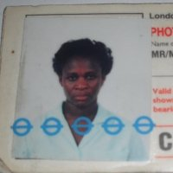
Mervelee Tomlinson
Carer at Carer at Home
More of what I am Capable of Presenting to the World
On this Fathers Day 2016, I realise more than ever why I have to leave no stones unturned to bring to the World's attention, the effects of Transitions on the Lives of Children and Young People and Vulnerable Adults from "cradle to the grave". In light of the murder of MP Jo Cox and Prince William's message of hope for all of us on Father's Day, there is no questions that more need to be done to support those of us with Mental Health Issues. The Equality Act 2010 states that a person has a disability if s/he has a physical or mental impairment, which has a substantial and long term adverse effect on his/her ability to carry out normal day-to-day activities.
Because of the most recent incidents occurring with me and yet another employers, I have to become an Advocate and Standard Bearer for sharing my experiences with the world. I believe by making myself the Case Studies for those who might have some hang ups or fears of what others might think about them if they share their insecurities. Then I might become instrumental and remembered for the right reasons other than what some misguided, prejudiced and biased employers like London Early Years Foundation (LEYF) might like others who share their blinkered approach to life might think is the norms.
Therefore employers like LEYF will prefer to hide behind their contingent provisions, criterions and practices to in/directly DISCRIMINATE against Vulnerable children and adults at every chance they get to breach the Welfare Requirements of the Early Years Foundation Stage (EYFS) and OFSTED Standards. Employers like LEYF will make excuses for not performing their Statutory DUTY towards Safeguarding in line with changes in current laws and legislations, codes of practice and conduct. The Special Educatioal Needs and Disability Act 2001: Created duty on authorities to promote equality of opportunities for men and woment.
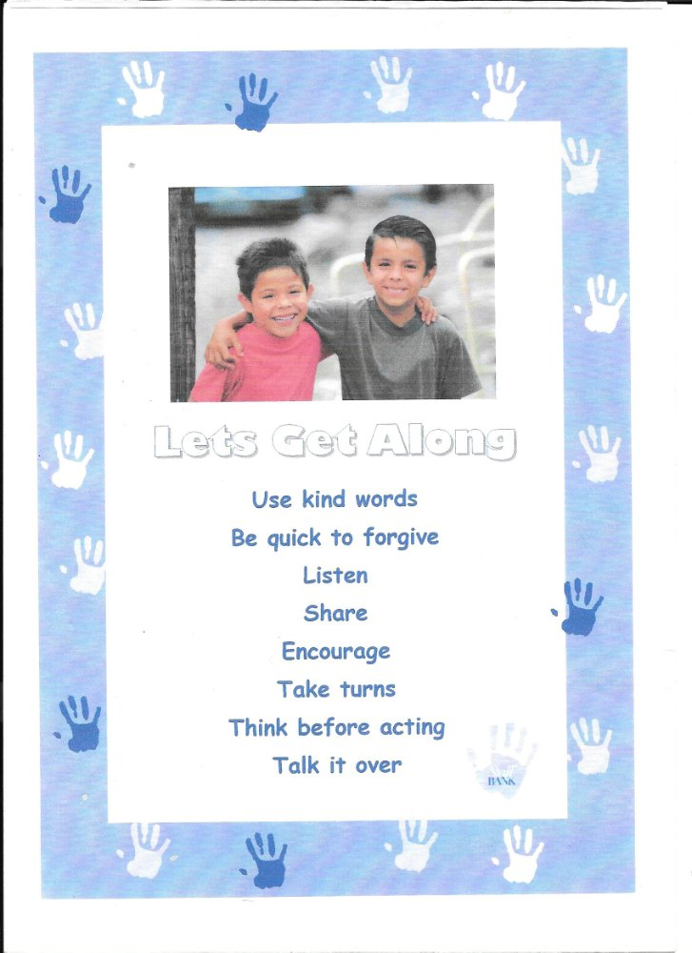
The Disability Discrimination Act 1995/2005 is the First legislation exclusively centred on early years and childcare. DDA introduced the EYFS which promotes the uniqueness of children and supported development of children. My foundation is in early years when I worked as a Basic School Teacher and done one year Apprenticeship as a Teaching Assistant in a Primary School as part of the Government Initiatives - National Youth Services. But most importantly, I started caring from about the age of 7 years old when my youngest sibling was born.
When one is an only girl, it is the norms that certain roles and responsibilities are yours by the "Rights of Passage" when I was growing up. I was privileged to be an inbetweener with status as Little and Big Sister for my 7 brothers. However I don't want anyone to get the false impressions I was "spoilt rotten" as the only girl in our "male dominated" household. I have to fight like the "Lioness Cub" for my place. My most recent experiences in the workplace and what I have seen of how the SYSTEMS are operating have left me thinking it seems so much have changed to make this world a much harder place for one to be their brother's/sister's keeper? 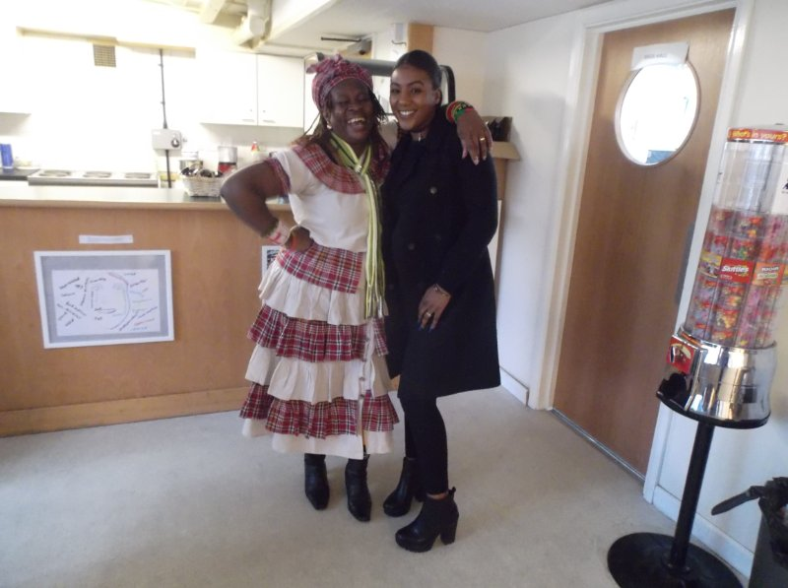
The United Nation Convention on the Rights of the Child (UNCRC) - Article 14 states that it is a basic entitlement of humans to enjoy their rights and freedoms without discriminations on any grounds.
I am proof positive that one can learn to live with some of the deficits we are born with and the limitations we might pick up along our transitional developmental journeys from "cradle to grave". With strong will power, determination and the resilence born of experiences, one can do much to overcome some of the circumstances in which we are born and not to let these determine the outcomes and our ambitions to achieve. Despite my struggles, however I am darned sure never to give up my fight to be the best I can become despite the odds stacked against me from the age of 10 years old.
Now maybe the Nay Sayers will begin to understand why I am an Advocate of Inclusion and is Passionate about laying Foundations for Children and Young People as well as empowering the Elderly to live independent lives as long as they are able to. The Every Child Matters 5 Outcomes and 4 Principles is the standards I set out to deliver as part of the "Statutory Duty" of laws, legislations, codes of practice and conduct in the job I train to do as an Early Years Practitioner. 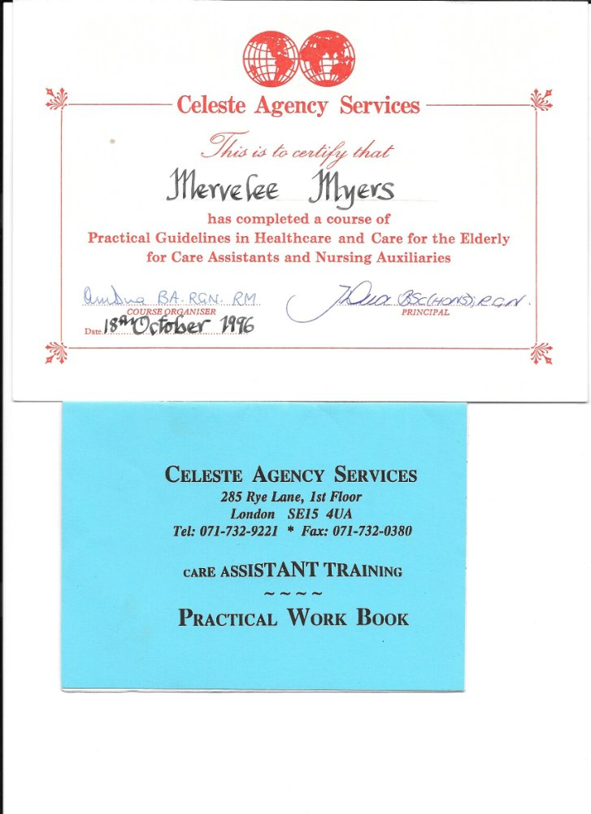
I also plan for every other eventualities, training to care for the elderly at the other end of the lifecycle - from cradle to grave. No amount of knowledge can ever be too much and science are advancing every day from the time of the earliest pioneers in their different areas of career - teaching and learning. At this later stage of my life I embark on enhancing my knowledge in preparation for a Career change in order that I can get another job. Work keeps me going as I told Senior HR Dilys Epton when she tried setting me up on the 27th March 2015 at the House Of Common (HOC). 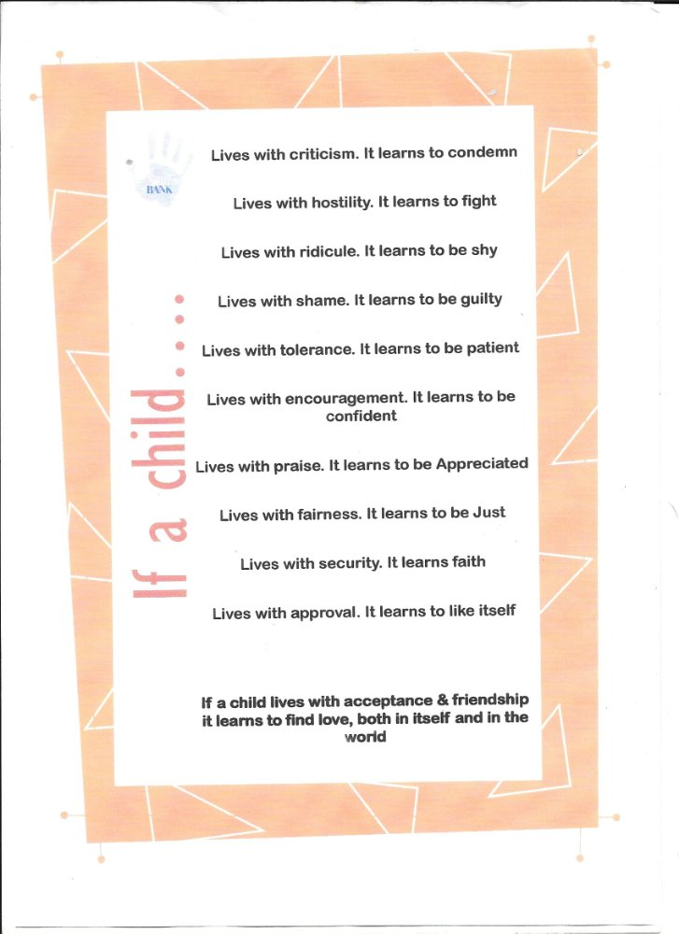The Employment Equality Regulations - Amended the Race Relations Act 1976 to include a Statutory Duty on Public Bodies to promote race equality, good relationships between different ethnic groups, and to demonstrate effectiveness of anti-discrimination procedures. I know about the struggles of my Family when my FATHER was struck down with Parkinson Disease from an early age. My Family life was changed for the worse with different transitions that none of us were prepared for, from my Parents to my Siblings to the children I went on to have. My first child was affected by the transitional trumas that affected me.
Luckily for both of us my steadfastness to get him involved with other young children of his own age in the school environment, paid off. The social interractions, early interventions and the nuturing helped him to overcome the impacts of lack of stimulations resulting from the interruptions in my developments. I was never one who gave up easily and have always fought my corners to get what I want from life. That's why my #FIGHT4JUSTICE campaign is for the VULNERABLE employees who need to get justice from employers.
The Disability Discrimination Act 1995/2005 Introduced the Special Educational Needs Code of Practice. In this, schools are required to develop a Special Educational Needs policy and appoint a Special Educational Needs Coordinator (SENCO) to identify and assess special educational needs, keep a register of children with SEND and work coorporatively with parents and other professionals. Amended in 2001 (SEND Code of Practice 2001): private nurseries and accredited childminders, amongst other groups, must 'have regard' to the Code of Practice.
Results of my Father's struggles with Parkinson Disease were he was made redundant from his job as a Common Labourer, working at the Sugar Estates in Westmoreland - WISCO. He was sick for 10+ years before dying a broken man at the age of 62 years old. The impacts on his family were astronomical. However I in particular being the only girl and my Dad's Pet, if not favourite experienced some of the most lasting developmental transitions. Inclusive of me developing "Chronic Anxiety" which lasted from I was 10 years old to date.
The greatest pity is, I nor anyone else had an inclinging of the reasons for my "Chronic Anxiety - Hidden Disability - now DISABILITY", because of the DISCRIMINATION in 2 different workplaces over a number of years in South London. Southwark Council Special Educational Needs Section have much to answer about their part in the debacle that ruined my carer. Because I was only doing my job when I contacted Southwark Council for support. Now Southwark Council is at it again and I will leave no stones unturned to get to the bottom of why I am being targetted.

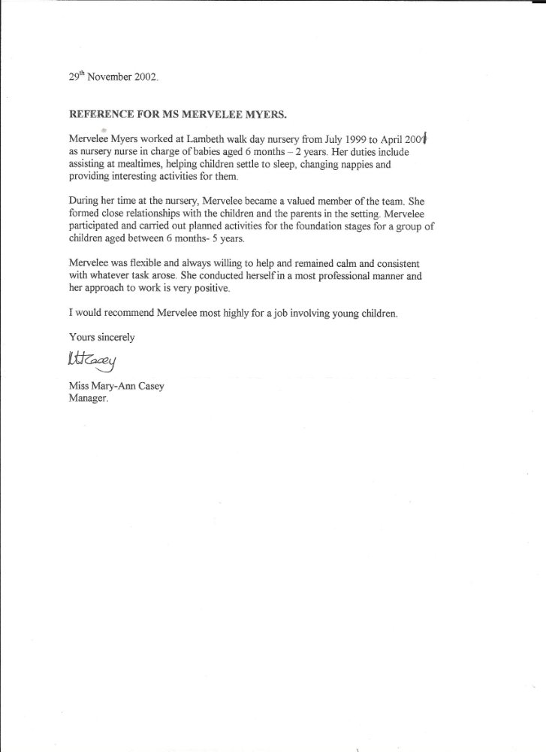In case Joelle Lax, manager of New Cross Community (LEYF) Nurseries is reading this alongside her Institutionalised Brainwashed Psychopathic Psychological Liars colleagues she will recognise me here. Yes I know all of (LEYF) read my Social Media as they are not sure who I will be naming and shaming next. But all who have worked with me collabortively, even when they made the usual blips, I am a forgiving person and understands the pressures to keep your jobs. This is history repeating itself because colleagues were threatened in the other workplace - KINGS that started the campaign with Southwark Council to ruin my LIFE! 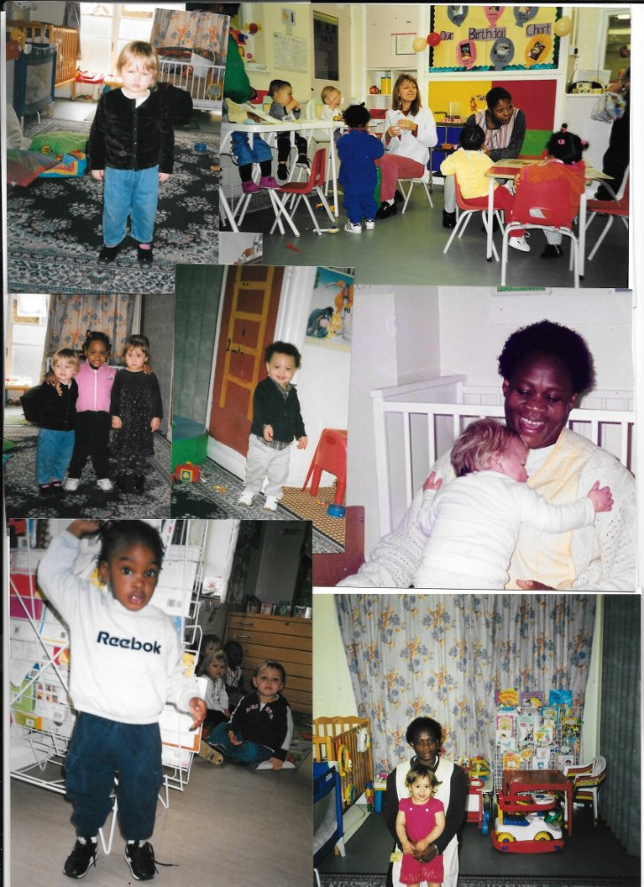Whilst LEYF is at it, I don't know who they can pay off to do their Dirty Work...? As these photos were given to me in Good Faith, I hope I will not be accused of stealing anyone else's Intellectual Property. I am not gaining Financially from any of these photographs and is only using them to show the World who I know myself to be. Not the uncorporative, unprofessional, rude, intimidating, confrontational, aggressive who is lacking empathy. And yesterday whilst reading through paperwork, I discovered that someone - BIB manager Lynne Kelly who threatened to show me who is COWARD thought I was Passive Aggressive.
Why because I looked SHOCKED and said I was not aware of any of the trumped up allegations by Benedicte Siewe at Rui's wedding. I would not admit under duress that I'd done anything wrong by attending the wedding to celebrate. Lord please deliver me from the Intellectual Imbeciles, because if they prove that they are incompetent, what do they expect me to say about them? No one told LEYF about the British Values Act 2014 whilst they were busy sactioning BIB and later HOC and New Cross to DISCRIMINATE against me. 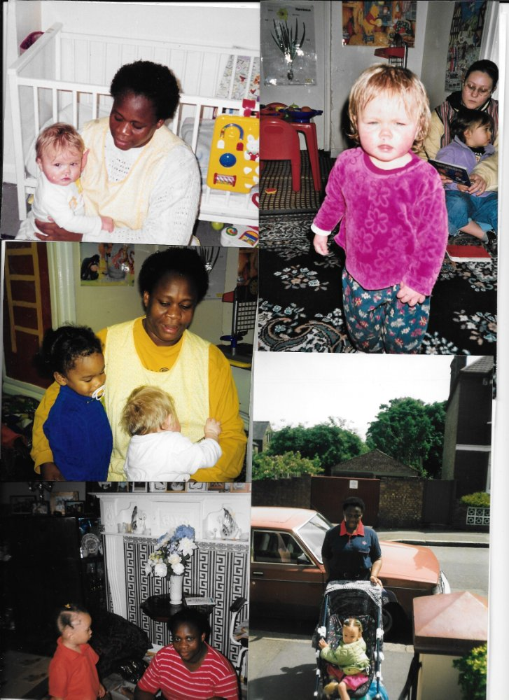So Ms Joelle Lax this is what my "Defensive Practice" is after you saved me from Maria Concalves and Freeman at Fitzrovia in 2009. By speaking out about my professionalism during the time we were working at William Wilberforce, Lambeth Walk Day Nursery July 199 - April 2001, you saved me from the scrap heap. Pity you changed from the humble teenager I knew to the one who was on the Panel at the Disciplinary Hearing who asked me that Silly Question. Only you on the Panel consisting of Rashid Iqbal Head of Children Services and Beverley Jean-Pierre knew me from as far back as 1999-2001.
Yet you joined with them to help push me over the edge then had the nerves to say on the day "Mervelee I told them I know you". But Joelle Lax, you certainly did not know me at all even though you recognised me that day in 2009 at Fitzrovia. And done me the favours of saying I was a professional at William Wilberforce! So how could you join in the Slow Kill of a Stalker, instead of the instant one of a "Lone Wolf"? Refer to the British Values 2014 & the Counter Terrorism and Security Act 2015 for further information. 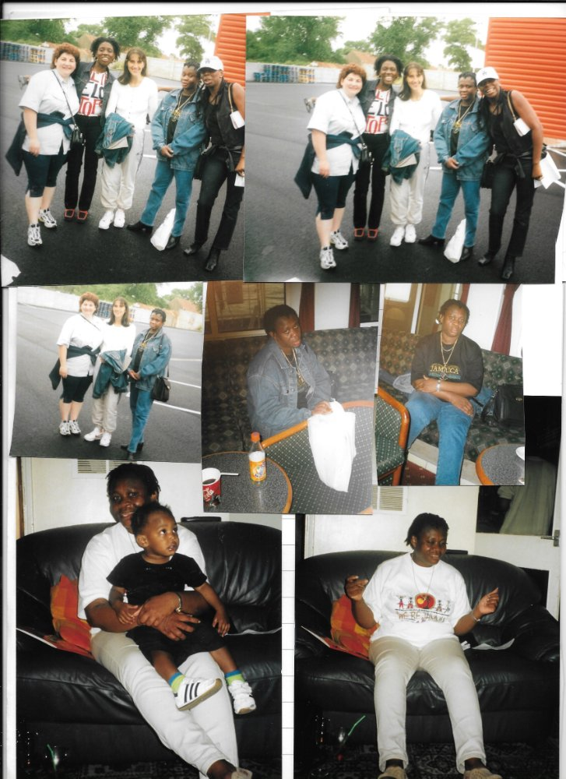I was always a Social Butterfly with a Wicked Sense of Humour from I was a Child, competing with my brothers for a place in the crowded male dominated household. Being an only girl, I was the apple of my FATHER'S eyes until his demise with the Parkinson Disease that is a part of my DNA that robbed him over the 10 years of his DIGNITY! I was the last to see him alive and first to find him dead. His death was a massive relief to the FAMILY. In writing this I am mindful that my youngest siblings if he has any memory of our FATHER is a man shaking like a leaf on a windy day. My brother was only 3 years old when Papa took sick. My youngest siblings therefore do not understand anything of my traumas.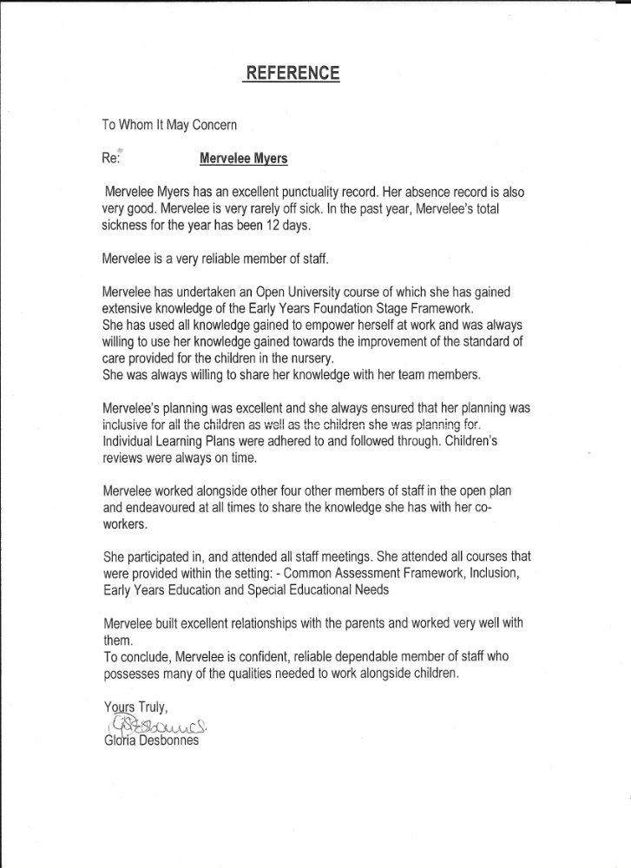
If there were the standards and pedagogy of teaching and learning about SEND, child development and child psychology that I later studied to gain recognisable qualifications, my life would have been different. Instead I lived a life that was almost unbearable. I have recently received professional support from the National Health Services (NHS) to deal with the Disability with counselling. My Hidden Disability - Chronic Anxiety was exacerbated by a NHS workplace setting for the NHS staff children. I worked at Kings Day Nursery Mapother House between 2003-2008.
It is strange because on reflections, I was resposible for using the enhanced knowledge I was gaining from studies with the Open University (OU) to implement and promote inclusion in the workplace. I made a vow then that I was going to become a graduate even if it was 2 years after my youngest son Valdin Legister graduated from GC Foster College in Jamaica. So I became a Proud Graduate within weeks of celebrating my 50th Birthday. Not even the DISCRIMINATION at KINGS could put a dampener on my achievements to be a Graduate.
The parents and their children have done me proud by supporting me throughout the time I worked at Kings Day Nursery Mapother House - Kings College Hospital NHS Foundation Trust. Ethan was one of my first key children at Kings Day Nursery Mapother House. I can still recall how much he wanted to be an achiever like his peers from a young age. 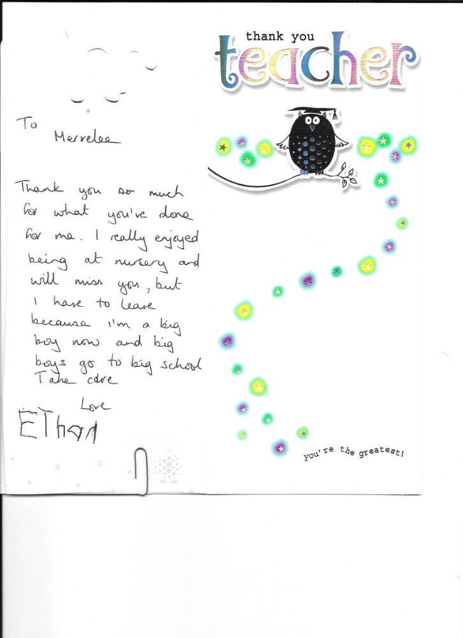Charlotte was a Daddy's Girl like me in so many respects. 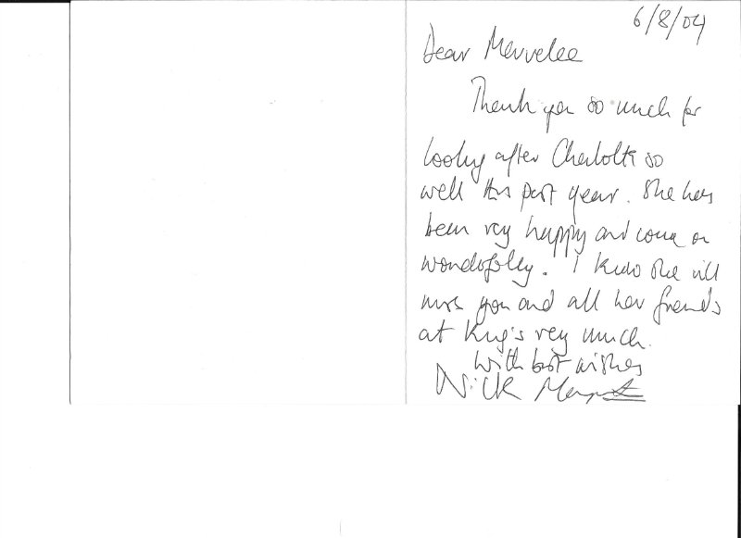Carys Ball and her elder brother, and honestly I don't recall his name, but I am looking at his cheeky smile right now attended Kings during my time. 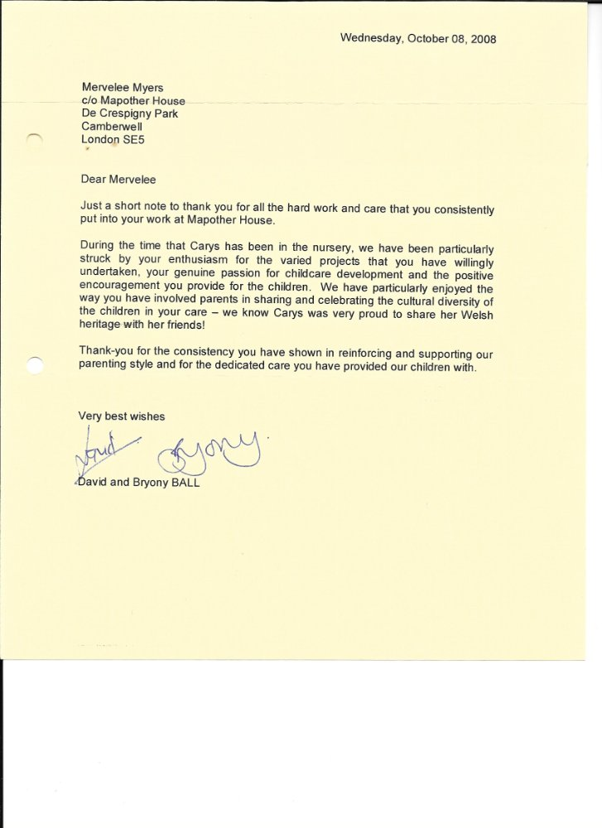Those are only some of the many accolades from KINGS. I will featture the others when I am writing a detailed pictorials about KINGS in the future.
I thought I should feature this because of what Augusta Foster done to me after I supported her all the way from we met at a training in Lambeth. Then we started working together at KINGS. I fought everyone's corner at KINGS, but everyone left me to stew in my own juices when I needed their support. Agusta Foster was no exception, however when I was down on my face she turned around and did even worse than what was done to me at KINGS. To this day I still can't comprehend why another fellow human being could treat their colleagues in such a manner.
After all I have been through, especially the female of the species, I discovered that this has to do with the Balance of Power. Some women just are unable to see their sisters flourish. That's why when she came to view at BIB and the manager Lynne Kelly asked about her, I shared the positive and leave out the negative. I was always put in a subordinate post at and after KINGS. I am expected to do the work without getting the recogition or the dues with regards to payments. So in order not to end up on the scrap heap of being unemployed I "Kiss Arse as my Old Folks say waiting for the time when I am in the position to Kick Arse". 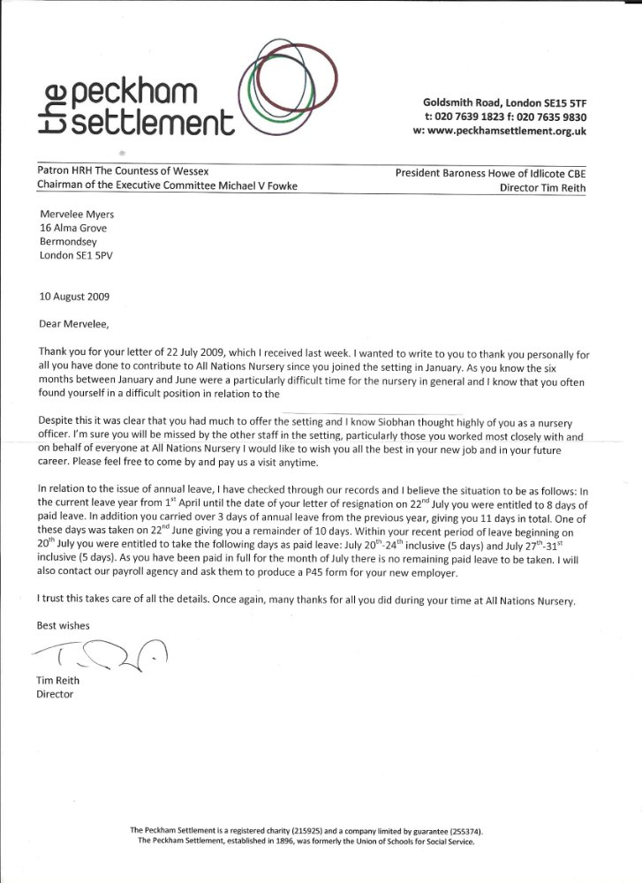It was such a privilege to attend the christening of Shantelle's and her husband's youngest child with Winnifred Jacques whom I can rely on during the times when I need someone to be there for me.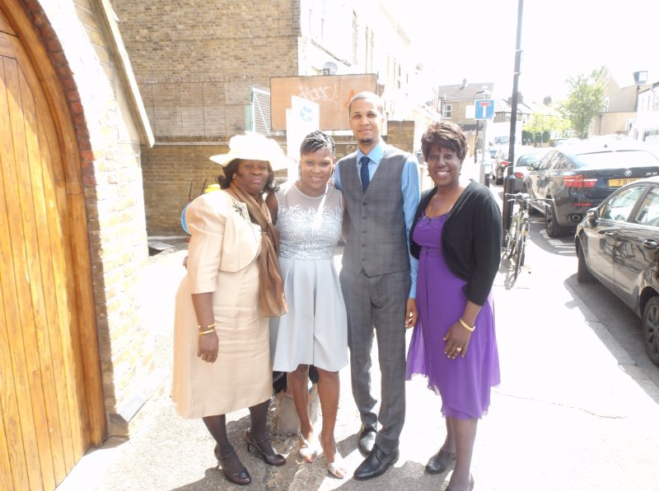Alev Sagnac another colleague who I met at KINGS in April 2003. She introduced me to London Early Years Foundation (LEYF). The rest of the LEYF story is history and water under the bridge...?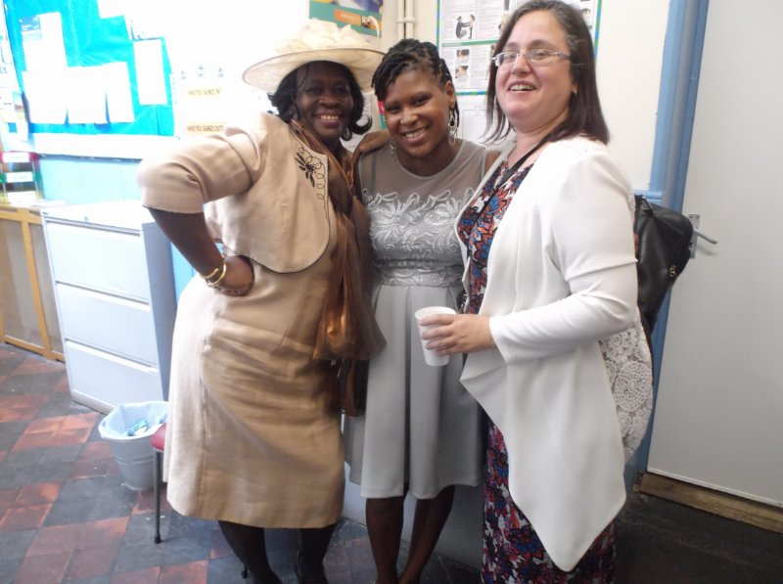Some of the more complementary ADJECTIVES used to describe me by complete strangers at a training. I don't know when LEYF decided I changed into the Ciracature of a Monster who they Disciplined in April & May 2015. This was after LEYF set up the Terrorist Cells with the Lone Wolves that ended up Radicalising me into defending myself with my campaign #FIGHT4JUSTICE. My Old Folks used to say whatever you sow, you will reap. Now LEYF is reaping the wraths of exacerbating and triggering my Mental Disabilities. I will not rest until JUSTICE is done for VULNERABLE EMPLOYEES everywhere!
Maybe LEYF will interpret these as me being Passive Aggressive as Lynne Kelly wrote in her statement. But only Lynne Kelly the Schemer can give that answer, because LEYF feel intimidated by professionals of my calibre and have to promote INCOMPETENTS like Lynne Kelly to cover up the way how LEYF has lost the plots in their bid to become the biggest. But then I got to Marion Breslin, Louise Elliason and Emma May Reug and I am convinced more than ever that Joelle Lax could do no better than what she was primed to do at the Disciplinary Hearing.
I am going through many different emotions reading through some of the Inspirational Narratives written about me. Gosh I am glad I paid attention when I attended school. But to be honest my Family is naturally gifted and talented in more ways than one! Wondering if LEYF can read and understand any of what is recorded in these notes. They are from total strangers who I met on a one day training whilst working at Luton Street - April 2010 - July 2014. I was saddened to read what Marion Breslin wrote about me after the way I admired as one of the Panellist at the interview in May 2009. But as God would have it, she fall on her own sword - Resign when she could no longer stand the pressures.
LEYF is responsible for exacerbating and triggering my DISABILITY when they sanction BIB, HOC and New Cross Nurseries to DISCRIMINATE against me October 2014 - September 2015. I know the triggers for my Chronic Anxiety and stay clear of them as documented in my FILE. The same FILE, LEYF refused to give me access to after I left Luton Street. Premeditated Act of Breach of Contract... without prejudice? LEYF breached the 33 Sections in the Contract I signed on the 07th October 2009. 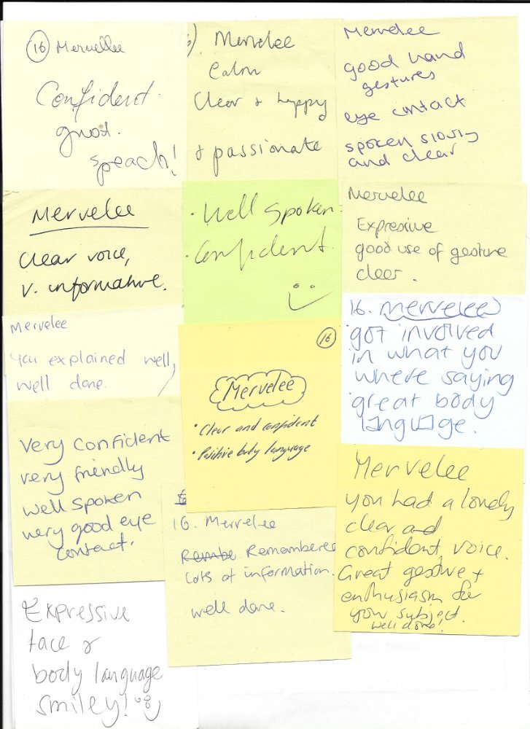
Move forward to 2016 and I am having to deal with yet another EMPLOYERS that think they can get away with murder by DISCRIMINATING against me. LEYF set out to destroy my life after I gave them some of the best years of my working life 1st September 2009 - 27th September 2015. Between a phase when I was experiencing one the most heartrending kind of transitions after the death of my MOTHER from dementia at the age of 90 years old. The hardest thing is I was still coming to terms with my MOTHER not knowing me her only daughter when I spent 5 weeks with her and left January 2014 after atteding my younger son's wedding.
LEYF hatch one of the wickedest plots known to mankind to destroy me from October 2014 - September 2015. But it has not stopped there, because I am being put under additional pressures to clear my name, character and reputation that are exacerbating the DISABILITIES that are the offshoot of a "Truamatised childhood into adulthood" over which I nor anyone else have any control. The unscrupulous Employers - LEYF and KINGS before, aided and abetted with their cohorts are continuing to make my life a living hell. But of course becasuse I don't have friends in High Places, I will not be getting any support.
Like back in 2008-2010 when the union UNISON colluded with KINGS after Southwark Council instigated my downfall so I could no longer further my career. The SYSTEMS whether by designs or not, allowed the High and Mighty to get away with destroying the life of another Vulnerable person. The Solicitiors - Capsticks played the same kinds of unscrupulous games of saying they did not receive documents I sent to them in the post. Now how can I ever trust, believe or have faith in any such professionals. But not only that the current union VOICE is still taking fees for providing a service under the pretext I am still working at Bird In Bush.
And because of standing up for me I am presuming without prejudice the Union Rep Darren Mahon lost out after accompanying me to the Disciplinary Hearing at LEYF Central Office and ask for clarifications about whether I was charged with Gross Misconduct or Misconduct. Of course the Chair of the Panel Rashid Iqbal Head of Children Services did not know the answer which came at the end of the Hearing. So back to the drawing board of Self-Reliant and not depending on help from others. Although I accept my Hidden Disabilities the Equality Act 2010 states that there is not need for me to establish a medically diagnosed cause for the impairment. What is important to consider is the effect of the impairment, not the cause.
One of my new converts who got used to my eccentricity at the Teaching Assistant Training course. I attended the course to change career and came away with more than I bargained for. God has a plan for every single one of his children, even a SINNER like me...?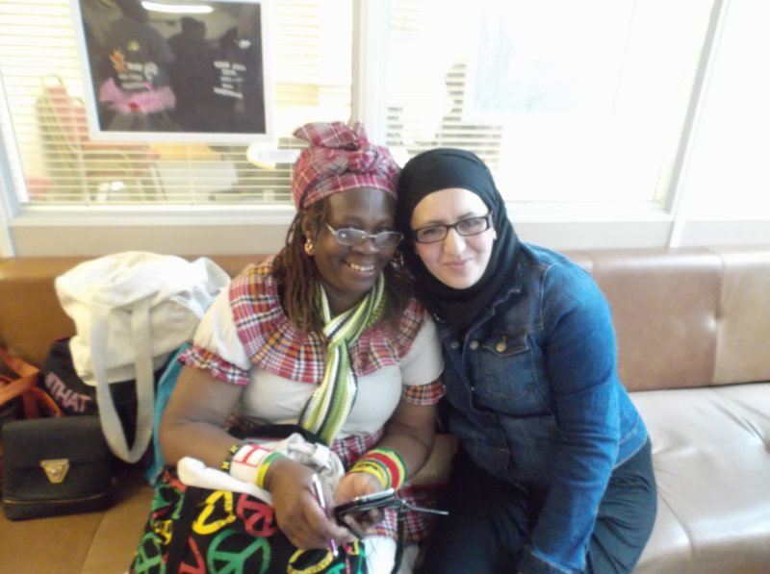My Tutor Danielle Williams told me I must not tell people I am not a Teacher. She claims I am a Teacher and I must claim my status. I was a Basic School Teacher in Jamaica, but they told me I am not in the UK. That did not stop me from mentoring colleagues at Lambeth Colleague, Open University, LEYF and now the Teaching Assistant courses. Empowering myself and others is what I am about. If I don't share the talents God bless me with, they will be of no use to me and others. 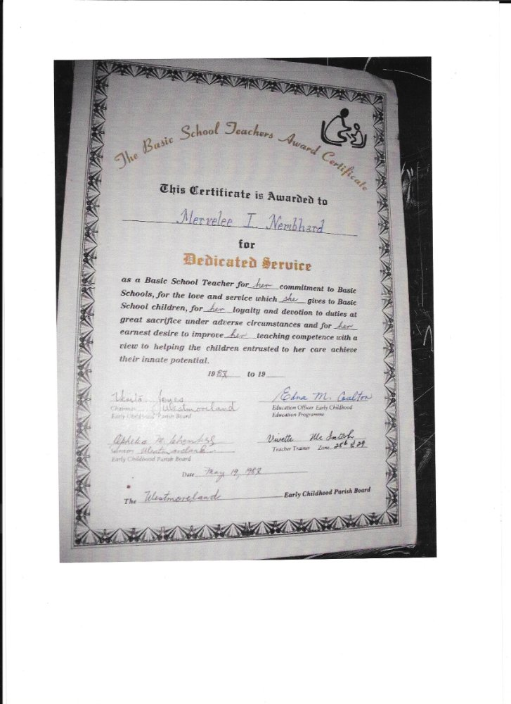End of Teaching Assistant course at STORM Family Centre in Wandsworth.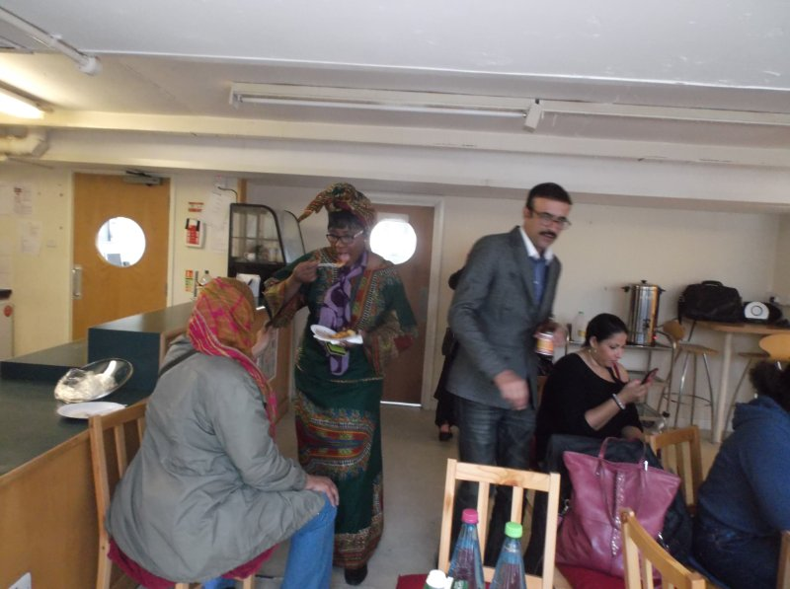Another of LEYF tokenisms! LEYF set out to deny me the opportunities of developing my Continuing Personal Professional Development Plan (CPPDP) the very same month I was presented with this tokenism. It kicked off when LEYF put their plots into place to DISMISS me, when I was eating a ripe banana. I was eating the banana so as not to fall over with a Hypo on the job. Anyone who has been following my story knows I was diagnosed with diabetes in 2012. However they don't necessarily have to know that I am MAD even though I don't have any secrets. The rest is history and as my old folks used to say the longest liver will see the most. And if I am dead, "ants will carry news" and tell me. But LEYF must be brought to book for the DISCRIMINATION of the Vulnerable Employees and neglecting their Staturory DUTY to children with Diverse and Complex Needs ad their Families. 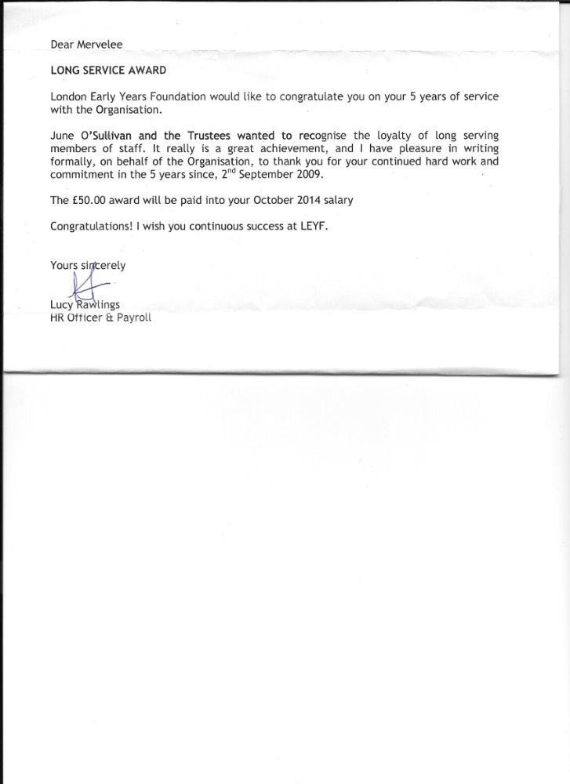I was one of the Oldest Student at Lambeth College. But I was determined to make the most of my opportunities that I never got in Jamaica. I embrace British Values as I was brought up by my Parents in a Christian home with all the principles, values and beliefs of the British Values that some seems they have to wait for an Act to comply with. So they go about like LEYF paying lip service and their Contract, Policies and Procedures are not worth the paper they are written on. Because LEYF Leaders and Management do not adhere to their Job Description and Person Specification. Some of them did not get the job fairly but via Positive Discrimination so as not show up the INCOMPETENCY of those at the top who refuse to share the POWER! My name was written for me by a Student on placement.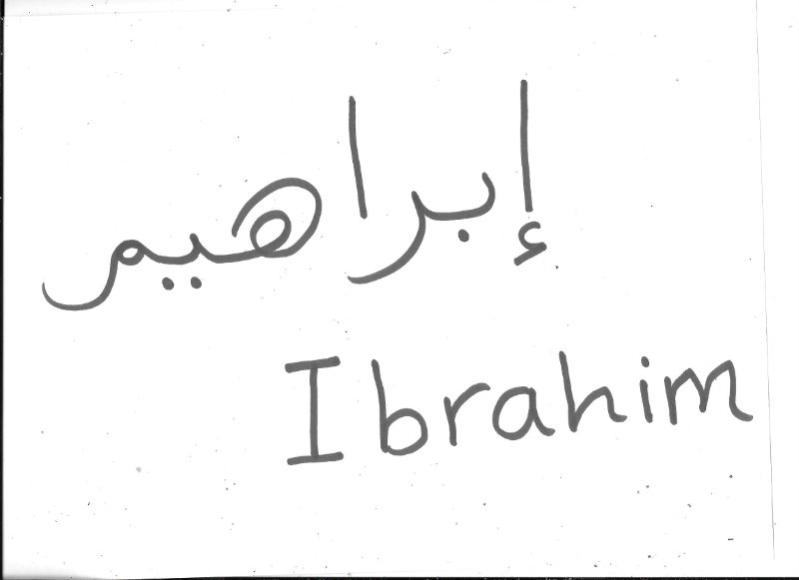I was involved in doing everything. Frome being SENCO, EYFS Cordinator, mentor, shoulder to cry on, editors, Face of Promotion, etc... You name the role and I covered it at Luton Street from April 2010 - July 2014 and some.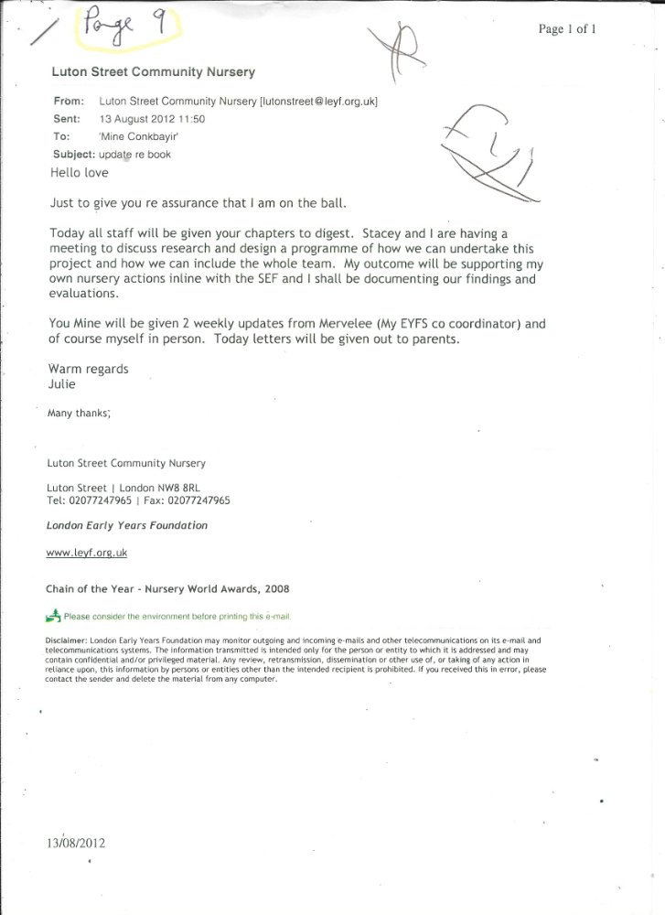I am known for my innovations. I got published in the Nursery World Magazine in 2011 after transferring to Luton Street. I used my (CPPDP) from studies and trainings to make Luton Street one of the Beacons of LEYF Nurseries. Of course I have to acknowledge the contrbutions of all the colleagues, apprentices, students on placements from colleges and schools with whom I worked and mentored. LEYF can think they can take away everything I owned because I signed a Contract, but I refuse to allowe LEYF to DESTROY me for no reasons except LEYF have become the Psychopaths that the CEO mentioned in her Blog of 2012. 
This is one of the students I took under my wings at Luton Street - yes she is Jamaican with Chinese Heritage. Like some of us, she still possess the Slave Qualities that allowed us to be bought by the Highest Bidder. So what did she do, set out to frustrate me soon after I got back from my son's wedding in January 2014. Pity they didn't know that I have my Defensive Practice firmly in place. So when the New Manager started the plots, I was way ahead of her. 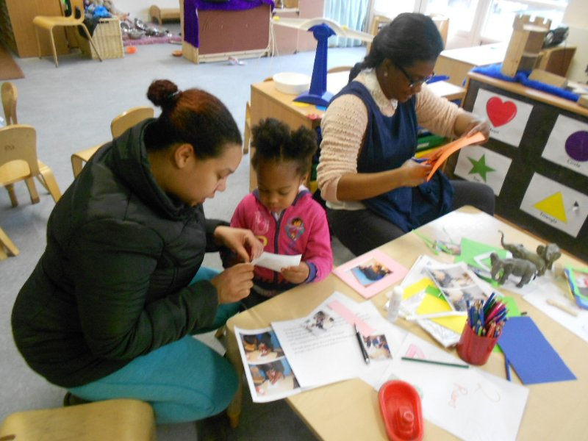My MOTHER and I during the 5 weeks I spent in Jamaica December 2013 - January 2014. Mama did not know not recognise her only daughter, but I guess I got the opportunities to prepare me for my other Statutory Duty of Care. Taking on the role of Carer for my elderly HUSBAND in due course. The time I spent with Mama in January were very rewarding, because I was able to empower her to go back to a time and place in her life that she was familiar with. Even though I was excluded I am happy I have those last special moments with her.
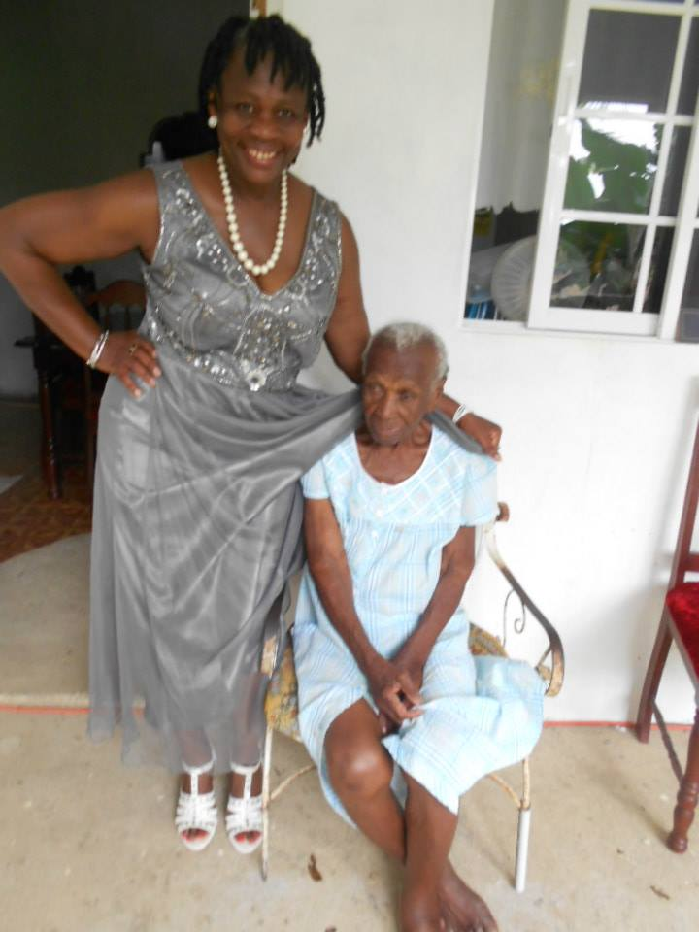Another happy time at Luton Street when I went out with colleagues to celebrate the good times.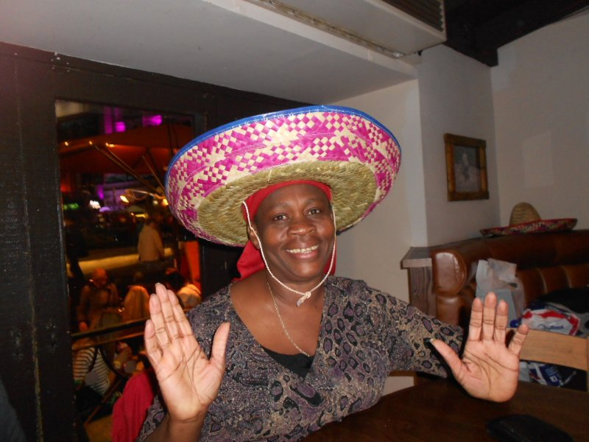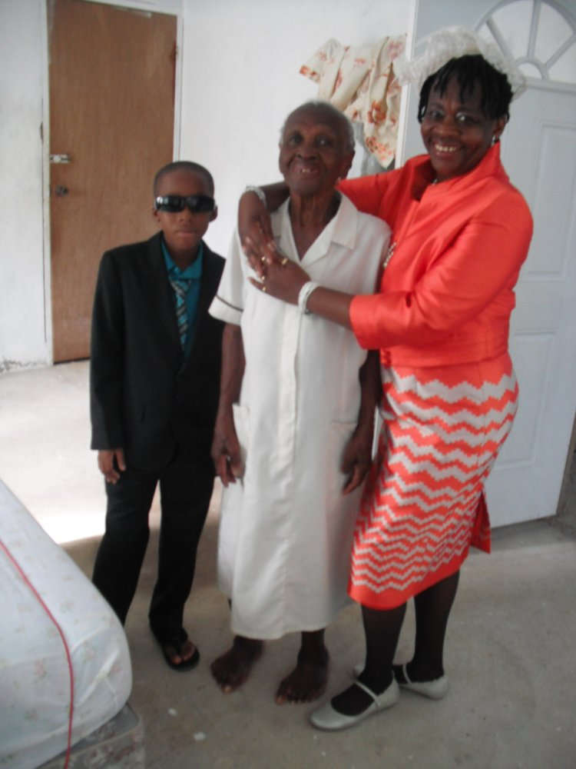My MOTHER and eldest Grandson on the day of my youngest son's wedding. Mama did not have a clue, but I tried my best whilst I was home to give her a sense of normality. I shared the precious moments doing the things that she remembered that were meaningful to her. More reasons why I dedicate myself to my #FIGHT4JUSTICE campaign against LEYF. Because LEYF set out to Radicalise me soon after I got back from burying Mama. I still have not had time to grieve for the loss of my MOTHER and LEYF continue their plots of making me out to be a CRIMINAL. Therefore I will show to the World who are the Uncooporative, Unprofessional, Rude, Intimidating, Confrotational, Aggressive and Lacking EMPATHY if is the last thing I do with my life in Memory of my Mother! It's time LEYF leave me alone to mourn the loss of my MOTHER 2 YEARS ON FROM HER DEATH?
- LikeDouble Standards - SYSTEMS...?
- Comment
- ShareShare Double Standards - SYSTEMS...?
Tagged in:
- system administration
- standards development
Mervelee Tomlinson
Carer at Carer at Home
- 71 articles
0 comments

