Tribute to Craig Damion Banhan – A Son of Townhead: From Cradle to Grave 17th June 2017 by Mervelee Myers.
A Westmoreland man died as result of injuries he sustained when the motor car he was driving overturned along the Bogue main road in St James on Friday evening.
The deceased has been identified as 33-year-old Damion Banhan of Burnt Savannah, Westmoreland.
Reports are that about 3:00 pm, Banhan was driving his grey Toyota motor car when, upon reaching a section of the Bogue main road, he lost control of the vehicle after hitting an embankment. The car overturned in a pool of water settled in a ditch.
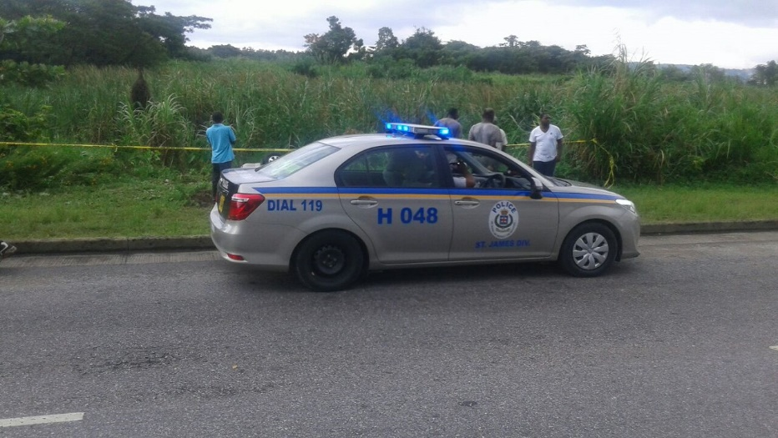
Police officers and onlookers at the scene of the accident
The driver, who was the lone occupant of the vehicle, sustained head injuries and died before help could reach him.
The Montego Bay police are investigating.
Source: Taken from the Internet.
I am writing this tribute to the deceased for many reasons, but most poignantly from the personal perspective of a Mother, a Teacher, a Carer and a Person who knows about the transitional journey of CRAIG BABHAN who I help to nurture and with whom he develop secondary attachments in his childhood. In order for anyone to get the fuller picture of my association with the family, I will have to go back a few centuries to my childhood. Therefore despite my memory is not as sharp as a few years ago, when I started writing and documenting…? I am hoping I can write this tribute to depict the close knit community from which I was born and lived for almost as much years as GRAIG was given on this earth.
I left Jamaica for the UK on the 6th June 1992, for those of you who are better than me at mathematics, please do the calculations. My Hidden Disabilities are inclusive of dyscalculia, as my age is liable to change, depending on my situation. I sometimes have this need to take on the persona of others. I worked as a Basic School Teacher before coming to the UK where I set up home since 1992. Craig was one of many of my students, but like a few of my pupils I have a close relationship with him and love and treated him like one of my own. I order for you to understand, therefore I need to go back to my reflections of growing up in the local communities of Townhead and the surroundings.
The Cocker
Therefore let me start with the COCKER as this is where I can recall that CRAIG family history lie. I was only young but the family of Cockers live together in this big house, entering the raising to Townhead. The head of the household was the only male and he was surrounded by his sisters. They were described as Mullatoes. They were not white and neither were they black. One of the sisters was the Registrar for the area, and I honestly don’t recall what the others do for a living. But I recall my granny saying, Mr. Cocker was a well-known jeweler, but never taught this skills to anyone else. He eventually died with this talent instead of passing it on to anyone else either. I recalled Mr. Cocker as the Bursar at Frome Secondary School, where I attended from 1972-1976.
One of his sisters, Ms. Hilda was the Registrar for the locality and her name is on my Birth Certificate. The others were named Ms. (Sibby – Sybil), Ms. (Al – Alice), and Joy Cocker aka Joy Banhan’s grandmother worked at the Cocker household. Joy and her grandmother come to live at Townhead when Mr Cocker moved to the area and was the Bursar at my school. I never know any other name except Joy Cocker for CRAIG Mother, Joy and to this day that name remains. I recalled my grandmother used to be helping out at the Cocker and we carried water for the family from the stand pipe at Pringle Corner. I am not sure if my granny got paid for her services, but must have gotten some forms of payments for her services to help her get along in life?
The Cocker’s home was one of the modern homes built and they moved from another area, might be Somerton, or at least Mr. Cocker, to live at Townhead. Mr. Cocker drove one of the biggest car and must have been one of only, a minority of persons to own their own transport. Honestly I can’t recall the make of the car either, because I do not have a good memory for that kind of information. If I had known these things would turn out to be important, I probably would have documented and stored for future reference. Joy, CRAIG Grandmother moving to live and work for Mr. Cocker meant that Joy became a part of the Townhead community. I recall Ms Joy, she was a Basic School Teacher.
Townhead Baptist Church
The Townhead Baptist Church is a monument for the community and has been in existence from time memorial. My Mother was christened, married and baptized there and the family have a long history dating back with the church. My siblings and I were christened there and so is one of my sons. Even I don’t think I could cover the history of the Townhead Baptist Church. However I would like to touch on how I understand the Townhead Basic School, which is the foundation for my developing my passion for working with young children started. I was reliably informed after I attended a funeral and meet Ms. IVY Haseley nee McKitty, that she started the School at her Moth Ms. Molvina Trout’s home. It was subsequently given a permanent home at the church.
Ms. Molvina - Molly Trout was one of the witness at my parents wedding and my Mother claimed they are family. I no longer question the authenticity of those who my Mother claim are her family. Most of Westmoreland people are related, and the only way my family is not doubly related to others, is because my Papa is from St Elizabeth. There have been many Teachers coming out of the system, who I understand cut their teeth, as gaining experiences at the Basic School located at the church. Ms. Candy Gooden and possible Ms. Jenny Turner were colleagues of Joy Cocker when they worked at the Basic School located at the Townhead Baptist Church where the school was located.
I remember the church was more than just doing the work of saving souls for God, but was a Social Enterprise, delivering all kinds of services to the local communities. I take my younger breda Ervin to the clinic and I attended the school. I also attended the Sunday School until I become a rebel, when I was getting teased for being different. That’s why I know without a shadow of a doubt that I have disabilities, which I am researching to find out how they impacted on my life. But let’s get back to more about CRAIG. Joy form a relationship with Linval Banhan from Georges Plain. I recall there was a Teacher named Banhan from Georges Plain, teaching at Townhead Primary School. My reasons for this is the stories she told. The one in particular was the story about the wife who calls out to his wife for the poon. When the wife asks him to put on the “S”, he replied, mi wife, wey di Poon-S deh?
Joy and Linval courtship ended in marriage and CRAIG was the youngest of 3 children from this union. Working as a Basic School Teacher at the school located at the Townhead School premises, where my breda ASHTER, in his tenor as Councillor for the Friendship Division got it relocated. CRAIG started attending the school and as a favour to his Mother, I used to keep him at my home until she comes from her job to pick him up. His older breda Bryan who attended Mannings High School at the time would come and wait with him most times until Joy arrived. He was such a tiny little boy, but he was well brought up with impeccable manners. I am more than proud saying I helped in the nurturing of CRAIG as his teacher and during the time he spent at my home.
He was kind and loving to his elder breda Bryan, sharing whatever he was given with him. However the one thing that I recalled which stand out to this day for me, was how worried he would become when the dusk start coming and his Mother didn’t arrive to pick him up. Without doubt you would hear him saying in a pitiful voice “Night a Come Dung and MAMA don’t Come Fi Me Yet”? As I am writing this, I am filled with so much sadness. Because at the tender age of 33 years old, CRAIG Maker came to take him home without any prior notice. I am sure if it was left to his family to make a choice, they would have bargained with his Maker to give him a few more years.
I do not know what it is like to lose a child, but I have been traumatised by having family who were sick for years and died. I have experiences of having family murdered, cut down in cold blood. I have family whose funeral I could not attend because of circumstances beyond my control. I witness the decline in my Grandma’s health and she eventually died of a broken heart 2 years after her son was brutally murdered. Therefore I am writing from my heart about this Young Man who I helped to nurture during his most impressionable years of transitional development during his childhood.
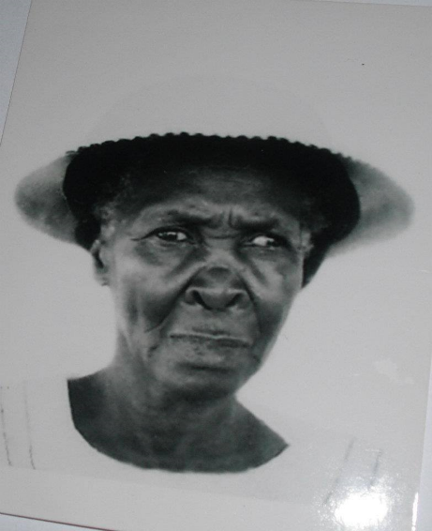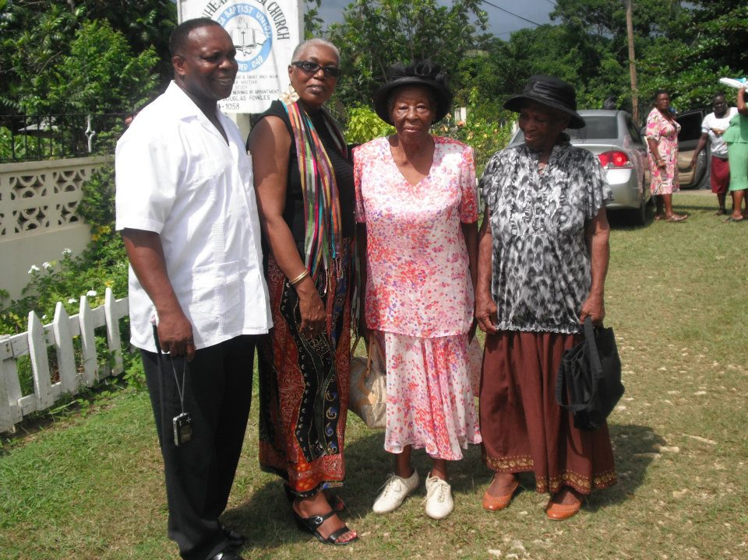

Laying the Foundations
I was brought up the old fashioned ways by my parents and grandma as well as the support network from the communities who were my keepers and who I consider part of my extended family. With the advent of Social Media, which I know can be used for whatever reasons we intend to. I am sad, but at the same time I am happy knowing that CRAIG did not change from the loving Child he was, the child I helped to nurture. The little boy who was worried that his Mother did not come to get him to take him home and night was coming down. There is a song I sung when Charmaine Mahabier was brutally taken from his family “Death Have a Time to Steal Us Away…” I got trolled by some on Facebook, because they did not understand the story I was trying to tell.
This time I want it known that although I doubt whether I have seen or have a conversation with CRAIG, in the past 25 years, I am happy about what I am reading about his life on Social Media. I am writing this tribute in the hope that CRAIG children will have it as a memory of their FATHER, when they grow up. It’s all good and well thinking of the moment that is now and not capturing and documenting for the future. I had a troubled childhood when my Father was struck down with Parkinson’s and I am only trying to capture 45+ years of a blighted life because I got counselling. I would like to tell everyone that knowledge is power and ignorance is bliss.
We need to unite for the benefit of the future generations and I am using my skills to help keep CRAIG memory alive for his children and family. RIP GRAIG DAMION BANHAN. Your legacy will live forever. You were only given 33 years to come, make your marks and leave your legacy. I am sure no one will allow all the good you have done to be ever forgotten. Already it is been documented in cyberspace.
Sleep on and take your rest. Precious Memories how they linger…?
I join in with all the families from Townhead and the surrounding communities of Westmoreland and the entire Jamaica in honouring your life that was cut short as a result of this terrible tragic accident.
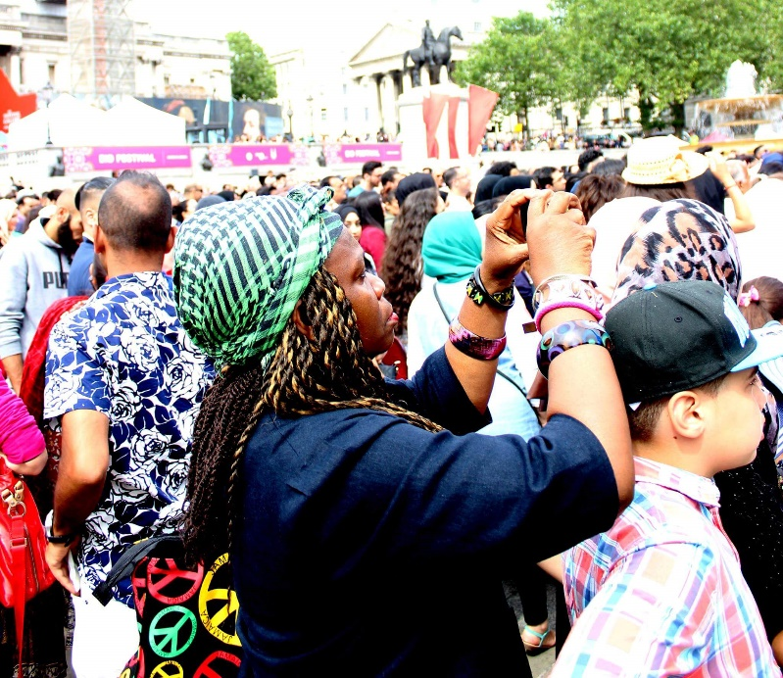
I am a writer and keen photographer. For me writing is therapy.
Written by:
Mervelee Myers
www.MerveleeConsultancy.uk
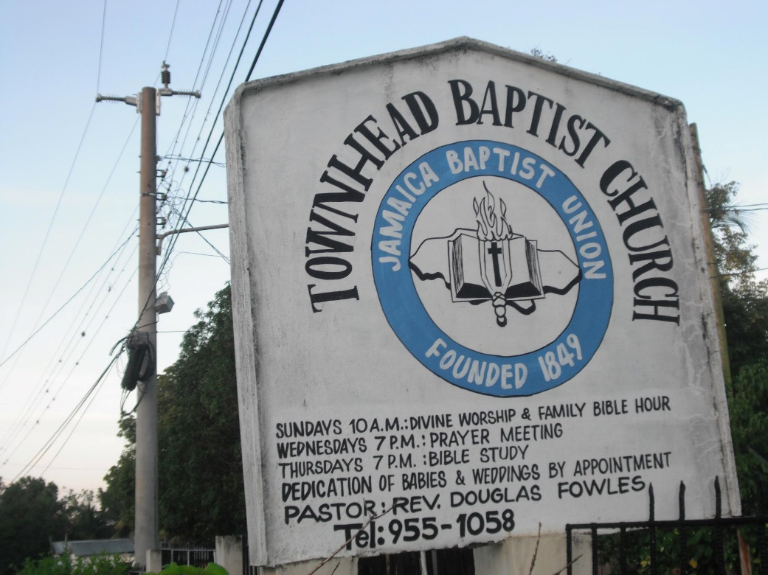
End.

